User manual  
Calculator dumdum

Content table

Use case 2

Installation 2

Prerequisites: 2

Installation process: 2

Launch: 2

Uninstallation 2

Special hotkeys 3

# Images table

Image 1 Icon in main menu 2

Image 2 Graphic User Interface description 3

# Use case

Calculator is used for basic mathematical function like addition, subtraction, multiplication, division, root, power, modulo and faktoriál

# Installation

Prerequisites:   
  
 „**libqt5gui5**“ library has to be installed on the system, if you don’t have this library installed use command:  
 „**sudo apt-get install libqt5gui5**“, requires **root** access.

Installation process:  
  
 Execute dumdumCalc.deb file to open Ubuntu Software Manager. Click „Install“ to install said software.

  
Launch:  
  
 1. You can launch the application throught main menu   
 2. Anywhere with command: „**calculator**“.

Image Icon in main menu

# Uninstallation

Odinstalovat program lze přes Ubuntu Software Manager, zvolením dumdumCalc ze seznamu nainstalovaných aplikací a kliknutí na tlačítko „**Odinstalovat**“.

You can uninstall program through Ubuntu Software Manager, with entry for dumdumCalc and clicking „**Unintall**“ button.

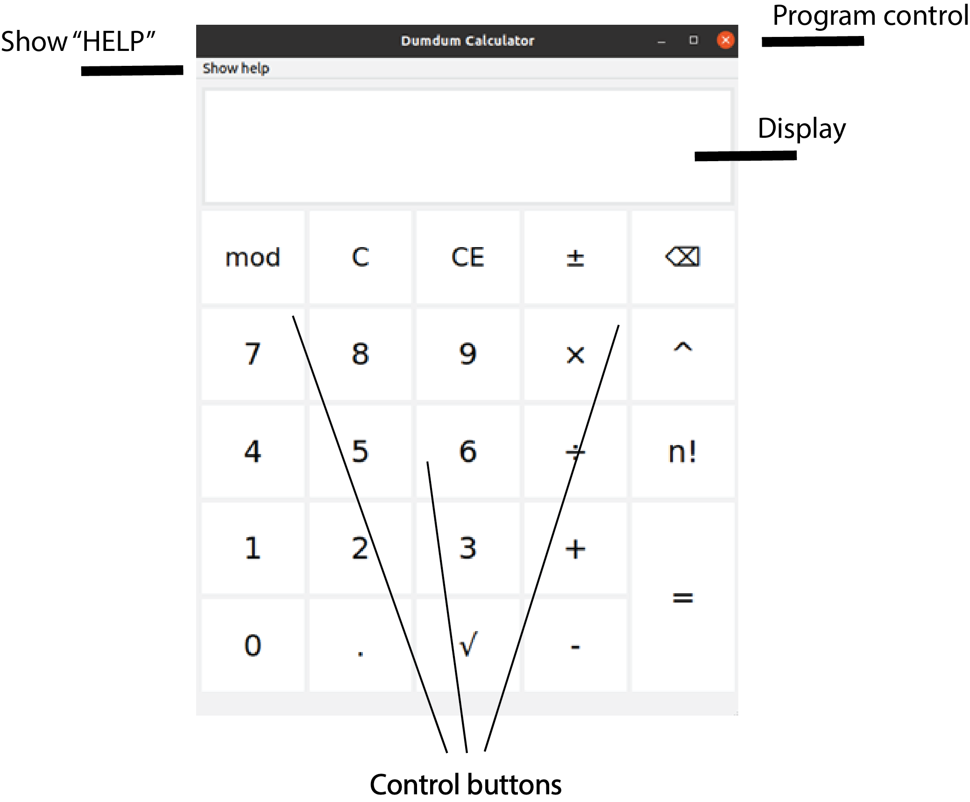

Image Graphic User Interface description

# Special hotkeys

Program uses these special hotkeys:  
„r“ root  
„s“ change sign  
„p“ power  
„escape“ end  
„Ctrl + V“ insert value from clipboard  
„F1“ help