Veteran trees as a key factor for bird diversity in spruce-dominated production forests: implications for conservation management

**Dominik Kebrlea,b, Petr Zasadila, Jan Hošekb, Karel Šťastnýa**

a Czech University of Life Sciences Prague, Faculty of Environmental Sciences, Department of Ecology, Kamýcká 1176, CZ-165 00 Prague, Czech Republic

bEcological Services, Tichá 784/4, 268 01 Hořovice, Czech Republic

**Key words:** beech, forest birds, retention forestry, old trees, integrative forest management

**Abstract**

Veteran trees are keystone structures for biodiversity worldwide. Retention forestry aims to keep veteran trees in production stands to support biodiversity. However, there is insufficient information about the effect of veteran trees on biodiversity and how many veteran trees should be left in different types of stands, including spruce-dominated production forest. We aimed to investigate the influence of veteran trees on bird assemblages (included generalist and specialist species) in spruce-dominated production forest throughout the Czech Republic, taking into consideration effects of stand age, tree species composition, and distance to a clearing. In 20 plots (each 600 ha), all trees ≥70 cm diameter at breast height (DBH) were exhaustively searched. Then we localized sampling plots representing a gradient of veteran tree numbers from zero to maximum on each plot. Birds were sampled using point count method in breeding seasons 2018 and 2019, and bird assemblages analysed using linear mixed effect models (LMMs). The total number of birds, number of generalist and specialist species significantly increased with the number of deciduous trees ≥70 cm DBH. Cover of all deciduous trees had a positive effect and, conversely, increasing distance to the clearing had a negative effect on the total number of species and generalist species. Furthermore, tree species diversity affected generalist (positive) and specialist (negative) species. Our results suggest that 5 deciduous trees ≥70 cm DBH/ha greatly improve bird diversity in spruce-dominated production forests and forest management should be adapted to reach ≤ 5 native veteran deciduous trees to improve structural diversity of conifer-dominated forests.

# Introduction

More than half of the forest area in the EU is covered by forest with production as the primary function (European Commission, 2011). Many native forests in Europe have been transformed into even-aged production forests of such commercially attractive conifers as Norway spruce (*Picea abies*), which here is out of its original range (FOREST et al., 2011; Klimo et al., 2000). The alteration of native (usually deciduous) forests to spruce-dominated production forests predicted the biodiversity of these forests is often considered to be very low (Felton et al., 2010; Sweeney et al., 2010). Conversely, unmanaged forest reserves are always the remaining island of the native (mostly deciduous) forests with high ecological potential in comparison to production forests (Felton et al., 2016; Horák et al., 2019; Lešo et al., 2020). Additionally, a large proportion of production forests are even-aged, usually between 20-80 years in Europe (FOREST et al., 2011). However, increasing forest age generally increases biodiversity (Moning and Müller, 2009, 2008). In particular, increased forest age increases the abundance of canopy and cavity-nesting bird species (Hobson and Bayne, 2000). For example, the critical forest age threshold for a satisfactory diversity of lichens, molluscs, and birds in European beech (*Fagus sylvatica* L.)-dominated forests ranges from 100 to 170 years in sub-montane forests and from 160 to 220 years in montane forests (Moning and Müller, 2009). On the other hand, production forestry aims to shorten the rotation length, for example in beech stands, to less than 120 years (Bütler et al., 2013). However, individual old forest structures such as large old trees, which are commonly found in non-intervention stands (Nilsson et al., 2003), rarely occur in production forests. These old-growth trees are keystone structures for biodiversity in landscapes worldwide (Lindenmayer, 2017; Prevedello et al., 2018).

Large old trees (also called veteran trees or habitat trees) may bear diverse defects (called tree microhabitats), for example, canopy deadwood, trunk cavities, cracks or bark pockets (Bütler et al. 2013, Kolařík et al. 2013, Paillet et al. 2018). The number of these tree microhabitats (TreMs) increase with increasing diameter at breast height (DBH) (Larrieu et al., 2014) and the incidence of TreMs increases dramatically on trees over 70 cm of DBH (Larrieu et al., 2012). Many species are dependent on TreMs during their life cycles because of source of food, shelter, or breeding habitat (Regnery et al. 2013). For example, Lesser Spotted Woodpecker (*Dryobates minor*) prefer stands with high occurrence of dead branches (Charman et al., 2012). Furthermore, there is evidence, that woodpeckers prefer trees with a larger diameter for excavating a breeding cavity (Hebda et al., 2017) and strong excavators, such as Black Woodpecker (*Dryocopus martius*), excavate cavities preferably in trees with signs of wood decay (Puverel et al., 2019). Abandoned woodpecker cavities can then serve as a nesting opportunity for secondary cavity nesters (Pakkala et al., 2018). Therefore, veteran trees play an important role for forest bird diversity, especially in production forests, where values of deadwood are low. The density of veteran trees with ≥70 cm DBH in managed forest is less than 2 trees per ha (Bütler Sauvain et al., 2011; Rita & Lachat, 2009). However, even such a low number of old trees can be of great importance for some species. For example, the Great Spotted Woodpecker (*Dendrocopos major*) and the Black Woodpecker (*Dryocopus martius*) only need a few suitable nesting trees in their territory in order to survive (Vandekerkhove et al. 2013). However, in modern managed forests, logging still systematically eliminates these ‘defective’ trees with low economic value (Bütler et al. 2013). This can negatively affected many forest species, including birds (Horák, 2017; Koch Widerberg et al., 2018; Lindenmayer et al., 2014). However, a more vulnerable species group could be habitat specialists linked to these old-growth structures (Birčák & Reif, 2015). In support of this, there is evidence of different population trends in birds between habitat-specialized species and habitat generalists in Europe (Gregory et al., 2007; Kameniar et al., 2021). Generalist species inhabit a wide niche range and are able to use wide habitat resources. Conversely, specialist species inhabit a narrow niche range and utilise limited habitat resources. Given that, generalist species are more likely to be tolerant of environment conditions than specialist species; however, specialist species are more likely to be sensitive to extinction (Devictor et al., 2008; Richmond et al., 2005). Considering this, specialist species may be used as bioindicator species of forest health. Accordingly, the population trends of forest specialist are declining in Europe (Gregory et al., 2007).

However, there is evidence of a contrasting increasing trend at a national level, specifically in the Czech Republic (CR). Additionally, forest specialists in the CR are positively correlated with an increase in forest coverage (Reif et al., 2007), which was confirmed not only in the CR (Ram et al., 2017; Reif et al., 2007; Santamaría-Rivero et al., 2016). Similarly, some forest specialist birds increase in densities from forest edges to interior habitats (Terraube et al., 2016) and significantly habitat-specialized bird species can be negatively affected by landscape fragmentation and disturbances (Devictor et al., 2008). However, for certain species of birds, including generalists, diverse factors as forest clearings, canopy openness, forest complexity, size of the forest fragment, topography, or even low-traffic forest roads may positively affect bird diversity in these structurally poor forests (Hofmeister et al., 2017; Lešo et al., 2019; Šálek et al., 2010; Żmihorski, 2016). In other words, generalist bird species can be positive affected by the edge effect (Batáry et al., 2014; Hofmeister et al., 2017). Conversely, bird associated with the forest interior (forest specialist) prefer a homogenous forest interior, and can be negatively affected by forest gaps and edges (Hofmeister et al., 2017). Additionally, another important positive factor is increasing proportion of native broadleaved tree species, which, in particular, increases bird diversity in spruce-dominated monocultures (Fuller, 2000; Sweeney et al., 2010; Vélová et al., 2021). For example, an admixture of only one deciduous tree species into spruce monocultures can lead to increased bird diversity (Felton et al., 2010). Moreover, broadleaves trees in coniferous plantations have a bigger effect on bird numbers if dispersed, rather than in a few large blocks (Bibby et al., 1989).

As was previously mentioned, spruce-dominated production forests cover a large part of forests in central Europe, which, together with ongoing forest management, depletes bird diversity. Several studies have explored the influence of veteran trees on diversity of birds or saproxylic beetles in deciduous or mixed production forests (e.g., Remm et al. 2006, Winter & Möller 2008, Augustynczik et al. 2019). However, research on the influence of individual veteran trees on bird assemblages in spruce-dominated production forests is missing. Furthermore, the possible effect of veterans on bird generalist and specialist species has not been investigated yet. However, the lack of large old trees in production forest stands could be one of the factors explaining the population decline of habitat-specialized species in Europe. Veteran trees are important forest elements for bird diversity. Protecting individual large old trees should therefore be a priority. The protection of old trees in production forests is also beginning to be applied thanks to retention forestry, which is an element of integrated forest management (Mölder et al., 2020). Moreover, there is evidence that retention forestry leads to increasing diversity of many taxa, included birds (Doerfler et al., 2018). Unfortunately, in many areas, veteran trees are still threatened by forest management and drawing attention to their importance for biodiversity is still necessary.

# Materials & Methods

## Study area and design

The study was conducted in spruce-dominated production forests in the CR. Forests cover approximately 34 % of the CR, with Norway spruce (*Picea abies*) covering about half of the total forest area (MZe, 2020). The original range of spruce forest was limited to montane areas of the CR. However, forest management often replaced original deciduous stands in lower areas with spruce-dominated forests (Neuhäuslová et al., 2001, 1998, 1997). Furthermore, due to forest management, the proportion of forests older than 120 years is less than 9 % in the CR (MZe, 2020). We examined 20 study plots across the CR. Each study plot is a 600-ha circle (ca. 1.4 km radius) of non-fragmented forest area. The selection of study plots was limited by the minimal size of forest (600 ha). The distance between study plot ranging from 6.5 to 432 km (mean 130.5 km). The study plots occupy elevations ranging from 357 to 947 m a.s.l. Additionally, we selected the nearest (range from 0.6 to 19.1 km, mean 6.7 km) unmanaged forest reserve as control for each study plot. On each study plot, all live trees over 70 cm DBH were exhaustively searched and their locations were recorded. This DBH threshold was chosen due to dramatic increase in the number of TreMs occurring above 70 cm DBH (Larrieu et al., 2012). Additionally, 70 cm DBH corresponds to an age of about 160 years for beech (Dobrovolný and Tesař, 2010). Similarly, all live trees ≥ 70 cm DBH were exhaustively searched within 1 ha circle study area (r = 56.4 m) in selected control forest reserves. Based on the occurrence of trees ≥ 70 cm DBH, localized sampling plots (circle r = 100 m) were created in each study plot in production forests; these represented a gradient of veteran trees ≥ 70 cm DBH, with numbers from zero to maximum on each study plot (beech or, less often, another deciduous trees were preferred as microhabitat rich and native tree species (Larrieu et al., 2012; Larrieu and Cabanettes, 2012)). Additionally, we avoided clearings, forest roads, and forest edge. The minimum distance of sampling plot centres from the forest edge, busy roads, or large clearings (above 0.25 ha) was 100 m. However, due to areas with a very low occurrence of trees ≥ 70 cm DBH, the avoidance condition for small forest roads and small clearings (under 0.25 ha) was limited to the middle ha of the sampling plot (50 m around sampling plot midpoint). The minimum distance between sampling plot midpoints was 200 m. We studied birds in spruce-dominated production forest. Therefore, we excluded sampling plots where the canopy cover of deciduous trees is over 50 % of the sampling plot area (r = 100 m). In total, we selected 180 sampling plots in spruce-dominated production forests and 20 study plots (r = 56.4 m) in unmanaged forest reserves. The location of study areas, study plots (600 ha), examples of sampling plots (r = 100 m), and examples of study plots in forest reserves (r = 56.4 m) is shown in Figure 1.

The dominant type of forest vegetation within the selected sampling plots (r = 100 m) located in production forests is coniferous forests (80 %). Norway spruce (*Picea abies*) was the most dominant tree species (total 76 %), further supplemented by Scot’s pine (*Pinus sylvestris*) and European larch (*Larix decidua*). Silver fir, (*Abies alba*) as well as some exotic tree species such as Douglas fir (*Pseudotsuga menziesii*), grand fir (*Abies grandis*), and eastern white pine (*Pinus strobus*) are also represented in a very small proportion. Deciduous forest vegetation occupies 12.9 %. The dominant deciduous tree species is European beech (*Fagus sylvatica*) (total 7 %). Other deciduous trees present are oaks (*Quercus petraea, Quercus robur),* alders (*Alnus glutinosa, Alnus incana),* silver birch (*Betula pendula),* small-leaved lime (*Tilia cordata),* sycamore (*Acer pseudoplatanus),* European ash (*Fraxinus excelsior),* European hornbeam (*Carpinus betulus),* rowan (*Sorbus aucuparia),* aspen (*Populus tremula),*  and field elm (*Ulmus minor*), with exotic tree species such as horse chestnut (*Aesculus hippocastanum)* and red oak (*Quercus rubra)* also represented in very small proportions. Cleared area, forest < 20 years (both deciduous and coniferous) and non-forest vegetation (forest roads and other paved areas) occupy in total 6.9 % of the study sampling plots. The weighted mean age (weighted by area of forest stand group) of production forest stand groups (excluding forest groups < 20 years) within sampling plots is 78.6 (SD 21.1) years. On the other hand, in unmanaged forest reserves, the mean proportion of deciduous forest cover within 100 m around study plots centre is 84 %, with beech the dominant tree species in most reserves. The weighted mean age (weighted by area of forest stand group) of forest reserves stand groups is 157 (SD 63.6) years.

## Bird survey

All bird counts were performed by the same person (Dominik Kebrle). Bird surveys in all study plots and forest reserves were carried out between 2019 and 2020 by a point count method (Bibby et al. 2000) from the midpoint of each sampling plot in spruce-dominated production forests and midpoint of each plot in control forest reserves. Each midpoint was surveyed twice in the same year, in April-May for early nesters and in May-June for late nesters (Bouvet et al. 2016) and the interval between consecutive visits exceeded two weeks. Surveys started at sunrise within 4 h, and were restricted to good weather conditions (Batáry et al., 2014; Bibby et al., 2000). All individuals heard or seen within 50 m of the midpoint were recorded. Owls and other raptors (< 0.3 % of the birds recorded) were excluded from our analyses as the point count method is inappropriate (Bouvet et al., 2016). Additionally, we excluded *Fringilla montifringilla*, which is not a nesting species in the CR. In total, 200 midpoints (180 in production forest and 20 in forest reserves) were surveyed, of which 106 were in 2019 and 94 in 2020.

Bird species were classified into generalist and specialist species (Supplement 1) for which we expected different responses based on habitat specialization. We adopted the attributes regarding bird habitat specialization relevant in CR by Reif et al. (2010).

## Spatial and environmental variables

We used the number of all live trees ≥ 70 cm DBH [NumLT70DBH] (58 % beech, 30 % spruce, supplemented by Douglas fir, oaks, larch, or fir – all under 2.8 %) and number of only deciduous trees over 70 cm DBH [NumDecidLT70DBH] (91 % beech, 6 % oaks, supplemented by ash, limes, sycamore, or alder – all under 1.6 %) occurring within sampling plots area (r = 100 m) as environmental variables explaining the effect of veteran trees in spruce-dominated production forests. Spatial attributes of forest stands were obtained from aerial photographs (scale 1:5000) using geographical information system (ArcGIS 10.4). For each sampling plot midpoint, we determined the nearest distance to the forest edge or clearing (which ever was closer) [ClearCutDist]. We analysed the type of forest vegetation: (i) deciduous forest [Decid_cover], (ii) coniferous forest [Conifer_cover], (iii) young forest under 20 years (both deciduous and coniferous) [Young_cover], all within sampling plot areas (r = 100 m). Furthermore, we calculated the Shannon’s index of tree species diversity [H_Trees], defined as follows: $H´=-\sum_{i=1}^{S}{p_{i}\ln{p_{i}}}$ where $p_{i}$ is the proportion of covered area in each stand group within sampling plots in the *i*th tree species, and *S* is the number of tree species. The maximum value for Shannon’s index occurs when the proportions are equal over all species (Staudhammer and Lemay, 2001). To include forest age as a factor, weighted average age of forest stand groups [AgeWMean] (weighted by area of each group) and standard deviation (SD) of forest group age were calculated [Age_SD]. SD of age represented the heterogeneity of forest stand group age. The age and representation of individual tree species in individual forest stand groups was obtained from forest management plans.

## Data analysis and modelling

For analyse, the maximum number of species from both controls recorded on each counting midpoint was used as a response variable. We used linear mixed effects models (LMMs) to test the effect of particular environmental variables on total bird species richness and species richness of generalist and specialist bird species in spruce-dominated production forests (1 ha plots in forest reserves were not included in this analysis). Study plot ID [ID_study_plot] was used as a random effect term to take into account that some study plots were closer together than others (3 study plots were sampled within the same stand). R command of full model as an example with total species richness: lme(Totan_number_of_species ~ Age_SD + H_Trees+ NumDecidLT70DBH +Elevation+Decid_cover+Conifer_cover+Young_cover+AgeWMean+ClearCutDist+ NumLT70DBH, data = birds, random = ~1|ID_study_plot, method = "ML"). The minimal adequate model (MAM) was selected via forward and backward stepwise model selection (both methods were used to ensure the correctness of the selected model) by Akaike’s Information Criterion (AIC) using stepAIC function of the MASS package (Venables and Ripley, 2002) in R 4.0.3 (R Core Team, 2020). The normality of model residuals was assessed using Shapiro test of normality. Calculations were made using nlme package (Pinheiro et al., 2020).

To determine the threshold values of veteran deciduous tree density (important for bird diversity), we divided densities of live deciduous trees ≥ 70 cm DBH in spruce-dominated production forest into four categories: **0**; **0<>1** (mean: 0.58); **1<>3** (mean: 1.89); **3<>9** (mean: 4.93) trees per ha (number and intervals of tree density were chosen with respect to the number of plots in each category) and compared the bird species richness of generalist, specialist, and total species richness between these density groups with species richness in forest reserves (**R**, mean: 22.8; SD: 10.4 deciduous trees ≥ 70 cm DBH/ha) using linear mixed effect models (ID of study plot and the closest forest reserve was used as factor with random effect) and simultaneous comparison of density categories and adjustment of *p*-values for multiple testing by means of function glht, R package multcomp (Hothorn et al., 2008).

Additionally, we used redundancy analysis (RDA) with 5 density categories of deciduous trees ≥ 70 cm DBH (0; 0<>1; 1<>3; 3<>9; R) to indicate species specific preferences toward veteran deciduous tree densities. Calculations of RDA were performed using vegan package for R (Oksanen et al., 2019).

# Results

In total, we recorded 41 bird species (35 species at 180 points in spruce-dominated production forest and 33 species at 20 points in forest reserves; 23 generalist and 18 specialist species). *Fringilla coelebs* was the most frequent, with 179 occurrences in production forest, followed by *Parus ater* (165), *Erithacus rubecula* (159), and *Regulus ignicapilla* (149). Regarding the occurrence of woodpeckers, *Dendrocopos major* was observed at 91 points and *Dryocopus martius* was observed at 3 midpoints. In forest reserves, the most frequent species were *Fringilla coelebs* and *Turdus merula* (20), followed by *Dendrocopos major*, *Troglodytes troglodytes*, and *Erithacus rubecula* (17). Regarding the occurrence of other woodpeckers, *Dendrocopos leucotos* was observed once. A few species were recorded only in forest reserves: *Ficedula* *parva*, *Ficedula* *albicollis*, *Muscicapa* *striata*, and *Dendrocopos* *leucotos*. Conversely, a few species were recorded only in production forests: *Phylloscopus* *trochilus*, *Sylvia* *borin*, *Poecile* *palustris*, *Lophophanes* *cristatus*, and *Nucifraga* *caryocatactes*.

## Effect of veteran trees and other forest factors

We found that the total species richness, number of specialist species, and number of generalist species were significantly affected by the number of deciduous trees ≥ 70 cm DBH (NumDecidLT70DBH) in production forests (Fig. 2). According to the LMMs, the distribution of total number of species was best fitted by a model that included number of deciduous trees ≥ 70 cm DBH, total proportion of deciduous tree cover (Decid_cover), standard deviation of forest stand groups age (Age_SD), and distance to the nearest clearing (ClearCutDist). The distribution of specialist species was best fitted by a model that included number of deciduous trees ≥ 70 cm DBH and Shannon’s diversity index of tree species (H_Trees). Similarly, the distribution of generalist species was best fitted by a model that included number of deciduous trees ≥ 70 cm DBH and Shannon’s diversity index of tree species, further including the total proportion of deciduous tree cover and distance to the nearest clearing.

The results of LMMs indicated that an increasing number of deciduous trees ≥ 70 cm DBH had a positive effect on total species richness, further on the number of specialists and generalist species (Fig. 2). The increasing proportion of deciduous stands within sampling plots (r = 100 m) had a positive effect on both total species richness and generalist species. Generalist species number increased and the specialist species decreased with Shannon’s diversity index of tree species. Furthermore, the total species richness and number of generalist species were negatively affected by increasing distance to the nearest clearing or forest road. All results are shown in Table 1.

## Comparison of production forests and forest reserves

The density of deciduous trees ≥ 70 cm DBH within sampling plots (r = 100 m) in production forests ranges from 0 to 8.3 tree per ha. In contrast, the density of deciduous trees ≥ 70 cm DBH in forest reserves ranges from 9 to 45 (mean: 22.8; SD: 10.4) per ha. According to the LMMs and post-hoc testing, the total species richness is significantly higher in categories where large deciduous trees are present (0<>1; 1<>3; 3<>9; R) than in plots in production forests where large deciduous trees are missing (0) (Fig. 3 a). The total species richness and number of generalist species is significantly higher in categories with higher densities (3<>9; and R) than in categories with density less than 1 large deciduous tree per ha (0 and 0<>1) (Fig. 3a and 3b). Additionally, total species richness is significantly higher in all categories (0<>1; 1<>3; 3<>9; R) than in sampling plots where large deciduous trees are missing (0) (Fig. 3c). Similarly, the number of generalist species is significantly lower in the category with an absence of deciduous trees ≥ 70 cm DBH than in other categories, excluding category 0<>1 (Fig. 3b). Furthermore, total species richness is significantly higher in sampling plots where density is 4.9 large deciduous trees per ha on average (3<>9) than in others with lower density values (Fig. 3a). Additionally, the difference between total species richness and number of generalist species between category 3<>9 and forest reserves is non-significant (Fig. 3a and 3b). However, for generalist species, the number of species is significantly higher in reserves than in categories with density less than 3 large deciduous trees per ha (0; 0<>1; 1<>3) (Fig. 3b). For forest specialists, only non-significant results were detected (Fig. 3c). However, in comparison to results of total species richness and generalist species, the values of the number of specialist species in the reserves (R) are very similar to the numbers in the category representing absence of large deciduous trees (0) (Fig. 3c).

Considering all bird species, the RDA plot displayed some cavity-nesting species (e.g., *Sturnus vulgaris*, *Dryocopus martius*, *Columba oenas*) and several shrub-nesting species (e.g., *Turdus merula*, *Sylvia atricapilla*, *Turdus viscivorus*) were associated with forest reserves (R). Some bark creepers (e.g., *Certhia familiaris*, *Dendrocopos major*, *Sitta europaea*) and some secondary cavity-nesting birds (e.g., *Cyanistes caeruleus*, *Parus major*) are associated with sampling plots in category 3<>9 large deciduous trees per ha. Furthermore, in plots with less than 1 tree per ha (0; 0<>1), there are often associated species nesting in the tree or shrub layer or foraging in the canopy (e.g., *Pyrrhula pyrrhula*, *Periparus ater*, *Regulus regulus*, *Regulus ignicapilla*, *Spinus spinus*, *Phylloscopus collybita*). Results of the RDA analysis are shown in Figure 4.

# Discussion

The main aim of the study was to determine the importance of veteran trees for common forest birds in spruce-dominated production forests. We found a positive effect of large deciduous trees (≥ 70 cm DBH) on the number of generalist and specialist bird species, as well as on total bird species richness. Additionally, the total number of bird species and number of generalist species were even similar between plots in unmanaged forest reserves and production forests with 4.9 veteran deciduous trees ≥ 70 cm DBH per ha on average. Surprisingly, we found very low numbers of specialist species in forest reserves. In particular, creepers were associated with veteran tree rich sampling plots (4.9 deciduous trees ≥ 70 cm DBH). Of the other characteristics that were tested, the total coverage of deciduous trees increased total species richness and number of generalist species. Conversely, with increasing distance to the nearest clearing or forest road, total number of species and number of generalist species decreased. Additionally, we found a contrasting effect of tree species diversity on specialist (negative) and generalist (positive) species.

## Importance of veteran trees for diversity

Veteran trees are known to be important habitats, especially for insect species (Horák, 2017; Koch Widerberg et al., 2018; Pilskog et al., 2020; Sverdrup-Thygeson et al., 2017) but also other taxa such as birds (Zawadzki et al., 2020) or lichens (Hofmeister et al., 2016). The high occurrence of large old trees is typical for protected forest reserves (Bütler and Lachat, 2009; Paillet et al., 2017). This may explain the higher bird species richness in forest reserves compared to managed forests (Horák et al., 2019; Lešo et al., 2020). Furthermore, veteran trees can be important as nest sites for some large birds species such as black stork *Ciconia nigra* (Zawadzki et al., 2020). The influence of veteran trees has so far been studied in more detail only in insects; the link between veteran trees and bird species is less explored. Furthermore, studies from spruce-dominated forest are missing. We have now found a positive effect of veteran trees (deciduous veteran trees specifically) on birds in spruce-dominated production forests. These veteran trees usually bear diverse tree microhabitats (TreMs) caused by climate, activity of organisms, mechanical injures, or decay (e.g., canopy deadwood, cavities, cracks, bark pockets) (Bütler et al., 2013; Paillet et al., 2018). Many species, including birds, are dependent on TreMs during their life-cycles because they are a source of food, shelter, or breeding habitat (Regnery et al., 2013). To build on this idea, we found that creepers (*Certhia familiaris*, *Dendrocopos* *major*, *Sitta europaea*) in particular were associated with these veteran tree rich plots, for which veteran trees with TreMs can be a food or nesting opportunity. In the CR, hollow-bearing trees (or den trees) in production forest are sometimes searched for and marked to prevent them from being harvested. However, not only hollow-bearing trees can be important and they should also be maintained in otherwise diversity-poor production stands. Additionally, the importance of veteran trees, especially for nesting, can be long-term. For example, the lifespan of cavities excavated in live trees is longer than lifespan of cavities in dead trees due to decomposition of dead trees (Hardenbol et al., 2019). However, veteran trees cannot fully replace dead trees, which are irreplaceable for some species groups. Generally, snags (standing, dead or dying trees) are particularly important for primary cavity-nesting birds (Remm et al., 2006) and live trees can be particularly important in stands where the incidence of dead trees is very low (such as spruce-dominated production forest). However, live mature trees are suitable for more bird species than dead trees (Hannan et al., 2019).

## Deciduous veteran trees

A number of studies have focused on deciduous tree species (Koch Widerberg et al., 2018; Pilskog et al., 2020; Sverdrup-Thygeson et al., 2017). Similarly, the number of deciduous trees ≥ 70 cm in DBH was choose as a better predictor compared to the total number of coniferous and deciduous trees in our analysis. In support of this, deciduous trees carry many more TreMs than conifers (Larrieu et al., 2012; Vuidot et al., 2011). As an example, 70 % of beech but only 18 % of firs bear one or more TreMs (Larrieu and Cabanettes, 2012). On the other hand, the number of TreMs increased dramatically above 71.6 cm DBH for beech and similarly above 68.4 cm DBH for fir (*Abies alba*) (Larrieu et al., 2012). Choosing the same DBH threshold for tree registration should therefore not play a role. To build on this idea, veteran deciduous trees may probably be more important for birds than coniferous veteran trees, especially in coniferous-dominated forests. The admixture of only non-veteran deciduous trees in coniferous monocultures increases the diversity of birds (Bibby et al., 1989; Felton et al., 2010; Fuller, 2000; Sweeney et al., 2010). Accordingly, our results show significant importance of the total coverage of deciduous trees within 100 m of the survey midpoint (including all deciduous trees over 20 years of age) for generalist species and total species richness. Considering this, the importance of veteran deciduous trees comes from the fact that they are deciduous trees. This effect should be further supported by the occurrence of TreMs. Tree species factor and TreMs occurrence can have a synergistic effect on bird species numbers. Moreover, deciduous tree species (especially beech) formed the dominant component in the original natural stands replaced by spruce dominated forest in the CR (Neuhäuslová et al., 2001, 1998, 1997). Veteran deciduous trees can thus be important for bird diversity, regardless of whether they bear any TreMs. In support of this, we found a positive effect of veteran deciduous trees without information about TreMs occurrence. The tree characteristics such as DBH strongly reflecting microhabitat occurrence and forest management generally had no effect on microhabitat indices (Vuidot et al., 2011). Hence, information about tree species is very important and, with DBH, may be used for easy identification of objects with high ecological value for retention in production forests.

## Critical thresholds of veteran trees and comparison with forest reserves

A few studies from Switzerland found the density of veteran trees (trees with DBH of over 70 cm) in production forest remains less than 0.5 to 2 trees per ha (Bütler and Lachat, 2009; Bütler Sauvain et al., 2011), whereas in virgin forests of Central Europe and southern Scandinavia it is between 10 to 20 (Nilsson et al. 2003). This corresponds to our findings. The high ecological potential of forest reserves in comparison to non-native forests is known (Horák et al., 2019). In forest reserves the number of threatened or near-threatened bird species or cavity-nesting species, such as woodpeckers, are higher, or occur exclusively here (Felton et al., 2016; Lešo et al., 2020). Similarly, we found some threatened or near-threatened bird species exclusively in forest reserves, for example *Ficedula parva* (VU), *Muscicapa striata*, *Ficedula albicollis* (NT), and *Dendrocopos leucotos* (EN) and some species, such as *Columba oenas* (VU)*,* were more numerous in forest reserves than in production forests. For reduction of negative impacts of forest management, 5 to 10 habitat trees per ha is recommended (Bütler et al. 2013). These recommended numbers (rather the lower threshold) approximate to our plots with 4.9 deciduous trees per ha on average (range 3 to 9 trees per ha), which was the maximum aggregate amount found in spruce-dominated production forests. However, it is not very clear which of the habitat trees are really important (e.g., with regard to tree species). Additionally, these recommended numbers were not specified for various types of forest stands. Our study shows that for spruce-dominated production forest, about 5 deciduous trees ≥ 70 cm DBH per ha can increase the number of bird species to similar numbers found in forest reserves. We would consider this value as the lower threshold of the recommended amount. Therefore, we also confirm the recommended numbers of veteran trees for spruce-dominated production forests. However, these trees should mainly be native deciduous trees. We found that, in sampling plots with 1 or less veteran deciduous trees per ha, a (non-significantly) higher number of species than in sampling plots with an absence of veteran trees. To build on this idea, we confirmed that aggregated habitat trees provide a better habitat for birds than scattered individual trees (Bütler et al., 2013; Lindenmayer, 2017). The aggregated occurrence of veteran trees probably reflects the high diversity of birds in non-intervention reserves (Lešo et al., 2019). Additionally, forest reserves had red list species which were not recorded in production forests (regardless of whether or not there was a veteran deciduous tree). Considering this, spruce-dominated production forests with a high occurrence of veteran trees cannot be as valuable as these forest reserves.

## Influence of forest stand structure

Total species richness and number of generalist species were positively associated with an increasing proportion of deciduous trees canopy cover within 100 m of the survey midpoint. The positive effect of deciduous trees on birds in non-native coniferous monocultures is also mentioned by other authors (Felton et al., 2010; Fuller, 2000; Sweeney et al., 2010). In our plots, the proportion of deciduous trees was limited to 50 % of share to maintain a high proportion of conifers. To build on this idea, there is evidence of higher bird species diversity in spruce-birch polyculture (*Betula* spp.) than in spruce monocultures (Felton et al., 2010). Furthermore, broadleaves trees in coniferous production forests have a bigger effect on the number of birds and species if dispersed, rather than in a few large blocks (Bibby et al., 1989). The admixture of deciduous tree species in coniferous-dominated monocultures increases bird diversity and can be an important tool in protecting birds while maintaining the productive function of the forest. On the other hand, the negative effect of the Shannon index diversity of tree species on specialist species suggests that these bird species prefer rather homogeneous stands with a few tree species. The link between specialists and homogeneous coniferous stands can also support an increase in their number with a growing share of forest cover, which was found in the CR between 1982 and 2003 (Reif et al., 2007). On the other hand, generalist species were positively associated with the Shannon index diversity of tree species. For conservation of all bird assemblages, there is probably a need to increase the species diversity of trees in forest stands. However, at the same time, maintaining a certain share of existing spruce-dominated forests.

We also found a negative effect of increasing distance to the nearest forest edge on total species richness and richness of generalist species. In our study, the forest edge was in most cases an interior edge of a forest stand, clearing, or low-traffic forest road. The positive association of generalist species with edge effect was found in a few studies (Batáry et al., 2014; Hofmeister et al., 2017). Similarly, the positive effect of forest roads on bird species richness (Šálek et al., 2010). This is probably due to the strong uniformity of study spruce-dominated forests and the positive effect on these bird species of fragmentation by low-traffic forest roads or clearings.

A few studies found forest stand age to be an important factor (Moning and Müller, 2009, 2008). However, in our study, forest stand group age did not prove to be a very important factor. Similarly, the diversity of forest stand group ages was non-significant, However, it has a weak effect on the total number of species. According to the literature, to sustain cavity breeding species, the age of Central European mixed montane forests needs to surpass 200–220 years (Moning and Müller, 2008). However, the weighted mean age of production forest stand groups in our survey point was only 78.6 (SD 21.1) years and thus has no effect on the number of bird species. This may explain why the age of the stand was non-significant in our study. Furthermore, the explanation can be a similar range of ages of forest stands in the monitored study areas and also of stands in their surroundings. On the other hand, the positive effect of old-growth forest structures such as veteran trees was significant for all bird assemblages. The age of veteran trees with 70 cm in DBH is about 160 years for beech (Dobrovolný and Tesař, 2010). However, the age of forest stands reflects the year of planting of the forest stand group and the age of individual veteran trees were not included. Considering this, the age of forest stand groups did not always reflect these old growth structures.

## Specialist and generalist species

Surprisingly, specialist species have very low numbers in forest reserves. Moreover, it is a little bit lower than in production forest with an absence of veteran trees. 54 % of recorded individuals were specialist species nesting in cavities (18 % individuals of recorded generalist) and 44 % in the canopy layer (33 % for generalists). More than 86 % of recorded specialist species were foraging in canopy layer (40 % of generalist foraging in canopy and 41 % foraging on ground). Our hypothesis is that specialist species are usually species of the forest interior and negatively associated with forest edge and fragmentation (Devictor et al., 2008; Terraube et al., 2016). Forest reserves are usually small forest fragments (range 5 to 658, mean 72 ha) of primeval deciduous forest stands in a matrix of non-native spruce-dominated production forests. Due to the small area of these reserves, and therefore also of deciduous trees, these forest are not always sufficient for specialized deciduous forest birds. This may reflect the decreasing population trends of specialist forest bird species in Europe (Gregory et al., 2007). Conversely, due to a high proportion of deciduous forests within 100 m of the survey midpoint in forest reserves (often 100 % of the area), the number of conifer forest specialists was lower than in production forests. In support of this, we found a negative effect of tree species diversity. This may reflect dominant conifer specialized bird species in assemblage. Moreover, forest reserves in this study are, in most cases, formerly managed stands and the increase in the amount of dead wood is still relatively low. This could also have contributed to the non-significant difference in the number of specialist species between sampling plots in spruce-dominated production forest and forest reserves. Similar non-significant result between production forest and forest reserves were also found for birds or beetles in beech and beech-oak forests (Leidinger et al., 2020). Additionally, specialist species are often endangered and rare bird species (*Ficedula parva*, *Ficedula albicollis*) or common species which are rare due to high territorial behaviour (*Dryocopus martius*, *Picus canus*) and the counting method used (10 min per survey midpoint) may not reveal these rare species.

Conversely, the number of generalist species was higher in forest reserves than in all production forest deciduous veteran tree density categories. However, for the category with 4.9 deciduous trees/ha on average, only a non-significant difference was found. Compared to specialist species, the number of generalists increased with diversity of tree species. Furthermore, we found positive effect of deciduous trees proportion within sampling plot. Surprisingly, with increasing distance to the clear cut or low-traffic forest road, the number of generalist species decreased. In other words, presence of small forest gaps increases the number of generalist birds. This corresponds to the findings on positive effect of forest roads (Šálek et al., 2010). Considering this, generalist species are positively affected with increasing heterogeneity of forests, including an increasing share of deciduous trees or tree species diversity in general, as well as fragmentation by small forest gaps and low-traffic roads in the forest interior, which corresponds to the findings of other authors (Batáry et al., 2014; Hofmeister et al., 2017).

## Veteran trees as a tool for forest conservation management

Veteran trees are important forest structures for many taxa, such as birds (Zawadzki et al., 2020), insects (Cuff et al., 2020; Horák, 2017; Koch Widerberg et al., 2018; Pilskog et al., 2020; Sverdrup-Thygeson et al., 2017), macrofungi, bryophytes (Hofmeister et al., 2015), or lichens (Hofmeister et al., 2016, 2015). In this way, veteran trees are an important habitat feature for biodiversity of forest ecosystems. However, the importance of large trees, for example, should also be in terms of carbon storage (Mildrexler et al., 2020). Veteran trees retained in spruce-dominated production forest should mainly be species with an original range in the given area, adapted to the local microclimate (in most deciduous tree species). Due to the addition of these native species, spruce-dominated stands should be more resistant to extreme climatic events such as drought, windstorms, or insect outbreaks. Furthermore, the age structure of even-aged production stands will improve. Veteran trees retained in production stands should be allowed to go throw their entire life cycle (until death of the tree and decomposition of dead wood), which will increase the presence of dead wood in production forests. Compared to dead wood (standing or laying), the lifespan of live veteran trees (or bearing microhabitats, e.g., cavities) is much longer (Hardenbol et al., 2019; Remm et al., 2006). The lifespan of temperate deciduous trees (*Quercus* sp., *Fagus* sp.) is between 300 to 400 years (Di Filippo et al., 2015). However, the age of production forest stands is limited for maximum wood production to about 120 years (Bütler et al., 2013). At present, a limited number of veteran trees are available and it is necessary to take into account their further loss (due to drying, uprooting, breaking, etc.). Therefore, the number of veteran trees in production forests should be constantly added to. For the future development of veteran trees, it is necessary to adjust the forest management for existing young spruce-dominated production forest stands, which should be supplemented with native deciduous tree species and allow these stands to reach the required age (tree diameter respectively) and associated ecological potential of veteran trees.

# Conclusions

Individually occurring native deciduous trees ≥ 70 cm DBH increased bird diversity of all the tested bird assemblages in spruce-dominated production forests. Additionally, the occurrence of veteran deciduous trees seems to be a better predictor than the other age-based predictors (age of forest stand or diversity of forest stand group age). In addition to trees, other environmental factors – such as canopy cover of all deciduous trees (above 20 years of age), distance to the nearest clearing or forest road, and tree species diversity (Shannon index) – were also statistically significant for some species guilds. However, the importance of these predictors varies between species guilds. Moreover, works in contrast (etc. tree species diversity). The total number of birds and number of generalist species was comparable between unmanaged forest reserves and production forests where the density of veteran deciduous trees was 4.9 tree per ha on average. On the other hand, specialist species were more balanced between sampling plots with various veteran deciduous trees densities, and we found only non-significant results. Surprisingly, the number of specialist species was similarly low in forest reserves as in production forest sampling plots with an absence of veteran trees. Creepers in particular were associated with veteran tree rich sampling plots in spruce-dominated production forests. However, Red List species were recorded mainly in forest reserves. Considering his, production forests with a high number of veteran deciduous trees do not have equal biological potential as forest reserves do. Leaving native veteran deciduous trees in non-native spruce-dominated production forests can lead to an increase in bird numbers. On average, 4.9 trees per ha can significantly increase the number of generalist bird species. Even a few veteran deciduous trees can have positive effect (although non-significant). Considering this, individual veteran deciduous trees have great ecological potential and should be retained in production forests. However, production forests with 4.9 veteran trees/ha are still not sufficient for some Red List Species and cannot fully replace the ecological functions of native stands in nature reserves. Moreover, this number of deciduous veteran trees is the maximum amount found in spruce-dominated production stands and therefore their harvesting should be limited to retain these actual numbers. In addition, it is desirable to adapt forest management to support veteran trees in spruce-dominated production forests and increase their numbers.

# References

Batáry, P., Fronczek, S., Normann, C., Scherber, C., Tscharntke, T., 2014. How do edge effect and tree species diversity change bird diversity and avian nest survival in Germany’s largest deciduous forest? For. Ecol. Manage. 319, 44–50. https://doi.org/10.1016/j.foreco.2014.02.004

Bibby, C.J., Aston, N., Bellamy, P.E., 1989. Effects of Broadleaved Trees on Birds of Upland Conifer Plantations in North Wales. Biol. Conserv. 49, 17–29.

Bibby, C.J., Burgess, N.D., Hill, D.A., Mustoe, S.H., 2000. Bird Census Techniques, 2. ed.

Birčák, T., Reif, J., 2015. The effects of tree age and tree species composition on bird species richness in a Central European montane forest. Biol. 70, 1528–1536. https://doi.org/10.1515/biolog-2015-0171

Bouvet, A., Paillet, Y., Archaux, F., Tillon, L., Denis, P., Gilg, O., Gosselin, F., 2016. Effects of forest structure, management and landscape on bird and bat communities. Environ. Conserv. 43, 148–160. https://doi.org/10.1017/S0376892915000363

Bütler, R., Lachat, T., 2009. Wälder ohne Bewirtschaftung: eine Chance für die saproxylische Biodiversität | Forests without harvesting: an opportunity for the saproxylic biodiversity. Schweizerische Zeitschrift fur Forstwes. 160, 324–333. https://doi.org/10.3188/szf.2009.0324

Bütler, R., Lachat, T., Larrieu, L., Paillet, Y., 2013. Habitat trees: key elements for forest biodiversity. Integr. approaches as an Oppor. Conserv. For. Biodivers. 84–91.

Bütler Sauvain, R., Bolliger, M., Senn-Irlet, B., Wermelinger, B., 2011. Naturwälder als Lebensraum, in: Brang, P.; Heiri, C.; Bugmann, H. (Ed.), Waldreservate. 50 Jahre Natürliche Waldentwicklung in Der Schweiz. Haupt, Birmensdorf, Eidg. Forschungsanstalt WSL; Zürich, ETH Zürich. Bern, Stuttgart, Wien, pp. 38–55. https://doi.org/10.1051/forest

Charman, E.C., Smith, K.W., Dodd, S., Gruar, D.J., Dillon, I.A., 2012. Pre-breeding foraging and nest site habitat selection by Lesser Spotted Woodpeckers Dendrocopos minor in mature woodland blocks in England. Ornis Fenn. 89, 182–196.

Cuff, J.P., Müller, C.T., Gilmartin, E.C., Boddy, L., Jones, T.H., 2020. Home is where the heart rot is: violet click beetle, Limoniscus violaceus (Müller, 1821), habitat attributes and volatiles. Insect Conserv. Divers. https://doi.org/10.1111/icad.12441

Devictor, V., Julliard, R., Jiguet, F., 2008. Distribution of specialist and generalist species along spatial gradients of habitat disturbance and fragmentation. Oikos 0, 080211051304426–0. https://doi.org/10.1111/j.2008.0030-1299.16215.x

Di Filippo, A., Pederson, N., Baliva, M., Brunetti, M., Dinella, A., Kitamura, K., Knapp, H.D., Schirone, B., Piovesan, G., 2015. The longevity of broadleaf deciduous trees in Northern Hemisphere temperate forests: Insights from tree-ring series. Front. Ecol. Evol. 3, 1–15. https://doi.org/10.3389/fevo.2015.00046

Dobrovolný, L., Tesař, V., 2010. Growth and characteristics of old beech ( Fagus sylvatica L .) trees individually dispersed in spruce monocultures 2010, 406–416.

Doerfler, I., Gossner, M.M., Müller, J., Seibold, S., Weisser, W.W., 2018. Deadwood enrichment combining integrative and segregative conservation elements enhances biodiversity of multiple taxa in managed forests. Biol. Conserv. 228, 70–78. https://doi.org/10.1016/j.biocon.2018.10.013

European Commission, 2011. Forestry in the EU and the world — A statistical portrait, Eurostat statistical books. https://doi.org/10.2785/13022

Felton, A., Hedwall, P.O., Lindbladh, M., Nyberg, T., Felton, A.M., Holmström, E., Wallin, I., Löf, M., Brunet, J., 2016. The biodiversity contribution of wood plantations: Contrasting the bird communities of Sweden’s protected and production oak forests. For. Ecol. Manage. 365, 51–60. https://doi.org/10.1016/j.foreco.2016.01.030

Felton, A., Lindbladh, M., Brunet, J., Fritz, Ö., 2010. Replacing coniferous monocultures with mixed-species production stands: An assessment of the potential benefits for forest biodiversity in northern Europe. For. Ecol. Manage. 260, 939–947. https://doi.org/10.1016/j.foreco.2010.06.011

FOREST, E., UNECE, FAO, 2011. State of Europe’s Forests 2011. Status and Trends in Sustainable Forest Management in Europe. Ministerial Conference on the Protection of Forests in Europe FOREST, Oslo.

Fuller, R.J., 2000. Influence of Treefall Gaps on Distributions of Breeding Birds within Interior Old-Growth Stands in Białowieża Forest, Poland. Condor 102, 267–274. https://doi.org/10.2307/1369637

Gregory, R.D., Vorisek, P., Van Strien, A., Gmelig Meyling, A.W., Jiguet, F., Fornasari, L., Reif, J., Chylarecki, P., Burfield, I.J., 2007. Population trends of widespread woodland birds in Europe. Ibis (Lond. 1859). 149, 78–97. https://doi.org/10.1111/j.1474-919X.2007.00698.x

Hannan, L., Le Roux, D.S., Milner, R.N.C., Gibbons, P., 2019. Erecting dead trees and utility poles to offset the loss of mature trees. Biol. Conserv. 236, 340–346. https://doi.org/10.1016/j.biocon.2019.06.001

Hardenbol, A.A., Pakkala, T., Kouki, J., 2019. Persistence of a keystone microhabitat in boreal forests: Cavities of Eurasian Three-toed Woodpeckers (Picoides tridactylus). For. Ecol. Manage. 450, 117530. https://doi.org/10.1016/j.foreco.2019.117530

Hebda, G., Wesołowski, T., Rowiński, P., 2017. Nest Sites of a Strong Excavator, the Great Spotted Woodpecker Dendrocopos major , in a Primeval Forest . Ardea 105, 61–71. https://doi.org/10.5253/arde.v105i1.a8

Hobson, K.A., Bayne, E.M., 2000. The effects of stand age on avian communities in aspen-dominated forests of central Saskatchewan , Canada. https://doi.org/10.1016/S0378-1127(99)00287-X

Hofmeister, J., Hošek, J., Brabec, M., Dvořák, D., Beran, M., Deckerová, H., Burel, J., Kříž, M., Borovička, J., Bě͗ák, J., Vašutová, M., Malíček, J., Palice, Z., Syrovátková, L., Steinová, J., Černajová, I., Holá, E., Novozámská, E., Čížek, L., Iarema, V., Baltaziuk, K., Svoboda, T., 2015. Value of old forest attributes related to cryptogam species richness in temperate forests: A quantitative assessment. Ecol. Indic. 57, 497–504. https://doi.org/10.1016/j.ecolind.2015.05.015

Hofmeister, J., Hošek, J., Brabec, M., Kočvara, R., 2017. Spatial distribution of bird communities in small forest fragments in central Europe in relation to distance to the forest edge, fragment size and type of forest. For. Ecol. Manage. 401, 255–263. https://doi.org/10.1016/j.foreco.2017.07.005

Hofmeister, J., Hošek, J., Malíček, J., Palice, Z., Syrovátková, L., Steinová, J., Černajová, I., 2016. Large beech (Fagus sylvatica) trees as ‘lifeboats’ for lichen diversity in central European forests. Biodivers. Conserv. 25, 1073–1090. https://doi.org/10.1007/s10531-016-1106-x

Horák, J., 2017. Insect ecology and veteran trees. J. Insect Conserv. 21, 0. https://doi.org/10.1007/s10841-017-9953-7

Horák, J., Brestovanská, T., Mladenovi, S., Bogusch, P., Halda, J.P., Zasadil, P., 2019. Green desert ?: Biodiversity patterns in forest plantations. For. Ecol. Manage. 433, 343–348. https://doi.org/10.1016/j.foreco.2018.11.019

Hothorn, T., Bretz, F., Westfall, P., 2008. Simultaneous Inference in General Parametric Models. Biometrical J. 50, 346–363.

Kameniar, O., Baláž, M., Svitok, M., Reif, J., Mikoláš, M., Pettit, J.L., Keeton, W.S., Pettit, J.M., Vostarek, O., Langbehn, T., Trotsiuk, V., Morelli, F., Frankovič, M., Kozák, D., Janda, P., Čada, V., Ferenčík, M., Málek, J., Begovič, K., Synek, M., Lábusová, J., Svobodová, K., Svoboda, M., 2021. Historical natural disturbances shape spruce primary forest structure and indirectly influence bird assemblage composition. For. Ecol. Manage. 481. https://doi.org/10.1016/j.foreco.2020.118647

Klimo, E., Hager, H., Kulhavý, J., 2000. Spruce Monocultures in Central Europe : Problems and Spruce, in: Klimo, E., Hager, H., Kulhavý, J. (Eds.), Spruce Monocultures in Central Europe – Problems and Prospects. EFI Proceedings, p. 208.

Koch Widerberg, M., Ranius, T., Drobyshev, I., Lindbladh, M., 2018. Oaks retained in production spruce forests help maintain saproxylic beetle diversity in southern Scandinavian landscapes. For. Ecol. Manage. 417, 257–264. https://doi.org/10.1016/j.foreco.2018.02.048

Larrieu, L., Cabanettes, A., 2012. Species, live status, and diameter are important tree features for diversity and abundance of tree microhabitats in subnatural montane beech-fir forests. Can. J. For. Res. 42, 1433–1445. https://doi.org/10.1139/X2012-077

Larrieu, L., Cabanettes, A., Brin, A., Bouget, C., Deconchat, M., 2014. Tree microhabitats at the stand scale in montane beech-fir forests: Practical information for taxa conservation in forestry. Eur. J. For. Res. 133, 355–367. https://doi.org/10.1007/s10342-013-0767-1

Larrieu, L., Cabanettes, A., Delarue, A., 2012. Impact of silviculture on dead wood and on the distribution and frequency of tree microhabitats in montane beech-fir forests of the Pyrenees. Eur. J. For. Res. 131, 773–786. https://doi.org/10.1007/s10342-011-0551-z

Leidinger, J., Weisser, W.W., Kienlein, S., Blaschke, M., Jung, K., Kozak, J., Fischer, A., Mosandl, R., Michler, B., Ehrhardt, M., Zech, A., Saler, D., Graner, M., Seibold, S., 2020. Formerly managed forest reserves complement integrative management for biodiversity conservation in temperate European forests. Biol. Conserv. 242, 108437. https://doi.org/10.1016/j.biocon.2020.108437

Lešo, P., Kropil, R., Kajtoch, Ł., 2020. Forest Ecology and Management Effects of forest management on bird assemblages in oak-dominated stands of the Western Carpathians – Refuges for rare species. For. Ecol. Manage. 453, 117620. https://doi.org/10.1016/j.foreco.2019.117620

Lešo, P., Kropil, R., Kajtoch, Ł., 2019. Effects of forest management on bird assemblages in oak-dominated stands of the Western Carpathians – Refuges for rare species. For. Ecol. Manage. 453. https://doi.org/https://doi.org/10.1016/j.foreco.2019.117620

Lindenmayer, D.B., 2017. Conserving large old trees as small natural features. Biol. Conserv. 211, 51–59. https://doi.org/10.1016/j.biocon.2016.11.012

Lindenmayer, D.B., Laurance, W.F., Franklin, J.F., Likens, G.E., Banks, S.C., Blanchard, W., Gibbons, P., Ikin, K., Blair, D., Mcburney, L., Manning, A.D., Stein, J.A.R., 2014. New policies for old trees: Averting a global crisis in a keystone ecological structure. Conserv. Lett. 7, 61–69. https://doi.org/10.1111/conl.12013

Mildrexler, D.J., Berner, L.T., Law, B.E., Birdsey, R.A., Moomaw, W.R., 2020. Large Trees Dominate Carbon Storage in Forests East of the Cascade Crest in the United States Pacific Northwest. Front. For. Glob. Chang. 3. https://doi.org/10.3389/ffgc.2020.594274

Mölder, A., Schmidt, M., Plieninger, T., Meyer, P., 2020. Habitat-tree protection concepts over 200 years. Conserv. Biol. 34, 1444–1451. https://doi.org/10.1111/cobi.13511

Moning, C., Müller, J., 2009. Critical forest age thresholds for the diversity of lichens, molluscs and birds in beech (Fagus sylvatica L.) dominated forests. Ecol. Indic. 9, 922–932. https://doi.org/10.1016/j.ecolind.2008.11.002

Moning, C., Müller, J., 2008. Environmental key factors and their thresholds for the avifauna of temperate montane forests. For. Ecol. Manage. 256, 1198–1208. https://doi.org/10.1016/j.foreco.2008.06.018

MZe, 2020. Zpráva o stavu lesa a lesního hospdářství v České republice v roce 2019. Ministerstvo zemědělství, Prague.

Neuhäuslová, Z., Blažková, D., Grulich, V., Husová, M., Chytrý, M., Jeník, J., Jirásek, J., Kolbek, J., Kropáč, Z., Ložek, V., Moravec, J., Prach, K., Rybníček, K., Rybníčková, E., Sádlo, J., 1998. Map of potential natural vegetation of the Czech Republic.

Neuhäuslová, Z., Moravec, J., Chytrý, M., Ložek, V., Rybníček, K., Rybníčková, E., Husová, M., Grulich, V., Jeník, J., Sádlo, J., Jirásek, J., Kolbek, J., Wild, J., 2001. Potential natural vegetat ion of the Czech Republic. Braun-Blanquetia 30, 1–80.

Neuhäuslová, Z., Moravec, J., Chytrý, M., Sádlo, J., Rybníček, K., Kolbek, J., Jirásek, J., 1997. Map of potential natural vegetation of the Czech Republic 1 : 500 000.

Nilsson, S.G., Niklasson, M., Hedin, J., Aronsson, G., Gutowski, J.M., Linder, P., Ljungberg, H., Mikusiński, G., Ranius, T., 2003. Erratum to “Densities of large living and dead trees in old-growth temperate and boreal forests.” For. Ecol. Manage. 178, 355–370. https://doi.org/10.1016/s0378-1127(03)00084-7

Oksanen, J., Blanchet, F.G., Friendly, M., Kindt, R., Legendre, P., Minchin, P.R., Hara, R.B.O., Simpson, G.L., Solymos, P., Stevens, M.H.H., 2019. Vegan: Community Ecology Package. R package version 2.5-6. 2019.

Paillet, Y., Archaux, F., Boulanger, V., Debaive, N., Fuhr, M., Gilg, O., Gosselin, F., Guilbert, E., 2017. Snags and large trees drive higher tree microhabitat densities in strict forest reserves. For. Ecol. Manage. 389, 176–186. https://doi.org/10.1016/j.foreco.2016.12.014

Paillet, Y., Archaux, F., du Puy, S., Bouget, C., Boulanger, V., Debaive, N., Gilg, O., Gosselin, F., Guilbert, E., 2018. The indicator side of tree microhabitats: A multi-taxon approach based on bats, birds and saproxylic beetles. J. Appl. Ecol. 55, 2147–2159. https://doi.org/10.1111/1365-2664.13181

Pakkala, T., Tiainen, J., Piha, M., Kouki, J., 2018. Three-toed Woodpecker cavities in trees: A keystone structural feature in forests shows decadal persistence but only short-term benefit for secondary cavity-breeders. For. Ecol. Manage. 413, 70–75. https://doi.org/10.1016/j.foreco.2018.01.043

Pilskog, H.E., Birkemoe, T., Evju, M., Sverdrup-Thygeson, A., 2020. Species composition of beetles grouped by host association in hollow oaks reveals management-relevant patterns. J. Insect Conserv. 24, 65–86. https://doi.org/10.1007/s10841-019-00210-5

Pinheiro, J., Bates, D., DebRoy, S., Sarkar, D., Team, R.C., 2020. nlme: Linear and Nonlinear Mixed Effects Models.

Prevedello, J.A., Almeida-Gomes, M., Lindenmayer, D.B., 2018. The importance of scattered trees for biodiversity conservation: A global meta-analysis. J. Appl. Ecol. 55, 205–214. https://doi.org/10.1111/1365-2664.12943

Puverel, C., Abourachid, A., Böhmer, C., Leban, J.M., Svoboda, M., Paillet, Y., 2019. This is my spot: What are the characteristics of the trees excavated by the Black Woodpecker? A case study in two managed French forests. For. Ecol. Manage. 453, 117621. https://doi.org/10.1016/j.foreco.2019.117621

R Core Team, 2020. R: A language and environment for statistical computing.

Ram, D., Axelsson, A.L., Green, M., Smith, H.G., Lindström, Å., 2017. What drives current population trends in forest birds – forest quantity, quality or climate? A large-scale analysis from northern Europe. For. Ecol. Manage. 385, 177–188. https://doi.org/10.1016/j.foreco.2016.11.013

Regnery, B., Couvet, D., Kubarek, L., Julien, J.F., Kerbiriou, C., 2013. Tree microhabitats as indicators of bird and bat communities in Mediterranean forests. Ecol. Indic. 34, 221–230. https://doi.org/10.1016/j.ecolind.2013.05.003

Reif, J., Jiguet, F., Šťastný, K., 2010. Habitat specialization of birds in the Czech Republic: Comparison of objective measures with expert opinion. Bird Study 57, 197–212. https://doi.org/10.1080/00063650903477046

Reif, J., Voříšek, P., Šťastný, K., Bejček, V., Petr, J., 2007. Population increase of forest birds in the Czech Republic between 1982 and 2003. Bird Study 54, 248–255. https://doi.org/10.1080/00063650709461481

Remm, J., Lõhmus, A., Remm, K., 2006. Tree cavities in riverine forests: What determines their occurrence and use by hole-nesting passerines? For. Ecol. Manage. 221, 267–277. https://doi.org/10.1016/j.foreco.2005.10.015

Richmond, C.E., Breitburg, D.L., Rose, K.A., 2005. The role of environmental generalist species in ecosystem function. Ecol. Modell. 188, 279–295. https://doi.org/10.1016/j.ecolmodel.2005.03.002

Šálek, M., Svobodová, J., Zasadil, P., 2010. Edge effect of low-traffic forest roads on bird communities in secondary production forests in central Europe. Landsc. Ecol. 25, 1113–1124. https://doi.org/10.1007/s10980-010-9487-9

Santamaría-Rivero, W., Leyequien, E., Hernandez-stefanoni, J.L., Wood, P., 2016. Influence of landscape structure and forest age on the richness and abundance of different bird feeding guilds and ... Trop. Ecol. 57, 313–332.

Staudhammer, C.L., Lemay, V.M., 2001. Introduction and evaluation of possible indices of stand structural diversity. https://doi.org/10.1139/cjfr-31-7-1105

Sverdrup-Thygeson, A., Skarpaas, O., Blumentrath, S., Birkemoe, T., Evju, M., 2017. Habitat connectivity affects specialist species richness more than generalists in veteran trees. For. Ecol. Manage. 403, 96–102. https://doi.org/10.1016/j.foreco.2017.08.003

Sweeney, O.F.M.D., Wilson, M.W., Irwin, S., Kelly, T.C., O’Halloran, J., 2010. Are bird density, species richness and community structure similar between native woodlands and non-native plantations in an area with a generalist bird fauna? Biodivers. Conserv. 19, 2329–2342. https://doi.org/10.1007/s10531-010-9844-7

Terraube, J., Archaux, F., Deconchat, M., van Halder, I., Jactel, H., Barbaro, L., 2016. Forest edges have high conservation value for bird communities in mosaic landscapes. Ecol. Evol. 6, 5178–5189. https://doi.org/10.1002/ece3.2273

Vélová, L., Véle, A., Horák, J., 2021. Land use diversity and prey availability structure the bird communities in Norway spruce plantation forests. For. Ecol. Manage. 480. https://doi.org/10.1016/j.foreco.2020.118657

Venables, W.N., Ripley, B.D., 2002. Modern Applied Statistics with S. Fourth Edition. Springer, New York.

Vuidot, A., Paillet, Y., Archaux, F., Gosselin, F., 2011. Influence of tree characteristics and forest management on tree microhabitats. Biol. Conserv. 144, 441–450. https://doi.org/10.1016/j.biocon.2010.09.030

Zawadzki, G., Zawadzka, D., Sołtys, A., Drozdowski, S., 2020. Nest-site selection by the white-tailed eagle and black stork – implications for conservation practice. For. Ecosyst. 7. https://doi.org/10.1186/s40663-020-00271-y

Żmihorski, M., 2016. Can clearcuts increase bird species richness in managed forests ? https://doi.org/10.17221/787-JFS

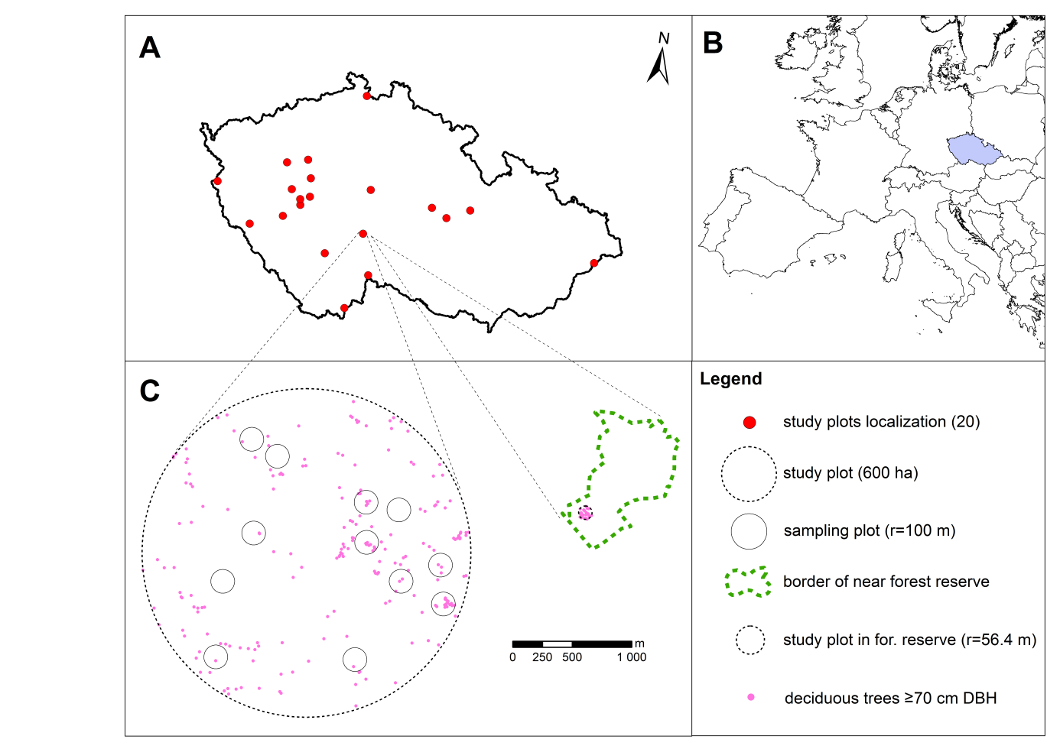

Figure 1: A) location of all (20) study plots in the Czech Republic; B) location of the Czech Republic in Europe; C) example of study plot (600 ha) with localization of sampling plots (r = 100 m) and example of unmanaged forest reserve with 1 ha study plot.

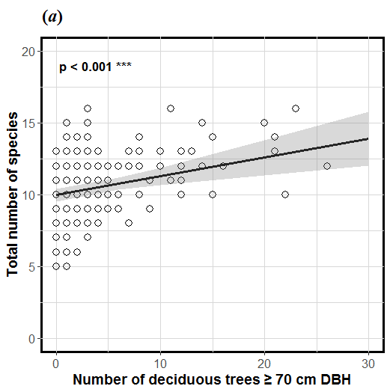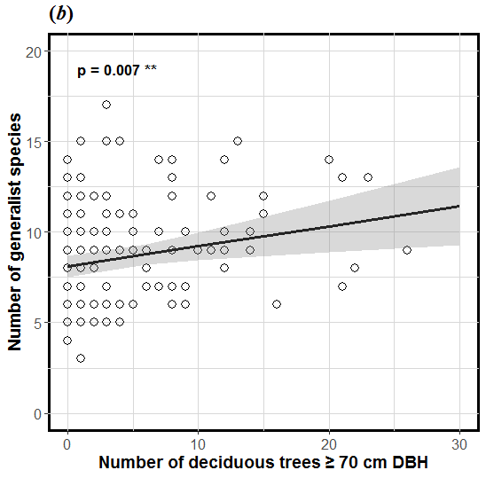

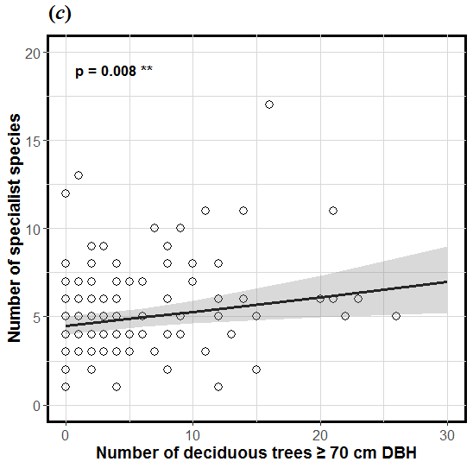

Figure 2: Relationship between number of live deciduous trees ≥70 cm DBH within sampling plots (r =100 m) and total number of bird species (a), or number of generalist bird species (b), or specialist bird species (c) in spruce-dominated production forests (p value from LMM top left). The black line is the regression curve from the linear mixed effect model and the grey area indicates the 95 % confident interval.

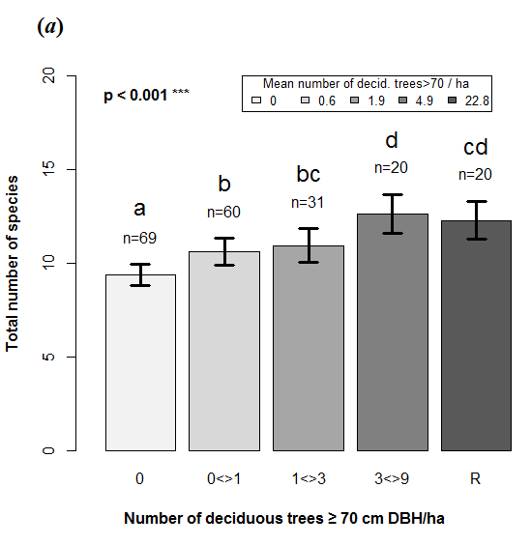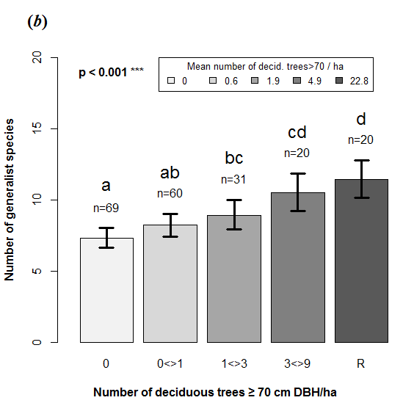

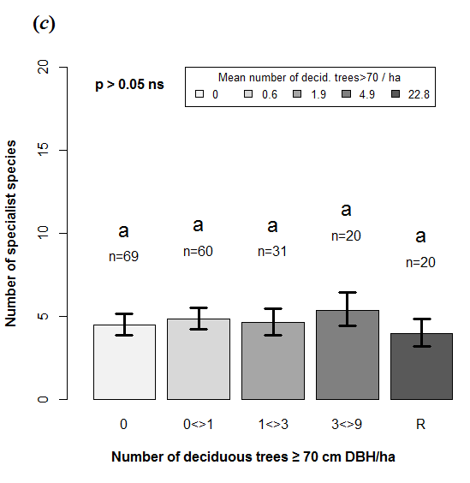

Figure 3: Total number of bird species (a), or number of generalist bird species (b), or specialist bird species (c) between deciduous trees ≥ 70 cm DBH density categories (0; 0<>1; 1<>3 or 3<>9 trees per ha) in spruce-dominated production forests and forest reserves (R). The colour scale expresses the mean density of trees in each category (0, 0.6, 1.9, 4.9, and 22.8 deciduous trees ≥ 70 cm DBH per ha). Letters indicate differences between each category from post-hoc Tukey test on linear mixed effect models (p value from LMM top left). Arrows indicate 95 % confident intervals.

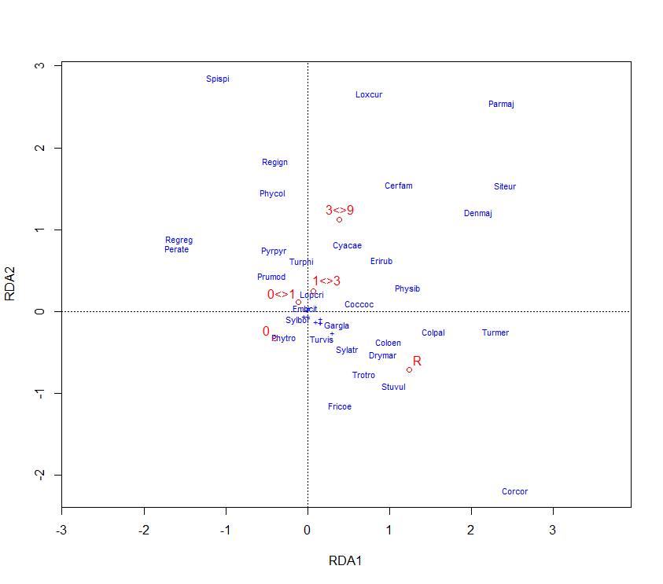

Figure 4: Plot from the redundancy analysis (RDA) showing variability of the bird community between deciduous trees ≥ 70 cm DBH density categories (0; 0<>1; 1<>3 or 3<>9 trees per ha) in spruce-dominated production forests and forest reserves (R). Abbreviations of species names include the first three letters of the genus and species scientific names.

**Table 1:** Effect of selected stand features in spruce-dominated production forest on total number of bird species, number of generalist bird species, and number of specialist bird species (last-mentioned sqrt-transformed).

|  |  |  |  |  |  |
| --- | --- | --- | --- | --- | --- |
|  | Variable | Est. (SE) | t | P | Response |
| Total species richness | NumDecidLT70DBH | 0.130 (0.035) | 3.685 | **<0.001** | + |
|  | Decid_cover | 0.032 (0.012) | 2.614 | **0.010** | + |
|  | Age_SD | 0.015 (0.011) | 1.400 | 0.163 | + |
|  | ClearCutDist | -0.008 (0.002) | -3.223 | **0.002** | - |
|  |  |  |  |  |  |
| Generalist | NumDecidLT70DBH | 0.110 (0.040) | 2.746 | **0.007** | + |
|  | H_Trees | 1.288 (0.565) | 2.281 | **0.024** | + |
|  | Decid_cover | 0.033 (0.016) | 2.150 | **0.033** | + |
|  | ClearCutDist | -0.007 (0.003) | -2.538 | **0.012** | - |
|  |  |  |  |  |  |
| Specialist | NumDecidLT70DBH | 0.017 (0.006) | 2.700 | **0.008** | + |
|  | H_Trees | -0.301 (0.097) | -3.104 | **0.002** | - |

# Supplementary material:

**Supplement 1:** List of all recorded birds in production forest and forest reserves used in the analysis (owls and raptors are excluded). In field Guild the generalist (G) and specialist (S) species are identified

|  | Species | Abbr. | Guild | Abundance | Density | Dominance | Frequency |
| --- | --- | --- | --- | --- | --- | --- | --- |
|  | (individuals) | (1 ha) |  | (% from 180 points) |
| 1 | *Fringilla coelebs* | *Fricoe* | G | 402 | 2.0 | 14.5 | 99.5 |
| 2 | *Periparus ater* | *Perate* | S | 256 | 1.3 | 9.2 | 89.0 |
| 3 | *Erithacus rubecula* | *Erirub* | G | 249 | 1.2 | 9.0 | 88.0 |
| 4 | *Regulus ignicapilla* | *Regign* | S | 187 | 0.9 | 6.8 | 81.0 |
| 5 | *Troglodytes troglodytes* | *Trotro* | G | 153 | 0.8 | 5.5 | 67.0 |
| 6 | *Certhia familiaris* | *Cerfam* | S | 148 | 0.7 | 5.3 | 69.5 |
| 7 | *Turdus merula* | *Turmer* | G | 143 | 0.7 | 5.2 | 60.5 |
| 8 | *Regulus regulus* | *Regreg* | S | 134 | 0.7 | 4.8 | 62.5 |
| 9 | *Sylvia atricapilla* | *Sylatr* | G | 130 | 0.7 | 4.7 | 56.5 |
| 10 | *Dendrocopos major* | *Denmaj* | G | 118 | 0.6 | 4.3 | 54.0 |
| 11 | *Parus major* | *Parmaj* | G | 116 | 0.6 | 4.2 | 45.5 |
| 12 | *Phylloscopus collybita* | *Phycol* | G | 108 | 0.5 | 3.9 | 49.5 |
| 13 | *Spinus spinus* | *Spispi* | S | 91 | 0.5 | 3.3 | 23.5 |
| 14 | *Columba palumbus* | *Colpal* | G | 78 | 0.4 | 2.8 | 33.5 |
| 15 | *Loxia curvirostra* | *Loxcur* | S | 72 | 0.4 | 2.6 | 18.5 |
| 16 | *Sitta europaea* | *Siteur* | G | 71 | 0.4 | 2.6 | 32.5 |
| 17 | *Turdus philomelos* | *Turphi* | G | 47 | 0.2 | 1.7 | 21.5 |
| 18 | *Prunella modularis* | *Prumod* | G | 37 | 0.2 | 1.3 | 17.0 |
| 19 | *Pyrrhula pyrrhula* | *Pyrpyr* | S | 30 | 0.2 | 1.1 | 13.0 |
| 20 | *Phylloscopus sibilatrix* | *Physib* | S | 29 | 0.1 | 1.0 | 13.0 |
| 21 | *Garrulus glandarius* | *Gargla* | G | 22 | 0.1 | 0.8 | 10.5 |
| 22 | *Cyanistes caeruleus* | *Cyacae* | G | 22 | 0.1 | 0.8 | 10.0 |
| 23 | *Coccothraustes coccothraustes* | *Coccoc* | G | 21 | 0.1 | 0.8 | 8.0 |
| 24 | *Corvus corax* | *Corcor* | G | 18 | 0.1 | 0.7 | 1.0 |
| 25 | *Turdus viscivorus* | *Turvis* | S | 17 | 0.1 | 0.6 | 8.5 |
| 26 | *Dryocopus martius* | *Drymar* | S | 9 | 0.0 | 0.3 | 4.5 |
| 27 | *Anthus trivialis* | *Anttri* | G | 9 | 0.0 | 0.3 | 4.0 |
| 28 | *Columba oenas* | *Coloen* | S | 8 | 0.0 | 0.3 | 2.5 |
| 29 | *Phylloscopus trochilus* | *Phytro* | G | 7 | 0.0 | 0.3 | 3.5 |
| 30 | *Sturnus vulgaris* | *Stuvul* | G | 7 | 0.0 | 0.3 | 1.0 |
| 31 | *Certhia brachydactyla* | *Cerbra* | S | 4 | 0.0 | 0.1 | 2.0 |
| 32 | *Sylvia borin* | *Sylbor* | G | 3 | 0.0 | 0.1 | 1.5 |
| 33 | *Phoenicurus phoenicurus* | *Phopho* | G | 2 | 0.0 | 0.1 | 1.0 |
| 34 | *Emberiza citrinella* | *Embcit* | G | 2 | 0.0 | 0.1 | 0.5 |
| 35 | *Ficedula albicollis* | *Ficalb* | S | 2 | 0.0 | 0.1 | 0.5 |
| 36 | *Ficedula parva* | *Ficpar* | S | 1 | 0.0 | 0.0 | 0.5 |
| 37 | *Poecile palustris* | *Poepal* | S | 1 | 0.0 | 0.0 | 0.5 |
| 38 | *Lophophanes cristatus* | *Lopcri* | S | 1 | 0.0 | 0.0 | 0.5 |
| 39 | *Muscicapa striata* | *Musstr* | G | 1 | 0.0 | 0.0 | 0.5 |
| 40 | *Nucifraga caryocatactes* | *Nuccar* | S | 1 | 0.0 | 0.0 | 0.5 |
| 41 | *Dendrocopos leucotos* | *Denleu* | S | 1 | 0.0 | 0.0 | 0.5 |