Title…

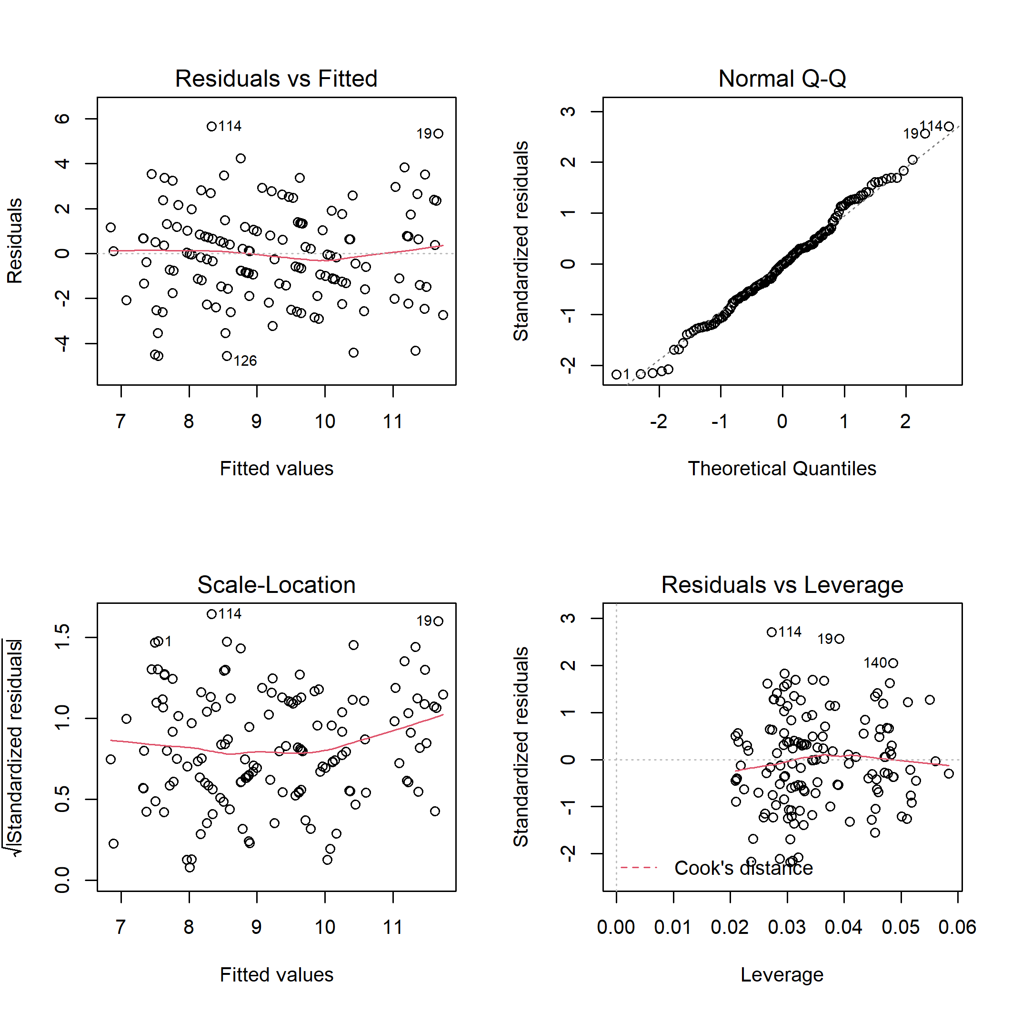

**Figure S1.** Diagnostic plots for linear model of the total bird species richness on disturbance class and elevation.

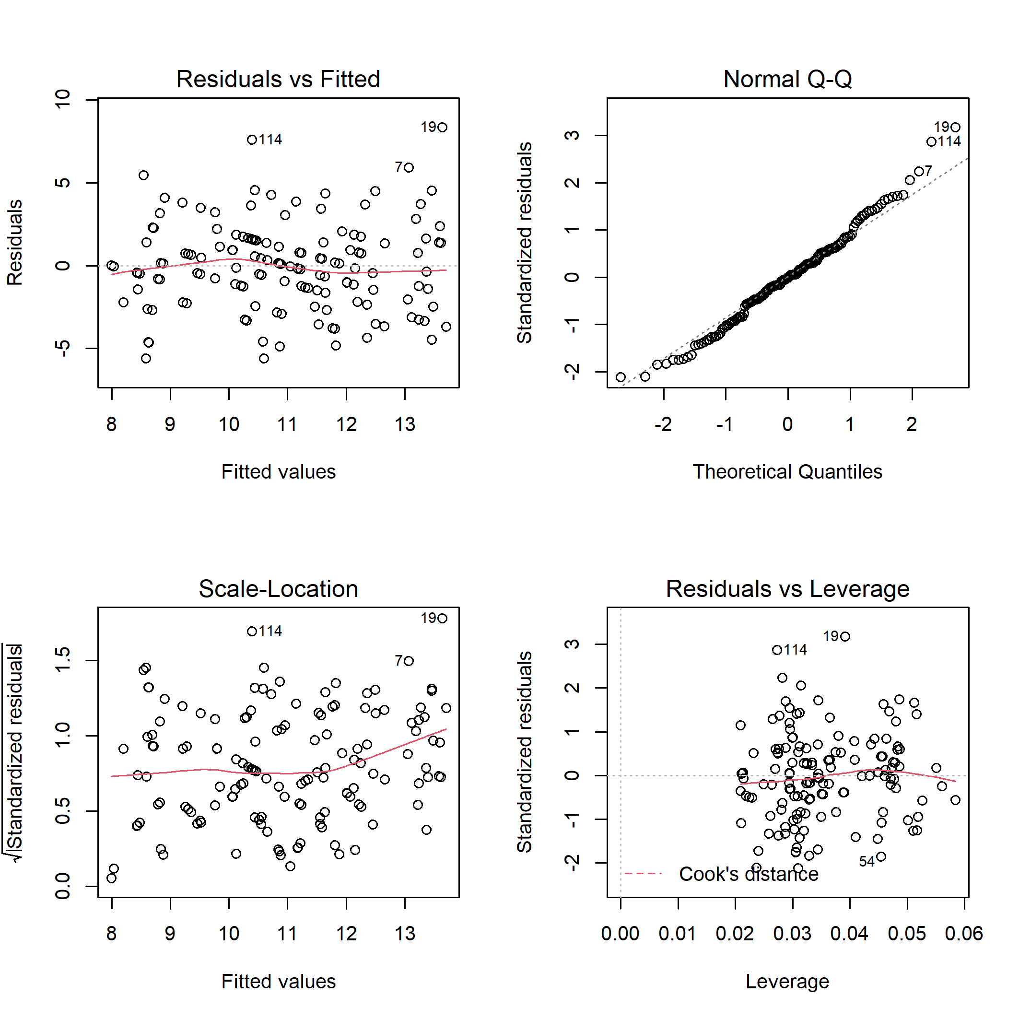

**Figure S2.** Diagnostic plots for linear model of the total bird species abundance on disturbance class and elevation.

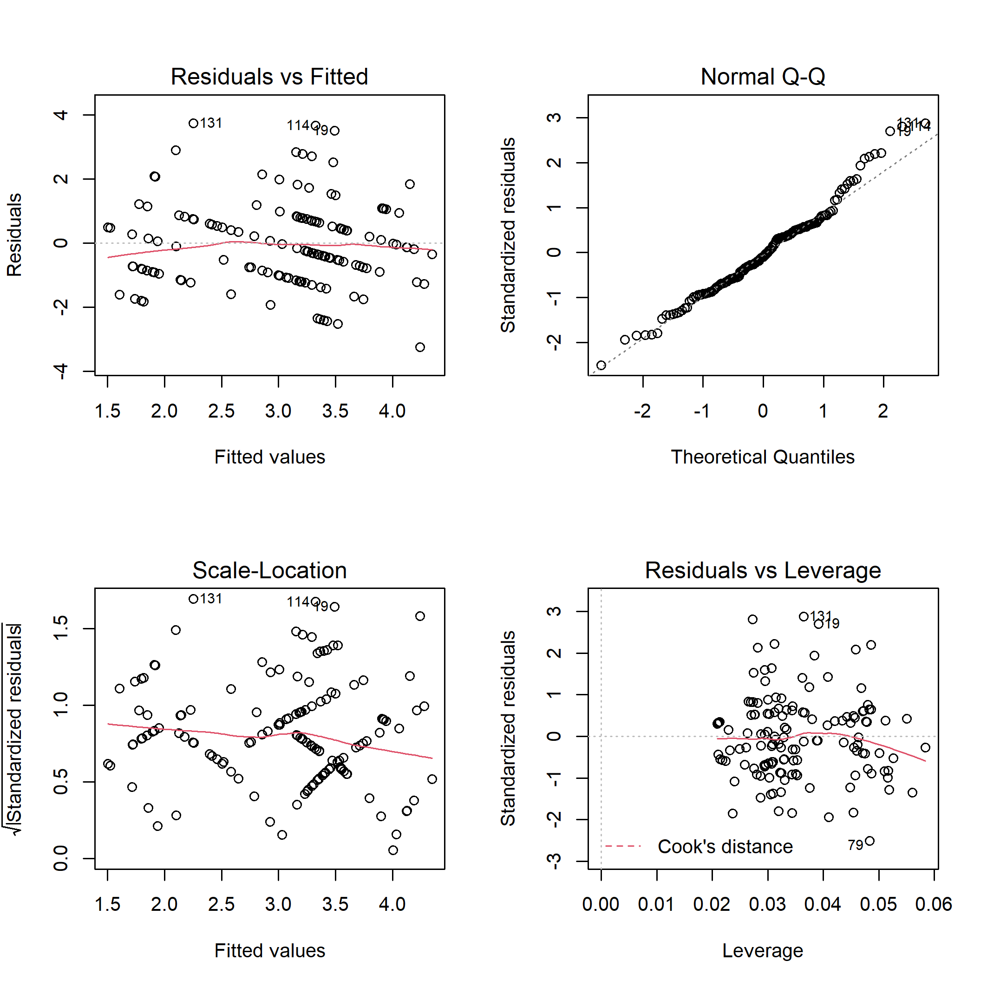

**Figure S3.** Diagnostic plots for linear model of the bird specialist species richness on disturbance class and elevation.

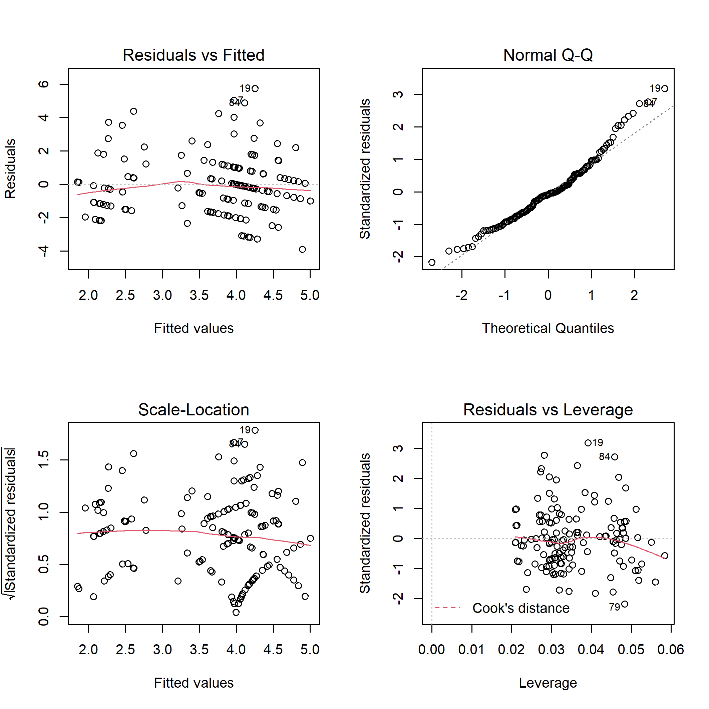

**Figure S4.** Diagnostic plots for linear model of the bird specialist species abundance on disturbance class and elevation.

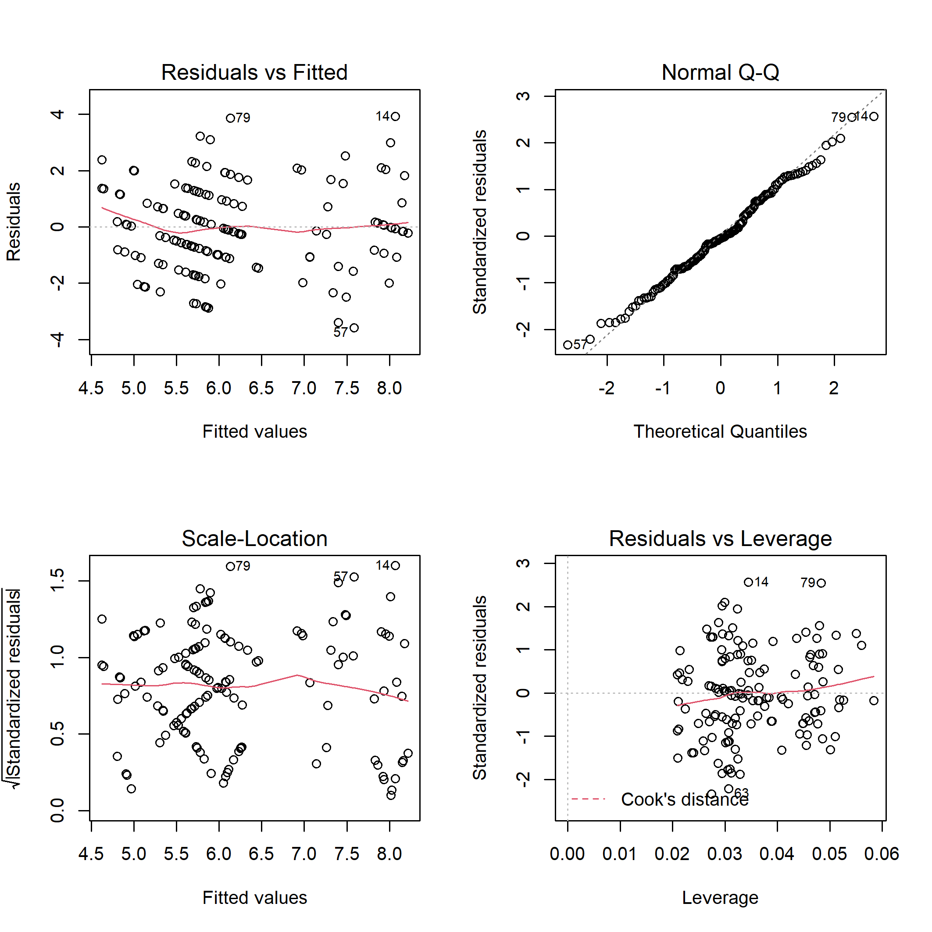

**Figure S5.** Diagnostic plots for linear model of the bird generalist species richness on disturbance class and elevation.

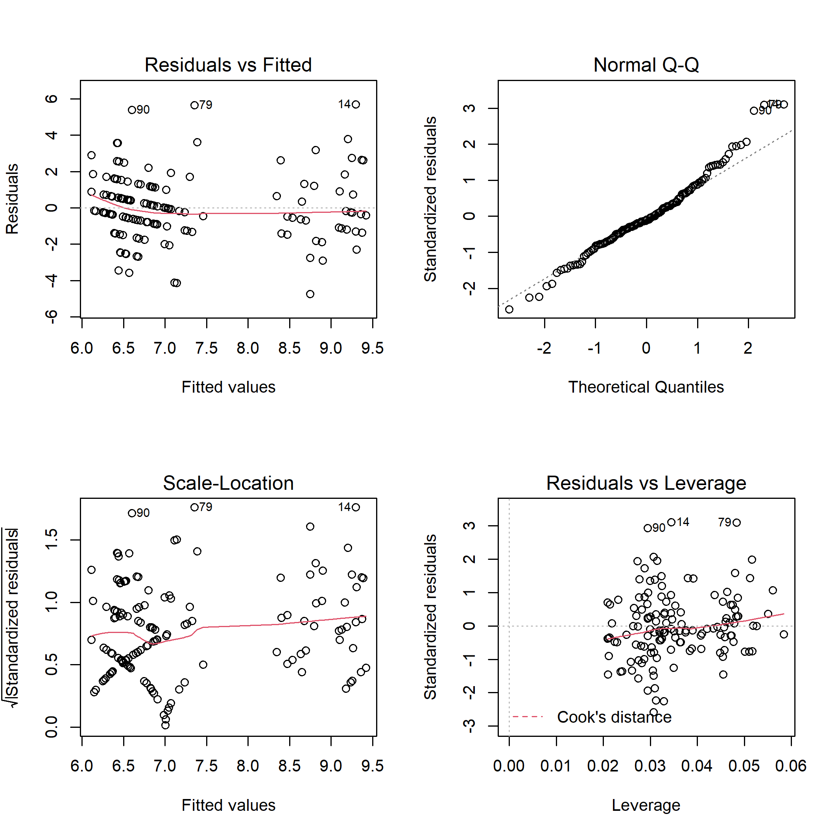

**Figure S6.** Diagnostic plots for linear model of the bird generalist species abundance on disturbance class and elevation.

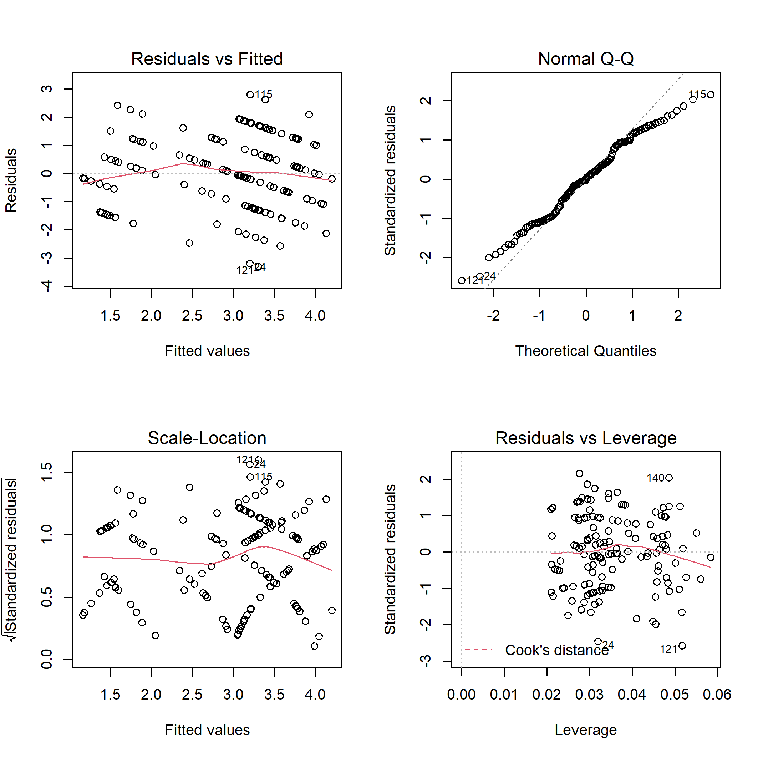

**Figure S7.** Diagnostic plots for linear model of the bird canopy nesters richness on disturbance class and elevation.

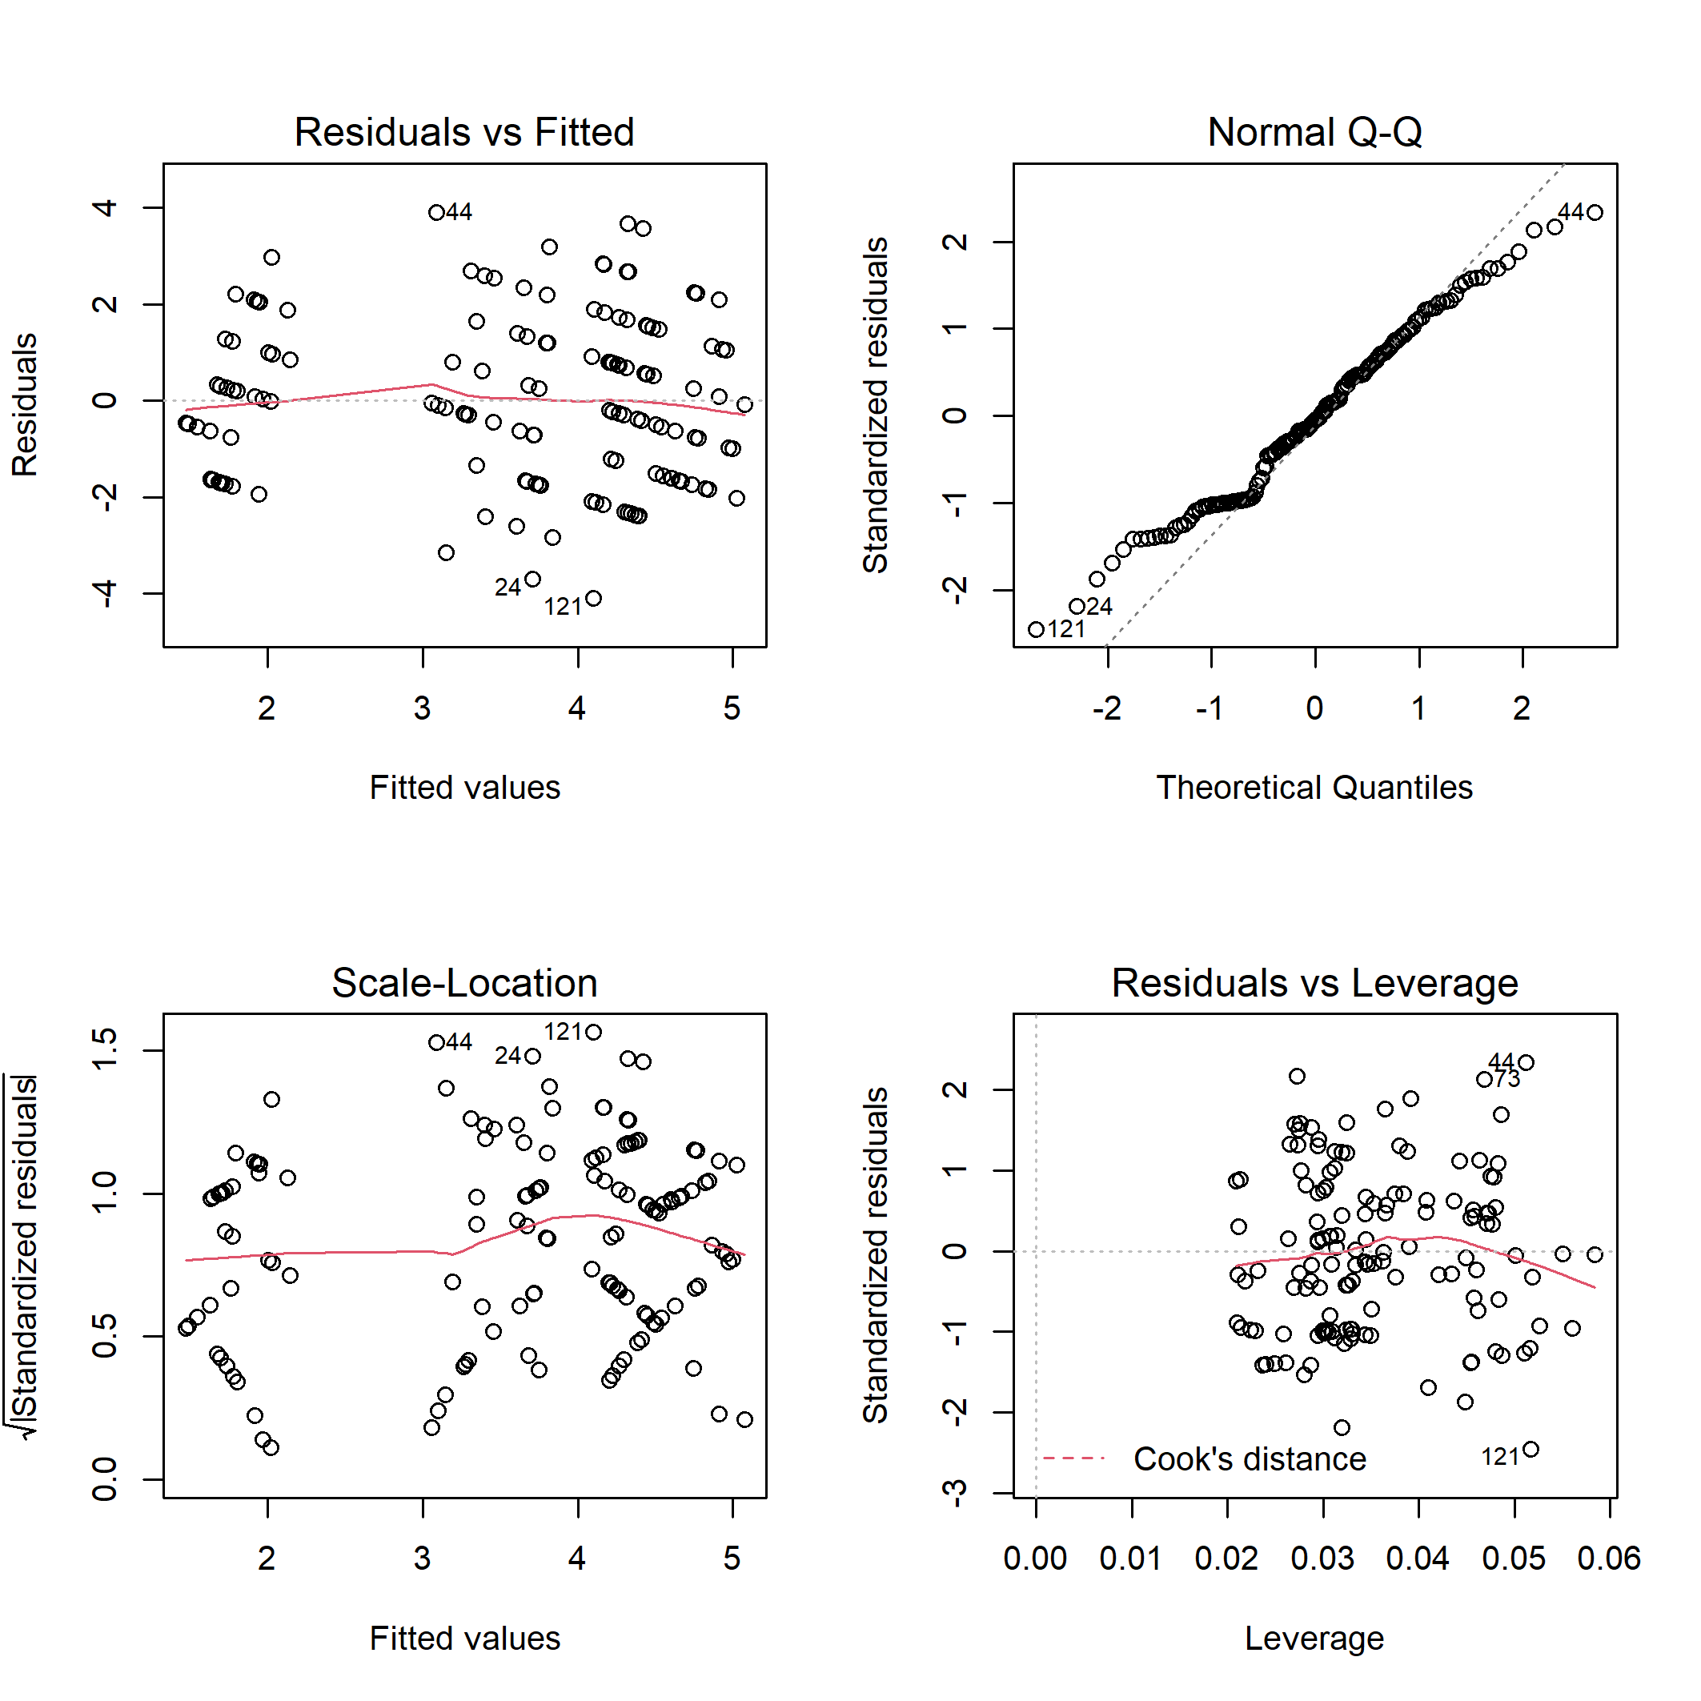

**Figure S8.** Diagnostic plots for linear model of the bird canopy nesters abundance on disturbance class and elevation.

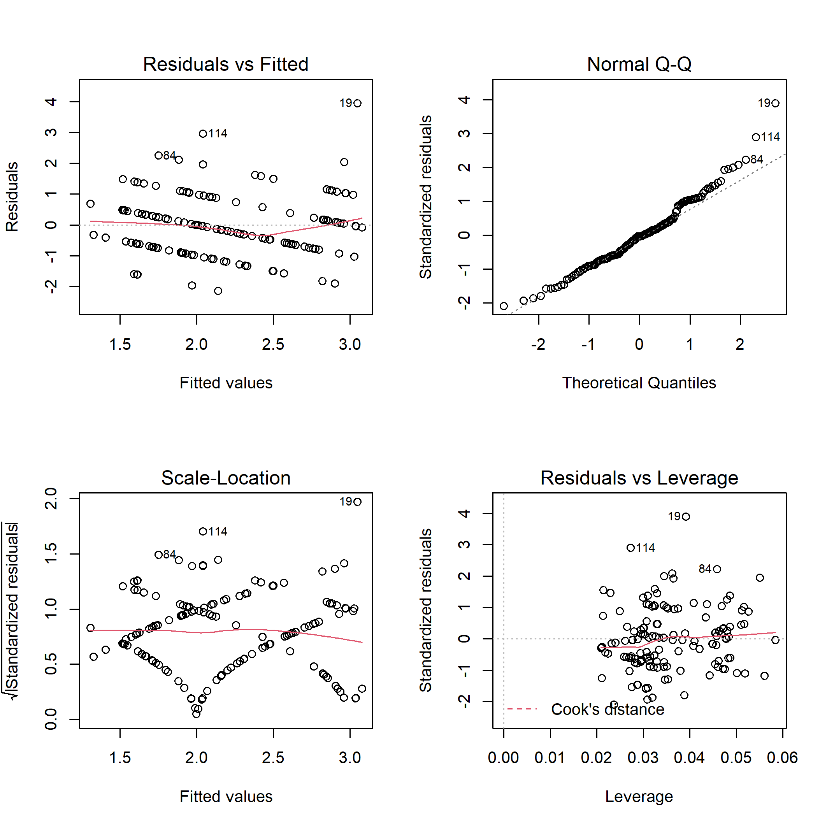

**Figure S9.** Diagnostic plots for linear model of the bird cavity nesters richness on disturbance class and elevation.

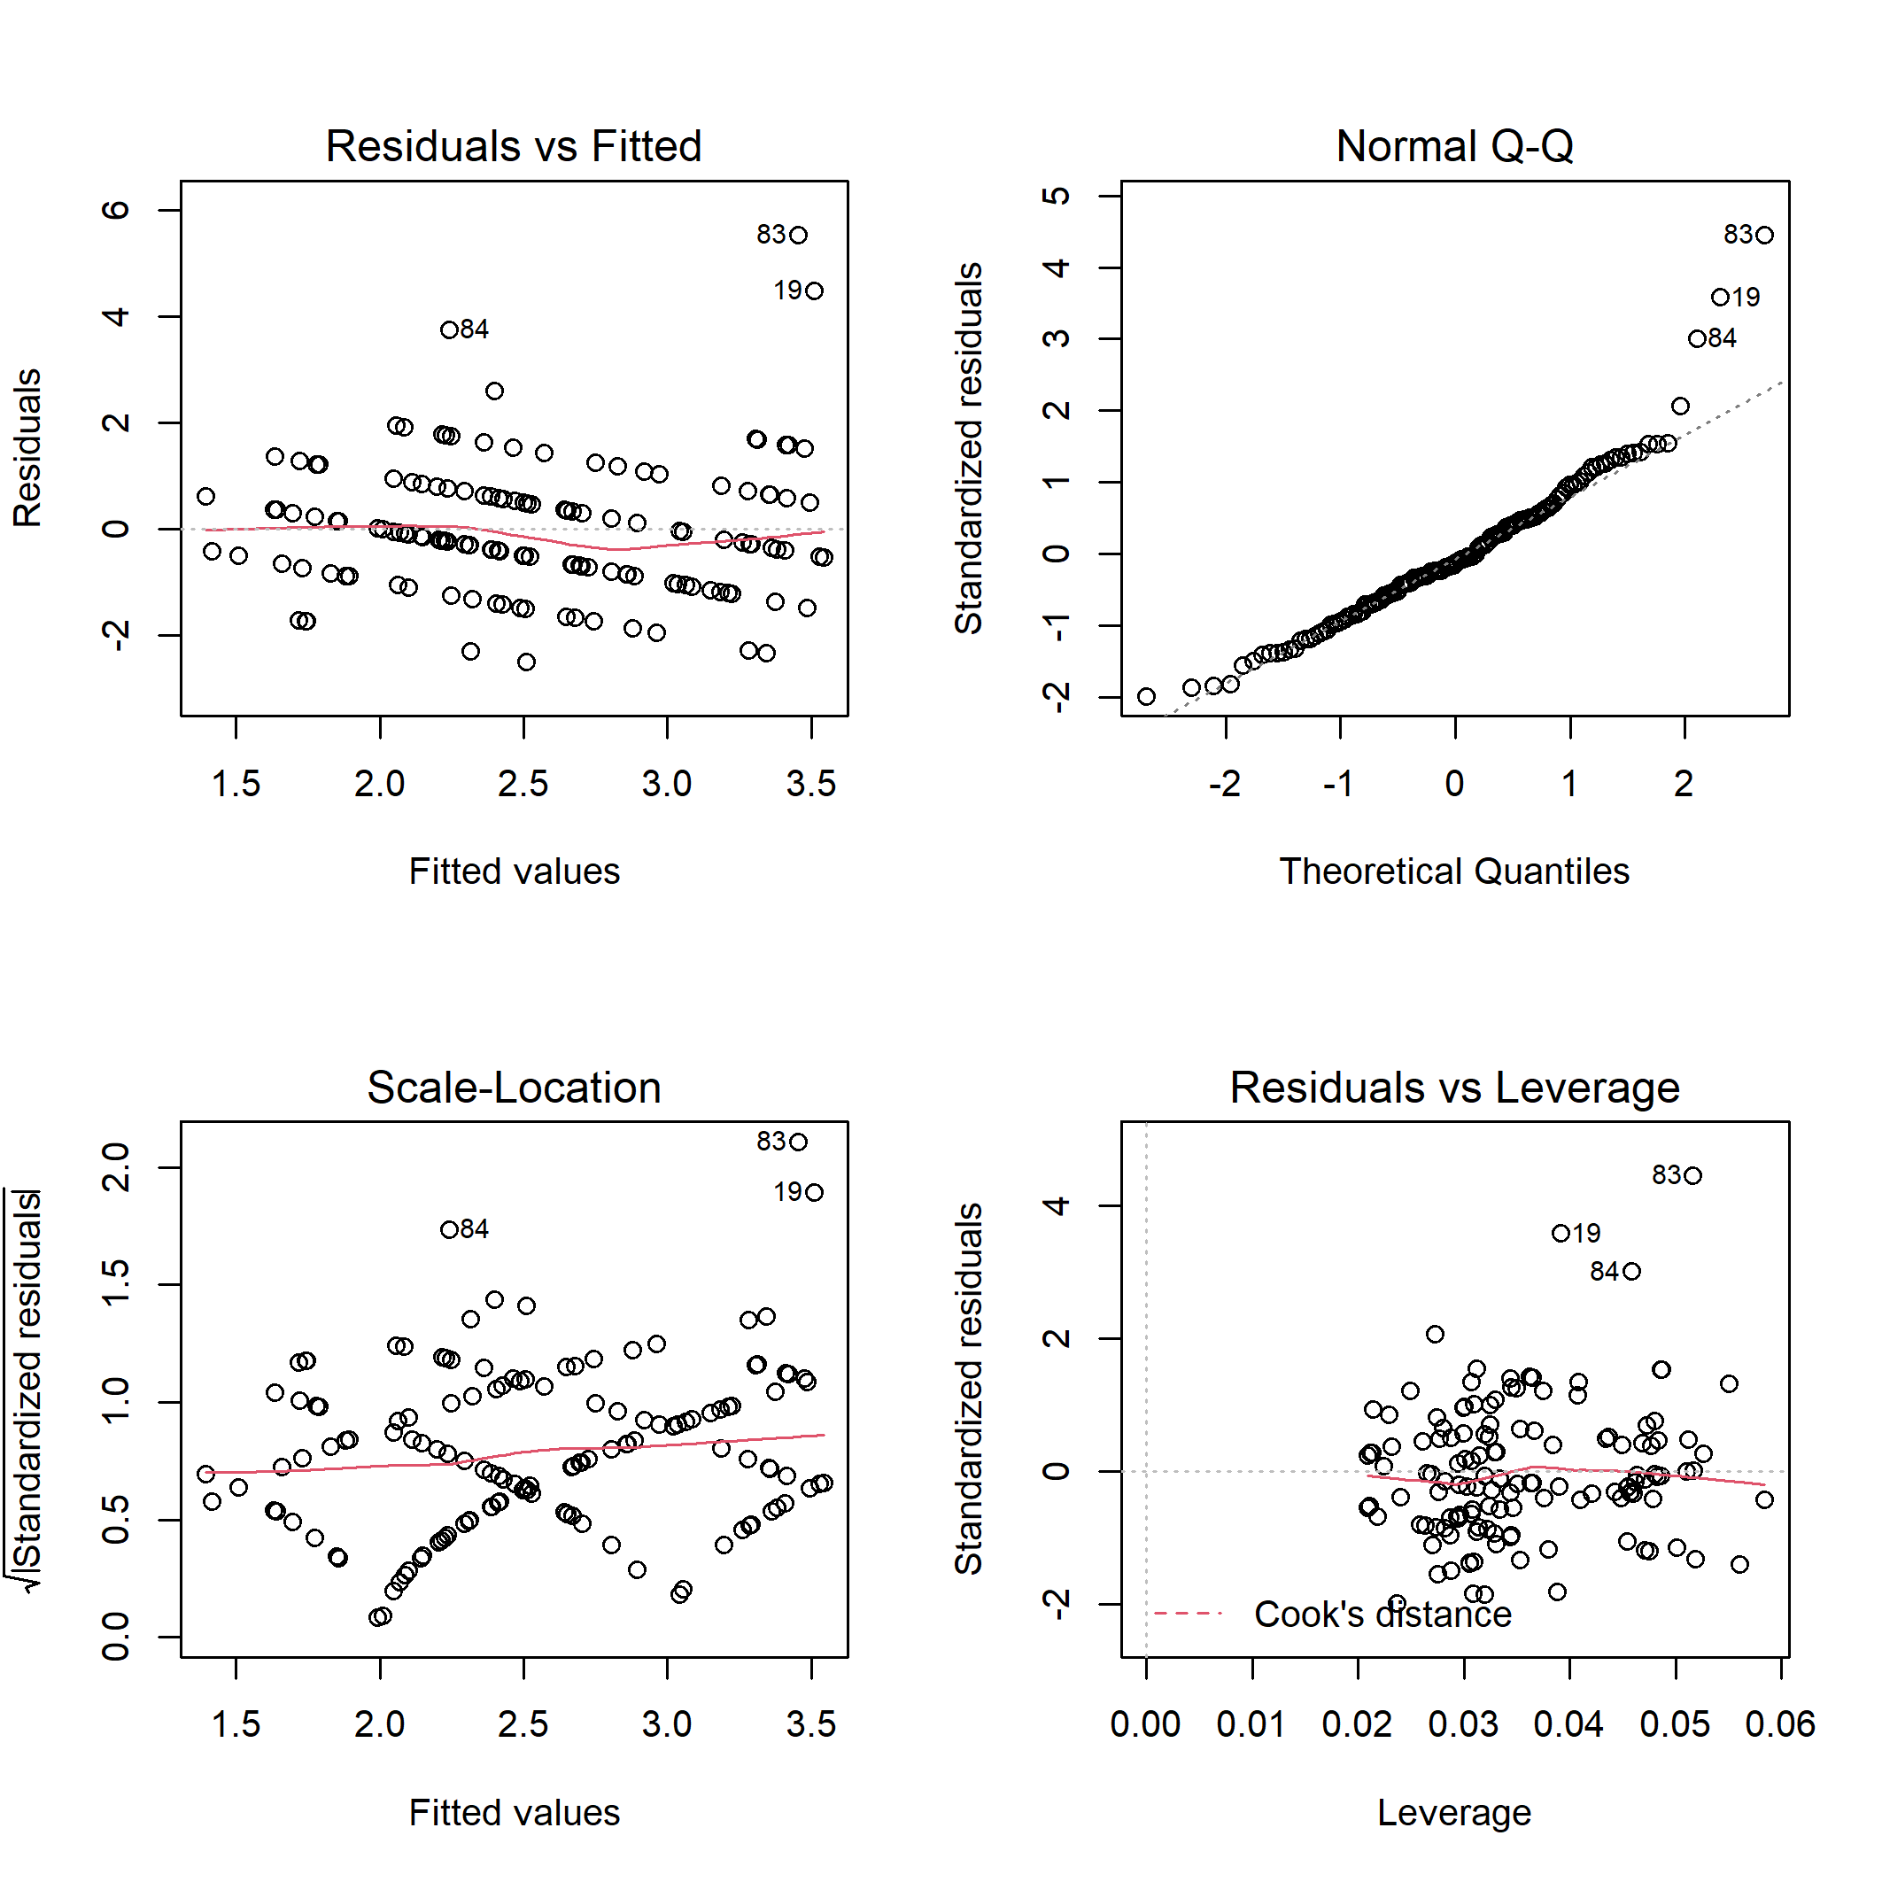

**Figure S10.** Diagnostic plots for linear model of the bird cavity nesters abundance on disturbance class and elevation.

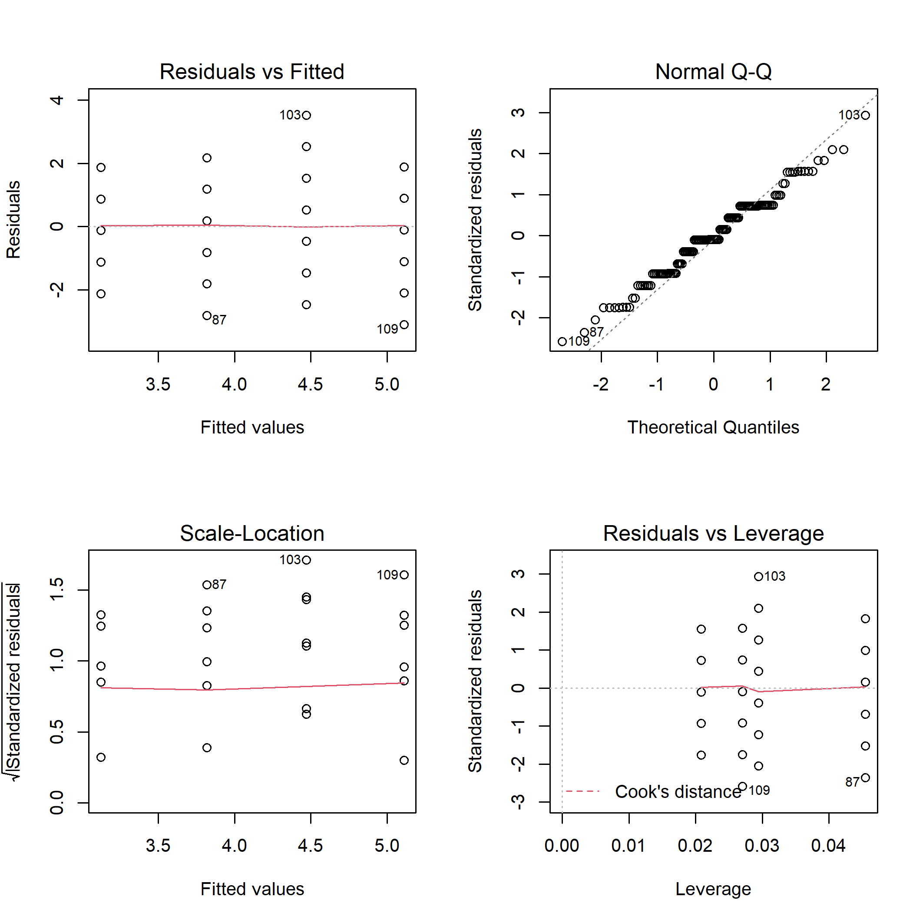

**Figure S11.** Diagnostic plots for linear model of the bird ground/shrub nesters richness on disturbance class and elevation.

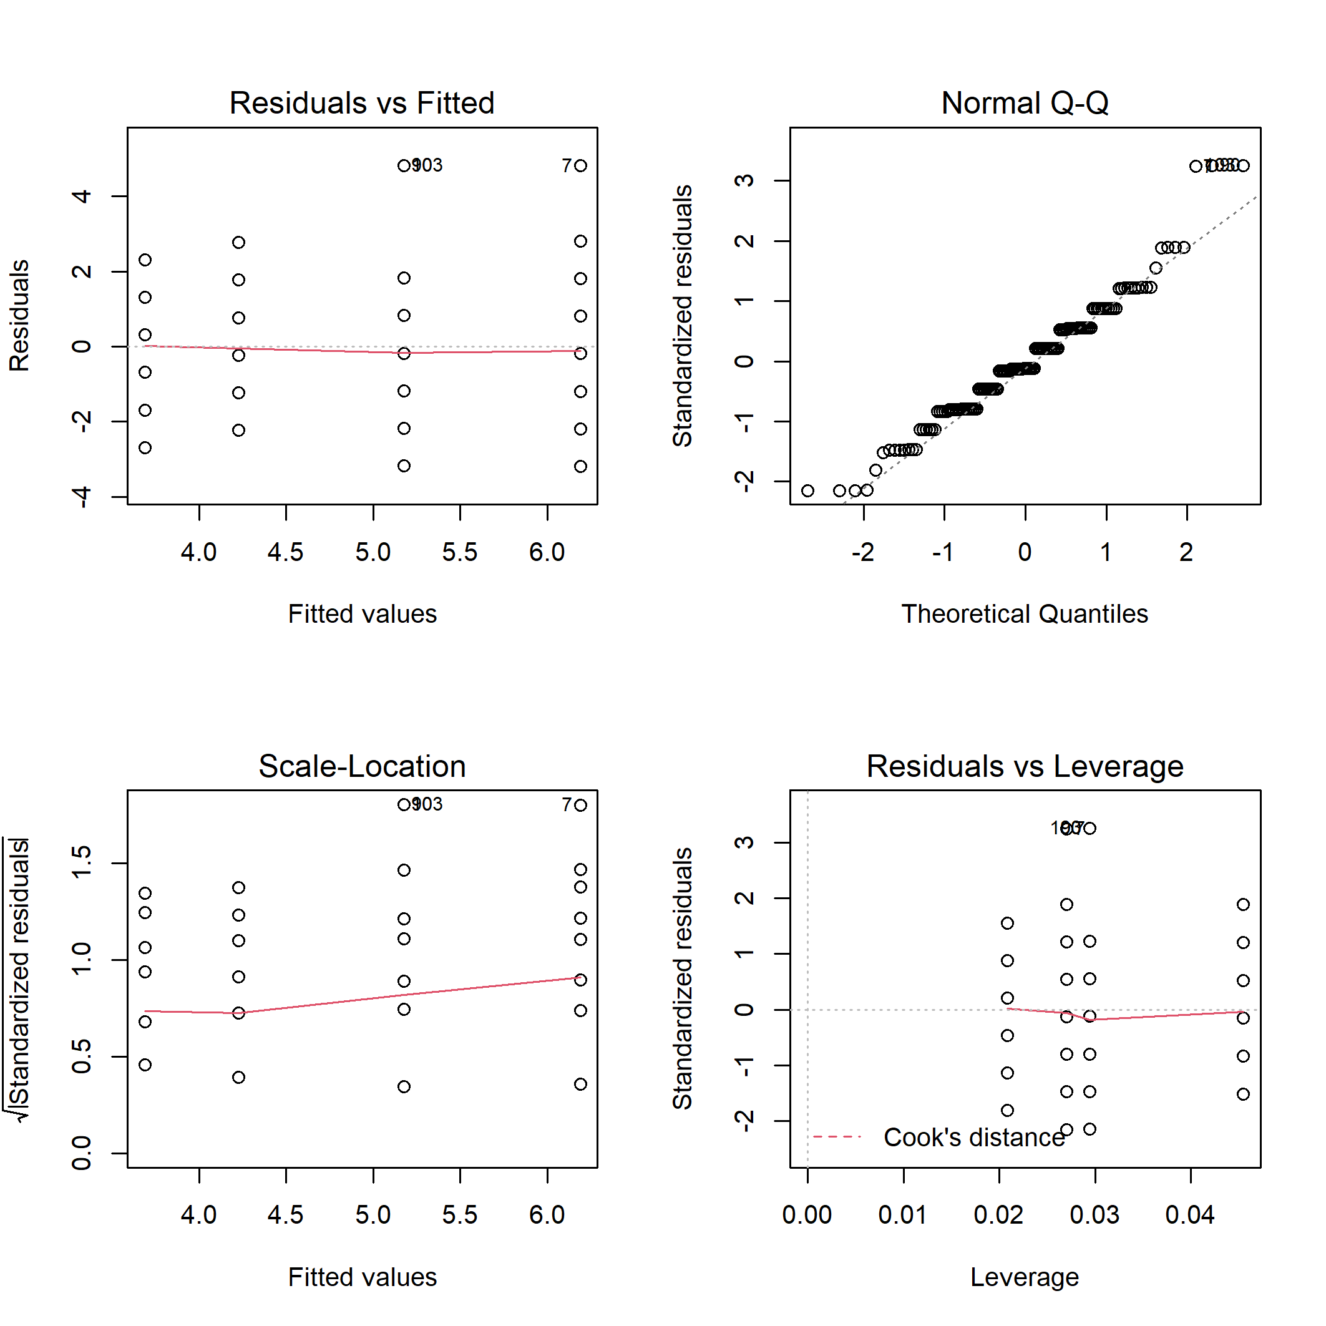

**Figure S12.** Diagnostic plots for linear model of the bird ground/shrub nesters abundance on disturbance class and elevation.

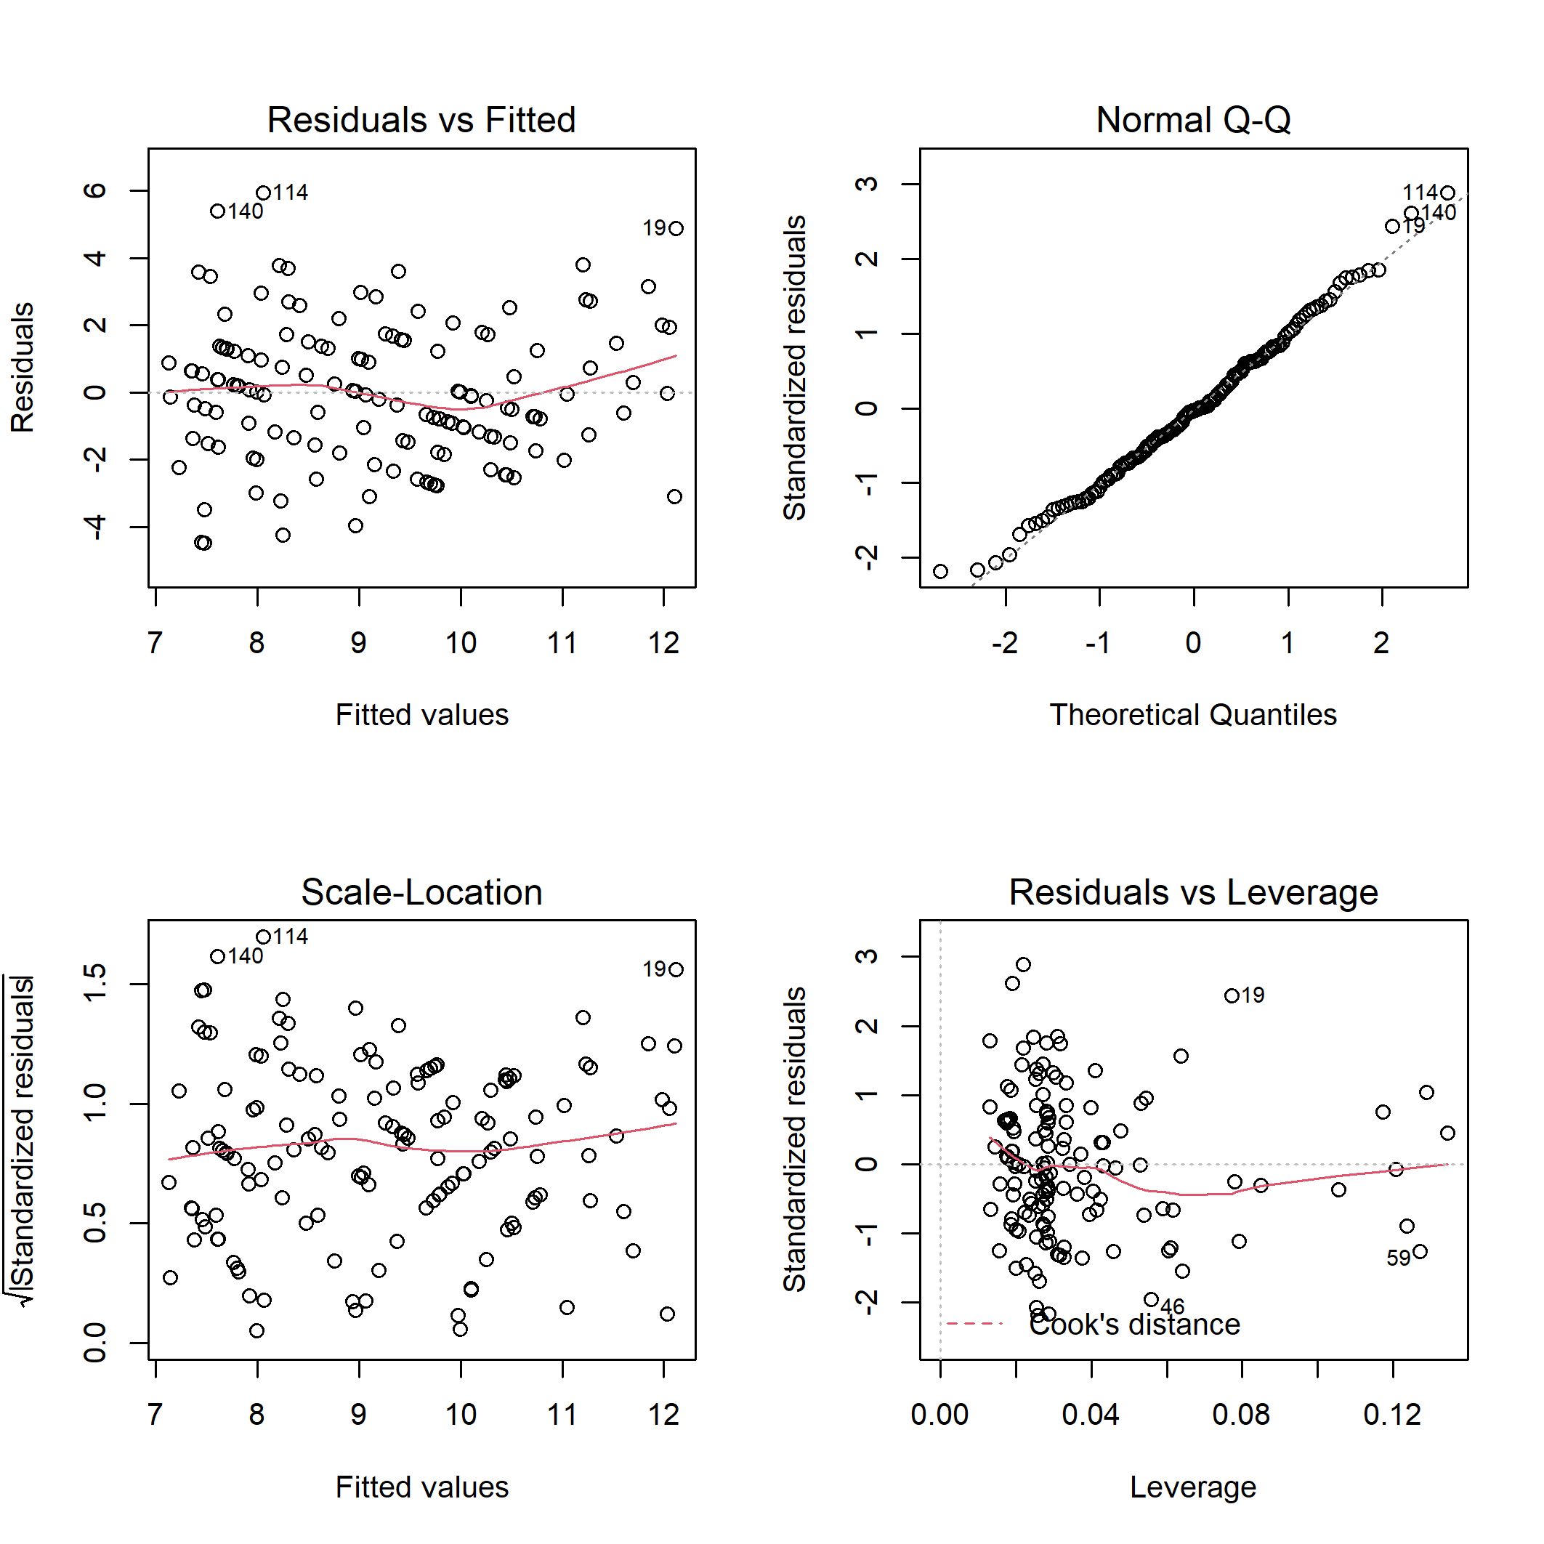

**Figure S13.** Diagnostic plots for linear model of the total bird species richness on habitat characteristics.

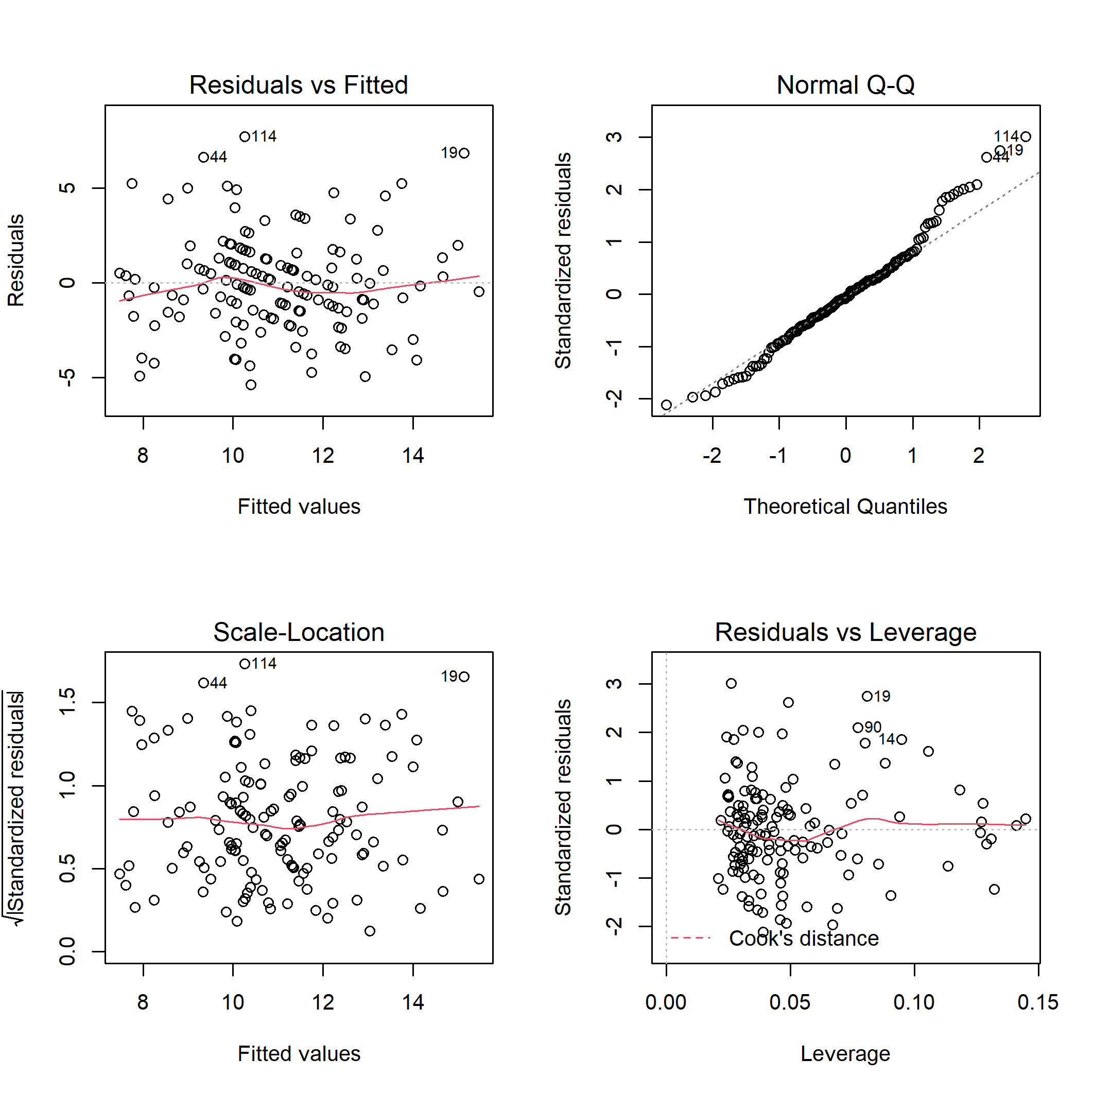

**Figure S14.** Diagnostic plots for linear model of the total bird species abundance on habitat characteristics.

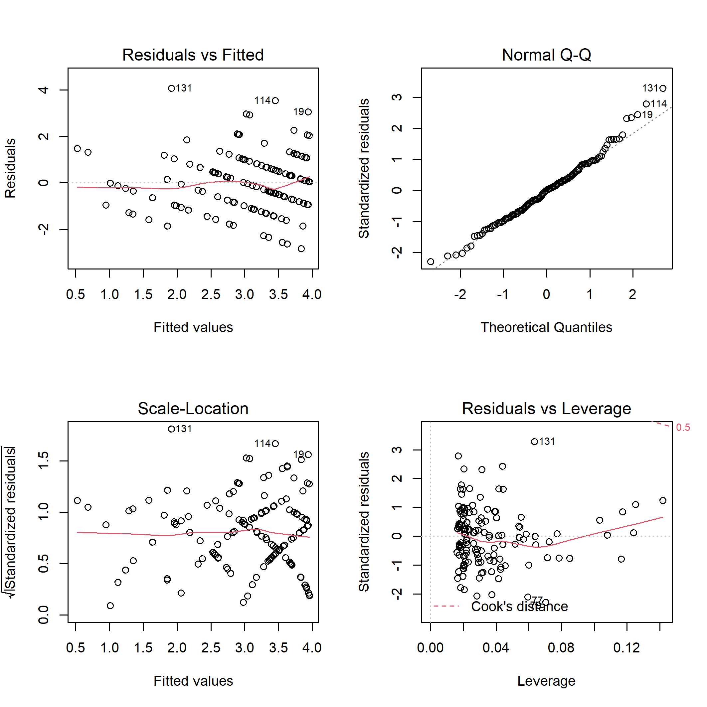

**Figure S15.** Diagnostic plots for linear model of the bird specialist species richness on habitat characteristics.

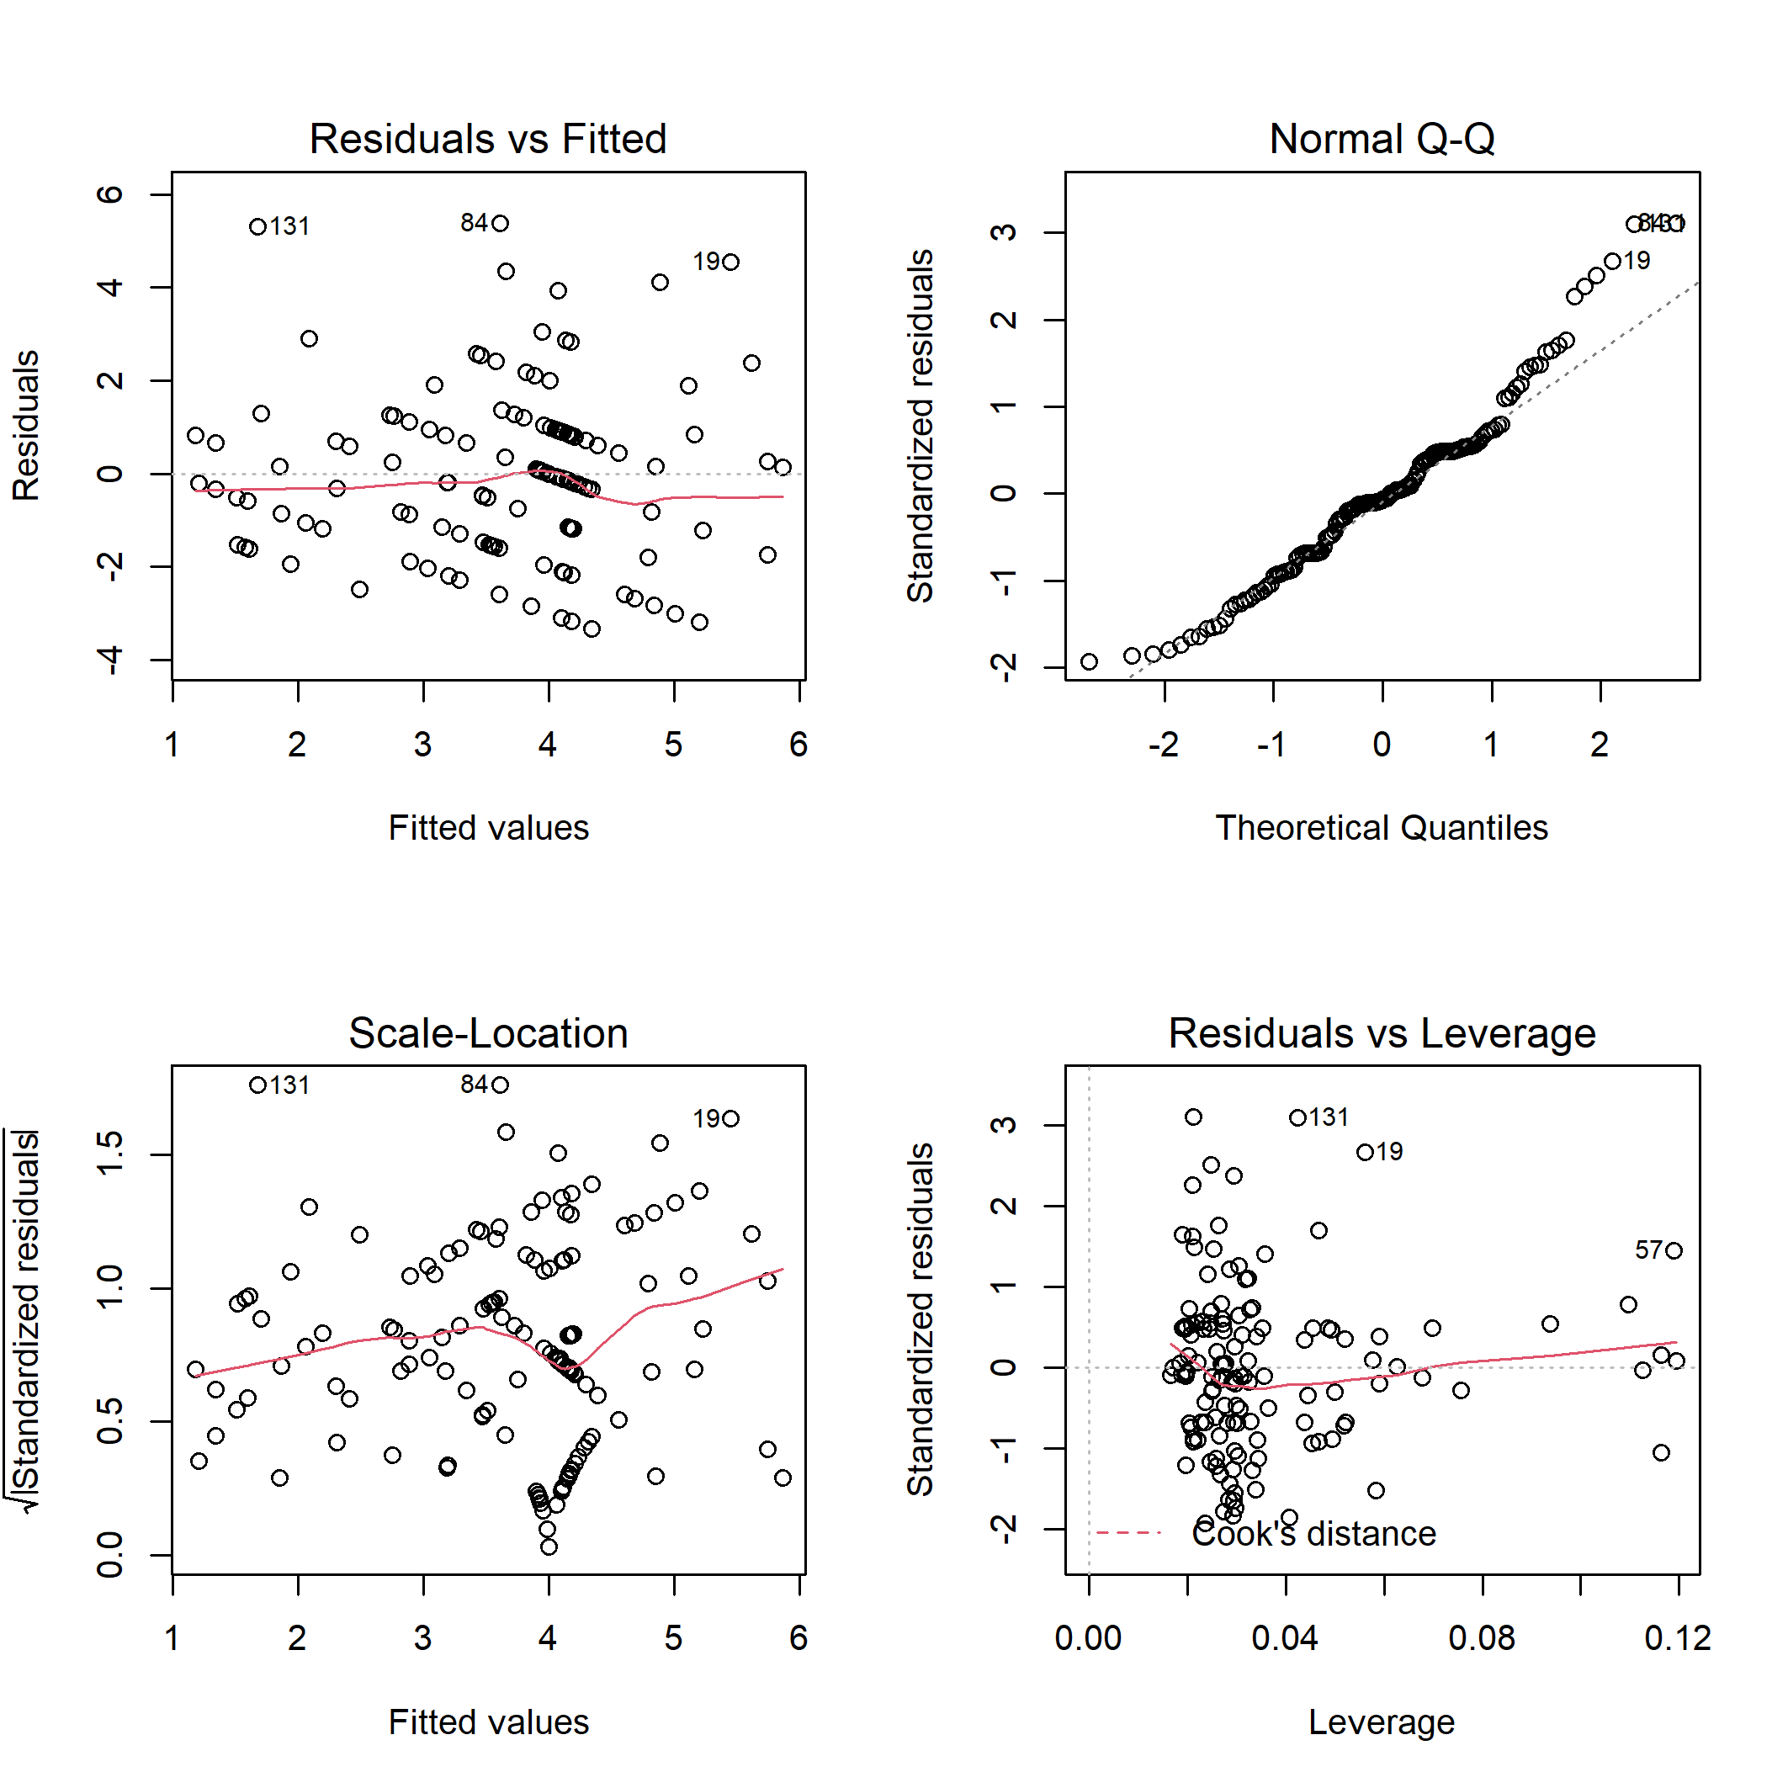

**Figure S16.** Diagnostic plots for linear model of the bird specialist species abundance on habitat characteristics.

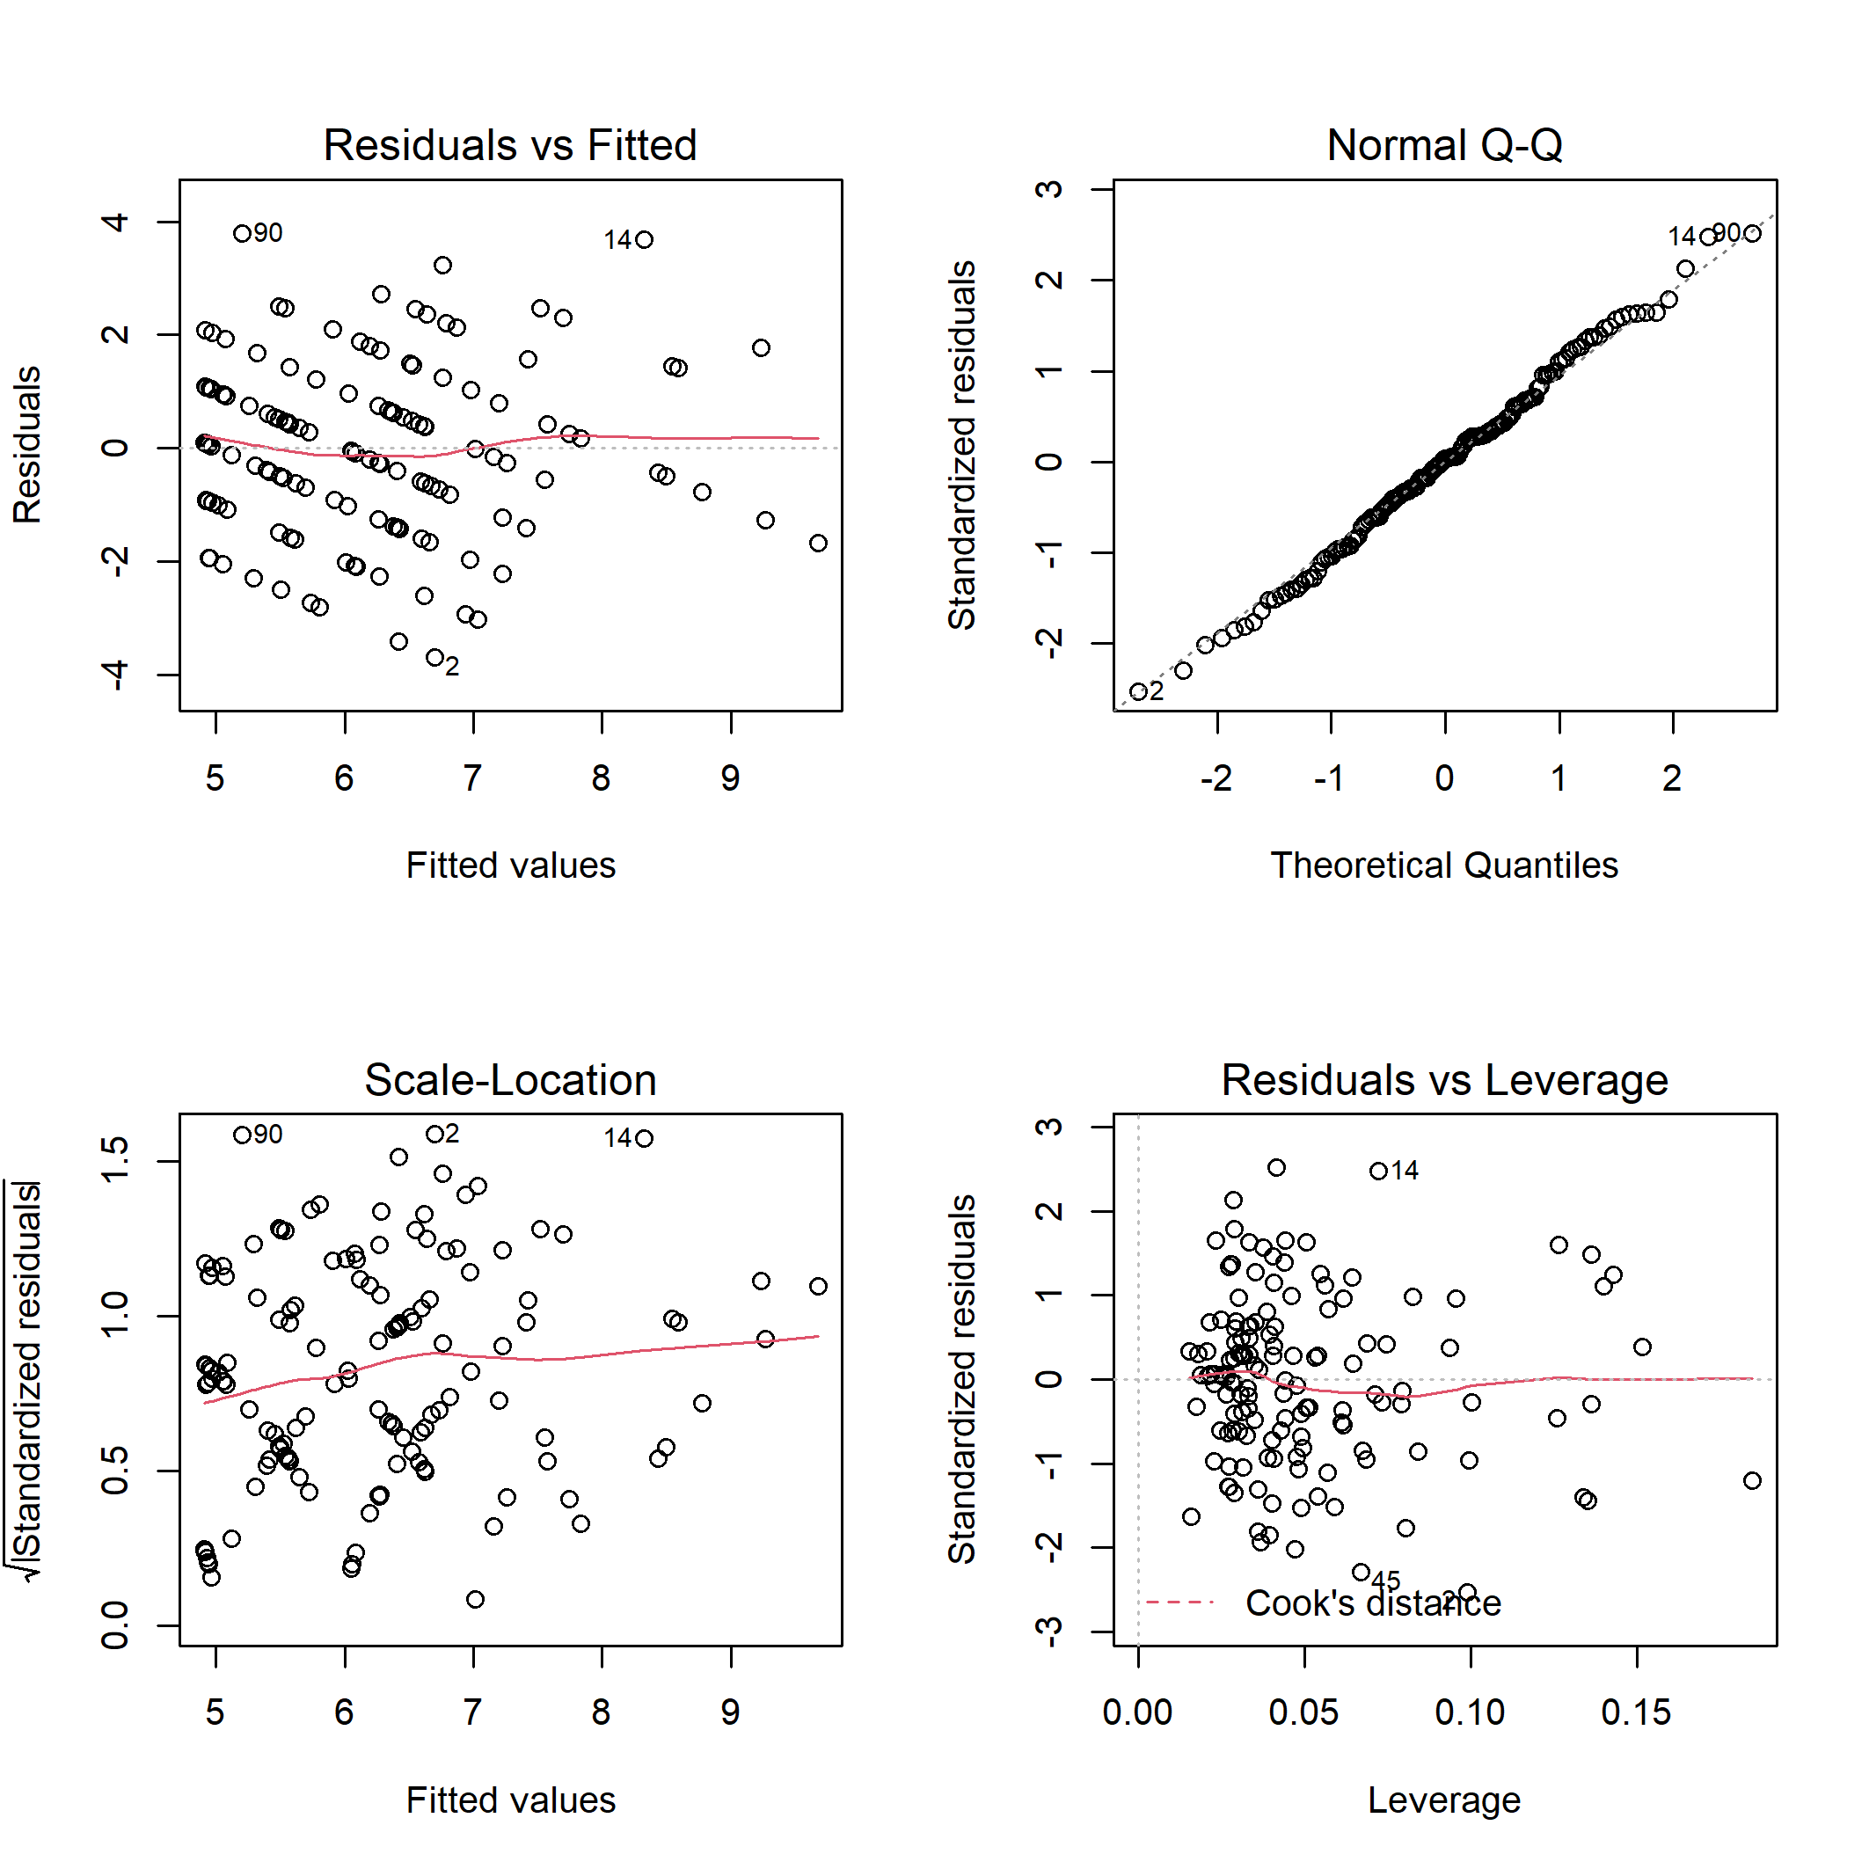

**Figure S17.** Diagnostic plots for linear model of the bird generalist species richness on habitat characteristics.

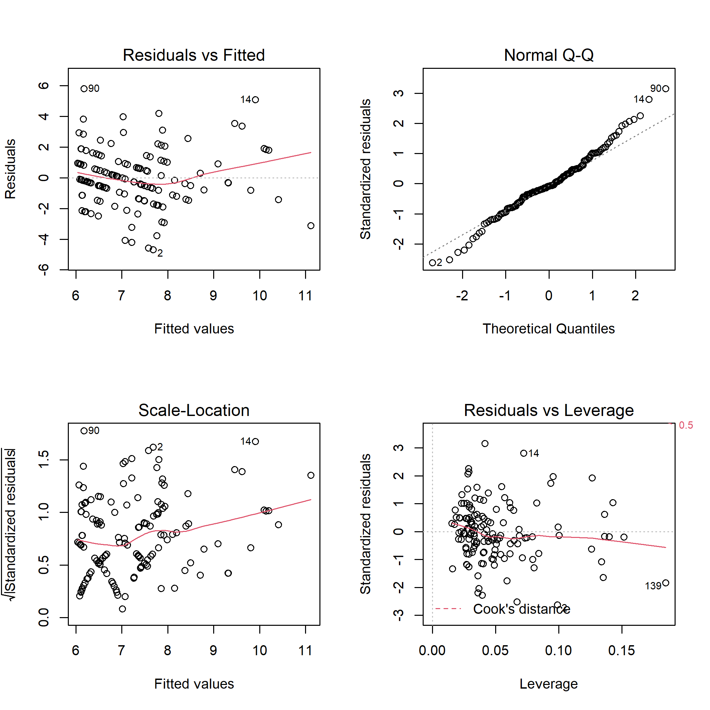

**Figure S18.** Diagnostic plots for linear model of the bird generalist species abundance on habitat characteristics.

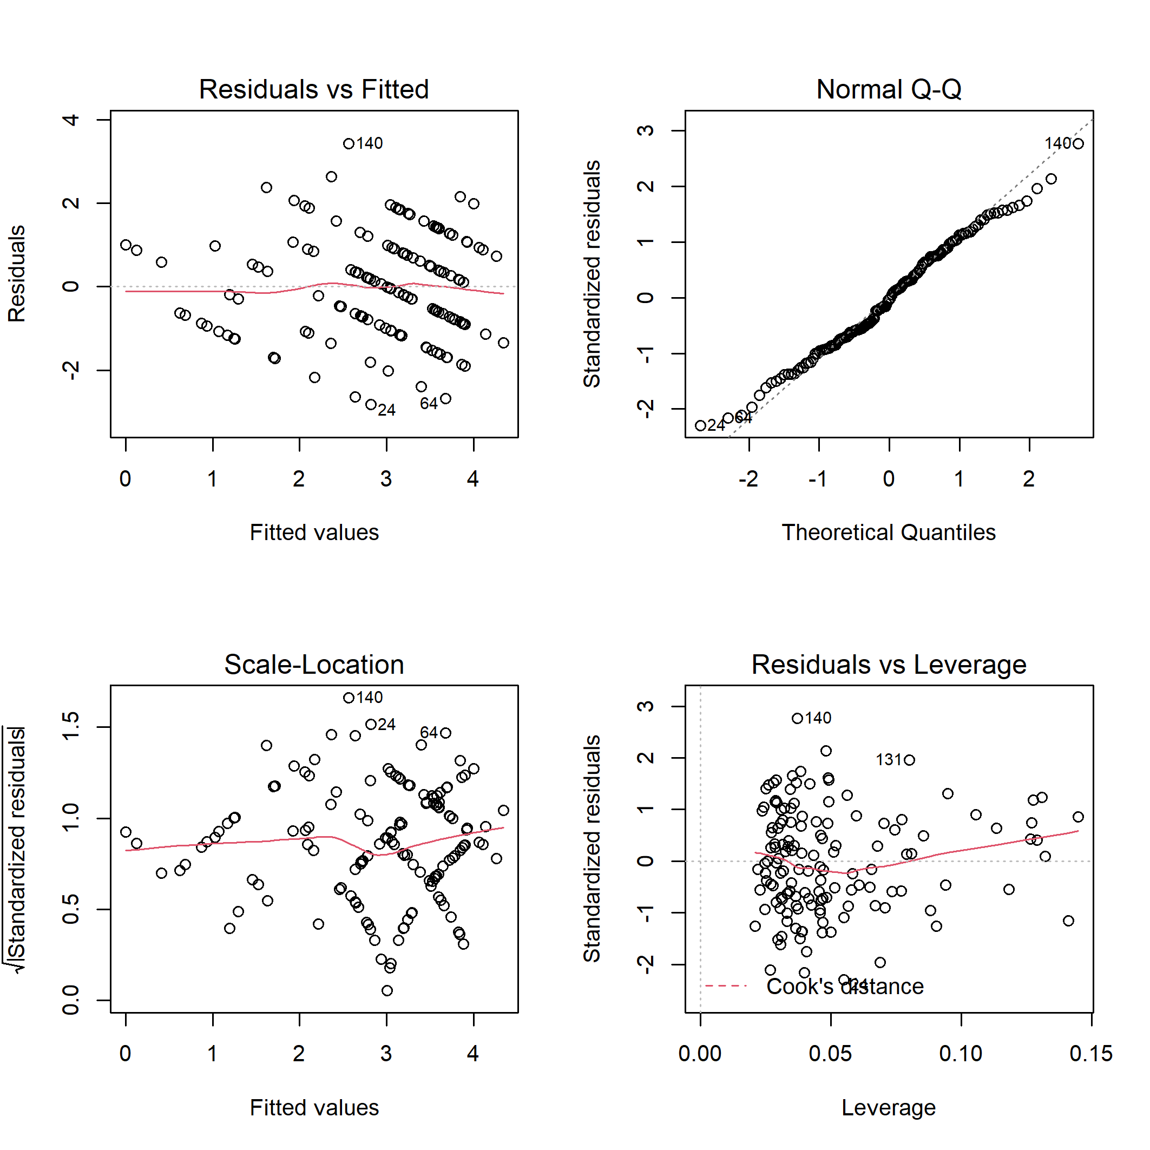

**Figure S19.** Diagnostic plots for linear model of the bird canopy nesters richness on habitat characteristics.

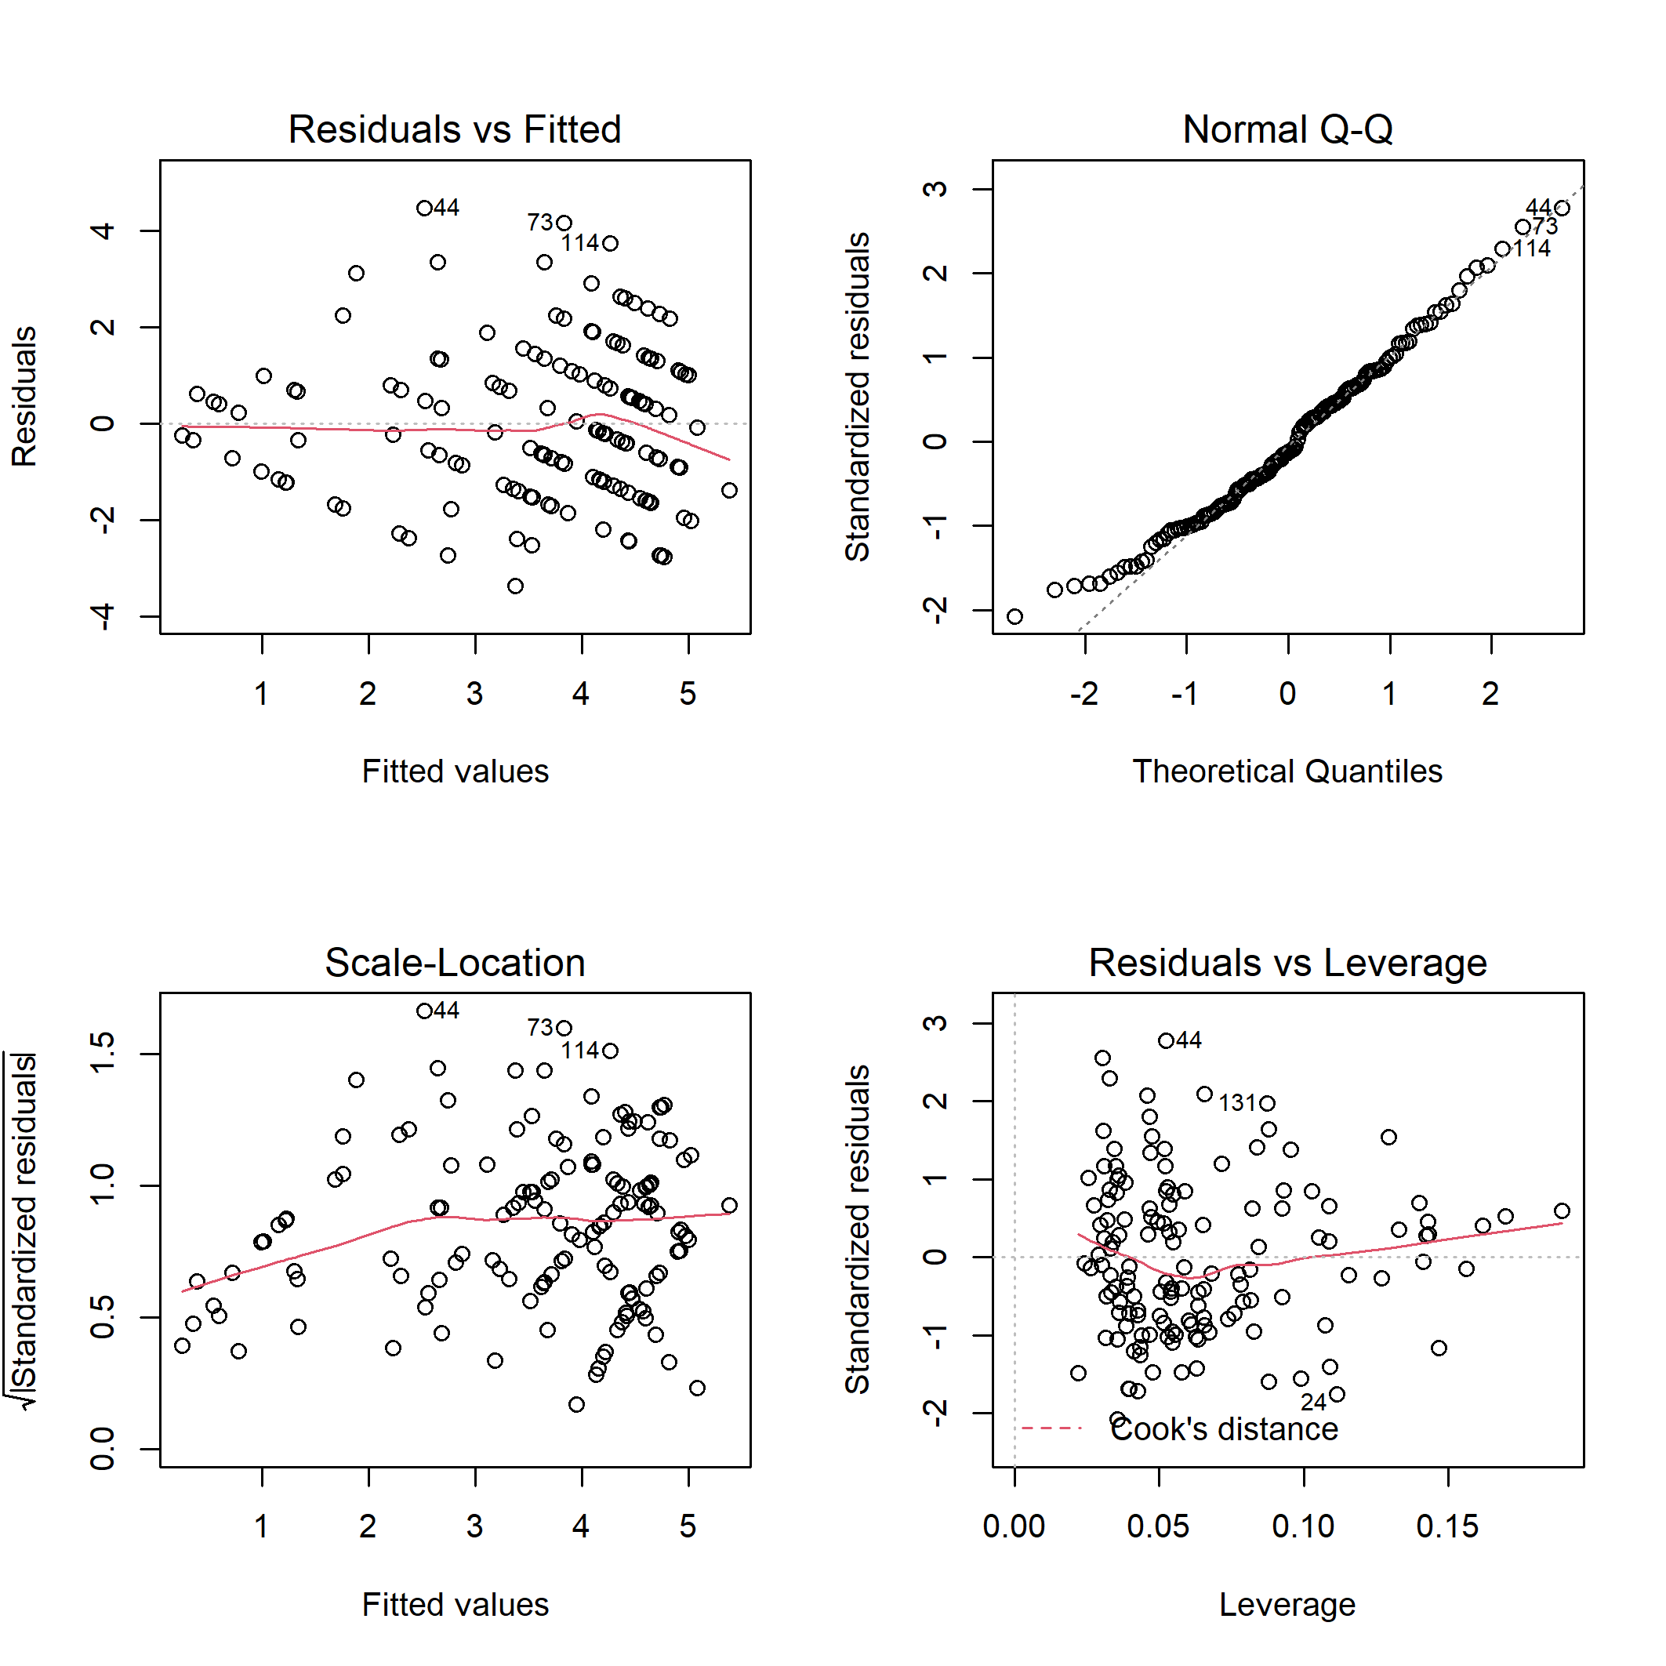

**Figure S20.** Diagnostic plots for linear model of the bird canopy nesters abundance on habitat characteristics.

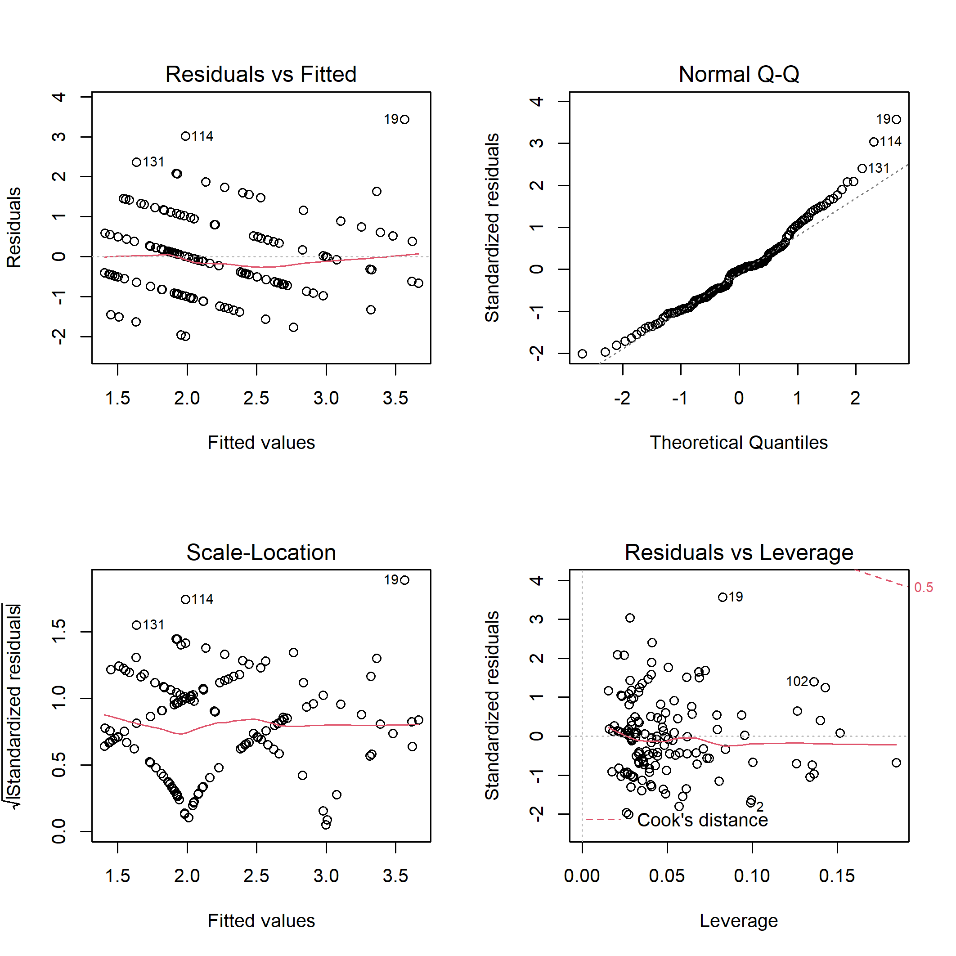

**Figure S21.** Diagnostic plots for linear model of the bird cavity nesters richness on habitat characteristics.

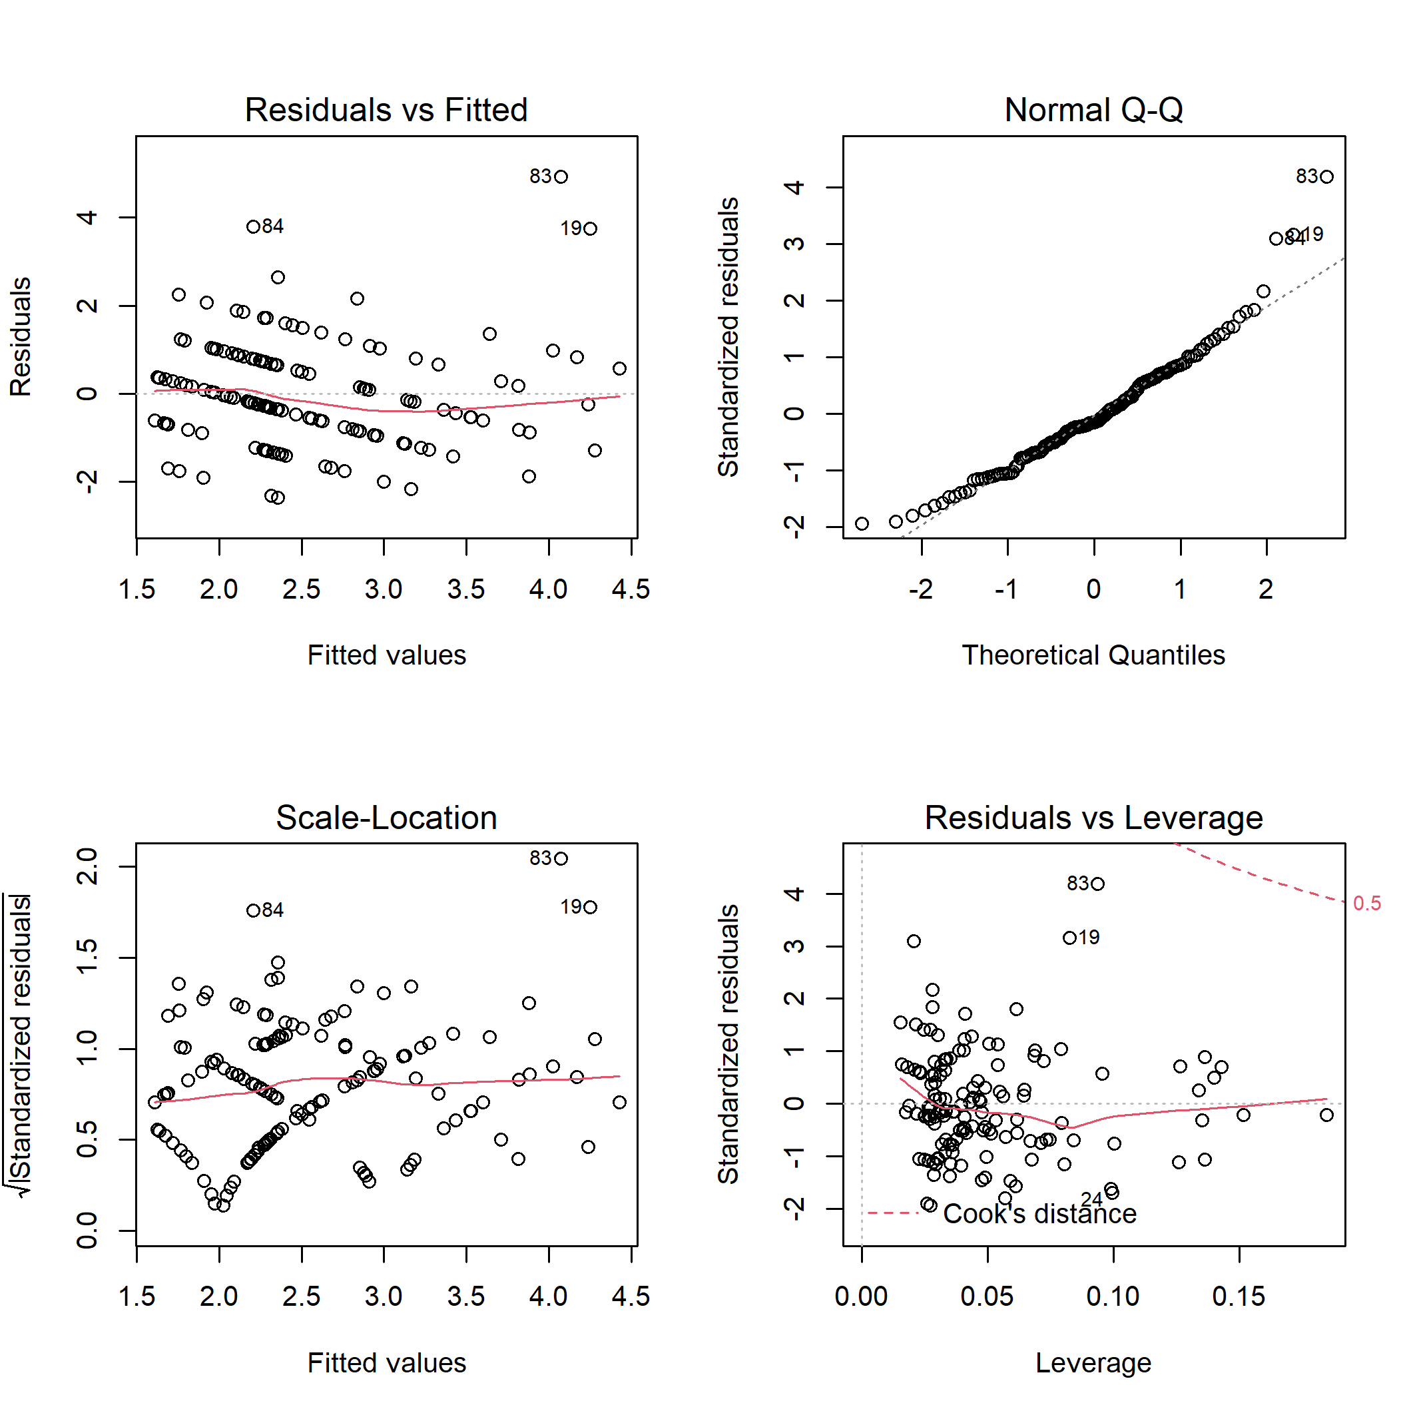

**Figure S22.** Diagnostic plots for linear model of the bird cavity nesters abundance on habitat characteristics.

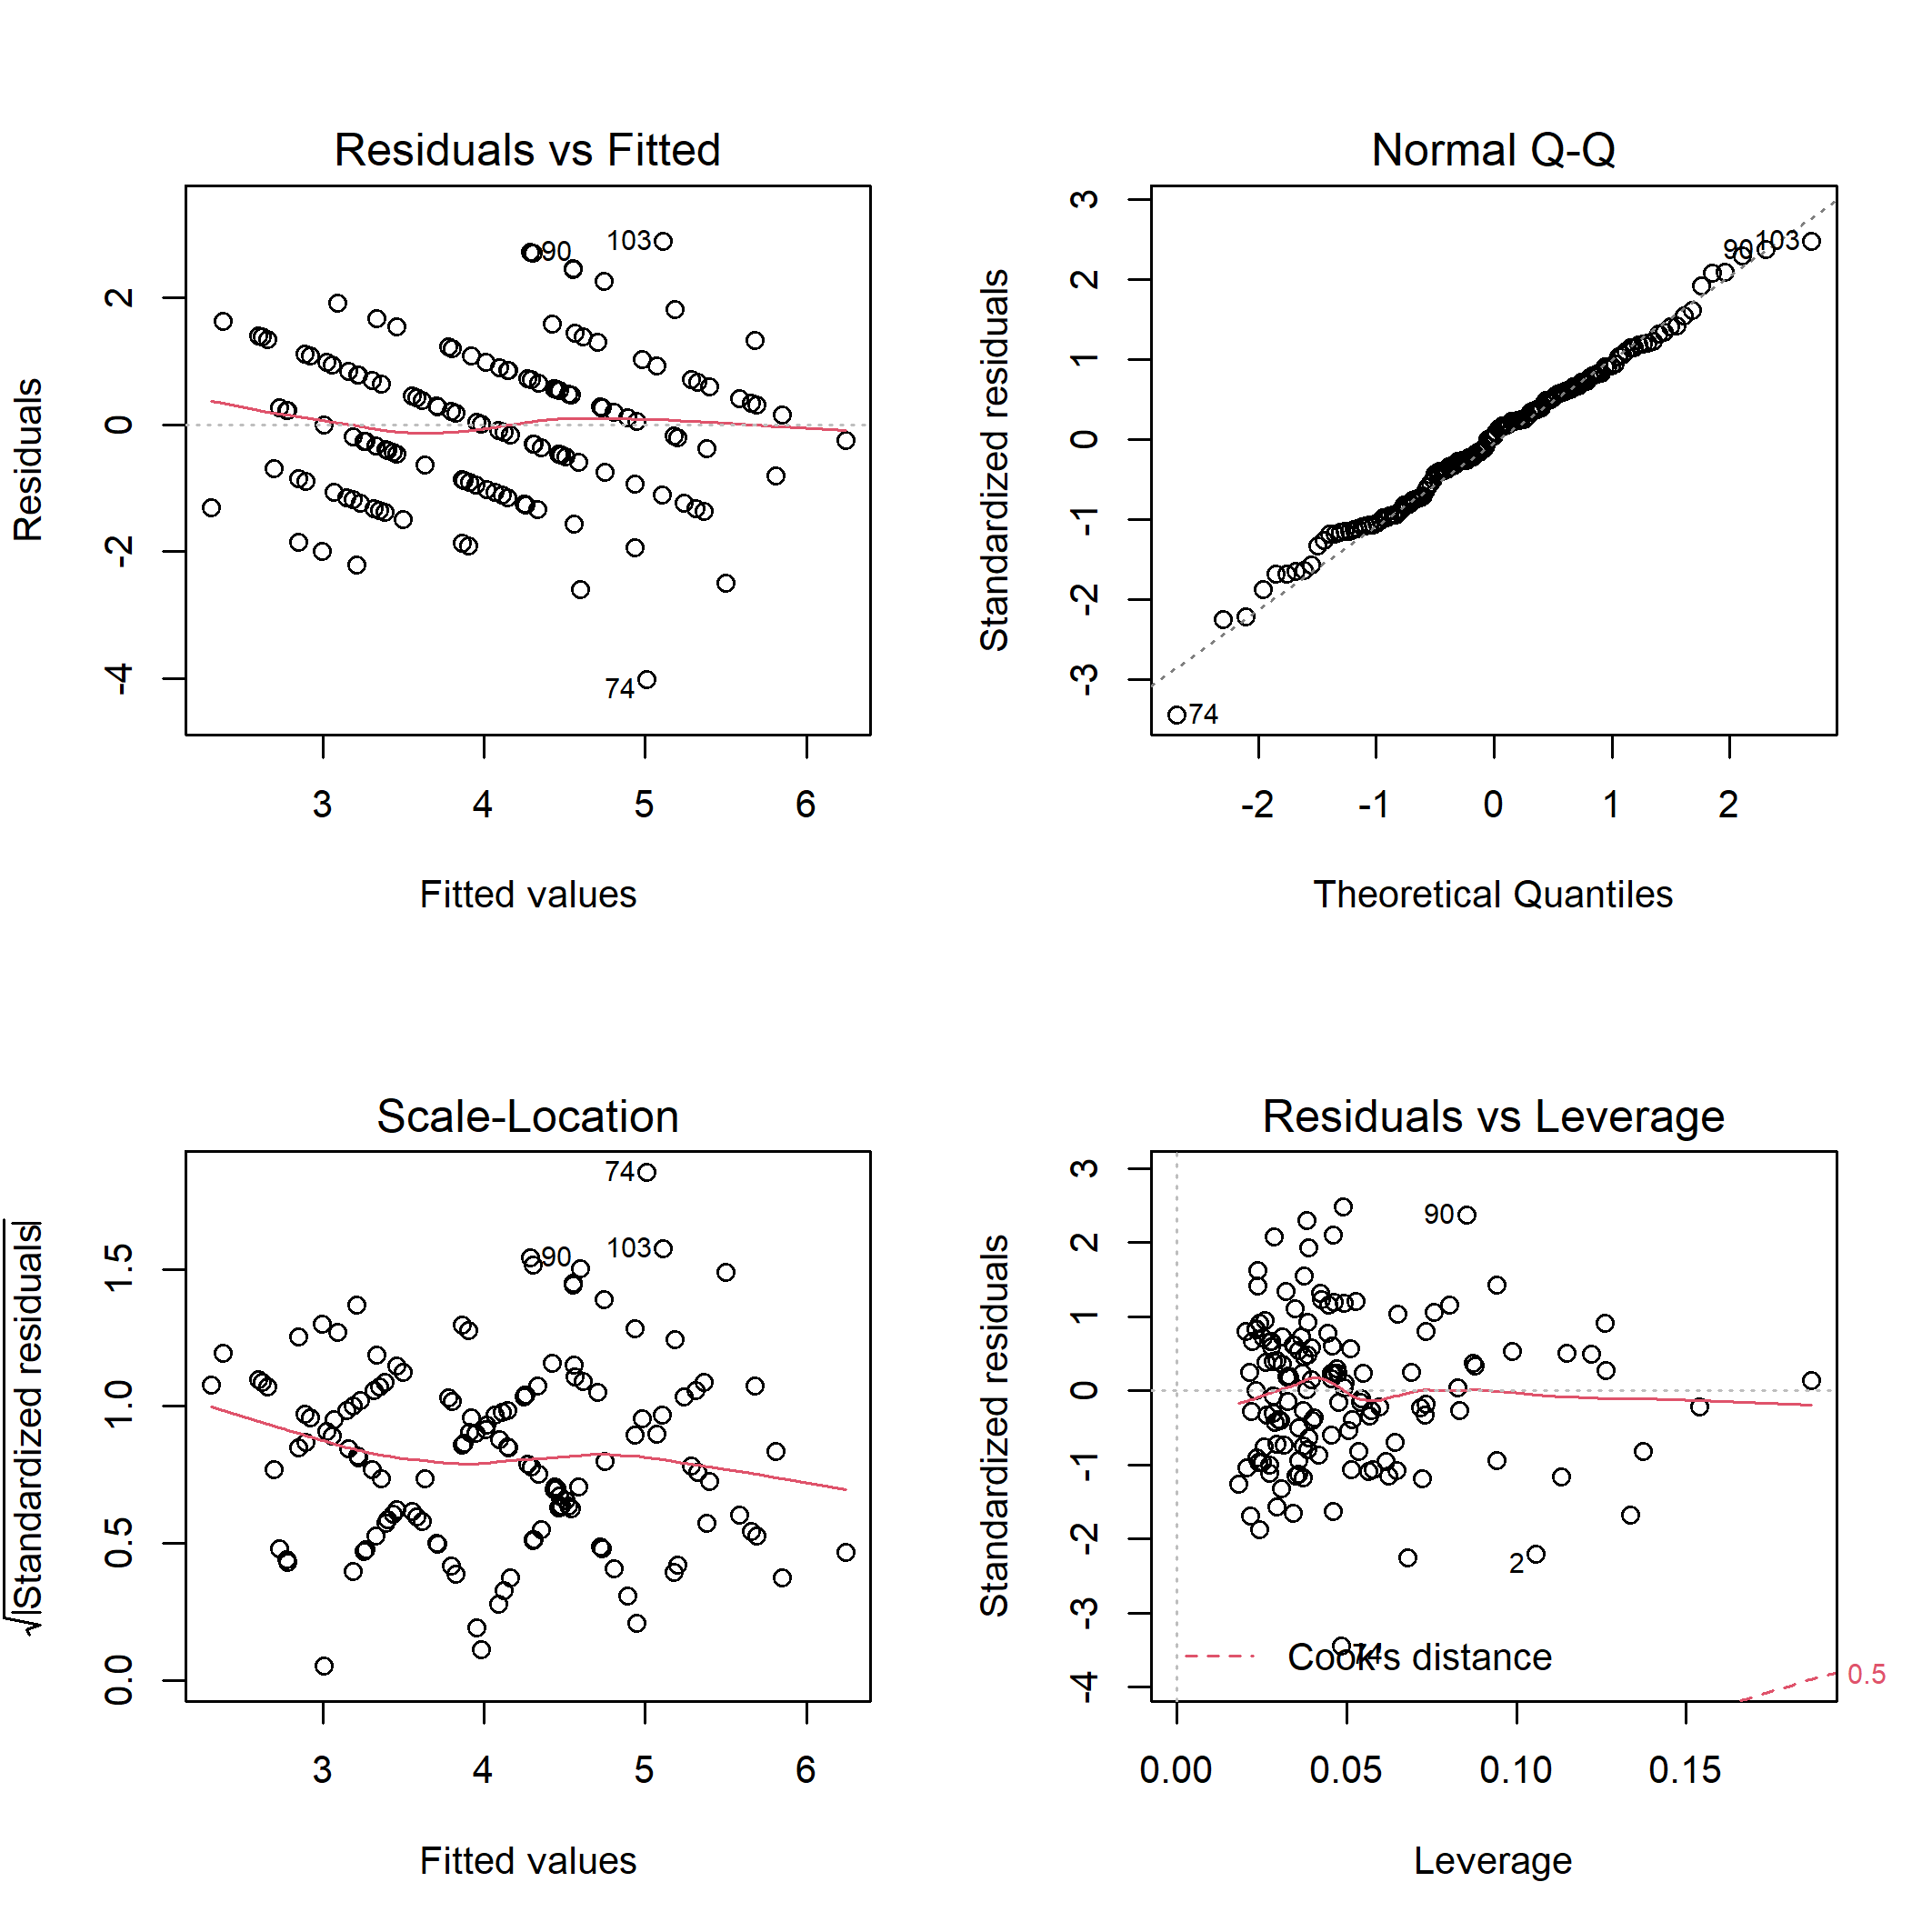

**Figure S23.** Diagnostic plots for linear model of the bird ground/shrub richness on habitat characteristics.

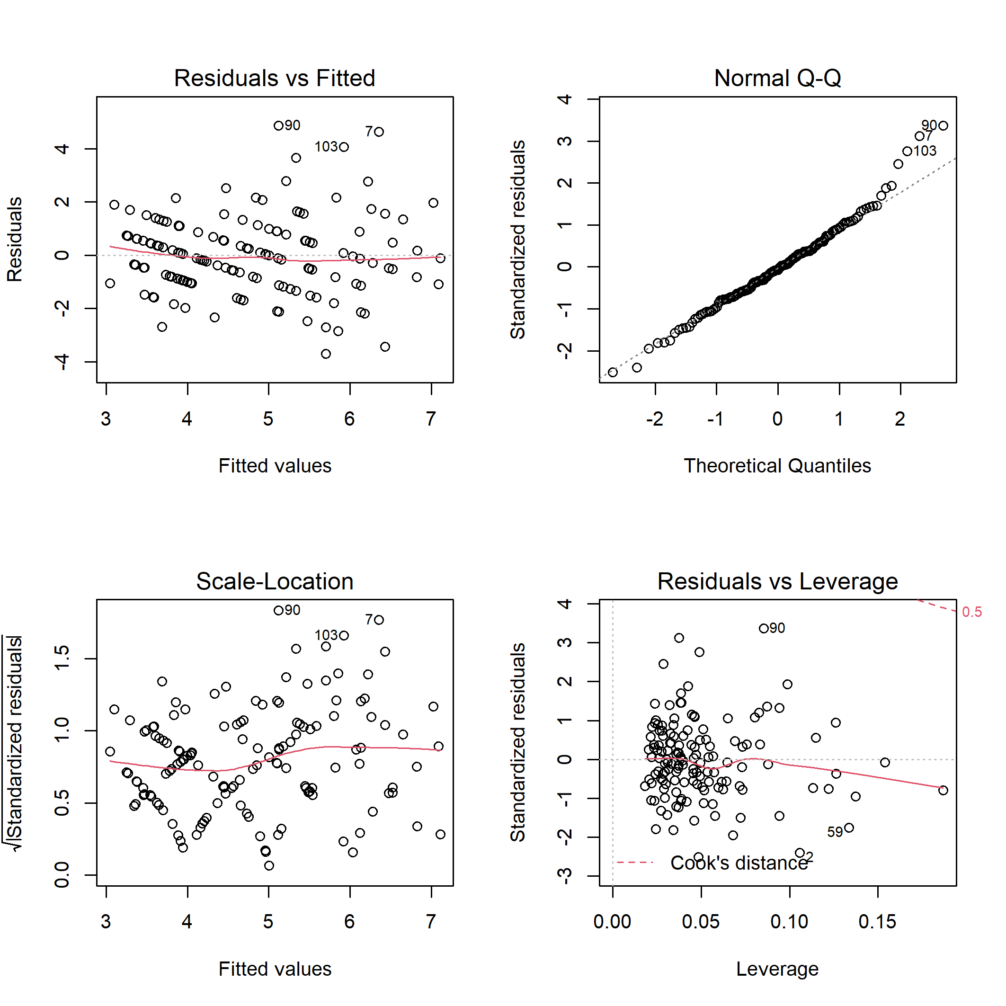

**Figure S24.** Diagnostic plots for linear model of the bird ground/shrub nesters abundance on habitat characteristics.