Title…
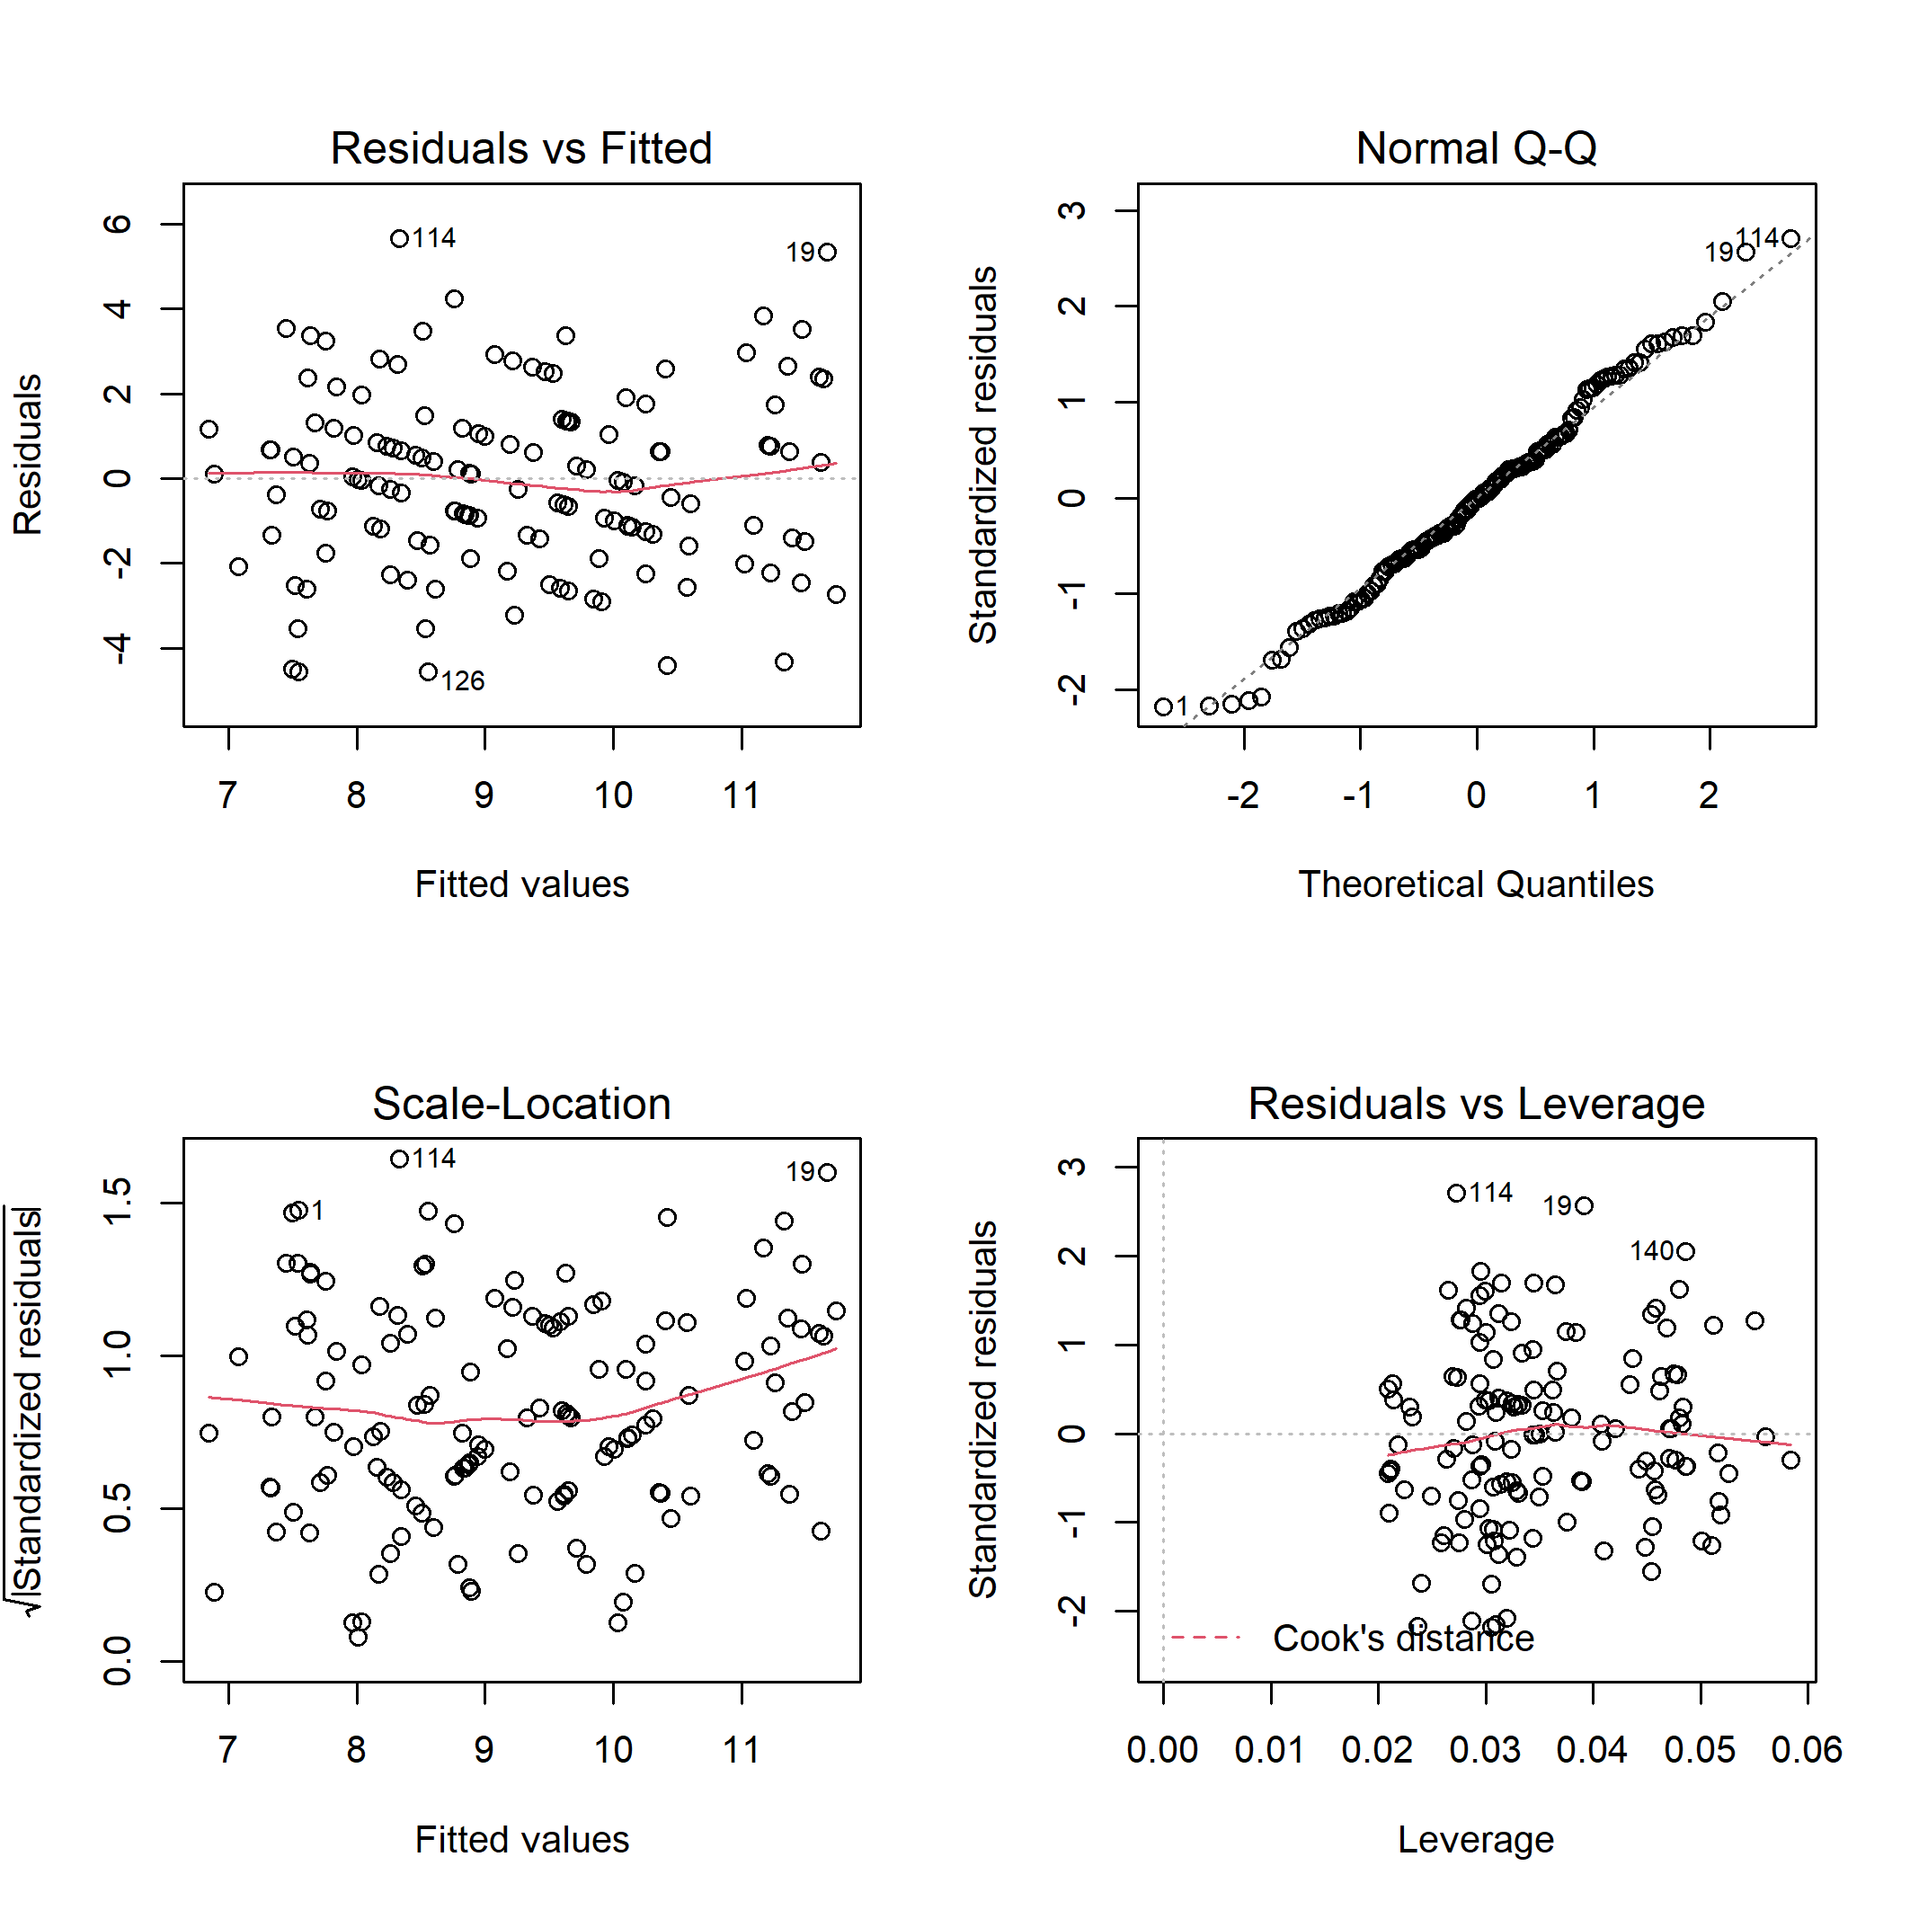
Figure S1. Diagnostic plots for linear model of the total bird species richness on disturbance class and elevation.

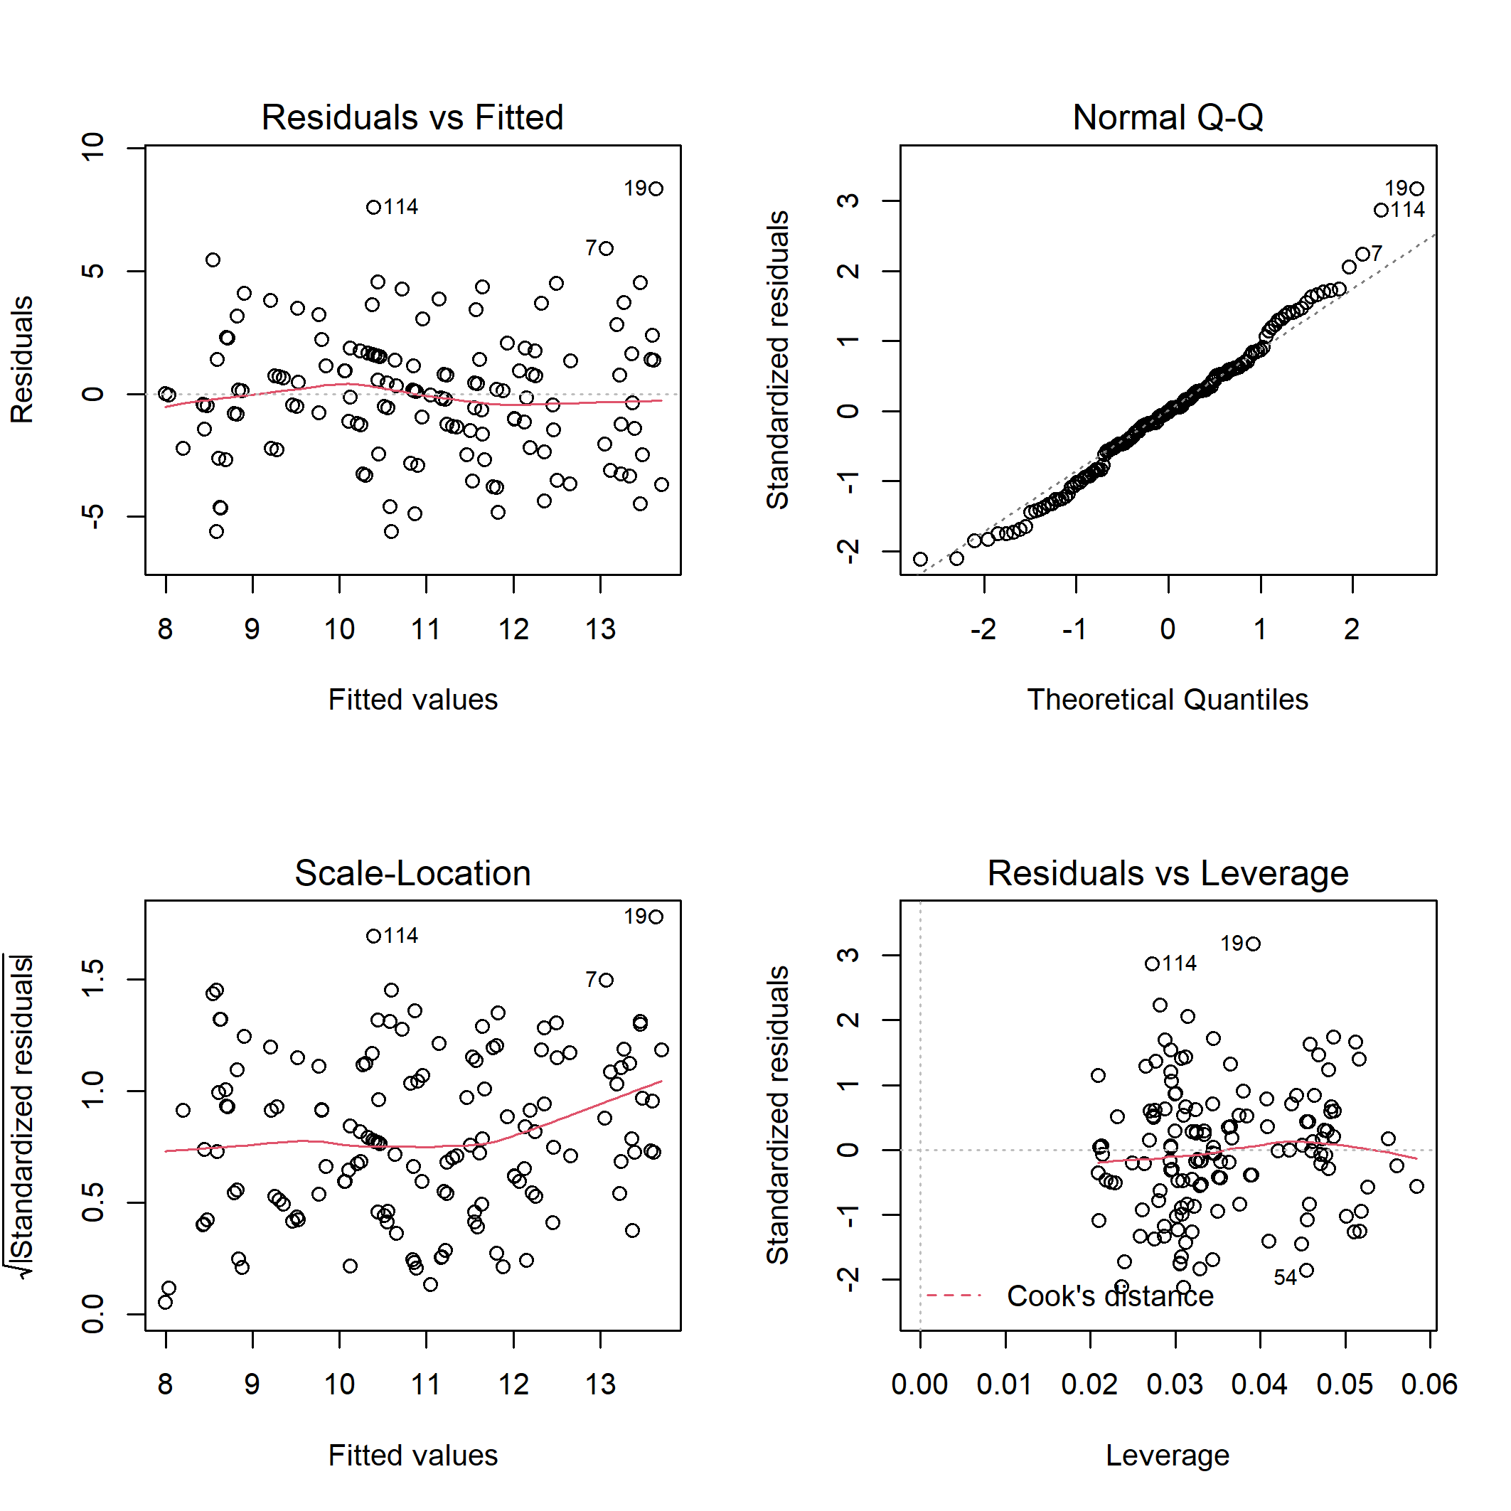
Figure S2. Diagnostic plots for linear model of the total bird species abundance on disturbance class and elevation.

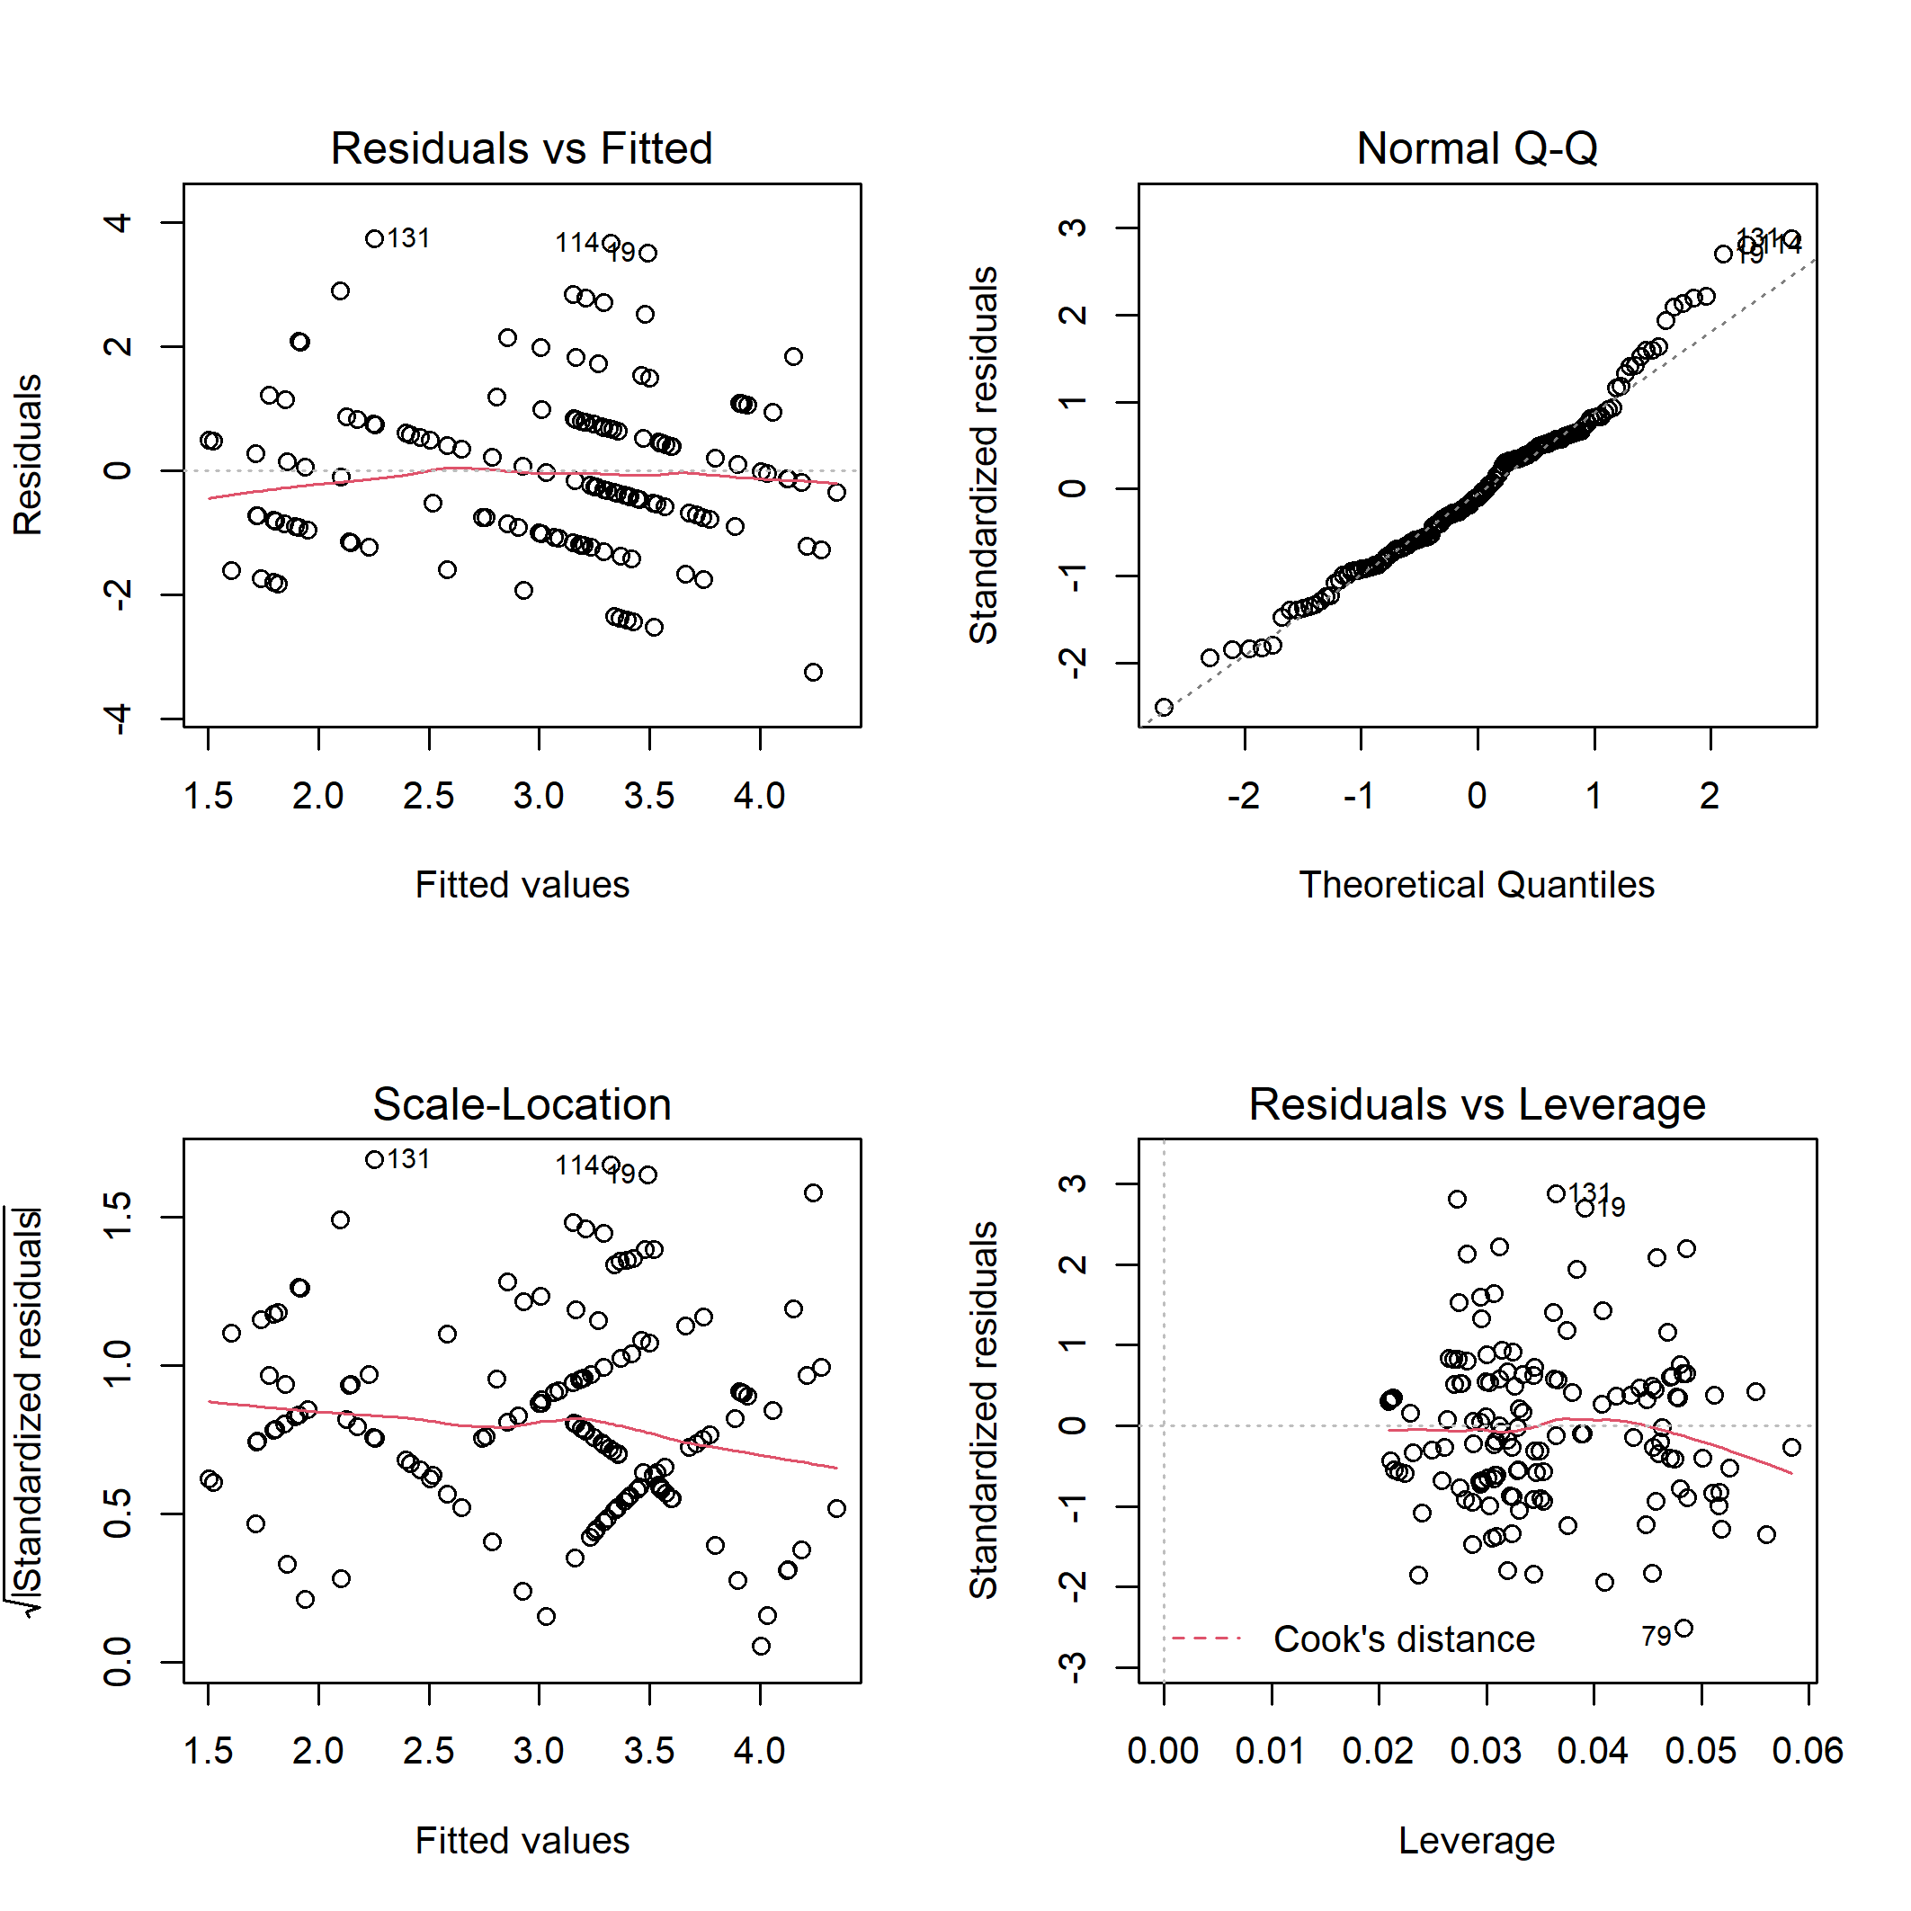
Figure S3. Diagnostic plots for linear model of the bird specialist species richness on disturbance class and elevation.

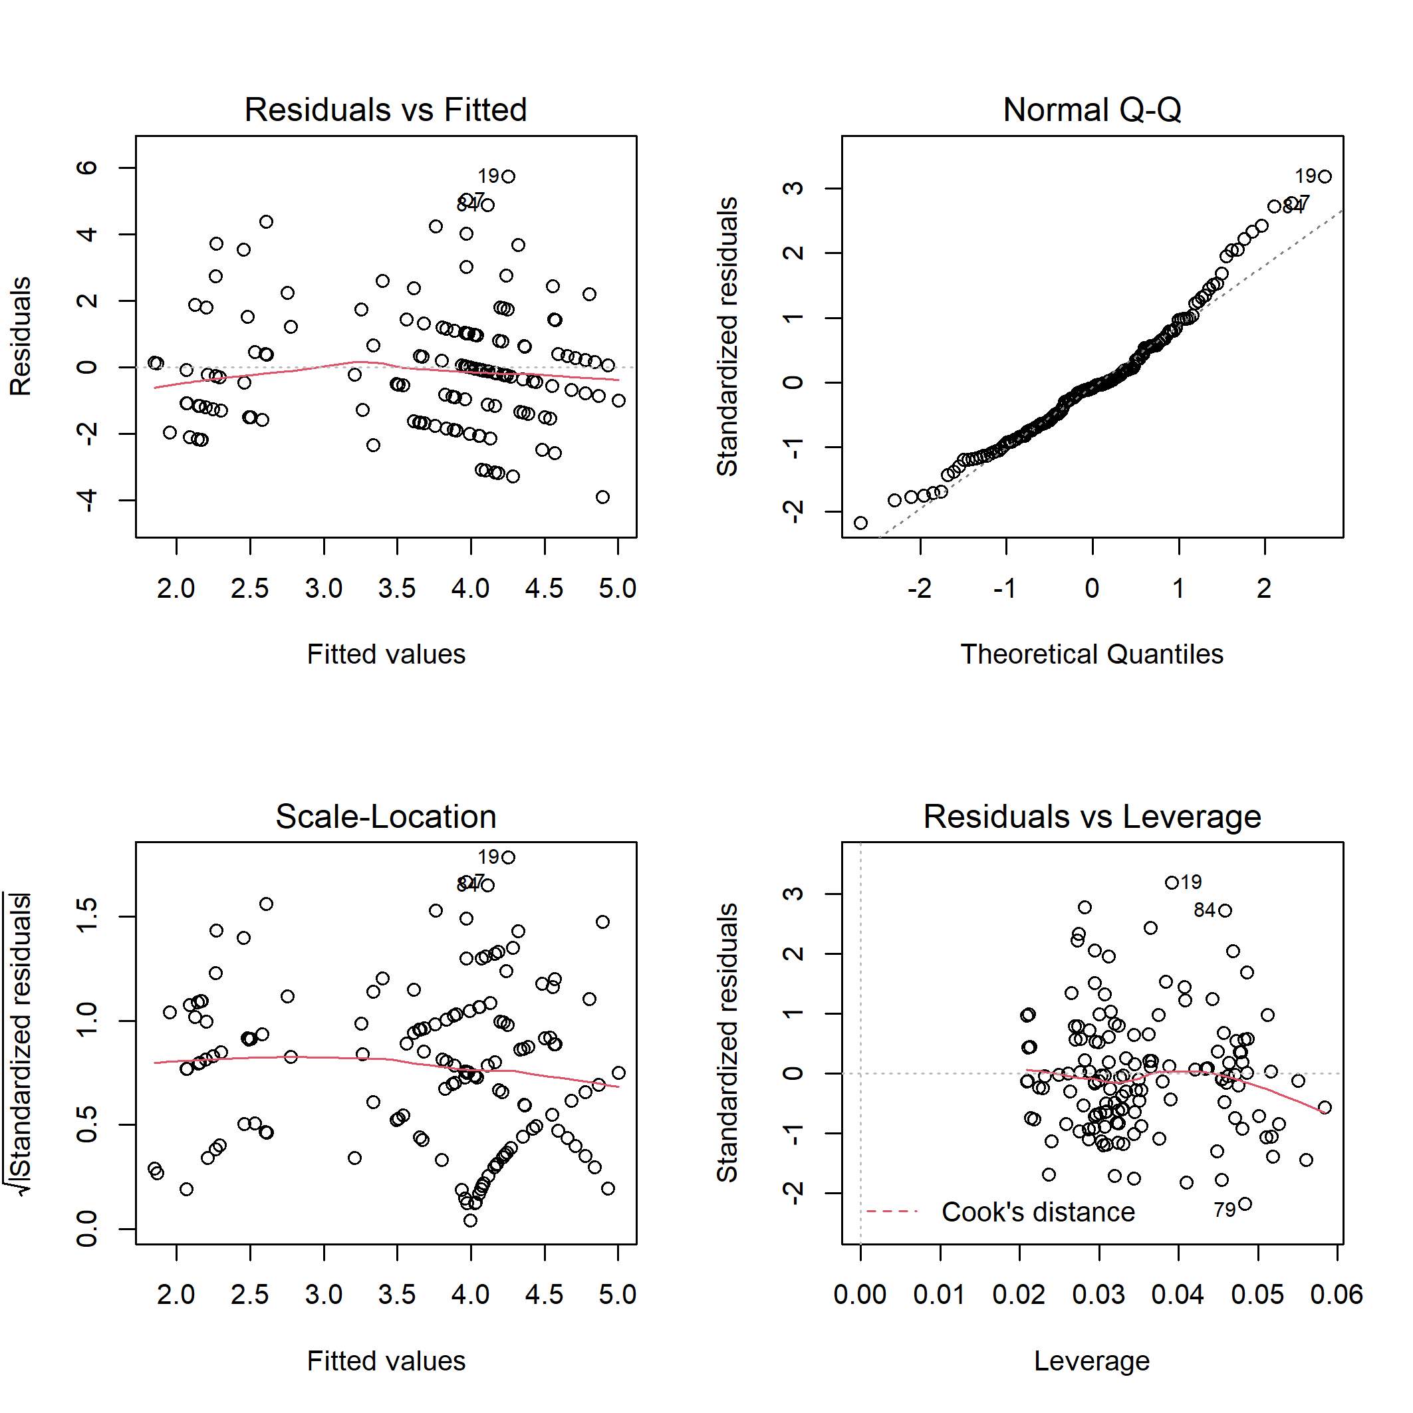
Figure S4. Diagnostic plots for linear model of the bird specialist species abundance on disturbance class and elevation.

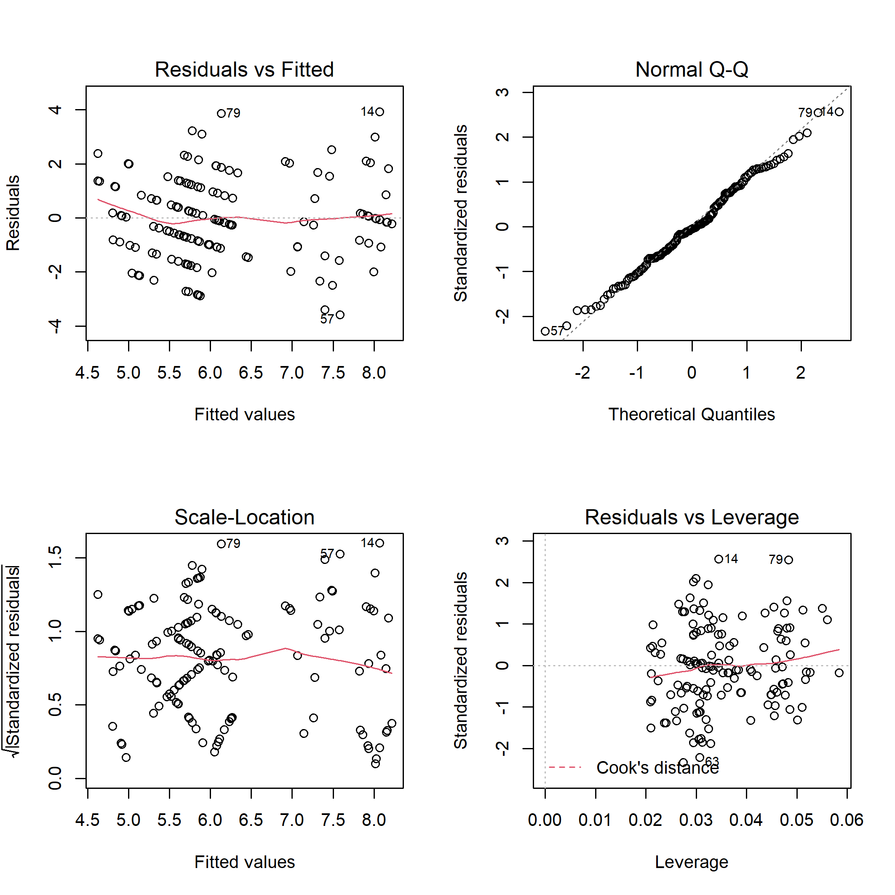
Figure S5. Diagnostic plots for linear model of the bird generalist species richness on disturbance class and elevation.

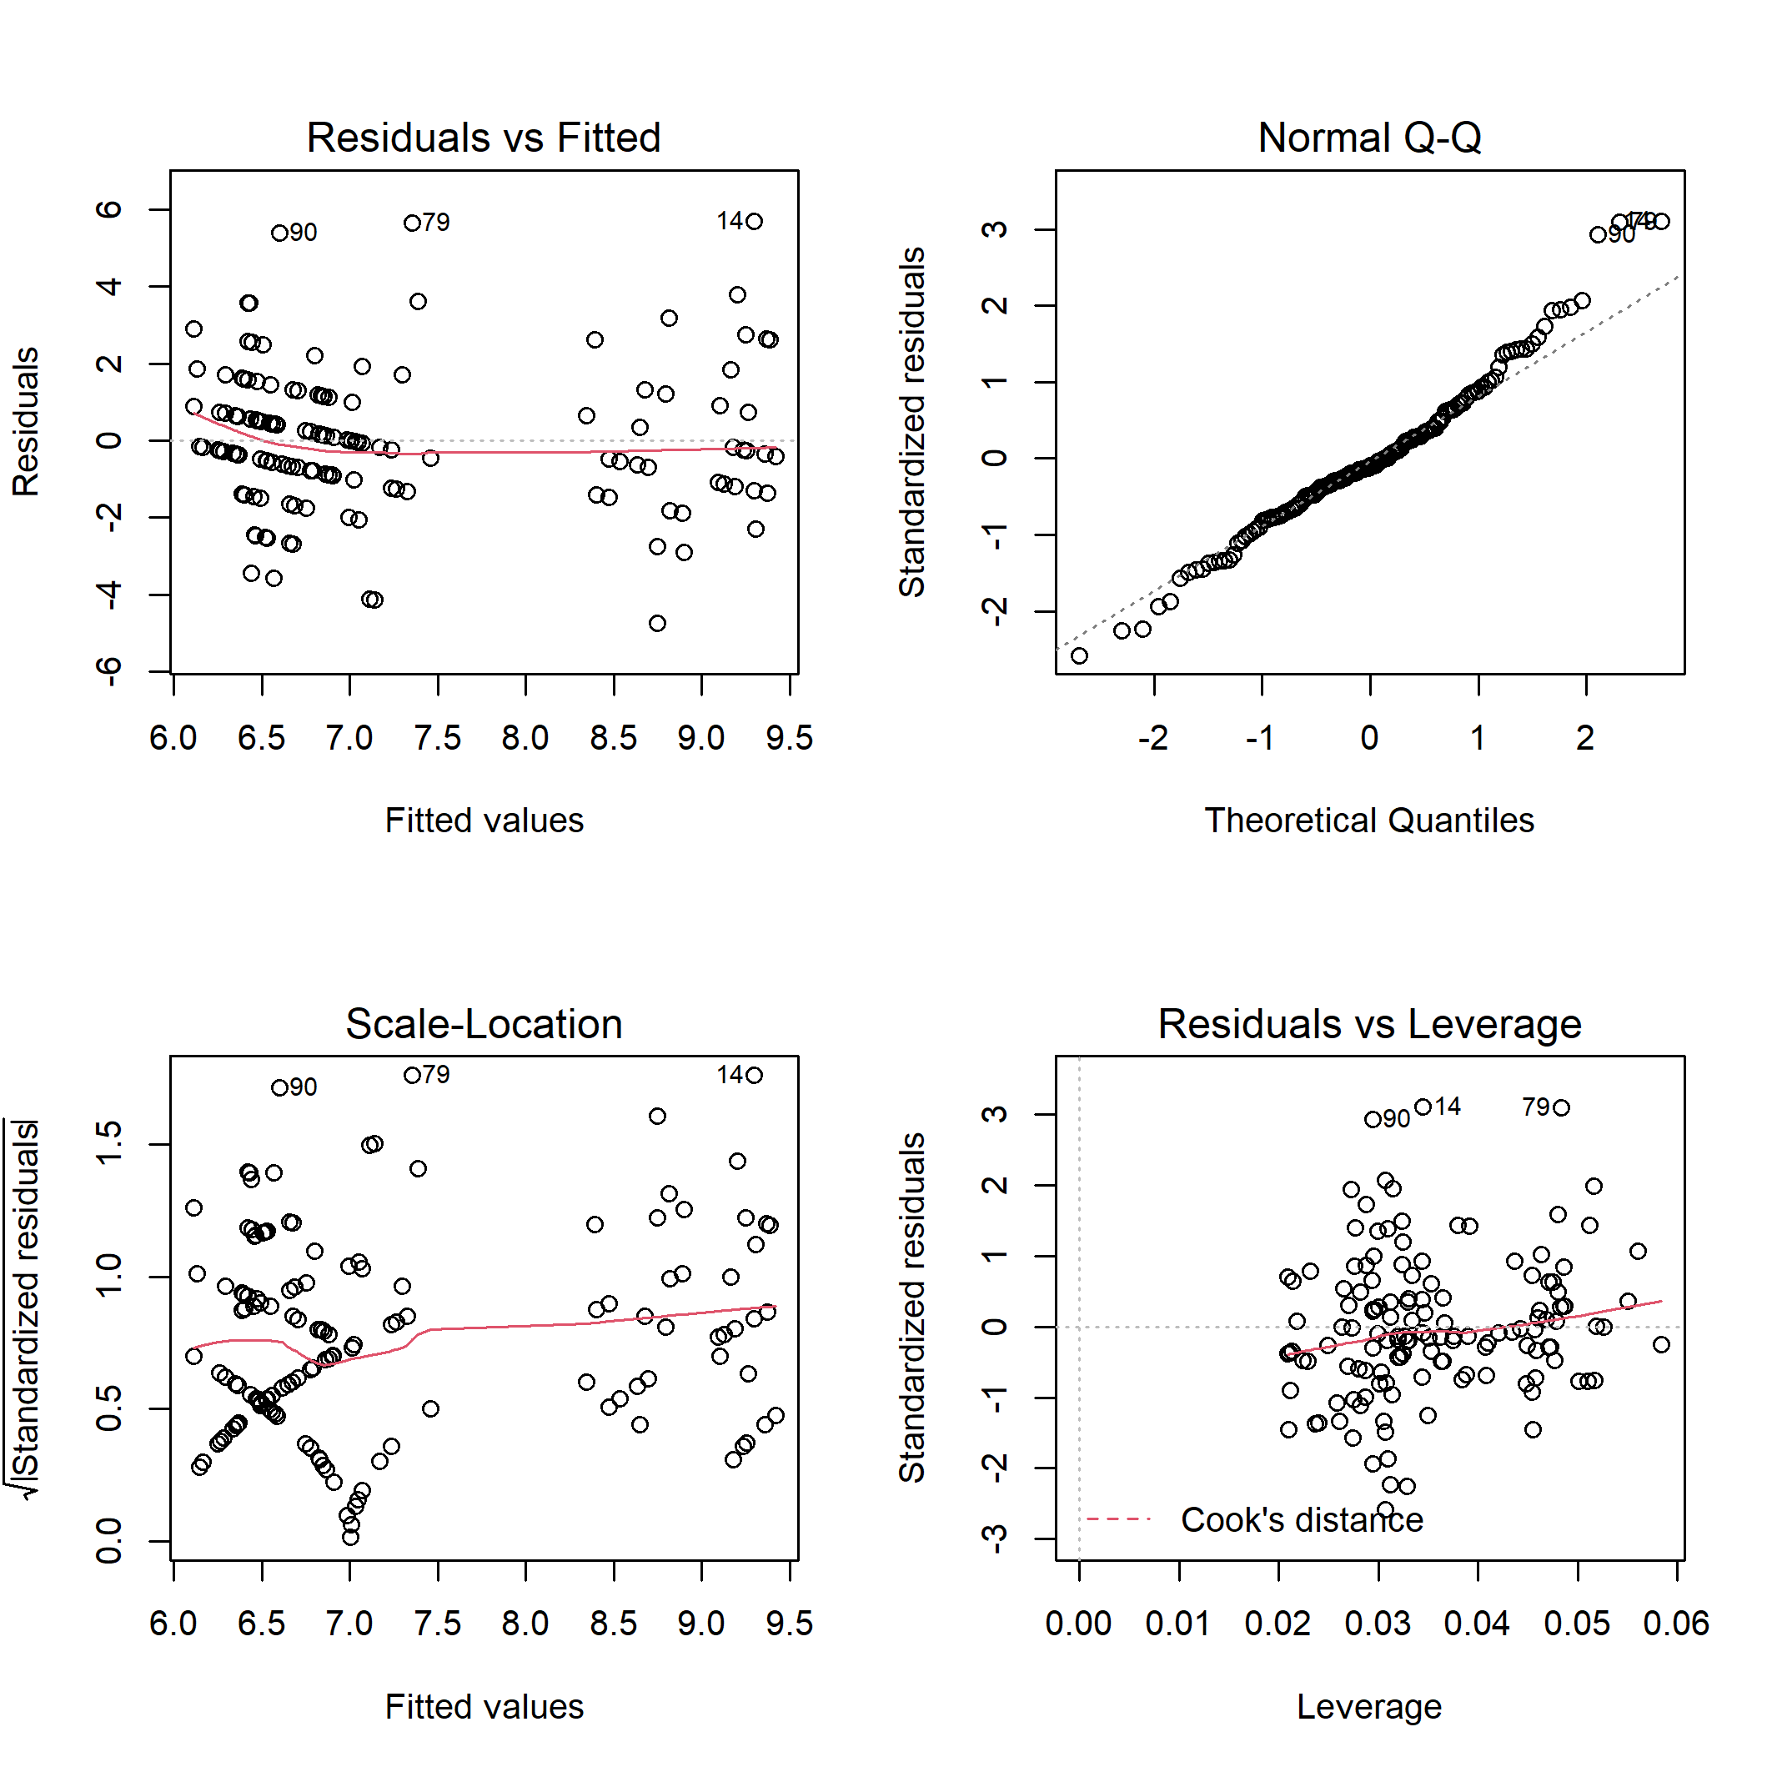
Figure S6. Diagnostic plots for linear model of the bird generalist species abundance on disturbance class and elevation.

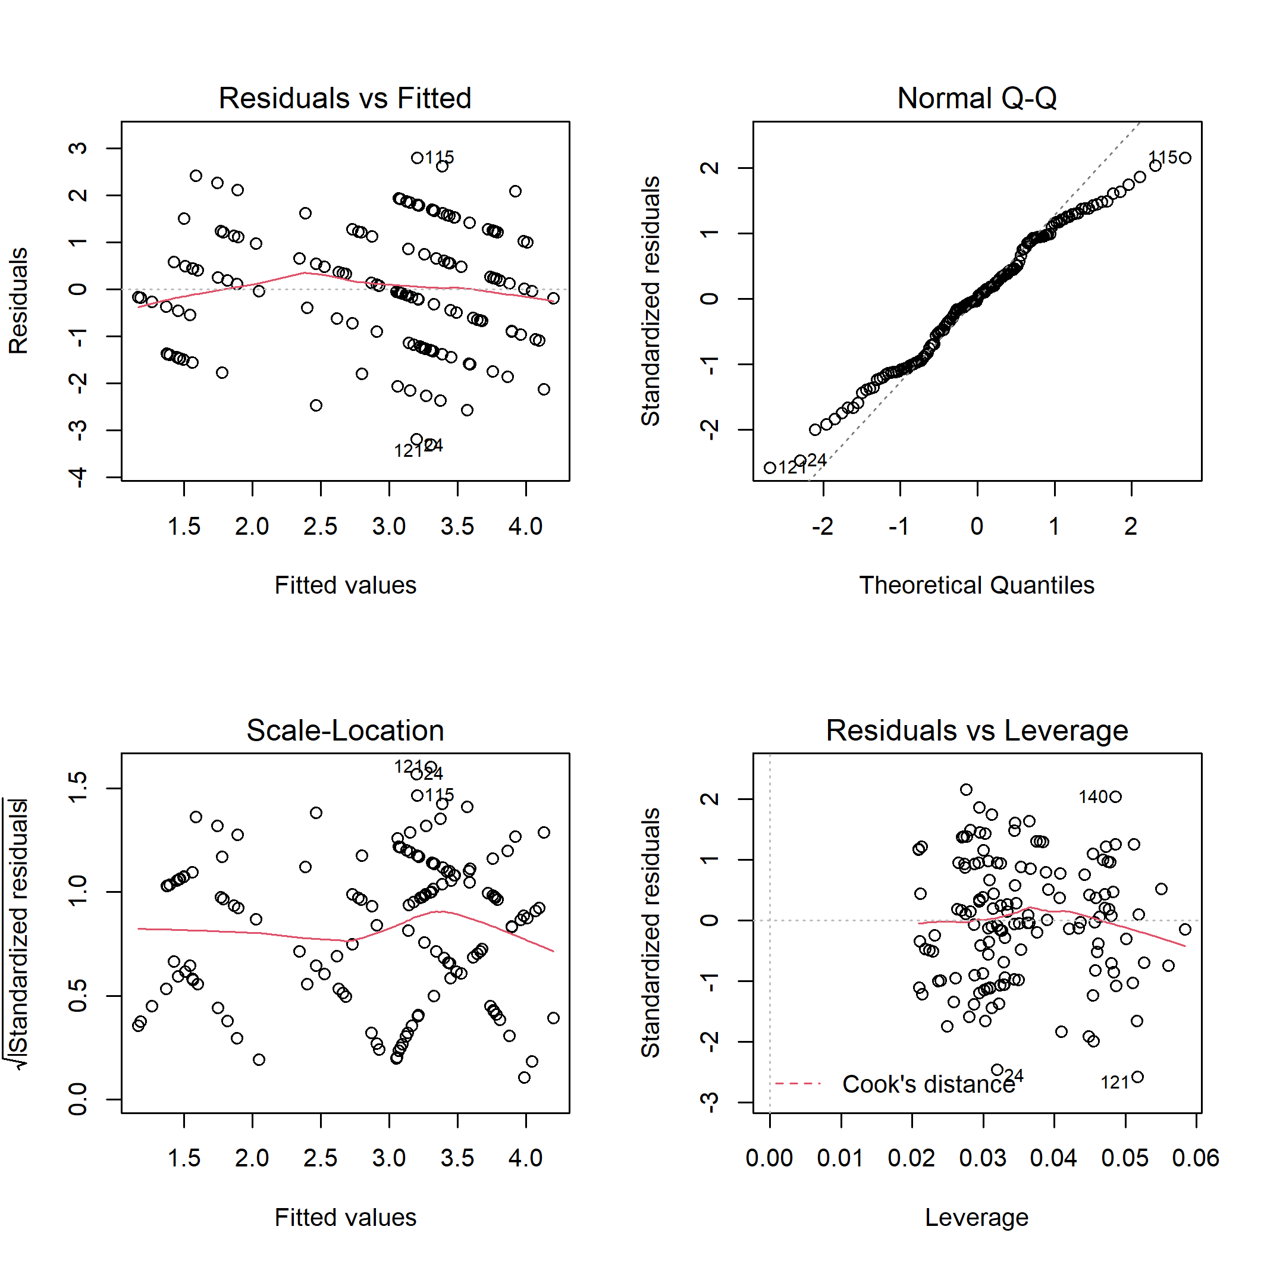
Figure S7. Diagnostic plots for linear model of the bird canopy nesters richness on disturbance class and elevation.

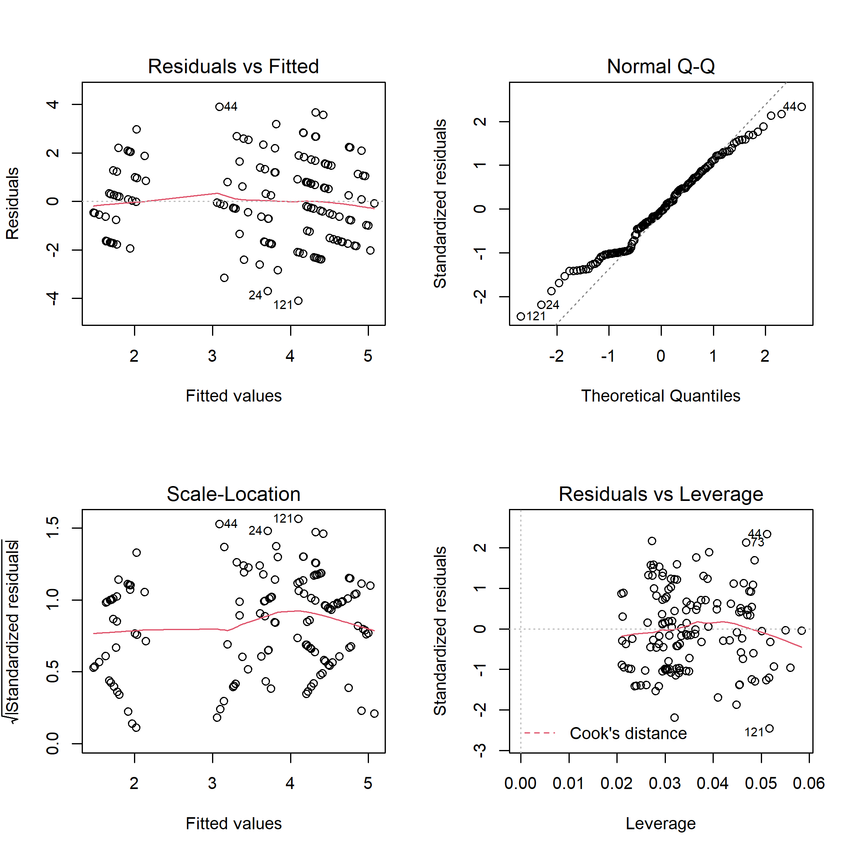
Figure S8. Diagnostic plots for linear model of the bird canopy nesters abundance on disturbance class and elevation.

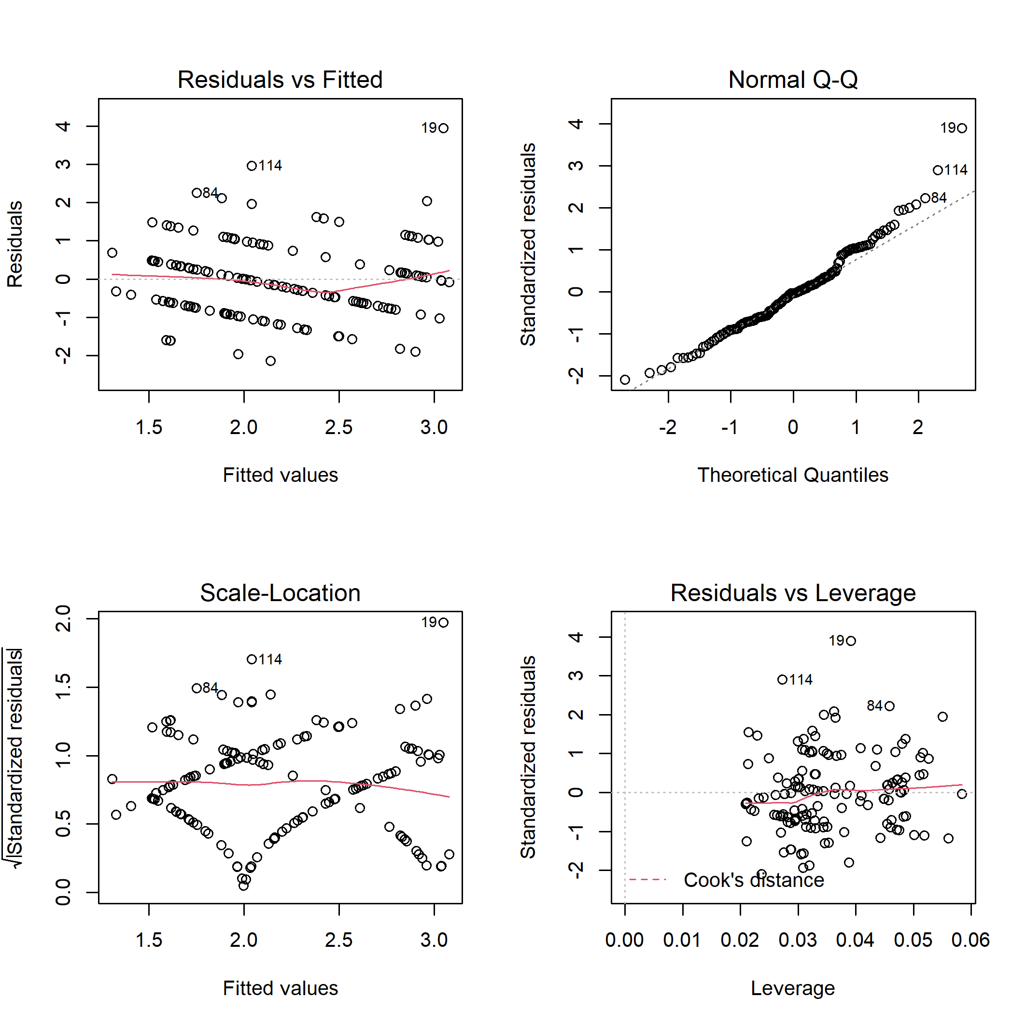
Figure S9. Diagnostic plots for linear model of the bird cavity nesters richness on disturbance class and elevation.

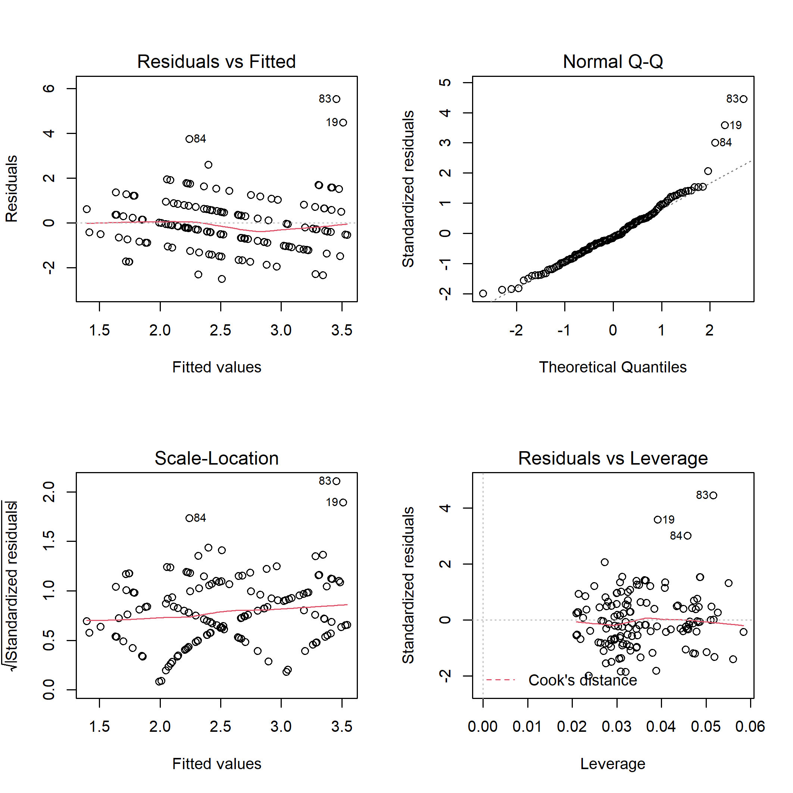
Figure S10. Diagnostic plots for linear model of the bird cavity nesters abundance on disturbance class and elevation.

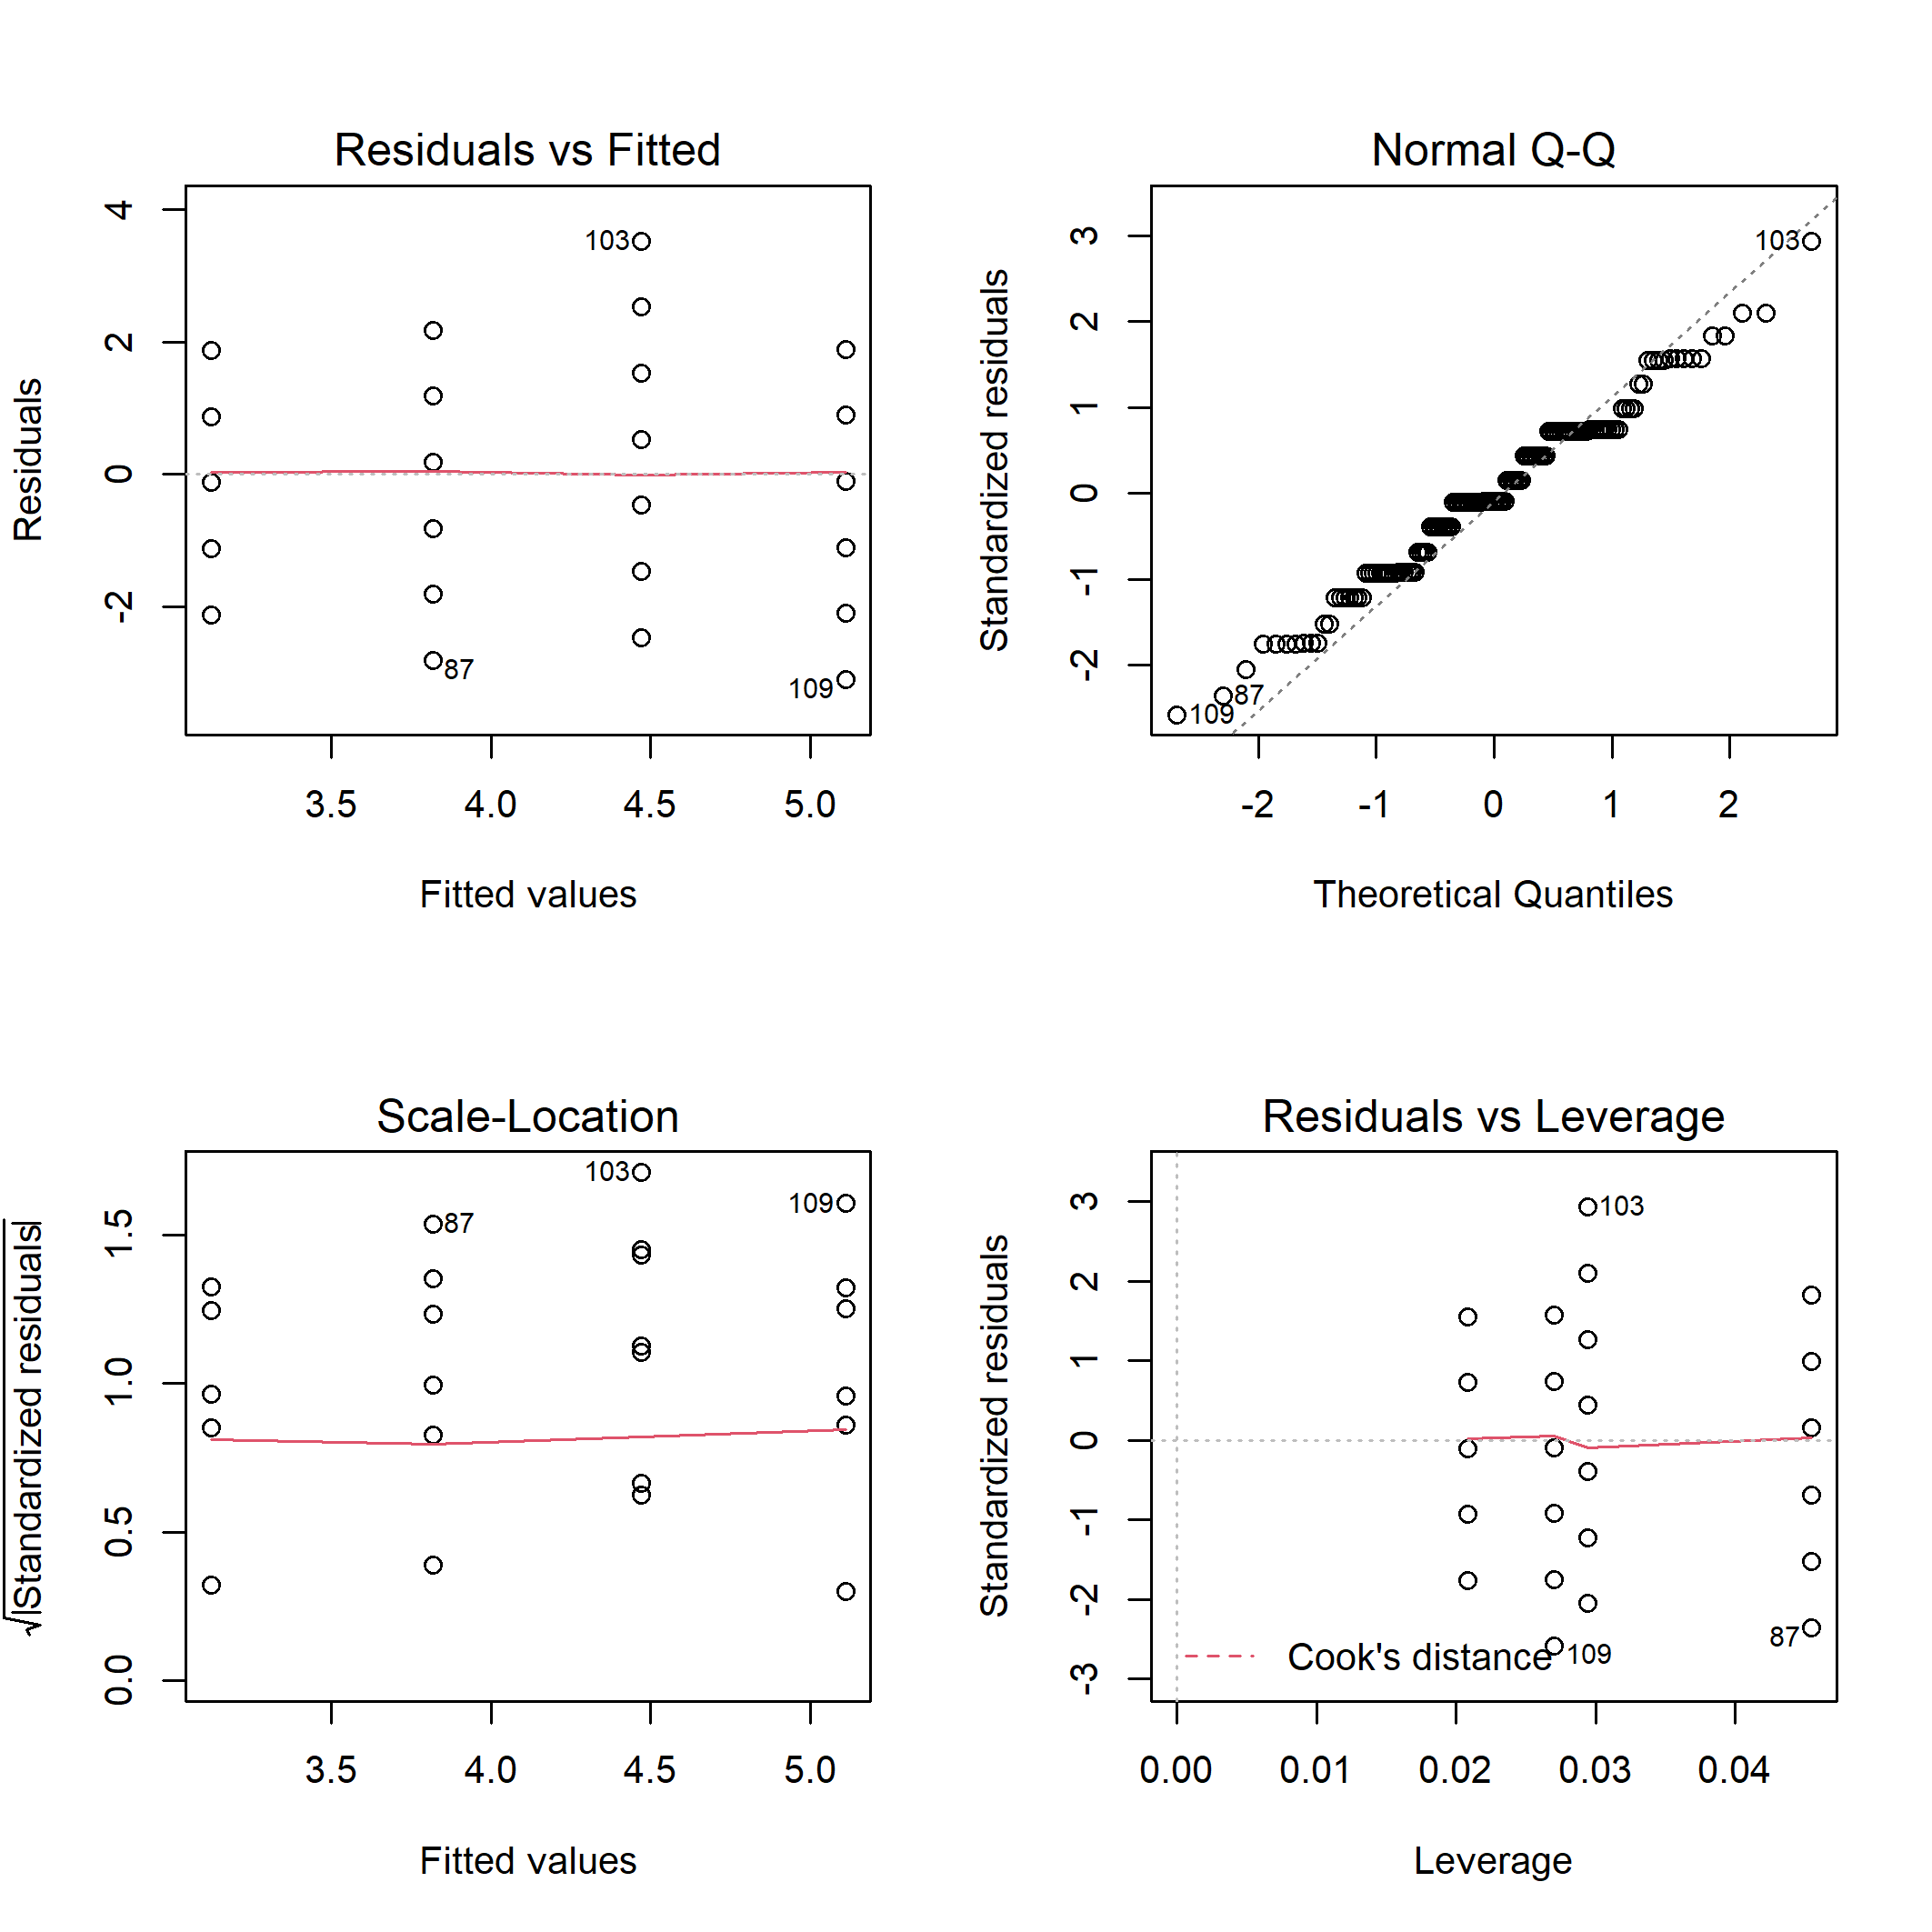
Figure S11. Diagnostic plots for linear model of the bird ground/shrub nesters richness on disturbance class and elevation.

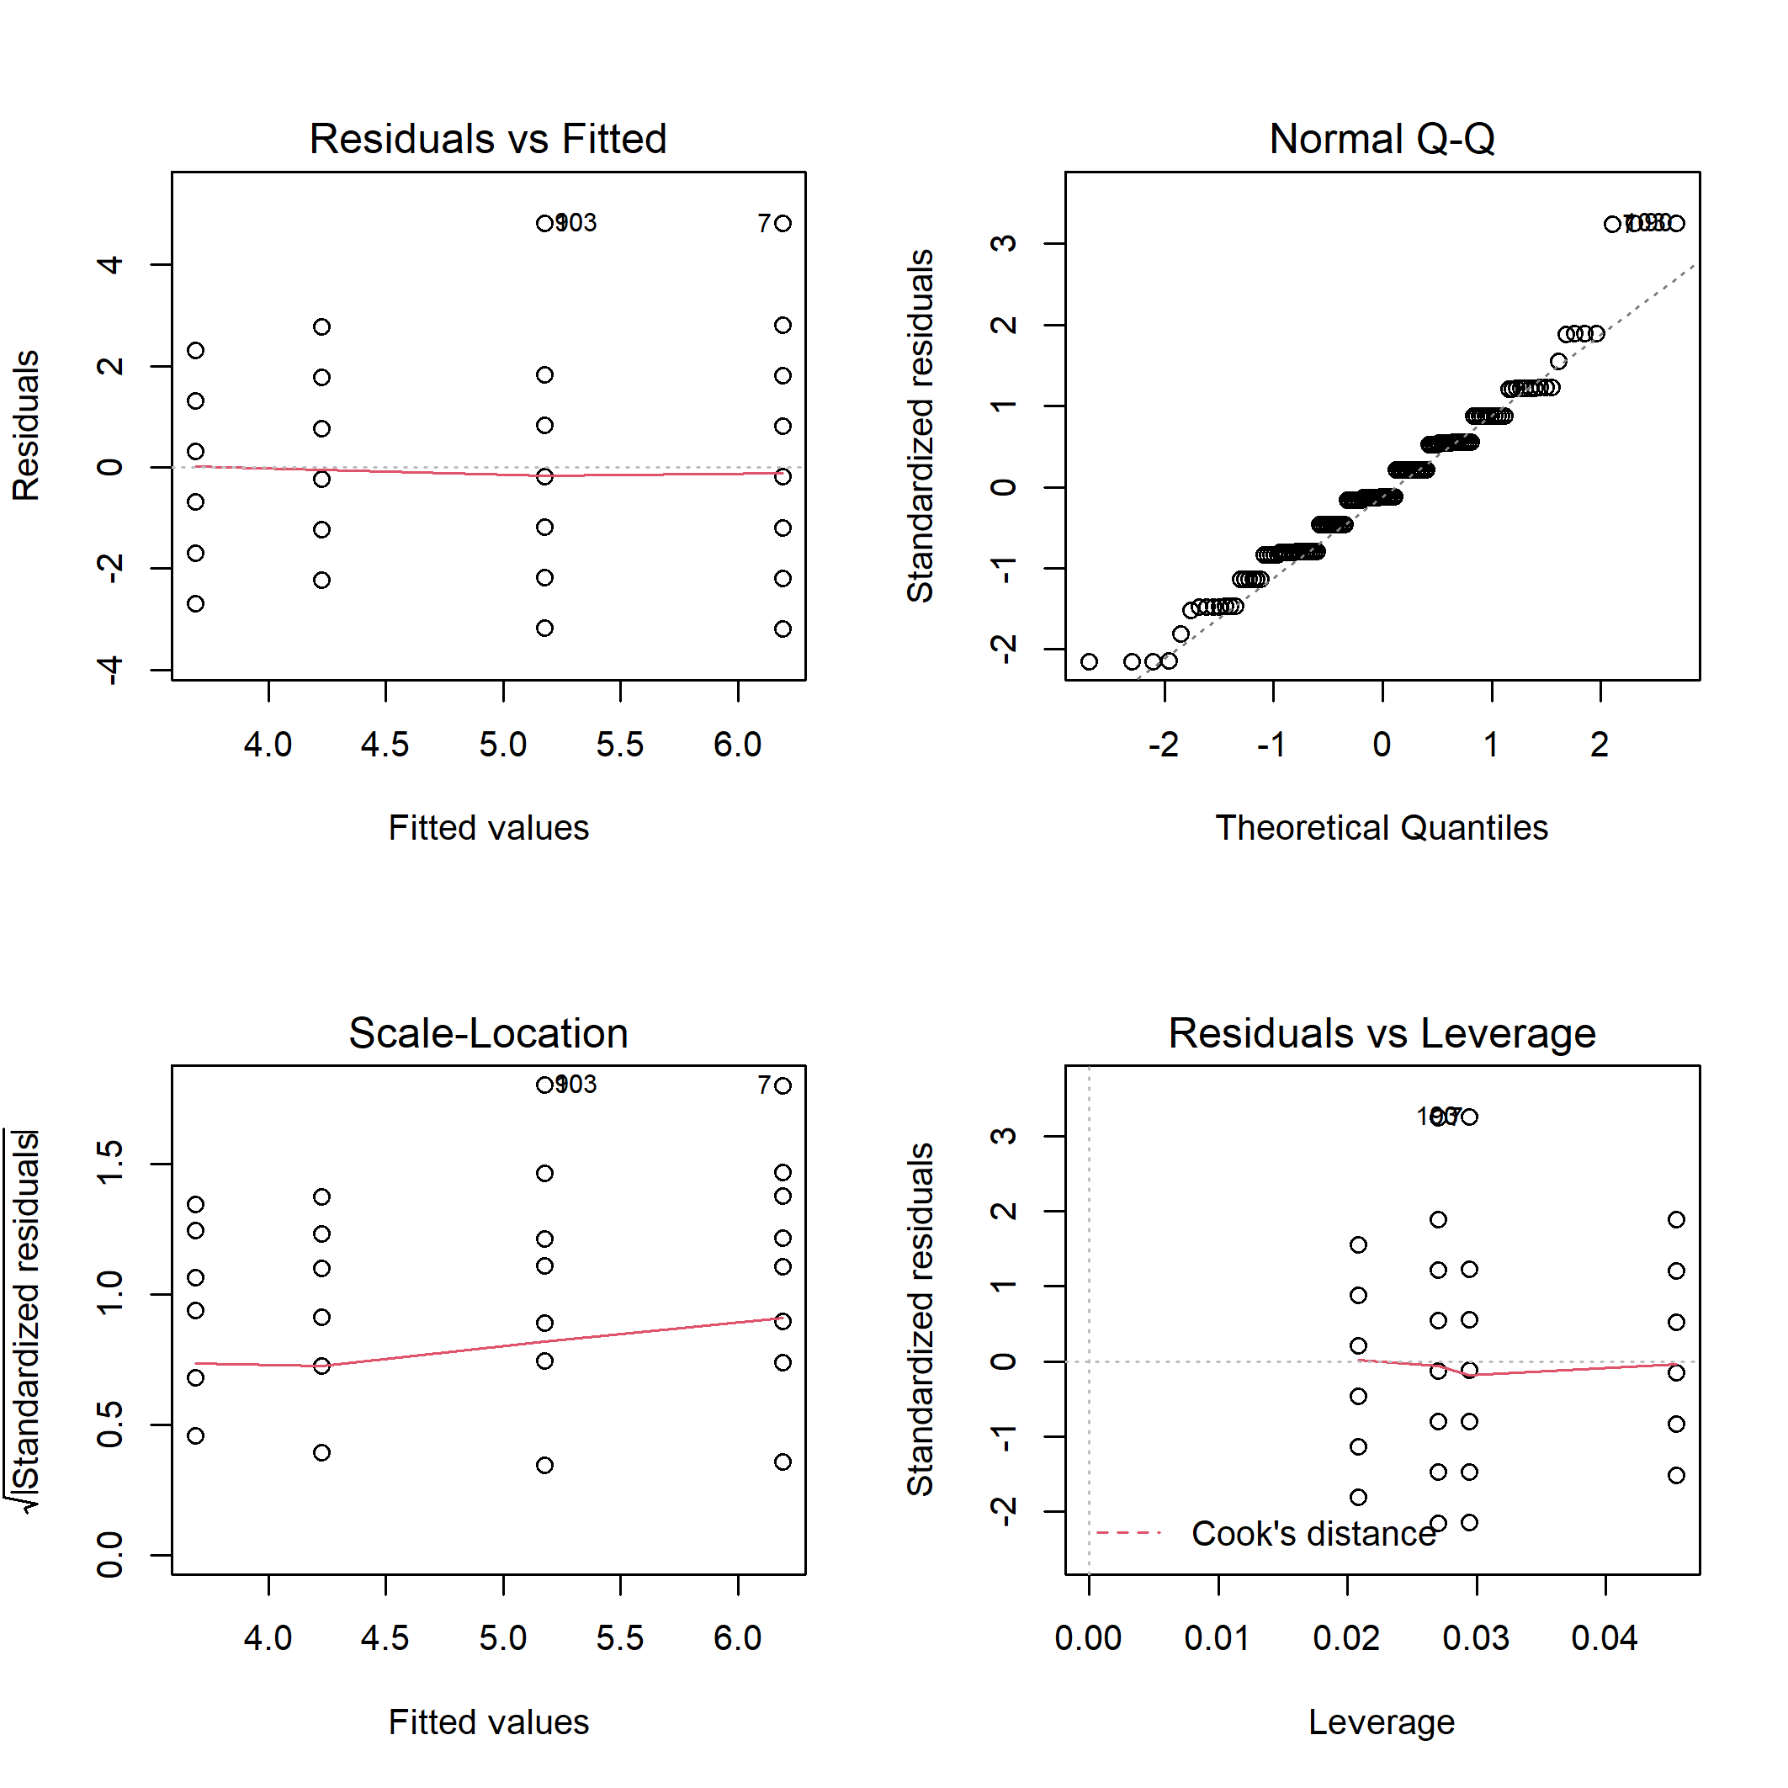
Figure S12. Diagnostic plots for linear model of the bird ground/shrub nesters abundance on disturbance class and elevation.

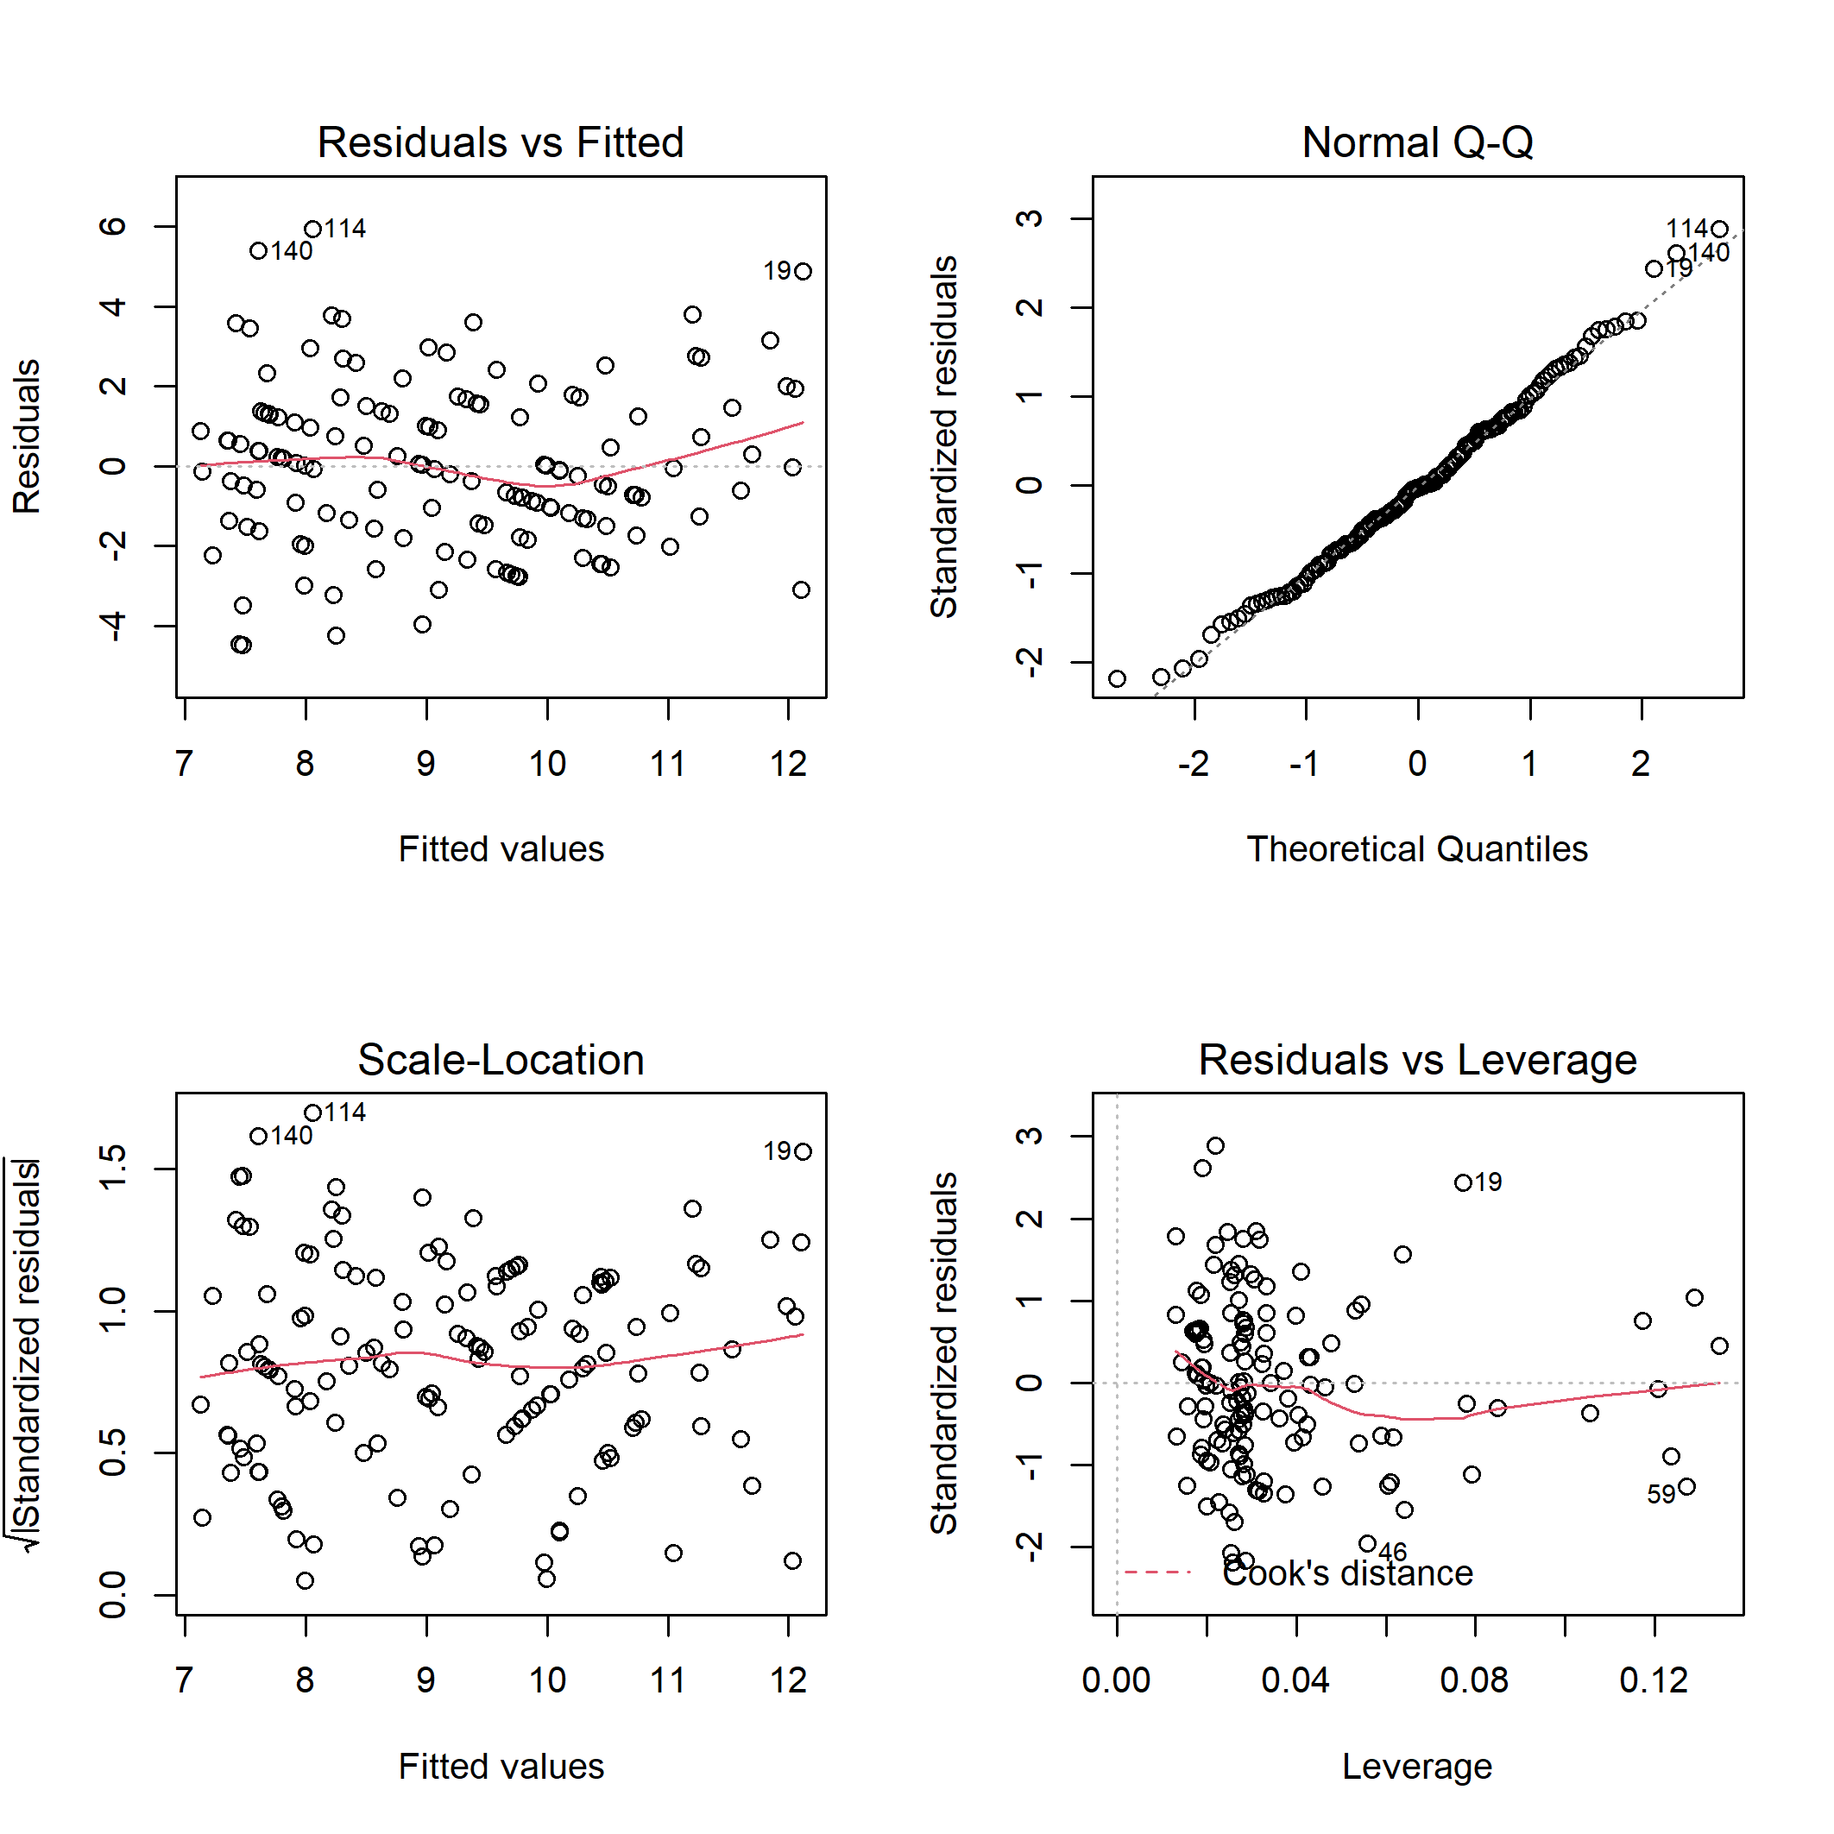
Figure S13. Diagnostic plots for linear model of the total bird species richness on habitat characteristics.

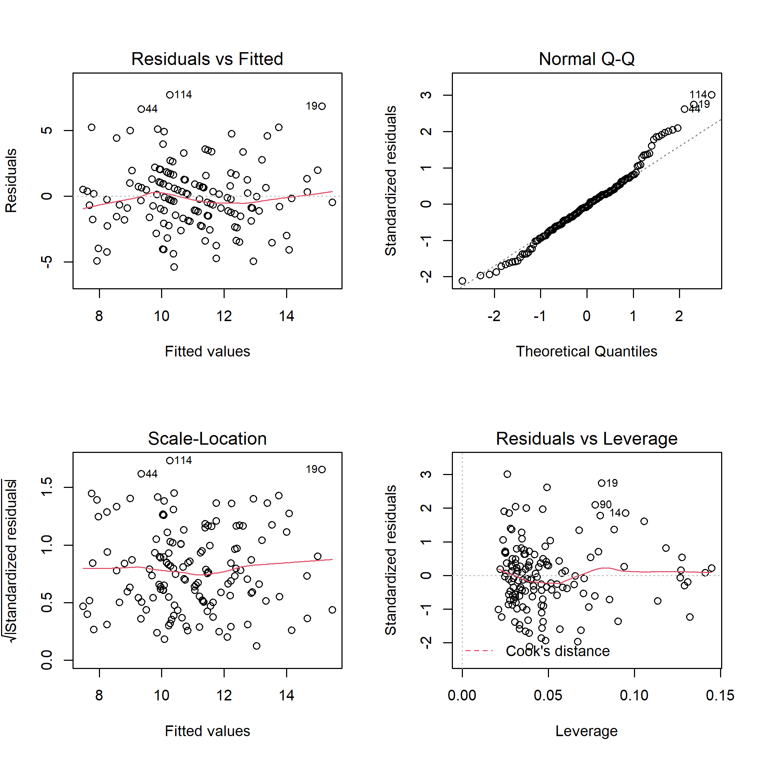
Figure S14. Diagnostic plots for linear model of the total bird species abundance on habitat characteristics.

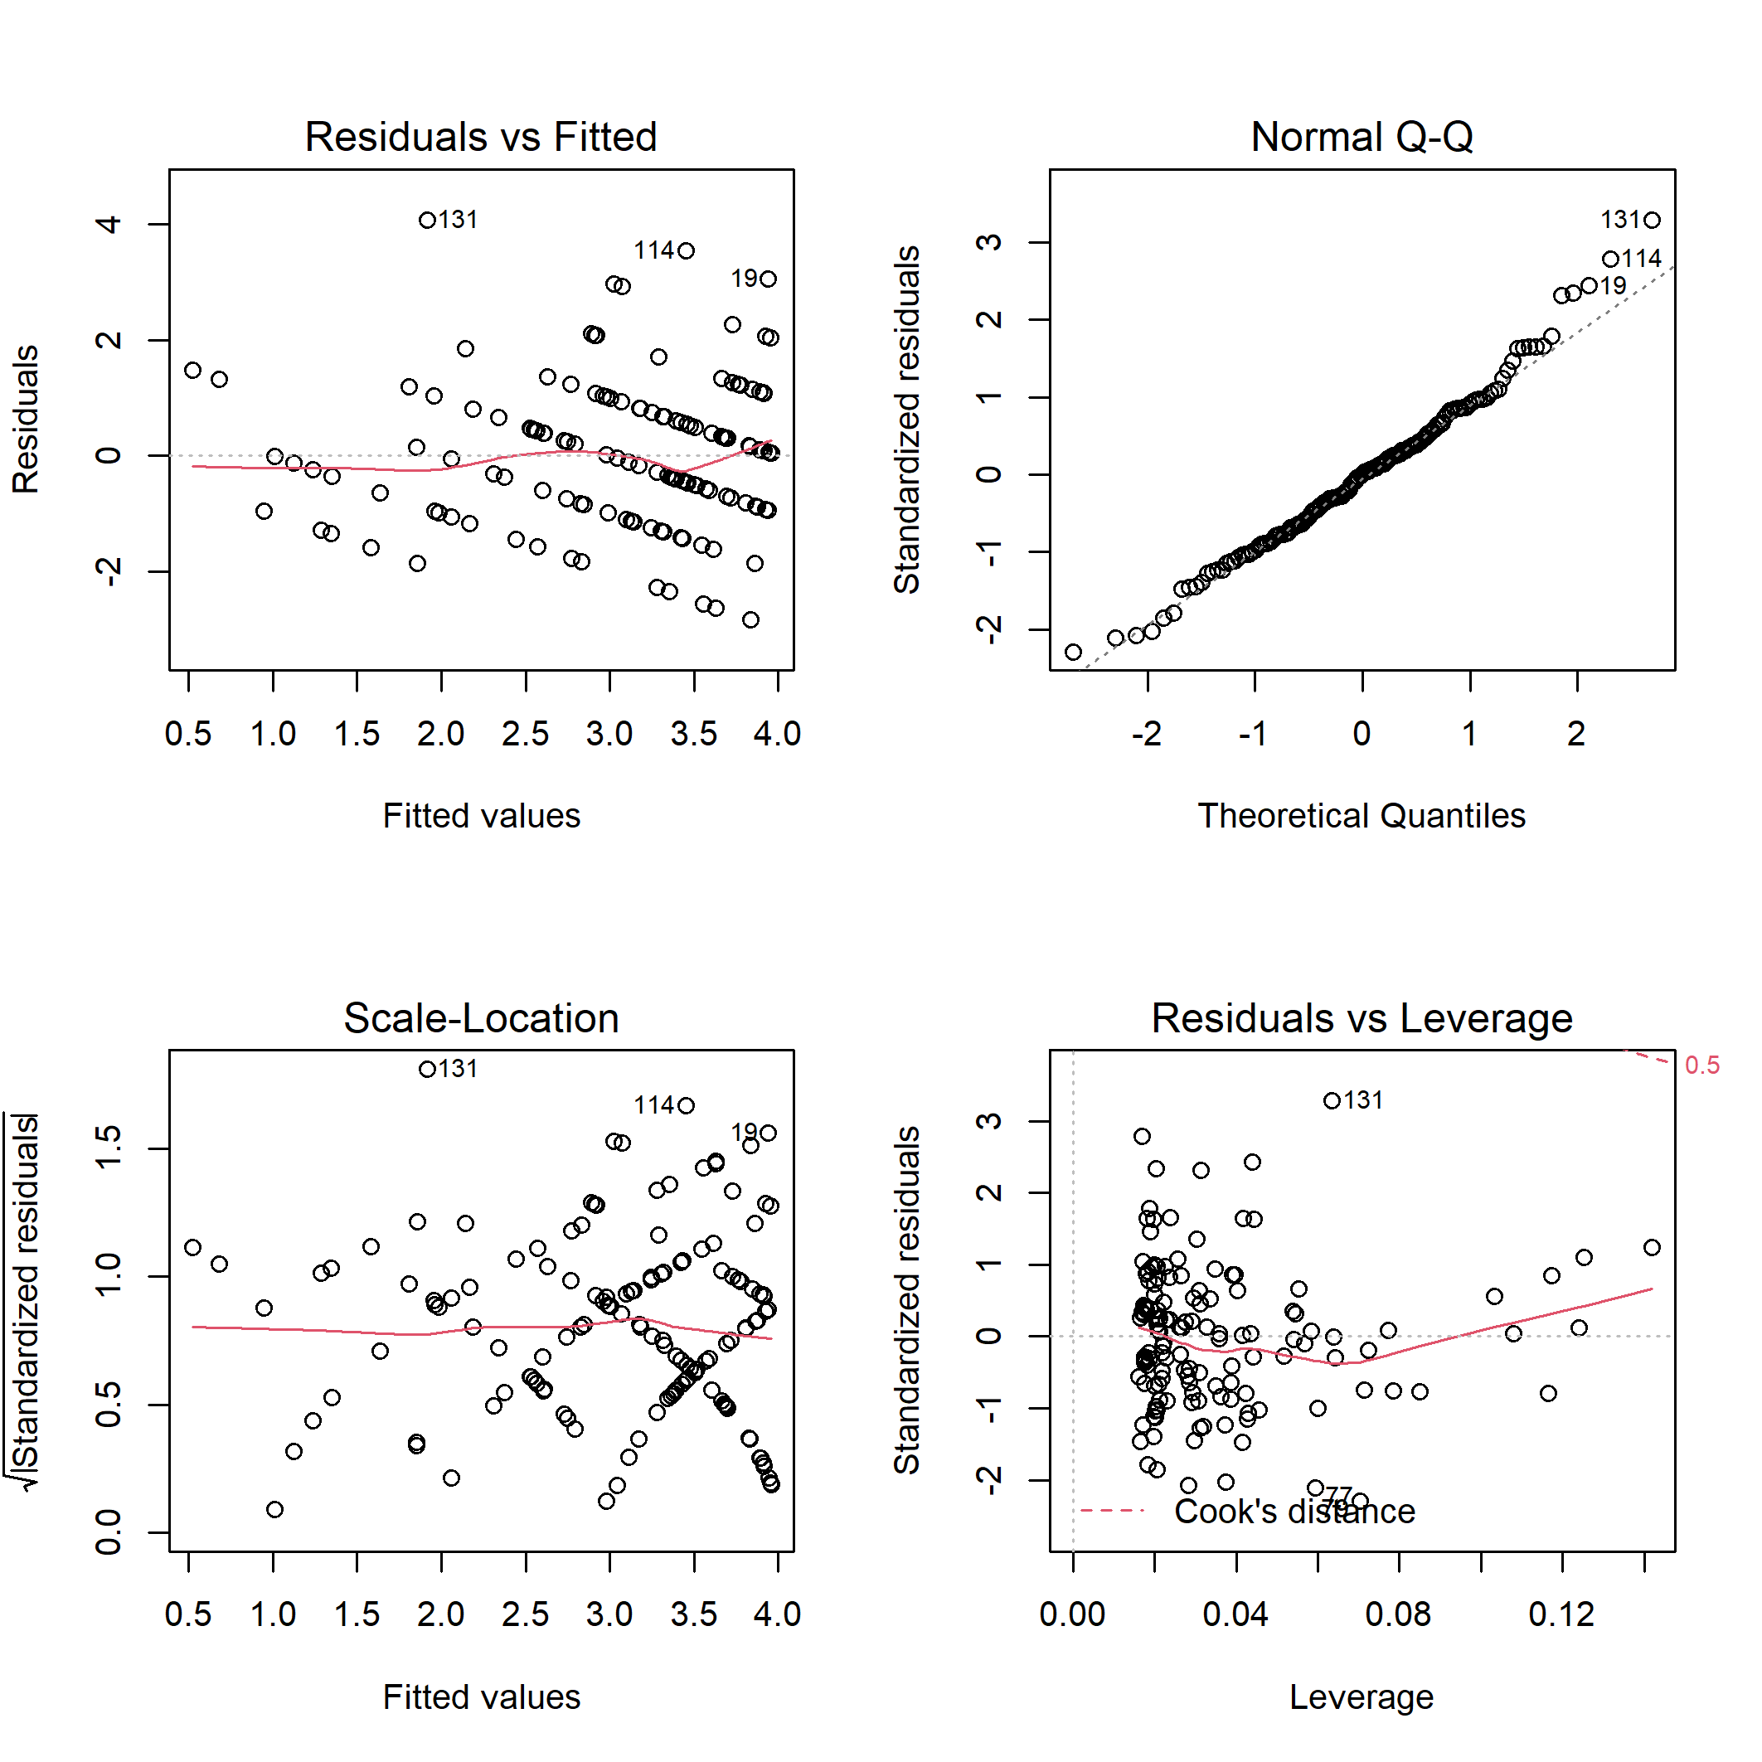
Figure S15. Diagnostic plots for linear model of the bird specialist species richness on habitat characteristics.

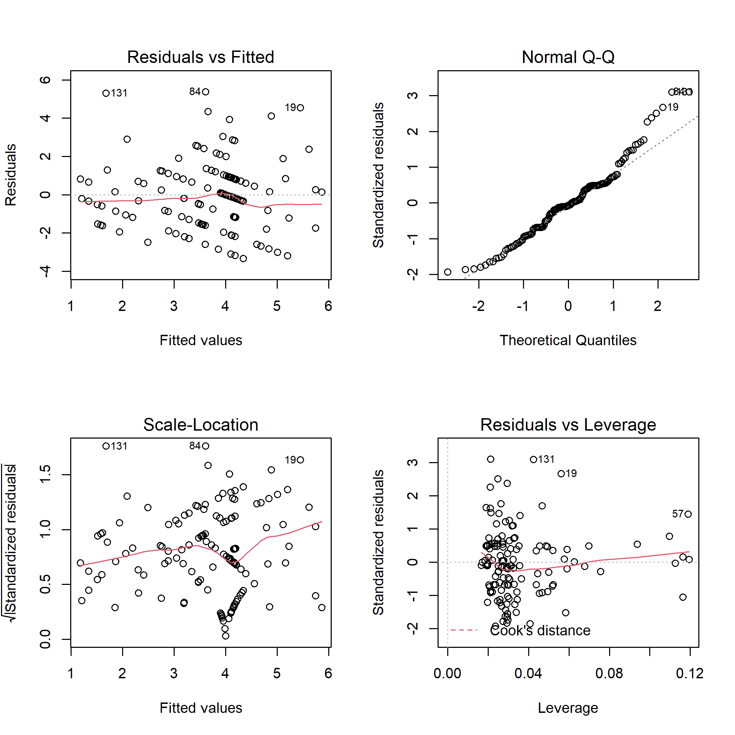
Figure S16. Diagnostic plots for linear model of the bird specialist species abundance on habitat characteristics.

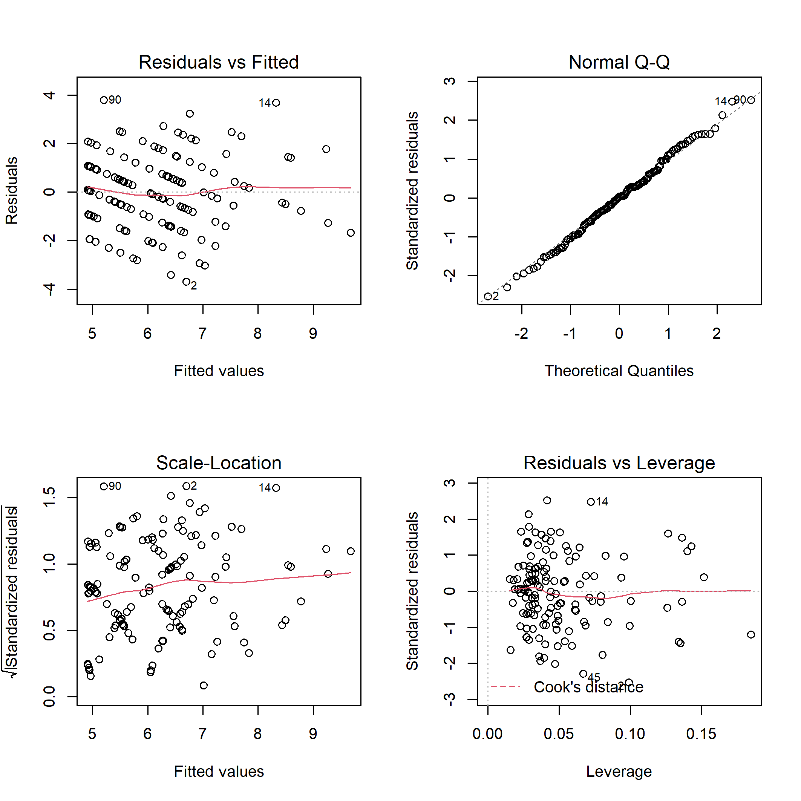
Figure S17. Diagnostic plots for linear model of the bird generalist species richness on habitat characteristics.

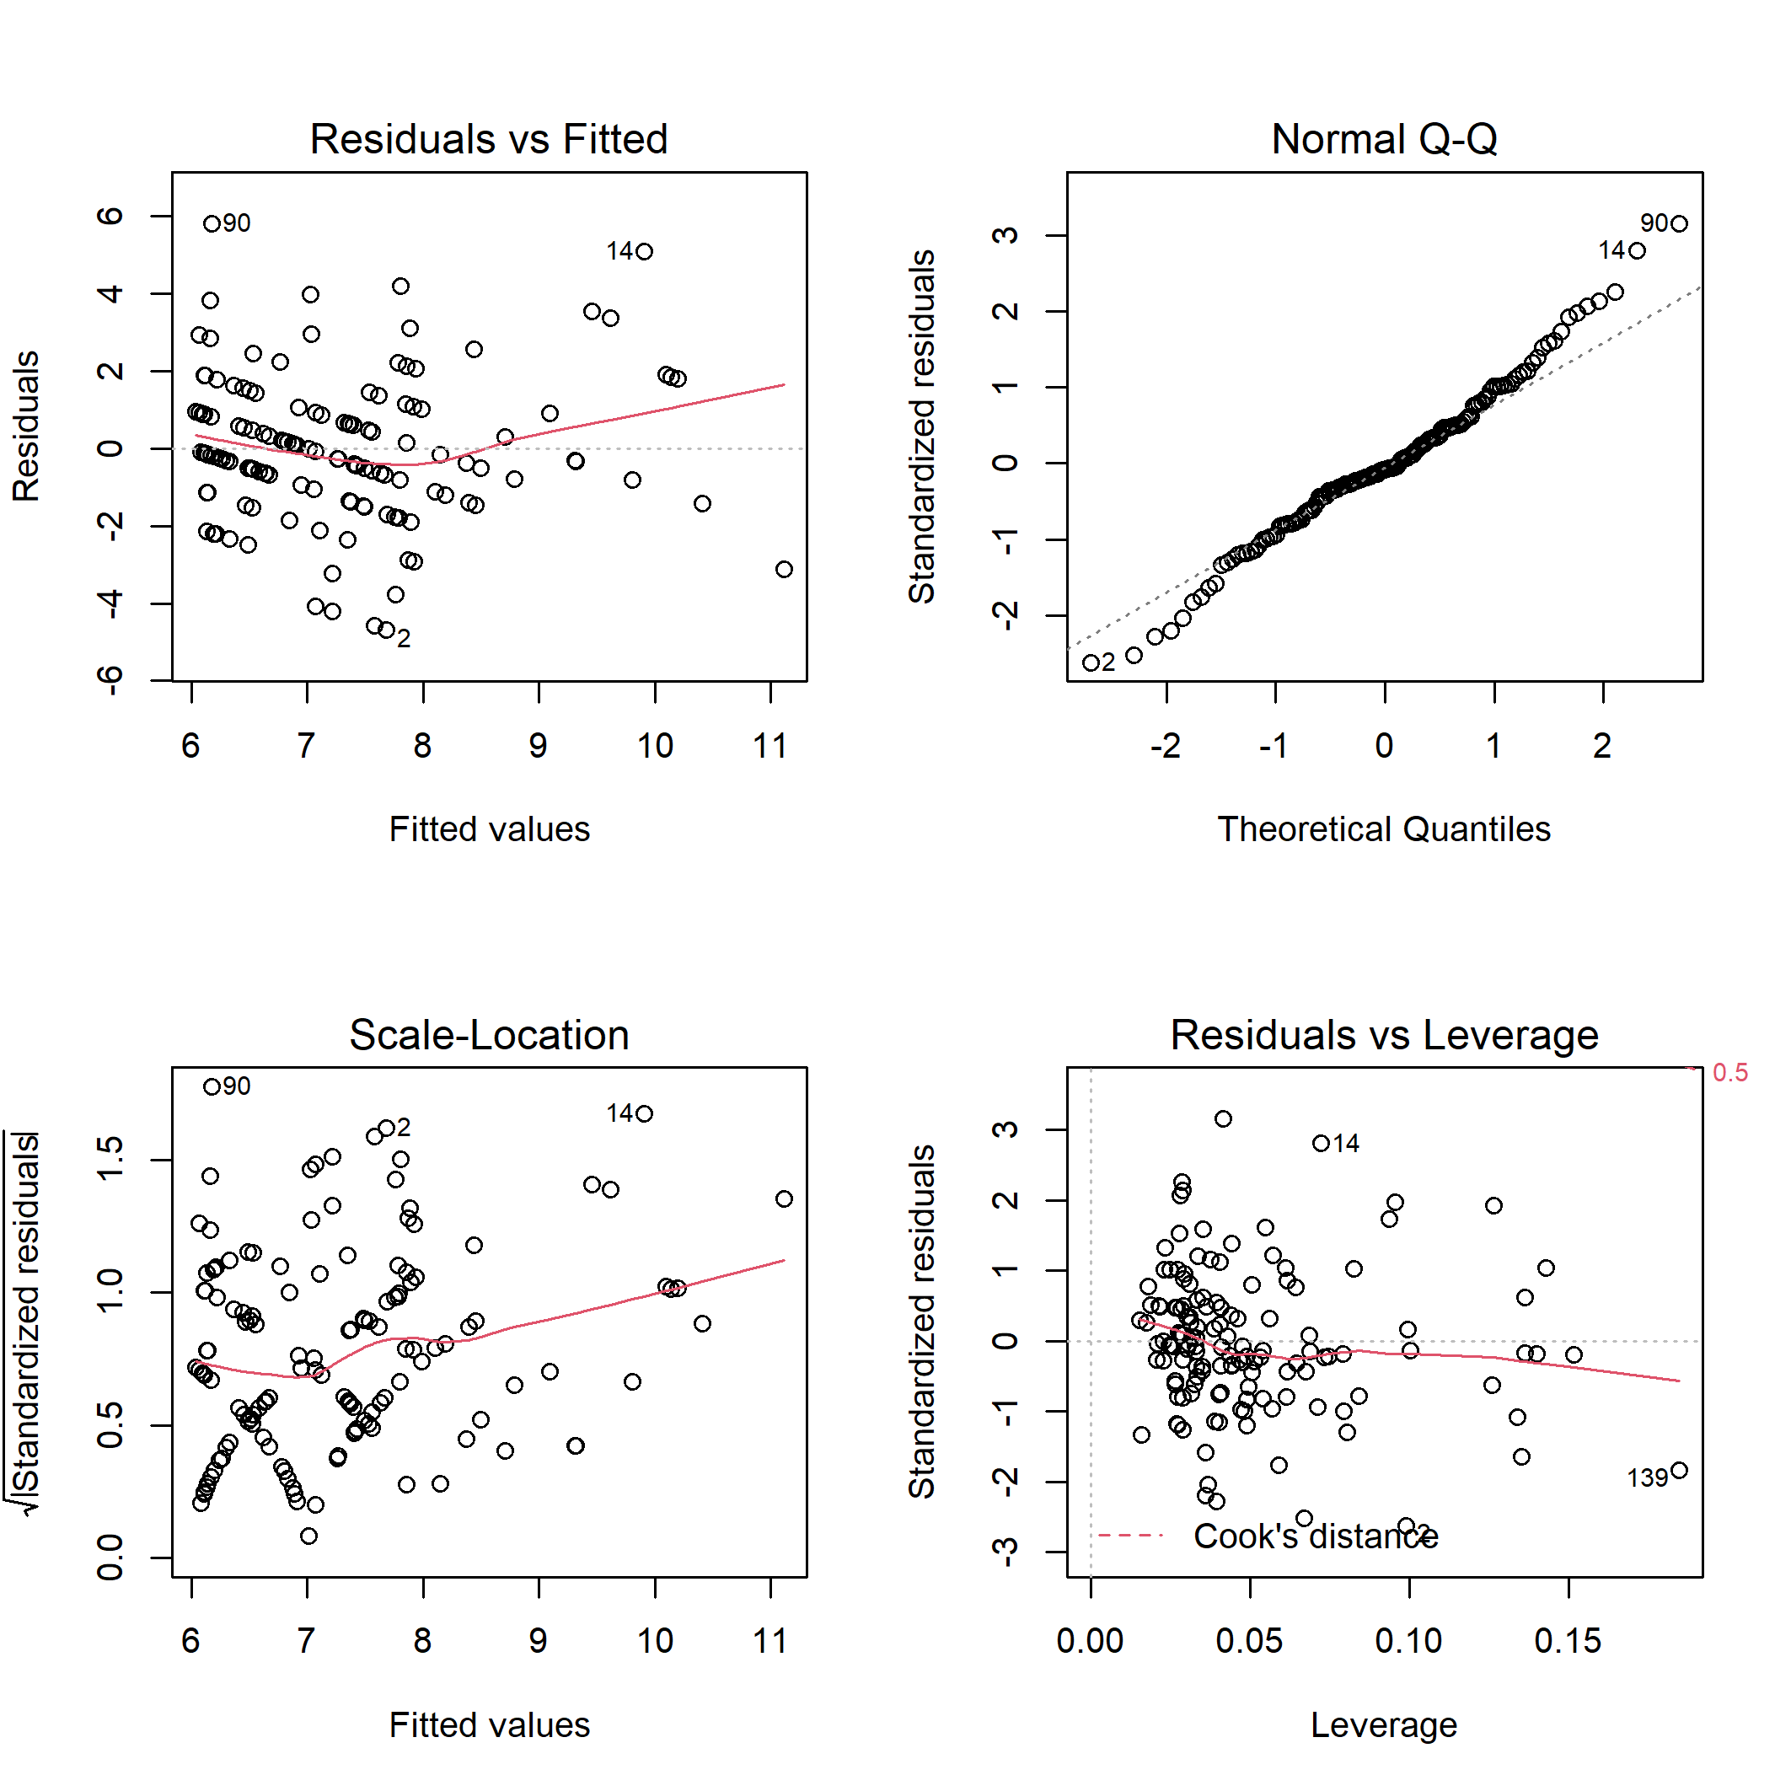
Figure S18. Diagnostic plots for linear model of the bird generalist species abundance on habitat characteristics.
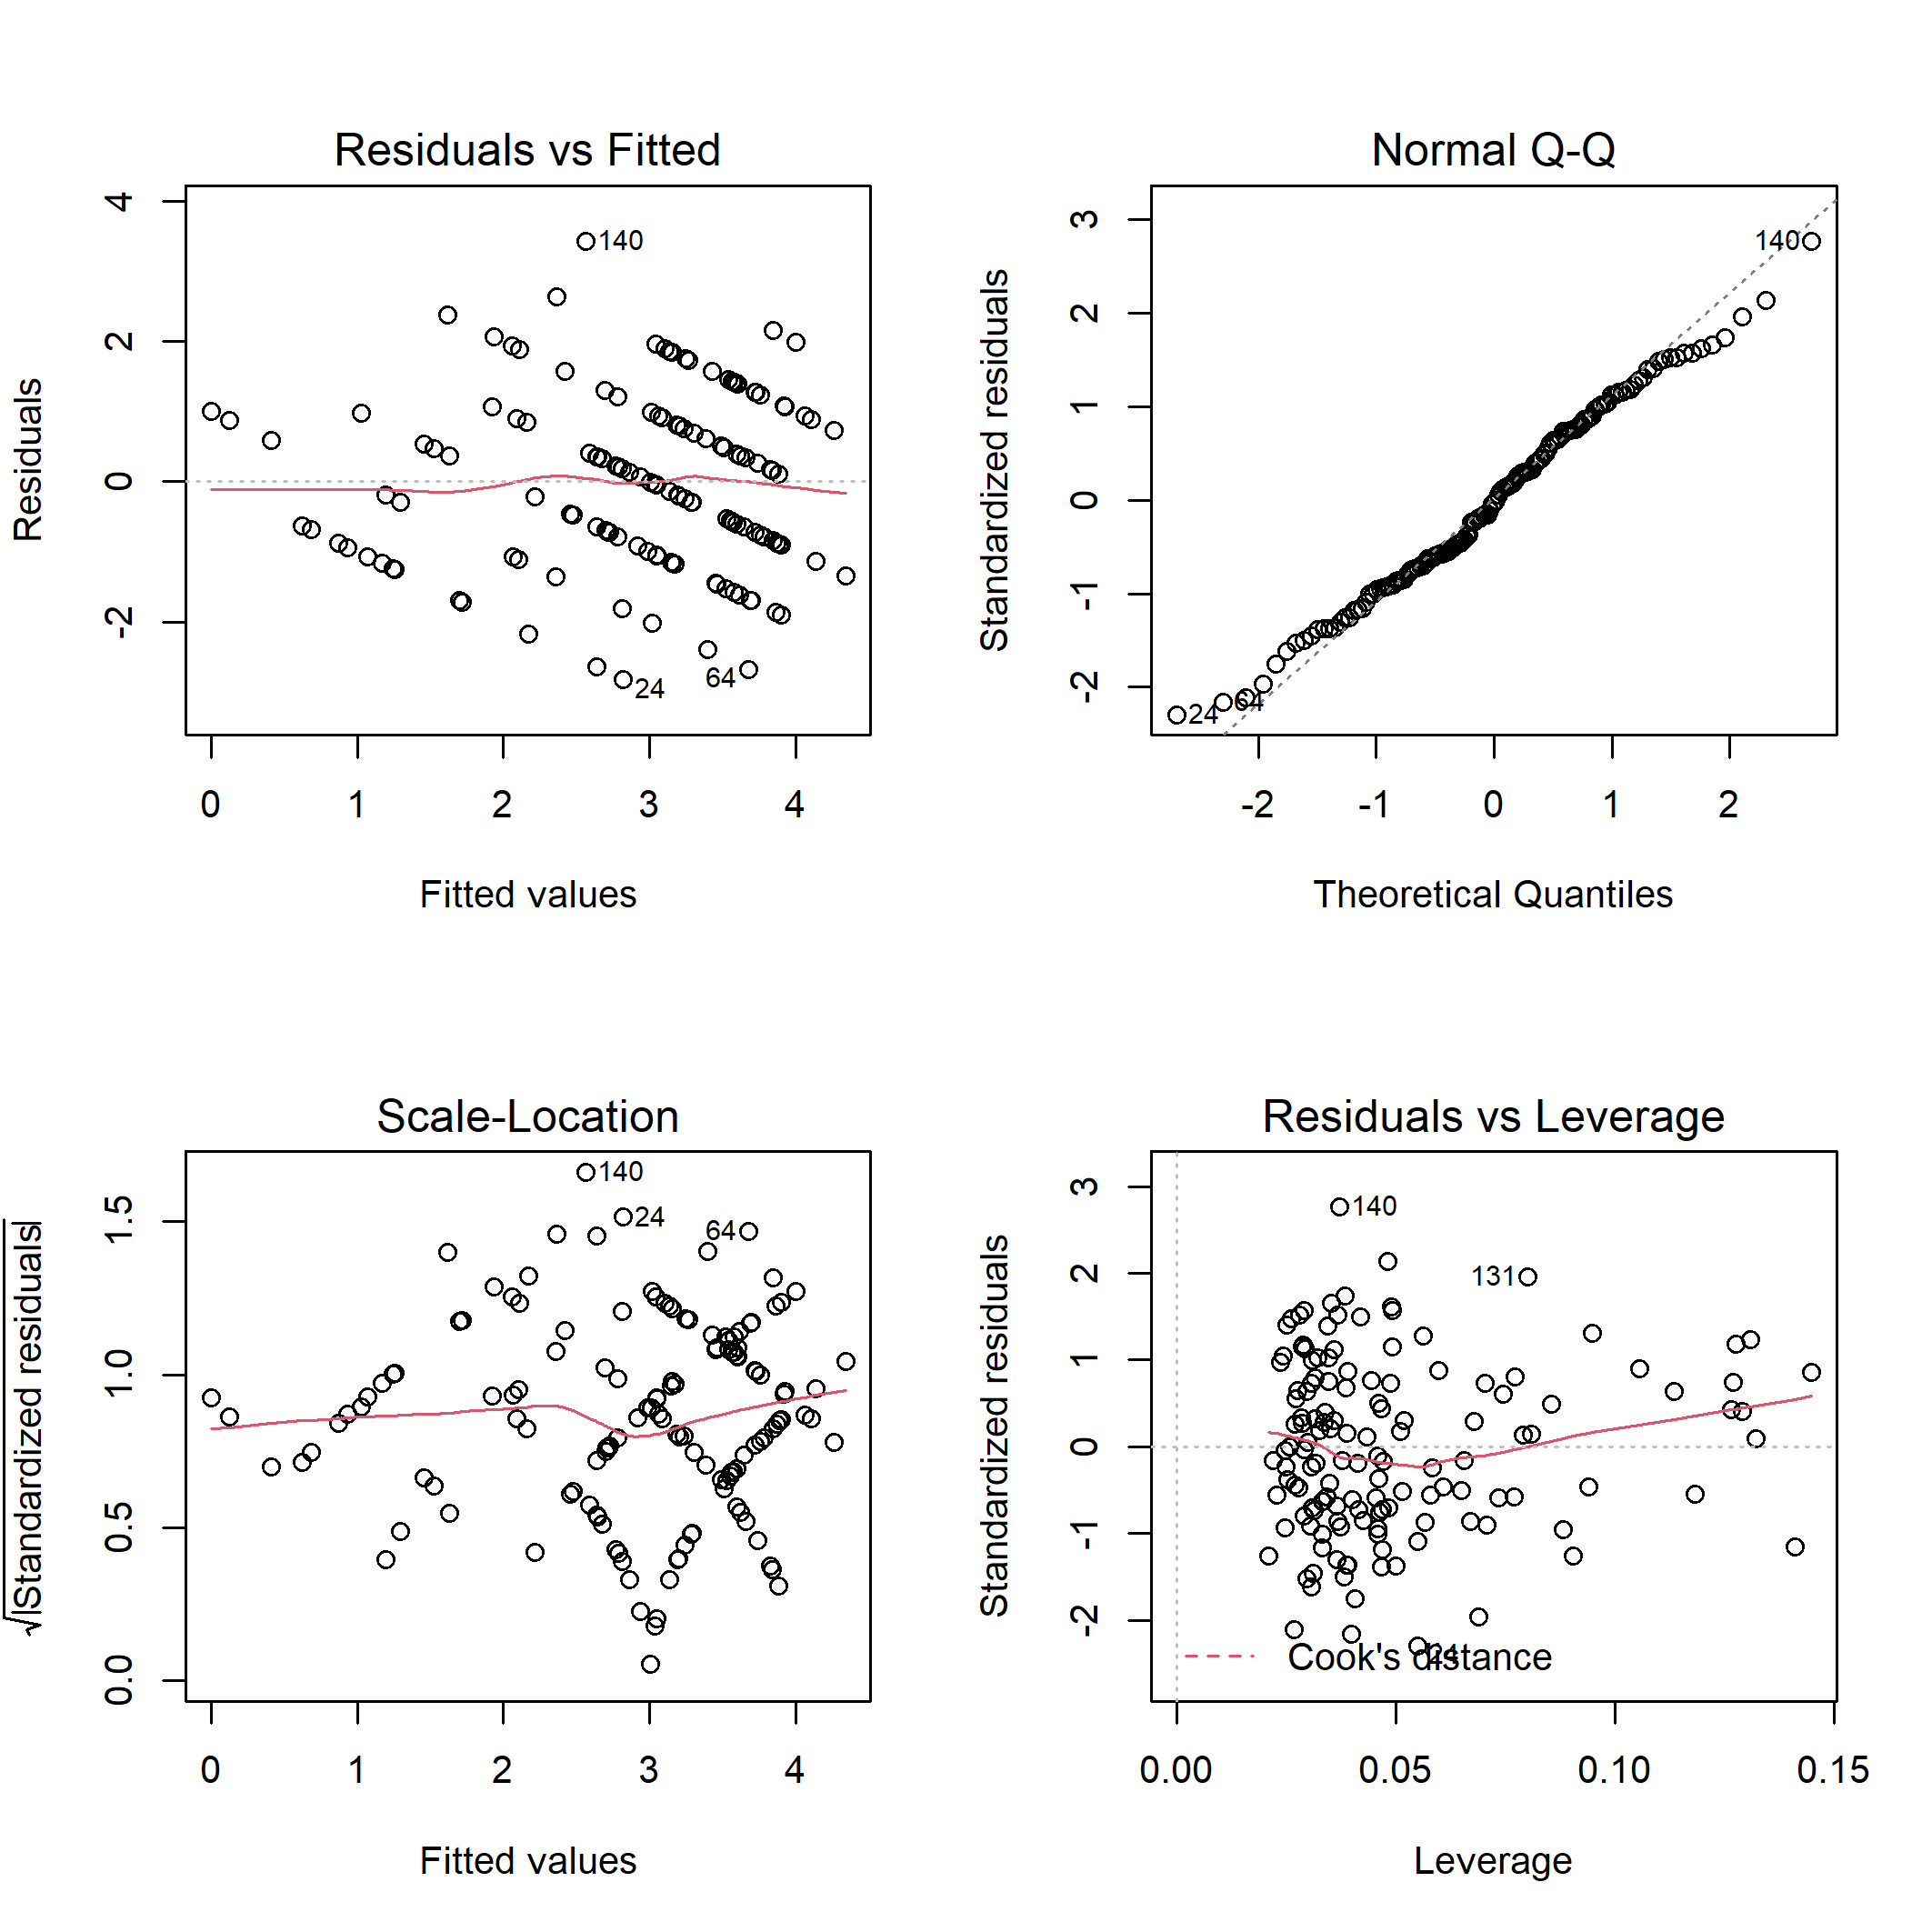
Figure S19. Diagnostic plots for linear model of the bird canopy nesters richness on habitat characteristics.

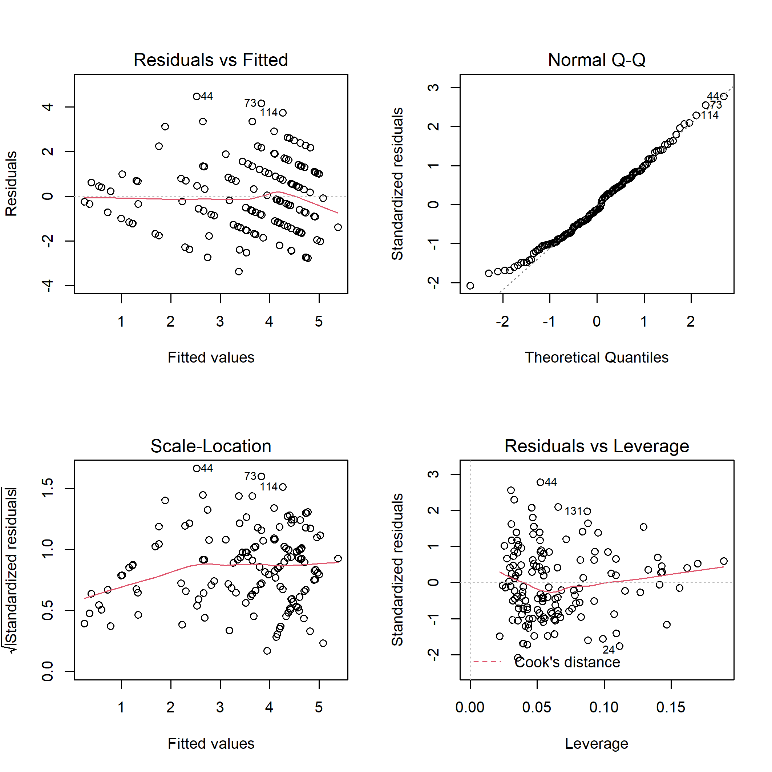
Figure S20. Diagnostic plots for linear model of the bird canopy nesters abundance on habitat characteristics.

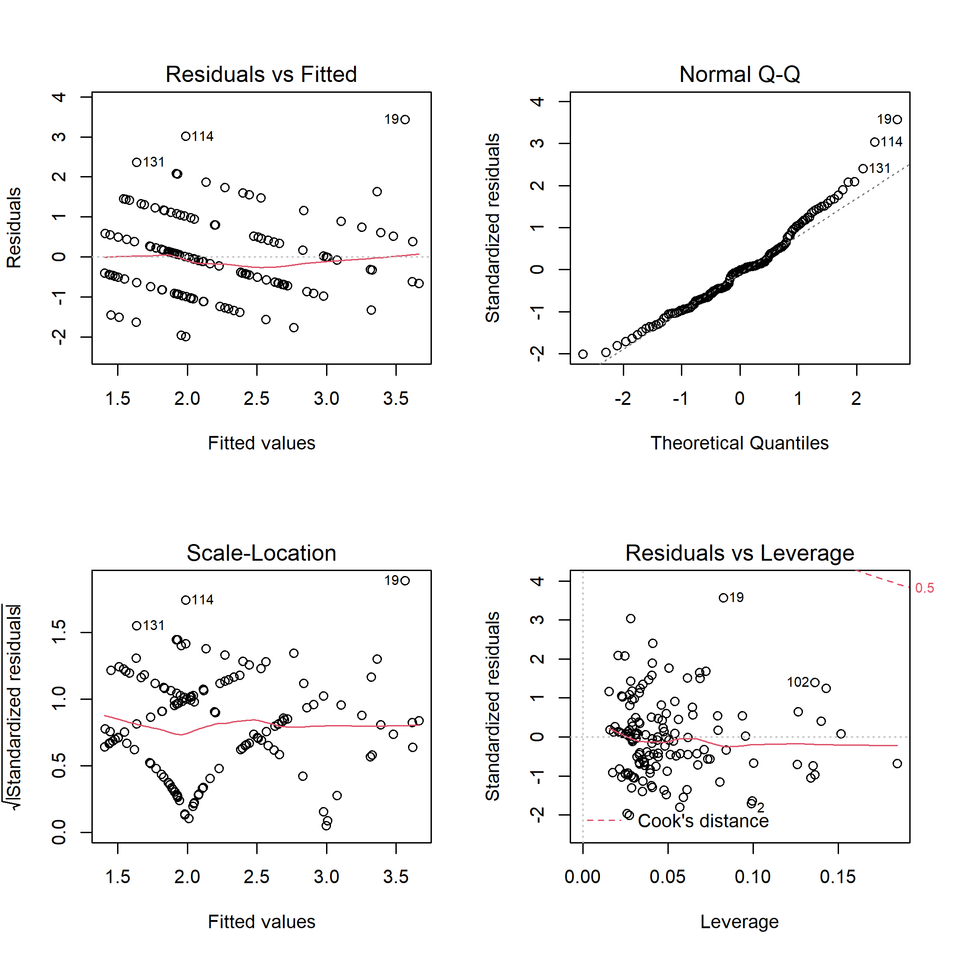
Figure S21. Diagnostic plots for linear model of the bird cavity nesters richness on habitat characteristics.

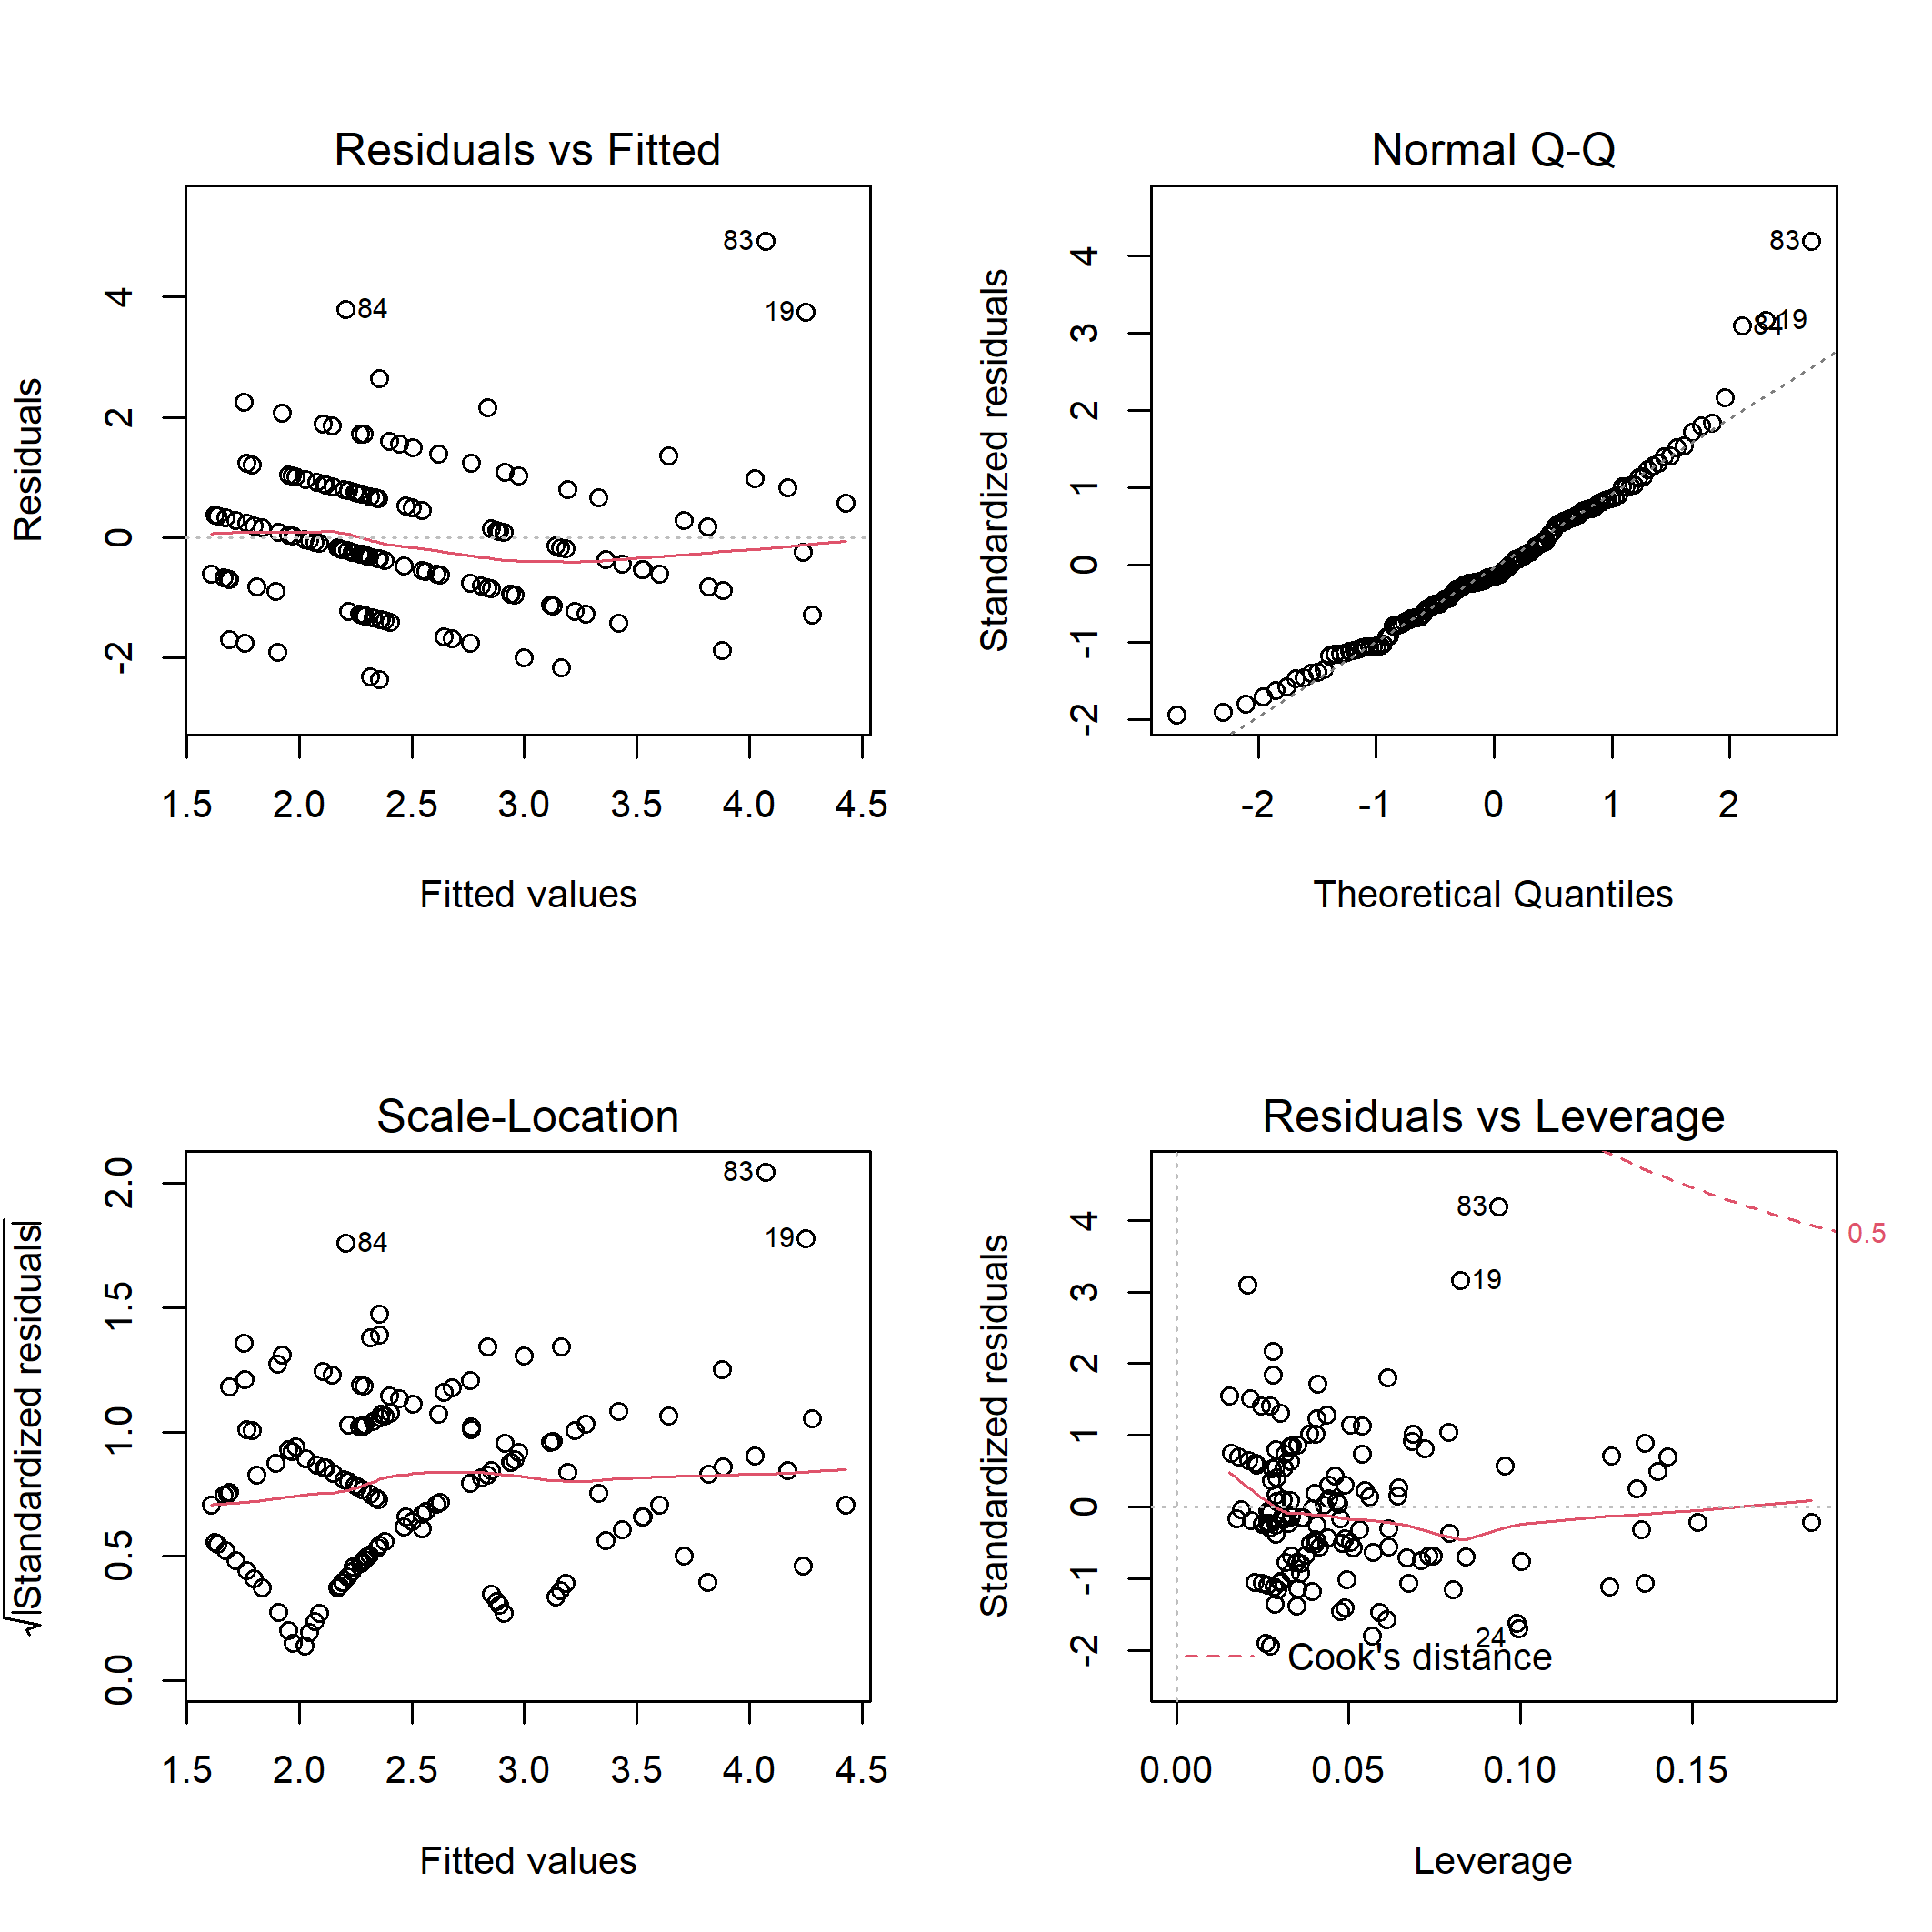
Figure S22. Diagnostic plots for linear model of the bird cavity nesters abundance on habitat characteristics.

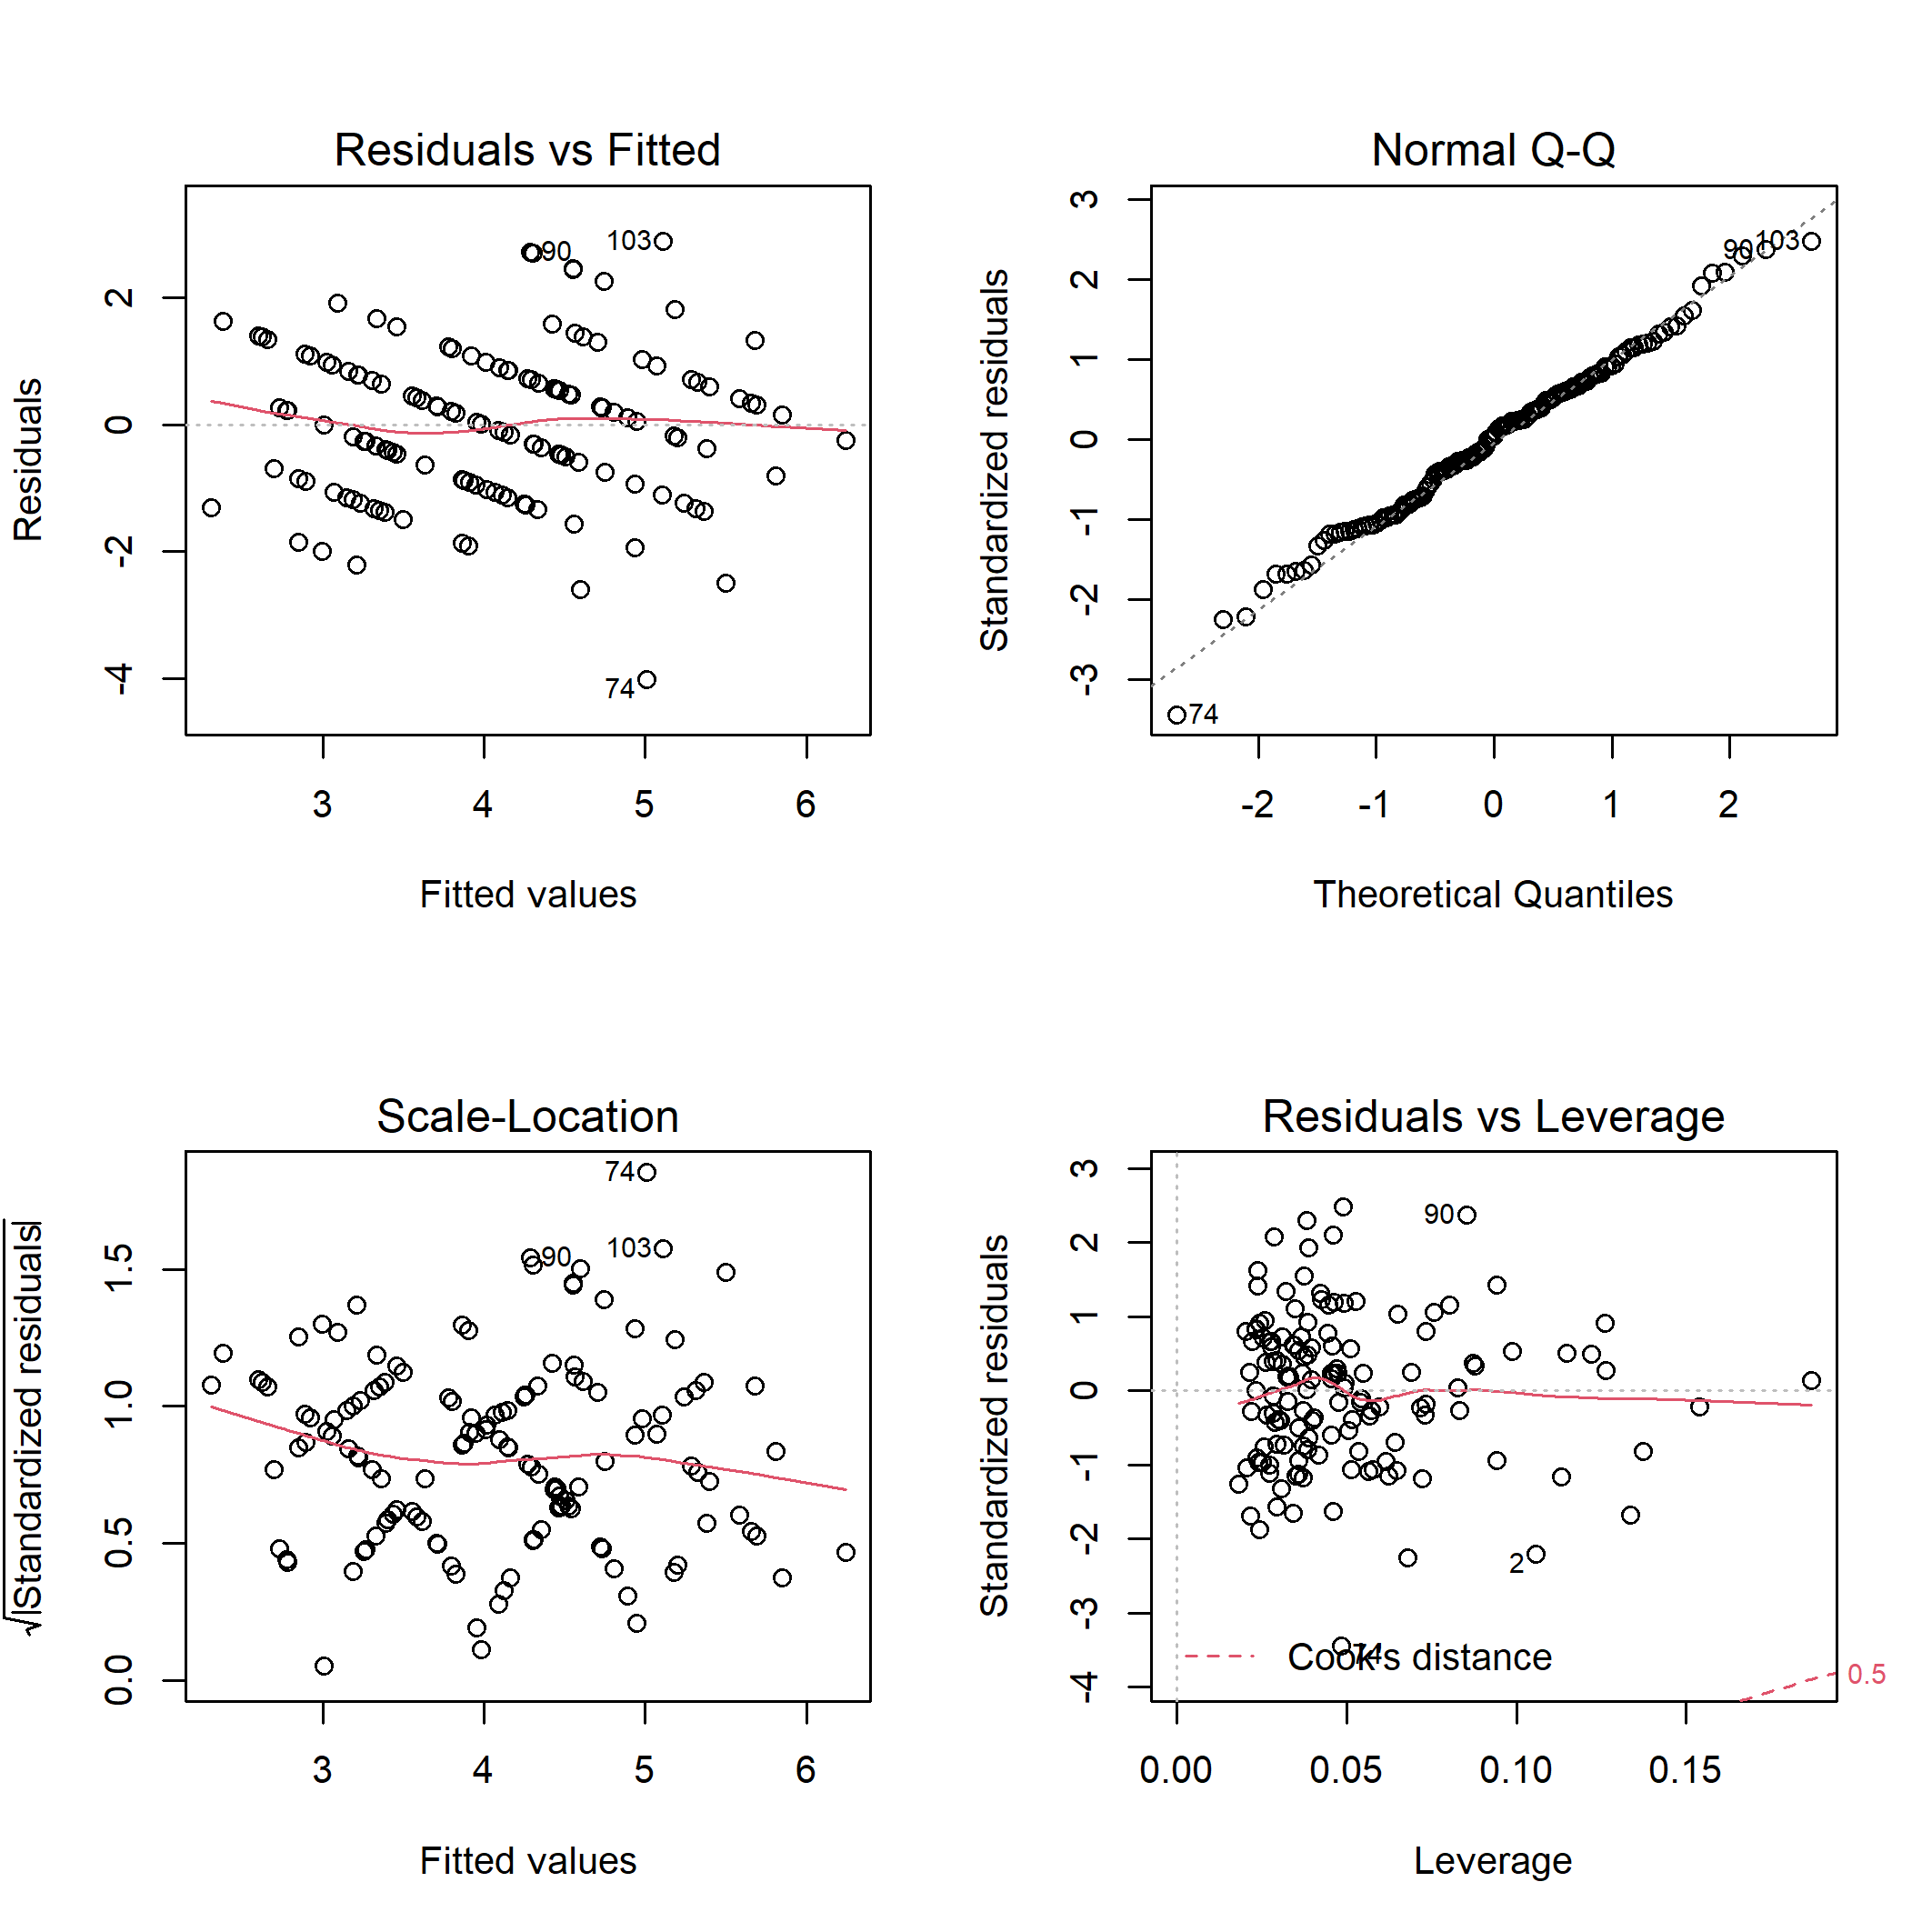
Figure S23. Diagnostic plots for linear model of the bird ground/shrub richness on habitat characteristics.

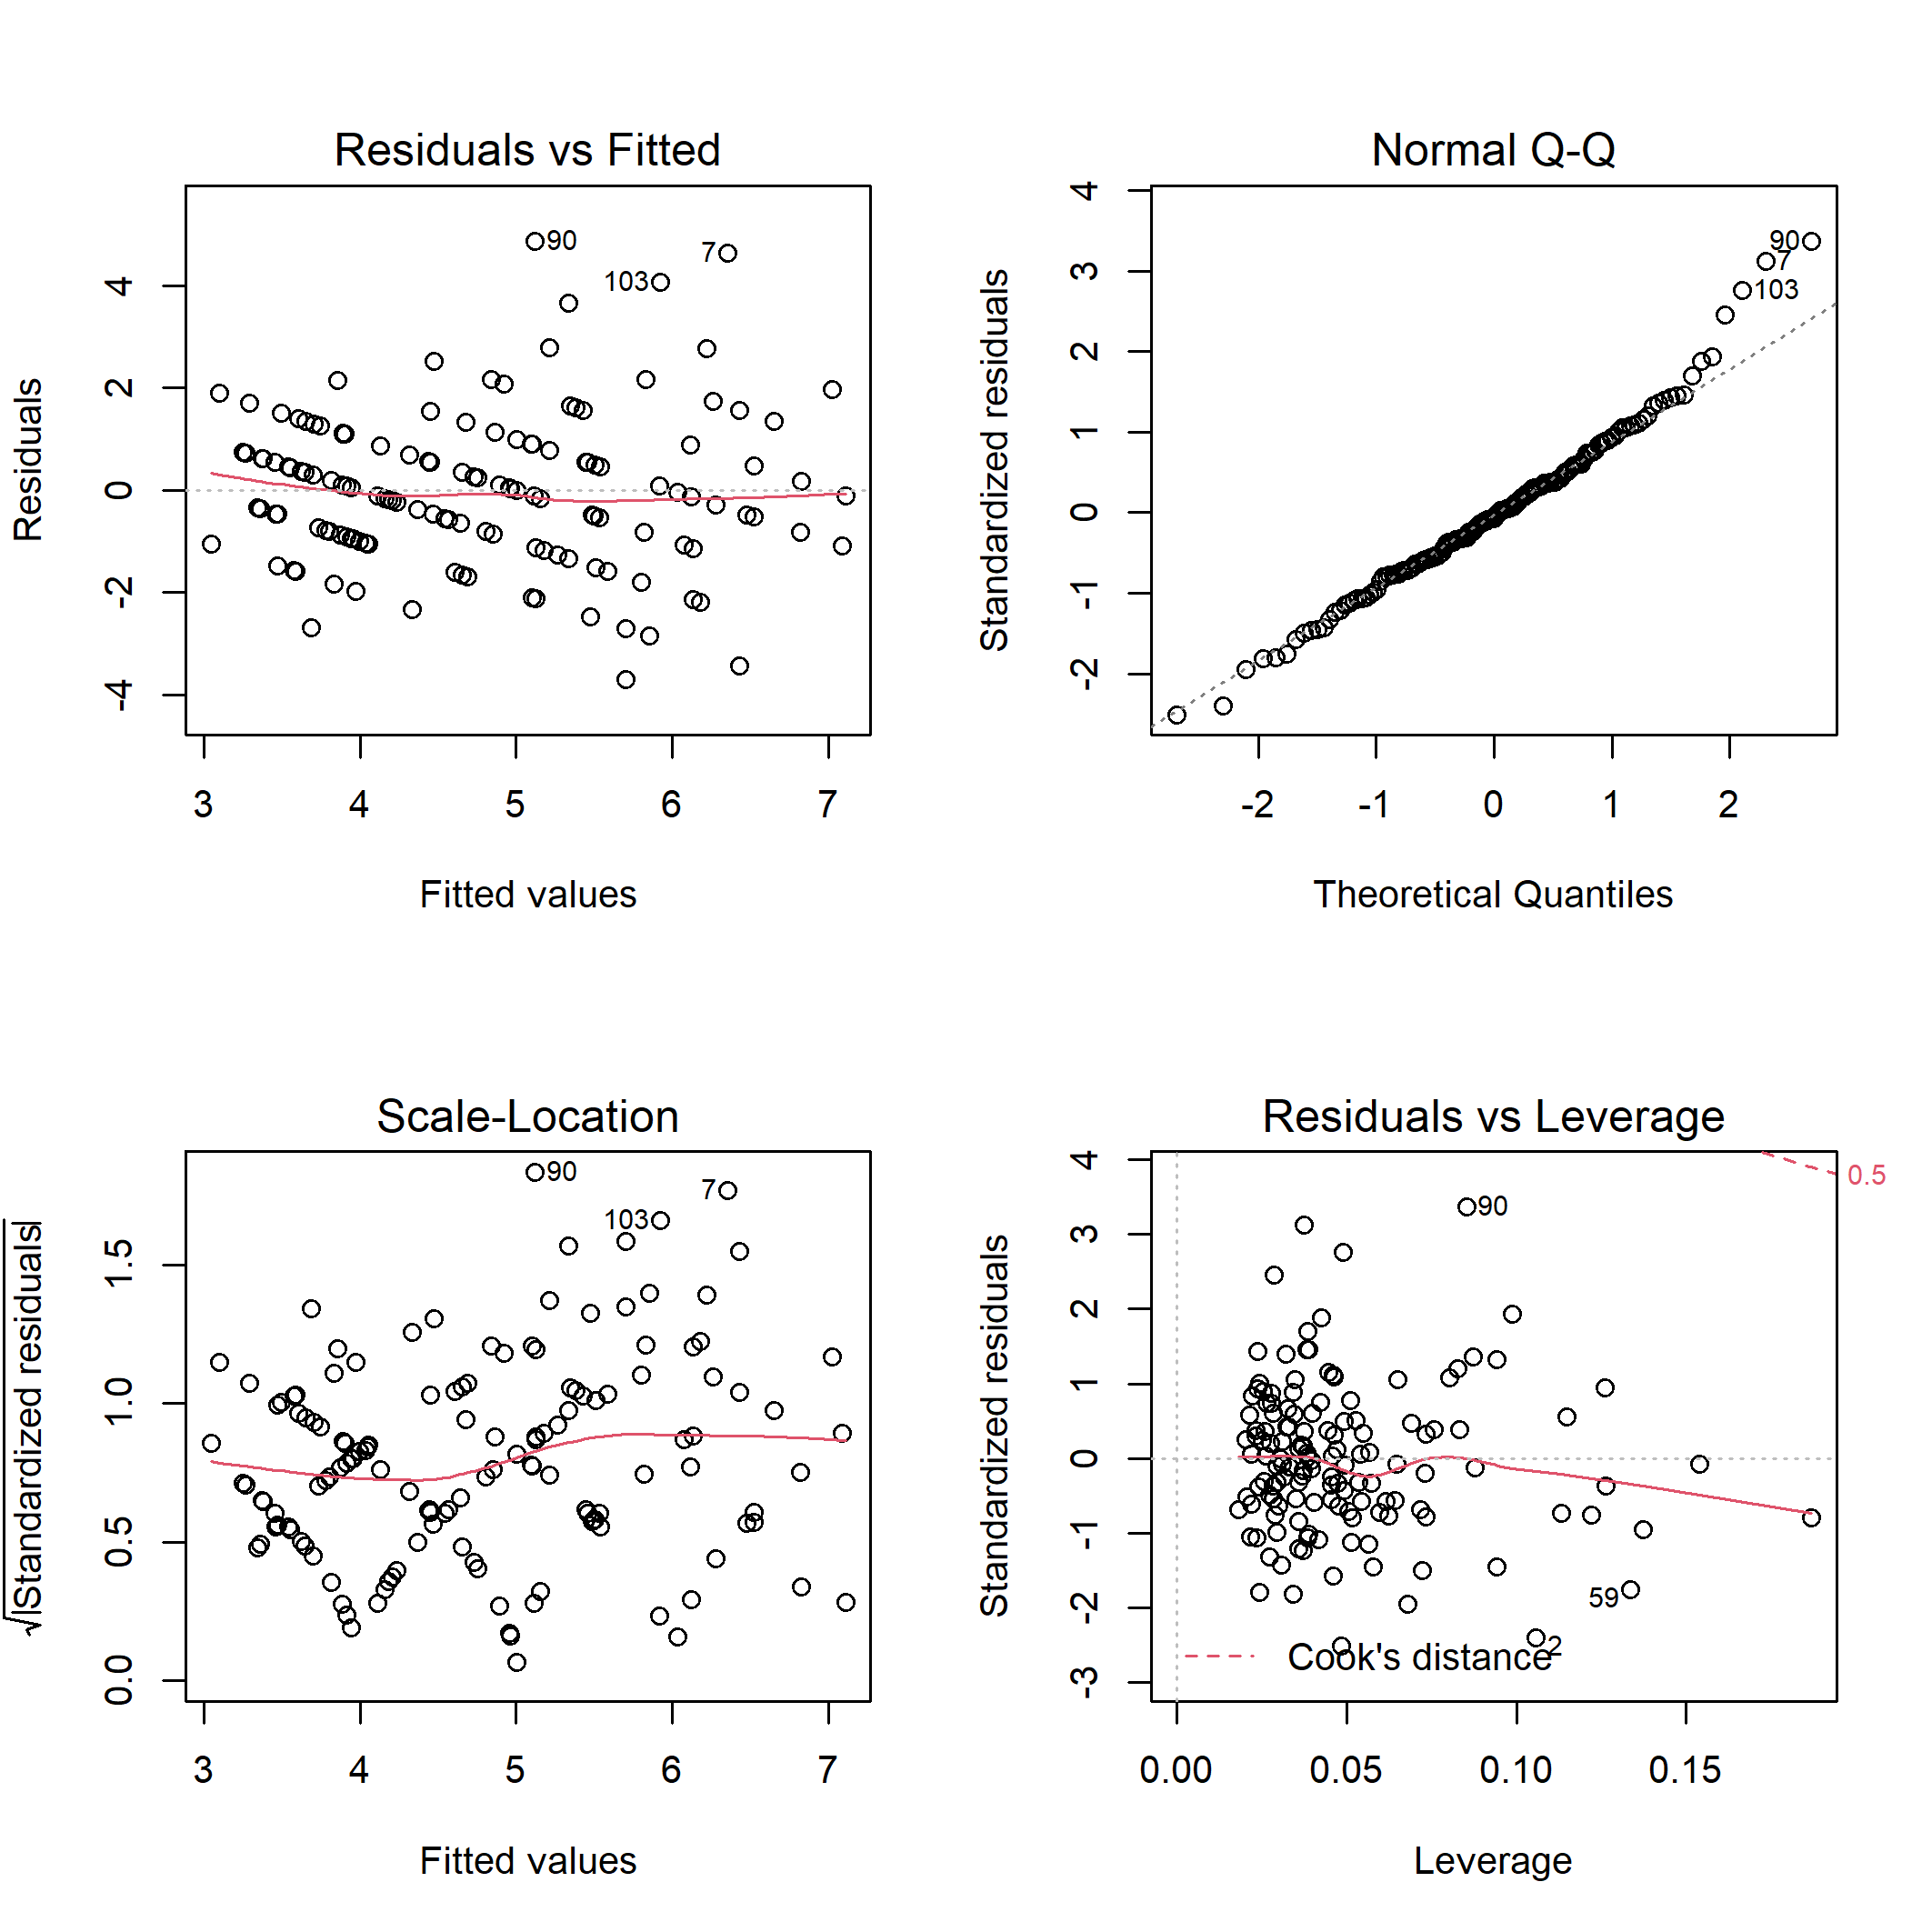
Figure S24. Diagnostic plots for linear model of the bird ground/shrub nesters abundance on habitat characteristics.

