Bird response to forest disturbance size in mountain spruce forests in Central Europe

Dominik Kebrle, Petr Zasadil, Vojtěch Barták, Jeňýk Hofmeister

Supplement B: Diagnostic plots of the linear models

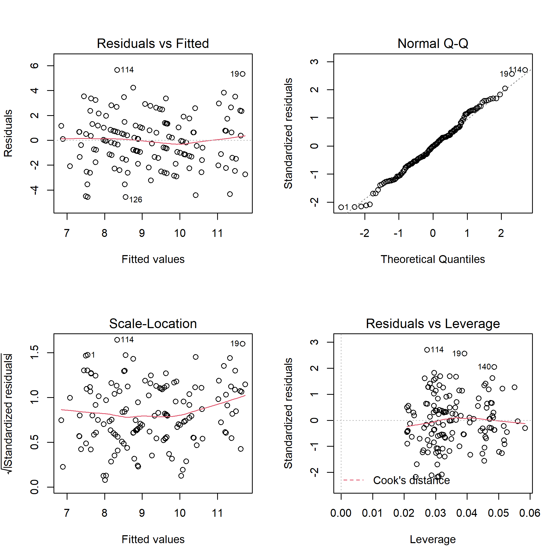

**Fig. B1.** Diagnostic plots for linear model of total bird species richness on disturbance class and elevation.

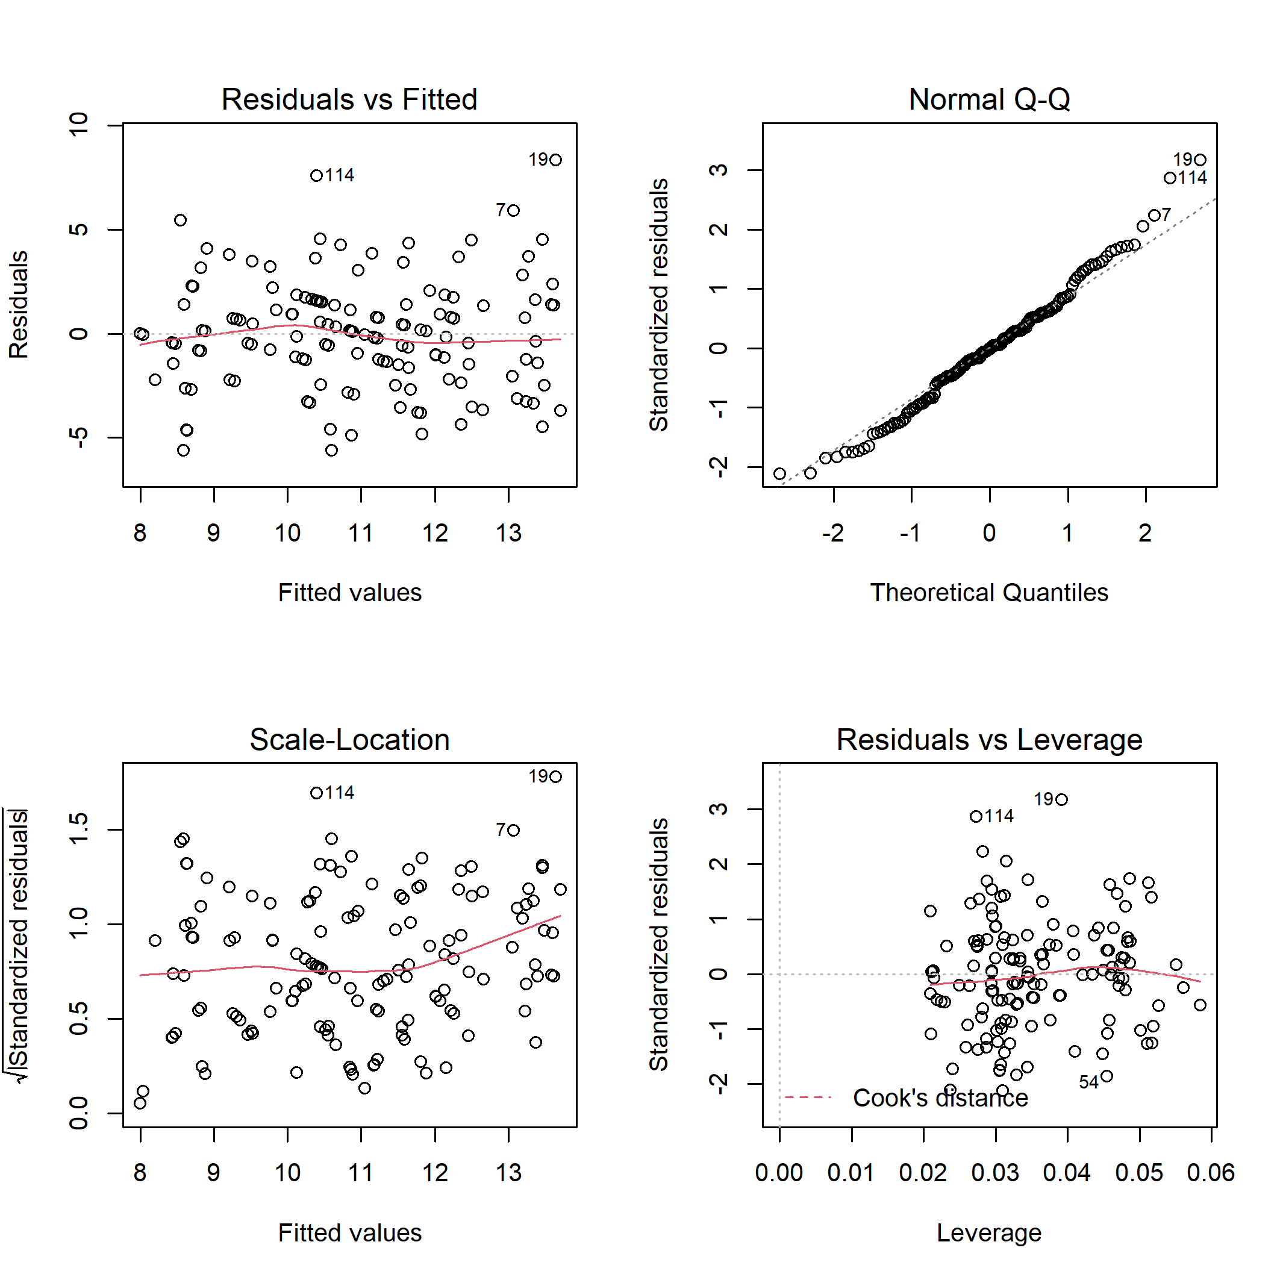

**Fig. B2.** Diagnostic plots for linear model of total bird species abundance on disturbance class and elevation.

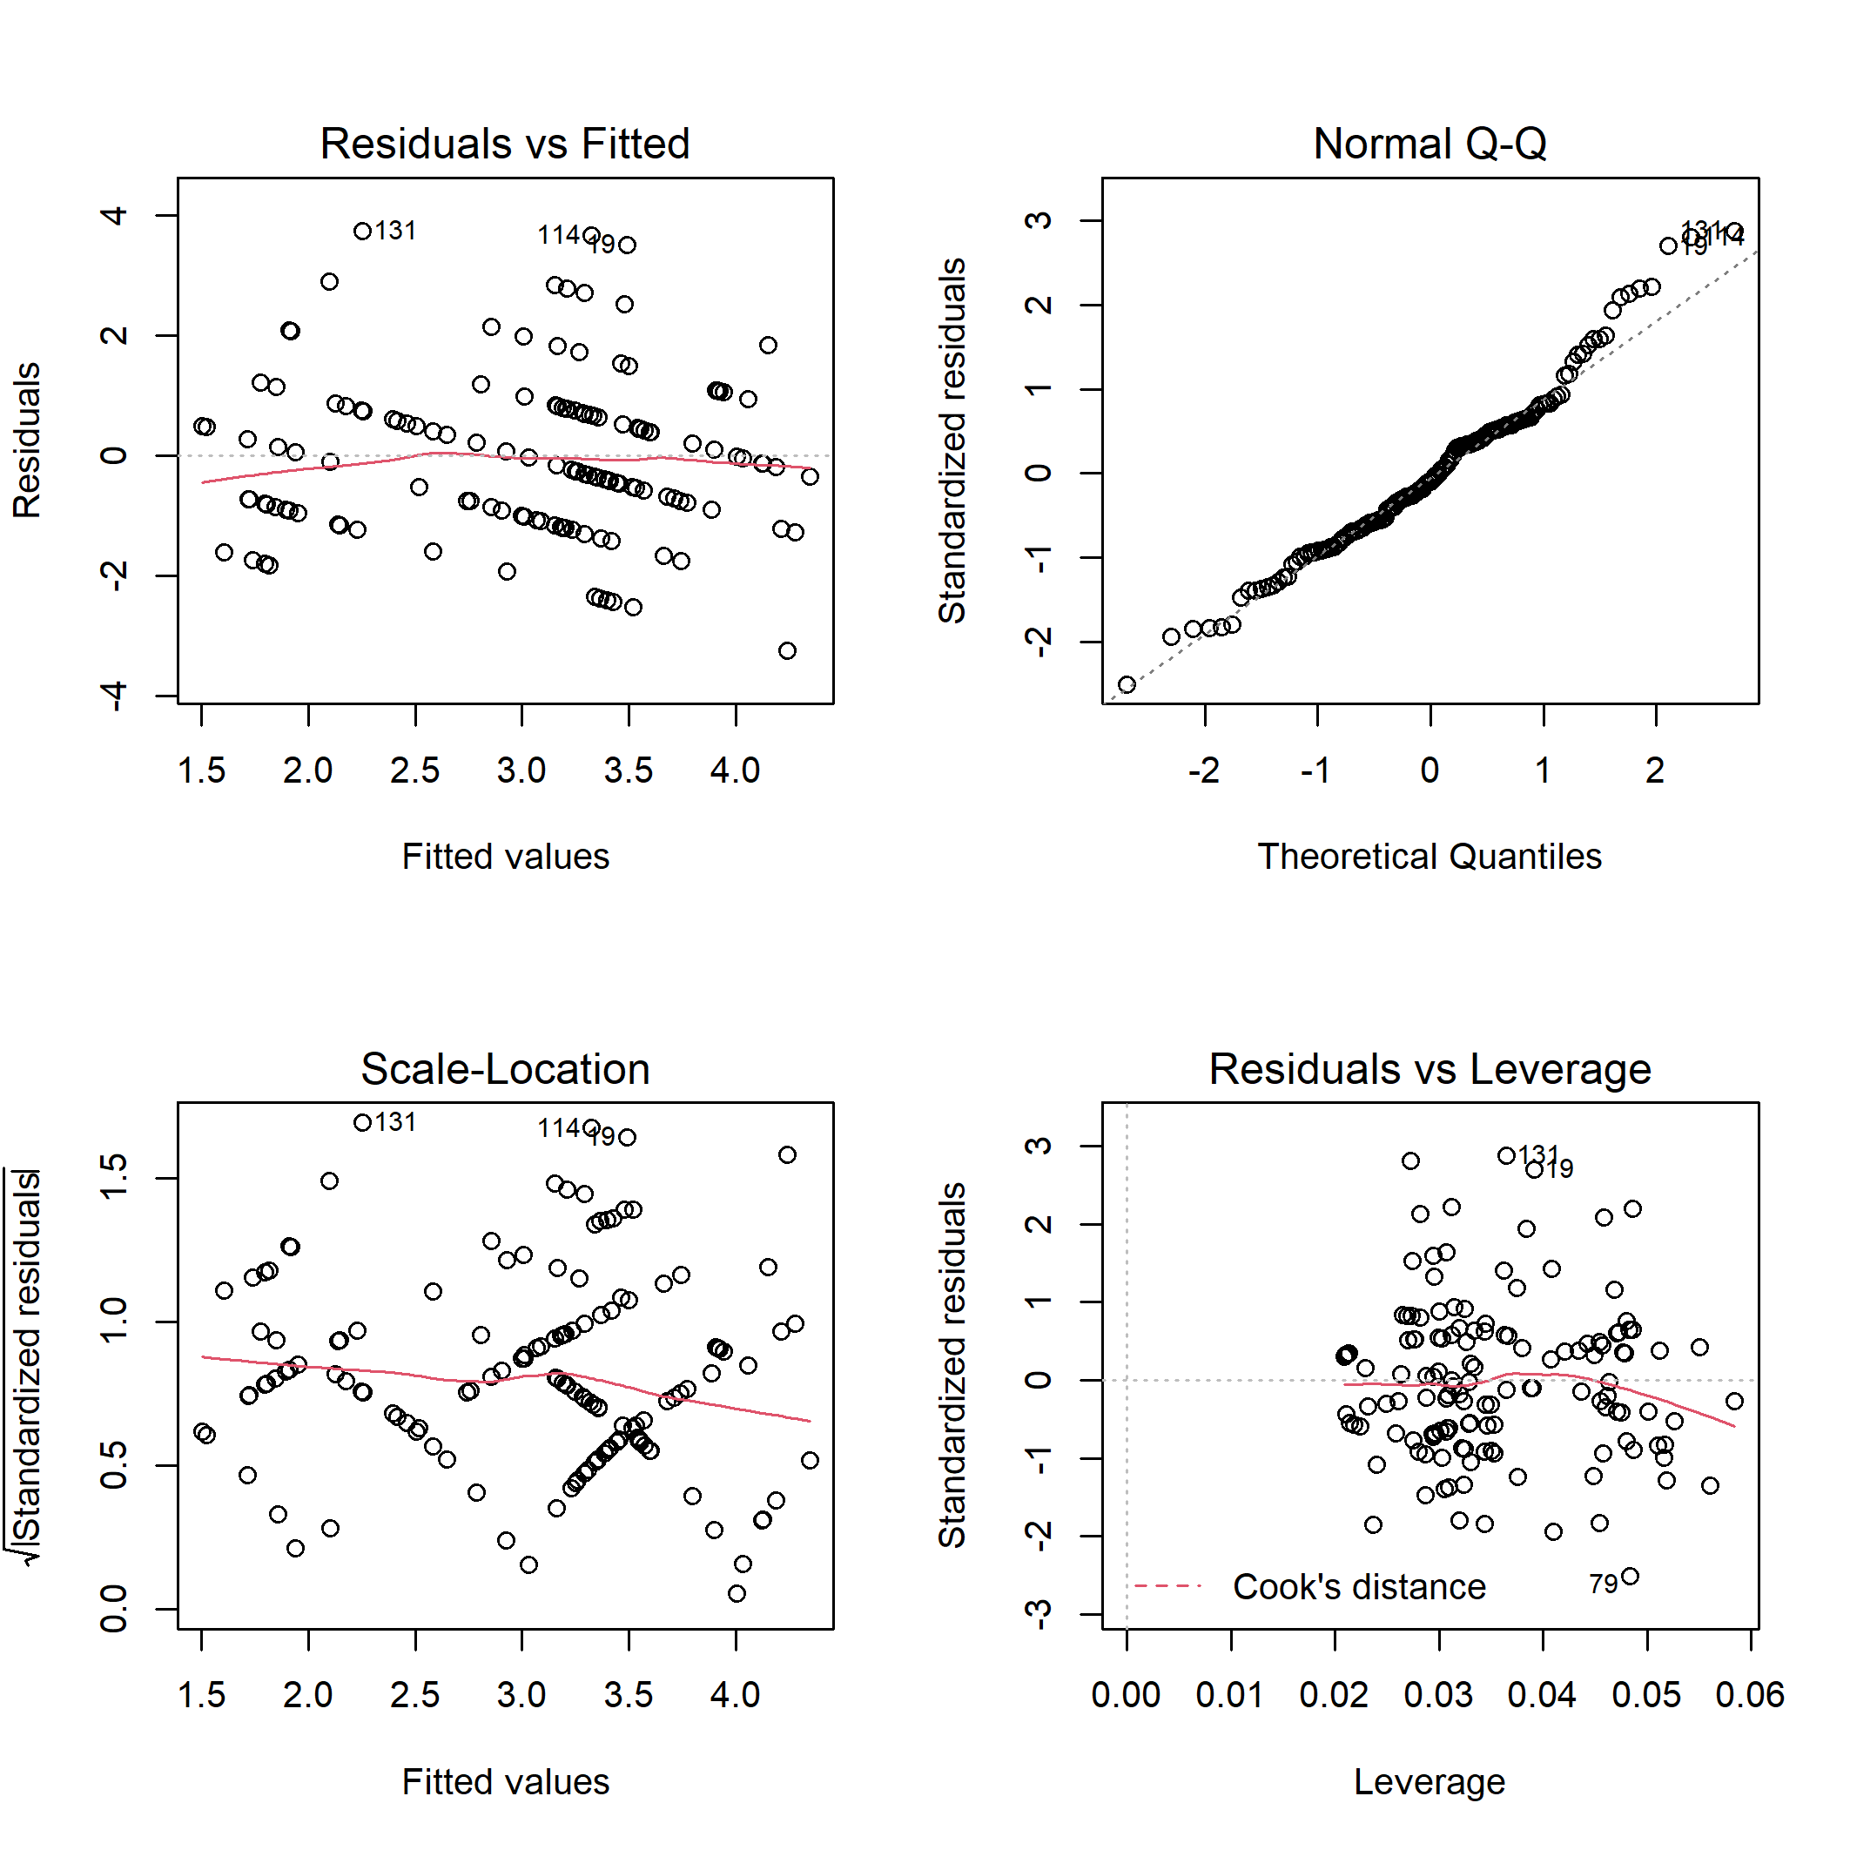

**Fig. B3.** Diagnostic plots for linear model of bird specialist species richness on disturbance class and elevation.

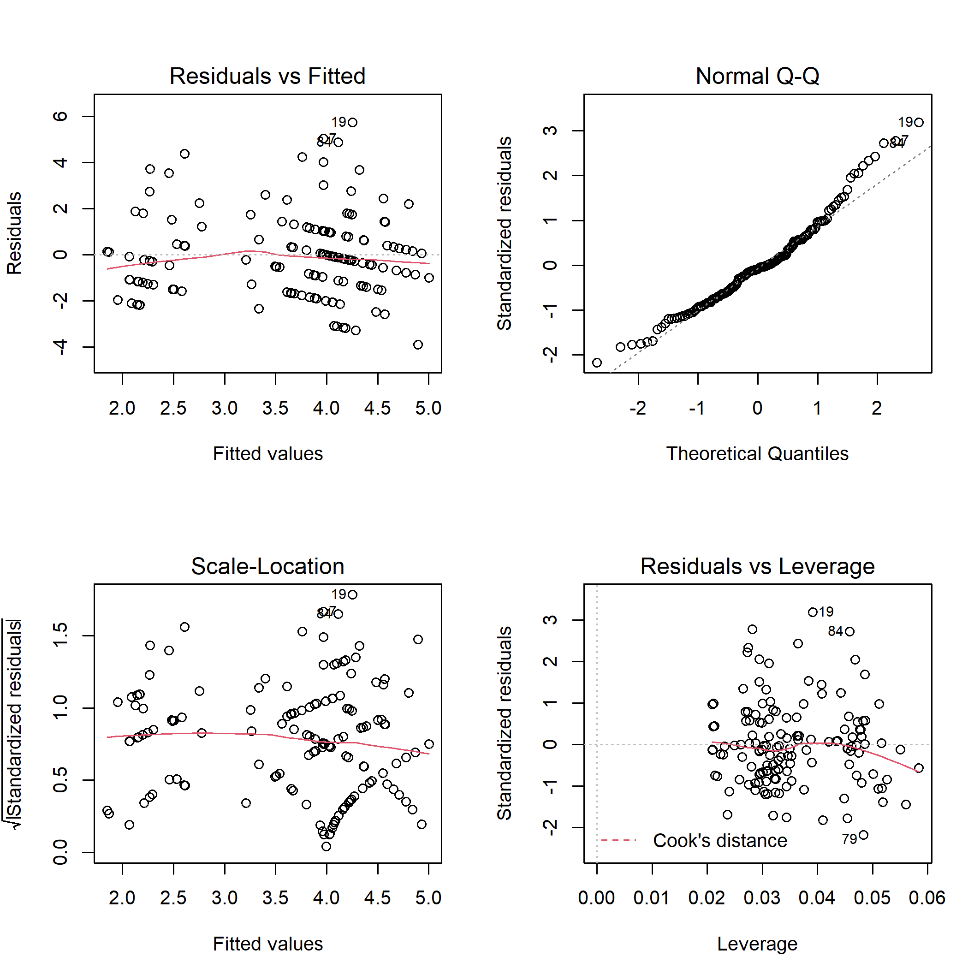

**Fig. B4.** Diagnostic plots for linear model of bird specialist species abundance on disturbance class and elevation.

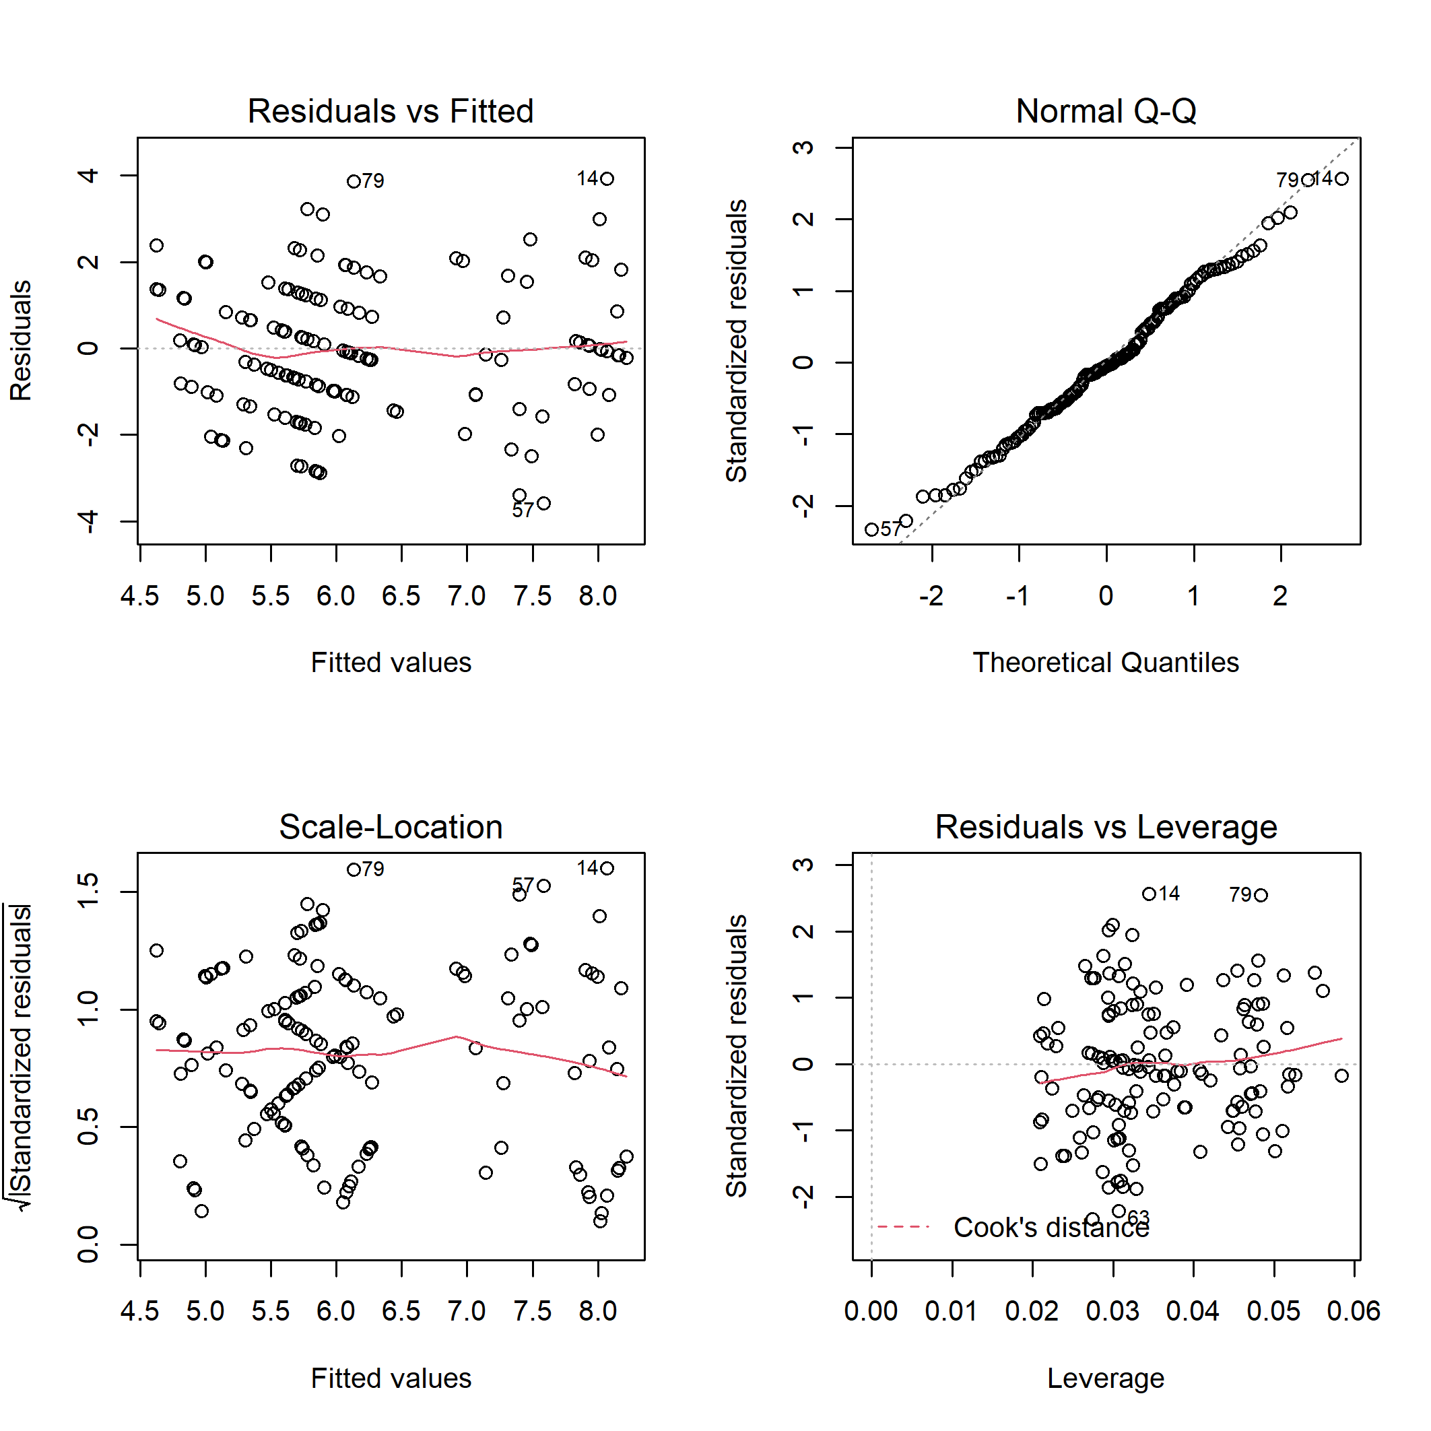

**Fig. B5.** Diagnostic plots for linear model of bird generalist species richness on disturbance class and elevation.

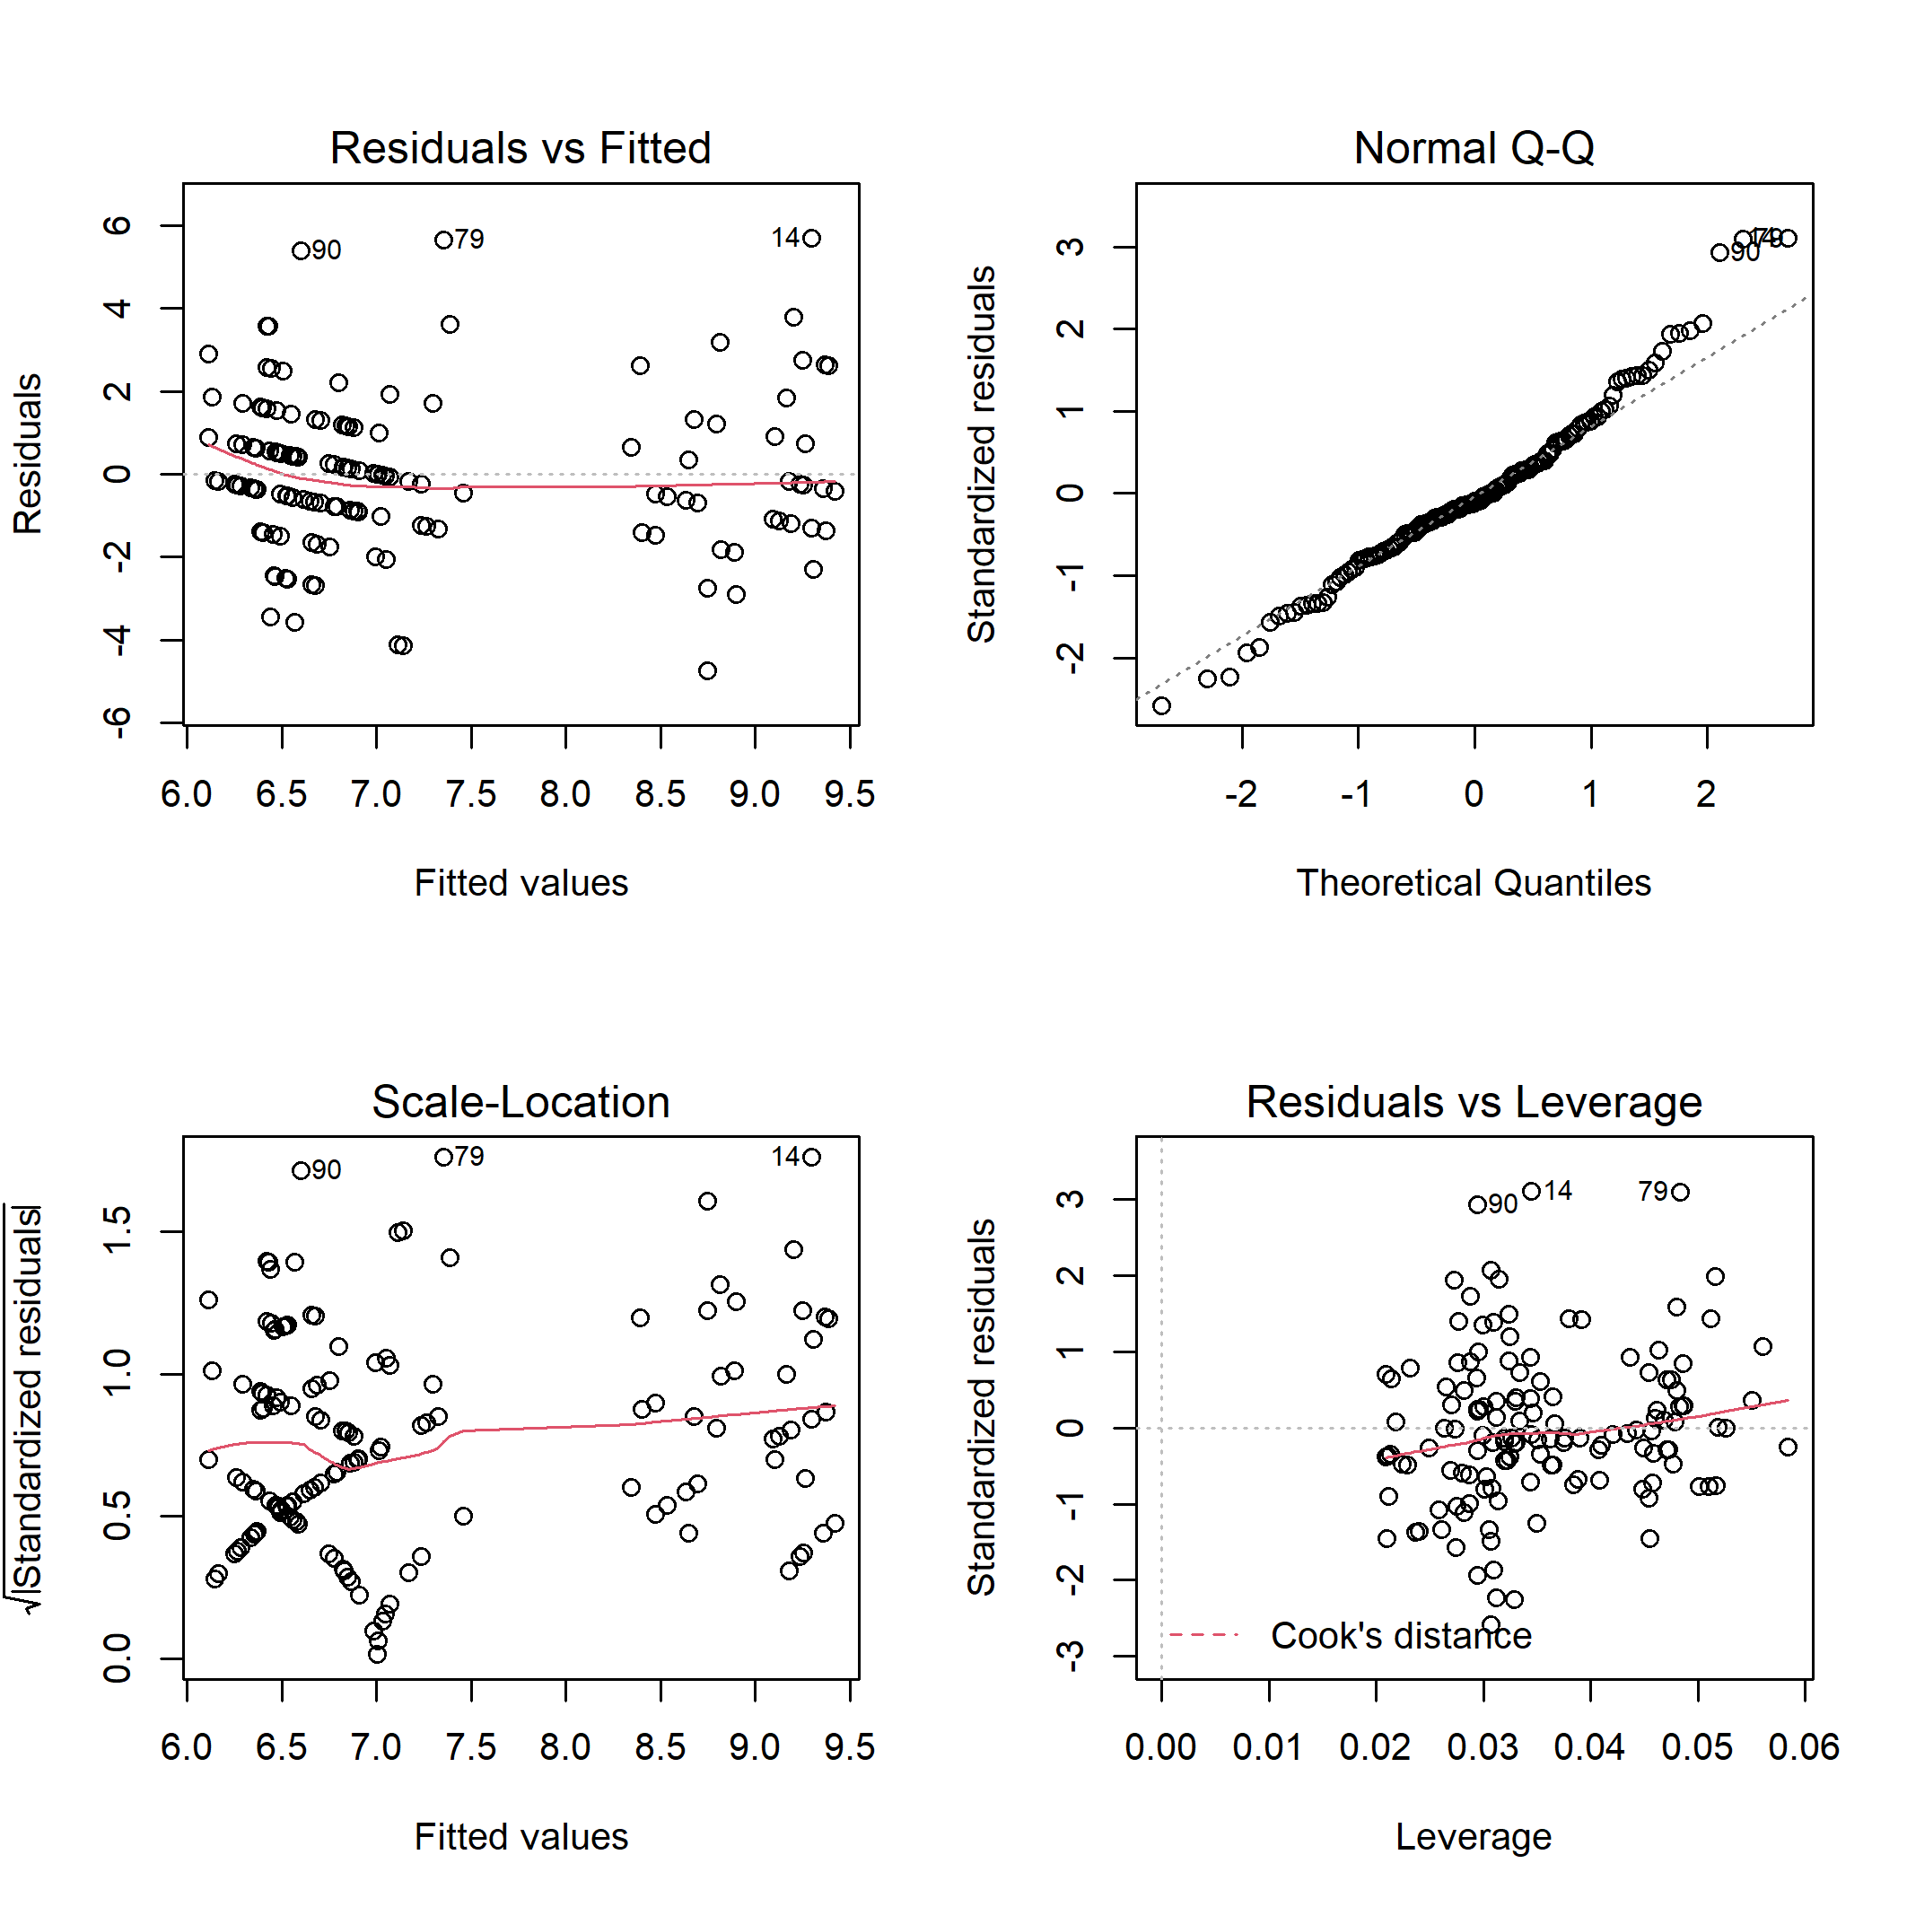

**Fig. B6.** Diagnostic plots for linear model of bird generalist species abundance on disturbance class and elevation.

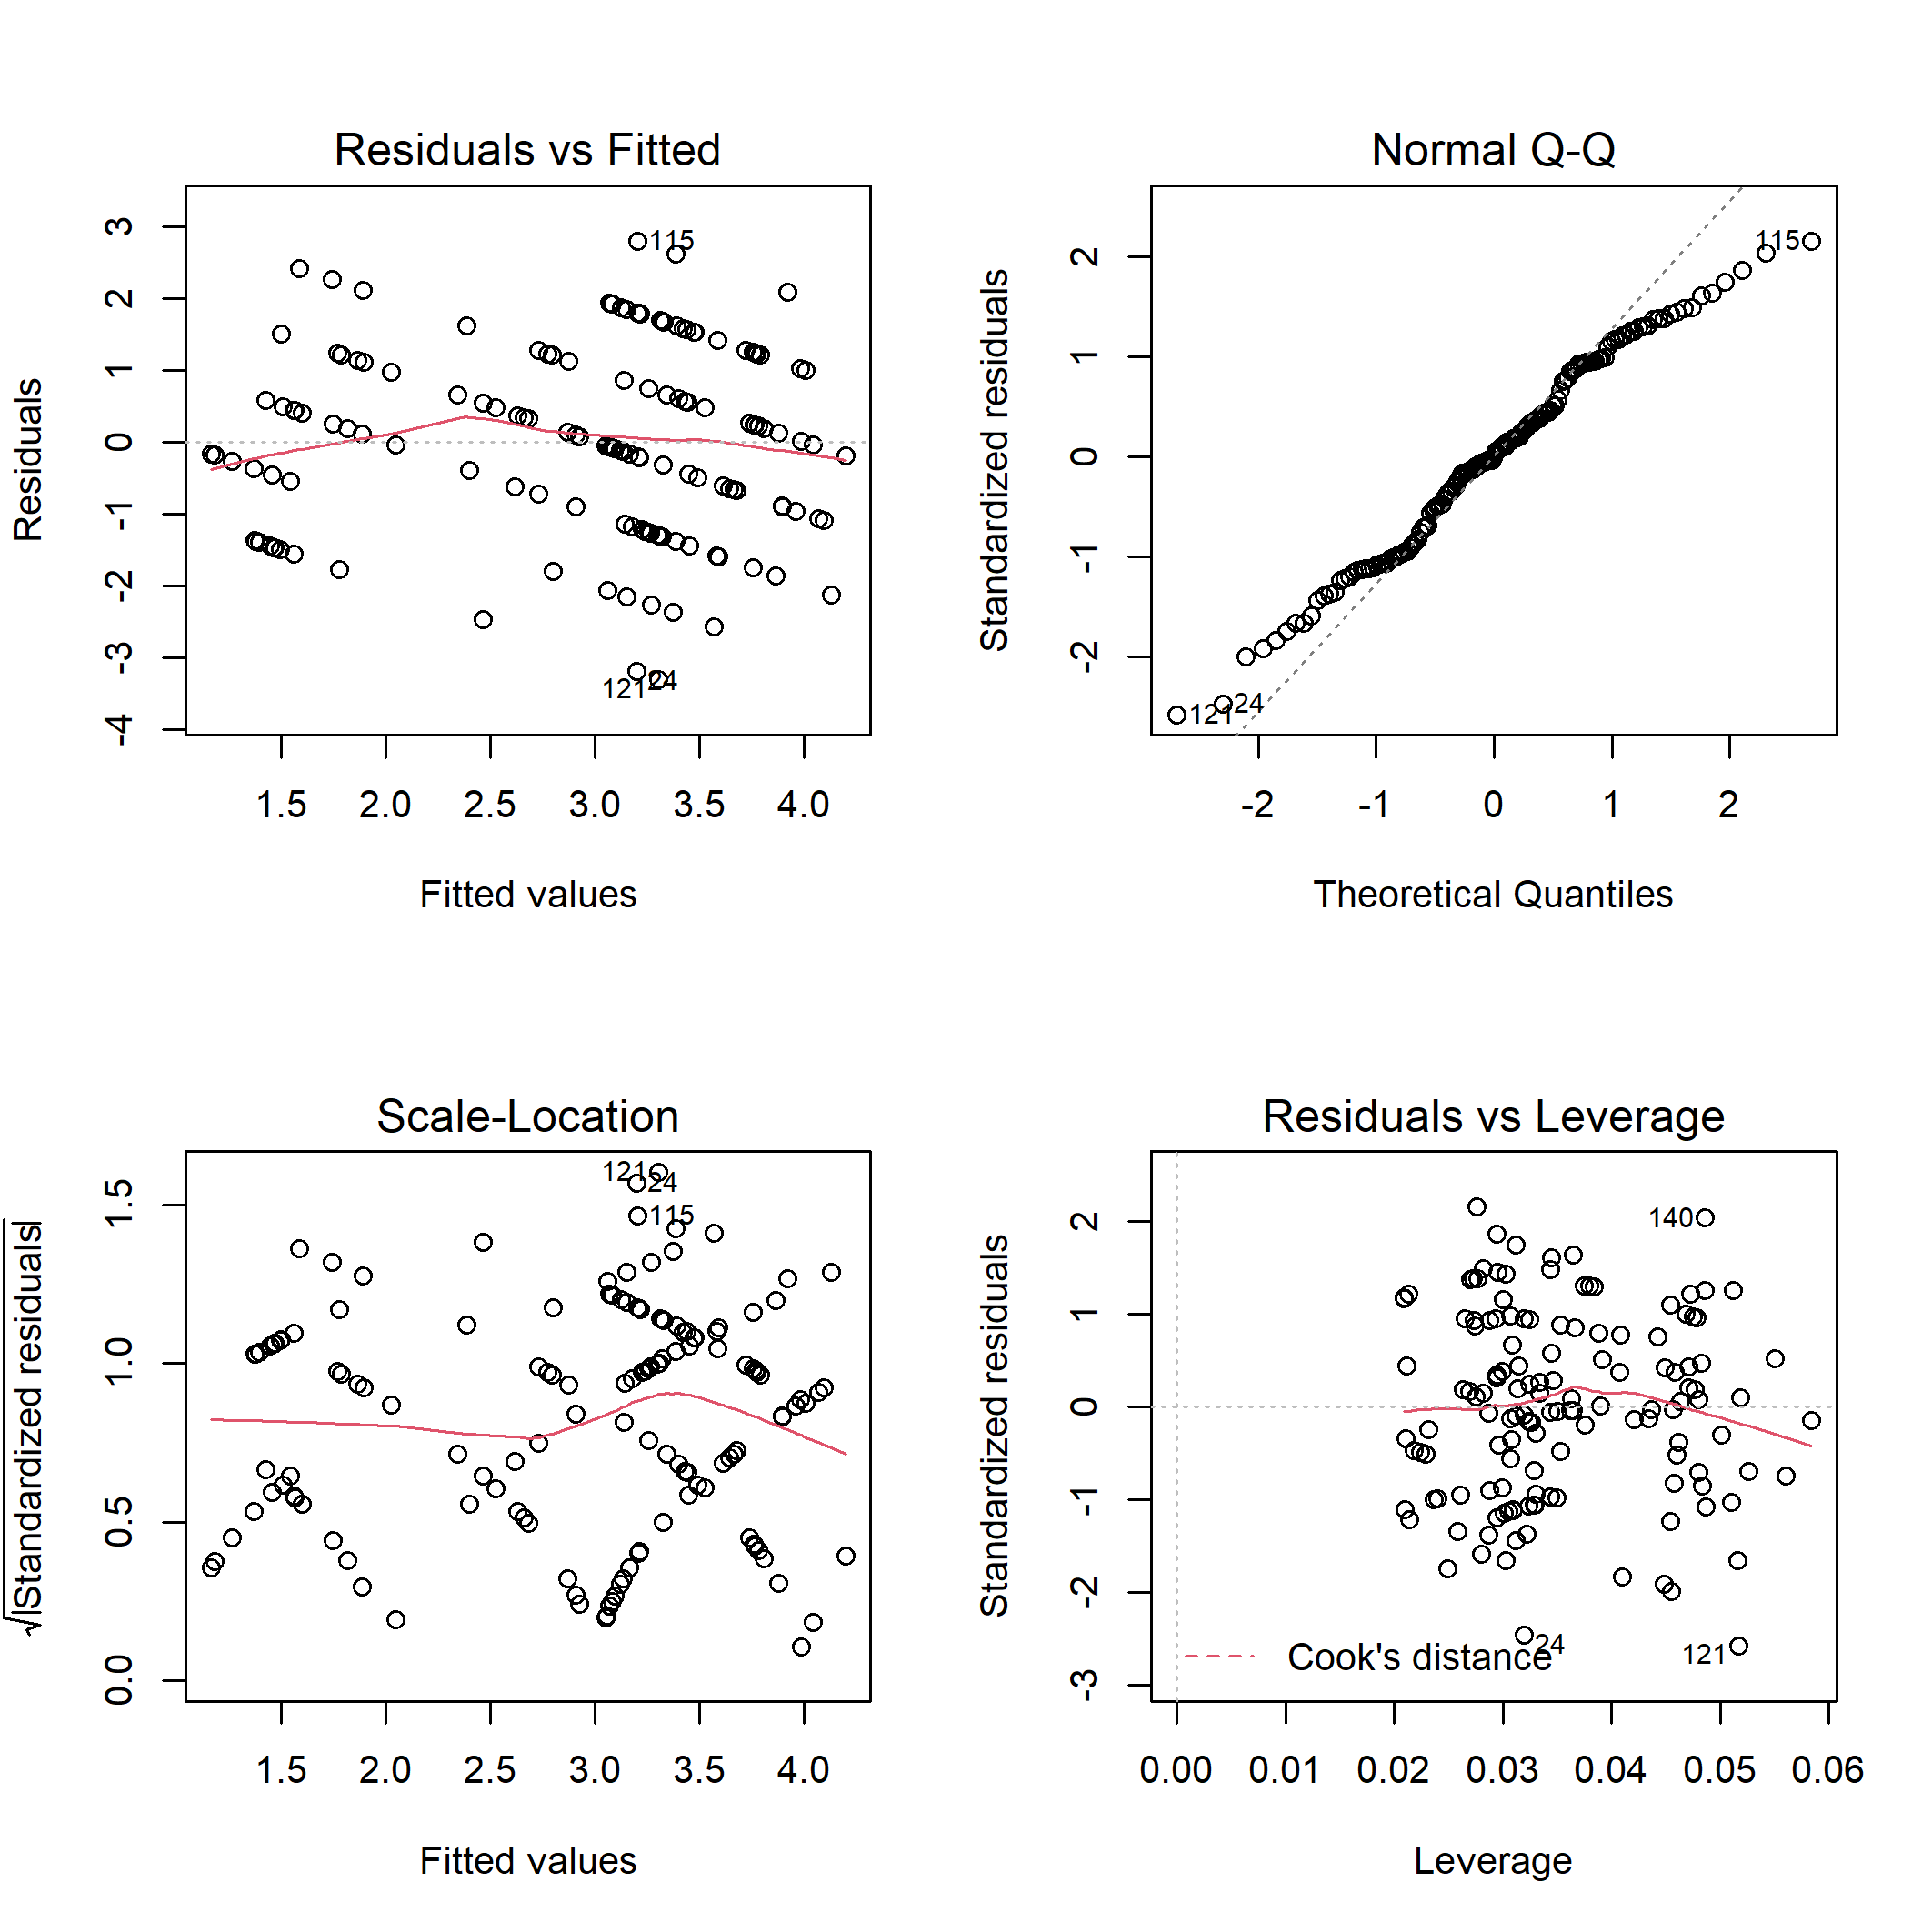

**Fig. B7.** Diagnostic plots for linear model of bird canopy nesters richness on disturbance class and elevation.

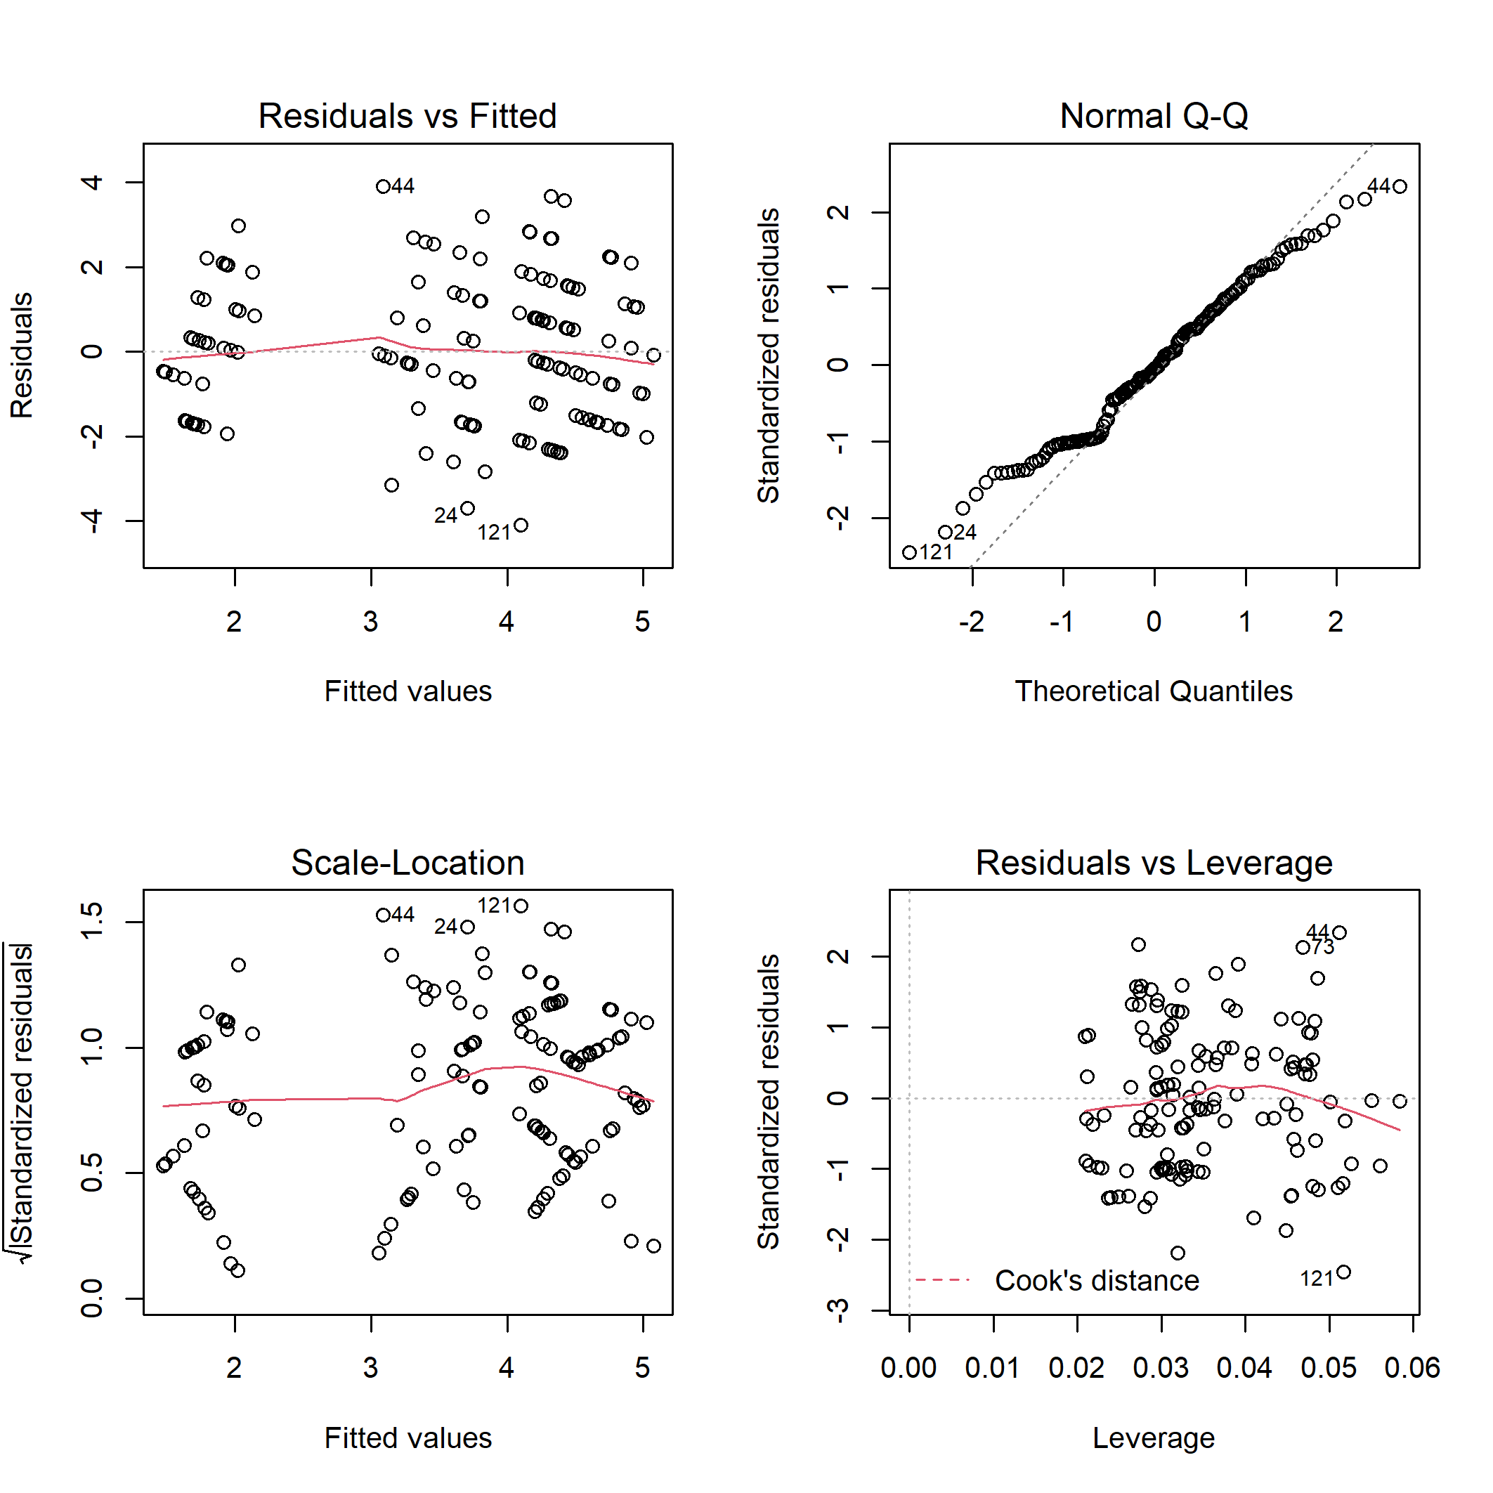

**Fig. B8.** Diagnostic plots for linear model of bird canopy nesters abundance on disturbance class and elevation.

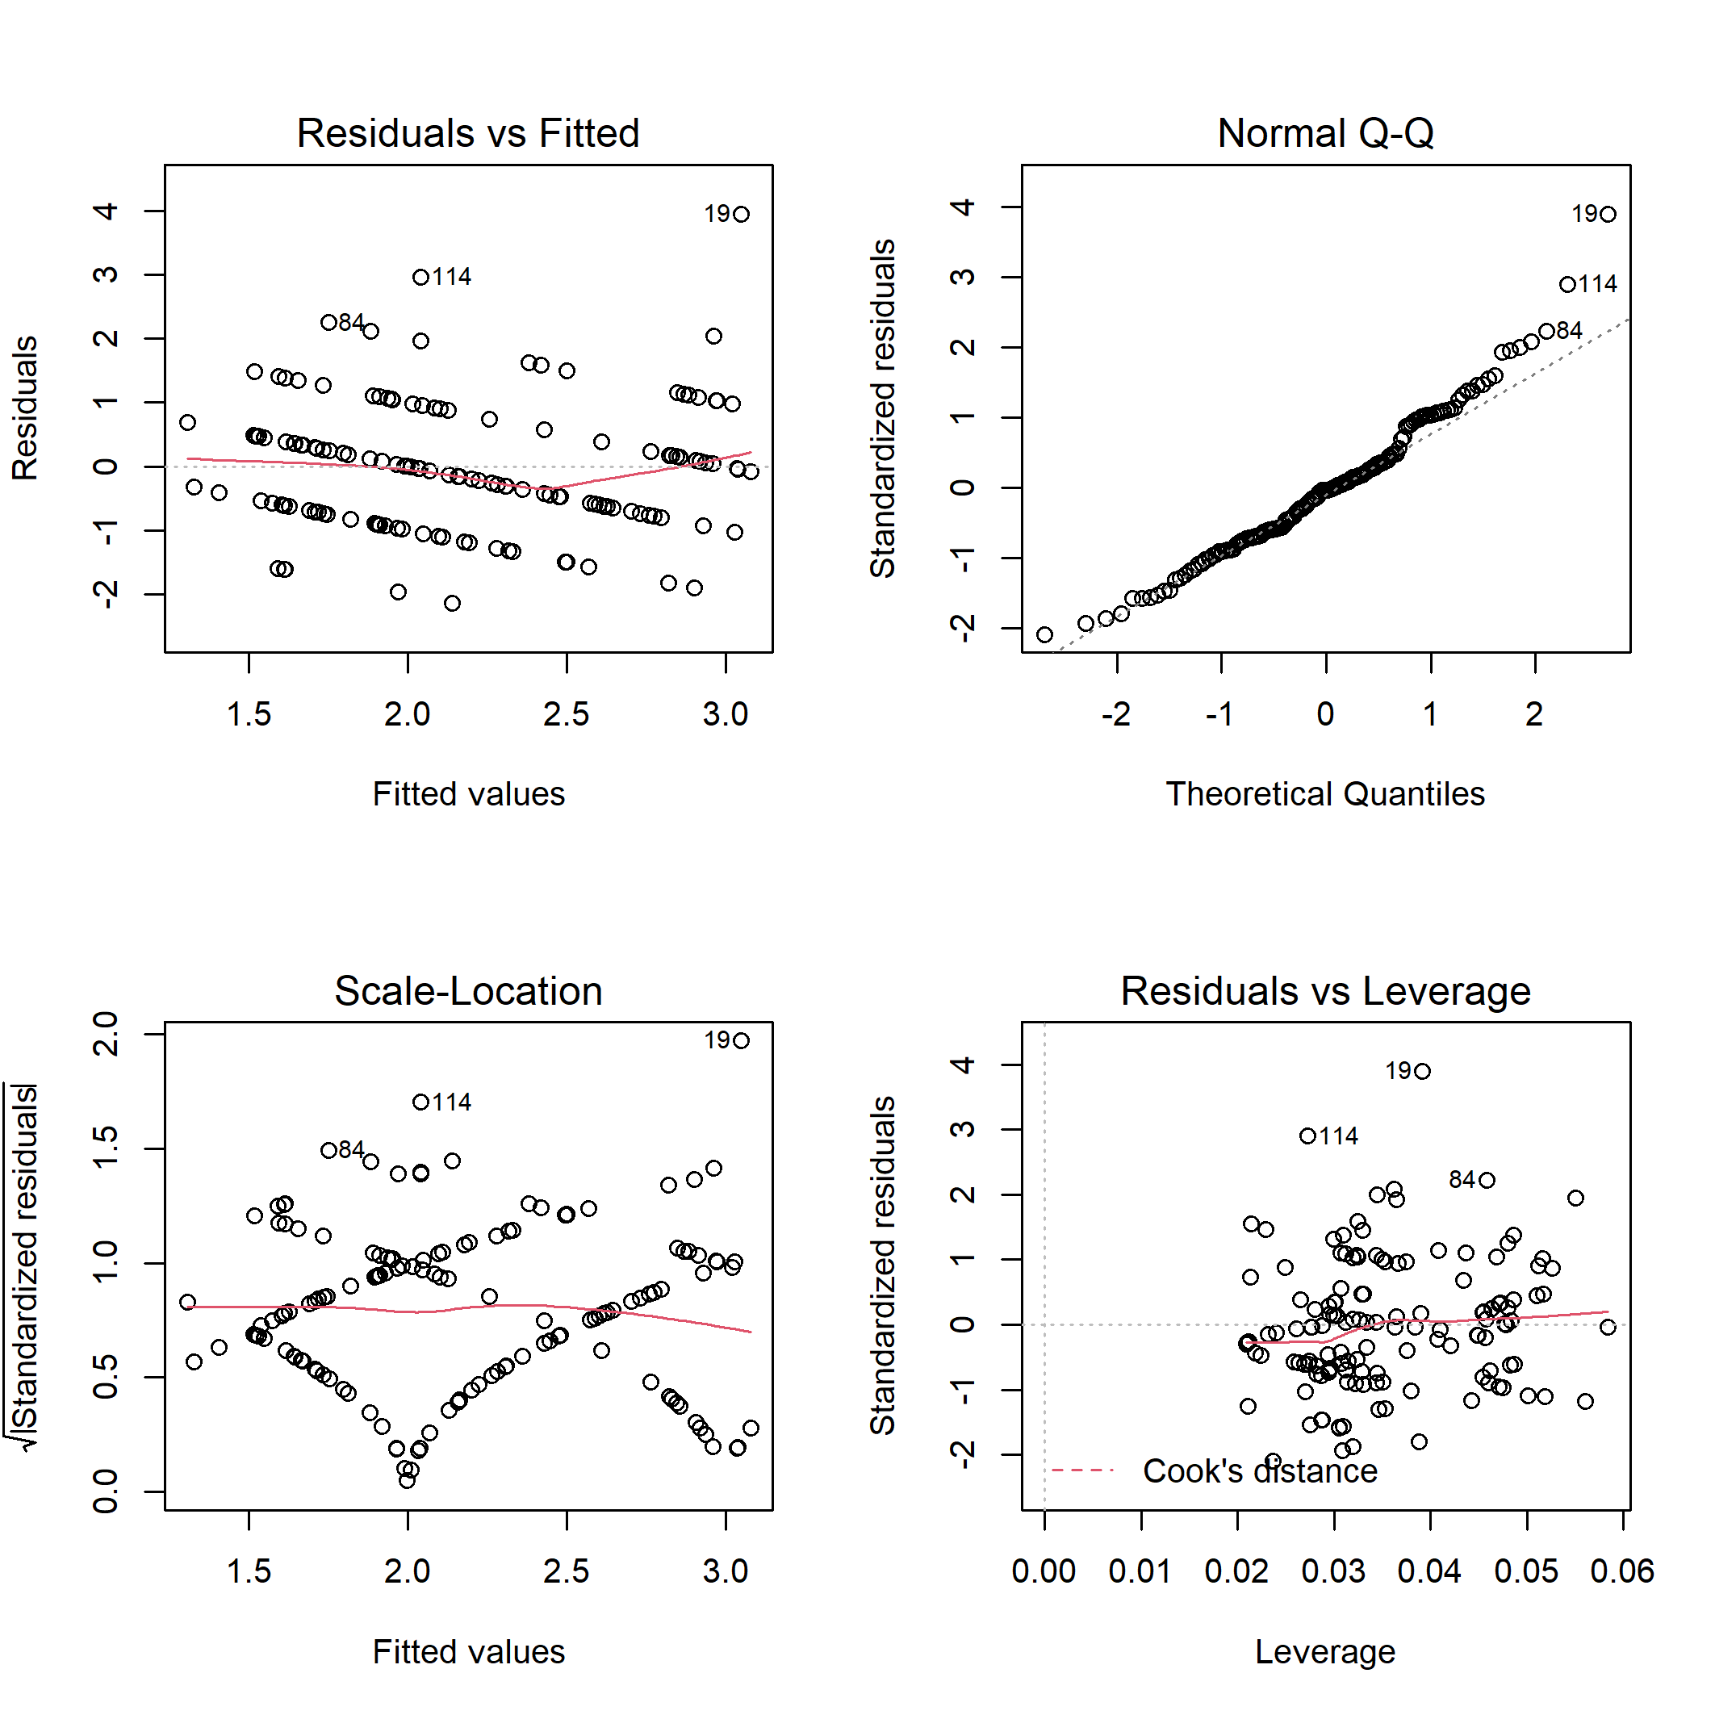

**Fig. B9.** Diagnostic plots for linear model of bird cavity nesters richness on disturbance class and elevation.

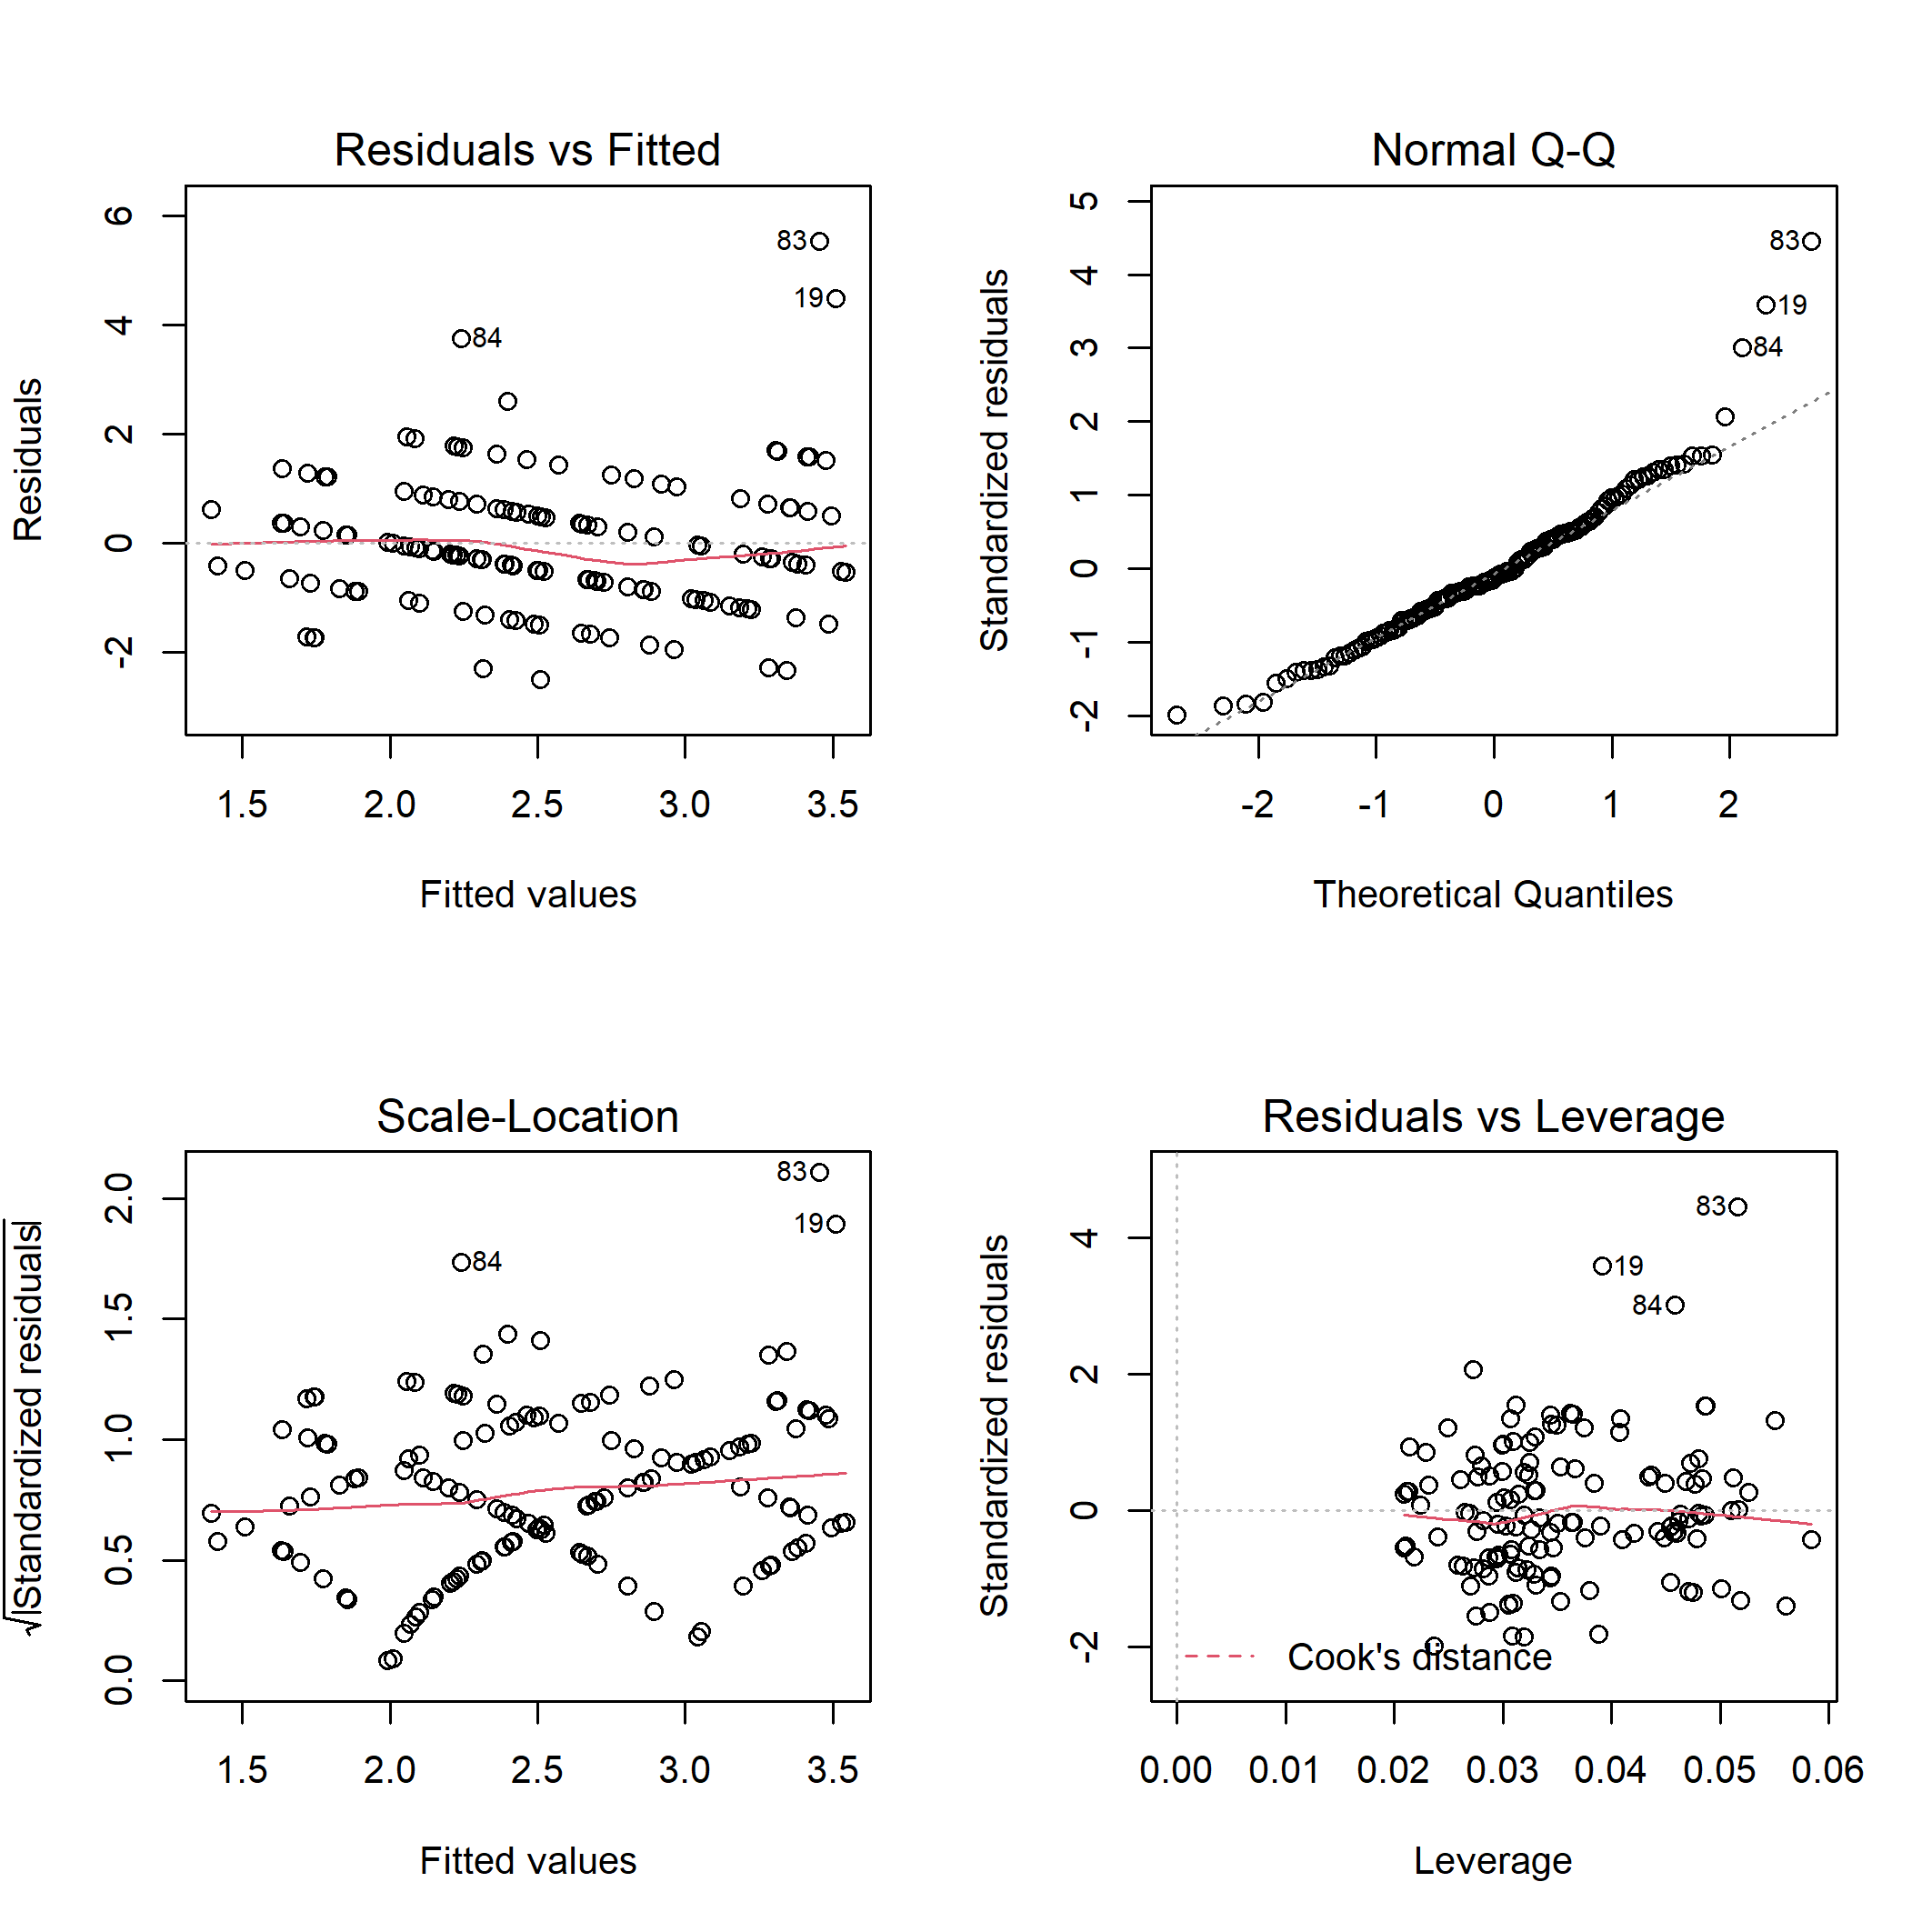

**Fig. B10.** Diagnostic plots for linear model of bird cavity nesters abundance on disturbance class and elevation.

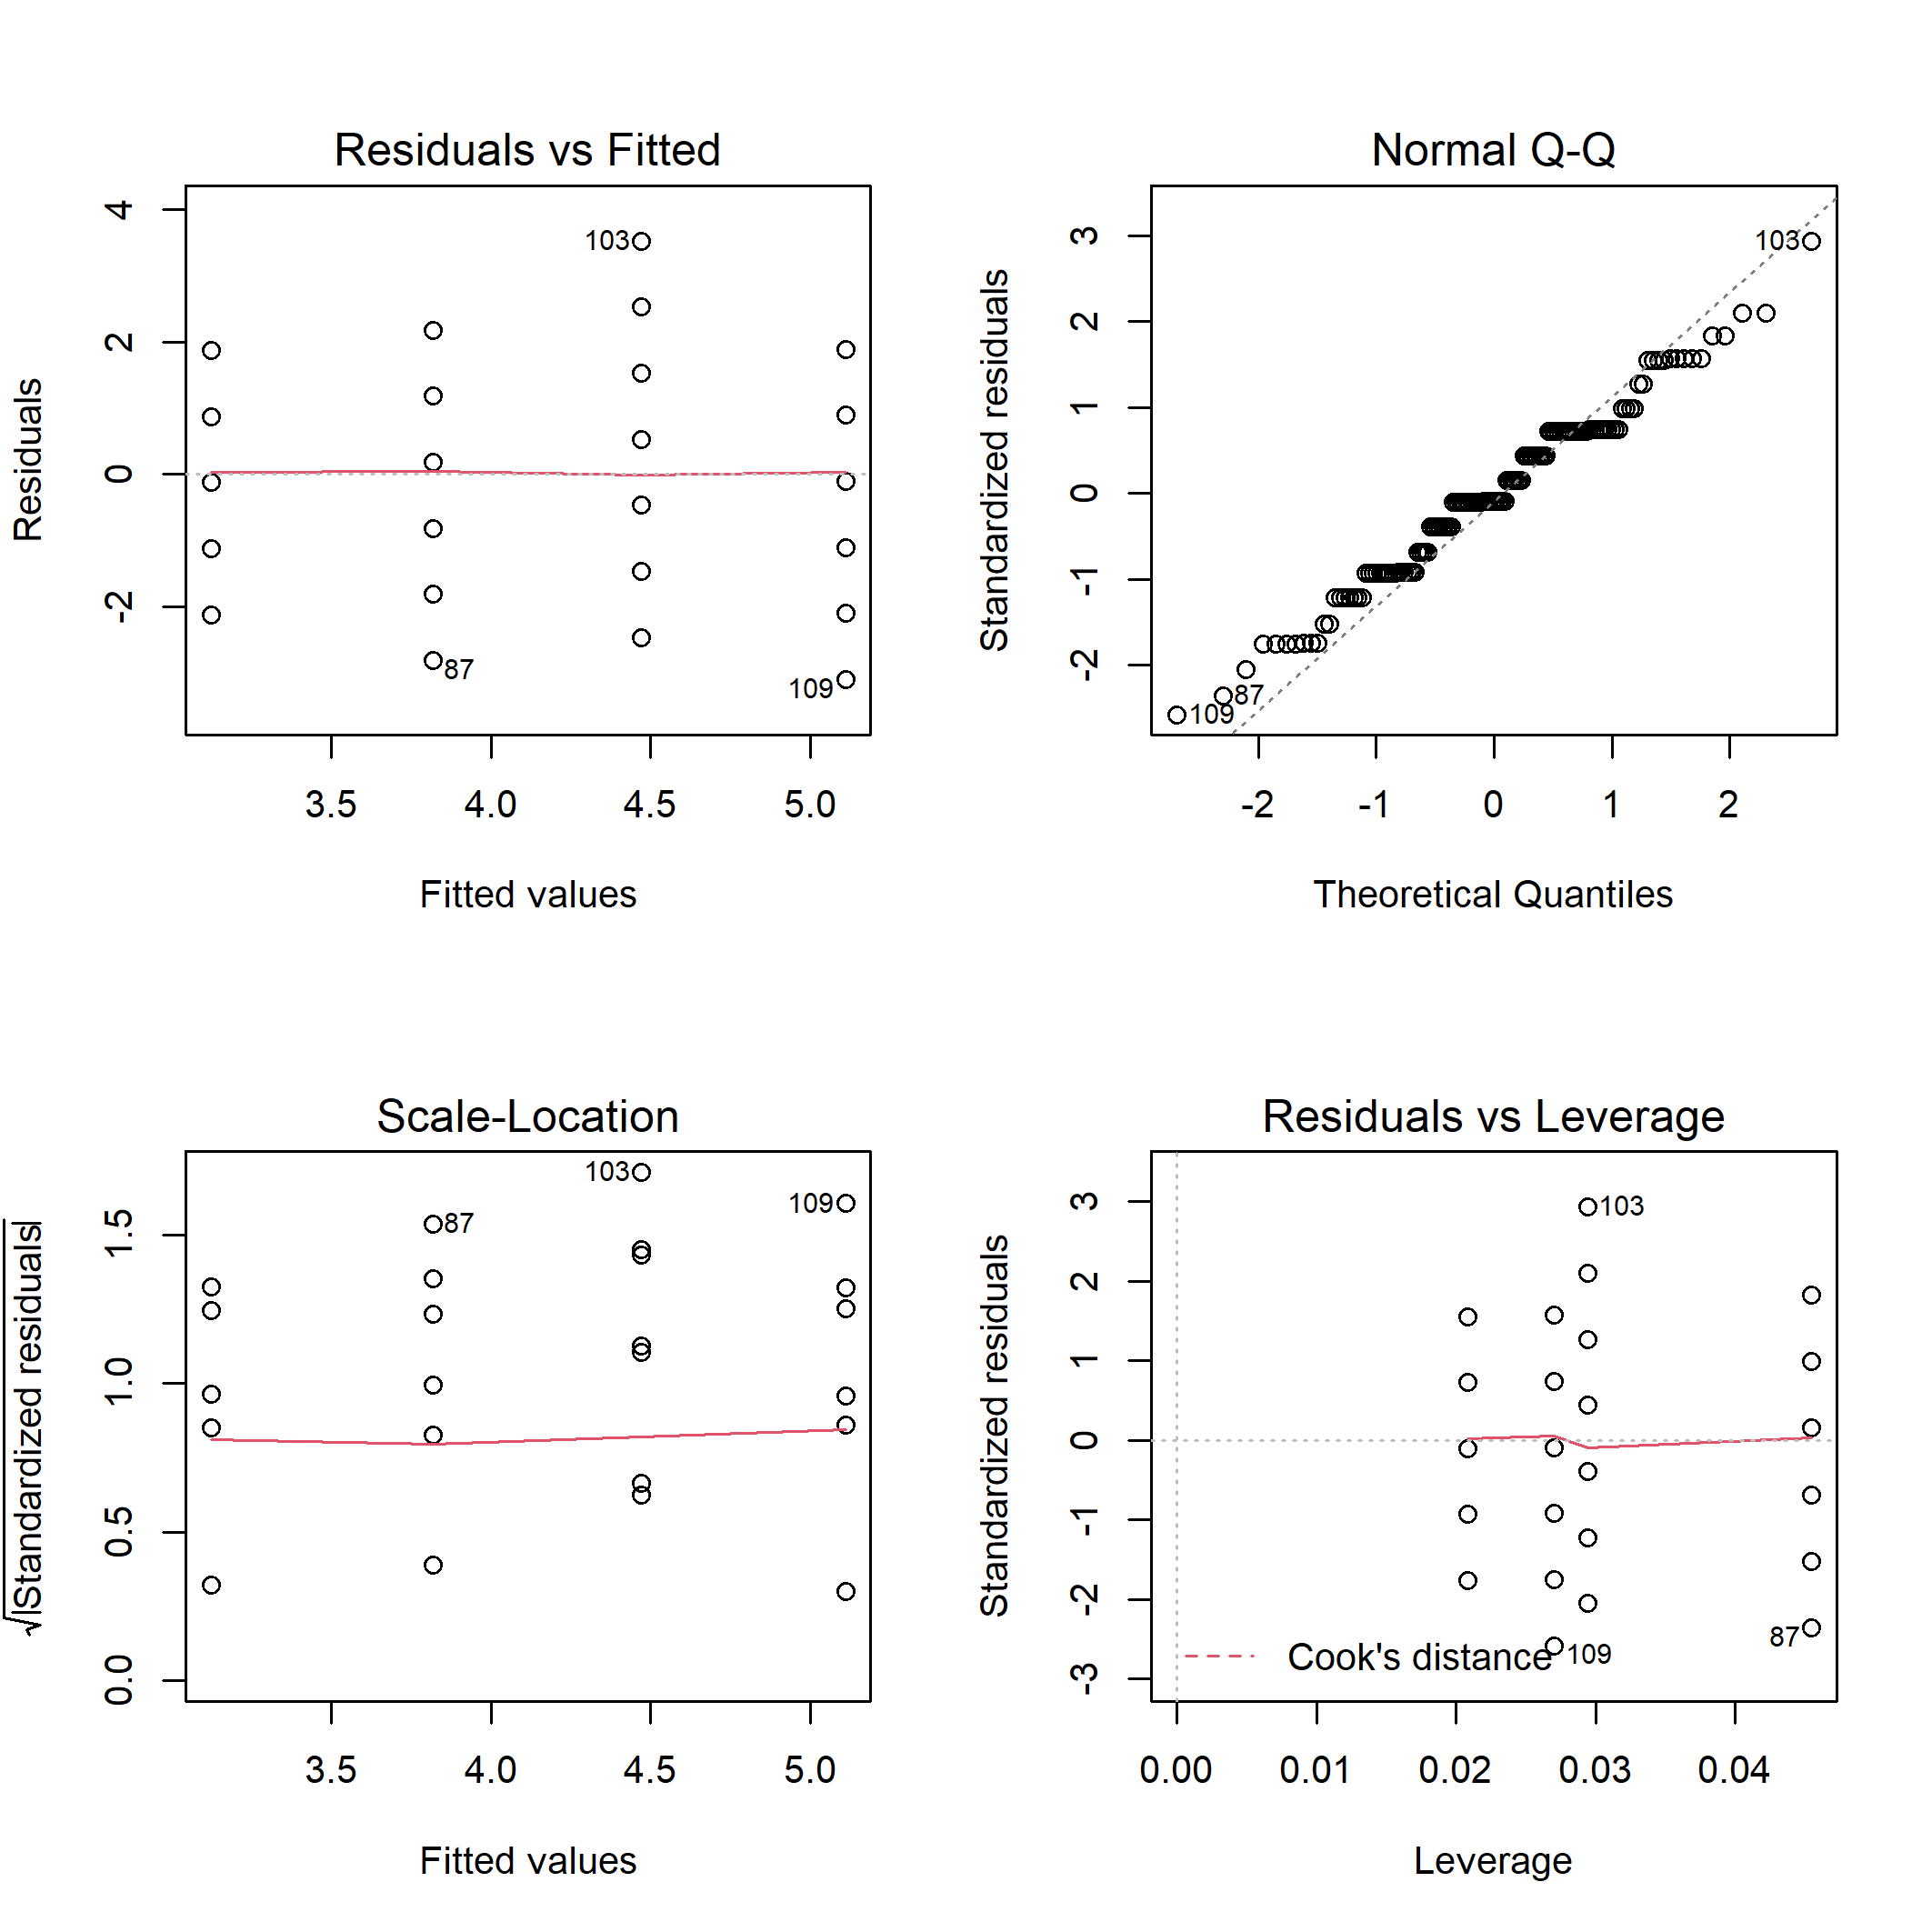

**Fig. B11.** Diagnostic plots for linear model of bird ground/shrub nesters richness on disturbance class and elevation.

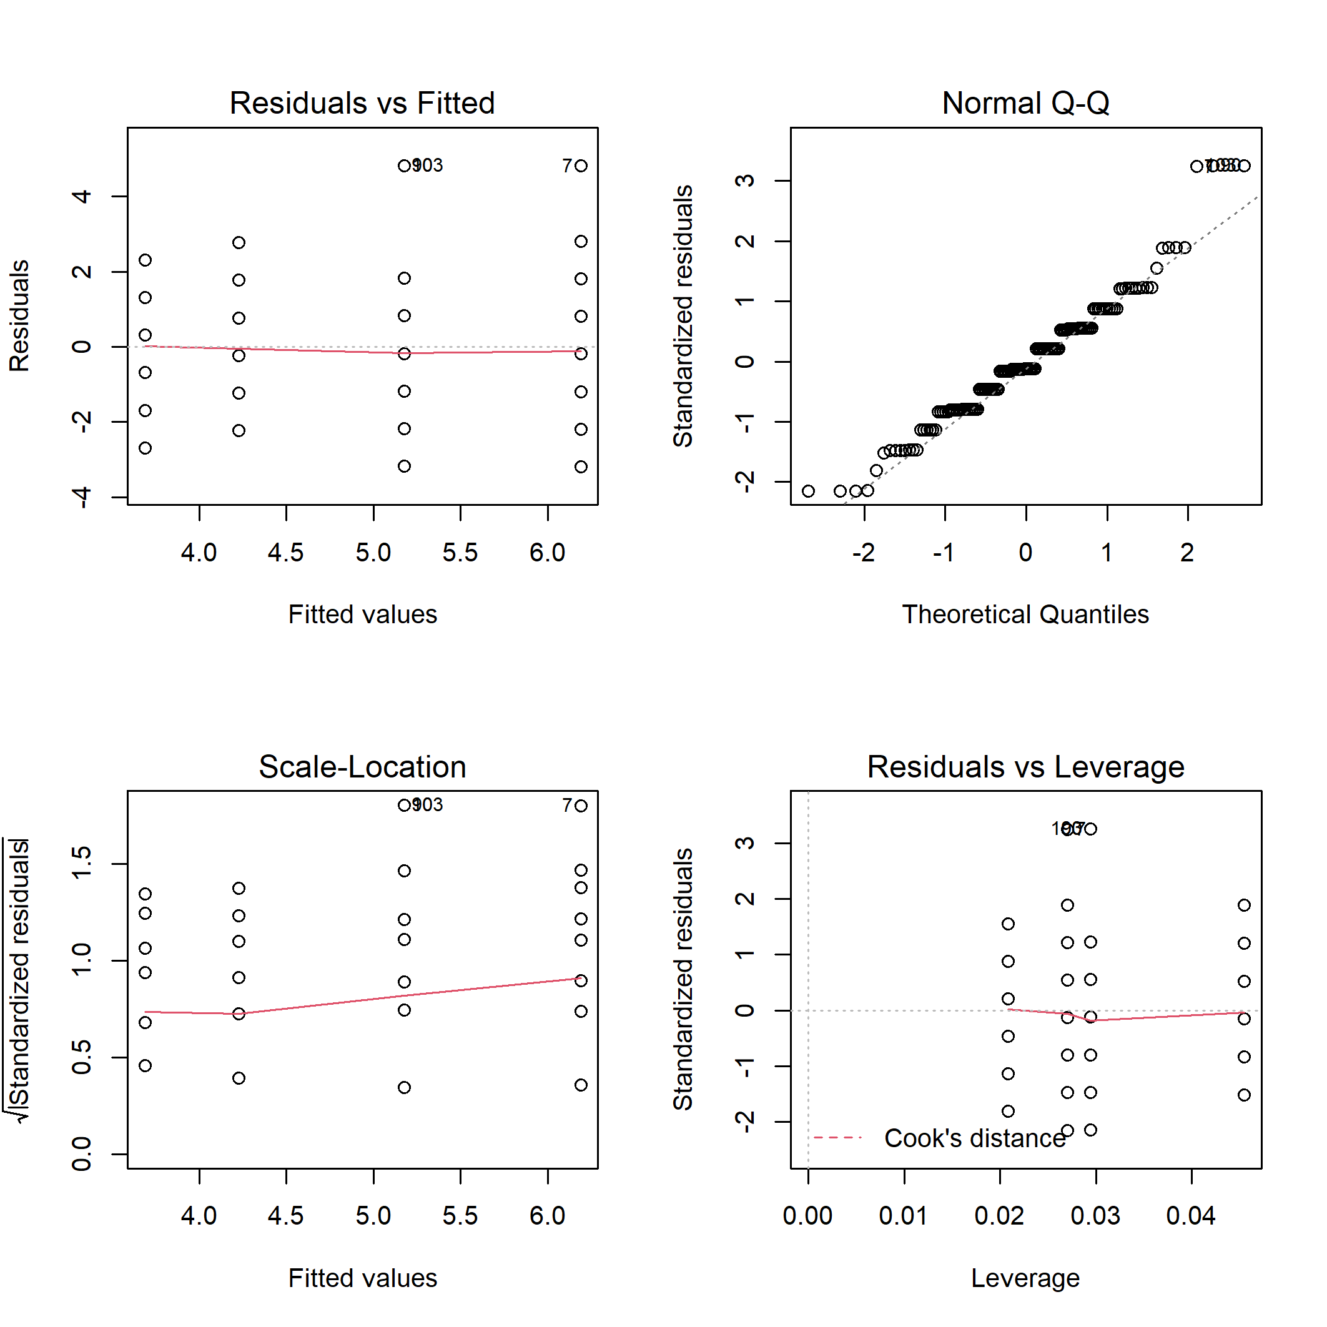

**Fig. B12.** Diagnostic plots for linear model of bird ground/shrub nesters abundance on disturbance class and elevation.

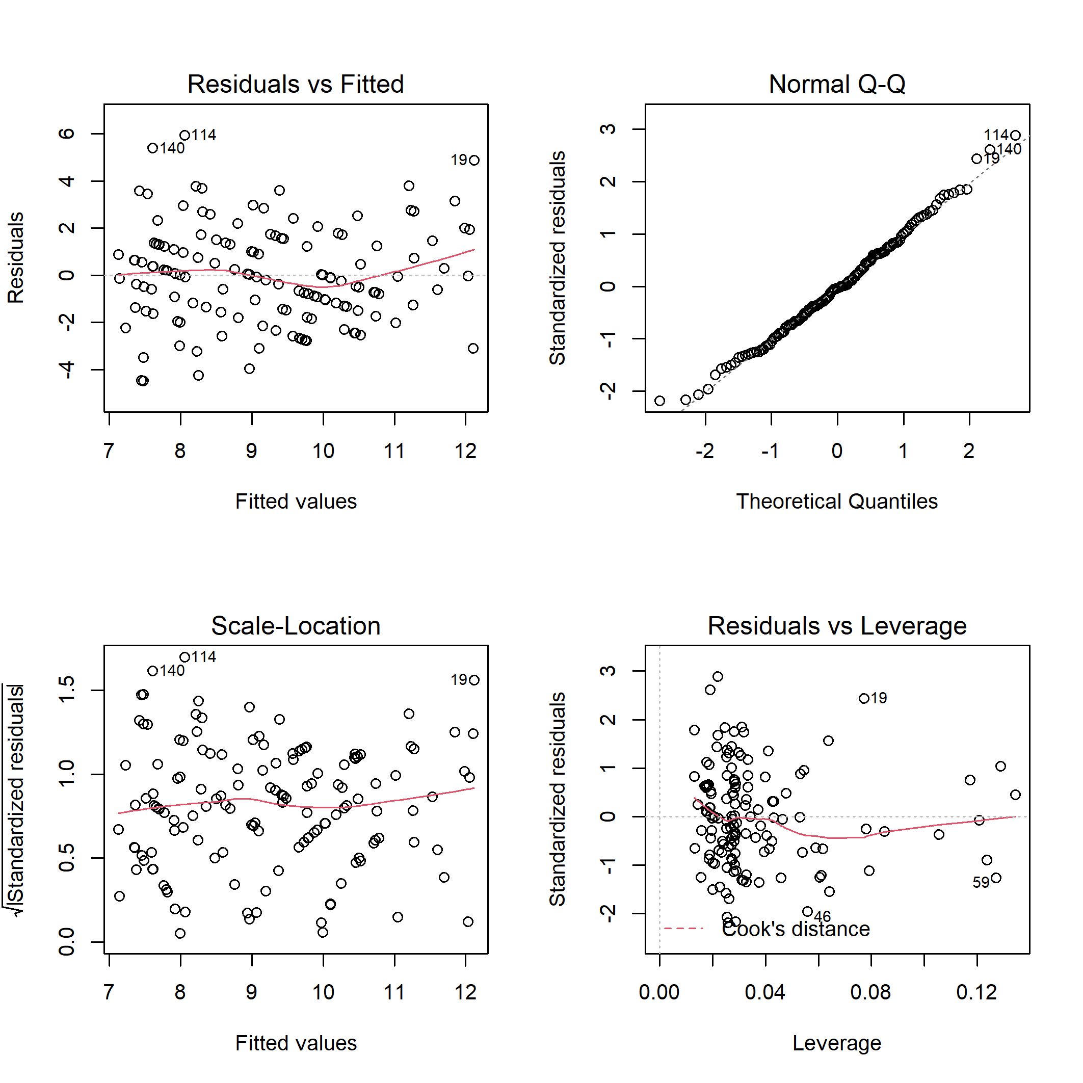

**Fig. B13.** Diagnostic plots for linear model of total bird species richness on habitat characteristics.

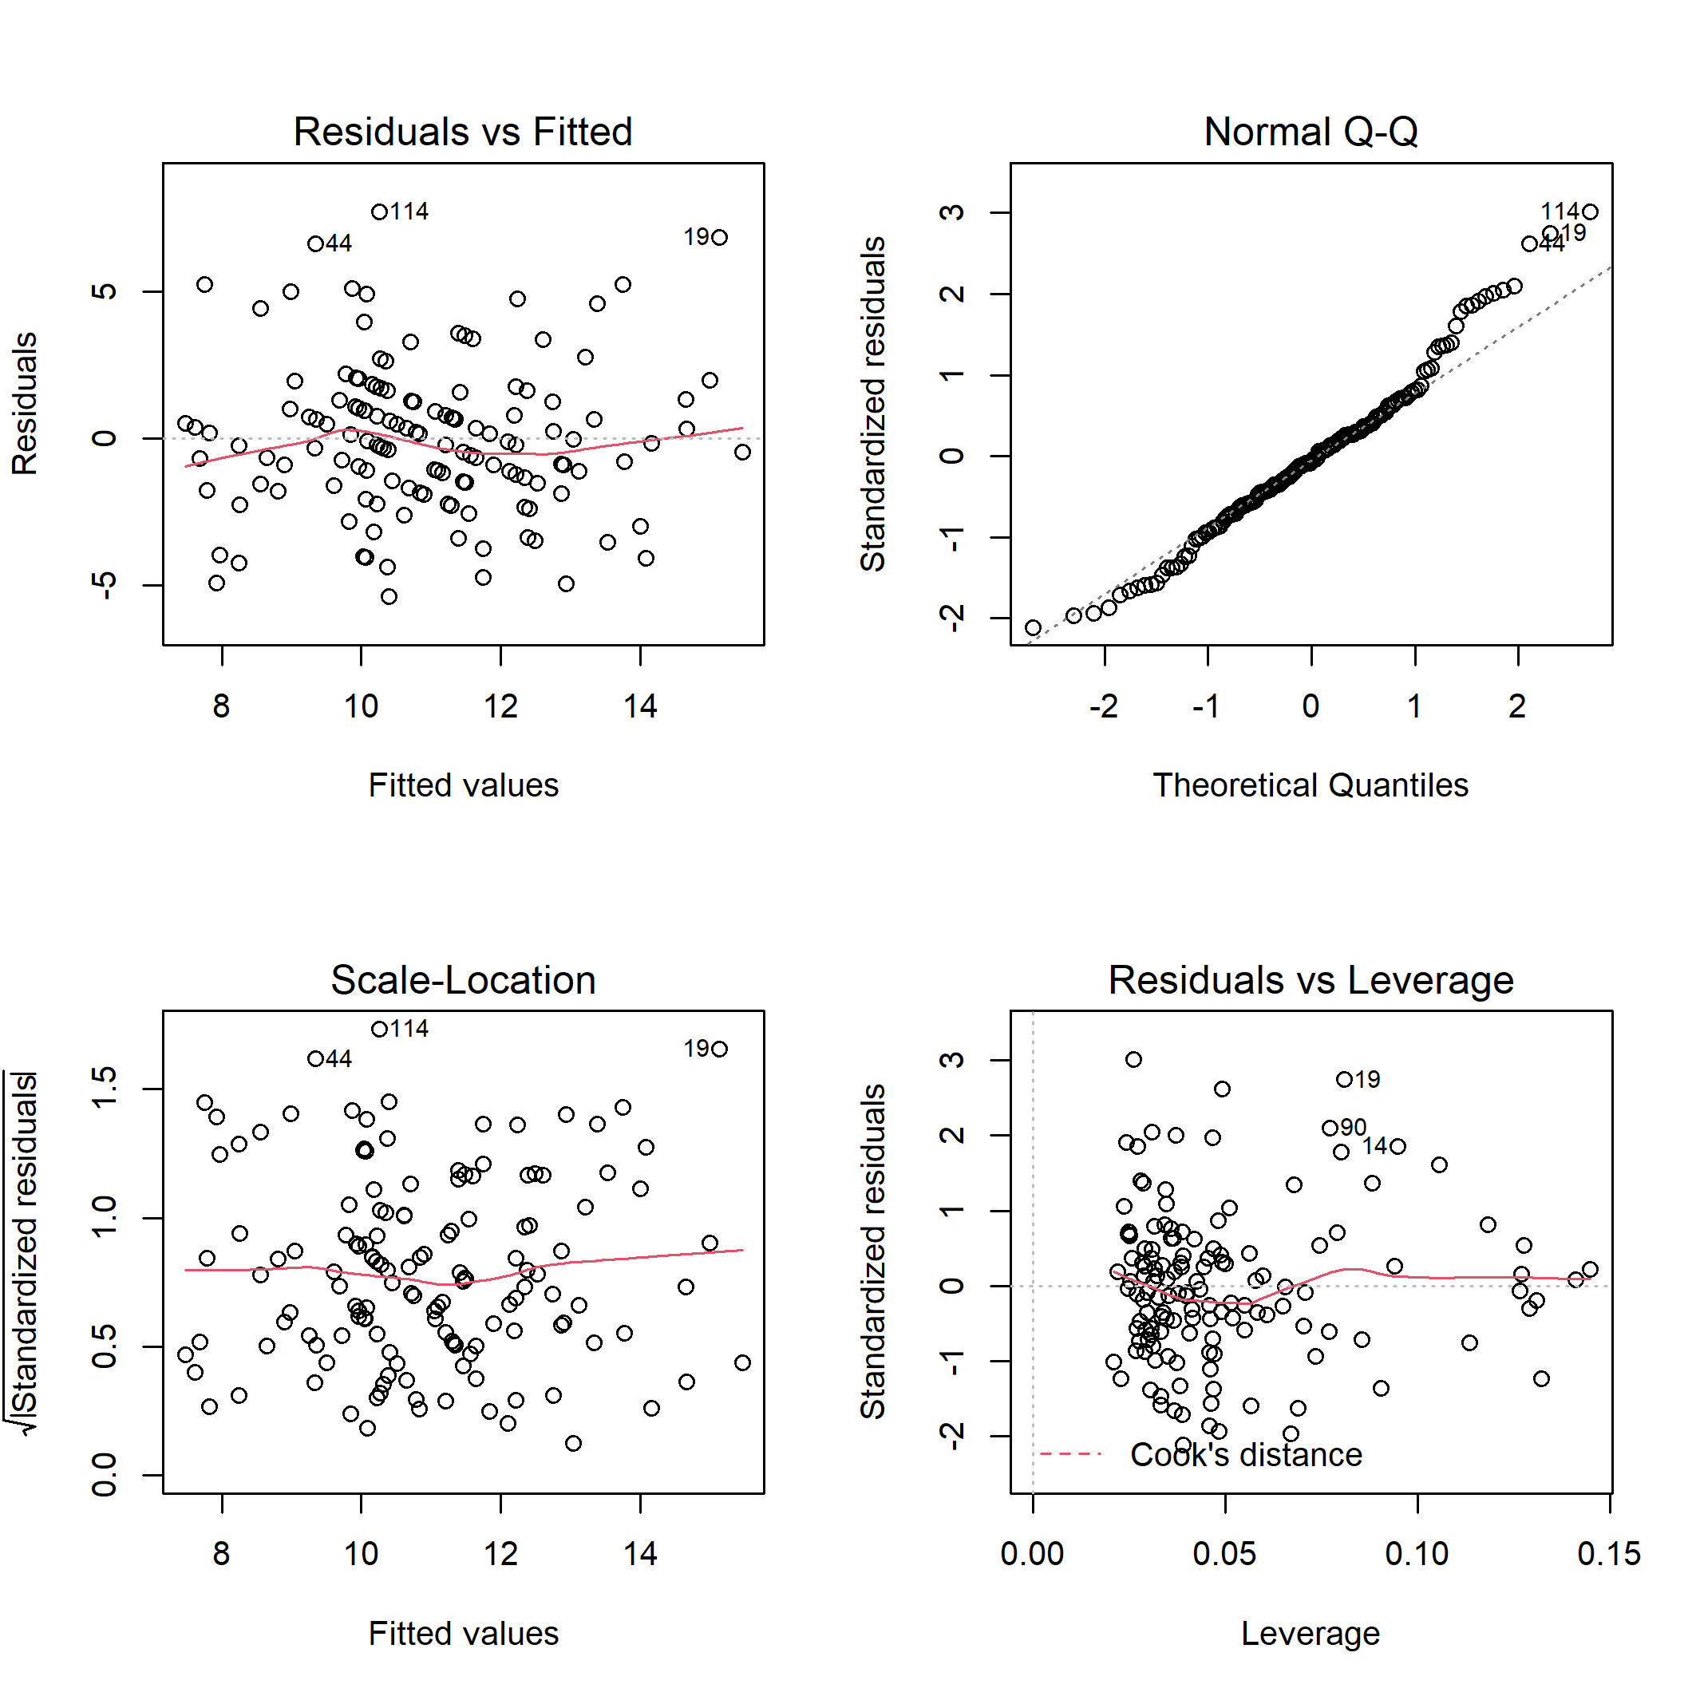

**Fig. B14.** Diagnostic plots for linear model of total bird species abundance on habitat characteristics.

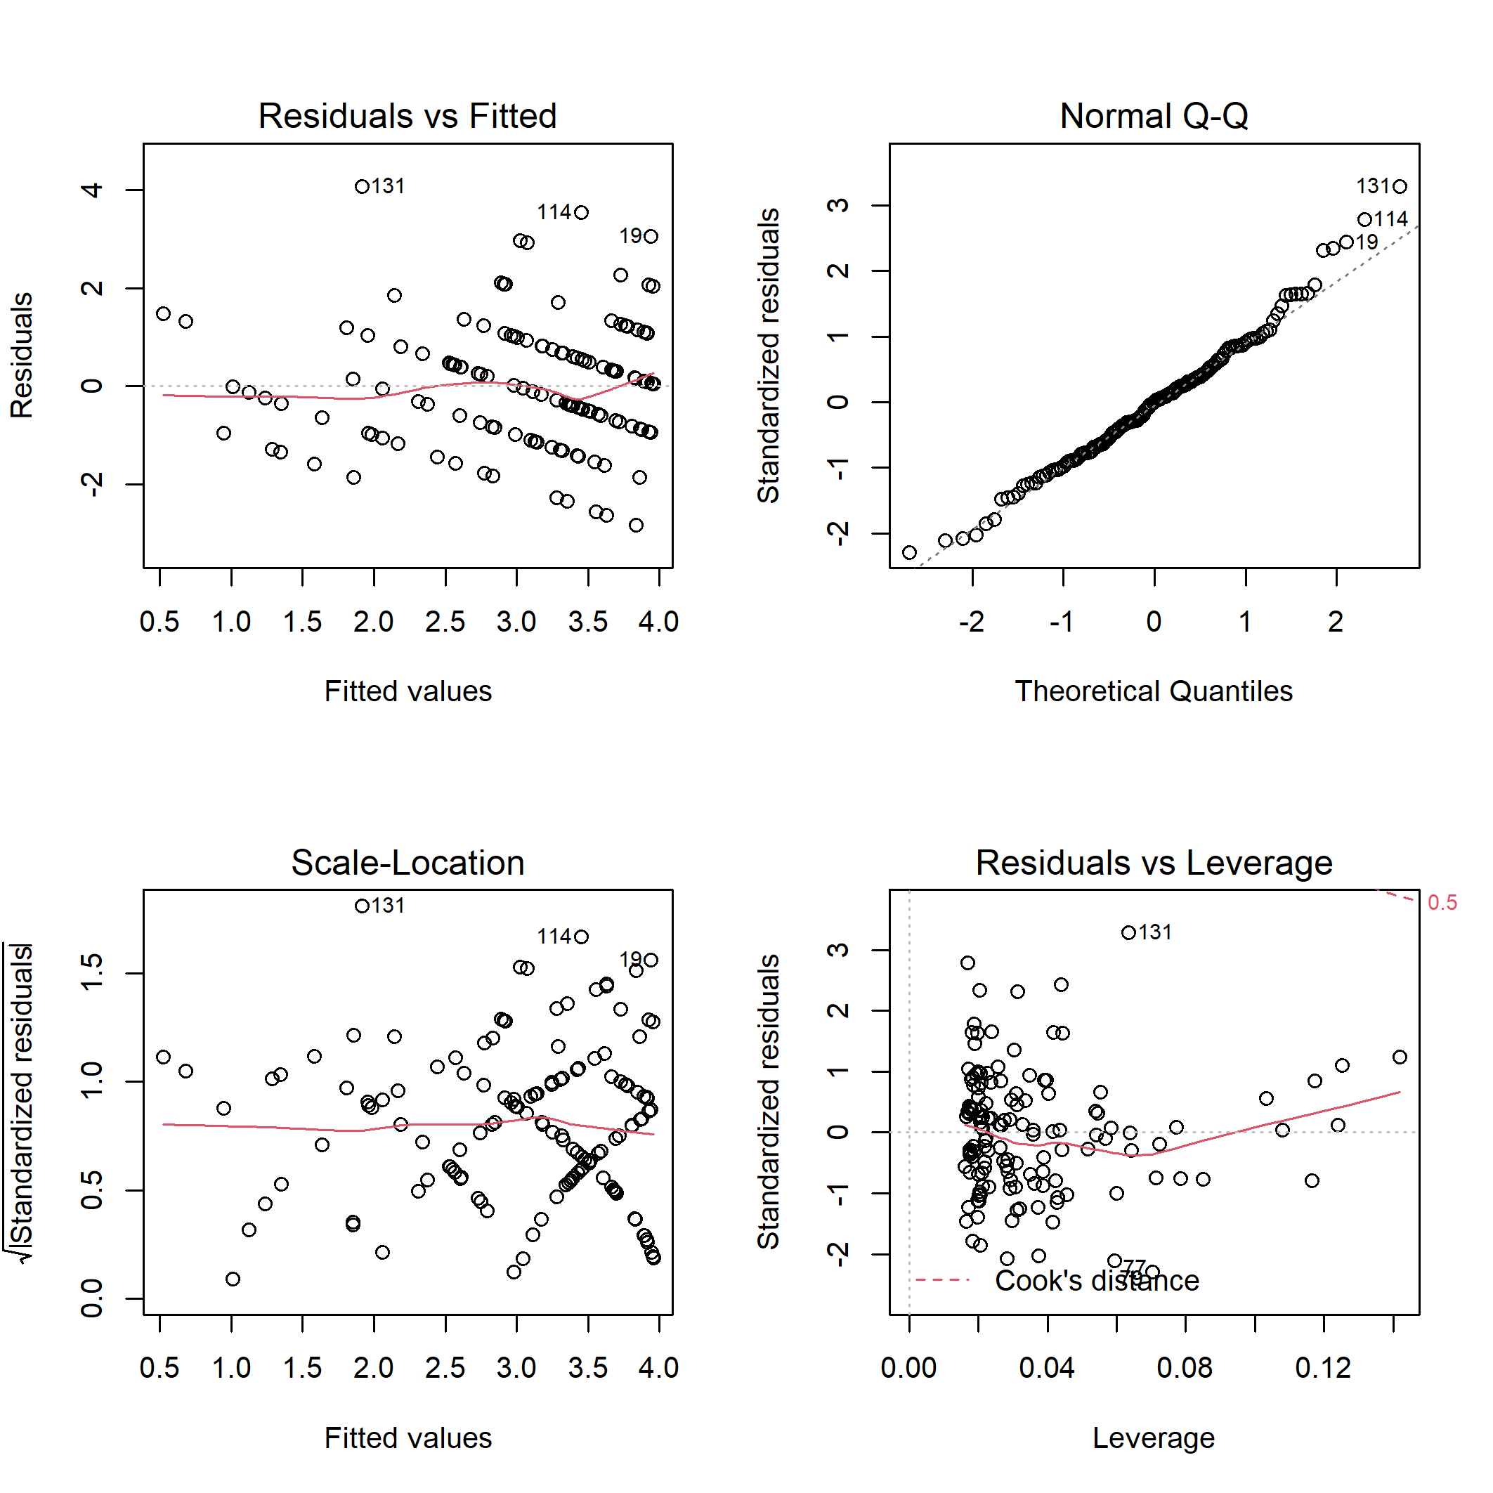

**Fig. B15.** Diagnostic plots for linear model of bird specialist species richness on habitat characteristics.

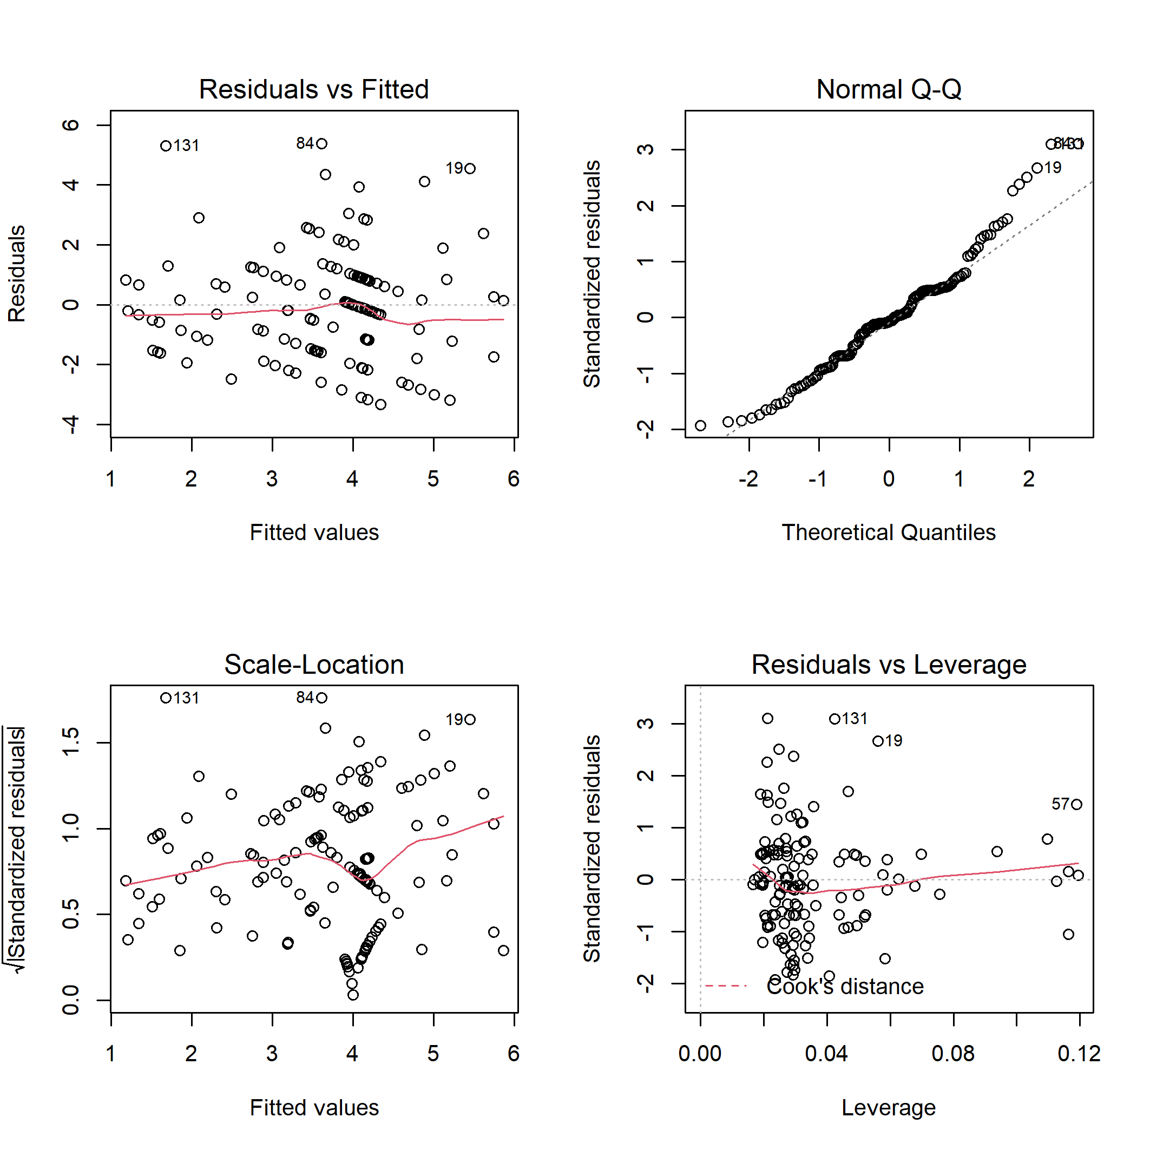

**Fig. B16.** Diagnostic plots for linear model of bird specialist species abundance on habitat characteristics.

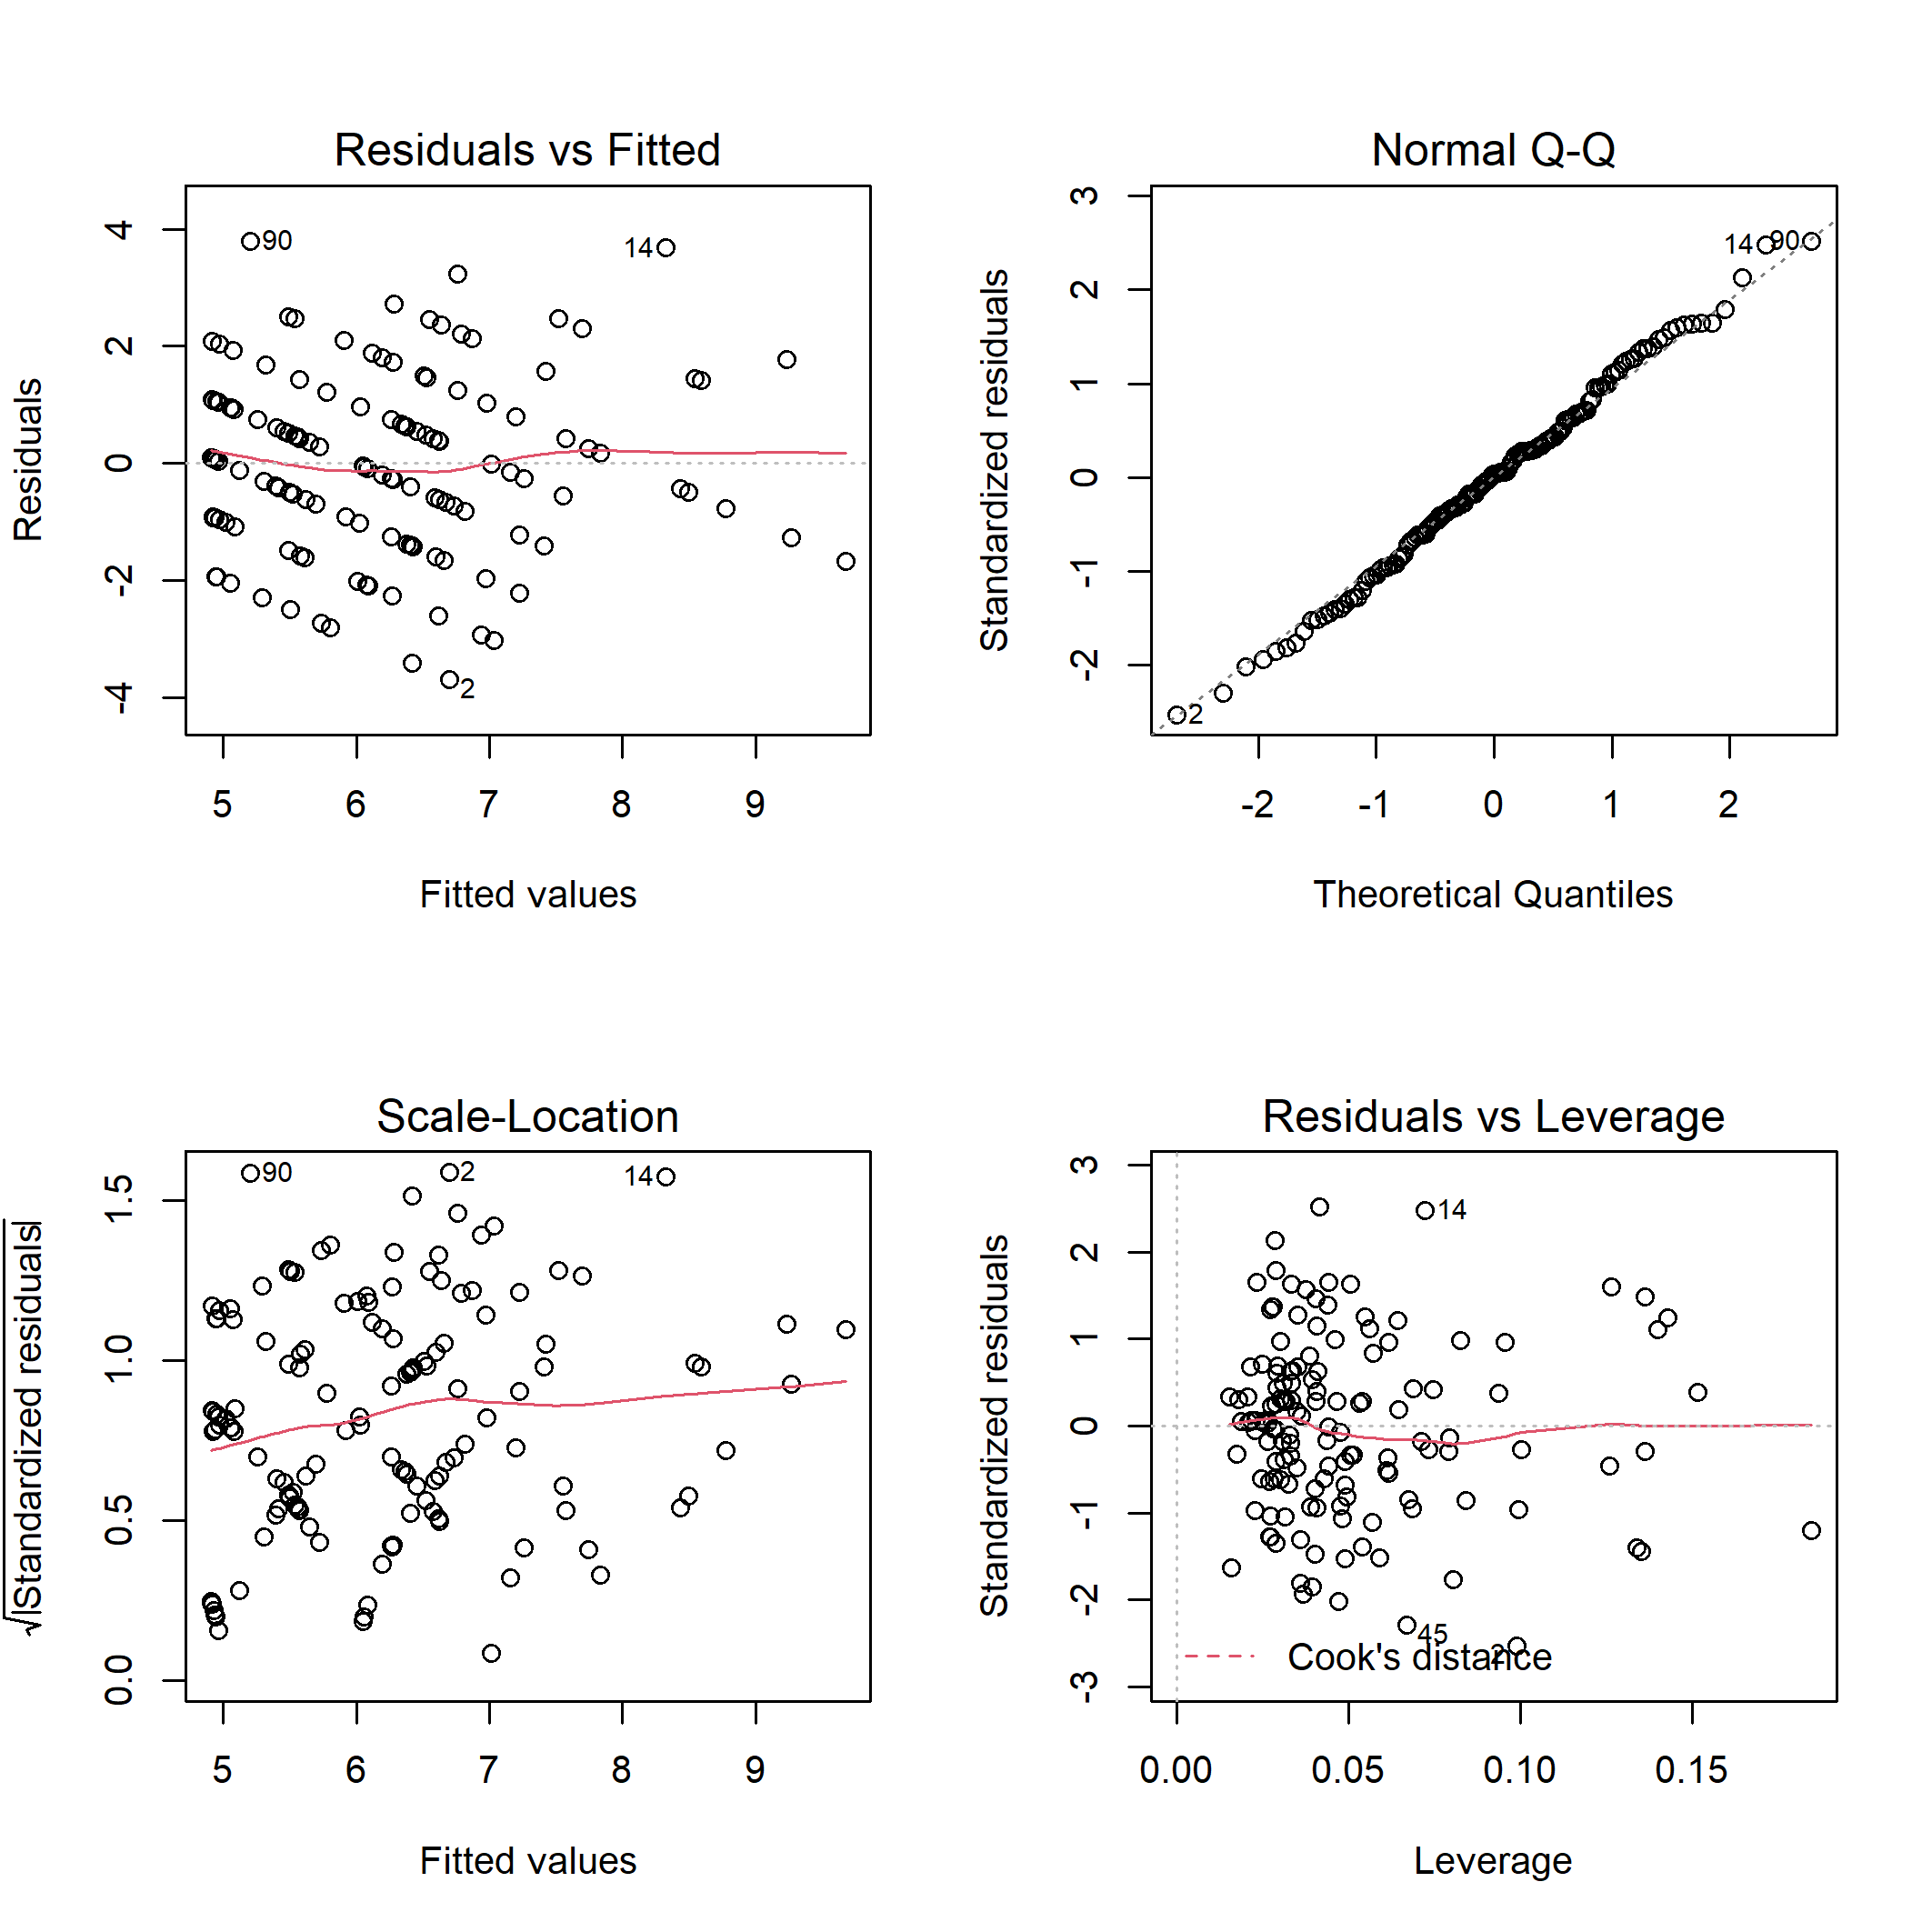

**Fig. B17.** Diagnostic plots for linear model of bird generalist species richness on habitat characteristics.

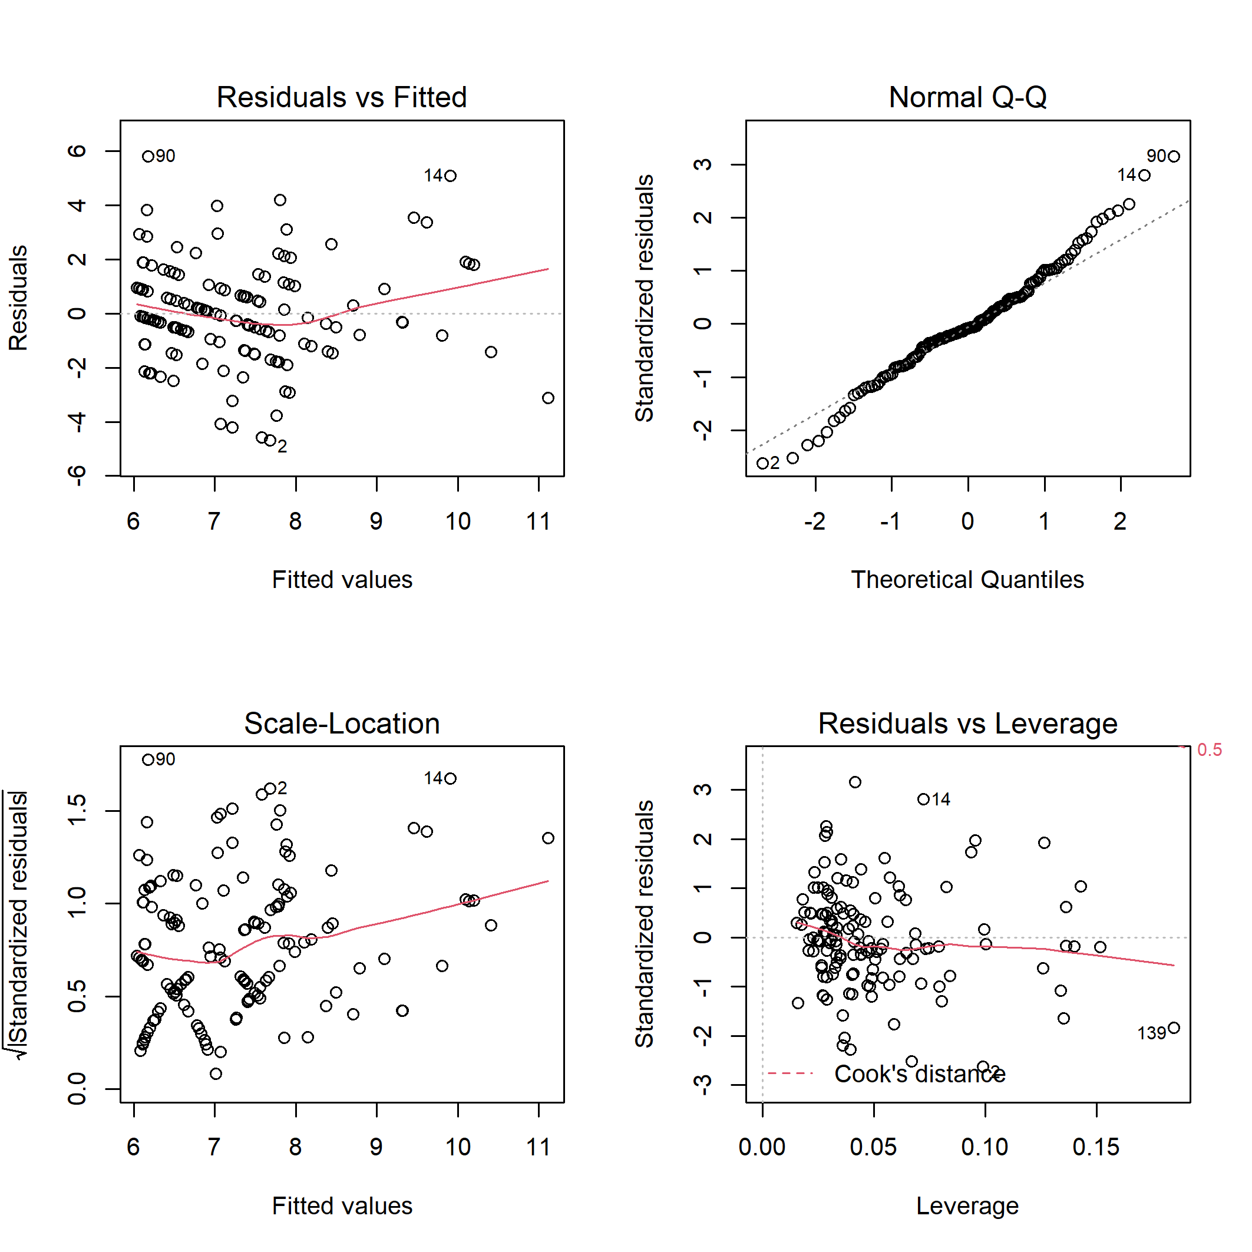

**Fig. B18.** Diagnostic plots for linear model of bird generalist species abundance on habitat characteristics.

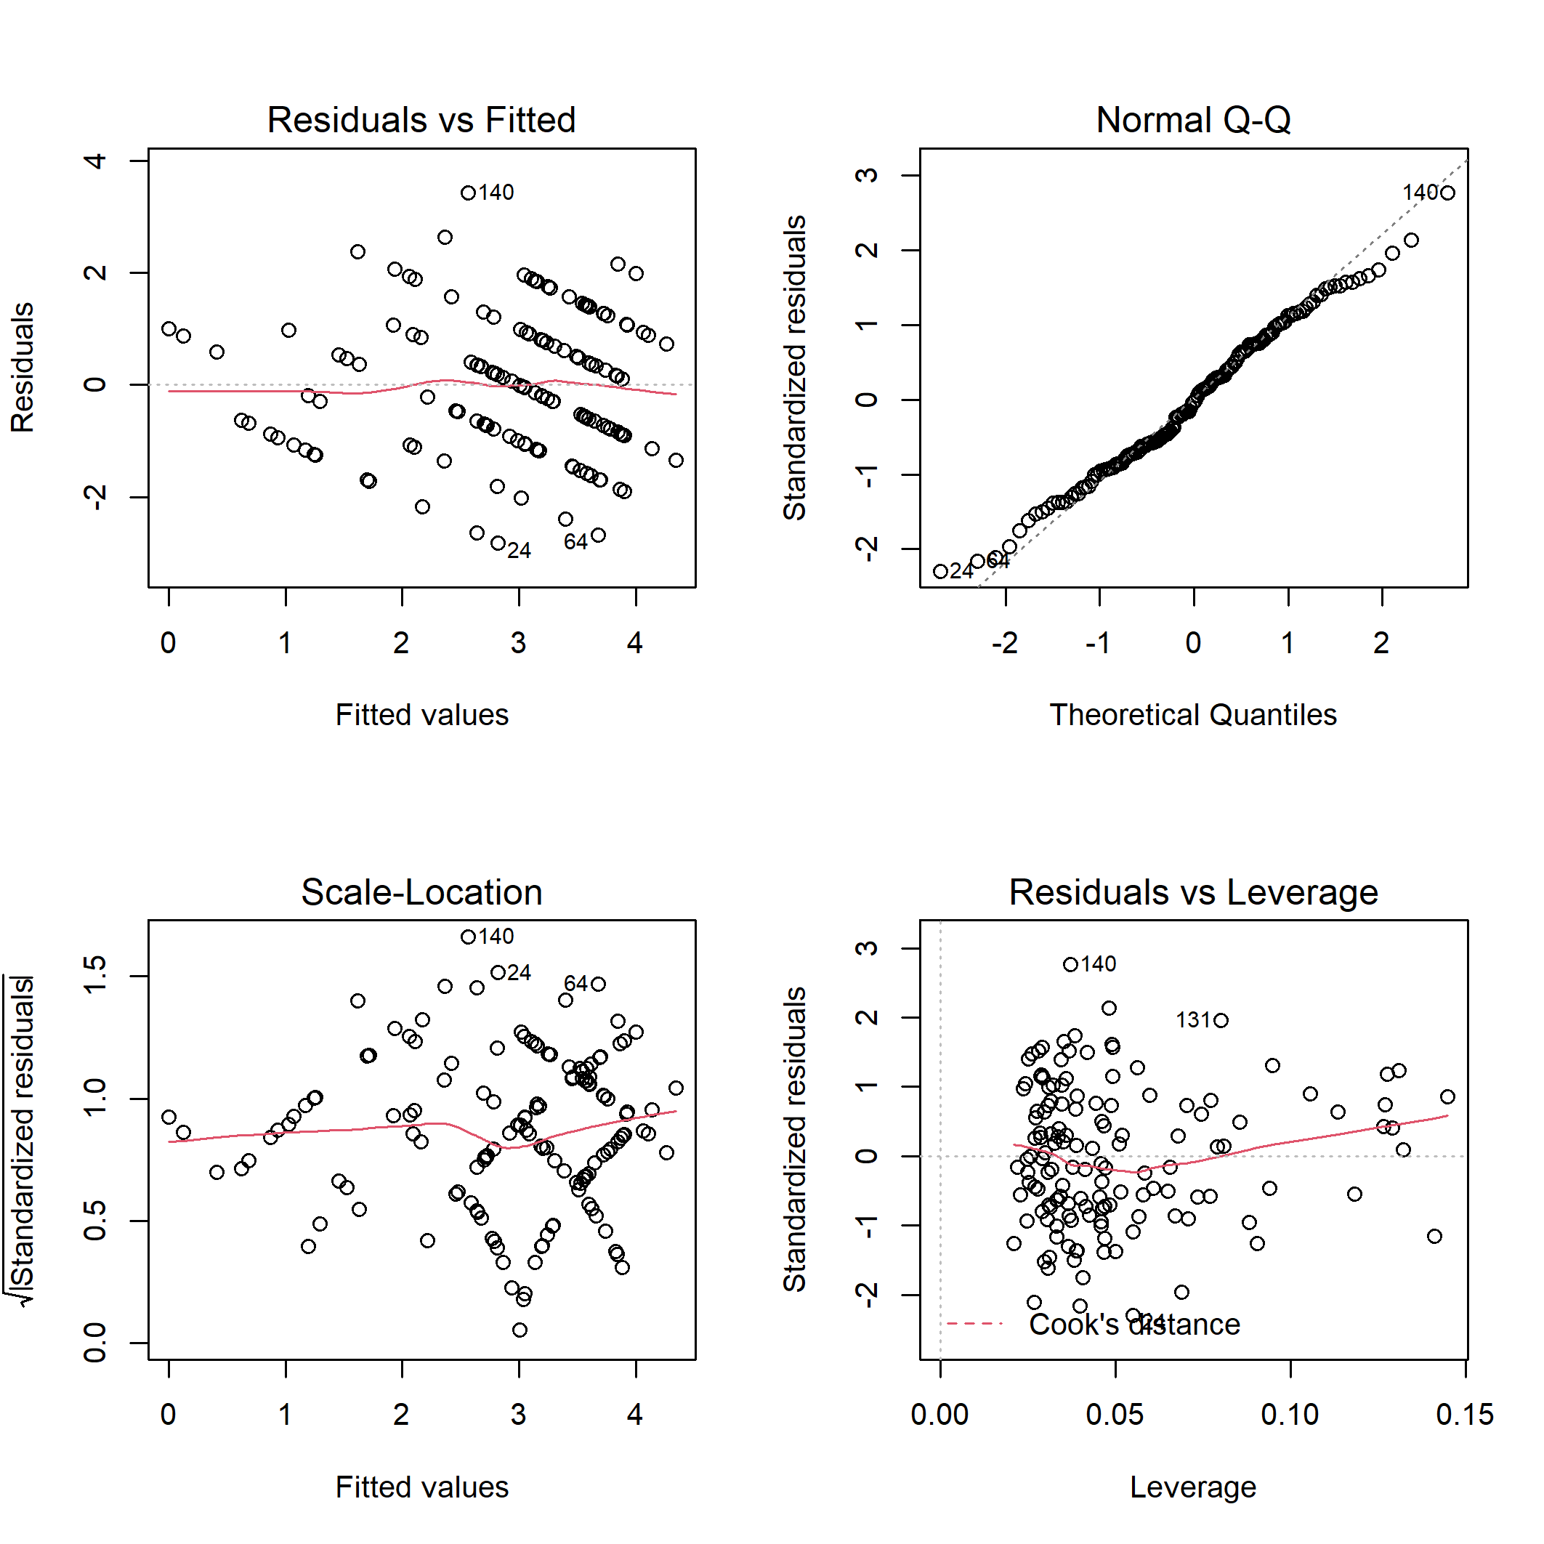

**Fig. B19.** Diagnostic plots for linear model of bird canopy nesters richness on habitat characteristics.

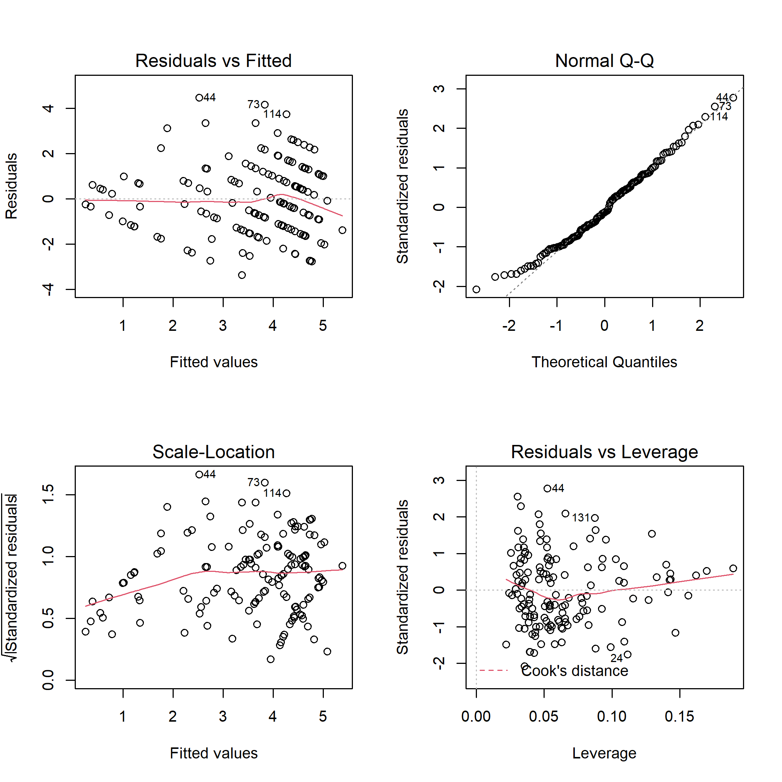

**Fig. B20.** Diagnostic plots for linear model of bird canopy nesters abundance on habitat characteristics.

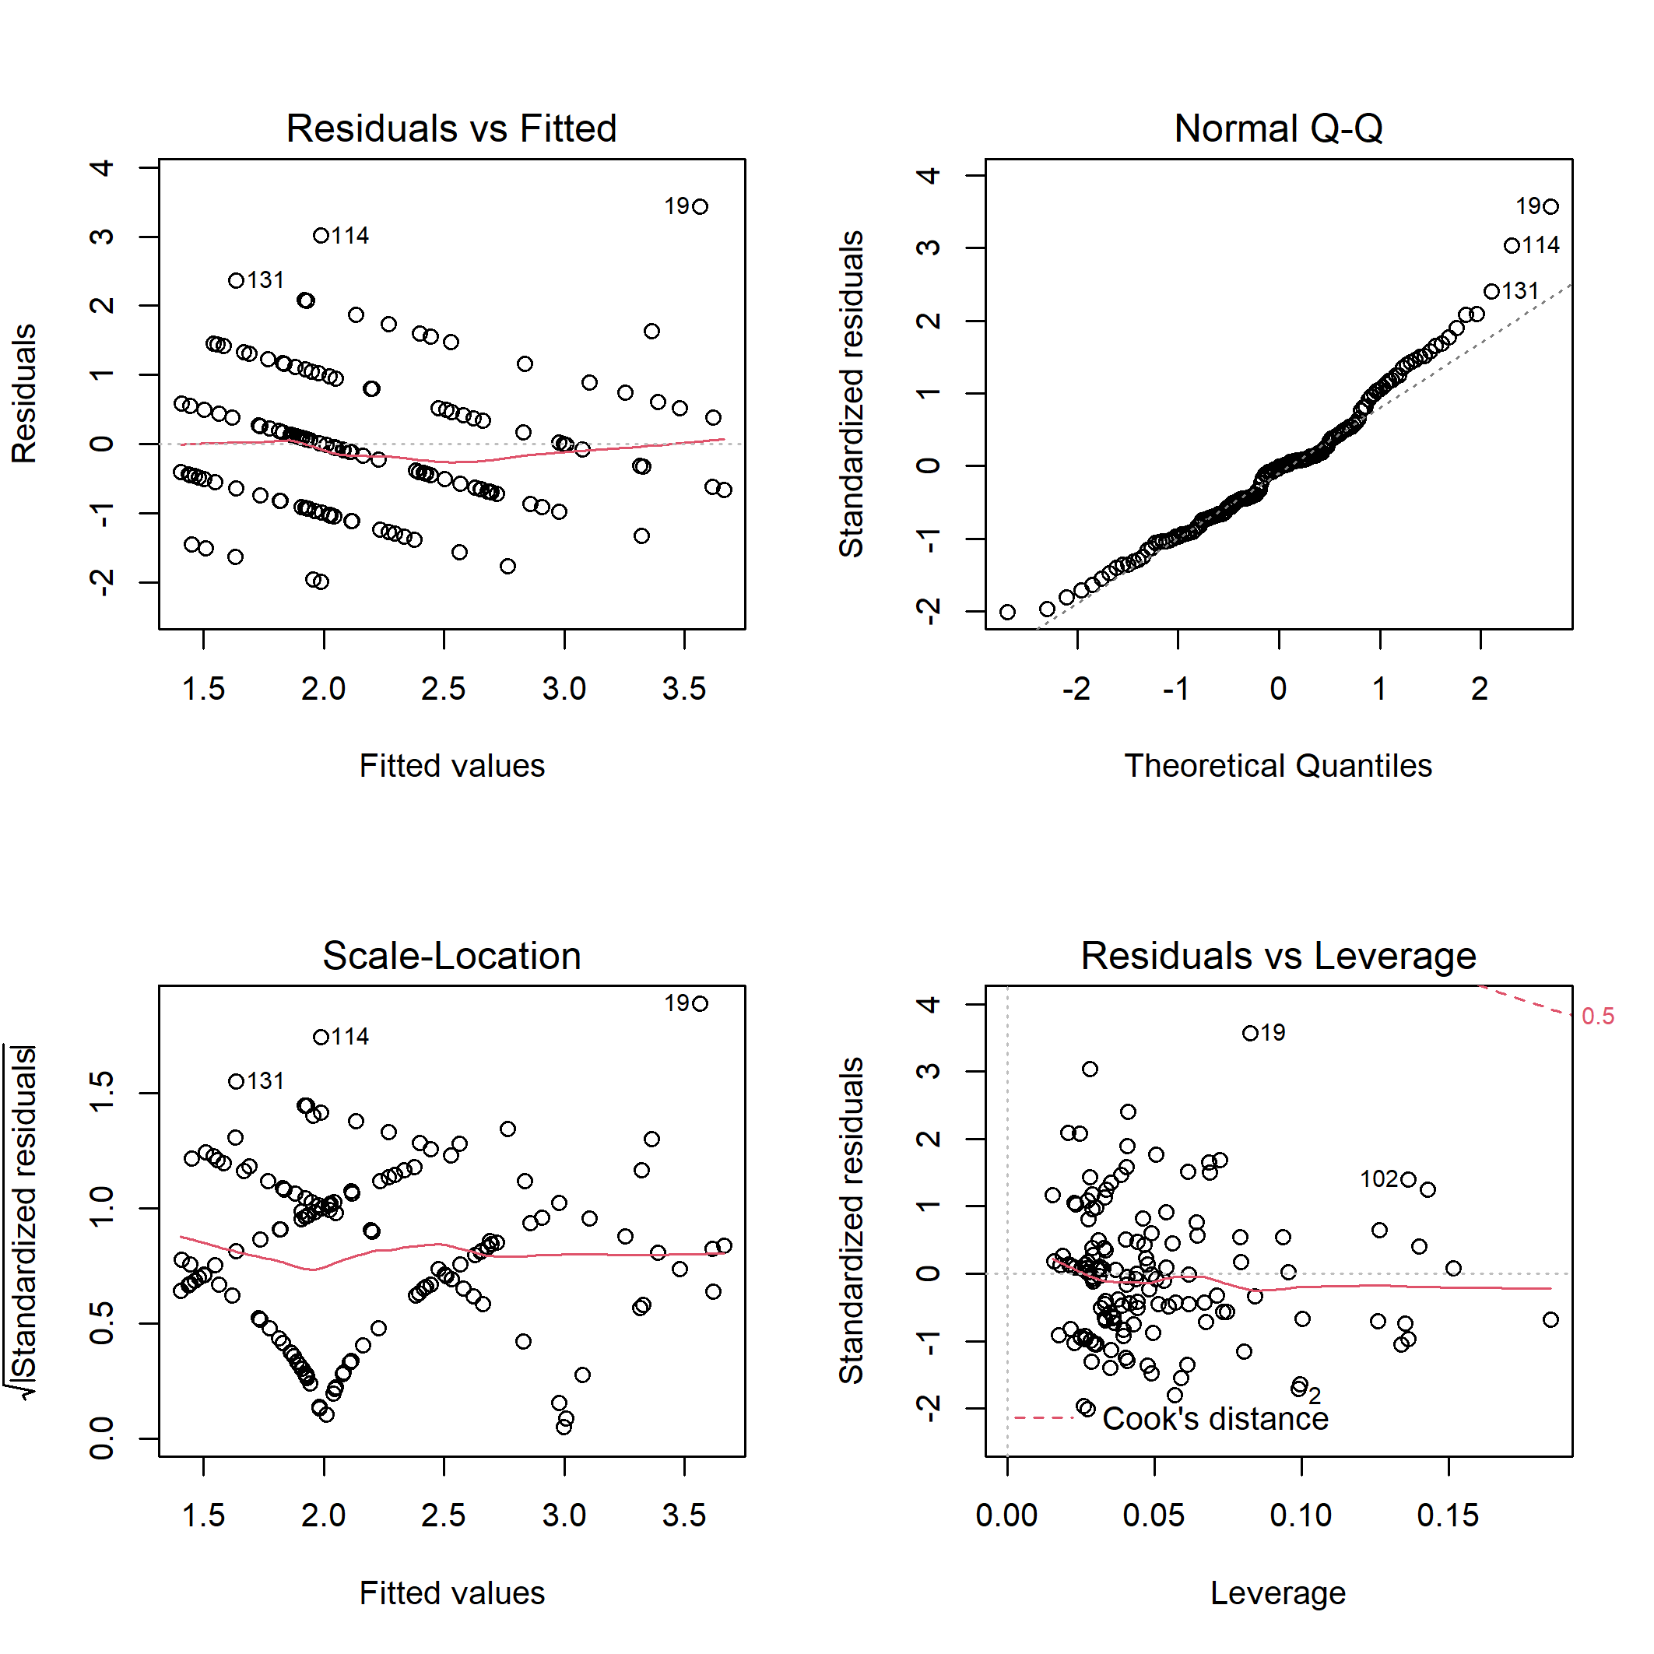

**Fig. B21.** Diagnostic plots for linear model of bird cavity nesters richness on habitat characteristics.

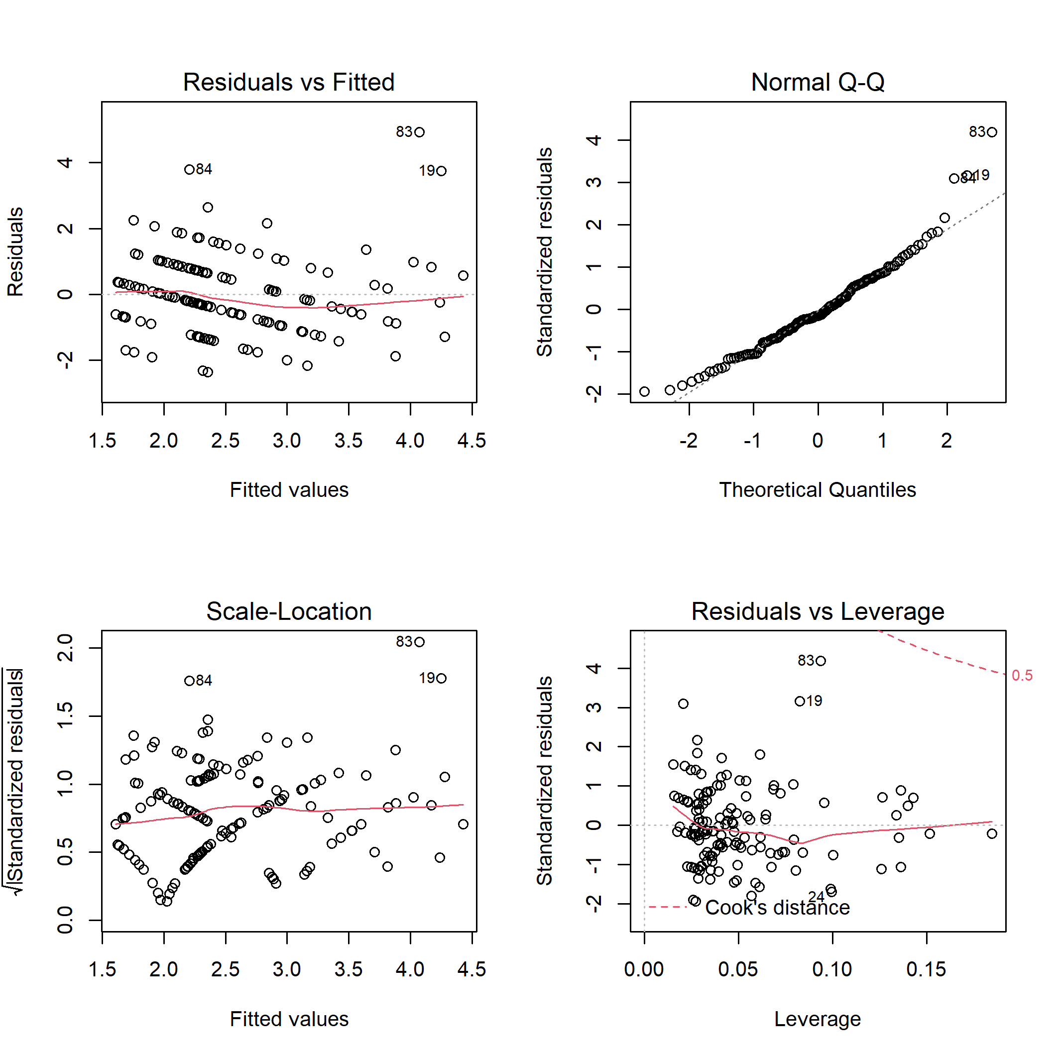

**Fig. B22.** Diagnostic plots for linear model of bird cavity nesters abundance on habitat characteristics.

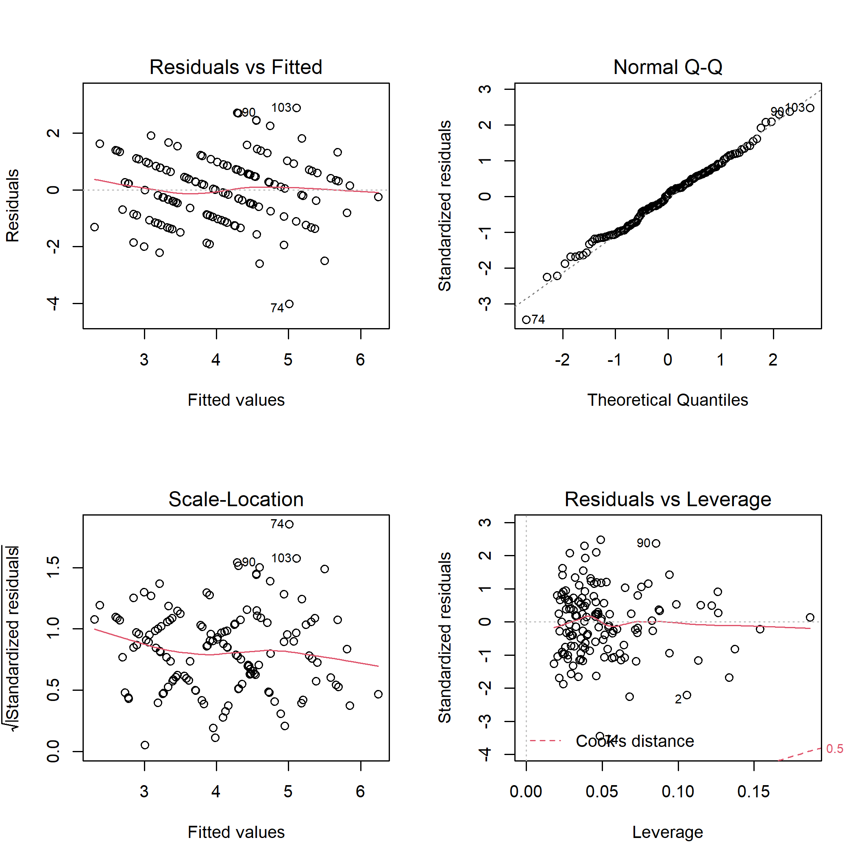

**Fig. B23.** Diagnostic plots for linear model of bird ground/shrub richness on habitat characteristics.

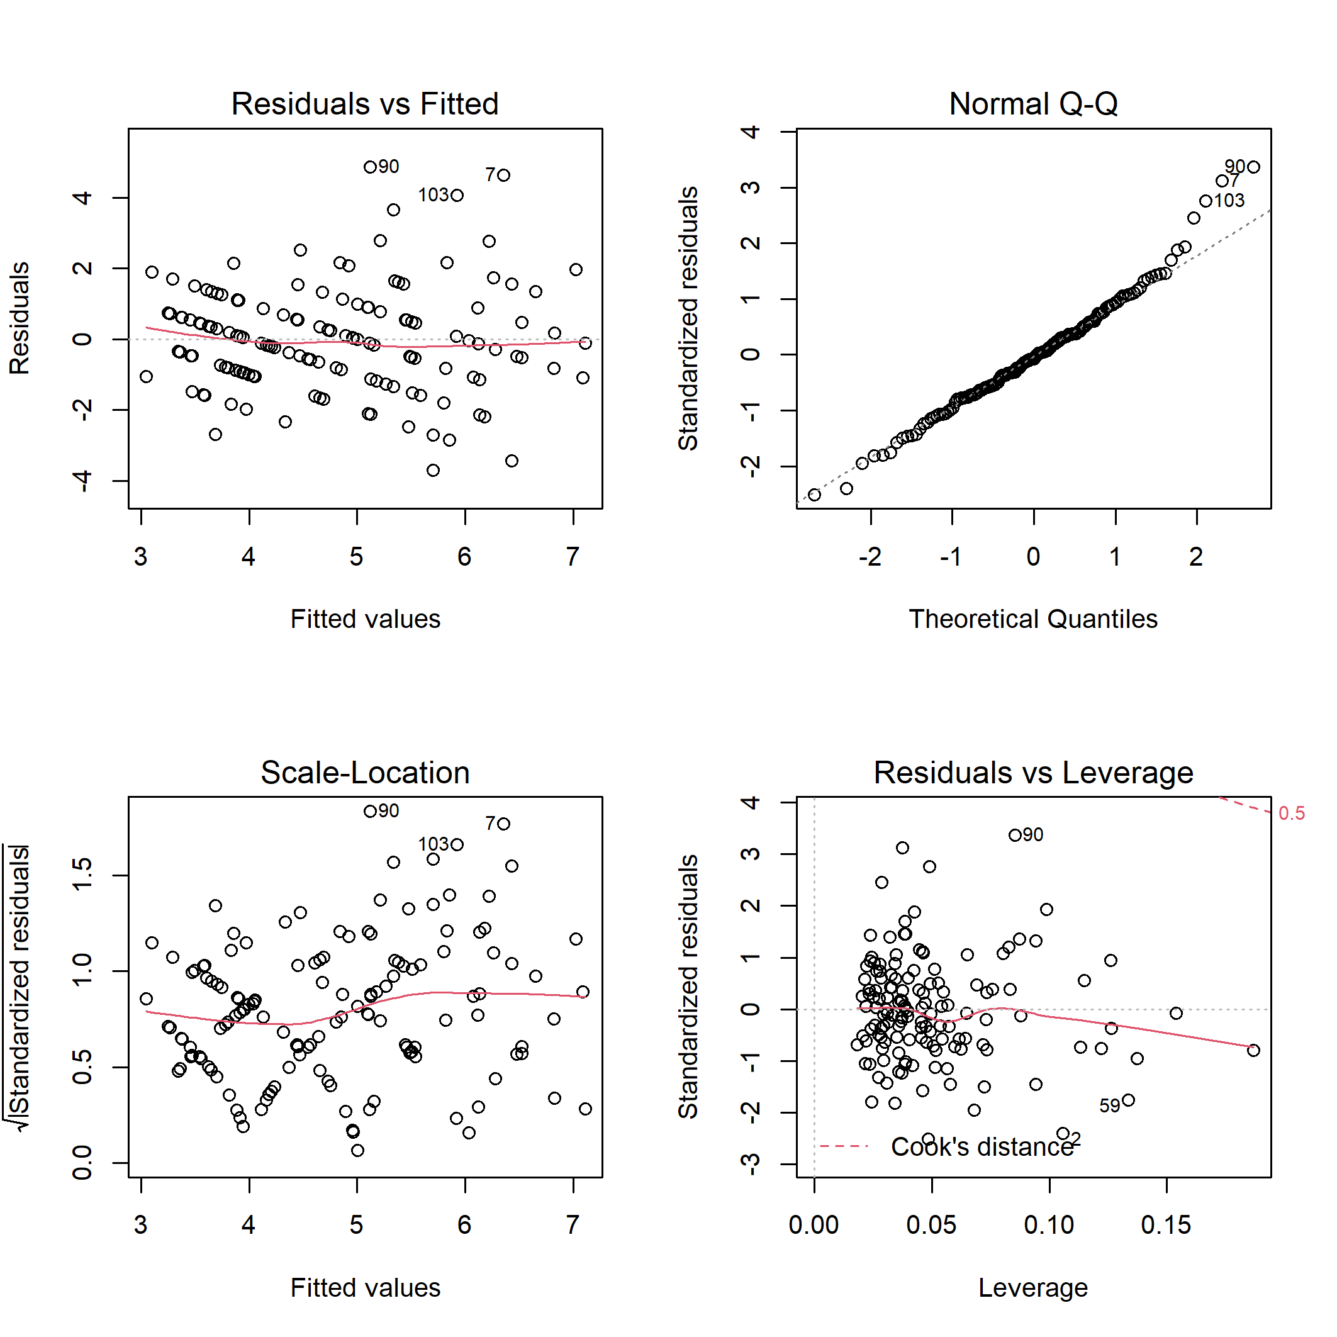

**Fig. B24.** Diagnostic plots for linear model of bird ground/shrub nesters abundance on habitat characteristics.