Large trees as a key factor for bird diversity in spruce-dominated production forests: implications for conservation management

**Dominik Kebrlea,b, Petr Zasadila, Jan Hošekb, Vojtěch Bartákc, Karel Šťastnýa**

aCzech University of Life Sciences Prague, Faculty of Environmental Sciences, Department of Ecology, Kamýcká 1176, CZ-165 00 Prague, Czech Republic

bEcological Services, Tichá 784/4, 268 01 Hořovice, Czech Republic

cCzech University of Life Sciences Prague, Faculty of Environmental Sciences, Department of Spatial Sciences, Kamýcká 129, CZ-165 21 Prague, Czech Republic

Corresponding author.

E-mail address: kebrle@fzp.czu.cz (Dominik Kebrle)

Phone number: +420 739 021 864

**Key words:** beech, forest birds, retention forestry, old trees, integrative forest management

**Abstract**

Large trees (also called veteran trees or habitat trees) are keystone structures for biodiversity worldwide. Retention forestry aims to keep large trees in production stands to support biodiversity. However, there is insufficient information about the effect of large trees on biodiversity and how many large trees should be left in different types of stands, including spruce-dominated production forest. We aimed to investigate the influence of large trees on birds (included generalist and specialist species) in spruce-dominated production forest throughout the Czech Republic, taking into consideration effects of stand age, tree species composition, and distance to a clearing. In 20 study sites (each 600 ha), all trees ≥70 cm diameter at breast height (DBH) were exhaustively searched. Then we localized sampling plots representing a gradient of large tree numbers from zero to maximum on each plot. Birds were sampled using point count method in breeding seasons 2018 and 2019, and bird assemblages analysed using Generalised Linear Mixed Models with a Poisson error distribution. The total number of birds, number of generalist species and number of specialist species significantly increased with the number of broadleaved trees ≥70 cm DBH. Furthermore, tree species diversity positively affected generalist species and negatively specialist species. Our results suggest that 5 broadleaved trees ≥70 cm DBH/ha greatly improve bird diversity in spruce-dominated production forests and forest management should be adapted to reach ≥ 5 native large broadleaved trees to improve structural diversity of spruce-dominated forests.

# Introduction

More than half of the forest area in the EU is covered by forest with production as the primary function (European Commission, 2011). Many native forests in Europe have been transformed into even-aged production forests of such commercially attractive conifers as Norway spruce (*Picea abies*), which is in the high part of these places out of its original range (FOREST EUROPE, 2020; Klimo et al., 2000). The alteration of native (usually broadleaved) forests to spruce-dominated production forests often caused the biodiversity of these forests to be very low (Felton et al., 2010; Sweeney et al., 2010). Conversely, unmanaged forest reserves are always the remaining island of the native (mostly broadleaved) forests with high ecological potential in comparison to production forests (Felton et al., 2016; Horák et al., 2019; Lešo et al., 2020). Additionally, about three-quarters of forests in Europe are even-aged, that are beyond the regeneration phase and have not yet reached the mature phase. (FOREST EUROPE, 2020) These are usually forests between 20-80 years old (FOREST EUROPE, 2011). However, increasing forest age generally increases biodiversity (Moning and Müller, 2009, 2008). In particular, increased forest age increases the abundance of canopy and cavity-nesting bird species (Hobson and Bayne, 2000). For example, the critical forest age threshold for a satisfactory diversity of lichens, molluscs, and birds in European beech (*Fagus sylvatica* L.)-dominated forests ranges from 100 to 170 years in sub-montane forests and from 160 to 220 years in montane forests (Moning and Müller, 2009). On the other hand, production forestry aims to shorten the rotation length, for example in beech stands, to less than 120 years (Bütler et al., 2013). However, individual old forest structures such as large old trees, which are commonly found in non-intervention stands (Nilsson et al., 2003), rarely occur in production forests. These old-growth trees are keystone structures for biodiversity in landscapes worldwide (Lindenmayer, 2017; Prevedello et al., 2018).

Large old trees (also called veteran trees or habitat trees) may bear diverse defects (called tree microhabitats), for example, canopy deadwood, trunk cavities, cracks or bark pockets (Bütler et al. 2013, Kolařík et al. 2013, Paillet et al. 2018). The number of these Tree related microhabitats (TreMs) increase with increasing diameter at breast height (DBH) (Larrieu et al., 2014) and the incidence of TreMs increases dramatically on trees over 70 cm of DBH (Larrieu et al., 2012). Many species are dependent on TreMs during their life cycles because of source of food, shelter, or breeding habitat (Regnery et al. 2013). For example, Lesser Spotted Woodpecker (*Dryobates minor*) prefer stands with high occurrence of dead branches (Charman et al., 2012). Furthermore, there is evidence, that woodpeckers prefer trees with a larger diameter for excavating a breeding cavity (Hebda et al., 2017) and strong excavators, such as Black Woodpecker (*Dryocopus martius*), excavate cavities preferably in trees with signs of wood decay (Puverel et al., 2019). Abandoned woodpecker cavities can then serve as a nesting opportunity for secondary cavity nesters (Pakkala et al., 2018). Therefore, large trees play an important role for forest bird diversity, especially in production forests, where values of deadwood are low. The density of large trees with ≥70 cm DBH in managed forest is less than 2 trees per ha (Bütler et al., 2011; Bütler and Lachat, 2009). However, even such a low number of old trees can be of great importance for some species. For example, the Great Spotted Woodpecker (*Dendrocopos major*) and the Black Woodpecker (*Dryocopus martius*) only need a few suitable nesting trees in their territory in order to survive (Vandekerkhove et al. 2013). However, in modern managed forests, logging still systematically eliminates these ‘defective’ trees with low economic value (Bütler et al. 2013). This can negatively affect many forest species, including birds (Horák, 2017; Koch Widerberg et al., 2018; Lindenmayer et al., 2014). However, a more vulnerable species group could be habitat specialists linked to these old-growth structures (Birčák & Reif, 2015). In support of this, there is evidence of different population trends in birds between habitat-specialized species and habitat generalists in Europe (Gregory et al., 2007). Generalist species inhabit a wide niche range and are able to use wide habitat resources. Conversely, specialist species inhabit a narrow niche range and utilise limited habitat resources. Given that, generalist species are more likely to be tolerant of environment conditions than specialist species. On the other hand, specialist species are more likely to be sensitive to extinction (Devictor et al., 2008; Richmond et al., 2005). Accordingly, the population trends of forest specialist are declining in Europe (Gregory et al., 2007).

However, there is evidence of a contrasting increasing trend at a national level, specifically in the Czech Republic (CR). Additionally, forest specialists in the CR are positively correlated with an increase in forest coverage (Reif et al., 2007), which was confirmed not only in the CR (Ram et al., 2017; Reif et al., 2007; Santamaría-Rivero et al., 2016). Similarly, some forest specialist birds increase in densities from forest edges to interior habitats (Terraube et al., 2016) and significantly habitat-specialized bird species can be negatively affected by landscape fragmentation and disturbances (Devictor et al., 2008). However, for certain species of birds, including generalists, diverse factors as forest clearings, canopy openness, forest complexity, size of the forest fragment, topography, or even low-traffic forest roads may positively affect bird diversity in these structurally poor forests (Hofmeister et al., 2017; Lešo et al., 2019; Šálek et al., 2010; Żmihorski, 2016). In other words, generalist bird species can be positive affected by the edge effect (Batáry et al., 2014; Hofmeister et al., 2017). Conversely, bird associated with the forest interior (forest specialist) prefer a homogenous forest interior, and can be negatively affected by forest gaps and edges (Hofmeister et al., 2017). Additionally, another important positive factor is increasing proportion of native broadleaved tree species, which, in particular, increases bird diversity in spruce-dominated monocultures (Fuller, 2000; Sweeney et al., 2010; Vélová et al., 2021). For example, an admixture of only one broadleaved tree species into spruce monocultures can lead to increased bird diversity (Felton et al., 2010). Moreover, broadleaves trees in coniferous plantations have a bigger effect on bird numbers if dispersed, rather than in a few large blocks (Bibby et al., 1989).

Spruce-dominated production forests cover a large part of forests in central Europe, which, together with ongoing forest management, depletes bird diversity. Several studies have explored the influence of large trees on diversity of birds or saproxylic beetles in broadleaved or mixed production forests (e.g., Remm et al. 2006, Winter & Möller 2008, Augustynczik et al. 2019). However, research on the influence of individual large trees on bird assemblages in spruce-dominated production forests is missing. Our aim is to investigate the influence of large trees on total bird species richness, number of generalist bird species and number of specialist bird species in spruce-dominated production forest throughout the Czech Republic. Furthermore, we aim is to determine the threshold value of the number of large trees in the spruce-dominated production forest, which will have a significant effect on the bird diversity. Additionally, we want to find out the importance of old trees for individual species of birds. The lack of large old trees in production forest stands could be one of the factors explaining the population decline of habitat-specialized species in Europe. Large old trees are important forest elements for bird diversity and their protection should therefore be a priority. The results of our study can be used to create careful forest management by leaving old trees in production forests to support biodiversity. At the same time, the results could bring new insights into the different trends of forest bird generalist and specialist species in Europe (Gregory et al., 2007). The protection of old trees in production forests is also beginning to be applied thanks to retention forestry, which is an element of integrated forest management (Mölder et al., 2020). Unfortunately, in many areas, large old trees are still threatened by forest management and drawing attention to their importance for biodiversity is still necessary.

# Materials & Methods

## Study area and design

The study was conducted in spruce-dominated production forests in the CR. Forests cover approximately 34 % of the CR, with Norway spruce (*Picea abies*) covering about half of the total forest area (MZe, 2020). The original range of spruce forest was limited to montane areas of the CR. However, forest management often replaced original broadleaved stands in lower areas with spruce-dominated forests (Neuhäuslová et al., 2001, 1998, 1997). Furthermore, due to forest management, the proportion of forests older than 120 years is less than 9 % in the CR (MZe, 2020). We examined 20 study sites across the CR. Each study site is a 600-ha circle (ca. 1.4 km radius) of non-fragmented forest area. The selection of study sites was limited by the minimal size of forest (600 ha). The distance between study sites ranging from 6.5 to 432 km (mean 130.5 km). The study sites occupy elevations ranging from 357 to 947 m a.s.l. Additionally, we selected the nearest (range from 0.6 to 19.1 km, mean 6.7 km) unmanaged forest reserve as control for each study site. On each study site, all live trees over 70 cm DBH were exhaustively searched and their locations were recorded. This DBH threshold was chosen due to dramatic increase in the number of TreMs occurring above 70 cm DBH (Larrieu et al., 2012). Additionally, 70 cm DBH corresponds to an age of about 160 years for beech (Dobrovolný and Tesař, 2010). Similarly, all live trees ≥ 70 cm DBH were exhaustively searched within 1 ha circle study area (r = 56.4 m) in selected control forest reserves. Based on the occurrence of trees ≥ 70 cm DBH, localized sampling plots (circle r = 100 m) were created in each study site in production forests; these represented a gradient of large trees ≥ 70 cm DBH, with numbers from zero to maximum on each study site (beech or, less often, another broadleaved trees were preferred as microhabitat rich and native tree species (Larrieu et al., 2012; Larrieu and Cabanettes, 2012)). Additionally, we avoided clearings, forest roads, and forest edge. The minimum distance of sampling plot centres from the forest edge, busy roads, or large clearings over 0.25 ha was 100 m. However, due to areas with a very low occurrence of trees ≥ 70 cm DBH, the avoidance condition for small forest roads and small clearings below 0.25 ha was limited to the middle ha of the sampling plot (50 m around sampling plot midpoint). The minimum distance between sampling plot midpoints was 200 m. We studied birds in spruce-dominated production forest. Therefore, we used information about tree species composition from Forest management plans (to ensure the proportion of spruce). Furthermore, we analyzed the canopy cover of broadleaved trees by digitizing aerial photographs for an accurate estimate of the proportion of broadleaved trees within sampling plots (r=100m). Based on these analyzes, we excluded sampling plots where the canopy cover of broadleaved trees is over 50 % of the sampling plot area (r = 100 m). In total, we selected 180 sampling plots in spruce-dominated production forests and 20 sampling plots (r = 56.4 m) in unmanaged forest reserves. The location of study areas, study sites (600 ha), examples of sampling plots (r = 100 m), and examples of sampling plots in forest reserves (r = 56.4 m) is shown in Figure 1.

Based on data from Forest management plans, the dominant type of forest vegetation within the selected sampling plots (r = 100 m) located in production forests is coniferous forests (80 %). Norway spruce (*Picea abies*) was the most dominant tree species (total 76 %), further supplemented by Scot’s pine (*Pinus sylvestris*) and European larch (*Larix decidua*). Silver fir, (*Abies alba*) as well as some exotic tree species such as Douglas fir (*Pseudotsuga menziesii*), grand fir (*Abies grandis*), and eastern white pine (*Pinus strobus*) are also represented in a very small proportion. Broadleaved forest vegetation occupies 12.9 %. The dominant broadleaved tree species is European beech (*Fagus sylvatica*) (total 7 %). Other broadleaved trees present are oaks (*Quercus petraea, Quercus robur),* alders (*Alnus glutinosa, Alnus incana),* silver birch (*Betula pendula),* small-leaved lime (*Tilia cordata),* sycamore (*Acer pseudoplatanus),* European ash (*Fraxinus excelsior),* European hornbeam (*Carpinus betulus),* rowan (*Sorbus aucuparia),* aspen (*Populus tremula),*  and field elm (*Ulmus minor*), with exotic tree species such as horse chestnut (*Aesculus hippocastanum)* and red oak (*Quercus rubra)* also represented in very small proportions. Cleared area, forest < 20 years (both broadleaved and coniferous) and non-forest vegetation (forest roads and other paved areas) occupy in total 6.9 % of the study sampling plots. The weighted mean age (weighted by area of forest stand group) of production forest stand groups (excluding forest groups < 20 years) within sampling plots is 78.6 (SD 21.1) years. On the other hand, in unmanaged forest reserves, the mean proportion of broadleaved forest cover within 100 m around sampling plots centre is 84 %, with beech the dominant tree species in most reserves. The weighted mean age (weighted by area of forest stand group) of forest reserves stand groups is 157 (SD 63.6) years.

## Bird survey

Bird surveys in all study sites and forest reserves were carried out between 2019 and 2020 by a point count method (Bibby et al. 2000) from the midpoint of each sampling plot in spruce-dominated production forests and midpoint of each plot in control forest reserves. Each midpoint was surveyed twice in the same year, in April-May for early nesters and in May-June for late nesters (Bouvet et al. 2016) and the interval between consecutive visits exceeded two weeks. Surveys were conducted within 4 hours of sunrise and were restricted to good weather conditions (Batáry et al., 2014; Bibby et al., 2000). All bird counts were performed by the same person. All individuals heard or seen within 50 m of the midpoint were recorded. Owls and other raptors (< 0.3 % of the birds recorded) were excluded from our analyses as the point count method is inappropriate (Bouvet et al., 2016). Additionally, we excluded *Fringilla montifringilla*, which is not a nesting species in the CR. In total, 200 midpoints (180 in production forest and 20 in forest reserves) were surveyed, of which 106 were in 2019 and 94 in 2020.

Bird species were classified into generalist and specialist species (Supplement 1) for which we expected different responses based on habitat specialization. We adopted the attributes regarding bird habitat specialization relevant in CR by Reif et al. (2010).

## Spatial and environmental variables

We used the number of all live trees ≥ 70 cm DBH [NumLT70DBH] (58 % beech, 30 % spruce, supplemented by Douglas fir, oaks, larch, or silver fir – all under 2.8 %) and number of only broadleaved trees over 70 cm DBH [NumBroadlLT70DBH] (91 % beech, 6 % oaks, supplemented by ash, limes, sycamore, or alder – all under 1.6 %) occurring within sampling plots area (r = 100 m) in production forests as environmental variables explaining the effect of large trees in spruce-dominated production forests. Spatial attributes of forest stands were obtained from aerial photographs (scale 1:5000) using geographical information system (ArcGIS 10.4). For each sampling plot midpoint, we determined the nearest distance to the forest edge or clearing (which ever was closer) [ClearCutDist]. We analysed the type of forest vegetation: (i) broadleaved forest [Broadl_cover], (ii) coniferous forest [Conifer_cover], (iii) young forest under 20 years (both broadleaved and coniferous) [Young_cover], all within sampling plot areas (r = 100 m). Furthermore, we calculated the Shannon’s index of tree species diversity [H_Trees], defined as follows: $H´=-\sum_{i=1}^{S}{p_{i}\ln{p_{i}}}$ where $p_{i}$ is the proportion of covered area in each stand group within sampling plots in the *i*th tree species, and *S* is the number of tree species. The maximum value for Shannon’s index occurs when the proportions are equal over all species (Staudhammer and Lemay, 2001). To include forest age as a factor, weighted average age of forest stand groups [AgeWMean] (weighted by area of each group) and standard deviation (SD) of forest group age were calculated [Age_SD]. SD of age represented the heterogeneity of forest stand group age. The age and representation of individual tree species in individual forest stand groups was obtained from forest management plans.

## Data analysis and modelling

The maximum number of bird species from both controls recorded on each counting midpoint was used as a response variable. We used generalised linear mixed models (GLMMs, package lme4 in R) with a Poisson error distribution to evaluate the effect of environmental variables on total bird species richness and species richness of generalist and specialist bird species in spruce-dominated production forests (1 ha plots in forest reserves were not included in this analysis). Study site ID [ID_study_site] was used as a random intercept term to take into account that local communities sampled at individual sampling plots inside a given study site form an inter-connected metacommunity, and thus the corresponding observations are not independent. To check for possible multicollinearity, we computed variance inflection factors (function vif in the R package car, Fox & Weisberg, 2019) for all predictors and found large values for coniferous and broadleaved forest cover (8.2 resp. 6.3). This was confirmed by high (and expectable) negative correlation between these two variables (*r* = -0.85). Therefore, we excluded coniferous forest cover from the list of model predictors. After fitting a full model with all predictors, we performed a backward stepwise model selection, excluding in each step the insignificant predictor with the largest *p* value in the Wald χ2 test comparing the model with and without the predictor. In the final model, we kept only predictors with *p* < 0.1. We checked possible overdispersion by Pearson’s χ2 test (R package performance, Lüdecke et al., 2021), and we evaluated the model performance by variance-function-based coefficient of determination (Zhang, 2020a) using function rsq from the R package rsq (Zhang, 2020b).

To determine the threshold values of large broadleaved tree density (important for bird diversity), we divided densities of live broadleaved trees ≥ 70 cm DBH in spruce-dominated production forest into four categories: **0**; **0<>1** (mean: 0.58); **1<>3** (mean: 1.89); **3<>9** (mean: 4.93) trees per ha (number and intervals of tree density were chosen with respect to the number of plots in each category) and compared the bird species richness of generalist, specialist, and total species richness between these density groups with species richness in forest reserves (**R**, mean: 22.8; SD: 10.4 broadleaved trees ≥ 70 cm DBH/ha) using generalised linear mixed models with a Poisson error distribution (ID of study site and the closest forest reserve were used as random intercept terms) and simultaneous comparison of density categories and adjustment of *p*-values for multiple testing by means of function glht, R package multcomp (Hothorn et al., 2008).

In case of total bird species richness, our GLMM models resulted in a singular fit. Although this is commonly attributed to overly complex random effect structure (see Ben Bolker’s comments on the issue available at https://bbolker.github.io/mixedmodels-misc/glmmFAQ.html), this is obviously not our case (we have single random intercept). Another possible reason could be a low actual variation in bird species richness among the study sites. However, this variation was comparable both with variation of specialist species richness and generalist species richness, although we haven’t encountered a singular model fit for neither of these response variables. Moreover, the model outputs were in general accordance with outputs of the models for specialists and generalists, as well as with outputs of corresponding GLM models of total species richness (not reported). Therefore, we decided to report results of these GLMM models, ignoring their singular fits.

Additionally, we used redundancy analysis (RDA) with 5 density categories of broadleaved trees ≥ 70 cm DBH (0; 0<>1; 1<>3; 3<>9; R) to indicate species specific preferences toward large broadleaved tree densities. Calculations of RDA were performed using vegan package for R (Oksanen et al., 2019). All analyses were done in R 4.0.3 (R Core Team, 2020). The complete commented code is in Appendix XXX.

# Results

In total, we recorded 41 bird species (35 species at 180 points in spruce-dominated production forest and 33 species at 20 points in forest reserves; 23 generalist and 18 specialist species). *Fringilla coelebs* was the most frequent, with 179 occurrences in production forest, followed by *Parus ater* (165), *Erithacus rubecula* (159), and *Regulus ignicapilla* (149). Regarding the occurrence of woodpeckers, *Dendrocopos major* was observed at 91 points and *Dryocopus martius* was observed at 3 midpoints. In forest reserves, the most frequent species were *Fringilla coelebs* and *Turdus merula* (20), followed by *Dendrocopos major*, *Troglodytes troglodytes*, and *Erithacus rubecula* (17). Regarding the occurrence of other woodpeckers, *Dendrocopos leucotos* was observed once. A few species were recorded only in forest reserves: *Ficedula* *parva*, *Ficedula* *albicollis*, *Muscicapa* *striata*, and *Dendrocopos* *leucotos*. Conversely, a few species were recorded only in production forests: *Phylloscopus* *trochilus*, *Sylvia* *borin*, *Poecile* *palustris*, *Lophophanes* *cristatus*, and *Nucifraga* *caryocatactes*.

## Effect of large old trees and other forest factors

All three final GLMMs (i.e., for total, specialist, and generalist bird species richness) resulting from the backward selection only included the number of broadleaved trees ≥ 70 cm DBH (NumBroadlLT70DBH) and Shannon’s diversity index of tree species (H_Trees) as predictors (see Table 1 for model coefficients and Appendix XXX for all model outputs). The former predictor had significant positive effect on bird species richness in all three models; the increase in number of broadleaved veteran trees from 0 to 20 led to an increase of the mean number of species – averaged across all random effect levels – from 9.8 to 13.4, from 7.9 to 10.9, and from 4.6 to 6.6 for all, generalist, and specialist species, respectively (Fig. 2). The Shannon’s index was significant for generalist and specialist bird species richness, but only weakly significant (*p* = 0.073) for the total bird species richness (Appendix XXX). Whereas mean total resp. generalist species richness increased with Shannon’s index (from 9.8 to 10.8 resp. from 7.2 to 9.1 with the Shannon’s index increasing from 0 to 1), its effect on the specialist bird species was opposite (the mean number of specialist species decreased from 5.9 to 4.4 with the Shannon’s index increasing from 0 to 1; see Table 1 and Fig. 2).

## Comparison of production forests and forest reserves

The density of broadleaved trees ≥ 70 cm DBH within sampling plots (r = 100 m) in production forests ranges from 0 to 8.3 tree per ha. In contrast, the density of broadleaved trees ≥ 70 cm DBH in forest reserves ranges from 9 to 45 (mean: 22.8; SD: 10.4) per ha. According to the GLMMs and post-hoc tests, the total species richness and richness of generalist species is significantly higher in categories 3<>9 (mean 4.9 tree/ha) and R (22.8 tree/ha) than in plots in production forests where the large broadleaved trees are missing. The total number of species resp. number of generalist species is 3.3 (for 3<>9 cat.) resp. 2.9 (for R cat.) higher compared to plots with large trees absence. The number of generalist species is 3.1 (for 3<>9 cat.) and 4.0 (for R cat.) higher compared to plots with large trees absence (Fig. 3 a). Additionally, the difference between total species richness and number of generalist species between category 3<>9 and forest reserves is non-significant (Fig. 3a and 3b). For forest specialists, only non-significant results were detected (Fig. 3c). However, in comparison to results of total species richness and generalist species, the values of the number of specialist species in the reserves (R) are lower (about 0.3 species) than the numbers in the category representing absence of large broadleaved trees (0) (Fig. 3c).

Considering all bird species, the RDA plot displayed some cavity-nesting species (e.g., *Sturnus vulgaris*, *Dryocopus martius*, *Columba oenas*) and several shrub-nesting species (e.g., *Turdus merula*, *Sylvia atricapilla*, *Turdus viscivorus*) were associated with forest reserves (R). Some bark creepers (e.g., *Certhia familiaris*, *Dendrocopos major*, *Sitta europaea*) and some secondary cavity-nesting birds (e.g., *Cyanistes caeruleus*, *Parus major*) are associated with sampling plots in category 3<>9 large broadleaved trees per ha. Furthermore, in plots with less than 1 tree per ha (0; 0<>1), there are often associated species nesting in the tree or shrub layer or foraging in the canopy (e.g., *Pyrrhula pyrrhula*, *Periparus ater*, *Regulus regulus*, *Regulus ignicapilla*, *Spinus spinus*, *Phylloscopus collybita*). Results of the RDA analysis are shown in Figure 4.

# Discussion

The main aim of the study was to determine the importance of large old trees for common forest birds in spruce-dominated production forests. We found a positive effect of the number of large broadleaved living trees (≥ 70 cm DBH) on the number of generalist and specialist bird species, as well as on total bird species richness. Additionally, the total number of bird species and number of generalist species were even similar between plots in unmanaged forest reserves and production forests with 4.9 large broadleaved trees ≥ 70 cm DBH per ha on average. Surprisingly, we found very low numbers of specialist species in forest reserves. In particular, creepers were associated with large tree rich sampling plots (4.9 broadleaved trees ≥ 70 cm DBH). Of the other characteristics that were tested, we found a contrasting effect of tree species diversity on specialist (negative) and generalist (positive) species.

## Importance of large old trees for diversity

Large old tress trees are known to be important habitats, especially for insect species (Grove, 2002; Horák, 2017; Koch Widerberg et al., 2018; Pilskog et al., 2020; Sverdrup-Thygeson et al., 2017). The large old trees seems to be an important habitat mainly for less mobile organisms, such as lichens, lignicolous fungi or bryophytes (Hofmeister et al., 2016, 2015). Similarly, there is evidence, that birds are also positively associated with large diameter trees (Basile et al., 2020; Gutzat and Dormann, 2018; Klein et al., 2020). For example, cavity-nesting birds of temperate and boreal forests selected for nesting trees on average 13.3 cm thicker than all trees occurred in the area, which had a mean diameter of 35.6 cm. Additionally, the probability of nest selection increased as the tree diameter increased and trees with a diameter ≥43 cm had a probability >50% to be selected as a nest tree (Gutzat and Dormann, 2018). The preference for thicker trees by cavity nesters may be due to the fact that the larger trees with harder sills provide more thermally stable cavity environments (Vierling et al., 2018). Considering these, large-diameter trees can be an important nesting opportunity for birds especially in young production stands with trees of small diameter. The diameter of the trunk in most cases reflects the age of the tree. The age of the stand is an important factor for the diversity of birds, but also for molluscs or lichens (Moning and Müller, 2009).

However, the weighted mean age of production forest stand groups in our survey point was only 78.6 (SD 21.1) years and therefore probably has no effect on the number of bird species. Furthermore, the explanation can be a similar range of ages of forest stands in the monitored study areas and also of stands in their surroundings. On the other hand, the positive effect of old-growth forest structures such as large trees was significant for all bird assemblages. The age of large trees with 70 cm in DBH is about 160 years for beech (Dobrovolný and Tesař, 2010). However, the age of forest stands reflects the year of planting of the forest stand group and the age of individual large old trees were not included. Considering this, the age of forest stand groups did not always reflect these old growth structures in production forests. According to the literature, to sustain cavity breeding species, the age of Central European mixed montane forests needs to surpass 200–220 years (Moning and Müller, 2008) and critical age limits for bird diversity in beech stands have been set between 80-100 years for the submontane stage and around 150-220 years for the montane stage (Moning and Müller, 2009). However, in our study, forest stand group age did not prove to be a very important factor. Similarly, the diversity of forest stand group ages was non-significant. The weighted mean age of production forest stand groups in our sampling plots was only 78.6 (SD 21.1) years and therefore probably has no effect on the number of bird species. Furthermore, the explanation can be a similar range of ages of forest stands in the monitored study areas and also of stands in their surroundings. Forest management maintains stands mostly up to app. 130 years of age, when wood growth id highest. Especially of beeches up to a maximum of 120-140 years due to the formation of red heartwood (Knoke, 2003; Moning and Müller, 2009). These facts are reflected in the age of the stands of interest. On the other hand, the positive effect of old-growth forest structures such as large trees was significant for all bird assemblages. The age of large trees with 70 cm in DBH is about 160 years for beech (Dobrovolný and Tesař, 2010). However, the age of forest stands reflects the year of planting of the forest stand group and the age of individual large old trees were not included. Considering this, the age of forest stand groups did not always reflect these old growth structures in production forests.

The influence of large trees has so far been studied in more detail only in insects and the link between large trees and bird species is less explored. Furthermore, studies from spruce-dominated forest are missing. We have now found a positive effect of large trees (broadleaved large trees specifically) on birds in spruce-dominated production forests. Individually occurring old trees in a production forest are thus old-grow attributes from forest reserves works like lifeboats for a number of taxa and are also important for birds. One explanation for the importance of old trees is the presence of Tree related microhabitats (TreMs) caused by climate, activity of organisms, mechanical injuries, or decay (e.g., canopy deadwood, cavities, cracks, bark pockets) (Bütler et al., 2013; Paillet et al., 2018). The number of TreMs increase with increasing diameter at breast height (DBH) (Larrieu et al., 2014) and the incidence of TreMs increases dramatically on trees over 70 cm of DBH (Larrieu et al., 2012). Many species, including birds, are dependent on TreMs during their life-cycles because they are a source of food, shelter, or breeding habitat (Regnery et al., 2013). To build on this idea, we found that creepers (*Certhia familiaris*, *Dendrocopos* *major*, *Sitta europaea*) in particular were associated with these large tree rich plots, for which large trees with TreMs can be a food or nesting opportunity. In the CR, hollow-bearing trees (or den trees) in production forest are sometimes searched for and marked to prevent them from being harvested. However, not only hollow-bearing trees can be important and they should also be maintained in otherwise diversity-poor production stands. Additionally, the importance of large trees, especially for nesting, can be long-term. For example, the lifespan of cavities excavated in live trees is longer than lifespan of cavities in dead trees due to decomposition of dead trees (Hardenbol et al., 2019). However, large trees cannot fully replace dead trees, which are irreplaceable for some species groups. Generally, snags (standing, dead or dying trees) are particularly important for primary cavity-nesting birds (Remm et al., 2006) and live trees can be particularly important in stands where the incidence of dead trees is very low (such as spruce-dominated production forest). However, live mature trees are suitable for more bird species than dead trees (Hannan et al., 2019).

## Broadleaved large trees

A number of studies have focused on broadleaved tree species (Koch Widerberg et al., 2018; Pilskog et al., 2020; Sverdrup-Thygeson et al., 2017). Similarly, the number of broadleaved trees ≥ 70 cm in DBH was chosen as a better predictor compared to the total number of coniferous and broadleaved trees in our analysis. In support of this, broadleaved trees carry many more TreMs than conifers (Larrieu et al., 2012; Paillet et al., 2019; Vuidot et al., 2011). As an example, 70 % of beech but only 18 % of firs bear one or more TreMs (Larrieu and Cabanettes, 2012). Similarly, broadleaves as ash, beech, chestnut, hornbeam, maple, oak and poplar showed higher microhabitat accumulation rates than conifers as fir, larch and spruce (Paillet et al., 2019). On the other hand, the number of TreMs increased dramatically above 71.6 cm DBH for beech and similarly above 68.4 cm DBH for fir (*Abies alba*) (Larrieu et al., 2012). Choosing the same DBH threshold for tree registration should therefore not play a role. To build on this idea, large broadleaved trees may probably be more important for birds than coniferous large trees, especially in coniferous-dominated forests. However, the importance of large broadleaved trees may come from the fact that they are broadleaved trees. The positive effect of broadleaved trees on birds in non-native coniferous monocultures is mentioned by some authors (Felton et al., 2010; Fuller, 2000; Sweeney et al., 2010). In our plots, the proportion of broadleaved trees was limited to 50 % of share to maintain a high proportion of conifers. To build on this idea, there is evidence of higher bird species diversity in spruce-birch polyculture (*Betula* spp.) than in spruce monocultures (Felton et al., 2010). Furthermore, broadleaves trees in coniferous production forests have a bigger effect on the number of birds and species if dispersed, rather than in a few large blocks (Bibby et al., 1989). An individual occurrence of large deciduous trees in a spruce monoculture may thus have a better effect on birds than a continuous stand of deciduous trees. The mixing of broadleaved trees in spruce-dominated forests is in fact a diversification of a niche, which can then be used by a wider range of species. However, this effect should be further supported by the occurrence of TreMs. Tree species factor and TreMs occurrence can have a synergistic effect on bird species numbers. And perhaps this is why we found a significant effect of large deciduous trees, whereas total deciduous tree cover alone (including younger trees) was not found to be significant by our analysis. Moreover, broadleaved tree species (especially beech) formed the dominant component in the original natural stands replaced by spruce dominated forest in the CR (Neuhäuslová et al., 2001, 1998, 1997). Large broadleaved trees can thus be important for bird diversity, regardless of whether they bear any TreMs. In support of this, we found a positive effect of large broadleaved trees without information about TreMs occurrence. The tree characteristics such as DBH strongly reflecting microhabitat occurrence and forest management generally had no effect on microhabitat indices (Vuidot et al., 2011). Hence, information about tree species is very important and, with DBH, may be used for easy identification of objects with high ecological value for retention in production forests. The admixture of broadleaved tree species in coniferous-dominated monocultures increases bird diversity and can be an important tool in protecting birds while maintaining the productive function of the forest. On the other hand, the negative effect of the Shannon index diversity of tree species on specialist species suggests that these bird species prefer rather homogeneous stands with a few tree species. The link between specialists and homogeneous coniferous stands can also support an increase in their number with a growing share of forest cover, which was found in the CR between 1982 and 2003 (Reif et al., 2007). On the other hand, generalist species were positively associated with the Shannon index diversity of tree species. For conservation of all bird assemblages, there is probably a need to increase the species diversity of trees in forest stands. However, at the same time, maintaining a certain share of existing spruce-dominated forests.

## Critical thresholds of large trees and comparison with forest reserves

A few studies from Switzerland found the density of large trees (trees with DBH of over 70 cm) in production forest remains less than 0.5 to 2 trees per ha (Bütler et al., 2011; Bütler and Lachat, 2009), whereas in virgin forests of Central Europe and southern Scandinavia it is between 10 to 20 (Nilsson et al. 2003). This corresponds to our findings. The high ecological potential of forest reserves in comparison to non-native forests is known (Horák et al., 2019). In forest reserves the number of threatened or near-threatened bird species or cavity-nesting species, such as woodpeckers, are higher, or occur exclusively here (Felton et al., 2016; Lešo et al., 2020). Similarly, we found some higher Czech red-listed bird species (Chobot and Němec, 2017) exclusively in forest reserves, for example *Ficedula parva* (Vulnerable), *Ficedula albicollis* (Near Threatened), and *Dendrocopos leucotos* (Endangered). Additionally, *Columba oenas* (Vulnerable) was more numerous in forest reserves than in production forests. On the other hand, the *D. leucotos* was recorded only once and it cannot be said that forest reserves are more favourable to them. For reduction of negative impacts of forest management, 5 to 10 habitat trees per ha is recommended (Bütler et al. 2013). These recommended numbers (rather the lower threshold) approximate to our plots with 4.9 large broadleaved trees per ha on average (range 3 to 9 trees per ha), which was the maximum amount found in spruce-dominated production forests within 100 m sampling plot. However, it is not very clear which of the habitat trees are really important (e.g., with regard to tree species). Additionally, these recommended numbers were not specified for various types of forest stands. Our study shows that for spruce-dominated production forest, about 5 broadleaved trees ≥ 70 cm DBH per ha can increase the number of bird species to similar numbers found in small forest reserves and increase the total species richness by 3.3 species in comparison to forest without occurrence of large broadleaved trees. We would consider this value as the lower threshold of the recommended amount. Therefore, we also confirm the recommended numbers of large trees for spruce-dominated production forests. However, these trees should mainly be native broadleaved trees. On the other hand, in forest reserves were occurred red-list species which were not recorded in production forests (regardless of whether or not there was a large broadleaved tree). Considering this, spruce-dominated production forests with a high occurrence of large broadleaved trees cannot be as valuable as these small forest reserves.

## Specialist and generalist species

Surprisingly, specialist species have very low numbers in forest reserves. Moreover, it is a little bit lower (about 0.3 species) than in production forest with an absence of large trees. 54 % of recorded individuals were specialist species nesting in cavities (18 % individuals of recorded generalist) and 44 % in the canopy layer (33 % for generalists). More than 86 % of recorded specialist species were foraging in canopy layer (40 % of generalist foraging in canopy and 41 % foraging on ground). Our hypothesis is that specialist species are usually species of the forest interior and negatively associated with forest edge and fragmentation (Devictor et al., 2008; Terraube et al., 2016). Forest reserves are usually small forest fragments (range 5 to 658, mean 72 ha) of primeval broadleaved forest stands usually in a matrix of non-native spruce-dominated production forests. Due to the small area of these reserves, and therefore also of broadleaved forest stands, these forest are not always sufficient for specialized broadleaved forest birds. This may reflect the decreasing population trends of specialist forest bird species in Europe (Gregory et al., 2007). Conversely, due to a high proportion of broadleaved forests within 100 m of the survey midpoint in forest reserves (often 100 % of the area), the number of conifer forest specialists was lower than in production forests. In support of this, we found a negative effect of tree species diversity on specialist species. This may reflect dominant conifer specialized bird species in assemblage. Moreover, forest reserves in this study are, in most cases, formerly managed stands and the increase in the amount of dead wood is still relatively low. This could also have contributed to the non-significant difference in the number of specialist species between sampling plots in spruce-dominated production forest and forest reserves. Similar non-significant result between production forest and forest reserves were also found for birds or beetles in beech and beech-oak forests (Leidinger et al., 2020). Additionally, specialist species are often endangered and rare bird species (e.g. *Ficedula parva,* *Ficedula albicollis*) or common species which are rare due to high territorial behaviour (e.g. *Dryocopus martius*, *Picus canus*) and the counting method used (10 min per survey midpoint) may not reveal these rare species. An interesting fact is the finding of a positive effect of deciduous large trees, which by their presence increase the species diversity of stands, and a negative effect of the diversity of tree species. These trends are in a way contradictory. The importance of large trees to specialists is more likely to be determined by other characteristics (e.g. the TreMs already mentioned).

Conversely, the number of generalist species was higher in forest reserves than in production forest with less than 1 broadleaved large tree per ha. Similarly, in category 3<>9 trees/ha is significantly higher number of generalist than in category without large broadleaved trees. Compared to specialist species, the number of generalists increased with diversity of tree species which corresponds to the assumptions. The opposing trends of generalists and specialists on the gradient of Shanon's tree species diversity index caused only a weakly significant result for total species richness. Our study showed an interesting difference between these groups of species. For these species groups, a heterogeneous population trend is also recorded in Europe with specialist species showing a long-term declining trend, whereas generalists are stable or slightly increasing (Gregory et al., 2007). Specialists may be more susceptible to habitat fragmentation and disturbance (Devictor et al., 2008). However, due to current climate change, extreme events such as extreme drought, windstorms, and bark beetle outbreaks are increasing, which can lead to forest fragmentation due to salvage logging of dead trees. Forest specialists may also be species tied to early successional stages (Reif et al., 2013). Due to forest management, some (early) successional stages are missing in forest stands. Uniform stands, that are beyond the regeneration phase and have not yet reached the mature phase (FOREST EUROPE, 2020) most commonly between 20-80 years of age (FOREST EUROPE, 2011), may thus not be ideal habitats for these specialist species and it is questionable how trends for these species will change further.

## Large trees as a tool for forest conservation management

Large old trees are important forest structures for many taxa, such as birds (Gutzat and Dormann, 2018; Klein et al., 2020; Zawadzki et al., 2020), insects (Cuff et al., 2020; Horák, 2017; Koch Widerberg et al., 2018; Pilskog et al., 2020; Sverdrup-Thygeson et al., 2017), macrofungi, bryophytes (Hofmeister et al., 2015), or lichens (Hofmeister et al., 2016, 2015). In this way, large trees are an important habitat feature for biodiversity of forest ecosystems. However, the importance of large trees, for example, should also be in terms of carbon storage (Mildrexler et al., 2020). Large trees retained in spruce-dominated production forest should mainly be species with an original range in the given area, adapted to the local microclimate (in most broadleaved tree species). Due to the addition of these native species, spruce-dominated stands should be more resistant to extreme climatic events such as drought, windstorms, or insect outbreaks. Furthermore, the age structure of even-aged production stands will improve. Large trees retained in production stands should be allowed to go throw their entire life cycle (until death of the tree and decomposition of dead wood), which will increase the presence of dead wood in production forests. Compared to dead wood (standing or laying), the lifespan of live large trees (or bearing microhabitats, e.g., cavities) is much longer (Hardenbol et al., 2019; Remm et al., 2006). The lifespan of temperate broadleaved trees (*Quercus* sp., *Fagus* sp.) is between 300 to 400 years (Di Filippo et al., 2015). However, the age of production forest stands is limited for maximum wood production to about 120 years (Bütler et al., 2013). At present, a limited number of large trees are available and it is necessary to take into account their further loss (due to drying, uprooting, breaking, etc.). Therefore, the number of large trees in production forests should be constantly added to. For the future development of habitat bearing large trees, it is necessary to adjust the forest management for existing young spruce-dominated production forest stands, which should be supplemented with native broadleaved tree species and allow these stands to reach the required age (tree diameter respectively) and associated ecological potential of large trees.

# Conclusions

Individually occurring native broadleaved trees ≥ 70 cm DBH increased bird diversity of all the tested bird assemblages in spruce-dominated production forests. Additionally, knowledge of large broadleaved tree occurrence seems to be a better predictor than the age-based predictors. In addition to trees, tree species diversity (Shannon index) was also statistically significant for generalist and specialist species guilds. Specifically, generalists showed a positive trend with tree diversity and specialists showed a negative trend. The total number of birds and number of generalist species was comparable between unmanaged forest reserves and production forests where the density of large broadleaved trees was 4.9 tree per ha on average. On the other hand, specialist species were more balanced between sampling plots with various large broadleaved trees densities, and we found only non-significant results. Surprisingly, the number of specialist species was similarly low in forest reserves as in production forest sampling plots with an absence of large trees. Creepers in particular were associated with large tree rich sampling plots in spruce-dominated production forests. However, Red List species were recorded mainly in forest reserves. Considering this, production forests with a high number of large broadleaved trees do not have equal biological potential as forest reserves do. Leaving native large broadleaved trees in non-native spruce-dominated production forests can lead to an increase in bird numbers. On average, 4.9 trees per ha can significantly increase the number of bird species in spruce dominated forests. Even a few large broadleaved trees can have positive effect (although non-significant). Considering this, individual large broadleaved trees have good ecological potential and should be maintained in production forests and protected from harvesting. The ecological potential of large trees for birds can be explained by the increased incidence of various injuries (rot, broken branches or trunk, cracks, cavities) that can be exploited by different species. It is to the high number of old and large trees that the high species richness of forest reserves is attributed. However, even individually occurring large trees in managed forests can be an important habitat for various, often low-movement, taxas such as fungi, lichens or saproxylic insects, which could disappear from these stands without their presence. We were also able to detect a positive effect of large broadleaved trees in spruce-dominated forests on birds. In this case, these were trees of natural composition, which diversify these often same-aged coniferous stands. Thus, the importance of these trees lies not only in increasing the age structure, but also in the admixture of the natural tree species to a coniferous forest and thus have an all-round significance. However, production forests with 4.9 large broadleaves trees/ha are still not sufficient for some Red List Species and cannot fully replace the ecological functions of native stands in nature reserves. Moreover, this number of broadleaved large trees is the maximum amount found in spruce-dominated production stands and therefore their harvesting should be limited to retain these actual numbers. In addition, it is desirable to adapt forest management to support large trees in spruce-dominated production forests and increase their numbers.

**Acknowledgments**

This work was supported by TACR, project no. TH02030913; and the Czech University of Life Science internal grant no. 2020B0035.

We thank Aleš Tenčík, Jaroslav Vojta, Kateřina Zajícová ,Viktor Iarema nad Kateryna Baltaziuk for collection of large trees occurrence data and Ecological services for a motor vehicle permit for forest roads and permission to enter off marked routes for the duration of the bird census in production forest and nature forest reserves.

# References

Basile, M., Asbeck, T., Pacioni, C., Mikusiński, G., Storch, I., 2020. Woodpecker cavity establishment in managed forests: Relative rather than absolute tree size matters. Wildlife Biol. 2020. https://doi.org/10.2981/wlb.00564

Batáry, P., Fronczek, S., Normann, C., Scherber, C., Tscharntke, T., 2014. How do edge effect and tree species diversity change bird diversity and avian nest survival in Germany’s largest deciduous forest? For. Ecol. Manage. 319, 44–50. https://doi.org/10.1016/j.foreco.2014.02.004

Bibby, C.J., Aston, N., Bellamy, P.E., 1989. Effects of Broadleaved Trees on Birds of Upland Conifer Plantations in North Wales. Biol. Conserv. 49, 17–29.

Bibby, C.J., Burgess, N.D., Hill, D.A., Mustoe, S.H., 2000. Bird Census Techniques, 2. ed.

Birčák, T., Reif, J., 2015. The effects of tree age and tree species composition on bird species richness in a Central European montane forest. Biol. 70, 1528–1536. https://doi.org/10.1515/biolog-2015-0171

Bouvet, A., Paillet, Y., Archaux, F., Tillon, L., Denis, P., Gilg, O., Gosselin, F., 2016. Effects of forest structure, management and landscape on bird and bat communities. Environ. Conserv. 43, 148–160. https://doi.org/10.1017/S0376892915000363

Bütler, R., Bolliger, M., Senn-Irlet, B., Wermelinger, B., 2011. Naturwälder als Lebensraum, in: Brang, P.; Heiri, C.; Bugmann, H. (Ed.), Waldreservate. 50 Jahre Natürliche Waldentwicklung in Der Schweiz. Haupt, Birmensdorf, Eidg. Forschungsanstalt WSL; Zürich, ETH Zürich. Bern, Stuttgart, Wien, pp. 38–55. https://doi.org/10.1051/forest

Bütler, R., Lachat, T., 2009. Wälder ohne Bewirtschaftung: eine Chance für die saproxylische Biodiversität | Forests without harvesting: an opportunity for the saproxylic biodiversity. Schweizerische Zeitschrift fur Forstwes. 160, 324–333. https://doi.org/10.3188/szf.2009.0324

Bütler, R., Lachat, T., Larrieu, L., Paillet, Y., 2013. Habitat trees: key elements for forest biodiversity. Integr. approaches as an Oppor. Conserv. For. Biodivers. 84–91.

Charman, E.C., Smith, K.W., Dodd, S., Gruar, D.J., Dillon, I.A., 2012. Pre-breeding foraging and nest site habitat selection by Lesser Spotted Woodpeckers Dendrocopos minor in mature woodland blocks in England. Ornis Fenn. 89, 182–196.

Chobot, K., Němec, M. (Eds.), 2017. Red List of Threatened Species of the Czech Republic. Vertebrates., 34th ed. Příroda, PRAHA.

Cuff, J.P., Müller, C.T., Gilmartin, E.C., Boddy, L., Jones, T.H., 2020. Home is where the heart rot is: violet click beetle, Limoniscus violaceus (Müller, 1821), habitat attributes and volatiles. Insect Conserv. Divers. https://doi.org/10.1111/icad.12441

Devictor, V., Julliard, R., Jiguet, F., 2008. Distribution of specialist and generalist species along spatial gradients of habitat disturbance and fragmentation. Oikos 0, 080211051304426–0. https://doi.org/10.1111/j.2008.0030-1299.16215.x

Di Filippo, A., Pederson, N., Baliva, M., Brunetti, M., Dinella, A., Kitamura, K., Knapp, H.D., Schirone, B., Piovesan, G., 2015. The longevity of broadleaf deciduous trees in Northern Hemisphere temperate forests: Insights from tree-ring series. Front. Ecol. Evol. 3, 1–15. https://doi.org/10.3389/fevo.2015.00046

Dobrovolný, L., Tesař, V., 2010. Growth and characteristics of old beech ( Fagus sylvatica L .) trees individually dispersed in spruce monocultures 2010, 406–416.

European Commission, 2011. Forestry in the EU and the world — A statistical portrait, Eurostat statistical books. https://doi.org/10.2785/13022

Felton, A., Hedwall, P.O., Lindbladh, M., Nyberg, T., Felton, A.M., Holmström, E., Wallin, I., Löf, M., Brunet, J., 2016. The biodiversity contribution of wood plantations: Contrasting the bird communities of Sweden’s protected and production oak forests. For. Ecol. Manage. 365, 51–60. https://doi.org/10.1016/j.foreco.2016.01.030

Felton, A., Lindbladh, M., Brunet, J., Fritz, Ö., 2010. Replacing coniferous monocultures with mixed-species production stands: An assessment of the potential benefits for forest biodiversity in northern Europe. For. Ecol. Manage. 260, 939–947. https://doi.org/10.1016/j.foreco.2010.06.011

FOREST EUROPE, 2020. State of Europe’s Forests 2020. Ministerial Conference on the Protection of Forests in Europe FOREST, Liaison Unit Bratislava.

FOREST EUROPE, 2011. State of Europe’s Forests 2011. Status and Trends in Sustainable Forest Management in Europe. Ministerial Conference on the Protection of Forests in Europe, Oslo.

Fuller, R.J., 2000. Influence of Treefall Gaps on Distributions of Breeding Birds within Interior Old-Growth Stands in Białowieża Forest, Poland. Condor 102, 267–274. https://doi.org/10.2307/1369637

Gregory, R.D., Vorisek, P., Van Strien, A., Gmelig Meyling, A.W., Jiguet, F., Fornasari, L., Reif, J., Chylarecki, P., Burfield, I.J., 2007. Population trends of widespread woodland birds in Europe. Ibis (Lond. 1859). 149, 78–97. https://doi.org/10.1111/j.1474-919X.2007.00698.x

Grove, S.J., 2002. Saproxylic insect ecology and the sustainable management of forests. Annu. Rev. Ecol. Syst. 33, 1–23. https://doi.org/10.1146/annurev.ecolsys.33.010802.150507

Gutzat, F., Dormann, C.F., 2018. Decaying trees improve nesting opportunities for cavity-nesting birds in temperate and boreal forests: A meta-analysis and implications for retention forestry. Int. J. Bus. Innov. Res. 17, 8616–8626. https://doi.org/10.1002/ece3.4245

Hannan, L., Le Roux, D.S., Milner, R.N.C., Gibbons, P., 2019. Erecting dead trees and utility poles to offset the loss of mature trees. Biol. Conserv. 236, 340–346. https://doi.org/10.1016/j.biocon.2019.06.001

Hardenbol, A.A., Pakkala, T., Kouki, J., 2019. Persistence of a keystone microhabitat in boreal forests: Cavities of Eurasian Three-toed Woodpeckers (Picoides tridactylus). For. Ecol. Manage. 450, 117530. https://doi.org/10.1016/j.foreco.2019.117530

Hebda, G., Wesołowski, T., Rowiński, P., 2017. Nest Sites of a Strong Excavator, the Great Spotted Woodpecker Dendrocopos major , in a Primeval Forest . Ardea 105, 61–71. https://doi.org/10.5253/arde.v105i1.a8

Hobson, K.A., Bayne, E.M., 2000. The effects of stand age on avian communities in aspen-dominated forests of central Saskatchewan , Canada. https://doi.org/10.1016/S0378-1127(99)00287-X

Hofmeister, J., Hošek, J., Brabec, M., Dvořák, D., Beran, M., Deckerová, H., Burel, J., Kříž, M., Borovička, J., Bě͗ák, J., Vašutová, M., Malíček, J., Palice, Z., Syrovátková, L., Steinová, J., Černajová, I., Holá, E., Novozámská, E., Čížek, L., Iarema, V., Baltaziuk, K., Svoboda, T., 2015. Value of old forest attribute related to cryptogam species richness in temperate forests: A quantitative assessment. Ecol. Indic. 57, 497–504. https://doi.org/10.1016/j.ecolind.2015.05.015

Hofmeister, J., Hošek, J., Brabec, M., Kočvara, R., 2017. Spatial distribution of bird communities in small forest fragments in central Europe in relation to distance to the forest edge, fragment size and type of forest. For. Ecol. Manage. 401, 255–263. https://doi.org/10.1016/j.foreco.2017.07.005

Hofmeister, J., Hošek, J., Malíček, J., Palice, Z., Syrovátková, L., Steinová, J., Černajová, I., 2016. Large beech (Fagus sylvatica) trees as ‘lifeboats’ for lichen diversity in central European forests. Biodivers. Conserv. 25, 1073–1090. https://doi.org/10.1007/s10531-016-1106-x

Horák, J., 2017. Insect ecology and veteran trees. J. Insect Conserv. 21, 0. https://doi.org/10.1007/s10841-017-9953-7

Horák, J., Brestovanská, T., Mladenovi, S., Bogusch, P., Halda, J.P., Zasadil, P., 2019. Green desert ?: Biodiversity patterns in forest plantations. For. Ecol. Manage. 433, 343–348. https://doi.org/10.1016/j.foreco.2018.11.019

Hothorn, T., Bretz, F., Westfall, P., 2008. Simultaneous Inference in General Parametric Models. Biometrical J. 50, 346–363.

Klein, J., Thor, G., Low, M., Sjögren, J., Lindberg, E., Eggers, S., 2020. What is good for birds is not always good for lichens: Interactions between forest structure and species richness in managed boreal forests. For. Ecol. Manage. 473, 118327. https://doi.org/10.1016/j.foreco.2020.118327

Klimo, E., Hager, H., Kulhavý, J., 2000. Spruce Monocultures in Central Europe : Problems and Spruce, in: Klimo, E., Hager, H., Kulhavý, J. (Eds.), Spruce Monocultures in Central Europe – Problems and Prospects. EFI Proceedings, p. 208.

Knoke, T., 2003. Predicting red heartwood formation in beech trees ( Fagus sylvatica L .) 169, 295–312. https://doi.org/10.1016/S0304-3800(03)00276-X

Koch Widerberg, M., Ranius, T., Drobyshev, I., Lindbladh, M., 2018. Oaks retained in production spruce forests help maintain saproxylic beetle diversity in southern Scandinavian landscapes. For. Ecol. Manage. 417, 257–264. https://doi.org/10.1016/j.foreco.2018.02.048

Larrieu, L., Cabanettes, A., 2012. Species, live status, and diameter are important tree features for diversity and abundance of tree microhabitats in subnatural montane beech-fir forests. Can. J. For. Res. 42, 1433–1445. https://doi.org/10.1139/X2012-077

Larrieu, L., Cabanettes, A., Brin, A., Bouget, C., Deconchat, M., 2014. Tree microhabitats at the stand scale in montane beech-fir forests: Practical information for taxa conservation in forestry. Eur. J. For. Res. 133, 355–367. https://doi.org/10.1007/s10342-013-0767-1

Larrieu, L., Cabanettes, A., Delarue, A., 2012. Impact of silviculture on dead wood and on the distribution and frequency of tree microhabitats in montane beech-fir forests of the Pyrenees. Eur. J. For. Res. 131, 773–786. https://doi.org/10.1007/s10342-011-0551-z

Leidinger, J., Weisser, W.W., Kienlein, S., Blaschke, M., Jung, K., Kozak, J., Fischer, A., Mosandl, R., Michler, B., Ehrhardt, M., Zech, A., Saler, D., Graner, M., Seibold, S., 2020. Formerly managed forest reserves complement integrative management for biodiversity conservation in temperate European forests. Biol. Conserv. 242, 108437. https://doi.org/10.1016/j.biocon.2020.108437

Lešo, P., Kropil, R., Kajtoch, Ł., 2020. Forest Ecology and Management Effects of forest management on bird assemblages in oak-dominated stands of the Western Carpathians – Refuges for rare species. For. Ecol. Manage. 453, 117620. https://doi.org/10.1016/j.foreco.2019.117620

Lešo, P., Kropil, R., Kajtoch, Ł., 2019. Effects of forest management on bird assemblages in oak-dominated stands of the Western Carpathians – Refuges for rare species. For. Ecol. Manage. 453. https://doi.org/https://doi.org/10.1016/j.foreco.2019.117620

Lindenmayer, D.B., 2017. Conserving large old trees as small natural features. Biol. Conserv. 211, 51–59. https://doi.org/10.1016/j.biocon.2016.11.012

Lindenmayer, D.B., Laurance, W.F., Franklin, J.F., Likens, G.E., Banks, S.C., Blanchard, W., Gibbons, P., Ikin, K., Blair, D., Mcburney, L., Manning, A.D., Stein, J.A.R., 2014. New policies for old trees: Averting a global crisis in a keystone ecological structure. Conserv. Lett. 7, 61–69. https://doi.org/10.1111/conl.12013

Mildrexler, D.J., Berner, L.T., Law, B.E., Birdsey, R.A., Moomaw, W.R., 2020. Large Trees Dominate Carbon Storage in Forests East of the Cascade Crest in the United States Pacific Northwest. Front. For. Glob. Chang. 3. https://doi.org/10.3389/ffgc.2020.594274

Moning, C., Müller, J., 2009. Critical forest age thresholds for the diversity of lichens, molluscs and birds in beech (Fagus sylvatica L.) dominated forests. Ecol. Indic. 9, 922–932. https://doi.org/10.1016/j.ecolind.2008.11.002

Moning, C., Müller, J., 2008. Environmental key factors and their thresholds for the avifauna of temperate montane forests. For. Ecol. Manage. 256, 1198–1208. https://doi.org/10.1016/j.foreco.2008.06.018

MZe, 2020. Zpráva o stavu lesa a lesního hospdářství v České republice v roce 2019. Ministerstvo zemědělství, Prague.

Neuhäuslová, Z., Blažková, D., Grulich, V., Husová, M., Chytrý, M., Jeník, J., Jirásek, J., Kolbek, J., Kropáč, Z., Ložek, V., Moravec, J., Prach, K., Rybníček, K., Rybníčková, E., Sádlo, J., 1998. Map of potential natural vegetation of the Czech Republic.

Neuhäuslová, Z., Moravec, J., Chytrý, M., Ložek, V., Rybníček, K., Rybníčková, E., Husová, M., Grulich, V., Jeník, J., Sádlo, J., Jirásek, J., Kolbek, J., Wild, J., 2001. Potential natural vegetat ion of the Czech Republic. Braun-Blanquetia 30, 1–80.

Neuhäuslová, Z., Moravec, J., Chytrý, M., Sádlo, J., Rybníček, K., Kolbek, J., Jirásek, J., 1997. Map of potential natural vegetation of the Czech Republic 1 : 500 000.

Nilsson, S.G., Niklasson, M., Hedin, J., Aronsson, G., Gutowski, J.M., Linder, P., Ljungberg, H., Mikusiński, G., Ranius, T., 2003. Erratum to “Densities of large living and dead trees in old-growth temperate and boreal forests.” For. Ecol. Manage. 178, 355–370. https://doi.org/10.1016/s0378-1127(03)00084-7

Oksanen, J., Blanchet, F.G., Friendly, M., Kindt, R., Legendre, P., Minchin, P.R., Hara, R.B.O., Simpson, G.L., Solymos, P., Stevens, M.H.H., 2019. Vegan: Community Ecology Package. R package version 2.5-6. 2019.

Paillet, Y., Archaux, F., du Puy, S., Bouget, C., Boulanger, V., Debaive, N., Gilg, O., Gosselin, F., Guilbert, E., 2018. The indicator side of tree microhabitats: A multi-taxon approach based on bats, birds and saproxylic beetles. J. Appl. Ecol. 55, 2147–2159. https://doi.org/10.1111/1365-2664.13181

Paillet, Y., Debaive, N., Archaux, F., Cateau, E., Gilg, O., Guilbert, E., 2019. Nothing else matters? Tree diameter and living status have more effects than biogeoclimatic context on microhabitat number and occurrence: An analysis in French forest reserves. PLoS One 14, 1–18. https://doi.org/10.1371/journal.pone.0216500

Pakkala, T., Tiainen, J., Piha, M., Kouki, J., 2018. Three-toed Woodpecker cavities in trees: A keystone structural feature in forests shows decadal persistence but only short-term benefit for secondary cavity-breeders. For. Ecol. Manage. 413, 70–75. https://doi.org/10.1016/j.foreco.2018.01.043

Pilskog, H.E., Birkemoe, T., Evju, M., Sverdrup-Thygeson, A., 2020. Species composition of beetles grouped by host association in hollow oaks reveals management-relevant patterns. J. Insect Conserv. 24, 65–86. https://doi.org/10.1007/s10841-019-00210-5

Pinheiro, J., Bates, D., DebRoy, S., Sarkar, D., Team, R.C., 2020. nlme: Linear and Nonlinear Mixed Effects Models.

Prevedello, J.A., Almeida-Gomes, M., Lindenmayer, D.B., 2018. The importance of scattered trees for biodiversity conservation: A global meta-analysis. J. Appl. Ecol. 55, 205–214. https://doi.org/10.1111/1365-2664.12943

Puverel, C., Abourachid, A., Böhmer, C., Leban, J.M., Svoboda, M., Paillet, Y., 2019. This is my spot: What are the characteristics of the trees excavated by the Black Woodpecker? A case study in two managed French forests. For. Ecol. Manage. 453, 117621. https://doi.org/10.1016/j.foreco.2019.117621

R Core Team, 2020. R: A language and environment for statistical computing.

Ram, D., Axelsson, A.L., Green, M., Smith, H.G., Lindström, Å., 2017. What drives current population trends in forest birds – forest quantity, quality or climate? A large-scale analysis from northern Europe. For. Ecol. Manage. 385, 177–188. https://doi.org/10.1016/j.foreco.2016.11.013

Regnery, B., Couvet, D., Kubarek, L., Julien, J.F., Kerbiriou, C., 2013. Tree microhabitats as indicators of bird and bat communities in Mediterranean forests. Ecol. Indic. 34, 221–230. https://doi.org/10.1016/j.ecolind.2013.05.003

Reif, J., Jiguet, F., Šťastný, K., 2010. Habitat specialization of birds in the Czech Republic: Comparison of objective measures with expert opinion. Bird Study 57, 197–212. https://doi.org/10.1080/00063650903477046

Reif, J., Marhoul, P., Koptík, J., 2013. Bird communities in habitats along a successional gradient: Divergent patterns of species richness, specialization and threat. Basic Appl. Ecol. 14, 423–431. https://doi.org/10.1016/j.baae.2013.05.007

Reif, J., Voříšek, P., Šťastný, K., Bejček, V., Petr, J., 2007. Population increase of forest birds in the Czech Republic between 1982 and 2003. Bird Study 54, 248–255. https://doi.org/10.1080/00063650709461481

Remm, J., Lõhmus, A., Remm, K., 2006. Tree cavities in riverine forests: What determines their occurrence and use by hole-nesting passerines? For. Ecol. Manage. 221, 267–277. https://doi.org/10.1016/j.foreco.2005.10.015

Richmond, C.E., Breitburg, D.L., Rose, K.A., 2005. The role of environmental generalist species in ecosystem function. Ecol. Modell. 188, 279–295. https://doi.org/10.1016/j.ecolmodel.2005.03.002

Šálek, M., Svobodová, J., Zasadil, P., 2010. Edge effect of low-traffic forest roads on bird communities in secondary production forests in central Europe. Landsc. Ecol. 25, 1113–1124. https://doi.org/10.1007/s10980-010-9487-9

Santamaría-Rivero, W., Leyequien, E., Hernandez-stefanoni, J.L., Wood, P., 2016. Influence of landscape structure and forest age on the richness and abundance of different bird feeding guilds and ... Trop. Ecol. 57, 313–332.

Staudhammer, C.L., Lemay, V.M., 2001. Introduction and evaluation of possible indices of stand structural diversity. https://doi.org/10.1139/cjfr-31-7-1105

Sverdrup-Thygeson, A., Skarpaas, O., Blumentrath, S., Birkemoe, T., Evju, M., 2017. Habitat connectivity affects specialist species richness more than generalists in veteran trees. For. Ecol. Manage. 403, 96–102. https://doi.org/10.1016/j.foreco.2017.08.003

Sweeney, O.F.M.D., Wilson, M.W., Irwin, S., Kelly, T.C., O’Halloran, J., 2010. Are bird density, species richness and community structure similar between native woodlands and non-native plantations in an area with a generalist bird fauna? Biodivers. Conserv. 19, 2329–2342. https://doi.org/10.1007/s10531-010-9844-7

Terraube, J., Archaux, F., Deconchat, M., van Halder, I., Jactel, H., Barbaro, L., 2016. Forest edges have high conservation value for bird communities in mosaic landscapes. Ecol. Evol. 6, 5178–5189. https://doi.org/10.1002/ece3.2273

Vélová, L., Véle, A., Horák, J., 2021. Land use diversity and prey availability structure the bird communities in Norway spruce plantation forests. For. Ecol. Manage. 480. https://doi.org/10.1016/j.foreco.2020.118657

Venables, W.N., Ripley, B.D., 2002. Modern Applied Statistics with S. Fourth Edition. Springer, New York.

Vierling, K.T., Lorenz, T.J., Cunningham, P., Potterf, K., 2018. Thermal conditions within tree cavities in ponderosa pine (Pinus ponderosa) forests: potential implications for cavity users. Int. J. Biometeorol. 62, 553–564. https://doi.org/10.1007/s00484-017-1464-4

Vuidot, A., Paillet, Y., Archaux, F., Gosselin, F., 2011. Influence of tree characteristics and forest management on tree microhabitats. Biol. Conserv. 144, 441–450. https://doi.org/10.1016/j.biocon.2010.09.030

Zawadzki, G., Zawadzka, D., Sołtys, A., Drozdowski, S., 2020. Nest-site selection by the white-tailed eagle and black stork – implications for conservation practice. For. Ecosyst. 7. https://doi.org/10.1186/s40663-020-00271-y

Żmihorski, M., 2016. Can clearcuts increase bird species richness in managed forests ? https://doi.org/10.17221/787-JFS

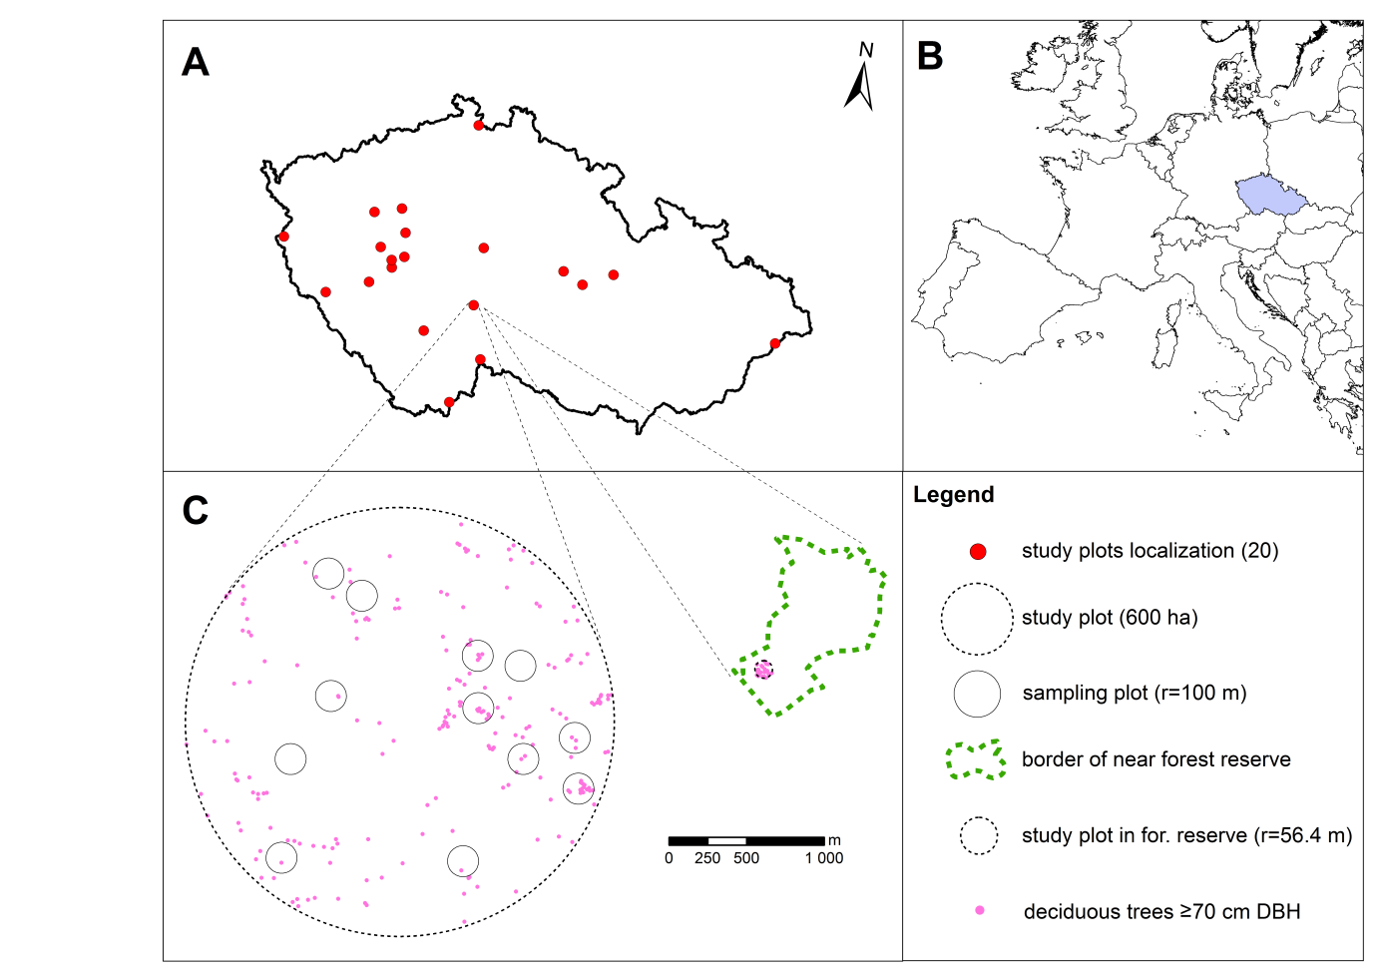

Figure 1: A) location of all (20) study sites in the Czech Republic; B) location of the Czech Republic in Europe; C) example of study site (600 ha) with localization of sampling plots (r = 100 m) and example of unmanaged forest reserve with 1 ha sampling plot.

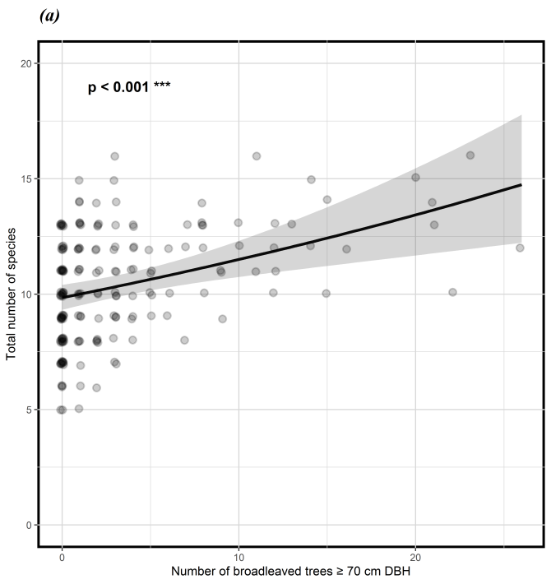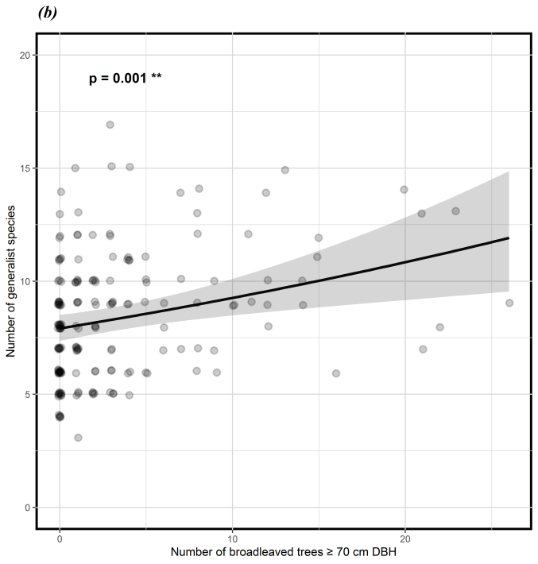

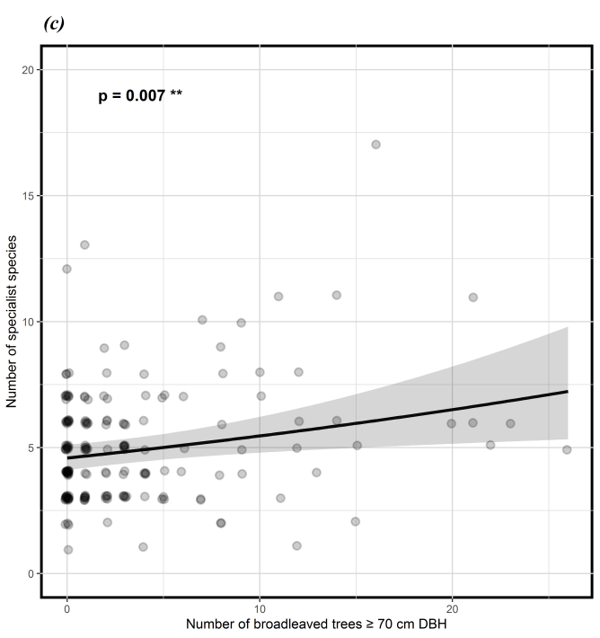

Figure 2: Relationship between number of live broadleaved trees ≥70 cm DBH within sampling plots (r =100 m) and total number of bird species (a), or number of generalist bird species (b), or specialist bird species (c) in spruce-dominated production forests (p value from GLMMs top left). The black line is the regression curve from the linear mixed effect model and the grey area indicates the 95 % confident interval.





Figure 3: Total number of bird species (a), or number of generalist bird species (b), or specialist bird species (c) between broadleaved trees ≥ 70 cm DBH density categories (0; 0<>1; 1<>3 or 3<>9 trees per ha) in spruce-dominated production forests and forest reserves (R). The colour scale expresses the mean density of trees in each category (0, 0.6, 1.9, 4.9, and 22.8 broadleaved trees ≥ 70 cm DBH per ha). Letters indicate differences between each category from post-hoc Tukey test on generalized mixed effect models (p value from GLMMs top left). Values in brackets show the difference in number of species between the category and the reference level (r.l.) =category without large broadleaved trees. Whiskers indicate 95 % confident intervals.

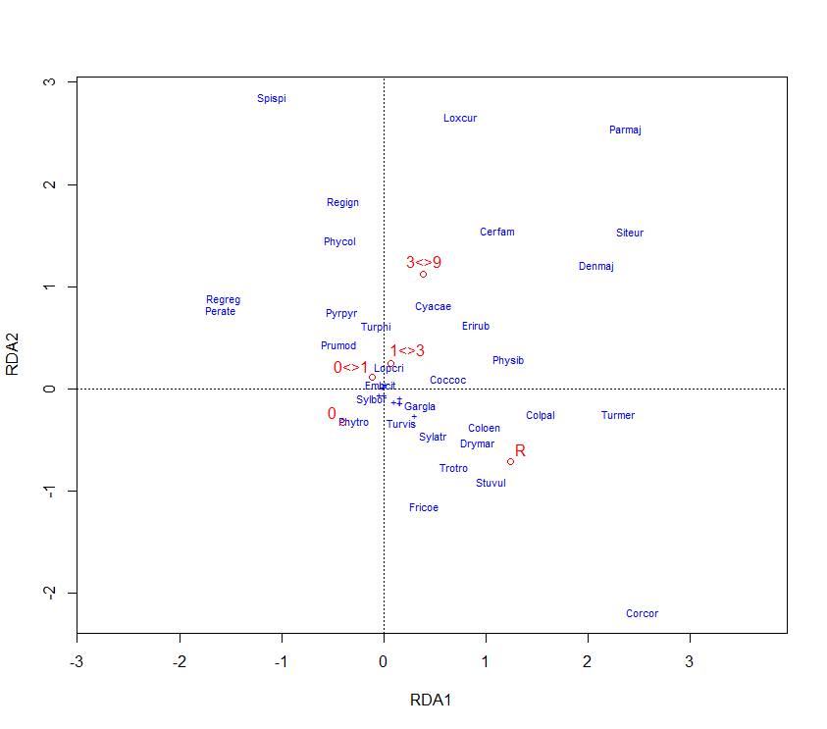

Figure 4: Plot from the redundancy analysis (RDA) showing variability of the bird community between broadleaved trees ≥ 70 cm DBH density categories (0; 0<>1; 1<>3 or 3<>9 trees per ha) in spruce-dominated production forests and forest reserves (R). Abbreviations of species names include the first three letters of the genus and species scientific names.

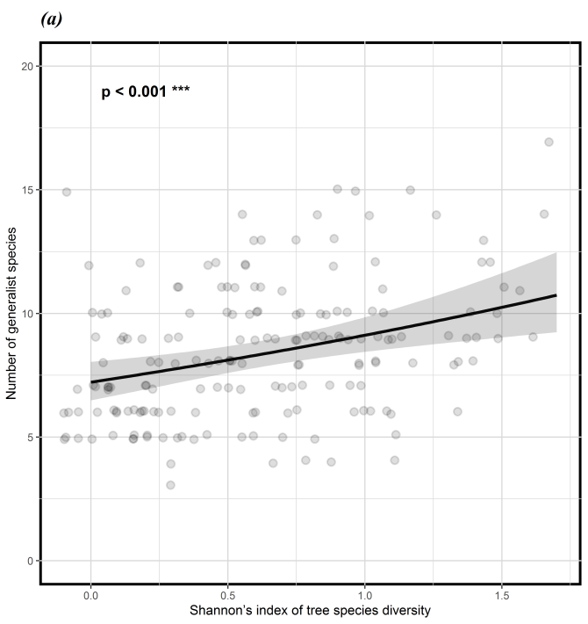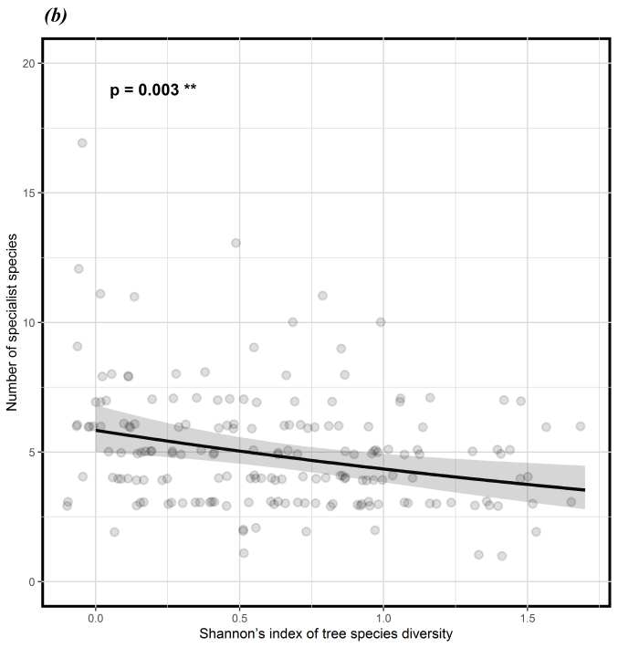

Figure 5: Relationship between Shannon’s diversity index of tree species and number of generalist bird species (a), or specialist bird species (b) in spruce-dominated production forests (*p* value from GLMMs top left). The black line is the regression curve from the GLMM and the grey area indicates the 95 % confident interval.

**Table 1:** Effect of selected stand features in spruce-dominated production forest on total number of bird species, number of generalist bird species, and number of specialist bird species (link scaled)

|  |  |  |  |  |  |
| --- | --- | --- | --- | --- | --- |
|  | Variable | Est. (SE) | z value | P | Response |
| Total species richness | NumBroadlLT70DBH | 0.079 (0.021) | 3.721 | **<0.001** | + |
|  | H_Trees | 0.041 (0.023) | 1.793 | 0.073 | + |
|  |  |  |  |  |  |
| Generalist | NumBroadlLT70DBH | 0.080 (0.025) | 3.236 | **0.001** | + |
|  | H_Trees | 0.103 (0.030) | 3.480 | **<0.001** | + |
|  |  |  |  |  |  |
| Specialist | NumLT70DBH | 0.089 (0.033) | 2.677 | **0.007** | + |
|  | H_Trees | -0.130 (0.044) | -2.975 | **0.003** | - |

# Supplementary material:

**Supplement 1:** List of all recorded birds in production forest and forest reserves used in the analysis (owls and raptors are excluded). In field Guild the generalist (G) and specialist (S) species are identified

|  | Species | Abbr. | Guild | Abundance | Density | Dominance | Frequency |
| --- | --- | --- | --- | --- | --- | --- | --- |
|  | (individuals) | (1 ha) |  | (% from 180 points) |
| 1 | *Fringilla coelebs* | *Fricoe* | G | 402 | 2.0 | 14.5 | 99.5 |
| 2 | *Periparus ater* | *Perate* | S | 256 | 1.3 | 9.2 | 89.0 |
| 3 | *Erithacus rubecula* | *Erirub* | G | 249 | 1.2 | 9.0 | 88.0 |
| 4 | *Regulus ignicapilla* | *Regign* | S | 187 | 0.9 | 6.8 | 81.0 |
| 5 | *Troglodytes troglodytes* | *Trotro* | G | 153 | 0.8 | 5.5 | 67.0 |
| 6 | *Certhia familiaris* | *Cerfam* | S | 148 | 0.7 | 5.3 | 69.5 |
| 7 | *Turdus merula* | *Turmer* | G | 143 | 0.7 | 5.2 | 60.5 |
| 8 | *Regulus regulus* | *Regreg* | S | 134 | 0.7 | 4.8 | 62.5 |
| 9 | *Sylvia atricapilla* | *Sylatr* | G | 130 | 0.7 | 4.7 | 56.5 |
| 10 | *Dendrocopos major* | *Denmaj* | G | 118 | 0.6 | 4.3 | 54.0 |
| 11 | *Parus major* | *Parmaj* | G | 116 | 0.6 | 4.2 | 45.5 |
| 12 | *Phylloscopus collybita* | *Phycol* | G | 108 | 0.5 | 3.9 | 49.5 |
| 13 | *Spinus spinus* | *Spispi* | S | 91 | 0.5 | 3.3 | 23.5 |
| 14 | *Columba palumbus* | *Colpal* | G | 78 | 0.4 | 2.8 | 33.5 |
| 15 | *Loxia curvirostra* | *Loxcur* | S | 72 | 0.4 | 2.6 | 18.5 |
| 16 | *Sitta europaea* | *Siteur* | G | 71 | 0.4 | 2.6 | 32.5 |
| 17 | *Turdus philomelos* | *Turphi* | G | 47 | 0.2 | 1.7 | 21.5 |
| 18 | *Prunella modularis* | *Prumod* | G | 37 | 0.2 | 1.3 | 17.0 |
| 19 | *Pyrrhula pyrrhula* | *Pyrpyr* | S | 30 | 0.2 | 1.1 | 13.0 |
| 20 | *Phylloscopus sibilatrix* | *Physib* | S | 29 | 0.1 | 1.0 | 13.0 |
| 21 | *Garrulus glandarius* | *Gargla* | G | 22 | 0.1 | 0.8 | 10.5 |
| 22 | *Cyanistes caeruleus* | *Cyacae* | G | 22 | 0.1 | 0.8 | 10.0 |
| 23 | *Coccothraustes coccothraustes* | *Coccoc* | G | 21 | 0.1 | 0.8 | 8.0 |
| 24 | *Corvus corax* | *Corcor* | G | 18 | 0.1 | 0.7 | 1.0 |
| 25 | *Turdus viscivorus* | *Turvis* | S | 17 | 0.1 | 0.6 | 8.5 |
| 26 | *Dryocopus martius* | *Drymar* | S | 9 | 0.0 | 0.3 | 4.5 |
| 27 | *Anthus trivialis* | *Anttri* | G | 9 | 0.0 | 0.3 | 4.0 |
| 28 | *Columba oenas* | *Coloen* | S | 8 | 0.0 | 0.3 | 2.5 |
| 29 | *Phylloscopus trochilus* | *Phytro* | G | 7 | 0.0 | 0.3 | 3.5 |
| 30 | *Sturnus vulgaris* | *Stuvul* | G | 7 | 0.0 | 0.3 | 1.0 |
| 31 | *Certhia brachydactyla* | *Cerbra* | S | 4 | 0.0 | 0.1 | 2.0 |
| 32 | *Sylvia borin* | *Sylbor* | G | 3 | 0.0 | 0.1 | 1.5 |
| 33 | *Phoenicurus phoenicurus* | *Phopho* | G | 2 | 0.0 | 0.1 | 1.0 |
| 34 | *Emberiza citrinella* | *Embcit* | G | 2 | 0.0 | 0.1 | 0.5 |
| 35 | *Ficedula albicollis* | *Ficalb* | S | 2 | 0.0 | 0.1 | 0.5 |
| 36 | *Ficedula parva* | *Ficpar* | S | 1 | 0.0 | 0.0 | 0.5 |
| 37 | *Poecile palustris* | *Poepal* | S | 1 | 0.0 | 0.0 | 0.5 |
| 38 | *Lophophanes cristatus* | *Lopcri* | S | 1 | 0.0 | 0.0 | 0.5 |
| 39 | *Muscicapa striata* | *Musstr* | G | 1 | 0.0 | 0.0 | 0.5 |
| 40 | *Nucifraga caryocatactes* | *Nuccar* | S | 1 | 0.0 | 0.0 | 0.5 |
| 41 | *Dendrocopos leucotos* | *Denleu* | S | 1 | 0.0 | 0.0 | 0.5 |