Supplementary Material

**Table S1.** Table of coefficients for linear mixed models comparing Yellowhammer singing activity at localities in agricultural landscape and near highways.

|  |  |  |  |  |  |  |  |  |  |
| --- | --- | --- | --- | --- | --- | --- | --- | --- | --- |
|  | *Response* | | | | | | | | |
| *Term* | *Song duration* | | | *Strophe length* | | | *Onset of singing* | | |
| *Estimate* | *Std. Error* | *t-value* | *Estimate* | *Std. Error* | *t-value* | *Estimate* | *Std. Error* | *t-value* |
| *Fixed effect terms:* | | | | | | | | | |
| (Intercept) | 180.109 | 28.927 | 6.226 | 1.392 | 0.121 | 11.515 | -10.578 | 14.61 | -0.724 |
| daySunday | 23.993 | 14.089 | 1.703 | - | - | - | - | - | - |
| locHW | -129.121 | 38.962 | -3.314 | -0.505 | 0.169 | -2.997 | 4.79 | 20.808 | 0.23 |
| pressure | 43.786 | 15.417 | 2.840 | - | - | - | -0.1 | 2.186 | -0.046 |
| wind | 35.813 | 14.633 | 2.447 | - | - | - | 5.44 | 2.539 | 2.142 |
| cloudiness | 21.550 | 13.460 | 1.601 | - | - | - | 5.858 | 2.242 | 2.612 |
| temp | - | - | - | 0.179 | 0.119 | 1.506 | - | - | - |
| locHW:pressure | -33.527 | 19.804 | -1.693 | - | - | - | 10.216 | 3.049 | 3.351 |
| locHW:temp | - | - | - | -0.329 | 0.164 | -2.014 | - | - | - |
| *Random effect terms:* | | | | | | | | | |
| *σlocality_id* | - | - | - | - | - | - | 36.643 | - | - |
| *σindividual_id* | 140.0 | - | - | 0.525 | - | - | 16.879 | - | - |
| *σresidual* | 65.4 | - | - | 0.498 | - | - | 8.515 | - | - |

**Table S2.** Table of coefficients for linear mixed models investigating effect of distance to nearest road on Yellowhammer singing activity.

|  |  |  |  |  |  |  |  |  |  |
| --- | --- | --- | --- | --- | --- | --- | --- | --- | --- |
|  | *Response* | | | | | | | | |
| *Term* | *Song duration* | | | *Strophe length* | | | *Onset of singing* | | |
| *Estimate* | *Std. Error* | *t-value* | *Estimate* | *Std. Error* | *t-value* | *Estimate* | *Std. Error* | *t-value* |
| *Fixed effect terms:* | | | | | | | | | |
| (Intercept) | 103.244 | 41.685 | 2.477 | 1.402 | 0.115 | 12.234 | -11.819 | 16.560 | -0.714 |
| dist_road | 100.255 | 34.401 | 2.914 | - | - | - | - | - | - |
| daySunday | - | - | - | - | - | - | 0.816 | 1.882 | 0.433 |
| wind | 46.759 | 20.735 | 2.255 | - | - | - | 8.381 | 3.320 | 2.525 |
| pressure | - | - | - | 0.126 | 0.086 | 1.456 | -7.793 | 2.805 | -2.779 |
| temp | - | - | - | 0.237 | 0.121 | 1.952 | -23.390 | 11.840 | -1.976 |
| cloudiness | - | - | - | - | - | - | 7.524 | 5.031 | 1.495 |
| daySunday:wind | - | - | - | - | - | - | 8.945 | 4.339 | 2.062 |
| daySunday:temp | - | - | - | - | - | - | 12.478 | 4.392 | 2.841 |
| *Random effect terms:* | | | | | | | | | |
| *σlocality_id* | - | - | - | - | - | - | 40.196 | - | - |
| *σindividual_id* | 137.45 | - | - | 0.545 | - | - | 9.071 | - | - |
| *σresidual* | 96.74 | - | - | 0.372 | - | - | 3.306 | - | - |

**Table S3.** Table of coefficients for linear mixed models investigating effect of long-term and present traffic intensity on Yellowhammer singing activity.

|  |  |  |  |  |  |  |  |  |  |
| --- | --- | --- | --- | --- | --- | --- | --- | --- | --- |
|  | *Response* | | | | | | | | |
| *Term* | *Song duration* | | | *Strophe length* | | | *Onset of singing* | | |
| *Estimate* | *Std. Error* | *t-value* | *Estimate* | *Std. Error* | *t-value* | *Estimate* | *Std. Error* | *t-value* |
| *Fixed effect terms:* | | | | | | | | | |
| (Intercept) | 64.102 | 15.811 | 4.054 | 1.031 | 0.132 | 7.801 | -16.472 | 6.003 | -2.744 |
| traff_int | -24.912 | 12.542 | -1.986 | - | - | - |  |  |  |
| temp | -33.118 | 14.615 | -2.266 | -0.256 | 0.132 | -1.943 |  |  |  |
| wind | 18.305 | 11.345 | 1.614 | -0.279 | 0.130 | -2.145 | 14.260 | 4.465 | 3.194 |
| vehicle | - | - | - | -0.212 | 0.098 | -2.161 | 6.801 | 2.872 | 2.368 |
| pressure | - | - | - | -0.203 | 0.117 | -1.737 | 10.228 | 2.706 | 3.780 |
| cloudiness | - | - | - | -0.334 | 0.123 | -2.710 | 13.444 | 3.783 | 3.554 |
| *Random effect terms:* | | | | | | | | | |
| *σlocality_id* | - | - | - | - | - | - | - | - | - |
| *σindividual_id* | 77.21 | - | - | 0.492 | - | - | 26.80 | - | - |
| *σresidual* | 50.69 | - | - | 0.547 | - | - | 10.36 | - | - |

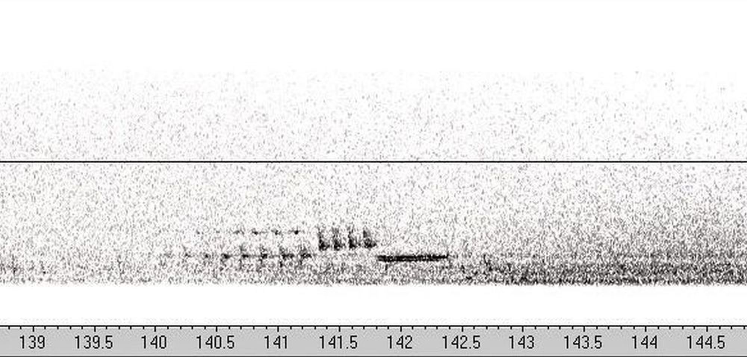

**Figure S2.** Spectrogram of a single strophe of Yellowhammer's song with two syllables downloaded from Avisoft SASLab Pro software

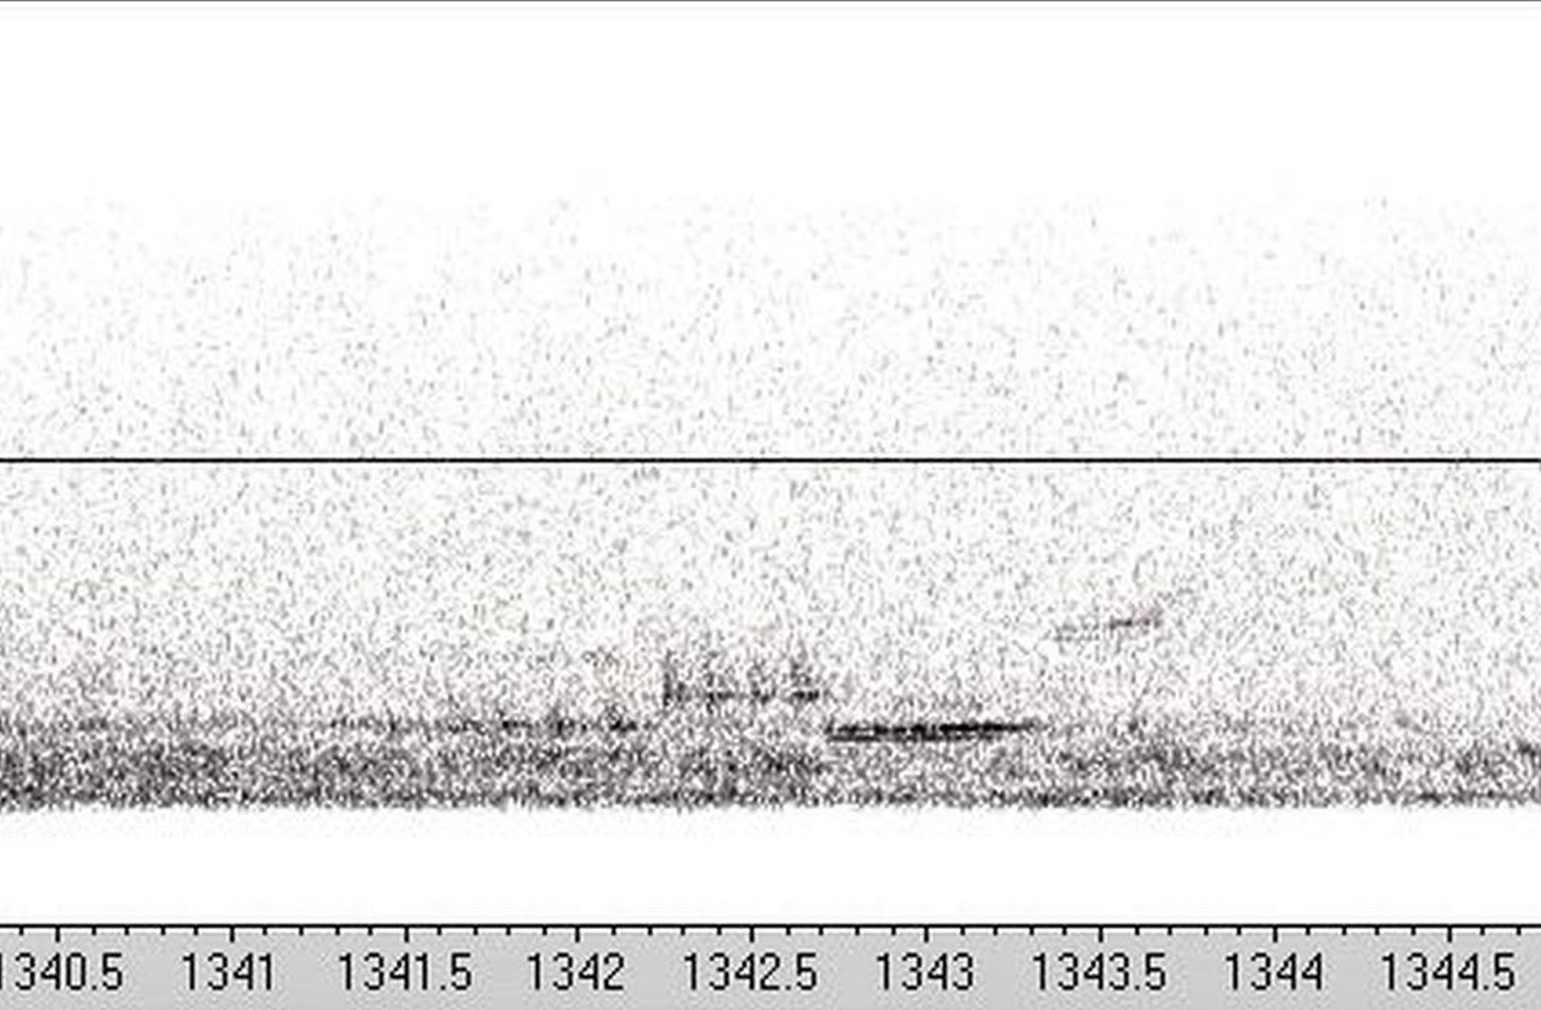

**Figure S3.** Spectrogram of a single strophe of Yellowhammer's song with three syllables downloaded from Avisoft SASLab Pro software