Variation in the salience of cultural issues across parties

##### OI: Radical right parties should place a higher degree of salience on cultural issues, particularly multiculturalism, nationalism and immigration, compared to other parties.

Association between party families and issue salience, OLS models with country and year fixed-effects

|  | Salience of cultural issues (aggregate) | Salience of multiculturalism |
| --- | --- | --- |
| Christian Democrat | 5.598** | 0.427 |
|  | (1.301) | (0.762) |
| Conservative | 4.607** | 1.878+ |
|  | (1.253) | (0.904) |
| Radical right | 10.927*** | 8.479*** |
|  | (1.217) | (1.338) |
| Green | 12.774** | 0.162 |
|  | (3.376) | (0.900) |
| Socialist | 0.517 | 0.401 |
|  | (0.577) | (0.756) |
| Liberal | 1.765 | 0.732 |
|  | (1.019) | (0.924) |
| Agrarian center | 3.610+ | 1.539 |
|  | (1.630) | (0.992) |
| No family | -0.563 | 0.774 |
|  | (1.969) | (0.764) |
| Regionalist | 5.646 | 6.423* |
|  | (3.390) | (2.129) |
| pervote | -0.033 | 0.005 |
|  | (0.030) | (0.023) |
| Num.Obs. | 646 | 646 |
| R2 | 0.358 | 0.296 |
| R2 Adj. | 0.304 | 0.237 |
| AIC | 4523.0 | 4197.2 |
| BIC | 4751.0 | 4425.2 |
| RMSE | 7.41 | 5.76 |
| Std.Errors | by: factor(country) | by: factor(country) |
| FE: factor(country) | X | X |
| FE: year | X | X |
| * p < 0.1, * p < 0.05, ** p < 0.01, *** p < 0.001 | | |
| Reference category: radical left | | |

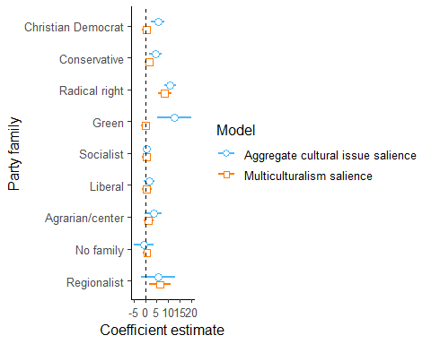

##### OI: Right-wing parties that do not belong to the radical right should place a higher emphasis on cultural issues compared to left-wing parties.

OLS of party issue salience on left-right position and vote share, excluding radical-right parties from the analysis

|  | Salience of cultural issues (aggregate) | Salience of multiculturalism |
| --- | --- | --- |
| log_rile | 2.200** | 1.054* |
|  | (0.626) | (0.421) |
| pervote | -0.070 | -0.026 |
|  | (0.043) | (0.031) |
| Num.Obs. | 554 | 554 |
| R2 | 0.262 | 0.171 |
| R2 Adj. | 0.201 | 0.103 |
| AIC | 3811.1 | 3413.0 |
| BIC | 3996.8 | 3598.7 |
| RMSE | 6.98 | 4.87 |
| Std.Errors | by: factor(country) | by: factor(country) |
| FE: factor(country) | X | X |
| FE: year | X | X |
| * p < 0.1, * p < 0.05, ** p < 0.01, *** p < 0.001 | | |

Does the association between left-right position and multiculturalism salience differ across countries?

Predictions from OLS models of multiculturalism on left-right position, adjusting for vote share and including year fixed-effects

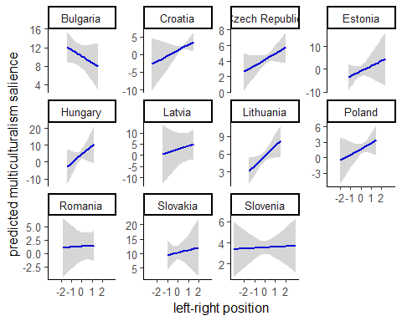

### Radical right success and mainstream parties’ issue emphasis

##### OI: The presence of a strong radical right party in the party system is associated with an increased emphasis on cultural issues by mainstream parties, and this association may be conditional on mainstream parties' left-right positions.

OLS of party issue salience on the vote share of the radical right at previous elections

|  | Salience of multiculturalism |
| --- | --- |
| far_right_vote_lag | 0.029 |
|  | (0.058) |
| log_rile | 1.311+ |
|  | (0.706) |
| pervote | 0.029 |
|  | (0.031) |
| Num.Obs. | 480 |
| R2 | 0.654 |
| R2 Adj. | 0.298 |
| AIC | 2919.0 |
| BIC | 3937.4 |
| RMSE | 3.04 |
| Std.Errors | by: factor(party) |
| FE: factor(party) | X |
| FE: year | X |
| * p < 0.1, * p < 0.05, ** p < 0.01, *** p < 0.001 | |

Do left and right-wing mainstream parties react differently to radical right success?

