
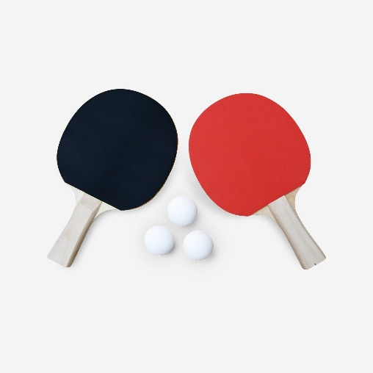
LED Ping-Pong
Adam Turičík
Richard Vaško
Václav Vojtovič
Authors
Researches are often under or on behalf of a university, an organization, or academic/research institutions. When available, include their logos with the names.
Affiliations
Use graphs to show visualization of your data's analysis.
Illustrations are also great aids
to help your research poster.
This project implements a Ping-Pong game on the Nexys A7-50T development board. A single LED, which is lit, represents the ball and moves across a 16-LED array. When the ball reaches the edge, the player must press the corresponding button (left button for the left edge, right button for the right edge). The ball speed increases after each successful hit. The score is displayed on 7-segment display as decimal number. To restart after game over, both buttons must be pressed as same time.
Project Summary
Game start on central LED (num. 7). When ball is on extreme position, player must press button. If player won’t make it in time, lit red LED and game will reset. If player press button in time, lit green LED, score increase by 1 and speed of ball rise. This continues until one of the players miss.
Rules
Signal name | I/O | Size | Note
clk | in | 1 | system clock (100 MHz)
rst | in | 1 | system reset (centre button)
btn_r_in | in | 1 | right button
btn_l_in | in | 1 | left button
led | out | 15:0 | LED array (ball position)
led_g | out | 1 | green LED (successful hit)
led_r | out | 1 | red LED (miss / game over)
seg | out | 6:0 | 7-segment display segments
anode | out | 7:0 | 7-segment display anodes

Inputs and outputs
Results show the outcome of the research and should answer the question or hypothesis stated in the introduction. State what you've found from your study.
Results
In a regular research paper, the analysis section is one of the longest parts as it builds on the information that supports the objective and thesis. With a research poster, you can trim down the analysis to the most important parts. Use bullets to emphasize points. Include key graphs, tables, graphics, and other images that support the study and show a visual analysis of the data.
Analysis
To wrap up your poster, present two to three key findings. You can also add a brief explanation or narrative to these that can encourage conversation or dialogue with the audience. These findings can be actionable items that can lead to implementation, policy creation, or further study.
Conclusion
Image link: https://sweeek.twic.pics/sweeek-images/site-gris/PPT2BAT_01.jpg?twic=v1/resize=1500/quality=70

Sources

