NEAP 2001 | CHEMISTRY | Unit 4 | Trial Examination Solutions

Section A Multiple Choice Questions

- C
- D
- A
- C
- C
- D
- B
- D
- B
- A
- C
- D
- B
- C
- A
- B
- A
- D
- B
- A

Section B Short Answer

Question 1
a. | (i) | Al³⁺ (l) + 3 e– → Al (l) |  | 1 mark
 |  | 2 O^{2–} (l) + C (s) → CO₂ (g) + 4 e– |  | 1 mark
 | (ii) | Reduction of the Al³⁺ ion requires 3 mole of electrons per mole of aluminium. or  Heat produced by the electrical resistance is used to maintain the high temperature of the cell. |  | 1 mark
b. | (i) | Al₂O₃ (s) + 2 OH– (aq) + 3 H₂O (l) → 2 Al(OH)₄– (aq) |  | 1 mark
 | (ii) | Al₂O₃ (s) + 6 HCl (aq) → 2 AlCl₃ (aq) + 3 H₂O (l) |  | 1 mark
c. | 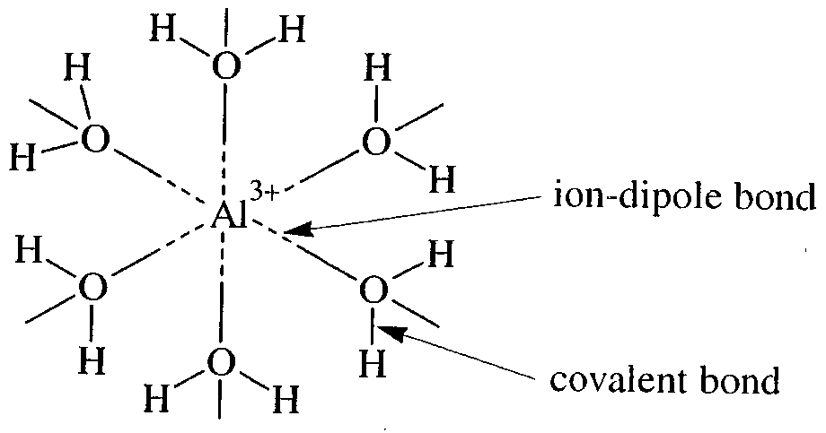 |  |  | 2 marks
d. | (i) | Aluminium: | 1s² 2s² 2p⁶ 3s² 3p¹ | 1 mark
 |  | Copper: | 1s² 2s² 2p⁶ 3s² 3p⁶ 3d¹⁰ 4s¹ (or 1s² 2s² 2p⁶ 3s² 3p⁶ 3d⁹ 4s²) | 1 mark
 | (ii) | For example:  - formation of coloured solutions  - variable oxidation states in compounds  - formation of a range of complex ions  - some transition metals (not Cu) are magnetic |  | 1 mark
Total 10 marks

Question 2
a. | 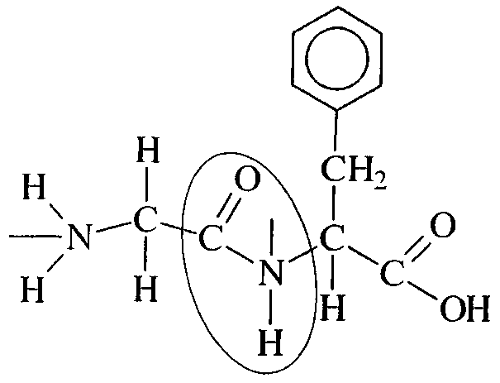 |  |  | 1 mark
b. | 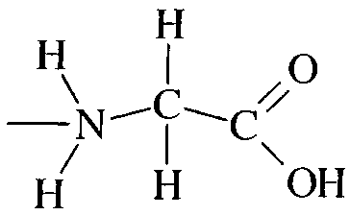 |  | 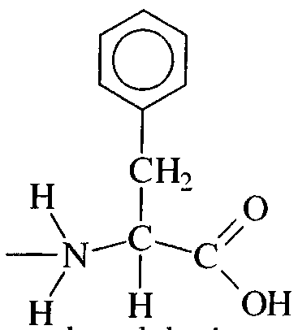
 | glycine |  | phenylalanine | 2 marks
c. | 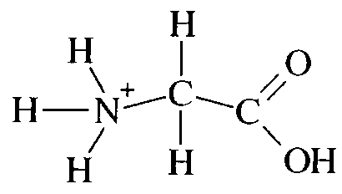 |  |  | 1 mark
d. | The number, type and sequence of amino acids making up the polypeptide chain. |  |  | 1 mark
e. | (i) | Any one of:  - temperature change  - pH change  - addition of chemicals |  | 1 mark
 | (ii) | For example:
 |  | Desirable:  - cooking of an egg to change the clear liquid to solid white  - cooking of meat to enable easier digestion |  | 1 mark
 |  | Undesirable:  - curdling of milk due to presence of acid produced by bacteria  - altered enzyme activity due to changes in pH or temperature |  | 1 mark
Total 8 marks

Question 3
a. | E = m × c × ΔT = 150 × 4.18 × 54.7 = 34 297 J = 34.3 kJ | 2 marks
b. | 60.0 g (1 mol) releases 2016 kJ  ∴ 1.20 g releases x kJ  ∴ x = 40.3 kJ | 2 marks
c. | % = 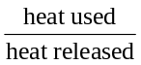 × 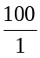 = 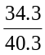 × 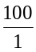 = 85.1 % | 1 mark
d. | The activation energy for the methanol/oxygen reaction is smaller due to the smaller molecular size (hence fewer covalent C–H bond to be broken). | 1 mark
Total 6 marks

Question 4
a. | (i) | - Rutherford’s model saw the electrons orbiting the nucleus in a circular orbit much like the planets orbit the Sun. In this model the electrons should emit radiation and lose energy.  - Bohr’s model saw the electrons circling the nucleus in orbits of fixed energy. | 1 mark
 | (ii) | When an electron receives an exact amount of energy it is promoted to a higher energy orbit. The energy received must be equal the difference in energy between the two orbits.  The ‘excited’ electron quickly returns to the lower energy orbit, releasing the energy gained by emitting electromagnetic radiation.  The energy of emitted radiation equals the difference in energy between the two orbits. This radiation will be of a specific frequency and wavelength, producing a characteristic line on the emission spectrum. | 2 marks
b. | (i) | A hydrogen atom has one proton, helium has two. Since mass was concentrated in the nucleus (Assumed to contain only protons), helium should be twice as heavy as hydrogen. | 1 mark
 | (ii) | Helium atoms contain two neutrons and two protons. Since neutrons and protons have similar mass, the helium atom is four times as heavy as a hydrogen atom which contains only one proton (no neutrons). | 1 mark
c. | Let RIM of ⁷¹Ga = x, Abundance of ⁷¹Ga = 39.5%  RAM = Σ(RIM × Abundance fraction)  ∴ 69.7 = 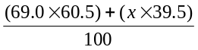  Solve for x  RIM(⁷¹Ga) = 70.8 |  | 2 marks
Total 7 marks

Question 5
a. | anode: |  | H₂ (g) + 2 OH– (aq) → 2 H₂O (l) + 2 e– | 1 mark
 | cathode: |  | O₂ (g) + 2 H₂O (l) + 4 e– → 4 OH– | 1 mark
b. | (i) | Any two of:  - They act as catalysts.  - They allow the gases to come into contact with the electrolyte.  - They are the site of oxidation and reduction. |  | 2 marks
 | (ii) | Any two of:  - Fuel cells are highly efficient in converting chemical energy directly to electrical energy (approximately 60%). Petrol combustion engines have low overall efficiency (approximately 25%).  - The product of the cell is water. This is preferable to the gaseous pollutants (CO₂, CO, hydrocarbons, etc) released by petrol combustion engines.  - The reactants (H₂ and O₂) can be produced from water and so are renewable sources, unlike petrol. |  | 2 marks
c. | n(e–) = 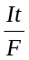 = 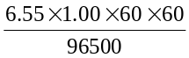 = 0.2444 mol  n(H₂) = ½ n(e–) = ½ × 0.2444 = 0.1222 mol  V(H₂) = 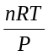 = 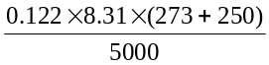 = 0.106 L or 106 mL |  |  | 3 marks
Total 9 marks

