NEAP
2005
UNIT 4 CHEMISTRY

SECTION A – Multiple-choice questions

Question 1
During the operation of a coal-fired power station like those at Yallourn in Victoria, the chemical energy of the coal is converted to a number of different forms of energy. Which of the following shows the approximate percentage conversion of energy in coal into other forms of energy?

 | Percentage of energy in coal converted to:
 | heat | electrical | other forms
A. | 60 | 5 | 35
B. | 5 | 35 | 60
C. | 60 | 35 | 5
D. | 35 | 60 | 5

Question 2
Nitrogen consists of two isotopes with relative isotopic masses of 14.003 and 15.001. The relative atomic mass of nitrogen is 14.006. The percentage abundance of the ¹⁴N isotope is

- 0.301
- 0.314
- 99.686
- 99.699

Question 3
A 1.0 M aqueous solution of nickel nitrate (Ni(NO₃)₂) was electrolysed using inert graphite electrodes. In this electrolysis of nickel nitrate solution, water acts as

- an oxidant and as a solvent
- a reductant and as a solvent
- both oxidant and reductant, and as a solvent
- a solvent only

Question 4
Which of the following comparisons between galvanic and electrolytic cells is incorrect?

 | Galvanic cell | Electrolytic cell
A. | Spontaneous chemical reactions occur. | Non-spontaneous chemical reactions occur.
B. | Electricity is generated by a chemical reaction. | Electricity is provided by a power source.
C. | Reduction occurs at the cathode. | Reduction occurs at the cathode.
D. | Oxidation occurs at the positive electrode. | Oxidation occurs at the negative electrode.

Question 5
Consider the elements in Period 4 of the Periodic Table. When compared to Group I and II metals, transition metals in this period
- display variable oxidation numbers and have lower melting points
- have smaller atomic radii and are more likely to form coloured compounds
- have higher ionisation energies and are less likely to form complex ions
- are softer and more likely to display magnetic properties

Question 6
Enzymes are important biological catalysts. Which of the following statements concerning enzymes is incorrect?
- Enzymes become denatured when heated strongly.
- Enzymes operate over a relatively narrow pH range.
- Enzymes are inefficient catalysts and so are required in large quantities.
- Enzymes are composed of protein.

Question 7
In which of the following compounds does chromium have the highest oxidation number?

- K₂Cr₂O₇
- CrO₂
- Cr₂(SO₄)₃
- CrCl₃

Question 8
The excited state electron configuration of an aluminium ion could be written as

- 1s²2s²2p⁶
- 1s²2s²2p⁶3s³3p¹
- 1s²2s²2p⁶3s¹3p²
- 1s²2s²2p⁵3p¹

Question 9
0.250 L of a solution containing Cu²⁺ ions was electrolysed using a steady current of 3.00 A. After 5.00 minutes, all the Cu²⁺ ions had been deposited as Cu atoms. The original concentration of the Cu²⁺ solution was

- 3.10 × 10⁻⁴ M
- 1.87 × 10⁻² M
- 3.73 × 10⁻² M
- 7.46 × 10⁻² M

Question 10
Which of the following correctly lists the products formed during the complete metabolic breakdown of protein in the human body?

- CO₂, H₂O and (NH₂)₂CO
- CO₂H₂O and NH₃
- amino acids and H₂O
- amino acids and (NH₂)₂CO

Question 11
When element number 109 was first prepared, a single atom of 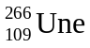 was made by bombarding a bismuth nucleus, 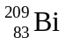, with an iron nucleus, 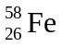. The other product formed besides was

- an alpha particle
- an electron
- a neutron
- a proton

Question 12
Industrial applications of electrolysis include the Down’s cell for production of sodium from sodium chloride, and the Membrane cell for the production of sodium hydroxide from sodium chloride. Which of the following features is common to both the Down’s cell and the Membrane cell?
- both operate at the same temperature
- both produce the same product at the anode
- both produce the same product at the cathode
- both use the same electrolyte

Question 13
Which of the following species would be expected to have the largest radius?

- O²⁻ ion
- O atom
- Al³⁺ ion
- Na⁺ ion

Question 14
Which of the following would normally be produced by the action of denitrifying bacteria in the soil?

- NO₃⁻
- NH₄⁺
- N₂
- (NH₂)₂CO

Question 15
Which of the following sketch graphs is the most accurate representation of the trend in ionisation energies of the elements of Period 3 across the Periodic Table from sodium to chlorine?
 | 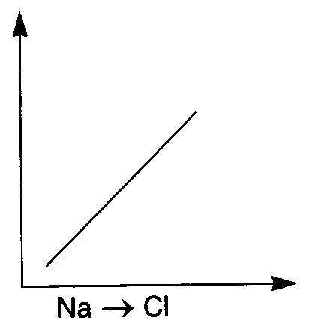 |  | 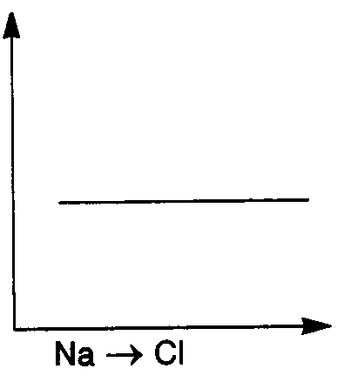 |  | 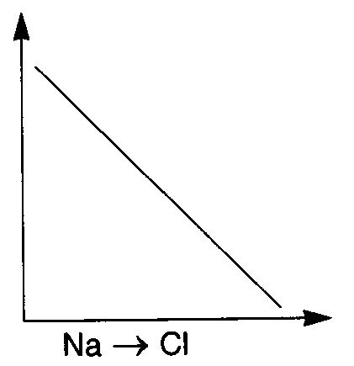 |  | 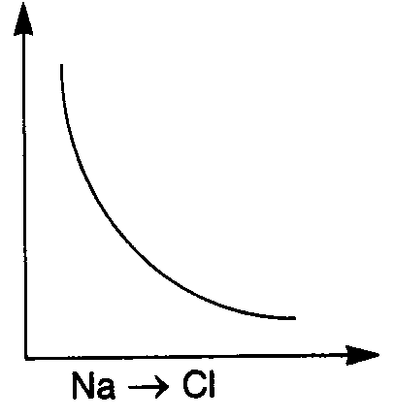

Question 16
Ozone, a toxic gas, is found in moderate concentrations in the upper atmosphere. It decomposes to form oxygen according to the equation:
2 O₃ (g) → 3 O₂ (g) ΔH = –285 kJ mol⁻¹
When 6.02 × 10¹⁸ molecules of ozone are converted to oxygen, the amount of energy produced is

- 0.950 J
- 1.43 J
- 2.85 J
- 8.55 J

Question 17
Which of the following statements concerning the Periodic Table is incorrect?
- The ground state electron configuration for a manganese atom is 1s²2s²2p⁶3s²3p⁶3d⁵4s².
- Oxidising strength increases across the Period 3 elements from sodium to chlorine.
- The Lanthanide series of elements corresponds to those elements in which the f subshell is progressively filling.
- Electronegativity increases down the Group IV elements from carbon to lead.

Questions 18 and 19 refer to the following information

Methanol can be used in a fel cell to provide energy. The overall equation for the combustion of methanol is:
2 CH₃OH (g) + 3 O₂ (g) → 2 CO (g) + 4 H₂O (g)

Question 18
Which of the following best describes the reaction occurring at the anode in a methanol fuel cell using a potassium hydroxide electrolyte?
- CH₃OH (g) + 6 OH⁻ (aq) → CO₂ (g) + 5 H₂O (g) + 6 e-
- O₂ (g) + 2 H₂O (g) + 4 e⁻ → 4 OH⁻ (aq)
- CH₃OH (g) + H₂O (l) → CO₂ (g) + 6 H⁺ (aq) + 6 e⁻
- O₂ (g) + 4 H⁺ (aq) + 4 e⁻ → 2 H₂O (g)

Question 19
During the operation of the fuel cell, the pH of the solution near the cathode would

- decrease as H⁺ is produced
- increase as H⁺ is produced
- decrease as OH⁻ is produced
- increase as OH⁻ is produced

Question 20
For which one of the following reactions is the sign of ΔH different to the other three?

- Cl₂ (g) → 2 Cl (g)
- Cl₂ (s) → Cl₂ (g)
- Cl (g) + e⁻ → Cl⁻ (g)
- Cl (g) → Cl⁺ (g) + e⁻

SECTION B – Short-answer questions

Question 1
- Complete the table below by writing balanced equations for the reactions described. When selecting oxides to complete your equations, you should select from oxides formed by the elements found in Period 3 of the Periodic Table.

Reactants | Equation for reaction
i. Acidic oxide + H₂O (l)
ii. Basic oxide + HCl (aq)
iii. Amphoteric oxide + NaOH (aq)

3 marks
- Write balanced equations to illustrate the processes described in the table below.

Process | Equation
i. The conversion of solar energy
to chemical energy.
ii. A nuclear fusion reaction
iii. The radioactive decay of N-16
to form O-16

3 marks
Total 6 marks

Question 2
When fats and oils are allowed to stand in open air, reactions occur that slowly produce molecules with bad tastes and odours. The fat or oil becomes rancid and inedible. Two major reactions are responsible for rancidity.
Oxidative rancidity is due to the oxidation of fatty acids by oxygen in the air.
Hydrolytic rancidity is due to the hydrolysis of triglycerides
- The percentage fatty acid composition of two lipids (A and B) is shown in the table below. Each fatty acid is named and its molecular formula is shown.

 | Fatty Acid
Lipid | Myristic  C₁₄H₂₈O₂ | Palmitic  C₁₆H₃₂O₂ | Stearic  C₁₈H₃₆O₂ | Oleic  C₁₈H₃₄O₂ | Linoleic  C₁₈H₃₂O₂
Lipid A | 6.4 | 27.4 | 14.1 | 49.6 | 2.5
Lipid B | 2.6 | 2.7 | 2.6 | 18.6 | 73.5

Which lipid (A or B) would you expect to show the greatest degree of oxidative rancidity? Explain your choice.
_______________________________________________________________________________________
_______________________________________________________________________________________
_______________________________________________________________________________________
_______________________________________________________________________________________
2 marks
- When the triglyceride with semi-structural formula C₃H₅(C₁₄H₂₇O₂)₃ undergoes hydrolysis, two types of molecules form. Draw full structural formulas for each of these types of molecules in the spaces provided below.

Molecule 1

Molecule 2

2 marks
- Briefly explain two methods used to prevent of slow the rate at which fats and oils become rancid.
_______________________________________________________________________________________
_______________________________________________________________________________________
_______________________________________________________________________________________
_______________________________________________________________________________________
2 marks
Total 6 marks

Question 3
- An experiment is to be conducted involving the electrolysis of an aqueous copper(II) chloride solution. Explain two factors that must be considered when predicting the products of this electrolysis experiment.
_______________________________________________________________________________________
_______________________________________________________________________________________
_______________________________________________________________________________________
_______________________________________________________________________________________
_______________________________________________________________________________________
_______________________________________________________________________________________
2 marks
- State two key components of a simple solution calorimeter and explain why each is necessary in the operation of the calorimeter.
_______________________________________________________________________________________
_______________________________________________________________________________________
_______________________________________________________________________________________
_______________________________________________________________________________________
2 marks
Total 4 marks

Question 4
- The polysaccharide cellulose is an important source of energy in the diet of grass-eating animals such as sheep. The cellulose must be hydrolysed to produce glucose molecules.
State the chemical conditions necessary for the hydrolysis of cellulose.
_______________________________________________________________________________________
_______________________________________________________________________________________
1 mark
- The shells of insects and crabs contain a polysaccharide called chitin. The structure of chitin is shown below.
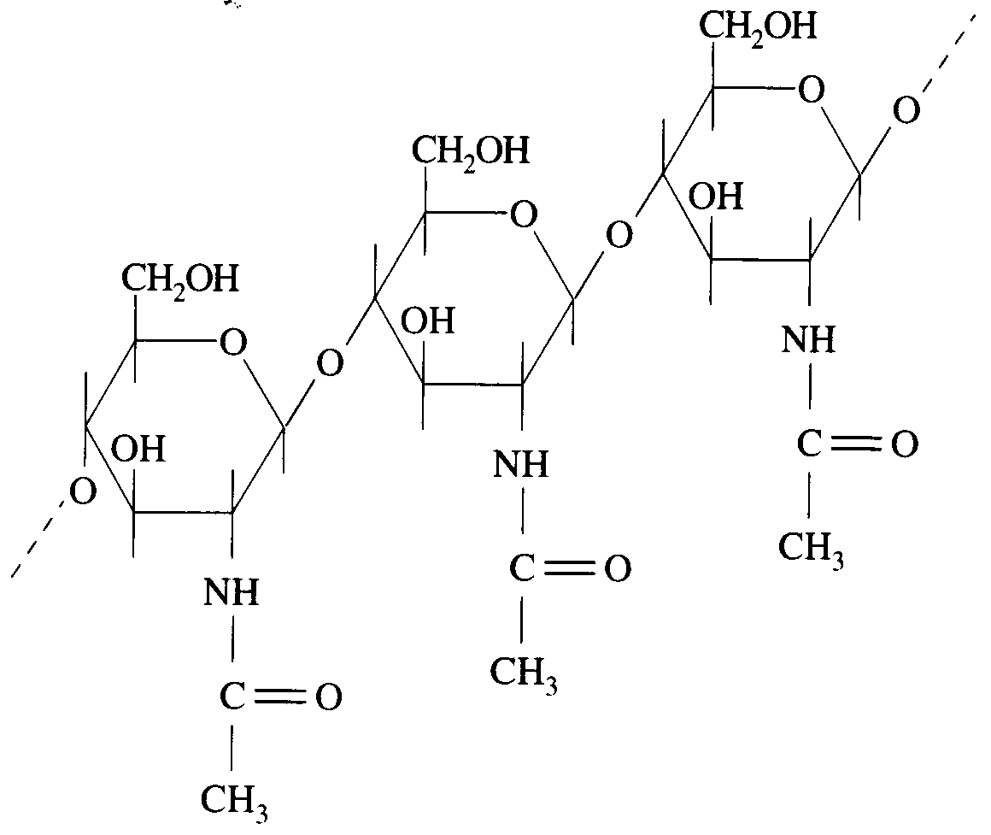
- State one way in which the structure of chitin resembles that of cellulose.
__________________________________________________________________________________
__________________________________________________________________________________
- State one way in which the structure of chitin differs from that of cellulose.
__________________________________________________________________________________
__________________________________________________________________________________
1 + 1 = 2 marks
Total 3 marks
Question 5
It has been suggested that hydrogen gas obtained from the decomposition of water might be a substitute fuel for natural gas or petrol.
- A bomb calorimetry experiment was performed to compare the energy released by the combustion of natural gas and hydrogen gas. Samples of each fuel were placed in a calorimeter and completely reacted with oxygen.
Calorimeter calibration factor: 12.5 kJ °C⁻¹
Mass of natural gas sample: 1.57 g
Temperature change when natural gas sample was reacted: 6.90 °C
Mass of hydrogen gas sample: 1.17 g
Temperature change when hydrogen gas sample was reacted: 13.1 °C
- Calculate the energy content of natural gas in kJ g⁻¹.
__________________________________________________________________________________
__________________________________________________________________________________
- Calculate the energy content of hydrogen gas in kJ g⁻¹.
__________________________________________________________________________________
__________________________________________________________________________________
1 + 1 = 2 marks
- A virtually inexhaustible supply of hydrogen exists in the water of the world’s oceans. This hydrogen may be obtained by electrolysis. The diagram below shows laboratory apparatus that may be used to electrolyse water, to which a small amount of Na₂SO₄ has been added.
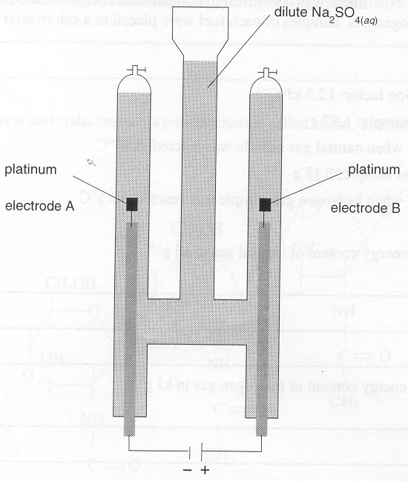
- Write a balanced half-equation for the reaction occurring at electrode A.
__________________________________________________________________________________
- Write a balanced half-equation for the reaction occurring at electrode B.
__________________________________________________________________________________
- Determine the value of the ratio: 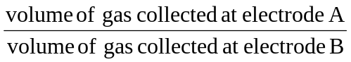
Show how you obtained your answer.
__________________________________________________________________________________
__________________________________________________________________________________
__________________________________________________________________________________
__________________________________________________________________________________
- Suggest one reason why producing hydrogen by electrolysis of water may not be a viable source of a substitute fuel for natural gas
__________________________________________________________________________________
__________________________________________________________________________________
1 + 1 + 2 + 1 = 5 marks
- The internal combustion engine of automobiles can be easily adapted to burn hydrogen instead of petrol.
- Use the following data to determine the volume of hydrogen gas required to produce the same energy as a typical 40.0 L tank of petrol.
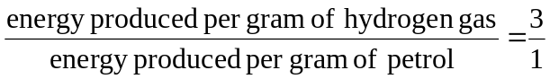
Mass of petrol in a 40.0 L tank: 29.6 kg
Temperature of hydrogen storage tank: 25.0 °C
Pressure of hydrogen storage tank: 101.3 kPa
__________________________________________________________________________________
__________________________________________________________________________________
__________________________________________________________________________________
__________________________________________________________________________________
__________________________________________________________________________________
- Based on your calculation in i., comment on the feasibility of replacing petrol with hydrogen gas as a fuel for automobiles.
__________________________________________________________________________________
__________________________________________________________________________________
3 + 1 = 4 marks
Total 11 marks

Question 6
Protein chains are composed of amino acids. Several amino acids are named below, along with the structural formula of their side groups.
Amino acid | Side group
Glutamic acid, Glu | HO₂C(CH₂)₂—
Alanine, Ala | CH₃—
Lysine, Lys | (NH₂)(CH₂)₄—
Valine, Val | (CH₃)₂CH—

- Draw the structural formula for alanine as it would exist in a solution of pH 12.

1 mark
- Normal adult haemoglobin (Hb) is a complex protein made up of four polypeptide chains, containing a total of about 570 amino acids. Some people have a slightly different form of haemoglobin (HbS). HbS differs from Hb in that two chains each have one different amino acid. The altered amino acid sequence is shown below.
Hb —Thr—Pro—Glu—Glu—Lys—Ala—
HbS —Thr—Pro—Val—Glu—Lys—Ala—
This change affects only 2 amino acids in about 570, but is sufficient to produce the very serious disease sickle cell anaemia in people with HbS.
- Draw a possible structure for the section of Hb chain represented by —Lys—Ala—

- Explain why the substitution of glutamic acid (Glu) by valine (Val) might affect the structure of haemoglobin.
__________________________________________________________________________________
__________________________________________________________________________________
__________________________________________________________________________________
__________________________________________________________________________________
__________________________________________________________________________________
2 + 2 = 4 marks
Total 5 marks

Question 7
- When Mendeleev first published his Periodic Table in 1869, the elements gallium, scandium and germanium were unknown. Mendeleev correctly predicted the existence and properties of these elements. By considering the structure of Mendeleev’s Periodic Table, briefly explain how he was able to make these predictions.
_______________________________________________________________________________________
_______________________________________________________________________________________
_______________________________________________________________________________________
_______________________________________________________________________________________
_______________________________________________________________________________________
_______________________________________________________________________________________
_______________________________________________________________________________________
_______________________________________________________________________________________
_______________________________________________________________________________________
3 marks
- Properties of elements such as atomic radius, electronegativity and ionisation energy show pronounced trends when moving across the Periodic Table from Group I to Group VII. However, the transition metals from scandium to zinc show considerable similarity in these properties. Explain why the trends in properties are not seen in the transition metals.
_______________________________________________________________________________________
_______________________________________________________________________________________
_______________________________________________________________________________________
_______________________________________________________________________________________
2 marks
Total 5 marks

