Letter
STUDENTNUMBER
STUDENT NAME
________________________________________________

LEGAL STUDIES UNITS 3 & 4
2020

TRIAL EXAM A
Reading time: 15 minutes
Writing time: 2 hours

QUESTION AND ANSWER BOOK
Structure of book
Students are NOT permitted to bring mobile phones and/or any other unauthorised electronic devices into the examination room
- Students are permitted to bring into the practice examination: pens, pencils, highlighters, erasers, sharpeners and rulers.
- Students are NOT permitted to bring into the examination room: blank sheets of paper and/or white out liquid/tape.
- No calculator is allowed in this examination

Materials supplied
- Question and answer book of 23 pages.
- Additional space is available at the end of the book if you need extra paper to complete an answer.

Instructions
- Write your student number and name in the space provided above on this page.
- All written responses must be in English.
Section | Number of questions | Number of questions to be answered | Number of marks
A | 6 | 6 | 40
B | 3 | 3 | 40
 |  |  | Total 80

SECTION A
Instructions for Section A
Answer all questions in the spaces provided
Question 1 (2 marks)
- Explain one purpose of committal proceedings.
___________________________________________________________________________________________
___________________________________________________________________________________________
___________________________________________________________________________________________
___________________________________________________________________________________________
___________________________________________________________________________________________
___________________________________________________________________________________________
___________________________________________________________________________________________
___________________________________________________________________________________________
Question 2 (6 marks)
John is Suing
John is suing his employer for defamation. He is seeking $500,000 in compensation and the trial is set to be heard in the Magistrates Court on the 30th of November. The prosecution said, “John’s case is not strong”. Lawyers representing John are confident they will prove loss of reputation beyond reasonable doubt.
There are errors in the case “John is Suing”. Identify three errors and state what the correct legal principle, process or procedure should be applied. (2 + 2 + 2 = 6 marks)

Error 1_____________________________________________________________________________________
___________________________________________________________________________________________
___________________________________________________________________________________________
___________________________________________________________________________________________
___________________________________________________________________________________________
___________________________________________________________________________________________
Error 2_____________________________________________________________________________________
___________________________________________________________________________________________
___________________________________________________________________________________________
___________________________________________________________________________________________
___________________________________________________________________________________________
___________________________________________________________________________________________
Error 3_____________________________________________________________________________________
___________________________________________________________________________________________
___________________________________________________________________________________________
___________________________________________________________________________________________
___________________________________________________________________________________________
___________________________________________________________________________________________
Question 3 (4 marks)
In reference to one right of the accused, discuss to what extent the accused achieves access before the Victorian Criminal Justice System.
___________________________________________________________________________________________
___________________________________________________________________________________________
___________________________________________________________________________________________
___________________________________________________________________________________________
___________________________________________________________________________________________
___________________________________________________________________________________________
___________________________________________________________________________________________
___________________________________________________________________________________________
___________________________________________________________________________________________
___________________________________________________________________________________________
___________________________________________________________________________________________
___________________________________________________________________________________________
___________________________________________________________________________________________
___________________________________________________________________________________________
___________________________________________________________________________________________
___________________________________________________________________________________________
Question 4 (9 marks)

Chief Justice Faye Dean recently said,
“Section 109 of the Australian constitution places a restriction on the Commonwealth Governments law-making authority”
- Do you agree with Chief Justice Dean? Justify your answer. (3 marks)

___________________________________________________________________________________________
___________________________________________________________________________________________
___________________________________________________________________________________________
___________________________________________________________________________________________
___________________________________________________________________________________________
___________________________________________________________________________________________
___________________________________________________________________________________________
___________________________________________________________________________________________
___________________________________________________________________________________________
___________________________________________________________________________________________
___________________________________________________________________________________________

- Examine to what extent the role of the High Court interpreting the Australian Constitution limits parliaments law-making powers. (6 marks)

___________________________________________________________________________________________
___________________________________________________________________________________________
___________________________________________________________________________________________
___________________________________________________________________________________________
___________________________________________________________________________________________
___________________________________________________________________________________________
___________________________________________________________________________________________
___________________________________________________________________________________________
___________________________________________________________________________________________
___________________________________________________________________________________________
___________________________________________________________________________________________
___________________________________________________________________________________________
___________________________________________________________________________________________
___________________________________________________________________________________________
___________________________________________________________________________________________
___________________________________________________________________________________________
___________________________________________________________________________________________
___________________________________________________________________________________________
___________________________________________________________________________________________
___________________________________________________________________________________________
___________________________________________________________________________________________
___________________________________________________________________________________________
___________________________________________________________________________________________
___________________________________________________________________________________________
___________________________________________________________________________________________
___________________________________________________________________________________________
___________________________________________________________________________________________
___________________________________________________________________________________________
Question 5 (15 marks)
Helen bought a second-hand car from Cars R US for $5,000. Gerry the salesman, said the car is in good working order and is one of the best buys they have on display.
After 10 days driving the car, it breaks down. Helen after having her car inspected by a mechanic, is told it needs a new engine and it will cost $6,000 in parts and labour to repair.
Helen calls Cars R US and asks for a full refund. Gerry advises Helen there will be no refund and that in her contract it stated ‘buyer beware’ as no refunds or returns will be accepted.
Helen has spoken to a legal adviser at a community legal centre and is considering suing Cars R US.

- Justify whether the car dispute is a criminal or civil dispute. (2 marks)

___________________________________________________________________________________________
___________________________________________________________________________________________
___________________________________________________________________________________________
___________________________________________________________________________________________
___________________________________________________________________________________________
___________________________________________________________________________________________

- Explain the role of Victorian community legal centres in relation to accused persons in a criminal case. (3 marks)

___________________________________________________________________________________________
___________________________________________________________________________________________
___________________________________________________________________________________________
___________________________________________________________________________________________
___________________________________________________________________________________________
___________________________________________________________________________________________
___________________________________________________________________________________________
___________________________________________________________________________________________
___________________________________________________________________________________________
___________________________________________________________________________________________
___________________________________________________________________________________________
___________________________________________________________________________________________

After consulting with the Victorian community legal centre Helen decides to take Cars R US to Court.

- Identify who will have the burden of proof and explain the meaning of standard of proof that will be required in Court. (4 marks)

___________________________________________________________________________________________
___________________________________________________________________________________________
___________________________________________________________________________________________
___________________________________________________________________________________________
___________________________________________________________________________________________
___________________________________________________________________________________________
___________________________________________________________________________________________
___________________________________________________________________________________________
___________________________________________________________________________________________
___________________________________________________________________________________________
___________________________________________________________________________________________
___________________________________________________________________________________________

- Identify and examine in detail two purposes of civil pre-trial procedures. (6 marks)

___________________________________________________________________________________________
___________________________________________________________________________________________
___________________________________________________________________________________________
___________________________________________________________________________________________
___________________________________________________________________________________________
___________________________________________________________________________________________
___________________________________________________________________________________________
___________________________________________________________________________________________
___________________________________________________________________________________________
___________________________________________________________________________________________
___________________________________________________________________________________________
___________________________________________________________________________________________
___________________________________________________________________________________________
___________________________________________________________________________________________
___________________________________________________________________________________________
___________________________________________________________________________________________
___________________________________________________________________________________________
___________________________________________________________________________________________
___________________________________________________________________________________________
___________________________________________________________________________________________
___________________________________________________________________________________________
___________________________________________________________________________________________
___________________________________________________________________________________________
___________________________________________________________________________________________
Question 6 (4 marks)
A law expert said,
“It would improve the efficiency of the legal system if judges could make changes to statute law when the need arises”
Identify which principle entrenched in the Australian Constitution needs to be considered here. Explain the principle and its purpose within the Australian legal system.

___________________________________________________________________________________________
___________________________________________________________________________________________
___________________________________________________________________________________________
___________________________________________________________________________________________
___________________________________________________________________________________________
___________________________________________________________________________________________
___________________________________________________________________________________________
___________________________________________________________________________________________
___________________________________________________________________________________________
___________________________________________________________________________________________
___________________________________________________________________________________________
___________________________________________________________________________________________

END OF SECTION A

SECTION B
Instructions for Section B

Use stimulus material, where provided, to answer the questions in this section. It is not intended that this material will provide you with all the information to fully answer the questions.

Answer all questions in the spaces provided.

Question 1 (17 marks)
Source 1: COVID-19 Omnibus (Emergency measures) Act 2020 (Vic)
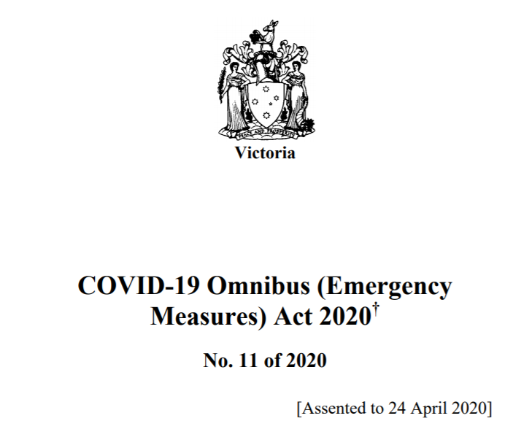

Source 2: Residential Tenancies Act 1974 (Vic) - Amendment Sub Sections 562
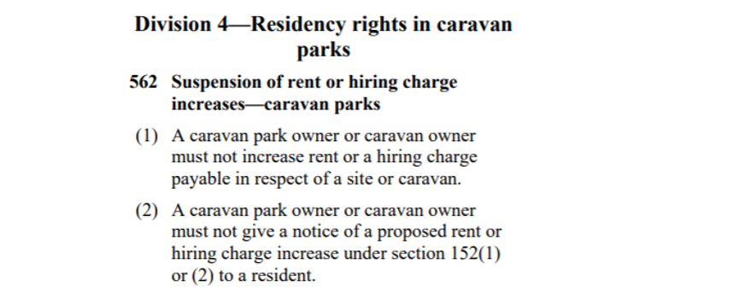

Source 3: First Reading of the Bill COVID-19 Omnibus (Emergency measures) Act 2020

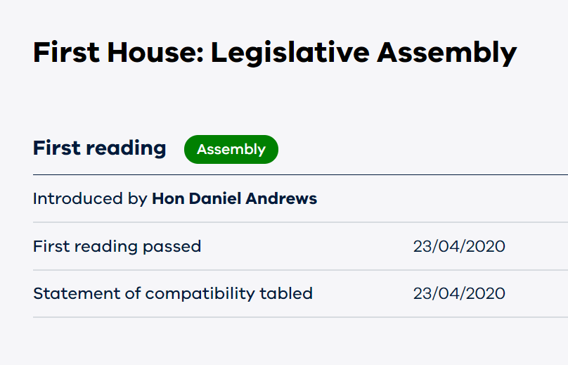

- Explain one reason for the COVID-19 Omnibus (Emergency measures) Act 2020 law reform. (2 marks)
___________________________________________________________________________________________
___________________________________________________________________________________________
___________________________________________________________________________________________
___________________________________________________________________________________________
___________________________________________________________________________________________
___________________________________________________________________________________________
___________________________________________________________________________________________

- With reference to the roles of the Legislative Assembly, discuss two factors that may have impacted the parliament’s ability to pass this law. (8 marks)

___________________________________________________________________________________________
___________________________________________________________________________________________
___________________________________________________________________________________________
___________________________________________________________________________________________
___________________________________________________________________________________________
___________________________________________________________________________________________
___________________________________________________________________________________________
___________________________________________________________________________________________
___________________________________________________________________________________________
___________________________________________________________________________________________
___________________________________________________________________________________________
___________________________________________________________________________________________
___________________________________________________________________________________________
___________________________________________________________________________________________
___________________________________________________________________________________________
___________________________________________________________________________________________
___________________________________________________________________________________________
___________________________________________________________________________________________
___________________________________________________________________________________________
___________________________________________________________________________________________
___________________________________________________________________________________________
___________________________________________________________________________________________
___________________________________________________________________________________________
___________________________________________________________________________________________
___________________________________________________________________________________________
___________________________________________________________________________________________
___________________________________________________________________________________________
___________________________________________________________________________________________
___________________________________________________________________________________________
___________________________________________________________________________________________

In reference to Source 2: ‘Residency Rights in Caravan Parks’

- Explain one reason why a judge may need to interpret the words ‘Caravan Parks’ and outline the effect of a judge giving meaning to these words. (4 marks)

___________________________________________________________________________________________
___________________________________________________________________________________________
___________________________________________________________________________________________
___________________________________________________________________________________________
___________________________________________________________________________________________
___________________________________________________________________________________________
___________________________________________________________________________________________
___________________________________________________________________________________________
___________________________________________________________________________________________
___________________________________________________________________________________________
___________________________________________________________________________________________
___________________________________________________________________________________________

Stuart a Victorian Caravan Park owner said…
“It’s Okay for him to increase rent because Tenancies laws is an exclusive power and the Victorian government have no authority making laws like these…”

- Do you agree with Stuart? Justify your answer. (3 marks)
___________________________________________________________________________________________
___________________________________________________________________________________________
___________________________________________________________________________________________
___________________________________________________________________________________________
___________________________________________________________________________________________
___________________________________________________________________________________________
___________________________________________________________________________________________
___________________________________________________________________________________________
___________________________________________________________________________________________
___________________________________________________________________________________________
___________________________________________________________________________________________
___________________________________________________________________________________________
___________________________________________________________________________________________

Question 2 (10 marks)
Olivia and Ted are olive farmers from Swan Hill. During growing season, on a windy day, their neighbour John sprayed his wheat crop for weeds. The chemicals drifted onto Olivia and Ted’s farm killing one half of their olive trees. It is estimated the financial loss for the current year will be $450 000 and it will cost $500 000 to replace the dead trees. Olivia and Ted are considering taking legal action against their neighbour.

- Explain why enforcement issues should be considered before Olivia and Ted take legal action. (2 marks)
___________________________________________________________________________________________
___________________________________________________________________________________________
___________________________________________________________________________________________
___________________________________________________________________________________________
___________________________________________________________________________________________
___________________________________________________________________________________________
___________________________________________________________________________________________

- Advise Olivia and Ted on whether they should mediate or take their case to court. (6 marks)

___________________________________________________________________________________________
___________________________________________________________________________________________
___________________________________________________________________________________________
___________________________________________________________________________________________
___________________________________________________________________________________________
___________________________________________________________________________________________
___________________________________________________________________________________________
___________________________________________________________________________________________
___________________________________________________________________________________________
___________________________________________________________________________________________
___________________________________________________________________________________________
___________________________________________________________________________________________
___________________________________________________________________________________________
___________________________________________________________________________________________
___________________________________________________________________________________________
___________________________________________________________________________________________
___________________________________________________________________________________________
___________________________________________________________________________________________
___________________________________________________________________________________________
___________________________________________________________________________________________
___________________________________________________________________________________________
___________________________________________________________________________________________
___________________________________________________________________________________________
___________________________________________________________________________________________
___________________________________________________________________________________________
___________________________________________________________________________________________
___________________________________________________________________________________________
- Describe the remedy Olivia and Ted would be seeking. (2 marks)
___________________________________________________________________________________________
___________________________________________________________________________________________
___________________________________________________________________________________________
___________________________________________________________________________________________
___________________________________________________________________________________________
___________________________________________________________________________________________
___________________________________________________________________________________________
Question 3 (13 marks)
SOURCE 1: Royal Commission Summary Report 2016 & Recommendation 76
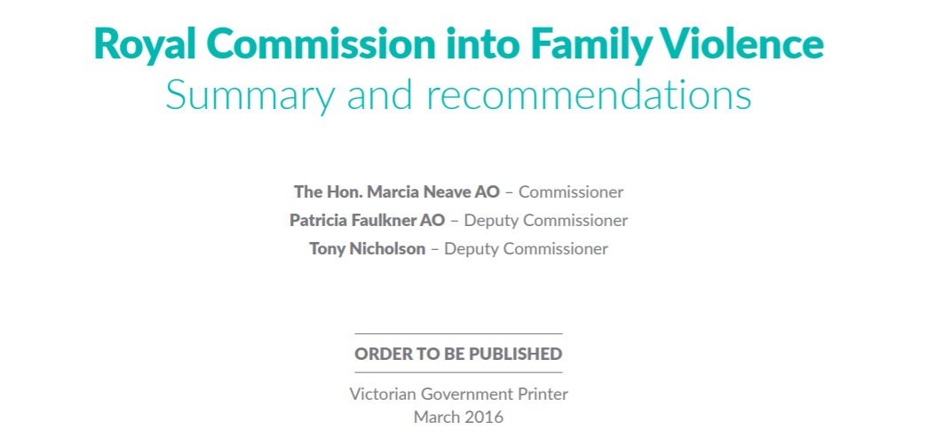
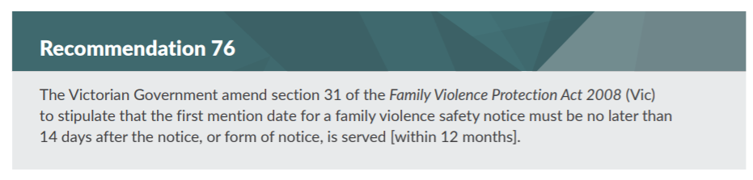

Source 2: Parliamentary Committee Final Report – Inquiry into end of life choices.
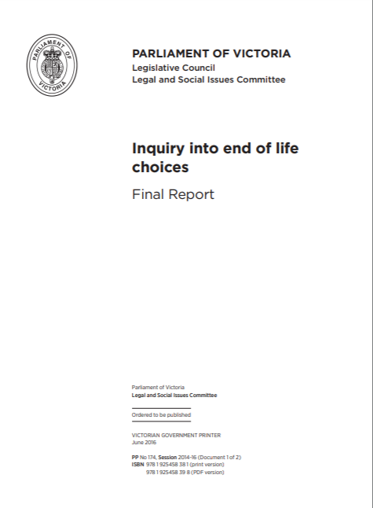
- Explain the role of one parliamentary committee or one Royal Commission. (3 marks)

___________________________________________________________________________________________
___________________________________________________________________________________________
___________________________________________________________________________________________
___________________________________________________________________________________________
___________________________________________________________________________________________
___________________________________________________________________________________________
___________________________________________________________________________________________
___________________________________________________________________________________________
___________________________________________________________________________________________
- Discuss the ability of either one parliamentary committee or one Royal Commission to influence law reform. (6 marks)
___________________________________________________________________________________________
___________________________________________________________________________________________
___________________________________________________________________________________________
___________________________________________________________________________________________
___________________________________________________________________________________________
___________________________________________________________________________________________
___________________________________________________________________________________________
___________________________________________________________________________________________
___________________________________________________________________________________________
___________________________________________________________________________________________
___________________________________________________________________________________________
___________________________________________________________________________________________
___________________________________________________________________________________________
___________________________________________________________________________________________
___________________________________________________________________________________________
___________________________________________________________________________________________
___________________________________________________________________________________________
___________________________________________________________________________________________
___________________________________________________________________________________________
___________________________________________________________________________________________
___________________________________________________________________________________________
___________________________________________________________________________________________
___________________________________________________________________________________________
___________________________________________________________________________________________
___________________________________________________________________________________________
___________________________________________________________________________________________
___________________________________________________________________________________________
___________________________________________________________________________________________
___________________________________________________________________________________________
___________________________________________________________________________________________

- Analyse whether parliament or the courts are best placed to respond to a recommendation made by a parliamentary committee or Royal Commission (4 marks)
___________________________________________________________________________________________
___________________________________________________________________________________________
___________________________________________________________________________________________
___________________________________________________________________________________________
___________________________________________________________________________________________
___________________________________________________________________________________________
___________________________________________________________________________________________
___________________________________________________________________________________________
___________________________________________________________________________________________
___________________________________________________________________________________________
___________________________________________________________________________________________
___________________________________________________________________________________________
___________________________________________________________________________________________
___________________________________________________________________________________________
___________________________________________________________________________________________
___________________________________________________________________________________________

___________________________________________________________________________________________
___________________________________________________________________________________________
___________________________________________________________________________________________

END OF QUESTION AND ANSWER BOOK

Extra space for responses
Clearly number all responses in this space

___________________________________________________________________________________________
___________________________________________________________________________________________
___________________________________________________________________________________________
___________________________________________________________________________________________
___________________________________________________________________________________________
___________________________________________________________________________________________
___________________________________________________________________________________________
___________________________________________________________________________________________
___________________________________________________________________________________________
___________________________________________________________________________________________
___________________________________________________________________________________________
___________________________________________________________________________________________
___________________________________________________________________________________________
___________________________________________________________________________________________
___________________________________________________________________________________________
___________________________________________________________________________________________
___________________________________________________________________________________________
___________________________________________________________________________________________
___________________________________________________________________________________________
___________________________________________________________________________________________
___________________________________________________________________________________________
___________________________________________________________________________________________
___________________________________________________________________________________________
___________________________________________________________________________________________
___________________________________________________________________________________________
___________________________________________________________________________________________
___________________________________________________________________________________________
___________________________________________________________________________________________
___________________________________________________________________________________________
___________________________________________________________________________________________
___________________________________________________________________________________________
___________________________________________________________________________________________
___________________________________________________________________________________________
___________________________________________________________________________________________
___________________________________________________________________________________________
___________________________________________________________________________________________
___________________________________________________________________________________________
___________________________________________________________________________________________
___________________________________________________________________________________________
___________________________________________________________________________________________
The material is the property of prime.edu © and is subject to the copyright laws of Australia. Disclaimer: This resource has been written by the author for use with students of VCE Legal Studies. This does not imply that it has been endorsed by the Victorian Curriculum and Assessment Authority (VCAA). The current VCE Legal Studies Study Design (2018–2022) can be accessed directly via the VCAA website. VCE is a registered trademark of VCAA. While every care is taken, PRIME.EDU accepts no responsibility for the accuracy of information or advice contained in the exam. Teachers are advised to preview and evaluate all PRIME.EDU resources before using them or distributing them to students.

