2000 Exam1 solutions
Question | Correct response | % | Question | Correct response | %
1 | A | 7 | 15 | B | 69
2 | B | 86 | 16 | B | 49
3 | E | 87 | 17 | D | 46
4 | D | 44 | 18 | A | 64
5 | A | 69 | 19 | D | 30
6 | D | 37 | 20 | A | 36
7 | D | 64 | 21 | C | 64
8 | C | 64 | 22 | E | 39
9 | E | 72 | 23 | C | 88
10 | E | 50 | 24 | B | 66
11 | B | 75 | 25 | E | 55
12 | B | 52 | 26 | B | 62
13 | A | 52 | 27 | A | 59
14 | E | 40

Question 1
As can be seen from the percentage that got this correct on the exam (7%), this was an extremely difficult question. The factors must be in the form of (x –a), and (x –b)² as it only touches at this point.
It doesn’t matter that the ‘a’ is negative, the factor is still (x – (intercept)).
So the best answer was f(x) = (x – a)(x – b)²
∴ A

Question 2
y = 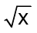 becomes y = - when reflected in the x-axis.
A translation of 2 units to the right, changes ‘x’ into (x – 2). ∴y = 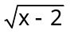. A translation of 1 unit down, effectively subtracts 1 from the equation. ∴ y = - 1.
∴ B

Question 3
y= 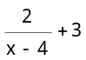,
has a vertical asymptote when x – 4 = 0
∴ x = 4.
and a horizontal asymptote as x → ∞.
As x → ∞, 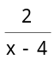 → 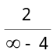 → 0. So y → 0 + 3 = 3
∴ Asymptotes are x = 4, and y = 3
∴ E

Question 4
A quick look/sketch of the data, indicates that it is cyclic in nature. This infers a circular function.
You can use your graphics calculator to plot these points and view the graph.
Press  choose EDIT, and put the data into L₁ and L₂.
PLOT
Select PLOT 1
Plot 1 should be 
Type 
X list L₁
Y list L₂
Mark 
⬧
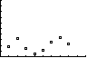

Question 5
The inverse of the function is a reflection in the line y = x.
This graph appears to go through the points
(0, 0) and (3, 1) so the reflection should go through the points (0, 0) and (1, 3)

OR try to draw the line y = x. and then reflect across it, by using a piece of paper to copy the line onto, and then flipping it about the line
y = x.
Either way Graph A is the best answer.

Question 6
domain range
f(x) = 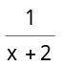 D₁ = R|{-2} R|{0}
g(x) = e^{2x} D₂ = R R⁺
h(x) = - e^{2x} D₃ = R|{-2} R
∴ D₁ = D₃
But Ran(f) ≠ Ran(g) ≠ Ran(h)
∴ D.

Time permitting you may want to sketch these on your graphics calculator to confirm this.
f(x)
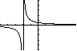
g(x)
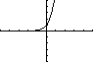
h(x)
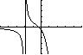

Question 7
For a function to have an inverse which is a function, any horizontal line and any vertical line can cut the function at most once.
A f(x) is a straight line ∴ 1:1
B g(x) is half a parabola, because of its restricted domain, so it is 1:1
C h(x)is cubic, ∴ 1:1
D k(x) looks like
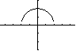
∴ not 1:1
E m(x) is 1:1 in the restricted domain
∴ D

Question 8
The display of Pascal’s triangle, does not go far enough. The expansion of (x + a)⁷ requires the next row in the triangle.
1 6 15 20 15 6 1
1 7 21 35 35 21 7 1
decreasing powers of x means x⁷ → x⁰
The 5th term will be 35x³a⁴
∴ C

Question 9
If x = 4 is a solution to log_{e}(ax + 2) = 3
Then when we let x = 4 we get
log_{e}(4a + 2) = 3
∴ e³ = 4a + 2
∴ 4a = e³ – 2
∴ a = 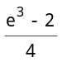
∴ a ~ 4.5214
∴ E is the exact answer

Question 10
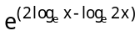 = 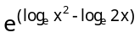
= 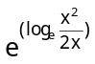
= 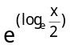
= ∴ E

Question 11
Amplitude = 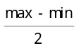 = 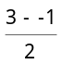 = 2
From the graph, the range = [-1, 3]
Also the period = 12
∴ B

Question 12
2sin3x = 1 [0, π]
Since Dom: 0 ≤ x ≤ π
Then 0 ≤ 3x ≤ 3π
∴ sin3x = ½
∴ 3x = , 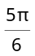, 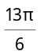, 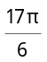
∴ x = 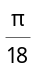, 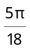, 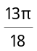, 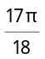
∴ Σx = (1 + 5 + 13 +17)
= 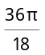
= 2π ∴ B

Question 13
The standard tan graph looks like
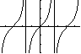
Here the vertical asymptotes are at ±
This graph has been reflected in the y-axis. This means that a < 0.
The period for a tan graph is , so in this
∴ = 2b ∴ 2ab = π
∴ if a = -3, then b = 6b = π
We only need the magnitude of a, the negative sign causes the reflection in the y axis.
∴ b = ∴ A

Question 14
f(x + h) ~ f(x) + h f’(x)
if f(x) = ,
then 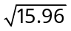 = 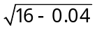
∴ f(x – h) = f(x) – h f’(x)
~ f(16) – 0.04f’(16) ∴ E

Question 15
If y = -x³ – x² + 2x + 2
∴ the gradient is given by: y’ = -3x² – 2x + 2

These can both be plotted on the calculator at the same time.
Let Y₂ = nDeriv(Y₁, X, X)
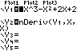
To get this {nDeriv( } and complete using the format nDeriv(expression, variable, variable, h)
If h is not specified, the default is 0.001.
To insert Y₁, select, then y-VARS, then Function and Y₁.
Then insert , , )
Select . Move the cursor to the graph, using the keys and then to find the point.
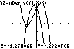

From this we can see that the gradient is positive between ~ -1.25 → ~ 0.5
∴ B

Question 16
V = 2t² – 3t + 2
Average rate of change = V(10) – V(0)
V(10) = 2(10)² – 3(10) + 2
= 200 – 30 + 2
= 172
V(0) = 2(0)² – 3(0) + 2
= 2
∴ Average = 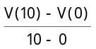 = 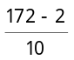 = 17
∴ B

Question 17
f(x) = e^{-x}(x³ – 4)
Let u = e^{-x} and v = x³ - 4
∴ 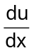 = -e^{-x} and 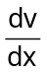 = 3x²
∴ f’(x) = v + u
= (x³ – 4)(-e^{-x}) + e^{-x}(3x²)
= e^{-x}(4 – x³ + 3x²)
= e^{-x}(– x³ + 3x² + 4) ∴D

Question 18
If y = 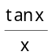 = tanx × x⁻¹
Let u = tanx, and v = x⁻¹
Then = sec²x and = -x⁻²
∴ 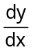 = v + u
= x⁻¹ sec²x + tanx × (-x⁻²)
= 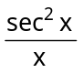 - 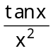
As the answer does not involve sec x, you need to make the substitution that sec x = 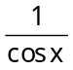
∴ = 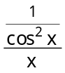 -
= 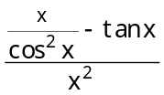
= A

Question 19
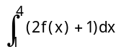 = 2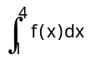 + 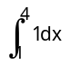
= 2 + 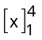
= 2 + [4 – 1]
= 2 + 3 ∴D

Question 20

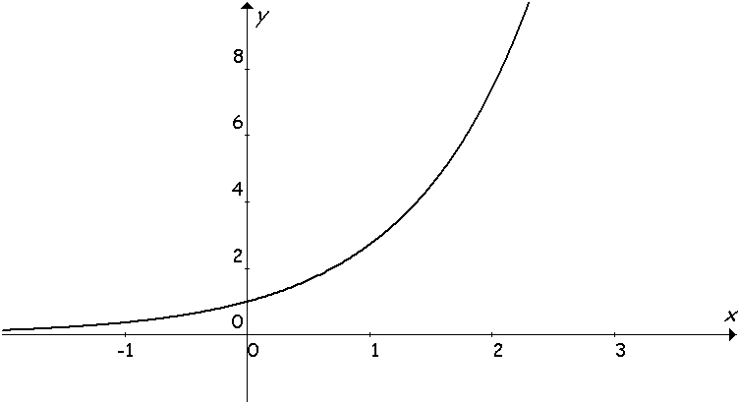
(0, 1)
(1, e)
(2, e²)
The area is given by the height by the width of each rectangle.
Rectangle 1, height = e⁰ = 1, width = 1 ∴ area = 1
Rectangle 2, height = e¹, width = 1 ∴ area = e¹
Rectangle 3, height = e², width = 1 ∴ area = e²
∴ Area = e² + e + 1 ∴ A

Question 21
If = 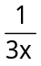 + sin2x, x > 0
Then y = 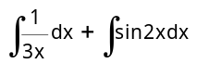
= 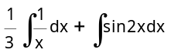
= log_{e}x - cos2x ∴ C

Question 22
If = 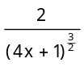, and c is a real constant.
Use 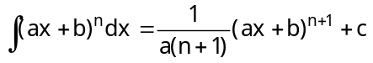, n ≠ -1.
Here a = 4, and n= 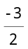
∴ y = 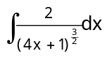
= 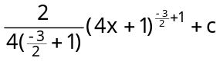
= 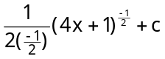
= 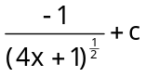 ∴ E

Question 23
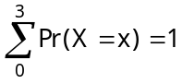
∴ k + 2k + 4k + 8k = 1
∴ 15k = 1 ∴ k = 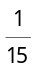 ∴ C

Question 24
VAR(X) = E(X²) – (E(X))²
E(X²)= 0²×0.2 + 1²×0.2 + 2²×0.3 + 3²×0.2 + 4²×0.1
= 0 + 0.2 + 1.2 + 1.8 + 1.6
= 4.8
E(X) = 0 ×0.2 + 1 ×0.2 + 2 ×0.3 + 3 ×0.2 + 4 ×0.1
= 0 + 0.2 + 0.6 + 0.6 + 0.4
= 1.8
∴ VAR(X) = 4.8 – 1.8²
= 4.8 – 3.24 = 1.56
∴ B

Question 25
This is a hypergeometric, because there is no replacement.
Pop: N = 36, D = 12
Sample n = r, x = 3
Pr(3 faulty) = 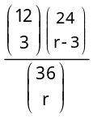 ∴ E

Question 26
This is a binomial distribution, as there is a clear success/failure.
Pr(success) = 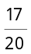 = 0.85
Pr(failure) = 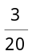 = 0.15

More than 8 goals → 9 or 10 goals.
Pr(X = 9) = ¹⁰C₉(0.85)⁹(0.15)¹
Pr(X = 10) = ¹⁰C₁₀(0.85)¹⁰(0.15)⁰
∴ Pr(X > 8) = ¹⁰C₉(0.85)⁹(0.15)¹ + (0.85)¹⁰
∴ B

Question 27
μ₁ < μ₂ since X₁ is centred to the left of X₂
σ₁ < σ₂ since X₂ is flatter and more spread out.
∴ A

Part 2 Short answer

Question 1

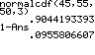
∴ 0.096 correct to 3 decimal places

Question 2
We hope that this is hypergeometric, i.e. no replacement.
If X = no. of green jelly beans,
∴ Pr(X ≥ 3) = Pr(X = 3) + Pr(X = 4)
Pr(X ≥ 3) =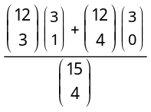
= 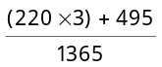
= 0.8462
= 0.846 (to 3 decimal places)

Question 3a
This question requires you to partition the function into its component functions. This can only be done by having 2 (or more) functions that ‘sum’ together to give f(x).
The simplest way was to say f(x) = g(x) + h(x).
Where g(x) = (x – 1)(x – 3)(x + 2), and
h(x) = 4
This question was only worth 1 mark, so anticipate a straight forward answer.

Question 3b
The exact values of all roots, requires you to solve the equation f(x) = 0.
∴ (x – 1)(x – 3)(x + 2) + 4 = 0
∴ (x – 1)(x² – x – 6) + 4 = 0
∴ x³ – x² – 6x –x² + x + 6 + 4 = 0
∴ x³ – 2x² – 5x +10 = 0
Since the x⁰ term = 10, try a factor of x – 2
P(2) = 8 – 8 – 10 + 10 = 0
∴ (x – 2) is a factor.

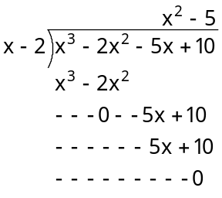

So f(x) = 0 → (x – 2)(x² – 5) = 0
∴ the factors are
(x – 2), (x - 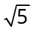) and (x + )
∴ Roots (solutions) are x = 2, ±

Question 4
y = f(x) is a basic sine function. g(x) is produced by dilating by a factor of ½ parallel to the x axis, (to turn y = sin x into y = sin 2x) and then dilating by a factor of 2 parallel to the y-axis. ∴ y = sin 2x → y = 2sin 2x.
∴ g(x) = 2sin 2x.
OR
- dilated by a factor of 0.5 from the y-axis
- dilated by a factor of 2 from the x-axis.
(note the mistake on the examiners report)
It was was not acceptable to state that the amplitude had doubled and the period had halved, and to give the new equation.
You had to state the transformations involved.

Question 5
If sin2x = 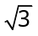cos2x, -π ≤ x ≤ π
then tan2x = -π ≤ x ≤ π
-2π ≤ 2x ≤ 2π
Tan is positive in the first and third quadrants. So this will be
∴ 2x = 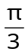, π + ,if we start at zero and go clockwise , or
2x = -π + , -2π + , if we start at zero and go anticlockwise. (to cope with the domain).

∴ 2x = , 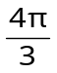, 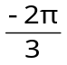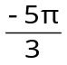,
∴ x = 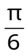, 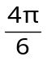, 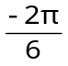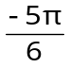,
∴ x = , 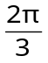, 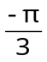,

Question 6

f(0) = 0 f(4) = 0
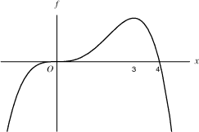
stationary point of inflexion
local maximum

f’(0) = 0 f’(3) = 0

f’(x) > 0 for {x: x < 3}\{0} (i.e positive gradient, except {0}

f’(x) < 0 for {x: x > 3}

Question 7i
This question can only be done on a calculator. Since it is difficult to see the function on a regular screen, use the ZoomFit feature.
 gets the screen set to the correct size. Then select , use and to get near the maximum.
Select  to get [CALC], , to get maximum.
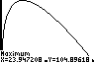
∴ 104.896
Make sure that you answer the question, it asks for the maximum value of f(x), not the value of x at the maximum.

Question 7ii
(100 – x)log₁₀x = 0
∴ (100 – x) = 0 or log₁₀x = 0
∴ x = 100 or x = 1

OR use the calculator, and find when y= 0, using calc.

Question 7iii
Since x > 1, f(x) = 0 implies x = 100.

On the calculator, find f’(x) when x = 100.
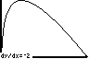
∴ -2.

Question 8a
If y = xlog_{e}2x – x
(make sure that you understand how the question is supposed to read.)
Let u = x and v = log_{e}(2x)
∴ y = uv – u.
Using the product rule
= 1 and = 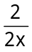=
∴ = u +v - 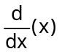
= x × + log_{e}(2x) × 1 - 1
= 1 + log_{e}2x – 1
= log_{e}2x

Question 8b
Hence means that you must use part (a) to find your answer
Shaded area = 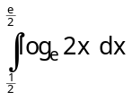
= 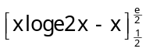
= log_{e}e - - 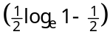
= - - 0 + ½ = ½ square units.

