

Australian Education Academy
2004

MATHEMATICAL METHODS

TRIAL EXAMINATION 1 (Solutions)

© Australian Education Academy Pty Ltd 2004

Published by Australian Education Academy Pty Ltd
ABN: 18 104 474 893
105, Normanby Drive, Greenvale, Vic 3059
Ph: (03) 9333 2392 Fax: (03) 9333 4865
Email: dilshan@aol7.com.au

Mathematical Methods
Written examination 1 (facts, skills and applications)
Suggested answers and solutions

Part I (Multiple-choice) Answers

1. E 2. E 3. B 4. A 5. A

6. D 7. C 8. D 9. E 10. A

11. D 12. C 13. B 14. E 15. D

16. E 17. A 18. B 19. B 20. D

21. C 22. D 23. B 24. E 25. A

26. C 27. A

1. x-intercepts are –2, 0 and 1in turn provide the factors 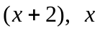and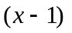. The
graph is the shape of a negative cubic function so it can be presented as
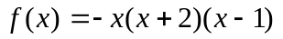∴ Answer is E

2. 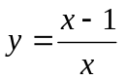The inverse is 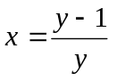
⇒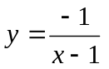 ∴ Answer is E

3. 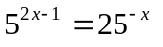
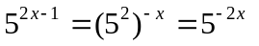
⇒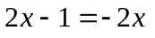
⇒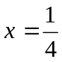 ∴ Answer is B

4. If 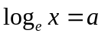 then 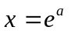

∴ 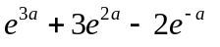=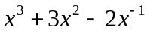
∴ Answer is A

5. The graph of the inverse function is a reflection of about the line 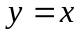.
Given graph is symmetric about the line
. ∴ Answer is A

6. Given graph is a parabola and has a repeated solution when 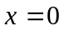. So 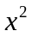should appear in the expression for . But when 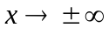 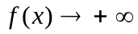⇒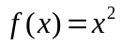
∴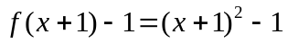
So the graph of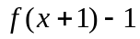 is a parabola
with a minimum value at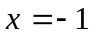andthe value of the minimum is –1.
∴ Answer is D

7. 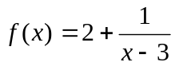Clearly x cannot be 3. Thus domain is R\{3}. The only value that fraction 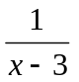cannot take is zero. Thus cannot be equal to 2.
- Range is R\{2}.
∴ Answer is C

8. When 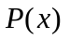is divided by 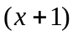, the remainder is 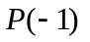.
∴
∴Answer is D

9.
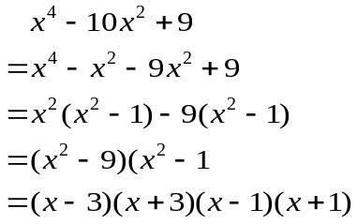
∴ Answer is E

10. Given graph is not a log graph since there is no vertical asymptote.
When 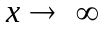 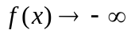 and
when 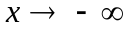 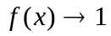. 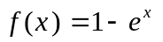satisfies all these conditions. ∴ Answer is A
According to the graph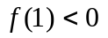. Only
satisfy this condition.
∴ Answer is A

11. Draw the line 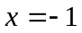on the same diagram. We can see that amplitude is 4, period isand range is [-5,3].
Answer is D

12. 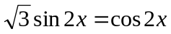, 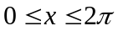
⇒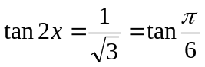
⇒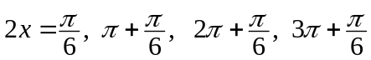
⇒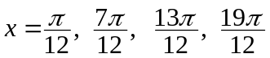
Answer is C

13. 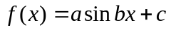
amplitude = a , period = 2π/b
range = [c-a,c+a]
Answer is B

14. The given 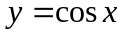 can be transformed into the graph 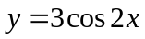
by a dialation in the y- direction by a scale factor of 3 and dialation in the x-direction by a scale factor of ½.
Answer is E

15. Given graph very much like the parabola 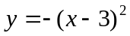.
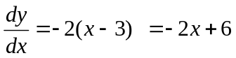
This represents a straight line with negative gradient.
Answer is D

16. 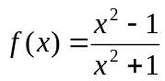
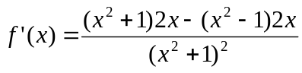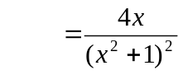 ∴ Answer is E

17. 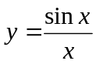
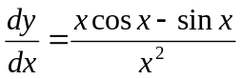 Answer is A

18. 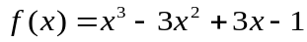
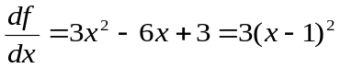
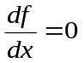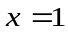 and for all the other values of x 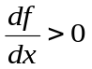 is a point of inflexion.
∴ Answer is B

19. 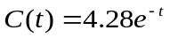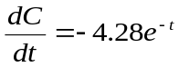
When 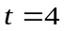 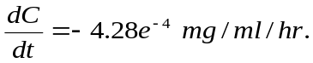

The concentration is decreasing at the rate of 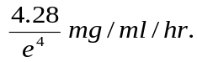
Answer is A

20. 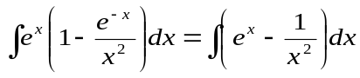
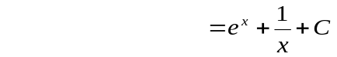
∴ Answer is D

21. 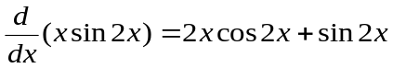
⇒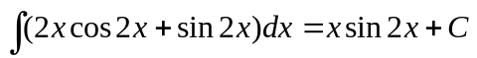
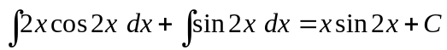
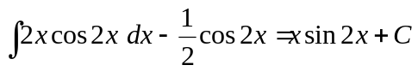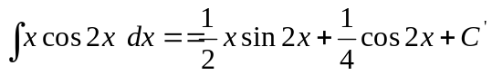
Answer is C

22. 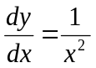
⇒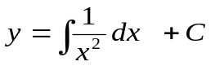
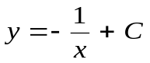. Given that 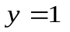when 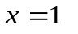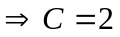
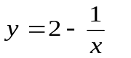
Answer is D

23.
X | 1 | 2 | 3 | 4 | 5 | 6
P(X=x) | k | k/2 | k/3 | k/4 | k/5 | k/6

Since P(X=x) represent a probability
distribution 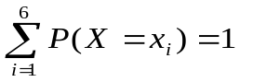

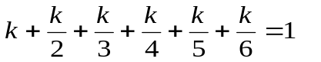

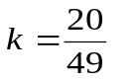 Answer is B

24. Coefficient of 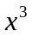 is 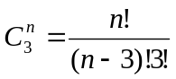
Coefficient of 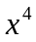 is 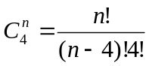
Given that 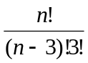=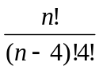
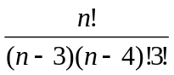=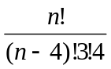
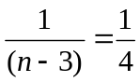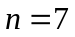
Answer is E

25.
This is a binomial experiment with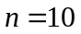and 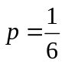 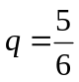
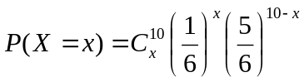
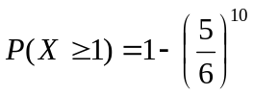
∴ Answer is A

26. Out of 10 balls 2 balls are taken simultaneously. Thus, this hyper geometric with bottom line equal to 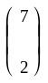. The probability of selecting one ball of each color is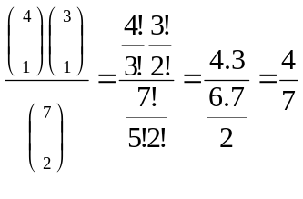
Answer is C

27..X –length of life of the tyre
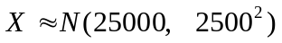
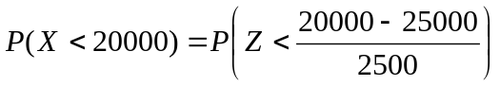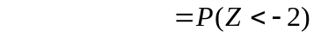
Answer is A

Part 2: Short answers

1.
a.

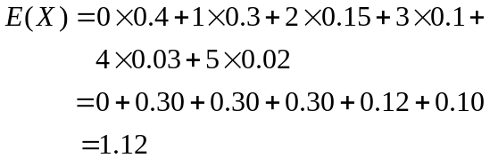
[1 mark]

b.
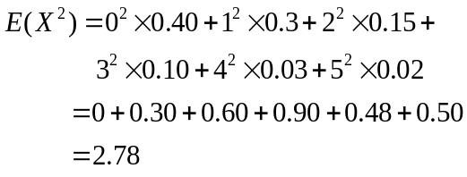
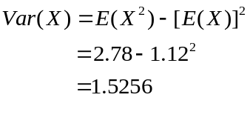
Standard deviation 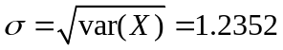
[1 mark]
c.
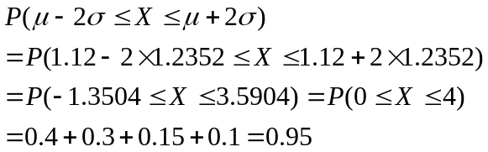

[1 mark]

2. X-height of males
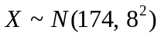
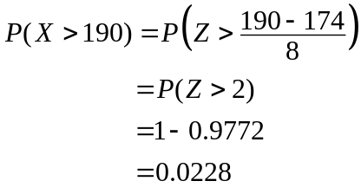
2
[1 mark]

b.
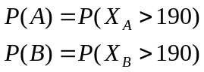and
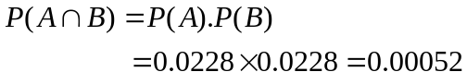
( A and B are independent)
[1 mark]

3.
a.
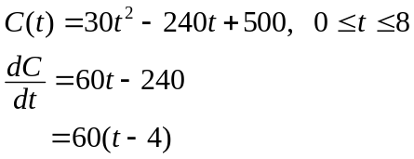
maximum and minimum values of C(t)
are given by
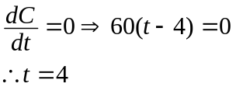
[1 mark]

b.
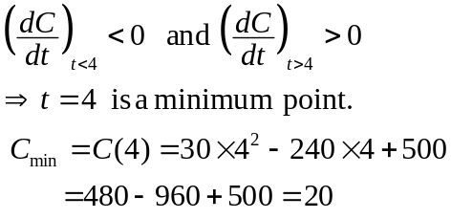
[1 mark]

4.
a. 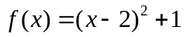is one-to-one within the domain [2,∞).
[1 mark]

b. The range of f is [1,∞).
[1 mark]

c.
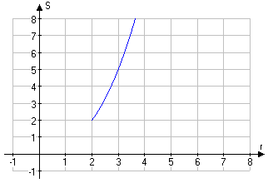
[1 mark]

d.
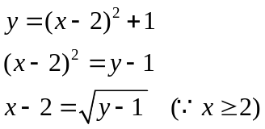
Now change x by y
∴Inverse function of f is 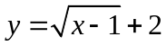
[2 marks]

5.
a. Since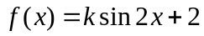 passes through the point 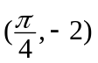 we have
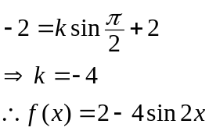
[1 mark]

b. 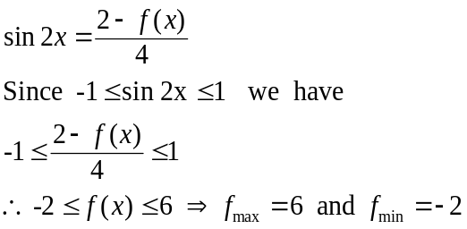
[1 mark]

c.
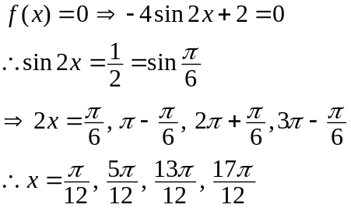
[2 mark]

6. Gradient of the left most line segment is

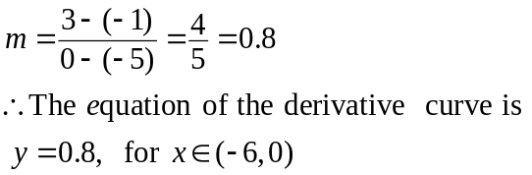

Gradient of the middle line segment is 0.
Hence the equation of the derivative curve is y=0 for 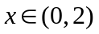.
Equation of the parabola is 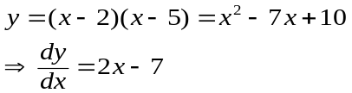
∴ The equation of the derivative curve is 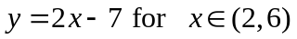.
Derivative does not exists at the points –6, 0, 2 and 6.
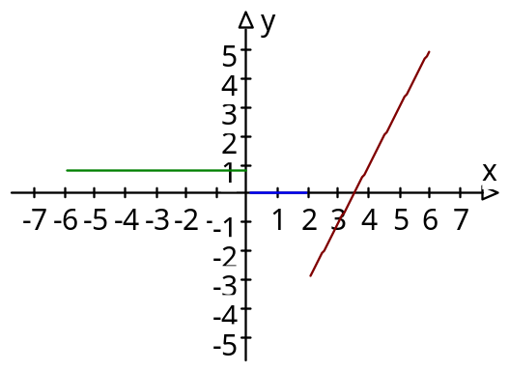
[2 marks]

b. Domain of the derivative function is 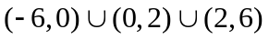
[1 mark]

7. Intersection points are given by

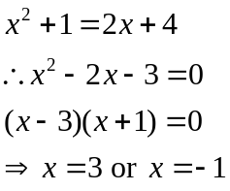
[1 mark]

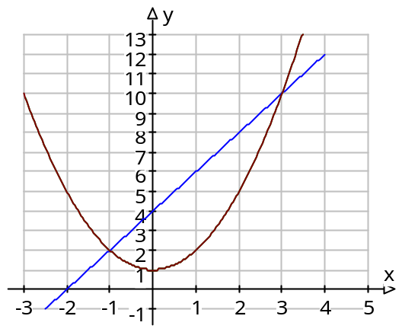
[1 mark]

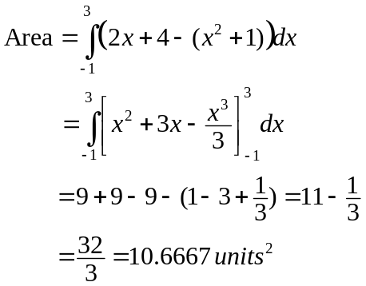 [1 mark]

[1 mark]

[1 mark]

