

Australian Education Academy
2004

MATHEMATICAL METHODS

TRIAL EXAMINATION 2 (Solutions)
(Analysis)

© Australian Education Academy Pty Ltd 2004

Published by Australian Education Pty Ltd
ABN: 18 104 474 893
105, Normanby Drive, Greenvale, Vic 3059
Ph: (03) 9333 2392 Fax: (03) 9333 4865
Email: dilshan@aol7.com.au

Question 1

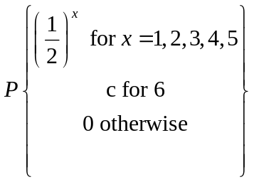
a. (i)
X | 1 | 2 | 3 | 4 | 5 | 6
P(X=x) | 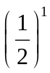 | 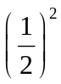 | 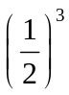 | 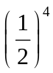 | 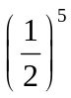 | c
(2 marks)
(ii)
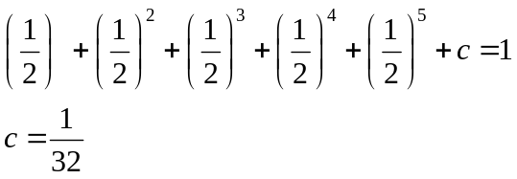
(1 mark)
b. (i)
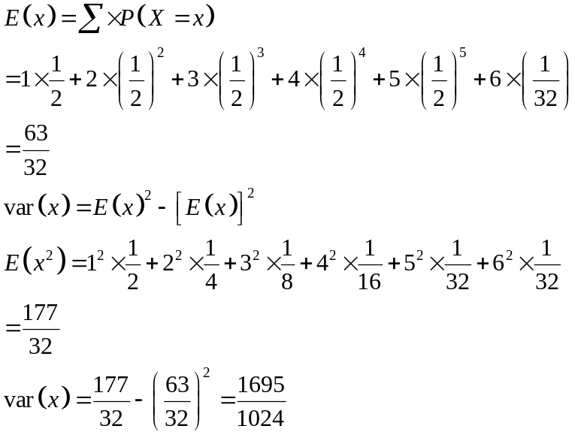
(3 marks)

(ii)
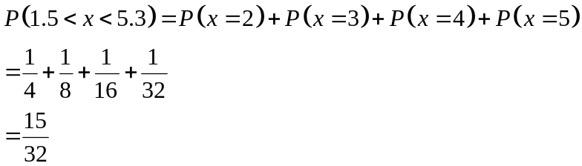
(1 mark)
c.
(i)
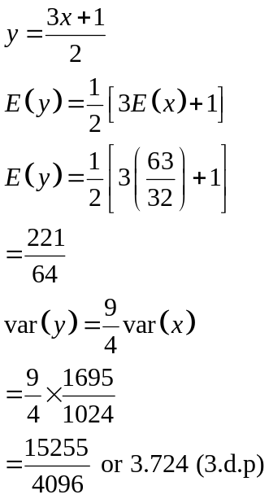
(2 marks)
(ii)
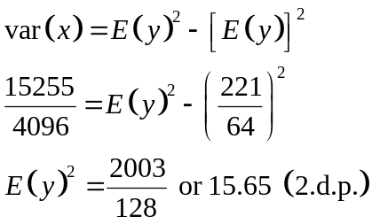
(1 mark)

Question 2
a.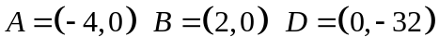
(1 mark)
b.
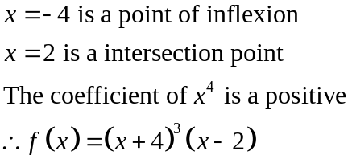
(2marks)
c.
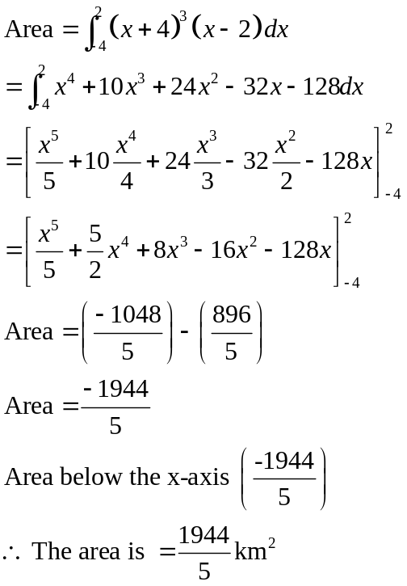
(3 marks)

d. (i)
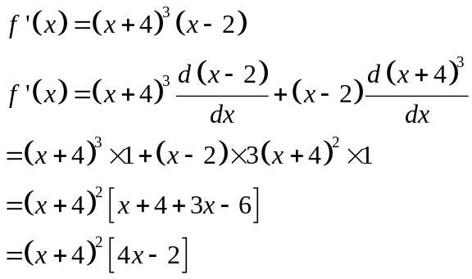
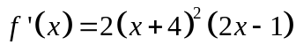
(2 marks)

(ii)
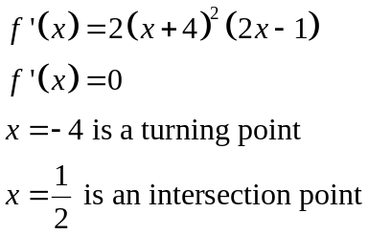
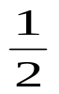
y=f’(x)
-4
(2 marks)

e.
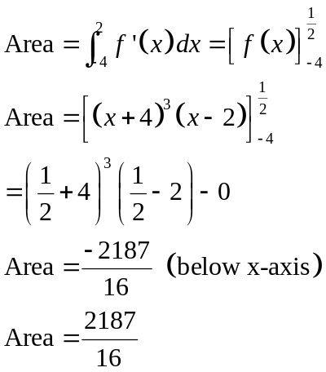
(2 marks)
Question 3
a.
(i)
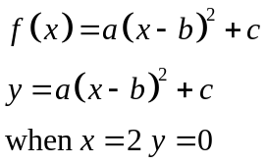
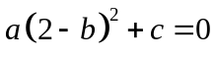 - ①
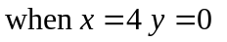
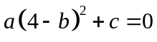 - ②
① - ②
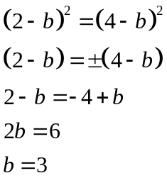
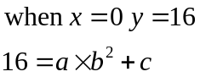
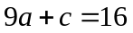 - ③
By ① 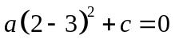
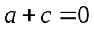 - ④
③ - ④
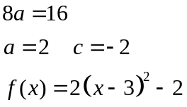
(3marks)
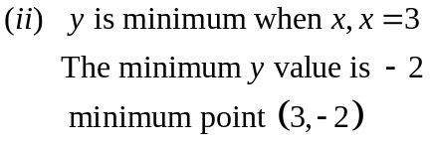
(1 mark)

b.
(i)
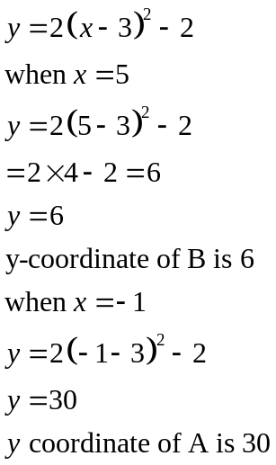
(1 mark)
(ii)
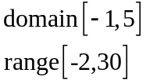
(1 mark)
c.
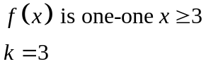
(1 mark)
d.
(i)
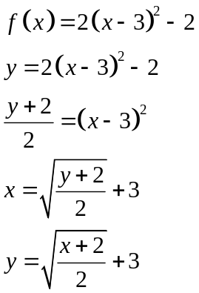
(2 marks)

(ii)
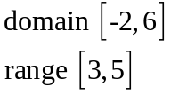
(1 mark)

e.
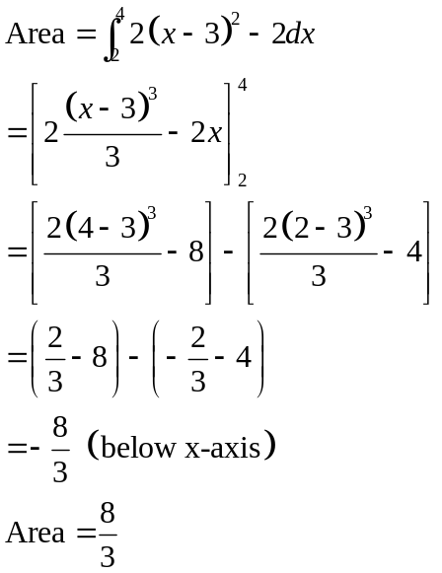
(2 marks)

Question 4
a.
(i)
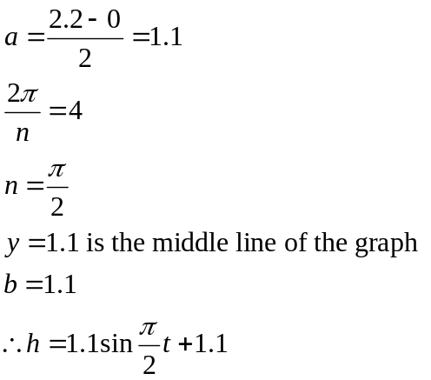
(3 marks)

(ii)
2.2
1.1
4
8
t
h
(1 mark)
(iii)
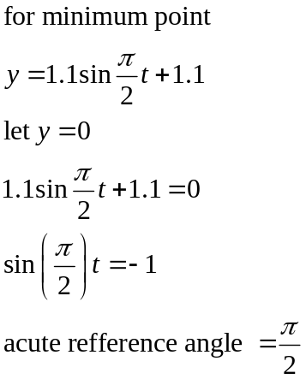

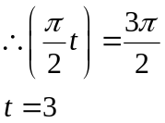
(3 marks)
(ii)
The coordinates of two minimum points is (3, 0) and (7, 0)
(2 marks)

b.
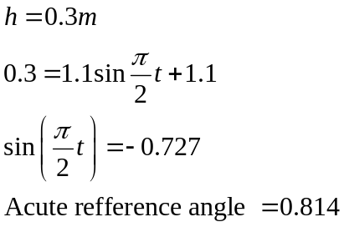
0.814
0.814
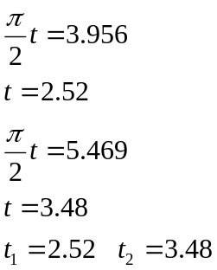
(2 marks)

c.
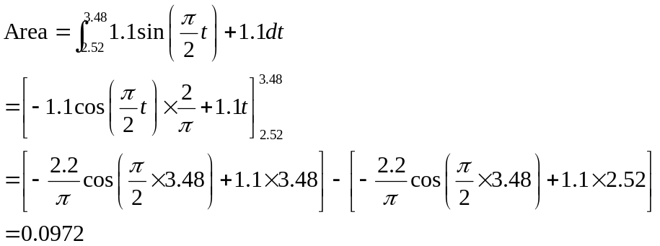
(3 marks)

d.
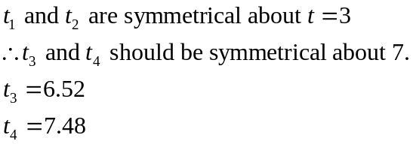
(1 mark)
e.
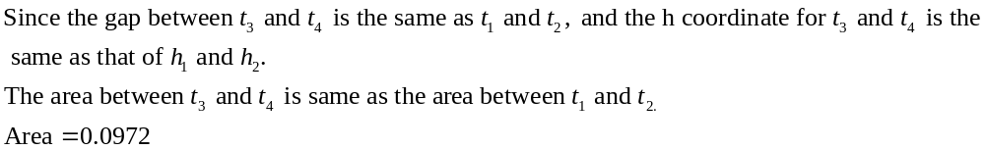(1 mark)

