

Australian Education Academy
2004

MATHEMATICAL METHODS

TRIAL EXAMINATION 2
(Analysis)

Reading time: 15 minutes
Writing time: 1 hour 30 minutes

Student’s name: ______________________________________

Directions to students
This examination consists of six questions.
Answer all questions.
All working and answers should be written in the spaces provided.
The marks allotted to each part of each question appear at the end of each part.

There are 47 marks available for this task.
A formula sheet is attached.

These questions have been written and published to assist students in their preparations for the 2004 Mathematical Methods Examination 2. The questions and associated answers and solutions do not necessarily reflect the views of the Victoria Curriculum and Assessment Authority. The Association gratefully acknowledges the permission of the Authority to reproduce the formula sheet.

© Australian Education Academy Pty Ltd 2004
This Trial Examination is licensed to the purchasing school or educational organization with permission for copying within that school or educational organization. No part of this publication may be reproduced, transmitted or distributed, in any form or by any means, outside purchasing schools or educational organizations or by individual purchases without permission.

Published by Australian Education Academy Pty Ltd
ABN: 18 104 474 893
105, Normanby Drive, Greenvale, Vic 3059
Ph: (03) 9333 2392 Fax: (03) 9333 4865
Email: dilshan@aol7.com.au

- The discrete random variable X has the following probability function.
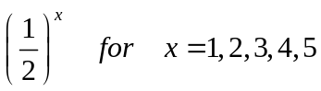
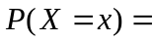 C 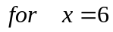

0 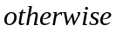

(a)
- Complete the following table using the above given function.


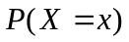

[2 Marks]
(11) Hence find the value of C.

[1 Mark]
(b)
- Find the expected value and the variance of the random variable X

[3 marks]

(11) Find the probability that X is greater than 1.5 and less than 5.3

[1 mark]

- The discrete random variable Y is defined as 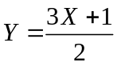

(1) Find the expected value and the variance of the random variable Y.

[2 Marks]

(11) Hence find the value of E(Y)

[1 mark]

(2) The shows a main road passing through A, O, B and E. The road crosses a river at A and then at B which is 6 km east from A .Between A and B the furthest the river from the road is OD where OD = 32 km. The point O is 4 km east of point A. If the point O is taken as the origin and the road is taken as the x – axis, then the path of the river can be modelled by a quartic function.
A
B
O
D
E
4 km
2 km
Road
River

(a) Write down the coordinates of the points A, B & D.

[1 Mark]

- Find the rule for the quartic function.

[2 Marks]

(c) Rudolph wanted to find the area bounded by the river and the road between A and
B. Find the area to 2 decimal places.

[3 Marks]

(d)
(i) Find the function 

[2 Marks]

(ii) Sketch the graph of on the set of axes given below.

x
y

[2 Marks]

(e) Find the area enclosed by the x – axis and the function.

[2 Marks]

(3) The graph of the function 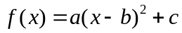 is given below.
2
4
x
16
y
A
B
-1
5

(a)
- Find the values of a, b, c.

[3 Marks]

(11) Hence determine the coordinates of the minimum point.

[1 Mark]

(b)
(1) Find the y coordinate of the points A and B.

[1 Mark]

- Hence determine the domain and the range of the function.

[1 Mark]

(c) The function is one – one for 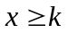 .Find the least possible value for.

[1 Mark]

(d)
(1) Find the inverse function of for

[2 Marks]

(11) State the domain and the range of the inverse function.

[1 Mark]

(e) Find the area enclosed by the function and x – axis.

[2 Marks]

- The height above the ground of the middle of a skipping rope as it is being turned in a child’s game is found by using the equation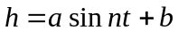, where , is the number of seconds after the rope has begun the to turn .During the game the maximum height the rope reach is 2.2m, and it takes 4s for the rope to complete a full turn.

(a)
(i) Find the value of 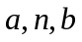 and hence write down the equation of in terms of

[2 Marks]

- Sketch the graph of against for 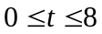
t
h

[2 Marks]

(iii) Find the coordinates of the two minimum points

[2 Marks]

(b) The rope is 30cm above the ground for two values of, 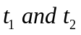, in the region 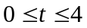 . Find the values of to two decimal places.

[2 Marks]

(c) Find the area bounded by the curve, the - axis and the lines 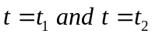.

[3 Marks]

(d) The rope would be again 30cm above the ground for another two values of , 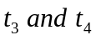, for 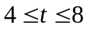. Determine the vales of .

[1 Mark]

(e) Hence determine the value of the area bounded by the curve , - axis ,and the lines 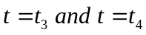 .

[1 Mark]

