

Student Name……………………………………

MATHEMATICAL METHODS UNITS 3 & 4

TRIAL EXAMINATION 1

(FACTS, SKILLS AND APPLICATIONS TASK)

2004

Reading Time: 15 minutes
Writing time: 90 minutes

Instructions to students
This exam consists of Part I and Part II.
Part I consists of 27 multiple-choice questions, which should be answered on the detachable answer sheet which can be found on page 22 of this exam.
Part II consists of 7 short-answer questions that should be answered in the spaces provided.
Part I begins on page 2 of this exam and is worth 27 marks.
Part II begins on page 12 of this exam and is worth 23 marks.
There is a total of 50 marks available.
All questions in Part I and Part II should be answered.
Students may bring up to two A4 pages of pre-written notes into the exam.
Formula sheets and a table of the Normal distribution - cdf can be found on pages 19-21 of this exam.

This paper has been prepared independently of the Victorian Curriculum and Assessment Authority to provide additional exam preparation for students. Although references have been reproduced with permission of the Victorian Curriculum and Assessment Authority, the publication is in no way connected with or endorsed by the Victorian Curriculum and Assessment Authority.

© THE HEFFERNAN GROUP 2004
This Trial Exam is licensed on a non transferable basis to the purchaser. It may be copied for educational use within the school which has purchased it. This license does not permit distribution or copying of this Trial Exam outside that school or by any individual purchaser.
PART I

Question 1
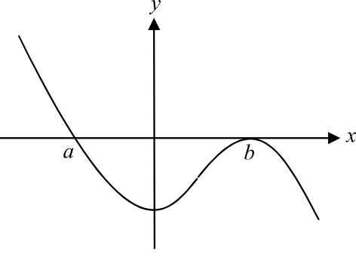

The graph above could have the rule

- 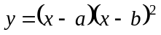
- 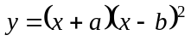
- 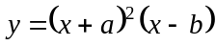
- 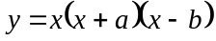
- 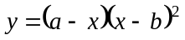

Question 2

The graph of 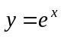 is reflected in the y-axis and then translated 3 units up. The equation of this new, transformed graph is
- 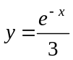
- 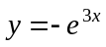
- 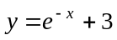
- 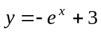
- 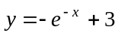

Question 3

Which one of the following rules does not have a corresponding graph that has an asymptote given that a is a positive constant?

- 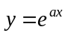
- 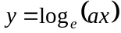
- 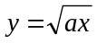
- 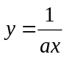
- 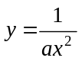
Question 4

The graph of the discontinuous function f is shown below.
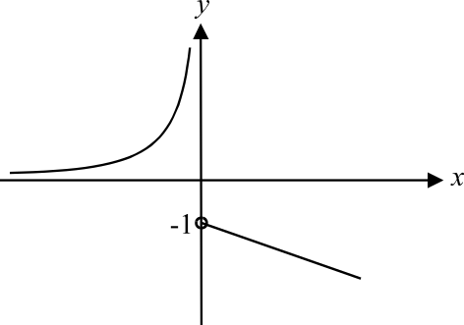

The graph of the inverse function 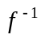 could be

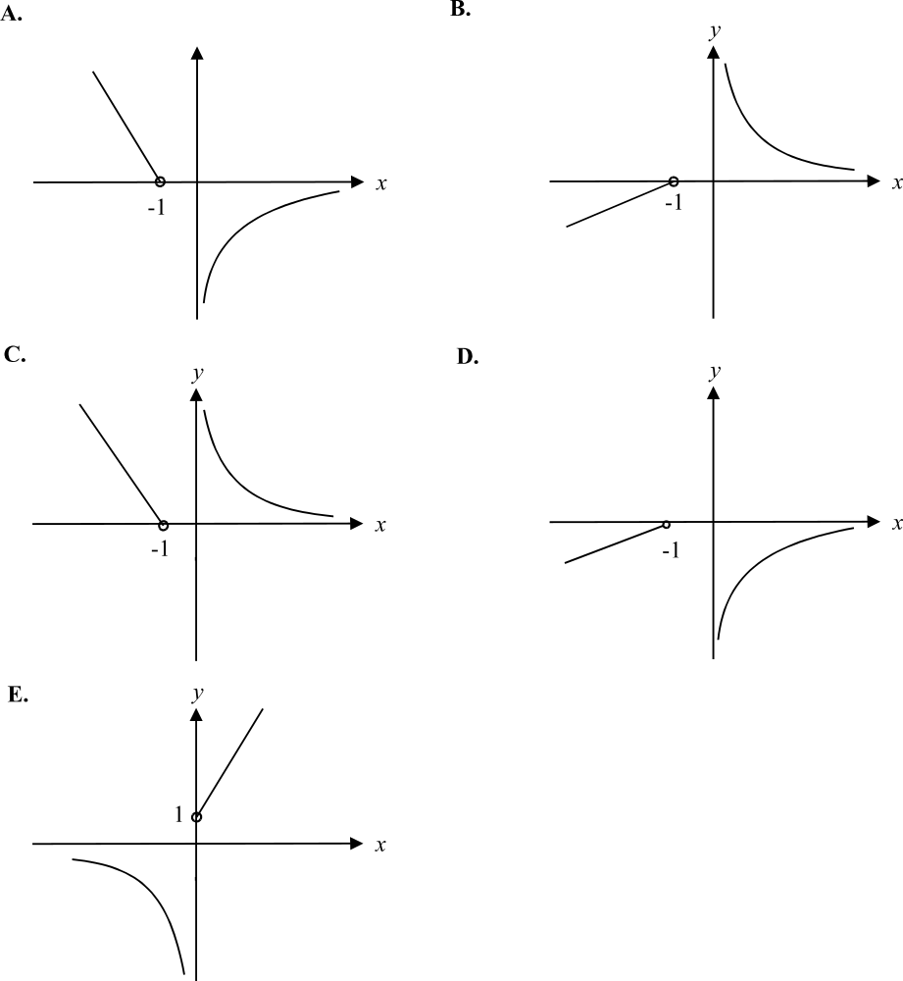

Question 5

x | 1 | 2 | 3 | 4 | 5 | 6 | 7 | 8
y | -9.2 | -3.7 | 0.4 | 1.2 | 1.7 | 2.1 | 2.3 | 2.4

The data in the table above would be best modelled using

- a logarithmic function
- an exponential function
- a linear function
- a circular function
- a quadratic function

Question 6

The graph below shows one cycle of the graph of a circular function.
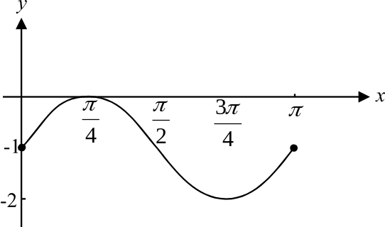

The equation of this function could be

- 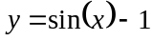
- 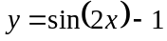
- 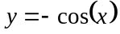
- 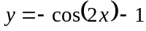
- 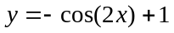

Question 7

The solution to the equation 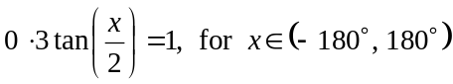 is closest to

- 3°
- 37°
- 73°
- 147°
- 213°

Question 8

The graph of 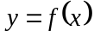 is shown below.

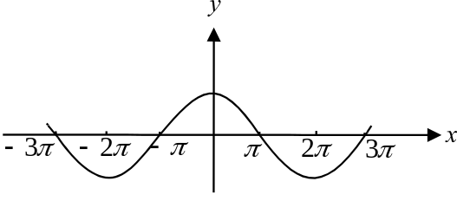

Which one of the following graphs could be the graph of 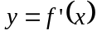?

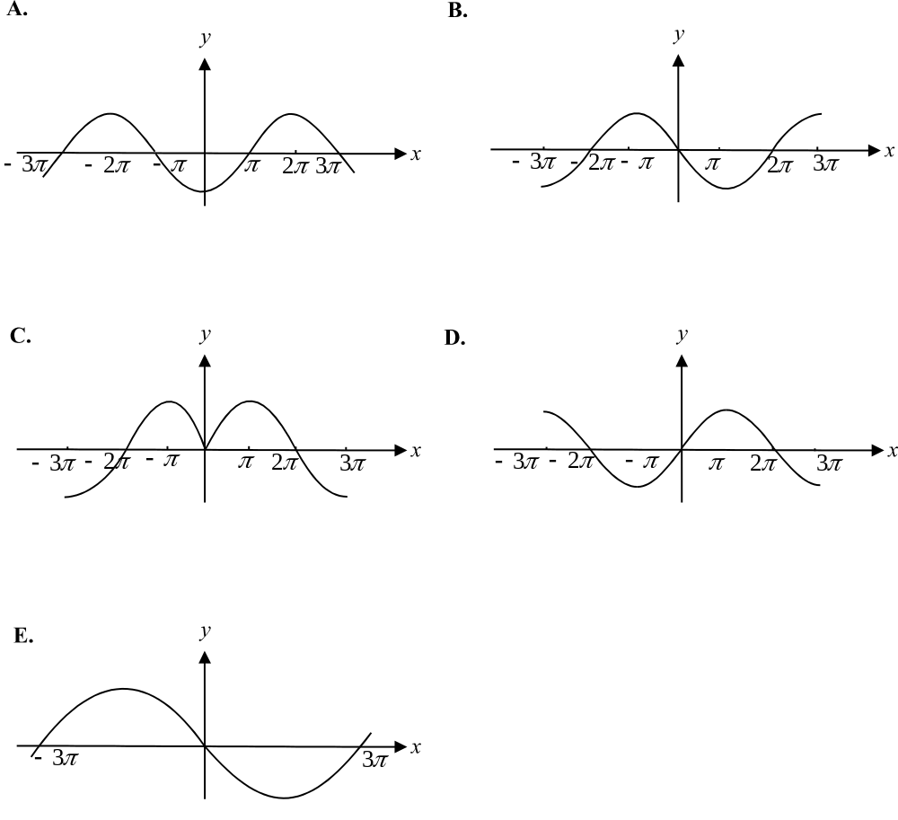

Question 9

Over which one of the following domains is the function 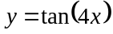 defined for all values
of x?

- 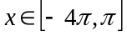
- 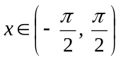
- 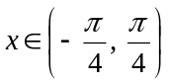
- 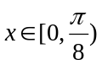
- 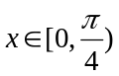

Question 10

If 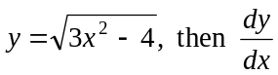 is equal to

- 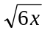
- 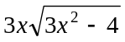
- 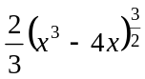
- 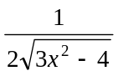
- 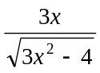

Question 11

The derivative of 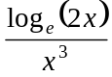 is
- 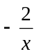
- 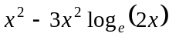
- 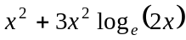
- 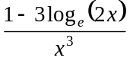
- 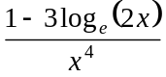

Question 12

The average rate of change of the function 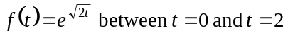 is
- 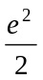
- 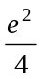
- 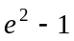
- 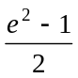
- 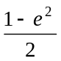

Question 13

The equation of the normal to the curve with the rule 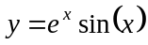 at the point where 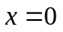 is given by

- 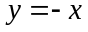
- 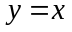
- 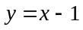
- 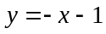
- 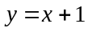

Question 14

If you used the approximation formula 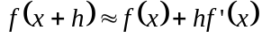, where 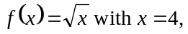an approximate value for 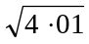 would be

- 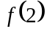
- 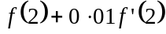
- 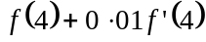
- 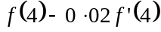
- 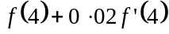

Question 15

The graph of 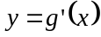 is shown below.

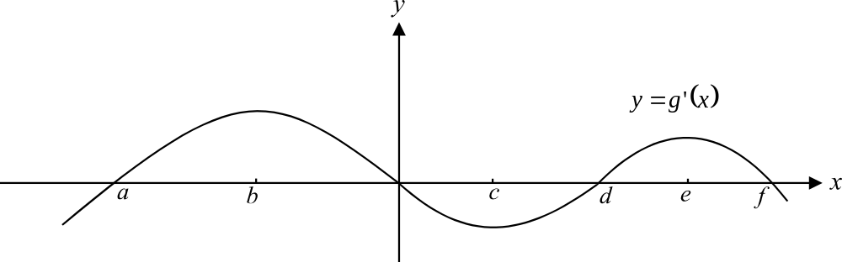

The graph of 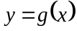, will have a positive gradient for

- 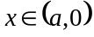 only
- 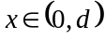 only
- 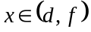 only
- 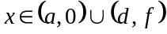
- 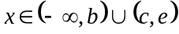

Question 16

An approximation for the area enclosed by the x-axis, the y-axis and the graph of 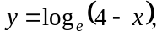 using rectangles of width 1 unit and the method of right rectangles, is given by

- 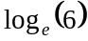
- 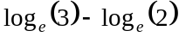
- 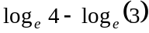
- 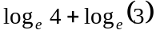
- 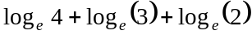

Question 17

If 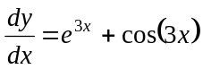 and c is a constant then y is equal to

- 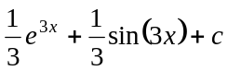
- 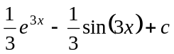
- 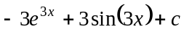
- 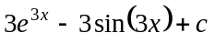
- 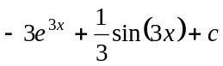
Question 18
The total area enclosed by the graph of 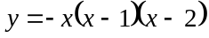 and the x-axis is
- 0
- 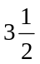

Question 19
If 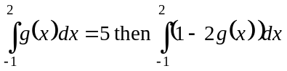 is equal to
- – 9
- – 7
- – 4
- 3
- 4

Question 20
Consider the function 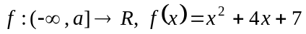.
If 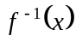 exists then a could be equal to
- – 5
- – 1
- 0
- 2
- 3

Question 21
The sixth and seventh lines of Pascal’s triangle are shown.
 | 1 |  | 5 |  | 10 |  | 10 |  | 5 |  | 1
1 |  | 6 |  | 15 |  | 20 |  | 15 |  | 6 |  | 1

The coefficient of 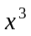 in the expansion of 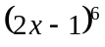 is equal to
- –160
- –120
- –80
- –40
- 80

Question 22
If 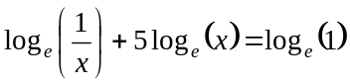, then x is equal to

- –1
- 0
- 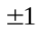
- 1
- 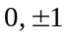
Question 23

The probability distribution of a discrete random variable is shown in the table below.

X | 5 | 10 | 15 | 20
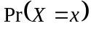 | 0.2 | 0.1 | 0.4 | 0.3

The expected value of X is

- 11
- 12.5
- 14
- 15
- 16.5

Question 24

In Victoria, one of two daily morning newspapers claims that 85% of households that subscribe to the newspaper have their papers delivered each morning before 7.30am.
In a random sample of 50 households that subscribe to this daily newspaper, the probability that exactly 45 receive their paper before 7.30am is given by

- 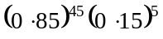
- 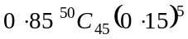
- 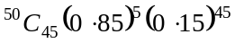
- 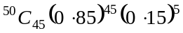
- 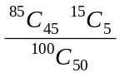

Question 25

Children in a grade 3 class are divided into four groups. There are 5 children in red group, 6 in blue group, 7 in yellow group and 6 in green group.
The principal randomly selects 3 children from this class to do a special job for her.
The probability that two of the three children are from blue group is

- 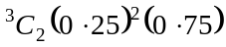
- 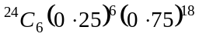
- 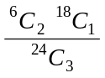
- 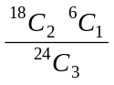
- 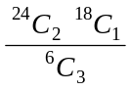
Question 26

Which one of the following graphs could best show the shape of a binomial distribution of the random variable X with 8 trials and the probability of success for each trial is 0.7?

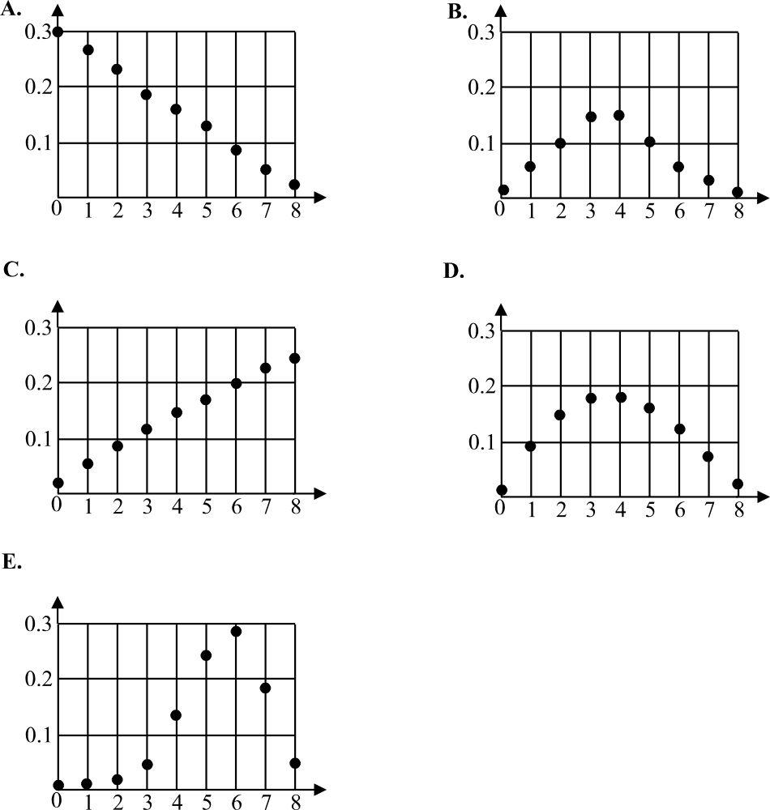

Question 27

The random variable X has a normal distribution with a mean of 20. The random variable z has a standard normal distribution.
If 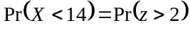 then the standard deviation of X is
- –3
- –2
- 2
- 3
- 6

PART II

Question 1

- Expand and simplify 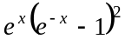.

- 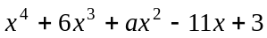 is exactly divisible by 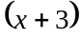.
Find the value of a.

1 + 2 = 3 marks

Question 2

The graph of is shown below.
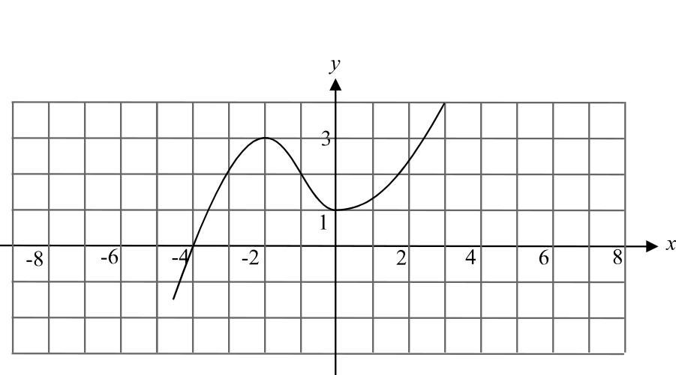

This graph of is reflected in the x-axis and then dilated 2 units parallel to the x-axis to obtain the graph of .
Use the sets of axes below to sketch the graph of .
Clearly label your graphs.
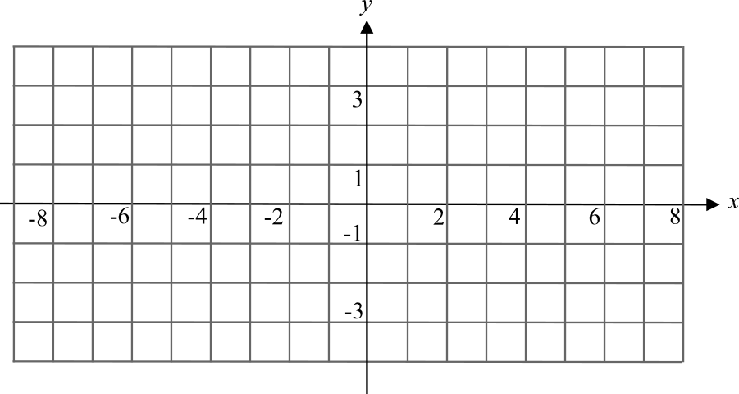

2 marks

Question 3

- Complete the table below by writing down the probability distribution of the number of times that a six appears when a fair die is tossed twice.

Number of sixes  (X) | Probability
0

1

2

- A different die is biased so that the probability of throwing a six with it is 0.3.
What is the probability that when this biased die is thrown five times, a six appears more than three times? Express your answer correct to 4 decimal places.

2 + 1 = 3 marks

Question 4

Consider the function

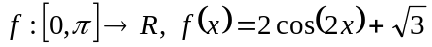

- Solve the equation 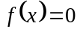 and express your value(s) of x as exact values.

- Find 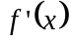.

- Explain why 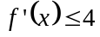.

1 + 1 + 1 = 3 marks

Question 5

- Differentiate 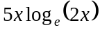.

- Hence find 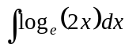.

1 + 2 = 3 marks

Question 6

Consider the function
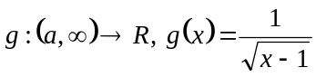

- Find the value of a such that g has a maximal domain.

- Without finding the rule for 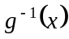, explain whether the graph of 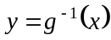 crosses the y-axis.

- Given that 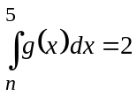, find the value of n.

1 + 1 + 2 = 4 marks
Question 7

- Show that the tangent to the graph of 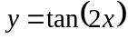 at the point 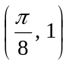 crosses the
x-axis at 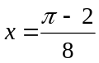.

____________________________________________________________________

____________________________________________________________________

____________________________________________________________________

____________________________________________________________________

- Hence write down an expression involving definite integrals, that gives the area enclosed by the graph of , the tangent at the point 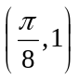 and the x-axis.
(Do not evaluate this expression.)

3 + 2 = 5 marks
Total 23 marks
Table 1 Normal distribution – cdf

x | 0 1 2 3 4 5 6 7 8 9 | 1 2 3 4 5 6 7 8 9
0.0  0.1  0.2  0.3  0.4  0.5  0.6  0.7  0.8  0.9  1.0  1.1  1.2  1.3  1.4  1.5  1.6  1.7  1.8  1.9  2.0  2.1  2.2  2.3  2.4  2.5  2.6  2.7  2.8  2.9  3.0  3.1  3.2  3.3  3.4  3.5  3.6  3.7  3.8  3.9 | .5000 .5040 .5080 .5120 .5160 .5199 .5239 .5279 .5319 .5359  .5398 .5438 .5478 .5517 .5557 .5596 .5636 .5675 .5714 .5753  .5793 .5832 .5871 .5910 .5948 .5987 .6026 .6064 .6103 .6141  .6179 .6217 .6255 .6293 .6331 .6368 .6406 .6443 .6480 .6517  .6554 .6591 .6628 .6664 .6700 .6736 .6772 .6808 .6844 .6879  .6915 .6950 .6985 .7019 .7054 .7088 .7123 .7157 .7190 .7224  .7257 .7291 .7324 .7357 .7389 .7422 .7454 .7486 .7517 .7549  .7580 .7611 .7642 .7673 .7703 .7734 .7764 .7793 .7823 .7852  .7881 .7910 .7939 .7967 .7995 .8023 .8051 .8078 .8106 .8133  .8159 .8186 .8212 .8238 .8264 .8289 .8315 .8340 .8365 .8389  .8413 .8438 .8461 .8485 .8508 .8531 .8554 .8577 .8599 .8621  .8643 .8665 .8686 .8708 .8729 .8749 .8770 .8790 .8810 .8830  .8849 .8869 .8888 .8907 .8925 .8944 .8962 .8980 .8997 .9015  .9032 .9049 .9066 .9082 .9099 .9115 .9131 .9147 .9162 .9177  .9192 .9207 .9222 .9236 .9251 .9265 .9279 .9292 .9306 .9319  .9332 .9345 .9357 .9370 .9382 .9394 .9406 .9418 .9429 .9441  .9452 .9463 .9474 .9484 .9495 .9505 .9515 .9525 .9535 .9545  .9554 .9564 .9573 .9582 .9591 .9599 .9608 .9616 .9625 .9633  .9641 .9649 .9656 .9664 .9671 .9678 .9686 .9693 .9699 .9706  .9713 .9719 .9726 .9732 .9738 .9744 .9750 .9756 .9761 .9767  .9772 .9778 .9783 .9788 .9793 .9798 .9803 .9808 .9812 .9817  .9821 .9826 .9830 .9834 .9838 .9842 .9846 .9850 .9854 .9857  .9861 .9864 .9868 .9871 .9875 .9878 .9881 .9884 .9887 .9890  .9893 .9896 .9898 .9901 .9904 .9906 .9909 .9911 .9913 .9916  .9918 .9920 .9922 .9925 .9927 .9929 .9931 .9932 .9934 .9936  .9938 .9940 .9941 .9943 .9945 .9946 .9948 .9949 .9951 .9952  .9953 .9955 .9956 .9957 .9959 .9960 .9961 .9962 .9963 .9964  .9965 .9966 .9967 .9968 .9969 .9970 .9971 .9972 .9973 .9974  .9974 .9975 .9976 .9977 .9977 .9978 .9979 .9979 .9980 .9981  .9981 .9982 .9982 .9983 .9984 .9984 .9985 .9985 .9986 .9986  .9987 .9987 .9987 .9988 .9988 .9989 .9989 .9989 .9990 .9990  .9990 .9991 .9991 .9991 .9992 .9992 .9992 .9992 .9993 .9993  .9993 .9993 .9994 .9994 .9994 .9994 .9994 .9995 .9995 .9995  .9995 .9995 .9995 .9996 .9996 .9996 .9996 .9996 .9996 .9997  .9997 .9997 .9997 .9997 .9997 .9997 .9997 .9997 .9997 .9998  .9998 .9998 .9998 .9998 .9998 .9998 .9998 .9998 .9998 .9998  .9998 .9998 .9999 .9999 .9999 .9999 .9999 .9999 .9999 .9999  .9999 .9999 .9999 .9999 .9999 .9999 .9999 .9999 .9999 .9999  .9999 .9999 .9999 .9999 .9999 .9999 .9999 .9999 .9999 .9999  1.0000 1.0000 1.0000 1.0000 1.0000 1.0000 1.0000 1.0000 1.0000 1.0000 | 4 8 12 16 20 24 28 32 36  4 8 12 16 20 24 28 32 35  4 8 12 15 19 23 27 31 35  4 8 11 15 19 23 26 30 34  4 7 11 14 18 22 25 29 32  3 7 10 14 17 21 24 27 31  3 6 10 13 16 19 23 26 29  3 6 9 12 15 18 21 24 27  3 6 8 11 14 17 19 22 25  3 5 8 10 13 15 18 20 23  2 5 7 9 12 14 16 18 21  2 4 6 8 10 12 14 16 19  2 4 6 7 9 11 13 15 16  2 3 5 6 8 10 11 13 14  1 3 4 6 7 8 10 11 13  1 2 4 5 6 7 8 10 11  1 2 3 4 5 6 7 8 9  1 2 3 3 4 5 6 7 8  1 1 2 3 4 4 5 6 6  1 1 2 2 3 4 4 5 5  0 1 1 2 2 3 3 4 4  0 1 1 2 2 2 3 3 4  0 1 1 1 2 2 2 3 3  0 1 1 1 1 2 2 2 2  0 0 1 1 1 1 1 2 2  0 0 0 1 1 1 1 1 1  0 0 0 0 1 1 1 1 1  0 0 0 0 0 1 1 1 1  0 0 0 0 0 0 0 1 1  0 0 0 0 0 0 0 0 0  0 0 0 0 0 0 0 0 0  0 0 0 0 0 0 0 0 0  0 0 0 0 0 0 0 0 0  0 0 0 0 0 0 0 0 0  0 0 0 0 0 0 0 0 0  0 0 0 0 0 0 0 0 0  0 0 0 0 0 0 0 0 0  0 0 0 0 0 0 0 0 0  0 0 0 0 0 0 0 0 0  0 0 0 0 0 0 0 0 0
Reproduced with permission of the Victorian Curriculum and Assessment Authority, Victoria, Australia.
These formula sheets have been copied from the 2003 Maths Methods Exam 1. Teachers and students are reminded that changes to formula sheets are notified in the VCE Bulletins and on the VCAA website.at www.vcaa.vic.edu.au
The VCAA publish an exam issue supplement to the VCAA Bulletin.

Mathematical Methods Formulas

Mensuration

area of a trapezium: 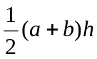 volume of a pyramid: 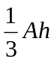
curved surface area of a cylinder: 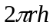 volume of a sphere: 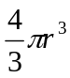
volume of a cylinder: 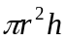 area of a triangle: 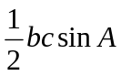
volume of a cone: 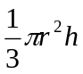

Calculus

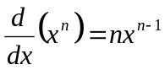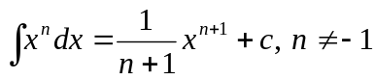
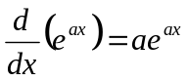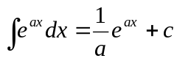
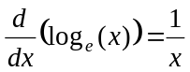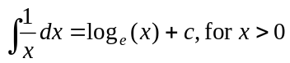
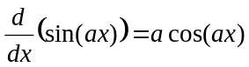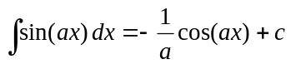
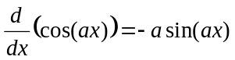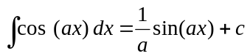
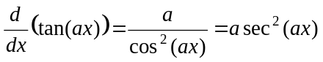

product rule: 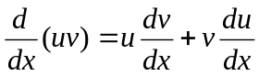
chain rule: 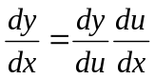 quotient rule: 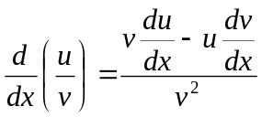

approximation: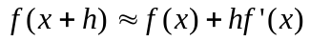

Reproduced with permission of the Victorian Curriculum and Assessment Authority, Victoria, Australia.
These formula sheets have been copied from the 2003 Maths Methods Exam 1. Teachers and students are reminded that changes to formula sheets are notified in the VCE Bulletins and on the VCAA website.at www.vcaa.vic.edu.au
The VCAA publish an exam issue supplement to the VCAA Bulletin.

Statistics and Probability

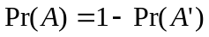

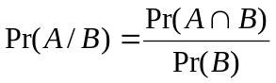

mean: 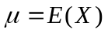 variance:

Discrete distributions
 | 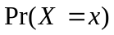 | mean | variance
general | 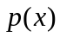 | 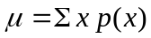 | 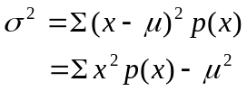
binomial | 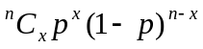 | 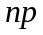 | 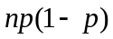
hypergeometric | 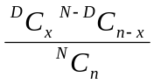 | 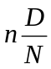 | 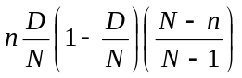

Continuous distributions
normal | If is distributed 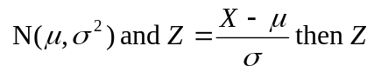is distributed 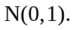

Reproduced with permission of the Victorian Curriculum and Assessment Authority, Victoria, Australia.
These formula sheets have been copied from the 2003 Maths Methods Exam 1. Teachers and students are reminded that changes to formula sheets are notified in the VCE Bulletins and on the VCAA website.at www.vcaa.vic.edu.au
The VCAA publish an exam issue supplement to the VCAA Bulletin.

