

Student Name……………………………………

MATHEMATICAL METHODS UNITS 3 & 4

WRITTEN TRIAL EXAMINATION 1

2006

Reading Time: 15 minutes
Writing time: 60 minutes

Instructions to students
This exam consists of 11 questions.
All questions should be answered.
There is a total of 40 marks available.
The marks allocated to each of the eleven questions are indicated throughout.
Where more than one mark is allocated to a question, appropriate working must be shown.
Unless otherwise stated, diagrams in this exam are not drawn to scale.
Students may not bring any notes or calculators into the exam.
A formula sheet can be found on page 12 of this exam.

This paper has been prepared independently of the Victorian Curriculum and Assessment Authority to provide additional exam preparation for students. Although references have been reproduced with permission of the Victorian Curriculum and Assessment Authority, the publication is in no way connected with or endorsed by the Victorian Curriculum and Assessment Authority.

© THE HEFFERNAN GROUP 2006
This Trial Exam is licensed on a non transferable basis to the purchaser. It may be copied for educational use within the school which has purchased it. This license does not permit distribution or copying of this Trial Exam outside that school or by any individual purchaser.
Question 1

The probability distribution for the discrete random variable X is shown in the table below.

x | 0 | 1 | 2 | 3 | 4
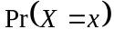 | 0.27 | 0.13 | 0.19 | 0.34 | a

- Find the value of a.

- Find 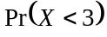.

- Find the mean of X.

- Find the median of X.

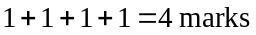

Question 2

- Find, in simplest form, 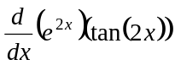.

- Find the antiderivative of the function 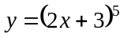.

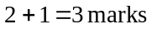

Question 3

For ,

- explain whether or not 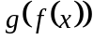 exists.

- explain whether or not the inverse function 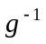 exists.

- find the rule and the domain of the inverse function 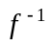.

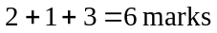
Question 4

Solve the equation 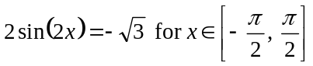. Express your answers as exact values in terms of .

3 marks

Question 5

For the function 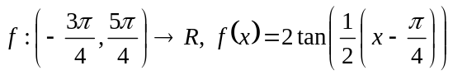

- write down the period of the function.

- Sketch the graph of the function f on the set of axes below. Given that 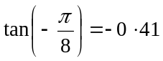 (to 2 decimal places) label any intercepts with the axes and give the equation of any asymptotes.

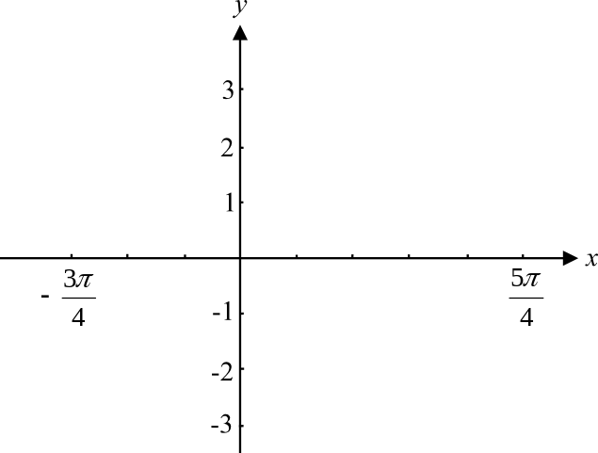

1 + 3 = 4 marks

Question 6

The random variable X has a normal distribution with a mean of 16 and standard deviation of 4. The random variable Z has a standard normal distribution.

- Find the value of a such that 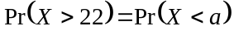.

- Find the value of b such that 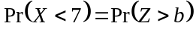

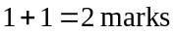

Question 7

Consider the function 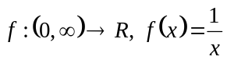. The graph of 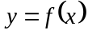 is shown on the graph below.

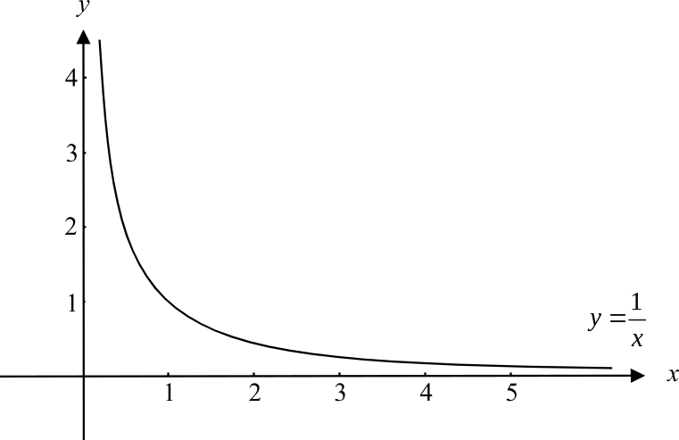

The graph of is to be transformed to become the graph of 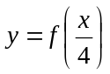.

- On the graph above, sketch this transformed function. Clearly mark the coordinates of any two points on your graph.

- Describe the transformation that has taken place.

- Write down a rule for this transformed function.

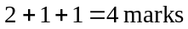
Question 8

The tangent to the curve 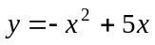 at the point where 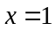, crosses the x-axis at the point 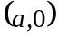. Find the value of a.

4 marks

Question 9

The graph of a cubic function with rule is shown below. There are stationary points located at 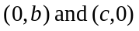.

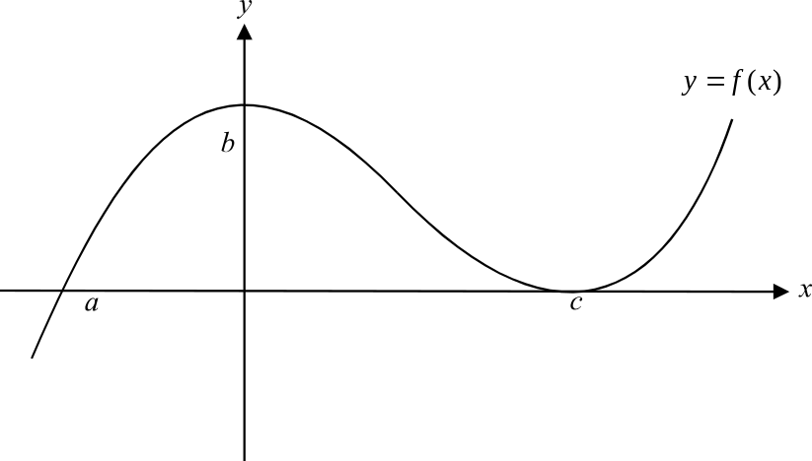

- Write down the three linear factors of the function f.

- Find the values of x for which 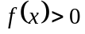.

- Find the values of x for which 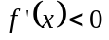.

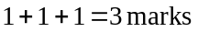

Question 10

A different team of students is assigned to clean up the school yard each day. The probability that a team does a good or bad job is dependent on whether a good or bad job was done by the team on the previous day. The probability that a team does a good job when the previous day’s team did a good job is 0.8. The probability that a team does a good job when the previous day’s team did a bad job is 0.6.

- What is the probability that a team does a bad job when the previous day’s team did a good job?

- What is the probability that Friday’s team did a good job given that the team on the previous Wednesday did a bad job?

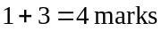

Question 11

Find the exact area enclosed by the graph of 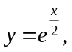 the line and the positive x and y axes.

3marks

END OF EXAM

Mathematical Methods Formulas

Mensuration

area of a trapezium: 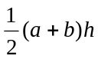 volume of a pyramid: 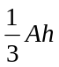
curved surface area of a cylinder: 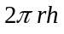 volume of a sphere: 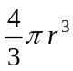
volume of a cylinder: 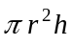 area of a triangle: 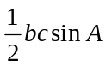
volume of a cone: 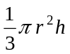

Calculus
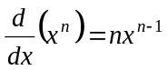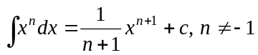
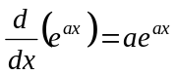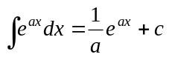
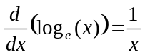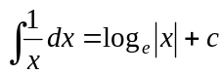
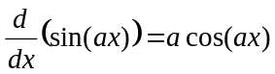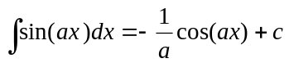
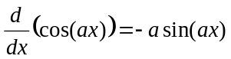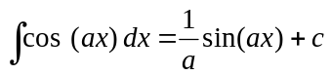
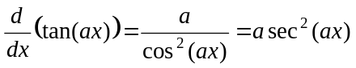
product rule: 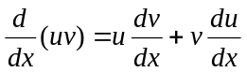 quotient rule: 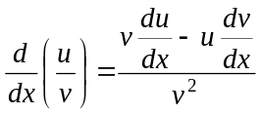
chain rule: 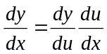 approximation: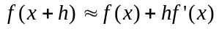

Probability
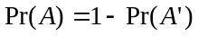
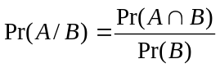
mean: 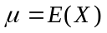 variance:

probability distribution |  | mean | variance
discrete | 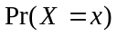=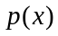 | 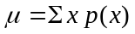 | 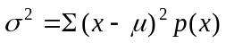
continuous | 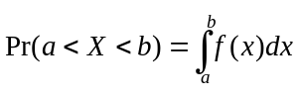 | 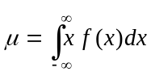 | 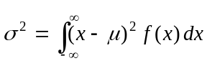

Reproduced with permission of the Victorian Curriculum and Assessment Authority, Victoria, Australia.
This formula sheet has been copied in 2006 from the VCAA website www.vcaa.vic.edu.au
The VCAA publish an exam issue supplement to the VCAA bulletin.

