
MATHS METHODS 3 & 4
TRIAL EXAMINATION 2
SOLUTIONS
2006

SECTION 1 – Answers
_____________________________________________________________________
- B 9. C 17. B
- E 10. E 18. C
- A 11. B 19. D
- E 12. E 20. A
- C 13. C 21. D
- E 14. C 22. B
7. B 15. D
8. D 16. D

SECTION 1– Multiple-choice solutions

Question 1

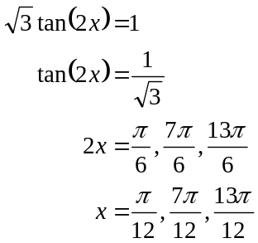
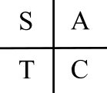
The answer is B.

Question 2

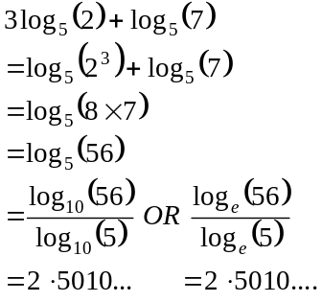
The answer is E.

Question 3

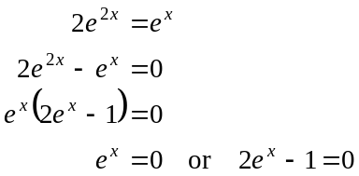
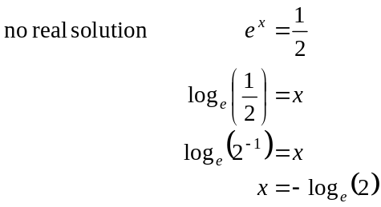
The answer is A.

Question 4

Method 1
Using the number line.
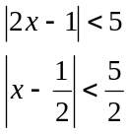
The distance from x to is less than .
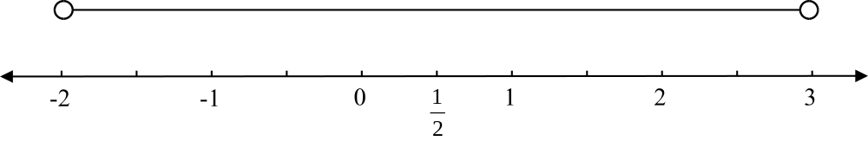

So 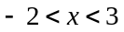

Method 2
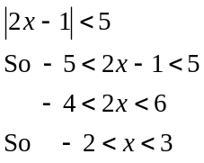

Method 3
Sketch the graph of 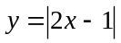.
Find the values of x for which for which 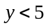.
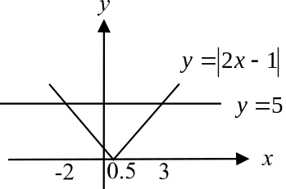

So
The answer is E.

Question 5

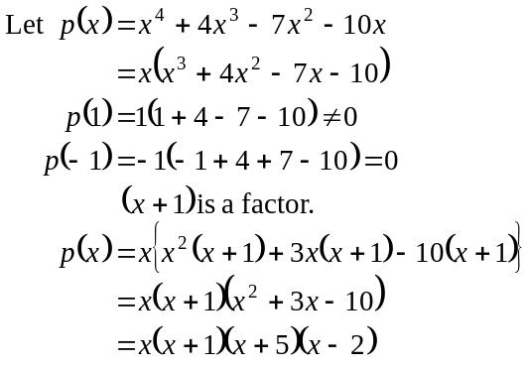
The linear factors are 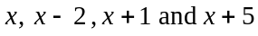.
The answer is C.

Question 6

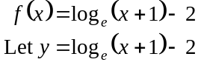
Swap x and y.
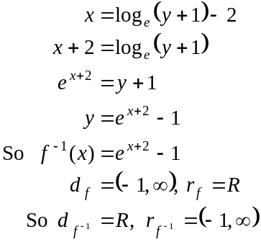
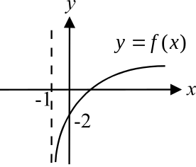
So we have 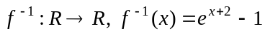.

The answer is E.

Question 7

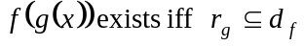
Now,
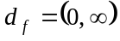
Sketch the graph of g, that is 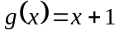.
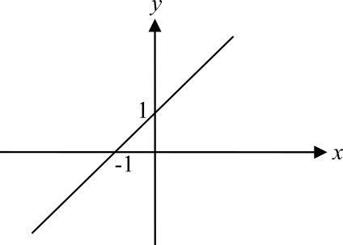

If 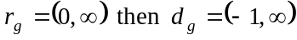 as shown in the diagram below.
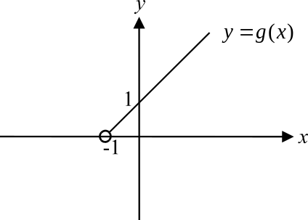

So 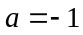.
The answer is B.

Question 8

The part of the graph shown could form part of a sin graph, or a graph of a cubic function or a log function or a quadratic function if there are appropriate transformations involved.
It could not form part of the graph of the function 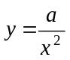 since there is an asymptote at 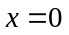 on this graph.
The answer is D.

Question 9

The 2 in the rule for g indicates that there has been a dilation by a scale factor of 2 from the x-axis (or parallel to the y-axis).
There is a horizontal translation of units to the left.
The answer is C.

Question 10

The rate of change of f is also the derivative of f or the gradient of f. It is positive for 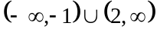
The answer is E.

Question 11

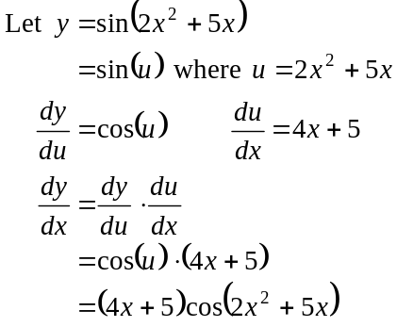
The answer is B.

Question 12

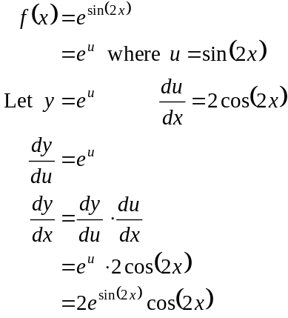
The answer is E.

Question 13

For the left branch 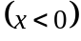 of the graph of 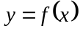 the gradient is negative.
This eliminates options B and E.
For the right branch 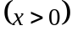 of the graph of the gradient is positive.
This eliminates option A.
As 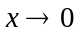 from the left hand side, the gradient of the graph of approaches . Conversely, as from the right hand side, the gradient of the graph of approaches .
Only option C shows this.
The answer is C.

Question 14

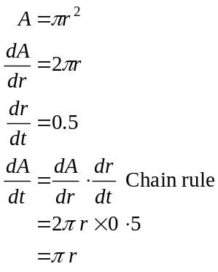
When 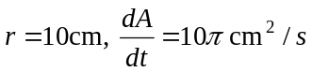.
The answer is C.

Question 15

Sketch the graph of .
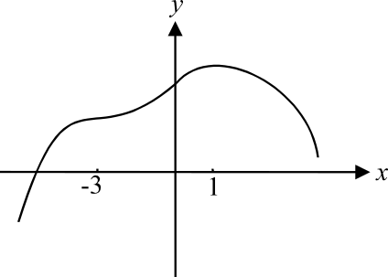

There is a local maximum at 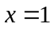 and a stationary point of inflection at 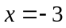.
The answer is D.

Question 16

For 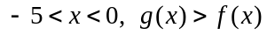.
For 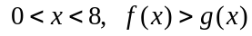.
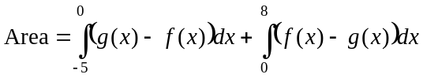
The answer is D.

Question 17

Sketch the graph.

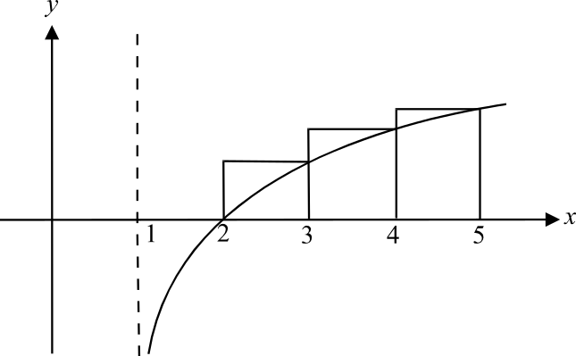

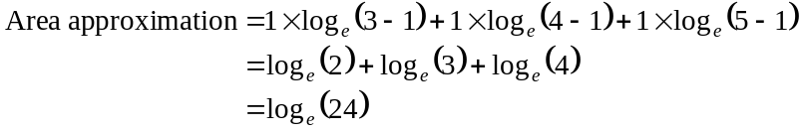
The answer is B.

Question 18

The graph we are given can be considered as the gradient function.
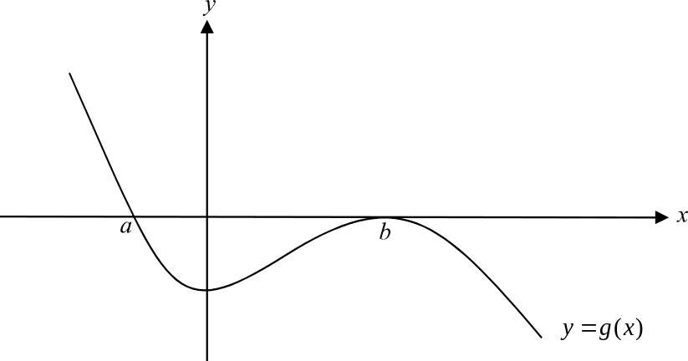

For the graph of the antiderivative function of g,
for , the gradient is positive.
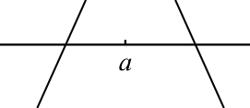
At , there is a stationary point and because
the gradient to the left of is positive and
to the right is negative, it is a local maximum.

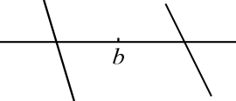

Similarly at 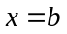 there is a stationary point.
To the left of the gradient is negative and
to the right it is negative so there is a stationary point of inflection at . Only option C shows these features.
The answer is C.

Question 19
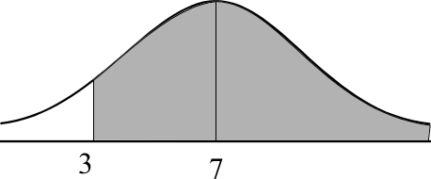

Using a graphics calculator 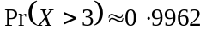
The answer is D.

Question 20

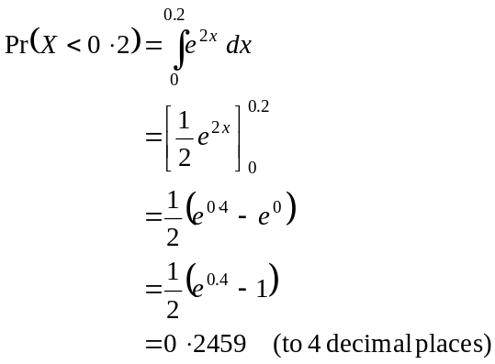
The answer is A.

Question 21

We have a binominal distribution since we have 3 trials and each attempt is independent of every other attempt.
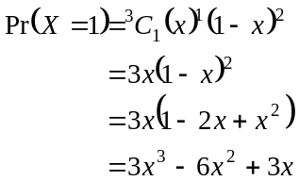
The answer is D.

Question 22

Use a tree diagram to create a probability distribution.
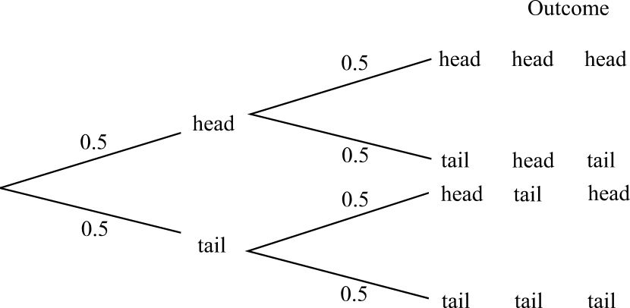

The probability distribution is

X | 0 | 1 | 2
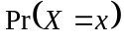

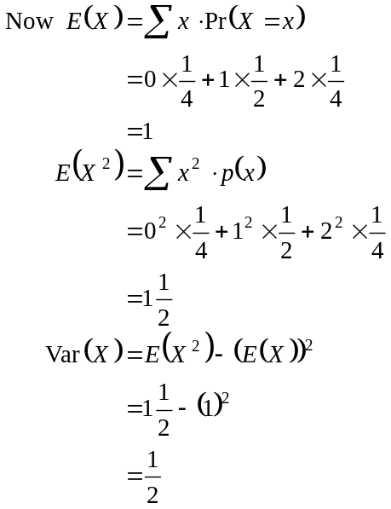
The answer is B.

SECTION 2

Question 1

- Since the area under the pdf is equal to 1 we have,
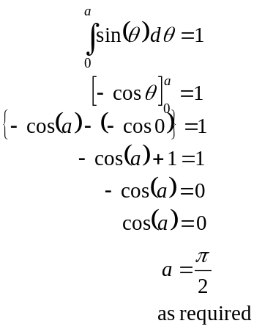
(1 mark)
(1 mark)
(Note that a cannot equal 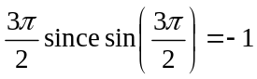 and for a pdf, the value of the function cannot be negative.)

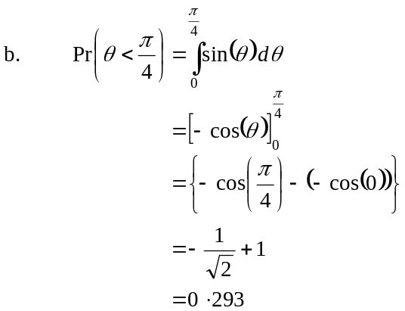
(1 mark)
(correct to 3 decimal places)
(1 mark)

- The probability that the door is left ajar at an angle of less than 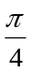 on the next two occasions is
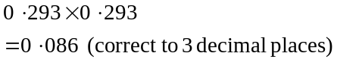
(1 mark)

- Let X = the outcome that the door is left open at an angle less than .
There are 5 trials.
X has a binomial distribution.
Pr(the door is left open at an angle less than on 4 of the next 5 occasions)
(1 mark)
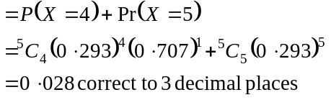
(1 mark)

- The median value is the middle value, 50% of values are less than the median value.
Let n = the median value.
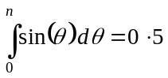 (1 mark)
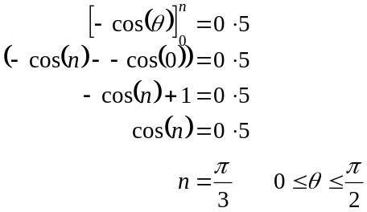
(1 mark)
(1 mark)
The median value is 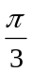.
(1 mark)
Total 11 marks

Question 2

- The amplitude of the function is 20. So the length of the track is 40cm.
(1 mark)

- 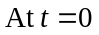,
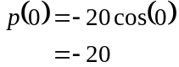
Since 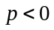, the meat holder starts at the left end of the track.
(1 mark)

- The period of the motion of the meat holder is given by 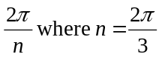.
So 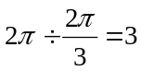.
The period is 3 seconds.
(1 mark)

- From part c., the period is 3 secs, so 20 slices of meat are cut in 1 minute.
So 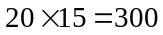 slices have been cut by 10.15am on Tuesday.
(1 mark)

- The meat first hits the rotating blade when
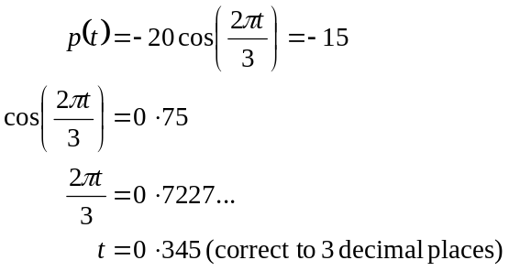
(1 mark)
(1 mark)

- i. The blade is 15cm in radius. The width of the meat is 17cm. So the trailing edge of the meat will be cut when the leading edge is 2cm to the right of C; that is when
(1 mark)

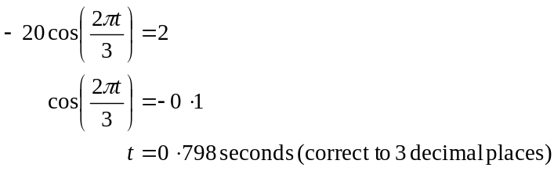
(1 mark)

  - Using your answer to parts e. and f. i., it takes 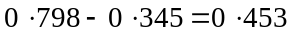 seconds to cut one slice of meat.
(1 mark)
g. i.
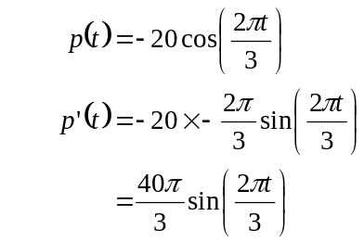
gives the rate of change of p with respect to time.
(1 mark)

- The rate of change of p is a maximum when
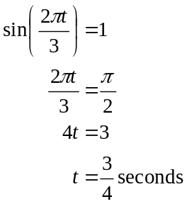
(1 mark)

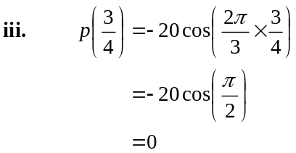
The leading edge of the meat slicer is located at point C when the rate of change is a maximum.
(1 mark)

iv. At 10.30 on Tuesday,
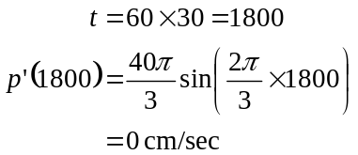
(1 mark)
Total 13 marks

Question 3

- Sketch the graph of 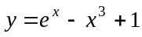.
Note that 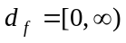.
The minimum value of f occurs at the turning point located at 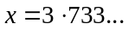

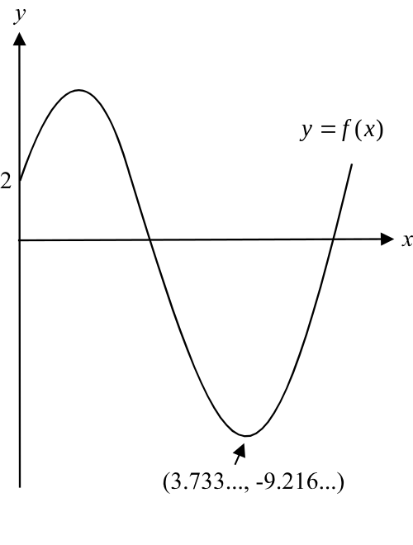

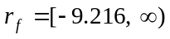, where –9.216 is expressed correct to 4 significant figures.
(1 mark) for –9.216
(1 mark) for

- i. Look at the graph of again since 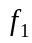 has the same rule as f. The right endpoint of the function occurs at 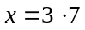 which is just before the minimum turning point that occurs at from part i.
Since 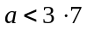, a must be the x-coordinate of the local maximum that occurs between 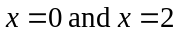. So 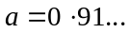(correct to 2 decimal places).
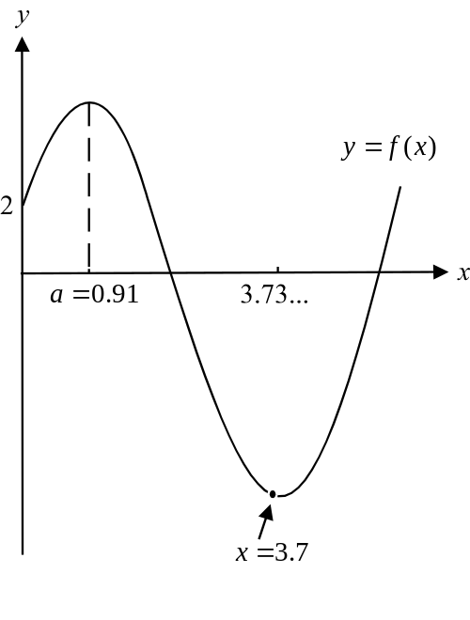

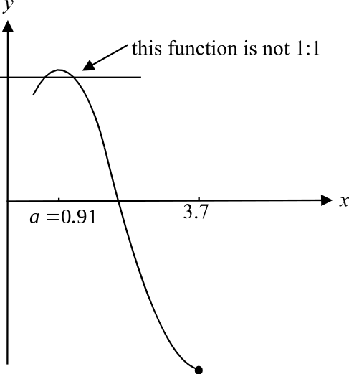

The value of a cannot be less than
0.91 because then the function is
not a 1:1 function and the inverse
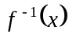 will not exist. (1 mark)
The value of a cannot be greater
than 0.91 because then the function
will not have a maximal domain.
So the value
of a is 0.91(correct to 2 decimal places).
(1 mark)

    - The endpoints of the function where the y-coordinates are expressed correct to 2 decimal places. (1 mark)
The endpoints of the inverse function 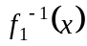 are therefore 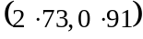 and 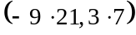.
(1 mark)
    - The graphs of the functions 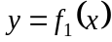 and 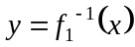 will intersect along the line 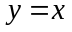. Sketch the graph of i.e. 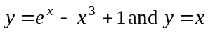. They intersect at the point 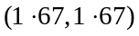.(each correct to 2 decimal places)(1 mark)

- i. Since 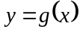 is a reflection in the x-axis of the graph of , then 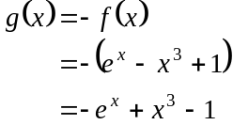
(1 mark)
- Method 1
Look at the graphs of 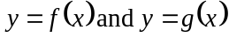 for 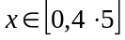. The difference between the values of the functions is a maximum where the graph of has a local minimum (and therefore where the graph of has a local maximum).
From part a. we saw that the local minimum for the graph of occurred at (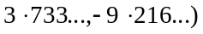. (1 mark)
Therefore the maximum value of 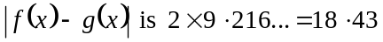 correct to 2 decimal places. (1 mark)

Method 2
Consider the graph of
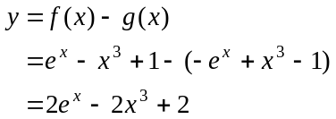
(1 mark)
The maximum value of 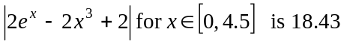 correct to 2 decimal places.
(1 mark)
iii. Method 1
Again look at the graphs of for . The difference between the values of the functions is a maximum where the graph of has a local minimum (and therefore where the graph of has a local maximum).
From part a. we saw that the local minimum for the graph of occurred at (. Therefore the maximum value occurs when 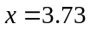 correct to 2 decimal places. (1 mark)

Method 2
Again, consider the graph of
The maximum value of 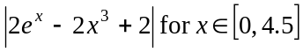 occurs when correct to 2 decimal places.
(1 mark)

iv. Method 1
Again, looking at the graphs of for the minimum difference is zero and this occurs when the two graphs intersect which occurs when they cross the x-axis. This occurs at 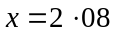 (correct to two decimal places). (1 mark)

Method 2
Again, consider the graph of
The value of 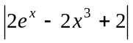 is a minimum when 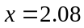 correct to 2 decimal places. (1 mark)

- The graph of has been moved h units to the left. (1 mark)

- i. Look at the graph of . It crosses the x-axis at and at 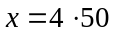; each correct to two decimal places. (from part c. iv) (1 mark)

    - Using our answers from part e.i., if the graph of is moved 2.07 units to the left, it will cross the x-axis at 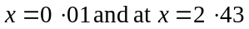. This means that there will be two positive solutions to the equation 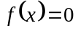.
If the graph of is moved 2.08 units to the left, it will cross the x-axis at 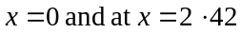. In this case the equation will have only 1 positive solution.
So the graph can go left up to but not including 2.08 units.

The graph can move any amount to the right and always have two positive x-intercepts and hence will always have 2 positive solutions. So h can have any negative value.

So 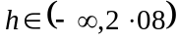.
(1 mark) for
(1 mark) for 2.08
(1 mark) for the round bracket around 2.08
Total 17 marks
Question 4

- When 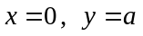.
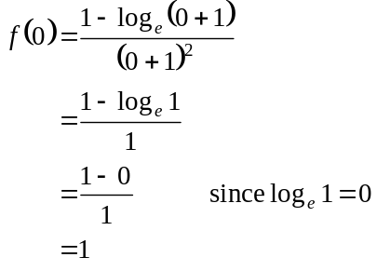
So, 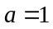. (1 mark)

- The function f crosses the x-axis when .
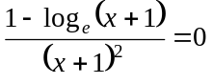
This can only happen if
(1 mark)
since if 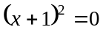 the function f is undefined
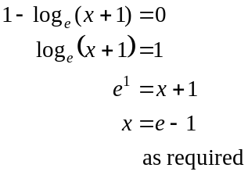
(1 mark)

- Look at the diagram. The eastern boundary extends from the point 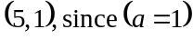 to the point 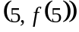
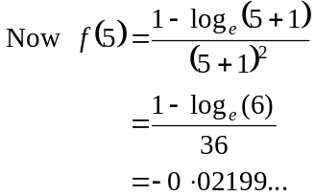
(1 mark)
So the length of the eastern boundary is 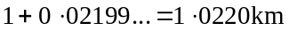 correct to 4 decimal places.
(1 mark)

- Sketch the graph.
Be careful to use appropriate window settings since the minimum is a very “shallow” one.
The furthest point south has coordinates of 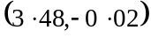 where each coordinate is expressed correct to 2 decimal places.
(1 mark) for x coordinate
(1 mark) for y coordinate

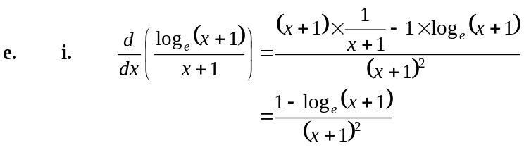
(quotient rule)
So, 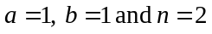.
(1 mark)
(1 mark)

ii. 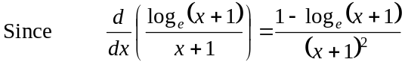
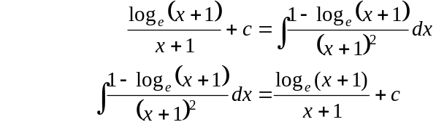
(1 mark)

f. i. 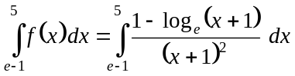
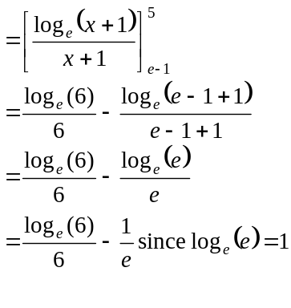
(1 mark)
as required (1 mark)

- The value is negative because the area enclosed by the graph of the function , the x-axis, and the lines 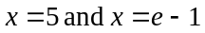 lies below the x-axis.
(1 mark)

- First find the area between the graph of the function and the x and y-axis. Let this area be called area A.

That is, find
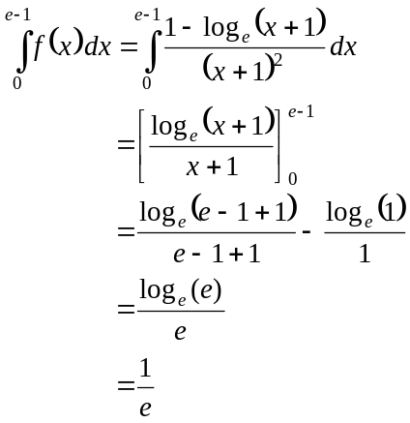
(1 mark)
So area A is square kilometres.
(1 mark)
Total area of golf course

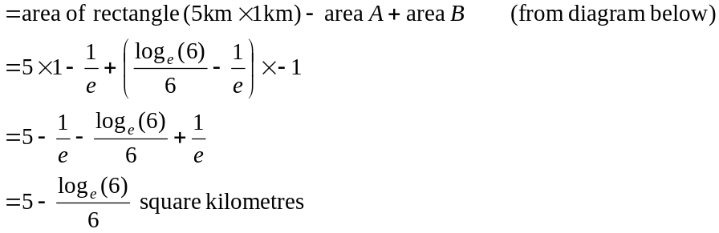
(1 mark)
(Note that area B is equal to 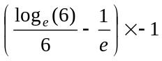 because area B lies below the x-axis and the value of the integral in part f. i. is therefore negative.)
(1 mark)
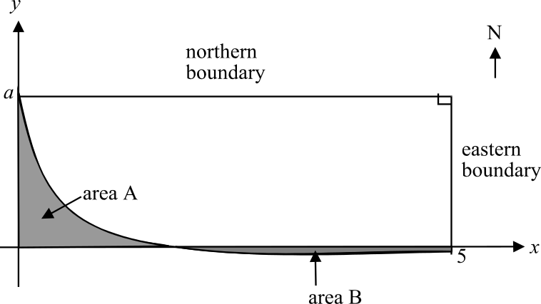

Total 17 marks

Total for Section 2 - 58 marks

