Student Name……………………………………


MATHEMATICAL METHODS UNITS 3 & 4

WRITTEN TRIAL EXAMINATION 2

2006

Reading Time: 15 minutes
Writing time: 2 hours

Instructions to students
This exam consists of Section 1 and Section 2.
Section 1 consists of 22 multiple-choice questions, which should be answered on the detachable answer sheet that can be found on page 25 of this exam.
Section 2 consists of 4 extended-answer questions that should be answered in the spaces provided.
Section 1 begins on page 2 of this exam and is worth 22 marks.
Section 2 begins on page 12 of this exam and is worth 58 marks.
There is a total of 80 marks available.
All questions in Section 1 and Section 2 should be answered.
Unless otherwise stated, diagrams in this exam are not drawn to scale.
Where more than one mark is allocated to a question, appropriate working must be shown.
Students may bring one bound reference into the exam.
Students may bring an approved graphics or CAS calculator into the exam.
A formula sheet can be found on pages 24 of this exam.

This paper has been prepared independently of the Victorian Curriculum and Assessment Authority to provide additional exam preparation for students. Although references have been reproduced with permission of the Victorian Curriculum and Assessment Authority, the publication is in no way connected with or endorsed by the Victorian Curriculum and Assessment Authority.

© THE HEFFERNAN GROUP 2006
This Trial Exam is licensed on a non transferable basis to the purchaser. It may be copied for educational use within the school which has purchased it. This license does not permit distribution or copying of this Trial Exam outside that school or by any individual purchaser.
SECTION 1

Question 1

The first three positive solutions of the equation 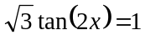 are

- 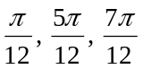
- 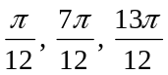
- 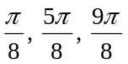
- 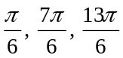
- 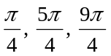

Question 2

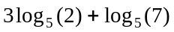 is closest to

- 0.08
- 0.22
- 1.39
- 2.32
- 2.5

Question 3

The solution/s to the equation 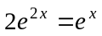 is/are

- 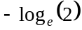
- 0
- 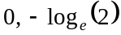
- 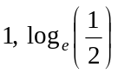
- 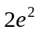

Question 4

Find the real values of x for which 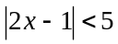.

- 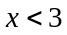
- 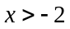
- 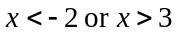
- 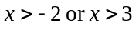
- 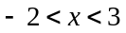

Question 5

The complete set of linear factors of the polynomial 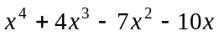 are

- 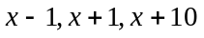
- 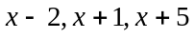
- 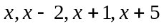
- 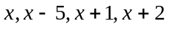
- 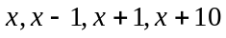

Question 6

The inverse function of the function is given by

- 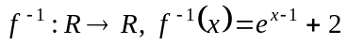
- 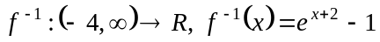
- 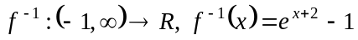
- 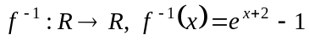

Question 7

Consider the functions

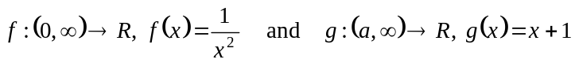

The least value of a such that the composite function 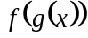 exists, is

- – 1
- 0
- 1
- 2

Question 8

Just part of the graph of a function is shown below.
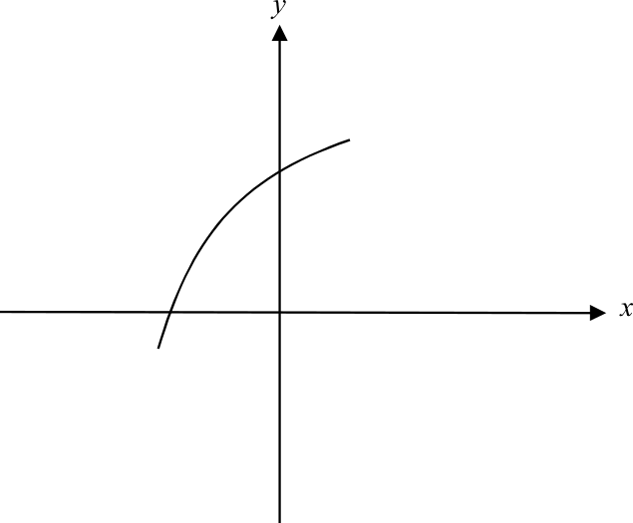

Given that a, b, c and d are all constants, which one of the following rules could definitely not model that part of the function shown in the graph above?

- 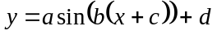
- 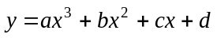
- 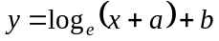
- 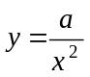
- 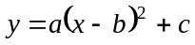

Question 9

The graph of the function f with the rule 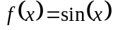 is transformed to become the graph of the function g where the rule of g is given by 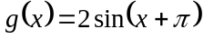. The transformations that have taken place are

- a dilation by a scale factor of from the x-axis and a translation of units left.
- a dilation by a scale factor of from the x-axis and a translation of units right.
- a dilation by a scale factor of 2 from the x-axis and a translation of units left.
- a dilation by a scale factor of from the y-axis and a translation of units left.
- a dilation by a scale factor of 2 from the y-axis and a translation of units right.

Question 10

The graph of the function f is shown below. Stationary points occur at 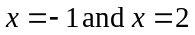.

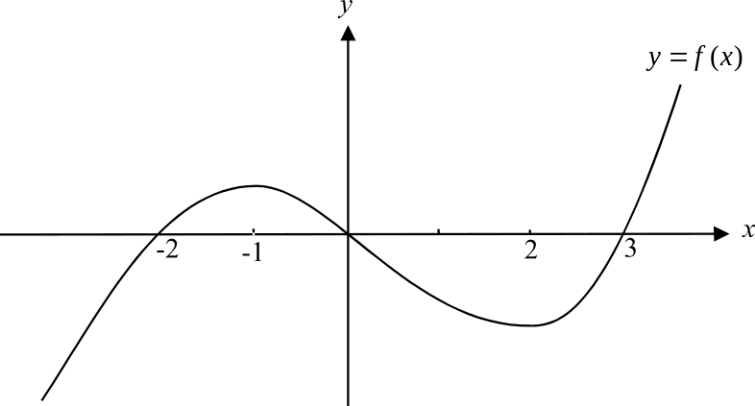

The rate of change of f with respect to x is positive for

- 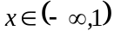
- 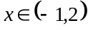
- 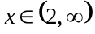
- 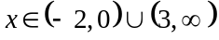
- 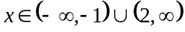

Question 11

The derivative of 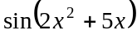 is

- 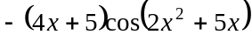
- 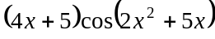
- 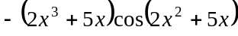
- 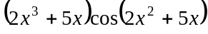
- 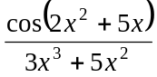

Question 12

The gradient function of the function 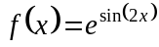 is given by

- 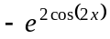
- 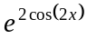
- 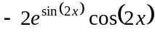
- 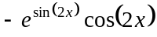
- 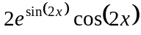
Question 13

The graph of the function 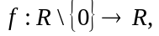with the rule 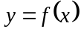 is shown below.
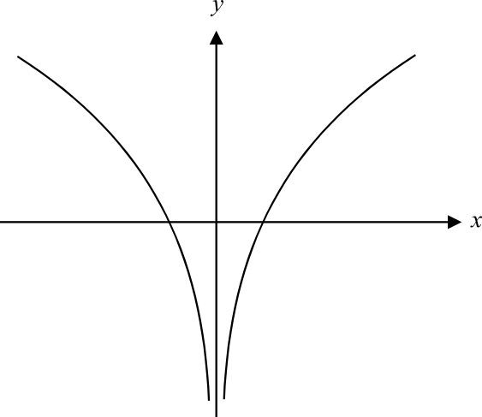

Which one of the following graphs could be the graph of 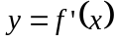?
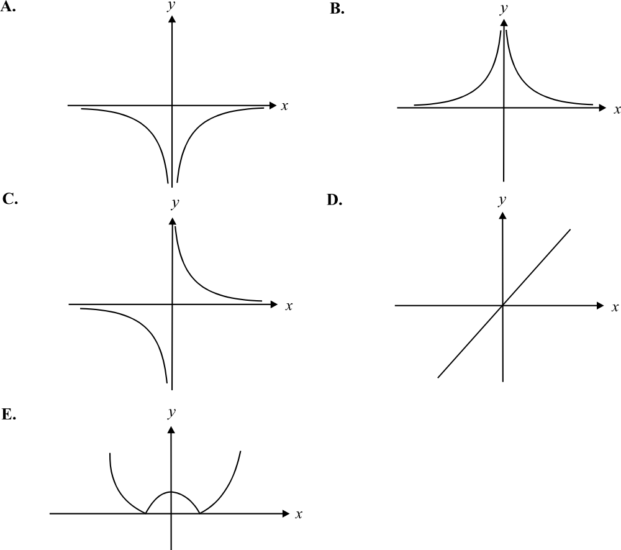

Question 14

A circular puddle is expanding. Its radius is increasing at the rate of 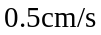. The rate at which the area of the puddle is increasing when the radius is 10 cm is

- 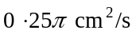
- 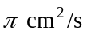
- 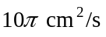
- 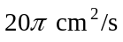
- 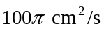

Question 15

A continuous function, f, has the following properties:

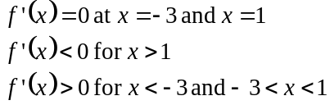

Which one of the following is true?

- The graph of has a local minimum at 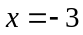.
- The graph of has a local maximum at .
- The graph of has a local minimum at 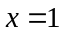.
- The graph of has a stationary point of inflection at .
- The graph of has a stationary point of inflection at .

Question 16

The graphs of 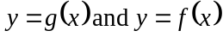 are shown below.
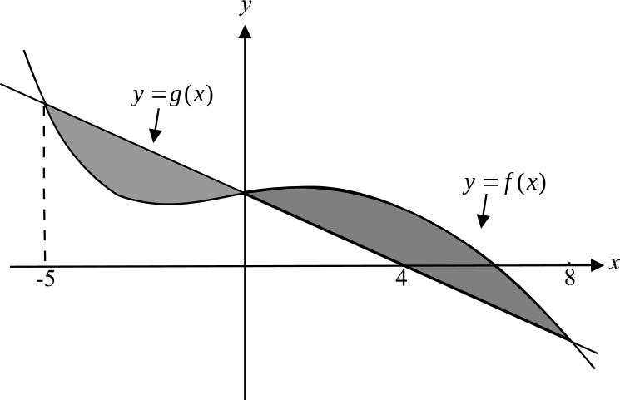

The shaded region between these two graphs has an area in square units of

- 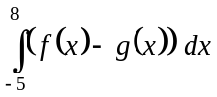
- 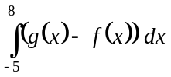
- 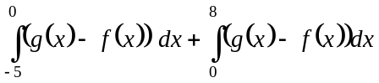
- 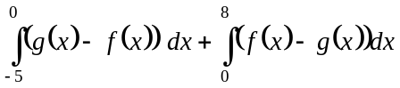
- 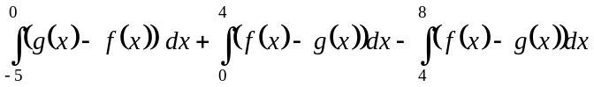

Question 17

The area enclosed by the graph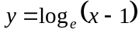 the x-axis and the line 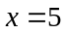 is approximated using the method of right rectangles with rectangles of width 1 unit.
The approximation in square units is

- 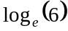
- 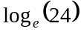
- 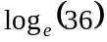
- 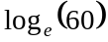
- 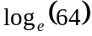

Question 18

The graph of the function g with rule 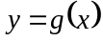 is shown below.

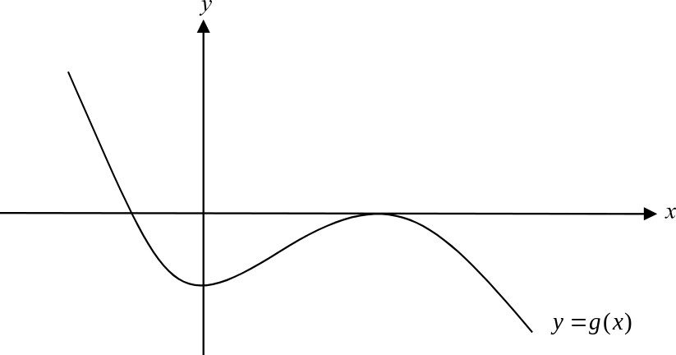

Which one of the following could be the graph of an antiderivative function of g?
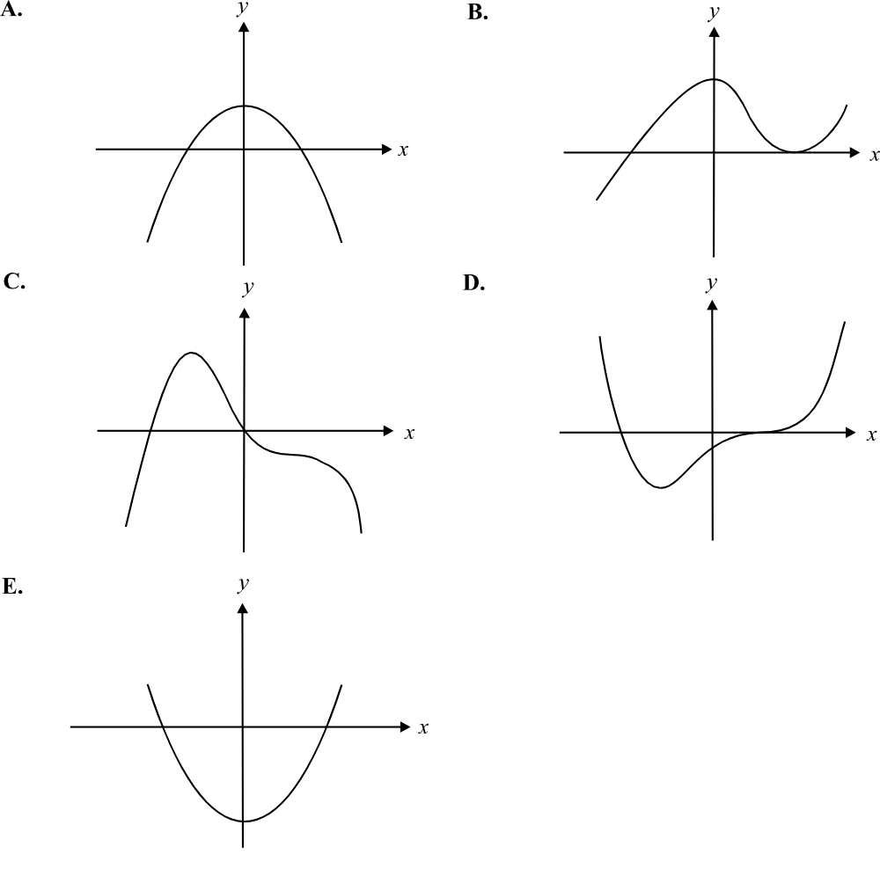

Question 19

A random variable X has a normal distribution with a mean of 7 and a standard deviation of 1.5. The probability that X is greater than 3 is closest to

- 0.0038
- 0.7146
- 0.8623
- 0.9962
- 0.9987

Question 20

The continuous variable X has a probability density function given by

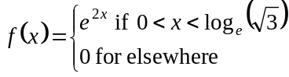

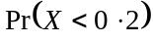 is closest to

- 0.2459
- 0.3746
- 0.4918
- 0.6107
- 0.7459

Question 21

In a game, Larry has a probability of x of landing a ball in a bucket. Each attempt to land the ball in the bucket is independent of any other attempt. The probability that he lands the ball in the bucket just once out of 3 attempts is given by the expression

- 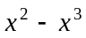
- 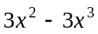
- 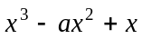
- 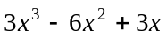
- 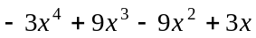

Question 22

Claire throws a fair coin twice. Let X represent the number of heads that are thrown by Claire.
The variance of X is closest to

- 1
- 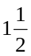

SECTION 2

Answer all questions in this section.

Question 1

A door is in constant use and is left ajar after each use. The angle that is created when the door is left ajar is ; where is a variable, and is indicated in the diagram below.

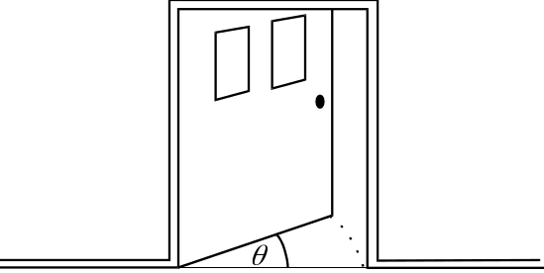

The angle that the door is left ajar on one occasion is independent of the angle that it is left ajar on another occasion.
The angle is a random variable with a probability density function given by

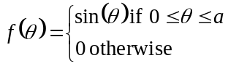

- Show that 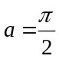.

2 marks
- Show that the probability that the door is left ajar at an angle of less than 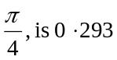 (correct to 3 decimal places).

2 marks

- What is the probability that the door is left ajar at an angle of less than 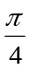 on the next two occasions? Express your answer correct to 3 decimal places.

1 mark

- What is the probability that the door is left ajar at an angle of less than on at least 4 out of the next 5 occasions it is used. Express your answer correct to 3 decimal places.

2 marks

  - What is the median value of ?

4 marks
Total 11 marks

Question 2

A meat slicer that is used in a butchers shop is shown on the diagram below.
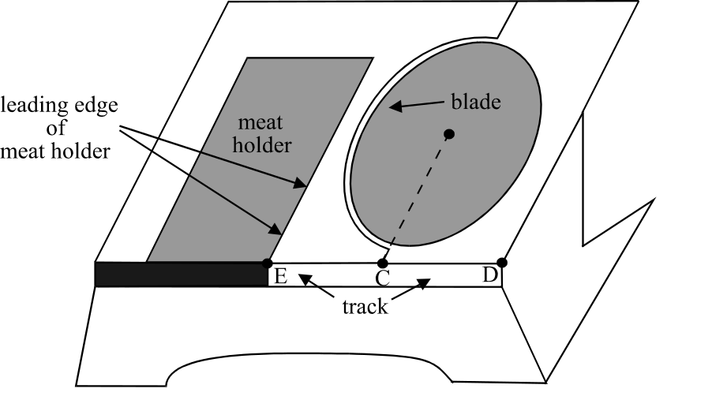

The main parts of the meat slicer are the blade, the meat holder and the track along which the meat holder runs indicated on the diagram as ED. The point C is in line with the centre of the circular blade and is halfway between points E and D. The point E lies on the track along which the meat holder slides and is in line with the leading edge of the meat holder when it is as far left as it can slide (the position shown in the diagram above).
The meat holder slides backwards and forwards along the track that runs from point E to point D. With every forward movement a slice of meat is cut by the rotating blade and falls to the underside of the machine. The meat slicer can be put on automatic so that the meat holder moves backwards and forwards continuously.
When on automatic, the position, p, of the leading edge of the meat holder along the track at time t seconds after the slicer is switched on, is given by

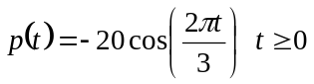

where positive values of p indicate that the leading edge of the meat slicer is to the right of point C and negative values indicate that it is to the left of point C. The unit of measurement is the centimetre.
The meat slicer is switched on to automatic in the butchers shop at 10am on Tuesday.

- What is the length of the track?

1 mark

- According to the rule for 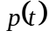, confirm whether or not the meat holder starts at the left end of the track.

1 mark
c. How long does it take for one complete forward and one complete backward movement of
the meat holder?

1 mark

- How many slices of meat have been cut by 10.15am on Tuesday?

1 mark

- If the radius of the blade is 15cm and assuming that the edge of the meat to be sliced is on the leading edge of the meat holder in line with point E as indicated in the diagram, find the value of t when the meat first hits the rotating blade. Express your answer correct to 3 decimal places.

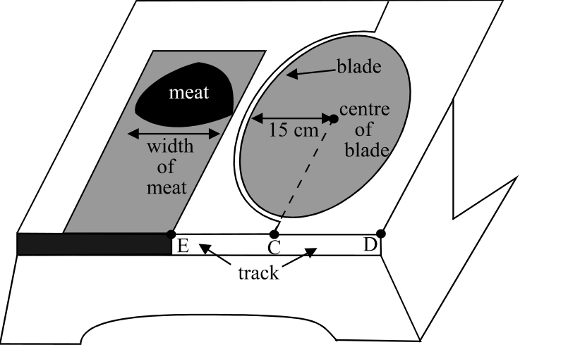

2 marks

- The width of the meat that is to be sliced is 17cm.

  - What is the value of t when the first slice of meat has just been sliced off completely. Express your answer correct to 3 decimal places.

  - How long does it take for the blade to cut one slice of meat? Express your answer correct to 3 decimal places.

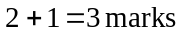

- i. Find an expression for the rate of change of p with respect to time.

  - Without using calculus find when the rate of change of p is a maximum.

  - What is the position of the leading edge of the meat slicer when the rate of change of p is a maximum?

  - At what rate (in cm/sec), is p changing at 10.30am on Tuesday?

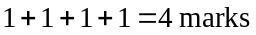
Total 13 marks
Question 3

Consider the function

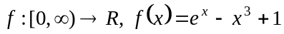.

- Write down the range of f, expressing your answer correct to 4 significant figures where appropriate.

2 marks

- The function 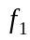 has the same rule as the function f.

The domain of 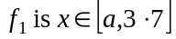.

  - Find the value of a correct to 2 decimal places, such that both the following conditions are satisfied:

- the inverse function 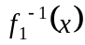 exists
- the domain of is a maximal domain

  - Using your result to part i. write down the coordinates of the two endpoints of the graph of the inverse function 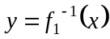. Express your coordinates correct to 2 decimal places where appropriate.

  - Find the coordinates of the point of intersection of the graphs of 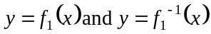. Express the coordinates correct to 2 decimal places.

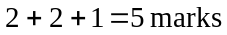

- The graph of is a reflection in the x-axis of the graph of .

  - Write down a rule for the function g.

  - Find the maximum value for 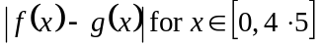. Express your answer correct to 2 decimal places.

  - Find the value of x, correct to 2 decimal places, for which is a maximum.

  - Find the value of x, correct to 2 decimal places, for which is a minimum.

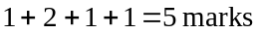
The graph of is transformed to become the graph of 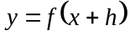.

- Describe the transformation to the graph of that has taken place.

1 mark

- i. Find the two solutions to 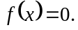 Express them each correct to 2 decimal places.

ii. Using your answers to part e.i., find the real values of h for which 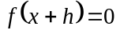 has two positive solutions.

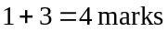
Total 17 marks

Question 4

A golf club is bordered by two straight boundaries and a river.
The shaded area on the diagram below shows the golf club. The y-axis runs in a north-south line and in relation to the set of axes, the northern boundary of the golf club is described by the equation 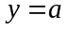. The eastern boundary is described by the equation .
The river boundary is described by the function

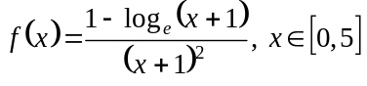

where 1 unit represents 1 kilometre. The north-west corner of the golf course is located at the point 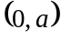.
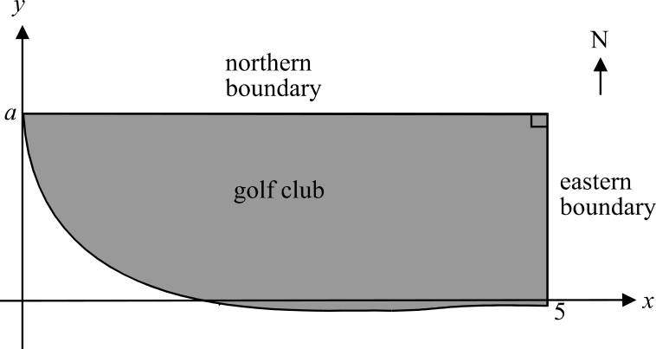

- Show that 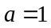.

1 mark

- Show that the function f crosses the x-axis at 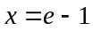.

2 marks

  - Find the length of the eastern boundary of the golf course. Express your answer in kilometres correct to four decimal places.

2 marks

  - Find the coordinates of the southern most point on the golf club’s boundary.
Express each coordinate correct to 2 decimal places.

2 marks

  - i Given that

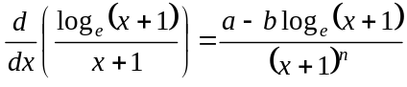

find the values of a, b and n.

2 marks

    - Hence find 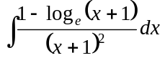.

1 mark

  - i. Using your result to part e. ii., show that 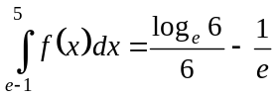.

    - Explain why this value is negative.

    - Hence find the area of the golf course. Express your answer as an exact value.

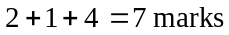
Total 17 marks

END OF EXAM

Mathematical Methods Formulas

Mensuration
area of a trapezium: 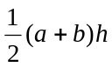 volume of a pyramid: 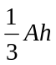
curved surface area of a cylinder: 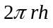 volume of a sphere: 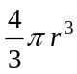
volume of a cylinder: 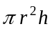 area of a triangle: 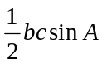
volume of a cone: 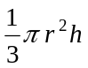

Calculus
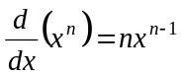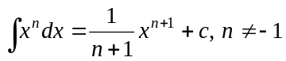
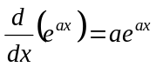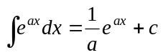
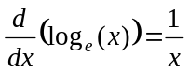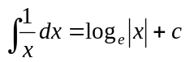
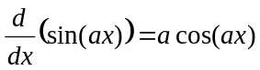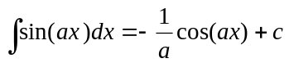
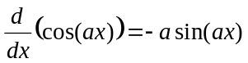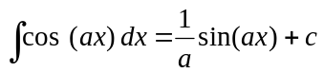
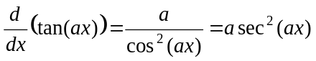
product rule: 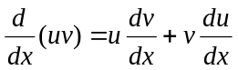 quotient rule: 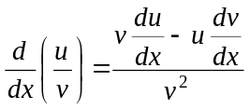
chain rule: 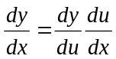 approximation: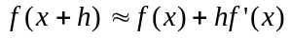

Probability
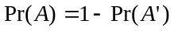
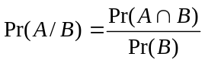
mean: 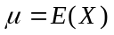 variance:

probability distribution |  | mean | variance
discrete | 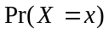=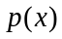 | 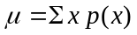 | 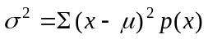
continuous | 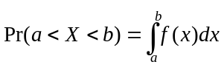 | 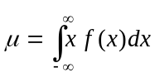 | 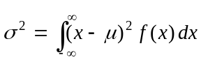
Reproduced with permission of the Victorian Curriculum and Assessment Authority, Victoria, Australia.
This formula sheet has been copied in 2006 from the VCAA website www.vcaa.vic.edu.au
The VCAA publish an exam issue supplement to the VCAA bulletin.
