VCE Physics Pilot Unit 4 Sample Exam Solutions

There were some poorly expressed questions. Here are some corrections and clarifications to the paper.

Light and Matter
3 Write down, in terms of the length AD an expression for the path difference.
5 The last line of the preamble simply means that the students know the frequency of the light from the light source.
7-9 The wavelength of the x-rays is 35 x 10⁻¹² m = 35 pm (picometres)
10 Check that the outer shell is labelled n = 3 (It is not labelled such on some older copies.)
Electric Power
2 Use arrows to indicate the direction of the field.
7 No value for the size of the field is given. Assume the field of the magnet is 5 cm wide.
9 Note that the magnetic field in the lower diagram is not oriented the same way as that in the upper diagram.
11 Amend question to state: i) State Faraday’s law ii) Use Faraday’s law to …
Synchrotron
7 This question seems rather vague. It could be answered simply by quoting the law, but I assume the intention is to ask about the assumptions underlying the law. It could be reworded thus:
“Explain the assumptions underlying the way in which Bragg used the concept of diffraction to determine the angles at which x-rays would be significantly deflected.”
Photonics
5-7 Point P should be where the light meets the cladding. Remember that light of shorter wavelengths generally has a slightly higher refractive index.

Solutions Section A - Core
Area 1 Light and Matter
1 A, D (2) Constructive interference occurs when the waves are in phase.
2 In order to produce the interference pattern it is necessary that the phase difference in the light from the two sources is constant (1). Although the light from lasers is coherent, there is no fixed relationship between the phases from two different lasers. (1).
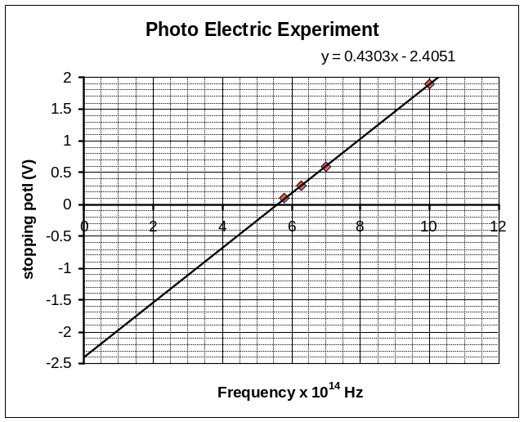
3 The path difference is BD (1) which = (AB² – AD²)^{½} or (5² – AD²)^{½} mm (1) (Given P is a long way away.)
4 When the path difference is an even number of half wavelengths, constructive interference produces a bright band. (1) If the path difference is an odd number of half wavelengths, destructive interference produces a dark band. (1)
5 See graph at right. (3, one mark off for each incorrect plot)
6 6.9 x 10⁻³⁴ J.s (3) h is found from the slope of the graph (1), slope = 1.9/(10–5.6) = 0.43 (1), So h = 4.3 x 10⁻¹⁵ eV.s = 6.9 x 10⁻³⁴ J.s (1)
7 The patterns appear similar because in both cases we have a diffraction pattern caused by the wave nature of the electrons or photons. (1) The wavelength of the electrons must also be around 35 x 10⁻¹² m = 35 pm (picometre) = 0.035 nm (1)
8 35.5 keV (2) E_{ph} = hc/λ = 1242/(0.035) (1) = 35.5 keV (1)
9 35 pm (2) The de Broglie wavelength of the electrons must be about the same as that for the x-rays, that is, about 35 pm. (No need to calculate it, but could do it via momentum – not energy!)
10 The ‘shells’ represent energy levels associated with standing electron waves around the atom. Only those energy levels are possible. (1) The atom can only take in energies which correspond to the differences between energy levels. (1). As the atom drops down to the ground (n=1) level, photons are emitted with energies corresponding to the differences between levels. (1)
11 3 (2) This state seems to have 3 wavelengths around the circumference and hence it is the n=3 level.

Area 2 Electric Power
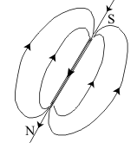
1 The current flowing creates a magnetic field which points along the length of the coil. (1). The many coils increase the total strength of the field. (1). The iron nail is magnetised by the field and adds its own field to amplify the total field many times. (1)
2 i) The lower end is the north pole end (the field lines point downwards through the coils) (1)
ii) The lines point downwards through the nail, out from the bottom of it, and then sweep upward to the top of the nail (see diag at right). (1)
3 Closed for a few seconds – no deflection (no changing B field). (1)
Returned to open position – deflects momentarily⇨RIGHT (1) (opposes change of field).
4 6 V (2) V_{QR} = V_{p} x N_{QR}/N_{p} = 240 x 30/1200 (1) = 6 V (1)
5 Points to be connected: Q-U (1), R-S (1), T-V (1) as the two coils must be in series to provide 24V.
6 D (2) Diag D is correct (B field goes from N to S), use right hand rule. (2)
7 4.0 amp (2) F = IlB and so I = F/lB = 0.02/(0.05x0.1) (2) = 4.0 amp (2) [Note correction: Assume the field of the magnet is 5 cm wide.]
8 The wire would vibrate (1) up and down (1) with a frequency of 50 Hz . The vibrations may not be visible if it is a heavy wire.
9 From left to right the voltage is sinusoidal: 0, V_{max}, 0, –V_{max}, 0 (note, or: 0, –V_{max}, 0, V_{max}, 0) (2)
10 The voltage increases with increasing speed. (2)
11 i) Lenz’s law: The induced current in a coil must oppose the change of flux. (Original question)
i) Faraday’s law: The EMF generated in a loop is proportional to the rate of change of magnetic flux. (1)
ii) Lenz’s law cannot explain 10. Faraday’s law tells us that the EMF is proportional to the rate of change of flux and thus if the rate is increased (1) so is the EMF. (1)
12 Circle the words shown: AC, Transformed, Voltage, Currents, High, Low, Increase, 100.
13 C (2) There is a greater voltage drop in the longer wires. Note that lamp 1 is dimmer than lamp 2 as the voltage drop in the wires to it is greater because of the greater current due to lamp 3.
14 1.0 ohm (3) The lamps are rated as 12 W and thus they operate at 1 A (1). As this current caused a 1 V drop in the lead the resistance must be R = ΔV/I (1) = 1.0 ohm. (1) [Actually the current would have been a little less as the voltage at the lamp was only 11 V, and so the resistance must be slightly greater than 1ohm.]
15 9 V (2) Assuming that lamp 3 causes another 1 V drop in the first section of lead, there will have been a 2 V drop between the battery and lamp 1 (1) and another 1 V drop between lamps 1 and 3 (1), hence the voltage at lamp 3 will be close to 9 V.
16 17 V (2) Voltage P is the peak voltage 12 x √2 (1) = 17 V (1)
17 15 ms (2) This is three quarters of a period and so is 20 ms x 0.75 (1) = 15 ms (1)
[T = 1/50 = 0.02 s = 20 ms]

Solutions Section B - Detailed Studies
1. Synchrotron and applications
1 Synchrotron radiation compared to conventional x-rays
• can be coherent rather than incoherent (1)
• is much more intense (1)
• is bright enough so that it can be filtered to produce an intense narrow wavelength band
• comes as a highly collimated narrow beam (1)
• can be linearly or circularly polarised (1)
• for all these reasons it is much more useful in determining the structure of materials and molecules
2 Thomson A (elastic scattering), Compton B (inelastic), Photoelectric D (absorption, x-ray vanishes, so does it really have zero energy?)
3 7100 V (3) For the electrons ½mv² = eV (1) and so V = mv²/2e (1) = 7100 V or 7 kV (1)
4 In a linac electrons are accelerated between ‘drift tubes’. (1) Inside the tubes the electrons experience no electric field and do not accelerate. (1). In the gap between tubes the electrons experience a field which accelerates them. (1) The relative potential of the tubes alternates in such a way that the next one appears positive to the electron when it emerges from the previous one. (1)
5 D (2) Energy must be lost if energy is radiated away.
6 2.4 x 10⁻¹⁸ kg.m/s (3) For electrons moving in a magnetic field: p = rqB (1)
p = 10 x 1.6x10⁻¹⁹ x 1.5 (1) = 2.4 x 10⁻¹⁸ kg.m/s (1)
7 Bragg’s law states that nλ = 2dsinθ for constructive interference of x-rays (1), d is the spacing between the crystal layers and θ is the angle at which the x-rays strike the crystal (1), so the 2dsinθ is the path difference between x-rays that have been diffracted from different layers (1). if the path difference is a whole number of wavelengths, nλ, there will be constructive interference (1), this leads to a greater number of photons being detected at these angles (1)
8 1.9x10⁻¹¹ m (1) From Bragg’s law, nλ = 2dsinθ (1), , where n is 1 and θ = ½ x 27º as the angle shown is 2θ. In this case: λ = 2 x 40 x sin13.5º (1), = 18.7 pm (1),
λ = 1.9x10⁻¹¹ m
9 B (2) From Bragg’s law, nλ = 2dsinθ, if the angle is greater, for x-rays of the same wavelength the spacing d must be smaller. Answer B.

2. Photonics
1 Laser light is produced by stimulated emission from excited atoms and thus is coherent and in phase. (1). As the photons are all of the same energy the wavelength of the light is the same, ie., monochromatic. (1). The filtered beam from the incandescent lamp will still have a narrow range of wavelengths. (1). It will also be incoherent and consist of pulses of random phase. (1)
2 Electric stove: B (that is, infra red); Blue theatre light: A (the shorter wavelength end of the visible spectrum); Sodium vapour lamp: C (narrow spectrum source) (3)
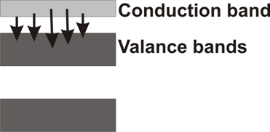
3 Two approaches could be taken:
i) The electrons in a LED are either in a valence band or a conduction band (see diagram of bands). (1) The current through the forward biased LED gives electrons energy to reach the conduction band. (1). As they fall back to the valence bands (1). they emit photons with energy equal to the difference between the bands – the band gap (but this energy varies over a range depending on the width of the bands. (1).
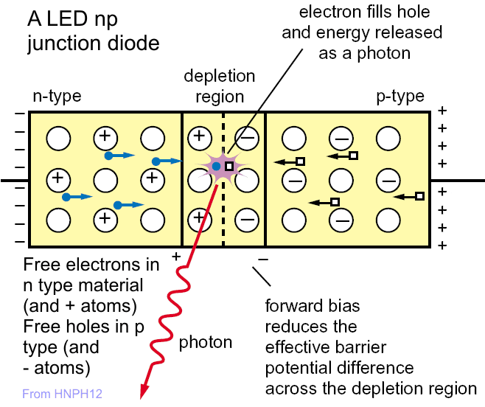
ii) In a forward biased PN junction (see diagram) electrons and holes recombine as the two meet in the depletion layer. (1). As this happens they release energy in the form of a photon (1). E_{ph} will equal the energy needed to cross the depletion layer (1), which is equal or more than the ‘strike voltage’ of the diode and is equal to the ‘band gap’ as described in 1). (1).
4 2.0 eV (2) The band gap energy is equal to the energy of the photons: E_{ph} = hc/λ = 1242 / 615 (1)= 2.0 eV (1).
(Note:hc = 4.14 x 10⁻¹⁵ x 3 x 10⁸ = 1242 eV.nm)
5 D (2) The cladding must have a lower refractive index than the core/.
6 1.50 (2) As the beam goes from air into the core: n₁ x sin 6º = 1 x sin9º and so n₁ = 1.50 (or 1.497)
7 D (2) As green light will refract slightly more it will meet the cladding beyond P.
8 B Answer B is the only reasonable one. Note that no materials have n < 1 as in A, and although D might work it is impracticable (and pointless) to have a refractive index of 1.0 in the centre.
9 At 1000 nm most of the losses are due to Rayleigh scattering (1), that is, the scattering of the light waves from the structure of the glass itself (1). A little will be due to absorption by impurities. (1)
10 D This will be due to absorption.

3. Sound
1 M1 is dynamic (D) and M2 is electret condenser (A) OR could be interpreted as a crystal microphone (B). (2)
2 M1: The sound wave vibrates the moving coil in the magnetic field. (1) This induces a small current in the coil which is the signal out. (1)
M2: The sound wave vibrates the diaphragm which is permanently charged (polarised). (1) The diaphragm is effectively one side of a capacitor. (1) As the capacitance changes a tiny current is induced and hence a signal voltage appears across the resistor. (1) OR A piezoelectric crystal attached to the diaphragm produces a voltage when subject to the variations in pressure.
3 D (2) 200 Hz to 10 kHz is the flat region
4 C (2) 4kHz has a higher relative response
5 B (2) Longitudinal wave
6 Sound waves are longitudinal pressure waves in air (1). They cause the air, and anything light enough suspended in it, to vibrate backwards and forwards in the direction of propagation. (1)
7 D (2) Sound spreads.
8 Sounds from a speaker diffract in a similar way to those coming through any gap. (1) Long wavelengths (low frequencies) will diffract widely as the wavelength is of the order of size of the speaker or greater. (1) High frequencies will not diffract as much as the wavelength is quite a bit less than the size of this speaker (which is why tweeters are small and dome shaped). (1)
9 97 dB (2) From L = 10log(5x10⁻³/10⁻¹²) (1) or, simply 90 + 10log 5 (1)
10 300cm (2) From graph about 300 cm (+/– 20 cm)
11 8 cm (2) About 8 cm (+/– 2 cm)

