INSIGHT PRACTICE EXAM (solutions)

Area of study 1

Electric Power

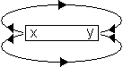

- X

- 0.0024 N

- C

- The coil will not rotate.
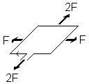

- 1.6 × 10⁻⁴ Wb

- 0.64 V

- B

- The best design is B. Karlii is correct.

The current is DC and therefore needs to change direction every half cycle in order to keep the loop rotating in the same direction (anticlockwise).

Only B does this: A will not work as the commutator does not disengage when the loop is at right angles to the magnetic field thus, preventing the loop from continuing to rotate. It will be held horizontal.

- 20 A

- N_{S} = 50 turns

- 40 W

- R = 0.1 Ω

Connect the transformer to the end of the cables at the pump. This will reduce the line current in the cables.

Since P_{LOSS} = I²R, lower current results in lower power loss.

Transformer P_{in} = P_{out} = 240 W = VI = 12 x 20 at pump.

At mains 240 W = VI = 240 x I so current in cables is 1 A

P_{LOSS} = I²R = l² x 0.1 = 0.1 W

- A

When S closes, coil X starts to conduct and induces a magnetic field to the right in the iron rod.

Coil Y will generate a magnetic field to the left to oppose this change in flux.

A current will flow clockwise around circuit Y. The galvanometer needle will indicate this by deflecting (to the right).

Once the field in coil X is established and no longer changes, coil Y stops inducing a magnetic field.

The current ceases to flow in circuit Y and the needle returns to its original position.

- I
Right hand grip rule

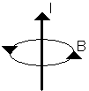

Area of study 2
Interactions of Light and Matter

- 1.828 eV

- 1.823 eV

- Caesium

- B
B is correct as intensity will increase the number of photoelectrons emitted - that is, the current increases.

The maximum kinetic energy of the photoelectrons remains unchanged so the stopping potential does not vary.



- 0.218

- 0.1393 keV < 2.6 keV
∴electron’s KE is less than the 2.6 keV of the photon

- C

The electron gains enough energy to jump beyond the 5th energy level.
OR
It can escape the attraction of the nucleus and become a free electron.

The atom is no longer neutral; it has a +1 charge; it is now an ion. The answer must state that the atom is ionised for full marks.

No, it is not possible.

Interference patterns rely on path difference (distance from each slit to a point).
OR
Constructive interference (maxima) occur when the path difference is equal to a whole number of wavelengths (or zero) path difference = nλ (λ = 0,1,2,...)

Destructive interference (minima) requires the path difference to be p.d. =
(n+ '/₂) λ, where n = 0,1,2,...
OR
The central line is always equidistant between the two slits, so the path difference is always zero, hence only a central maximum is possible.

Detailed study
Recording and Reproducing Sound

- 339.1 ms⁻¹

- D
D is correct.

Resonance is constructive interference between reflected waves and new waves in a tube.

Reflection will always occur but it will not make the sound louder.

Diffraction is the spreading out of waves as they exit a gap comparable to their wavelength.

Refraction occurs when waves change media.

- L₁ = 0.314 m

But 1 < L < 2
L₄ = 4 × 0.314 = 1.256 m

540 Hz is the fourth harmonic for this length

Convert 80 dB into an intensity: I = 1 × 10⁻⁴ W m⁻²

Calculate the intensity at 2 m: I = 6.25 × 10⁻⁴ W m⁻²

The jackhammer intensity is just too high so the equipment is unsafe to use.

- A
A would give the best acoustic performance as it has baffles to separate each driver in the airtight enclosure. This prevents changes in air pressure from affecting driver movement.

High-frequency sound is very directional so it is better for the tweeter to be higher up, whilst low-frequency sound is not, so the larger drivers can be closer to the floor without affecting sound clarity.

- B
B is the best choice as this driver is similar in sound level It has a flat response in the region where it overlaps the frequency response curves of the woofer and tweeter.

3 marks
Simone is correct.
Low frequencies diffract more than high frequencies.
Or draw a diagram to explain diffraction.

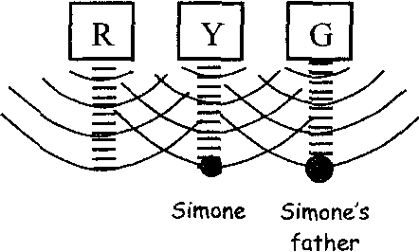
Low frequency spread out
High frequency travel in straight lines

Simone is in front of the central speaker so she can hear sound from all speakers. Her father is in front of speaker G and he struggles to hear any high frequency from speaker R.

- B
Of those listed only the velocity (or ribbon) microphone does not use a diaphragm. Instead it uses a thin aluminium ribbon in a magnetic field which responds to changes in air speed to generate a current.

- 9.66 cm

- C
A pipe one at one end can only produce odd harmonics.

