Response to Reviewer Comments
Manuscript #18579
Revised title: “Byzantine-Robust Federated Learning with Adaptive Aggregation and Blockchain: Empirical Validation of ATMA and Resolution of the Transparency Paradox”
We thank the editor and reviewers for their constructive comments. The manuscript has been rebuilt around one reproducible protocol. This revision distinguishes the implemented MAD-ATMA rule from FedATM and later ATMA work, adds equal-client and ledger-informed attacker experiments, reports measured write-once blockchain evidence, includes the required declarations and readable figures, and uses native ETASR Word styles. The original title is restored, while the manuscript now makes clear that the empirical validation claim concerns the executed MAD-ATMA variant and the bounded Transparency Paradox protocol rather than all ATMA-family algorithms. The comments, answers, and revised manuscript are supplied in one Word file as requested.

Reviewer A
Comment A1: “Attack types are limited to label-flip and random noise; sophisticated attacks (ALIE [18], backdoor [20]) require future study.” Rephrase this as the citations look strange now.
Answer: The limitation is now stated with named authors and methods: “This study evaluates one combined untargeted attack consisting of cyclic label flipping and scaled model updates. More sophisticated attacks, including the A Little Is Enough attack introduced by Baruch et al. [10] and targeted backdoor attacks studied by Sun et al. [11], remain outside the present scope.” The references now unambiguously identify the cited attacks.
Comment A2: Figures 1–2 not readable.
Answer: Figures 1–3 were regenerated directly from the final three-seed result file at their actual one-column publication width and 300 DPI. Figure 1 reports mean convergence with one-standard-deviation bands. Figure 2 reports final mean accuracy with $t$-distribution 95% confidence intervals, and Figure 3 reports the measured transparency tradeoff. Fonts, labels, line widths, markers, and legends were set for the final displayed size.
Comment A3: Conclusion (and article) too short I think.
Answer: The manuscript now provides a complete threat model, exact implementation parameters, formal aggregation equations, a step-by-step procedure, computational considerations, statistical analysis, measured blockchain evidence, a security-scope discussion, limitations, and an expanded conclusion. The manuscript body has also been expanded toward the journal’s standard article length.
Comment A4: Expand it to include comparative analysis, contribution discussion.
Answer: Sections 3 and 4 now compare clean FedAvg, attacked FedAvg, Krum, TrimmedMean, and the implemented adaptive rule under the same configuration. The discussion distinguishes accuracy, robustness, adaptation, assumptions, computational cost, and auditability. We report that no statistically significant final-accuracy difference was detected between adaptive and static trimming in this three-seed experiment. We now explicitly distinguish the implemented distance–MAD rule from FedATM by Nishimoto et al. (2023), which ranks clients using inter-model distances and a distance threshold, and from the variance-aware, layer-wise ATMA framework published by Mukisa et al. in 2025. The expanded comparison also evaluates blind and ledger-informed attackers under identical MAD-ATMA settings and reports both attacker evasion and defender audit evidence.

Reviewer B
Comment B1: It is not clear what EXACTLY the authors did and how (step by step).
Answer: Sections 2.8–2.9 now list the executed procedure step by step. The unified protocol uses the actual MNIST dataset, one fixed CNN architecture, 20 clients, full participation, four fixed Byzantine clients, Dirichlet $α=0.5$ partitioning, 20 rounds, three SGD mini-batches per client per round, learning rate 0.05, seeds 42/43/44, and the same combined label-flip and scaled-update attack for all defended and undefended methods. A separately identified equal-client mean sensitivity run uses the same configuration and tests whether the conclusion depends on FedAvg’s canonical sample weighting. The exact result artifacts are results/unified_mnist_actual.json and results/unified_mnist_equal_weight_sensitivity.json. The Transparency Paradox experiment additionally executes blind and ledger-informed attackers for the same three seeds and stores all model, detection, controller, transaction, and read-back results in results/transparency_paradox_actual.json.
Comment B2: There is no point in throwing a lot of terms without being specific on what you did exactly and how. Not generic information. SPECIFICALLY in this work.
Answer: Generic and unsupported sections were removed. The revised methodology defines every transformation, aggregator, statistical calculation, and blockchain transaction used in this work. The Krum implementation excludes self-distance and uses $n−f−2$ other neighbors. The adaptive rule is stateful, uses a 25% safety ceiling rather than the known 20% Byzantine fraction, and updates its trim ratio from the observed robust outlier fraction. Blockchain evidence comes from an actually deployed write-once Solidity contract on Ganache and includes 420 successful transactions plus deployment. Client hashes, flags, aggregate hashes, submitted counts, flagged counts, and trim counts are all verified by read-back. The revised method also states the aggregation estimand: canonical FedAvg weights clients by partition size, whereas Krum and the trimmed rules are client-symmetric. The equal-client sensitivity baseline exposes the effect of this choice. In the Transparency Paradox experiment, both conditions use identical contracts and training; only the informed attacker reads the previous round’s committed flags through contract view calls.
Byzantine-Robust Federated Learning with Adaptive Aggregation and Blockchain: Empirical Validation of ATMA and Resolution of the Transparency Paradox
Rachmad Andri Atmoko^{1,2}
¹Electrical Engineering Department, Faculty of Engineering, Universitas Brawijaya, Malang, Indonesia | ²Faculty of Vocational Studies, Universitas Brawijaya, Malang, Indonesia | ra.atmoko@ub.ac.id (corresponding author)
Sholeh Hadi Pramono¹
¹Electrical Engineering Department, Faculty of Engineering, Universitas Brawijaya, Malang, Indonesia | sholehpramono@ub.ac.id
Muhammad Fauzan Edy Purnomo¹
¹Electrical Engineering Department, Faculty of Engineering, Universitas Brawijaya, Malang, Indonesia | mfauzanep@ub.ac.id
Panca Mudjirahardjo¹
¹Electrical Engineering Department, Faculty of Engineering, Universitas Brawijaya, Malang, Indonesia | panca@ub.ac.id
Mahdin Rohmatillah¹
¹Electrical Engineering Department, Faculty of Engineering, Universitas Brawijaya, Malang, Indonesia | mahdin94@ub.ac.id
Cries Avian¹
¹Electrical Engineering Department, Faculty of Engineering, Universitas Brawijaya, Malang, Indonesia | cries.avian@ub.ac.id

Abstract
Federated learning is vulnerable to Byzantine clients that transmit malicious model updates. This study empirically evaluates a fully specified adaptive trimmed-mean variant (MAD-ATMA) and tests the Transparency Paradox using an Ethereum-compatible audit contract. All experiments use MNIST, 20 clients, four fixed Byzantine clients, Dirichlet($α=0.5$) non-IID partitions, full participation, 20 rounds, and seeds 42–44. Final accuracy (mean $±$ sample SD) is $82.49\%±1.29\%$ for clean FedAvg, $22.36\%±2.81\%$ for attacked sample-weighted FedAvg, $60.01\%±7.37\%$ for Krum, $78.23\%±1.51\%$ for TrimmedMean, and $78.22\%±1.98\%$ for MAD-ATMA. No significant final-accuracy difference is detected between MAD-ATMA and TrimmedMean ($p=0.967$). Under the fixed attack, MAD-ATMA obtains 96.77% precision, 100% recall, and 98.36% F1 for Byzantine-client flagging. To test transparency, blind and ledger-informed attackers use identical training, contracts, and initial attack scale; only the informed attacker reads prior on-chain flags. Ledger information reduces detection recall from 100% to 47.5% and reduces final accuracy from $78.22\%±1.98\%$ to $76.59\%±1.65\%$ ($−1.62$ points, paired $p=0.0145$). Across six deployed contracts, 2,400 client commitments and 120 round summaries pass read-back verification. Thus, transparency materially aids evasion but yields a limited utility loss while preserving a complete read-back-verified record of committed fields; this measured tradeoff operationally bounds the paradox for the stated threat model.
Keywords: federated learning, Byzantine robustness, ATMA, adaptive attacker, blockchain auditability, transparency paradox

Introduction
Federated learning (FL) trains a shared model from decentralized client data by aggregating locally computed updates [1]. Data heterogeneity, partial trust, and adversarial clients remain central open problems in FL [2]. A Byzantine client may submit an arbitrary update, so ordinary weighted averaging can be driven far from the update supported by honest clients. This problem is particularly difficult under non-independent and identically distributed (non-IID) data because honest client updates may already differ substantially.
Recent journal surveys organize trustworthy FL around mutually dependent requirements for privacy, security, robustness, transparency, and accountability [3, 4, 5, 6]. They also stress that defenses should be evaluated under explicit threat models and data heterogeneity rather than treated as interchangeable security components. This study follows that guidance by separating robust aggregation, anomaly diagnostics, and blockchain audit evidence.
Krum selects one update that is geometrically close to other updates and was introduced as a Byzantine-resilient alternative to linear aggregation [7]. Coordinate-wise median and trimmed mean estimators provide another family of robust methods with statistical guarantees [8]. These defenses have different behavior under non-IID data: Krum retains one client update, whereas trimmed estimators combine coordinate-level information from several clients. Their assumptions also differ. Krum and static TrimmedMean require a Byzantine bound $f$. Krum uses that bound to define its neighbor count; TrimmedMean uses it to determine how many values are removed from each coordinate tail. Secure aggregation creates an additional design dimension: SEAR demonstrates that privacy-preserving aggregation and Byzantine resilience can be combined through a trusted execution environment, but this changes the trust and system assumptions [9]. The present experiment instead keeps model aggregation in ordinary PyTorch and uses blockchain only for post-computation commitments.
Attack strategies extend beyond conspicuous large outliers. Baruch et al. [10] showed that small distribution-aware perturbations can evade several robust rules. Sun et al. [11] studied targeted backdoor attacks in FL. The present experiment intentionally uses one transparent, untargeted attack so that every transformation can be reproduced. Consequently, the results measure robustness to the stated label-poisoning and delta-scaling attack, not to arbitrary Byzantine behavior.
Blockchain has also been proposed as an audit and coordination layer for FL [12, 13]. It cannot by itself determine whether an update is malicious, but it can preserve update commitments and aggregation decisions after an off-chain detector has produced them. This distinction is important: auditability should not be presented as an improvement in model accuracy. Recent surveys of blockchain-empowered and decentralized FL likewise distinguish provenance and verifiability from model robustness, while identifying consensus, resource cost, and new attack surfaces as separate concerns [14, 15]. Public audit data can also expose detector decisions to an adversary. This creates the Transparency Paradox studied here: the same visibility that supports accountability may supply feedback for attack adaptation. We examine this empirically by holding training and blockchain logging fixed while varying only whether the attacker can read prior committed anomaly flags.
The broader trustworthy-FL literature classifies robust aggregation as one component of a system that must also state its privacy, fairness, and accountability assumptions [16]. Nishimoto et al. proposed FedATM, an adaptive trimmed-mean defense that ranks clients according to distances between local models and uses a distance-based threshold to determine which models are retained [17]. The name adaptive trimmed mean aggregation (ATMA) was later used by Mukisa et al. [18] for a variance-aware, layer-wise IDS framework with a permissioned blockchain. The method evaluated here is not a reproduction of either algorithm. To avoid conflation, this paper calls the implemented rule MAD-ATMA. It constructs a coordinate-wise median reference, scores each client’s full update distance using a median-absolute-deviation (MAD) statistic, converts the observed flagged fraction into one smoothed per-tail ratio, and then performs coordinate-wise trimming. Its contribution is this explicit detector-to-trim mapping plus measured audit-contract integration, not the first use of adaptive trimming in FL. Accordingly, every empirical claim below refers to the executed MAD-ATMA rule and should not be read as a reproduction or validation of FedATM or the later variance-aware, layer-wise ATMA framework.
The contributions of this work are:
- a single controlled comparison of clean FedAvg, attacked FedAvg, Krum, TrimmedMean, and MAD-ATMA under identical data, model, attack, and optimization settings;
- a corrected Krum implementation and an explicitly defined adaptive distance–MAD trimming rule distinguished from FedATM and later ATMA work;
- a separate equal-client mean sensitivity baseline that quantifies the effect of canonical FedAvg sample weighting under unbalanced partitions;
- a controlled three-seed Transparency Paradox experiment comparing blind and ledger-informed attackers with identical contracts, attack initialization, data, model, and optimization;
- three-seed results with sample standard deviations and $t$-distribution confidence intervals, with cautious interpretation due to the small number of seeds;
- measured evidence from seven write-once contract deployments across the main audit and transparency experiments, including transaction receipts, overwrite guards, view calls, and read-back of all client and round-summary fields.

Methodology

Experimental Protocol
Table 1 is the single source of truth for all accuracy comparisons.
- Unified Experimental Configuration
Parameter | Value
Dataset | MNIST, 60,000/10,000 [19]
Model | CNN, 105,866 parameters
Clients | 20
Clients per round | 20 (full participation)
Byzantine clients | IDs 0–3 (20%)
Data partition | Dirichlet $α=0.5$
Communication rounds | 20
Local work | 3 mini-batch SGD steps
Batch size | 64
Optimizer | SGD without momentum
Learning rate | 0.05
Attack scale | 5.0
MAD-ATMA ratio bounds | 0.05–0.25
Seeds | 42, 43, 44
The model contains two convolutional layers with 16 and 32 channels, two max-pooling layers, a 64-unit fully connected layer, and a ten-class output layer. Inputs are normalized with the MNIST mean 0.1307 and standard deviation 0.3081. For each seed, class-specific training indices are divided among 20 clients with a Dirichlet distribution. The same partition and deterministic mini-batch order are reused across methods for that seed. Client datasets range from 909 to 6,632 images, so every client executes exactly three mini-batches per round. The four Byzantine clients account for 26.60%, 19.11%, and 24.35% of training samples in seeds 42, 43, and 44, respectively. These fractions differ from the fixed 20% client fraction because the partition is unbalanced.

Threat Model
Clients 0–3 are Byzantine in every attacked run. During local training, a Byzantine client replaces each label by
$$y^{′}=(y+1) mod 10.$$ (1)
Let $Δ_{i}^{t}=w_{i}^{t}−w^{t}$ be the local model delta produced from global model $w^{t}$. A Byzantine client transmits
$${\tilde{Δ}}_{i}^{t}=5Δ_{i}^{t},$$ (2)
thereby amplifying the update learned from poisoned labels. Honest clients transmit $Δ_{i}^{t}$. The attack is applied in every round. A clean FedAvg run with identical optimization settings but no Byzantine behavior provides the upper comparison baseline. The server, blockchain coordinator, and test set are trusted. The experiment does not model a malicious server, coordinator collusion, privacy leakage, network dropout, or client impersonation.

FedAvg and Aggregation Weighting
For client sample counts $n_{i}$, FedAvg computes
$$Δ_{FA}^{t}=\sum_{i=1}^{N}{\frac{n_{i}}{\sum_{j=1}^{N}{n_{j}}}}Δ_{i}^{t}.$$ (3)
The weight $n_{i}/\sum_{j=1}^{N}{n_{j}}$ targets the global empirical objective in which every training example has equal influence. In this experiment, however, every client executes the same three mini-batches per round. Consequently, $n_{i}$ describes the size of the client’s full partition rather than the number of examples processed in that round. Attacked FedAvg is therefore influenced by the seed-specific sample share of the four Byzantine clients. This is the canonical FedAvg estimand, but it is not identical to the client-symmetric estimand used by the robust aggregators.
Krum, TrimmedMean, and MAD-ATMA use their standard client-symmetric vector rules; weighting them by $n_{i}$ would define different robust aggregators and is not done here. This means that the primary comparison evaluates deployed aggregation rules, not identical estimands. To make the effect visible, a sensitivity baseline computes the attacked equal-client mean
$$Δ_{EQ}^{t}=\frac{1}{N}\sum_{i=1}^{N}{Δ_{i}^{t}}$$ (4)
under the same data, seeds, attack, local work, and rounds. It is reported separately as “equal-client mean,” not as canonical FedAvg.

Krum
For $N$ submitted updates and a Byzantine bound $f$, the score of update $i$ is
s(i)=j∈Ni​∥Δit−Δjt∥22, (5)
where $N_{i}$ contains the $N−f−2$ nearest other updates. Self-distance is set to infinity before neighbor selection. Krum returns the single update with minimum score. Here $N=20$ and $f=4$, satisfying $N≥2f+3$. Flattening a $d$-parameter update gives an $O(N^{2}d)$ distance computation and $O(N^{2})$ distance storage.

Static TrimmedMean
For coordinate $q$, the 20 scalar values $\{Δ_{i,q}^{t}\}_{i=1}^{20}$ are sorted. Static TrimmedMean removes four values from each tail and averages the remaining 12:
$$Δ_{TM,q}^{t}=\frac{1}{N−2f}\sum_{i=f+1}^{N−f}{Δ_{(i),q}^{t}}.$$ (6)
This static baseline is explicitly supplied with the correct bound $f=4$. Coordinate sorting has $O(dNlogN)$ time and combines values from 12 clients at each coordinate.

Distance–MAD Adaptive Trimmed Mean
MAD-ATMA first flattens each update and computes the coordinate-wise median vector $m^{t}$. Client distance is
$$d_{i}^{t}=∥Δ_{i}^{t}−m^{t}∥_{2}.$$ (7)
Using the median distance ${\tilde{d}}^{t}$ and median absolute deviation $MAD(d^{t})$,
$$MAD(d^{t})={median}_{i}\left|d_{i}^{t}−{\tilde{d}}^{t}\right|,$$ (8)
the robust score is
$$z_{i}^{t}=\frac{d_{i}^{t}−{\tilde{d}}^{t}}{1.4826MAD(d^{t})+ϵ}.$$ (9)
Here $ϵ$ is the update dtype machine epsilon used in the implementation (torch.finfo(dtype).eps); it prevents division by zero and is not a tunable hyperparameter. Clients with $z_{i}^{t}>3.5$ are flagged. If ${\hat{p}}_{t}$ is the flagged fraction, the per-tail trim ratio is updated by
$$r_{t}=clip\left[r_{t−1}+η\left(clip({\hat{p}}_{t},0.05,0.25)−r_{t−1}\right),0.05,0.25\right],$$ (10)
with $r_{0}=0.10$ and $η=0.50$. MAD-ATMA then applies coordinate-wise trimmed mean with $k_{t}=round(Nr_{t})$ values removed from each tail. The 25% ceiling is a prespecified safety bound and is not set to the experiment’s known 20% Byzantine fraction. The detector adds $O(Nd)$ work before the same $O(dNlogN)$ coordinate sorting used by TrimmedMean. Flags are diagnostic: flagged vectors remain in the coordinate pool, while extreme coordinate values are removed by trimming.

Blockchain Audit Contract
The Solidity contract stores an update-hash mapping indexed by round and client, the corresponding anomaly flag, and a round summary containing the aggregate hash, submitted count, flagged count, trim count, and timestamp. Boolean existence mappings make every round–client slot and every round summary write-once: duplicate writes revert. The coordinator submits SHA-256 commitments; model tensors are not stored on-chain. The contract was compiled with Solidity 0.8.19 and deployed to Ganache chain 1337. Blockchain logging was enabled for the main MAD-ATMA audit with seed 42 and for all six Transparency Paradox runs. Ordinary aggregator accuracy comparisons do not use blockchain state and are therefore not attributed to blockchain.
After each successful transaction, the experiment reads the client commitment, flag, and existence bit from the contract. After finalization, it reads the aggregate commitment, submitted count, flagged count, trim count, timestamp, and finalized bit. Local calls that attempt to overwrite an existing client record or finalized round are required to revert. These checks establish write-once behavior for this contract under the trusted-coordinator assumption; they do not establish decentralized consensus or prevent the coordinator from submitting a false value initially.

Transparency Paradox Protocol
The Transparency Paradox experiment compares two MAD-ATMA conditions for each seed. Both deploy a fresh contract, record the same fields, begin with attack scale $a_{1}=5$, and use the same data partition, client batches, Byzantine IDs, label shift, model, optimizer, and rounds. In the blind condition, the attacker cannot read anomaly flags and keeps $a_{t}=5$. In the ledger-informed condition, before round $t>1$ the attacker issues four flag queries for the Byzantine clients from round $t−1$. Each query uses one existence view call and one flag view call.
Let $q_{t−1}$ be the fraction of the four Byzantine clients flagged in the previous round. The prespecified feedback controller is
$$a_{t}=clip\left(a_{t−1}c(q_{t−1}),1,5\right),$$ (11)
where
$$c(q)=\left\{\begin{matrix}0.70, & q≥0.75, \\ 1.10, & q≤0.25, \\ 0.90, & \text{otherwise}.\end{matrix}\right.$$ (12)
The attacker therefore trades update magnitude for lower detection risk using only public ledger feedback. Contract reads do not create transactions or change state. Attacker benefit is measured by Byzantine detection recall, the undetected-update fraction, and final model accuracy. Defender benefit is measured by successful commitments and complete contract read-back.

Executed Procedure
For each seed and method, the implementation executes:
- set Python, NumPy, PyTorch, and CUDA seeds;
- load and normalize MNIST;
- create the seed-specific Dirichlet partition;
- initialize the same CNN architecture;
- copy the global model to each of the 20 clients;
- perform three deterministic mini-batch SGD steps;
- poison labels and scale deltas for clients 0–3 in attacked runs;
- aggregate all 20 deltas using the selected method;
- update and evaluate the global model on all 10,000 test images;
- for the audited MAD-ATMA run, submit all update hashes and the complete round summary, wait for receipts, and read every stored field back;
- for each transparency condition and seed, deploy a fresh contract, repeat the same MAD-ATMA training, and permit only the informed attacker to read prior Byzantine-client flags before choosing the next attack scale;
- serialize per-round metrics, metadata, receipts, and summaries to results/unified_mnist_actual.json; the equal-client sensitivity run is serialized separately to results/unified_mnist_equal_weight_sensitivity.json, and the transparency experiment to results/transparency_paradox_actual.json.
OpenAI Codex was used during revision to assist code inspection and editing, experiment orchestration, consistency checks, language editing, and LaTeX/Word document preparation. Experiments were executed locally from the reviewed scripts; numerical outputs and figures were generated programmatically from the recorded results rather than invented or manually altered. The authors reviewed the code, execution logs, results, figures, and manuscript.

Statistics
Final accuracy is summarized across three seeds with the sample standard deviation. The 95% confidence interval uses Student’s $t$ distribution with two degrees of freedom. Paired, two-sided $t$ tests use seed-matched final accuracies. Because $n=3$, inferential results are interpreted as supporting evidence rather than broad population estimates. In particular, failure to reject a difference is not treated as proof of statistical equivalence. The Transparency Paradox comparison uses a paired two-sided $t$ test for seed-matched blind and informed final accuracies; detection outcomes are reported descriptively because blind recall is at the 100% ceiling for every seed.

Results
- Final MNIST Accuracy Across Three Seeds
Method | Mean (%) | SD | 95% CI
FedAvg (clean) | 82.49 | 1.29 | [79.28, 85.69]
FedAvg (attack) | 22.36 | 2.81 | [15.39, 29.33]
Equal-client mean (attack) | 31.94 | 7.06 | [14.41, 49.48]
Krum | 60.01 | 7.37 | [41.71, 78.32]
TrimmedMean | 78.23 | 1.51 | [74.47, 81.99]
MAD-ATMA | 78.22 | 1.98 | [73.29, 83.14]
The attack reduces sample-weighted FedAvg from 82.49% to 22.36%, a mean decrease of 60.12 percentage points. The attacked equal-client mean reaches $31.94\%±7.06\%$ (95% CI 14.41–49.48%), 9.58 points above attacked sample-weighted FedAvg ($p=0.070$). Thus, weighting materially affects the undefended baseline, although the three-seed difference is not statistically significant. Krum improves on the equal-client mean by 28.07 points, TrimmedMean by 46.29 points, and MAD-ATMA by 46.27 points. Relative to the prespecified sample-weighted FedAvg baseline, Krum improves accuracy by 37.65 points, TrimmedMean by 55.87 points, and MAD-ATMA by 55.85 points. Seed-paired tests give $p=0.018$ for Krum versus attacked FedAvg, $p=0.0019$ for TrimmedMean, and $p=0.0024$ for MAD-ATMA. These values should be read cautiously because only three seeds were evaluated and the intervals are correspondingly wide.
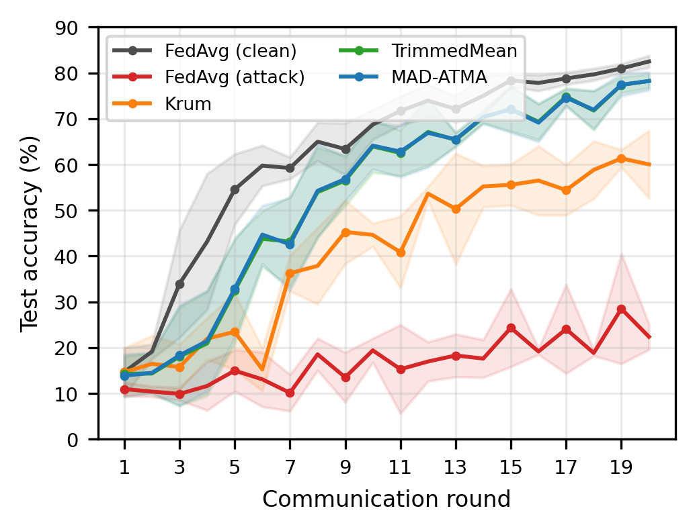
- Mean test accuracy across seeds 42, 43, and 44. Shaded regions show one sample standard deviation. Every method uses the configuration in Table 1.
Figure 1 shows that clean FedAvg converges fastest. Attacked FedAvg remains unstable and low. Krum avoids malicious clients but learns more slowly because each round retains only one client update. TrimmedMean and MAD-ATMA combine coordinate information from several updates and finish close to the clean baseline.
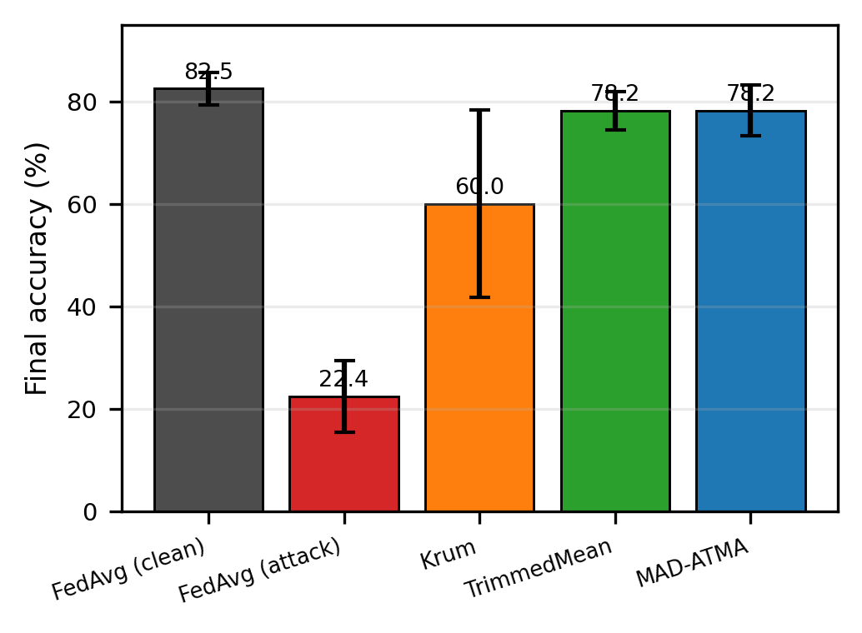
- Final accuracy at round 20. Error bars are 95% confidence intervals computed with Student’s $t$ distribution for three seeds.
MAD-ATMA and TrimmedMean differ by only $−0.01$ percentage points on average, with $p=0.967$. Thus, no significant final-accuracy difference is detected; this is not an equivalence test and does not prove that the methods are identical. MAD-ATMA starts at 0.10, moves to approximately 0.15 after the first round, and reaches final ratios of 0.213, 0.238, and 0.200 for seeds 42, 43, and 44. The observed range across all rounds is 0.150–0.238, demonstrating that the rule is not fixed at the known 20% Byzantine fraction.

Detection and Krum Selection
Across 60 MAD-ATMA rounds, there are 240 Byzantine client-round instances and 960 honest instances. MAD-ATMA produces 240 true positives, eight false positives, no false negatives, and 952 true negatives. Precision is 96.77%, recall is 100%, and F1 is 98.36%. The number of flags per round ranges from four to six. The eight false positives explain why the adaptive ratio sometimes rises above 0.20. These metrics concern the explicit attack used here and should not be interpreted as performance against the ledger-informed condition reported below.
Corrected Krum selects an honest client in all 60 evaluated rounds. Its lower accuracy therefore does not indicate Byzantine selection; it reflects the utility cost of reducing a heterogeneous 20-client round to one update.

Measured Blockchain Evidence
- Measured Ganache Audit Transactions
Operation | Count | Mean Gas
Contract deployment | 1 | 789,893
Client update record | 400 | 76,669
Round finalization | 20 | 159,517
Total measured gas | – | 34,647,901
The audited run deploys contract 0xe78A...a8Ab; the complete address is preserved in the result artifact. Deployment occurs in block 1. The run then records 400 client updates and 20 round summaries in 420 transactions, all with receipt status 1. The final block is 421. Total measured gas including deployment is 34,647,901. All client commitments, flags, existence bits, aggregate commitments, submitted counts, flagged counts, trim counts, timestamps, and finalized bits pass contract read-back verification. Simulated duplicate client and round writes revert without changing block 421. These are local EVM execution measurements, not Ethereum-mainnet cost, latency, or decentralization claims.

Transparency Paradox Results
- Transparency Paradox Results Across Three Seeds
Condition | Accuracy (%) | Recall (%) | Undetected (%) | Scale
Blind attacker | 78.22 $±$ 1.98 | 100.0 | 0.0 | 5.00
Ledger-informed | 76.59 $±$ 1.65 | 47.5 | 52.5 | 1.63
The blind condition reproduces the main MAD-ATMA accuracies ($78.22\%±1.98\%$) and detects all 240 Byzantine client-round updates. The ledger-informed condition performs 228 flag queries, implemented as 456 contract view calls including existence checks, reduces its mean attack scale from 5.00 to 1.63, and leaves 126 of 240 Byzantine updates unflagged. Detection recall therefore falls from 100% to 47.5%.
Final accuracy under ledger information is $76.59\%±1.65\%$, which is 1.62 percentage points below the blind condition. The seedwise reductions are 1.36, 2.01, and 1.50 points, with paired $p=0.0145$. This provides evidence of an attacker advantage for the prespecified feedback controller: public flags improve evasion and are associated with a small additional utility loss.
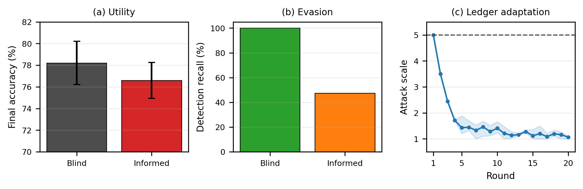
- Measured Transparency Paradox. Blind and ledger-informed attackers use identical training and contracts. The informed attacker reads previous-round flags, lowers its scale, reduces detection recall, and is associated with a 1.62-point additional final-accuracy loss. The band in (c) spans the three seeds.
The defender nevertheless retains complete committed-field audit evidence. Six contracts record 2,400 client commitments and 120 finalized round summaries in 2,520 successful transactions; all stored client and summary fields pass read-back verification. The 456 attacker view calls are state-free and do not modify the ledger. Thus, the empirical resolution is a bounded tradeoff rather than a claim that transparency is uniformly beneficial: transparency aids adaptive evasion while preserving a complete read-back-verified record for subsequent response.

Discussion

Comparative Interpretation
The comparison supports three bounded conclusions. First, the combined label-flip and scaled-update attack severely damages both sample-weighted FedAvg and an equal-client mean. The latter performs 9.58 points better, showing that the reported magnitude of FedAvg degradation is partly sensitive to aggregation weights. The experiment does not establish a monotonic causal relationship between Byzantine sample share and accuracy. Second, coordinate-wise trimming preserves substantially more utility than single-update Krum under the evaluated non-IID partitions. Krum selects no Byzantine update, so its lower accuracy is better explained by discarding information from 19 clients than by a selection failure. Third, MAD-ATMA tracks the observed outlier fraction and obtains essentially the same final accuracy as a static rule supplied with the correct $f=4$ bound. Its demonstrated benefit is automatic adjustment and diagnostic client flags, not superior accuracy.
- Scope of Compared Robust Aggregators
Method | Exact $f$? | Aggregation | Audited here?
Krum | Yes | Single update | No
TrimmedMean | Yes | Coordinate mean | No
MAD-ATMA | No | Adaptive mean | Yes
“No exact $f$” in Table 5 does not mean parameter free. MAD-ATMA uses a robust-score threshold, smoothing rate, and 5–25% safety interval. Its upper limit is intentionally different from the actual 20% Byzantine fraction, but future work must evaluate sensitivity to these hyperparameters and to changing attack prevalence. FedATM of Nishimoto et al. [17] also adapts trimming from model distances, but it ranks local models and applies a distance-based retention threshold. MAD-ATMA instead measures every update against a coordinate-median reference, standardizes those distances with MAD, and smooths the flagged fraction into a bounded coordinate-wise trim ratio. The later ATMA of Mukisa et al. [18] is variance-aware and layer-wise in an intrusion-detection setting. These three methods therefore share adaptive trimming terminology but use different scoring variables, threshold mechanisms, and aggregation pipelines.

Resolution of the Transparency Paradox
The paradox is operationally bounded for the stated experiment by measuring both sides of the same public information. From the attacker perspective, previous-round flags provide useful feedback: the controller more than halves detection recall and produces a statistically detectable 1.62-point additional accuracy loss. From the defender perspective, this adaptation cannot erase or rewrite the 2,520 transactions that expose submitted commitments, server flags, trim decisions, and aggregate commitments.
These quantities are not directly commensurate, so the experiment does not claim a universal net-benefit score. Instead, it rejects two simplistic positions. Transparency is not attacker-neutral because it enables evasion; it is also not equivalent to surrendering integrity because every adaptive action still occurs against a complete committed-field write-once audit record. Operational deployment therefore requires delayed disclosure, access control, or detector randomization when immediate public flags create unacceptable feedback.

Contribution of Blockchain
The blockchain component contributes write-once commitments and reproducible execution evidence, not robust aggregation. Detection is performed off-chain before its output is committed. Storing SHA-256 commitments rather than 105,866-parameter tensors limits on-chain payload size. The contract prevents the coordinator from overwriting a populated round–client slot or finalized round, and later readers can compare local tensors and metadata with the stored commitments.
This guarantee is narrower than saying that the complete FL system is immutable. A trusted coordinator can still commit an incorrect hash on its first write, and the single-node Ganache chain does not provide independent validators. The experiments therefore validate contract execution, write-once storage, transaction receipts, public view calls, and read-back semantics. They do not validate decentralized consensus, public-network latency, client authentication, economic feasibility, or resistance to coordinator compromise.

Limitations
This study uses one dataset, one CNN, 20 clients, 20 rounds, three seeds, and one combined untargeted attack. The local computation is capped at three mini-batches per client per round. Blockchain validation uses a single-node Ganache environment rather than independent validators. No claim is made regarding live Layer-2 deployment, production readiness, or dollar-denominated cost.
The primary FedAvg baseline uses canonical partition-size weighting, whereas the robust rules are client-symmetric. The equal-client sensitivity run reduces this comparability concern but does not replace a broader study of weighted robust aggregators, balanced partitions, or alternative client objectives.
This study evaluates one combined untargeted attack consisting of cyclic label flipping and scaled model updates. More sophisticated attacks, including the A Little Is Enough attack introduced by Baruch et al. [10] and targeted backdoor attacks studied by Sun et al. [11], remain outside the present scope. The fixed Byzantine IDs also make detection easier to interpret but do not test intermittent or colluding attackers. Finally, three seeds are adequate for a reproducible correction but too few for strong claims about population-level superiority or equivalence.
The informed attacker uses one transparent multiplicative controller and reads only binary flags for its own four clients. It does not observe honest-client updates, model tensors, private server state, or future decisions. Alternative controllers, delayed disclosure, randomized detectors, different attack budgets, and public multi-validator chains may produce a different transparency tradeoff.

Conclusion
This work empirically evaluates MAD-ATMA and provides a bounded operational resolution of the Transparency Paradox under one reproducible protocol. A combined label-flip and scaled-update attack reduces sample-weighted FedAvg from 82.49% clean accuracy to 22.36%. Krum reaches 60.01%, while TrimmedMean and MAD-ATMA reach 78.23% and 78.22%, respectively. No significant final-accuracy difference is detected between the two trimmed methods, but MAD-ATMA adapts without being supplied the exact $f=4$ trimming bound and provides diagnostic client flags.
Ledger-informed adaptation reduces detection recall from 100% to 47.5% and is associated with a further 1.62-point accuracy loss ($p=0.0145$), supporting the claim that public flags can aid attacker evasion under this controller. At the same time, six transparency contracts preserve all 2,400 client commitments and 120 round summaries, and the main audit contract preserves another 400 commitments and 20 summaries. The paradox is therefore operationally bounded as a measured tradeoff: immediate transparency creates attacker feedback, while write-once logging preserves evidence that the attacker cannot remove.
Future work should increase the number of seeds and rounds, test larger and more heterogeneous datasets, evaluate partial participation, deploy the audit contract on a multi-node or public test network, and include ALIE, model replacement, targeted backdoor attacks, and sensitivity analysis for the MAD threshold, trim-ratio bounds, feedback controller, and disclosure delay.

Declarations

Declaration of Competing Interests
The authors declare that they have no known competing financial interests or personal relationships that could have appeared to influence the work reported in this article.

Acknowledgment
The authors would like to thank the Electrical Engineering Department, Faculty of Engineering, Universitas Brawijaya, and the Laboratory of Internet of Things and Human Centered Design, Faculty of Vocational Studies, Universitas Brawijaya, for providing computational resources and supercomputer support for this research.

Data Availability
The experiment script, robust aggregation module, Solidity source, raw JSON results, generated tables, and figure-generation code are packaged with this revision. MNIST is publicly available from its original source and through torchvision. The exact R4 code and results, including the equal-client sensitivity and Transparency Paradox artifacts, are supplied in the supplementary archive 18579_R4_REPRODUCIBILITY_SUPPLEMENT.zip. A public project repository is identified in [20]; the supplementary archive remains the authoritative artifact for this R4 journal review.

AI Use and Declaration of Generative AI Use
During the preparation of this revision, the authors used OpenAI Codex to assist with code inspection and editing, experiment orchestration, consistency checks, language editing, and LaTeX/Word document preparation. Experiments were executed locally from author-reviewed scripts, and figures were generated programmatically from recorded JSON results. After using this tool, the authors reviewed and edited the code, outputs, figures, and text as needed and take full responsibility for the content of the publication.

References
- H. B. McMahan, E. Moore, D. Ramage, S. Hampson, and B. Agüera y Arcas, “Communication-efficient learning of deep networks from decentralized data,” in Proc. 20th Int. Conf. Artif. Intell. Statist. (AISTATS), vol. 54, 2017, pp. 1273–1282.
- P. Kairouz, H. B. McMahan, B. Avent, et al., “Advances and open problems in federated learning,” Found. Trends Mach. Learn., vol. 14, no. 1–2, pp. 1–210, 2021, doi: 10.1561/2200000083.
- V. Mothukuri, R. M. Parizi, S. Pouriyeh, Y. Huang, A. Dehghantanha, and G. Srivastava, “A survey on security and privacy of federated learning,” Future Gener. Comput. Syst., vol. 115, pp. 619–640, Feb. 2021, doi: 10.1016/j.future.2020.10.007.
- A. Tariq, M. A. Serhani, F. M. Sallabi, E. S. Barka, T. Qayyum, H. M. Khater, and K. A. Shuaib, “Trustworthy federated learning: A comprehensive review, architecture, key challenges, and future research prospects,” IEEE Open J. Commun. Soc., vol. 5, pp. 4920–4998, 2024, doi: 10.1109/OJCOMS.2024.3438264.
- K. Hu, S. Gong, Q. Zhang, C. Seng, M. Xia, and S. Jiang, “An overview of implementing security and privacy in federated learning,” Artif. Intell. Rev., vol. 57, art. no. 204, Jul. 2024, doi: 10.1007/s10462-024-10846-8.
- Y. Feng, Y. Guo, Y. Hou, et al., “A survey of security threats in federated learning,” Complex Intell. Syst., vol. 11, art. no. 165, Jan. 2025, doi: 10.1007/s40747-024-01664-0.
- P. Blanchard, E. M. El Mhamdi, R. Guerraoui, and J. Stainer, “Machine learning with adversaries: Byzantine tolerant gradient descent,” in Advances in Neural Information Processing Systems, vol. 30, 2017.
- D. Yin, Y. Chen, R. Kannan, and P. Bartlett, “Byzantine-robust distributed learning: Towards optimal statistical rates,” in Proc. 35th Int. Conf. Mach. Learn. (ICML), vol. 80, 2018, pp. 5650–5659.
- L. Zhao, J. Jiang, B. Feng, Q. Wang, C. Shen, and Q. Li, “SEAR: Secure and efficient aggregation for Byzantine-robust federated learning,” IEEE Trans. Dependable Secure Comput., vol. 19, no. 5, pp. 3329–3342, Sep./Oct. 2022, doi: 10.1109/TDSC.2021.3093711.
- M. Baruch, G. Baruch, and Y. Goldberg, “A little is enough: Circumventing defenses for distributed learning,” in Advances in Neural Information Processing Systems, vol. 32, 2019.
- Z. Sun, P. Kairouz, A. T. Suresh, and H. B. McMahan, “Can you really backdoor federated learning?” arXiv:1911.07963, 2019.
- H. Kim, J. Park, M. Bennis, and S.-L. Kim, “Blockchained on-device federated learning,” IEEE Commun. Lett., vol. 24, no. 6, pp. 1279–1283, Jun. 2020, doi: 10.1109/LCOMM.2019.2921755.
- Y. Lu, X. Huang, K. Zhang, S. Maharjan, and Y. Zhang, “Blockchain empowered asynchronous federated learning for secure data sharing in Internet of Vehicles,” IEEE Trans. Veh. Technol., vol. 69, no. 4, pp. 4298–4311, Apr. 2020, doi: 10.1109/TVT.2020.2973651.
- J. Zhu, J. Cao, D. Saxena, S. Jiang, and H. Ferradi, “Blockchain-empowered federated learning: Challenges, solutions, and future directions,” ACM Comput. Surv., vol. 55, no. 11, art. no. 240, pp. 1–31, Feb. 2023, doi: 10.1145/3570953.
- E. Hallaji, R. Razavi-Far, M. Saif, B. Wang, and Q. Yang, “Decentralized federated learning: A survey on security and privacy,” IEEE Trans. Big Data, vol. 10, no. 2, pp. 194–213, Apr. 2024, doi: 10.1109/TBDATA.2024.3362191.
- Y. Zhang, D. Zeng, J. Luo, X. Fu, G. Chen, Z. Xu, and I. King, “A survey of trustworthy federated learning: Issues, solutions, and challenges,” ACM Trans. Intell. Syst. Technol., vol. 15, no. 6, art. no. 112, pp. 1–47, 2024, doi: 10.1145/3678181.
- K. Nishimoto, Y.-H. Chiang, H. Lin, and Y. Ji, “FedATM: Adaptive trimmed mean based federated learning against model poisoning attacks,” in Proc. IEEE 97th Veh. Technol. Conf. (VTC2023-Spring), Florence, Italy, Jun. 2023, pp. 1–5, doi: 10.1109/VTC2023-Spring57618.2023.10200010.
- K. J. Mukisa, L. A. C. Ahakonye, D.-S. Kim, and J.-M. Lee, “Blockchain-augmented FL IDS for non-IID edge-IoT data using adaptive trimmed mean aggregation,” IEEE Internet Things J., vol. 12, no. 21, pp. 45150–45159, Nov. 2025, doi: 10.1109/JIOT.2025.3598832.
- Y. LeCun, L. Bottou, Y. Bengio, and P. Haffner, “Gradient-based learning applied to document recognition,” Proc. IEEE, vol. 86, no. 11, pp. 2278–2324, Nov. 1998, doi: 10.1109/5.726791.
- R. A. Atmoko, “Byzantine-robust federated learning with blockchain: Reproducibility repository,” 2026. [Online]. Available: https://github.com/vokasitibrawijaya/byzantine-robust-fl-blockchain. Accessed: Jun. 25, 2026.

