Response to Reviewer Comments
Manuscript #18579
Revised title: “Byzantine-Robust Federated Learning with Adaptive Aggregation and Blockchain: A Reproducible Empirical Evaluation”
We thank the editor and reviewers for their constructive comments. The manuscript has been rebuilt around one reproducible experiment rather than combining results from incompatible configurations. We also removed claims that were not supported by the final experiment, including the Transparency Paradox, Layer-2 deployment, production readiness, CIFAR-10 comparisons from legacy scripts, and projected blockchain costs. The revised manuscript and response are provided in this single file as requested.

Reviewer A
Comment A1: “Attack types are limited to label-flip and random noise; sophisticated attacks (ALIE [18], backdoor [20]) require future study.” Rephrase this as the citations look strange now.
Answer: The limitation is now stated with named authors and methods: “This study evaluates one combined untargeted attack consisting of cyclic label flipping and scaled model updates. More sophisticated attacks, including the A Little Is Enough attack introduced by Baruch et al. [5] and targeted backdoor attacks studied by Sun et al. [6], remain outside the present scope.” The references now unambiguously identify the cited attacks.
Comment A2: Figures 1–2 not readable.
Answer: Figures 1 and 2 were regenerated directly from the final three-seed result file at 300 DPI. Figure 1 reports mean convergence with one standard-deviation bands. Figure 2 reports final mean accuracy with $t$-distribution 95% confidence intervals. Labels, line widths, markers, and legends were enlarged.
Comment A3: Conclusion (and article) too short I think.
Answer: The manuscript now provides a complete threat model, exact implementation parameters, formal aggregation equations, a step-by-step procedure, statistical analysis, measured blockchain evidence, limitations, and an expanded conclusion.
Comment A4: Expand it to include comparative analysis, contribution discussion.
Answer: Sections 4 and 5 now compare clean FedAvg, attacked FedAvg, Krum, TrimmedMean, and ATMA under the same configuration. The discussion distinguishes accuracy, robustness, adaptation, and auditability. In particular, we explicitly report that ATMA and static TrimmedMean have statistically indistinguishable final accuracy in this experiment, while ATMA contributes automatic trim adaptation and client-level anomaly flags.

Reviewer B
Comment B1: It is not clear what EXACTLY the authors did and how (step by step).
Answer: Section 3.7 now lists the executed procedure step by step. The single experiment uses the actual MNIST dataset, one fixed CNN architecture, 20 clients, full participation, four fixed Byzantine clients, Dirichlet $α=0.5$ partitioning, 20 rounds, three SGD mini-batches per client per round, learning rate 0.05, seeds 42/43/44, and the same combined label-flip and scaled-update attack for all defended and undefended methods. The exact result artifact is results/unified_mnist_actual.json.
Comment B2: There is no point in throwing a lot of terms without being specific on what you did exactly and how. Not generic information. SPECIFICALLY in this work.
Answer: Generic and unsupported sections were removed. The revised methodology defines every transformation, aggregator, statistical calculation, and blockchain transaction used in this work. The Krum implementation excludes self-distance and uses $n−f−2$ other neighbors. ATMA is stateful and updates its trim ratio from the observed robust outlier fraction. Blockchain evidence comes from an actually deployed Solidity contract on Ganache and includes 420 successful transactions plus deployment, rather than estimated transactions.
REVISED MANUSCRIPT FOLLOWS
Byzantine-Robust Federated Learning with Adaptive Aggregation and Blockchain: A Reproducible Empirical Evaluation
Rachmad Andri Atmoko$​^{1,2}$, Sholeh Hadi Pramono$​^{1}$, M. Fauzan Edy Purnomo$​^{1}$, Panca Mudjirahardjo$​^{1}$, Mahdin Rohmatillah$​^{1}$, and Cries Avian$​^{1}$
$​^{1}$Electrical Engineering Department, Faculty of Engineering, Universitas Brawijaya, Malang 65145, Indonesia
$​^{2}$Faculty of Vocational Studies, Universitas Brawijaya, Malang 65145, Indonesia
Corresponding author: Sholeh Hadi Pramono (sholehpramono@ub.ac.id)

Abstract
Federated learning is vulnerable to Byzantine clients that transmit malicious model updates. This study presents a reproducible comparison of FedAvg, Krum, coordinate-wise TrimmedMean, and an adaptive trimmed mean aggregation method (ATMA), with an Ethereum-compatible audit contract. All methods are evaluated under one configuration using MNIST, 20 clients, four Byzantine clients, Dirichlet($α=0.5$) non-IID partitions, full client participation, 20 communication rounds, and seeds 42, 43, and 44. Byzantine clients train on cyclically flipped labels and scale the transmitted model delta by 5. Clean FedAvg reaches $82.49\%±1.29\%$ final accuracy, whereas attacked FedAvg falls to $22.36\%±2.81\%$. Krum reaches $60.01\%±7.37\%$, TrimmedMean reaches $78.23\%±1.51\%$, and ATMA reaches $78.15\%±1.80\%$. ATMA and TrimmedMean are statistically indistinguishable in final accuracy ($p=0.706$), but ATMA automatically adapts its per-tail trim ratio from 0.10 toward 0.20 and obtains 96.77% precision, 100% recall, and 98.36% F1 for Byzantine-client flagging over 60 evaluated rounds. For one ATMA run, a Solidity contract records 400 client-update hashes and 20 round summaries in 420 successful Ganache transactions. All stored hashes pass contract read-back verification. These results support robust aggregation for utility preservation while defining blockchain as an audit mechanism rather than an accuracy-improving component.
Keywords: federated learning, Byzantine robustness, Krum, trimmed mean, adaptive aggregation, blockchain auditability

Introduction
Federated learning (FL) trains a shared model from decentralized client data by aggregating locally computed updates . Data heterogeneity, partial trust, and adversarial clients remain central open problems in FL . A Byzantine client may submit an arbitrary update, so ordinary weighted averaging can be driven far from the update supported by honest clients.
Krum selects one update that is geometrically close to other updates and was introduced as a Byzantine-resilient alternative to linear aggregation . Coordinate-wise median and trimmed mean estimators provide another family of robust methods with statistical guarantees . These defenses have different behavior under non-IID data: Krum retains one client update, whereas trimmed estimators combine coordinate-level information from several clients.
Blockchain has also been proposed as an audit and coordination layer for FL . It cannot by itself determine whether an update is malicious, but it can preserve update commitments and aggregation decisions after an off-chain detector has produced them. This distinction is important: auditability should not be presented as an improvement in model accuracy.
The contributions of this work are:
- a single controlled comparison of clean FedAvg, attacked FedAvg, Krum, TrimmedMean, and ATMA under identical data, model, attack, and optimization settings;
- a corrected Krum implementation and an explicitly defined adaptive trimming rule;
- three-seed results with sample standard deviations and $t$-distribution confidence intervals;
- measured blockchain evidence from a deployed Solidity audit contract, including transaction receipts, gas use, and hash read-back verification.

Related Work
FedAvg computes a sample-weighted average of client updates and is effective when participants are benign . It does not provide Byzantine protection. Blanchard et al. proposed Krum, which scores an update using its nearest other updates and selects the minimum-score candidate. Yin et al. analyzed coordinate-wise robust estimators including trimmed mean.
Attack strategies extend beyond large outliers. Baruch et al. showed that small, distribution-aware perturbations can evade several robust rules. Sun et al. studied targeted backdoor attacks in FL. The present experiment intentionally uses one transparent, untargeted attack so that implementation and comparison can be audited; it does not claim coverage of these stronger attacks.
BlockFL and blockchain-empowered asynchronous FL illustrate how ledgers can exchange, verify, or preserve model update information. In this work, model training and robust aggregation remain off-chain. Only SHA-256 commitments, anomaly flags, and round summaries are stored on-chain.

Methodology

Experimental Protocol
Table 1 is the single source of truth for all accuracy comparisons.
Unified Experimental Configuration
Parameter | Value
Dataset | MNIST, 60,000/10,000
Model | CNN, 105,866 parameters
Clients | 20
Clients per round | 20 (full participation)
Byzantine clients | IDs 0–3 (20%)
Data partition | Dirichlet $α=0.5$
Communication rounds | 20
Local work | 3 mini-batch SGD steps
Batch size | 64
Learning rate | 0.05
Attack scale | 5.0
Seeds | 42, 43, 44
The model contains two convolutional layers with 16 and 32 channels, two max-pooling layers, a 64-unit fully connected layer, and a ten-class output layer. Inputs are normalized with the MNIST mean 0.1307 and standard deviation 0.3081. For each seed, class-specific training indices are divided among 20 clients with a Dirichlet distribution. The same partition and deterministic mini-batch order are reused across methods for that seed.

Threat Model
Clients 0–3 are Byzantine in every attacked run. During local training, a Byzantine client replaces each label by
$$y^{′}=(y+1) mod 10.$$
Let $Δ_{i}^{t}=w_{i}^{t}−w^{t}$ be the local model delta produced from global model $w^{t}$. A Byzantine client transmits
$${\tilde{Δ}}_{i}^{t}=5Δ_{i}^{t},$$
thereby amplifying the update learned from poisoned labels. Honest clients transmit $Δ_{i}^{t}$. The attack is applied in every round. A clean FedAvg run with identical optimization settings but no Byzantine behavior provides the upper comparison baseline.

FedAvg
For client sample counts $n_{i}$, FedAvg computes
ΔFAt=i=1Nnij​njΔit.

Krum
For $N$ submitted updates and a Byzantine bound $f$, the score of update $i$ is
s(i)=j∈Ni​∥Δit−Δjt∥22,
where $N_{i}$ contains the $N−f−2$ nearest other updates. Self-distance is set to infinity before neighbor selection. Krum returns the single update with minimum score. Here $N=20$ and $f=4$, satisfying $N≥2f+3$.

Static TrimmedMean
For coordinate $q$, the 20 scalar values $\{Δ_{i,q}^{t}\}_{i=1}^{20}$ are sorted. Static TrimmedMean removes four values from each tail and averages the remaining 12:
$$Δ_{TM,q}^{t}=\frac{1}{N−2f}\sum_{i=f+1}^{N−f}{Δ_{(i),q}^{t}}.$$

Adaptive Trimmed Mean
ATMA first flattens each update and computes the coordinate-wise median vector $m^{t}$. Client distance is
$$d_{i}^{t}=∥Δ_{i}^{t}−m^{t}∥_{2}.$$
Using the median distance ${\tilde{d}}^{t}$ and median absolute deviation $MAD(d^{t})$, the robust score is
$$z_{i}^{t}=\frac{d_{i}^{t}−{\tilde{d}}^{t}}{1.4826MAD(d^{t})+ϵ}.$$
Clients with $z_{i}^{t}>3.5$ are flagged. If ${\hat{p}}_{t}$ is the flagged fraction, the per-tail trim ratio is updated by
$$r_{t}=clip\left[r_{t−1}+η\left(clip({\hat{p}}_{t},0.05,0.20)−r_{t−1}\right),0.05,0.20\right],$$
with $r_{0}=0.10$ and $η=0.50$. ATMA then applies coordinate-wise trimmed mean with $k_{t}=round(Nr_{t})$ values removed from each tail.

Blockchain Audit Contract
The Solidity contract stores an update-hash mapping indexed by round and client, the corresponding anomaly flag, and a round summary containing the aggregate hash and accepted/flagged counts. The coordinator submits SHA-256 commitments; model tensors are not stored on-chain. The contract was compiled with Solidity 0.8.19 and deployed to Ganache chain 1337. Blockchain logging was enabled for ATMA with seed 42. Accuracy comparisons do not use blockchain state and are therefore not attributed to blockchain.

Executed Procedure
For each seed and method, the implementation executes:
- set Python, NumPy, PyTorch, and CUDA seeds;
- load and normalize MNIST;
- create the seed-specific Dirichlet partition;
- initialize the same CNN architecture;
- copy the global model to each of the 20 clients;
- perform three deterministic mini-batch SGD steps;
- poison labels and scale deltas for clients 0–3 in attacked runs;
- aggregate all 20 deltas using the selected method;
- update and evaluate the global model on all 10,000 test images;
- for the audited ATMA run, submit all update hashes and the round summary, wait for receipts, and read stored hashes back from the contract;
- serialize per-round metrics, metadata, receipts, and summaries to results/unified_mnist_actual.json.

Statistics
Final accuracy is summarized across three seeds with the sample standard deviation. The 95% confidence interval uses Student’s $t$ distribution with two degrees of freedom. Paired, two-sided $t$ tests use seed-matched final accuracies. Because $n=3$, inferential results are interpreted as supporting evidence rather than broad population estimates.

Results
Final MNIST Accuracy Across Three Seeds
Method | Mean (%) | SD | 95% CI
FedAvg (clean) | 82.49 | 1.29 | [79.28, 85.69]
FedAvg (attack) | 22.36 | 2.81 | [15.39, 29.33]
Krum | 60.01 | 7.37 | [41.71, 78.32]
TrimmedMean | 78.23 | 1.51 | [74.47, 81.99]
ATMA | 78.15 | 1.80 | [73.68, 82.62]
The attack reduces FedAvg from 82.49% to 22.36%, a mean decrease of 60.12 percentage points. Krum improves attacked accuracy by 37.65 points, TrimmedMean by 55.87 points, and ATMA by 55.79 points. Seed-paired tests give $p=0.018$ for Krum versus attacked FedAvg, $p=0.0019$ for TrimmedMean, and $p=0.0022$ for ATMA. These values should be read cautiously because only three seeds were evaluated.
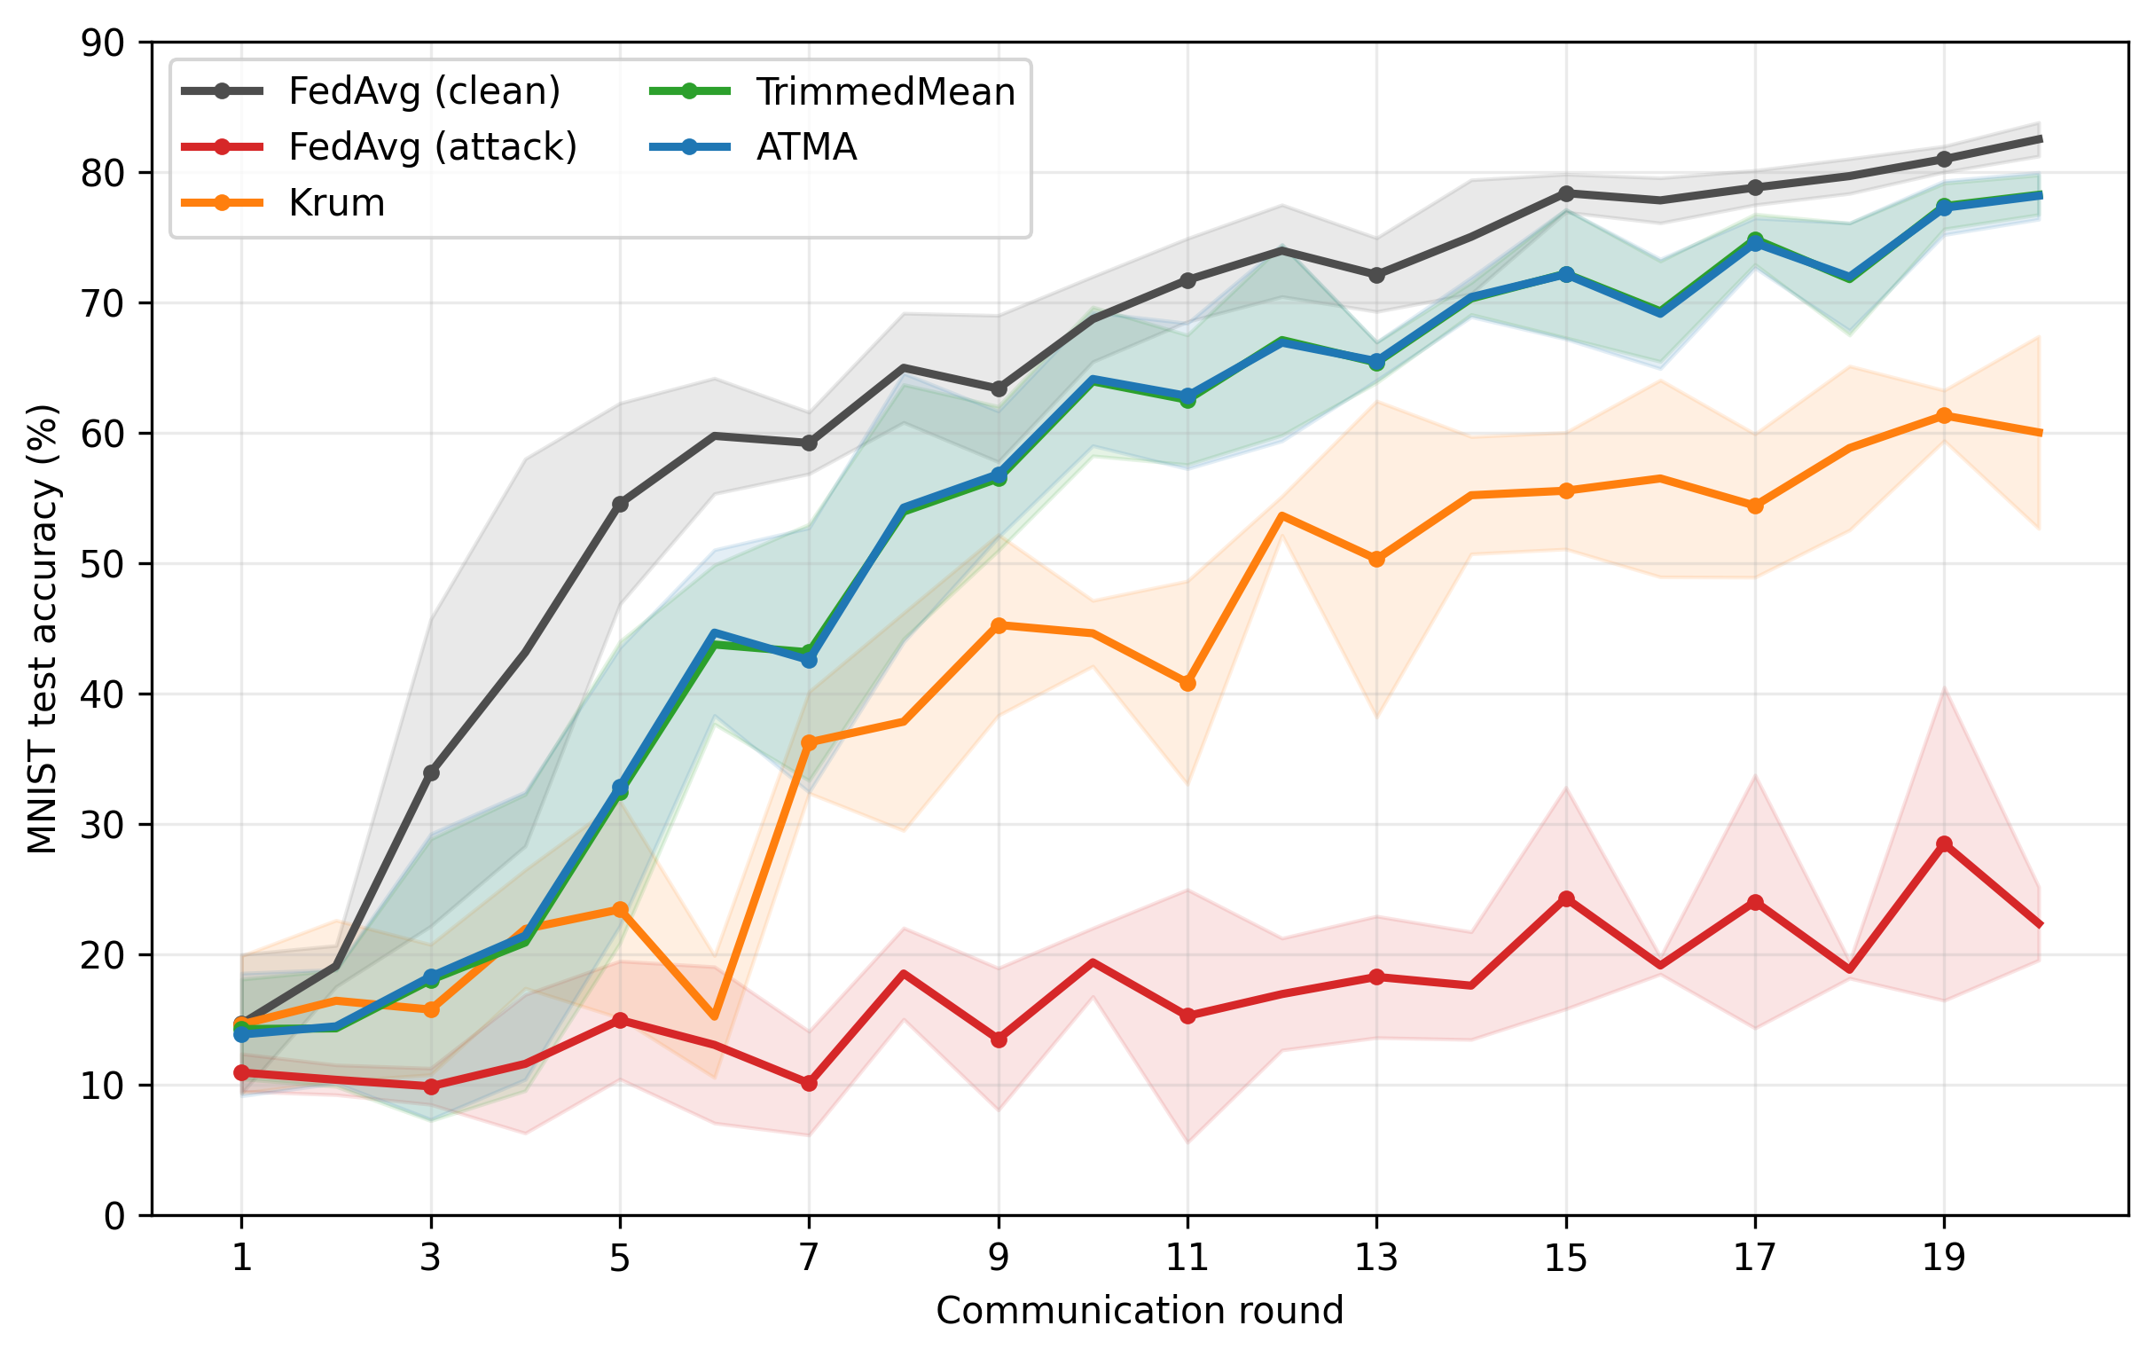
Mean test accuracy across seeds 42, 43, and 44. Shaded regions show one sample standard deviation. Every method uses the configuration in Table 1.
Figure 1 shows that clean FedAvg converges fastest. Attacked FedAvg remains unstable and low. Krum avoids malicious clients but learns more slowly because each round retains only one client update. TrimmedMean and ATMA combine several updates and finish close to the clean baseline.
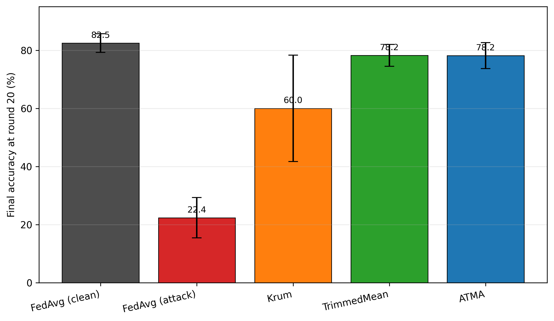
Final accuracy at round 20. Error bars are 95% confidence intervals computed with Student’s $t$ distribution for three seeds.
ATMA and TrimmedMean differ by only $−0.08$ percentage points on average, with $p=0.706$. Therefore, this experiment does not establish an ATMA accuracy advantage. Instead, ATMA removes the need to manually set the final trim count: its ratio is initialized at 0.10, changes to 0.15 after the first observed round, and approaches 0.20 in all three runs.

Detection and Krum Selection
Across 60 ATMA rounds, there are 240 Byzantine client-round instances and 960 honest instances. ATMA produces 240 true positives, eight false positives, no false negatives, and 952 true negatives. Precision is 96.77%, recall is 100%, and F1 is 98.36%. The number of flags per round ranges from four to six. These metrics concern the explicit attack used here and should not be generalized to stealthier attacks.
Corrected Krum selects an honest client in all 60 evaluated rounds. Its lower accuracy therefore does not indicate Byzantine selection; it reflects the utility cost of reducing a heterogeneous 20-client round to one update.

Measured Blockchain Evidence
Measured Ganache Audit Transactions
Operation | Count | Mean Gas
Contract deployment | 1 | 512,965
Client update record | 400 | 54056
Round finalization | 20 | 113991
Total measured gas | – | 24,415,241
The audited run deploys contract 0xe78A...a8Ab; the complete address is preserved in the result artifact. Deployment occurs in block 1. The run then records 400 client updates and 20 round summaries in 420 transactions, all with receipt status 1. The final block is 421. Total measured gas including deployment is 24,415,241. Every client hash and anomaly flag passes contract read-back verification. These are local EVM measurements, not Ethereum-mainnet cost or latency claims.

Discussion

Comparative Interpretation
The comparison supports three conclusions. First, the combined label-flip and scaled-update attack severely damages ordinary FedAvg. Second, coordinate-wise trimming preserves substantially more utility than single-update Krum under the evaluated non-IID partition. Third, adaptive trimming matches the static method without being told to use the final 20% trim ratio. The experiment does not show that ATMA is universally better than static trimming.

Contribution of Blockchain
Blockchain contributes immutable commitments and reproducible evidence, not robust aggregation. Detection is performed off-chain before its output is committed. This design avoids storing high-dimensional model updates on-chain and permits later verification that a recorded hash or flag was not changed. The experiment uses a single-node Ganache network, so it validates contract execution and audit semantics but not decentralized consensus, public-network latency, or economic feasibility.

Limitations
This study uses one dataset, one CNN, 20 clients, 20 rounds, three seeds, and one combined untargeted attack. The local computation is capped at three mini-batches per client per round. Blockchain validation is limited to one ATMA seed on Ganache. No claim is made regarding live Layer-2 deployment, production readiness, or dollar-denominated cost.
This study evaluates one combined untargeted attack consisting of cyclic label flipping and scaled model updates. More sophisticated attacks, including the A Little Is Enough attack introduced by Baruch et al. and targeted backdoor attacks studied by Sun et al. , remain outside the present scope.

Conclusion
This work presents a reproducible evaluation of Byzantine-robust FL and blockchain auditability under one consistent protocol. A combined label-flip and scaled-update attack reduces FedAvg from 82.49% clean accuracy to 22.36%. Krum recovers to 60.01%, while TrimmedMean and ATMA reach 78.23% and 78.15%, respectively. ATMA does not significantly outperform static TrimmedMean, but it adapts its trimming ratio automatically and detects all 240 Byzantine client-round instances with eight false positives.
The blockchain component records 400 client-update commitments and 20 round summaries in 420 successful transactions, with all values verified by contract read-back. Thus, robust aggregation supplies model protection, while blockchain supplies tamper-evident evidence. This narrower conclusion is supported by the released code, raw JSON result, generated figures, contract artifact, and transaction receipts.
Future work should increase the number of seeds and rounds, test larger and more heterogeneous datasets, evaluate partial participation, deploy the audit contract on a multi-node or public test network, and include ALIE, model replacement, and targeted backdoor attacks.

Data and Code Availability
The public repository provides the exact experiment script, robust aggregation module, Solidity contract source, raw JSON result, generated tables, and figure generation code.
9
H. B. McMahan, E. Moore, D. Ramage, S. Hampson, and B. Agüera y Arcas, “Communication-efficient learning of deep networks from decentralized data,” in Proc. 20th Int. Conf. Artif. Intell. Statist. (AISTATS), vol. 54, 2017, pp. 1273–1282.
P. Kairouz, H. B. McMahan, B. Avent, et al., “Advances and open problems in federated learning,” Found. Trends Mach. Learn., vol. 14, no. 1–2, pp. 1–210, 2021, doi: 10.1561/2200000083.
P. Blanchard, E. M. El Mhamdi, R. Guerraoui, and J. Stainer, “Machine learning with adversaries: Byzantine tolerant gradient descent,” in Advances in Neural Information Processing Systems, vol. 30, 2017.
D. Yin, Y. Chen, R. Kannan, and P. Bartlett, “Byzantine-robust distributed learning: Towards optimal statistical rates,” in Proc. 35th Int. Conf. Mach. Learn. (ICML), vol. 80, 2018, pp. 5650–5659.
M. Baruch, G. Baruch, and Y. Goldberg, “A little is enough: Circumventing defenses for distributed learning,” in Advances in Neural Information Processing Systems, vol. 32, 2019.
Z. Sun, P. Kairouz, A. T. Suresh, and H. B. McMahan, “Can you really backdoor federated learning?” arXiv:1911.07963, 2019.
H. Kim, J. Park, M. Bennis, and S.-L. Kim, “Blockchained on-device federated learning,” IEEE Commun. Lett., vol. 24, no. 6, pp. 1279–1283, Jun. 2020, doi: 10.1109/LCOMM.2019.2921755.
Y. Lu, X. Huang, K. Zhang, S. Maharjan, and Y. Zhang, “Blockchain empowered asynchronous federated learning for secure data sharing in Internet of Vehicles,” IEEE Trans. Veh. Technol., vol. 69, no. 4, pp. 4298–4311, Apr. 2020, doi: 10.1109/TVT.2020.2973651.

https://github.com/vokasitibrawijaya/byzantine-robust-fl-blockchain

