

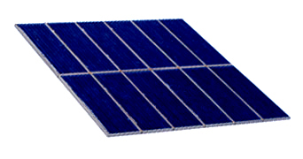

Photovoltaic Cells capture the sun’s energy and transform it into electricity.

Power of the Sun
Solar energy travels from the sun to the Earth, powering the Earth's natural systems and sustaining its life. This energy can also be used directly to produce heat or electricity. Understanding the way solar energy travels and what happens when it reaches the Earth helps in understanding how solar photovoltaics use this energy.

Importance of the Sun
The sun is the Earth's primary source of energy, powering its most basic systems and cycles and shaping the world around us. It provides the planet with light and heat. The reaction between the sun’s energy and the Earth’s atmosphere determines weather patterns and rainfall, and our planet's tilt towards the sun creates the seasons. Its role in photosynthesis helps plants to grow and its role in biodegradation helps complete the natural cycle of ecosystems.
A lesser known role of solar energy is that it is the root of most the other forms of energy humans use for power. Wind power depends on the sun's impact on atmospheric movement to create wind patterns. Bioenergy (wood and other plant material) depends on photosynthesis. Even fossil fuels indirectly owe their creation millions of years ago to solar energy.

The Sun's Energy
The sun is composed of two layers of gas: an inner core of hydrogen and an outer layer of helium. For millions of years, the core of hydrogen gas has been burning and producing the outer layer of helium. An enormous amount of energy is created in this process. This solar energy radiates outward from the sun and into space, and some of this energy reaches the Earth's surface. This movement of energy is known as solar radiation.

How Solar Energy Travels
The energy radiating from the sun is released as concentrated particles called photons, smaller than atoms and invisible to the human eye. These tiny packets of energy travel in a pattern best described as a wave. These waves, like the photons that travel along them, are too small to be visible, ranging from 160 to 1,500 nanometers (a nanometer is one billionth of a meter) in length.
Wavelength, defined as the distance between one peak of a wave to the next peak of the same wave, is key to understanding the varying qualities of solar energy. Wavelength is directly linked to the amount of energy carried by a particular wave. A wave with a very short wavelength carries a high amount of photon energy. Likewise, a wave with a longer wavelength carries a lower amount of photon energy.
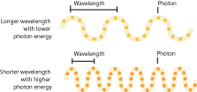

How Humans Perceive Solar Energy
The lengths of different solar waves determine how they are perceived and used on Earth. Solar waves with wavelengths between 400 and 780 nanometers are perceived by the human eye as visible light. Most of the solar energy that reaches the Earth travels in waves within this range. In essence, the sunlight we see is the primary form of solar energy, and solar technologies depend on this sunlight to create heat and electricity.
In addition to energy perceived as visible light, the sun releases smaller amounts of energy in waves with shorter and longer wavelengths. Solar waves with wavelengths between 160 and 400 nanometers are known as ultraviolet rays and carry higher levels of energy than sunlight. Solar waves with wavelengths between 780 and 1,500 nanometers are known as infrared rays and carry lower levels of energy than sunlight. Both types of energy have important roles on Earth, but, largely because only small amounts hit the Earth's surface, they are not used in solar energy techniques and technologies.
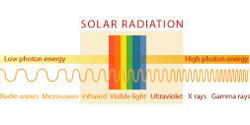
Solar waves carry very little heat. Rather, most solar heat is created when waves of solar energy hit certain materials on Earth. The Earth's surface and various materials absorb some of this solar energy, then release energy back into the air in the form of heat. This process is the central element in both passive solar techniques and solar heating technologies.

What Happens when Solar Energy Reaches the Earth?
As solar energy radiates outward from the sun, some of it reaches the outer layer of the Earth's atmosphere. At this point, several factors affect how much solar energy penetrates the atmosphere and the way it reaches different parts of the Earth's surface at different times of year.
The Earth's atmosphere significantly impacts the amount of solar energy reaching the surface of the Earth. Some waves are reflected by the outer layers of the atmosphere, while others are blocked by a lower layer of ozone. Still others are interrupted by clouds, some reflected back into the atmosphere and some deflected in their route to the Earth's surface. Finally, some waves pass through the atmosphere unimpeded, hitting the surface of the Earth as direct light.
Waves that are deflected by clouds before hitting the surface are known as diffuse light because they hit the earth at different angles than direct light. Some direct light is also reflected when it hits the surface, creating more diffuse light. This distinction is relevant to the human uses of solar energy, as certain technologies, like solar thermal, can only use direct light to produce energy while others, like photovoltaics, can use both direct and diffuse light.
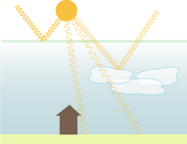
Levels of direct light vary greatly from region to region because of differing atmospheric qualities, ozone levels, and weather patterns. The level of direct sunlight typically received in a region is measured as solar intensity. Solar intensity affects the amount of energy available for solar technologies, and as a result impacts their efficiency.
Another important factor in using solar energy is the angle at which solar waves reach the Earth. This angle is constantly changing as the Earth rotates toward the sun in the morning and away from the sun at night. The tilt of the Earth's axis also impacts the angle at which solar waves reach different regions at different times of year.
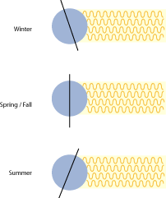
These changes in the angle of solar radiation do not affect the amount of energy carried by solar waves, but need to be considered when designing solar techniques and technologies to best accommodate solar energy throughout the day and in different regions.

