Tropical Cyclone Report
Hurricane Felix
(AL062007)
31 August – 5 September 2007

Jack Beven
National Hurricane Center
16 January 2008

Hurricane Felix was a small, but powerful, category 5 hurricane (on the Saffir-Simpson Hurricane Scale) that caused major damage in northeastern Nicaragua.

- Synoptic History

Felix formed from a tropical wave that departed the coast of Africa on 24 August. The wave moved westward across the tropical Atlantic for several days while producing a persistent area of disorganized cloudiness and showers. The shower activity increased in organization beginning on 29 August accompanied by a gradual increase in low-level vorticity. It is estimated that a tropical depression formed around 1200 UTC 31 August about 195 n mi east-southeast of Barbados. The “best track” chart of the tropical cyclone’s path is given in Fig. 1, with the wind and pressure histories shown in Figs. 2 and 3, respectively. The best track positions and intensities are listed in Table 1.

The depression initially moved westward, then made a west-northwestward jump that was possibly due to reformation of the center. As a westward motion resumed, the cyclone became a tropical storm around 0000 UTC 1 September about 60 n mi south of Barbados. The center of Felix passed over Grenada about 0845 UTC 1 September, then moved across the southern portion of the Caribbean Sea embedded in deep-layer easterly flow. Felix quickly strengthened, becoming a hurricane near 0000 UTC 2 September while centered about 155 n mi east of Bonaire in the Netherlands Antilles.

Felix moved just north of due west on 2 September, with its center passing 35-45 n mi north of the Netherlands Antilles. Very rapid strengthening occurred during the day, with the maximum sustained winds increasing to 145 kt by 0000 UTC 3 September – Category 5 on the Saffir-Simpson Hurricane Scale. The central pressure reached a minimum of 929 mb at 0700 UTC 3 September - a 64-mb fall in 32 h. An eyewall replacement cycle began later that day, with Felix weakening to a Category 3 hurricane and the central pressure rising to 953 mb. This was followed by re-intensification at the end of the cycle, and it is estimated that Felix regained Category 5 status just before landfall near Punta Gorda, Nicaragua at 1200 UTC 4 September.

After landfall, Felix weakened rapidly to a tropical storm over northern Nicaragua less than 12 h after landfall. The cyclone decelerated and turned west-northwestward, and it weakened to a remnant low over northern Honduras early on 5 September. The low briefly emerged over the Gulf of Honduras later that day. However, no re-development occurred before it moved into Belize and Guatemala. While the remnant low dissipated over eastern Mexico late on 6 September, the residual cloudiness and showers moved westward into the Pacific and could be tracked until 9 September.

- Meteorological Statistics

Observations in Felix (Figs. 2 and 3) include satellite-based Dvorak technique intensity estimates from the Tropical Analysis and Forecast Branch (TAFB) and the Satellite Analysis Branch (SAB), as well as flight-level and dropwindsonde observations from flights of the 53rd Weather Reconnaissance Squadron of the U. S. Air Force Reserve Command and the NOAA Aircraft Operations Center. Data and imagery from NOAA polar-orbiting satellites, the NASA Tropical Rainfall Measuring Mission (TRMM), the NASA QuikSCAT, the NASA Aqua, the Department of Defense Windsat, and Defense Meteorological Satellite Program (DMSP) satellites were also useful in tracking Felix.

The Air Force and NOAA Hurricane Hunters made 13 missions into Felix producing 26 center fixes. The first mission reported 42-kt winds at a flight-level of 1500 ft at 2238 UTC 31 August, which is the basis for designating Felix as a tropical storm in the best track at 0000 UTC 1 September. These winds were just a few nautical miles east of the center, indicating that Felix had a small radius of maximum winds at an early stage of its existence. Felix would remain a small hurricane through its life, with tropical-storm force winds never extending more than 100 n mi from the center and hurricane-force winds never extending more than 40 n mi from the center.

The maximum intensity of Felix near 0000-0600 UTC 3 September has greater than normal uncertainty. A NOAA Hurricane Hunter aircraft estimated a 163 kt surface wind in the northeastern eyewall using the Stepped Frequency Microwave Radiometer (SFMR), while a dropsonde in the vicinity measured winds of 195 kt about 120 m above the surface. (The sonde subsequently fell into the eye, which significantly reduced the low-level layer-average winds that are normally used to assess the surface winds.) Examination of these SFMR data by personnel at the NOAA Hurricane Research Division found no obvious problems with signal contamination by rain or graupel. However, the observed flight-level winds (152 kt at 700 mb), aircraft Doppler radar data, central pressure, and satellite signature do not support an intensity of 160-165 kt. Detailed data from the sonde show that the extreme winds were confined to the lowest 200 m, and that it made a left turn into the eye while passing through this layer. This suggests that the sonde and the SFMR sampled a small-scale feature in the eyewall that likely was not representative of the true strength of Felix. As the plane passed through the southeastern eyewall, the SFMR estimated surface winds of 142 kt, while a dropsonde reported low-level layer averages supporting 130-140 kt surface sustained winds. Given the westward motion at the time, it is likely that the stronger winds existed in the northern eyewall. The maximum intensity is set at 150 kt based on a blend of these data, and this could be conservative.

It should be noted that during this eye penetration, the NOAA aircraft encountered extreme turbulence and vertical motions, and it had to abort the mission and return to base.

Felix’s winds increased by 115 kt – from 35 kt to 150 kt – in the 48 h period ending at 0000 UTC 3 September. In the 24-h period ending at that time, the winds increased by 85 kt. In the history of Atlantic tropical cyclones, only Hurricane Wilma of 2005 is known to have intensified faster over 24- and 48-h periods.

The maximum flight level winds were 162 kt at 700 mb at 1111 UTC 3 September. The minimum pressure of 929 mb is based on an eye dropsonde at 0658 UTC 3 September with a 931 mb surface pressure and 30 kt surface winds. At this time, the lowest height for the 700 mb pressure surface was measured.

The last flight into Felix before landfall in Nicaragua on 4 September found that the central pressure had fallen to 939 mb with 700 mb flight-level winds of 148 kt. The aircraft departed the storm about five hours before landfall, and after its departure satellite imagery showed increasing organization with cooling of the eyewall cloud tops and warming of the eye. Objective Dvorak Technique T-numbers reached 6.9 (137 kt) at 1045 UTC, and based on this, Felix is estimated to have regained Category 5 intensity just before landfall.

Surface observations near the core of Felix were scarce, with selected surface observations from land stations given in Table 2. Puerto Cabezas, Nicaragua reported sustained winds of 44 kt at 1300 UTC 4 September as the southern eyewall of Felix passed nearby. Point Saline International Airport on Grenada reported a wind gust of 57 kt at 0930 UTC 1 September and a minimum pressure of 1001.0 mb 40 minutes earlier. Bequia Island in the Grenadines reported a gust of 47 kt at 0606 UTC 1 September, while Barbados reported a gust of 43 kt at 0230 UTC that day. Aruba in the Netherlands Antilles reported a gust to 36 kt at 1436 UTC 2 September.

There were no ship reports of hurricane or tropical storm force winds from Felix. NOAA buoy 42059 reported a wind gust of 35 kt at 0806 UTC 2 September, at which time it was about 140 n mi north-northeast of the center.

The small size and relatively fast movement of Felix resulted in relatively light rainfall totals (Table 2) along most of the track. Heavier amounts occurred when the storm decelerated over Central America, with a maximum amount of 9.62 inches at Omoa Cortes, Honduras.

- Casualty and Damage Statistics

Media reports indicate that Felix caused 130 deaths in Nicaragua and Honduras, along with 70 others missing. While detailed figures on how many were killed in each country are not available, the reports suggest that the majority of the deaths were in Nicaragua.

Felix’s landfall in Nicaragua caused severe damage to structures from winds and storm surge along the coast from Puerto Cabezas northward. Media reports indicate thousands of homes and other structures were destroyed. Additional damage from rain-induced flooding occurred inland in both Nicaragua and Honduras. Monetary damage figures are not available.

Wind and high surf caused minor damage on Aruba, Bonaire, and Curacao, while wind and lightning caused minor damage on St. Vincent and the Grenadines.

- Forecast and Warning Critique

The genesis of Felix was fairly well anticipated. The precursor tropical wave was first mentioned in the Tropical Weather Outlook on 27 August, and the possibility of development into a depression was noted on 30 August – about 24 h before genesis. These outlooks also included statements that the Windward Islands should monitor the progress of the approaching system. One noteworthy aspect of Felix’s genesis was that the National Weather Service’s Global Forecast System model failed to predict it.

A verification of official and guidance model track forecasts is given in Table 3. Average official track errors for Felix were 21, 37, 53, 71, 106, and 120 n mi for the 12, 24, 36, 48, 72, and 96 h forecasts, respectively. The number of forecasts ranged from 17 at 12 h to 3 at 96 h. These errors are notably lower than the average long-term official track errors (Table 3). The official track forecasts errors were better than those for most of the individual and consensus track guidance. A few of the models had lower average forecast errors than the official forecast, with the best performers being the interpolated European Center for Medium Range Weather Forecasting model (EMXI) and the interpolated mean of National Weather Service Global Forecast System ensembles (AEMI).

Average official intensity errors were 18, 26, 35, 53, 56 and 35 kt for the 12, 24, 36, 48, 72, and 96 h forecasts, respectively. These errors are significantly larger than average long-term official intensity errors of 6, 10, 12, 14, 18, and 20 kt, respectively. The 72-h forecast errors were larger than those of the climatology-persistence model SHF5, indicating these forecasts had no skill. There were two sources of the intensity forecast errors. First, while it was correctly anticipated that Felix would intensify, the rapid intensification that occurred was poorly forecast. For example, the 48-h intensity forecast issued at 0000 UTC 1 September was 95 kt too low. The second source came from early track forecasts that showed the center of Felix passing north of Nicaragua and Honduras rather than over them. This led to intensity forecasts that were significantly too strong in the belief the center would remain over water. It should be noted that while a couple of the intensity forecast models had lower average errors than the official forecast at a majority of the forecast time, the models all had very large average errors.

Table 5 shows the coastal watches and warnings for Felix.

Acknowledgements

Data from Nicaragua, Honduras, the Netherlands Antilles, Grenada, Barbados, and St. Vincent and the Grenadines were provided by the meteorological services of those countries.
Table 1. Best track for Hurricane Felix, 31 August – 5 September 2007.

Date/Time  (UTC) | Latitude  (°N) | Longitude  (°W) | Pressure  (mb) | Wind Speed  (kt) | Stage
31 / 1200 | 11.5 | 56.6 | 1009 | 25 | tropical depression
31 / 1800 | 11.5 | 58.0 | 1008 | 30 | “
01 / 0000 | 12.1 | 59.4 | 1007 | 35 | tropical storm
01 / 0600 | 12.1 | 61.1 | 1005 | 40 | “
01 / 1200 | 12.2 | 62.8 | 1001 | 50 | “
01 / 1800 | 12.4 | 64.5 | 999 | 60 | “
02 / 0000 | 12.6 | 66.1 | 992 | 65 | hurricane
02 / 0600 | 12.7 | 67.8 | 985 | 85 | “
02 / 1200 | 13.0 | 69.4 | 980 | 90 | “
02 / 1800 | 13.4 | 71.1 | 962 | 115 | “
03 / 0000 | 13.8 | 73.0 | 935 | 150 | “
03 / 0600 | 14.0 | 75.0 | 930 | 150 | “
03 / 1200 | 14.2 | 76.9 | 937 | 140 | “
03 / 1800 | 14.3 | 78.7 | 951 | 115 | “
04 / 0000 | 14.4 | 80.4 | 950 | 115 | “
04 / 0600 | 14.3 | 81.9 | 939 | 135 | “
04 / 1200 | 14.3 | 83.2 | 934 | 140 | “
04 / 1800 | 14.3 | 84.4 | 962 | 85 | “
05 / 0000 | 14.6 | 85.4 | 982 | 50 | tropical storm
05 / 0600 | 15.0 | 86.4 | 1004 | 25 | tropical depression
05 / 1200 | 15.5 | 87.3 | 1006 | 20 | remnant low
05 / 1800 | 16.1 | 88.3 | 1007 | 20 | “
06 / 0000 | 16.5 | 89.5 | 1007 | 20 | “
06 / 0600 | 16.7 | 90.8 | 1007 | 20 | “
06 / 1200 | 17.2 | 92.4 | 1007 | 20 | “
06 / 1800 | 17.7 | 93.8 | 1010 | 15 | “
07 / 0000 |  |  |  |  | dissipated
03 / 0700 | 14.0 | 75.3 | 929 | 150 | minimum pressure
01 / 0845 | 12.1 | 61.7 | 1001 | 45 | landfall on Grenada
04 / 1200 | 14.3 | 84.4 | 934 | 140 | landfall near Punta Gorda, Nicaragua

Table 2. Selected surface observations for Hurricane Felix, 31 August – 5 September 2007.
Location | Minimum Sea Level Pressure |  | Maximum Surface  Wind Speed |  |  | Storm surge  (ft)^{c} | Storm  tide  (ft)^{d} | Total  rain  (in)
Location | Date/  time  (UTC) | Press.  (mb) | Date/  time  (UTC)ª | Sustained  (kt)^{b} | Gust  (kt) | Storm surge  (ft)^{c} | Storm  tide  (ft)^{d} | Total  rain  (in)
Nicaragua
Puerto Cabezas |  |  | 04/1300 | 44 |  |  |  | 7.11
El Boquete |  |  |  |  |  |  |  | 3.38
El Rosario |  |  |  |  |  |  |  | 4.02
El Sauce |  |  |  |  |  |  |  | 3.64
Masatepe |  |  |  |  |  |  |  | 4.37
Rio Grande Matagalpa |  |  |  |  |  |  |  | 3.56
Telica |  |  |  |  |  |  |  | 3.13
Yeye-Siuna Salto |  |  |  |  |  |  |  | 4.28
Honduras
La Ceiba |  |  |  |  |  |  |  | 6.17
La Labor Ocotepeque |  |  |  |  |  |  |  | 3.95
La Mesa |  |  |  |  |  |  |  | 3.98
Omoa Cortes |  |  |  |  |  |  |  | 9.62
Puerto Lempira |  |  |  |  |  |  |  | 4.20
Santa Rosa de Copan |  |  |  |  |  |  |  | 3.98
Tela |  |  |  |  |  |  |  | 3.38
Trujillo |  |  |  |  |  |  |  | 4.13
Yoro |  |  |  |  |  |  |  | 3.20
Grenada
Point Saline Intl. Airport | 01/0850 | 1001.0 | 01/0930 |  | 57 |  |  | 3.34
Barbados
Grantley Adams Airport | 31/2000 | 1010.8 | 01/0230 | 30 | 43 |  |  | 0.85
Grenadine Islands
Bequia | 01/0656 | 1010.3 | 01/0801 | 26 | 47 |  |  | 1.00
St. Vincent
E. T. Joshua Airport | 01/0650 | 1011.1 | 01/0550 | 21 | 36
Netherlands Antilles
Aruba | 02/1408 | 1008.4 | 02/1436 | 29e | 36 |  |  | 1.31
Bonaire | 02/0727 | 1006.5 | 02/0636 | 25e | 31 |  |  | 0.88
Curacao | 02/0922 | 1006.7 | 02/1052 | 20e | 28 |  |  | 2.14

ª Date/time is for sustained wind when both sustained and gust are listed.
^{b} Except as noted, sustained wind averaging periods are 10 minutes.
^{c} Storm surge is water height above normal astronomical tide level.
^{d} Storm tide is water height above National Geodetic Vertical Datum (1929 mean sea level).
^{e} 1-min average wind
Table 3. Preliminary early model track forecast evaluation (heterogeneous sample) for Hurricane Felix, 31 August – 5 September 2007. Forecast errors (n mi) are followed by the number of forecasts in parentheses. Errors smaller than the NHC official forecast are shown in bold-face type. Verification includes the depression stage.

Forecast Technique | Forecast Period (h)
Forecast Technique | 12 | 24 | 36 | 48 | 72 | 96 | 120
CLP5 | 28 (18) | 63 (16) | 106 (14) | 162 (12) | 256 ( 8) | 363 ( 4)
GFNI | 31 (14) | 55 (12) | 94 (10) | 122 ( 8) | 219 ( 4)
GFDI | 27 (18) | 47 (16) | 61 (14) | 75 (12) | 95 ( 8) | 145 ( 4)
HWFI | 36 (18) | 59 (16) | 83 (14) | 114 (12) | 162 ( 8) | 282 ( 3)
NAMI | 30 (11) | 59 ( 9) | 87 ( 7) | 89 ( 5) | 152 ( 1)
COAI | 37 (13) | 87 (11) | 154 ( 9) | 232 ( 7)
GFSI | 26 (18) | 45 (15) | 64 (13) | 64 ( 9) | 89 ( 6) | 120 ( 2)
AEMI | 18 (18) | 28 (11) | 39 (11) | 62 ( 9) | 95 ( 4)
NGPI | 35 (18) | 59 (16) | 86 (14) | 121 (12) | 195 ( 7) | 159 ( 3)
UKMI | 25 (15) | 43 (13) | 58 (11) | 80 ( 9) | 148 ( 5) | 184 ( 1)
EMXI | 26 (16) | 37 (14) | 42 (12) | 61 (10) | 84 ( 6) | 76 ( 2)
JGSI | 40 ( 8) | 60 ( 5) | 134 ( 5) | 102 ( 3) | 73 ( 1)
LBAR | 28 (18) | 62 (16) | 93 (14) | 114 (12) | 132 ( 8) | 89 ( 2)
BAMD | 28 (18) | 47 (16) | 67 (14) | 92 (12) | 114 ( 8) | 154 ( 4)
BAMM | 30 (18) | 56 (16) | 84 (14) | 114 (12) | 155 ( 8) | 229 ( 4)
BAMS | 34 (18) | 66 (16) | 103 (14) | 138 (12) | 206 ( 8) | 253 ( 4)
CONU | 25 (18) | 43 (16) | 64 (14) | 80 (12) | 127 ( 7) | 140 ( 3)
CCON | 25 (18) | 42 (16) | 60 (14) | 73 (12) | 122 ( 7) | 176 ( 3)
GUNA | 22 (15) | 39 (12) | 53 (10) | 73 ( 8) | 136 ( 5) | 184 ( 1)
FSSE | 21 (15) | 31 (13) | 43 (11) | 68 ( 9) | 138 ( 5) | 204 ( 1)
OFCL | 21 (17) | 37 (15) | 53 (13) | 71 (11) | 106 ( 7) | 120 ( 3)
NHC Official  (2002-2006 mean) | 35 (1852) | 61 (1686) | 86 (1519) | 112 (1362) | 162 (1100) | 221 (885) | 290 (723)

Table 4. Preliminary intensity forecast evaluation (heterogeneous sample) for Hurricane Felix, 31 August – 5 September 2007. Forecast errors (kt) are followed by the number of forecasts in parentheses. Errors smaller than the NHC official forecast are shown in bold-face type. Verification includes the depression stage.

Forecast Technique | Forecast Period (h)
Forecast Technique | 12 | 24 | 36 | 48 | 72 | 96 | 120
SHF5 | 29.1 (18) | 38.6 (16) | 47.7 (14) | 58.3 (12) | 55.5 ( 8) | 39.0 ( 4)
GFNI | 31.1 (14) | 42.8 (12) | 62.1 (10) | 67.1 ( 8) | 73.3 ( 4)
GHMI | 24.5 (18) | 32.7 (16) | 45.2 (14) | 49.9 (12) | 46.3 ( 8) | 46.8 ( 4)
HWFI | 25.7 (18) | 40.6 (16) | 48.0 (14) | 74.6 (12) | 77.9 ( 8) | 55.3 ( 3)
SHIP | 27.7 (18) | 36.9 (16) | 43.2 (14) | 53.2 (12) | 49.6 ( 8) | 42.8 ( 4)
DSHP | 19.7 (18) | 24.2 (16) | 33.1 (14) | 52.1 (12) | 49.6 ( 8) | 51.5 ( 4)
LGEM | 20.5 (18) | 23.0 (16) | 31.8 (14) | 49.6 (12) | 48.9 ( 8) | 50.0 ( 4)
FSSE | 28.0 (15) | 33.7 (13) | 42.0 (11) | 50.2 ( 9) | 49.2 ( 5) | 37.0 ( 1)
ICON | 23.8 (18) | 31.8 (16) | 39.8 (14) | 58.2 (12) | 55.1 ( 8) | 39.5 ( 4)
OFCL | 17.9 (17) | 25.7 (15) | 35.4 (13) | 53.2 (11) | 55.7 ( 7) | 35.0 ( 3)
NHC Official  (2002-2006 mean) | 6.4 (1852) | 9.8 (1686) | 12.0 (1519) | 14.1 (1362) | 18.3 (1100) | 19.8 (885) | 21.8 (723)

Table 5. Watch and warning summary for Hurricane Felix, 31 August – 5 September 2007.

Date/Time (UTC) | Action | Location
31 / 2100 | Tropical Storm Warning issued | St. Vincent, the Grenadines, Grenada, Tobago
31 / 2100 | Tropical Storm Watch issued | Coast of Venezuela from Cumana to Pedernales including the island of Margarita
31 / 2100 | Tropical Storm Watch issued | Aruba, Bonaire, Curacao
1 / 0900 | Tropical Storm Warning issued | Aruba, Bonaire, Curacao
1 / 0900 | Tropical Storm Warning discontinued | Tobago
1 / 1200 | Tropical Storm Warning discontinued | St. Vincent and the Grenadines
1 / 1500 | Tropical Storm Warning discontinued | Grenada
1 / 1800 | Tropical Storm Watch discontinued | Coast of Venezuela from Cumana to Pedernales including the island of Margarita
2 / 0000 | Tropical Storm Watch issued | Jamaica
2 / 0300 | Hurricane Watch issued | Aruba, Bonaire, Curacao
2 / 1500 | Tropical Storm Watch issued | Grand Cayman Island
2 / 1800 | All coastal watches and warnings discontinued | Aruba, Bonaire, Curacao
3 / 0300 | Hurricane Watch issued | Coast of Honduras from Limon eastward to the Nicaragua/Honduras border
3 / 0900 | Hurricane Warning issued | Coast of Honduras from Limon eastward to the Nicaragua/Honduras border
3 / 0900 | Hurricane Watch issued | Coast of Honduras west of Limon to the Honduras/Guatemala border
3 / 1200 | Hurricane Watch issued | Coasts of Guatemala and Belize
3 / 1500 | Hurricane Warning issued | Coast of Nicaragua from Puerto Cabezas northward to the Nicaragua/Honduras border
3 / 1800 | Tropical Storm Watch discontinued | Jamaica
3 / 2100 | Tropical Storm Warning issued | Isla de Providencia
4 / 0000 | Tropical Storm Watch discontinued | Grand Cayman Island
4 / 0300 | Tropical Storm Warning issued | Coast of Nicaragua south of Puerto Cabezas to Prinzapolka
4 / 0300 | Tropical Storm Warning issued | Coast of Honduras west of Limon to Honduras/Guatemala border including Islas de la Bahia
4 / 1500 | Tropical Storm Warning discontinued | Isla de Providencia
4 / 1800 | All coastal watches and warnings discontinued | Coast of Nicaragua
4 / 1800 | Hurricane warning changed to Tropical Storm Warning | Coast of Honduras from Limon eastward to the Nicaragua/Honduras border
4 / 1800 | Hurricane Watch discontinued | Coast of Guatemala and coast of Belize north of Placentia Village
4 / 1800 | Hurricane watch changed to Tropical Storm Watch | Coast of Belize from Placentia Village southward to the Belize-Guatemala border
5 / 0300 | All coastal watches and warnings discontinued

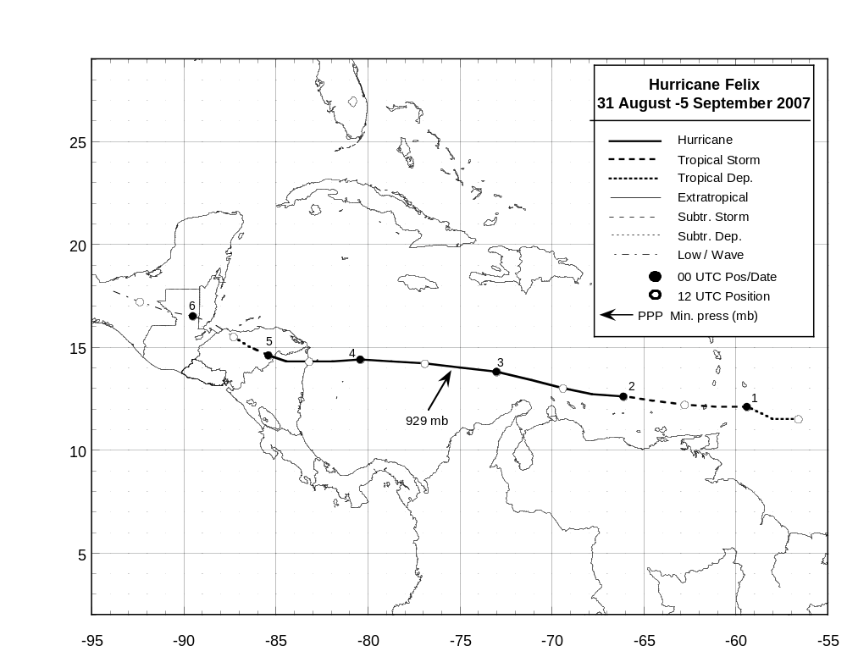
Figure 1. Best track positions for Hurricane Felix, 31 August – 5 September 2007.
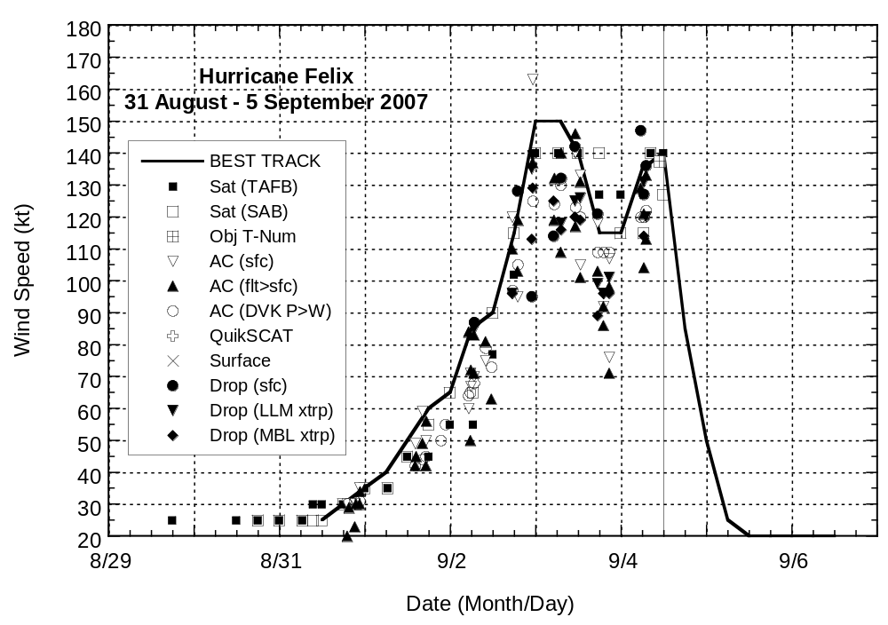
Figure 2. Selected wind observations and best track maximum sustained surface wind speed curve Hurricane Felix, 31 August – 5 September 2007. Aircraft observations have been adjusted for elevation using 90%, 80%, and 80% reduction factors for observations from 700 mb, 850 mb, and 1500 ft, respectively. Dropwindsonde observations include actual 10 m winds (sfc), as well as surface estimates derived from the mean wind over the lowest 150 m of the wind sounding (LLM), and from the sounding boundary layer mean (MBL). Solid vertical line denotes landfall.
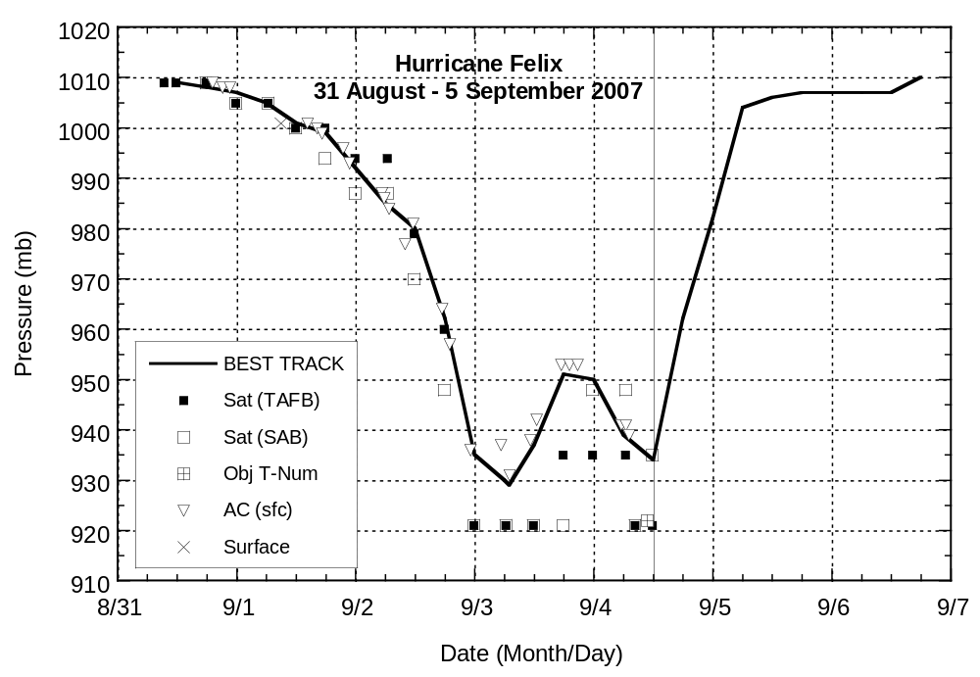
Figure 3. Selected pressure observations and best track minimum central pressure curve for Hurricane Felix, 31 August -5 September 2007. Solid vertical line denotes landfall.

