Group Hospitalization and Medical Services, Inc.
doing business as

CareFirst BlueCross BlueShield
550 12th Street, SW
Washington, DC 20065
202-479-8000

An independent licensee of the Blue Cross and BlueShield Association

PRESCRIPTION DRUG BENEFIT RIDER
SCHEDULE OF BENEFITS

Participating Pharmacy | You may use your identification card to purchase a covered Prescription Drug from a Participating Pharmacy without submitting a claim. You are responsible for the Copayment.
Non-Participating Pharmacy | If you purchase a covered Prescription Drug from a Non-Participating Pharmacy or without your identification card, you are responsible for paying the total charge and submitting a claim to the Plan or its designee for reimbursement. You will be entitled to reimbursement from the Plan or its designee in the amount of the actual charges, minus the deductible and coinsurance when applicable.
Mail Service Pharmacy | You may submit a Prescription Order to a Mail Service Pharmacy and receive maintenance Prescription Drugs by mail. You are responsible for the deductible or Copayment when applicable. Unless otherwise specified in the Prescription Order, and in conformance with the laws governing Generic substitution, a Generic drug automatically will be dispensed in lieu of a Brand-name drug.
Plan Payment | - Participating Pharmacy – 100% of Plan Allowance, minus the Copayment  - Non-Participating Pharmacy or without your identification card – 80% of charges, minus the deductible.
Deductible (per Member per calendar year) | Participating Pharmacy - $0  Non-Participating Pharmacy or without your identification card - $50
Non-Participating Pharmacy  Coinsurance | 20% of charges
Participating Pharmacy  (Copayment when Identification card used)  (Non-Maintenance and Maintenance Prescription Drugs) | $4 Copayment per Generic Prescription Drug for up to a 34-day supply.  $8 Copayment per Generic Prescription Drug for a 35-68-day supply.  $12 Copayment per Generic Prescription Drug for a 69-102-day supply.  $8 Copayment per Brand Name Prescription Drug for up to a 34-day supply.  $16 Copayment per Brand Name Prescription Drug for a 35-68-day supply.  $24 Copayment per Brand Name Prescription Drug for a 69-102-day supply.  NOTE: The Generic Copayment applies if there is no Generic Prescription Drug equivalent

Copayment for Mail Service  (Maintenance Prescription Drugs) | $4 Copayment per Generic Prescription Drug for up to a 34-day supply.  $8 Copayment per Generic Prescription Drug for a 35-68-day supply.  $12 Copayment per Generic Prescription Drug for a 69-102-day supply.  $8 Copayment per Brand Name Prescription Drug for up to a 34-day supply.  $16 Copayment per Brand Name Prescription Drug for a 35-68-day supply.  $24 Copayment per Brand Name Prescription Drug for a 69-102-day supply.  NOTE: The Generic Copayment applies if there is no Generic Prescription Drug equivalent
Annual Maximum | Unlimited
Coinsurance (After the Annual Maximum has been reached) | Not applicable
Supply Amount | There is a up to a 102-day supply of a covered Non-Maintenance or Maintenance Drug, unless limited by a lesser quantity designated by the Prescriber on the Prescription Order when purchased at a Pharmacy or through a Mail Service Pharmacy.
Refill Amount | Up to one year of Prescriber authorized refills
Prescription Contraceptives | Covered
Smoking Deterrents | Covered

Group Hospitalization and Medical Services, Inc.

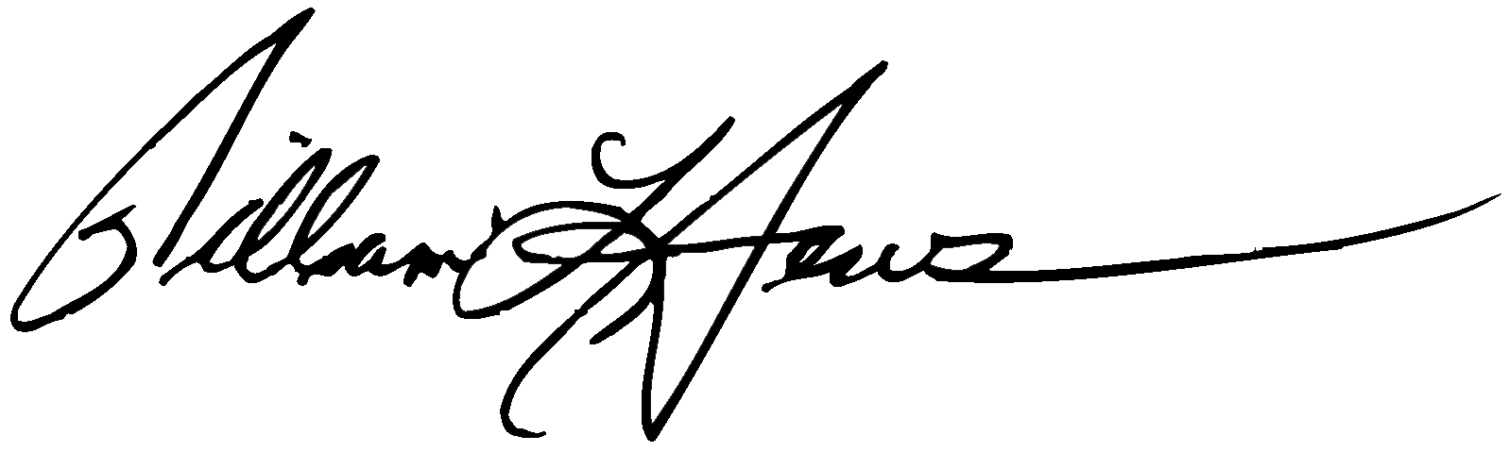
William L. Jews
President and Chief Executive Officer

