R&D Policy Models

and Data Needs

Gregory Tassey

National Institute of Standards and Technology

Strategic Planning and Economic Analysis Group

APPAM 1999 Research Conference

November 4, 1999

tassey@nist.gov
www.nist.gov/director/planning/strategicplanning.htm

R&D Policy Models and Data Needs

Gregory Tassey

S&T policy is a subset of economic growth policy; it therefore needs to be grounded in sound economic rationales, if it is to be appropriately addressed in the broader policy arena. In spite of the general recognition of science and technology’s (S&T) critical role in economic and social well being, debilitating disagreement continues over the mechanisms by which technology drives economic growth and the respective roles of industry and government in supporting technology investment.
In this context, the most frequently discussed issue is the amount of R&D conducted in the U.S. economy. A commonly used indicator of the amount of R&D undertaken by a high-tech industry is its R&D intensity (R&D-to-sales ratio). In the United States, relatively few industries have the high R&D-to-sales ratios (in the 8–12 percent range) that will allow continued world class innovation. These industries together only account for about 7 percent of GDP.
At the same time, the composition of U.S. private-sector R&D is shifting toward shorter-term objectives, at the expense of next-generation research. Annual surveys by the Industrial Research Institute show continued declines in private-sector intentions to fund long-term, high-risk research. Such compositional market failures significantly reduce the long-term competitive prospects for U.S. industries.
When global technology-based competition was less severe, the average technology life cycle was sufficiently long to allow U.S. industry to apply lower discount rates to future returns from R&D investment and thereby undertake more next-generation technology research. Neither private-sector nor government research establishments had to be particularly efficient.
These conditions have largely disappeared. Today, central corporate research labs have been de-emphasized, redirected or eliminated entirely. Funding of government research for economic objectives has yet to regain its peak level in real terms reached in the mid-1960s. New programs providing decades of research support similar to those for molecular biology (which created a world-leading biotechnology industry) or for information networks (which led to the Internet) cannot be found ⎯ at least not at levels that project first mover advantages for U.S. industries.

1.0. Needed: A Technology-Based Economic Policy Model
From a policy perspective, The “S” portion of S&T is relatively easy to deal with. Basic science is widely recognized as close to a pure public good, which means that massive underinvestment occurs without government support. This premise has been understood and incorporated into policy since the end of World War II.
The “T” portion is another matter. Unlike basic science, technology is a “mixed” good, containing both private and public elements. Because of the complexity of market failure mechanisms and resulting underinvestment patterns, the roles of industry, universities, and especially government are poorly defined, leaving endless debates over different classes of possible policy responses.
Most S&T analyses gloss over the economics of R&D investment and the associated market failure mechanisms, jumping to a set of poorly defined and supported policy recommendations. For example, support for some form of “collaboration,” “cooperation,” or “partnering” appears in most policy documents. Yet, few specifics are available regarding what technologies, what point in their life cycles (e.g., what phase of R&D), and what number and combination of institutions—public and private—should receive support.
As discussed later, a varied set of factors can and do thwart private sector investment in certain types of essential R&D. These sources of market failure derive from the influence of today’s emerging technologies and supporting infrastructures on R&D investment. The number and complexity of these market failures has caused the Federal government’s role in supporting industrial R&D to be poorly understood and therefore inefficiently funded and managed. More specifically, inadequate R&D policy analysis is due to the absence of the following three elements:
- The R&D policy process needs a conceptual model for assessing government roles in support of technology development, based on the idea of a national innovation system. This includes the concept of networks as the basic structure of a modern, effective R&D establishment. That is, the typical industrial technology consists of a set of distinctly different technology elements requiring the combined efforts of both private and public entities. That is what distinguishes this model from 50 years of simplistic concepts where science is a pure public good and technology is viewed as a homogeneous, purely private good. Because pure public goods are provided by government and pure private goods are provided by industry, government roles in supporting technology development have either been undeservedly rejected or poorly conceived and implemented.
- Such a model must be grounded in an economic context that provides clear descriptions of the mechanisms by which technology drives productivity and economic growth. Policy studies typically make the general statement that “technology is essential for economic growth” and move on. While this characterization engenders little dissent, it also is woefully inadequate for defining issues relating to technology development and diffusion. In particular, the competitive dynamics of technology-based economic activity needs to be represented in a way that allows incisive analyses of the factors that determine underinvestment at critical stages in a technology’s evolution.
- More data from a variety of sources need to be collected and analyzed to fully identify, characterize, and assess government roles in supporting industry’s R&D investment. Most S&T policy studies not only fail to provide a robust conceptual model and its economic underpinnings, but they offer little or no data either to elucidate the relevant policy issues (in particular, the market failure mechanisms that lead to the need for government support) or to identify and construct policy responses that efficiently remove the market failure.

2.0. Life Cycle Models of Technology Development
As increasing numbers and types of technology permeate the global economy and as the number of technology-based competitors grows, the volatility of global markets will increase. Technology (and hence R&D) life cycles will continue to shorten, industry structures will evolve more rapidly, and employment opportunities will be more volatile. To deal effectively with this complexity, decision makers need a realistic and policy-relevant economic framework of investment and performance over the technology life cycle and, equally important, the transition between life cycles.
Peter Drucker in his classic 1985 Harvard Business Review article simply but accurately summed up the nature of technology-based progress:
“Knowledge-based innovations differ from all others in the time they take, in their casualty rates, and in their predictability, as well as in the challenges they pose to entrepreneurs…They have, for instance, the longest lead times of all innovations. There is a protracted span between the emergence of new knowledge and its distillation into usable technology. Then there is another long period before this new technology appears in the marketplace in products, processes, or services…To become effective, innovation of this sort demands not one kind of knowledge but many”.
Drucker argues that major technology life cycles have persistently taken about 50 years from the initiation of significant basic research to the emergence of market applications. Simple numbers—the increasing resources around the world devoted to scientific and technology research—argue for a reduction in this time frame in the future.
Within these long-term cycles, national economies will undoubtedly vary in how they absorb scientific advances and demonstrate economic potential through technological proof of concept. This fact raises a critical issue from a national economic growth perspective: How can the domestic industry gain early access to both the basic science and the generic technology based on that science?
The technology assessment literature identifies three distinct cycles. The shortest and least controversial is the “product life cycle,” which is simply the time from concept or initiation of product development through market penetration and eventual decline. A number of product life cycles are typically derived from the same underlying generic or fundamental technology, which collectively forms a “generic technology life cycle”. The generic technology is not static but evolves during its life cycle. However, this evolution is not major compared with differences from the previous generic technology that drove product development for the same market functions before being replaced by the current technology. Finally, several generations of generic technology life cycles typically evolve from the same underlying set of basic scientific principles. Eventually, a major new science base appears, allowing a transition to a new long-term “major technology life cycle” or “wave”.
Over the typical generic technology life cycle, product technologies become progressively more stable. As opportunities to apply the underlying or generic technology decline, design volatility decreases and an industry’s product structure takes on a “commodity” character (electric power transmission is an example). Competition shifts to efficiency in production processes and hence to price and service as increasingly important determinants of market performance. Over such a life cycle, this evolutionary pattern of technology-based competition increasingly favors less advanced and low-cost economies. They can acquire the now maturing technology and combine it with cheap labor and incremental improvements in process technology. Even within industries viewed as high-tech, this pattern occurs. Certain classes of semiconductors, computers, and many types of software are examples of maturing phases of this life cycle pattern and the resulting competitive convergence.
The transition between two generic technology life cycles presents a different set of competitive threats. The more radical the transition between two cycles, the greater the risk to individual companies and even entire industries. Such a transition typically demands multidisciplinary skills needed to conduct the research for the new technology life cycle, skills that existing firms do not fully possess. Hence, they assign higher technical and market risk values to the prospective research program. A company considering undertaking the risk of investing in the new technology faces a value (performance per dollar) curve, such as curve 2 in Figure 1, that initially will be below the existing or “defender” technology (represented by curve 1). The risk of high-cost performance, possibly for some time, adds to the market risk associated with the dynamics of the marketplace.
Therefore, two key policy issues based on this technology life cycle concept are
- Within a generic technology life cycle the amount and speed of advance achieved by domestic industry is critical because these performance variables determine the economic return realized on the total investment over successive product life cycles.
- Transitioning across technology life cycles is an even more difficult issue for the policy process to address. A number of high-tech companies manage transitions among successive product life cycles quite effectively. However, the transition between two generic technology life cycles, especially to a radically new generic technology, is seldom achieved by the majority, if any, of firms applying the defender technology. Most of these companies lose out to new industries—either domestic or foreign.
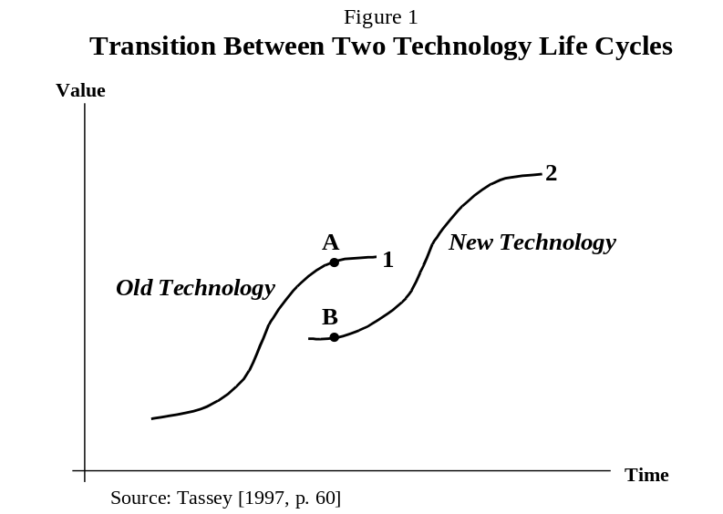Under a Vannevar Bush-type of model, government can rationalize funding years, even decades, of basic research. At some point, enough knowledge is accumulated to allow judgements of risk associated with potential market applications of a new technology based on the underlying science. In an oversimplified model, applied technology research should be more or less automatically initiated and a new technology life cycle started.
However, a major problem for R&D policy arises at this transition from basic research to technology research. Here, for the first time, market risk assessments must be added to estimates of technical risk. Combining technical and market risk complicates corporate R&D decisions way beyond what is involved in allocating government funds for basic research.
Figure 2 indicates that technology research, with its ultimate objective of market applications, encounters an initial major increase in technical risk because the scientific principles presented must now be proven capable of conversion into specific technological forms with specific performance attributes that meet specific market needs. This additional risk, RR', occurring in the early phases of the R&D life cycle, can and does act as a substantial barrier to private investment in technology research. Understanding the evolution of and the interaction between technical and market risk and the consequent impacts on private-sector investment are the key elements for effective R&D policy analysis.
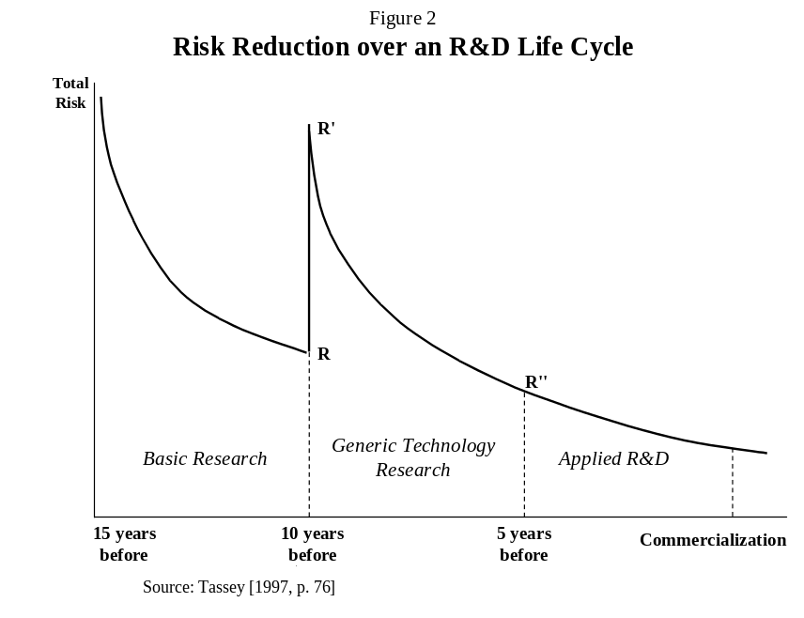The last phase of a major technology life cycle is characterized by increasingly intense competition, shrinking profit margins, and structural unemployment and/or, underemployment—all of which have been observed in major industry groups within industrialized nations during the 1990s. Certainly, economic growth policy must help ease transition costs, but it also must facilitate adaptation to the next technology life cycles by identifying the relevant market failures and developing appropriate responses. During the last phases of a given life cycle, the new technologies that will drive the next life cycle already exist, but with small market shares. Thus, opportunities for adaptation are available, but attempts to take advantage of them usually do not occur until economic conditions have become significantly distressed.

3.0. The Dual Value of an R&D Capability
Conventional wisdom actually understates the importance of R&D in technology-based industries by indicating that capital spending exceeds R&D spending. Such a relative ratio of investment has been true until recently. However, R&D has two strategically critical roles in the “knowledge-based economy”: (1) implementation of internal innovation strategies, and (2) to provide the capability to absorb technology from external sources.
Given the growing importance of these functions, many companies are increasingly spending more on R&D than on plant and equipment. More than one-half of Hewlett-Packard’s sales now come from products the company developed within the previous two years. In 1997 and 1998, HP spent more on R&D than on plant and equipment ($3.1B versus $2.3B and $3.4B versus $2.0B, respectively). To some extent, such relative increases in R&D spending are due to the fact that high-tech firms such as HP are contracting out more of their manufacturing requirements than in the past, which reduces capital expenditures. However, such strategies only accentuate the evolution of these companies toward a focus on knowledge-based competitive advantage.
HP exemplifies the dual R&D strategy. The company is recognized as one of the world’s leading innovators, but one of HP’s most successful products in recent years is the ink-jet printer, which was the result of successful imitation and improvement upon the innovating firm, Canon. Canon had the patents on early ink-jet designs but made a strategic error by choosing to attempt a complex implementation that ultimately set it years behind.
However, R&D at the company level cannot exist in a vacuum. Corporations increasingly require access to R&D conducted by other firms in their supply chains and to the broader technology infrastructure provided by a national innovation system. The overall health of the entire R&D network, in turn, determines the breadth and depth of national competitiveness.

4.0. Transition to a Life-Cycle Based Economic Model
The essence of technology-based economic growth is that a body of scientific knowledge is drawn upon for the development of technologies which, to varying degrees and in various forms, eventually result in markets that contribute to the gross domestic product of the economy. This value added is therefore the end point for economic growth policy, and the factors determining its growth over time constitute the critical elements of policy analysis.
An effective economic model of technology-based growth will incorporate four basic elements:
- The early phases of technology development encounter considerable technical and market risks that are often beyond the capabilities and hence the investment criteria of individual firms or even groups of firms.
- Efficient development of technology by industry requires a complex set of supporting technical infrastructures to evolve along with the technology itself.
- Transactions in technology-based markets involve sophisticated products and services, which require equally sophisticated infrastructure support.
- R&D investment patterns and the consequent success or failure of domestic industries in global markets is time dependent; that is, the technology life cycle is the dominant framework for the critical analysis of how different R&D investments are made—including the early investments that initiate the cycle across supply chains.
Corporate managers, business analysts and economists have argued over how to best represent all four elements in a conceptual economic model. So-called linear models capture the time dimension to a degree but have been appropriately rejected as too narrow in scope and overly simplistic. However, no consensus on a more comprehensive policy-relevant replacement has emerged. Other concepts, such as feedback loops and chain-link or cross-fertilization among several areas of science and technology, represent different dimensions of R&D investment patterns. Each of these concepts enables a characterization of factors in the evolution of technology at various phases in the R&D life cycle.
While each concept has its limitations, they are not mutually contradictory. In fact, they embody complementary elements of the needed economic policy model. The feedback loop seems to be an attractive concept for R&D managers, referring to the integration of the three phases of economic activity—R&D, production, and marketing. Market experiences feed back to R&D and production, resulting in adjustments to product design and process technologies. Certain feedback loops are consciously compressed by companies⎯in particular, the interactions between product and process R&D that reduce manufacturing problems. This phenomenon is most prominent in shorter product life cycles. The existence of information feedback creates a concept of technological change that is more dynamic and even circular, in which the phases of R&D and subsequent market use change almost simultaneously.
Academic researchers, who are interested in a broad representation of the innovation process itself, have proposed more complicated frameworks such as the chain link model. Such models not only embody interactive relationships among stages in the development and commercialization of technology, but include complementary roles of several distinctly different technologies. Here, the pattern of technological progress is ascribed more to a mating of complementary technology assets, independent of any evolutionary process. In fact, some proponents purport to show how “technological breakthroughs are just as likely to precede, as to stem from, basic research”.
The chain link effect occurs most prominently in the mid-length or generic technology life cycles. That is, when new generic technologies are being developed and applied for the first time, cross fertilization often occurs among heretofore separate areas of technology.
For example, HIV protease inhibitors were synthesized by chemists in the pharmaceutical industry based on understanding the structure of HIV protease as determined by biologists using physicists' x-ray diffraction techniques. Two drug companies finalized their formulations using the ultra-powerful x-ray beams from synchrotron radiation sources normally used for nuclear physics research. Today, about 35% of the running time on the Department of Energy's synchrotron radiation sources is used for this kind of structural biology. Conversely, the development of neural network computing algorithms to efficiently sort complex multi-dimensional data sets has it origins in neurobiologists’ attempts to develop an understanding of the brain’s structure.
The example of biotechnology (text box) does not mean that technology evolves in a purely linear process. Obviously, areas of science such as molecular biology continue to advance and thereby make possible new technological applications. Moreover, the basic research producing these advancements is often influenced by the success or failure of past technological applications. As the HIV protease example shows, chain-link phenomena are real and important. Feedback loops have been accentuated in recent years by corporate strategies such as concurrent engineering, rapid prototyping, and, more recently, quality function deployment approaches to managing technology development and commercialization.

Applying Alternative Models—Biotechnology
One frequently used example of the non-linearity of technological progress is Pasteur’s development of the first vaccine, where both basic and applied research are characterized as being conducted at the same time. That is, Pasteur set out to solve a problem—the need to cure a disease—but at the same time he discovered some basic principles of microbiology.
However, such historical examples do not reflect the current status of the majority of research and development as a process. Today, R&D is more structured and sequential out of necessity. Somewhat specialized tools and techniques are used for each research phase by scientists or engineers with unique skills for that type of research. Moreover, technology R&D today seldom progresses very far unless it can draw on a reservoir of scientific knowledge.
Medicine is, in fact, a good example of this evolutionary pattern. Through NIH, the U.S. government sponsored basic research over a thirty-year period before the science of molecular biology evolved to the point at which a biotechnology industry could begin to evolve. It is hard to imagine that the genetically engineered drugs that are appearing with increasing frequency could have been developed by a modern-day Pasteur using trial and error methods (which is basically the way drugs were developed from Pasteur’s time until the past fifteen years of biotechnology R&D).
In general, neither increases in scientific knowledge nor technological progress are particularly steady. Major advancements occur and feed a host of applications for a period of time. The process of developing these applications for the marketplace itself creates knowledge, which feeds back to stimulate a more orderly evolution of the initial breakthrough. Demand pressures and technological opportunity promote linking across heretofore separate areas of technologies.
However, the example of molecular biology and other important areas of science, such as solid-state physics, demonstrate that a linear progression of knowledge still takes place as the technology life cycle progresses. The knowledge gained not only feeds back into the existing life cycle but it also eventually contributes to the subsequent technology life cycle.
Thus, the debate over whether to use a linear model or to adopt one of the more sophisticated variants is somewhat artificial. In some cases, those who use a linear model typically do so for simplicity’s sake. The policy analysis to be undertaken does not require a more complex representation, only acceptance of a net progression of knowledge to successively more applied levels. Most users of such linear models acknowledge that reality is more complicated. Moreover, another distinction is that the two conceptual approaches address two different steps in long-term technological change. The linear model typically represents a higher level of aggregation of technology than does the chain link framework, which focuses on single technologies.

5.0. Elements of an Economic Policy Model of R&D
Any sound policy approach to understanding technology-based growth must satisfy two basic requirements.
- The first requirement is the need to define a set of elements that comprise the typical industrial technology. These elements are distinguished primarily by differences in private sector incentives to invest in them.
- A second requirement is that the relevant investment behavior be depicted over time because of the existence of multiple cycles that characterize private sector investment in technology research.
With these two requirements satisfied, a more accurate and policy-relevant analysis of specific market failure mechanisms is possible. Equally important, appropriate government policy responses can be constructed and matched to these market failures, thereby greatly increasing the efficiency of R&D policy.
The general elements of industrial technology that are relevant for R&D policy are depicted in Figure 3. The relevance of these elements for policy analysis derives from the fact that each needs a unique set of R&D skills, facilities, and supporting infrastructures. Each one also requires a different research time frame (especially relative to each other in the R&D cycle). Finally, each element displays a markedly different degree or type of public good content. Thus, the sources of and processes for the development of each technology element are significantly different.
5.1. Generic Technology. A particular science base evolves over several decades and eventually reaches a critical mass, at which point industry begins to extract commercially relevant technology from this science base. Typically, before large amounts of private-sector funds can be committed to developing market applications of the technology, the generic technical concept must be demonstrated. This necessary generic technology research demonstrates that the general technology may work in specific market applications. For many technologies, the “proof of concept” can be a laboratory prototype. Each generation of digital electronic technology (transistor, integrated circuit, multifunction chip) was first demonstrated in the laboratory and then was further developed to yield market applications over many product life cycles.
The existence of generic technology as the basis for huge amounts of follow-on private sector investment was clearly identified by Richard Nelson, but policy models have only vaguely recognized its critical importance. In essence, generic technology provides general inferences about how the technology works, identifies the attributes that determine the performance of the technology, demonstrates how these attributes combine to realize overall performance, and indicates initial ranges of variation for each attribute.
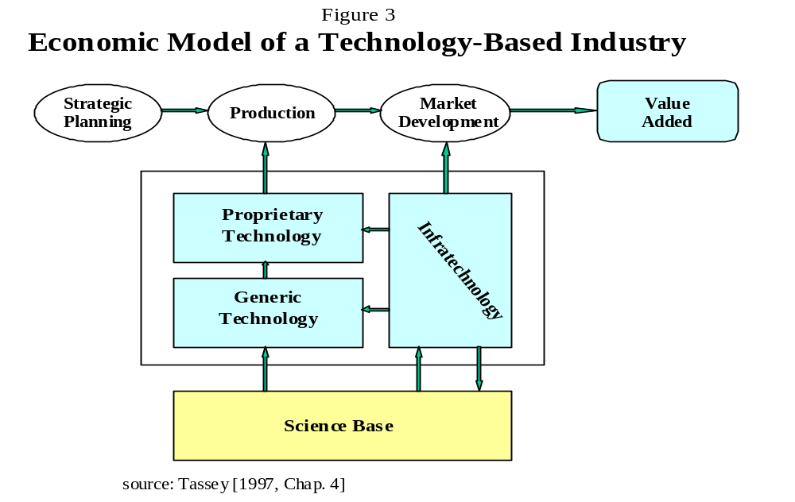The broader, deeper, and more accurate the generic technology is, the greater the amount of R&D stimulated and the larger the number of market applications eventually produced. Equally important for R&D policy is the fact that generic technology diffuses to a relatively greater extent than do more applied versions of the technology. Such spillovers mean that generic technology is simultaneously drawn upon by competing companies in developing market applications. It therefore has some of the characteristics of infrastructure.
Biotechnology provides an excellent example of how generic technologies arise out of the science base, but ahead of specific market applications. The biotechnology industry is, in fact, typical of the existence of multiple technology elements and the complex relationships among them. As shown in Table 1, multiple areas of science have had to advance before a larger set of generic product and process technologies could evolve. Supported by a number of infratechnologies, these generic technologies have advanced over the past 20 years and are just now beginning to yield significant numbers of proprietary market applications.

Table 1

Phases in the Biotechnology Life Cycle

Basic Research | Generic Technologies |  | Infratechnologies | Products
Basic Research | Product | Process | Infratechnologies | Products
- molecular and cellular biology  - microbiology/ virology  - immunology  - neuroscience  - physiology  - pharmacology  - genomics | - gene testing  - gene therapy  - gene delivery systems  - gene expression systems  - antisense  - apoptosis  - antiangiogenesis | - combinatorial chemistry  - recombinant DNA/genetic engineering  - nucleic acid amplification & probes  - gene transfer  - transgenic animals  - cell culture  - immunoassays  - monoclonal antibodies  - cell encapsulation  - implantable delivery systems | - biospectroscopy  - mitochondrial DNA standards  - DNA profiling standards  - nucleic acid diagnostics  - thermodynamics of protein-nucleic acid interactions  - bioinformatics database | - protease inhibitors  - hormone restorations  - DNA probes  - neuroactive steroids  - neuro-transmitter inhibitors  - vaccines  - coagulation inhibitors  - inflammation inhibitors

5.2. Infratechnology. The other category of industrial technology with significant public good content is infratechnology. Infratechnologies are a varied set of technical tools that perform a wide range of measurement, integration, and other infrastructure functions. These functions include:
- measurement and test methods
- artifacts such as standard reference materials that allow these methods to be used efficiently
- scientific and engineering databases
- process models
- the technical basis for both physical and functional interfaces between components of systems technologies, such as factory automation and communications systems.
As Table 2 indicates, these technical tools are ubiquitous in the technology-based economic growth process. They affect the efficiency of R&D, production, and marketing. Because individual infratechnologies typically have a focused application and hence impact (e.g., measurement and test methods are applied to specific steps in a production process), their economic importance has been overlooked. However, the complexity of technology-based economic activity and the demands by users of technology for accuracy and high levels of quality have reached levels that a large number of diverse research-intensive infratechnologies are required⎯even within single industries. The resulting aggregate economic impact of these infrastructural technologies is substantial. Examples of infratechnologies supporting a specific industry (biotechnology) is shown in Table 2.
One indication of the pervasive and substantial impact of measurement infratechnologies has been provided by a NIST study of the semiconductor industry’s investment in measurement equipment. This industry invested about $2.5 billion in measurement equipment in 1996, triple the amount spent in 1990. This expenditure is expected to continue growing at least 15 percent per year, reaching between $3.5 billion

Table 2
Uses of Infratechnologies by Stage of Economic Activity
R&D | PRODUCTION | MARKET DEVELOPMENT
Timing & Efficiency  - Materials Characterization  - Measurement Methods  - Techniques (design for manufacturing, rapid prototyping) | Process & Quality Control  - Process Modeling  - Measurement and Test Methods  - Process and Quality Control Techniques | Transaction Cost Reduction  - Acceptance Test Methods  - Interface Standards  - Compatibility/Conformance Test Facilities
Source: Tassey [1997, p. 158]

and $5.5 billion in 2001. Thus, the cost of not having needed infratechnologies and associated standards in place to support this investment can be substantial. Another NIST study of interoperability in the U.S. automotive supply chain found that the lack of standard formats for transferring electronic product design data between suppliers and automobile manufacturers is costing that industry approximately $1 billion per year.
The range and technical sophistication of infratechnologies support a varied and complex standards infrastructure. Infratechnologies are a necessary basis for standardization at all levels in the modern manufacturing process: individual equipment, the process systems level, and even at the customer/vendor interface. In service industries, infratechnologies help define output, interoperability, security protocols, and intellectual property.
Infratechnologies also could include the various techniques, methods, and procedures that are necessary to implement the firm's product and process strategies. Methods such as total quality management can be differentiated upon implementation within a firm. However, they must be traceable to a set of generic underlying principles if customers are to accept claims of product quality. Hence, they have an infrastructural or public good character.

6.0. Market Failure and Underinvestment
The concept of technology life cycles is particularly important for R&D policy because it implies a time order or evolutionary character—including both a beginning and an end—to various market failures that appear at different points in the typical life cycle. Hence, this concept helps determine of appropriate policy responses within life cycles as well as the critical transitions between cycles.
In general, four basic categories of underinvestment can and do occur:
- aggregate underinvestment by an industry (e.g., insufficient total R&D);
- underinvestment in applied R&D in new firms (e.g., insufficient venture capital);
- underinvestment in new generations of existing technology or in radically new technology (e.g., insufficient generic technology research)
- underinvestment in supporting technology infrastructures (e.g., insufficient infratechnology R&D).
Because the process of technology development evolves cyclically, market failures that lead to underinvestment tend to repeat themselves. Moreover, distinctly different types of market failure exist and therefore require different government or industry/government response modes. In each case of market failure, the particular barrier increases the probability that the project’s risk-adjusted and time-discounted expected rate of return will not exceed a company’s hurdle rate. In such cases, where the social or aggregate economic rate of return is high (above society’s hurdle rate), underinvestment occurs and economic growth is reduced below its potential.
6.1. Important Characteristics of Market Failure. The following are the major types of market failure that can and frequently do occur over the typical technology life cycle.
- Technology is inherently complex. A certain amount of risk is reasonable given the considerable expected rewards from technology investment. However, the more radical or complex the attempted technical advance (technical risk), or the longer the time period needed to conduct the R&D during which demand can shift or competitors can commercialize the technology first (market risk), the greater the probability of an inadequate rate of return being realized.
- The benefits from technology tend to diffuse or leak to firms beyond the originator (innovator). Such spillovers are of two major types: price and knowledge.
- Price spillovers occur when the market price does not fully capture the additional benefits from the new technology. That is, the user (buyer) in effect receives some of the benefits for free. Up to a point, the existence of such spillovers is desirable because, if the new technology were fully priced, the buyer would be indifferent between the old and the new technologies. Market forces determine the actual distribution of benefits. The supplier (innovator) must simply capture enough of the benefits to meet or exceed the investment hurdle rate applied to the original R&D investment decision. For most technologies and competitive structures, a sufficient rate of return cannot be projected when significant price spillovers ocurr.
- Knowledge spillovers refer to leakage of the innovator’s new technical knowledge horizontally to competing suppliers. This type of spillover is good for the economy as a whole, but it decreases the expected returns for potential innovators. To the extent that rates of return fall below the private hurdle rate, investment by potential innovators will not occur.
- Market Structure can reduce expected rewards from technology investment. An increasing number of technologies are systems. System components must interface seamlessly with other components to work effectively. That is, they must interact in a fully functional manner with minimal effort by the user (system integrator). Otherwise, the cost and flexibility advantages from having choices among suppliers of individual components (as opposed to buying turnkey systems from a single supplier) are eroded.
Interfaces between complex components often are far from seamless, frequently being just as complex as the components themselves. In such cases, achieving compatibility or interoperability results in significant additional costs, thereby raising total system costs and lowering the expected rate of return to both the suppliers and users of the components. These costs are particularly high (and, in fact, interoperability is usually not achieved) when competing private interests attempt to provide this type of infrastructure independently. The higher cost of non-interoperable systems, coupled with reduced functionality, lowers the technology’s rate of market penetration.
This segmentation of markets for systems technologies can last for long periods of time and therefore result in significant economic loss.
- Corporate strategies often are narrower in scope than a new technology’s market potential. Some new technologies (advanced ceramics, for example) have applications in a number of markets previously served by very different technologies and hence industries. Companies in the existing industries typically do not have the strategic profile or the production and marketing knowledge to target all the potential applications (i.e., to capture economies of scope). Thus, the expected rate of return to each company is lowered relative to the risk of developing the generic technology, which applies to all potential applications.
- Increasingly dominant “systems” technologies require complex infrastructure. Sophisticated customers demand customized versions of the technology, which require highly complex and flexible productions systems. Automated production systems and technology-based services such as finance, communications, and entertainment all require sophisticated information infrastructures. Significant private investment in applications only occurs after the infrastructure is developed and implemented (for example, several decades of government support for the Internet were required before private investment in applications using it took off).
In addition to price and knowledge spillovers, network externalities are frequently labeled as a third type of spillover. However, this phenomenon does not cause a redistribution of benefits from the innovating firm to other firms. Rather, it usually results in increased benefits for all market participants. The expanding market for the network increases the value for individual network participants and therefore most likely for the original supplier (innovator). The market failure risk here is associated with the potential for network externalities to generate increasing returns to scale for the innovator. If increasing returns are strong enough, the innovator could become a monopoly and bar entry by other firms and possibly restrain innovation for some period of time.
In summary, the scope of market failure mechanisms affecting technology-based investment is broad. Spillovers are the most frequently (and sometimes are the only) reason cited for private-sector underinvestment in R&D. However, as the above analysis indicates, spillovers are only one characteristic of technology-based competition that can lead to inadequate investment. These characteristics directly affect either the benefit or the cost side of the investment calculation.
6.2. Transitions between Technology Life Cycles. One of the main factors causing shifts in market share leadership across companies, industries and countries is the phenomenon of transitions between successive technology life cycles that serve the same market function (e.g., computing or communications). New technologies often have very different characteristics from the old or defender technologies that they seek to replace. Hence, strategies, organizational characteristics, and R&D capabilities that work well in one life cycle are not effective in the next cycle.
An example is computing. The first life cycle’s generic technology was manifested in the mainframe computer. Processing power was a scarce resource and hence everything was optimized to maximize the productivity of the processor. A single, huge machine was housed in an air-conditioned room, operated by technicians who strictly allocated users’ access. In the second life cycle, the personal computer reversed the control of the system. The user now owned the highly dispersed processing power. Now, a third technology life cycle is emerging in which the Internet offers the prospect of a reversion to a centralized computing system. In each of these three periods, the nature of the technology, the organizations supplying it, and the interface with the user vary significantly.
Within each life cycle, technology evolves according to conventional market dynamics. Efficiency can be achieved within short-term product life cycles largely by the private sector, with modest infratechnology support from government. However, major market share shifts occur across national economies, if the original generic technology is not improved over its life cycle. Even greater shifts in competitive position occur between major life cycles. Failure to prepare domestic industries for the transition by advancing new generic technologies typically causes major losses in sales, profits, and jobs to foreign competition.

7.0. The Tenuous Nature of Competitive Advantage
Even when industry has access to a rich generic technology base for applied R&D, market success can be fleeting or never achieved. The past several decades are littered with U.S. firms and entire industries that failed to conduct enough R&D or the right type of R&D to create and sustain competitive advantage. Too many instances exist of important technologies whose development was initiated in the United States but were taken over by industries in other nations to the substantial benefit of those other nations’ economies.
7.1. Examples of technology-based markets lost to foreign competition. The following are just a few examples of technology-based economic growth opportunities that have been lost by U.S. industry for a variety of reasons:
- Semiconductor production equipment: Steppers. The stepper was invented in the United States, but market share is now almost totally Japanese. The loss of competitive position in semiconductor manufacturing equipment not only reduces the contribution to domestic economic growth in the electronics supply chain, but it also may reduce the productivity of other levels in that supply chain (particularly, U.S. semiconductor manufacturers). These manufacturers can find themselves at a competitive disadvantage relative to their competitors in Japan, who are more closely linked to the Japanese equipment suppliers. (Solving this vertical integration problem has been the primary objective of SEMATECH.)
- Flat panel displays. RCA invented the liquid crystal display, but had too narrow a view of its applications and essentially gave the technology to the Japanese. The Japanese now own 95 percent of a world market that is growing rapidly and driving downstream equipment/product markets.
- Advanced Ceramics. The current revolution in wireless communications would not have been possible without the discovery and development of oxide ceramics. The ceramic requirements of microwave applications (e.g. filters, oscillators, resonators) are critical and these components collectively represent a majority of end-use devices. Every modern commercial wireless communication and detection system in actual use or in advanced development incorporates oxide ceramics. This important compound was discovered and its processing phase diagrams determined in the early 1970s at Bell Labs and the National Bureau of Standards, respectively. Despite these early and fundamental U.S. advances, Japanese industry today clearly dominates the markets for these ceramics (estimated at $700 million for 1997). For example, only two U.S. companies (Motorola, which serves a captive market, and Trans-Tech, a small company with annual sales of $35 million) produce ceramic components, as compared with six major companies in Japan. Furthermore, control of this technology has stimulated additional Japanese R&D and led to most of the new materials that are enabling dramatic advances in miniaturization and performance of wireless communications equipment.
- Robotics. Today's industrial robotics market (worth about $6 billion) is dominated by Japanese companies such as Fanuc, Yaskawa Electric, Kawasaki Robotics, Mitsubishi Electric, and Motoman. U.S. companies—Westinghouse, General Electric, General Motors, and Unimation—first established the industrial robotics market in the 1960s but, by the mid-1980s, all had sold their robotics interests to Japanese companies. Today, the largest U.S. robotics manufacturer (Adept Technology, San Jose) employs just 375 people. The only non-Japanese robotics manufacturer of any size is the Swiss-Swedish company ABB Flexible Automation.
- Video cassette recorder. Ampex and RCA developed the video tape recorder (VTR) in the 1950s. By the 1980s, its descendent, the videocassette recorder (VCR), was in one-half of all American homes, with virtually all of these VCRs made by Japanese firms.
- Semiconductor memory devices. The United States invented the transistor and the integrated circuit. Yet between 1979 and 1986 U.S.-based firms saw their world-market share decline from 75 percent to 27 percent. After that, U.S.-based firms recovered some of this loss. However, the persistently weak U.S. position is indicated by the fact that only two of the top ten firms worldwide in the major memory circuit markets (DRAM and SRAM) are based in the United States.
- Digital watches. The first electronic digital watch was introduced in 1971 by a U.S. company, Time Computer, which held all the patents. The semiconductor chip that ran the watch was purchased from RCA. Today, the Japanese dominate both the component and watch markets. Even though a number of U.S. electronics companies (such as Motorola, National Semiconductor, and Texas Instruments) made significant improvements and cost reductions early in the technology life cycle, the Japanese relentlessly improved the technology and reduced its cost, thereby taking over this market.
- Interactive electronic games. In 1972 Magnavox developed the first interactive game designed to be played on the screen of a TV. Two years later, Atari, Inc., was formed and led the market for a number of years. Now, that market is controlled by Japanese firms.
Many argue that competitive failures such as the above examples are the fault of poor industry strategy and that the inherent efficiency of the market place demands no government interference. This view has considerable merit with respect to market applications within a single technology life cycle that result largely from applied R&D. However, if applied R&D needed no stimulus at all from government, various tax incentives such as the R&E tax credit would not be needed. Moreover, data cited below suggest that industry is increasingly under investing in two critical areas:
- Next generation technology (the technology base for the next technology life cycle) and
- The extremely varied sets of technical tools that are used to conduct R&D, control production processes, and execute the sale of complex technology-based goods and services.
7.2. Underinvestment in Generic Technology Research. Universities are the primary source of a nation’s basic science. Scientific knowledge diffuses in part through contact with industry and certain types of partnering, but mainly through new graduates in science and engineering. The next step—proving the generic technological concept, so that corporate R&D managers can make the technical and market risk assessments necessary for follow-on applied R&D investments—is much more complex. This early-phase generic technology research does not absorb a large portion of total R&D spending in most areas of technology, but its critical position in the R&D cycle means it has the potential to leverage much greater amounts of follow-on applied R&D.
As the next section describes, various combinations of industry, government, and universities fund or conduct generic technology research through a variety of organizational arrangements. These partnerships are attempts to deal with the quasi-public good nature of generic technologies and the consequent set of market failures that result from the mismatches between their characteristics and private-sector risk tolerances, R&D capabilities, and market strategies.
Table 3
IRI Annual R&D Trends Forecast for
Industry-Funded Directed Basic Research, 1991–1999
Survey | Percent of Respondents Increasing Directed Basic Research | Percent of Respondents Decreasing Directed Basic Research
1991-1995 | 8–14 % | 23–38 %
1996 | 17 % | 5 %
1997 | 15 % | 13 %
1998 | 14 % | 28 %
1999 | 14 % | 37 %
Source: Industrial Research Institute

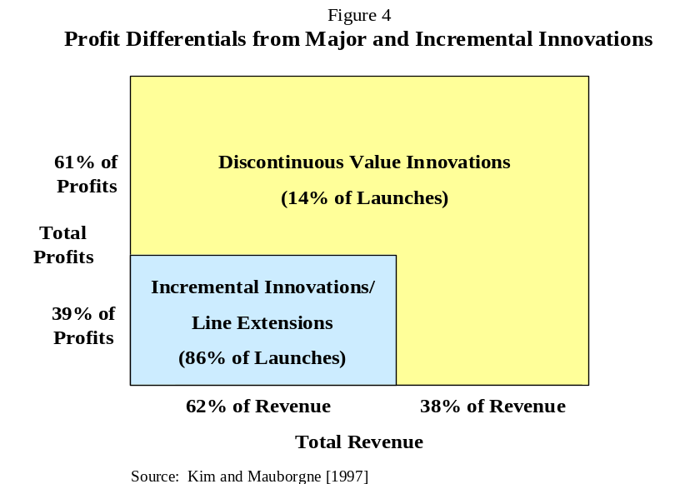Case studies have shown that long-term, high-risk corporate research is declining. In Table 3, the Industrial Research Institute survey data for “directed basic research” spending plans by industry during the 1990s supports the case studies. Moreover, this research has a discontinuous character, thereby stretching out the R&D life cycle and making the eventual market applications highly uncertain. From 11 case studies of radical innovation efforts within major corporations, a team from Rensselaer Polytechnic Institute concluded that “the life cycle of a discontinuous innovation project is profoundly different from a continuous improvement project”. The 11 projects exhibited many of the types of market failure described earlier. In eight of the 11 case studies, the researchers found that government was a major source of funds after the project was formalized. For the most part, these funds were used to extend, expand, or accelerate projects. Partnering with other firms (large and small), universities, and government laboratories was a common approach.
The critical point for R&D policy is that major technological advances take more time and entail more risk than do incremental change and improvements. More radical R&D often is contracted out or accomplished through partnering; both options lengthen R&D cycle time. Yet, as a study by Kim and Mauborgne (see Figure 4) clearly indicates, longer-term and more radical R&D projects are more profitable.
7.3. Underinvestment in Infratechnology Research. Support for infratechnology research also has been generally inadequate. For example, the budget for the NIST laboratories has grown only 2.0 percent per year in real terms in the last 24 years, 1973-97, compared with an average annual real growth rate of 8.9 percent for industry-funded R&D—the productivity of which NIST’s measurement-related infratechnology research is charged with supporting. The markedly different growth rates have resulted in the NIST laboratory research budget declining by one half relative to industry R&D spending during this period.
The NIST labs provide a wide range of measurement-related infratechnologies to industry. As described earlier, these infratechnologies—either directly or through incorporation in industry standards—are pervasive in terms of their economic impacts. They leverage the productivity of R&D, enhance quality and process control, and facilitate efficient marketplace transactions for complex, technology-based products and services. Because of the large number of infratechnologies required by a single technologically advanced industry, the collective economic impact is large. However, their infrastructure and hard-to-visualize character and the diffuse nature of their impacts create difficulties for policy makers.

8.0. Policy Implications
Corporate R&D investment decisions do not take place in a vacuum. They are driven by “the invisible hand”⎯perceived technological and market opportunities⎯as well as by “the invisible foot”⎯the threat of competition. In addition to these factors, investment decisions are also strongly influenced by the breadth and depth of a supporting technological infrastructure. Major elements of this infrastructure are:
- the availability of skilled workers;
- access to generic technical knowledge and external scientific and engineering research capabilities;
- the existence of a set of technically complex infrastructures including science and engineering data bases, measurement and test methods, interface standards, and quality assurance procedures.
The first of these is a well-defined policy issue and fortunately is now getting focused attention by policy makers. However, the second and third elements are complex and not particularly well understood. Thus, effective policy development remains constrained.
8.1. The Relative Size and Impacts of Government-Funded Research. Figure 5 indicates that amounts spent on generic technology research and infratechnology research between the 10th and 5th years before commercialization are relatively small. However, significant risk reduction in terms of advancing the generic technology to at least proof of concept or laboratory prototype often is essential to stimulate the much larger applied R&D investment by individual companies that eventually brings products, processes, and services to market. The availability of appropriate infratechnologies makes this process more efficient and, in some cases, is necessary for it to occur at all. The subsequent acceleration of industry R&D spending over the average R&D life cycle is pronounced. Industry spends 4.4 times as much on applied research as on basic research and 2.7 times as much on development as on applied research.
8.2. Matching Market Failure and Policy Response. Four major categories of market failure were identified above. Each requires a very different policy response:
- Aggregate underinvestment by an industry—insufficient total R&D. This problem is the result of either excessive risk avoidance due to adverse macroeconomic conditions or inadequate R&D capability (which raises entry costs and hence risk). Tax incentives can be effective as long as the R&D being targeted is comparable to the type already pursued by industry⎯that is, as long as the normal corporate R&D investment decision criteria can be applied. In other words, a tax incentive can stimulate more of the same type of R&D already 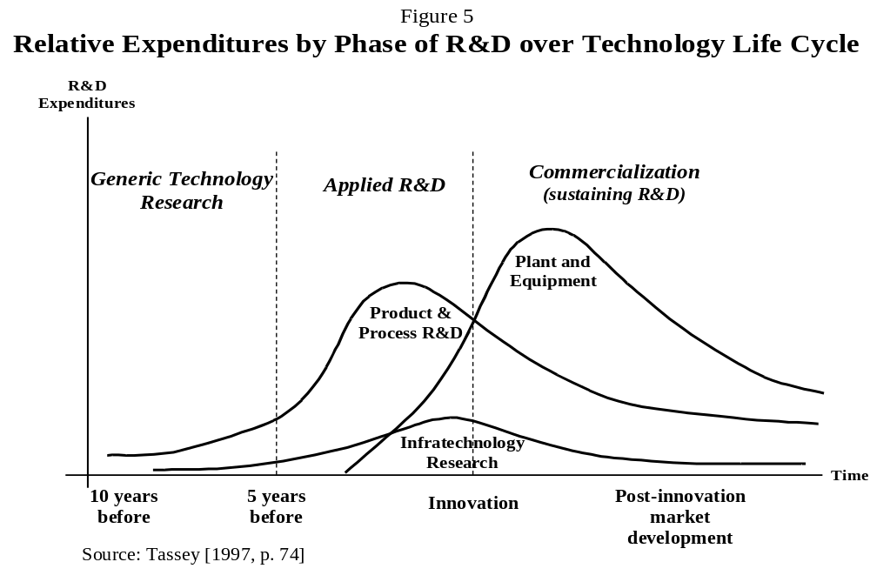conducted.
- Underinvestment in the formation of new firms—insufficient venture capital. Venture capital is plentiful in the United States and available for most areas of technology, once the generic technology is sufficiently advanced to allow the private sector sources of venture funding to make assessments of both technical and market risk. The policy issue is how to get to that point. A government role in advancing generic technology research has been accepted in the United States only in a few situations where an industry deemed necessary to achieve a major social objective is either inadequately structured or not formed at all. That is, if a new technology has potentially large social as well as economic benefits, is not capital intensive (it can be supplied by small firms), and is radical enough to inhibit investment by large firms focused on the existing technology, then R&D policy can consider subsidizing the creation of a new industry structure as a policy objective.
Biotechnology is an example of a radically new technology that meets these criteria. The National Institutes of Health (NIH) therefore funds some applied research in small biotech firms. The Small Business Innovation Research (SBIR) Program was created to fund research in new technologies that are both socially and economically important. In such cases, funding R&D by young, development-stage companies can expand both the number and variety of such firms. However, from an economic growth perspective, such policies for one or two industries will be highly inadequate in the evolving world economy.
- Underinvestment in new generations of existing technology or in radically new technology—insufficient generic technology research. Because of the highly microeconomic character of technology development, and hence the uniqueness of the sets of market failures that affect individual technologies, broad R&D incentives, such as a tax credit, are generally not effective. Tax expenditures tend to leak to both technologies and phases in the R&D process that do not require government support. Instead, the efficient policy response would combine direct funding of generic technology research with appropriate joint strategic planning among government, industry, and universities.
Early-phase, generic technology research often is conducted through a variety of partnership mechanisms, because this approach allows a more effective combination of research skills and facilities, pools risk, and increases the rate of technology diffusion. All nations with technology-based growth strategies have industry-government programs to cooperatively advance the early phases of a variety of technologies with considerable economic potential.

- Underinvestment in supporting technology infrastructures—insufficient infratechnology R&D. Infratechnologies not only have common use characteristics (including their use as standards), but they often derive from a different science and generic technology base than does the core technology being applied by industry through its internally funded R&D. The latter fact argues for a strong role by government laboratories in the conduct and diffusion of infratechnology research. Government labs can realize economies of scale and scope from unique research skills and facilities that can be applied to meet the infratechnology needs of a number of industries. These labs also can provide neutral third party facilitation of the standards process.
8.3. Responding to technical and Market Risk Barriers. As described earlier, the intrinsic technical and market risk faced by R&D firms varies over a technology’s life cycle. Therefore, both industry and government responses to market imperfections and resulting underinvestment in R&D and/or slower market penetration by the new technology also must vary. Figure 6 indicates how a set of existing policy responses can be used to mitigate market failures over the different phases of an R&D life cycle.
For example, after basic research has gone on for some time, the accumulated level of knowledge begins to spark interest by industry in the possibility of developing technologies based on this science. Diffusion of the basic science and subsequent initial evaluation of its economic potential can be facilitated through graduates of universities and entities such as the National Science Foundation’s Science and Technology Centers 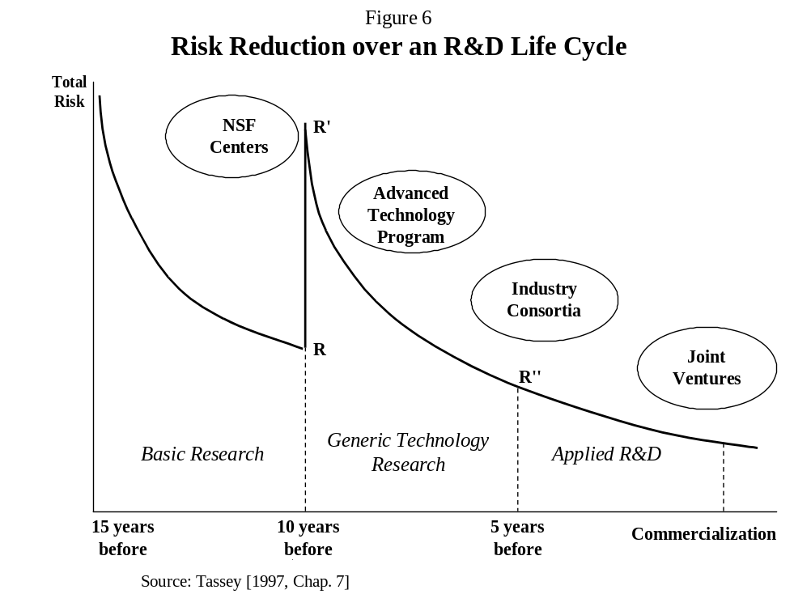and Engineering Research Centers, where industry and university researchers can interact. For specific areas of technology, industry-operated entities such as the Semiconductor Research Corporation (SRC) fund research under a similar format. More recently, the Focus Center Research Program (FCRP) was established as a network, including the U.S. semiconductor industry, the U.S. Government, and 14 universities.
Diffusion of basic scientific knowledge through mechanisms such as the NSF centers and the FCRP can provide industry with an indication of an emerging technology’s potential. However, the decision process for investing in the early phases of technology research is a difficult one for individual companies to manage effectively. There are several reasons for this difficulty:
- competitive pressures of fighting for market share in the current technology life cycle consume corporate energies;
- corporate management applies different decision criteria to long-term projects compared with the bulk of corporate R&D;
- recognition of the extremely high technical and market risks associated with a potential technology whose concept has not been proven even in the laboratory;
- R&D capabilities needed to launch a significant research program in a new technology, especially involving multiple research disciplines and laboratory facilities, are frequently incomplete within individual firms.
Even with new R&D management approaches such as options pricing techniques, these factors can combine to raise overall risk to prohibitive levels. The lack of appropriate R&D capability relative to the skills and facilities required for pursuing development of emerging technologies increases risk substantially beyond that associated with an immature state of development. This latter factor is especially important when new technological opportunities require combining several heretofore separate areas of scientific or technical knowledge.
The result is the large jump in overall risk from R to R' in Figure 6. This combined technical and market risk must be reduced to levels that fit within conventional R&D decision criteria—that is, those criteria applied by companies to the majority of candidate R&D projects.
In response, risk pooling is a common strategy for conducting early-phase technology research. Consortia are widely used for this purpose in advanced economies. A number of cooperative organizational forms can be used to share costs and complementary R&D capabilities. National laboratories and research institutes frequently participate in research consortia because they have the time horizons, the multiple disciplinary skills, and the unique research facilities to undertake generic technology research.
Cost-shared research consortia with various combinations of industry, government, and universities as partners are the efficient approach to conducting much early-phase generic technology research in the United States. NIST’s Advanced Technology Program (ATP) stimulates investment in generic technology through cost-shared industry/government partnerships. Similar but larger programs include the European Framework Program and Japan’s Industrial Science and Technology Frontier Program and its System to Support Development of Creative Technology for New Industries. As portrayed in Figure 6, such programs focus on generic technology research, i.e., early-phase research where economies of scope, long time to expected commercialization, R&D capability mismatches, and related factors inhibit corporate R&D investment decision making.
Once beyond this early-phase, industry can usually apply conventional R&D decision criteria and take on most of the applied research and development required to take the generic technology to commercialization. Figure 6 indicates that firms also will use consortia for applied research. However, such industry-led consortia seldom have a time frame of more than five years, with three to five years being the typical range. Scientific research programs are typically at least 10 years long and often span several decades. Proof of concept through generic technology research often begins 5 to 10 years before commercialization. In other words, this period in the R&D life cycle can constitute a funding “gap” between basic research—largely a public good—and applied R&D—largely a private good. This “valley of death” is described by Congress in the widely discussed “Ehlers’ report” as a “widening gap between federally-funded basic research and industry-funded applied research and development”. Government programs such as ATP attempt to help fill this gap.

9.0. Summary
A number of categories of technology embody significant public good elements:

- emerging technologies that entail high risk and long gestation periods but create new markets with significant value added;
- systems technologies that provide infrastructure to many product and service technologies and thereby drive growth in major economic sectors;
- enabling or multi-use technologies which benefit multiple segments of an industry or group of industries, but encounter economies of scope and diffusion investment barriers;
- infratechnologies which leverage investment in both development and use of proprietary technologies, but which require distinct competencies to develop and common ownership (such as standards) to effectively use.
For these classes of technology, the evolutionary patterns of technical and market risk over the relevant life cycle can and do result in inadequate investment a key points in the life cycle. This underinvestment results from a much wider set of economic conditions (market failures) than commonly believed. Specifically,
- Technical complexity: The need for multiple disciplines to be combined within one organizational structure to conduct R&D.
- Time: The negative effect on investment decision making of excessive discounting
- Capital intensity: The effect on risk assessment of the capital intensity of many research processes (i.e., of the cost of these processes, especially as a percentage of a firm’s R&D portfolio).
- Economies of scope: A broad and uncertain scope of potential market applications for many of the most important emerging technologies.
- Spillovers: A tendency for excessive “leakages” or “spillovers” of the technical knowledge produced by individual companies to others that did not contribute to the research.
- Infratechnologies and standards: Public good character and low visibility cause inadequate investment.
- Market segmentation: The emergence of sophisticated users who demand sets of performance attributes that cannot be provided by existing industrial R&D capabilities.
Three particularly important negative impacts of these market failures are:
- Corporate investment decision dysfunction with respect to longer-term, complex, and multidisciplinary technology research. Underinvestment is particularly pronounced in the early phases of the R&D life cycle, which most strongly exhibit the investment barriers resulting from the intrinsic technical risk of the technology and its mismatches with existing corporate strategies and competences.
- Excessive compression of R&D life cycles with resulting disincentives to undertake long-term, high payoff research. Global competition is forcing shorter total product life cycles which, in turn, are forcing corporate R&D portfolios to overemphasize product-line extensions and incremental process improvements. In general, less market risk is assumed by the private sector.
- Failure to project access to the markets for increasingly system-based technologies. Many of today’s most important technologies have complex system structures, which require equally complex interfaces to enable market entry by small and medium suppliers and system optimization by users. Without the needed infrastructure, inefficient industry structures evolve.
Given the nature of technology market failures and the significance of rectifying them, the two major R&D policy issues facing the U.S. economy today are
- Understanding and providing appropriate policy responses for the early phases of technology research. Efficiently bridging the valley of death—the widening gap between federally funded basic research and industry-funded applied research and development—does not require large amounts of federal funding. However, this funding for generic technology research is essential to lowering the substantial technical and market risks typical of early phases in a technology’s life cycle and must be available when the window of opportunity is open. All industrialized nations have or participate in industry-government partnerships of various forms to provide this essential category of technology infrastructure.
- Identifying and providing technical infrastructures needed by technology-based industries. The needs for these infrastructures vary over the typical technology life cycle and have strong public good content, thereby requiring effective government support. As with generic technology, research support for the needed range of infratechnologies requires relatively modest amounts of funding. However, this funding must not only be adequate, but it needs to be directed to unique research facilities that can achieve the large economies of scale and scope that characterize this type of technology infrastructure and that can also efficiently diffuse it to industry, standards organizations, and other users.
The major technology trends identified here obviously have implications for the amount and type of R&D needed to achieve steady, high rates of economic growth. Equally important, technology trends interact with corporate strategy, industry structure, and government policy (in particular, policies that provide technical infrastructure at the various phases in a technology’s life cycle). Technology trends or trajectories, once established, can have dramatic effects on a number of industries or even sectors of the economy in terms of both rate and directions of growth. Hence, early evaluation of the multiple trajectories afforded by the timely development of generic technology and supporting infratechnologies is essential.

References

American Electronics Association [1997], Cybernation. Washington, DC: The American Electronics Association.

Arthur, W. Brian [1996], “Increasing Returns and the New world of Business,” Harvard Business Review 74 (July–August): 100–109.

Caracostas, P. and U. Muldur [1995], “Long Cycles, Technology and Employment: Current Obstacles and Outlook,” STI Review (No. 15): 75–104.

Cohen, L. and D. Levinthal [1989], “Innovation and Learning: The Two Faces of R&D,” Economic Journal (September).

Corcoran, Elizabeth [1994], “The Changing Role of U.S. Corporate Research Labs,” Research•Technology Management (July–August):14–20.

Department of Commerce [1998], The Emerging Digital Economy. Washington, DC: U.S. Department of Commerce (April).

Doremus, P., W. Keller, L. Pauly, and S. Reich [1998], The Myth of the Global Corporation. Princeton, NJ: Princeton University Press.

Drucker, Peter [1998], “The Discipline of Innovation,” Harvard Business Review 76:6 (November–December): 149–157.

Duga, Jules [1994], IRI Forecast Reflects Major Change in How U.S. Industry Will Perform R&D,” Research•Technology Management (May–June): 9–11.

Eidt, C. and R. Cohen [1997], “Reinventing Industrial Basic Research,” Research•Technology Management (January–February): 29–36.

Finan, William [1997], Metrology-Related Costs in the U.S. Semiconductor Industry, 1990, 1996, and 2001 (Planning Report 98-4). Washington, DC: Technecon Analytic Research (prepared for the Program Office, National Institute of Standards and Technology (May).

Freeman, Christopher [1979], “The Kondratiev Long Wave” in Structural Determinants of Employment and Unemployment. Paris: Organization for Economic Cooperation and Development.

Geppert, Linda [1994], “Industrial R&D: The New Priorities,” IEEE Spectrum (September): 30–41.

Kim, W. Chan and Renée Mauborgne [1997], “Value Innovation: The Strategic Logic of High Growth,” Harvard Business Review 75:1 (January-February): 102–112.

Klein, S. and N. Rosenberg [1986], “An Overview of Innovation” in Ralph Landau and Nathan Rosenberg (eds.), The Positive Sum Strategy: Harnessing Technology for Economic Growth. Washington, DC: National Academy Press.

Link, A. N. and J. T. Scott [1998b], Public Accountability: Evaluating Technology-Based Instistutions. Norwell, MA: Kluwer.

Luehrman, Timothy [1998], “Strategy as a Portfolio of Real Options,” Harvard Business Review 76 (September–October): 89–99.

Mowery, David [1998], “Collaborative R&D: How Effective Is It?” Issues in Science and Technology (Fall) 37-44.

National Science Board [1996], Science & Engineering Indicators – 1996. Arlington, VA: National Science Foundation, (NSB 96-1).

National Science Board [1998], Science & Engineering Indicators – 1998. Arlington, VA: National Science Foundation, (NSB 98-1).

Nelson, Richard [1987], Understanding Technological Change as an Evolutionary Process. Amsterdam: North Holland.

Nelson, Richard [1992], “What Is ‘Commercial’ and What Is ‘Public’ About Technology, and What Should Be?” in N. Rosenberg, R. Landau and D. Mowery (eds.), Technology and the Wealth of Nations. Stanford, CA: Stanford University Press.

Papaconstantinou, G., N. Sakurai, and A. Wyckoff [1998], “Domestic and International Product-Embodied R&D Diffusion,” Research Policy 27: 301–314.

Research Triangle Institute [1999], Interoperability Cost Analysis of the U.S. Automotive Supply Chain (Planning Report 99–3). Gaithersburg, MD: National Institute of Standards and Technology (March).

Rice, M., G.C. O’Conner, L. Peters, and J. Morone [1998], “Managing Discontinuous Innovation,” Research • Technology Management 41:3 (May–June): 52–58.

Richter, Paul [1998], “Long-Term Research and Its Impact on Society,” address to a Senate Forum on “Research as an Investment” (February).

Schumpeter, J. [1939], Business Cycles: A Theoretical, Historical and Statistical Analysis of the Capitalist Process. New York: McGraw Hill.

Schumpeter, J. [1950], Capitalism, Socialism, and Democracy (3rd ed.). New York: Harper and Row.

Tassey, Gregory [1992], Technology Infrastructure and Competitive Position. Norwell, MA: Kluwer.

Tassey, Gregory [1996], “Choosing Government R&D Policies: Tax Incentives vs. Direct Funding,” Review of Industrial Organization 11: 579–600.

Tassey, Gregory [1997], The Economics of R&D Policy. Westport, CT: Quorum Books.

Tassey, Gregory [1999], R&D Trends in the U.S. Economy: Strategies and Policy Implications (NIST Planning Report 99-2).

Tassey, Gregory [2000], “Standardization in Technology-Based Markets”, Research Policy 29.

Vonortas, Nicholas [1997], Cooperation in Research and Development. Norwell, MA: Kluwer.

The high-tech sector is defined here as consisting of four major categories: high-tech manufacturing (IT-related plus industrial electronics), communication services, software and computer-related services, and pharmaceuticals). For alternative definitions of IT-related high-tech industries, see American Electronics Association [1997, p. 128] and Department of Commerce [1998, Appendix p. A1–2]. The AEA definition results in a 6.1 GDP estimate for 1996 and the Commerce definition yields about 8 percent for 1998. To either of these definitions should be added pharmaceuticals, which brings the AEA-defined high-tech sector’s GDP contribution to 7 percent. Obviously, no precise definition can be constructed. What is included is a matter of drawing the line at some level of dependency on internally-funded R&D. All of the industries included in the AEA definition plus pharmaceuticals have company-funded R&D intensities of 8 percent or more. The next most R&D intensive industry group is health services with an R&D intensity of about 6 percent. Including this large industry group would add approximately 5.5 percentage points to the high-tech industry GDP contribution. Even with this expanded definition, “high-tech” is still a small fraction of the U.S. economy.
Schumpeter [1939, 1950] and Caracostas and Muldur [1995, p. 77]. Several generations of microprocessors are an example of product life cycles “nested” under a generic technology life cycle (integrated circuits). These generic technology cycles are, in turn, nested under a major technology life cycle (solid-state digital electronics). See Tassey [1997, Chap. 4].
See Freeman [1979].
See Cohen and Levinthal [1989].
The term “supply chain” as used in this report refers to the vertical structure of industries that begin with raw materials and eventually serve a final demand. An example of a first level in a supply chain would be silicon and other semiconductor materials. These materials are used to manufacture semiconductor devices, which are combined to form electronic components and equipment. The latter are further combined to form “systems,” such as an automated factory that manufactures a product (computer) or a telecommunications network that provides a service.
See, for example, Klein and Rosenberg [1986].
National Science Board [1996, p. 4-10].
Richter [1998].
In the important area of digital electronics, the transistor could never have been invented without prior knowledge of the basic science of solid-state physics, which provided the theoretical basis for thinking that a semiconducting material could be used to construct an electronic switch or amplifier. Once invented, the importance of the transistor stimulated an avalanche of further basic research making possible further cycles in digital electronics technology.
Economists distinguish among these elements with the concepts of “rivalous” and “non-rivalous” goods. The former cannot be consumed by one individual without preventing consumption by others (e.g. toothbrush), while the latter can be collectively consumed (software). Non-rivalous goods present investment incentive problems because “free riders” consume the good but do not pay for it. However, a second condition—that of “excludability”—is necessary to determine private sector investment in non-rivalous goods. Patents, for example, are a mechanism for excluding free riders from consuming technical knowledge produced by others. Technology infrastructure falls into the non-rivalous category, but excluding additional consumers of this knowledge is not in the public interest. Thus, these types of public technology goods are funded at least partially by government to compensate for spillovers.
See for example, Nelson [1987, 1992].
Tassey [1997, Chap. 8].
For summaries of microeconomic studies of infratechnologies and associated methodologies, see Link and Scott [1998] and Tassey [1997, 1999].
Finan [1998]. The estimate does not include the labor and overhead required to implement this measurement infrastructure.
Research Triangle Institute [1999].
These four categories of market failure and the appropriate policy responses are discussed in detail in Tassey [1997, Chaps. 6–10].
Tassey [1997, Chap. 5].
The role of standards is extremely important here. See Tassey [2000].
See Arthur [1996].
This phenomenon is the general economic basis for the Justice Department’s antitrust suit against Microsoft.
See, for example, Corcoran [1994], Duga [1994], and Geppert [1994].
This is comparable to generic technology research.
Rice, Peters, and Morone [1998, pp. 57–58]. Also, see Eidt and Cohen [1997].
Tassey [1997, Chap. 8].
National Science Board [1998, Appendix Tables A 4-7 and A 4-11].
Tassey [1997, pp. 107-111].
Small firms now get a lot of NIH funding, both through the SBIR Program and otherwise; but, prior to SBIR they did not. In fact, Congressional hearings in 1978 documented the fact that NIH had no research contracts with small business at that time.
Tassey [1997, Chap. 7].
Tassey [1997, Chap. 8].
For an overview of these new R&D decision techniques, see Luehrman [1998].
Vonortas [1997] provides a comprehensive overview of cooperative R&D.
Mowery [1998, p. 39].
Unlocking Our Future: Toward a New National Science Policy. A report to Congress by the House Committee on Science, September 24, 1998.

