  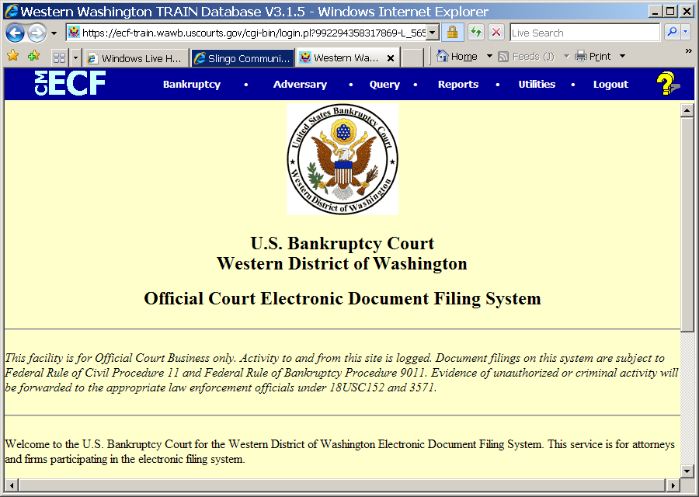
  Slide 1
  Text Captions: Attachments (Adding Exhibits)
  This lesson is for training purposes only. Actual documents must be filed in the court's official ECF system. Read and follow instructions as outlined in each page of the lesson. Procedural instructions appear in white call-outs. Information that appears in the header is for informational purposes only. Each page is timed. If no response is made within the allotted time period, the page may time out.
  You may use the playback controls at the bottom of the screen to navigate the lesson.
  Click the Start button to begin.
  USBC - Western Washington Attachments (Adding Exhibits)
  Click Start to begin
  Slide 2. Text Captions: This lesson demonstrates how to upload attachments to documents being filed in ECF. The Court does not accept exhibits on their own; they must be included as attachments when making a docket entry. In ECF, the term Type is used to define a generic attachment type. You'll find the following types listed in ECF: Exhibit, Notice of Hearing, Pleading, Proof of Service, Proposed Order, and Schedule. The term Description is used to define a specific type of attachment. Enter text that describes the attachment. Example: When attaching a car title as an exhibit, select “Exhibit” from the Type drop-down list and enter “Car Title” in the Description field. NAMING STANDARDS: Types should not be entered in the Description field. Example: When selecting “Exhibit” as the type, do not enter the word “Exhibit” in the Description field, i.e., Exhibit 1, Exhibit 2, etc. Rather, enter text that describes the Exhibit. Click the Continue button
  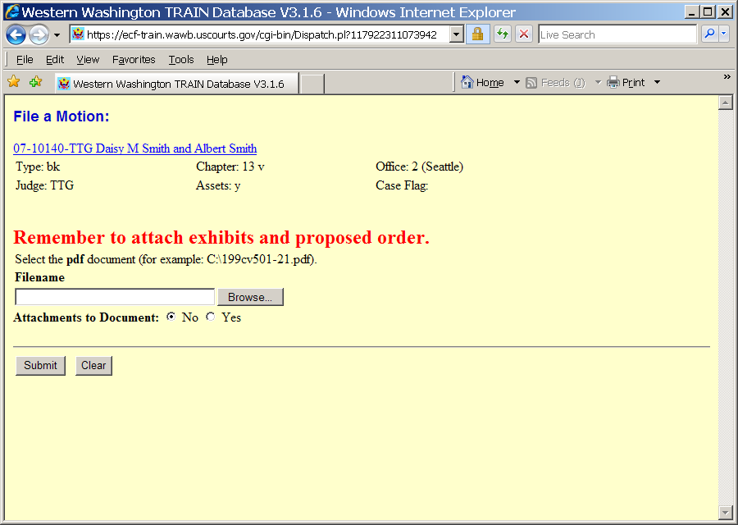
  Slide 3
  Text Captions: Click Browse to upload the PDF image of the main filing document, in this case the Motion for relief from stay.
  Click the button
  The PDF Attachment screen displays. This screen allows for the upload of the PDF image of the document being electronically filed and all attachments to the filing.
  Note: This lesson focuses on attachments to the filing event. All other ECF screens will not display in this lesson.
  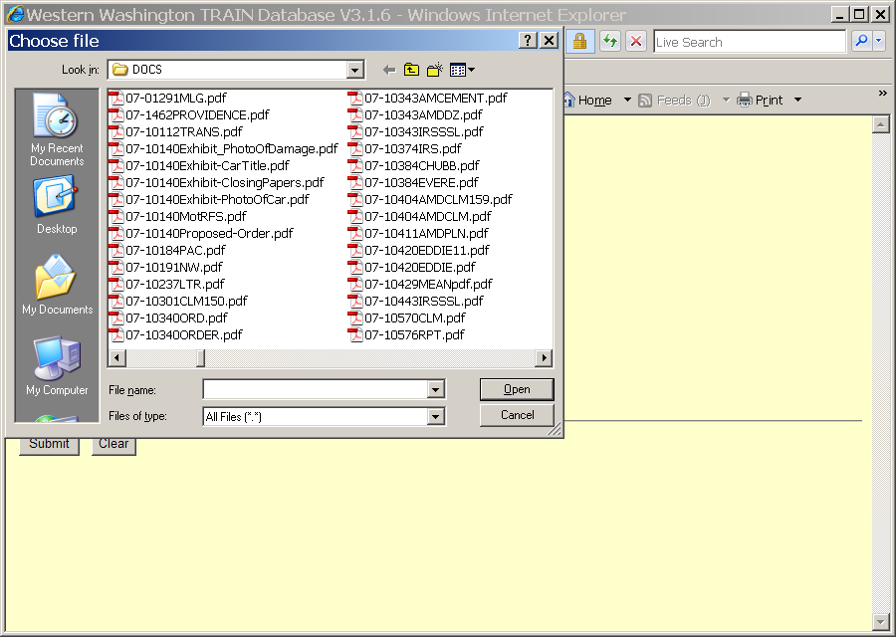
  Slide 4
  Text Captions: Select the 07-10140MotRFS.pdf item
  The Choose file box displays. This box allows for the navigation through drives, folders and file for the saved PDF image. The motion must be saved to PDF prior to upload into ECF.
  For this example a Motion for Relief from Stay is being electronically filed.
  Click on 07-10140MotRFS.pdf to select it.

  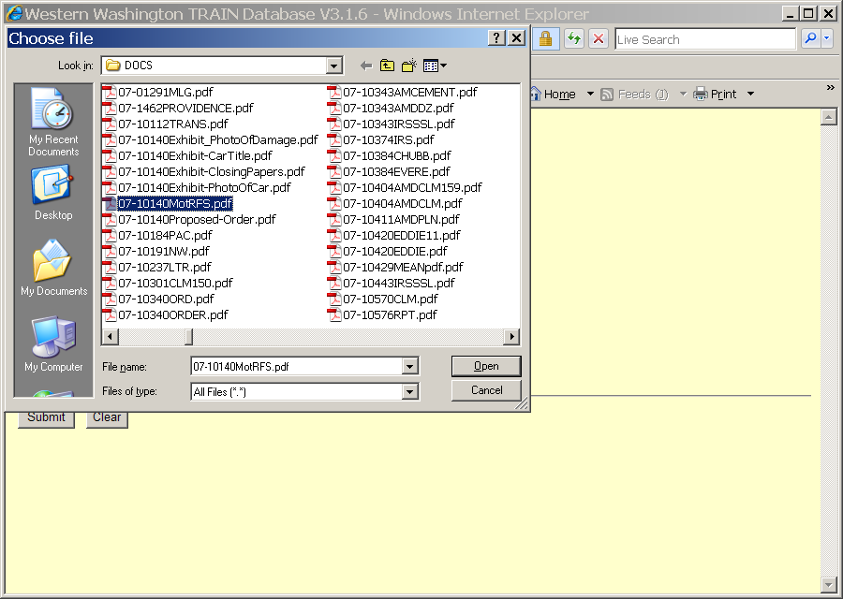
  Slide 5
  Text Captions: Click the Open button
  The Choose file box displays. This box allows for the navigation through drives, folders and file for the saved PDF image. The motion must be saved to PDF prior to upload into ECF.
  Click the Open button
  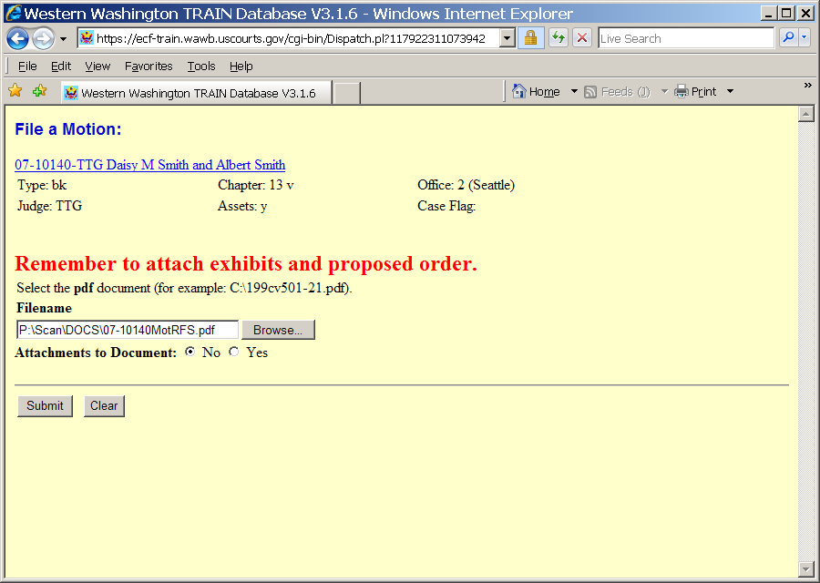
  Slide 6
  Text Captions: Select the Yes radio button to upload Attachments to Document.
  Select the radio button. The PDF Attachment screen displays again. The path and file name displays in the Filename field. Review the information for accuracy. Attachments are added as Attachments to Documents. A PDF document may not be larger than 5 megabytes (MB) in size. Larger PDF documents must be broken apart, with the additional parts uploaded as attachments.
  NOTE: Attachments must be uploaded during the initial filing. The court will NO LONGER attach e-mailed copies of documents. When an attachment is required but was not uploaded during the filing, the docket event MUST be re-filed along with any attachments.
  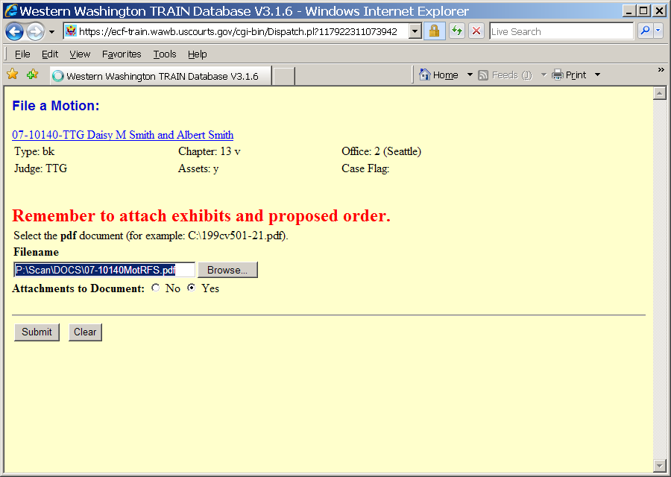
  Slide 7
  Text Captions: Click the Submit button
  Click the Submit button.
  The PDF Attachment screen displays again. The path and file name displays in the Filename field. Review the information for accuracy. Attachements are added as Attachments to Documents.
  A PDF document may not be larger than 5 megabytes (MB) in size. Larger PDF documents must be broken apart, with the additional parts uploaded as attachments.
  NOTE: Attachments must be uploaded during the initial filing. The court will NO LONGER attach e-mailed copies of documents. When an attachment is required but was not uploaded during the filing, the docket event MUST be re-filed along with any attachments.
  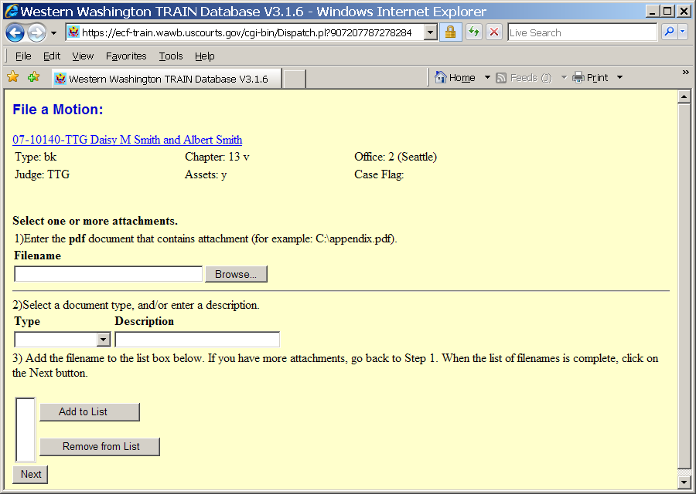
  Slide 8
  Text Captions: Click the Browse button
  The Attachment screen displays. This screen allows for the upload of attachments to the event being filed. "Type" is used to define the generic attachment type. "Description" is used to give a specific description of the attached document. When attaching an exhibit, for example, enter a specific description of the exhibit in the Description text box.
  Click the Browse button.

  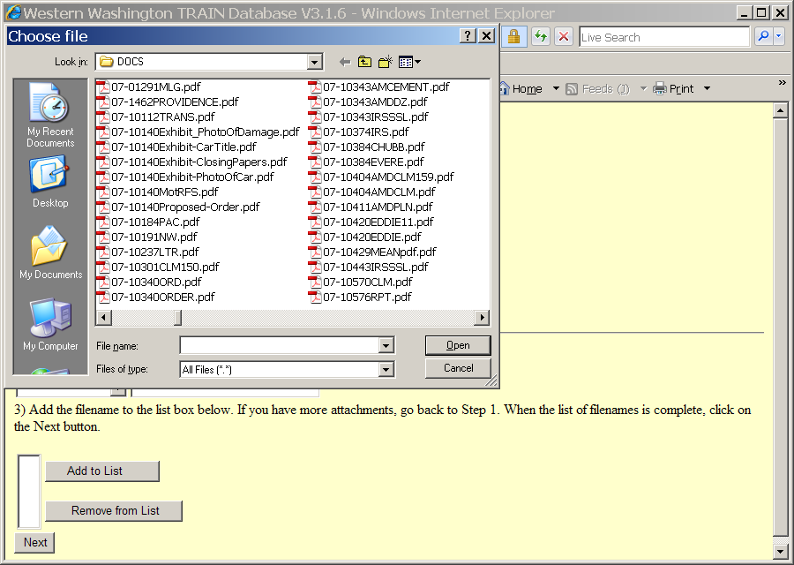
  Slide 9
  Text Captions: Select the 07-10140Proposed-Order.pdf item
  The Attachment screen displays. This screen allows for the upload of attachments to the event being filed. "Type" is used to define the generic attachment type. "Description" is used to give a specific description of the attached document. When attaching an exhibit, for example, enter a specific description of the exhibit in the Description text box.
  Click on 07-10140Proposed-Order.pdf to select it.
  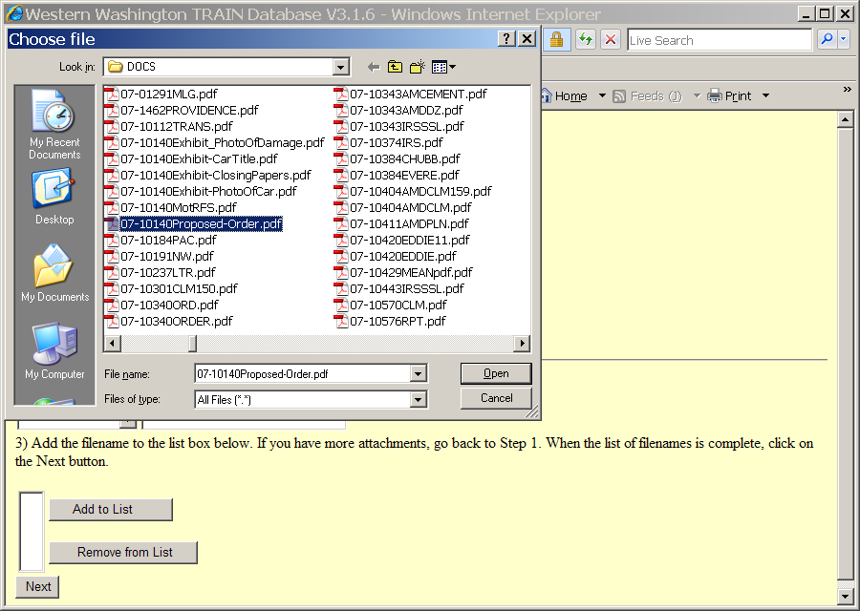
  Slide 10
  Text Captions: Click the Open button
  Click the Open button
  The Attachment screen displays. This screen allows for the upload of attachments to the event being filed. "Type" is used to define the generic attachment type. "Description" is used to give a specific description of the attached document. When attaching an exhibit, for example, enter a specific description of the exhibit in the Description text box.
  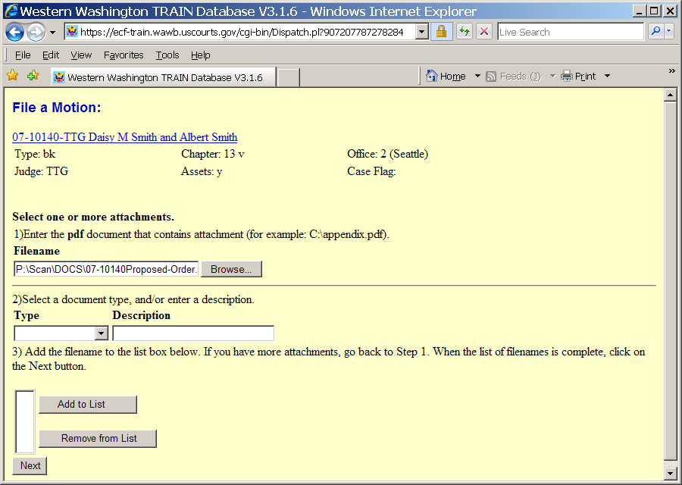
  Slide 11
  Text Captions: Click the Type drop-down arrow to make a type selection.
  Click the Type drop-down arrow
  The Attachment screen displays. This screen allows for the upload of attachments to the event being filed. "Type" is used to define the generic attachment type. "Description" is used to give a specific description of the attached document. When attaching an exhibit, for example, enter a specific description of the exhibit in the Description text box.
  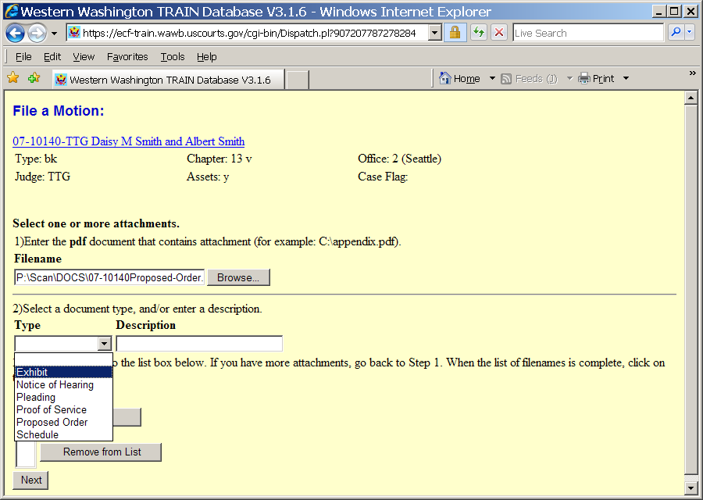
  Slide 12
  Text Captions: Click on Proposed Order to select it.
  Select the Proposed Order item
  The Attachment screen displays. This screen allows for the upload of attachments to the event being filed. "Type" is used to define the generic attachment type. "Description" is used to give a specific description of the attached document. When attaching an exhibit, for example, enter a specific description of the exhibit in the Description text box.

  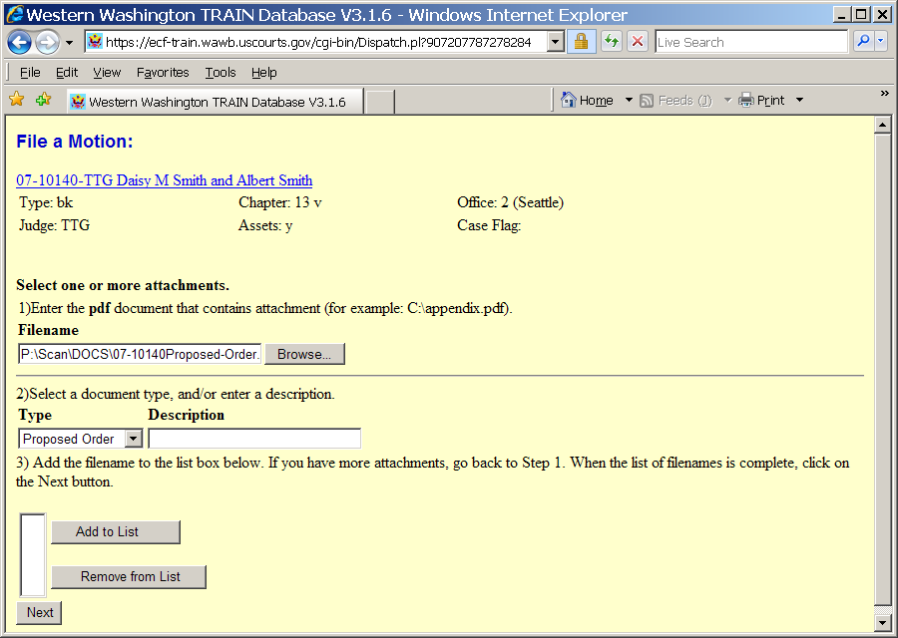
  Slide 13
  Text Captions: A description is not required for the proposed order.
  Click the Add to List button to continue.
  Click the Add to List button
  The Attachment screen displays. This screen allows for the upload of attachments to the event being filed. "Type" is used to define the generic attachment type. "Description" is used to give a specific description of the attached document. When attaching an exhibit, for example, enter a specific description of the exhibit in the Description text box.
  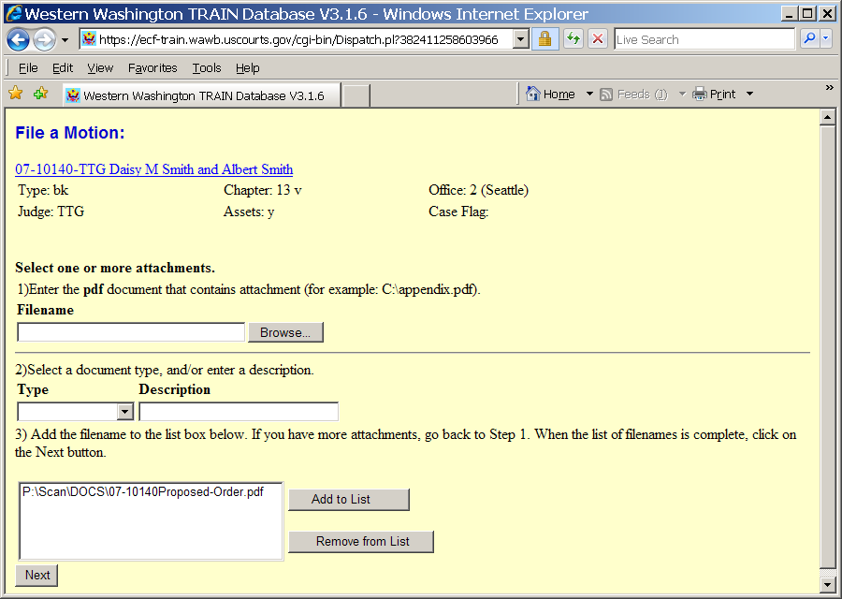
  Slide 14
  Text Captions: For this example additional attachments are required.
  Click the Browse button.
  Click the Browse button
  The Attachment screen displays. This screen allows for the upload of attachments to the event being filed. "Type" is used to define the generic attachment type. "Description" is used to give a specific description of the attached document. When attaching an exhibit, for example, enter a specific description of the exhibit in the Description text box.
  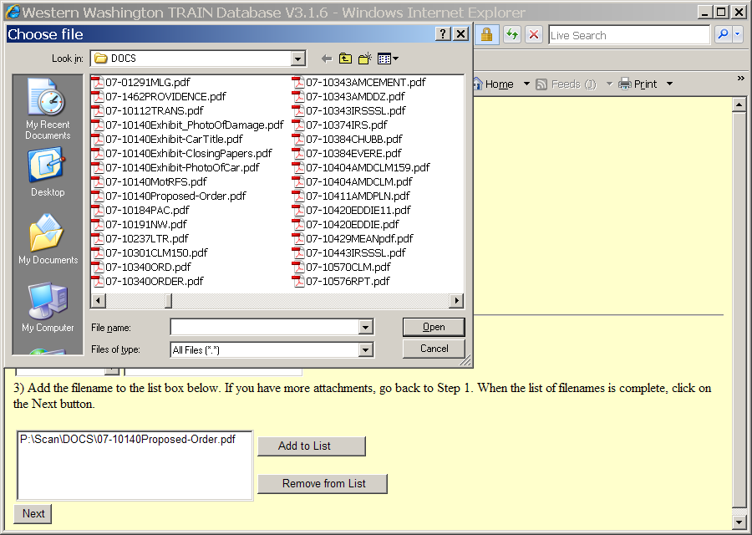
  Slide 15
  Text Captions: For this example click on 07-10140Exhibit-ClosingPapers.pdf to upload it.
  Select the 07-10140Exhibit-ClosingPapers.pdf item
  The Attachment screen displays. This screen allows for the upload of attachments to the event being filed. "Type" is used to define the generic attachment type. "Description" is used to give a specific description of the attached document. When attaching an exhibit, for example, enter a specific description of the exhibit in the Description text box.
  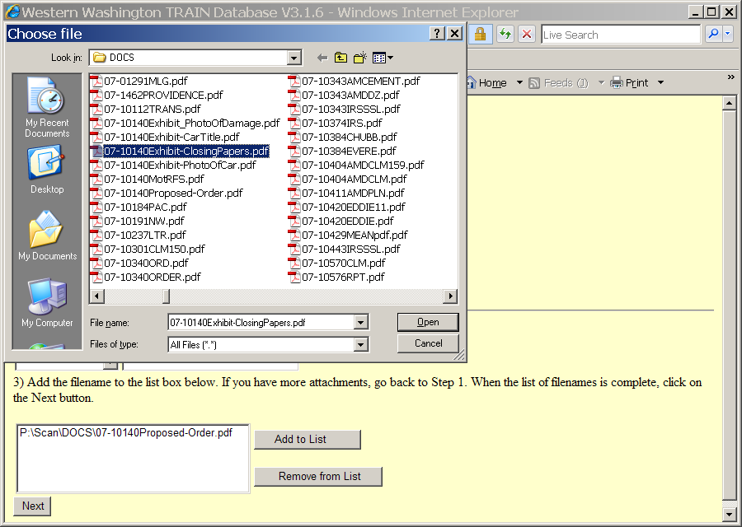
  Slide 16
  Text Captions: Click the Open button
  Click the Open button
  The Attachment screen displays. This screen allows for the upload of attachments to the event being filed. "Type" is used to define the generic attachment type. "Description" is used to give a specific description of the attached document. When attaching an exhibit, for example, enter a specific description of the exhibit in the Description text box.

  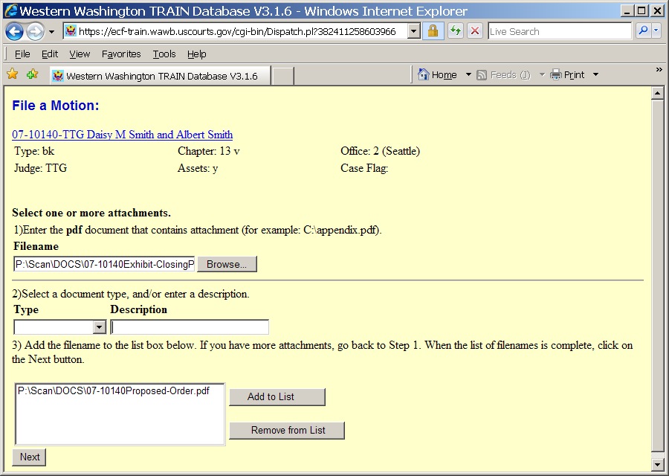
  Slide 17
  Text Captions: Click the Type drop-down arrow
  The Attachment screen displays. This screen allows for the upload of attachments to the event being filed. "Type" is used to define the generic attachment type. "Description" is used to give a specific description of the attached document. When attaching an exhibit, for example, enter a specific description of the exhibit in the Description text box.
  Click the Type drop-down arrow to select a type of event.
  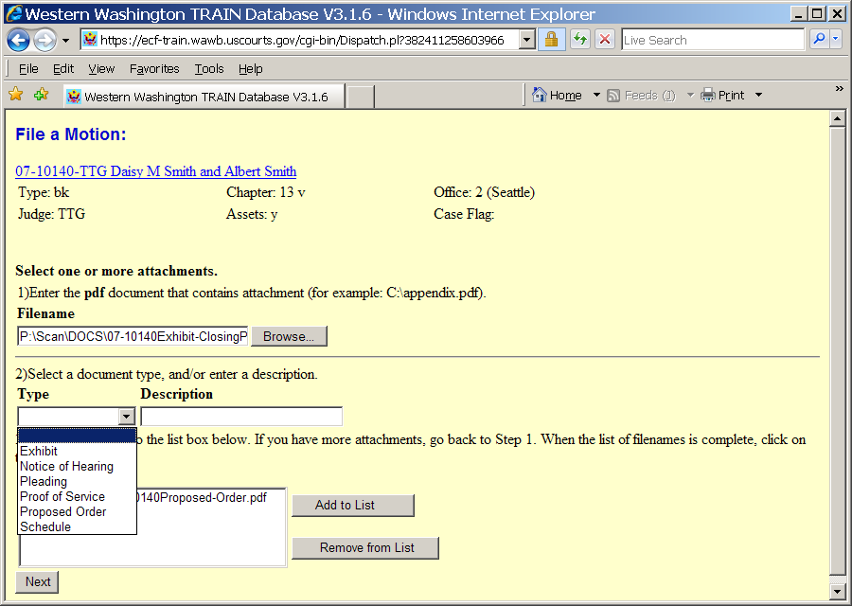
  Slide 18
  Text Captions: Click Exhibit as the filing Type.
  Select the Exhibit item
  The Attachment screen displays. This screen allows for the upload of attachments to the event being filed. "Type" is used to define the generic attachment type. "Description" is used to give a specific description of the attached document. When attaching an exhibit, for example, enter a specific description of the exhibit in the Description text box.
  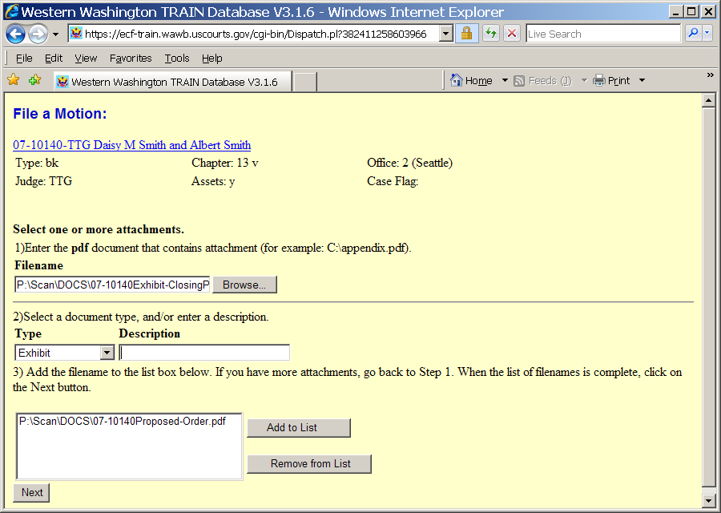
  Slide 19
  Text Captions: Incorrect, please try again
  The Attachment screen displays. This screen allows for the upload of attachments to the event being filed. "Type" is used to define the generic attachment type. "Description" is used to give a specific description of the attached document. When attaching an exhibit, for example, enter a specific description of the exhibit in the Description text box.
  Exhibits require a more specific description. For this example enter Closing Documents in the Description field.
  Then click Add to List button.
  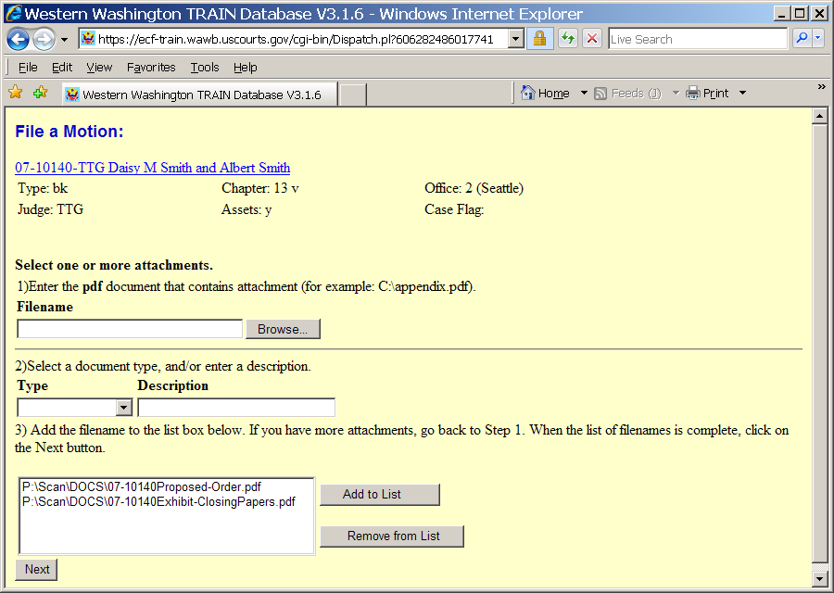
  Slide 20
  Text Captions: Click the Browse button to upload another attachment.
  Click the Browse button.
  The Attachment screen displays. This screen allows for the upload of attachments to the event being filed. "Type" is used to define the generic attachment type. "Description" is used to give a specific description of the attached document. When attaching an exhibit, for example, enter a specific description of the exhibit in the Description text box.

  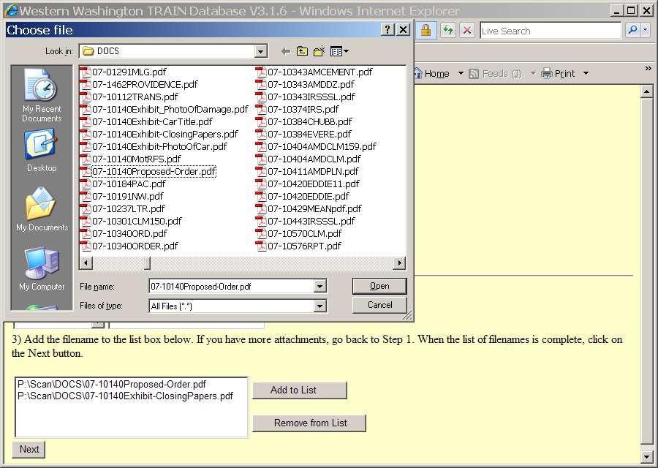
  Slide 21
  Text Captions: For this example click on 07-10140Exhibit-CarTitle.pdf to upload it.
  Select the 07-10140Exhibit-CarTitle.pdf item
  The Attachment screen displays. This screen allows for the upload of attachments to the event being filed. "Type" is used to define the generic attachment type. "Description" is used to give a specific description of the attached document. When attaching an exhibit, for example, enter a specific description of the exhibit in the Description text box.
  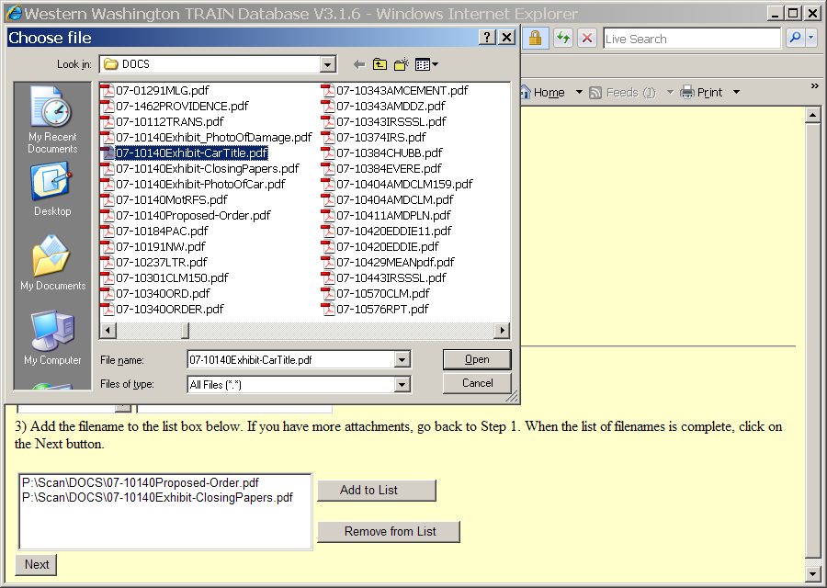
  Slide 22
  Text Captions: Click the Open button
  Click the Open button
  The Attachment screen displays. This screen allows for the upload of attachments to the event being filed. "Type" is used to define the generic attachment type. "Description" is used to give a specific description of the attached document. When attaching an exhibit, for example, enter a specific description of the exhibit in the Description text box.
  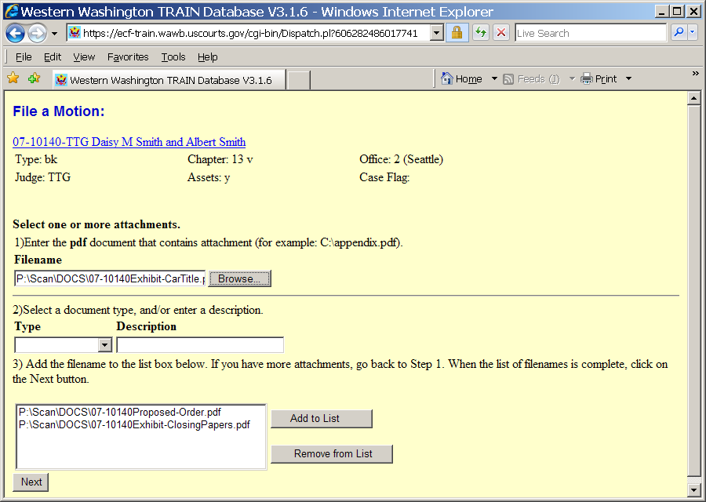
  Slide 23
  Text Captions: Click the Close button
  The Attachment screen displays. This screen allows for the upload of attachments to the event being filed. "Type" is used to define the generic attachment type. "Description" is used to give a specific description of the attached document. When attaching an exhibit, for example, enter a specific description of the exhibit in the Description text box.
  Click the Type drop-down arrow to select a type of event.
  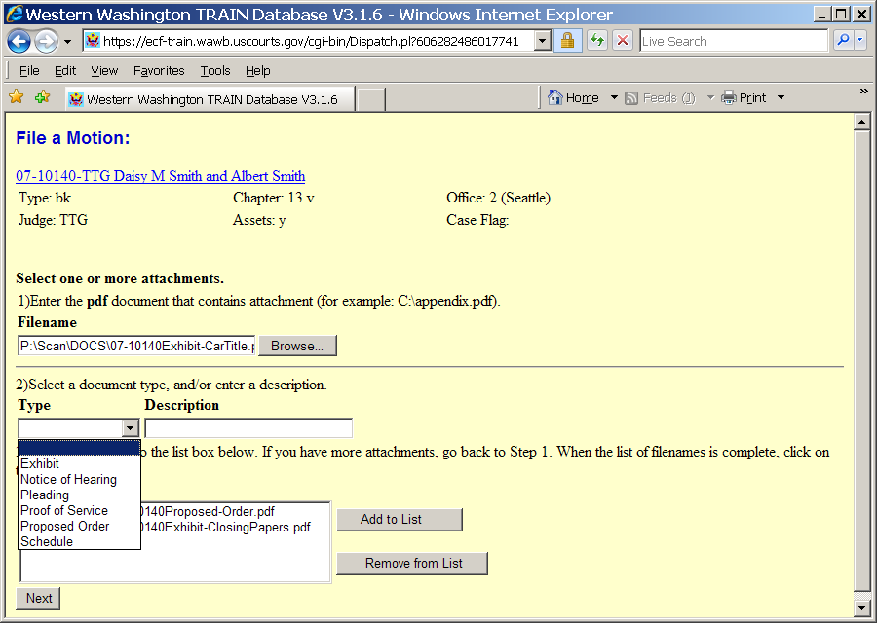
  Slide 24
  Text Captions: Select the Exhibit item
  The Attachment screen displays. This screen allows for the upload of attachments to the event being filed. "Type" is used to define the generic attachment type. "Description" is used to give a specific description of the attached document. When attaching an exhibit, for example, enter a specific description of the exhibit in the Description text box.
  Click Exhibit as the filing Type.

  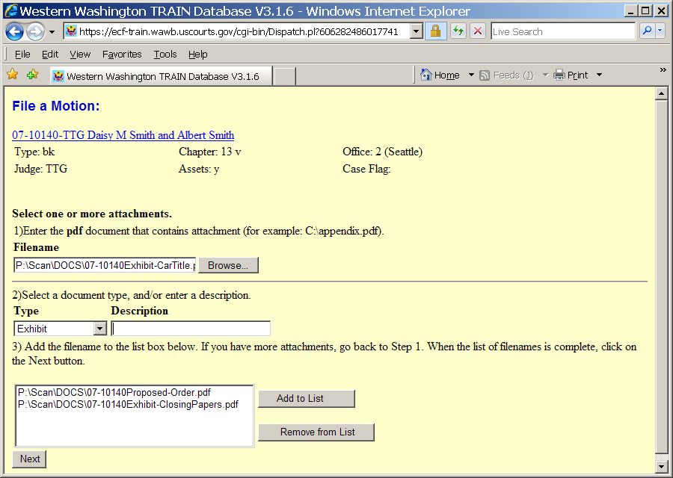
  Slide 25
  Text Captions: Incorrect, please try again
  The Attachment screen displays. This screen allows for the upload of attachments to the event being filed. "Type" is used to define the generic attachment type. "Description" is used to give a specific description of the attached document. When attaching an exhibit, for example, enter a specific description of the exhibit in the Description text box.
  Exhibits require a more specific description. For this example enter Car Title in the Description field.
  Then click Add to List button.
  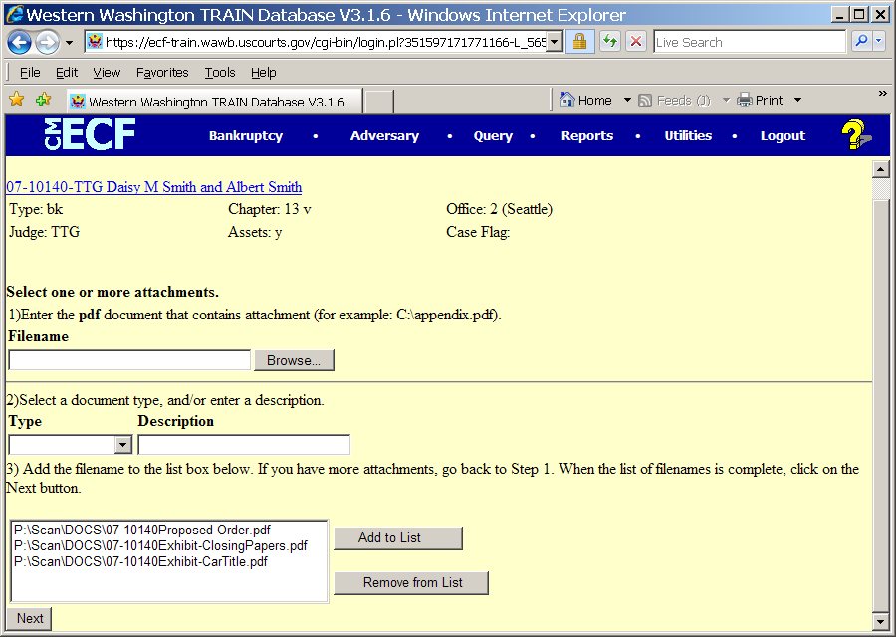
  Slide 26
  Text Captions: Click the Next button
  All uploaded attachments display in the Add to List box. Review for accuracy.
  Click the Next button
  The Attachment screen displays. This screen allows for the upload of attachments to the event being filed. "Type" is used to define the generic attachment type. "Description" is used to give a specific description of the attached document. When attaching an exhibit, for example, enter a specific description of the exhibit in the Description text box.
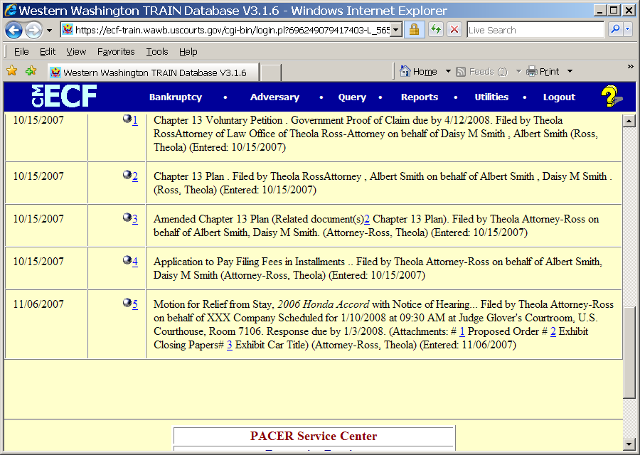
Slide 27
Text Captions: The Filing event, all attached documents and their specific descriptions display on the electronic docket. Clicking on the hyperlink for the attachment will display the pdf image of it.

