June 4, 1999 DCL -99-55

Dear Colleague:

Enclosed is a copy of the Child Support Enforcement FY 1998 Preliminary Data Report. This report will provide a summary of financial and statistical information on the Child Support Enforcement Program for fiscal years 1994 through 1998. This includes data reported to the Office of Child Support Enforcement as of May 1999. The data in this report are preliminary and subject to change.

Preliminary data show that in FY 1998, the Child Support Enforcement Program:

- Established and acknowledged 1.5 million paternities;
- Established 1,110,755 orders for child support; and
- Collected more than $14.3 billion in child support payments.

This performance information reflects the commitment of the Federal, State and local agencies to the child support program. We acknowledge these results, but realize there are still many children to help.

If you have any questions or comments concerning the report please call Renée Jackson at (202) 401-5101, Nina T Campbell at (202) 401-5049, or Adrienna Johnson at (202) 401-9384.

Sincerely,

David Gray Ross
Commissioner
Office of Child Support
Enforcement

Enclosure

Child Support Enforcement

FY 1998

PRELIMINARY DATA

REPORT

OCSE-- Giving Hope and Support to America’s Children since 1975

MAY 1999


Department of Health and Human Service
Administration for Children and Families
Office of Child Support Enforcement
Division of Policy and Planning

Preface

The following Office of Child Support Enforcement (OCSE) preliminary data report highlights financial and statistical achievements of the Child Support Enforcement program for fiscal year 1998. Since its inception in 1975, the child support program has grown in caseloads, paternities established, orders established, and collections received. This preliminary data report is a first look at the advancements we have made in these important program areas and others for fiscal year 1998.

Table of Contents

Office of Child Support Enforcement
FY 1998 Preliminary Data Report

Preface

Table of Contents

Program Results 1

Child Support Enforcement Program Background 2
Program Results for FY 1998 3

Table 1 - Financial Overview 7
Table 2 - Statistical Overview 8
Table 3 - Financial Program Status 9
Table 4 - Statistical Program Status 10
Table 5 - Program Trends 11
Table 6 - In-Hospital Paternity Acknowledgments 12
Table 7 - Total Distributed Collections Per Full-Time Equivalent Staff 13
Table 8 - Accounts Receivable - Current Support Due and Received 14
Table 9 - Accounts Receivable - Orders for Current Year Support 15
Table 10 - Accounts Receivable - Prior Year Support Due and Received 16
Table 11 - Accounts Receivable - Number of Orders for Prior Year 17
Table 12 - Interstate Activity 18

Program Box Scores 19

Regional Box Scores for FY 1998 20

Regional Scores:

Region I - Region VI 22
Region VII - Region X and Nationwide 23
State Scores:

Alabama - Colorado 24
Connecticut - Guam 25
Hawaii - Kansas 26
Kentucky - Michigan 27
Minnesota - Nevada 28
New Hampshire - North Dakota 29
Ohio - Rhode Island 30
South Carolina - Vermont 31
Virgin Islands - Wyoming 32

Program Charts and Graph 33

Program Charts and Graphs for FY 1998

Figure 1 - Total Collections, FY 1998 34
Figure 2 - Total Collections, FY 1994 -1998 35
Figure 3 - TANF Collections, FY 1998 36
Figure 4 - CS Collected per Paying Case, FY 1994 -1998 37
Figure 5 - Total Expenditures, FY 1994 -1998 38
Figure 6 - Cost Effectiveness Ratios, FY 1994 -1998 39
Figure 7 - Total Caseload, FY 1998 40
Figure 8 - Total Caseload, FY 1994 -1998 41
Figure 9 - IV-D Paternities, FY 1994 - 1998 42

Appendix 43

Organizational Charts

Office of Child Support Enforcement (OCSE) 44
Immediate Office of the Commissioner (OC) 45
Office of Grants Management (OGM) 46
Office of Associate Commissioner Central Office Operations (COO) 47
Division of Audit (DA) 48
Division of Consumer Services (DCS) 49
Division of Policy & Planning (DPP) 50
Division of Program Operations (DPO) 51
Division of State/Local Assistance (DSLA) 52
Regional Child Support Program Managers (RPM) 53
Office of Automation & Special Projects (ASP) 54
Division of Child Support Information Systems (DCSIS) 55

Child Support Enforcement

Program Results



Child Support Enforcement Program Background

The Child Support Enforcement program was established in 1975 under title IV-D of the Social Security Act as a joint Federal/State partnership. As a Federal/State/Local partnership, it generally functions through social services departments, but also through State attorney general's offices or departments of revenues. Most States work with prosecuting attorney's and other law enforcement agencies and officials of family or domestic relations courts to carry out the program at the local level.
The child support program locates non-custodial parents, establishes paternity, establishes and enforces support orders, and collects child support payments from those who are legally obligated to pay. While programs vary from State to State, services are available to all parents who need them. States are largely responsible for operating the program, but there tends to be greater Federal involvement in the interstate caseload.
The Federal Government shares in the cost of funding the CSE program by contributing to State's administrative costs and providing incentive payments to them. Since 1975 the program has been continually strengthened through Federal and State statutory and executive actions.

Program Results for FY 1998

The following tables provide initial financial and statistical information on the Child Support Enforcement (CSE) program for fiscal year 1998 and in some cases for the last five years. Table 1 provides national totals on child support collections, expenditures, program savings, fees recovered, and cost-effectiveness for fiscal years 1994 through 1998. Table 2 gives national statistics on the CSE caseload, cases with collections, locations made, paternities established and paternities acknowledged through in-hospital programs, child support orders established, and the percentage of TANF/FC payments recovered for the same time period. Tables 3 and 4 present financial and statistical data for individual States' Child Support Enforcement programs for fiscal year 1998. Program trends for fiscal years 1992, 1997 and 1998 are shown on table 5. Information on States in-hospital paternity acknowledgment programs for fiscal year 1998 are presented on table 6. Total FTE staff, total distributed collections, and total distributed collections per full-time equivalent staff for fiscal year 1998 are presented on table 7. Tables 8 through 11 show accounts receivable data for fiscal year 1998 including the amount and percent of current (Table 8) and prior (Table 10) year support due and received, and the number and percent of orders for current (Table 9) and prior (Table 11) year support due and received. Table 12 provides interstate collections for fiscal year 1998. Readers should note that all numbers quoted are based on information supplied to the Office of Child Support Enforcement (OCSE) by the individual State CSE programs. Fiscal year 1998 data are preliminary as of May 1999, and are subject to change.
As the following summaries show, during FY 1998 over $14.3 billion in child support payments were collected, and services were provided in almost 19.7 million cases through the program. The CSE program had almost 1.5 million paternities established and acknowledgements and over 1 million new child support orders were established in 1998.
Caseload. OCSE defines a child support case as a non-custodial parent who is now or may eventually be obligated under law for the support of one or more dependent children. In addition, a non-custodial parent who has children with more than one custodial parent is counted once for each custodial family. There were almost 19.7 million cases reported in fiscal year 1998 (Table 2). This was a 3.1 percent increase over the number reported for fiscal year 1997. The total caseload reflects a 10.2 percent increase in the number of non-TANF cases, and a 4.6 percent drop in TANF/FC cases which is most likely due to the implementation of Welfare Reform and time limited TANF benefits (Table 2). Over the past five years there has been a 32.6 percent increase in cases with collections.
Paternities Established. When children are born out-of-wedlock establishing paternity is the necessary first step for obtaining an order. In addition, establishing paternity provides access to social security, pension, retirement benefit, health insurance, and interaction with members of both parents' families.
Many fathers voluntarily acknowledge paternity. In cases were there is no voluntary acknowledgement the father, mother, and child can be required to get genetic tests.
The results of these tests are highly accurate. States must have procedures that allow paternity to be established at least up to the child's eighteenth birthday. Child support IV-D caseload paternities were established for over 844,000 children in fiscal year 1998, and over 614,000 paternities were established through in-hospital paternity acknowledgment programs (Table 2). A total of 1.5 million paternities were established and acknowledged in fiscal year 1998. This represents a 12.1 percent increase in paternity establishments and acknowledgements for that year. Forty-one states voluntarily reported statistics on the number of in-hospital paternity acknowledgments for fiscal year 1998 (Table 6).
Orders Established. States must use guidelines to determine how much a parent should pay for child support. CSE staff can take child support cases to court, or to an administrative hearing process to establish the order. About 1.1 million orders for child support were established in fiscal year 1998.
Collections. Total child support collections were $14.3 billion for fiscal year 1998 (Table 1). This was a 7.4 percent increase in collections over fiscal year 1997. Non-TANF collections were almost $11.7 billion in fiscal year 1998, an increase of 11.2 percent over fiscal year 1997. TANF collections were $2.6 billion and shows a 6.8 percent decrease which was most likely due to the decreasing TANF caseload. However, most of the TANF cases became non-TANF cases.
Collections per Full-Time Equivalent Staff. Nationally, the amount of child support collected per full-time equivalent staff (FTE) was $259,452 in fiscal year 1998 (Table 7). There was less than a 1 percent increase from the $259,152 collected per FTE in fiscal year 1997. There was 55,300 FTE staff in fiscal year 1998.
Expenditures. The cost of running the Child Support Enforcement program
increased during the last fiscal year. In fiscal year 1998, total administrative expenditures were up 4.6 percent to $3.6 billion. Total Automated Data Processing (ADP) costs for developing and implementing automated statewide child support enforcement systems decreased by 10 percent since fiscal year 1997. In fiscal year 1998, $524 million was spent on ADP.
Accounts Receivable. The total amount of current support due for fiscal year 1998 was $13.7 billion. About 50.7 percent or $6.9 billion of that amount was collected (Table 8). A total of 3.5 million current support orders had collections out of the 5.7 million orders with collections due (Table 9). Of prior year support due, $2.4 billion or 7.8 percent was collected (Table 10).
Other Statistics. Program increases were also noted for total cases in which a collection was made and locations made -- up 7.2 percent and 1.8 percent, respectively (Table 5). The total collections made on behalf of other States for fiscal year 1998 was $1.1 billion, $333 million for TANF/FC, and $729 million for non-TANF (Table 12). Cost-effectiveness ratios have increased by 2.7 percent since the previous year (Table 1).

PRELIMINARY
Table 1
Office of Child Support Enforcement
FINANCIAL OVERVIEW FOR FIVE CONSECUTIVE FISCAL YEARS
 | 1994 | 1995 | 1996 | 1997 | 1998
TOTAL COLLECTIONS ($000) | $9,850,159 | $10,827,167 | $12,019,789 | $13,363,972 | $14,347,707
TANF/FC COLLECTIONS | 2,549,723 | 2,689,392 | 2,855,066 | 2,842,681 | 2,649,930
State Share | 890,717 | 938,865 | 1,013,666 | 1,158,831 | 1,089,385
Federal Share | 762,341 | 821,551 | 888,258 | 1,044,288 | 960,653
Payments to TANF/FC Families | 457,125 | 474,428 | 480,406 | 157,033 | 151,738
Incentive Payments (estimated) | 407,242 | 399,919 | 409,142 | 411,527 | 396,388
Medical Support Payments | 32,299 | 54,629 | 63,570 | 70,683 | 51,766
NON-TANF COLLECTIONS | 7,300,436 | 8,137,775 | 9,164,723 | 10,521,291 | 11,697,777
TOTAL ADMINISTRATIVE* | $2,556,372 | $3,012,385 | $3,054,821 | $3,431,840 | $3,589,335
EXPENDITURES ($000)
TOTAL PROGRAM SAVINGS | (496,072) | (852,050) | (738,182) | (813,086) | (1,143,310)
COST-EFFECTIVENESS RATIOS
Total/Total | 3.85 | 3.59 | 3.93 | 3.90 | 4.00
TANF/FC/Total | 1.00 | 0.89 | 0.93 | 0.83 | 0.74
Non-TANF Total | 2.86 | 2.70 | 3.00 | 3.07 | 3.26
SOURCE: OCSE-396A and 34A
NOTE: Data for fiscal year 1998 are preliminary. The cost-effectiveness ratio is total collections per dollar of total administrative expenditures, not the cost-effectiveness ratio used to calculate incentives.
* Fiscal years 97 & 98 administrative expenditure data are estimated. State and Federal share expenditures are still being calculated.

PRELIMINARY
Table 2
Office of Child Support Enforcement
STATISTICAL OVERVIEW FOR FIVE CONSECUTIVE FISCAL YEARS
 | 1994 |  | 1995 | 1996 | 1997 |  | 1998
TOTAL IV-D CASELOAD | 18,609,805 |  | 19,162,137 | 19,318,691 | 19,057,164 |  | 19,652,195
TANF/FC Caseload | 7,985,983 |  | 7,879,725 | 7,379,629 | 6,461,877 |  | 5,672,361
Non-TANF Caseload | 8,189,569 |  | 8,783,238 | 9,347,875 | 9,947,322 |  | 10,957,933
TANF/FC Arrears Only Caseload | 2,434,253 |  | 2,499,174 | 2,591,187 | 2,647,965 |  | 3,021,901
TANF/FC and TANF/FC  Arrears Only Caseload | 10,420,236 |  | 10,378,899 | 9,970,816 | 9,109,842 |  | 8,694,262
TOTAL CASES FOR WHICH | 3,403,287 |  | 3,727,516 | 3,952,347 | 4,207,824 |  | 4,511,389
A COLLECTION WAS MADE
TANF/FC Cases | 926,214 |  | 975,607 | 939,755 | 864,709 |  | 789,897
Non-TANF Cases | 2,168,630 |  | 2,408,411 | 2,612,188 | 2,850,491 |  | 3,070,932
TANF/FC Arrears Only | 308,443 |  | 343,498 | 404,404 | 492,624 |  | 650,560
TANF/FC and TANF/FC  Arrears Only Caseload | 1,234,657 |  | 1,319,105 | 1,340,159 | 1,357,333 |  | 1,440,457
TOTAL PERCENTAGE OF CASES | 18.3 |  | 19.5 | 20.4 | 22.1 |  | 23.1
WITH COLLECTIONS
TANF/FC Cases | 11.6 |  | 12.4 | 12.7 | 13.4 |  | 13.9
Non-TANF Cases | 26.5 |  | 27.4 | 27.9 | 29.1 |  | 28.0
TANF/FC Arrears Only | 12.7 |  | 13.7 | 15.6 | 18.6 |  | 21.5
TANF/FC and TANF/FC  Arrears Only Caseload | 11.8 |  | 12.8 | 13.4 | 15.1 |  | 17.3
TOTAL IV-D CASES WITH ORDERS ESTABLISHED | 10,429,167 |  | 10,972,667 | 11,413,684 | 11,006,016 |  | 11,729,975
TANF/FC Caseload | 2,956,224 |  | 2,942,789 | 2,811,063 | 2,289,902 |  | 2,060,766
Non-TANF Caseload | 5,038,690 |  | 5,530,704 | 5,591,434 | 6,068,149 |  | 6,647,308
TANF/FC Arrears Only Caseload | 2,434,253 |  | 2,499,174 | 2,591,187 | 2,647,965 |  | 3,021,901
TANF/FC and TANF/FC  Arrears Only Caseload | 5,390,477 |  | 5,441,963 | 5,462,250 | 4,937,867 |  | 5,082,667
TOTAL PERCENTAGE OF CASES WITH COLLECTIONS TO CASES WITH ORDERS | 32.6 |  | 34.0 | 34.6 | 38.2 |  | 38.5
TANF/FC Caseload | 31.3 | 33.2 |  | 33.4 | 38.1 | 38.3
Non-TANF Caseload | 43.0 | 43.6 |  | 46.7 | 47.1 | 46.2
TANF/FC Arrears Only Caseload | 12.7 | 13.7 |  | 15.6 | 18.6 | 22.1
TANF/FC and TANF/FC  Arrears Only Caseload | 22.9 | 24.2 |  | 24.6 | 27.5 | 28.3
TOTAL LOCATIONS MADE | 4,204,004 | 4,949,912 |  | 5,808,147 | 6,441,451 | 6,557,438
TOTAL PATERNITIES ESTABLISHED & ACKNOWLEDGED | 676,459 | 932,102 |  | 1,058,288 | 1,300,922 | 1,458,962
Total IV-D Paternities Established | 592,048 | 659,373 |  | 733,693 | 814,136 | 844,881
In-hospital Paternities Acknowledged | 84,411 | 272,729 |  | 324,595 | 486,786 | 614,081
TOTAL SUPPORT ORDERS ESTABLISHED* | 1,024,675 | 1,051,336 |  | 1,092,992 | 1,155,973 | 1,110,755
TOTAL SUPPORT ORDERS ENFORCED | 5,805,452 | 6,546,411 |  | 7,912,685 | 9,934,411 | 11,906,953
OR MODIFIED
SOURCE: OCSE-156 report
NOTE: Some States voluntarily report in-hospital information to OCSE. In-hospital numbers include an unknown number of acknowledgements for
children in the IV-D caseload. Data for fiscal year 1998 are preliminary. The Temporary Assistance for Needy Families (TANF) replaces the former AFDC program. The TANF program came under the welfare reform legislation signed in 1996.
*Due to system problems, the number of orders established were inconsistent for fiscal years 1997 and 1998 for the State of Tennessee. Therefore, the
total number of orders established do not include those for Tennessee.

PRELIMINARY
Office of Child Support Enforcement
Table 3
Financial Program Status, FY 1998
 |  | -------------------- | IV-D COLLECTIONS --------------------
States | TOTAL |  |  | TANF/FC | NON-TANF | ADMINISTRATIVE* EXPENDITURES
ALABAMA | $172,407,203 |  |  | $ 15,486,257 | $156,920,946 | $50,747,000
ALASKA | 64,262,422 |  |  | 17,690,635 | 46,571,787 | 18,244,000
ARIZONA | 144,347,745 |  |  | 20,631,588 | 123,716,157 | 54,188,000
ARKANSAS | 99,373,428 |  |  | 14,759,855 | 84,613,573 | 34,541,000
CALIFORNIA | 1,372,354,157 |  |  | 611,023,488 | 761,330,669 | 515,391,000
COLORADO | 140,311,116 |  |  | 29,957,797 | 110,353,319 | 45,083,000
CONNECTICUT | 154,373,662 |  |  | 56,903,538 | 97,470,124 | 47,853,000
DELAWARE | 42,005,824 |  |  | 7,594,950 | 34,410,874 | 16,490,000
DISTRICT OF COLUMBIA | 32,715,624 |  |  | 4,689,310 | 28,026,314 | 16,545,000
FLORIDA | 507,112,518 |  |  | 61,624,671 | 445,487,847 | 166,882,000
GEORGIA | 300,772,452 |  |  | 58,404,611 | 242,367,841 | 85,109,000
GUAM | 7,251,380 |  |  | 1,465,044 | 5,786,336 | 4,215,000
HAWAII | 62,314,371 |  |  | 11,577,740 | 50,736,631 | 23,961,000
IDAHO | 53,778,625 |  |  | 7,873,702 | 45,904,923 | 14,561,000
ILLINOIS | 300,239,940 |  |  | 80,565,587 | 219,674,353 | 119,900,000
INDIANA | 227,203,313 |  |  | 38,070,056 | 189,133,257 | 41,694,000
IOWA | 185,098,729 |  |  | 42,357,762 | 142,740,967 | 38,646,000
KANSAS | 122,229,999 |  |  | 24,763,992 | 97,466,007 | 40,066,000
KENTUCKY | 185,549,683 |  |  | 37,785,747 | 147,763,936 | 47,620,000
LOUISIANA | 170,555,482 |  |  | 21,552,936 | 149,002,546 | 42,329,000
MAINE | 73,782,781 |  |  | 30,408,557 | 43,374,224 | 17,364,000
MARYLAND | 357,094,944 |  |  | 31,480,290 | 325,614,654 | 82,899,000
MASSACHUSETTS | 274,662,473 |  |  | 58,241,894 | 216,420,579 | 59,950,000
MICHIGAN | 1,151,824,001 |  |  | 150,356,782 | 1,001,467,219 | 160,376,000
MINNESOTA | 394,670,957 |  |  | 56,176,935 | 338,494,022 | 102,461,000
MISSISSIPPI | 112,224,456 |  |  | 16,926,840 | 95,297,616 | 30,376,000
MISSOURI | 286,734,739 |  |  | 58,139,912 | 228,594,827 | 85,274,000
MONTANA | 36,921,587 |  |  | 7,212,886 | 29,708,701 | 11,706,000
NEBRASKA | 117,127,490 |  |  | 12,893,075 | 104,234,415 | 25,108,000
NEVADA | 69,133,221 |  |  | 7,507,939 | 61,625,282 | 23,866,000
NEW HAMPSHIRE | 60,975,803 |  |  | 8,994,605 | 51,981,198 | 13,562,000
NEW JERSEY | 581,901,606 |  |  | 77,519,674 | 504,381,932 | 125,291,000
NEW MEXICO | 37,310,412 |  |  | 9,381,495 | 27,928,917 | 23,406,000
NEW YORK | 834,476,910 |  |  | 187,613,358 | 646,863,552 | 200,763,000
NORTH CAROLINA | 311,684,239 |  |  | 51,171,022 | 260,513,217 | 108,863,000
NORTH DAKOTA | 36,064,761 |  |  | 4,744,083 | 31,320,678 | 7,594,000
OHIO | 1,151,228,761 |  |  | 102,348,309 | 1,048,880,452 | 202,888,000
OKLAHOMA | 86,664,599 |  |  | 22,482,608 | 64,181,991 | 27,935,000
OREGON | 209,181,643 |  |  | 25,003,102 | 184,178,541 | 39,516,000
PENNSYLVANIA | 1,042,987,090 |  |  | 117,670,354 | 925,316,736 | 147,723,000
PUERTO RICO | 145,131,794 |  |  | 2,323,558 | 142,808,236 | 26,994,000
RHODE ISLAND | 41,902,316 |  |  | 19,131,070 | 22,771,246 | 10,016,000
SOUTH CAROLINA | 153,915,622 |  |  | 20,071,757 | 133,843,865 | 32,649,000
SOUTH DAKOTA | 34,488,847 |  |  | 5,294,107 | 29,194,740 | 5,629,000
TENNESSEE | 188,406,296 |  |  | 34,186,587 | 154,219,709 | 56,973,000
TEXAS | 685,028,480 |  |  | 121,982,308 | 563,046,172 | 181,978,000
UTAH | 97,013,689 |  |  | 21,261,676 | 75,752,013 | 32,059,000
VERMONT | 31,712,200 |  |  | 8,554,864 | 23,157,336 | 7,557,000
VIRGIN ISLANDS | 6,122,511 |  |  | 573,439 | 5,549,072 | 2,294,000
VIRGINIA | 276,875,539 |  |  | 43,326,488 | 233,549,051 | 61,083,000
WASHINGTON | 474,432,883 |  |  | 102,533,074 | 371,899,809 | 126,830,000
WEST VIRGINIA | 109,384,212 |  |  | 13,213,448 | 96,170,764 | 24,471,000
WISCONSIN | 499,272,091 |  |  | 53,597,331 | 445,674,760 | 90,924,000
WYOMING | 33,110,055 |  |  | 2,826,930 | 30,283,125 | 8,892,000
NATIONWIDE TOTALS | $14,347,706,681 |  |  | $2,649,929,623 | $11,697,777,058 | $3,589,335,000
SOURCE: OCSE-34A and 396A reports
NOTE: Data for fiscal year 1998 are preliminary.
*Fiscal year 98 administrative expenditure data is estimated.

PRELIMINARY
Table 4
Office of Child Support Enforcement

Statistical Program Status, FY 1998
STATES | Caseload | Cases with Orders | Locations | Paternities *  & Acknowledgements | Orders** Established | Cases with Collections
ALABAMA | 365,914 | 227,642 | 48,914 | 9,995 | 21,176 | 78,473
ALASKA | 59,272 | 48,588 | 16,438 | 3,976 | 3,146 | 14,552
ARIZONA | 328,944 | 187,430 | 40,945 | 30,159 | 9,121 | 70,435
ARKANSAS | 223,934 | 136,762 | 73,618 | 20,574 | 9,741 | 57,194
CALIFORNIA | 2,092,732 | 1,319,177 | 723,673 | 337,262 | 223,541 | 588,337
COLORADO | 216,428 | 158,801 | 73,582 | 13,375 | 9,982 | 43,953
CONNECTICUT | 253,977 | 166,060 | 51,419 | 13,322 | 31,995 | 48,271
DELAWARE | 60,634 | 45,422 | 62,045 | 4,477 | 2,354 | 16,962
DISTRICT | 106,887 | 53,246 | 3,308 | 3,465 | 6,814 | 14,966
FLORIDA | 981,912 | 432,583 | 31,080 | 59,760 | 18,757 | 165,511
GEORGIA | 531,016 | 318,701 | 62,993 | 37,084 | 31,092 | 173,284
GUAM | 9,955 | 5,520 | 5,647 | 526 | 336 | 2,134
HAWAII | 68,103 | 32,689 | 199,530 | 1,671 | 4,150 | 15,592
IDAHO | 87,218 | 62,508 | 15,097 | 4,457 | 3,218 | 16,213
ILLINOIS | 746,331 | 226,967 | 64,925 | 82,005 | 30,765 | 88,899
INDIANA | 343,960 | 164,696 | 433 | 2,260 | 32,272 | 51,915
IOWA | 207,751 | 178,757 | 190,124 | 3,897 | 14,930 | 47,824
KANSAS | 144,806 | 87,643 | 143,609 | 16,647 | 17,318 | 54,090
KENTUCKY | 314,518 | 206,323 | 27,286 | 11,419 | 27,190 | 61,037
LOUISIANA | 332,741 | 147,627 | 38,554 | 25,292 | 17,419 | 60,445
MAINE | 69,981 | 60,346 | 79,872 | 2,243 | 4,687 | 30,770
MARYLAND | 320,357 | 207,674 | 67,324 | 53,002 | 20,933 | 92,071
MASSACHUSETTS | 239,446 | 197,262 | 29,804 | 24,902 | 12,297 | 68,392
MICHIGAN | 1,720,920 | 794,709 | 73,288 | 35,880 | 28,212 | 331,308
MINNESOTA | 268,437 | 201,766 | 30,594 | 14,420 | 18,657 | 107,235
MISSISSIPPI | 289,339 | 144,490 | 152,597 | 21,059 | 14,561 | 39,921
MISSOURI | 405,522 | 306,242 | 302,465 | 41,963 | 22,756 | 90,367
MONTANA | 41,342 | 30,827 | 59,035 | 2,204 | 2,232 | 12,780
NEBRASKA | 121,421 | 90,480 | 31,400 | 7,066 | 4,887 | 23,827
NEVADA | 84,116 | 53,396 | 14,832 | 4,498 | 4,186 | 21,311
NEW HAMPSHIRE | 51,352 | 40,617 | 7,548 | 3,283 | 3,877 | 20,729
NEW JERSEY | 482,752 | 372,069 | 192,990 | 32,689 | 23,192 | 134,857
NEW MEXICO | 77,894 | 18,714 | 6,145 | 9,563 | 3,633 | 8,362
NEW YORK | 1,295,332 | 868,539 | 291,037 | 88,834 | 50,361 | 257,846
NORTH CAROLINA | 520,191 | 308,052 | 62,257 | 49,431 | 35,959 | 3,594
NORTH DAKOTA | 40,783 | 29,398 | 4,425 | 1,699 | 2,177 | 10,896
OHIO | 941,803 | 700,602 | 390,031 | 45,617 | 63,051 | 324,177
OKLAHOMA | 134,461 | 72,640 | 63,974 | 7,124 | 9,272 | 25,220
OREGON | 267,783 | 152,720 | 102,938 | 9,590 | 12,850 | 62,186
PENNSYLVANIA | 875,637 | 568,975 | 105,875 | 47,081 | 108,510 | 216,697
PUERTO RICO | 227,176 | 145,814 | 6,015 | 26,942 | 9,359 | 52,225
RHODE ISLAND | 72,458 | 42,954 | 41,065 | 3,585 | 2,283 | 12,003
SOUTH CAROLINA | 218,833 | 119,945 | 46,996 | 13,941 | 13,641 | 70,748
SOUTH DAKOTA | 33,479 | 31,496 | 30,370 | 2,280 | 3,792 | 12,090
TENNESSEE | 497,627 | 197,440 | 271,611 | 21,311 | NA | 93,611
TEXAS | 1,234,783 | 639,364 | 371,295 | 128,373 | 37,019 | 242,375
UTAH | 109,262 | 82,885 | 100,084 | 5,925 | 4,386 | 33,890
VERMONT | 27,022 | 24,010 | 2,130 | 978 | 2,229 | 12,123
VIRGIN ISLANDS | 28,123 | 7,368 | 352 | 31 | 556 | 2,177
VIRGINIA | 414,861 | 269,272 | 116,487 | 23,044 | 20,298 | 96,124
WASHINGTON | 404,163 | 361,391 | 1,316,069 | 25,132 | 27,248 | 160,393
WEST VIRGINIA | 124,021 | 62,037 | 27,852 | 9,382 | 7,221 | 29,493
WISCONSIN | 475,363 | 278,228 | 260,163 | 13,361 | 19,418 | 130,065
WYOMING | 59,122 | 41,111 | 25,298 | 906 | 1,698 | 11,439
NATIONWIDE TOTALS | 19,652,195 | 11,729,975 | 6,557,438 | 1,458,962 | 1,110,755 | 4,511,389
SOURCE: OCSE-156 report
NOTE: Data for fiscal year 1998 are preliminary.
* Includes in-hospital paternity acknowledgements for States reporting such information.
** Due to system problems, the number of orders established were inconsistent for fiscal years 1997 and 1998 for the State of Tennessee. Therefore,
the total number of orders established do not include those for Tennessee.

PRELIMINARY
Table 5
Office of Child Support Enforcement
PROGRAM TRENDS for FY 1992, 1997, 1998
 |  |  |  |  |  |  |  |  |  |  |  |  |  |  |  | Percent Change
 |  |  |  |  |  |  |  |  | 1992 |  |  | 1997 |  |  | 1998 |  |  | 1997-1998 | 1992-1998
 |  | Total IV-D Collections ($000) |  |  |  |  |  |  | $ 7,964,141 |  |  | $13,363,972 |  |  | $14,347,707 |  |  | 7.4 |  | 80.2
 |  | TANF/FC Collections |  |  |  |  |  | $2,258,825 |  |  | $2,842,681 |  |  | $2,649,930 |  |  | (6.8) |  | 17.3
 |  | Non-TANF Collections |  |  |  |  |  | $5,705,316 |  |  | $10,521,291 |  |  | $11,697,777 |  |  | 11.2 |  | 105.0
 |  | Total IV-D Administrative*
 |  | Expenditures ($000) |  |  |  |  |  | $1,994,691 |  |  | $3,431,840 |  |  | $3,589,335 |  |  | 4.6 |  | 79.9
 |  | Total ADP Expenditures |  |  |  |  |  | $212,633 |  |  | $577,167 |  |  | $524,508 |  |  | (9.1) |  | 146.7
 |  | Total IV-D Caseload |  |  |  |  |  | 15,157,966 |  |  | 19,057,164 |  |  | 19,652,195 |  |  | 3.1 |  | 29.6
 |  | TANF/FC Caseload |  |  |  |  |  | 6,752,458 |  |  | 6,461,877 |  |  | 5,672,361 |  |  | (12.2) |  | (16.0)
 |  | Non-TANF Caseload |  |  |  |  |  | 6,440,712 |  |  | 9,947,322 |  |  | 10,957,933 |  |  | 10.2 |  | 70.1
 |  | TANF/FC Arrears Only Caseload |  |  |  |  |  |  | 1,964,796 |  |  | 2,647,965 |  |  | 3,021,901 |  |  | 14.1 |  | 53.8
 |  | Total Cases for Which a Collection was Made |  |  |  |  |  | 2,840,660 |  |  | 4,207,824 |  |  | 4,511,389 |  |  | 7.2 |  | 58.8
 |  | Total Locations Made |  |  |  |  |  | 3,151,513 |  |  | 6,441,451 |  |  | 6,557,438 |  |  | 1.8 |  | 108.1
 |  | Total Paternities Established & Acknowledged |  |  |  |  |  |  | 511,862 |  |  | 1,300,922 |  |  | 1,458,962 |  |  | 12.1 |  | 185.0
 |  | Total IV-D Paternities Established |  |  |  |  |  |  | 511,862 |  |  | 814,136 |  |  | 844,881 |  |  | 3.8 |  | 65.1
 |  | In- Hospital Paternities Acknowledged |  |  |  |  |  | NA |  |  | 486,786 |  |  | 614,081 |  |  | 26.2 |  | NA
 |  | Total Support Orders Established** |  |  |  |  |  |  | 879,422 |  |  | 1,155,973 |  |  | 1,110,755 |  |  | (3.9) |  | 26.3
SOURCE: Financial and statistical data as reported by the States.
NOTE: Data for fiscal year 1998 are preliminary.
*Fiscal years 97 & 98 administrative expenditure data are estimated.
**Due to system problems, the number of orders established were inconsistent for fiscal years 1997 and 1998 for the State of Tennessee. Therefore, the total number of
orders established do not include those for Tennessee.

PRELIMINARY
Table 6
Office of Child Support Enforcement
In-Hospital Paternity Acknowledgments, FY 98
 | STATES |  |  | Voluntary |  |  |  | Out-of-wedlock |  |  | Percent
 |  |  |  | Acknowledgments |  |  |  | Births
 | ALABAMA |  |  | 4,577 |  |  | 14,869 |  | 30.8
* | ALASKA |  |  | 2,170 |  |  | NA |  | NA
 | ARIZONA |  |  | 15,615 |  |  | 29,236 |  | 53.4
* | ARKANSAS |  |  | 6,865 |  |  | NA |  | NA
 | CALIFORNIA |  |  | 126,922 |  |  | 167,376 |  | 75.8
 | COLORADO |  |  | 8,310 |  |  | 14,431 |  | 57.6
* | CONNECTICUT |  |  | 6,240 |  |  | NA |  | NA
* | DELAWARE |  |  | 1531 |  |  | NA |  | NA
 | DISTRICT OF COLUMBIA |  |  |  | 1,101 |  |  | 2,708 |  | 40.7
 | FLORIDA |  |  | 18,852 |  |  | 36,121 |  | 52.2
* | GEORGIA |  |  | 27,114 |  |  | NA |  | NA
 | IDAHO |  |  | 1,547 |  |  | 2,730 |  | 56.7
* | ILLINOIS |  |  | 31,549 |  |  | NA |  | NA
 | IOWA |  |  | 3,283 |  |  | 5,077 |  | 64.7
* | KANSAS |  |  | 6,243 |  |  | NA |  | NA
* | KENTUCKY |  |  | 2,074 |  |  | NA |  | NA
* | LOUISIANA |  |  | 2,901 |  |  | NA |  | NA
 | MARYLAND |  |  | 14,610 |  |  | 17,955 |  | 81.4
 | MASACHUSETTS |  |  | 14,855 |  |  | 20,924 |  | 71.0
 | MICHIGAN |  |  | 22,437 |  |  | 43,375 |  | 51.7
 | MINNESOTA |  |  | 9,910 |  |  | 16,313 |  | 60.7
 | MISSISSIPPI |  |  | 7,841 |  |  | 12,426 |  | 63.1
* | MISSOURI |  |  | 17,993 |  |  | NA |  | NA
 | MONTANA |  |  | 1,017 |  |  | 3,026 |  | 33.6
* | NEBRASKA |  |  |  | 3,530 |  |  | NA |  | NA
 | NEVADA |  |  |  | 2,205 |  |  | NA |  | NA
* | NEW HAMPSHIRE |  |  |  | 2,363 |  |  | NA |  | NA
 | NEW JERSEY |  |  |  | 21,416 |  |  | 32,705 |  | 65.5
* | NEW YORK |  |  |  | 49,732 |  |  | 95,000 |  | 52.3
 | NORTH CAROLINA |  |  |  | 18,839 |  |  | 35,926 |  | 52.4
* | OHIO |  |  |  | 7,803 |  |  | NA |  | NA
 | OREGON |  |  |  | 5,916 |  |  | 9,555 |  | 61.9
* | PENNSYLVANIA |  |  |  | 16,526 |  |  | NA |  | NA
 | PUERTO RICO |  |  |  | 26,909 |  |  | 28,899 |  | 93.1
 | SOUTH DAKOTA |  |  |  | 1,555 |  |  | 2,351 |  | 66.1
 | TENNESSEE |  |  | 14,526 |  |  | 27,495 |  | 52.6
 | TEXAS |  |  | 56,802 |  |  | 104,075 |  | 54.6
 | UTAH |  |  | 3,940 |  |  | 5,862 |  | 67.2
* | VIRGINIA |  |  | 11,251 |  |  | NA |  | NA
* | WASHINGTON |  |  | 11,406 |  |  | NA |  | NA
 | WEST VIGINIA |  |  | 3,805 |  |  | 6,994 |  | 54.4
 | NATIONWIDE TOTALS |  |  | 614,081 |  |  | 735,429 |  | 83.5
SOURCE: As voluntarily reported by the States.
NOTE: The percent is the number of out-of-wedlock births for which a voluntary acknowledgment for paternity was signed, divided by the total number of out-of-wedlock births and multiplied by 100. Not all children for whom acknowledgments were signed are in the IV-D caseload. All States were asked to report information on voluntary acknowledgments, but some States did not report and some States reported incomplete information. NA means data was not available.
*Out-of-wedlock births were not available so a percent could not be calculated.

 | PRELIMINARY
 | Table 7
 | Office of Child Support Enforcement
 | Total Distributed Collections Per Full-Time Equivalent, FY 1998
 |  | STATES | Total FTE Staff |  | Total Distributed Collections |  | Total Distributed Collections Per FTE
 |  | ALABAMA | 699 |  | $172,407,203 |  | $246,648
 |  | ALASKA | 235 |  | 64,262,422 |  | 273.457
 |  | ARIZONA | 967 |  | 144,347,745 |  | 149,264
* |  | ARKANSAS | 633 |  | 99,373,428 |  | 157,004
 |  | CALIFORNIA | 8,122 |  | 1,372,354,157 |  | 168,968
 |  | COLORADO | 696 |  | 140,311,116 |  | 201,596
 |  | CONNECTICUT | 570 |  | 154,373,662 |  | 270,831
 |  | DELAWARE | 184 |  | 42,005,824 |  | 228,293
 |  | DISTRICT | 215 |  | 32,715,624 |  | 152,166
* |  | FLORIDA | 1,902 |  | 507,112,518 |  | 266,620
 |  | GEORGIA | 1,115 |  | 300,772,452 |  | 269,751
 |  | GUAM | 58 |  | 7,251,380 |  | 132,825
 |  | HAWAII | 199 |  | 62,314,371 |  | 313,137
 |  | IDAHO | 153 |  | 53,778,625 |  | 351,494
* |  | ILLINOIS | 1,665 |  | 300,239,940 |  | 180,324
 |  | INDIANA | 775 |  | 227,203,313 |  | 293,166
 |  | IOWA | 518 |  | 185,098,729 |  | 357,333
 |  | KANSAS | 442 |  | 122,229,999 |  | 276,538
 |  | KENTUCKY | 891 |  | 185,549,683 |  | 208,249
 |  | LOUISIANA | 895 |  | 170,555,482 |  | 190,565
 |  | MAINE | 252 |  | 73,782,781 |  | 292,789
 |  | MARYLAND | 919 |  | 357,094,944 |  | 388,569
 |  | MASSACHUSETTS | 828 |  | 274,662,473 |  | 331,718
 |  | MICHIGAN | 2,441 |  | 1,151,824,001 |  | 470,866
* |  | MINNESOTA | 1,402 |  | 394,670,957 |  | 281,506
 |  | MISSISSIPPI | 656 |  | 112,224,456 |  | 171,073
 |  | MISSOURI | 1,105 |  | 286,734,739 |  | 259,488
 |  | MONTANA | 190 |  | 36,921,587 |  | 194,324
 |  | NEBRASKA | 398 |  | 117,127,490 |  | 263,368
 |  | NEVADA | 485 |  | 69,133,221 |  | 142,542
 |  | NEW HAMPSHIRE | 216 |  | 60,975,803 |  | 282,295
 |  | NEW JERSEY | 2,162 |  | 581,901,606 |  | 269,149
 |  | NEW MEXICO | 266 |  | 37,310,412 |  | 140,265
 |  | NEW YORK | 2,921 |  | 834,476,910 |  | 285,681
 |  | NORTH CAROLINA | 1,625 |  | 311,684,239 |  | 191,806
 |  | NORTH DAKOTA | 130 |  | 36,064,761 |  | 277,421
 |  | OHIO | 4,656 |  | 1,151,228,761 |  | 246,257
 |  | OKLAHOMA | 483 |  | 86,664,599 |  | 179,433
 |  | OREGON | 686 |  | 209,181,643 |  | 304,930
 |  | PENNSYLVANIA | 3,074 |  | 1,042,987,090 |  | 273,059
 |  | PUERTO RICO | 782 |  | 145,131,794 |  | 185,591
 |  | RHODE ISLAND | 154 |  | 41,902,316 |  | 272,093
 |  | SOUTH CAROLINA | 234 |  | 153,915,622 |  | 657,759
 |  | SOUTH DAKOTA | 87 |  | 34,488,847 |  | 396,424
* |  | TENNESSEE | 661 |  | 188,406,296 |  | 285,032
 |  | TEXAS | 2,415 |  | 685,028,480 |  | 283,656
 |  | UTAH | 517 |  | 97,013,689 |  | 187,647
 |  | VERMONT | 104 |  | 31,712,200 |  | 296,376
 |  | VIRGIN ISLANDS | 33 |  | 6,122,511 |  | 185,531
 |  | VIRGINIA | 835 |  | 276,875,539 |  | 331,587
 |  | WASHINGTON | 1,791 |  | 474,432,883 |  | 264,898
 |  | WEST VIRGINIA | 621 |  | 109,384,212 |  | 175,142
* |  | WISCONSIN | 1,023 |  | 499,272,091 |  | 482,385
 |  | WYOMING | 214 |  | 33,110,055 |  | 154,720
 |  | NATIONWIDE TOTALS | 55,300 |  | $14,347,706,681 |  | $259,452
SOURCE: OCSE-158 and OCSE-34A reports
NOTE: Data for fiscal year 1998 are preliminary.
* FTE was estimated using the previous years’ total.

PRELIMINARY

Table 8
Office of Child Support Enforcement
Accounts Receivable - Amount of Total Current Support Due and Received FY 98
 | STATES | Total Collections Due | Total Collections Received | Percent of Collections Received
 | ALABAMA | $287,273,802 | $127,554,905 | 44.4%
 | ALASKA | 96,992,385 | 58,463,159 | 60.2%
 | ARIZONA | 278,244,312 | 114,792,619 | 41.2%
 | ARKANSAS | * | * | *
 | CALIFORNIA | NA | NA | NA
 | COLORADO | 191,287,342 | 111,696,850 | 58.3%
 | CONNECTICUT | 283,463,173 | 150,774,985 | 53.1%
 | DELAWARE | 66,005,888 | 40,271,076 | 61.0%
 | DISTRICT | 88,610,986 | 18,444,152 | 20.8%
 | FLORIDA | NA | NA | NA
 | GEORGIA | 535,167,995 | 239,744,421 | 44.7%
 | GUAM | NA | NA | NA
 | HAWAII | 163,405,129 | 58,598,690 | 35.8%
 | IDAHO | 74,009,802 | 45,438,451 | 61.3%
 | ILLINOIS | NA | NA | NA
 | INDIANA | 245,281,379 | 100,919,500 | 41.1%
 | IOWA | * | * | *
 | KANSAS | 135,940,161 | 77,839,095 | 57.2%
 | KENTUCKY | 336,561,060 | 150,935,037 | 44.8%
 | LOUISIANA | 97,546,710 | 61,563,846 | 63.1%
 | MAINE | 91,339,500 | 51,658,181 | 56.5%
 | MARYLAND | 440,869,731 | 243,407,599 | 55.2%
 | MASSACHUSETTS | 392,196,730 | 211,517,016 | 53.9%
 | MICHIGAN | 1,475,685,084 | 928,604,383 | 62.9%
 | MINNESOTA | NA | NA | NA
 | MISSISSIPPI | 175,828,919 | 88,760,216 | 50.4%
 | MISSOURI | 1,489,782,456 | 219,961,994 | 14.7%
 | MONTANA | 61,874,982 | 35,056,598 | 56.6%
 | NEBRASKA | 174,485,702 | 92,361,007 | 52.9%
 | NEVADA | NA | NA | NA
 | NEW HAMPSHIRE | 89,982,304 | 61,094,798 | 67.8%
 | NEW JERSEY | 787,056,528 | 530,019,068 | 67.3%
 | NEW MEXICO | 8,660,574 | 3,539,233 | 40.8%
 | NEW YORK | NA | NA | NA
 | NORTH CAROLINA | 452,968,100 | 261,935,791 | 57.8%
 | NORTH DAKOTA | * | * | *
 | OHIO | 1,501,462,303 | 879,493,959 | 58.5%
 | OKLAHOMA | 13,691,767 | 3,623,296 | 26.4%
 | OREGON | 243,433,012 | 153,012,737 | 62.8%
 | PENNSYLVANIA | 668,137,944 | 424,672,280 | 63.5%
 | PUERTO RICO | 273,384,131 | 124,514,930 | 45.5%
 | RHODE ISLAND | 63,965,047 | 24,988,465 | 39.0%
 | SOUTH CAROLINA | 255,840,202 | 140,481,457 | 54.9%
 | SOUTH DAKOTA | 47,004,579 | 31,102,049 | 66.1%
 | TENNESSEE | NA | NA | NA
 | TEXAS | 1,050,080,389 | 518,383,440 | 49.3%
 | UTAH | 127,666,129 | 66,759,789 | 52.2%
 | VERMONT | 53,047,507 | 41,990,629 | 79.1%
 | VIRGIN ISLANDS | 12,238,648 | 6,428,645 | 52.5%
 | VIRGINIA | 8,911,537 | 3,653,730 | 40.9%
 | WASHINGTON | 704,745,160 | 354,492,069 | 50.3%
 | WEST VIRGINIA | 112,999,721 | 67,347,732 | 59.5%
 | WISCONSIN | NA | NA | NA
 | WYOMING | 46,251,816 | 22,128,933 | 47.8%
 | NATIONWIDE TOTALS | $13,703,380,626 | $6,948,026,810 | 50.7%
SOURCE: OCSE-158 report
NOTE: Data for fiscal year 1998 are preliminary.
*Collections received exceeded collections due. NA means data were not reported for these States.

PRELIMINARY
Table 9
Office of Child Support Enforcement
Accounts Receivable - Number of Total Orders for Current Year Support, FY 98
 | STATES | Orders for Current Support | Orders with collections Collections | Percent of Orders with Collections
 | ALABAMA | 163,983 | 81,746 | 49.8%
 | ALASKA | 37,299 | 24,637 | 66.0%
 | ARIZONA | 112,145 | 61,800 | 55.1%
* | ARKANSAS | * | * | NA
 | CALIFORNIA | NA | NA | *
 | COLORADO | 83,077 | 50,524 | 60.8%
 | CONNECTICUT | 153,599 | 95,246 | 62.0%
 | DELAWARE | 27,860 | 19,932 | 71.5%
 | DISTRICT | 33,258 | 13,295 | 39.9%
 | FLORIDA | NA | NA | NA
 | GEORGIA | 218,627 | 156,327 | 71.5%
 | GUAM | NA | NA | NA
 | HAWAII | 50,790 | 17,122 | 33.7%
 | IDAHO | 46,078 | 29,452 | 63.9%
 | ILLINOIS | NA | NA | NA
 | INDIANA | 94,399 | 61,612 | 65.2%
 | IOWA | 120,374 | 78,589 | 65.2%
 | KANSAS | 53,549 | 43,311 | 80.8%
 | KENTUCKY | 139,160 | 83,374 | 59.9%
 | LOUISIANA | 53,767 | 39,743 | 73.9%
* * | MAINE | 32,501 | 16,583 | 51.0%
 | MARYLAND | 209,651 | 127,818 | 60.9%
 | MASSACHUSETTS | 140,556 | 90,088 | 64.0%
 | MICHIGAN | 585,240 | 386,951 | 66.1%
 | MINNESOTA | NA | NA | NA
 | MISSISSIPPI | 209,737 | 134,426 | 64.0%
 | MISSOURI | 153,961 | 70,234 | 45.6%
 | MONTANA | 26,177 | 19,444 | 74.2%
 | NEBRASKA | 63,159 | 30,489 | 48.25
 | NEVADA | NA | NA | NA
 | NEW HAMPSHIRE | 31,891 | 24,727 | 77.5%
 | NEW JERSEY | 296,619 | 199,161 | 67.1%
 | NEW MEXICO | 22,228 | 9,267 | 41.6%
 | NEW YORK | NA | NA | NA
 | NORTH CAROLINA | 347,950 | 162,628 | 46.7%
 | NORTH DAKOTA | 14,158 | 9,506 | 67.1%
 | OHIO | 519,285 | 325,675 | 62.7%
 | OKLAHOMA | 6,203 | 2,154 | 34.7%
 | OREGON | 89,223 | 65,976 | 73.9%
 | PENNSYLVANIA | 323,384 | 229,074 | 70.8%
 | PUERTO RICO | 128,017 | 84,800 | 66.2%
 | RHODE ISLAND | 24,824 | 15,757 | 63.4%
 | SOUTH CAROLINA | 132,736 | 95,848 | 72.2%
 | SOUTH DAKOTA | 22,303 | 16,709 | 74.9%
 | TENNESSEE | NA | NA | NA
 | TEXAS | 471,380 | 278,536 | 59.0%
 | UTAH | 53,297 | 36,295 | 68.0%
* | VERMONT | * | * | *
 | VIRGIN ISLANDS | 5,166 | 3,353 | 64.9%
 | VIRGINIA | 33,075 | 13,445 | 40.6%
 | WASHINGTON | 232,552 | 150,336 | 64.6%
 | WEST VIRGINIA | 69,388 | 47,948 | 69.1%
 | WISCONSIN | NA | NA | NA
 | WYOMING | 23,530 | 15,124 | 64.2%
 | NATIONWIDE TOTALS | 5,656,156 | 3,519,062 | 62.2%
SOURCE: OCSE-158 report
NOTE: Data for fiscal year 1998 are preliminary.
*Total orders with collections exceeded total orders for current support due. NA means data were not reported for these States.

PRELIMINARY
Table 10
Office of Child Support Enforcement
Accounts Receivable - Amount of Total Prior Year Support Due and Received, FY 98
 | STATES | Total Collections Due | Total Collections Received | Percent of Collections Received
 | ALABAMA | $884,854,901 | $63,124,950 | 7.1%
 | ALASKA | 377,775,194 | 20,557,904 | 5.4%
 | ARIZONA | 1,410,848,868 | 48,140,285 | 3.4%
 | ARKANSAS | 331,334,170 | 25,158,990 | 7.5%
 | CALIFORNIA | NA | NA | NA
 | COLORADO | 846,813,233 | 52,453,407 | 6.1%
 | CONNECTICUT | 569,265,950 | 19,950,060 | 3.5%
 | DELAWARE | 163,323,712 | 8,962,593 | 5.4%
 | DISTRICT OF COLUMBIA | 95,969,761 | 5,714,675 | 5.9%
 | FLORIDA | NA | NA | NA
 | GEORGIA | 666,182,687 | 103,681,221 | 15.5%
 | GUAM | NA | NA | NA
 | HAWAII | NA | NA | NA
 | IDAHO | 285,064,601 | 16,950,806 | 5.9%
 | ILLINOIS | NA | NA | NA
 | INDIANA | 461,801,471 | 37,149,430 | 8.0%
 | IOWA | 880,944,400 | 121,200,950 | 13.7%
 | KANSAS | 427,476,431 | 43,280,106 | 10.1%
 | KENTUCKY | 942,168,293 | 47,421,145 | 5.0%
 | LOUISIANA | 316,441,705 | 104,465,968 | 33.0%
 | MAINE | 342,926,376 | 26,078,389 | 7.6%
 | MARYLAND | 1,190,234,642 | 94,211,004 | 7.9%
 | MASSACHUSETTS | 943,340,313 | 64,852,230 | 6.8%
 | MICHIGAN | 3,025,369,750 | 140,684,676 | 4.6%
 | MINNESOTA | NA | NA | NA
 | MISSISSIPPI | 522,322,110 | 14,146,310 | 2.7%
 | MISSOURI | 61,304,479 | 53,084,124 | 86.5%
 | MONTANA | 160,116,800 | 8,414,930 | 5.2%
 | NEBRASKA | 69,867,762 | 30,855,322 | 44.1%
 | NEVADA | NA | NA | NA
 | NEW HAMPSHIRE | 213,438,403 | 16,339,881 | 7.6%
 | NEW JERSEY | 1,471,368,973 | 91,494,929 | 6.2%
 | NEW MEXICO | NA | NA | NA
 | NEW YORK | NA | NA | NA
 | NORTH CAROLINA | 976,413,426 | 77,172,829 | 7.9%
 | NORTH DAKOTA | 18,884,346 | 11,312,530 | 59.9%
 | OHIO | 2,215,896,265 | 225,098,596 | 10.1%
 | OKLAHOMA | 134,258,094 | 84,345,231 | 62.8%
 | OREGON | 675,749,193 | 78,586,935 | 11.6%
 | PENNSYLVANIA | 1,581,528,615 | 125,733,203 | 7.9%
 | PUERTO RICO | 425,287,946 | 21,312,645 | 5.0%
 | RHODE ISLAND | 187,545,962 | 18,221,959 | 9.7%
 | SOUTH CAROLINA | 324,850,750 | 13,430,611 | 4.1%
 | SOUTH DAKOTA | 112,866,621 | 9,515,287 | 8.4%
 | TENNESSEE | NA | NA | NA
 | TEXAS | 5,831,746,066 | 215,561,507 | 3.6%
 | UTAH | 542,099,107 | 38,796,422 | 7.1%
 | VERMONT | 71,693,688 | 5,893,215 | 8.2%
 | VIRGIN ISLANDS | 31,358,219 | 672,731 | 2.1%
 | VIRGINIA | 369,625,917 | 40,658,851 | 11.0%
 | WASHINGTON | 485,519,224 | 154,239,035 | 31.7%
 | WEST VIRGINIA | 68,496,839 | 53,137,171 | 77.5%
 | WISCONSIN | NA | NA | NA
 | WYOMING | 266,858,195 | 14,468,927 | 5.4%
 | NATIONWIDE TOTALS | $30,981,233,458 | $2,446,531,970 | 7.8%
SOURCE: OCSE-158 report
NOTE: Data for fiscal year 1998 are preliminary. NA means data were not reported for these States.

PRELIMINARY
Table 11
Office of Child Support Enforcement
Accounts Receivable - Number of Total Orders for Prior Year Support, FY 98
 | STATES | Total Orders for Prior Year Support | Total Orders with Collections | Percent of Orders with Collections
 | ALABAMA | 144,601 | 83,448 | 57.7%
 | ALASKA | 37,411 | 15,122 | 40.4%
 | ARIZONA | 153,951 | 71,851 | 46.6%
* | ARKANSAS | * | * | *
 | CALIFORNIA | NA | NA | NA
 | COLORADO | 126,379 | 53,754 | 42.5%
 | CONNECTICUT | 132,991 | 56,886 | 42.7%
 | DELAWARE | 28,600 | 11,971 | 41.8%
 | DISTRICT | 31,084 | 11,077 | 35.6%
 | FLORIDA | NA | NA | NA
 | GEORGIA | 245,857 | 161,322 | 65.6%
 | GUAM | NA | NA | NA
 | HAWAII | NA | NA | NA
 | IDAHO | 66,939 | 23,834 | 35.6%
 | ILLINOIS | NA | NA | NA
 | INDIANA | 79,800 | 57,959 | 72.6%
 | IOWA | 257,358 | 116,791 | 45.3%
 | KANSAS | 80,966 | 57,807 | 71.3%
 | KENTUCKY | 147,608 | 53,289 | 36.1%
 | LOUISIANA | 106,990 | 77,388 | 72.3%
 | MAINE | 24,393 | 9,735 | 39.9%
 | MARYLAND | 111,493 | 56,331 | 50.5%
 | MASSACHUSETTS | 163,262 | 79,370 | 48.6%
 | MICHIGAN | 680,673 | 212,131 | 31.1%
 | MINNESOTA | NA | NA | NA
 | MISSISSIPPI | 199,026 | 49,807 | 25.0%
 | MISSOURI | 267,546 | 45,836 | 17.1%
 | MONTANA | 23,134 | 10,102 | 43.6%
 | NEBRASKA | 31,283 | 26,367 | 84.2%
 | NEVADA | NA | NA | NA
 | NEW HAMPSHIRE | 31,310 | 22,073 | 70.4%
 | NEW JERSEY | 241,460 | 133,872 | 55.4%
 | NEW MEXICO | NA | NA | NA
 | NEW YORK | NA | NA | NA
 | NORTH CAROLINA | 352,571 | 123,803 | 35.1%
* | NORTH DAKOTA | * | * | *
 | OHIO | 461,621 | 201,707 | 43.6%
 | OKLAHOMA | 67,540 | 15,171 | 22.4%
 | OREGON | 114,609 | 32,195 | 28.0%
 | PENNSYLVANIA | 353,268 | 134,389 | 38.0%
 | PUERTO RICO | 106,794 | 51,028 | 47.7%
 | RHODE ISLAND | 23,301 | 16,515 | 70.8%
 | SOUTH CAROLINA | 94,809 | 22,169 | 23.3%
 | SOUTH DAKOTA | 22,710 | 15,413 | 67.8%
 | TENNESSEE | NA | NA | NA
 | TEXAS | 639,042 | 245,116 | 38.3%
 | UTAH | 101,452 | 47,517 | 46.8%
 | VERMONT | 19,298 | 9,340 | 48.3%
 | VIRGIN ISLANDS | 4,659 | 1,107 | 23.7%
 | VIRGINIA | 358,973 | 39,487 | 10.9%
 | WASHINGTON | 347,268 | 174,654 | 50.2%
 | WEST VIRGINIA | 46,065 | 26,633 | 57.8%
 | WISCONSIN | NA | NA | NA
 | WYOMING | 25,741 | 10,491 | 40.7%
 | NATIONWIDE TOTALS | 6,553,836 | 2,664,858 | 40.6%
SOURCE: OCSE-158 report
NOTE: Data for fiscal year 1998 are preliminary
*Total orders with collections exceeded total orders for prior year support due. NA means data were not reported for these States.

PRELIMINARY
Table 12
Office of Child Support Enforcement
Interstate Activity - Total Collections Made on Behalf of other States, FY 98
 | STATES | Total | TANF/Foster Care | Non-TANF
 | ALABAMA | $15,552,975 | $4,484,413 | $11,068,562
 | ALASKA | 12,039,210 | 3,492,967 | 8,546,243
 | ARIZONA | 20,433,671 | 7,239,388 | 13,194,283
 | ARKANSAS | 12,014,173 | 5,036,578 | 6,977,595
 | CALIFORNIA | 98,057,767 | 37,264,927 | 60,792,840
 | COLORADO | 23,891,508 | 8,980,635 | 14,910,873
 | CONNECTICUT | 15,135,037 | 528,397 | 14,606,640
 | DELAWARE | 7,468,130 | 216,395 | 7,251,735
 | DISTRICT | 10,110,824 | 2,119,668 | 7,991,156
 | FLORIDA | 85,871,890 | 32,551,178 | 53,320,712
 | GEORGIA | 40,191,841 | 9,287,321 | 30,904,520
 | GUAM | 830,334 | 326,526 | 503,808
 | HAWAII | 5,372,212 | 1,429,957 | 3,942,255
 | IDAHO | 9,917,277 | 4,245,346 | 5,671,931
 | ILLINOIS | 24,331,566 | 11,267,388 | 13,064,178
 | INDIANA | 26,993,783 | 17,880,753 | 9,113,030
 | IOWA | 13,169,127 | 5,816,735 | 7,352,392
 | KANSAS | 9,576,863 | 4,103,174 | 5,473,689
 | KENTUCKY | 10,851,379 | 3,097,266 | 7,754,113
 | LOUISIANA | 20,283,680 | 2,297,498 | 17,986,182
 | MAINE | 3,062,984 | 924,128 | 2,138,856
 | MARYLAND | 3,760,973 | 467,458 | 3,293,515
 | MASSACHUSETTS | 4,420,630 | 1,493,559 | 2,927,071
 | MICHIGAN | 16,476,901 | 2,273,195 | 14,203,706
 | MINNESOTA | 15,530,956 | 5,108,839 | 10,422,117
 | MISSISSIPPI | 9,171,940 | 3,582,037 | 5,589,903
 | MISSOURI | 23,138,687 | 6,614,655 | 16,524,032
 | MONTANA | 6,595,302 | 2,562,309 | 4,032,993
 | NEBRASKA | 26,230,478 | 1,591,361 | 24,639,117
 | NEVADA | 26,345,250 | 11,432,619 | 14,912,631
 | NEW HAMPSHIRE | 5,109,464 | 1,727,361 | 3,382,103
 | NEW JERSEY | 39,717,591 | 7,522,309 | 32,195,282
 | NEW MEXICO | 3,466,040 | 1,213,805 | 2,252,235
 | NEW YORK | 60,405,080 | 19,107,239 | 41,297,841
 | NORTH CAROLINA | 27,443,835 | 6,882,794 | 20,561,041
 | NORTH DAKOTA | 2,977,719 | 1,665,563 | 1,312,156
 | OHIO | 42,028,147 | 9,154,640 | 32,873,507
 | OKLAHOMA | 11,844,918 | 4,762,468 | 7,082,450
 | OREGON | 25,734,132 | 12,663,338 | 13,070,794
 | PENNSYLVANIA | 34,277,637 | 4,720,287 | 29,557,350
 | PUERTO RICO | 4,768,675 | 387,400 | 4,381,275
 | RHODE ISLAND | 3,166,948 | 1,144,690 | 2,022,258
 | SOUTH CAROLINA | 8,596,919 | 2,145,321 | 6,451,598
 | SOUTH DAKOTA | 6,165,672 | 2,190,610 | 3,975,062
 | TENNESSEE | 16,767,214 | 1,530,177 | 15,237,037
 | TEXAS | 53,879,598 | 21,230,752 | 32,648,846
 | UTAH | 9,841,847 | 3,917,028 | 5,924,819
 | VERMONT | 2,366,614 | 763,099 | 1,603,515
 | VIRGIN ISLANDS | 1,108,101 | 99,672 | 1,008,429
 | VIRGINIA | 44,013,411 | 12,984,015 | 31,029,396
 | WASHINGTON | 36,480,868 | 15,332,866 | 21,148,002
 | WEST VIRGINIA | 8,721,762 | 1,314,481 | 7,407,281
 | WISCONSIN | 13,572,050 | 2,451,837 | 11,120,213
 | WYOMING | 3,528,542 | 800,463 | 2,728,079
 | NATIONWIDE Totals | $1,062,810,132 | $333,428,885 | $729,381,247
SOURCE: OCSE-158 report
NOTE: Data for fiscal year 1998 are preliminary

Child Support Enforcement
Program Box Scores


Regional Box Scores for FY 1998

The following box scores summarize the child support program data for each of the ten HHS regions and gives an overall nationwide summary. Box score tables for the individual States follow the regional box scores. Box scores are a quick listing of 15 measures that give a summary of the program for each region and each State.
Financial Data. Preliminary total distributed collections reached a high of $14.3 billion for fiscal year 1998, a 7.4 percent increase over fiscal year 1997. Four regions achieved increases equal to or above the national average in FY 1998 (Regions I, V, VI, VIII, and IX). Region IX collections were the highest with an increase of 16 percent for fiscal year 1998.
Preliminary total expenditures grew to $3.6 billion in fiscal year 1998. This is a 4.6 percent increase over the $3.4 billion reported in fiscal year 1997. Regions IV and IX had the lowest overall increase, in fact, their expenditures actually decreased by 1 percent in fiscal year 1998. Cost-effectiveness in fiscal year 1998 increased to $4.00. Five regions had higher cost-effectiveness ratios with Region V achieving the highest with a cost-effective ratio of $5.19.
Statistical Data. The preliminary number of total IV-D paternities established and acknowledged increased by 12.1 percent from 1.3 million in fiscal year 1997 to 1.5 million in fiscal year 1998. Regions IV, VI, VII, and IX reported increases above the overall average of 12.1 percent.
The preliminary total number of support orders established decreased in fiscal year 1998 by 3.9 percent. Three regions, however, reported increases and seven regions reported a decrease in the number of child support orders established. Region VII reported the largest increase with 13.2 percent in support orders established.
The preliminary number of locations made of non-custodial parents, their employer, or assets increased by 1.8 percent in fiscal year 1998. Six regions reported increases in the number of locations made.
In fiscal year 1998, the preliminary total caseload increased to 3.1 percent. Three regions, however, reported decreases in the preliminary total caseload for fiscal year 1998.

Child Support Enforcement

Program Charts and Graphs



Program Charts and Graphs for FY 1998

The following preliminary charts and graphs of the Child Support Enforcement program financial and statistical data are for fiscal year 1998 and previous years.
Total Collections. Preliminary total child support collections for fiscal year 1998 were $14.3 billion, this represents a 7.4 percent increase over the amount collected in fiscal year 1997. Of these monies, 81 percent were non-TANF collections, 19 percent were TANF/FC collections, and three-tenths of a percent were foster care (FC), Title IV-E, collections as shown in Figure 1.

Figure 1
Preliminary Total Collections, FY 1998
$14.3 Billion

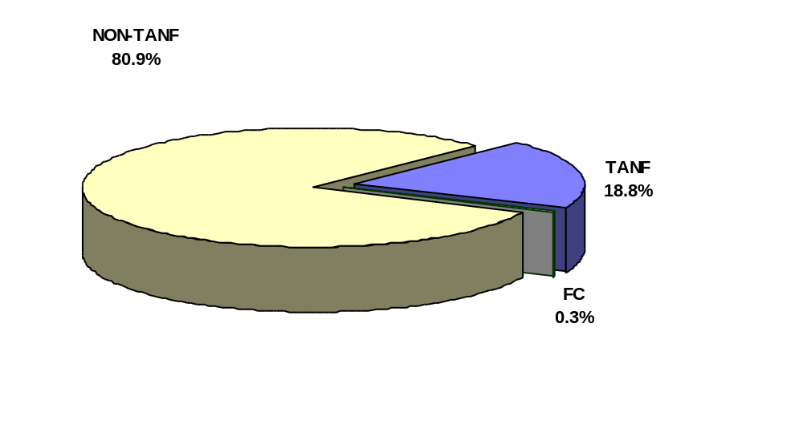

Preliminary Total Collections. Over $14 billion was collected in fiscal year 1998, this is a 45 percent increase from the $9.8 collected in FY 1994. (Figure 2) During the five-year span, TANF/FC collections increased from $2.5 billion in FY 1994 to $2.6 billion in fiscal year 1998. Non-TANF collections jumped from $7.3 billion in 1994 to $11.7 billion in 1998, a 60 percent increase.

Figure 2
Preliminary Total Collections
(In $Billions)

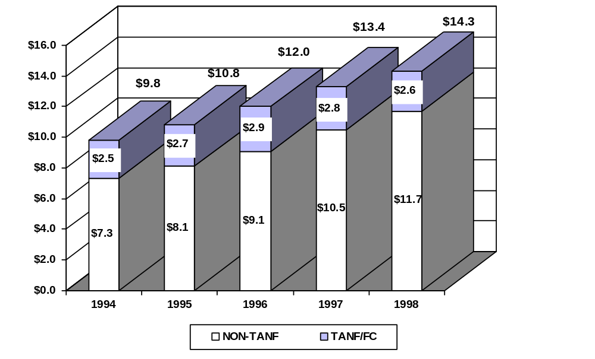

TANF/FC Collections. Preliminary TANF/FC collections amounted to $2.6 billion in fiscal year 1998, a decrease of 6.8 percent over the previous year. This is likely due to a drop in the TANF caseload, caused by the Personal Responsibility and Work Opportunity Reconciliation Act of 1996 (PRWORA). The States’ share of TANF/FC collections were $1.1 billion, this accounted for 41 percent of the collections. The Federal share was $960 million or 36 percent. TANF/FC families received $152 million or 6 percent of these payments. States’ received $396 million or 15 percent for incentive payments. About $52 million or 2 percent were for medical support payments (Figure 3).

Figure 3
Preliminary Distribution of TANF/FC Collections, FY 1998
$2.6 Billion

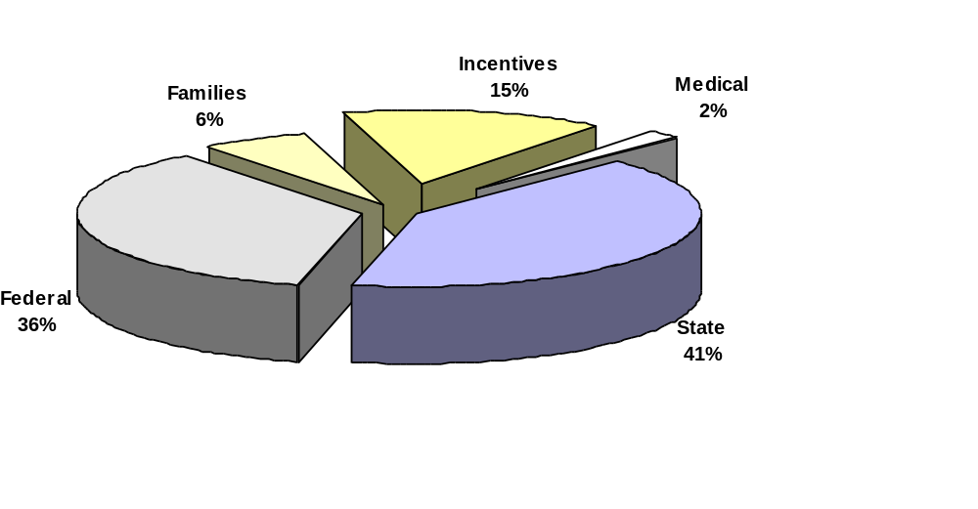

Collections per Paying Case. There were 4.5 million child support enforcement cases with collections reported in fiscal year 1998. A total amount of $3,132 was collected per paying case for fiscal year 1998 (Figure 4). In fiscal year 1998, an average of $2,175 was collected from each TANF and Arrears paying case and $3,732 from each non-TANF paying case. This represents a 10 percent increase in collections per paying case over the past five years.

Figure 4
Preliminary Collections Per Paying Case
(In Dollars)
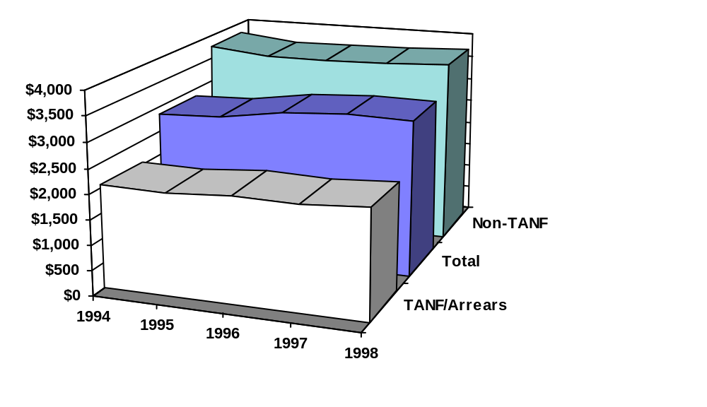
Total Expenditures. Preliminary administrative expenditures were $3.6 billion in

FY 1998 (Figure 5). This represents a 38 percent increase over the $2.6 billion in total

expenditures in fiscal year 1994.

Figure 5
Preliminary Total Expenditures
(In $Billions)

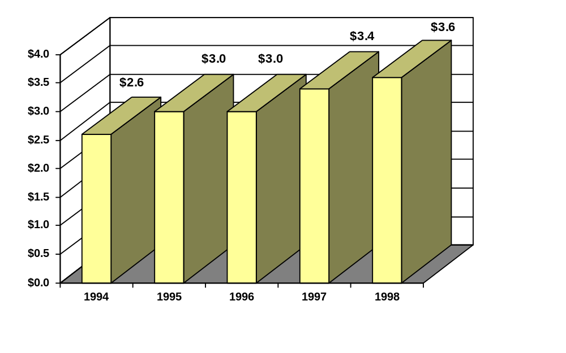
Cost-Effectiveness. Cost-effectiveness is the amount of child support collected per dollar of total administrative expenditures. In 1998, the cost-effectiveness ratio increased to $4.00 from the $3.90 in the previous year. (Figure 7)

Figure 7
Preliminary Cost-Effectiveness Ratio
(In Dollars)
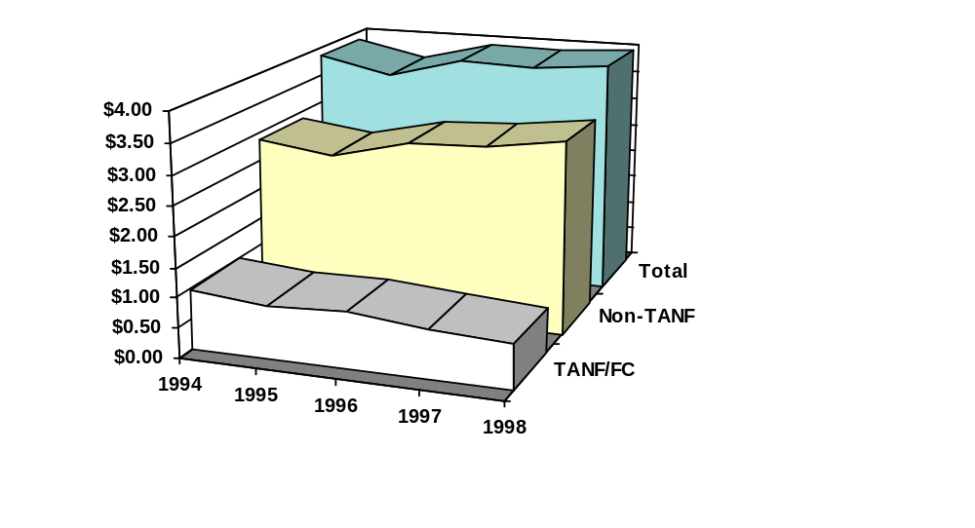
These cost-effectiveness ratios are not used to calculate incentives.

Total Caseload. Child Support Enforcement programs preliminary average caseload for fiscal year 1998 was 19.6 million. Fifty-five percent of the total caseload came from non-TANF cases. Twenty-nine percent of the caseload came from TANF/FC, and the remaining sixteen percent from TANF/FC arrears only cases (Figure 8).

Figure 8
Preliminary Total Caseload, FY 1998
19.7 million cases

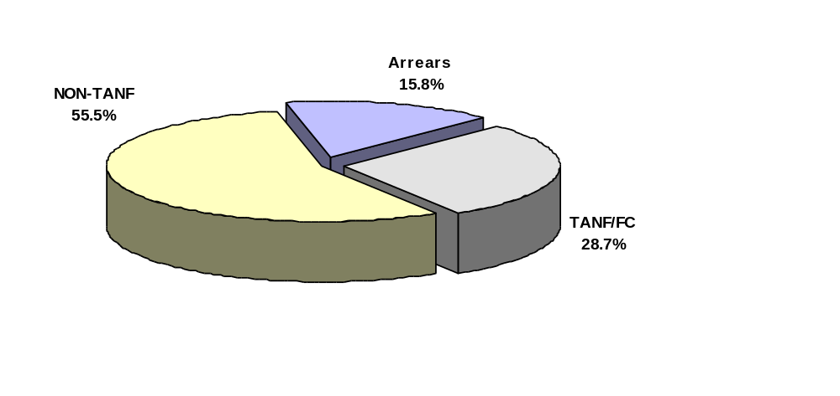

The total caseload grew 5.6 percent in the last five years (Figure 9). State CSE agencies reported 18.6 million cases in 1994. This number has increased to 19.7 million cases with the largest portion coming from the 11 million non-TANF cases reported in 1998. Due to PRWORA, TANF cases have decreased while non-TANF cases have steadily increased.

Figure 9
Preliminary Total Caseload
(In Millions)

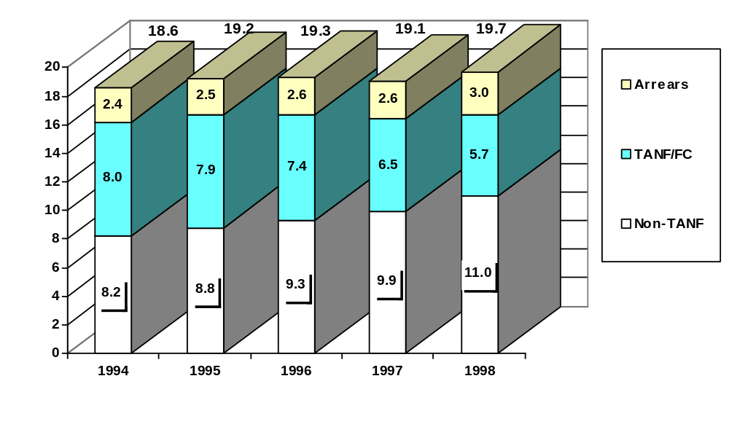

Preliminary Paternities Established and Acknowledged. The 1.5 million paternities established and acknowledged in 1998 shows over a 100 percent increase from the 676,459 reported during fiscal year 1994 (Figure 10). In fiscal year 1998, forty-one states reported a total of 614,081 in-hospital acknowledgements.

Figure 10
Preliminary Paternities Established and Acknowledged

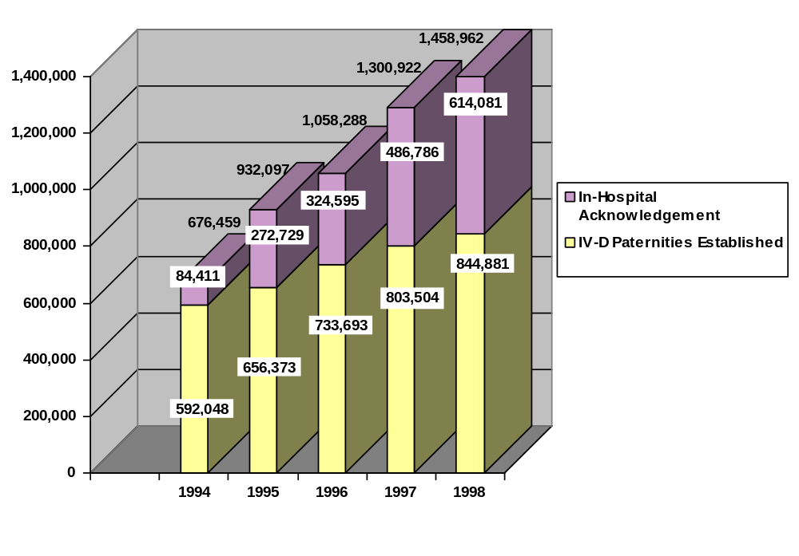
Some States voluntarily report in-hospital/paternity acknowledgement information to OCSE. In-hospital numbers include an unknown number of acknowledgements for children in the IV-D caseload.
Data are preliminary for FY 1998.



Appendix

? Florida data associated with the OCSE 156 are only for three quarters and data for the OCSE 158 annual report were not submitted due to a system change which occurred in January 1996.
? Due to system problems, the number of orders established were inconsistent for fiscal years 1997 and 1998 for the State of Tennessee. Therefore, the total number of orders established do not include those for Tennessee.
3 The 90 percent funding of ADP costs ended at the end of fiscal year 1997.
? The Department of Health and Human Services (HHS), like many Federal agencies, divides States into regions for administrative purposes. HHS has ten regional areas made up of four to eight States each, with a HHS regional office located in each area. Each regional office includes a Child Support Enforcement staff providing technical assistance to the States in that region. Along with the Central Office of Child Support Enforcement, regional offices help States implement Federal child support laws and regulations, and monitor State performance.
? The cost-effectiveness ratio is the total amount of child support collected per dollar of total administrative expenditures.
? Due to system problems, the number of orders established were inconsistent for fiscal years 1997 and 1998 for the State of Tennessee. Therefore, the total number of orders established do not include those for Tennessee.

