
Tennessee Job Sheet
Conservation Reserve Program (CRP)
CP11 – Trees Already Established

Conservation Practices No. 528 and 511
UNITED STATES DEPARTMENT OF AGRICULTURE

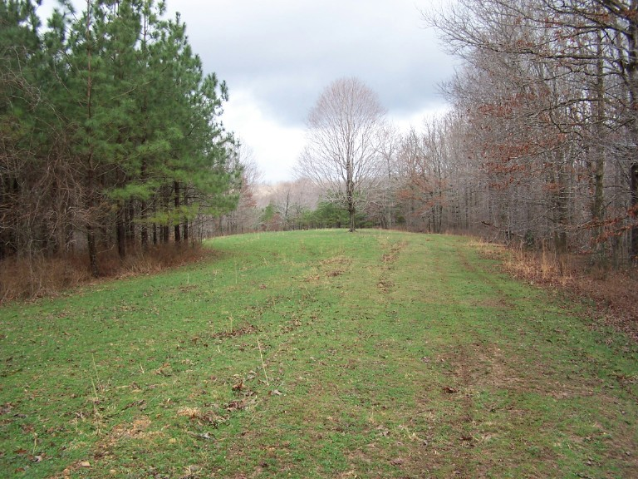
In General Signup 33, program applicants must select the desired practice from a list of practices. The type of cover to be established earns points in a method or ranking called the Environmental Benefit Index (EBI). The purpose of the CP11 practice is to maintain a stand of trees in a timber planting previously established on cropland as practice CP-3 or CP-3A to enhance environmental benefits. This practice is available only through a re-offer of expiring or expired program acres. Existing tree stands shall NOT be offered as CP3 or 3A.

GENERAL PROVISIONS

Existing tree areas available as a practice option for the CRP earn one of the following ranking point categories:
- 10 points – N1a-solid stand of pines or non-mast producing hardwood species.
- 20 points – N1a- solid stand of a single hard mast-producing species.
- 30 points – N1a- mixed stand (2 species) of hardwoods best suited for wildlife.
- 50 points – N1a – mixed stand (3 or more species) of hardwoods best suited for wildlife.
- 50 points – N1a -Pine/softwood established at, or thinned, to provide 10 to 20 percent openings of native herbaceous plants and/or shrub planting or natural regeneration best suited for wildlife.

Wildlife habitat on areas in existing trees can be enhanced through the following practice options (there is a maximum point score of 20 points for this ranking category):

- 20 points – N1b Wildlife water development (where water is a limiting factor for wildlife)*
- 5 points – N1b Annual or permanent food plot (10% of a field up to 5 acres in size)

* Available water cannot be present within a 1320 foot radius of the approximate center of the fields offered and the producer must be willing to create a wildlife watering facility without cost share.

SPECIFICATIONS
The following specifications are required and will be specified in the conservation plan as part of the CRP contract.

- Planned openings shall be either established to an approved 50 point mixture from CP4D (50 point native grass mixture only) or allowed to naturally regenerate (slopes of 12% or less).
- Openings shall be a minimum of 10% up to a maximum 20% of practice acres. For fields larger than 20 acres, openings shall be a minimum 2 acres in size up to a maximum of 5 acres. For fields less than 20 acres, openings will be on the percentage basis. Openings may be established as field perimeters not to exceed an average width 30 feet.
- Thinning, if required, must be completed within 3 years of contract date. Trees must be removed from the site.
- The participant shall ensure an adequate approved forest and opening cover is maintained to control erosion for the CRP-1 period.
- At least one management practice in the mid-contract period will be required to be performed for pine stands with planned openings. Options for the openings include strip disking, strip herbiciding, legume interseeding, or prescribed burning. A prescribed burn may be conducted in the pine timber. Hardwood contracts do not require a mid-management treatment to be performed.
- Firebreaks must be established prior to burning as required in the conservation plan. The breaks will not be
constructed closer than 2 feet from the existing trees. Openings which include shrubs or other fire-sensitive species
will be protected during the burning.

