“Man of Padua” –
A Tale in the Vesalius Kiosk of NLM’s “Dream Anatomy” Exhibit
Oct 18, 2002
Glenn Pearson, Karen Steely, and Michael Sappol

Introduction
At the US National Library of Medicine, an exhibit, “Dream Anatomy”, is running from Oct. 9, 2002 to July 31, 2003; a portion of this can be seen at the web site:
www.nlm.nih.gov/exhibition/dreamanatomy.
Within the exhibit are several touchscreen kiosks. One is based on an earlier collaboration with the British Library to take a sampling of images from Vesalius’ anatomy book of 1531, and present it to the viewer as book, whose pages can be turned by dragging a finger across them. For the exhibit, several extensions where made to the presentation. Most notably, four button-invoked “Tales” were embedded. Each is a self-running multimedia piece of 4-5 minute duration, in which the book appears in the background, and is programmatically flipped to particular page spreads, to illustrate the theme being narrated. The voice-over is also presented as a text crawl at the bottom.
Below is the annotated script for one of the tales, “Man of Padua”, supplemented with representative screenshots. In the live production, images fade in and out, the “musclemen panoramas” move horizontally across the screen, and the city views at the figures’ feet enlarge and fade away.

The “Man of Padua” Tale
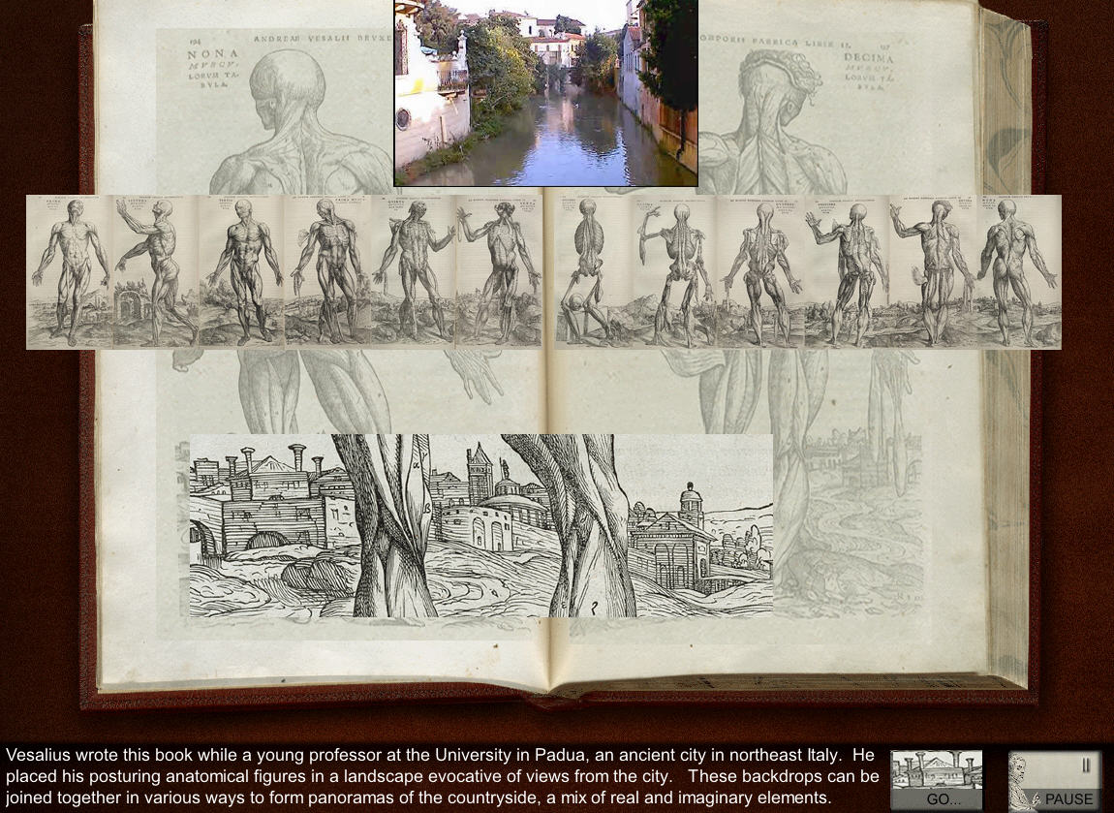

Vesalius wrote this book while a young professor at the University in Padua, an ancient city in the northeast of Italy. He placed his posturing anatomical figures in a landscape evocative of views from the city. These backdrops can be joined together in various ways to form panoramas of the countryside, a mix of real and imaginary elements.

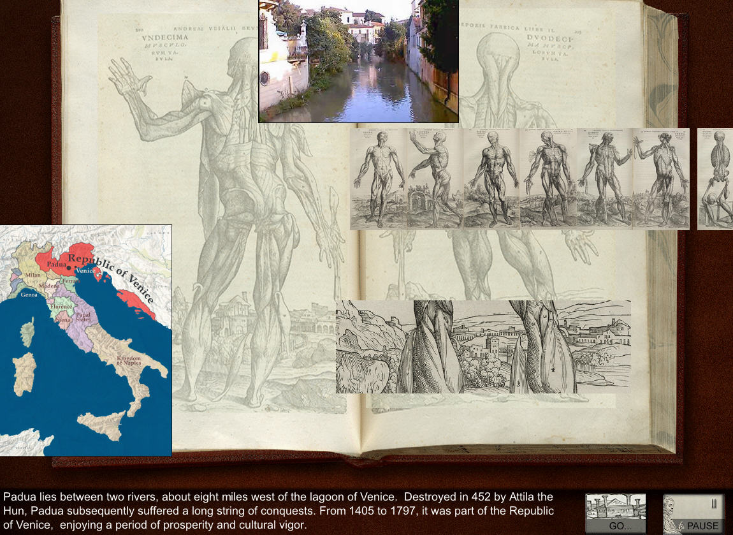

Padua lies between two rivers, about eight miles west of the lagoon of Venice. Destroyed in 452 by Attila the Hun, Padua subsequently suffered a long string of conquests. From 1405 to 1797, it was part of the Republic of Venice, enjoying a period of prosperity and cultural vigor.

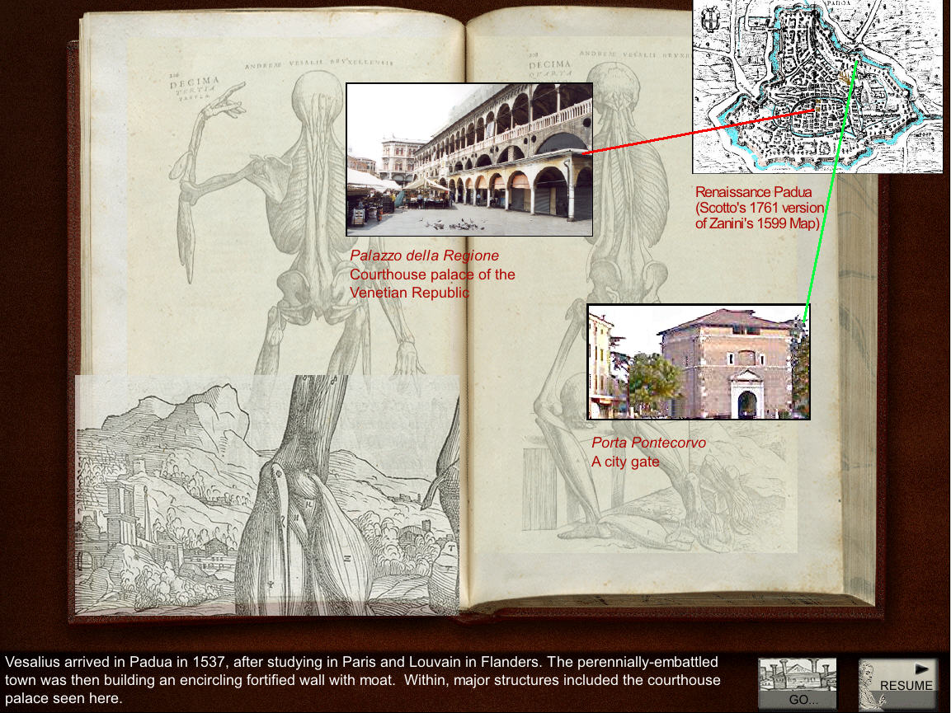

Vesalius arrived in Padua in 1537, after his medical training in Paris and Louvain in Flanders. The perennially-embattled town was then building an encircling fortified wall with moat. Within, major structures included the courthouse palace seen here.

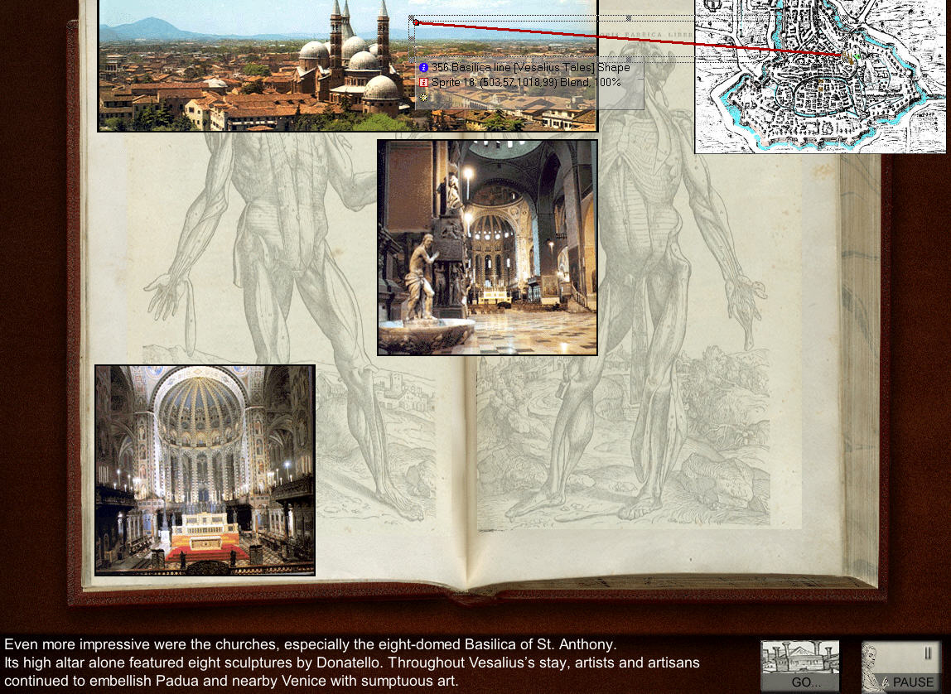

Even more impressive were the churches, especially the eight-domed Basilica of St. Anthony, the most richly decorated church in the region. The high altar alone featured eight sculptures by Donatello, including a statue of St. Anthony, who was born and died in Padua. Throughout Vesalius’s stay, artists and artisans continued to embellish the buildings of Padua and nearby Venice with sumptuous art.

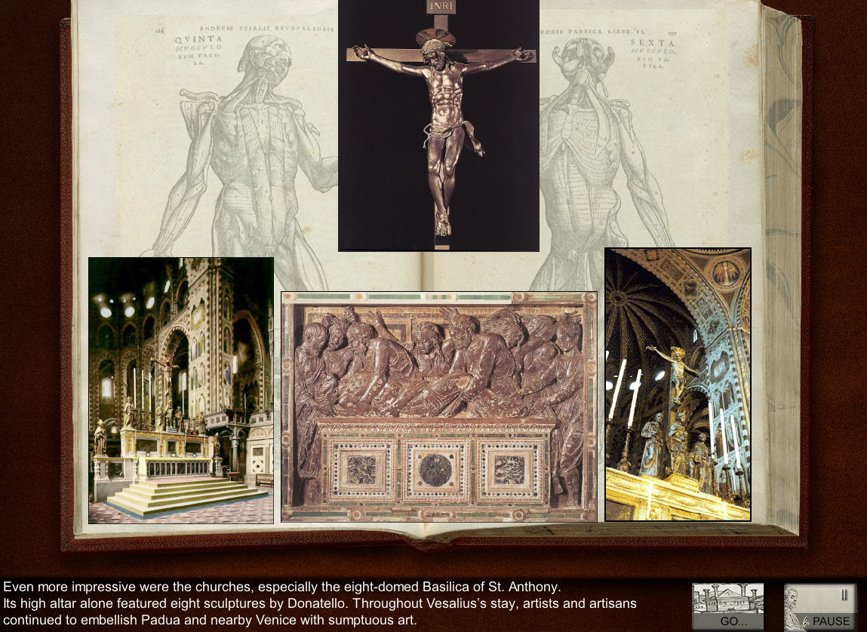

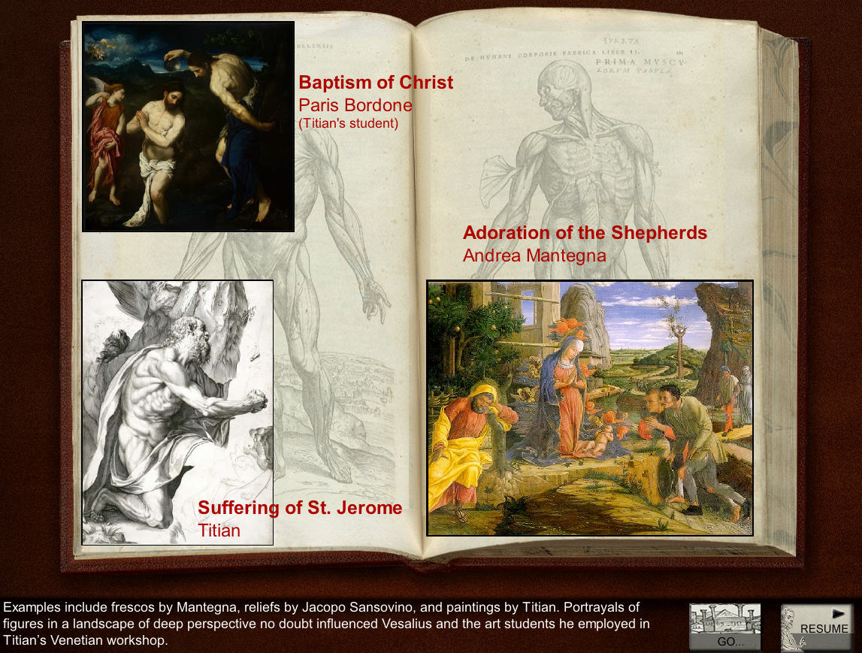

Examples include frescos by Mantegna, reliefs by Jacopo Sansovino, and paintings by Titian. Portrayals of figures in a landscape of deep perspective no doubt influenced Vesalius and the art students he employed in Titian’s Venetian workshop.

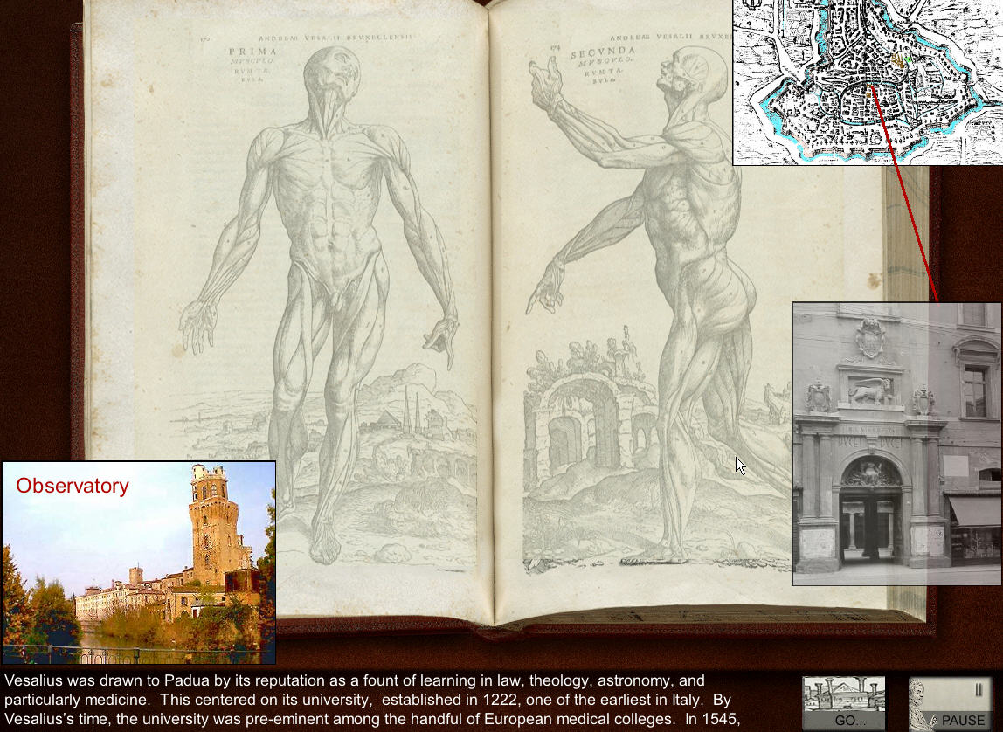

Vesalius was drawn to Padua by its reputation as a fount of learning in law, theology, astronomy, and particularly medicine. This centered on its university, established in 1222, one of the earliest in Italy.

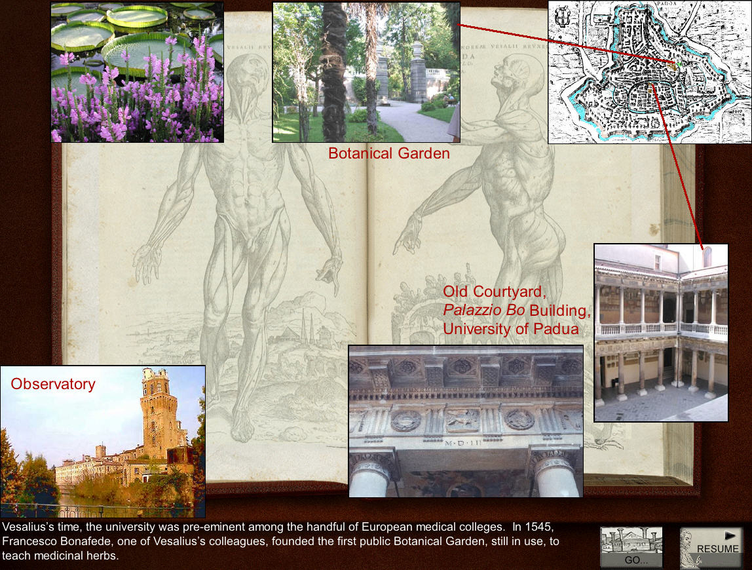

By Vesalius’ time, the university was pre-eminent among the handful of European medical colleges. Colleagues of Vesalius would include Francesco Bonafede, who in 1545 founded the first public Botanical Garden, still in use, to teach medicinal herbs.

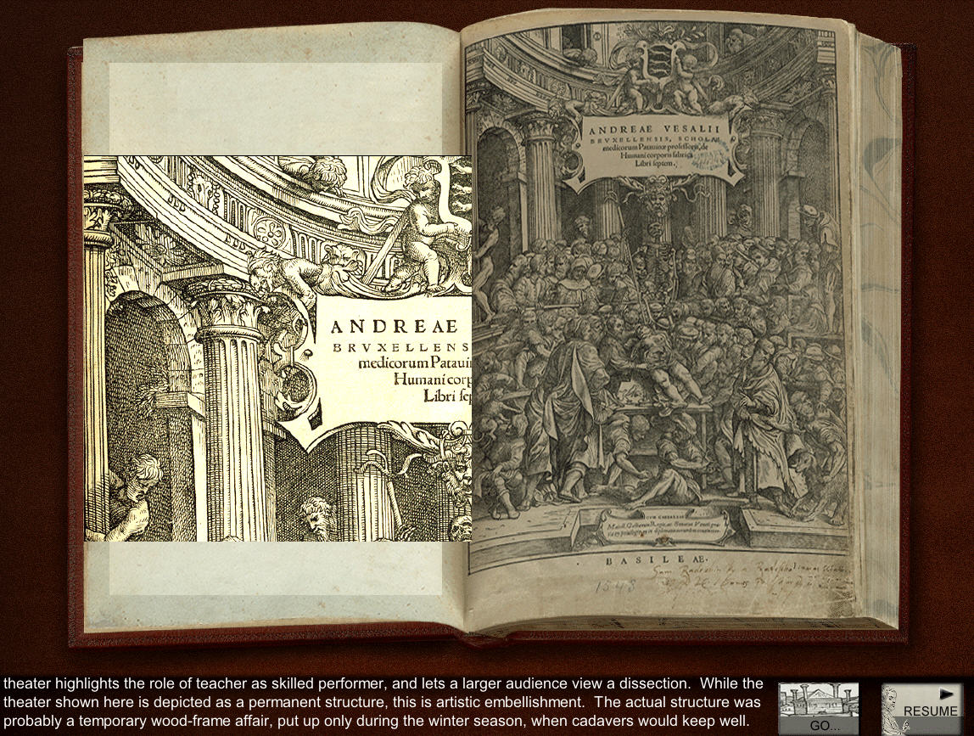

In his teaching, Vesalius made use of an anatomical theater, an idea conceived just fifty years earlier. The theater highlights the role of teacher as skilled performer, and lets a larger audience view a dissection, a one-shot performance. While the image of the theatre shown here suggests a permanent structure, this is artistic embellishment. The actual structure was probably a temporary wood-frame affair, put up only during the winter season, when cadavers would keep well.

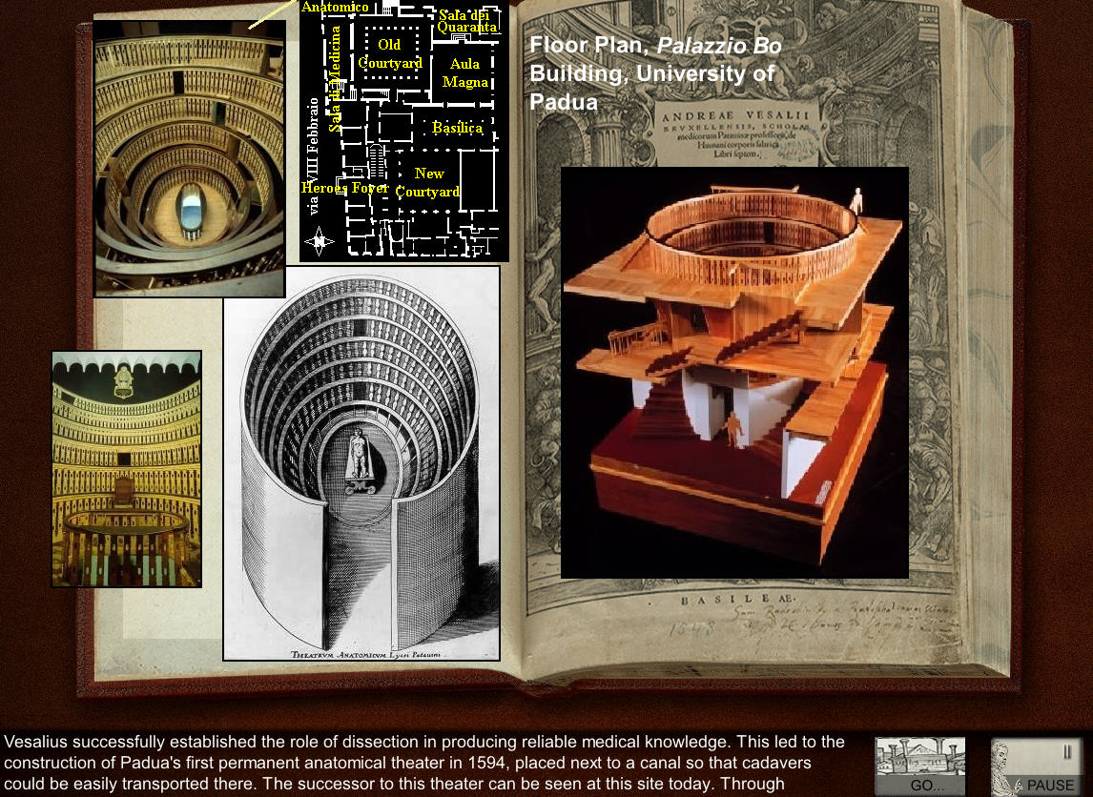

Vesalius successfully established the role of dissection in producing reliable medical knowledge. This led to the construction of Padua’s first permanent anatomical theater in 1594, placed next to a canal so that cadavers could be easily transported there. The successor to this theater can be seen at this site today. Through professors like Vesalius, and later, Galileo, the University of Padua helped birth the scientific revolution.

Other Tales
Besides “Man of Padua”, other tales that the viewer can select are:
- “Portraying Anatomy”. Discusses the groundbreaking modes of anatomical representation due to Vesalius.
- “Getting Deep, Getting Real”. Begins with Vesalius’ use of progressive, layered dissection, and shows some ways this treatment has been extended in modern anatomical rendering and medical education.
- “The Slice”. Surveys the use of cross-sectioning in anatomy and histology, its deployment in the Visible Human project, and its extension to non-invasive anatomical and diagnostic methods such as X ray, MRI and CT scanning, and ultrasound.
- “Credits”. Kiosk contributors and photo/illustration credits
