A Tale of Two Agencies:

The Quest for Developing a Health Data Sharing Agreement

2007 - 2008

Environmental Public Health Leadership Institute Fellow:

Greg Kearney; Dr.P.H., M.P.H., R.S.
Environmental Epidemiologist;Florida Department of Health
4052 Bald Cypress Way,
Tallahassee, Florida 32399
(850) 245-4577
Greg_Kearney@doh.state.fl.us

Mentor:

CAPT Steve Inserra, REHS, MPH
Environmental Epidemiologist; Agency for Toxic Substances and Disease Registry
Department of Homeland Security,
Health Investigations Branch

Acknowledgements:

Meade Grigg

Director and State Registrar, Florida Department of Health, Office of Planning, Evaluation, Data Analysis and Statistics

Carina Blackmore, DVM., Ph.D.
State Public Health Veterinarian, Florida Department of Health, Division of Environmental Health

Denise Love

National Association of Health Data Organization

Carolyn Turner

Agency for Health Care Administration

Judith Qualters, Ph.D.
Chief, Health Tracking Branch, Centers for Disease Control and Prevention,

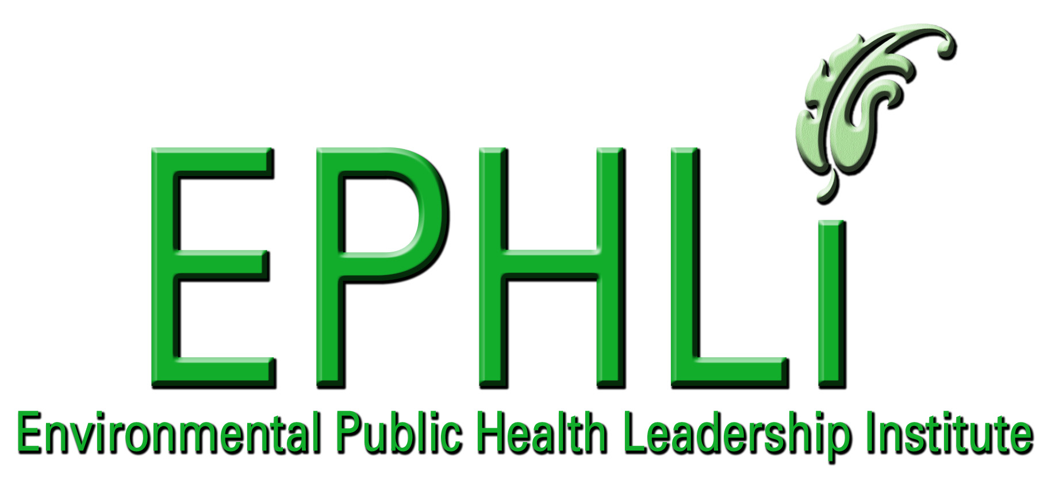

EXECUTIVE SUMMARY:

Hospital data can be used by epidemiologists and public health officials to monitor the health status of a community and to perform disease surveillance. Although primarily used for medical billing purposes, hospital data can serve as a rich source of health information providing valuable insight for evaluating selected chronic and acute diseases, and establishing and reporting health trends in the population.

In Florida, the Agency for Health Care Administration (AHCA) collects and manages all hospital data for the entire state. Hospital data is considered confidential, and to receive this data, all applicants, including the Florida Department of Health (FDOH) must submit an annual “request for data” application. From a state health department’s perspective, requesting this data has proven to be a repetitive, lengthy and time consuming process. This leadership project utilizes methods focused on recognizing, describing and identifying barriers in an attempt to facilitate a process to overcome a cumbersome, annual renewal application process. The goal is to work towards developing a multi-year data sharing agreement (DSA) between the Florida Department of Health and the Florida, Agency for Health Care Administration.

The “shifting the burden” and “fixes that backfire” archetypes were selected, a casual loop developed, role-playing dialogue was constructed and an action plan developed. Other methods included interviews with data administrators and attorneys among the two agencies and internal meetings with stakeholders.

The short term benefits include, an interagency application being developed, and a January 2008 meeting scheduled with the new AHCA leadership to propose a DSA. As a result of this project, FDOH senior leadership is now cognizant of the situation and intends to pursue this idea. The EPHLI has improved my knowledge and abilities to strategize and frame the discussions for FDOH with AHCA for enabling a continuing this dialogue into 2008. In addition, this project has improved my negotiation approaches and skills For collaborating with other agencies. Long term, these AHCA negotiations may prove to have long lasting benefits to the Division of Environmental Health as well as other Divisions within the Florida Department of Health.

A policy determination has yet to be made of why a DSA can not be developed, however the recent change of leadership at AHCA may prove to be an opportunity for securing a DSA. Also, the National Association of Health Data Organization had developed a national-level work group to develop a uniform DSA that can be used by all states. Florida has been participating in these efforts, which may prove beneficial not only to Florida, but at the national level.

INTRODUCTION/BACKGROUND:

Hospital data plays an important role in public health surveillance. In Florida, hospitals and medical care facilities are required by Florida Statutes to report patient health data to the Agency for Health Care Administration. Throughout time, the Florida Department of Health (FDOH), Office of Planning, Evaluation, Data Analysis and Statistics (Vital Stats) has been the primary users of AHCA data to cross verify vital birth and death records. AHCA provides non-confidential health data to the Office of Vital Stats on an annual basis.

Besides using hospital data for tracking and producing vital statistics reports, there are many other important uses for the data, including public health surveillance. Currently, FDOH is being funded by CDC to help develop an environmental public health tracking network (EPHTN). One of the primary goals of EPHTN project is to link selected hospital health data with data on environmental hazards, to help identify patterns and trends of chronic diseases in the population. For example, linking asthma hospitalization data with outdoor air pollution data to identify if there are certain times of the year when there is an increase in rates.

Obtaining confidential hospital data on an on-going, un-interrupted, electronic basis is crucial for the project to succeed. Confidential data differs from non-confidential data by the variable contained in the dataset. The confidential hospital data needed for the project includes obtaining these selected identifiers within the data, such as social security number and zip codes. The Office of Vital Statistics does not get this detailed (low-level resolution) therefore; they receive a non-confidential, public-use CD, in a time efficient, non rigorous manner.

AHCA has an annual renewal application process for confidential information that has been both cumbersome and time consuming to complete. As a “sister” agency, FDOH is still required to complete many application forms, obtain multiple signatures, and proceed through a lengthy, often time-delayed process of obtaining recurring data.

A request for confidential information to AHCA, from any state agency, Division or Bureau within government, requires the applicant to complete a formal application, and a hierarchy of upper management signatures from both Agencies. Despite the importance of obtaining data from AHCA, there has never been an “official” agreement between the two agencies that would allow Division’s, Bureau’s at FDOH to obtain confidential data in an easy manner.

According to sources within FDOH, the Department has been actively pursuing a health data sharing agreement (DSA) from the Agency for Health Care Administration for a number of years. However, a DSA has never transpired.

The primary stakeholders of this project are those epidemiologists with FDOH, and 16 other state and city health departments federally funded for the Environmental Public Health Tracking grant. As mentioned, the primary focus of the grant is to integrate data from health and environmental agencies to evaluate adverse chronic disease outcomes, such as cancers and birth defects. Other stakeholders include other state health departments, county health departments (CHD’s), Agencies for Health Care, Department’s of Environmental Protection (DEP’s), Federal agencies (i.e, US EPA, ATSDR), not-for-profit agencies and professional organizations. The Tracking states must partner with stakeholders, with the goal of bringing health and environmental data sets together for the purposes of exploring potential health risk relationships.

The majority of state health and environmental agencies collect data as a regulatory means. Health agencies collect health data for billing purposes, and environmental agencies collect data to assure compliance of air, water, sewage, etc.., Both, health and environmental agencies are typically stove-piped with data, and rarely do the two meet; state health agencies would benefit by having hospital data that could be “linked” with environmental hazard data to analyze and determine trends of health outcomes (i.e., asthma, myocardial heart infarctions and birth defects) in the population-at-risk.

Health and environmental data will continue to be stored and under utilized for the purposes of research or public health surveillance. It is unknown at this point if either the environmental or health agencies perceive change. Some agencies, for example, the US EPA, are making a paradigm shift for sharing their data for accountability, others may potentially follow suit.

Problem Statement:

In Florida, the Agency for Health Care Administration (AHCA) requires the Florida Dept. of Health (FDOH) to proceed through a lengthy and time consuming application process to receive health data. As a “sister” governmental agency, bound by similar health care protection laws and regulations as AHCA, FDOH receives no special consideration or expedited review in the data request process. This process presents concerns for surveillance purposes. This process appears to be similar at the national level, and needs to be streamlined, so that health data can be more easily retrieved by state (environmental) health departments.

Behavior Over Time Graph:

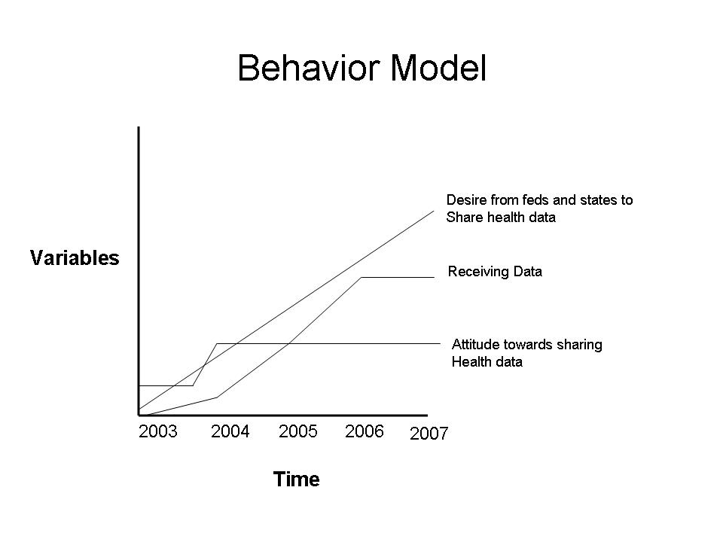

Causal Loop Diagrams and applicable archetypes:

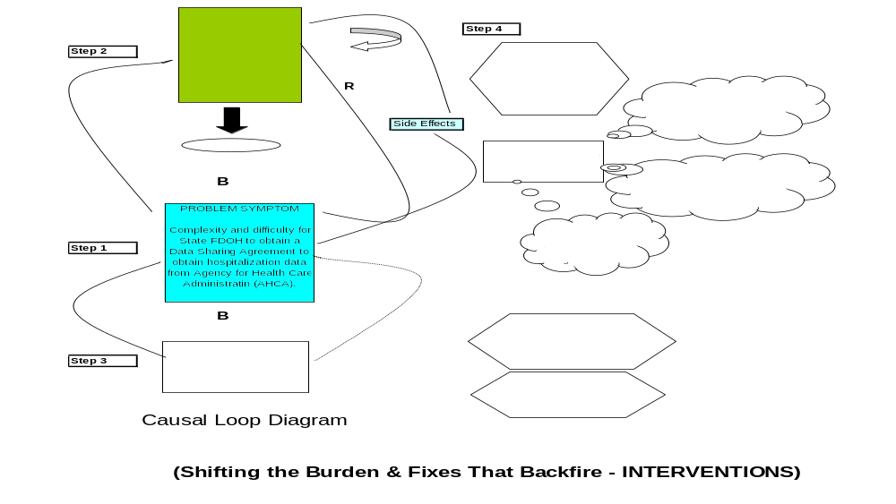

10 Essential Environmental Health Services:
This project, “The Quest to Develop a Data Sharing Agreement” fulfills six (6) of the objectives identified in the Institute of Medicine (IOM) Report, including Assessment, Policy Development and Assurance including;

ASSESSMENT:
- Monitor Health: This project is primarily built on the need for conducting surveillance using hospital data linked with environmental data.
- Diagnose and Investigate: result of this project will be to use data to help better understand the relationship between health and environmental hazards

ASSURANCE:
- Evaluate Effectiveness: Having a DSA will enable the Florida EPHTN to evaluate and measure progress of intervention and prevention efforts

POLICY DEVELOPMENT:
- Inform, Educate and Empower: By using the data from this project, will be used to inform stakeholders, communities about how their health may be impacted by environmental hazards.
- Mobilizing Community Partnerships: The end results after formalizing a DSA and providing researchers with data needed to produce results in a more timely fashion may help to mobilize and engage community partnerships, particularly stakeholders to identify environmental hazards and the need of environmental interventions.
- Develop Policies: With a successful project, a data sharing agreement may spur a national policy effort for all state health care administration agencies to share data with their Department of Health.

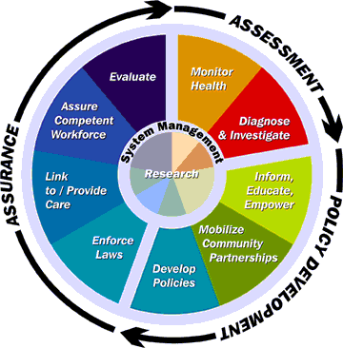
Figure 1: Picture courtesy of Carl Osaki, MSPH, RS
Department of Environmental & Occupational Health, Northwest Center of Public Health Practice
University of Washington

National Goals Supported

1. CDC Health Protection Goals

This project supports the primary CDC Health Protection Goal: “Healthy People in Healthy Places.” As a result of implementing the data sharing agreement, health department’s capacity will increase by having data partners and a more efficient and increased way of conducting surveillance on a routine basis, promoting the health and safety of communities.

2. Healthy People 2010

In addition, this project also meets the following Health People 2010 objectives:

23-2. Increase the proportion of Federal, Tribal, State, and local health agencies that have made information available to the public in the past year on the leading health indicators, and priority needs.
23-12. Increase the proportion of Tribal, State, and local public health agencies that provide or assure comprehensive epidemiology services to support essential public health services.
8-27. Increase or maintain the number of Territories, Tribes, and States, and the District of Columbia that monitor diseases or conditions that can be caused by exposure to environmental hazards.

3. National Strategy to Revitalize Environmental Public Health Services

This project support four (4)goals outlined to support revitalizing environmental public health services.

Goal I. Build Capacity. Enlighten policy makers and other state agencies to Environmental Public Health and Data Sharing, and an opportunity to coordinate and collaborate with policy development.
Goal II. Support Research to define Effective Approaches to Enhance Environmental Public Health Services. Linking research with health and environmental data.
Goal III. Foster Leadership to Enhance Environmental Public Health Service. Enhance EPH by developing strong working relationships, specifically, among stakeholders,
Goal IV. Communicate and Market. Improve communication, information and data sharing among health care administration and public health agencies.

4. Environmental Health Competency Project: Recommendation for Core Competencies for Local Environmental Health Practitioners

This project supports two (2) recommendation for Core Competencies for Local Environmental Health Practitioners.

A2. Data Analysis and Interpretation: The capacities to analyze data, recognize meaningful test results, interpret results, and present the results in a meaningful way to different types of audiences. This project supports data sharing for public health surveillance.

B7 Partnering: The capacity to form partnerships and alliances with other individuals and organizations in order to enhance performance on the job. This project recognizes the need for state agencies to share data and form partnerships so that epidemiologists and other public health authorities enhance findings.

Project Logic Model:
Resources/Inputs  Stakeholders Buy-In and  Engage key players including;  FDOH State Epidemiologists  Bureau and Division Chiefs  County Health Departments  Work towards building internal support within FDOH to make issue more viable/visible. | Activities  Work towards building internal support within FDOH to make issue more visible.  - Hold meeting(s) with State Epidemiologist and other key players within the FDOH  - Request a DSA in writing from AHCA, and ask them to specifically address any policy, law or other limitation, that precludes FDOH from obtaining confidential information in a timely manner.  Develop a Data Needs Assessment Group within FDOH  - Identify key players  - Develop objectives  - Propose a DSA  - Draft DSA | Outputs  Raise internal awareness at FDOH of need to obtain data  Provide additional needed support from stakeholders to develop a DSA  Provide internal clarification on what data is needed through completed needs assessment to stakeholders | Short & Long Term Outcomes  and Impacts  Long Term Outcomes (3-5 years)  Improved Public Health Surveillance  Increased Capacity  Impacts  - Reduced chronic diseases  - Increased awareness of environmental hazards related to chronic diseases.  - Increased knowledge of prevention through target messaging of public health outcomes.

PROJECT OBJECTIVES/DESCRIPTION/DELIVERABLES:

Program Goal: To increase inter-agency collaboration between the FDOH and AHCA, and develop a data sharing agreement (DSA) between FDOH and AHCA to share (confidential) hospitalization data in a timely and consistent manner.

Health Problem: Increasing rates of chronic diseases and lack of public health surveillance of adverse health conditions associated with environmental hazards.

Outcome Objective: Develop a data needs assessment group, and establish a joint DSA agreement between the AHCA and FDOH.

Determinant: Hospital data is not being used to full potential - a lengthy application process to obtain confidential health information contributes to a gap in proactive public health surveillance.

Impact Objective: By 2008, one (1) Division or Bureau within the FDOH should be obtaining confidential hospitalization data and using it for public health surveillance purposes.

Contributing Factors:

- There has never been a coordinated effort from FDOH, Divisions or Bureaus to
obtain confidential hospitalization data from AHCA, except in a piece-meal fashion.

- Lack of communication between agency, and no clear criteria available that would explain why FDOH cannot obtain data, only verbal responses.

Process Objectives:

1. By 2008, key stakeholders within FDOH will demonstrate awareness of complications and need towards receiving confidential information from AHCA.

METHODOLOGY:

Events and Activities

Event: Awareness of issue is common knowledge among key stakeholders and upper management.

Activities:
a) Internal FDOH meeting held to discuss strategy to move towards developing a Data Sharing Agreement.
b) Obtain an electronic spreadsheet list of all FDOH users of AHCA data.
c) Hold internal FDOH meeting. Appoint liaison, Meade Grigg, Director, Office of Planning, Evaluation, Data Analysis and Statistics, to take leadership role to discuss a data sharing agreement with AHCA.
e) Meeting scheduled with new leadership at AHCA.

RESULTS:

At this time, a formal DSA between FDOH and AHCA has not been developed, however an interagency data application (see attached) was modified to help ease the data application process. The interagency request for data is now a less intensive process, however, still requires an annual renewal. Additionally, a recent change of leadership has prompted another meeting which may prove to be an opportunity for securing a DSA in the near future. In addition, communication between the two agencies has increased, and the stimulation provided by this project has helped to formulate an internal partnership among selected Division’s within FDOH, and gain momentum to support an effort for a DSA.

CONCLUSIONS AND NEXT STEPS:

In summary, the system thinking approach using the shifting the burden and fixes that backfire archetypes, helped to propel this project towards identifying obstacles to reach resolution. The result of the work effort of this leadership project helped to stimulate a heightened interest between agencies of sharing hospital data. Although a forma data share data on a recurring basis between agencies has not matured, an interagency data request application was developed. More importantly, a communication channel has been established, and management is keenly aware of the need for a more collaborative effort to partner to share data.

At the National level, this project is supported by the CDC Environmental Public Health Tracking Branch, National Association Health Data Organization and several other Health Tracking funded states. The National Association of Health Data Organization (NAHDO) has been working to make DSA’s between health care agencies and health departments a reality among states. Currently, NAHDO and CDC are assisting a national work group effort to develop a uniform DSA that can be used by at a national level. Florida Department of Health is involved with this federally funded Environmental Pubic Health Tracking states to work on this issue at a national level.

Next steps include continuing to participate at the state and national levels in workgroups and to advocate the need for agencies to develop DSA’s and to share hospital data.

Application for Inter-Agency Staff Access to Confidential Data

Name of Applicant ____________________________________________Date:______________

Phone: ____________________________________ E-mail: ____________________________

Applicant’s Organization: _________________________________________________________

Title of Project: ________________________________________________________________

Agreement for Inter-Agency Staff Access to Confidential Data
By signing below, the Applicant agrees not to share the data externally or internally unless specifically authorized. The Applicant agrees to use the data only for the purpose stated in this application. The Applicant agrees to secure the data and any reports containing the data when not being used, use password protection, and provide for proper disposal of the data and reports, so that confidentiality will not be breached. The Applicant acknowledges that failure to abide by the terms of this agreement may subject the Applicant to penalties for wrongful disclosure of Protected Health Information under federal law. The Applicant agrees to ensure that any subcontractors of the Applicant do agree to the same conditions and restrictions for safeguarding the data.

Signed: ______ ________________
Applicant Date

Approved: __________
Applicant’s Bureau Chief Date

____
Applicant’s Division Director Date

_____
Data Owner’s Security Administrator Date

_____
Data Owner’s Bureau Chief Date

_____
Data Owner’s Division Director Date

Data _____
Released: Data Owner’s Dissemination Administrator Date

Note: Access authorization must be renewed annually.

1. Identify Database(s) Requested:
2. Purpose of Project and Statutory Authority:
3. List subcontractor(s) who will receive access to confidential data and identify the contract manager.
4. Describe the subset of records requested (time periods, types of patients, diagnoses and etc.)
5. List confidential data elements* requested and provide an explanation of why each element is necessary for the successful completion of the project or study.
6. Describe any linkage to other data files, sources of linked files, and identifying information contained in the linked files. Will any identifiable data obtained for this project be used as a basis for any actions which may affect individuals and/or establishments identified from the confidential data?
7. Describe the least aggregate data or research results that will be released internally and/or externally.

8. Indicate the anticipated project completion date and the duration of access requested.
9. Provide (print) name, title, and phone number of persons approving request on behalf of the applicant.
10. Applicant’s mailing address.

*Program must provide applicant with a list of confidential data elements

LEADERSHIP DEVELOPMENT OPPORTUNITIES:

Greg Kearney, DrPH, MPH, RS

Attending the Environmental Public Health Leadership Institute (EPHLI) has played an important role in helping me to develop important leadership skills. The systems thinking assignment, readings and exercises have taught me to understand the dynamics of a problem, and how to resolve it, by breaking it down into more manageable parts. By applying the system thinking assignment to a “real world” project, I was able to clearly identify weaknesses and where to target my efforts towards obtaining successful results. By completing the Individual Development plan, I was able to work towards focusing on those areas that needed attention as identified in the Skillscope self assessment. By tracking my progress towards these objectives, I was able to reach several of my personal leadership development goals.

The resources provided by EPHLI, including quality speakers, reading material, mentoring, coaching, projects and assignments were all top notch. The face to face meetings throughout the various locations were filled with valuable information, and the group projects provided for great opportunities to learn leadership skills and have some fun in the process. More importantly, I was impressed with the dedication and commitment by the mentors, staff and others attending the EPHLI sessions. The networking opportunities provided for a great chance to meet with other professionals and discuss environmental health issues from all over the country.

I am very thankful to my mentor and EPLI for providing the time to share their knowledge, skills and learning experiences with me. I am proud to have been a part of the EPHLI class of 2008, and look forward to encouraging others to apply for this great opportunity to improve their environmental public health leadership skills.

ABOUT THE EPHLI FELLOW(s)

Greg Kearney has 18 years of professional experience working in environmental health and epidemiology. Dr. Kearney currently works as an Environmental Epidemiologist for the Florida Department of Health (FDOH), Division of Environmental Health and adjunct professor at Florida Agricultural and Mechanical University (FAMU). Dr. Kearney serves as the Principal Investigator for the CDC Environmental Public Health Tracking Network (EPHTN) grant at FDOH, and is primarily responsible for overseeing the work involving the design and implementation of a state/national environmental epidemiology public health surveillance network system.

Dr. Kearney holds a Doctor of Public Health (Dr.P.H.) in Environmental Health Sciences, from the University of Alabama at Birmingham, a Masters of Public Health (M.P.H.) from the University of South Florida, and a Bachelor of Science (B.S.) in Urban and Regional Planning from East Carolina University. He received his Florida Registered Sanitarian (R.S.) certification in 1995, National RS certification in 1997. Dr. Kearney also serves as Chair for the National Environmental Health Association’s, Environmental Public Health Tracking and Informatics’ Technical Committee.

Dr Kearney enjoys collecting and reading books on environmental health and epidemiology and has a special interest in spatial analysis (using GIS). He lives in Tallahassee, Florida with his beautiful wife, Michelle, video-game expert son Patrick, and his two pugs, Bandit and Mojo. Whether working or playing, each day, he looks forward to living, learning, laughing, and never wasting a precious moment.

REFERENCES

- Osaki, C., Northwest Center for Public Health Practice, 10 Essential Environmental Health Services.

- CDC National Strategy to Revitalize Environmental Public Health Services.
http://www.cdc.gov/nceh/ehs/Docs/nationalstrategy2003.pdf

3. CDC Health Protection Goals for the 21st Century http://www.cdc.gov/about/goals/default.htm

4. Healthy People 2010
http://www.cdc.gov/nchs/about/otheract/hpdata2010/abouthp.htm

5. Rowitz, L., Pubic Health Leadership: Putting Principles into Practice, (2003). Jones and Bartlett Publishing Co.

6. Environmental Health Competency Project: Recommendation for Core Competencies for Local Environmental Health Practitioners http://www.apha.org/programs/standards/healthcompproject/corenontechnicalcompetencies.htm

