GYPSUM DUNES FROM WHITE SANDS NATIONAL MONUMENT – POTENTIAL TERRESTRIAL ANALOG TO NORTH POLAR DUNES ON MARS. A. Szynkiewicz¹, L.M. Pratt¹, M. Glamoclija², and D. Bustos³, ¹Indiana University (Department of Geological Sciences, 1001 East 10th Street, Bloomington, IN 47405-1405, aszynkie@indiana.edu; ²Geophysical Laboratory, Carnegie Institution of Washington, 5251 Broad Branch Road NW Washington, DC 20015; ³White Sands National Monument, P.O. Box 1086, Holloman Air Force Base, NM 88330).

Introduction: On Earth, gypsum dunes are rare and restricted to semi-arid areas where older sedimentary sulfate-rich rocks undergo dissolution by meteoric waters on/near the surface. Further, new evaporitic deposits are formed from solute transport by surface runoff, meteoric and/or hydrothermal groundwaters. Overall, gypsum dunes appearance is closely connected with climate changes toward increasing aridity after last global glaciaciation on Earth. The White Sands gypsum dunes (WSgd) are the largest known on Earth. Their geological setting, however, completely differs compared to the gypsum-rich dunes of Olimpia Undae (OUgd) on Mars. In spite of this, we found few similar morphological features within WSgd like those found on OUgd that might provide some insights regarding the climate history of polar processes on Mars.
The OUgd in the North Polar region of Mars reveal complex chemical and physical evolution [1,2,3,4]. Gyspum was found in the presence of dunes only, and its content decreases from the eastern edge of the main polar north dune sea toward west following the main wind direction [1,2]. Dunes contain gypsum grains of a few tens micrometers and milimiters in size showing its elevated content within the dunes crest [1]. The other component of dunes are mafic minerals and oxides. The source area for gypsum has not been found yet. The spatial distribution of gypsum suggests that region of meltwater channels could have contained evaporites precipitated from water originated from the Chasma Boreal melting events [2,4]. The regional geological and morphological comparison suggests that gypsum deposits may result from circulation of hydrothermal groundwater associated with magmatism at Alba Patera and later eolian activity excavated this deposits [3]. On the contrary, [1] proposed that elevated gypsum content may result from in-situ alteration of sulfide and high-calcium-pyroxene-bearing dunes during melting of the layered polar deposits. This hypothesis has a major problem with “missing sulfide” as roughly 30 times more sulfide could be needed than what likely was detected within the OUgd [1].

Geological settings: WSgd are located in southern central New Mexico, in the closed-drainage basin of Tularosa formed by extensional tectonism of the Rio Grande Rift. The pluvial Lake Otero existed in the northern part of Tularosa Basin during the late-Pleistocene and left the evaporative sequences with laminated clays and silts, laminated gypsiferous marls, limestones, and massive silts containing large gypsum crystals; today, these sediments are exposed in gullies and incised by at least 20 playa lakes [5]. The aeolian processes are driven mainly by hydrological changes in groundwater table [5], but vegetation and surface cementation primarily acts to limit deflation as well [6].

Results and discussion: Three aspects of WSgd evolution relating to climate variation will be discussed in comparison to OUgd: i) gypsum sources, ii) groundwater discharge into interdunes areas, and iii) dessication of dunes.
Gypsum sources – the sulfur isotopic analysis on gypsum from dunes (mean δ³⁴S, 13.15‰), lake beds (δ³⁴S from 11.33 to 14.27‰), domes on the playa surface (mean δ³⁴S, 13.07 ‰) and SO₄²⁻ dissolved in local groundwater system (mean δ³⁴S: 11.26‰ and 13.27‰) showed that SO₄²⁻ mostlikely originates from dissolution of two different sequences of Permian evaporites located on and beneath the surface. Contribution of each source seems to relate to a given climate condition, wetter or drier, that governed varied inputs of sulfate from shallow or deeper circulating groundwater system, respectively. Additionaly, the alignment of some domes implies that local tectonism could have released a deeper water through faults into the playa surface in the past.
Today, eolian processes are inhibited by relatively high groundwater table, advanced dunes cementation and re-exposition of old lacustrine clay sequence in the playa surface being a region of gypsum source for WSgd in the past. The clay remains moist, most if not all of the time, and contains varied in size (fine to coarse grained) secondary gypsum crystals originated from groundwater currently discharging on the playa’s surface. This example shows that depending on the type of deposited sediments on the playa surface in the past, the source region may be subjected to exhaustion of gypsum. In analogy to OUgd, it may be proposed that lack of source area for gypsum implies the limited resources of gypsum sediments in the north polar region of Mars.
Groundwater discharge into the interdune areas – was possible to observe during the winter 2006/2007. Last time, this process was observed in WSgd around 60 years ago. A monsoon season of 2006 abundant in precipitation caused a rapid discharge of groundwater and
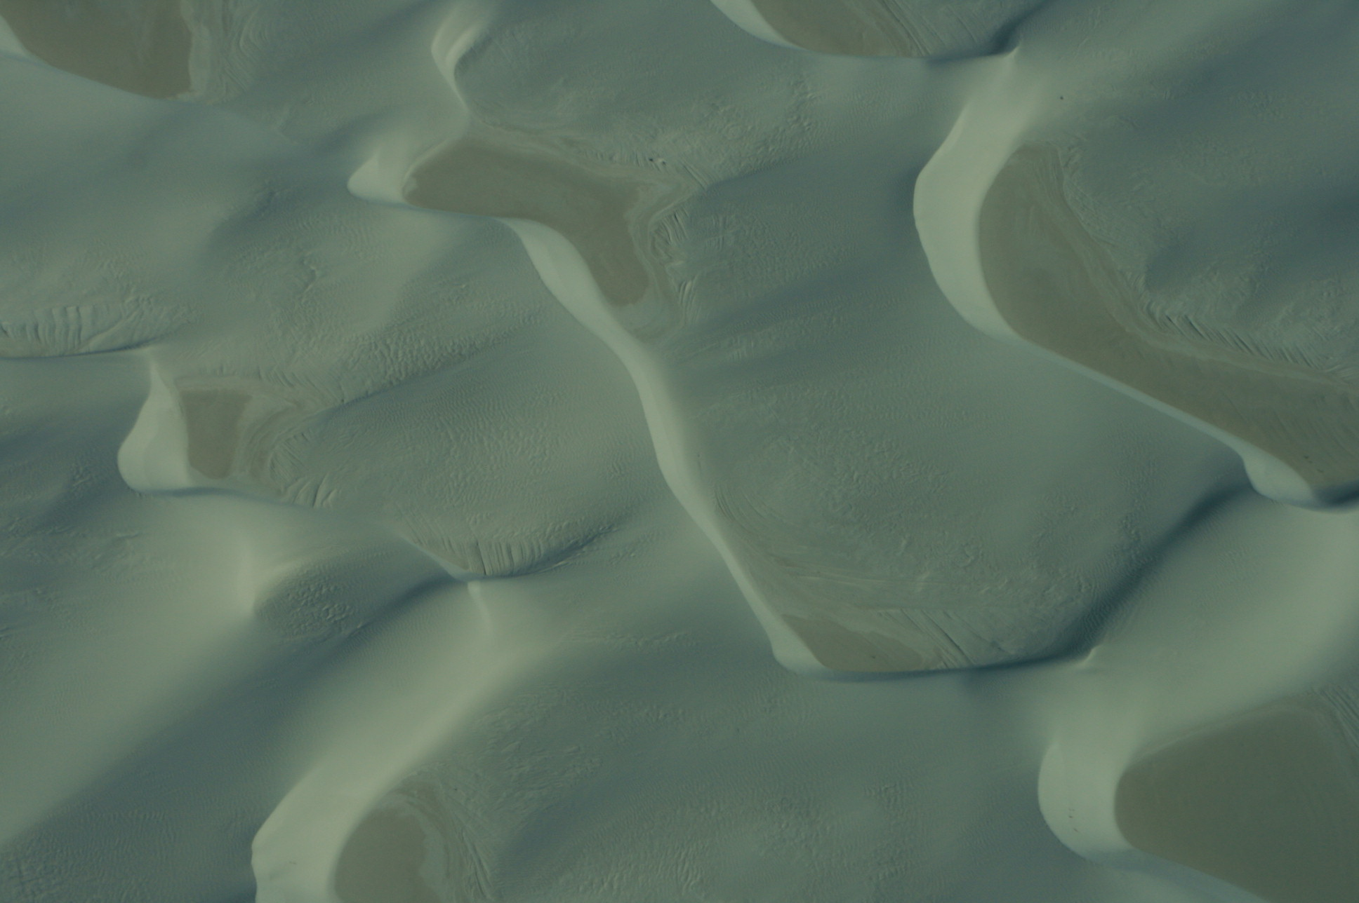
New
deposits
100 m
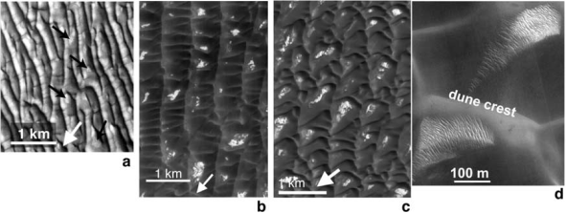
ONLY FIGURE “C” WILL BE INCLUDED
Fig. 1. A) New gypsum sediments formed after groundwater discharge into interdune areas during winter 2006/2007. Field of traverse dunes in WSNM. Photo taken by first author from altitude about 1,500 feet on October 2007. A dark color of interdune areas relsted from higher moisture content; B) Examples of dunes with associated bright patches which may be gypsum [1].

flooding of interdune areas that led to formation of shallow ponds. After the water went down, a thin layer of new gypsum-rich sediments were deposited on the surface of interdune areas (Fig. 1A). Mostly, new sediments consist of fine-grained gypsum re-worked by waves and its further cementation by loss of water due to evaporation. The OUgd inclose bright patches of material in low areas between dune crests (Fig 1B) that in the way of occurance resemble the new deposits observed in WSgd. The bright patches are relatively low in gypsum compared to the dunes themselves but grain-size effect resulted from limitation of the orbiter camera may cover up the real content of gypsum in the interdune areas of OUgd [1].
Dessication of dunes – were manifested by cross-cutting cracks under an angle of 90º after hot summer of 2007 (Fig. 2A). One system of cracks propagated parallel to the cross-bedding originated from dunes migration. The second system of cracks did not follow any sedimentary structures. Some of OUgd have an eroded rather than fresh appearance indicating inactivity and possible induration (Fig. 2B). A close similiratity of the way of cracks propagation between WSgd and OUgd implies a possible important loss of water by OUgd in the past. More advanced incision of

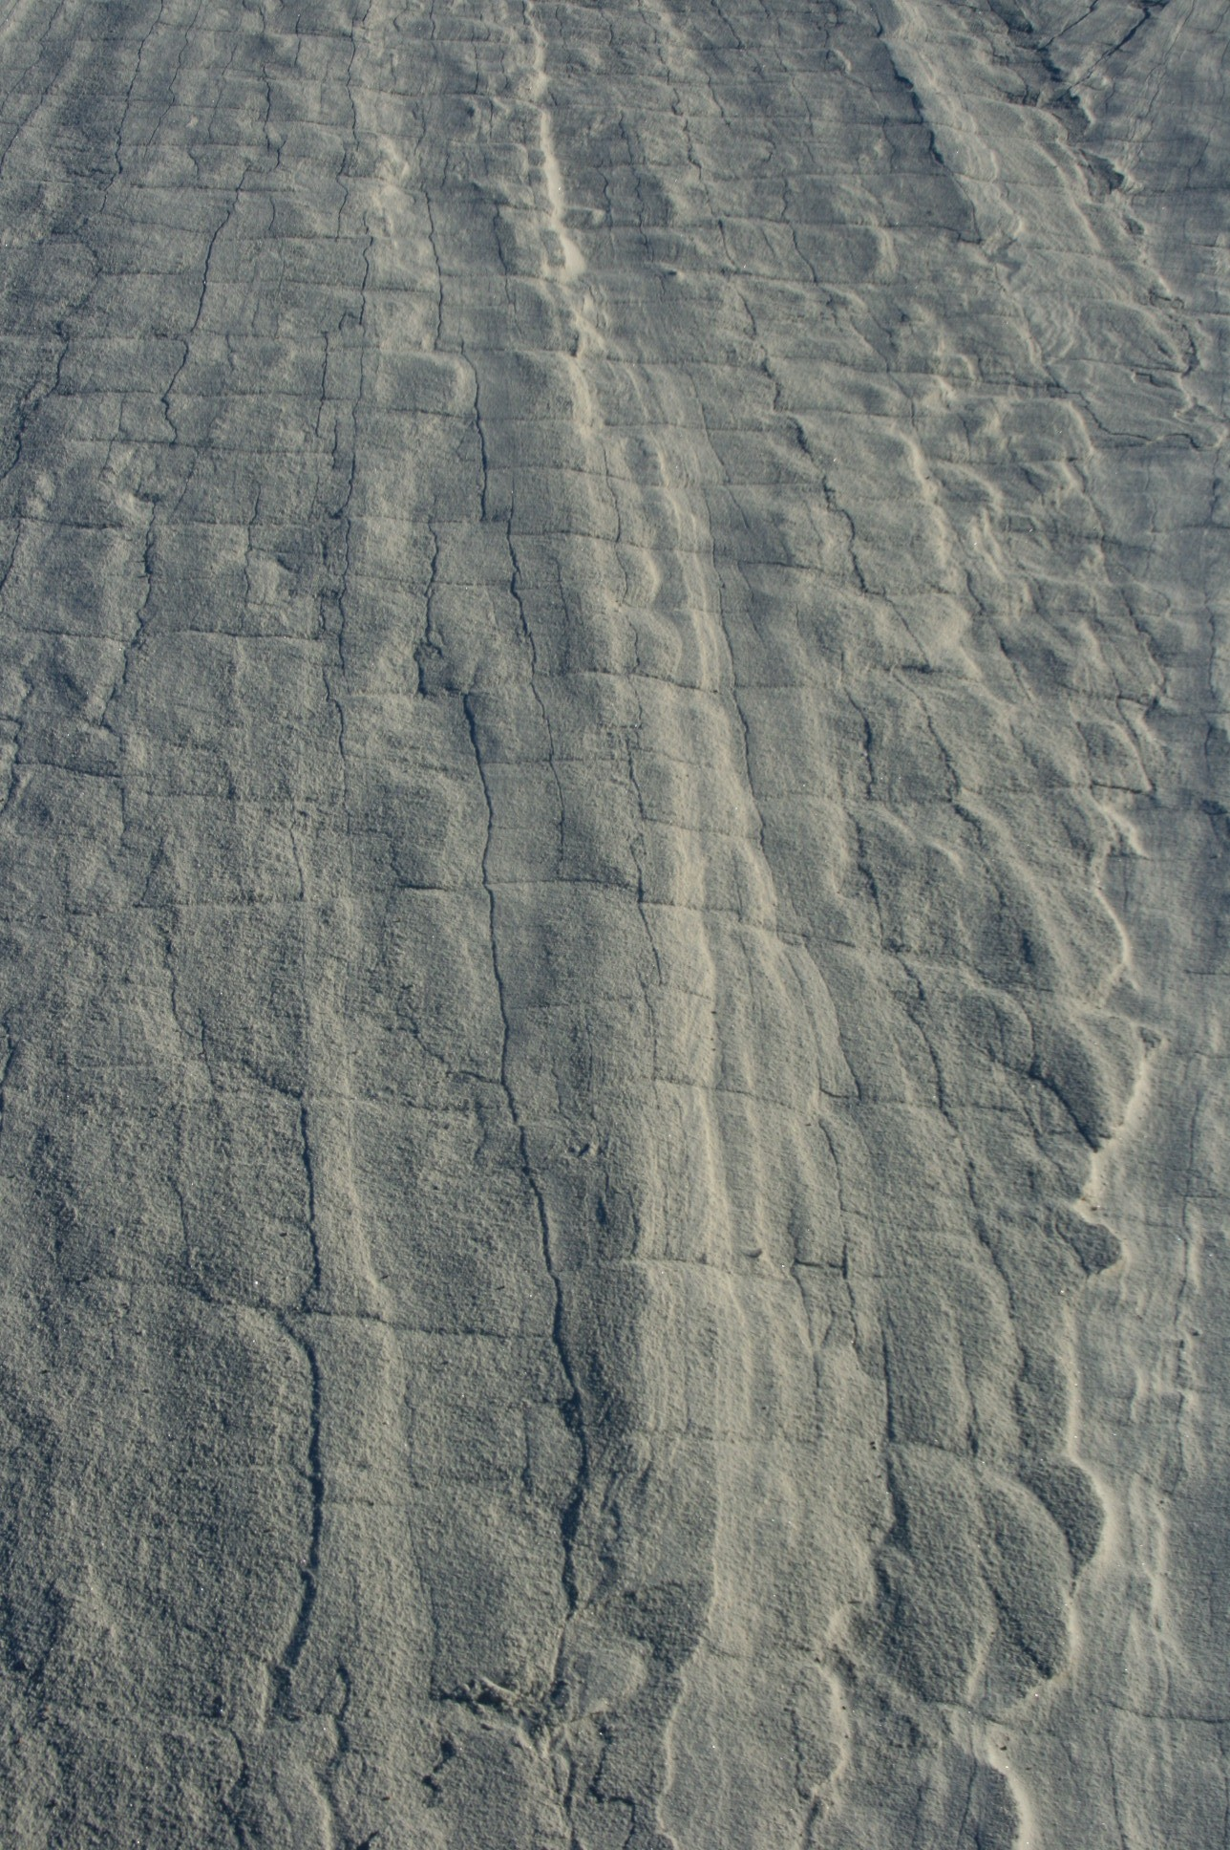  30 cm  A | 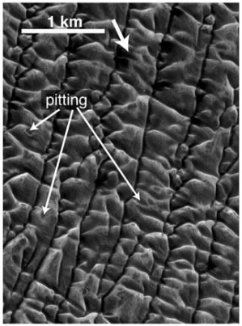  B
Fig. 2. A) cross-cutting cracks formed at dune slopes after summer. Photo taken by first author in the WSNM area of traverse dunes on October 2007; B) examples of eroded and possibly indurated dunes within Olympia Undae [1].

OUgd may have resulted from further eolian erosion rather than surface or groundwater activity.

Conclusions: By analogy to the origin and evolution of WSgd, the reported chemical composition and advanced physical weathering of OUgd on Mars [1] may indicate complex processes taken place under few different climate conditions (episodes). We selected at least two wet episodes and two dry episodes that could have been involved during evolution of OUgd:
- wet condition – deposition of sulfate-rich sediments in the region of meltwater channels mostlikely from precipitation of evaporites from water originated from the Chasma Boreal melting events;
- dry condition – formation of gypsum-rich dunes by eolian deflation of sediments deposited earlier in the region of melting channels;
- wet condition – cementation of dunes by capillary fringe, groundwater discharge or/and another sources of surface water;
- dry condition - desiccation of dunes and formation of cross-cutting cracks; further erosion of dunes through existing cracks mostlikely by wind.

Acknowledgments: This study was supported by the NASA Astrobiology Institute team award directed by L.M. Pratt. Sincerest thanks are due to Parker Bradley and Kevin Dunshee from a Division of Heron Aerospace Corp. in Alamogordo for organizing the flight and permission from the White Sands Missile Range for flying over the dune field of White Sands; to Esther Singer for help in preparation of lake sediments for sulfur isotopic analysis.

References: [1] Fishbaugh K.E. et al. (2007) JGR, 112, E07002. [2] Fishbaugh K.E. et al. (2006) LPSC XXXVII, Abstract#1642. [3] Tanaka (2006) Fourth Mars Polar Polar Science Conference, Abstract#8024. [4] Langevin et al. (2005) Science, 307,1584-1586. [5] Langford R.P. (2003) Quatern Internat, 104, 31-39. [6] Schenk C.J. and Fryberger S.G. (1988) Sediment Geol 55, 109-120.

