Production and Nutritive Value of Orchardgrass Along a Gradient From Open Pasture to Woodland
D.P. Belesky, J. J. Halvorson, J. M. Ruckle and C. M. Feldhake
USDA-ARS, Appalachian Farming Systems Research Center
Beaver, West Virginia



American Society of Agronomy Annual Meeting
10 – 14 November 2002
Indianapolis, Indiana

INTRODUCTION

Environmental heterogeneity associated with the mosaic of land use and terrain patterns on small-scale farms in the Appalachian Region creates spatial and temporal variability in resources. As a consequence, optimal conditions for plant growth vary, and resultant patches in resource availability lead to conditions that influence phytomass production and allocation. Conditions in the W (e.g., high N, low light) and O (e.g., low N, high light) sites, along with repeated defoliation superimposed to represent rotational grazing, created a suite of stresses influencing plant growth.

OBJECTIVE

Determine productivity and nutritive value of orchardgrass grown along a light gradient as part of a silvopastoral system.

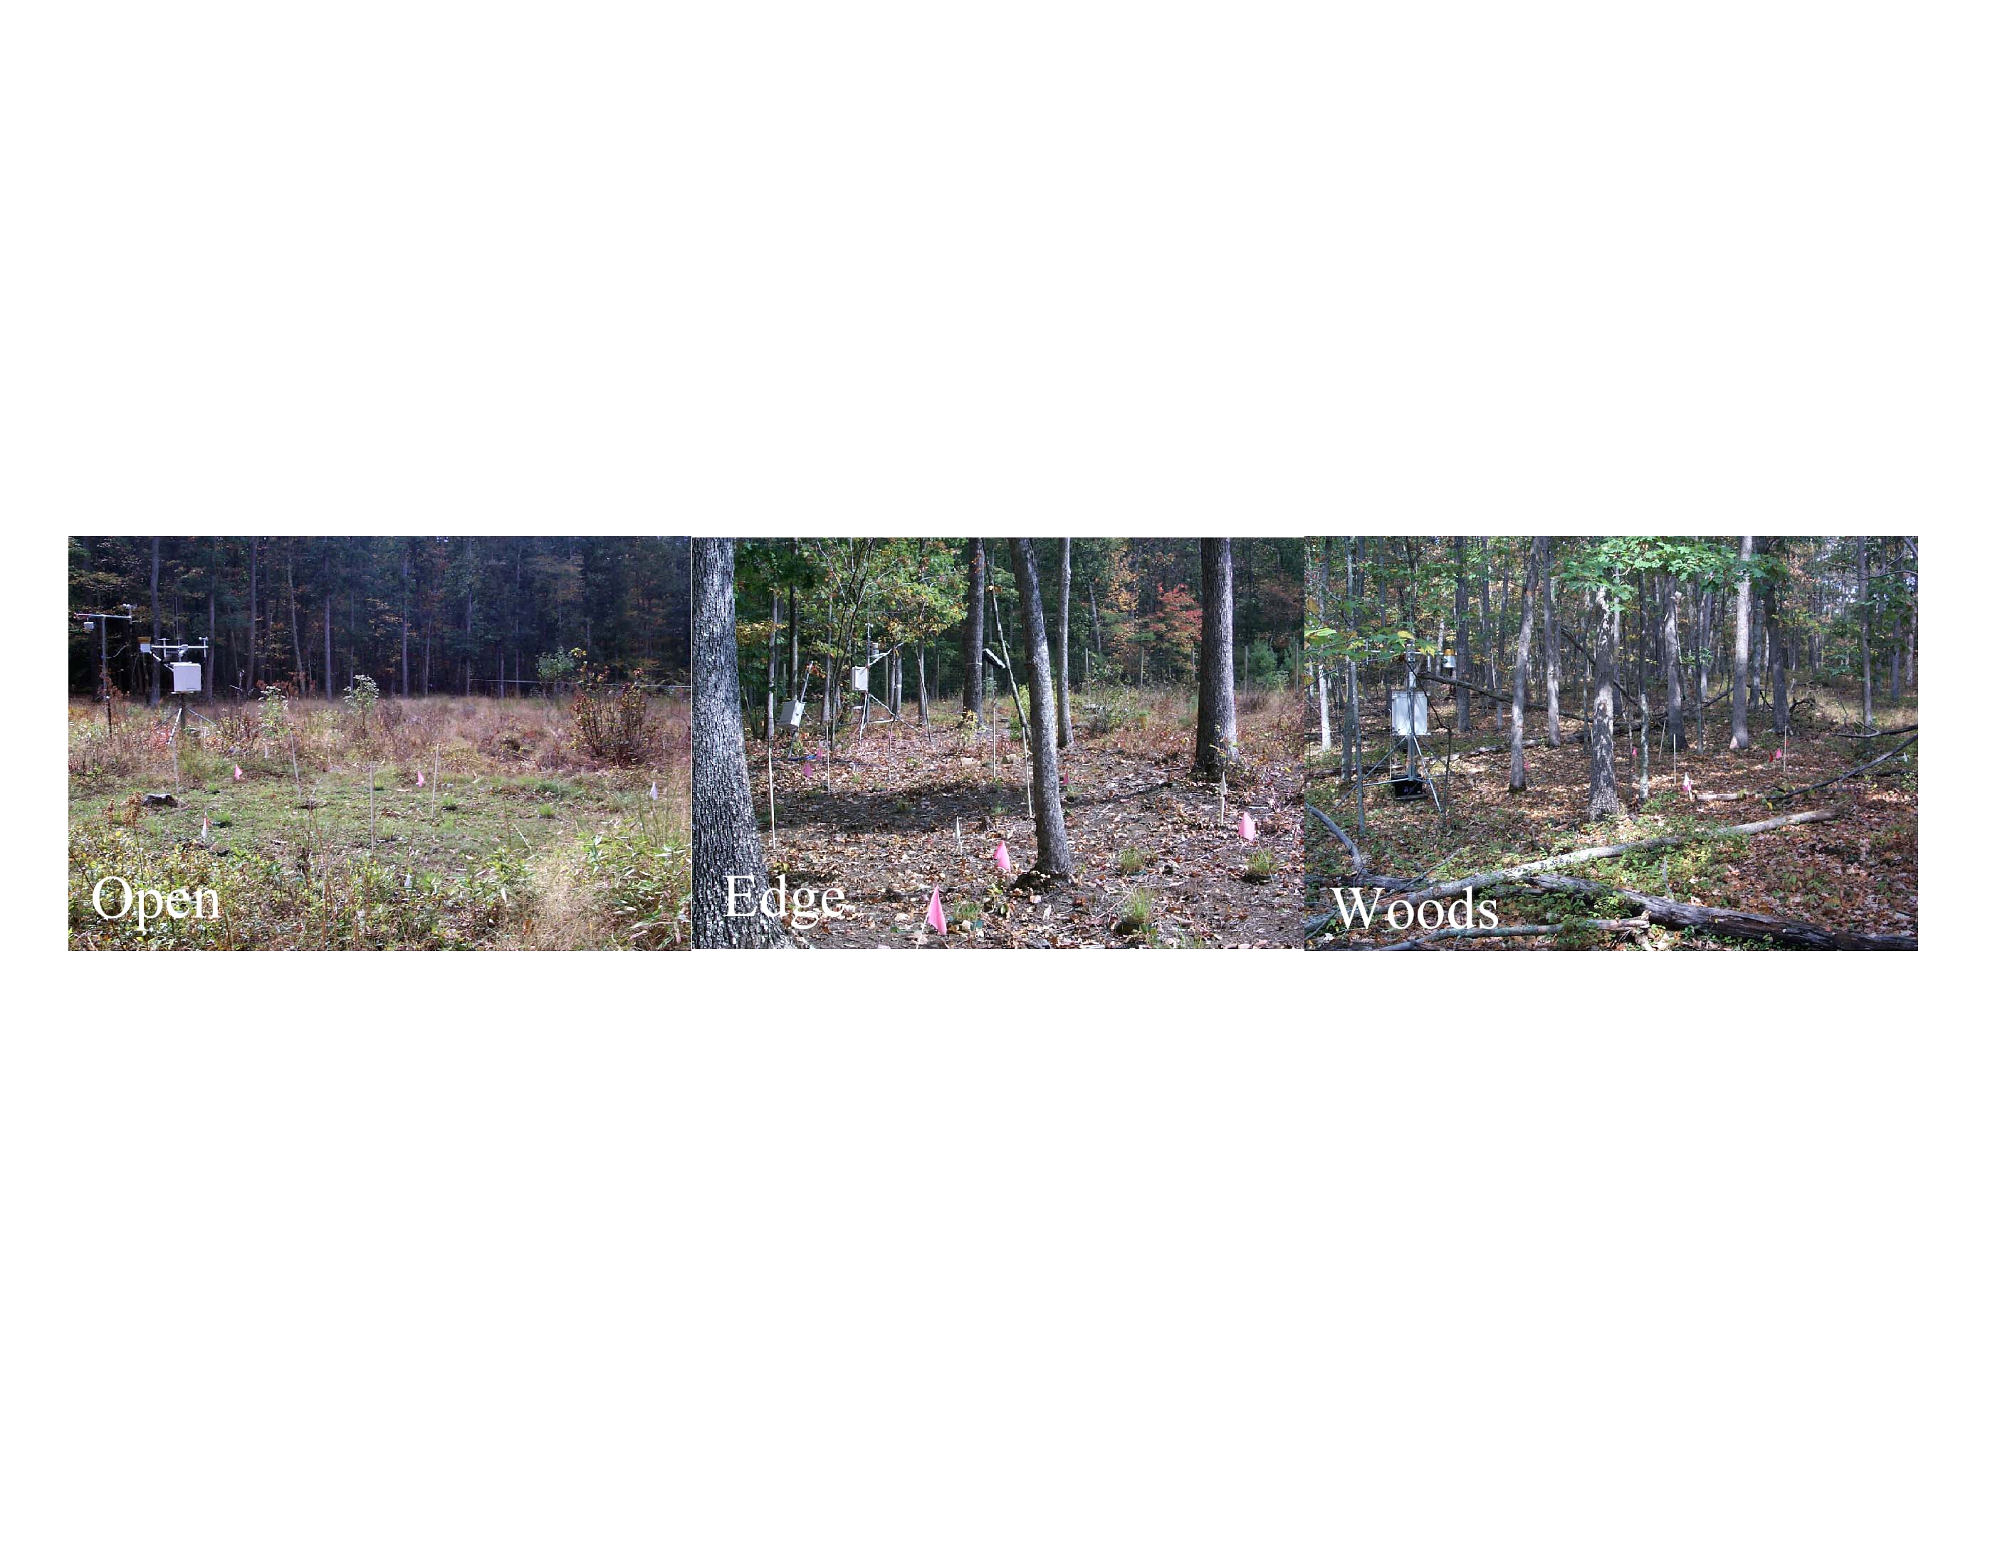

TABLE 1. Representative conditions at each site (growth interval in parentheses).

 |  | OPEN(O) | EDGE _{O} | EDGE _{W} | WOODS (W)
PPFD (mol m⁻²) |  | 4160 (126d) | 1454 (129d) | 823 (77d) | 383 (98d)
ET_{O}† | MAY | 22.4 | 18.3 | 18.3 | 6.3
 | JULY | 47.2 | 11.5 | 11.5 | 2.2
 | AUGUST | 5.4 | 2.7 | 2.7 | 0.3
 | SEPTEMBER | 6.1 | 3.8 | 3.8 | 0.5

† ETO values (mm) calculated according to the Penman-Monteith equation. Monteith, J.L. and M.H. Unsworth. 1990. Principals of environmental physics. 2nd ed. Edward Arnold. London. Calculations include air temperature, wind speed, relative humidity and longitude, latitude and elevation above sea level.

EXPERIMENT DETAILS
Orchardgrass (Dactylis glomerata L.) plants were started in a growth chamber then acclimated out-of-doors for two wk prior to planting at the microsites (Table 1). Nitrogen, P and K was supplied throughout the experiment. Microsites included: W, wooded (undisturbed tree canopy); O, open (cleared of trees) and transitional sites at the edge of the woodland (EW) to open (EO) transition.
Plants at each site were clipped to a 5 cm residue each time mean extended leaf length reached 20 cm. Three replicate pots were harvested (measurements normalized for 15 cm of extended leaf length) each time plants were clipped at a given location. Data included shoot and root fresh and dry mass (DM), leaf area, tiller and leaf number, N, nitrate (NO3) and total nonstructural carbohydrates (TNC). Values are means (on a per tiller basis) of five harvests ± standard error of the mean.
Microsite conditions

Daily mean air temperatures were similar among sites, but daily mean soil temperatures (5 cm depth) were lower at W than other sites (data not shown). Soil temperatures were highest at the O site early in the season and highest at E sites in mid August, and were associated with daily maximum soil temperatures. Volumetric soil moisture varied at the W site and declined across the growing season, and varied less and was greater at the O than W site. Benefits of shade on forage growth (e.g., lower evapotranspiration) may be offset by competition for water occurring between forages and trees.

DRY MATTER PRODUCTION

DRY MASS

Whole plant mass declined (38%) as light attenuation increased from the O to the W site.

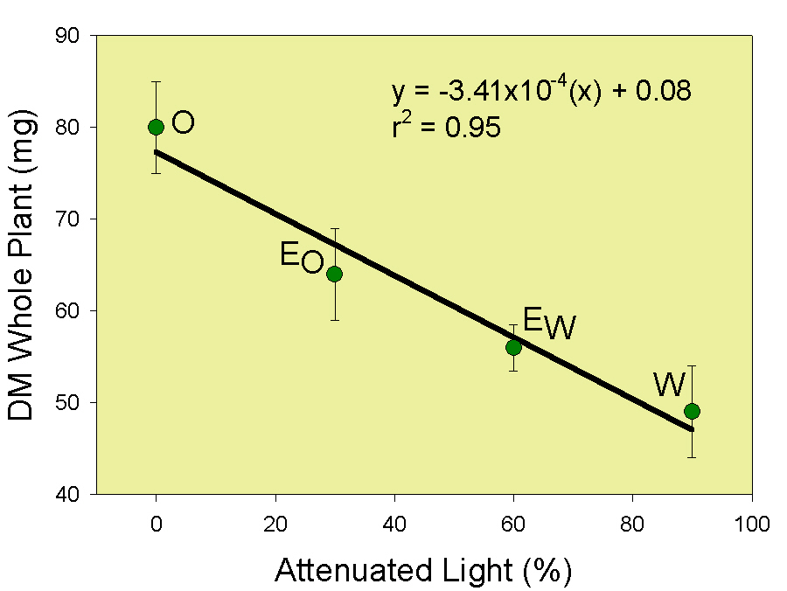

DRY MATTER ALLOCATION

EO and EW sites produced 30% more shoot per unit of root than O or W. E site plants adjust to light limitation with increased shoot growth. W site plants have few large leaves and few tillers yet shoot relative to root mass was similar to O site plants.
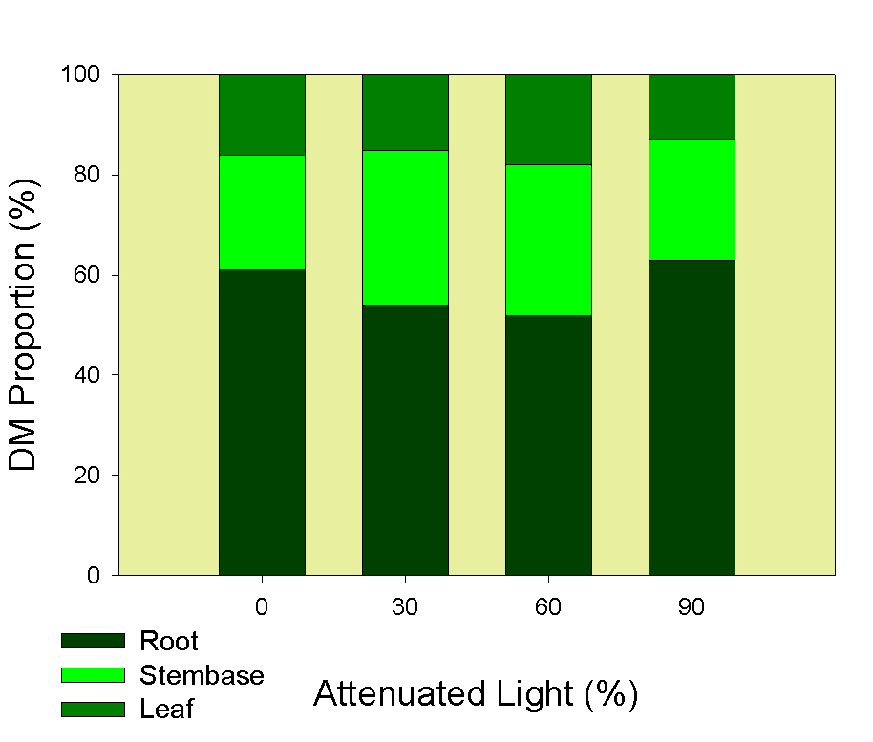

TILLER LOSS

Tiller loss rate in W was twice that of O sites and tiller number was 61% greater in O than W. Orchardgrass plant and stand longevity in W sites is compromised by low tiller production and a high loss rate.

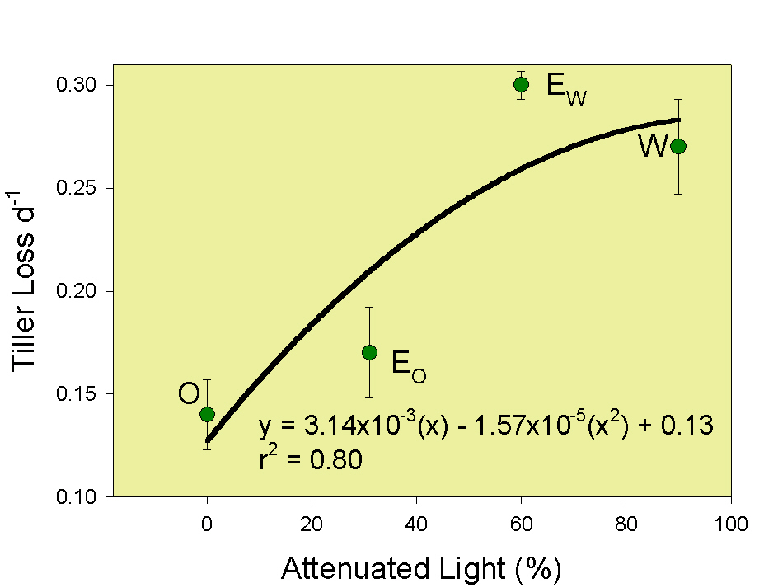

DISTRIBUTION AND RATE OF PRODUCTION

Growth intervals, based upon the time required to reach 20 cm of average canopy height varied among sites, and were 126d at the O and only 98d at the W site. Gompertz growth curves of cumulative yields show O sites producing more shoot and root over more of the growing season than W or E sites.
Shoot regrowth was rapid in W and EW sites (fast-growers) early in the growing season. Maximum shoot growth rates, based on instantaneous growth rates (IGR), occurred 35 d later in the O (slow) than W (fast-grower) site.
Maximum root growth rates occurred 49 d later in the O than W site. The EO and EW sites achieved maximum growth early in the growing season and were similar to those for the W site.

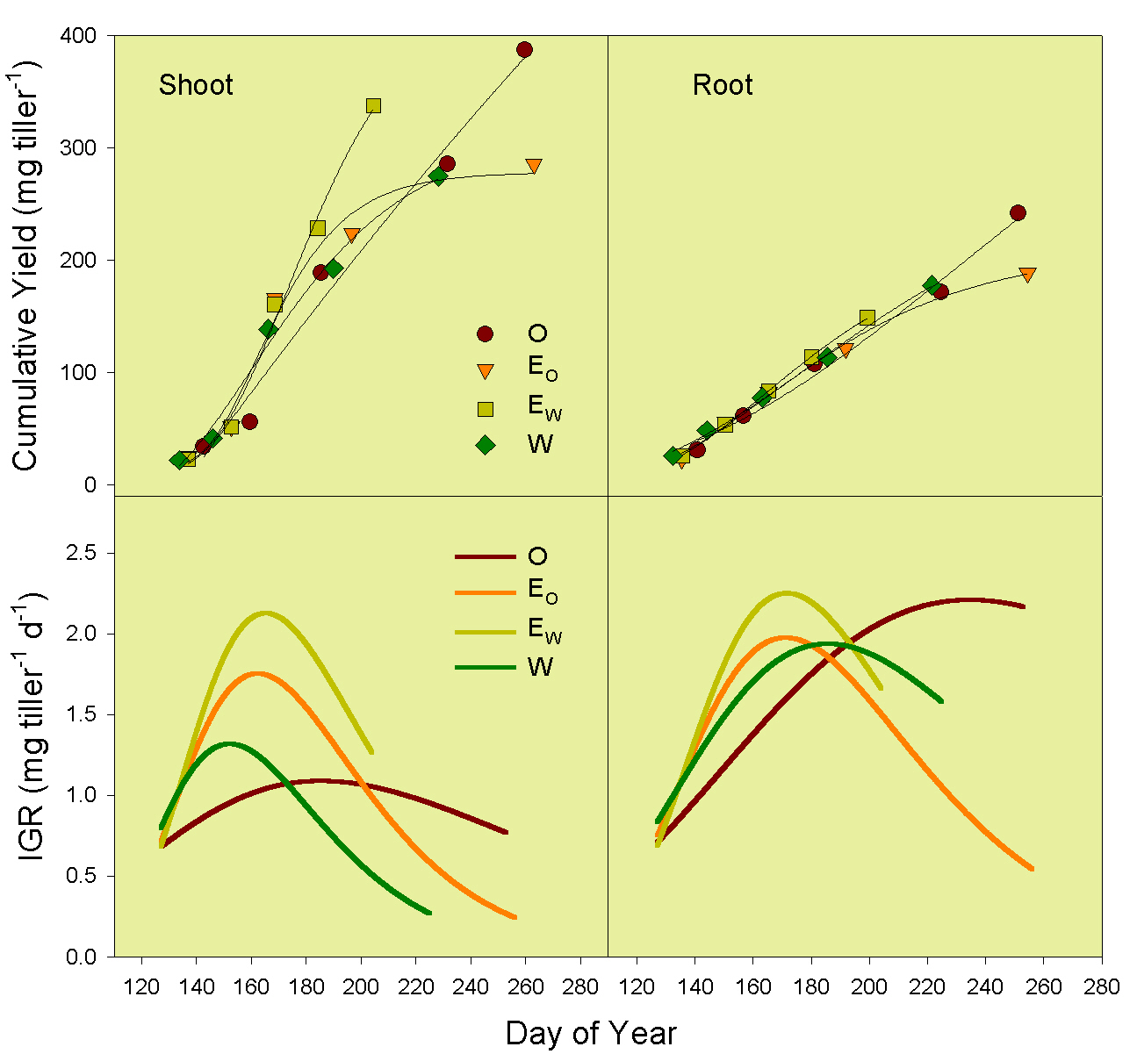

PRODUCTION MECHANISMS

Relative regrowth rate (RGR) calculated as: RGR = NAR * LMR * (1/DMCL) * AL/MFL includes morphological and physiological attributes of RGR. RGR was inversely associated with whole plant mass, and as such regrowth rates of W were greater than O plant rates.
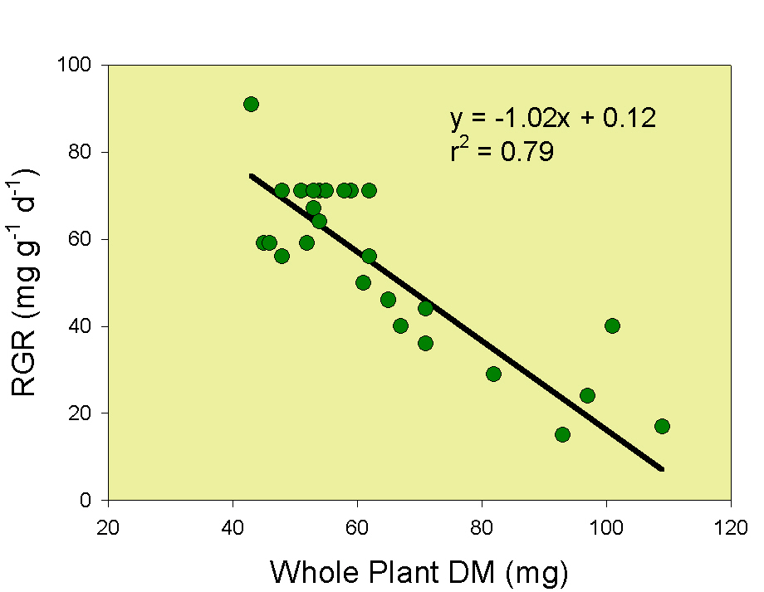

Specific leaf area (SLA) increased as light attenuation increased. SLA was greater in the W than O site illustrating morphological adaptation to low light conditions and contributed to greater RGR in W. Leaf DM content was less in W compared to O plants (data not shown).

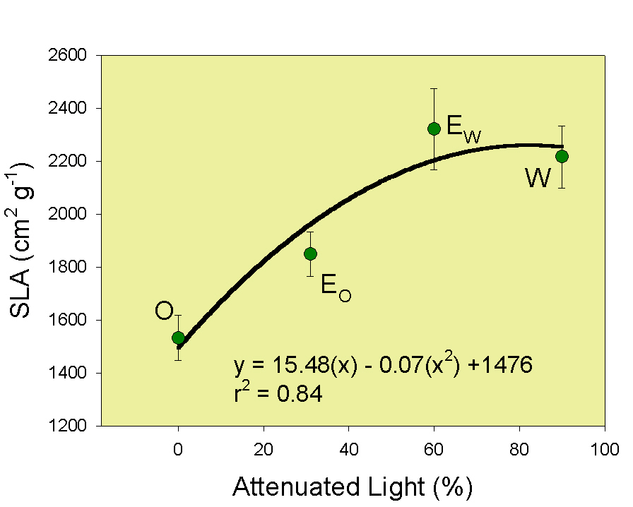

Abundance of TNC in shoots exceeded CHO assimilatory capacity of N-limited plant at the O site, whereas at the W site plants had very little TNC and excess N. W plants were unable to generate leaves and tillers.

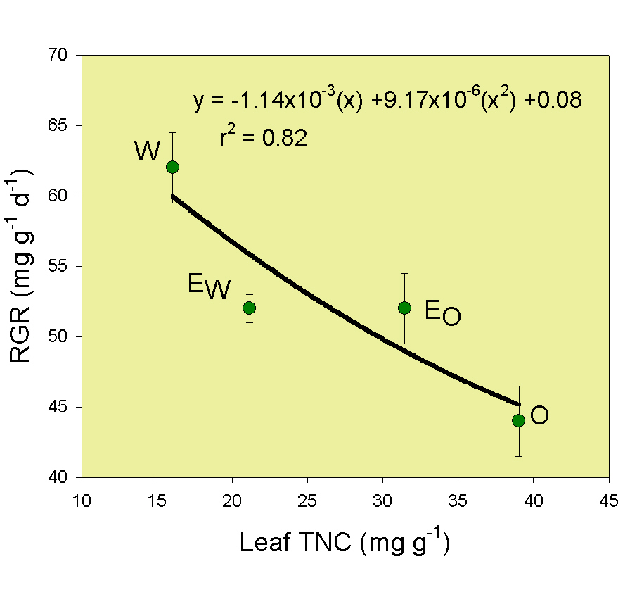

Photosynthetic N use efficiency (PNUE; whole plant DM / mol leaf N / Δ time) decreased 43% as light attenuation increased, leading to greater herbage production at high light and relatively low N (O) compared to low light and high N conditions in W. [See Hirose and Bazzaz (1998. Ann. Bot. 82:195-202) for further interpretation of PNUE.]

PNUE and TNC are linearly and positively related. PNUE corresponds with TNC concentrations and the ability to generate TNC reserves. Relationship suggests strong light use efficiency in W relative to O where excess TNC accumulates and additional tissue development is retarded by insufficient N.
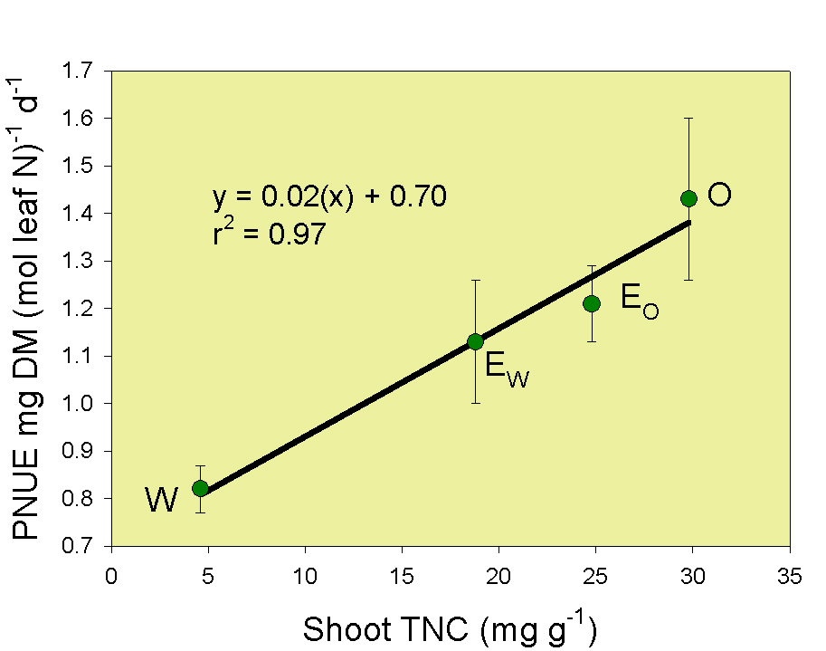

INCREASED SHADE WAS ASSOCIATED WITH:

LESS EVAPOTRANSPIRATION
SMALLER PLANTS
FEWER TILLERS
GREATER TILLER LOSS
LARGE, THIN LEAVES

SHORTER GROWTH INTERVAL

GREATER RGR
LOWER PNUE
NUTRITIVE VALUE

TNC declined five-fold in stembases (where TNC is localized in cool-temperate origin grasses) as light decreased, and was five times greater in stembases than leaves at all sites (data not shown).

Leaf N increased as light decreased. N concentration was greatest in W and least in O site plants.

Nitrate increased about 10-fold as light decreased. Concentrations were very low for plants grown at O and EO all season. Nitrate concentrations in EW and W plants could be deleterious to grazing livestock health.

The ratio of TNC:Protein in leaves suggests that nutritive value and energy declines as light attenuation increases.

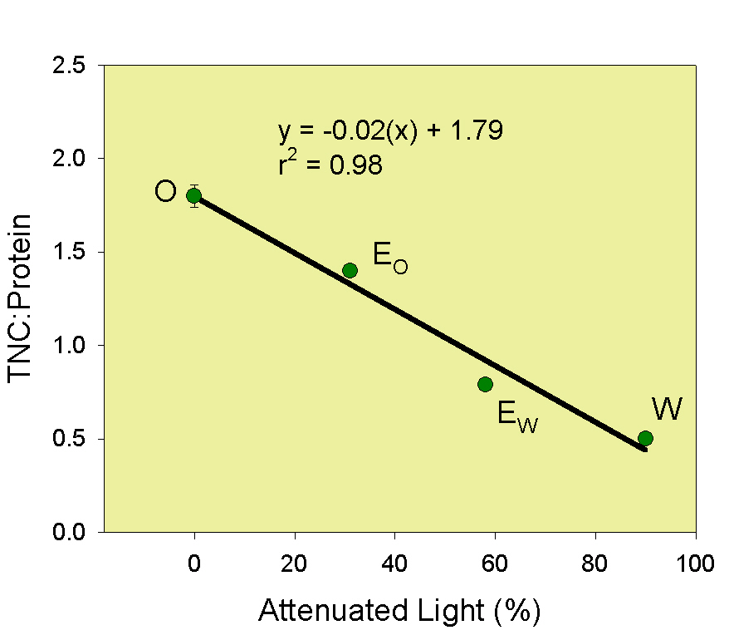

Metabolizable energy (ME), based on digestibility of herbage organic matter, was less in W than O plants, probably because of less herbage energy.

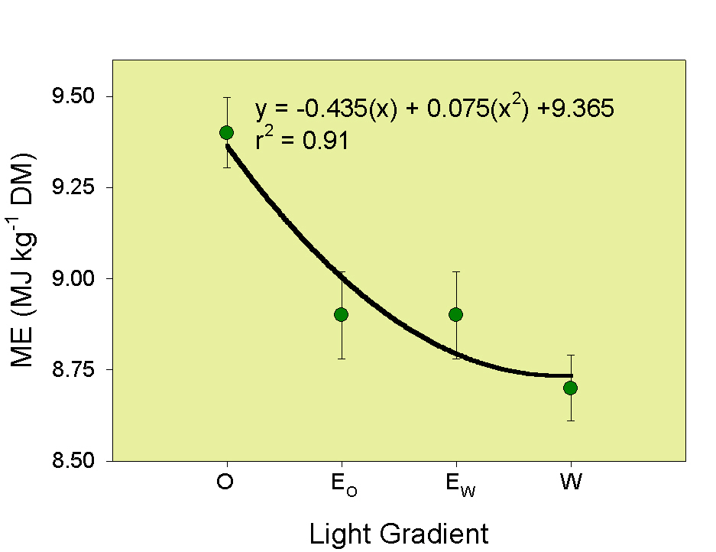

INCREASED SHADE LEADS TO:

LESS DRY MATTER
MORE N
MORE NO3
LESS PROTEIN YIELD
LESS TNC
LOWER TNC:PROTEIN RATIO
LOWER METABOLIZABLE ENERGY

SUMMARY & INTERPRETATION
• Maximum shoot and root DM production occurred earlier in W and E than in O sites, providing some additional early season herbage but compromising season-long production within shaded sites.

• Lower DM yield in W compared to O sites suggests that decreased production should be compensated for with increased land area allocated to the shaded component of silvopastoral systems.

• Plant growth (based on the time to make five harvests at 20 cm mean canopy height) was slower at the O (126d) than the W (98d) site. Management decisions based on sward height alone may be inappropriate for forage growing in shaded sites, since leaf elongation is a means to increase light acquisition (shade avoidance) and not an index of productivity in shade.

• Tiller loss rate was greatest at the W and least at the O site, whereas tiller number was the opposite leading to relatively rapid stand loss in heavily shaded sites.

• Shoot:root ratios reflect limited resources; N in O and light in W sites. Plants in the O site allocated more resources to roots, whereas W site plants had only a few large leaves and a small root system. The ratios were similar but plant mass was not.
•Plants growing in O sites used light less efficiently (based on PNUE values) than did plants in W sites, which is reflected in relatively high TNC concentrations and lower RGR in O compared to W sites. TNC data suggest that energy is insufficient for leaf regrowth and tiller initiation at the W site.

• Plants from heavily shaded (W) sites have lower energy and excess N in terms of nutritive value for grazing livestock. Low TNC is associated with low preference by the grazer, suggesting that herbage acceptance and nutritive value would be low at the W site.

• Herbage production and nutritive value at EO (~ 30% light attenuation) were comparable to the O site and agree with findings reported by Devkota et al. (1998. Proc. Agron. Soc. N.Z. 28:129-135.) for temperate silvopastoral systems in New Zealand.

• Our findings establish the suitability of orchardgrass as an understorey forage crop for Appalachian hardwood (Quercus sp.) silvopastoral systems.

Acknowledgements
We thank M. L. Huffman for technical assistance with sample collection and microsite environmental condition monitoring and Mr. K.N. Harless for in vitro digestibility analyses. For additional information contact D. P. Belesky at 304.256.2841 or dbelesky@afsrc.ars.usda.gov.

