Assurance Process Mapping

J. Steven Newman, D.Sc. ⁽¹⁾, Stephen M. Wander, M.E.A. ⁽²⁾, Don Vecellio, B.S.M.E. ⁽³⁾

⁽¹⁾ NASA Headquarters, 300 E Street SW, Washington, D.C. 20546 USA, Email: j.s.newman@nasa.gov
⁽²⁾ NASA Headquarters, 300 E Street SW, Washington, D.C. 20546 USA, Email: stephen.m.wander@nasa.gov
⁽³⁾ ARES Corporation, 201 12th Street South, Ste. 601, Arlington, VA 22202 USA, Email: dvecellio@arescorporation.com

ABSTRACT

Assurance Process (AP) Mapping is a means to graphically depict the multi-dimensional assurance processes implemented on organizationally complex NASA aerospace programs. AP Mapping helps to better understand and manage program/project complexity, particularly as it relates to managing key assurance activities and functions. Ultimately, the AP Map assists decision makers by providing knowledge of the governing assurance requirements, a baseline understanding of the assurance processes implemented on the program, and visibility into their implementation.

NASA and international space programs often involve multiple: development and implementation phases; project elements; flight elements; contractors; subcontractors; governments; and governmental agencies. Assurance processes must be implemented throughout the program lifecycle and across all levels of the program organization. Supporting this lifecycle framework are a myriad of “assurance agents,” individuals accountable for implementation of governing assurance requirements and the organizations that review them, each with some element of the overall assurance picture.

This paper provides a high-level tutorial and examples of the AP-Mapping protocol and graphical techniques that have been most recently applied to the Space Shuttle Program in preparation for Return to Flight.

- INTRODUCTION

Assurance Process (AP) Mapping is a methodology developed in the mid 1990’s by J.S. Newman and S.M. Wander as a means to graphically depict the multi-dimensional assurance processes implemented on organizationally complex NASA programs and projects. AP Mapping is a means to better understand and manage complexity in two key ways:

First, as a management tool to identify gaps in assurance coverage and accountability and provide a basis for resource requirements definition and justification. Second, as a communication tool to provide a quick and effective means of communicating the overall safety and mission assurance (SMA) function to program management, NASA Center management, the Mission Directorate, and, ultimately, the Chief Safety and Mission Assurance Officer.

"A wonderful harmony arises from joining together the seemingly unconnected."
– Heraclitus c.500 BC

Early analyses were performed for the X-33, X-34, X-37, Quiksat, FUSE, and NASA ELV programs. Over the past five years the methodology has evolved from an art toward a science. Most recently, AP Mapping has played a key role in NASA Review and Assessment Division (RAD) Programmatic Audit and Review activity, and it has been further refined by the authors in partnership with RAD support contractors from the ARES Corporation.

This paper provides a high-level tutorial and examples of the AP Mapping protocol and graphical techniques that have been recently applied to the Space Shuttle Program in preparation for Return-to-Flight. The paper also explores the advantages of an enhanced electronic AP Map compared to the inherent limitations of a two-dimensional or paper copy AP Map. Electronic or e-Map features can include hyper-links and pull-down menus. The concept of building layers, each representing a unique dimension or aspect of the overall assurance picture, is also explored along with the challenges of implementing a composite AP Map.

- THE ASSURANCE IMPERATIVE

The AP Map was originally developed as a tool to assist and enable the effective management of assurance responsibilities, i.e., “corporate due diligence,” that compel managers (by law and by good practice) to acquire knowledge of the governing assurance requirements, to develop a baseline understanding of the assurance processes implemented on the program, and to gain visibility into their implementation. Principle beneficiaries of AP Mapping and analysis include safety and mission assurance managers, independent assessment bodies such as the US Government Accounting Office (GAO), the Agency Inspector General, and special “blue ribbon” investigation teams. The most important customer, however, is the program or project manager who can employ the AP Mapping process as a program life-cycle management tool to assist in ensuring the integration and effectiveness of the overall mission assurance network. Ideally, the program manager and the entire program management team would collaboratively develop the map and matrix establishing shared ownership.

- BENEFITS OF ASSURANCE PROCESS (AP) MAPPING

AP Mapping establishes the goal of assembling the integrated or holistic view of the totality of assurance activities within a program/project. An immediate benefit of the AP Mapping process is the ability to see and understand key SMA roles, responsibilities, and interrelationships. In summary it:
- Provides management a systems view of the assurance net,
- Provides a formalized structure of program SMA complexities and actively tracks changing participants and responsibilities,
- Facilitates implementation of mission assurance processes,
- Identifies potential gaps in assurance coverage and accountability,
- Provides program management with the basis for resource adjustments,
- Provides critical and reusable background information for independent assessment and review teams (e.g., Corporate, ASAP, IG, GAO),
- Facilitates communication between levels of program management,
- Provides rapid insight to the most crucial assurance activities, and
- Provides basis for management to support major operations and launch decisions.

- THE COMPLEX, MULTI-VARIATE ENGINEERING MANAGEMENT ENVIRONMENT

Every flight or operational element and every program phase has a set of governing assurance requirements with specific organizations and individuals accountable for implementation. Organizational complexity within a given program (in-line reporting, matrixed reporting relationships), multiple government and/or commercial entities, multiple communication interfaces, and geographical dispersion are all factors that complicate understanding and management of the overall assurance effort.

NASA and international space programs are typically comprised of multiple flight elements including the booster, spacecraft, and payload of scientific instruments, or human occupants. Space programs and missions are also multi-phase, with the need to implement life-cycle assurance processes beginning in conceptual design, advancing through critical design, into design verification testing and analysis, manufacturing and manufacturing verification, leading to integrated systems test and operation. System elements are typically integrated at the launch site where hazardous processing and final test & check-out occur. Once on-orbit, another set of organizations and processes engage in the tasks of safely conducting and managing on-orbit operations. Finally, end-of-life mission operations require other assurance organ-izations to minimize orbital debris and ensure public safety during any planned or unplanned re-entry phase.

Within this life-cycle framework there exists a myriad of “assurance agents,” individuals, and reviewing organizations responsible for some element(s) of the overall assurance picture. Examples include quality assurance inspectors embedded with the prime contractor; government inspectors conducting safety critical inspections; assurance process oversight by the program manager; installation or NASA Center-based assurance oversight of the program; independent agency-level assurance oversight of NASA Centers and installations; engineering oversight of program safety-related decisions; Agency, Center, and program level reviews; and outside independent assessment teams such as NASA’s Aerospace Safety Assurance Panel.

- ASSURANCE PROCESS (AP) MAPPING DIMENSIONS AND VARIABLES

The AP Map is typically supported by an associated AP Matrix and AP Directory. The Matrix allows presentation of detailed assurance process descriptions while the Directory provides specific assurance agent affiliation and contact information. The collective of the map, matrix, and directory capture information and knowledge that can be indexed to the variables described below:

  - Program Phase

Recent AP Mapping experience has demonstrated the need for establishing program phase-dependent AP Maps. Programs typically span three to six years and evolve through the classic systems engineering life-cycle. The network of assurance agents will vary as a program progresses from requirements definition to design, to manufacturing, test, integration, operations, sustaining engineering and finally retirement. Thus the AP Mapping process provides an ideal tool for managing the dynamic nature of the SMA function as it evolves over the various program/project development stages.

  - Design / Implementation Activity

Differentiation of design and implementation activities for both hardware and software is important. NASA programs typically employ different assurance agents (and/or assurance organizations) operating in these two arenas. A rigorous and complete AP-Map and matrix will ensure inclusion of both hardware and software design, test, and integration activities.

  - Governing SMA Policies, Procedures and Requirements

The governing assurance process requirements for a program (usually identified in the AP Matrix) are linked with key assurance processes shown on the AP Map. The set may include Agency policies, procedures, or standards, program assurance requirements documents, and prime contractor process documentation, all of which govern the implementation of program assurance requirements. The AP Map provides a visual affirmation assisting in flow-down analyses undertaken to ensure that assurance process requirements are being implemented. The AP Map also assists programmatic audit and review teams in scoping their reviews and understanding the linkage between policies, require-ments, processes, and practices.

  - Program Organizational Structure

Most of NASA’s aerospace programs are inherently complex. This is particularly true for those that involve multiple NASA Centers, large numbers of contractors, suppliers, and international partners. The baseline AP Map provides the starting point for portraying the interactions of assurance agents with program elements over the program life-cycle for these organizationally complex programs.

  - Agency Headquarters and Center Management Organization Structure

Because NASA programs all exist within Headquarters Mission Directorates and are implemented (typically) at NASA Centers, it is important to also show the appropriate accountability linkages among the Mission Directorate, program management, and Center manage-ment. Likewise, it is important to show linkage between Center SMA organizations and the Headquarters-based Office of Safety and Mission Assurance.

An alternative and/or companion approach to AP-Mapping for depicting organizational accountability was examined in the case of the Space Shuttle Program. This approach involved building an “Assurance Accountability Work Breakdown Structure.” This disciplined outlining process, while potentially useful, quickly became cumbersome requiring seven or more levels of indenture (e.g., 2.1.3.4.5.6.1) to identify the accountability of an individual “assurance agent.”

  - Assurance-Organizations

Multiple assurance organizations and agents are required to interact during a typical program/project life-cycle. AP Mapping for complex programs will invariably require a multi-layer approach in which different independent assurance networks can be represented relative to a program’s basic organizational structure. Examples include the program assurance infrastructure, the prime contractor assurance organizations, the Agency SMA organization, the Center or facility SMA organization, other Federal agency assurance organizations such as the FAA and Department of Defense (supporting range safety), the Department of Energy (supporting nuclear payload safety), other Agency independent assurance groups such as the Software Independent Verification and Validation Facility, the Independent Technical Authority, the NASA Engineering and Safety Center, and the Independent Program Assessment Office (IPAO). Other key assurance agents include the Defense Contract Management Agency (DCMA) and assurance support contractors such as the Aerospace Corporation.

One particularly difficult challenge is to capture or depict “dotted-lined” or matrixed reporting relationships wherein an individual assurance agent “wears two hats,” reporting to an independent or functional organization but accountable to the program manager.

  - In-Line vs. Independent Assurance Activities

Assurance activities are typically characterized as “in-line,” that is belonging to and accountable to the program manager or, more generally, that which exists within the program management chain or organizational hierarchy, versus an “independent” reporting and accountability chain that does not flow through the program manager. In-line assurance activities include the program, project, prime, and sub-tier contractor assurance activities including: assurance planning, risk management, quality assurance, system safety and reliability analyses, verification, inspection, surveillance, and review. Descriptions are also included addressing scope, frequency, and depth of penetration for a given activity. In the case of independent assurance activities, the performing organization’s level or degree of independence can be defined on the basis of funding source, accountability, and/or reporting responsibility. Independent analyses and process review activity are identified with appropriate identification of scope, frequency, and depth of penetration.

  - Assurance Process & Review Forums

Key in-line and independent assurance review forums and boards are also shown on the AP Map. Depending upon which development phase the map represents, one will find a varying combination of boards and review panels. These typically include preliminary requirements review panels, program configuration control boards, system safety review panels, material control board, NASA Center director or program manager reviews, safety and mission assurance reviews, pre-launch operational review forums, or mission management team meetings.

  - Information Flow

An important dimension in the AP Map is the flow of information between assurance agents or organizations and the myriad of assurance forums. Information channels are shown between all elements on the AP Map, both in-line and independent.

- CREATING AN AP MAP

The AP Map is intended to be used as a one-page, graphical “roadmap” to help understand the SMA “what,” “how,” and “who” of the program/project.

  - Key AP Map Elements

Key elements of the map include the “documents,” the “boxes,” and the “arrows” (see Table 1).

Table 1. Key AP Map Elements
The “Documents” | - Top-level or Governing Documentation  - Policies  - Requirements
The  “Boxes” | - Basic Organizational Structures  - Program  - SMA
The  “Arrows” | - Key Interrelationships  - Flow of information  - Reporting and accountability  - Activity

  - Constructing an AP Map

Steps to follow in constructing map:

1. Lay out a top-down map structure depicting management organizations, followed by implementing organizations, and then flight or operational elements (e.g., orbiter, external tank, solid rocket booster, etc.)
2. List contracts and applicable assurance requirements, and identify management hierarchies, reporting accountabilities (in-line and matrixed), and flow of information.
3. Identify assurance agents on the map.
4. Enter numerically-indexed assurance “vectors” or activity arrows flowing from assurance agents to flight/operational elements or other recipients of assurance processes.
5. Enter detailed descriptions of assurance vectors into the AP Matrix to define the breadth and frequency of the activity, the depth of penetration, and the degree of independence.

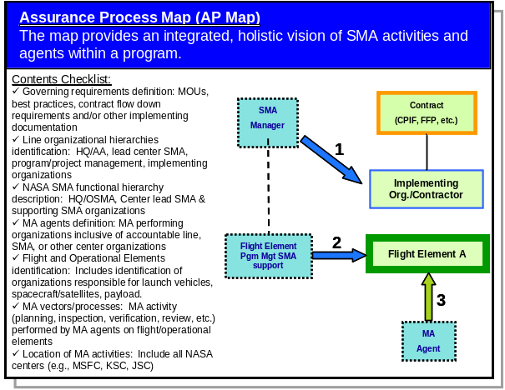

Figure 1. AP Map Checklist

Ultimately, the design layout and content of the map is driven by the life-cycle phased information contained in the AP Matrix. The overall AP analysis package should contain the map, matrix, and a directory (i.e., an assurance agent “Yellow Pages” with names and contact information).

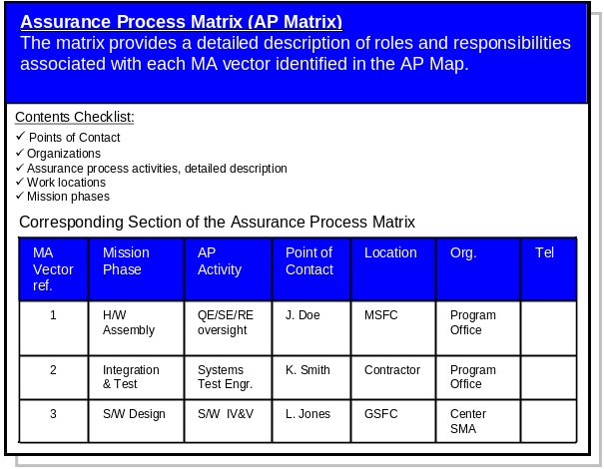

Figure 2. AP Matrix Checklist

  - Mapping Protocol

AP Maps draw heavily on several general graphical principles advocated by Tufte, including presentation of information adjacent in space as opposed to stacked in time. As a result, AP Maps are designed to be content-dense and contextually rich while striving to provide a 40,000-foot overview on a single chart.

This represents a significant challenge if the goal is to construct a two-dimensional map on paper in black and white. However, the addition of color to the map to indicate function (e.g., use of blue shading for in-line assurance activities/agents, use of yellow shading for independent assurance activities/agents, etc.), and the use of symbol and lines/arrows to indicate basic organizational structure and various types of interrelationships, can significantly increase the amount of information conveyed on a single page. In addition, the judicious use of numbering schemes can further alleviate clutter on the map. The following guidelines are proposed to achieve these goals:

- Use solid lines without arrowheads to indicate direct reporting (performance appraisal test) relationships.
- Use dashed lines without arrowheads to indicate organizationally-matrixed reporting relationships
- Use dotted lines with small arrowheads to represent information flow (Information flow from assurance players to the assurance forums creating KUV).
- Use block arrows to represent assurance vectors.
- Establish a color scheme (both line color and shading) to represent the different players on the map.
- Show reporting and information flow lines using the same color of the source of information.
- Use muted, pastel hues for shading whenever possible to reduce “graphical glare.” Consider using 5% gray or 5% color shading area fills.
- Use solid, single lined boxes for organizational entities.
- Use solid, double-lined boxes for operational elements (e.g., orbiter, external tank, solid rocket booster, etc.)
- Consider selectively using box outlines to show emphasis.
- Where possible, use numbers to link boxes or activities on the map and show relationships, thereby eliminating lines and reducing clutter. For example, the box for an assurance agent managed by 2.3 Review and Assessment Division box would be indexed 2.3.1.
- When possible, link number schemes on the map to the AP Matrix.

TEXT
In-line assurance organization / agent
TEXT
Independent assurance organization / agent
TEXT
Reviews, boards, or panels
Direct reporting relationship
Matrix reporting relationship

Information Flow
TEXT
Flight or operational element
Assurance vector (flows from assurance agent to entity where activity occurs)
Symbol/Color
Description
TEXT
Management or program organization box
Figure 3. Proposed Legend for AP Maps

Perhaps the most important guideline: follow these guidelines when at all possible, but remain flexible enough to adapt your AP Map and Matrix for the situation at hand.

- EXAMPLE AP MAP

Although a complete description of AP Mapping and a thorough understanding of the NASA assurance roles and responsibilities are beyond the scope of this paper (a short course could be dedicated to these topics alone), a representative AP Map for the Space Shuttle Program (SSP) is shown in Fig 4.

As an example of the benefit of such a map, it can be seen in the lower right hand corner of Fig. 4 that for the SSP External Tank (ET) element at Marshall Space Flight Center (MFSC), the ET Change Control Board (CCB) provides information (see green dotted line to left) to MSFC Engineering Risk Review Panel (MERRP), which in turns provides information to the MSFC CCB. The MSFC CCB provides information to the Program Management Council (PMC), which flows information for non-integrated hazards (i.e., hazards that do not affect more than one Shuttle element) to the Program Requirements Change Board. This flow of information, for example, provides critical insight to all waivers associated with safety and technical requirements associated safe and reliable operation of the Shuttle ET element to the Shuttle Program Manager, along with the Chief Engineer’s Independent Technical Authority (ITA) Technical Warrant Holders (TWHs) for the Shuttle, who participate in the PRCB. Based on this activity, the Shuttle Program Manager is an informed participant in the Shuttle Flight Readiness Review and is ultimately one of the individual signatories for the Certificate of Flight Readiness (CoFR).

Similarly, beginning in the lower right hand corner of Fig. 1, it can be seen that the MSFC Project SMA personnel for the ET (Ciancola) reports to the MSFC SSP SMA Manager (Dumbacher), who in turn reports to the MSFC Center SMA Director (Davis). While each of the Center SMA Directors is a direct report to their respective Center Directors, they are also matrixed to the program SMA Manager (Wilcutt). Therefore, the MSFC Center SMA Director (along with the Center SMA Directors for Kennedy Space Center (KSC), Johnson Space Center (JSC), and Stennis Space Center (SSC)), provides information (see blue dotted line to right) on the health of NASA Center SSP SMA activities directly to the SSP SMA Manager, who in turn provides information to the Chief Safety and Mission Assurance Officer (O’Connor) through participation in the SMA Readiness Review (SMARR). Based on this activity, the Chief SMA Officer is an informed participant in the Shuttle Flight Readiness Review and is ultimately one of the individual signatories for the Certificate of Flight Readiness (CoFR).

These are only two examples of the overall Shuttle Assurance Process providing independent and in-line SMA activities and reports in support of the SSP FRR and CoFR. Further details (e.g., description, key point-of-contact information, etc.) for all critical flows of SMA information and activities are provided in a SSP AP matrix, sample rows of which are provided as an example in Table 2.

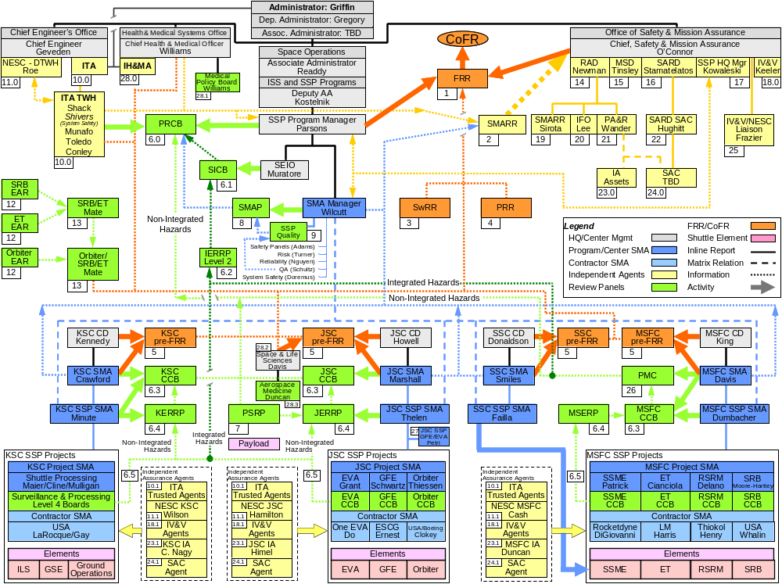

Figure 4. Space Shuttle Program AP Map (Notional)

Table 2. SSP Assurance Process Matrix (Notional)

ID | Description | Notes
1 | The SMARR is designed to: 1) affirm that assurance processes have been implemented over the life of the program and to verify compliance with the applicable baseline requirements set, 2) provide adequate knowledge and visibility for senior SMA managers to understand the residual risks associated with the safety and mission success of program launches, operations stages, or selected critical tests, 3) examine mission preparation status, open-work issues and concerns, and assess overall systems readiness, and 4) provide an SMA position on whether to concur or non-concur in proceeding with the event/operation in question.  Independent Assurance Process | Chief Safety and Mission Assurance Officer, OSMA, Bryan O’Connor  Chairman  Review & Assessment Division (RAD), Steve Newman  SMARR Coordinator, Len Sirota
2 | Flight Readiness Review (FRR) – Held approximately two weeks prior to launch, FRR is comprehensive review of all activities/elements necessary for the safe and successful conduct of all operations. The readiness of the Space Shuttle vehicle, flight crew, and payloads is determined at this review. A signed Certification of Flight Readiness endorsement certifies that all have successfully completed their Flight Preparation Processes.  Program Assurance Process | Deputy Associate Administrator, Michael Kostelik

- EVOLUTION – e-MAPS

The computer digital environment affords a wide range of presentation techniques that go far beyond the limitations of standard paper. The first innovation under consideration is a check-box selection functionality allowing the user to view selected layers in any desired combination (e.g., in-line assurance agents/activities, independent assurance agents/activities, or both layers at once). For very complex programs such as the Space Shuttle, a layered approach provides a series of less complex maps for each unique dimension of the assurance process that build to a single “composite” map (Fig. 4), which can aid in communicating the overall assurance picture one piece at a time. However, the advantage of an e-Map with the capability to turn on and off different combinations of assurance layers eliminates the need to flip between paper pages and has the potential to further enhance communication and comprehension.

Additional e-Map functionality will include pop-up “mouse-over” descriptions of assurance activities or assurance agents. Right-clicking can generate pull-down menus with options to view assurance agents contact information, hyperlinks to the latest assurance records, analyses, briefing slides, or audio/video clips. Expert rules-based “wizards” can be deployed to detect gaps and prompt the program manager to reexamine assurance process definition and implementation plans.

Electronic AP-Mapping and AP-Matrix functionality will evolve in the very near future to complement and work synergistically with electronic program management and systems engineering knowledge management tool suites

- CONCLUSION

Communication of complex ideas and relationships through the linear and relentlessly sequential format of PowerPoint is ineffective, prone to misinterpretation, and fails to adequately communicate complex relationships.

“To make connections would take hours using words. Your subconscious has to use pictures."
– William JJ Gordon

AP-Mapping can provide a clear and concise picture or map of any complex undertaking. Color, shape, form, images, structure, relative position, juxtaposition, visual stimulation all combine to communicate and help plan work, accomplish work and to manage work. AP-Mapping allows one to visualize and easily communicate the big picture and at the same time have the option to drill-down to details. AP-Mapping is recommended for all aerospace programs as an essential management process.

Edward R. Tufte in “The Visual Display of Quantitative Information” (Graphics Press, Cheshire Connecticut., 1983) defines graphical excellence as “… complex ideas communicated with clarity, precision, and efficiency … is that which gives to the viewer the greatest number of ideas in the shortest time with the least ink in the smallest space … is nearly always multi-variate”

