Biotechnology and Medical Device Industry
in Washington State: An Economic Analysis

Prepared for:

Washington Biotechnology and Biomedical Association
Seattle, Washington
Ruth Scott, Executive Director

Prepared by:

Huckell/Weinman Associates, Inc.
Kirkland, Washington
Robert A. Chase, Principal Economist

December, 2002
Biotechnology and Medical Device Industry in Washington:
An Economic Analysis

Executive Summary
Biotechnology and medical devices represent one of Washington’s young and dynamic knowledge-based industries. While the state’s economy languishes through a prolonged recession, biotechnology and medical devices continue to prosper and grow adding high-wage jobs.

Overview of Washington’s Biotechnology and Medical Device Industry
Comprised of more than 190 firms, Washington’s biotechnology and medical device industry makes a substantial contribution to the economy of Washington State. The state’s world-renowned academic and biological sciences institutes attract a sizable share of the National Institutes of Health grant funding--$650 million in 2002. Combined with other government funds, the biotechnology and medical device industry garners more than $1.5 billion annually for research and development. More than 19,300 Washingtonians work in the industry, earning an average annual salary of $68,000, and generating an estimated $1.8 billion in revenues and nearly $500 million in exports.

Although biotechnology and medical devices represent a relatively small portion of total economic activity in Washington, the industry has enjoyed robust employment growth—between 1990 and 2002, annual employment has grown by over nine percent. The biotechnology and medical device industry is largely characterized by small firms, with over 70 percent of all firms employing less than 50 persons. Half of all biotechnology and medical device firms in Washington started since 1995.

Biotechnology and Medical Device Industry Defined
Biotechnology and medical devices represent two important and distinct sectors within the biosciences industry. Biotechnology is defined as the application of biological knowledge and techniques pertaining to molecular, cellular, and genetic processes to develop products and services. Biotechnology has potential applications in a wide variety of industries—from natural resources (genetic engineering of plants and animals) to manufacturing (food processing and chemical engineering) and even computing (bio-computers). The largest category of biotechnology applications is in health and medicine—diagnosing, treating, and preventing disease. As elsewhere, diagnostics and therapeutics firms account for the lion’s share of activity in Washington’s biotechnology sector. Biotechnology should not be equated with medical technology or high-tech medicine. Many medical technologies are unconnected to genetic and molecular manipulation of biotechnology.

Medical device manufacturers produce a wide range of products used for the diagnosis and treatment of ailments. These include surgical and medical instruments, electromedical and electrotherapeutic appartuses, surgical appliances and supplies, ophthalmic goods, in vitro diagnostics, and laboratory equipment. Most of Washington’s medical device firms produce diagnostic and therapeutic products.

Economic Impact of Biotechnology and Medical Device Industry
Using a state input-output model, estimates indicate that each biotechnology and biomedical industry employee generates another 2.23 jobs within the statewide economy resulting from biotechnology and medical devices firms’ purchases and consumer spending by employees. In other words, the 19,360 jobs in the biotechnology and biomedical industry result in total impact (both direct and indirect) on state employment of 62,530 jobs. Every dollar of output produced by biotechnology and medical device firms is associated with another 95 cents of goods and services produced by other firms in Washington. The combined industry’s contribution to the Washington Gross State Product was $3.5 billion, about 1.6 percent of total gross state product in 2000.

Biotechnology and Medical Device Clusters
Washington’s biotechnology and medical device industry has clustered in and around academic centers and research institutes of excellence. Eight out of every ten biotechnology and medical device companies are found in King and Snohomish Counties (principally Seattle, Bothell, and Redmond). The Seattle-Tacoma-Everett metropolitan area is recognized as one of the top ten biotechnology clusters in the nation. Other biotechnology and medical device clusters in Washington are located in Spokane and the Tri-Cities area. These clusters involve more than the critical mass of firms from these core sectors of biotechnology and/or medical devices; firms from auxiliary sectors—suppliers, specialized services—are attracted to these same areas. Besides the mutual locational attributes between biotechnology and medical devices, there are important linkages with electronics, precision metal makers, plastic manufacturers, software developers, and specialized legal, accounting, and financial investment services.

Cluster analysis of the biotechnology and biomedical device industry found significant strength in industry linkages as well as impacts on the wider statewide economy. Such linkages provide a measure of relative strength in stimulating expansion within the regional economy, as both a driver of the local economy as well as key supplier to goods and services to other industries in the region. These linkages are both internal—intra-cluster and external to the wider economy.

A critical component and comparative advantage of the Washington biotechnology and medical device industry is research and development activities within academic and research institutes. The biotechnology and biomedical device industry is a research and development powerhouse in the state. Significant federal funds from the National Institutes of Health exceeding $650 million flow into the University of Washington, Fred Hutchinson Cancer Research Center, Washington State University, Seattle Biomedical Research Institute, Virginia Mason Research Center, and Battelle Pacific Northwest Laboratory. Spending on institutional-based basic research stimulates innovation that can lead to new products and more jobs.

Policy Considerations
Is Washington doing enough to capitalize on the state’s position in the growing biotechnology and medical device industry? Washington’s share of the biotechnology and medical device marketplace is strong by some measures, but falls short in others. The biotechnology and medical device sector holds great promise as an economic development engine. With Washington’s signal achievements in basic and applied research in biosciences, the state stands to lose significant ground if it remains passive in its support. Many states understand that the economic returns from public investments in biotechnology and medical devices are likely to be dramatic.

Washington State public policy needs to address those issues that support and nurture the biotechnology and medical device industry. The implementation of successful programs elsewhere provide some policy guidance here in Washington Such elements could include:
- Promoting the state as a place for biotechnology and medical device research & manufacturing.
- Develop a formal liaison between the industry and the state’s legislative and executive branches.
- Solicit a three-way partnership between the state, industry, and university in creating institutes for science and innovation.
- Improving the structure for commercializing innovation, including skilled staff in licensing and a physical facility to serve new ventures formed from the initiative.
- Address the issue of high cost of doing business in Washington as an obstacle to growth.
- Revisit the state’s existing program of research and development credits and tax deferrals for the biotechnology and medical device industry.
- Encourage the development of an early-stage venture capital fund for Washington-based biotechnology and medical device companies.

In the absence of Washington State providing any significant support to the biotechnology and medical device industry, it would be highly prudent for state policy makers to avoid harming the policy environment and business climate.

Growth Prospects for Biotechnology and Medical Devices
The graying of the population and growth in worldwide per capita incomes and per capita health care expenditures provide a platform for stable and steady growth for biotechnology and medical devices. Federal government regulation by the FDA will continue to directly impact the industry’s growth and profitability.

In order to foster continued growth in biotechnology and medical devices and to keep Washington in the forefront of the industry, state public policy should focus on making strategic investments in education and technology infrastructure, instituting a more formal liaison between the industry and state policy makers, and encouraging a structure for commercializing innovation.

Washington State-led initiatives pale in comparison with other states in supporting the biotechnology and biomedical devices industry. A number of states now have instituted bioscience strategies with significant increases in funding for academic research, venture capital funds, and publicly funded incubators, research parks, and commercialization centers. If Washington State continues to be passive in light of increased competition from other states, there is good reason to question if Washington can sustain its robust growth rates and thus maintain its “market share” within biotechnology and medical devices.

I. Introduction
Washington State’s biotechnology and medical device industry is thriving and growing. Even as the state’s economy languishes in one of its worst recessions, biotechnology and medical devices continues to show remarkable growth and resilience as the next wave of the Washington State economy.

In the short history of this industry—88 percent of Washington’s biotechnology and medical device industry were founded in the last two decades—the year 2000 stands out marked by the completion of the sequencing of the human genome. Today, new fields of proteonmics, bioinformatics, and medical nanotechnology are evolving from the human genome work, and the convergence of biology, medicine, and information technologies are opening up new pathways to improve the quality of life and extending life expectancy.

Comprised of more than 190 firms, Washington’s biotechnology and medical device industry makes a substantial contribution to the economy of Washington State. The state’s world-renowned academic and biological sciences institutes attract a sizable share of the National Institutes of Health grant funding--$650 million in 2002. Combined with other public funds, the biotechnology and medical device industry garners more than $1.5 billion annually for research and development. More than 19,300 Washingtonians work in the industry, earning an average annual salary of $68,000, and generating an estimated $1 billion in revenues and nearly $500 million in exports.

There are notable reasons for optimism—favorable demographics, growing international markets, and proliferation of new drugs and devices; all of these signal continued robust growth for biotechnology and medical devices. Yet, the industry faces some daunting challenges ahead. Growing outcry over rising health care expenses, highlighted by the political firestorm surrounding the price inflation within pharmaceuticals, is a major issue confronting the industry, particularly biotechnology. The lengthening time for product and compound development to a decade or more and increasing development costs of upwards of $800 million underscore the substantial risk for the industry. Biotechnology firms, and to a lesser extent, medical device companies are under increased pressure to fill development pipelines, contain rising R&D costs, bring more new drugs and products to market, and demonstrate credible value for their products. The U.S. Food and Drug Administration (FDA), with its regulatory oversight of the industry, faces challenges in balancing its major responsibilities of speeding drug and device development while maintaining high product quality standards with the emerging mandate to fight bioterrorism.

Despite recent growth in the statewide industry, there are storm clouds gathering around the industry. Financial health of the statewide biotechnology and medical device industry is far from ensured. Financial markets that once endorsed the promise of biotechnology have retreated of late. The Dow Jones U.S. biotechnology stock index is down 60 percent from its March 2000 peak. Such low trading prices indicate that Wall Street consider some of these biotechnology companies to have little or no real value. The state’s largest biotechnology company—Immunex—was recently acquired (July 2002) by Amgen, the world’s largest biotechnology firm, foreshadowing a consolidation trend already within the industry.

To help the industry meet its goal to improve medical care and grow the state economy, government policy will be critical on a number of issues including tax policy and incentives for R&D, continued funding for basic research, price controls on pharmaceutical products, and oversight of important medical-related research.

A. Study Objectives and Report Overview
This study assesses the important economic role of the biotechnology and medical device industry within Washington State. How important is that role—and given the inherent dynamism of the biotechnology and medical devices, how has that role changed in recent years? With increased policy attention given to industry clusters, where is the biotechnology and medical device industry concentrated in Washington?

In many circles, biotechnology and medical devices are viewed as two separate and distinct industries. Biotechnology and medical device developments are becoming more complementary over time, as devices of increasing sophistication and minaturization are used to deliver new biotechnology products. While distinctions between biotechnology and medical devices are increasingly blurred—for instance, nano devices used to deliver biological agents directly to cancer cells—this discussion nevertheless separately profiles the biotechnology and medical devices industries. With that in mind, how are the biotechnology and medical device industries defined? What are their basic characteristics—composition, products and markets, major suppliers, occupational distribution, recent trends, etc.?

Biotechnology and medical devices contribute far more to the regional economy than mere high-wage jobs. Viewing biotechnology and medical devices as simply the nexus within a knowledge-based economy, proximate connections to academic research institutions as well as manufacturing facilities are critical linkages to consider in the industry’s overall economic contribution. For most economic impact studies, production is viewed as the centerpiece of the analysis. Within the knowledge-based economy, research and development activity supported by public funds foster explicit ties between business and academic research institutions that ultimately propel the industry.

With the industry burgeoning and concentrating in certain geographical areas, states and regions are developing initiatives designed to foster an environment in which biotechnology and medical device firms can succeed and grow. These initiatives address specific needs of biotechnology and medical device companies, including strong academic research institutions, access to early-stage capital, successful transfer of public-funded basic research to product commercialization, specialized facilities, and highly skilled workforce. How will Washington State and its host regions support and grow this dynamic industry, especially within a heightened competitive environment?

The report is organized into five parts following the introduction. The first part profiles the current biotechnology and medical device industry in the United States and Washington—its recent growth and structure; its principal products and markets; and its future.

The second part of the report focuses on the overall economic contribution of the biotechnology and medical device industry by utilizing an input-output modeling framework. Such a model is essentially a general accounting system of the transactions taking place between industries, businesses, and consumers within a regional economy. These purchases and sales are adjusted for in-state and out-of-state sources and then summed to arrive at estimates of total impacts arising from an initial change in the biotechnology and medical device industry.

Third, the biotechnology and medical device industry’s development in Washington is placed into an industrial cluster analytical framework. An industry cluster is more than just a geographic concentration of companies within the same industry. Clusters also include suppliers providing a full range of inputs, customers and supporting agencies such as trade organizations, and university programs. Within such a context, discussion will center on the various dimensions of Washington’s biotechnology and medical device cluster—its “knowledge-based” structure, supply chain and inputs, and markets.

Fourth, the report presents a number of policy considerations confronting the biotechnology and medical device industry in Washington. What are the appropriate roles for state government, particularly when other states are vying for an increased share of the biotechnology and medical device industry?

Finally, the report concludes with a discussion of the outlook for the biotechnology and medical device industry in Washington. Will the industry continue along a path of robust growth or will there be a period of retrenchment characterized by increased consolidation? How each of these issues, individually and collectively, is played out in the future is somewhat speculative. However, to the extent that each of these issues has economic implications for the greater region, a number of these future scenarios are presented for the regional biotechnology and medical device industry.
II. Overview of the Biotechnology and Medical Device Industry
While economic uncertainties cloud the outlook for several industries, biotechnology and medical device sectors are likely to continue posting strong growth in revenues and earnings. At the heart of these sectors’ positive fundamentals are favorable demographics and continued growth in health care expenditures. Two worldwide trends—the aging of the post-World War II generation and the lengthening of life expectancy—bode well for the biotechnology and medical device industries. Globally, the over-60 year-old population is expected to more than triple between 2000 and 2050, representing more than a fifth of the world’s population. In the United States, the over-65 year-old population is expected to more than double between 2001 and 2030, thus expanding the market for biotechnology products and medical devices (Figure 1).

Figure 1. Medicare Beneficiaries, 1970-2030
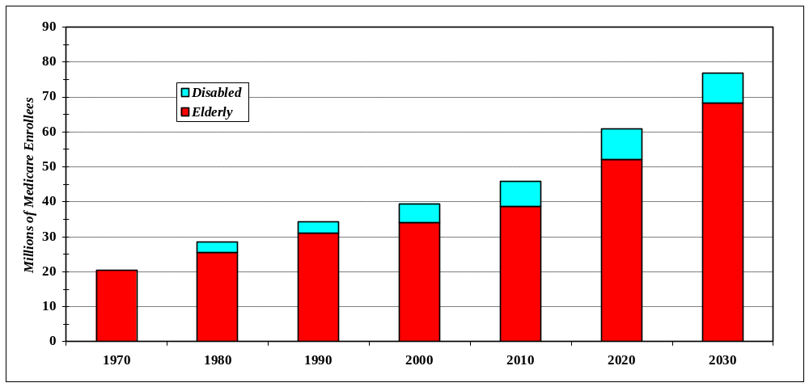
Note: 2010, 2020, and 2030 is estimated.
Source: Centers for Medicare & Medicaid Services, Office of the Actuary, 2002.

Currently, Americans 65 years and older account for 13 percent of the nation’s population yet consume an estimated 33 percent of all U.S. pharmaceutical output. Medical device companies are also well-positioned to benefit from this graying of the population, as the use of such medical devices as pacemakers, defibrillators, stents, and orthopedic implants increases in frequency with older patients.

Going forward, an aging segment of baby boomers will provide further stimulus for industrywide demand for biotechnology products and medical devices. Baby-boomers, according to the U.S. Census Bureau, account for almost a quarter of the population. Much of the increase in the over-65 year segment of the U.S. population will occur after 2010 when the leading edge of the baby boom generation begins to turn 65.

Americans now have a life expectancy at birth of 76.5 years. Those Americans who have reached their 65th birthday are likely to live another 16-19 years. Although more people than ever will be living longer, they will not necessarily be free of health problems. According to the World Health Organization (WHO), the incidence of cancer, heart disease, and other chronic diseases—which currently cause some 28 million deaths worldwide annually—is expected to increase in the future. This is largely due to unhealthy lifestyles, poor diet, obesity, smoking, and/or lack of exercise. The WHO projects a doubling of cancer cases in most countries over the next 25 years. In the United States, the top four causes of death are all disease-related: heart disease, cancer, stroke, and respiratory disease (National Center for Health Statistics, 2002). Biopharmaceuticals and medical devices should play an increasingly important role in combating the ravages of these diseases and benefiting the elderly, as well as dealing with more obscure maladies for which major pharmaceutical firms may not look to develop treatments.

Health care expenditures for hospital care, physician care, drugs, medical devices and medical nondurables rose 9.6 percent to $1.42 trillion in 2001 (Centers for Medicare & Medicaid Services, 2002). The rate of spending growth is expected to continue at an average annual rate of 6.9 percent into the next decade when health care expenditures will exceed $2.8 trillion and represent 17 percent of GDP (Figure 2). Both medical devices and pharmaceuticals account for a relatively small component of total U.S. healthcare expenditures at 3 percent ($19.9 billion) and 8 percent ($141.8 billion), respectively. While spending on medical devices is expected to grow at an average annual rate of 5.4 percent, spending on pharmaceuticals is expected to escalate to an average annual rate of 11 percent.

The government healthcare entitlement programs of Medicare and Medicaid also have a significant impact on biotechnology and medical device industry, particularly through changes in spending levels and reimbursement rates. The Centers for Medicare and Medicaid Services (CMS), which oversees these federal healthcare programs, is the single largest purchaser of health care in the world with aggregate outlays of $351 billion in 2001. Medicare and Medicaid indirectly fund large segments of biotechnology and medical device markets. Such funding is particularly important for makers of high-tech medical device products.

Figure 2. Personal Health Care Expenditures in United States, 1980 -2002
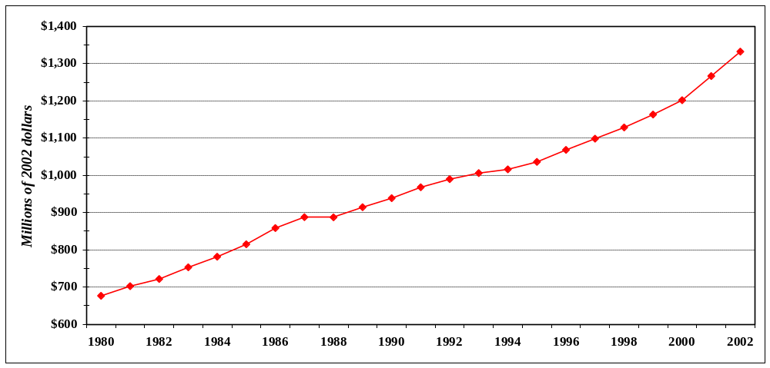
Source: Centers for Medicare & Medicaid Services

A. Biotechnology and Medical Devices Defined
Biotechnology and medical devices are distinct yet complementary sectors dynamically linked to each other within the biosciences industry. Developments within both biotechnology and medical devices are becoming more complementary over time, as medical devices of increasing sophistication and miniaturization are being used to deliver new pharmaceutical and biotechnology products.

1. Biotechnology
Biotechnology is unique among industries in that it is not defined by its products, but by the technologies used to make those products. Biotechnology is formerly defined as the application of biological knowledge and techniques pertaining to molecular, cellular, and genetic processes to develop products and services. Biotechnology has potential applications in a wide variety of industries—from natural resources (genetic engineering of plants and animals) to manufacturing (food processing and chemical engineering) and even computing (bio-computers). Industrywide revenues for public biotechnology firms exceeded $28 billion in 2001, with an anticipated increase to $33 billion in 2002. The biotechnology industry consists of more than 1,450 public and private companies with over 141,000 employees in the United States (Ernst & Young, 2002).

Because biotechnology is application-oriented, sales of products made through biotechnology cross several traditional industries. Data gathered concerning industries are usually collected based on the product or service produced, not on the method of production or technology used. Consequently, we do not know the full extent of sales of products made through biotechnology as a separate industry; almost all product sales are subsumed within the various traditional industry categories as pharmaceuticals, foods, chemicals, plastics, medical devices, environmental services, and research and development (Table 1).

Table 1. Applications of Biotechnology
Healthcare | Veterinary | Agriculture
Pharmaceuticals | Genetic engineering | Diagnostics
Therapeutics | Monoclonal antibodies | Biopesticides
Vaccines | Recombinant interferons | Microbial diagnostics
Gene therapy | Transgenic animals | Environmental adaptions
Growth & other hormones |  | Genetically modified foods
Pharmacogenomics | Industrial biotechnology | Natural fertilizers
Diagnostics | Energy conservation | Nutraceuticals
Biosensors | Pollution reduction | Transgenics
DNA probes | Waste reduction
Monoclonal antibodies | Bioelectronics | Forestry biotechnology
Polymerase chain reaction | Organic chemicals | Genetic engineering
Genomics/proteomics |  | Biological pest control
Biological instrumentation | Environmental biotechnology | Tissue culture propogation
Biological devices | Bioremediation | Transgenic plants
Drug-coated stents | Biotreatment
Microdevices | Immunoassays | Marine biotechnology
Bone growth devices | Microbial mining | Biomedical research
Cartilage regeneration | Environmental monitoring | Food supply
Tissue replacement |  | Therapeutics
Wound healing devices | Food Processing
Skin grafts & wound closures | Microbial starter cultures
 | Enzymes and vitamins
 | Food contamination tests
Notes: See glossary—appendix B for definitions of terms.
Sources: U.S. Industry & Trade Outlook 1998; BIO.com

Biotechnology firms are not separately classified in either the Standard Industrial Classification (SIC) system or its successor, the North American Industrial Classification System (NAICS). Instead, most biotechnology companies are assigned to one of two broader industry categories encompassing research and development and drug manufacturing, namely NAICS five-digit professional, scientific, and technical services industry 54171 (Research and development in the Physical, Engineering, and Life Sciences) or the NAICS manufacturing industry group 3254 (Pharmaceutical and medicine manufacturing).

By far, the largest category of biotechnology applications is within health and medicine—diagnosing, treating, and preventing disease. Biotechnology, however, should not be equated with medical technology or high-tech medicine. Many medical technologies fall outside the genetic and cellular manipulation of biotechnology.

In Washington State, nearly three-fourths of the 133 biotechnology companies are classified as healthcare—therapeutics, diagnostics, and genomics/informatics (Figure 3). The remaining one-fourth of Washington’s biotechnology companies is dispersed across various other market segments of natural resources (agriculture forestry and marine), food processing and other industrial, and environmental biotechnology. Most of the 19 publicly-traded biotechnology companies in Washington are within the healthcare and medicine segments.

Figure 3. Washington Biotechnology Companies by Market Segment, 2002
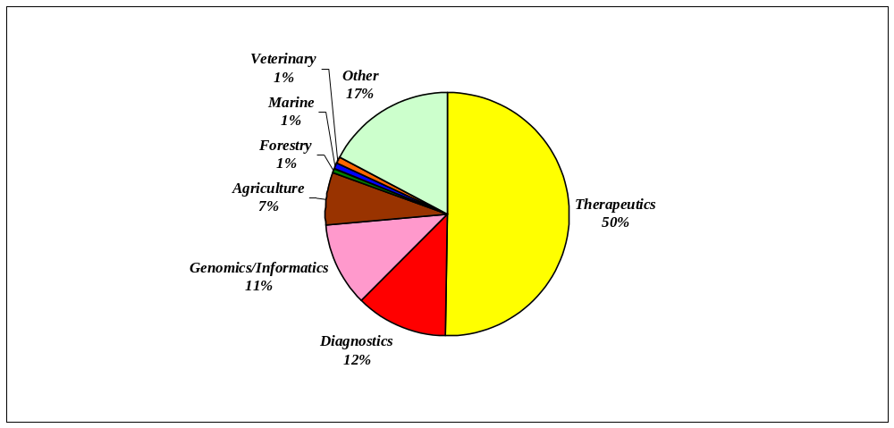
Source: Washington Biotechnology & Biomedical Association, 2002.

2. Medical devices
Medical device manufacturers produce a wide range of products used for the diagnosis and treatment of ailments. These include surgical and medical instruments, electromedical and electrotherapeutic apparatuses, irradiation apparatuses, surgical appliances and supplies, ophthalmic goods, in vitro diagnostics, and laboratory equipment. As in biotechnology, most medical device companies are assigned to one of three categories encompassing medical and surgical manufacturing, namely NAICS five-digit manufacturing industry 33911 (Medical Equipment and Supplies Manufacturing), or NAICS six-digit manufacturing industries 334510 (Electromedical and Electrotherapeutic Apparatus Manufacturing) and 334517 (Irradiation Apparatus Manufacturing).

In Washington State, two-thirds of the 57 medical device companies produce either medical and surgical equipment (e.g., syringes, catheters, blood transfusion equipment, surgical clamps, and stents) or medical and surgical appliances and supplies (e.g., orthopedic devices, prosthetic appliances, surgical dressings and sutures). One-fifth of the companies are classified within the electromedical and electrotherapeutic apparatuses (e.g., magnetic resonance imaging equipment, ultrasound equipment, pacemakers and defibrillators, hearing aids, and electrocardiographs), with the remaining companies in irradiation apparatus, laboratory apparatus, or in vitro diagnostic substances (Figure 4).

Figure 4. Washington Medical Device Companies by Market Segment, 2002
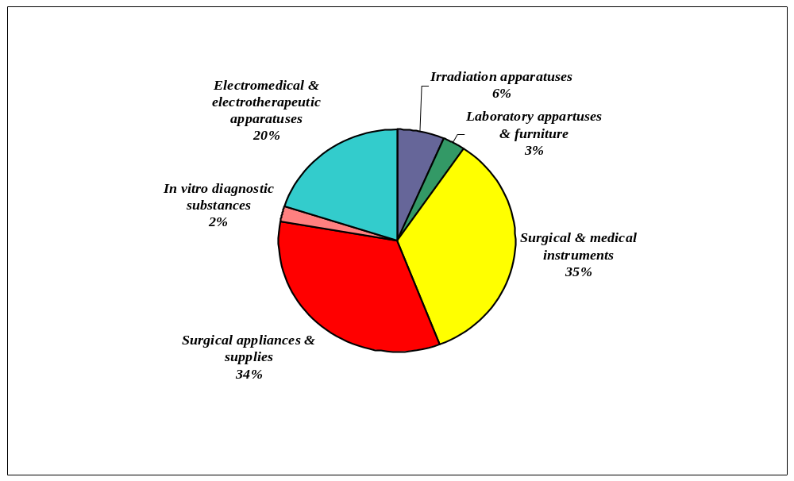
Sources: Washington Biotechnology & Biomedical Association; U.S. Census Bureau

B. Structure of the Biotechnology and Medical Device Industries
The biotechnology and medical device industries have a number of important characteristics that distinguish them from each other and from other industries. Here follows a brief overview and development of these two industry sectors, their current structures, and some of the important aspects of the regulatory and competitive environment surrounding firms in each sector.

1. Biotechnology
The structure of the biotechnology industry seems to be in a continual state of flux. Advances in bioscience over the last three decades have led to a circular evolution of the biotechnology industry structure: from the domination of large-scale pharmaceutical firms to the entry of many small, innovative start-ups to alliances between the large and small for more efficiency (and in some cases, survival) to currently a few dominant biotechnology powerhouses.

One of the earliest major milestones for biotechnology, which led to an explosion in research and production mechanisms and a sea-change in the industry’s organization, was the successful recombining of DNA by Stanley Cohen and Herbert Boyer in 1973. This advance in genetic science propelled the industry along a couple of different paths. One path employed genetic science as a process technology, that is, using the methods of Cohen and Boyer to mass produce proteins as therapeutic agents. Genetic engineering required new techniques and changes in R&D efforts by firms. Before genetic engineering, a small number of proteins could be manufactured either from natural sources or by organic chemical methods. Genetic engineering made it possible to produce large quantities of proteins, opening an entire new field in drug research. The number of these new “biotechnology” firms grew from nonexistent in the mid 1970s to over 1,450 firms less than three decades later, spawning a new industry and transforming an old industry—pharmaceuticals—in the process.

Another path employed biotechnology techniques as a primary research tool for discovering and manufacturing conventional “small molecule” drugs. This trend helped reinforced the dominance of the large pharmaceutical firms, which were able to leverage their competency in various R&D arenas to build on the knowledge already codified in the academic literature.

The academic research done in the universities during the 1970s and 1980s spawned many small, innovative start-up companies, beginning with Genentech, formed by Boyer and Robert Swanson in 1976. Start-ups increased during the 1990s along with a growth in merger activity as large biotechnology companies purchased innovative start-ups. Often, the mergers occurred because target R&D firms, while rich in talent, were poor in capital and resources to commercialize their research into products. These start-ups needed the distribution and production prowess of larger firms to take their products to market. In contrast, larger firms needed new ideas but found it more economical to acquire brain-rich start-ups than to expend scarce resources on cutting-edge in-house research. Moreover, by acquiring an established firm, a larger firm was able to diminish the uncertainty inherent in R&D efforts. Thus, few firms, even extraordinarily successful ones, do not grow into large biotechnology companies. Instead, biotechnology research firms tend to sell or license their technologies to larger concerns, or form joint ventures with them, or outright sell their entire companies.

Today, there are only a handful of companies that dominate the biotechnology industry. Each of these companies’ dominant position is in specific market segments, with the goal of broadening their product pipelines by acquiring smaller biotechnology concerns or partnering with undercapitalized entities.

The biotechnology industry in Washington State is recently established, with the majority of companies founded since 1990 (Figure 5). Before 1990, less than a third of all biotechnology firms had been started in Washington. At that time, much of the biotechnology–related research in the state was academic-oriented at the University of Washington and the Fred Hutchinson Cancer Research Center (founded in 1972).

Figure 5. Washington Biotechnology Companies by Year Founded
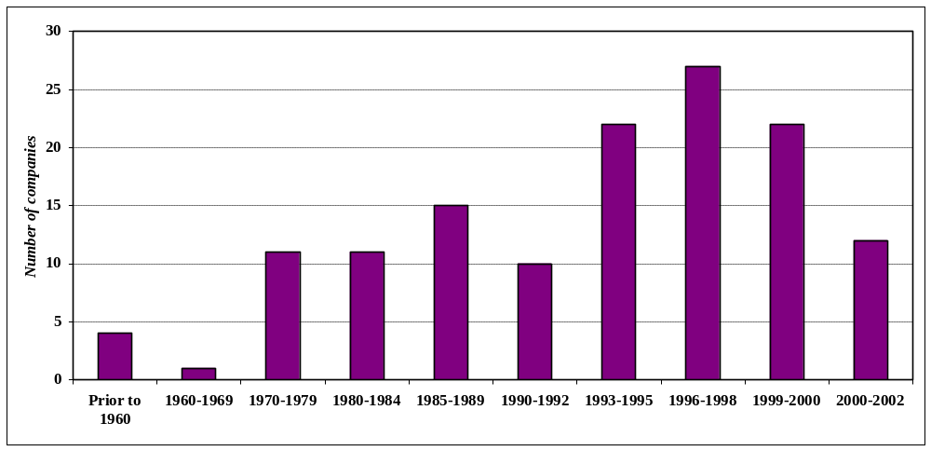
Source: Washington Biotechnology & Biomedical Association, 2002.

Most biotechnology firms in Washington, as elsewhere, are small companies. In 2002, more than four-fifths of all biotechnology firms had less than 100 employees (Figure 6). For the largest biotechnology companies, three are actually non-profit research institutes or federally-funded research laboratories. In general, most biotechnology companies have added employees over the years, fueled solely by research and development activities and the promise of eventual approval of medicines-in-development. According to the latest PhRMA survey, there are currently 371 biotechnology medicines in development by 144 companies. Washington-based companies account for twenty-five of these biotechnology medicines in various stages of development. Of the 95 biotechnology medicines already approved by the Food and Drug Administration, only a few drugs have reached “blockbuster” status. One of these “blockbuster” drugs, Enbrel®, was developed by Immunex, resulting in spectacular employment growth within the firm following the initial approval and marketing in late 1998.

Figure 6. Size of Washington Biotechnology Companies, 2002
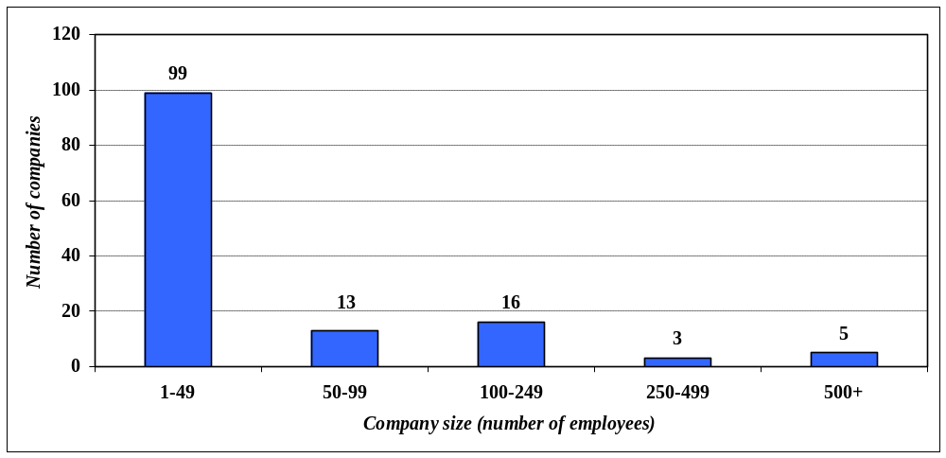Source: Washington Biotechnology and Biomedical Association, 2002

“Science is the pilot of industry” aptly describes biotechnology, for it is one of the nation’s most research-intensive industries. This knowledge-based sector is largely dependent upon universities as a significant source of basic research and applied technologies. Basic bioscience research and discovery conducted at academic universities and institutes can be powerful sources of economic growth, especially in collaboration with the private sector.

A major player behind these fundamental developments within biosciences is the Federal government. A wide variety of federal agencies provide funding to biosciences and medicine and biotechnology, but by far the largest single funding agency of such research is the National Institutes of Health. The lion’s share of federal health-related funding is directed toward supporting research activities at academic universities, medical schools, and non-profit institutions, underscoring their critical role within the biotechnology industry.

During the 1990s, the growth rate of NIH funding for biosciences research has been 7.8 percent annually. Total NIH spending, in fact, doubled during the decade from $6.5 billion in 1991 to over $13 billion in 2000. In 2001, NIH disbursed a total of $14.9 billion for research activities in biosciences. Among all states, Washington is ranked eighth in total NIH funding, with a per capita share far greater than the national average (Figure 7). In Fiscal Year 2002, Washington State universities, institutes, and companies received $649 million from the National Institutes of Health for biosciences research.

Figure 7. Top Ten National Institutes of Health Grantee States, FY2002
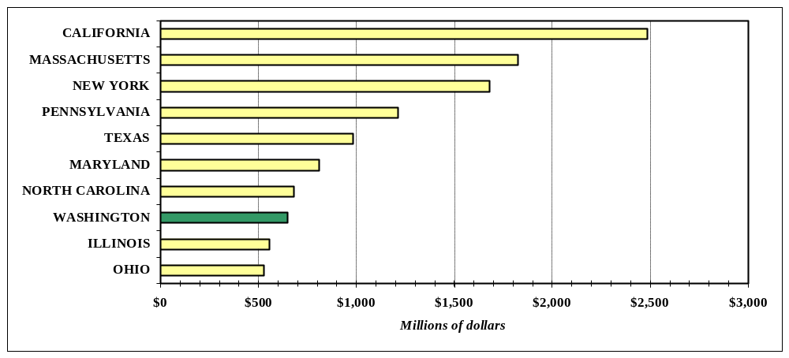
Source: National Institutes of Health

Washington’s academic universities and research institutes are the vital source of the state’s biosciences R&D industry. NIH funding within Washington State universities, research institutes, and companies have more than doubled in ten years (Figure 8). Broad, early-stage, basic research studies at the University of Washington, Fred Hutchinson Cancer Research, Washington State University and others—funded largely by the National Institutes of Health, National Science Foundation, Department of Energy, and Department of Defense—are essential to private sector innovation. In FY 2002, the National Science Foundation awarded $21.6 million for biosciences-related research to universities, research institutes, and companies in Washington. The Pacific Northwest National Laboratory’s biosciences program is underwritten by U.S. Department of Energy funding; amounting to $72.6 million in FY2002.

Figure 8. NIH Funding to Washington State, FY1992-2002
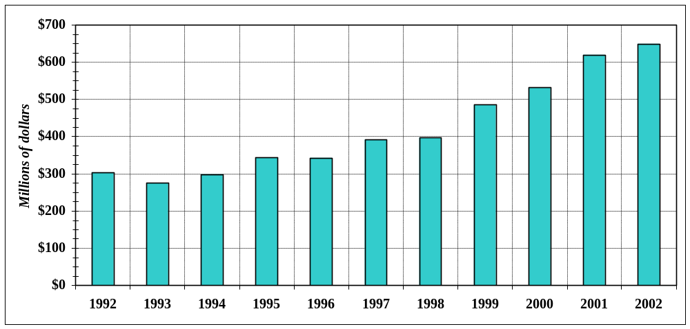
Source: National Institutes of Health.

The University of Washington ranks first among all public universities (third among all universities) in NIH funding. In FY 2002, bioscience researchers at the University of Washington received a total of $389.6 million in NIH funds. The Fred Hutchinson Cancer Research Center ranked 24th among all institutions (but first among all research institutes) in NIH funding with $161 million (FY2002) (Figure 9).

Recent studies underscore the premise that basic university science is integral to the successful commercialization of scientific discoveries. While universities and research institutes are not equipped to develop and market products, they can patent and license their inventions, and in turn transfer core technologies to biotechnology entrepreneurs. The history of biotechnology and medical devices is rather fluid—in ideas and people—between universities and institutes and companies. Most successful companies trace their origins back to academia; and many academic institutes profit from royalties on their faculties’ inventions.

In Seattle, the region’s biotechnology industry has been driven by spin-offs from the University of Washington and Fred Hutchinson Cancer Research Center. A majority of the biotechnology firms in the state trace their roots to technology breakthroughs developed at these two research centers. Two of the state’s earliest and ultimately largest biotechnology firms—Immunex and Zymogenetics—were started in 1981 by researchers from the “Fred Hutch” and the University of Washington.

Figure 9. Top Ten NIH-Funded Institutions in Washington State, FY2002
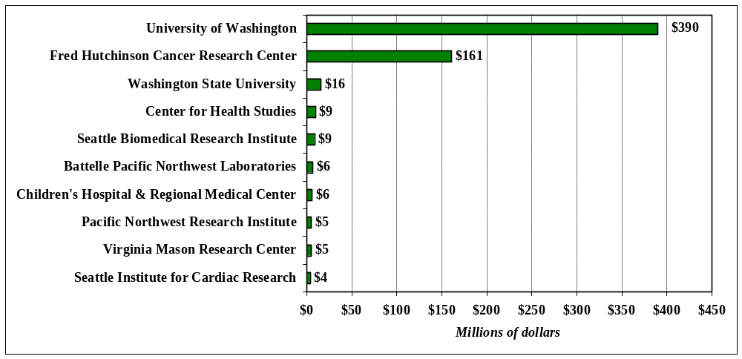Source: National Institutes of Health

Biotechnology demands a stock of innovations; indeed, growth in the biotechnology industry is inextricably linked to the rate of intellectual property generation. Predicated on knowledge creation and intellectual property, firms and institutes generally seek to patent new products and processes. Small firms in particular, seek to develop their intellectual property and sell it to larger firms for manufacture and distribution.

Patent data are classified according to product or technology characteristics (US Patent and Trademark Office, 2002). Combined with medical devices, biotechnology-related patents represent a large and growing fraction of all patents granted in the United States and Washington—about 14.3 percent and 15.7 percent respectively between 1997 and 2001 (Table 2). Private firms own most of these issued patents. Universities and government agencies also hold a sizeable share of patents because they sponsor a considerable amount of research. In Washington, Zymogenetics and Immunex are among the leading biotechnology patent holders with the University of Washington and the Fred Hutchinson Cancer Research Center also highly ranked. Overall, Washington State ranks 13th among all states in biotechnology patents and 10th in medical device patents.

Table 2. Patents in Biotechnology and Medical Devices, Washington and United States, 1997-2001
Patent |  | Washington | United | Washington's
Class | Description | State | States | Share of U.S.
424 | Drug, Bio-affecting & body treating compositions | 372 | 19,865 | 1.9%
435 | Chemistry: molecular biology & microbiology | 394 | 12,316 | 3.2%
800 | Multicellular living organisms & unmodified parts | 12 | 1,820 | 0.7%
 | Total, Biotechnology patents | 778 | 34,001 | 2.3%
128 | Surgery (includes Class 600) | 282 | 7,450 | 3.8%
601 | Surgery: kinesitherapy | 10 | 348 | 2.9%
602 | Surgery: splint, brace or bandage | 13 | 753 | 1.7%
604 | Surgery: medicators & receptors | 73 | 4,794 | 1.5%
606 | Surgery: instruments | 75 | 5,776 | 1.3%
607 | Surgery: light, thermal & electrical application | 119 | 1,853 | 6.4%
623 | Prosthesis: parts, or aids & accessories | 24 | 1,868 | 1.3%
 | Total, Medical devices patents | 596 | 22,842 | 2.6%
 | Total, Biotechnology & medical devices patents | 1,374 | 56,843 | 2.4%
Source: U.S. Patent and Trademark Office

The availability of capital plays a critical role in the growth and development of the biotechnology industry. Biotechnology requires expensive and time-consuming research and even resultant promising compounds must undergo a long process of testing and approval. Numerous biotechnology research projects and promising ideas fail to materialize revenue. Even those firms that ultimately succeed record many years of losses during research and development. As a result, large amounts of financial capital over an extended period are required in order to grow and develop firms within the biotechnology industry. Various financial capital programs are accessed by biotechnology companies—Small Business Innovation Research (SBIR) grants, venture capital, research alliances, and initial public offerings. These programs represent different phases in the life cycle of firms and in product development.

For early-stage financing for development and commercialization, many biotechnology and medical device research institutes and companies access the Small Business Innovation Research (SBIR) and Small Business Technology Transfer Research (STTR) programs. Washington State research institutes and companies have been increasingly successful in obtaining financial support from these competitive programs; in FY2002 alone, 50 research institutes and companies in Washington State were awarded grants totaling $23.5 million (Figure 10).

Figure 10. SBIR and STTR Funding for Biosciences Research in Washington State, 1197-2002 (Fiscal Year)
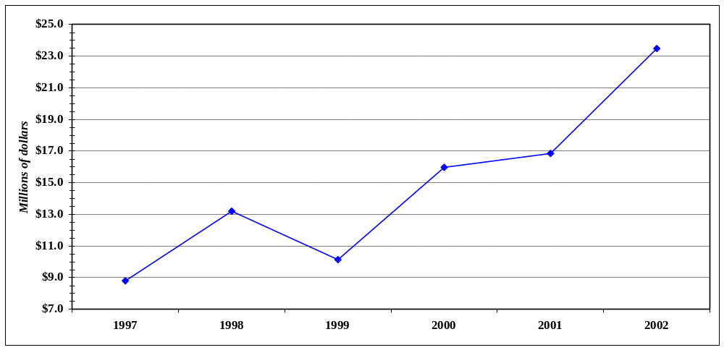
Notes: Small Business Innovation Research (SBIR) and Small Business Technology Transfer Research (STTR) are annual set-aside programs for small companies and research institutes and are administered by respective Federal agencies with extramural research and development budgets of $100 million or more. The presented award data is from the National Institutes of Health program.
Source: National Institutes of Health.

By far, the most important source of start-up capital is organized venture capital—private investments made by professional fund managers that typically specialize in a set of technologies. Venture capital investment finances most biotechnology companies from their inception through the early years of research and development needed to prove the potential of a promising idea. A firm may receive several rounds of financing as it develops its biotechnology products. Due to the considerable expense and long lead times associated with product development, venture capital essential to the start-up of firms may go several years before generating revenues.

Venture capital, as such, is a good leading indicator for the biotechnology industry. Since 1995, biotechnology firms in Washington have attracted over $764 million (77 deals) in venture capital investment (Figure 11 and Table 3). In 2000 during a capital market boom, biotechnology firms attracted nearly $3 billion in venture capital investments, $281 million of which was invested in Washington biotechnology companies.

Figure 11. Venture Capital Investment in Washington Biotechnology & Medical Device Industry, 1995-2002
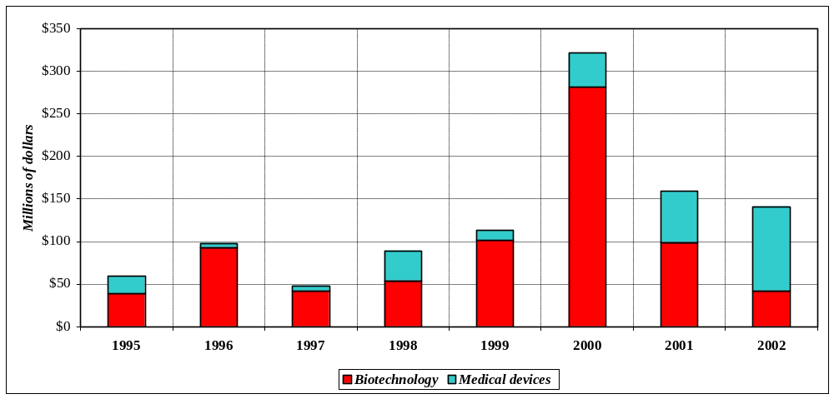
Note: All years annual totals except for 2002 which includes information from quarters 1-3 only.
Source: PriceWaterhouseCoopers Money Tree™ Survey.

Table 3. Venture Capital Investment in Washington, 1995-2002
Industry Sector | 1995 | 1996 | 1997 | 1998 | 1999 | 2000 | 2001 | 2002
Biotechnology | $39 | $93 | $42 | $54 | $101 | $281 | $99 | $42
Medical devices | $20 | $5 | $6 | $35 | $12 | $40 | $60 | $99
Total, biotech & med. devices | $59 | $98 | $48 | $89 | $113 | $321 | $159 | $141
Total, all industries | $330 | $417 | $438 | $756 | $2,010 | $2,741 | $1,060 | $494
Percent share of state total | 17.9% | 23.5% | 11.0% | 11.8% | 5.6% | 11.7% | 15.0% | 28.5%
Notes: Investments are in millions of dollars; all years--annual totals except for 2002 which includes information from quarters 1-3 only.
Source: PriceWaterhouseCoopers Money Tree™ Survey.

a. Workforce
Biotechnology requires a highly specialized labor force. In addition to the growth patterns displayed by the biotechnology and medical device sector, an understanding of the occupational structure of the industry is important for the constructing of sound economic development strategies as well as the design of employment and training programs. What are the important occupations associated with the biotechnology sector? In other words, what is the occupational mix for biotechnology? Second, how important is biotechnology as a source of employment for specific occupations within the statewide labor market?

The occupational distribution of Washington biotechnology workers is weighted heavily toward executive, administrative, managerial, professional specialty, and technical occupations. The leading occupations in the biotechnology sector for 2001 are based on information available from the Washington State Employment Security Department, Labor Market and Economic Analysis Branch (Table 4). The unique characteristics of biotechnology are clearly evident as there is a heavy reliance on science, medical, and technical positions. More specifically, eight of the top fifteen occupations are associated with either a science, medical, or technical skills set. Together with the other seven occupations, primarily in office-related occupations, these fifteen occupations account for 42 percent of total employment in the biotechnology sector.

Table4. Leading Occupations in the Biotechnology Sector, 2001
 |  |  |  | Annual
Rank | OES | Occupation | Employment | Wage | Percent
1 | 43-4111 | Interviewers, Ex. Eligibility and Loan | 1,505 | $15,456 | 7.5%
2 | 19-4021 | Biological Technicians | 1,325 | $26,109 | 6.6%
3 | 19-1042 | Medical Scientists, Ex. Epidemiologists | 767 | $34,313 | 3.8%
4 | 19-4031 | Chemical Technicians | 763 | $29,053 | 3.8%
5 | 19-2031 | Chemists | 547 | $48,240 | 2.7%
6 | 11-9121 | Natural Sciences Managers | 439 | $55,542 | 2.2%
7 | 13-1199 | Business Operations Specialists, All Other | 422 | $34,577 | 2.1%
8 | 41-9099 | Sales & Related Workers, All Other | 406 | $14,800 | 2.0%
9 | 11-1021 | General & Operations Managers | 350 | $65,763 | 1.8%
10 | 47-4041 | Hazardous Materials Removal Workers | 315 | $19,707 | 1.6%
11 | 29-1111 | Registered Nurses | 307 | $51,119 | 1.5%
12 | 43-9061 | Office Clerks, General | 303 | $19,123 | 1.5%
13 | 19-3022 | Survey Researchers | 297 | $14,548 | 1.5%
14 | 43-6011 | Executive Secretaries & Admin. Assistants | 283 | $30,623 | 1.4%
15 | 43-9111 | Statistical Assistants | 272 | $24,888 | 1.4%
 |  | Top Fifteen occupations | 8,301 | NA | 41.6%
Notes: NA is not available; Annual wage is for entry workers, with no experience.
Source: Washington State Employment Security Department, Labor Market & Economic Analysis Branch.

While occupational mix provides some indication of the importance of which occupations are most important within biotechnology, it is also useful to examine the relative importance of biotechnology as a source of employment for various occupations. Table 5 reports biotechnology’s share of total employment within these same major occupations. While the industry as a whole accounts for 0.8 percent of total state employment, it can claim a much higher share of employment in particular occupations. The majority of survey researchers—used in clinical trials, chemists, and chemical technicians—are mostly found in biotechnology.

Table5. Occupational Concentrations in Biotechnology, 2001.
 |  |  | Biotech | Education
OES | Occupation | Employment | Percent | Required
19-3022 | Survey Researchers | 502 | 59.2% | 3
19-2031 | Chemists | 974 | 56.2% | 1
19-4031 | Chemical Technicians | 1,395 | 54.7% | 2
19-4021 | Biological Technicians | 2,933 | 45.2% | 2
43-4111 | Interviewers, Ex. Eligibility and Loan | 3,522 | 42.7% | 2
19-1042 | Medical Scientists, Ex. Epidemiologists | 1,957 | 39.2% | 2
11-9121 | Natural Sciences Managers | 1,285 | 34.2% | 2
43-9111 | Statistical Assistants | 1,184 | 23.0% | 2
47-4041 | Hazardous Materials Removal Workers | 2,439 | 12.9% | 4
13-1199 | Business Operations Specialists, All Other | 28,247 | 1.5% | 2
43-6011 | Executive Secretaries & Admin. Assistants | 22,349 | 1.3% | 3
11-1021 | General & Operations Managers | 30,909 | 1.1% | 2
41-9099 | Sales & Related Workers, All Other | 40,000 | 1.0% | 3
29-1111 | Registered Nurses | 41,912 | 0.7% | 2
43-9061 | Office Clerks, General | 59,070 | 0.5% | 3
Notes: Education required: 1—long (4 years or more); 2—moderate (1-4 years); 3—short (1-12 months); and 4—little (less than 1 month).
Source: Washington State Employment Security Department, Labor Market & Economic Analysis Branch.

Most of these occupations are projected to increase faster than overall statewide employment during the 2000-2010 time period. Whether or not this demand will be satisfied will largely be a function of the extent to which the biotechnology industry faces competition from other sectors for these occupations and the degree to which individuals are educated and trained either within or outside of Washington State.

Each of these occupations has educational codes indicating the level of training and education required. In this table, relatively few occupations require “long” or “little” preparation. Most of these leading occupations require some formal education/training that is closely related to which a community and technical college or four-year college degree program provides. A consortium of local-area schools and colleges in Washington provide targeted training for employment in the biotechnology and biomedical fields.

2. Medical devices
The national medical device manufacturing industry generated $31 billion in sales in 2001. Medical devices are used in life-saving and life-enhancing medical procedures and include important value-added products such as infusion and related intravenous pacemakers, coronary stents, hip replacements, catheters, and implantable defibrillators.

Similar to biotechnology, the U.S. medical device industry is dominated by a few large companies that book over half of the industry’s annual sales. Nationally, 80 percent of all medical device companies have less than 50 employees. Washington’s medical device industry has a similar firm structure (Figure 12).

Figure 12. Size of Washington Medical Device Companies, 2002
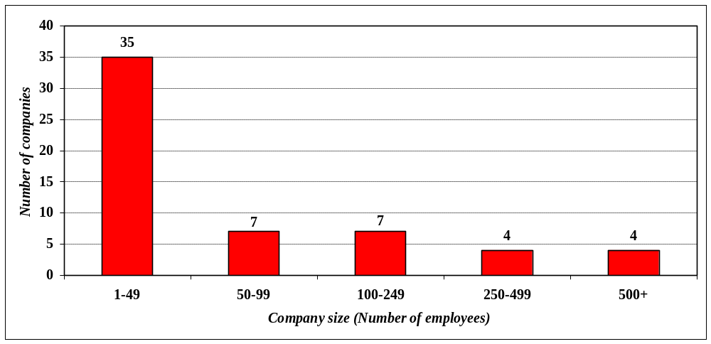
Source: Washington Biotechnology & Biomedical Association, 2002.

These small and emerging companies historically have made a critical contribution to innovation and early development of many novel devices. Often these small companies collaborate with larger companies to bring their products to market. Some small companies try to self-market new products, but there are significant barriers to entry including funding of research and development, manufacturing, and distribution. Unlike biotechnology, medical device product life cycles are relatively short because device makers are continually developing smaller, faster, and cheaper improvements of existing devices. In addition, patent protection of a new technology can often be challenged or circumvented, with no analogous patent to a biotechnology company’s “composition of matter” patent on the compound itself.

As in biotechnology, new products are the engine of growth in the medical device industry. Fueled by aggressive R&D spending and increasing investment in new medical technologies, a plethora of new sophisticated medical devices have come on the market in recent decades. Smaller start-up companies originally developed many of these new products. In Washington State, two-thirds of the medical device companies were started since 1990 (Figure 13).

Figure 13. Washington Medical Device Companies by Year Founded
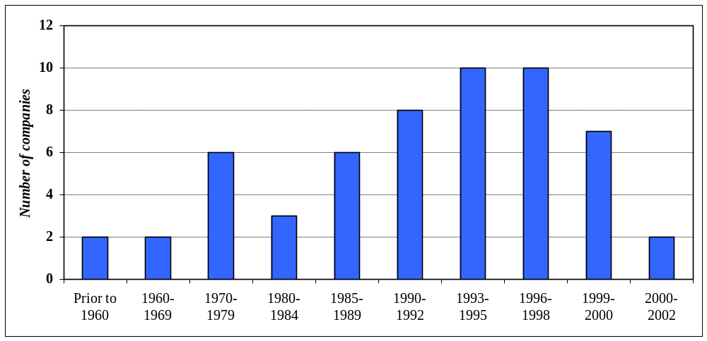Source: Washington Biotechnology and Biomedical Association, 2002

Medical device firms greatly benefit from basic biosciences research funded by the National Institutes of Health and other federal agencies. Collaboration between universities and medical device companies continues to increase with technology transfer, sponsored research, and license agreements. One of the early significant events within the Washington medical device industry was a 1974 technology transfer agreement reached between the University of Washington and Advanced Technology Labs, laying the groundwork for the rise of the ultrasound diagnostics segment in Washington State.

Private medical device companies fund the majority of research and development costs and rely on strong intellectual property rights to protect this research investment. As in biotechnology, any new device requires clinical studies to show the device is safe and effective, which are then submitted to the Federal Drug Administration (FDA) for review. If the device obtains FDA approval, the medical device company will generally seek Medicare coverage and payment from the Centers for Medicare & Medicaid Services. The speed of technology adoption often depends on a combination of clinical benefit data, regulatory decisions, and distribution.

The U.S. medical device industry is the recognized global leader. U.S. products account for close to half of the world’s medical device market, and leading U.S. manufacturers often generate roughly half of their total sales abroad. In recent years, export growth has benefited from the development of increasingly sophisticated medical devices and an increasing emphasis by foreign governments to improve the quality of healthcare for their citizens.

The high volume of Washington medical device exports is a major contributor to the state’s economy. The value of Washington medical device exports of $420 million in 2001 surged 21 percent over 1999, outpacing export growth nationwide. Washington biotechnology exports are relatively modest at $8 million (Figure 14). Most of the medical device exports leaving Washington are bound for Europe, North America (Canada and Mexico) or Asia. In 2001, these regional markets accounted for over 92 percent of all medical device (and biotechnology) exports from Washington (Figure 15).

Figure 14. Recent Trends in Washington State’s Biotechnology and Medical Devices Exports, 1999-2001
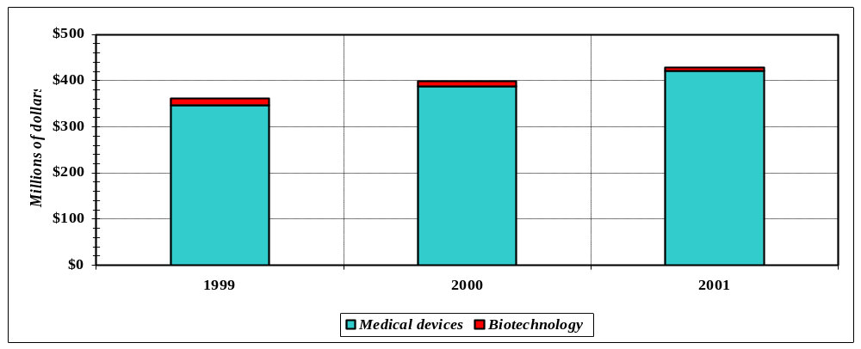
Sources: Washington State Community, Trade & Economic Development Department, International Trade Division; U.S. Bureau of the Census.

Figure 15. Value of Washington’s Biotechnology & Medical Device Exports by Region of the World, 2001
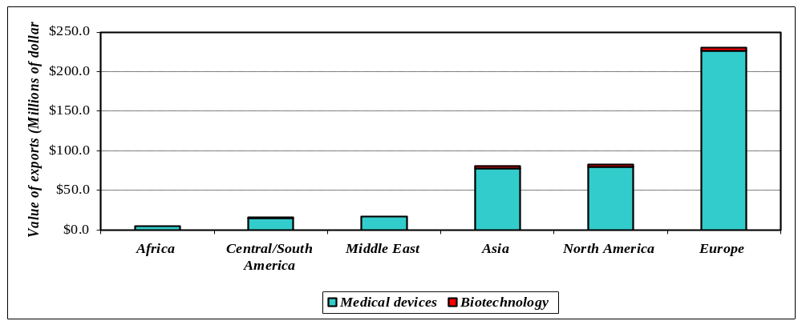
Notes: Central/South America includes Caribbean; Europe includes former Soviet republics; Asia includes Australia
Sources: Washington State Community, Trade & Economic Development Department, International Trade Division; U.S. Bureau of the Census.

III. Impact of Biotechnology and Medical Devices on the Washington Economy
The biotechnology and medical device industry represents a relatively small portion but dynamic part of the Washington State economy. Combined, these sectors of biotechnology and medical devices have significantly outperformed the Washington economy (Figure 16). Since 1990, employment in biotechnology and medical devices has grown at an average annual rate of 10 percent, compared to only modest statewide growth in total employment and actual decline in manufacturing.

Figure 16. Employment Indices in Washington State, 1990-2001
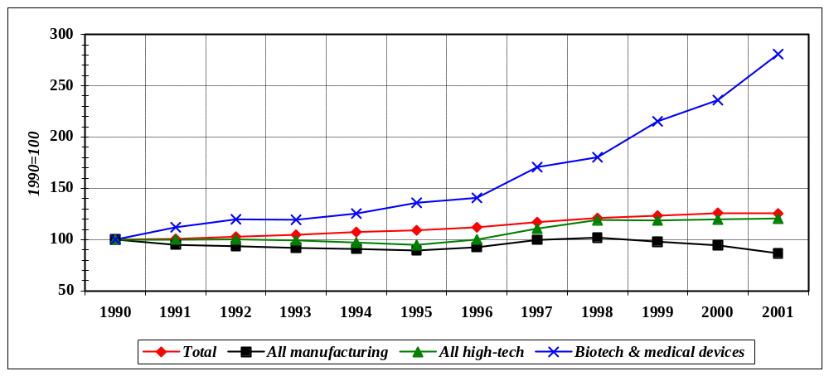Source: Washington State Employment Security Department, Labor Market & Economic Analysis Branch.

As stated earlier, government information sources do not permit the separation of traditional pharmaceutical activities from those based on biotechnology. Statistics above combine the biotechnology, medical device and commercial physical research. So defined, Washington’s biotechnology and medical device industry makes a substantial contribution to the state’s economy. According to the Washington Employment Security Department, Washington’s biotechnology and medical device industry employed over 22,330 people in over 680 establishments, earning direct wages of over $1.44 billion dollars. These are particularly well-paying jobs, thus stimulating employment in a number of other industries within the state. Biotechnology and medical device workers are some of the highest paid workers in Washington State (Table 6). On average, each worker in biotechnology and medical device industry earned $64,600 in 2001; nearly double that of the statewide average of $37,500. Pharmaceutical preparation manufacturing workers, with average annual wages of $116,600, represent the highest paid manufacturing workers in Washington State.

Table 6 Washington Biotechnology and Medical Device Industry, 2001
 |  |  |  | Total | Average
NAICS |  | Establish- |  | Wages | Annual
Class | Sector | ments | Employment | ($000) | Wage
 | Biotechnology
54171 | R&D--physical, engineer. & life sciences | 538 | 14,802 | 914,771 | $61,800
3254 | Pharmaceutical & medicine mfg. | 58 | 2,319 | 208,298 | $89,822
325411 | Medicinal & botanical mfg. | 12 | 238 | 7,472 | $31,395
325412 | Pharmaceutical preparation mfg. | 22 | 1,484 | 173,028 | $116,596
325413 | In-vitro diagnostic substance mfg. | 14 | 310 | 14,937 | $48,184
325414 | Biological product mfg. | 10 | 287 | 12,861 | $44,812
 | Total, biotechnology | 596 | 17,121 | 1,123,069 | $65,596
 | Medical devices
334510 | Electromed. & Electrotherapeutic mfg. | 24 | 4,023 | 270,654 | $67,277
334517 | Irradiation apparatus mfg | 4 | 130 | 8,580 | $66,000
339112 | Surgical & medical instrument mfg. | 22 | 275 | 14,580 | $53,018
339113 | Surgical & medical supplies mfg. | 37 | 781 | 24,698 | $31,624
 | Total, medical devices | 87 | 5,209 | 318,512 | $61,146
 | Total, biotechnology & medical devices | 683 | 22,330 | 1,441,581 | $64,558
Sources: Washington Employment Security Department, Labor Market & Economic Analysis Branch; and U.S. Bureau of Labor Statistics.

Another gauge utilized for assessing an industry’s economic contribution are taxes generated. In 2001, biotechnology and medical devices added $24.6 million to the state tax coffers. Similar to other states, biotechnology and medical device companies in Washington State have been eligible for research and development credits and sales and use tax deferral. For the first five years of the program (1995-1999), biotechnology and medical device firms took R&D credits totaling $54.4 million, or about 60 percent of tax revenues generated (Figure 17). Although state tax collections for the industry have increased between 1994 and 2001, the growth is more a function of increased gross revenues than increased rates. The share of state taxes paid by the industry is less than its share of total employment.

Figure 17. Washington State Taxes Collected from Biotechnology & Medical Device Firms, 1994-2001

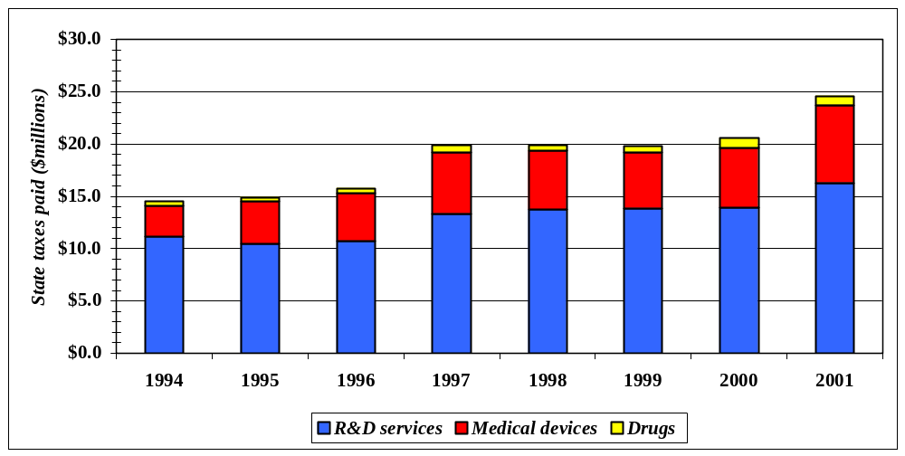Source: Washington State Department of Revenue.

Based on survey results directly from Washington-based biotechnology and medical device companies, employment growth within the combined industry has been substantial between 1990 and 2002 (Figure 18). During those years, total employment in the industry nearly tripled, with an average annual growth rate of 9.5 percent.

Figure 18. Biotechnology and Medical Device Employment in Washington State, 1990-2002
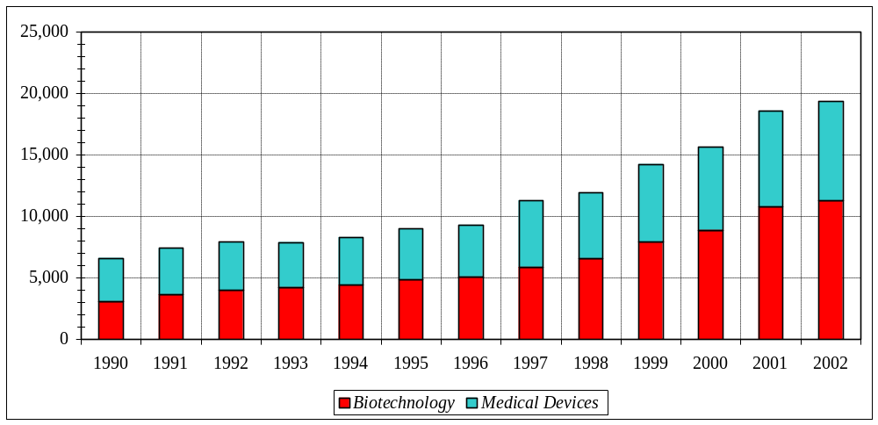Source: Washington Biotechnology and Biomedical Association

While the biotechnology and medical device industry may not represent one of the largest production sectors in the state, its aggregate impact on the state’s economy is far greater as many firms depend on the purchases of biotechnology and medical device companies and their employees.

The total economic impact of biotechnology and medical device industry is comprised of three components: direct, indirect, and induced impacts. The direct impacts are those directly attributable to biotechnology and medical device companies—their employees, revenues, and wages. In 2002, biotechnology and medical device companies employed about 19,400 workers with estimated salaries and wages of $1.32 billion and produced output (revenues) estimated at $1.85 billion.

In addition to the direct impacts of biotechnology and medical devices, the industry generated jobs, wages and salaries, and revenues through a number of indirect and induced impacts. Indirect impacts are the result of purchases made by the biotechnology and medical device sector from other industries. To operate, biotechnology and medical device companies create economic activity in other companies, such as computer and equipment manufacturers, contract research organizations (for clinical trials), and intellectual property legal firms. The revenues and associated employment and wage and salaries of these industries generated by the activities of the biotechnology and medical device industry are called the indirect impacts. The induced impact of the biotechnology and medical device industry are generated by the purchases of workers and owners in the biotechnology and medical device industry as well as supporting industries. These employees and their owners purchase goods and services in the general economy with the salaries and capital gains they earn. The revenues and associated employment and wage and salaries generated by these purchases are called the induced impacts. The sum of the direct, indirect, and induced impacts is the total economic impact of biotechnology and medical device industry.

As shown in Table 7, biotechnology and medical device companies in Washington directly employed 19,360 workers, but their purchases from other companies and the spending of their employees generated another 43,170 jobs, so that the total job generation attributable to the biotechnology and medical device industry is 62,530. In other words, there is an employment multiplier of 3.23, so that each job within the biotechnology and medical device industry generates another 2.23 jobs within the larger state economy.

Table 7. Economic Impact of Biotechnology & Medical Device Industry, 2002
 | Direct | Total | Implied
Measure | Impact | Impact | Multiplier
Employment | 19,360 | 62,530 | 3.23
Labor income* ($millions) | $1.316 | $2.961 | 2.25
Value added ($millions) | $1.652 | $3.503 | 2.12
Note: * Labor income includes both wages and salaries and proprietor income.
Sources: Washington State Input-Output Study; IMPLAN.

Similarly, labor income of biotechnology and medical device companies’ workers totaling $1.32 billion generated another $1.64 billion throughout the Washington economy. The combined biotechnology and medical device industries’ contribution to the Washington Gross State Product was $3.5 billion, about 1.5 percent of estimated total gross state product in 2002.

IV. Biotechnology and Medical Device Industry Clusters in Washington
Industry clusters are simply defined as groups of firms within one industry based within a common geographic area. Concentration and localization is typical of several types of industries. A number of industries have been founded through particular circumstances and these initial events have had large and long-lasting regional effects through the cumulative growth process of that industry. These localized features may be a new process or specialized set of inputs, a skilled labor pool related to that process, or more recently, technology and knowledge spillovers from high-technology industry sectors.

This phenomenon of concentration and localization of industries—which in regional economic development policy circles is now referred to as clusters—is certainly not a recent one. Clustering includes both the phenomenon of a critical mass of one industry sector developing in one place such that other firms within that same sector are attracted to that location, and the force of attraction that a core sector has on auxiliary sectors of that same industry to that location.

Washington’s biotechnology and medical device industry has clustered in and around academic centers and research institutes of excellence. Eight out of every ten biotechnology and medical device companies are found in King and Snohomish Counties (principally Seattle, Bothell, and Redmond). The Seattle-Tacoma-Everett metropolitan area is recognized as one of the top ten biotechnology clusters in the nation. Other biotechnology and medical device clusters in Washington are located in Spokane and the Tri-Cities area (Figure 19). These clusters involve more than the critical mass of firms from these core sectors of biotechnology and/or medical devices; firms from auxiliary sectors—suppliers, specialized services—are attracted to these same areas. Besides the mutual locational attributes between biotechnology and medical devices are important linkages with electronics, precision metal makers, plastic manufacturers, software developers, and specialized legal, accounting, and financial investment (e.g., venture capital) services.

Cluster analysis of the biotechnology and biomedical device industry found significant strength in industry linkages as well as impacts on the wider statewide economy. Such linkages provide a measure of relative strength in stimulating expansion within the regional economy, as both a driver of the local economy as well as key supplier to goods and services to other industries in the region. These linkages are both internal—intra-cluster and external to the wider economy.

Figure 19. 2002 Washington Biotechnology & Medical Device Employment by Region
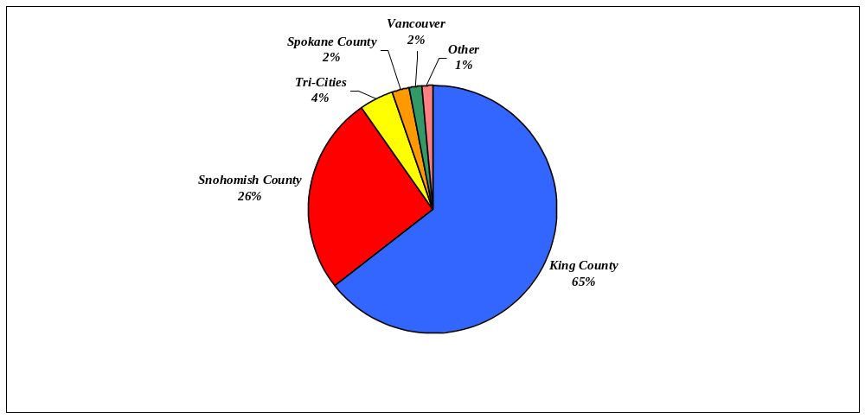Source: Washington Biotechnology & Biomedical Association, 2002.

A critical component of the biotechnology and medical device industry is basic research and development activities within academic and research institutes. The biotechnology and biomedical device industry is a research and development powerhouse in the state and has acted as a magnet for private companies. Significant federal funds from the National Institutes of Health exceeding $650 million flow into the University of Washington, Fred Hutchinson Cancer Research Center, Washington State University, Seattle Biomedical Research Institute, Virginia Mason Research Center, and Battelle Pacific Northwest Laboratory. Basic university and research institute science is integral to the successful commercialization of discoveries within biotechnology and medical device industries. Collaboration between academic and corporate scientists has had (and will continue to have) a significant effect on the biotechnology and medical device industry. Recent findings (Zucker et. al., 1998) indicate that the location of top scientists and research/academic institutes is a good predictor for where new technology firms will locate. The growth and location of the biotechnology and medical device industry were dependent upon the growth and location of intellectual capital. Intellectual capital flourishes around the great universities, but the existence of outstanding scientists (i.e., “star scientists”) is even more significant than burgeoning government funding. Local venture capital was also found to be important to the growth of the biotechnology and medical device industry.

Washington State Biotechnology and Medical Device Industry Clusters
Critical locational factors that encourage biotechnology and medical device industry clusters reside in certain regions of Washington State. For this knowledge-based industry, one of the most critical factors is a strong science base with leading research organizations and academic institutions, a critical mass of researchers (as well as employment opportunities) and a highly skilled labor pool. Biotechnology and medical devices companies, however, operate within two spheres: science intelligence—basic research conducted at universities and institutes; and business acumen—the ability to introduce new products valued by the marketplace. Equally critical to enhancing cluster activity is an attractive entrepreneurial culture, whose substance includes commercial awareness and entrepreneurship within research and academic institutes, encouragement and recognition of entrepreneurs, and a thriving mix of spin-off and start-up companies. Other important locational factors for biotechnology and medical device cluster development include available specialized facilities (e.g., wet laboratory space, specialized equipment, incubators) and infrastructure; local availability of finance; specialized business support services and large companies in ancillary sectors (e.g., healthcare, chemicals, high-technology); effective networks provided by industry trade associations; and supportive local and statewide policies.

A. Seattle-Redmond-Kirkland (King County) Cluster
Seattle-King County represents one of the top ten biotechnology clusters in the United States. Home to major world-class research centers as the University of Washington, and Fred Hutchinson Cancer Research Center, and the Institute for Systems Biology, Seattle received $617.6 million in National Institutes of Health (NIH) research funds in 2002, placing it sixth of all cities in the nation. Ninety-five percent of Washington State’s total NIH grants of $648.7 million flow to academic institutions, research centers, and companies located in Seattle (Figure 20). Among all public universities, the University of Washington is top-ranked with $389.6 million in grants; and the Fred Hutchinson Cancer Research Center, with $161.0 million in NIH funds, ranks first among all research centers in NIH support.

These academic and research centers have attracted a number of world-leading scientists (including three Nobel laureates in medicine) and a critical mass of researchers, making these institutes a significant growth engine for the biotechnology and medical device industry. Half of the estimated 7,300 biotechnology workers in Seattle are based in research institutions. The University of Washington and Fred Hutchinson Cancer Research Center have also become rich seed-beds for the biotechnology and medical device industry, spawning a number of biotechnology and medical device start-ups over the years. Indeed, University of Washington Regent William H Gates II asserts “that the University of Washington has been incredibly significant in creating the medical equipment and biotechnology industries in the state” (Walters, 1999).

Figure 20. Seattle’s Share of Total Washington State’s Funding from National Institutes of Health, FY 2002
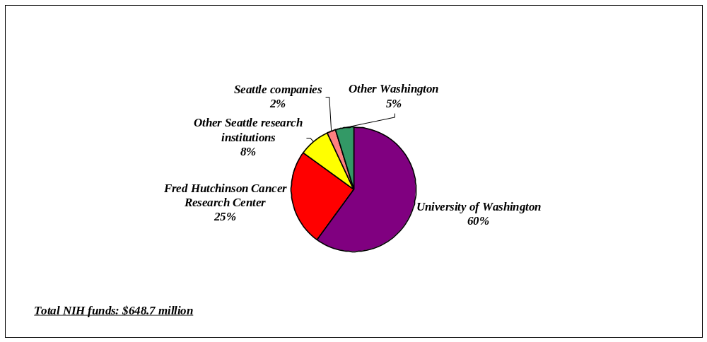
Source: National Institutes of Health

Overall, the biotechnology and medical device industry in King County has more than tripled in size since 1990 (Figure 21). Currently, there are 125 companies within the Seattle-King County biotechnology and medical device cluster employing 12,500 people, with more that one-third of the companies (49) formed in the last five years. Specialized support services, suppliers, customers, manufacturers of complementary products, supporting network agencies, and workforce education and training institutions are well-established in the region.

Figure 21. King County Biotechnology & Medical Device Employment, 1990-2002
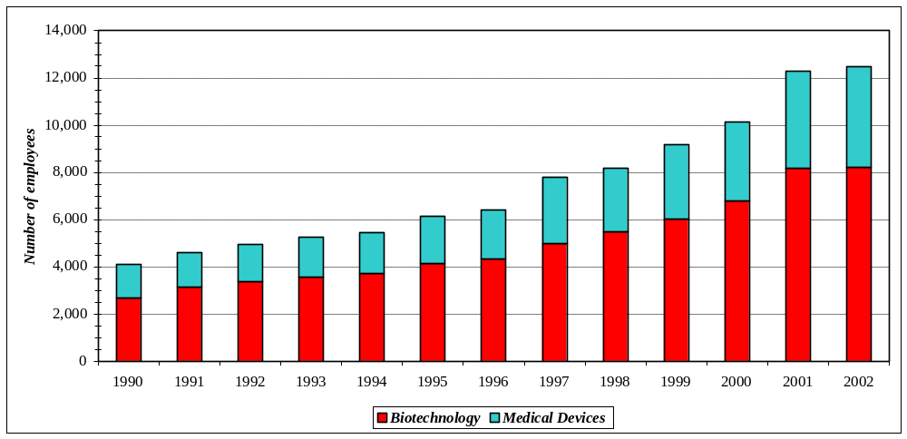
Source: Washington Biotechnology and Biomedical Association.

Although there are pockets of biotechnology and medical device activity scattered throughout King County, the hub of the industry is located in Seattle (Figure 22). Three out of every five biotechnology and medical device workers are employed in Seattle-based research institutes and companies.

Figure 22. Biotechnology and Medical Device Industry Employment by King County City, 2002
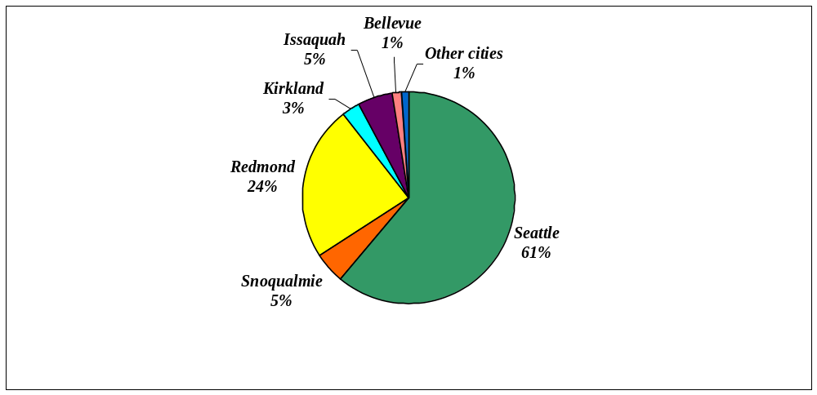
Source: Washington Biotechnology and Biomedical Association.
The vast majority of these Seattle-based institutes and companies are classified as biotechnology (Figure 23). Medical device firms are mostly located in the eastside cities of Redmond, Issaquah, and Snoqualmie.

Figure 23. Biotechnology and Medical Device Employment by City in King County, 2002
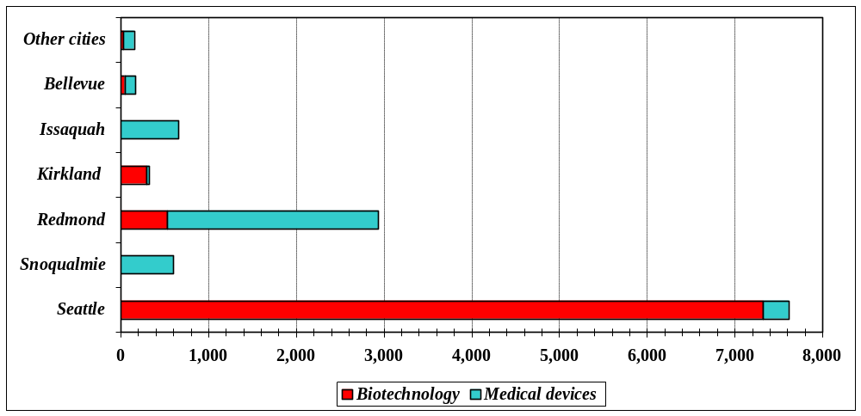

B. Bothell-Snohomish County Cluster
In 2002, 35 companies in Snohomish County employed 5,000 workers in the biotechnology and medical device industry. The vast majority (86 percent) of these firms and associated employment (93 percent) are located in Bothell. This cluster has a mix of mature medical device firms and start-up biotechnology companies. Although this suburban county lacks leading research organizations, the region has a branch campus of the University of Washington and two community colleges with specialized biotechnology training programs. Good quality specialized facilities, a highly skilled-highly trained workforce, and an effective network of economic development and trade associations have encouraged the growth of the industry. Since 1990, biotechnology and medical device industry employment in Snohomish County has more than doubled (Figure 24).

Figure 24. Snohomish County Biotechnology & Medical Device Employment, 1990-2002
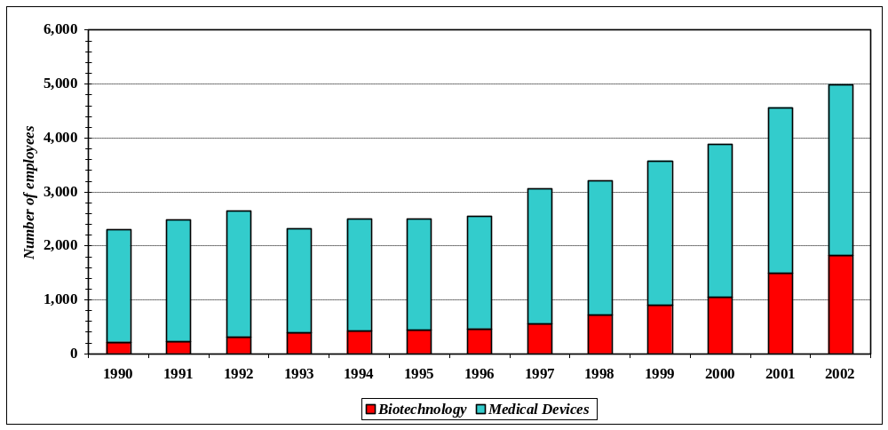
Source: Washington Biotechnology and Biomedical Association.

C. Tri-Cities Region Cluster
Home of a federally-supported national laboratory, the Tri-Cities has about 850 biotechnology and medical device industry workers. Recognition of this regional industry cluster is still one of conjecture, given the clear dominance of the Pacific Northwest National Laboratory. More than eight of every ten biotechnology and medical device workers in the region are employed at the national lab. Commercial awareness and spin-off opportunities, however, are being encouraged throughout the federal laboratory system with increasing evidence that supportive policies are paying dividends within the local economy (Figure 25). Of the eight biotechnology and medical device companies within the region, six companies were spawned by research conducted at the national laboratory.

D. Spokane Area Cluster
A nascent yet promising cluster with a good mix of leading research institutions and an effective network and skilled workforce, the Spokane area has seen substantial growth in biotechnology and medical device activity in recent years. Biotechnology and medical device employment is estimated at 450 workers which have more than doubled since 1990 (Figure 26). A sizeable share of the biotechnology-related activity is in contract manufacturing.
Figure 25. Tri-Cities Region Biotechnology & Medical Device Employment, 1990-2002
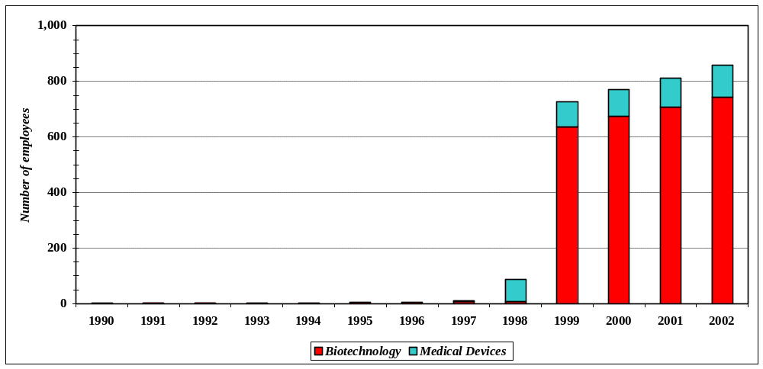
Source: Washington Biotechnology and Biomedical Association.

Figure 26. Spokane Biotechnology & Medical Device Employment, 1990-2002
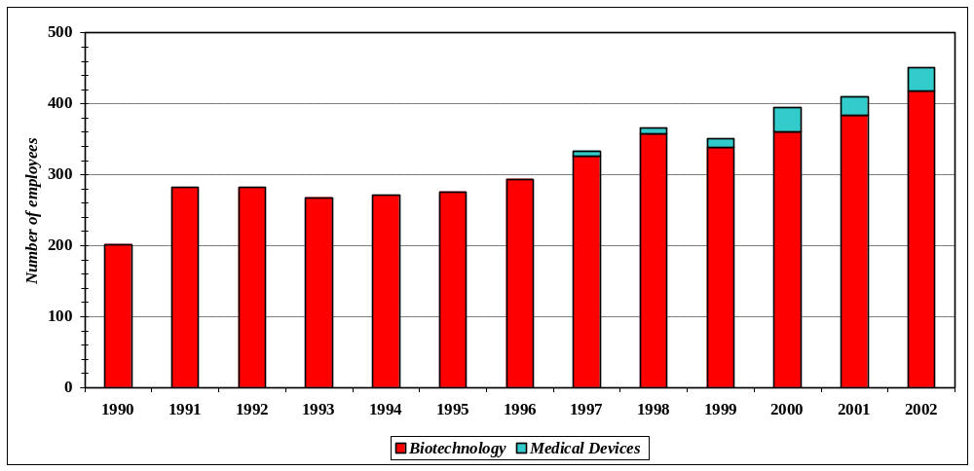
Source: Washington Biotechnology and Biomedical Association.

V. Policy Considerations
The growth and development of the biotechnology and medical device industry provides insights into how states—all now vying for a piece of the biosciences pie—can focus their efforts. The recipe for success, as illustrated in Washington State, starts with strong academic institutions and laboratories with a good research base. These institutions—University of Washington, Fred Hutchinson Cancer Research Center, Pacific Northwest National Laboratories, and Washington State University—have provided groundbreaking research and drawn top scientists to the state.

Another necessary ingredient is an attractive institutional framework that will aid technology transfer and/or commercialization of innovations arising from the research that will in turn foster start-up companies. In the long-run, firms will go where the research and start-ups are percolating.

The necessary conditions of knowledge, labor and capital for growing the biotechnology and medical device industry are increasingly evident within Washington State. Washington is a source of biotechnology and medical device innovation and already boasts a noticeable presence. Government and institutions can aid in the growth of biotechnology and medical devices by making strategic investments and removing barriers. Competition is significant as illustrated from a recent report on state government initiatives in biotechnology (Table 7).

Table 7. State Policy Initiatives in Biosciences, Washington and Other States
State Initiative | CA | GA | MD | MA | NJ | NY | NC | OR | PA | TX | WA
1. State biosciences strategy |  | x | x | x |  | x |  | x
2. Increased state funding of
academic biosciences research centers | x | x | x | x | x | x | x |  | x | x
3. Publicly supported bioscience seed
and venture funds | x |  | x | x |  | x | x | x | x | x
4. Facilities financing for companies | x |  |  | x | x |  | x |  | x | x
5. State tax policies | x | x | x | x | x | x | x | x | x | x | x
6. State financed biosciences research
parks and incubators | x | x | x | x | x | x | x | x | x | x
7. Commercialization & business
development initiatives for bioscience | x | x | x | x | x | x | x |  | x | x | x
8. Workforce development programs | x |  | x |  | x | x | x | x | x | x | x
9. Networking | x | x | x | x | x | x | x | x | x | x | x
Source: Battelle Memorial Institute. State Government Initiatives in Biotechnology, 2001.

Is Washington doing enough to capitalize on the state’s position in the growing biotechnology and medical device industry? Washington’s share of the biotechnology and medical device marketplace is strong by some measures, but falls short in others. Home to many world-class research institutions with a critical mass of “star scientists” achieving path-breaking discoveries in biotechnology and medical devices, Washington can and should be the location of choice for new private sector biotechnology and medical device research and development and manufacturing. The biotechnology and medical device sector holds great promise as an economic development engine. With Washington’s signal achievements in basic and applied research in biosciences, the state stands to lose significant ground if it remains passive in its support.

Many states understand that the economic returns from public investments in biotechnology and medical devices are likely to be dramatic. Hence, many states are becoming more active than Washington in supporting and growing the industry with initiatives ranging from building state-of-the-art research laboratories and research parks and incubators to investing seed and early-stage venture capital and improving workforce developments. Even in Washington State’s arenas of comparative advantage for this knowledge-centered industry—academic and research institutions—other states are making significant strides in funding for academic research. Consider California—the nation’s leading biotechnology state—where the state legislature funded $100 million (with $200 million of matching private sector funds) to establish an institute for biotechnology, bioengineering, and biomedical research and innovation. Or Georgia, which recently established a $300 million biosciences research fund underwriting endowments for faculty research and facilities. Many states want to achieve the maximum possible benefit from basic and applied research in their academic centers and institutes.

The state economy gains much more from biotechnology and medical devices if scientific discovery is connected with the commercial marketplace. Recipient universities and research institutes must devote significant resources to the difficult task of transferring newly-acquired knowledge to spin-offs and start-ups. And, in order to achieve the maximum possible benefit from the initial basic research investment, ventures based on new discoveries must be located within the state. Support for technology-based start-ups in biotechnology and medical devices is critical to maximizing the economic return to the residents of Washington State.

Other leading states—California, Massachusetts, and Maryland—have established bioscience venture capital funds for early-stage funding of biotechnology and medical device companies. These states recognize biotechnology and medical device start-ups’ need for financial capital with the potential pay-off of “home growing” the industry’s next Amgen or Medtronic. Despite state constitutional prohibitions, Washington cannot remain passive in this heightened state competition for biotechnology and medical devices. Otherwise, there is good question whether the state will be able to sustain its recent growth rates or maintain its market share in the future.

Washington can capitalize on its already-established biotechnology and medical device assets by making strategic investments in basic and applied research at the state’s major research institutions, developing a highly-trained and skilled workforce, and supporting the critical link where research innovation and commercialization are strong.

More specifically, Washington State public policy needs to address those issues that support and nurture the biotechnology and medical device industry. Such issues represent in part a return to the discussion on the locational factors that support and encourage cluster development of the biotechnology and medical device industry. The implementation of successful programs elsewhere provide some policy guidance here in Washington Such elements could include:

- Promote Washington as a place for biotechnology and medical device research and manufacturing. Other states promote their products and services. Washington needs to make strides to counter the perception that it is not friendly toward business. Furthermore, Washington—like most states—fails to champion its highly-skilled, highly-trained workforce for this knowledge-intensive industry.

- Develop a formal liaison between the industry and the state’s legislative and executive branches. Forging such a relationship could provide a conduit of information between the biotechnology and medical device community and the state government, particularly in informing state policy makers about issues pertinent to the industry’s health and competitiveness relative to other states, all of which are vying for an increased share of the industry. For example, how do tax provisions that affect the industry, such as research and development tax credits, compare with other leading biotechnology and medical device states of California, Massachusetts, Maryland, New York, Pennsylvania, North Carolina, Oregon and so on?

- Solicit a three-way partnership between the state, industry, and university in creating institutes for science and innovation. Such institutes will focus on a particular research field critical to the future of Washington’s economy. For biosciences, collaboration between private industry and researchers will generate new knowledge about atoms, protein molecules, cells, tissues, organs, and the entire human organism, setting the stage for new discoveries, technologies, and products benefiting human health and fostering growth within the biotechnology and medical devices industry. Related, a nanosystems institute could leverage the expertise of industrial researchers and scientists to explore the increasing power of manipulating structures atom-by-atom for engineering new materials, devices, and processes to improve every aspect of our lives.

- Improving the structure for commercializing innovation, including skilled staff in licensing and a physical facility to serve new ventures formed from the initiative. A number of states are investing directly in research and technology parks and incubators to foster commercial awareness and entrepreneurial culture, and cultivate home-grown start-up companies.

- Address the issue of high cost of doing business in Washington as an obstacle to growth. There is some consolation that the cost of living in other leading biotechnology and medical device states such as California, Massachusetts and Maryland is also high. Policy makers, however, must address underlying causes of high business cost. While not immediately apparent, the high cost of housing within the Puget Sound region is partially a result of disparities between municipalities in the quality of their public schools. Washington has some excellent public K-12 systems, but the quality of each school system depends on the individual community. Statewide improvements in the K-12 system can have a positive effect on housing and make a wider set of communities more attractive to families with children. Biotechnology and medical device companies will find it easier to recruit workers to Washington from other regions. Other related issues address the public infrastructure requirements for the industry and its workers.

- Revisit the state’s existing program of research and development credits and tax deferrals for the biotechnology and medical device industry. While Washington does provide tax deferrals for high-technology companies, carry-over provisions may not be long enough. In addition, the state’s research and development credits need to be expanded to include those expenses involved in prototype manufacturing and small-lot product manufacturing. Such an expansion would assist firms in the state to produce product more reliably and cost effectively, and perhaps most important, lay the groundwork for eventual full production within the state.

- Encourage the development of an early-stage venture capital fund for Washington-based biotechnology and medical device companies. A number of new private start-ups in biotechnology and medical devices lack access to early-stage capital. Building and sustaining a critical mass of biotechnology and medical device companies is unlikely without access to early-stage financial capital.

In the absence of Washington State providing any significant support to the biotechnology and medical device industry, it would be highly prudent for state policy makers to avoid harming the policy environment and business climate. Poorly written prescription drug legislation, cuts in higher education, and limitations on existing modest tax incentives, for instance, would directly harm prospects for future industry growth in Washington State.
VI. Outlook for Biotechnology and Medical Device Industry in Washington State
Washington biotechnology and medical devices form a large part of the state’s vibrant biosciences sector. Washington is one of the leading states in biotechnology and medical devices, providing good jobs that employ highly-paid research scientists, engineers, and production workers. Through its links with other sectors, biotechnology and medical devices comprises an important part of Washington’s high-technology economic base.

One future scenario for this sector is one of continued trend growth, supported by growing worldwide demand for health services and the state’s comparative advantages in research and discovering new technologies. For such a scenario, Washington expects increased employment in biotechnology and medical devices with an annual growth rate of 6.4 percent over the next few years (Figure 23). By 2005, total employment in the biotechnology and medical device sector will exceed 23,000 workers. Such sterling industry growth rates under this scenario dwarf those forecasted for statewide employment. Between 2002 and 2005, the Washington State Forecast Council projects that state jobs will grow by only 1.5 percent annually.

Figure 23. Washington Biotechnology and Medical Device Industry Employment Forecast, 2002-2005
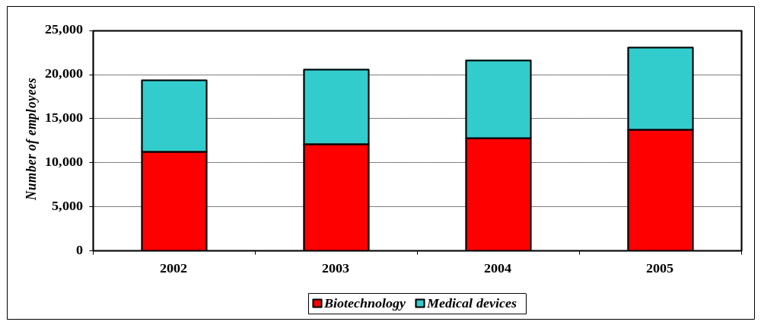

Whether Washington realizes this robust growth sector remains an open question. In order to ensure the future success of the biotechnology and medical devices sector—and the state’s economy as a whole—Washington public policy should focus on increasing support for the industry, facilitating collaboration between industry and universities research institutes, and promoting Washington as a place to conduct business.

With continued passive state involvement, however, a counter scenario with limited industrial growth prospects is increasingly plausible. Indeed, some view the biotechnology and medical device industry to be at a critical juncture in its history. Once upbeat with rosy forecasts, industry analysts are less sanguine about biotechnology and medical device growth prospects from earlier in the year. Medical devices—with shorter product approval spans—will continue to grow and keep the overall sector buoyant. Biotechnology companies, however, face a more daunting future. Consolidation will quicken apace within biotechnology and lack of early- and second-stage financial capital for product research and development will result in further job losses for private biotechnology firms in Washington. A more proactive public sector in Washington would prove to be crucial in propelling the biotechnology and medical device industry forward.

References

Battelle Memorial Institute. State Government Initiatives in Biotechnology 2001. Prepared for Biotechnology Industry Organization. Columbus, Ohio: Battelle Memorial Institute, Technology Partnership Practice, 2002.

Beyers, William B. and David P. Lindahl. The Economic Impact of Technology-Based Industries in Washington State in 2000. A report prepared by the Technology Alliance. Seattle, WA: Technology Alliance, June 2001.

Burrill, G. Steven. Life Sciences: State of the Industry. San Francisco: Burrill & Company, June 2002. http://www.burrillandco.com/presentation/bio_pdf.pdf

Carr, Geoffrey. “The Alchemists: A Survey of the Pharmaceutical Industry,” The Economist (February, 1998).

Center for Public Policy. An Analysis of Virginia’s Biotechnology Industry. Prepared for The Virginia Biotechnology Industry. Richmond, VA: Virginia Commonwealth University, Center for Public Policy, March 1999.

Centers for Medicare & Medicaid Services. National Health Care Expenditures Projections: 2001-2011. Hyattsville, MD: Centers for Medicare & Medicaid Services, Office of the Actuary, October 2002.

Chase, Robert A., Philip J. Bourque, and Richard S. Conway, Jr. The 1987 Washington State Input-Output Study. Prepared for the Washington State Office of Financial Management and Washington State Department of Transportation. Seattle, WA: University of Washington Graduate School of Business, 1993.

Clayton-Matthews, Alan. The Medical Device Industry in Massachusetts. A study prepared for the Massachusetts Medical Device Industry Council (MassMEDIC) and the University of Massachusetts Economic Project. Boston: University of Massachusetts Donahue Institute, 2001.

Cortright, Joseph and Heike Mayer. Signs of Life: The Growth of Biotechnology Centers in the U.S. Washington, DC: The Brookings Institution, Center on Urban and Metropolitan Policy, 2002.

Darby, Michael R. and Lynne. G. Zucker. “Growing by Leaps and Inches: Creative Destruction, Real Cost Reduction, and Inching Up.” Paper presented to the Science and Cents: Exploring the Economics of Biotechnology Conference, April 2002, Federal Reserve Bank of Dallas.

DiLorenzo, Frank. “Biotechnology,” Industry Surveys. New York: Standard & Poor’s, October 2002.

Ernst and Young. The Economic Contribution of the Biotechnology Industry to the U.S. Economy. 2001.

Ernst and Young. Beyond Borders: The Global Biotechnology Report 2002. New York: Ernst and Young, Health Sciences Group, 2002.

Gaisford, James D., Jill E. Hobbs, William A. Kerr, Nicholas Perdikis and Marni D. Plunkett. The Economics of Biotechnology. Cheltenham, UK: Edward Elgar, 2001.

Gardner, Kent. “Will NYS Miss the Biotech Train?” Close-up on the NYS Economy (1st Quarter, 2001). Rochester, NY: Gleason Center for State Policy.

Gillis, Malcolm. “Harvesting New Technologies for the 21st Century,” Paper presented to the Science and Cents: Exploring the Economics of Biotechnology Conference, April 2002, Federal Reserve Bank of Dallas.

Gold, Robert. “Healthcare: Products & Supplies,” Industry Surveys. New York: Standard & Poor’s, October 2002.

Grabowski, Henry. “Patents and New Product Development in the Pharmaceutical and Biotechnology Industries,” Paper presented to the Science and Cents: Exploring the Economics of Biotechnology Conference, April 2002, Federal Reserve Bank of Dallas.

Johnson, Daniel K.N. and Milena Mareva. It’s a Small(er) World: The Role of Geography and Networks in Biotechnology Innovation. Working Paper 2002-01. Wellesley, MA: Wellesley College, Department of Economics, January 2002.

Lawlor, Michael S. “Biotechnology and Government Funding: Economic Motivation and Policy Models,” Paper presented to the Science and Cents: Exploring the Economics of Biotechnology Conference, April 2002, Federal Reserve Bank of Dallas.

Minnesota Implan Group (MIG), Inc. IMPLAN Professional™, Version 2.0. 2000.

National Center for Health Statistics. Health, United States, 2002: with Chartbook on Trends in Health of Americans. Hyattsville, MD: National Center for Health Statistics, September 2002.

National Institutes of Health. NIH Extramural Awards by State and Foreign Site. 2002. website: http://grants.nih.gov/grants/award/state/state.htm

Paugh, Jon and John C. Lafrance. Meeting the Challenge: U.S. Industry Faces the 21st Century: The U.S. Biotechnology Industry. Washington, DC: U.S. Department of Commerce, Office of Technology Policy, July 1997.

Porter, Michael. Clusters of Innovation: San Diego. Washington DC: council on Competitiveness, April 2001.

Preverzer, Martha. “The Dynamics of Industrial Clustering in Biotechnology,” Small Business Economics (1997) 9: 255-271.

PriceWaterhouseCoopers, Venture Economics, and National Venture Capital Association. MoneyTree™Survey of Venture Capital Activity, 2002.
website: http://www.pwcmoneytree.com/moneytree/index.jsp

Rosenfeld, Stuart. A Governor’s Guide to Cluster-Based Economic Development. Washington, DC: National Governors Association, 2002.

Thompson, John, Mine K. Yucel, and John V. Duca. “The Economic Impact of Biotechnology,” Southwest Economy (March/April, 2002): 1, 6-10, 20.
http://www.dallasfed.org/htm/pubs/pdfs/swe/swe02_2b.pdf

Tripp-Umbach & Associates. Assessment of Opportunities for Biomedical Economic Development in Spokane and the Inland Northwest. Report prepared for Inland Northwest Technology Education Center, Inland Northwest Health Services, The Spokane Regional Chamber of Commerce, and Washington State University in Spokane. Pittsburgh, PA: Tripp-Umbach & Associates, July 2002.

Tufts Center for the Study of Drug Development. Outlook 2002: R&D Efficiency, Regulatory Environment, Biotechnology Trends, Prescription Drug Policy. Boston, MA: Tufts Center for the Study of Drug Development, 2002.

U.S. Patent and Trademark Office. United States Patent Grants by State and Technology. Washington, DC 2002.
website: http://www.uspto.gov/web/offices/ac/ido/oeip/taf/reports.htm

van der Walde, Lambert and Kristen Choi.. Health Care Market Update: Medical Device and Supply Manufacturers. Hyattsville, MD: Centers for Medicine & Medicaid Services, Office of Research, Development, and Information, October 2002.

Walker, Meredith M. “Biotech Bonanza: Prospects for Texas,” Southwest Economy (July/August, 1999) 4:1-7.
http://www.dallasfed.org/htm/pubs/pdfs/swe/swe99_4.pdf

Walters, Kenneth D. “University Startup Companies Pick Up the Pace.” Northwest Science & Technology (Spring 1999): 12-15.

Walters, Kenneth D. University of Washington: Engine of the Knowledge-Based Economy. Seattle, University of Washington, 2001.

Washington State Department of Revenue. High-Tech R&D Tax Incentives Study. Olympia, WA: Department of Revenue, Research Division, December 2000.
World Health Organization. World Health Report 2002: Reducing Risks, Promoting Healthy Life. Geneva, Switzerland: World Health Organization, October 2002.

World Health Organization. The World Health Report, 2002: Reducing Risks, Promoting Healthy Life. Geneva, Switzerland: World Health Organization, November 2002.

Zucker, Lynne G., Michael r. Darby, and Marilynn B. Brewer. :Intellectual Human Capital and the Birth of U.S. Biotechnology Enterprises,” American Economic Review (March, 1998) 88(1):290-306.
Appendix A:

Glossary of terms in Biotechnology(BT) and Medical Devices (MD)

Adjuvant: A substance capable of enhancing or boosting an immune response, making vaccines more effective. BT

Agonist: A drug that promotes certain kinds of cellular activity by binding to a cell’s receptor. BT

Amino acids: the building blocks of protein, which includes alanine, aspartic acid, glutamic acid, and some 17 additional compounds. BT

Angiogram: An x-ray image in which blood vessels can be seen, made possible by injecting special dyes (called contrast media) into a patient’s bloodstream. MD

Angioplasty: A surgical procedure that employs a balloon catheter threaded into a constricted blood vessel to widen it and improve blood flow. MD

Antagonist: A drug that prevents certain types of cellular reactions by blocking other substances from binding to a cell’s receptor. BT

Antibiotic: A drug that has the capacity to inhibit the growth or to kill microorganisms, such as bacteria or fungi. BT

Antibody: A protein produced by certain types of white blood cells to deactivate foreign proteins. BT

Antigen: Any substance that induces a body’s immune response. BT

Antisense: A drug that is the complementary image of a small segment of messenger RNA (mRNA), the substance that carries instructions from a cell’s genes to its protein-making machinery. The drug binds to the mRNA strand, keeping it from transmitting its instructions to the cell and inhibiting the production of an unwanted protein. BT

Arrhythmia: An abnormality in the rhythm or rate of the heartbeat. There are two main kinds: tachycardia, in which the rate is faster than normal (more than 100 beats a minute) and bradycardia, in which the rate is slower than normal (less than 60 beats per minute). MD

Arteriosclerosis: A thickening and loss of elasticity in artery walls. The most common kind of is atherosclerosis, in which the inner layer of the arterial wall thickens, narrowing the channel and impairing blood flow. MD

Assay: A test that measures a biological response. BT

Autoimmune disease: a condition such as multiple sclerosis where the body produces antibodies against its own tissues. BT

Bioavailability: the percentage of a drug’s active ingredient that reaches a patient’s bloodstream and body tissues. BT

Biochip: A miniaturized test, usually slides or chips etched with genetic information, used by researchers to analyze DNA sequences, ascertain gene or protein expression or detect single nucleotide polymorphisms (SNPs). Also known as microarrays or gene clips. BT

Bioinformatics: A system whereby biological information is collected, stored, and accessed via computers and similar other electronic media. BT

Biologicals: also known as biological drugs, biologicals are medicinal preparations made from living organisms or their byproducts. Vaccines, antigens, serums, and plasmas are examples of biologicals. BT

Biologics license application (BLA): the formal filing that drugmakers submit to the U.S. Food and Drug Administration (FDA) for approval to market new biologic-based drugs. The application includes extensive information regarding the chemistry, manufacturing, and control of the product; the labeling and packaging of the product; as well as the nonclinical and clinical testing and evaluation of the investigational drug. BT

Blood gas monitors: Instruments that determine the levels of oxygen and carbon dioxide in a patient’s blood. These levels must be monitored during the administration of anesthesia and in other operating room procedures. MD

Breakthrough device: A medical instrument that employs novel technology to treat or diagnose medical conditions. Typically, such devices target medical problems for which no other therapy is available. MD

Breakthrough drug: A compound whose mode of action is significantly different from that of existing drugs, representing a major therapeutic advance. BT

Cardiac catherterization: A technique use to assess heart vessels by threading a catheter (a thin tube) into the heart. MD

Cardiac pacemaker: A device that supplies electrical impulses to the heart to keep it beating at a regular rate. It consists of a small electronic device and power source connected to the heart by electrical wire. MD

Chemotherapy drugs: Drugs used to treat cancers. BT

Chromosomes: Microscopic, threadlike components in the nucleus of a cell that carry hereditary information in the form of genes. BT

Clinical trials: Studies that must be performed before a new drug or medical device can be approved by the FDA. The new product is administered to humans to determine their safety and efficacy. BT/MD

Clotting factors: Proteins involved in the normal clotting of blood. BT

Colony-stimulating factors: Proteins responsible for controlling the production of white blood cells. BT

Combination therapy: The use of two or more drugs that together have greater therapeutic power in treating illness and diseases than either used alone. BT

Computerized tomography (CT): A diagnostic technique that employs x-rays and a computer to produce cross-sectional images of body tissue; also known as computerized axial tomography or CAT scanning. MD

Coronary bypass: A surgical procedure in which an artery or vein taken from another part of the patient’s body is used to create an alternative passage around narrowed or blocked heart arteries. MD

Coronary stent: A small wire meshlike tube inserted into a coronary blood vessel to prevent arterial reocclusion following angioplasty. MD

Defibrillator: An electronic instrument that delivers a brief electric shock to restore normal rhythm to a malfunctioning heart. MD

Deoxyribonucleic acid (DNA): The basic molecule that contains genetic information for most living systems. The DNA molecule consists of four nucleotide bases (adenine, cytosine, guanine, and thymine) and a sugar-phosphate frame arranged in two connected strands forming a double helix. BT

Dialysis: A process by which waste products and excess fluids are removed from the body; used for patients suffering from kidney failure. There are currently two dialysis methods—hemodialysis, which removes wastes by passing blood through an artificial kidney machine; and pertoneal dialysis which makes use of a natural filtering membrane in the body’s abdomen. MD

Echocardiography: A diagnostic tool using ultrasound to detect heart abnormalities. MD

Electrocardiogram (EKG): A record of the heart’s electrical impulses; it is used to diagnose heart disorders. MD

Endoscope: An illuminated optical instrument that is inserted into body cavities for diagnostic and treatment purposes. MD

Enzyme: Protein that controls chemical reactions in the body. BT

FDA Modernization Act of 1997 (FDAMA). Reauthorized the collection of “user fees” by the FDA and amended the Federal Food, Drug and Cosmetic Act and the Public Health Service Act to improve the regulation of food, drugs, devices, and biological products, and facilitate the development and evaluation of new drugs and biologics designed to treat serious and life-threatening illnesses. BT/MD

Gene: The basic determinant of heredity, genes are chromosomal segments that direct the syntheses of proteins and conduct other molecular regulatory functions. BT

Gene sequencing: A scientific technique whereby DNA strands are decoded in order to quantify the exact order of DNA’s four nucleotides (A-adenine, C-cytosine, G-guanine, and T-thymine). This method allows scientists to analyze the sequence of strands and identify specific genes embedded in DNA. BT

Gene therapy: The introduction of specific genes into a patient’s body to replace defective ones or to suppress the action of a harmful one. BT
Genetically modified organism: An organism that has undergone changes in its genetic code by the methods of genetic engineering, natural processes, cloning, and mutagenesis. BT

Genome: The total complement of genetic material in a cell, comprising the entire chromosomal set found in each nucleus of a given species. BT

Genomics: The study of genes and their function, including mapping genes within the genome, identifying their nucleic acid structures, and investigating their functions. BT

Growth factors: Proteins responsible for regulating cell proliferation, function, and differentiation. BT

Human growth hormone: pituitary hormone that stimulates the growth of long bones in prebubertal children. BT

Immunomodulator: a drug that attempts to modify the immune system. BT

Interferon: A glycoprotein, produced naturally by cells, which interferes with a virus’s ability to reproduce after it invades the body. Interferon may curtail the spread of certain types of cancer. BT

Interleukin: A endogenous substance that stimulates the production of different types of white blood cells or leukocytes. BT

Investigational new drug (IND): Regulatory classification of an experimental new compound that has successfully completed animal studies and has been approved by the FDA to proceed to human trials. BT

Investigational device exemption (IDE): An FDA submission made by a medical device manufacturer to obtain permission for clinical trials on a potentially risky new product. MD

In-vitro diagnostics: Tests performed outside the body on blood, tissue, or other body substances. MD

In-vivo diagnostics: Tests performed in or on a patient’s body, such as an MRI scan or x-ray. MD

Macrophage: A type of white blood cell that is involved in the production of interleukin 1. These substances are being studied as potential anticancer therapies. BT

Magnetic resonance imaging (MRI): A diagnostic technique that provides high-quality cross-sectional images of organs and structures within the body; it does so with short bursts of a powerful magnetic field, rather than with x-rays or other radiation. MD

Managed care: A supervised system of financing and providing healthcare services for a defined population group. Health maintenance organizations (HMOs) are currently the most popular form of managed care. BT

Monoclonal antibodies: Large protein molecules produced by white blood cells, which seek out and destroy harmful foreign substances. BT

Mutagenesis: The introduction into a gene of an alteration that changes the structure or function of the gene product. BT

Nanotechnology: The application of findings of the interdisciplinary field of nanoscale science, which deals with objects as small as one billionth of a meter (nanometer). Refers to activity involving the measurement, manipulation, and fabrication of objects less than one to about 100 nanometers across. BT/MD

New drug applications (NDA): The formal filing that drugmakers submit to the FDA for approval to market new chemical-based drugs. The application must contain clinical evidence of the compound’s safety and efficacy. BT

Nucleic acid testing (NAT): A method of biological screening and diagnostic testing that entails amplifying DNA and RNA to identify diseases and infections. NAT is more accurate and faster than more traditional screens and is being used to test blood supplies for HIV and hepatitis infection. BT

Orphan drug: A drug designed to treat rare diseases afflicting a relatively small population (currently less than 200,000 cases). The FDA gives drugmakers exclusive rights to market these drugs for a period of time as an incentive to develop them. BT

Polymerace chain reaction (PCR): A method that simulates an environment for rapid DNA replication of specific DNA segments. This procedure results in multiple copies of the DNA sequence which are then used in various experiments for diagnostic and analytical purposes. BT

Premarket approval (PMA): The formal filing submitted to the FDA by medical device makers seeking approval to market an innovative (Class III) product—one that isn’t similar to anything already on the market. The document must contain clinical evidence of the device’s safety and efficacy. MD

Premarket notification /510(k) filing: A submission made to the FDA by a manufacturer of a new medical device/product that’s substantially equivalent to products already on the market. MD

Prescription Drug User Fee Act of 1992 (PDUFA). Legislation passed by Congress authorizing the FDA to collect “user fees” for regulatory review of human drug applications. The FDA agreed to use the income from the fees to hire more reviewers to speed up drug review without compromising review quality. BT

Priority review: An investigational drug receiving this status from the FDA will be reviewed by the agency within six months of its BLA or NDA submission. BT

Prodrug: An inactive compound that converts to an active agent through contact with a specific enzyme. BT

Proteome: The set of all proteins expressed by a genome. BT

Proteomics: The study of encoded proteins and their function, with an emphasis on the role that proteins may play in the development of disease. BT

Rapid exchange (RX): A feature available on balloon catheters, also known as monorail or rail, which allows for the easy exchange of the balloon catheter without removing the original guide wire. MD

Recombinant DNA technology: The process of creating new DNA by combining components of DNA from different organisms. Usually, the new DNA is then incorporated into therapeutic substances. BT

Recombinant soluble receptors: Synthetic versions of cellular receptors manufactured with recombinant DNA technology, used as decoys to attract pathogens that otherwise would bind to cellular receptors and cause disease. BT

Single nucleotide polymorphism (SNP): A variation in the sequence of a gene due to a change in a single nucleotide. BT

Stent: Tiny wire mesh tubes that are implanted into an artery, providing the necessary scaffolding to hold the artery open and ensure proper blood flow. The stent procedure has become common, sometimes used as an alternative to coronary artery bypass surgery. MD

Tissue culture: The cultivation of cells or tissues in an artificial environment, such as the laboratory or in vitro. BT

Tissue plasminogen activator (TPA): A substance produced in small amounts by the inner lining of blood vessels, TPA prevents abnormal blood clotting by converting plasminogen, a chemical in the blood, to the enzyme plasmin. BT

Transgenic: Genetically engineered to contain DNA from an external source. BT

Transgenic plant: Genetically modified plant expressing traits not found in its natural relatives. Many are more tolerant of herbicides, are resistant to insects or viral pests, or express modified versions of fruit or flowers. BT

Treatment IND: An FDA program that allows experimental drugs treating life-threatening illnesses to be made commercially available to very sick patients before the drugs obtain formal FDA approval. BT

Tumor necrosis factors (TNF): Rare proteins of the immune system that appear to destroy some types of tumor cells without affecting healthy cells. BT

A glossary of biotechnology and medical device terms is found in Appendix B.
Definitions of the industry continue to change. One recent definition refers to biotechnology as life sciences using biology/chemical technology affecting the discovery and development of products for human healthcare (therapeutics, diagnostics, drug delivery, cell and gene therapy, including devices and drug/device combinations); agriculture (food, fiber, feed, transgenics); environment (bio-remediation); bio-based industrial processes and efficiency; bio-based energy; and supplies (reagents, biologicals)—all driven by a new set of enabling technology, genomics, combinatorial chemistry, Single nucleotide polymorphisms (SNPs), proteomics, etc. (Burrill, 2002).
As such, these categories contain much more than the biotechnology segment. For instance, Research & development in the physical, engineering, and life sciences contains substantially more research and development activity (in such fields as electronics, computers, mathematics, physics, and engineering) than biotechnology. This study adopts the common definition of biotechnology used by the Washington Biotechnology and Biomedical Association (WABBA) and Biotechnology Industry Organization (BIO).
So reads the inscription on the dome of the National Academy of Sciences Great Hall in Washington, DC.
The leading recipient universities of NIH funding are Johns Hopkins University (Baltimore, MD) and University of Pennsylvania (Philadelphia). These two private universities garnered $479.2 million and $413.4 million, respectively in FY2002 funds from the National Institutes of Health.
Other important developments in the early 1980s aided the nascent biotechnology industry in Washington State, namely (1) the Bayh-Dole Act (1980) that allowed universities intellectual property rights to their federally-funded research and directed universities to commercialize discoveries; and (2) the establishment of the nonprofit Washington Research Foundation (1981) that invests in start-ups based on in-state research. The foundation has established a $50 million capital investment fund to provide early-stage capital for technology firms in Washington State. A recent report (Walters, 2002) indicates that 150 companies have been founded between 1970 and 2000 based on University of Washington-related technology.
Data on biotechnology occupations were obtained for the Standard Industrial Classification sectors of Drugs (SIC 283) and Research, Development & Testing services (SIC 873). Biotechnology is viewed as merely a subset of these two industry sectors. Comparable occupational data for medical devices was not available.
The exceptions are survey researchers and chemical technicians. Information on occupational projections by industry sector was unavailable.
The Northwest Biotechnology/Biomedical Education and Careers consortium membership includes: Bates Technical College, Juanita High School, Northeast Vocational Consortium, Seattle Central Community College, Seattle Pacific University, Shoreline Community College, Shorewood High School, Tech Prep (Edmonds Community College), University of Washington, and the Washington Biotechnology and Biomedical Association.
The industry definition of biotechnology and medical devices used here by the Washington Employment Security Department is based on the new North American Industrial Classification System (NAICS). Sectors that define the biotechnology and medical device industry are: Biotechnology--54171, Research & development in physical, engineering & life sciences; 3254, Pharmaceutical & medicine manufacturing; and Medical devices—334510, Electromedical & electrotherapeutic apparatus manufacturing; 334517, irradiation apparatus manufacturing; 339112, surgical & medical instrument manufacturing; and 339113, surgical & medical supplies and apparatus manufacturing. Combined, these sectors approximate (but overstate) the biotechnology & medical device industry. In particular, the research & development in physical, engineering, and life sciences sector substantially overstates the biotechnology research institution portion. Data was used primarily for comparison purposes and worker wages and salaries. The industry survey data does not include wage & salary information.
Eligible companies receive a credit against their business and occupation taxes for R&D expenditures.
Tax deferrals are especially important for start-ups, which are usually not profitable for five years; even longer for biotechnology and medical device firms given the protracted time in bringing new products to market in light of substantial FDA hurdles.
Obviously, the definition utilized here for the biotechnology and medical device industry is quite different from the aggregated data obtained from the Washington Employment Security Department.
The top five recipient cities in NIH research funds are Boston, New York, San Diego, Philadelphia, and Baltimore, respectively.
Biotechnology and medical device workers housed at the University of Washington were not estimated for this study. Given the workforce at Fred Hutchinson Cancer Research Center nearly tops 3,000 workers, the researchers in basic and applied biosciences at the University of Washington could easily exceed 6,000.

