Total Dose Degradation of MEMS Optical Mirrors
T. F. Miyahira, Member, IEEE, H. N. Becker, S. S. McClure, L. D. Edmonds,
A. H. Johnston, Fellow, IEEE, and Y. Hishinuma

Abstract – This paper discusses the effect of ionizing radiation on two types of deformable MEMS mirrors. Little effect was observed in the technology that was based on electrostatic deflection, consistent with the structural design that does not contain insulators between the two sections. Significant changes in the operating characteristics were observed for the second type of mirror, which uses piezoelectric material for actuation. The mirrors required higher total dose levels before they were affected compared to MEMS accelerometers, which can be explained by the larger interelement spacing used in the mirror arrays.
I. Introduction
There are many possible implementations of microelectromechanical (MEMS) devices, including cantilevers, diaphragm assemblies, mirrors, springs, and even motors. Many of these are of interest for space applications. To date, however, radiation studies have been done on only a limited number of MEMS structures [1-5]. The results of the earlier work have shown that charge trapping in insulators within various MEMS devices can cause a shift in the voltage required to activate mechanical motion, as well as “stiction”. Most MEMS devices are significantly degraded at total dose levels between 30 and 100 krad, unless they are fabricated without dielectric materials between the regions that are mechanically actuated [5].
This paper reports the results of total dose degradation on deformable optical mirror arrays that can be deflected by applying an external voltage. Devices of this type are proposed for use in ultra-large lightweight space telescopes [6]. The purpose of the present study is to determine how mirror arrays of this type fabricated in different processes are affected by space radiation, as well as on more general insight into the susceptibility of optical MEMS devices to radiation.
- - - -
Manuscript received July 21, 2003; revised September, 2003.

T. F. Miyahira, H. D. Becker, L. D Edmonds, A. H. Johnston and Y. Hishnuma are with the Jet Propulsion Laboratory, California Institute of Technology, Pasadena, CA.
S. S. McClure is with Northrop Grumman, Los Angeles, CA.
This work was carried out at the Jet Propulsion Laboratory, California Institute of Technology, under contract with the National Aeronautics and Space Administration under the NASA Electronic Parts and Packaging Program, Code Q.
II. Description of Devices
A. Electrostatic Mirror Assemblies
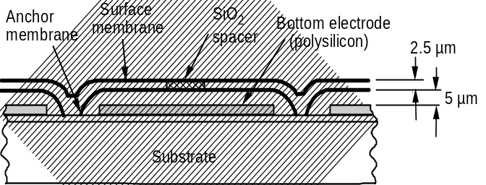
The first type of device studied in this work was a commercial MEMS deformable mirror array manufactured by Boston Micromachines Corporation (BMC). The arrays are fabricated using silicon micromachining techniques with structural silicon and sacrificial oxides. As shown in Fig. 1, they consist of two polysilicon membranes, separated from each other by a thin airgap. The top membrane provides the mirror surface. The lower membrane is fixed at the edges to the substrate. The two membranes are attached at the center with a silicon-dioxide spacer, 5 μm thick. The lower membrane can be deflected by the electrostatic attraction that results from applying a voltage to the lower electrode, which induces an image charge in the membrane. Electrodes at the bottom layer, formed on a silicon wafer isolated with a one-micron layer of nitride, are individually addressable. Voltage is applied to the individual lower electrodes to achieve the desired mirror contour. The upper membranes are both grounded. Note that although this structure contains silicon-dioxide, it is not present in the regions between the top and bottom electrodes.

Fig. 1. Physical diagram of the membrane-based mirror segment of the Boston Micromachine device. It is electrostatically activated.

The deflection of the mirror varies with distance from the edge, where the “anchor” membrane is attached to the substrate. The mirrors were designed for a typical center deflection of approximately 1.5 micron at a deflection voltage of 140 V. The maximum voltage that can be applied is 250 V. The peak deflection at the center of the mirror is a key parameter for mirror applications. The deflection is nonlinear with voltage, as shown in Fig. 2.

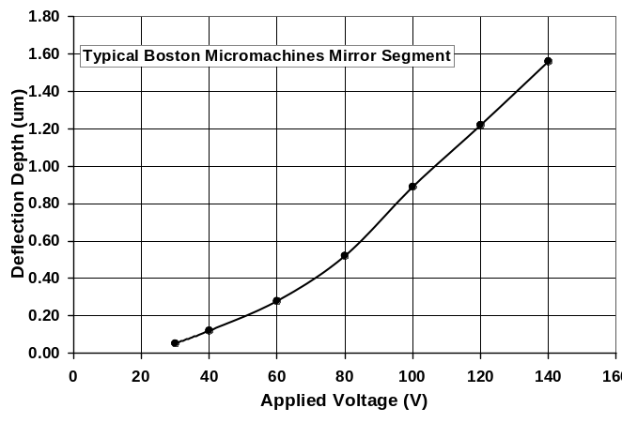
Fig. 2. Dependence of maximum deflection at the center of the mirror membrane on applied voltage for a typical BMC micromirror.

These mirrors deflect in a highly nonlinear manner, and behave more like a stretched membrane than a plane mirror. A typical deflection contour for a mirror segment is shown in Fig. 3.

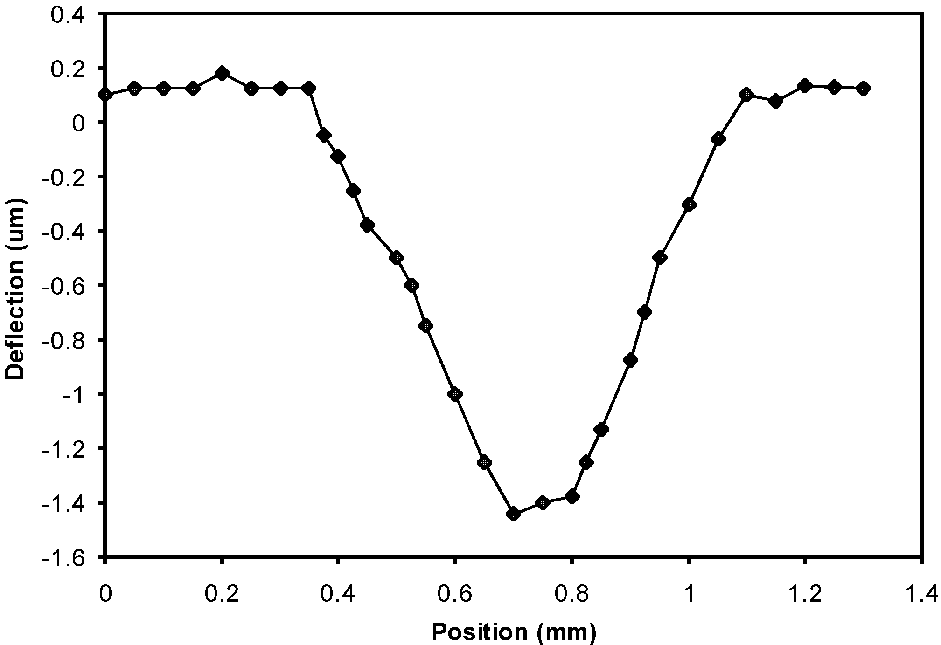

Fig. 3. Typical deflection depth profile for a segment of the BMC mirror with 140 V applied.

B. Piezoelectric Activated Mirror
Deformable mirrors that are activated by piezoelectric elements were developed by JPL in conjunction with Pennsylvania State University, and were included in the study even though they are not commercially available. While the target applications for this device are the same as for the BMC device, the JPL device has a completely different process and structure. Rather than being electrostatically driven, mirror segments in this device are controlled by a piezoelectric actuator. Further the JPL device is fabricated using a wafer bonding silicon membrane transfer technique. The resulting cross sectional structure, shown in Fig. 4, consists of a silicon mirror membrane, connected by an indium post to the controlling piezoelectric membrane. This membrane is lead zirconium titanate (PZT) on silicon nitrite. The moving structure is supported on silicon posts.
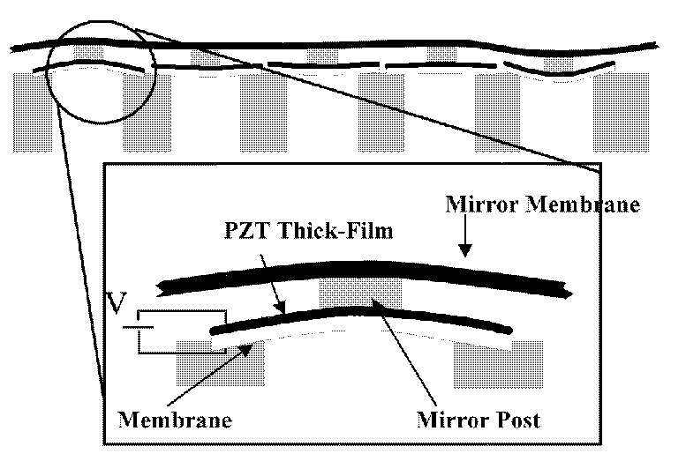

Fig. 4. Cross section of the JPL/Penn State piezoelectric deformable mirror.

This device is controlled by applying a voltage across the piezoelectric membrane. Flexure of this membrane moves the mirror surface. One advantage of this structure is that the resulting device has a much larger deflection sensitivity than the typical BMC device, operating at much lower voltage.
The dependence of deflection on voltage for a typical piezoelectric mirror segment is shown in Fig. 5. It is linear at low voltages, but becomes sublinear at higher voltage.
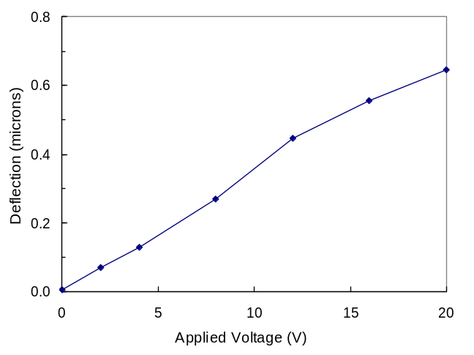
Fig. 5. Dependence of deflection on voltage for a typical PZT mirror.
III. Experimental Procedure
Measurements of the peak deformation depth of the BMC micromirrors were made using a Wyko model RST Plus Optical Profiler. This device scans the surface of the device measuring the deflection by counting interference fringes, a delicate experimental procedure. The maximum deflection occurs at the center of the mirror. This deflection was measured at a specific drive voltage by performing difference scans between the 0V and 140V applied condition. The control voltage was applied using a mirror drive system provided by BMC. This is a time-consuming process, requiring careful attention to alignment of the mirror assembly with the laser measurement apparatus. The maximum voltage that can be applied to the BMC device is 250 V. A voltage of 140 V, which produces a deflection of approximately 1.5 µm, is typical of many applications, and measurements at that voltage were used to determine how the mirror actuation was affected by radiation.
A similar experimental approach was used for the PZT actuated micromirrors, measuring them with the same optical profiling system. A voltage of 20 V, 2/3 of the maximum operating voltage, was used as a reference point for radiation characterization. The repeatability of the measurements was about 0.02 µm. Two scans were made during each measurement, averaging the results.
Figure 6 shows the results of a typical scan of one segment of the mirror array. The deflection is measured at the center of the mirror assembly. The left part of the figure shows the location of the scanned mirror within the overall mirror array. The scan at the right is produced by the Wyco measurement apparatus, which counts interference fringes at each point in the scan.
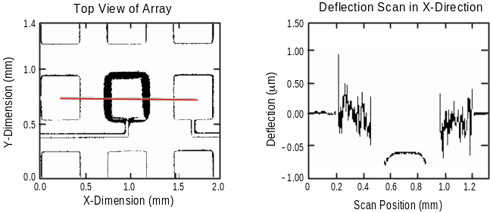
Fig. 6. Experimental results of a scan of the piezoelectric mirror with the interferometer.
The irradiations were done with cobalt-60 gamma rays at the JPL irradiation facility. The test samples were split into two groups. One group was biased during irradiation, while the other was unbiased (all pins at ground). Samples were removed after successive irradiations for measurement. Control devices were tested before each set of measurements.

IV. Experimental Results
A. BMC Mirrors
For the BMC mirrors, testing was performed on two groups with five mirror segments each, all located on a single device. One group of segments was irradiated without bias (electrodes at ground), while the other was irradiated with a deflection voltage of 140 volts. The device was removed after each exposure run temporarily removing bias from the segments that were biased, and measured with the optical profiler. This required about one hour between successive irradiations.
Total dose testing of biased and unbiased mirror segments was done in several steps to a maximum of 3 Mrad. Deflection data for both of the test groups indicated no significant effects due to radiation. Data for the biased devices, with measurement error bars is shown in Fig. 7. Similar results were obtained for the unbiased segments. Although there is a slight change at lower total dose levels, the change is within the measurement accuracy (2%), as determined from measurements on the unirradiated control samples. Thus, the radiation test results for the BMC mirrors essentially produce a null result, even after irradiation to very high total dose levels.
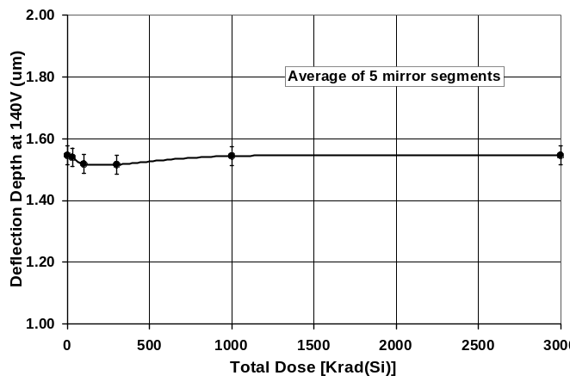
Fig. 7. Change in mirror deflection due to radiation for biased segments of the BMC mirror array.

B. Piezoelectric Mirrors
A bias voltage of 20 V was applied to samples of the piezoelectric mirrors that were irradiated in a biased condition. Additional samples were irradiated without bias (all pins at ground). Typical results for samples from both groups are shown in Fig. 8. In contrast to the results for the BMC mirrors, there are significant shifts in deflection sensitivity. The biased devices are affected at much lower levels compared to the unbiased samples, but both groups show some change in deflection sensitivity after irradiation.
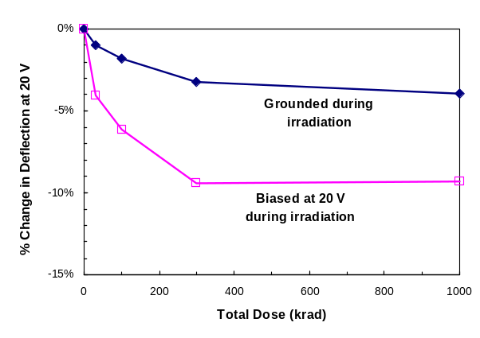

Fig. 8. Change in mirror deflection due to radiation for a typical piezoelectric mirror.
IV. Discussion
A. Previous Models of Charge Trapping in MEMS Structures
It has been previously shown for other electrostatically actuated devices that the presence of charge trapping dielectric materials can produce permanent shifts in the voltage conditions required to actuate MEMS devices [1-5]. For MEMS accelerometers significant changes occurred in actuation voltage at about 20 krad(Si), and there was evidence of “stiction” effects at about 30 krad(Si). Edmonds, et al. developed a quantitative model for this device based on a model for charge trapping in the dielectric material below the movable sensor. The model incorporated parameters that describe the balance between charge deposition and secondary emission, which competes with charge deposition for this structure.
B. BMC Micromirrors
Ideally, there is no dielectric between the lower and upper electrodes of the BMC mirror actuator. However, during fabrication the entire region between the electrodes is filled with silicon dioxide. This material is removed by chemical etching through a manifold of very small holes in the achor membrane. If some of this material remains, it could trap charge between the electrodes during irradiation. The null result obtained for several different mirror segments suggests that this did not occur. The electric field required to operate these devices is 3 MV/cm. To generate this field strength would require the presence of a substantial dielectric layer.
C. Piezoelectric Micromirrors
In contrast to the BMC device the JPL/Penn State micromirror has an insulating material, PZT, between the top and bottom electrodes. The thickness of the PZT film in the piezoelectric mirrors is 1.5 µm. The lateral dimension of the PZT between different mirror segments is 500 µm. PZT has a dielectric constant of approximately 1700. Note that in these structures the PZT film is continuous. Nevertheless, electrostriction causes highly localized deformation of the PZT material, deflecting the mirror downward when either a positive or negative voltage is applied between the two electrodes. Note that only the top electrode has a defined pattern.
Prior to irradiation the leakage current through the PZT layer was on the order of a few microamps. After irradiation the leakage current increased, as shown in Fig. 9.
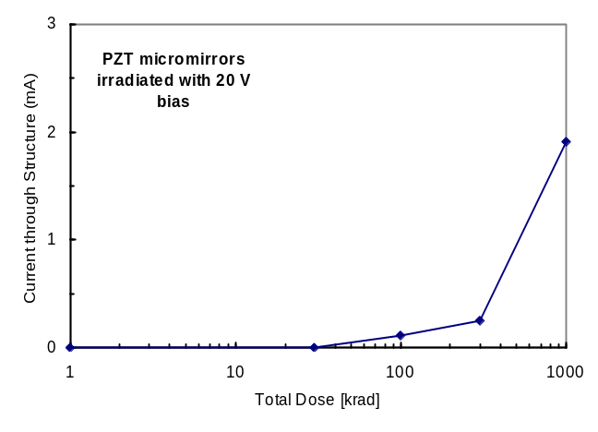

Fig. 9. Increase in leakage current through PZT layer after irradiation.
Tests of the PZT micromirrors showed that the change in deflection sensitivity was the same regardless of whether a positive or negative actuation voltage was used to deflect the mirror. This contrasts with results in [5] for GaAs MEMS switches where the change in deflection sensitivity was different for the two polarities.
For cobalt-60 gamma rays the mass absorption coefficient is essentially the same for materials with differing densities, nominally 0.03 cm²/g. This allows us to determine absorption in PZT from the density of the material, which is 7.5.

V. Conclusions
This paper has shown the first results for optical MEMS devices. Although the first type of micromirror was not affected by radiation, that was consistent with the structure of the device which does not include any oxides or similar insulating material in the path between the top and bottom electrodes of the device, provided that the sacrificial silicon dioxide used during the fabrication process is completely removed by etching.
The PZT element used on the second type of MEMS micromirror is a dielectric, and charge trapping within this dielectric can potentially affect device operation.
Micromirrors are an important new class of devices that are of interest for space applications. Thorough radiation characterization studies are required to determine the possible radiation effects. The tests reported herein are part of a continuing effort to evaluate these effects.

References
[1] C. I. Lee, et al., “Total Dose Effects on Micromechanical Systems (MEMS): Accelerometers,” IEEE Trans. Nucl. Sci., 43(6), pp. 3127-3132 (1996)
[2] A. R. Knudsen, et al., “The Effects of Radiation on MEMS Accelerometers,” IEEE Trans. Nucl. Sci., 43(6), pp. 3122-3126 (1996).
[3] L. P. Shanwald, et al., “Radiation Effects on Surface Micromachined Comb Drives and Microengines,” IEEE Trans. Nucl. Sci., 45(6), pp. 2789-2798 (1998).
[4] L. D. Edmonds, G. M. Swift and C. I. Lee, “Radaiton Response of a MEMS Accelerometer: An Electrostatic Force,” IEEE Trans. Nucl. Sci., 45(6), pp. 2779-2788 (1998).
[5] S. S. McClure, et al., “Radiation Effects in Micro-Electromechanical Systems (MEMS): RF Relays,” IEEE Trans. Nucl. Sci., 49(6), pp. 3197-3302 (2002).
[6] E. H. Yang, et al, “Concept, Modeling and Fabrication Techniques for Large-Stroke Piezoelectric Unimorph Deformable Mirrors,” submitted to the IEEE Journal of Microelectromechanical Systems, 2003.

