Discussion Document
A Crystal Collimation Experiment at the Tevatron

Abstract:

We are writing this letter to express our interest in pursuing an experiment at Fermilab’s Tevatron to measure the predicted improvement in collimation efficiency that could be obtained by replacing amorphous primary collimators with bent crystals. Considering the unique possibility provided by the Tevatron Collider, and having already established fruitful collaborative efforts on crystal characterization, tests and use for collimation, we propose to test and confirm models of multi-turn dynamics with crystals by exploiting channeling and newly understood phenomena such as volume reflection. In our view, this is a necessary first step to being able to evaluate an engineering implementation of this technique in LHC that if proven promises an enhanced performance of the LHC collimation system with a reduced impedance and easier implementation for heavy-ion beam halo cleaning. There is also an interest to crystal channeling from the ILC and Muon Collider projects. We present the conceptual design of the system, results obtained in preliminary beam tests, and plans for the near-term measurements. Then minor modifications to the Tevatron needed to implement the full crystal and beam diagnostics systems are described along with studies proposed at a second stage based on substantial contributions of all the parties involved. The US LHC Accelerator Research Program (LARP) will co-ordinate and partially support the U.S. side of the collaboration.

Table OF COntents
1. Introduction and Motivation 3
2. First Studies at the Tevatron 5
2.1 Crystal Setup 5
2.2 First Measurements 7
2.3 Modifications 10
3. Crystal Collimation Experiment 12
3.1 Goal and Deliverables 12
3.2 Phase I 14
3.3 Phase II 15
4. Outlook 15
4.1 Rough Estimate of Cost and Timeline 16
Bibliography 18

Introduction and Motivation

At hadron colliders, as at any other accelerator, the creation of beam halo is unavoidable. This happens because of beam-gas interactions, intra-beam scattering, proton-proton, proton-antiproton or heavy-ion collisions in the interaction points (IP), and particle diffusion due to RF noise, ground motion and resonances excited by the accelerator magnet nonlinearities and power supply ripple. As a result of halo interactions with limiting apertures, hadronic and electromagnetic showers are induced in accelerator and detector components causing numerous deleterious effects ranging from minor to severe. An accidental beam loss caused by an unsynchronized abort launched at an abort system malfunction can cause catastrophic damage to the collider equipment. Only with a very efficient beam collimation system can one reduce uncontrolled beam losses in the machine to an allowable level [1]. Beam collimation is mandatory at any superconducting hadron collider to protect components against excessive irradiation, minimize backgrounds in the experiments, maintain operational reliability over the life of the machine (quench stability among other tasks), and reduce the impact of radiation on the environment.

In so-called single-stage conventional collimation the beam halo is scraped by a collimator moved into the halo. Typically the collimator is a 1.5 m long block of steel or other medium or high-Z material. A certain fraction of the halo will survive, either by traversing the length of the collimator or by scattering out of the collimator block. Suppressing the out-scattered particles is quite difficult, so that the typical efficiency of a single-stage collimator is of the order of 50% for high-energy beams. A more sophisticated way to handle the out-scattered particles is to go to a two-stage collimation system. As shown in the left-hand panel of Fig. 1.1, a thin primary target is used to scatter the beam out by increasing the amplitude of the betatron oscillations of the halo particles and thereby increasing the impact parameters on to secondary collimators during the next turns without influencing the unscattered beam. The overall collimation efficiency of the Tevatron two-stage collimation system is 99.9%. That is adequate for the machine performance. At the same time, the situation at the LHC – with its hundreds times more powerful beam - is more stringent, requiring a higher collimation efficiency.

A crystal channeling collaboration of several groups from Europe, USA and Russia – which started about 15 years ago – has recently been stimulated by an exciting new challenge. The challenge is related to the potential crystals provide for Phase 2 of the LHC collimation, the recent encouraging results from the experiments at the Tevatron and the H8 beam at the CERN SPS, and new developments in crystal techniques including the volume reflection phenomenon. Crystals also provide interesting possibilities for beam separation at J-PARC and beam halo collimation at the ILC. First results are already available and tests are planned at CERN with the H8 beam of 300-GeV electrons that bear on the ILC.

Extremely high inter-planar electric fields from screened nuclei (a few GV/cm) make it possible to bend and focus high-energy beams with very short crystals [2]. The bent-crystal technique is well established as a technique for extraction and handling of high energy hadron and heavy-ion beams from accelerators. The extraction technique was successfully demonstrated in the mid-80’s through the mid-90’s for up to 900 GeV beams at JINR, IHEP, CERN and Fermilab. Measurements have demonstrated the high efficiency predicted in simulations. Recent results from Japan for channeling with proton and electron beams are consistent with earlier data. Bent crystals are routinely used at IHEP to extract and form proton beams with an intensity of 10¹² ppp and higher. It has been shown at CERN, IHEP, and Fermilab that crystals are heat- and radiation-resistant. Deflection efficiency deteriorates at a rate of about 6% per 10²⁰ p/cm² [3].

The promise of bent crystal channeling technique for beam halo collimation at high-energy colliders was recognized at the SSC in 1991 [4]. A bent crystal, serving as a primary element, coherently deflects beam halo particles, directing them deeper into a second collimator body compared to the case of an amorphous primary scatterer (Fig. 1.1, right). This would substantially reduce the out-scattering probability from the system. Moreover, the number of inelastic nuclear interactions in the optimal crystal is typically four times lower for high-energy proton beams compared to that in an optimal amorphous target. That reduces radiation load to the downstream superconducting magnets by the same factor. Preliminary measurements of channeling collimation, performed at IHEP in 1998 for 1 to 70 GeV protons [5], confirmed the basic findings and demonstrated an increase of the collimation efficiency with energy.

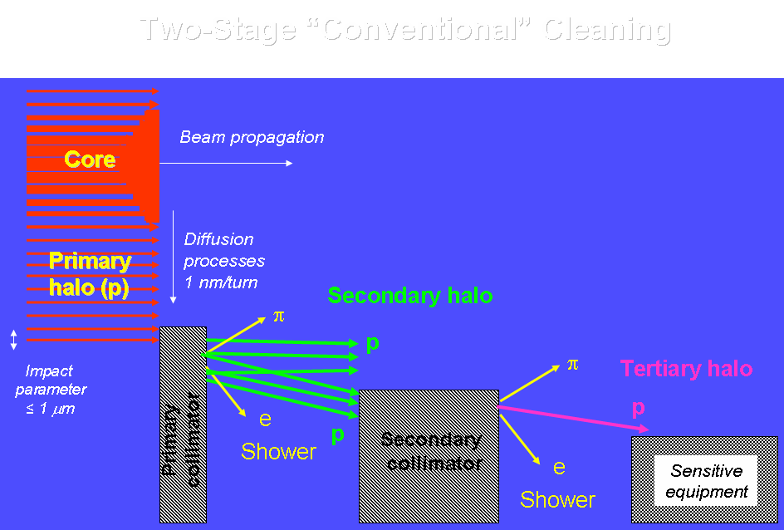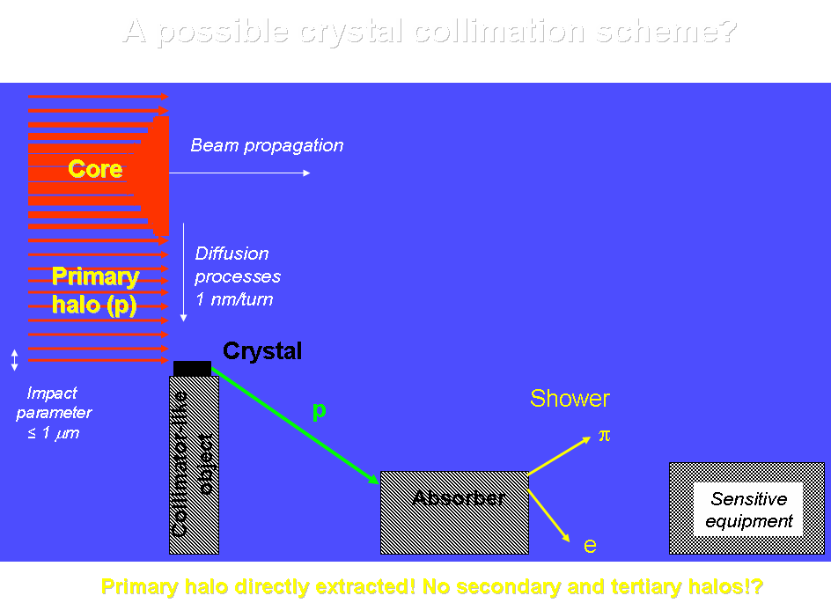

Figure 1.1: Principle of two-stage collimation with a primary collimator based on an amorphous target (left) and a bent crystal (right).

Based on realistic modeling, it was proposed to implement a bent crystal in the Tevatron collimation system [6]. Calculations have indicated that employing a silicon bent crystal instead of amorphous primary collimators (targets) can improve the Tevatron collimation system efficiency and reduce backgrounds in the CDF and D0 collider detectors:

- by a factor of 2 with one (horizontal) target replaced, and with contribution from beam-gas scattering unsuppressed;
- by a factor of 3 with one (horizontal) target replaced, and with contribution from beam-gas scattering suppressed;
- by a factor of 4 to 6 for the two-plane collimation.

A crystal collimation experiment was performed at RHIC at BNL in 2003 [7]. Measured bent crystal channeling efficiency for gold ions was found to be 26%. Crystal channeling worked as expected and as predicted by simulations, once lattice functions and halo distribution were understood. Reduction of background was not achieved because the lattice was not optimal in the area of collimator resulting in an angular spread at the crystal which was too high.

Parenthetically, this recent work at RHIC and later at FNAL uncovered the importance of the long-neglected coherent crystal effect predicted at Tomsk two decades ago, volume reflection [8]. Conventional channeling and volume reflection are illustrated in Fig. 1.2. Contrary to ordinary channeling, which is extremely sensitive to beam-crystal alignment (10-μrad level in the Tevatron), volume reflection has a much higher angular acceptance. Therefore it seems to be very promising as a collimation tool for high-energy beams. The studies have helped to spark interest in the volume reflection process including a fast track investigation in the H8 beam at the CERN SPS in the fall of 2006. That precision investigation has produced a spectacular confirmation of volume reflection with 97% efficiency [9] and also developed tools to characterize crystals that could potentially serve as LHC collimators.
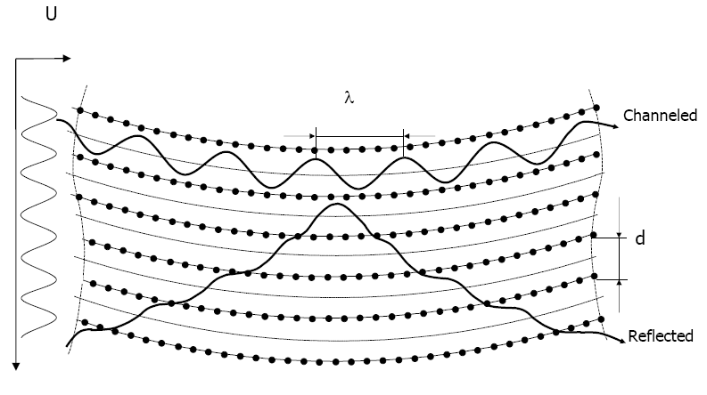
Figure 1.2: Schematics of beam channeling and volume reflection.

First Studies at the Tevatron

Crystal Setup

In the fall of 2004, the modified BNL assembly with a 5-mm thick silicon crystal was installed in the Tevatron in the dog-leg of the E0 straight section downstream of the horizontal 5-mm thick tungsten primary collimator D49 (Fig. 2.1). The primary collimator and crystal could be alternatively inserted into the beam halo. The phase advance with respect to the secondary collimators was similar in both cases. A scattered baseline beam or a beam deflected by the crystal was intercepted by a 1.5-m long steel secondary collimator E03H 23.8 meters downstream. At E0 the proton helical orbit is on the inside of the accelerator central orbit. Fig. 2.1 is a schematic of the location, while Fig. 2.2 shows the crystal assembly.

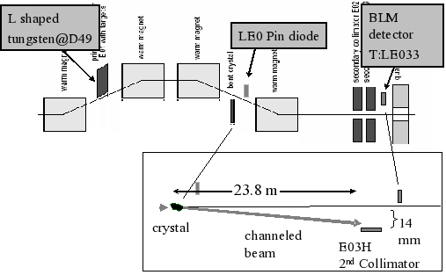

Figure 2.1: Schematic of the experimental setup at E0.

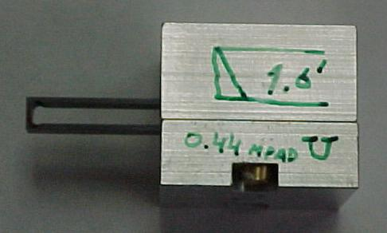
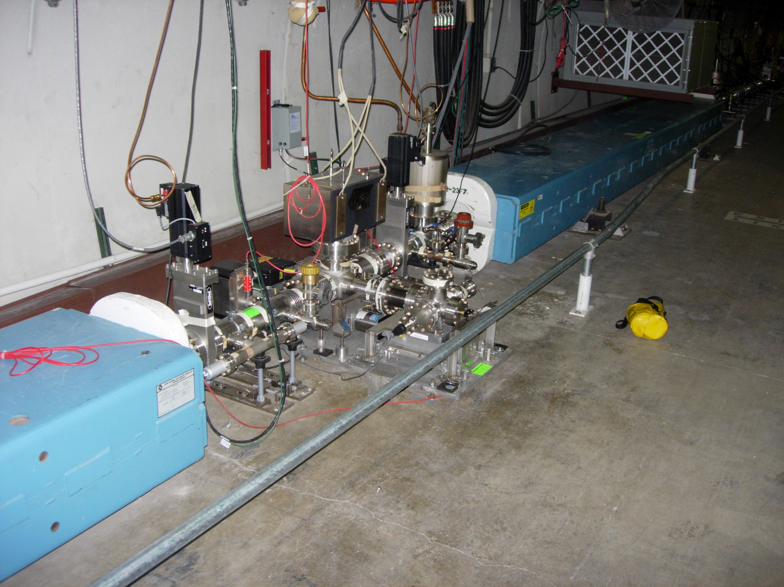

Figure 2.2: E0 crystal collimator assembly (left) and O-shaped crystal in holder (right).

The crystal was mounted in a high vacuum goniometer. It rotated around a vertical axis with a pivot point about 8 cm from the beam and deflected the halo in the horizontal direction. The crystal orientation could be monitored with a laser system. The device moved in and out of the accelerator beam pipe in the horizontal plane. The crystal was a so-called "O" crystal of silicon with the bend in a (110) plane. It had a miscut angle of 0.465 mrad arranged so that there was not a possibility of partial deflections for particles near the crystal face. The "O" geometry pioneered at PNPI produces a bend in the small leg of the "O" by compressing the long leg. The length of the crystal along the beam was 5 mm. The long leg of the "O" was 45 mm. The bending angle was approximately 0.44 mrad. The crystal deflected the beam toward the inside of the ring.

The principal detector used for this investigation was an ion chamber beam loss monitor (LE033) behind the E03 collimator (labeled E03H in Fig. 2.1). The LE033 signal was generated by scraped or channeled halo showering in the E03 collimator. The signal was reduced significantly when the collimator was withdrawn. For example the collimator out/collimator in ratio when the crystal was aligned for channeling was < 0.01. A standard PIN diode (LE0PIN) was also available about 25 cm downstream of the crystal. It was at an angle of about 45 degrees to the beam so that it was detecting mostly low-energy secondaries from interactions in the crystal. Removing the crystal from the beam halo caused the LE0PIN signal to disappear. Detectors like C:LOSTP at the CDF collider detector were used to monitor proton losses for different collimation arrangements at E0. Since the crystal was 5-mm long, the interaction probability per pass was only 1.6%. Thus, when the 1.5-m collimator was moved in closer to the beam than the crystal, the count rate in LE033 have been sixty times higher.

First Measurements

Beam studies first at 150 and then at 980 GeV were conducted in the Tevatron in the summer and fall of 2005. These were a series of 2-hour long End-of-Store Studies (EOS). The crystal was aligned in the halo by varying its angle in steps of several μrad. Typically the crystal angle was scanned over 2000 μrad in forty-five minutes. Several points were taken for each angular setting.
Collimators E03H and F172H were used to intercept a channeled beam. All other collimators were pulled out, with the exception of the A48V tertiary one used for kicker prefire protection. At any angle there were statistical fluctuations due to slight beam motions in the Tevatron at a minute by minute level. Fig. 2.3 shows the LE033 readings behind collimator E03 as a function of the crystal angle for a typical scan. The crystal angle scale has been set to 0 μrad for the situation where the front end of the crystal is aligned.
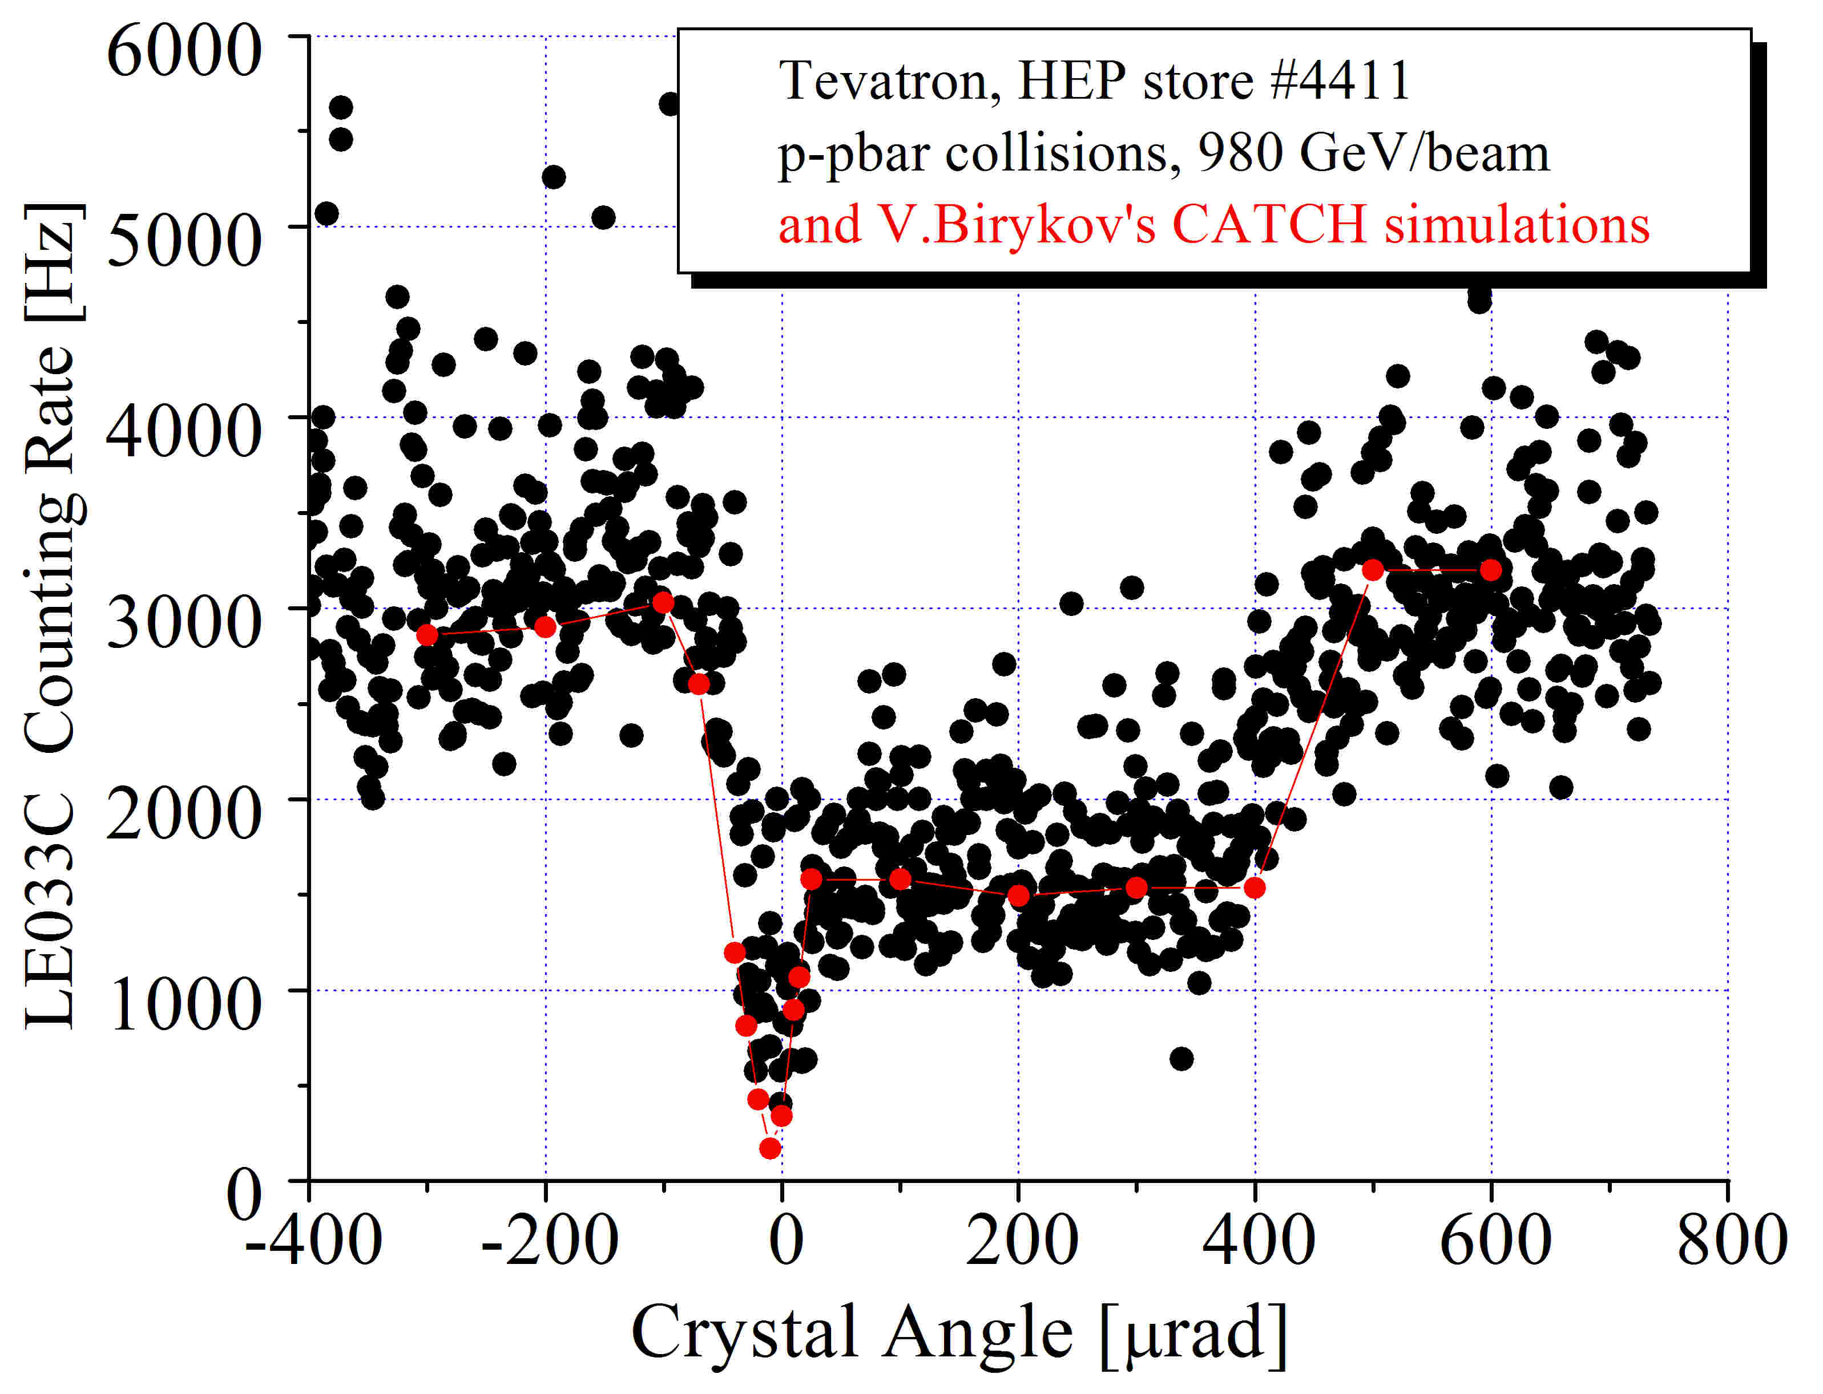

Figure 2.3: Crystal angle scan. The CATCH simulation results are shown in red.
Characteristically the crystal was at 5.5 σ_{b} from the beam while the collimator was at 6 σ_{b} (σ_{b}, the horizontal spread of the beam, was 0.45 mm). A channeling dip is present at 0 μrad with a width of 22 ± 4 μrad (rms). The width of the channeling dip is a convolution of the beam divergence, the channeling critical angle, and multipass channeling effects. The width of this distribution can be compared to the 32 μrad width (rms) observed in the E853 crystal extraction experiment at the Tevatron for a collider mode beam angular divergence at the crystal of 18 μrad. It is difficult to do a deconvolution of the crystal angular scan to get the critical angle. However, the distribution is consistent with the beam divergence and the 5 μrad channeling critical angle at 980 GeV. At the bottom of the dip the LE033 signal is 22% of the signal at a random angular setting. This depth is a measure of the channeling efficiency and gives a channeling efficiency of η_{c} = 78 ± 12% including the effects of multiple passes.

A shoulder extends 460 ± 20 μrad to the right of the channeling dip. A similar feature was observed for the first time at RHIC. This shoulder width is equal to the magnitude of the crystal bend. The shoulder is a coherent crystal effect acting over the whole arc of the crystal bend. A typical volume reflection away from the convex side of the crystal is on the order of the critical angle. It is a coherent process so over several passes through the crystal it can grow to a deflection several times the critical angle. Like channeling it will diminish nuclear interactions and thereby decrease the LE033 rate. The whole-arc efficiency, η_{r}, was 52 ± 12%. The results of Biryukov’s CATCH simulation for the conditions in the Tevatron are shown in the plot. Note that there are no free parameters in this simulation except average counting rate. The angular distribution of particles interacting with or channeling in the crystal was measured by plotting the LE033 count rate as the E03 collimator was withdrawn further from the beam. Note that the LE033 signal is an integral of the flux as a function of radial position along the front face of the collimator.

The central purpose of the Tevatron study has been to demonstrate and study effective crystal collimation to reduce halo at the collider detectors. Both of the large detectors at Fermilab have halo monitors to monitor these losses continuously. During the crystal collimation studies, the CDF LOSTP halo monitor was recorded for most of the runs. Fig. 2.4 shows a comparison of crystal collimation with the crystal aligned for channeling collimation and for the case for conventional collimation with a thin tungsten target at D49. For CDF losses, the crystal case goes down to a rate about half the rate with the conventional D49 W target. In the crystal case, the nuclear interaction rate in it, proportional to the PIN diode readings, is substantially lower compared to that in the tungsten target.

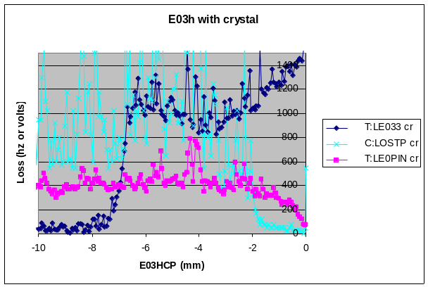
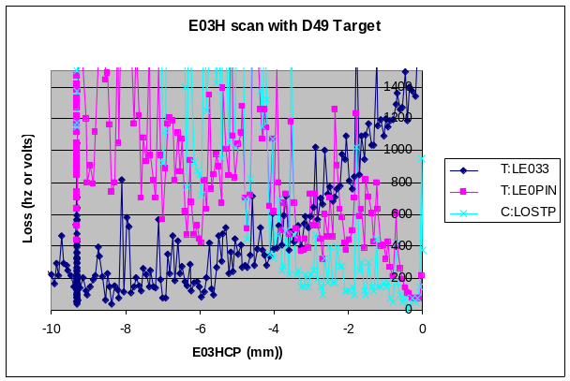

Figure 2.4: E03H collimator effect on halo at CDF for D49 amorphous target (left) and using the bent crystal. (right). Dark blue symbols are LE033 rates, magenta symbols are PIN diode readings, and cyan symbols are C:LOSTP beam loss rates at CDF.

To reiterate, when using the crystal, the secondary collimator E03 achieved almost a factor of 2 better reduction of CDF losses a half a ring or three kilometers downstream (in agreement with modeling)! Moreover, the secondary collimator could remain further (1 mm or so) from the beam thus reducing impedance, and the nuclear interaction rate in the crystal was 2 to 3 lower compared to the amorphous target, reducing proportionally irradiation of the downstream components.

Modifications

The first crystal collimation test system collimates only in the horizontal plane. A comprehensive system would also collimate in the vertical plane as well as in dispersion for off-momentum partricles. These results are multiplicative, so the halo scraping could be improved by up to a factor of eight. The original modeling indicated that in an ideal Tevatron lattice, an order of magnitude reduction might be achieved. Thus, the present incomplete and rudimentary system appears to be well on the way to fulfilling the potential of crystal collimation. We aim at the full system in Phase II of this proposal.

It turned out that the parameters of the BNL’s crystal used in the first studies are not optimal for the Tevatron conditions. Express simulations by V. Biryukov, have shown that the collimation efficiency can be noticeably improved by replacing the original 5-mm long crystal with a shorter one which has a smaller bending angle (Fig. 2.5). Of course, the optimal parameters depend on details of the lattice, collimation system configuration and beam loss region layout, but the trends shown in the Fig. 2.5, convinced us to replace the original crystal with a new shorter one. Moreover, we also wanted to investigate a new technology developed to improve crystal performance.

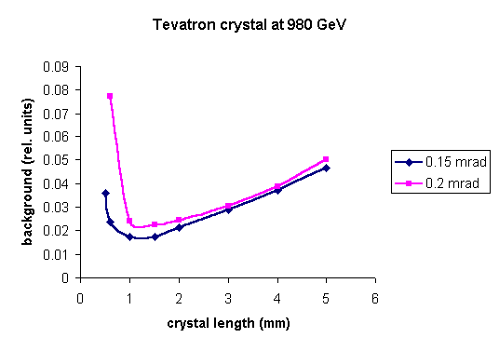

Figure 2.5: Estimated beam loss reduction in Tevatron as a function of crystal length for two bending angles as simulated with CATCH (courtesy V. Biryukov).

In 2006, the original O-shaped crystal was replaced with a new custom crystal based on a novel strip technology. It was designed, fabricated, mechanically bent and characterized in a collaboration between IHEP (Protvino) and the University of Ferrara-INFN. The chemically etched crystal is 3-mm long (along the beam) with a 0.15-mrad bending angle (Fig. 2.6). The new crystal was installed in the Tevatron in late 2006.

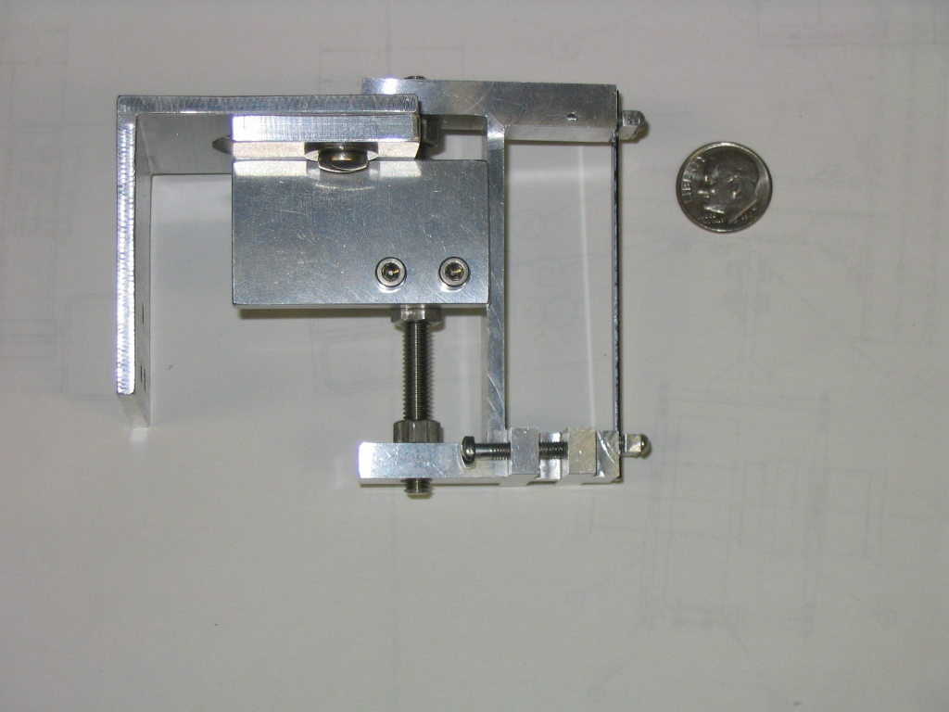

Figure 2.6: Strip crystal prepared by IHEP and INFN and installed in Tevatron in late 2006.

A team of experts from IHEP, CERN, INFN and KEK came to Fermilab in February 2007 to perform measurements with the new crystal. In a series of EOS studies, the entire angular range has been scanned at 2 μrad steps. No channeling was detected. It was then found that there was a problem with the alignment of the crystal. It was misaligned by ~14mrad. The crystal was realigned and scans continued on May 26, 2007.

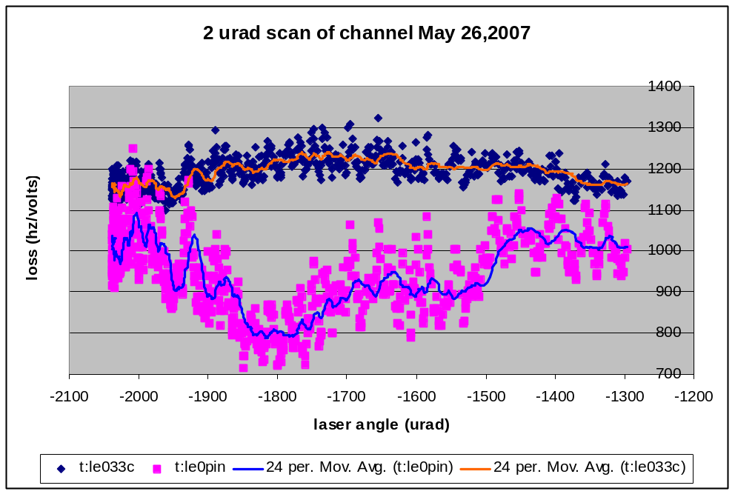

Figure 2.7: Angle scan with the new strip crystal.

The data which looked like channeling was demonstrated with the new crystal (Fig. 2.7). But the size of the volume reflected region should be proportional to the bend angle of the crystal (150μrad). The data showed ~ 320μrad which is too large. Therefore, an additional period on July 9 was requested to produce a finer 1-μrad scan of this region. However, channeling could not be observed at all. During the fall 2007 shutdown, the laser scans in the tunnel have revealed that there is unacceptably large wobbling of the new crystal holder, which is much heavier than the original one. As a result, the positioning of the crystal with respect to the beam is extremely unstable, and results of the angle scans are irreproducible. The current consensus is that the mechanics (goniometer) needs to be replaced.

Crystal Collimation Experiment

Goal and Deliverables

Crystals are an interesting advanced technology for Phase 2 of LHC collimation. To evaluate their benefits in detail the following information is required:
- Crystal parameters for the highest efficiency for channeling and volume reflection at both injection (450 GeV) and top (7 TeV) proton energies.
- Probability spectrum of proton deflections at 0.45 to 7 TeV for all physics processes down to a 10⁻⁵ level.
- Damage limit of crystals for instantaneous shock beam impact at ~15 MJ/mm².
- Damage limit of crystals for integrated dose at ~5×10¹⁶ p/year at 7 TeV.
- Handling of crystals during normal operation at high-power impact.
- Number, opening (impedance) and locations of absorbers for extracted and scattered beam.
- Sensitivity to beam angle and angular spread in the TeV region.
- Requirements for alignment and operational set-up (tolerances, time, etc.).

Aiming at the high-performance collimation vital for the LHC, considering the unique possibility provided by the Tevatron collider (before its shutdown for collider physics), and having already established fruitful collaborative efforts on crystal characterization, tests and use for collimation, we propose to conduct crucial studies in the time frame required by the LHC plans. The primary goal would be to address the issues listed above in the next two or three years. The directions would include:

- Beam tests in the CERN SPS extracted beams including measurements with 400-GeV protons, 200 GeV/A ions, and 30-GeV electrons and positrons.
- Beam tests as well as post-irradiation tests employing the Tevatron beam abort line to study damage limits of crystals; these high-priority studies would use mechanical, optical tests and SPS beams.
- Design and fabrication of new crystals characterized mechanically, optically and with beams.
- Studies of novel technologies to improve efficiency (multi-strip, quasi-mosaic, etc.).
- Further development of the crystal-related theoretical models and simulation tools for refined modeling of the channeling and volume reflection effects in the crystals and particle tracking in realistic multi-component collimation systems and collider lattices; full-scale modeling of the system performance in the Tevatron and LHC realms.
- Development of beam and alignment instrumentation – including single-particle tracking - adequate to crystal-based collimation, and the test of the instrumentation at the Tevatron.
- Demonstration in the Tevatron of single and multi-crystal volume reflection, and of a two-plane crystal collimation.
- Full-scale crystal collimation experiment at the Tevatron with up to three crystals, two for betatron cleaning and one for momentum, with beam diagnostics as above.
- Possible crystal collimation experiment in the SPS ring.
- Preliminary tests of crystals at U70 at IHEP (Protvino).

The following near-term action items are important for understanding in a timely manner the potential of channeling collimation at the LHC:
    - Experiments should be conducted to provide information about the possible deformation of the crystal or crystal holder during a vacuum baking process. It would be good to go up to 200 degrees C.
    - IHEP/CERN/INFN will provide Fermilab with the crystal that was characterized in the H8 experiment at CERN.
    - Consider and design a crystal damage experiment where crystals and instrumentation for assessing dose rates could be placed in the Tevatron abort line. Once enough beam is integrated on one crystal, it should be moved back to CERN for H8 beam line characterization. Ideally several crystals should be studied at once so one could be removed early.
    - Consider and design a test at the end of the Tevatron experimental collider run (2009) for crystal collimation studies. The test would be 2 to 4 weeks long and would be used to demonstrate two-plane crystal collimation. This proposal will need new style goniometers, new crystals and holders and additional instrumentation built and installed in the Tevatron.
    - Continue to assess crystal collimation performance by producing a new goniometer, crystals and instrumentation for the Tevatron to be installed by the 2008 shutdown.

Our goals are measurements of:

- Channeled beam*
- Volume-reflected beam*
- Beam loss and radiation levels downstream of the crystal setup
- Beam loss rate in the B0 (CDF beam-halo monitors) for 1- and 2-plane collimation
- Possible deformation of the crystal or crystal holder during a vacuum baking process.
- Attempt to study crystal damage: shock and integrated dose.

(*) Add dedicated beam diagnostics

Quantitative measure of collimation efficiency improvement is reduction of (3) – primarily an LHC concern – and (4). We are going to simulate the deflected beam loss in the Tevatron and LHC (in collaboration with IHEP and CERN colleagues). Consistency with the current secondary collimator and absorber layout is of a concern here. This needs simulations and optimizations.

Deliverables:
- Conclusive data and directly relevant input for decisions on a possible upgrade path for LHC collimation: improved collimation efficiency and reduced irradiation of downstream components in a quantitative agreement with corresponding calculations, and quantitative answers to the questions on damage limits and sensitivity analyses.

2. Crystal technology, process (channeling or volume reflection), hardware (goniometer etc.) & instrumentation most suitable for 2-plane collimation of LHC beams, transferred to CERN.

Phase I

Our plan for the remaining part of 2007 is

- Initiate studies of new possibilities for collimation exploiting volume reflection.
- Try to demonstrate channeling with the existing strip crystal and confirm the 2005-2006 result that crystal channeling and volume reflections can improve the Tevatron collimation system efficiency.
- Initiate design and manufacturing process to replace the existing goniometer.
- Initiate detailed simulations of collimation system performance with a single strip crystal in the realistic Tevatron lattice for both channeled and volume-reflected beams.
- Work out a plan on beam diagnostics improvement and installation of the new goniometer for the 2009 beam studies.

Our plan for calendar 2008 is

- Build improved beam diagnostics system and new Ferrara goniometer.
- Develop new strip and multistrip crystals.
- Complete end-of-store studies and proton-only store angular scans with the crystal chosen in 2007.
- Perform detailed simulations for a complete two-plane crystal-based Tevatron collimation system.
- Try to perform tests to provide information about the possible deformation of the crystal or crystal holder during a vacuum baking process (up to 200 degrees).
- Investigate a possibility for a crystal damage experiment where crystals and instrumentation for assessing dose rates could be placed in the Fermilab beams. Once enough beam is integrated on one crystal, it should be moved back to CERN for H8 beam line characterization.

Phase II

The goal for 2009 is to demonstrate efficiency of a well-prepared bent crystal collimation system for 2 planes with channeled and volume-reflected 1-TeV beams at least for two crystal types (single and multi-layer) in comparison with tungsten target results.

Our plan for 2009 is
- Install New Hardware:
- Remove E01 collimator to replace with vertical crystal assembly
- Crystal, goniometer, instrumentation tunnel installation

2. 150-GeV Beam Tests (1.25 shifts):
- Test BLM response, inchworm and channel the beam
- Debug all motion control and instrumentation

3. 980-GeV End-of-Store Beam Studies (4.75 shifts):
- Find and characterize channeling (V-plane)
- Collimate channeled beam (V, H)
- Collimate volume-reflected beam (V, H)
- Attempt full channeled collimation (V&H)
- Attempt full volume-reflected collimation (V&H)
- Repeat with another crystal type

Outlook

August 2007’s Accelerator Advisory Committee at Fermilab fully supported this unique opportunity to perform dedicated end-of-store beam studies in the Tevatron in order to (1) confirm the Accelerator Science of this phenomenon, and (2) build a case for an LHC implementation. It called it “an experiment with great potential which could definitively establish the multi-turn physical model, building on the recent single-pass success in the H8 beam line at the SPS; it could revolutionize collimation systems in the LHC and other future accelerators”.

It stated that LARP is an appropriate vehicle through which such a “high-risk, high-gain” activity could be coordinated. FY08 & 09 planning should become a high priority for LARP Accelerator Systems management. The AAC recommended:
- To enhance beam diagnostics, perhaps even including single-particle tracking capabilities.
- Invite particle physicists to join the experiment, the approach proven to be very effective, e.g., in the SPS H-8 experiment.
- Beam time planning for 2009 should depend on reasonable demonstrations of success in 2008.

Rough Estimate of Cost and Timeline

CERN support: "In view of the possible limitations for conventional collimation like implemented for the LHC start-up, CERN is presently investigating possible paths to enhancing the efficiency of the LHC cleaning systems. The use of crystals has been proposed as one possibility for improving collimation. However, a clear demonstration of improved collimation efficiency in an existing storage ring is still missing.

The CERN collimation team therefore fully supports the proposed experimental investigation at the Tevatron. The support will include advice on important experimental observables, participation to beam tests and help for analysis of recorded data. It is our hope and expectation that Tevatron beam tests on crystal collimation provide conclusive data and directly relevant input for decisions on a possible upgrade path for LHC collimation."

CERN: Experiments at H-8 beamline, manpower, beam characterization of “TeV” crystals to guarantee success at Tevatron
INFN: manpower, crystal preparation, etching, mechanical and optical characterization, goniometer (100 keuro)
IHEP: manpower, crystal preparation, etching, characterization; simulations, new crystal technologies
PNPI, JINR: manpower, theory, simulations, beam diagnostics, DAQ, new crystal technologies
KEK: manpower, beam diagnostics
Fermilab: manpower, crystal and other hardware implementation in the Tevatron,
EOS beam time, beam diagnostics, DAQ, simulations, deformation/damage tests
SLAC, BNL: manpower, beam diagnostics, deformation and damage tests

Ferrara is ready to take the responsibility and the charge of building the goniometer and eventually incorporating the most appropriate crystal.
A preliminary request has been made by Walter Scandale of funding this experiment at the INFN CSN1 (the body in charge of funding experiments in the INFN). The basic idea described was to install roman pots with scintillation fibers, silicon strips and whatever appropriate, upstream of the secondary collimator at FNAL, a second goniometer for crystals at the location of the primary collimator and additional detectors in at least another position downstream of the secondary, with very encouraging answers and the request of better defined plans.
Initial points to be considered are the following: roman pots, detectors and electronics;
radiation hardness; space; occupancy; integrability of existing roman pots to the FNAL vacuum pipe (from TOTEM, from FPD, or from ZEUS); constraints induced by the FNAL standards; cross-qualification with LHC design and cryogenic standards; control system; counting room.
Beam studies: parasitic approaches in preparing the circulating beam; beam instrumentation (list of possible improvements to the existing ones); special software; sharing the tasks and the financial loads.

Bibliography

1 AAA

