Some considerations for an interferometer set of sightlines in the divertor

IDM ID: ITER_D_24HYZK (2.0)

G. Vayakis (1 / 8 / 2006)

In assessing the capabilities and possibilities of such a system, there is a trade-off between dynamic range and number of sightlines. This was clear from David Brower’s analysis of December 2005 and later [1,2], where he showed that, for good dynamic range, long wavelength sightlines are needed (57-118 um), in addition to the more compact CO₂ wavelengths.

These sightlines are rather large, and lead to a limit of a 10 or so sightlines per port, as seen in the CATIA study by ITER [3]. Figures 1-4 show some views of such beam outlines (the red tubes are representative of the width available for each beam, about 65 mm here). In addition, in the toroidal direction, it is hard to consider ideal QO beam behaviour for such a system, due to the presently expected limit of 20 mm or less for the width of the mirrors.

At the same time, the Divertor ITPA TG recommended [4] that the ideal resolution along the leg should be 50 mm (not 100) perhaps dropping to 20 mm near the target plates. To look at the reasons, I considered a divertor simulation of the density [5]. The question was, to what extent is the fine 2D structure reproduced in the simulations (Figure 5) also seen in a line-integrated system?

To answer once can postulate a set of dense (here 36) sightlines arranged in a fan coming from below the dome and in principle hitting a set of roof-top reflectors supported on the side of the targets. The source of these lines would be a convex mirror, sending them horizontally out towards the port, where they can be deflected toroidally in a similar way to the long-wavelength beams of Figures 1-3, but with a single flat mirror. This is based on a suggestion made by N. Bretz made for ITER-98 [6] and similar to a system designed for C-MOD [7] and also similar to the system designed [8] for the ITER erosion monitor. The C-mod system used 4 mm diameter beams in a multichord dispersion interferometry arrangement reproduced in Figure 6.

Figures 7-9 clearly show that lines of the resultant pitch (about 20 mm) give a lot of information on the detailed structure of the “flame front” and are consistent with the recommendation of the Divertor TG. In fact, the pitch is clearly too dense far from the target but a better match to the details of the structure near the plate.

Such a system would also have the advantage that it will be flexible, that is, one could provide a small number of external beam lines (say 10) which are then adjusted in height from outside the machine to the expected height of the strike point. The number of retroreflectosr would be larger to give flexibility. The scale of such a system might be as Figure 10. A similar system could be used for the high field side leg on the other side.

The penalty, as [1,2] showed, is reduced dynamic range at low density. This may or may not be serious. X-point formation in ITER is planned at 7.5 MA (4 MA was recently proposed), and the density is unlikely to be low for any serious divertor exploitation. A compromise is also possible with one long wavelength sightline per leg alongside a dense CO2 set. In addition, limited tomography may also be possible with retroreflectors placed in other locations (in the dome region etc).

[1] D.Brower, “Conceptual Design Study for ITER Divertor Interferometer Diagnostic”, Report to the US ITER office dated 14-Dec-2005, ITER_D_24KAZZ
[2] D.L. Brower, B.H. Deng, and W.X. Ding “Divertor Interferometer Diagnostic for ITER”, paper presented at the HTPD (2006) and submitted to RSI, ITER_D_24KB9V
[3] R.O. Alex Martin (alex.martin@iter.org)
[4] R.A. Pitts, presentation at ITPA-2, ITER_D_24KBEG
[5] Indicative data supplied by Andre Kukushkin (andre.kukushkin@iter.org)
[6] N. Bretz, private communication (1997)
[7] N. Bretz, F. Jobes and J. Irby, “The design of a second harmonic tangential array interferometer for C-Mod”, Rev. Sci. Instrum., Vol. 68, No. 1, January 1997
[8] K. Itami1, T. Sugie, G. Vayakis, C. Walker, “Study of an Erosion Monitor for the ITER Divertor Target Plates”, EPS 2005, ITER_D_22J8QS

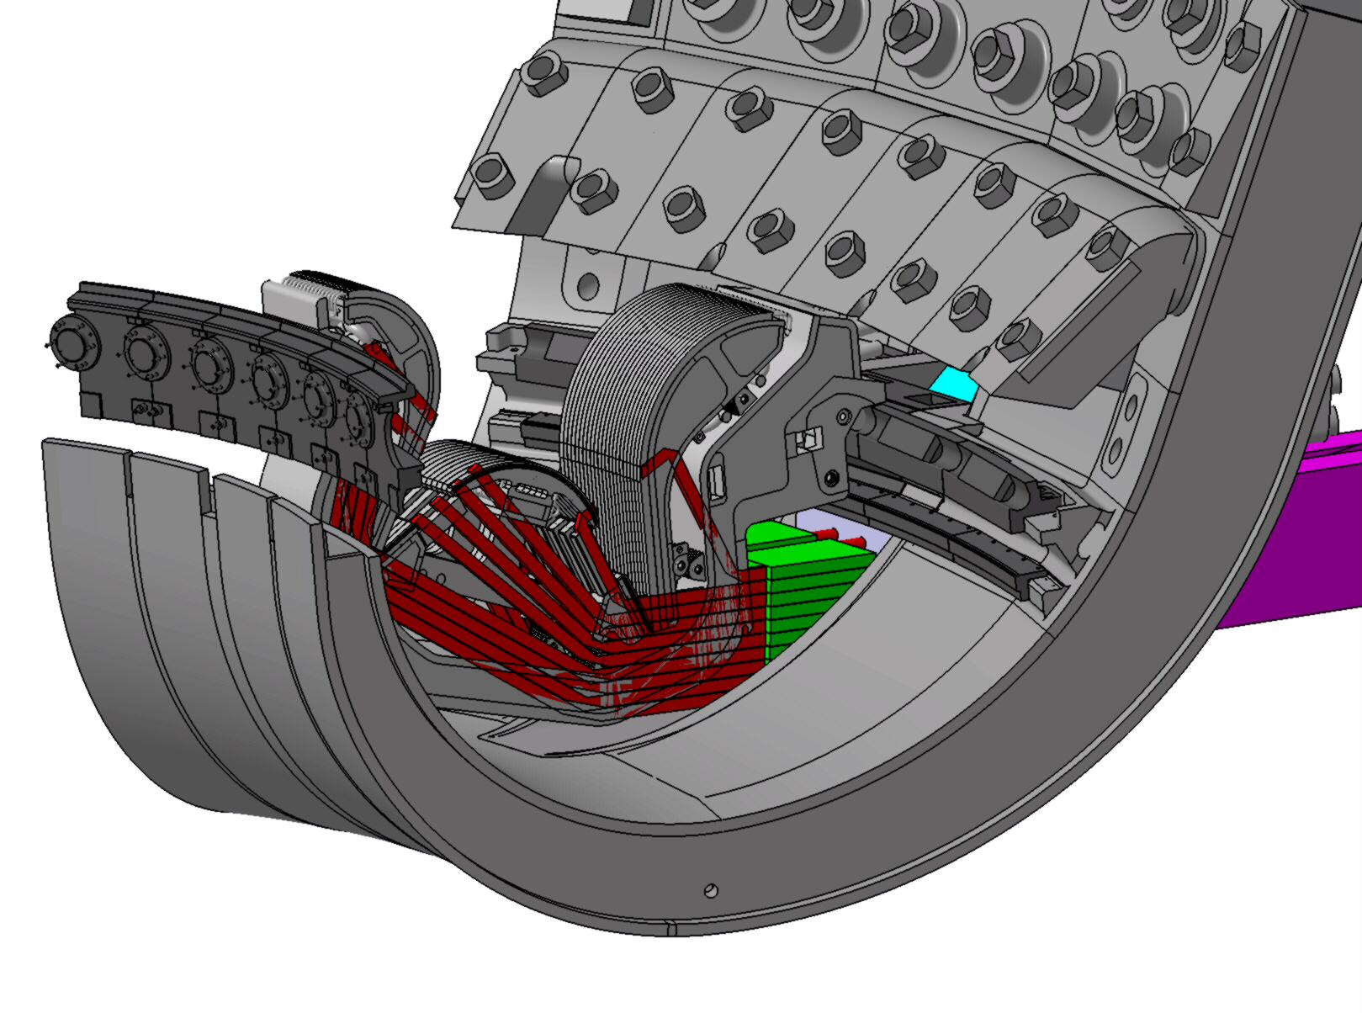
Figure 1: Overview of the long-wavelength system in the port
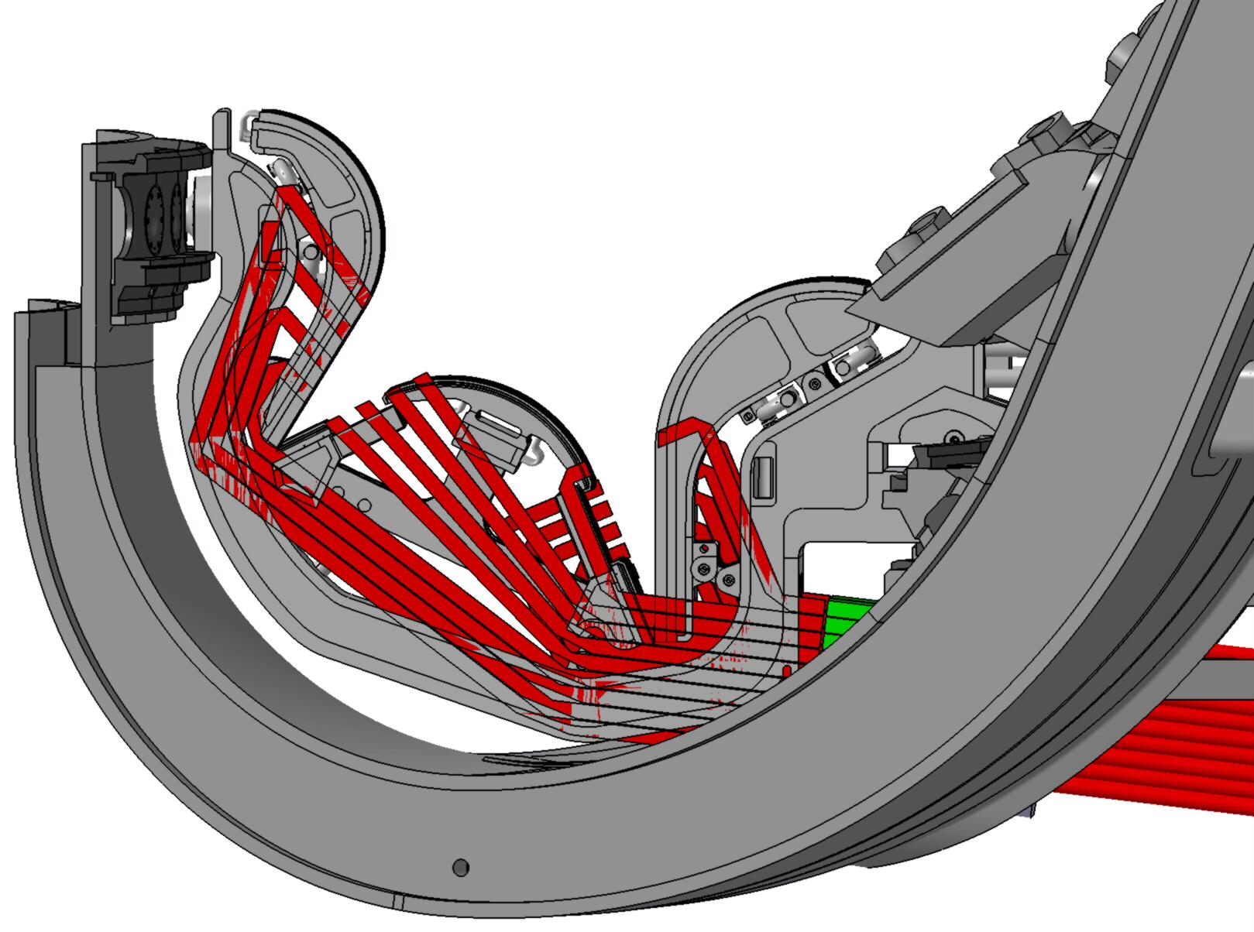
Figure 2: Side view of the long wavelength system in the port. Note some of the sightlines are difficult to interpret as they intersect the plasma twice (bottom and top of the leg)
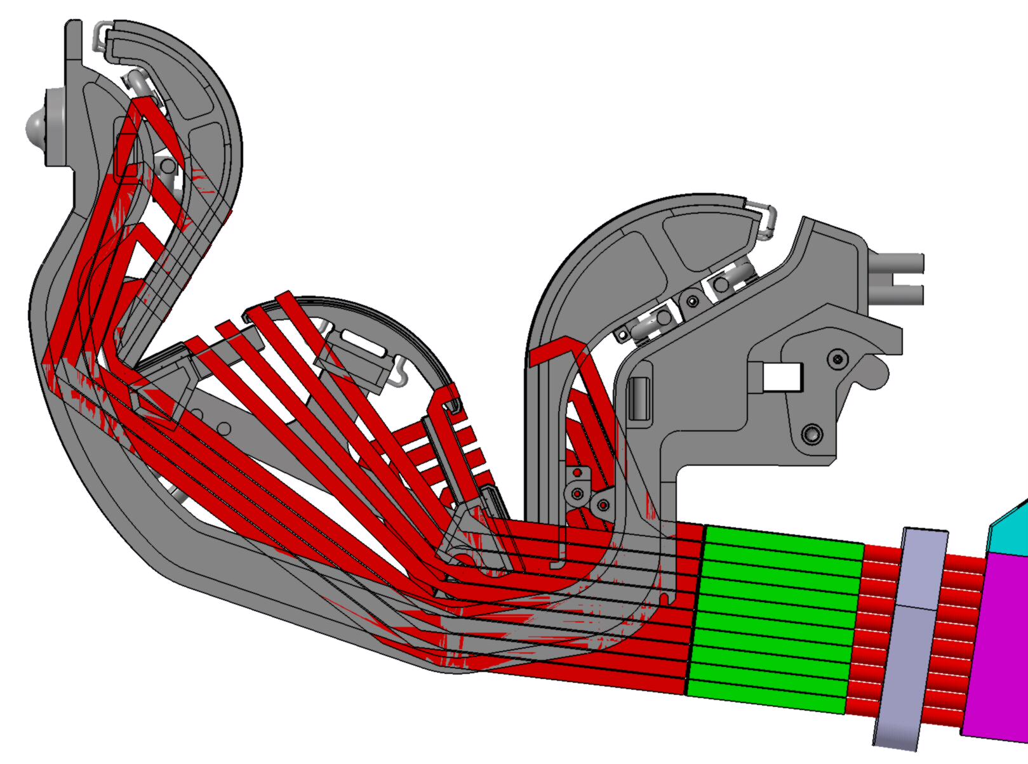
Figure 3: side view of the long wavelength system. Three mirrors per sightline redirect, and possibly refocus the beam within the red boundaries (which are not a waveguide). The green boxes shift the beams toroidally and couple them to round dielectric waveguide. A CO2 beam could be co-linear with this system. Separate transmit and receive lines are needed.
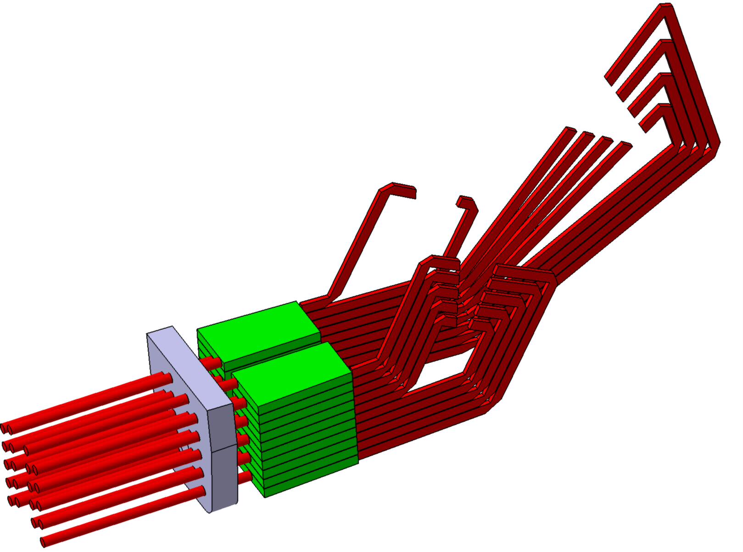
Figure 4: Isometric view of the diagnostic components and beams
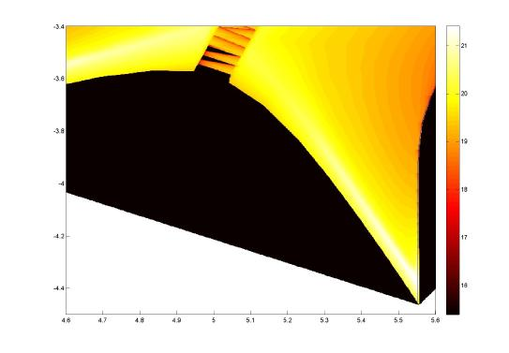

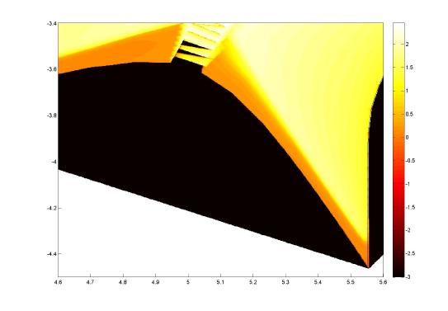
Figure 5: Contours of density (top) and temperature (bottom) for the outer leg; logarithmic scale.

Figure 6: The CMOD arrangement reproduced from [7] .
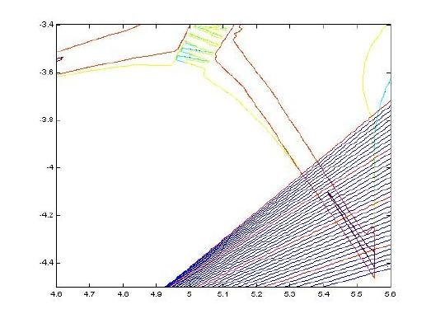

Figure 7: Sightlines shown through the density contours of the outer leg

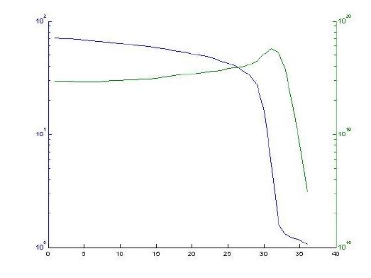

Figure 8: Line integral density and peak temperature reconstructed from the 36 sightlines. The line integral density peak is clearly correlated with the “flame front” location.
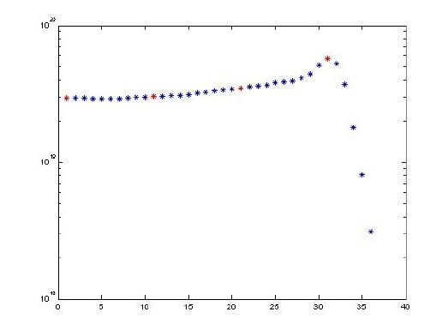

Figure 9: Line integral density for the 36 sightlines.
Figure 10: CO2 lines of sight on cassette?

