LASER BEAM-PROFILE MONITOR DEVELOPMENT AT BNL FOR SNS

R. Connolly, P. Cameron, J. Cupolo, C. Dawson, C. Degen, A. Della Penna,
D. Gassner, M. Grau, M. Kesselman, S. Peng and R. Sikora
Brookhaven National Lab,Upton, NY, USA

Abstract
A beam profile monitor for H⁻ beams using laser photoneutralization is being developed at Brookhaven National Laboratory [1] for use on the Spallation Neutron Source (SNS) [2]. An H⁻ ion has a first ionization potential of 0.75eV and can be neutralized by light from a Nd:YAG laser (λ=1064nm). To measure beam profiles, a narrow laser beam is passed through the ion beam neutralizing a portion of the H⁻ beam struck by the laser, and the perturbation of the beam current caused by the laser is measured. The laser trajectory is stepped across the ion beam generating a transverse profile. Proof-of-principle experiments were done at 750keV and 200MeV. Also a compact scanner prototype was used at Lawrence Berkeley National Laboratory (LBNL) [3] during commissioning of the SNS RFQ.

1. INTRODUCTION

The H⁻ ion, a bound state of one proton and two electrons, has no excited bound states [4]. When the ion gains 0.75eV one of the electrons becomes a free particle. Negative hydrogen ions can thus be neutralized with beams of light with λ≤1.67μm. The detached electron is boosted into the continuum so the cross section variation with photon energy is a broad curve with a gentle maximum at 1.3eV (λ=930nm), fig. 1 [5].
Photoneutralization can be used to select a small portion of an H⁻ beam for measurement. For instance at Los Alamos National Lab longitudinal emittance has been measured by neutralizing a short phase slice of a bunch with a pulsed laser, removing the rest of the beam with a magnet, and measuring the momentum spread of the selected beam [6]. Also at Los Alamos the transverse emittance of an intense beam was measured by passing the light from a Q-switched laser through the full cross section of the beam. A magnet removed the charged beam, and a slit and parallel-channel collector was placed after the clearing magnet. Beam loading on the slit was avoided and there were no space-charge effects since the measurement was made on neutral beam [7].
This paper reports on the development of a profile measurement system in which a laser beam serves the same role as the wire in a stepped-wire profile scanner. Focused light from a Nd:YAG laser passes through the ion beam and neutralizes some of the ion beam it passes through. Downstream either the dip in the beam current is measured or the pulse of detached electrons is deflected into a Faraday cup and measured. The laser beam is stepped across the ion beam and a profile is built up [8].

Figure 1: Calculated cross section for H⁻ photoneutralization as a function of photon wavelength. Data are from a table in ref. [5].

This technique is being considered for SNS as an alternative to placing carbon wire scanners into the superconducting linac. Beam heating will limit wire scanners to tuning and matching applications with either the beam pulses shortened or the current reduced. Also there are concerns about placing wires near the superconducting cavities where wire failure can cause cavity damage.

2. PHOTONEUTRALIZATION

Figure 1 shows the photoneutralization cross section as a function of photon wavelength in the center-of-mass frame. All the experiments reported here use λ=1064nm light. For low ion-beam velocities the neutralization cross section is about 3.7 x 10⁻¹⁷cm². As the ion velocity increases, the photon energy in the ion rest frame increases. If the laser beam crosses the H⁻ beam at a lab angle of θ_{L} the photon energy in the moving frame is Lorentz shifted by the amount [9],

E_{CM}=γE_{L}[1-βcos(θ_{L})] (1)

For the SNS laser installation θ_{L} will be 90° so, at the full energy of 1GeV, the center-of-mass photon energy will be double the lab energy. For these measurements and probably for the final SNS installation the laser will be a Q-switched Nd:YAG laser operating at its fundamental of λ=1064 nm so at the full energy of 1GeV the neutralization cross section will be about 70% of the low energy cross section.
The fraction of beam ions which get neutralized passing through the laser beam is,

f_{neut} = 1 - e^{-σ(E)Ft} (2)

Here σ(E) is the energy-dependent cross section, F is the photon flux, and t is the time the ion is in the laser light. For ion beam energies up to about 200MeV the cross section changes very little and the time the ions take to cross the laser path decreases so the neutralization fraction drops with increasing beam energy.
The photon flux in the moving reference is also transformed the same as the photon energy [10],

F_{CM}=γF_{L}[1-βcos(θ_{L})] (3)

The relativistic increase in photon flux compensates for the decreased time the ions spend in the laser path and for the drop in cross section as the Lorentz-shifted photon wavelength drops below 700nm resulting in an almost flat neutralization fraction from 400MeV to 1GeV.
For example, the laser on the SNS MEBT experiment produces a 20ns-long pulse with an output energy of 50mJ. It is focused to a rectangular spot 1mm wide by 3mm along the beam. The approximate variation of neutralization fraction with beam energy this laser will produce is shown in fig. 2.

Figure 2: Calculated neutralization fraction vs. beam energy for a 20ns-long, 50mJ laser pulse focused to a spot size of 1mm x 3mm.

3. 750 KeV EXPERIMENT

Our first profile measurement was made on the BNL linac between the rfq and the first drift tube linac tank. A light pulse from a 200mJ/pulse Q-switched Nd:YAG passed through the 750keV H⁻ beam from the linac rfq neutralizing >95% of the beam the light passed through, fig. 3. The beam passed through a weak magnet to remove the detached electrons, and a downstream current transformer measured a dip in the beam current which was proportional to the fraction of the beam hit with the light, fig. 4. The laser beam was stepped across the ion beam and the profile constructed by plotting the depth of the current notch vs. laser beam position, fig. 5.

Figure 3: Laser scanner experiment on BNL linac. The first of two 10 Gm dipole magnets removes the free electrons from the beam and the second straightens the beam.

Figure 4: Scope trace of the current transformer signal showing notch created by the laser pulse.

Figure 5: Measured horizontal profile with Gaussian fit to the data.

4. SNS MEBT MEASUREMENTS

We built a laser platform that attached to a wire-scanner chamber on the SNS medium energy beam transport line (MEBT) at LBNL. Mounted on the platform, fig. 6, are a 50mJ/pulse laser head, a lens holder, and three linear actuators which move 45° mirrors. The top-left mirror is a switch. For vertical scans it is inserted into the laser beam directing the laser light to the bottom-left mirror which moves vertically. For horizontal scans it is removed and the top-right mirror is moved horizontallly. We installed the platform on the MEBT after it was under vacuum and ready for first beam.
A 300mm-focal-length cylindrical lens is mounted directly in front of the laser head and the two optical path lengths from the lens to the beam center are the same. The lens produces a 1mm-wide by 3mm-long light ribbon across the beam producing a measurement window of rms width 0.3mm. Since the measured rms width of the horizontal profile is 1.60mm the width of the laser beam caused 2% broadening of the profile.

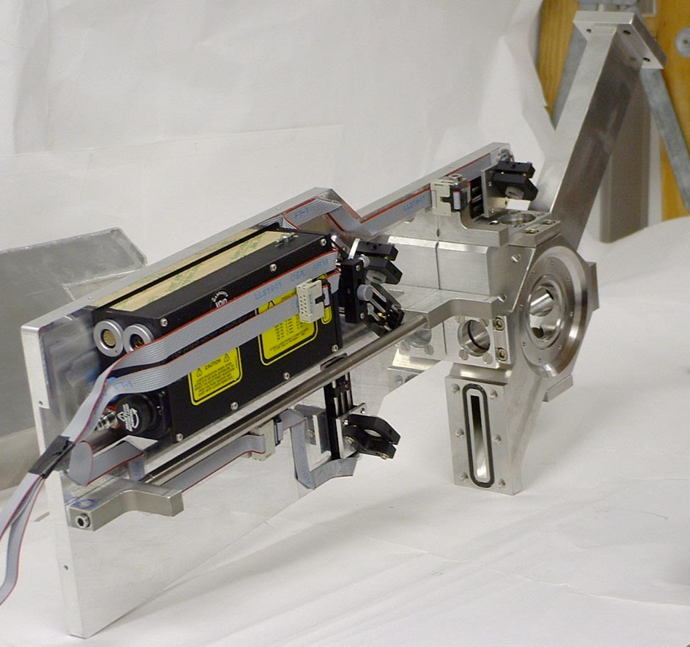

Figure 6: Laser scanning platform mounted on the SNS MEBT wire scanner chamber.

The signal was detected with the existing beam transformer at the end of the MEBT. The BCM signal was fed into a LeCroy LT374L scope with ethernet connection [11]. A math channel on the scope was used to average for several pulses to reduce noise and rf pickup. For the profile shown in fig. 7, the signals from 25 beam pulses were averaged giving about 40dB signal/background in the beam center. This was the first beam profile measured during the SNS MEBT commisioning.
The experiment was controlled in Labview. The program switched the laser, moved the mirrors, initialized the scope for each new position, and read the data. Cursors on the scope were set manually around the pulse. For each set of averaged data the program summed the channels between the cursors, summed an equal number of channels before the pulse, and subtracted these two 'integrals' to give one data point in the profile.

Figure 7: Horizontal beam profile measured on the SNS MEBT with the laser profile monitor. The Gaussian fit to the data has a measured width of σ=1.60±0.04mm

5. MEASUREMENTS AT 200 MEV

One concern driving this development is the risk of placing carbon-wire scanners near superconducting cavities where the formation or release of particulate matter (from actuator mechanisms, hot wires, breaking wires, etc.) may contaminate cavity surfaces. Superconducting cavity surfaces must be clean to semiconductor-grade standards. Contamination can introduce field-emission sites leading to degraded performance from field-emission heating and reduced operating gradients. Once a cavity is degraded remedial action, which may include rebuilding the cryomodule, is required in order to restore the cavities to their specified level of performance [12]. The SNS linac has normal-conducting rf cavities to accelerate the beam to 185MeV and superconducting cavities to take the beam to 1 GeV. For this reason we needed to make a test in the energy range of the superconducting linac (SCL)
The apparatus that was used to measure the 750keV profiles was installed in the linac-AGS transfer line, which is no longer used for beam transport, to measure 200-MeV beam. Also a single-plane RHIC stripline beam position transducer was installed before and after the beam box. The goal of this experiment was to measure SNS-energy ion beams using stripline beam position monitors (BPMs) to measure the laser notch.
In the SCL there are BPMs between rf tanks but only one current transformer at the exit of the linac. Using the striplines as detectors gives us access to an upstream and downstream detector spaced by a single rf structure. Using the transformer for signal detection will require good beam transmission through the full linac before profiles can be made at any point.
The arrangement of the laser and optics on the linac beamline is shown in fig. 8. A CFR200 laser from Big Sky Laser [13] is mounted on a shelf at the top left. Three 45° mirrors are mounted inside the vacuum on rail-mounted trollies driven by linear motion feedthroughs. The top-left mirror was used to switch between vertical and horizontal scans and the other two were used for scanning. The top-right mirror scanned horizontally and the bottom-left mirror scanned vertically. Arms to hold lenses are attached to the scanning mirror trollies. Figure 9 is a photograph of the tunnel installation.

Figure 8: Laser scanning assembly installed on linac beamline. View is looking up beamline.

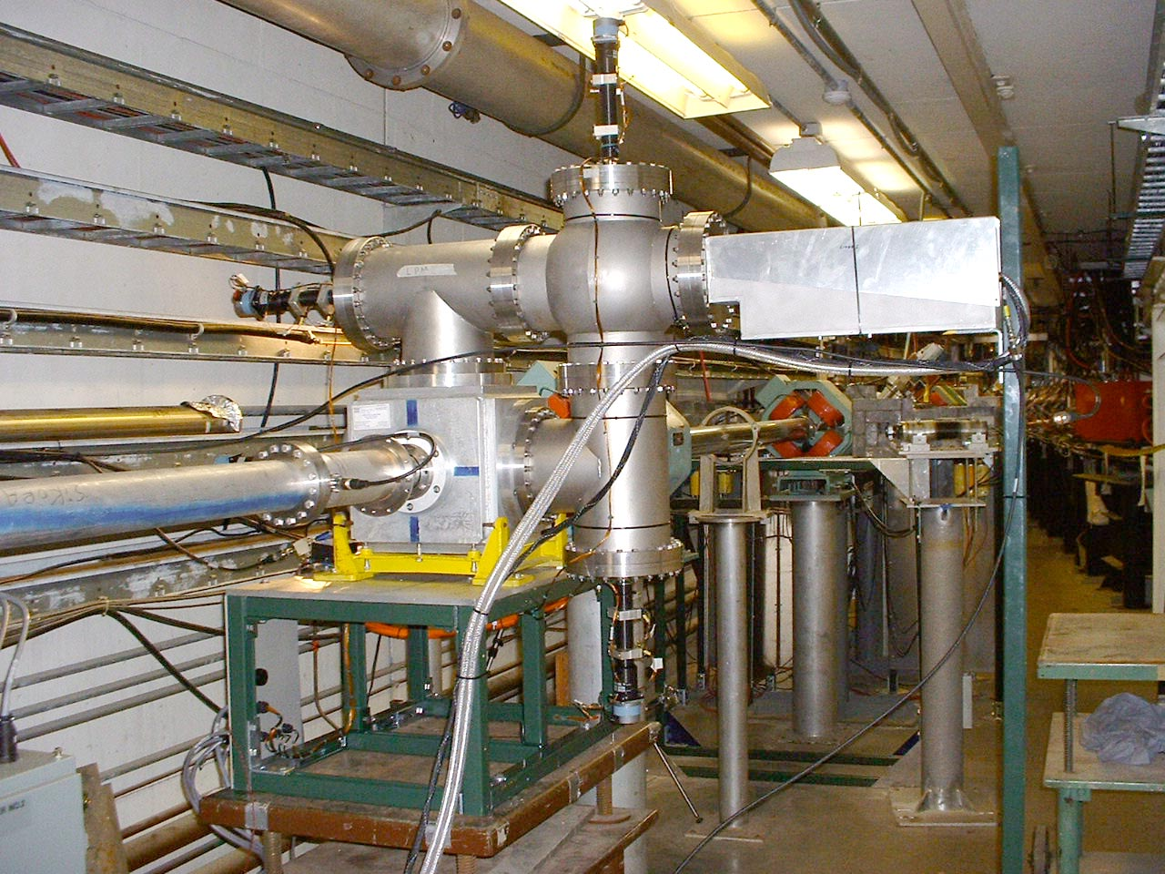

Figure 9: Laser profile monitor at 200 MeV in the BNL linac.

Experiments at 200MeV were conducted over a period of several months. During this time several techniques were tried to produce clean measurements of the laser-induced current notch. The detection method that has worked best so far is shown in fig. 10.
Signals from one upstream and one downstream stripline are passed through filters at the linac bunch frequency of 200MHz to remove higher harmonics and adjusted to be in phase. A 180° hybrid subtracts the two signals to produce a nulled signal in the absence of laser neutralization. The laser pulse causes a signal imbalance which appears either as a wide or narrow spot in the rf envelope depending on how the signals are combined.
The 200-MHz carrier frequency is removed from the difference signal using a homodyne receiver [14]. The difference signal is mixed with a reference signal from the linac rf system and the mixer output is passed through a 50-MHz low-pass filter. Figure 11 shows the signal generated by the laser pulse striking a photodiode and the output of the mixer. The beam-current notch was generated by averaging 50 pulses.

Figure 10: Circuit used to detect current notch in beam.

Figure 11: Oscilloscope trace of laser pulse (top) and beam-current notch generated by circuit in fig. 10.

The laser platform was located 40m from the exit of the linac. In this drift distance the energy jitter of 2.2MeV in the linac beam causes a time-of-flight jitter of ±1ns which is ±70° at 200MHz. For this reason there was a lot of rf noise in this measurement which will be not be present in measurements made along the SNS linac.
Figure 12 shows beam profiles measured with the laser (dotted line) and with a carbon wire scanner located in the laser beam chamber. The Gaussian fitted curve to the laser data has an rms width of σ_{laser}=6.67±0.6mm. The spatial flux distribution of the laser spot was not measured but a uniform round laser spot of 6mm diameter would have an rms width of 1.7mm. When the profile broadening caused by the size of the laser beam is removed the measured beam width is σ_{laser}=6.45±0.6mm. The width of the fit to the carbon wire data is σ_{wire}=5.7±0.3mm.

Figure 12. Beam profiles measured with the laser scanner (blue, dotted curve with round markers) and with the carbon wire scanner.

6. DISCUSSION

Transverse profiles of H- beams can be measured by scanning a laser beam across the ion beam and detecting the notch in the beam current downstream. This technique is attractive because no components are in the vacuum, profile measurements can be made without disrupting machine operation, and measurements can be made on high power beams. As we demonstrated on the SNS MEBT, profile measurement capability can be added to an operating accelerator if a suitable window exists and a downstream current transducer is available.
Q-switched Nd:YAG lasers are perfect for these measurements on beams with energies up to about 1GeV. These lasers are readily available with a wide range of output energies. Lasers with pulse energies of close to a Joule are available with compact laser heads attached to power units by umbilicals which make them suitable for mounting on compact platforms on beamlines.
Our experiments have placed the laser controller and cooling unit next to the beamline for convenience. Two laser controllers have failed from radiation. Any installation of a LPM in a radiation area has to have the controller in a nonradiation area. We do not know the radiation doses the laser heads can take. The plan for SNS is to place the entire laser outside of the tunnel and transport the light by mirrors or fiber optics.
The two LPM experiments which used beam current transformers for beam-current detection produced extremely clean signals with very little set up time. The measurement at 750keV gave a signal/noise ratio at beam center of 25dB and the MEBT experiment gave 40dB. Measurements on 200MeV beam using BPM striplines for the current transducers have been made but they suffered from large rf backgrounds. These backgrounds are from phase jitter caused by the 1% energy jitter of the linac beam together with the 240ns flight time from linac to detector. The SNS installations in the linac will have far more phase stable beam.

ACKNOWLEDGEMENTS

The authors thank Brian Briscoe and Vinnie LoDestro at the BNL linac. Also we thank Alex Ratti, Larry Doolittle and John Staples at LBNL for letting us try the MEBT platform during commissioning.

7. REFERENCES

[1] http://intranet.bnl.gov/
[2] http://www.sns.gov/
[3] http://www.lbl.gov/Science-Articles/Archive/AFRD- SNS-first-stage.html
[4] R.N. Hill, Phys. Rev. Lett. 38, 643 (1977).
[5] J.T. Broad and W.P. Reinhardt, Phys. Rev. A14 (6) (1976) 2159.
[6] V.W. Yuan, R.C. Connolly, R.C. Garcia, K.F. Johnson, K. Saadatmand, O.R. Sander, D.P. Sandoval and M.A. Shinas, "Measurement of longitudinal phase space in an accelerated H⁻ beam using a laser- induced neutralized method", Nucl. Instr. and Meth. A329 (1993) 381-392.
[7] R.C. Connolly, K.F. Johnson, D.P. Sandoval and V. Yuan, "A transverse phase-space measurement technique for high-brightness H⁻ beams", Nucl. Instr. and Meth. A132 (1992) 415-419.
[8] R. Connolly, P. Cameron, J. Cupolo, M. Grau, M. Kesselman, C-J Liaw and R. Sikora, "Laser Profile Measurements of an H- Beam", Proc. 5th European Workshop on Beam Daignostics and Instrumentation, (Grenoble), http:/www.esrf.fr/conferences/DIPAC/DIPAC2001Pr oceedings.html
[9] R.E. Shafer, "Laser Diagnostic for High Current H- Beams", Proc. 1998 Beam Instrumentation Workshop (Stanford). A.I.P. Conf. Proceedings, (451), 191.
[10] S.M. Shafroth and J.C. Austin, Eds., Accelerator- Based Atomic Physics Techniques and Applications, A.I.P. Press (1997) Chap. 6.
[11] LeCroy Corp., Chestnut Ridge, NY 10977.
[12] Thomas Powers, Thomas Jefferson National Accelerator Lab, priv. comm.
[13] Big Sky Laser Technologies, Inc., Bozeman, MT 59715.
[14] Suggested by Robert Weber, Fermi National Accelerator Lab.

3] M.J.Ajmera and K.T. Chung, Phys. Rev. A12 (2) (1975) 475.
[4] M. Daskhan and A.S. Ghosh, Phys. Rev. A28 (5) (1983) 2767.
[5] W.B. Cottingame, G.P. Boicourt, J.H. Cortez, W.W. Higgins, O.R. Sander and D.P. Sandoval, Proc. 1985 Particle Accelerator Conf., IEEE Trans. Nucl. Sci. NS-32 (1985) 1871.

[8] R. Tomlin, "Ion Beam Notcher Using a Laser", FERMILAB-Conf-01/117-E (2001).
[9] D.R. Swenson, E.P. MacKerrow and H.C. Bryant, "Non-Invasive Diagnostics for H- Ion Beams using Photodetachment by Focused Laser Beams", Proc. 1993 Beam Instrumentation Workshop (Santa Fe). A.I.P. Conf. Proceedings, (319), 343.

[11] R.E. Shafer, "Laser Diagnostic for High Current H- Beams", Proc. 1998 Beam Instrumentation Workshop (Stanford). A.I.P. Conf. Proceedings, (451), 191.
[12] R. Tomlin, "Laser Stipping of Relativistic H- Ions with Practical Considerations", FERMILAB-TM-1957, (1995).
[13] S.M. Shafroth and J.C. Austin, Eds., Accelerator-Based Atomic Physics Techniques and Applications, A.I.P. Press (1997) Chap. 6.
[14] Big Sky Laser Technologies, Inc., Bozeman, MT 59715.
[15] LeCroy Corp., Chestnut Ridge, NY 10977.

