Accident |  | National Airlines DC-10, Flight 27
Location |  | Albuquerque, New Mexico
Date |  | November 3, 1973
Summary |  | On November 3, 1973, while National Airlines DC-10, flight 27, from Miami to San Francisco, was cruising at 39,000 feet, the No. 3 engine fan assembly completely disintegrated. See Figure 1.  The No. 3 inlet and fan case separated simultaneously with fan blade liberation, allowing the blades to impact the airplane at high speed.  Flight 27 was a McDonnell Douglas DC-10-10 with General Electric Aircraft Engines (GEAE) CF6-6D turbofan engines installed (Figure 2). See Figure 3 for a close up of the CF6-6 wing installation. See Figure 4 for a cutaway view of the CF6-6 engine.  The liberated blades struck the fuselage, right wing, engines No. 1 and 2, and caused a cabin window to fail. See Figure 5 and Figure 6.  This resulted in the expulsion of one passenger through the opening during rapid decompression. Many passenger oxygen masks failed to deploy, causing a panic among the remaining passengers.  The engine debris caused damage to two of the aircraft's three hydraulic systems resulting in loss of all hydraulic fluid for both systems.  At the time of the No. 3 fan failure (Figure 7), the pilot and flight engineer were "experimenting" with the relationship between the engine's fan speed (N1) signals and the automatic flight control systems. The pilot and flight engineer appeared to be curious as to where the autopilot/auto throttle received its engine speed signal (i.e., N1 gauge or N1 tachometer generator). The crew reported that their "experiment" was conducted as follows:  - Autopilot selected in airspeed mode - 257 KIAS.  - Flight engineer pulled circuit breakers for N1 tachometers on engine numbers 1, 2, and 3.

Summary (continued) | - Target airspeed reduced by 5 knots.  - When throttles retarded, pilot disengaged auto throttle.  - Crew then heard explosion and cabin decompression.  The crew declared an emergency and executed an emergency descent. There was an uneventful landing at Albuquerque, New Mexico. The oil tank in the No. 1 engine had been penetrated by fan blade debris and upon landing had lost all oil, and the No. 1 engine constant speed drive generator line was severed.  Engine No. 2 ingested fan debris and sustained minor foreign object damage.  The failure of a substantial number of oxygen masks to deploy appeared to result from multiple electrical failures.  Analysis of cockpit voice recorder data shows that the No. 3 engine accelerated from 97% N1 to 100% N1, fluctuated for a few seconds and failed at 100%; the flight data recorder was inoperative. Engines No. 1 and 2 also accelerated from 97% N1 to a maximum of 107% N1.  See Figure 8 of the No. 1 engine cowl showing impact damage from the No. 3 engine debris. Engine debris penetrated the oil tank resulting in total loss of engine oil upon landing.  The investigation centered on vibratory characteristics of the fan blades and fan case. There was a debate on the role of the inlet on the blade/case relationship that asked: "Did the inlet failure cause tip rub?" or "Did tip rub cause the inlet failure?"  The initial triggering event was never completely agreed upon by all parties. However, the failure mechanism was sufficiently understood so that corrective actions to prevent additional occurrences could be defined.  The identified failure mechanism involved a fan case "6-wave" mode traveling at 1/2 fan speed in the direction of the fan rotation. See Figure 9.

Summary (continued) | The fan blade assembly also exhibited a fore-and-aft rocking vibratory mode (Figure 10) which has a traveling wave shape at 1/2 fan speed in an opposite direction to the fan.  A vibratory mode shape is the way in which the object deflects at its natural frequency.  An example of natural frequency and mode shape is given in the case of a guitar string. When struck, the string vibrates at a certain frequency and attains a deflected shape. The frequency can be noted by the pitch coming from the string. Different string geometrics (length and diameter) lead to different natural frequencies or notes.  It was generally agreed that two conditions had to be present for a massive engine failure such as this to result:  - A coincident and coupled fan case wave and blade "rocking" wave mode, and  - Fan blade tip rub.  The Campbell diagram in Figure 11 illustrates the fan case and blade vibratory modes.  It is important to note that although the flight crew was experimenting with the aircraft systems and not following an approved procedure, the root cause of the failure was not the improper flight crew actions in the cockpit, but a design problem with the engine.  The maximum speed of the fan rotor on the No. 3 engine when it failed was determined to be approximately 100% which is below the maximum red line speed of 111%. Had the No. 3 engine not failed on the National Airlines flight, there would have eventually been a similar failure on that model engine at some future time in revenue service.  It is also important to recognize and be on guard during the investigative phase of accidents/incidents for red herrings or preliminary findings/observations that may not be relevant and may detract from determining the true root cause and necessary corrective actions for the event.

Accident Board Findings | The National Transportation Safety Board (NTSB) determined that the probable cause of this accident was the disintegration of the No. 3 engine fan assembly as a result of interaction between the fan blade tips and the fan case. See Figure 12. The fan-tip rub condition was caused by the acceleration of the engine to an abnormally high fan speed, which initiated a multiwave vibration resonance within the fan section of the engine.  The precise reason or reasons for the acceleration and the onset of the destructive vibration could not be conclusively determined.  The NTSB identified 14 findings for this accident that can be found in the National Airlines Albuquerque NTSB Accident Report, NTSB-AAR-75-2. View the report at: http://case.pr.erau.edu/reports/US_reports/1970/1973.11.03_NationalAirlines_27.pdf.
Accident Board Recommendations | The NTSB issued nine safety recommendations to the FAA. View the detailed NTSB safety recommendations and corresponding FAA responses at: http://faalessons.workforceconnect.org/rawmedia_repository/5e75d016_3085_4755_9383_e2f186d1e25f?/document.pdf.  Three of the recommendations (A-73-116, -117, and -118) pertain to the inspection and maintenance of digital flight data recorders. The digital flight data recorder from the National Airlines airplane was found to be defective and no meaningful data could be retrieved.  Five recommendations concern the passenger and portable oxygen systems installed in the DC-10. The accident revealed deficiencies relative to the installation of the cabin oxygen generating units, functionality of the system and accessibility of portable oxygen units in the cabin.  One final recommendation pertains to the assessment of aircraft damage by flight crews during in-flight emergencies. The NTSB investigation identified that National Airlines did not have a procedure for crew members to assess the structural damage to the airplane in an emergency situation. After the emergency was under initial control, the cockpit crew did not assess the extent of damage to the airplane or the condition in the cabin.

Accident Board Recommendations (continued) | Due to the prompt and effective actions taken by the FAA, GEAE, McDonnell Douglas, and airlines flying the DC-10, no recommendations regarding engine installation were necessary.  Immediately following the accident, the FAA issued a telegraphic Airworthiness Directive (AD) that applied to all DC-10 aircraft. The AD required inspection of the engine nose cowl mounting integrity and correction of any possible deficiencies. Also, it was recognized early that fan-tip rub was a necessary condition in the sequence of events that brought about the loss of the fan blades.  As a preventive measure against the recurrence of this type of condition, the fan blade tip-to-shroud clearances were increased. As backup for the possibility of blade-tip rub even after the tip clearance was modified, an extensive development, testing, and production program was established to increase the capabilities of the blade retention devices.  The blade retention devices were redesigned with increased capability of more than 3 times the original configuration. These modified blade retention devices were incorporated in all revenue service engines.  In the accident report, the NTSB addressed the flight crew performance of an experiment with the autothrottle/speed control system. The NTSB stressed that the operator and the pilot in command should be fully cognizant of their operational responsibilities to conduct the flight in a professional manner and not to conduct experiments with aircraft systems in which they have not received specific training or instruction.  The individual NTSB safety recommendations can be found in the National Airlines Albuquerque NTSB Accident Report, NTSB-AAR-75-2, at: http://case.pr.erau.edu/reports/US_reports/1970/1973.11.03_NationalAirlines_27.pdf.
Unsafe Conditions | The unsafe conditions that contributed to this incident included:  - The destructive "interactive" fan blade and fan case vibration mode within the engine operating envelope.
Unsafe Conditions (continued) | - Engine design and certification standards that require the engine structure to contain damage resulting from a single rotor blade failure at the outermost retention groove. This engine failure resulted in a number of complete fan blades being released from the fan disk at high speed coincident with the fan containment case separating from the engine. This reduced its effectiveness in containing the engine debris and minimizing the hazard to the aircraft. High energy rotors and uncontained engine debris can cause a hazard to the aircraft. Aircraft safety for this type of threat is provided by a combined effort of precluding the uncontained failures and by mitigating the effects to aircraft in the event of a failure. In this failure scenario, the aircraft safety depended upon the DC-10-10 design precautions that were taken to minimize the hazards from uncontained engine debris.
Design and Safety Assumptions | The following design and safety assumptions are relevant to this accident:  - There were no harmful interacting vibratory modes existing within the engine operating range.  - Engine design and certification standards require the engine structure to contain damage resulting from a single rotor blade failure at the outermost retention groove. The National Airlines engine failure resulted in a number of complete fan blades being released from the fan disk at high speed and the engine structure (fan containment case) separating from the engine which reduced its effectiveness in containing the fan blades and minimizing the hazard to the aircraft. This failure mode exceeded design and certification standards for the engine and aircraft safety relied upon aircraft design considerations for minimizing hazards caused by uncontained engine debris.
Precursors | There are two precursors that have been identified for the National Airlines Flight 27 accident.  First, American Airlines experienced a similar engine failure during test cell operation of a CF6 engine on November 15, 1972; the bellmouth (Figure 13) and exhaust cone separated and all the fan blades were liberated.  This was a precursor because the same failure mode as the National Airlines event was experienced but was not fully understood and the risk for a repeat event to a revenue service engine was not recognized.
Precursors (continued) | The failure investigation put considerable focus on the cause of the failure due to possible improper installation of the bellmouth to engine attachments bolts by American Airlines. This was eventually shown to be irrelevant to the failure. This is another example of a "red herring" that can detract from determining the true root cause.  GEAE experienced a similar engine failure during test cell operation of a highly instrumented CF6 engine (engineering test) on January 12, 1973.  This failure was initiated by the rubbing between the fan rotor and casing and resulted in damage similar to the other occurrences.  This was a precursor because the same failure mode as the National Airlines event and the American Airlines event was experienced and the risk for a repeat event to a revenue service engine was not recognized. This engine was instrumented and was undergoing engineering tests in part as a result of the previous American Airlines test cell failure.
Resulting ACs, Regulatory Guidance and Policy | There were no specific ACs resulting from this accident. However, as a result of the events of November 3, 1973, the following changes were made:  Engine/Airplane Design Changes:  Number of inlet cowl brackets increased from 12 to 21.  Blade axial retention increased from 18,000 to 60,000 pounds-force ultimate.  Fan blade/case tip clearance increased.  GEAE Design Practice:  GEAE engine design practice was updated to incorporate lessons learned regarding fan rotor and case harmful interacting vibratory modes.  Advisory Material:  This accident provided data and information relative to engine fragment spread angles that were used for development of FAA Order 8110.11, titled "Design Considerations for Minimizing Damage Caused by Uncontained Aircraft Turbine Engine Rotor Failures," dated November 19, 1975.

Resulting ACs, Regulatory Guidance and Policy (continued) | The information in this Order was subsequently revised and issued in AC 20-128, which you can view at: http://www.airweb.faa.gov/Regulatory_and_Guidance_Library/rgAdvisoryCircular.nsf/0/536BFC2BFEABC079862569AF006AAE73?OpenDocument&Highlight=20-128.
Airworthiness Directives Issued | The following airworthiness directives were issued as a result of this event. View the ADs in the FAA's Regulatory and Guidance Library at: http://www.airweb.faa.gov/Regulatory_and_Guidance_Library/rgWebcomponents.nsf/HomeFrame?OpenFrameSet.  Engine:  No airworthiness directives were issued on the engine.  Airplane:  - Telegraphic AD issued November 7, 1973, that applies to DC-10-10, -30, -30F series aircraft. The AD required inspection of nose cowl bolts on DC-10 wing-mounted engines. AD 73-26-04 became effective on December 19, 1973, and incorporates the requirements of the telegraphic AD.  - AD 75-04-03 became effective on February 14, 1975, and requires improvements to the DC-10 cabin oxygen mask deployment system. Before the National Airlines accident, the FAA was working with McDonnell Douglas on improving the DC-10 cabin oxygen mask deployment system. This accident resulted in the higher prioritization of this activity and contributed to the issuance of AD 75-04-03.
Lessons Learned | The following lessons should be learned from this event:  - Fan blades and fan case can have harmful vibratory modes.  - Previous test cell failures were precursor events for the accident.  - Precursor events must be resolved or risk being repeated.

Lessons Learned (continued) | - The engine failure exceeded the design and certification standards for engine rotor blade containment. However, the aircraft design precautions were successful in that the damage sustained by the aircraft was not excessive to the point where it prevented a successful emergency landing.  - In the investigative phase of accidents or incidents, it is important to recognize and be on guard in the for "red herrings" or preliminary findings/observations that may not be relevant and may detract from determining the true root cause and necessary corrective actions of the event.  - Following the accident, the FAA conducted a Critical Design Review (CDR) to address potential DC-10 safety issues related to CF6 engine fan blade fragment ejection. The CDR put considerable focus on fan blade fragment ejection and its potential hazards to the aircraft for a specific fan blade problem that was resulting in frequent fan blade failures in revenue service. This review may have been too focused on a specific revenue service problem and did not address system level threats such as loss of the aircraft hydraulic system due to uncontained engine debris. The investigation needs to be broad enough to look for other possible accident precursors.

Category | Environmental Mechanical Aging Aircraft  Avionics Propulsion Human Factors  Electrical Auxiliary, other Software  Interior Airframe Environment  Cabin Safety Flight Crew Maintenance, Operations  Propulsion Installation  Regulations, policies, standards
Application of Lessons Learned | Design & Certification Regulation, Policy, etc.  ADs, TCs, etc. Other: __________________  Maintenance  Continued Operational Safety
Key Words | National Airlines, Albuquerque New Mexico, interactive vibratory modes, rotor-case interaction, fan blade, rapid decompression, tip rub.
Potential Databases | NTSB PTRS  ASRS SDR  ATOS Other: ANE-140 and ANM-140L project files  CSET AAI – Office of Accident Investigation
Figure 1: National Flight 27 After the Incident
(Select here to return)

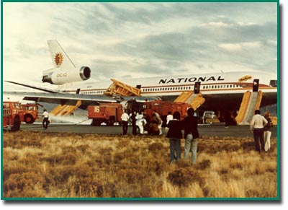
Figure 2: DC-10 Airplane View Illustrated with Engine Arrangement
(Select here to return)

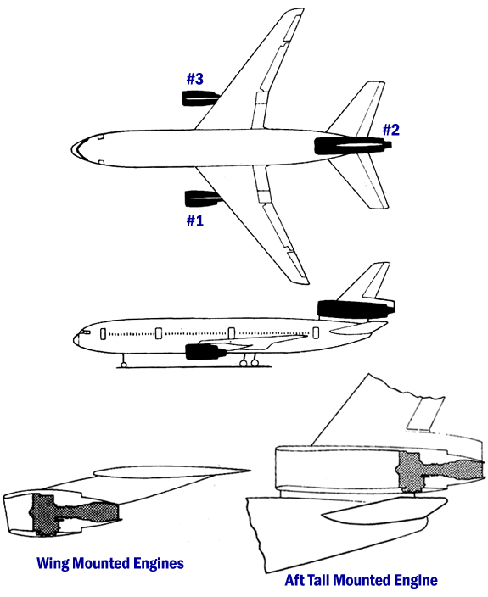
Figure 3: CF6-6 Wing Installation
(Select here to return)

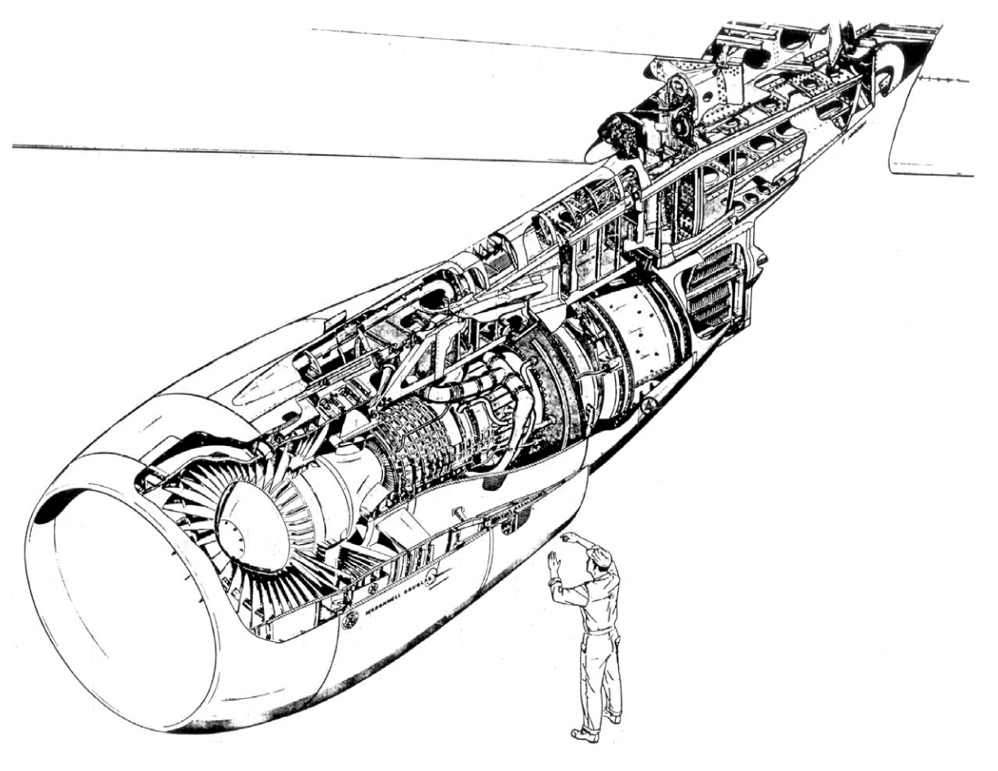
Figure 4: CF6-6 Engine Cut-Away View
(Select here to return)

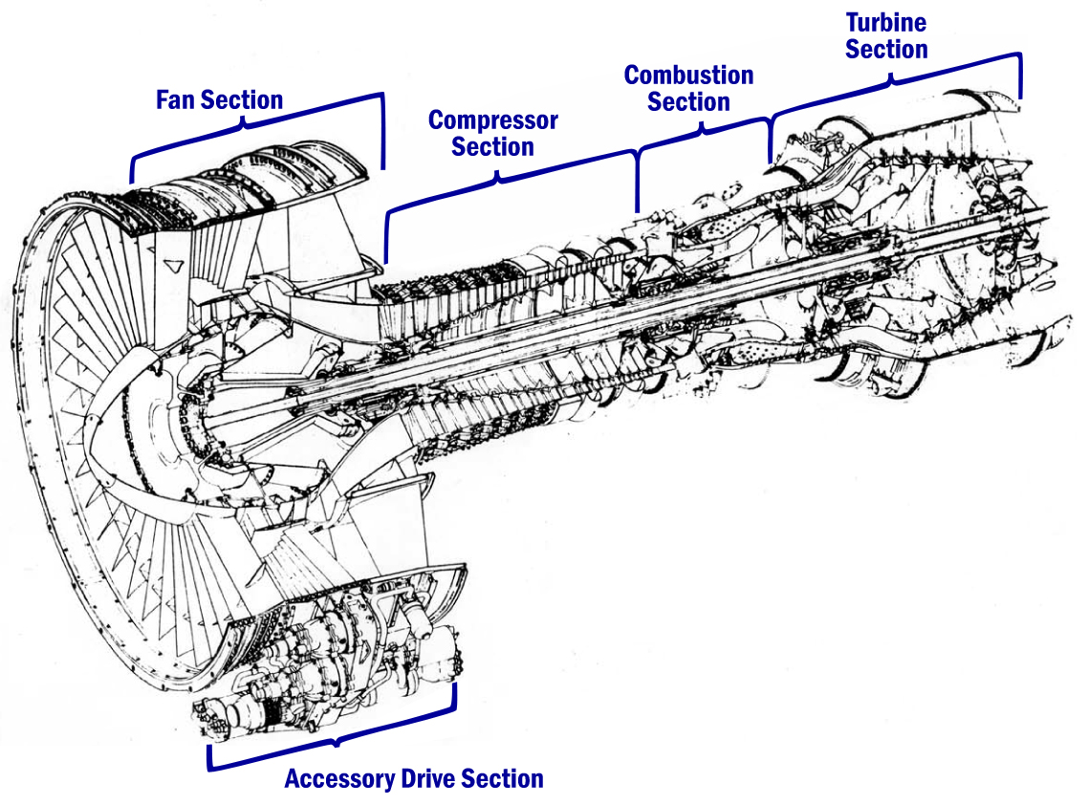

Figure 5: National Airlines DC-10 Flight #27, No. 3 Engine; November 3, 1973
(Select here to return)

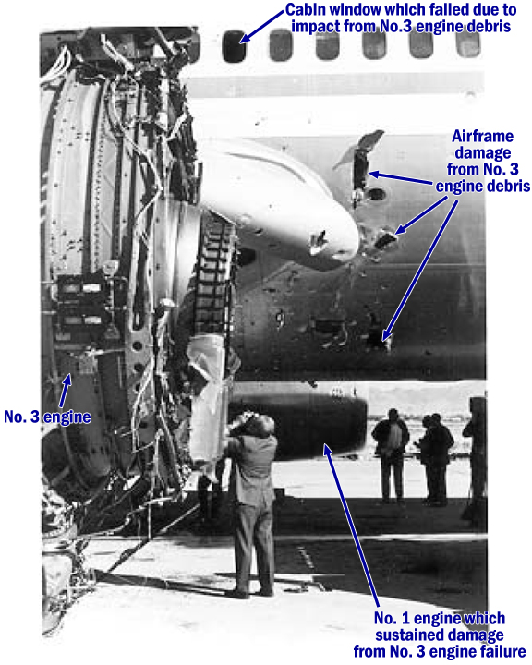
Figure 6: National Airlines DC-10 Flight #27,
View of Engine No. 3 Through Missing Cabin Window, Seat #17H, November 3, 1973
(Select here to return)

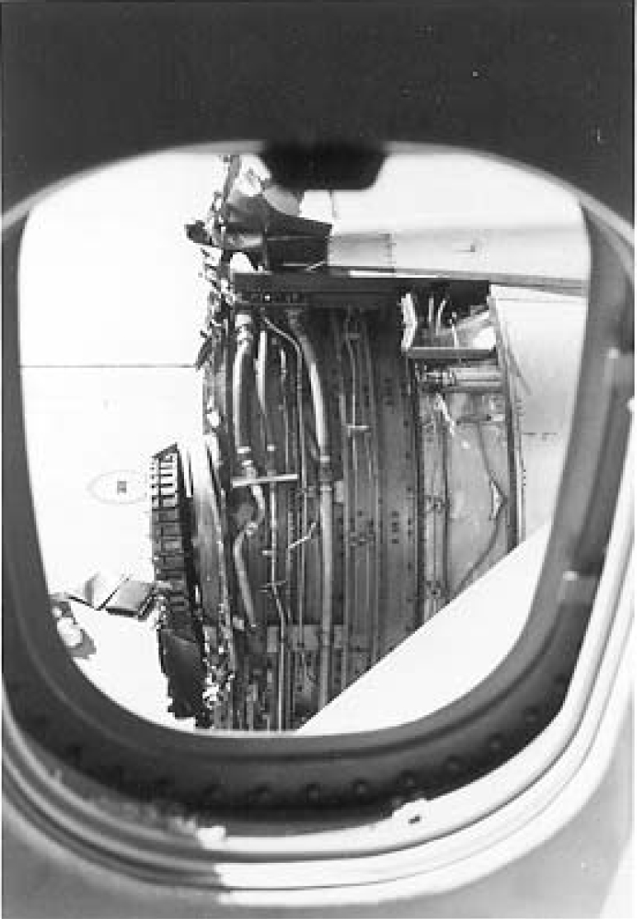
Figure 7: National Airlines DC-10 Flight #27, No. 3 Engine; November 3, 1973
(Select here to return)

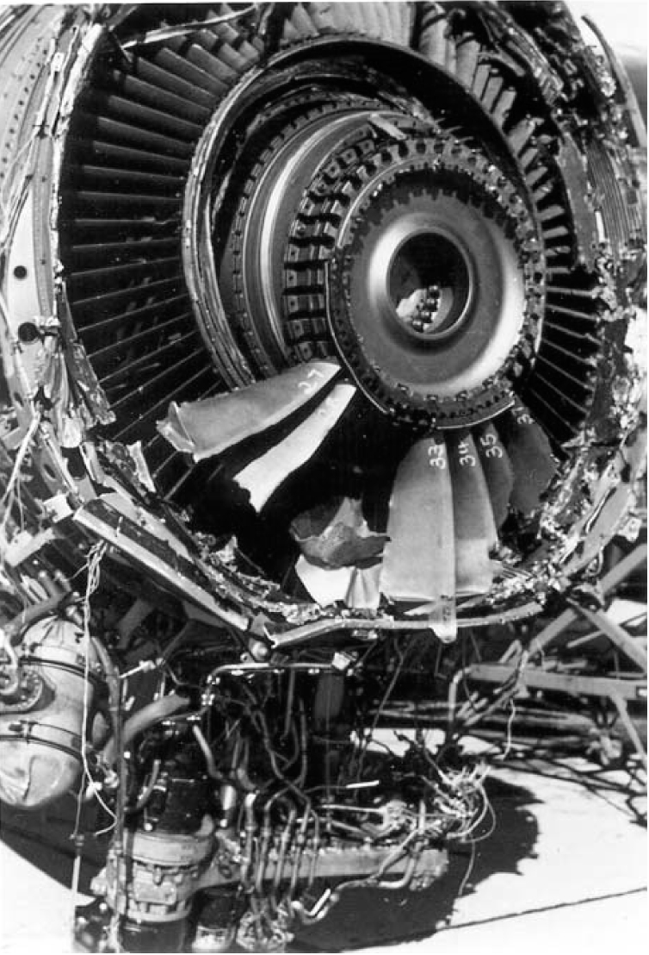
Figure 8: National Flight 27 with a Number 3 Fan Blade
through the Oil Tank of the Number 1 Engine
(Select here to return)

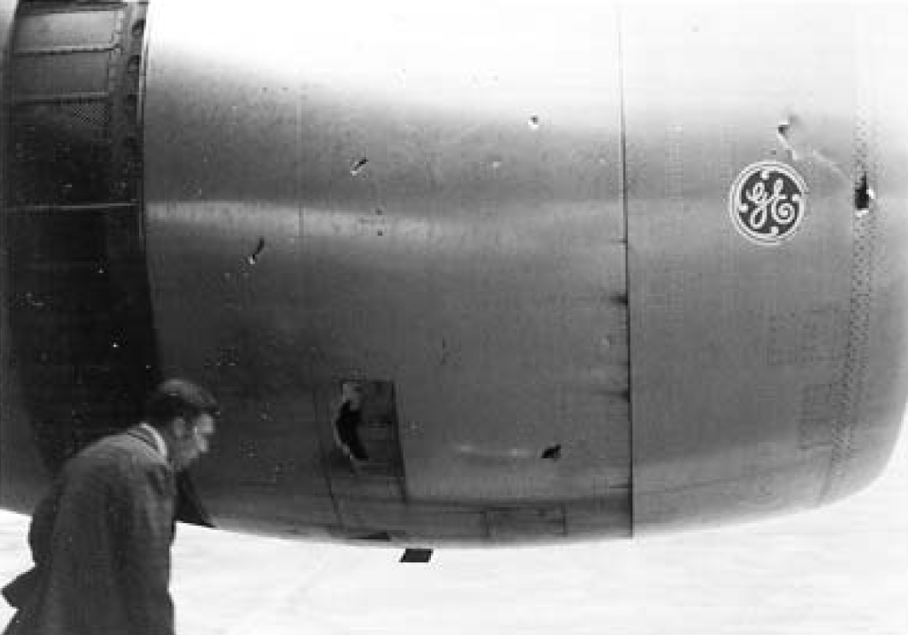
Figure 9: Fan Case “6-Wave” Mode (Front View of Engine Looking Aft)
(Select here to return)

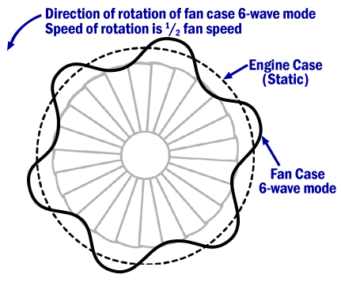
Figure 10: Fan Blade Assembly Fore-and-Aft Rocking Mode
(Select here to return)

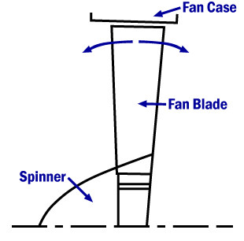
Figure 11: Example of Campbell Diagram of Fan Case and Blade Vibratory Modes
(Select here to return)

This figure shows a Campbell diagram of the fan case and blade vibratory modes. It is for illustrative purposes only and is not to scale. A Campbell diagram is a method of illustrating the natural frequency of an object and its common exciting forces.

The designer uses this information to determine the conditions where a part may be susceptible to high vibrations which can lead to part failure, and to assure that resonance does not occur during steady state operation, particularly at high power.

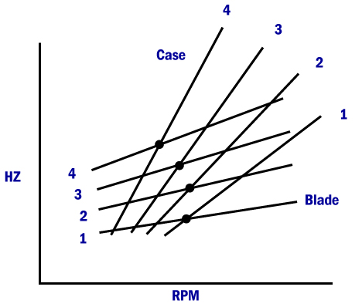
Figure 12: National Airlines DC-10 Flight #27,
No. 3 Engine Fan Blade – Typical; November 3, 1973
(Select here to return)

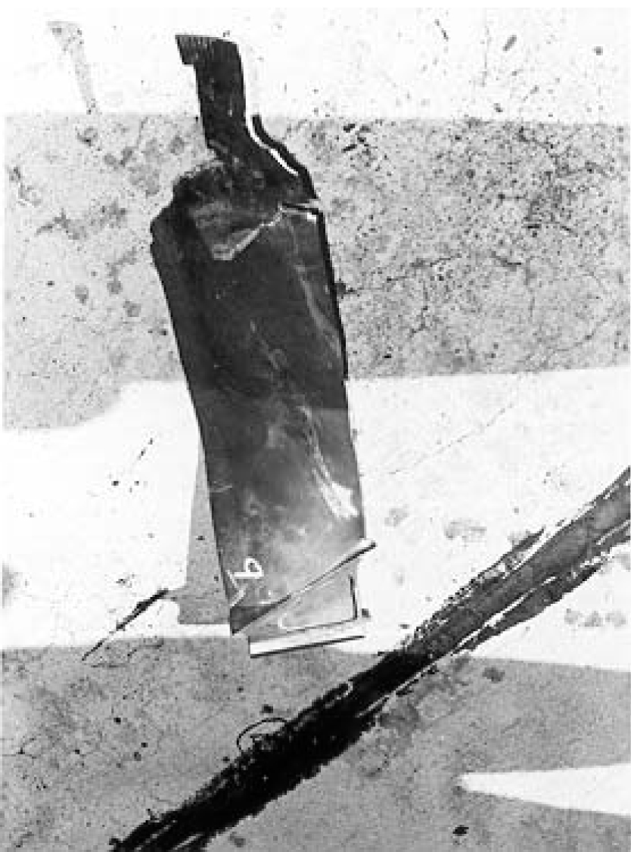
Figure 13: Example of Bellmouth Attached to Front of Engine for Testing
(Select here to return)

A bellmouth inlet is usually installed on an engine being calibrated in a ground test stand. This type of inlet is easily attached and removed from the engine. It is designed with the objective of obtaining very high aerodynamic efficiency.

The inlet is a bell shaped funnel having carefully rounded shoulders which offer very little air resistance.

Very accurate engine performance data can be obtained while using the bellmouth inlet.

