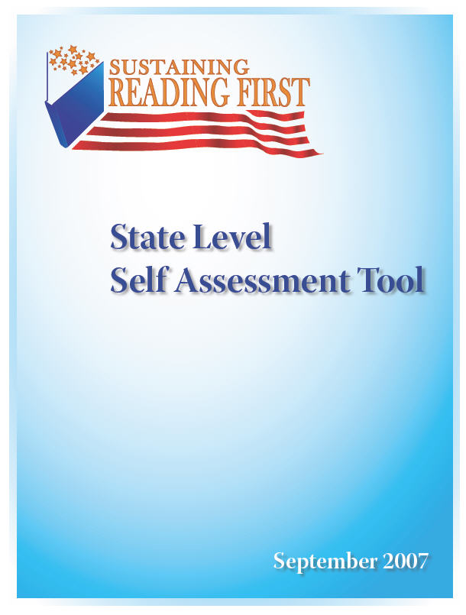

Self Assessment Tools for Teachers, Schools and Districts | The State Level Self Assessment Tool is part of a set of instruments intended to be used together to begin a process for planning to sustain evidence-based reading initiatives at the state and local levels. Used as a needs assessment, the material will (1) promote reflection on current areas of strength in implementing and sustaining scientifically based reading instruction, (2) spark conversations among staff, and (3) facilitate identification of areas that are important for sustainability.
Background | Throughout the self assessment many references are made to “scientifically based research” and “research-based” reading practices. The Reading First initiative is based on the findings of research, in particular the five elements of effective reading instruction identified in 2000 by the National Reading Panel—phonemic awareness, phonics, fluency, vocabulary, and comprehension. If the users of this self assessment feel the need for a brief refresher on the research findings on effective reading instruction, the Guidance for the Reading First Program (http://www.ed.gov/programs/readingfirst/guidance.pdf) document, especially the “Components of an Effective Reading Program” section found on Page 3, will help put all of the indicator statements describing effective Reading First implementation in proper context and perspective. A complete description of the elements of effective reading instruction can be found in the Reading First legislation (http://www.ed.gov/policy/elsec/leg/esea02/pg4.html).
Understanding and Using the Self Assessment | The quality indicator statements in the self assessment were drawn from the findings of research and literature on effective sustainability practices, where sustainability is defined as the ability of a program to operate on its core beliefs and values (its reading culture) and use them to guide essential and inevitable program adaptations over time while maintaining improved outcomes (adapted from Century and Levy, 2002).  The statements are organized around three functions that state leaders perform as they develop and implement research-based reading instruction. Those functions are:  - Support a statewide reading culture focused on the improvement of reading achievement;  - Apply the elements of Reading First to the context of the State’s system of standards-based teaching and learning; and  - Use data to review implementation and impact of local reading programs and recognize success.  It is recommended that the state Reading First Director coordinate use of the instrument. First, you may want to ask individuals within the state department who have a stake in increasing reading outcomes to complete the rating form and synthesize their thoughts in the first Begin to Plan worksheet at the end of the self assessment tool. Appropriate individuals to engage in this exercise might include: the State Superintendent or Assistant; leaders of other federal programs such as Title I, II, II and Special Education; state English and Language Arts/Reading supervisors; and staff who are charged with organizing professional development. Then you may want to convene a meeting to compare and combine conclusions. Remember to use the suggested sources of evidence and reflection questions as you discuss and reach consensus. The second Begin to Plan worksheet is suggested as a place to capture group consensus on priorities and strategies for sustaining Reading First.
Understanding and Using the Self Assessment
Next Steps | State leaders will want to consider how they use the other capacity self assessments in this series (district, school, classroom). In particular, they should consider how they will guide local leaders in using the other self assessments and determine the best way to debrief and integrate findings of the state and local level self assessments.  Sustaining evidence based reading programs will require collaboration and support from a variety of state and local education leaders and a clear plan for promoting sustainability over time. This self assessment is one tool that states can use in planning to sustain Reading First. Additional materials or upcoming opportunities for training and technical assistance on sustaining Reading First can be found at the Reading First Sustainability website.

State leaders…

- Support a statewide reading culture focused on the improvement of reading achievement, by:
- Providing leadership in implementing evidence-based reading programs. |  | Implementation Progress
 |  | 4 | 3 | 2 | 1
Possible Sources of Evidence  - Memos, letters and other documents or communications about reading instruction from state leaders (Chief State School Officer or representatives, Title I Director, Special Education Director, etc.) to school district leaders.  - Documentation of state sponsored professional development that supports scientifically based reading research. | Guiding Questions  - What are some occasions that state leaders have (a) presented findings of Reading First evaluation to make the case for effectiveness of scientifically based reading instruction, and (b) communicated a sense of urgency in improving students’ reading outcomes?  - What are examples of occasions when state leaders deferred or deflected competing policies, procedures or practices in teaching reading?  - How has the state influenced districts to use evidence based reading programs to meet state targets?  - How has the state provided instructional leadership?
- Forming a state steering committee for literacy that uses its leverage to support and expand scientifically based reading instruction programs in the state. |  | Implementation Progress
 |  | 4 | 3 | 2 | 1
Possible Sources of Evidence  - Agendas and minutes from meetings of the state steering committee.  - Defined roles and responsibilities. | Guiding Questions  - What are some of the accomplishments of the state steering committee for literacy that show it has played a change agent role in supporting and expanding scientifically based reading instruction?
- Creating a state literacy plan that addresses building capacity in implementing scientifically based reading instruction programs. |  | Implementation Progress
 |  | 4 | 3 | 2 | 1
Possible Sources of Evidence  - State literacy plan.  - State strategic plan.  - Documentation of collaborative efforts among offices and divisions. | Guiding Questions  - In what ways does the state literacy plan reflect the findings of scientifically based reading research?  - How does the state literacy plan provide a basis for measuring both implementation of reading instruction strategies and student results?  - If the state has a strategic plan in addition to the state literacy plan, what has been done to ensure alignment of the two plans?

- Extending scientifically based reading research to the content of pre-school programs. |  | Implementation Progress
 |  | 4 | 3 | 2 | 1
Possible Sources of Evidence  - Documents addressing early childhood reading (e.g. state legislation on early childhood programs).  - Agendas from meetings of state early childhood staff and state Title I, Reading First, and other state staff working on K-3 reading.  - State plans. | Guiding Questions  - If the state is working in early childhood, how have research findings on early literacy development been communicated and promoted?
- Extending scientifically based reading research to assist struggling readers in grade 4 and beyond. |  | Implementation Progress
 |  | 4 | 3 | 2 | 1
Possible Sources of Evidence  - Documents addressing needs of struggling readers.  - Agendas from meetings of state staff addressing the needs of struggling readers.  - State plans. | Guiding Questions  - How has the state extended the successful elements of research based reading instruction to students in grade 4 and beyond?
- Making district staff aware of federal and state funds available to meet school needs in implementing an evidence-based reading instruction program. |  | Implementation Progress
 |  | 4 | 3 | 2 | 1
Possible Sources of Evidence  - State communications and professional development (documents, meetings, state website) with districts on funding.  - Documents communicating state support to incorporate various funding streams. | Guiding Questions  - Is there information on funding streams that are appropriate for supporting reading achievement for the K-12 grade range?  - How has the state communicated information about appropriate resources—how many communication mechanisms and how frequently?  - What has the state done to encourage the coordination of funding streams to provide the necessary supports for implementing research reading programs?

- Integrating scientifically based reading practices into all professional development and technical assistance in reading. |  | Implementation Progress
 |  | 4 | 3 | 2 | 1
Possible Sources of Evidence  - Agendas of professional development on reading from all offices in the SEA, including professional development provided under state contract.  - List of technical assistance provided by state staff or by entities under contract to the state in improving reading instruction or in school improvement.  - Scope of work of any intermediate agencies working with districts. | Guiding Questions  - How does the state review professional development and technical assistance across divisions for consistency with scientifically based reading research? For alignment to student assessment data?  - How does the state review professional development and technical assistance provided under contract or through regional entities?  - What are some examples of change made as a result of such reviews?
- Promoting collaboration between program managers to improve reading outcomes through use of scientifically based reading instruction. |  | Implementation Progress
 |  | 4 | 3 | 2 | 1
Possible Sources of Evidence  - Agendas from internal state agency meetings.  - List of collaborative state projects. | Guiding Questions  - To what extent do the various divisions within the state agency have collaborative ownership of improving reading outcomes through scientifically based reading instruction?

State leaders…

- Apply the elements of Reading First to the context of the State’s system of standards-based teaching and learning, by:
- Including the five elements of effective reading instruction identified by research in the state’s reading or English/Language Arts standards. |  |  | Implementation Progress
 |  |  | 4 | 3 | 2 | 1
Possible Sources of Evidence  - Documents showing alignment between scientifically based reading instruction and the state’s English Language Arts standards.  - Communications to both Reading First and non-Reading First districts defining research based reading instruction and how it fits into the state’s standards-based system.  - State processes for selecting instructional materials (e.g., textbook adoption). | Guiding Questions  - How confident are you that educators in your state see research based reading instruction as the best way to ensure that students will meet state targets for Grade 3 English Language Arts performance? That the instructional materials they are using are both reflective of reading research and aligned to your English Language Arts standards?
- Developing a state assessment system that supports implementation of scientifically based reading programs. |  |  | Implementation Progress
 |  |  | 4 | 3 | 2 | 1
Possible Sources of Evidence  - List of suggested assessments  - Communications (meetings, workshops, mailings, website) that have reached both Reading First and non-Reading First districts with a message on purposes of assessing reading and how the reading assessment system will contribute to meeting state English Language Arts targets for grade 3.  - Data warehouses containing data from reading assessment.  - Utilization of several types of data.  - Examples of data reports that are available to districts. | Guiding Questions  - To what extent has the state suggested formative assessments that cover a range of purposes (screening, diagnosing, monitoring progress) and measure outcomes for all five reading components?  - How has the state actively promoted district use of formative assessments that are aligned with State reading standards and the state assessment system?  - To what extent has the state used reading data in state data warehouses for the purposes of (1) making electronic reports readily available to districts and (2) using the data to evaluate and improve outcomes?
- Developing improvement planning processes for schools and districts that encourage the use of student data from formative reading assessments to identify student and teacher needs. |  |  | Implementation Progress
 |  |  | 4 | 3 | 2 | 1
Possible Sources of Evidence  - Guidelines for improvement planning that show how to use formative assessment data to identify student and teacher needs.  - District or school plans showing objectives for student reading outcomes beyond a target on the state test and that specify high quality professional development for teachers in areas of need.  - Guidelines for processes used when the state reviews and approves local plans or applications. |  | Guiding Questions  - How effectively have state-promoted school improvement processes supported implementation of evidence based reading programs?  - What point in the process has provided the most leverage—providing guidance on planning or reviewing plans/ applications?

- Developing district monitoring processes that include the review of reading outcomes and dialog with districts on how they are planning to improve student achievement in reading. |  |  | Implementation Progress
 |  |  | 4 | 3 | 2 | 1
Possible Sources of Evidence  - List of all state monitoring processes. | Guiding Questions  - To what extent has the state incorporated the review of reading outcomes in existing district monitoring processes?
- Aligning state legislation, regulations policies, and guidance to support scientifically based reading instruction. |  |  | Implementation Progress
 |  |  | 4 | 3 | 2 | 1
Possible Sources of Evidence  - Existing legislation, regulations, policies, and guidance on reading. |  | Guiding Questions  - What processes has the state used to analyze existing legislation, regulations, and policies to determine how well aligned they are with scientifically based reading research and each other? To make any needed revisions?
- Working with universities to ensure that pre-service programs produce reading teachers who are prepared to implement scientifically based reading instruction. |  |  | Implementation Progress
 |  |  | 4 | 3 | 2 | 1
Possible Sources of Evidence  - The content of pre-service programs.  - Documentation of collaboration with IHEs.  - Teacher licensing requirements.  - Documentation of IHE membership on Reading Task Forces and Leadership Teams.  - Documentation of scientifically based reading instruction in course syllabi and use of texts based on research based principles. | Guiding Questions  - Has the state incorporated the knowledge and skill teachers need to be successful in providing scientifically based reading instruction into the review of teacher education programs? Into Teacher licensure and certification?  - Do representatives of IHE programs attend statewide reading professional development activities?

State leaders…

- Use data to review implementation and impact of local reading programs and recognize success, by:
- Reviewing data from local reading programs systematically to determine fidelity of implementation and success in increasing student outcomes. |  | Implementation Progress
 |  | 4 | 3 | 2 | 1
Possible Sources of Evidence  - Evaluation reports showing level of implementation of research based reading instruction and student results by district and school.  - Databases. | Guiding Questions  - What process does the state use to review evaluation reports and/or other data to make decisions for improving reading instruction in the state?
- Recognizing and celebrating success in teaching K-3 students to read. |  | Implementation Progress
 |  | 4 | 3 | 2 | 1
Possible Sources of Evidence  - List of recognition programs or any mechanisms the state uses to showcase best practices.  - Other recognition programs (e.g., federal programs such as Title I Distinguished School or Blue Ribbon Schools). | Guiding Questions  - Does recognition include information on how and why the school succeeded?  - Does the state provide matched school comparisons with shared results for demographically similar schools?  - Does the state broker connections between successful and striving schools?

Begin to Plan at the State Level:
Synthesize Your Own Thoughts

Leadership Function | What’s in Place and Working? | Areas to Develop
- Support a statewide reading culture focused on the improvement of reading achievement.

- Apply the elements of Reading First to the context of the State’s system of standards-based teaching and learning.

- Use data to review implementation and impact of local reading programs and recognize success.

Begin to Plan at the State Level:
Meet with Others and Reach Consensus

Based on group discussion, identify the top priority Areas to Develop.

Based on group discussion, what general strategies are needed to address the listed priorities?

Based on group discussion, what general challenges do you anticipate?

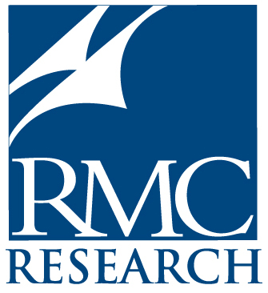

RMC Research Corporation
1501 Wilson Boulevard, Suite 1250
Arlington, VA 22209

This publication was created by RMC Research Corporation under contract ED04CO0041 with the U.S. Department of Education. The views expressed herein do not necessarily represent the policies of the U.S. Department of Education. No official endorsement by the U.S. Department of Education of any product, commodity, or enterprise in this publication is intended or should be inferred.

