4.6 Ultralight Operations (gliders, motorized gliders, paragliders, motorized paragliders, hangliders, ultralight aircraft):
Special nature of ultralight flying
Hypoxia
Trapped gas expansion
Thermal stress
Noise
Vibration
Crash survival and crash worthiness

Ultralight operations include aircraft categorized as gliders or sailplanes, motor gliders, paragliders, motorized paragliders, hang gliders, and ultralights. The unique nature of the ultralight aircraft category is that these aircraft are usually small, lightweight (under 1,000 pounds), and operated by a single pilot and occasionally a passenger. A pilot's license is required for operating gliders and motorized gliders.

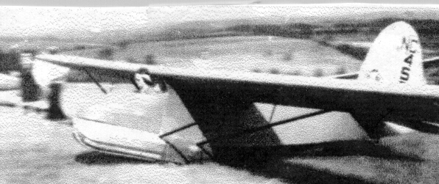
EARLY GLIDING IN AMERICA

Other categories of ultralight aircraft do not require a pilot's license, and only gliders and motor gliders will require a medical certificate if the pilot is performing commercial operations. Instructors do not require medical certificates. These aircraft generally operate in localized areas and relatively close to the ground and frequently do not use runways or controlled airports. Their instrumentation is basic and the most important of them is a strip of yarn attached to the canopy: the yaw string. It indicates coordinated flight, critical for smooth and efficient operation.
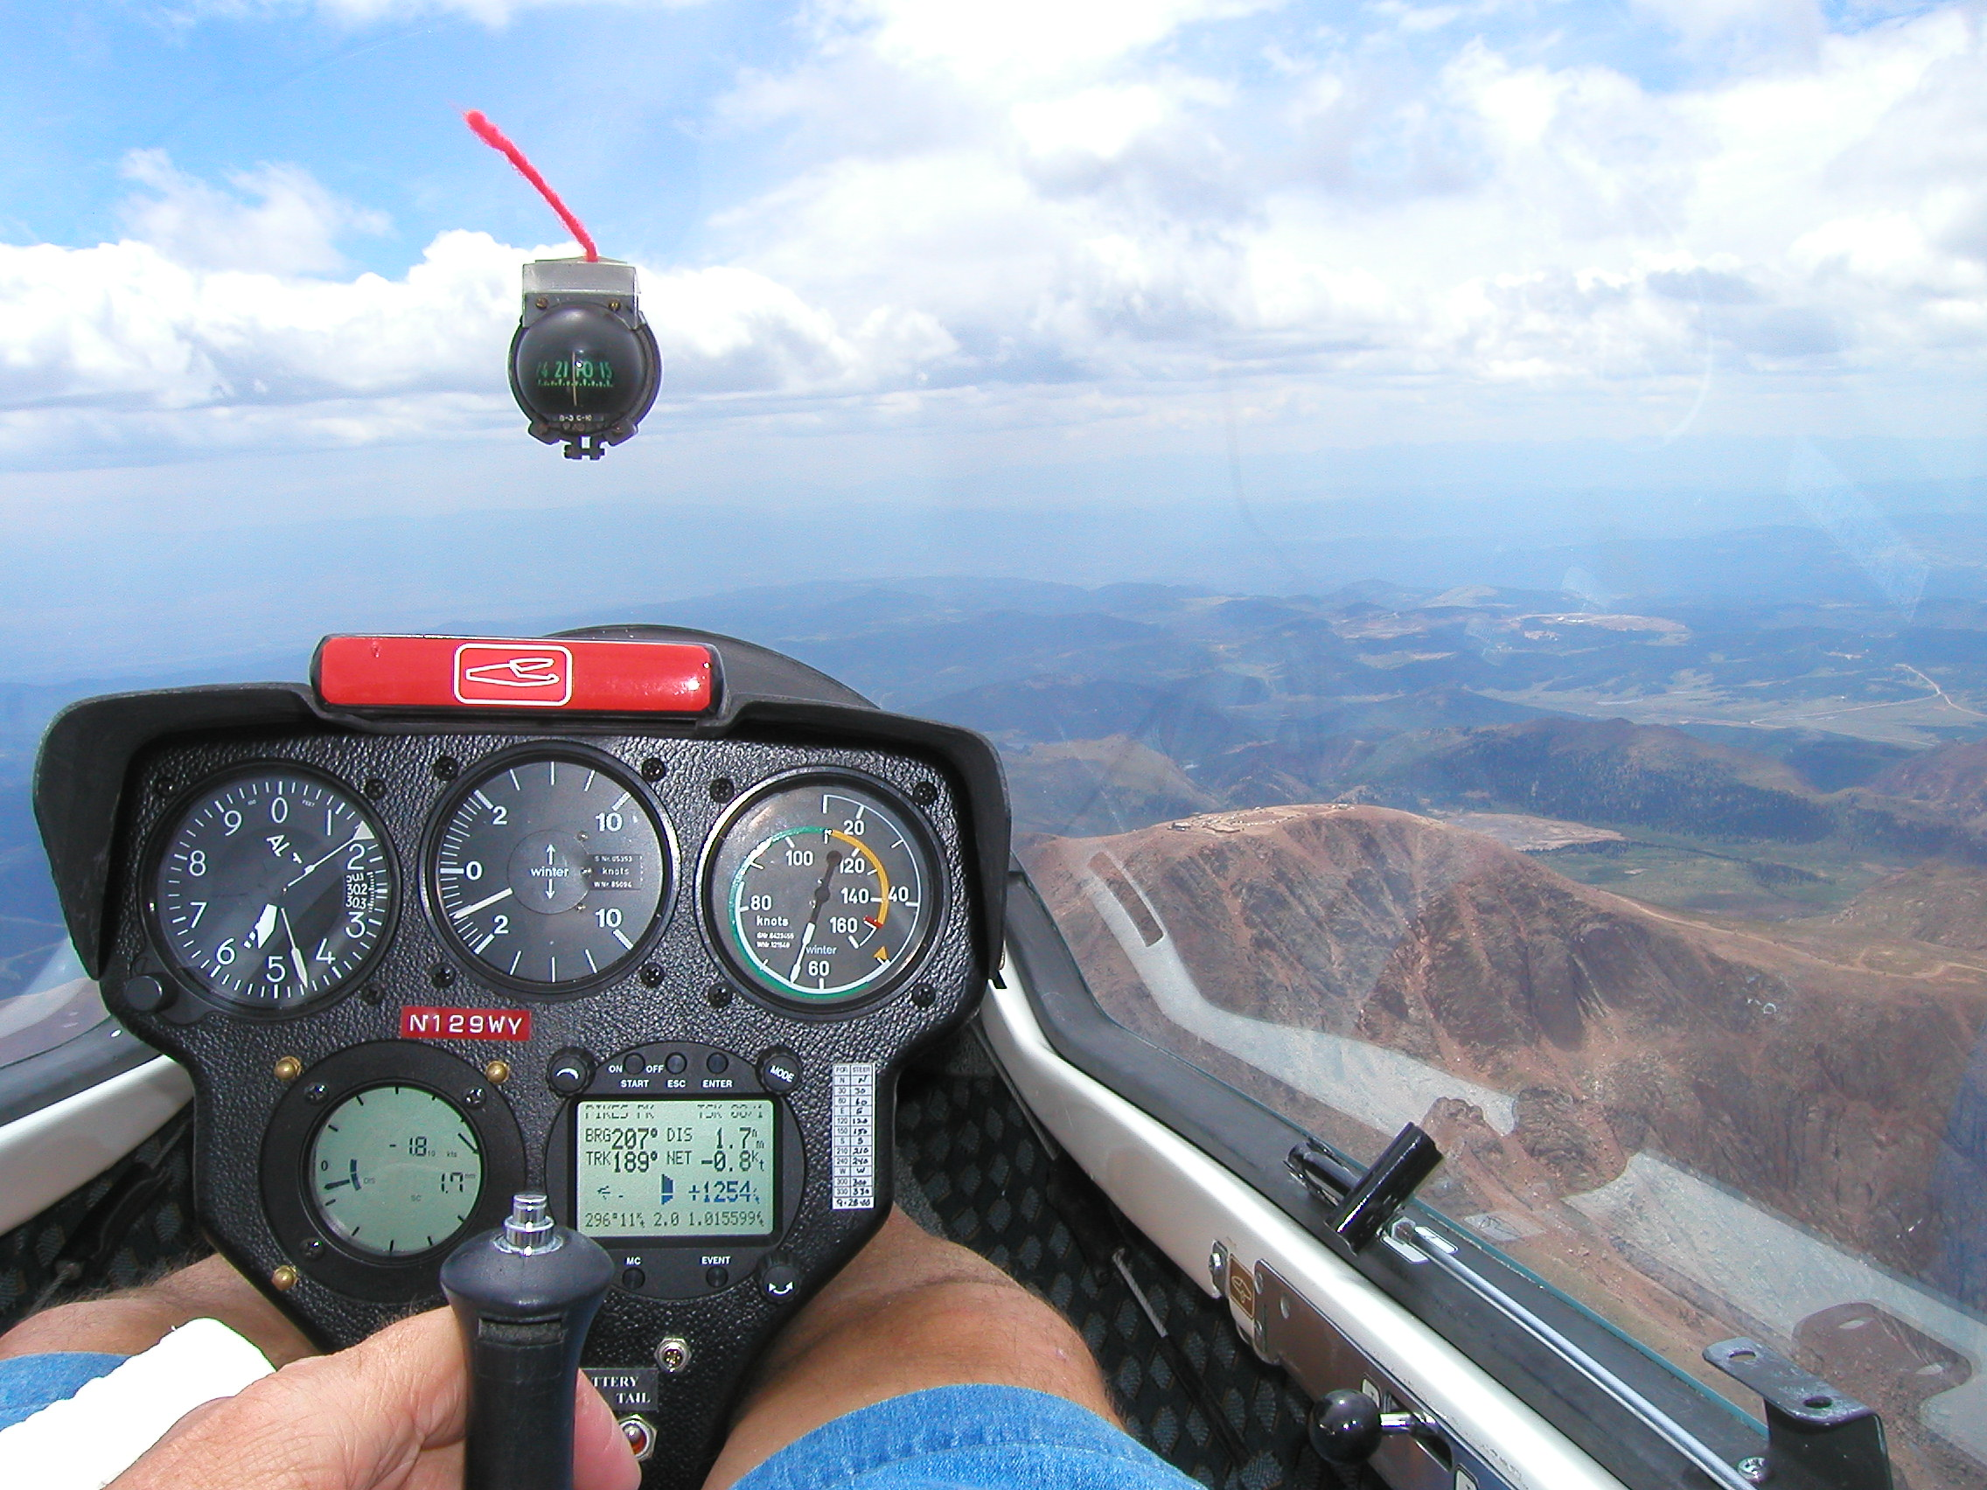

VIEW FROM THE COCKPIT, NOTE THE YAW STRING ON THE OUTSIDE OF THE CANOPY, ABOVE COMPASS.

Gliders and motorized gliders are larger aircraft and some of them have extremely long wing span of up to 50 meters. They are characterized by very high lift-to-drag ratios, as high as 70:1 or greater. This means that for every foot of altitude lost the airplane will glide forward at 70 feet. The difference between a glider and the motor glider is that the motor glider has an internal engine, which is used for brief periods of time to launch the aircraft and climb to altitude. The engine is then turned off, and in some cases can be withdrawn entirely within the aircraft, after which, it functions as a glider. It requires a single engine land pilot’s license and medical certificate to operate.
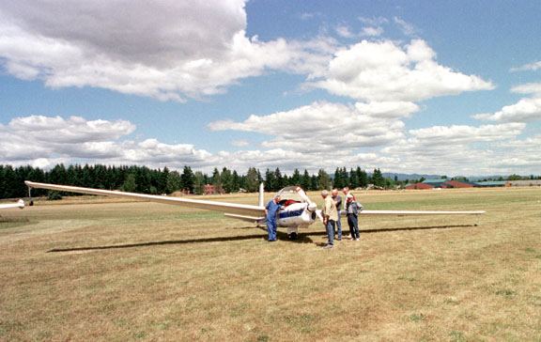
VIVAT MOTORGLIDER

Pure gliders much be launched. This can be done primarily through a tow aircraft using a long tow cable to pull the other aircraft to the release altitude. Special rules and training for towing and being towed are part of the basic pilot education program, and are required for certification as both a tow pilot or glider pilot.

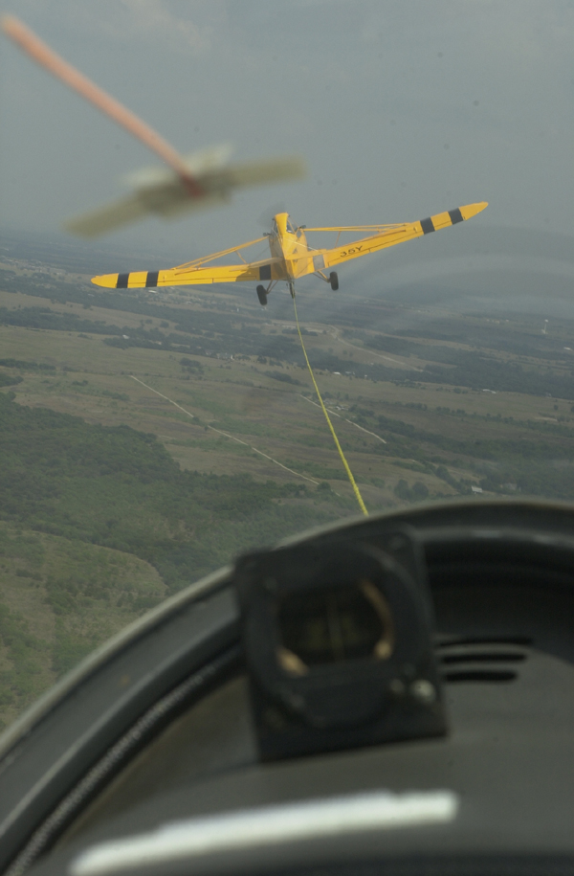

The view behind a towplane.

Additional methods of launching gliders includes a winch, which consists of a very long cable stretched along the runway, which rapidly winds up the tow cable. The glider achieves flying speed, usually on the order of 35 to 40 miles per hour within the space of a few feet. The aircraft then climbs at a 45 degree nose-up angle, until maximum altitude is achieved, which is rarely more than 600 or 700 feet. The cable is then released and descends to the ground via a small parachute while the glider proceeds on its flight.
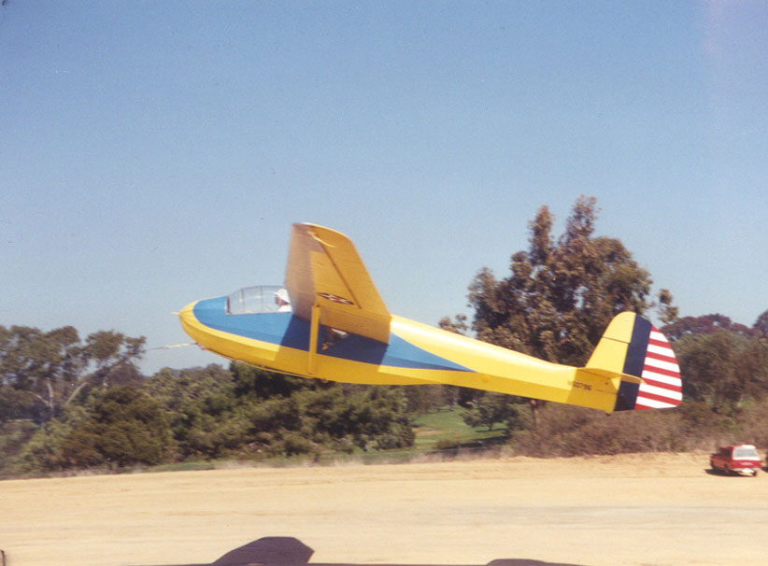
WINCH LAUNCH OF A REBUILT T-2, WORLD WAR II TRAINING GLIDER.

A third method of launching is to use a tow car or automobile simply driven down a runway with a tow cable behind it. Obviously, this is even more limited than winch launches.

A final method of launching sailplanes, and the oldest, is called a bungee launch, where the sailplane is on the side of the mountain or hill, and is catapulted into the air by means of a short, elastic cable, somewhat like a rubber band. Once the sailplane achieves flying speed, one of the initial actions of the pilot is to prepare to land. Sailplanes can only descend through the air. Therefore, the pilot must immediately prepare to land and hope that rising air is found. Sailplanes fly because air, under certain circumstances, rises, while the plane itself is descending through the air mass, the air mass is rising faster than the plane is descending.

Sailplanes can gain altitude under three circumstances. The first is called a thermal. A rising column of warm air, usually in the summertime, will begin to climb off a sun-heated area of ground. Typically marked by birds, also circling in the thermal, a sailplane will enter a thermal and spiral upwards. This requires constant flying and delicate control. Sailplane pilots, unlike almost any other kind of pilot, except a helicopter pilot, must fly their airplane constantly, and cannot trim up the airplane and allow it to “fly itself” for even the briefest periods of time.

One of the hazards of thermaling is that more than one airplane may enter the same thermal. The rules of the air indicates that the first plane into the thermal will dictate the direction of turning, either right-handed or left-handed, and all other aircraft will follow that convention. Sometimes, there may be so many birds in the thermal that they will in turn dictate the direction of the turn, and it is not an usual for a bird to fly formation on the wing tip of a sailplane in the thermal, and ride the additional lift off the sailplane’s wing tip vortex.

A second type of lift is known as ridge lift. A constant wing blowing across the land will strike raised terrain, such as a ridge or hillside. The air will then rise on the upwind side of the ridge, and the sailplane may enter this and gain altitude. Areas along seacoasts and low mountains are famous for sustained ridge lift of many hours duration. Sailplanes in the United States have literally flown from one end of the Appalachians to the other and back, holding distance records of several thousand miles in a single day.
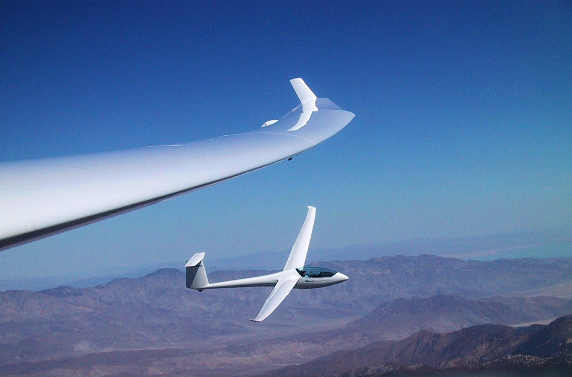
SOARING IN RIDGE LIFT

A third form is known as the mountain wave. This is a modification of ridge lift where high-speed jetstream strikes a mountain and is deflected upwards. Mountain waves may begin as low as 5,000 feet above sea level in mountainous terrain and the updrafts created can be extremely violent and moving at thousands of feet per minute. A sailplane caught in such an updraft may find itself with no choice but going up, and the current world record was set to 49,000 feet in this manner.

The downwind side of mountain waves, however, is extremely violent, with sharp, spinning vortices created, known as rotors, which create extremely turbulent conditions on the downwind side. The aim of most sailplane pilots is to either gain altitude, distance, or sustained time aloft. Flight speeds of all sailplanes are relatively low and even under the demands of racing conditions, will rarely exceed 100 miles per hour.

It is possible, particularly under mountain wave conditions, for sailplanes to be carried to significant altitudes, where hypoxia and oxygen requirements are necessary. Pilots of sailplanes, like those of conventional aircraft, are required to use oxygen if flying above 12,500 feet. Thermal stress can be a significance factor in sailplane operations, as most sailplanes have very large, glass canopies, and when thermaling in the summertime, a significant greenhouse effect takes place. Since sailplanes are unpowered, they are not air-conditioned, and the only cooling factor will be venting of the air into the cabin. Additionally, in a prolonged flight, high thermal load dehydration may be a factor. The altitude gained on occasion may be significant enough for trapped gas to expand particularly in the ears and sinuses.

Sailplanes operate out of any kind of airport. Often they utilize and airfield dedicated only to glider operations. Many sailplanes will not have radios, relying on hand signals to coordinate operations on the ground. If they do operate at an airfield with a control tower, the same rules of controlled airspace apply to them as any other aircraft.

Sailplanes fly extremely low speed, are very stable and are rarely involved in accidents. The requirements for licensing and an FAA Certificate are stringent and sailplanes are considered extremely safe. Most problems occur during “outlandings”, that is landings that occur away from an airport, usually when lift is lost.
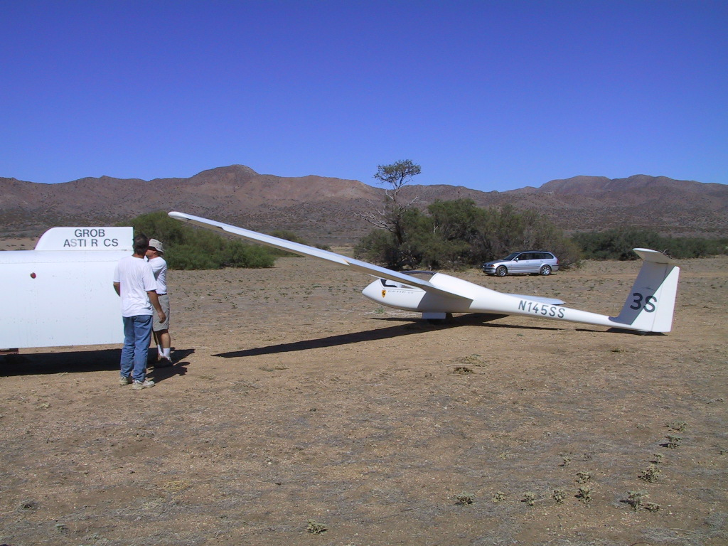
OUTLANDING

Conversely, ultralights, paragliders, and hang gliders, do not require an FAA Certificate or pilot's license. Such operations are haphazard and often require only the price of the aircraft. Some of them may be powered by small engines from 15 to 50 hp. The noise and vibration from such engines can be extremely high. With little in the way of certification or training required, and the smaller hang gliders, usually simply launched off a hill or a cliffside, are used for recreation by individuals with minimal training. The pilots are suspended in an open cage and their personal protection may consist of entirely a helmet, if worn or a parachute. Accidents are frequent and there are many injuries associated with these aircraft. Some are braced with a roll cage, but others may have no protection for the pilots, whatsoever. And those that are foot launched, such as a hang glider, provide no structural protection. There are literally hundreds of different types of ultralight aircraft, which may look like anything from a small conventional airplane to a powered parachute or a kite with an engine.

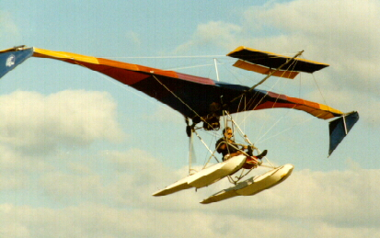
AMERICAN AEROLIGHT EAGLE

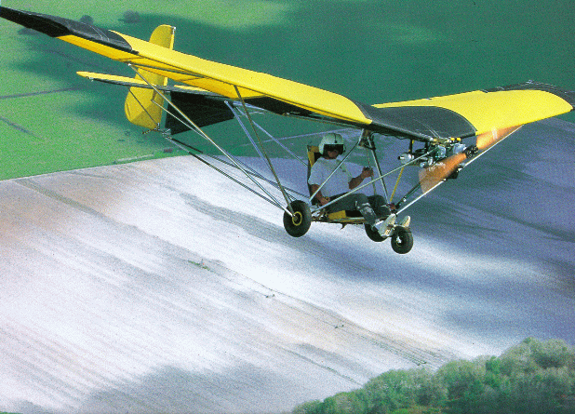
WEEDHOPPER

The accident and injury rate for hang gliders, paragliders, and other ultralights is not known precisely, but is extremely high, at least in order of magnitude greater than general aviation aircraft. Some ultralights have even been equipped with parachutes to lower them safely in an emergency.

Ultralights are relatively free from rules. Medical certificates and pilot’s licenses are not required. However there are some rules of the road for these craft: No passengers are allowed, no flying over towns or inhabited areas, no flying at night or in clouds, no flying in controlled airspace and no commercial operations.

Sailplanes and ultralights have the right of way in the air over all other aircraft except lighter-than-aircraft: blimps and balloons.
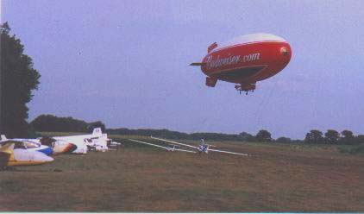
WHO HAS THE RIGHT OF WAY?

Information source: Soaring Society of America

