Chapter 5: Recovery
Chapter Outline
- Introduction of topics and concepts to be discussed in the chapter.
  - Federal individual and public assistance programs
  - Small Business Administration loan programs
  - State and local assistance programs
  - Roles and responsibilities
  - Volunteer groups
  - Recovery planning tools
- Case Studies
  - Federal Government Recovery Efforts following the 1993 Midwest Floods
  - Housing Reconstruction after the 1994 Northridge Earthquake
  - September 11 Philanthropic Recovery Efforts
- Additional Sources of Information
- Glossary of Terms
- Acronyms
- Discussion Questions
  - General
  - 1993 Midwest Floods
  - Northridge Earthquake
  - September 11 Attacks
- Suggested Out of Class Exercises

Introduction

The recovery function or process is characterized by a complex set of issues and decisions that must be made by individuals and communities. Recovery involves decisions and actions relative to rebuilding homes; replacing property; resuming employment; restoring businesses; and permanently repairing and rebuilding infrastructure. The recovery process requires balancing the more immediate need to return the community to normalcy with the longer term goal of reducing future vulnerability. The recovery process can provide individuals and communities with opportunities to become more economically secure and improve the overall safety and quality of life.

Because the recovery function has such long lasting impacts and usually high costs, the participants in the process are numerous. They include all levels of government, the business community, political leadership, community activists and individuals. Each of these groups plays a role in determining how the recovery will progress. Some of these roles are regulatory, such as application of State or local building ordinances, and some, such as the insurance industry, provide financial support. The goal of an effective recovery is to bring all of the players together to plan, finance and implement a recovery strategy that will rebuild the disaster impacted area safer and more secure as quickly as possible.

The National Response Plan for Disaster Recovery Operations

Issued in 1992, the National Response Plan (NRP), formerly the Federal Response Plan (FRP) outlines how the Federal Government implements the Robert T. Stafford Disaster Relief and Emergency Assistance Act, as amended, to assist State and local governments when a major disaster or emergency overwhelms their ability to respond effectively. The NRP describes the policies, planning assumptions, concept of operations, response and recovery actions, and responsibilities of 32 Federal departments and agencies, including the American Red Cross and the National Voluntary Organizations Active in Disaster, that guide Federal operations following Presidential declaration of a major disaster or emergency. .
The NRP describes the structure for organizing, coordinating, and mobilizing Federal resources for disaster recovery. The Stafford Act assigns to FEMA the principal coordination function - the interactive process by which multiple Federal assistance programs are reviewed, initiated, implemented, and delivered to address the unique needs of a particular disaster area.
The fundamental assumption in the NRP is that recovery is a cooperative effort among Federal, State, local, voluntary agencies and the private sector in partnership. A Federal Coordinating Officer (FCO) is appointed by the FEMA Director on behalf of the President and coordinates Federal activities from the Disaster Field Office (DFO). The FCO works in partnership with the State Coordinating Officer (SCO), who is named by the Governor. In conjunction with the SCO, the FCO determines the need for Disaster Recovery Centers (DRCs) in the disaster area. State and Federal agencies staff the DRCs with knowledgeable officials who provide recovery program information, advice, counseling, and technical assistance. Voluntary organizations are encouraged to provide leadership and coordinate with Federal, State and local governments in recovery planning and program implementation.

Federal disaster assistance available under a major disaster falls into three general categories: Individual Assistance, Public Assistance and Hazard Mitigation Assistance. Individual Assistance is aid to individuals, families and business owners. Public Assistance is aid to public and certain private non-profit entities for emergency services and the repair or replacement of disaster-damaged public facilities. Hazard Mitigation Assistance is funding available for measures designed to reduce future losses to public and private property. A detailed description of the first two types of assistance follows. More information on Hazard Mitigation Assistance can be found in Chapter Three - Mitigation.

FEMA’s Individual Assistance Recovery Programs

Individual Assistance programs are oriented to individuals, families, and small businesses, and the programs include temporary housing assistance, individual and family grants, disaster unemployment assistance, legal services, and crisis counseling. The disaster victim must first register for assistance and establish eligibility.

Disaster Housing Program

The Disaster Housing Program assures that people whose homes are damaged by disaster have a safe place to live until repairs can be completed. These programs are designed to provide funds for expenses that are not covered by insurance, and are available to homeowners and renters who are legal residents of the United States and were displaced by the disaster.

The Individuals and Households Program (IHP)

The Individuals and Households Program (IHP), formerly called the Individual and Family Grant (IFG) Program, provides funds for the necessary expenses and serious needs of disaster victims that cannot be met through insurance or other forms of disaster assistance. The IHP is not designed to cover all of a victim’s losses (home, personal property, household goods) that resulted from the disaster, nor is it intended to restore damaged property to its condition before the disaster. Also, the IHP does not cover any business-related losses that resulted from the disaster. By law, the IHP cannot provide any money for losses that are covered by insurance.

The following list illustrates the assistance available through the IHP:
- Temporary Housing (a place to live for a limited period of time): Money is available to rent a different place to live, or a government provided housing unit when rental properties are not available.
- Repair: Money is available to homeowners to repair damage from the disaster that is not covered by insurance. The goal is to make the damaged home safe, sanitary, and functional.
- Replacement: Money is available to homeowners to replace their home destroyed in the disaster that is not covered by insurance. The goal is to help the homeowner with the cost of replacing their destroyed home.
- Permanent Housing Construction: Direct assistance or money for the construction of a home. This type of help occurs only in insular areas or remote locations specified by FEMA, where no other type of housing assistance is possible.
- Other Needs: Money is available for necessary expenses and serious needs caused by the disaster. This includes medical, dental, funeral, personal property, transportation, moving and storage, and other expenses that are authorized by law.

Disaster Unemployment Assistance
The Disaster Unemployment Assistance (DUA) program provides unemployment benefits and re-employment services to individuals who have become unemployed because of major disasters, and who are not eligible for disaster benefits under regular unemployment insurance programs.

Legal Services

The Young Lawyer’s Division of the American Bar Association, through an agreement with FEMA, provides free legal assistance to low-income disaster victims. The assistance that the participating lawyers provide is for insurance claims; counseling on landlord/tenant problems; assistance in consumer protection matters, remedies and procedures; and replacement of wills and other important legal documents destroyed in a major disaster. This assistance is intended for individuals who are unable to secure legal services adequate to meet their needs as a consequence of a major disaster.

Special Tax Considerations
Taxpayers who have sustained a casualty loss from a declared disaster may deduct that loss on the federal income tax return for the year in which the casualty occurred or through an immediate amendment to the previous year's return. Businesses may file claims with the Bureau of Alcohol, Tobacco and Firearms for payment of Federal excise taxes paid on alcoholic beverages or tobacco products lost, rendered unmarketable or condemned by a duly authorized official under various circumstances, including where a major disaster has been declared by the President.

Crisis Counseling

The Crisis Counseling Assistance and Training Program are designed to provide short-term crisis counseling services to people affected by a presidentially declared disaster. The purpose of the crisis counseling is to help relieve any grieving, stress or mental health problems caused or aggravated by the disaster or its aftermath. These short-term services are provided by FEMA as supplemental funds granted to State and local mental health agencies. The American Red Cross, the Salvation Army, and other voluntary agencies as well as churches and synagogues also offer crisis-counseling services.

Cora Brown Fund

Cora C. Brown of Kansas City, Missouri died in 1977 and left a portion of her estate to the United States to be used as a special fund solely for the relief of human suffering caused by natural disasters. The funds are used to assist victims/survivors of presidentially declared major disasters for disaster-related needs that have not or will not be met by government agencies or other organizations.
Small Business Administration (SBA)

The SBA can provide three types of disaster loans to qualified homeowners and businesses to repair or replace homes, personal property, or businesses that sustained damages not covered by insurance.

- Home disaster loans provide funds to homeowners and renters to repair or replace disaster-related damages to home or personal property.
- Business physical disaster loans provide funds to business owners to repair or replace disaster-damaged property, including inventory, and supplies.
- Economic injury loans provide capital to small businesses and to small agricultural cooperatives to assist them through the disaster recovery period. If the SBA determines that the individual is ineligible for a loan, or if the loan amount is insufficient to meet the individual’s needs, then the applicant is referred to the IFG program.

FEMA’s Public Assistance Grant Program
FEMA, under the authority of the Stafford Act, administers the Public Assistance Program. The Public Assistance Grant Program provides federal assistance to state and local governments and to certain private nonprofit (PNP) organizations. These grants allow them to recover from the impact of disasters and to implement mitigation measures to reduce the impacts from future disasters. The grants are aimed at governments and organizations with the final goal to help a community and its citizens recover from devastating major disasters. The federal share of assistance is not less than 75% of the eligible cost for emergency measures and permanent restoration. The State determines how the non-Federal share is split with the applicants.
Eligible applicants include the States, local governments and any other political subdivision of the State, Native American tribes, Alaska Native Villages, and certain PNP organizations. Eligible PNP facilities include educational, utility, irrigation, emergency, medical, rehabilitation, temporary or permanent custodial care facilities, and other PNP facilities that are open to the public and provide essential services of a governmental nature to the general public. The work must be required as the result of the disaster, be located within the designated disaster area, and be the legal responsibility of the applicant. PNPs that provide critical services such as power, water, sewer, wastewater treatment, communications or emergency medical care, may apply directly to FEMA for a disaster grant. All other PNPs must first apply to the SBA for a disaster loan. If the loan is declined or does not cover all eligible damages, the applicant may re-apply for FEMA assistance.
Work that is eligible for supplemental Federal disaster grant assistance is classified as either emergency work or permanent work.
- Emergency work includes debris removal from public roads and rights-of-way as well as from private property when determined to be in the public interest. This may also include protective measures performed to eliminate or reduce immediate threats to the public,
- Permanent work is defined as work that is required to restore an eligible damaged facility to its pre-disaster design. This effort can range from minor repairs to replacement. Some categories for permanent work include roads, bridges, water control facilities, buildings, utility distribution systems, public parks and recreational facilities. With extenuating circumstances the deadlines for emergency and permanent work may be extended. .

In 1998, FEMA redesigned the Public Assistance program to provide money to applicants more quickly and to make the application process easier. The redesigned program was approved for implementation on disasters declared after October 1, 1998. This redesigned program placed new emphasis on people, policy, process and performance. The focus of the program was also modified to provide a higher level of customer service for disaster recovery applicants and to change the role of FEMA from inspection and enforcement to an advisory and supportive role.

National Voluntary Relief Organizations

National Voluntary Organizations Active in Disaster (NVOAD) coordinates planning efforts by many voluntary organizations responding to disaster in order to provide more effective service to people affected by disaster. Members include 34 national voluntary organizations active in disaster mitigation and response, 52 State and territorial chapters (VOAD), and dozens of local organizations. Once a disaster occurs, NVOAD or an affiliated state VOAD encourages members and other voluntary agencies to convene on site.

The member organizations provide a wide variety of disaster relief services including emergency distribution services, mass feeding, disaster child care, mass or individual shelter, comfort kits, supplementary medical care, cleaning supplies, emergency communications, stress management services, disaster assessment, advocacy for disaster victims, building or repair of homes, debris removal, mitigation, burn services, guidance in managing spontaneous volunteers, and victim and supply transportation. NVOAD maintains a close relationship with FEMA and encourages the State and local affiliates to work closely with the State and local emergency management agencies.

The American Red Cross

Although the American Red Cross (ARC) is not a government agency, its authority to provide disaster relief was formalized when, in 1905, the Red Cross was chartered by Congress to "carry on a system of national and international relief in time of peace and apply the same in mitigating the sufferings caused by pestilence, famine, fire, floods, and other great national calamities, and to devise and carry on measures for preventing the same."

Red Cross disaster relief focuses on meeting people's immediate emergency disaster-caused needs and provides disaster assistance to individuals to enable them to resume their normal daily activities independently. The Red Cross provides shelter, food, and health and mental health services to address basic human needs. The Red Cross also feeds emergency workers, handles inquiries from concerned family members outside the disaster area, provides blood and blood products to disaster victims, and helps those affected by disaster to access other available resources.

The Red Cross is one of the nongovernmental organizations mentioned in the NRP and is the primary agency for ESF #6, Mass Care, Housing, and Human Services. The ARC functions as a Federal agency in coordinating the use of Federal mass care resources in a presidentially declared disaster or emergency, and coordinates Federal assistance in support of State and local efforts to meet the mass care needs of victims of a disaster. This Federal assistance supports the delivery of mass care services of shelter, feeding, and emergency first aid to disaster victims; the establishment of systems to provide bulk distribution of emergency relief supplies to disaster victims; and the collection of information to operate a Disaster Welfare Information system for the purpose of reporting victim status and assisting in family reunification.

Recovery Planning Tools

Despite the pressures on politicians and community leaders to return to a period of normalcy as quickly as possible and because of Federal incentives, public interest and insurance retractions, more and more communities are looking at ways to reduce their future vulnerability. As disasters repeat themselves and the public sees the emotional and financial benefits of mitigation, communities are making the long term investment in mitigation. For example the devastating 1993 Midwest Floods that occurred again in some areas in 1995, had a minimal impact in those towns where buyout and relocation programs were undertaken after the 1993 flood. The following is a partial list of policy areas and tools that should be considered by decision-makers as they develop their recovery plan. These are:

- Land use planning techniques including acquisition, easements, annexation, stormwater management, environmental reviews;
- Zoning, including special use permits, historic preservation, setbacks, density controls, wetlands protection, floodplain and coastal zone management;
- Building codes including design controls, design review, height and type, special study areas( soil stability ratings);
- Financial including special districts, tax exemptions, special bonds, development rights, property transfer or use change fees; and
- Information and Oversight, including public awareness and education, regional approaches and agreements, GIS systems, town hall meetings and public hearings.

Conclusion

The following three case studies provide a clear illustration of the involvement of the Federal government programs in the recovery process in major disasters. State and local recovery roles and responsibilities are detailed. Coordination among Federal, state and local; programs and activities are clearly illustrated. The September 11 case study details the significant role non-government contributions and relief programs played in the recovery from the terrorist attacks.

Case Study 5.1: Federal Government Recovery Efforts following the 1993 Midwest Floods

Introduction

The 1993 Midwest Flood developed over a period of more than 12 months, but outside the Upper Mississippi River Basin, most Americans did not become aware of the catastrophic potential of these events until the protracted fight against the rivers had come to a climax. Images of entire communities submerged beneath seemingly-endless quantities of water began to dominate the news media – on television and in the newspapers – and the flood captured the hearts of all who saw them. The damage that lay beneath the newly formed oceans over what was once towns and cities seemed incomprehensible.

The event was spurred by severe and persistent rainfall that spanned much of the Mississippi River basin – an area that encompasses almost forty percent of the continental United States. The rising rivers ultimately overcame the holding capacity of a great many of the flood-protection levees that had been placed upon their banks to mitigate such disasters as was occurring. These flood events, thereafter referred to as “The Great Flood of 1993,” would go on to affect people and property over such an expansive geographic boundary as had seldom been seen in the history of the nation. The event tallied up among the most devastating natural disasters in the United States, resulting in the loss of dozens of lives and billions of dollars in property damage. In addition to the losses in crops, infrastructure, and land, over 50,000 homes were destroyed. This case will detail the efforts of the Federal Government to enable recovery in the affected areas.

The Mississippi River Basin

To understand this event, it is important that one has a clear comprehension of both the size and significance of the Mississippi River Basin. The geographic limits of the basin stretch all the way from the foothills of the Rocky Mountain range in the west to New York State in the east. Thirty-two U.S. states and two Canadian provinces are either fully or partially drained into its vast system of rivers and streams. In total, 1.25 million square miles – over 40% of the land area of the continental United States - falls within its boundaries.

The Mississippi River, the central artery into which all tributaries in the Basin eventually empty, is one of the world’s greatest rivers. It runs from north to south across the United States, covering 1366 miles on its course. Its greatest tributary, the Missouri River, runs for 2466 miles, draining 529,000 square miles of land is it travels east towards the Mississippi River. The upper Mississippi Basin, where most of the flooding in the 1993 event occurred, is dominated by the Missouri River’s full expanse and the northernmost section of the Mississippi River, covering an area of 714,000 square miles – over 57 percent of the entire basin (Galloway, 1995). Other major tributaries of the Mississippi River include the Salt, Illinois, Kaskaskia, Meramec, Big Muddy, St. Francis, Rock, Des Moines, Iowa, Wisconsin, St. Croix, and Minnesota rivers (USACE, N/D).

These rivers, and many of their tributaries, have played a vital role in commerce and transportation since the birth of the nation. Over time, many cities and communities developed upon their shores, and population surges followed. When the lands on the floodplains were discovered to be exceptionally fertile, agriculture flourished, and both the importance and success of the region grew. There always was, however, the issue of seasonal flooding, which was managed through an extensive system of flood-control levees constructed on the banks of the Mississippi, the Missouri, and many of its tributaries. As often occurs behind the limited protection of a levee structure, a sense of security was instilled and more houses and other buildings were constructed in land that before would have been annually flooded and, therefore, never considered as a development option.

The Event

Beginning almost a full year before any destruction would be credited to The Great Flood of 1993, monthly rainfall amounts began to rise significantly beyond recorded averages. Of the fourteen months leading up to and including the summer of 1993, in fact, only three failed to exceed prior averages (with December of 2002 experiencing three times normal amounts) (see Figure 5.1.1). Heavy cloud coverage and persistently-cooler temperatures during these preceding months further exacerbated the drainage rates in the floodplain by limiting the amount of water that would have otherwise evaporated from the land (thereby drying it.) And thus, by early June as summer approached, the ground was already saturated to its holding capacity, and many of the rivers and streams that serve the Mississippi River were swelled beyond what was normally observed for that month.

What began in June, and continued through August, was a deluge of rainfall that broke nearly every precipitation record in the impacted region (see sidebar 5.1.1). The ground, unable to absorb much if any of the precipitation, dumped all of its runoff into any brook, stream, or river that passed nearby. Slowly, the rates of discharge and river elevations above normal began to rise. By mid-July, 45 of the almost 500 gauging stations in the region measured discharge rates consistent with a “100-year discharge” – a rate calculated to have a 1% chance of occurring in any given year. Astonishing 500-year discharge rates were being recorded along the Missouri River from southeastern Nebraska to St. Louis and from southern Iowa to above St. Louis on the Mississippi.

One by one, levees along the banks of these rivers began to breach, leaving the structures and lives behind them fully vulnerable to the tide of water that quickly submerged nearly everything in sight. The first of these levees collapsed on June 7th, 1993, but over the next two months over one thousand of the protection devices would fail. The result of these catastrophic failures was the flooding of over 6.6 million acres across 419 counties located in the Upper Mississippi River Basin. Nine states were affected: North Dakota, South Dakota, Nebraska, Kansas, Minnesota, Iowa, Missouri, Wisconsin, and Illinois (FEMA, 2003).

The Consequences

The consequences resulting from this devastating event place it among the top-ten most destructive in the history of the nation. Aside from the loss of life, ranging in number from 40 to 60 people depending upon the source, there were countless injuries, billions of dollars in damage to homes, businesses, government buildings, schools, utilities, roads, rails, agricultural land and equipment, and a large but unquantifiable cost associated with pollution, loss of work, lost tax revenues, lost tourism, and other damaging consequences.

The five-month deluge significantly affected nine states, and resulted in the evacuation of about 74,000 people (USACE, N/D). High water shut down 12 commercial airports, 388 sewage treatment plants and almost all bridges over the Missouri and Mississippi rivers between St. Louis, Kansas City and Davenport, Iowa. Missouri, within which the two great rivers meet, suffered the greatest amount of damage, with over $3 billion in registered losses (Galloway, 1995).

The ultimate cost of the flood in dollars has been calculated to have been somewhere between $12 and $16 billion, with the loss of agriculture (equipment, structures, livestock, crops, etc.) accounting for over half of these figures (Galloway, 1995). Of the remaining amount, a significant portion is attributable to the businesses and homes that were either damaged or destroyed both directly by the floodwaters or indirectly by basement flooding and sewage system backups (caused by very high groundwater levels, even in areas outside the floodplain) or secondary electrical fires.

The housing infrastructure in the affected area suffered a particularly strong blow. As many of the areas behind the flood protection levees were residential, whole neighborhoods were wiped out in a matter of minutes. While the affected areas tended to be patchwork in nature, affecting individual neighborhoods while completely avoiding others, there were a total of 75 communities that were entirely submerged (IAFSM, 2003). Again, estimates vary in the number of houses that were damaged or destroyed by the floods, but according to FEMA, who had the unique vantage of individual interaction with the majority of homeowners affected, there were more than 100,000 residences affected.

The transportation infrastructure, of which the rivers themselves were a component, suffered heavily. Virtually all forms of transportation on and across the Mississippi River were interrupted by the flood. Along the length of the Mississippi River that forms the western boundary of Illinois, more than 1,000 miles of roads were closed and nine of the 25 non-railroad bridges were shut down (USACE, N/D). During the height of the flooding over 800 miles of railroad track was submerged. The saturated soil and erosion-inducing currents combined in what resulted in a failure of many bridges, culverts, roads, and highways. Among those that were not damaged, many were unusable because of standing water over at least a portion of their expanse. Airports, which tend to be constructed in the floodplain because of the level terrain and proximity to urban centers, were heavily impacted during the floods. Thirty-three airports, including the Spirit of St. Louis Airport in St. Louis, MO, sustained damage and had to temporarily cease operations.

Public utilities, which also tend to be located within the floodplain (depending upon the utility type), also suffered extensive damage. Water and wastewater treatment plants, which are often built on the banks of the rivers for convenience and efficiency, were particularly hard hit. Two-hundred municipal water systems, as identified by the Environmental Protection Agency (EPA), were damaged as result of the flood events. Included in this group was the Des Moines Water Works, a utility that provides safe water to the city of Des Moines, IA, and many of the surrounding communities. Wastewater treatment plants not only sustained physical damages to their facilities as a result of onsite flooding, but environmental hazards were created when raw sewage flowed from the damaged and inoperable facilities directly into the adjoining waterways. In total, 388 wastewater treatment facilities were affected (Galloway, 1993). Damages to utilities, including water and wastewater treatment facilities and storm sewer systems, exceeded $85 million.

Public buildings, such as government offices, schools, police departments, fire departments, among others, suffered over $27 million in damages. Parks and recreation areas sustained another $22 million in damage, and water control facilities an additional $20 million. In the private sector, in addition to the great financial losses associated with business interruption and loss of inventory and equipment, between 35,000 and 45,000 commercial structures were damaged (USACE, N/D).

Recovery Efforts of the Federal Government

Following the floods, 534 counties across nine states were declared for Federal disaster aid (see Image 5.1.4). Response and recovery costs across all federal government agencies totaled more than $4.2 billion in direct Federal assistance, $271 million in payments from the National Flood Insurance Program, and over $621 million in Federal loans to individuals, businesses, and communities. By the time the recovery period had officially concluded, 168,340 people had registered with the Federal Government for assistance (FEMA 2004). Of the nine states, the most severe damage occurred in Iowa, Illinois, and Missouri. Image 5.1.5 shows the distribution of FEMA funding by state.

On August 12th, 1993, President Clinton signed into law the “Emergency Supplemental Appropriations for Relief From the Major, Widespread Flooding in the Midwest Act of 1993”, or H.R. 2667 (‘the Act’). The Act provided for $6.3 billion in Federal assistance to the flood’s victims (though some of the funding was earmarked for other disaster-related projects outside the scope of the 1993 flood).

The primary recipient of relief and recovery funding was the agricultural industry. Almost $2.35 billion was provided to farmers through the Commodity Credit Corporation. The act gave then-Secretary of Agriculture Mike Espy the authority to make payments for crop losses at a 100-percent payment rate for each eligible claim.

Through FEMA, $2.0 billion was provided for expenses related to disaster relief operations, both for the Midwest floods and for other disasters. The funding provided for the repair of public facilities (public assistance) and for housing and other assistance to those affected by the Midwest floods (individual assistance). $235 million was provided to the Army Corps of Engineers (USACE) for repairing damage to Federal and non-Federal levees and other flood control works.

The Small Business Administration (SBA) was given $389 million for use in the provision of SBA loans. The low-interest SBA loans were disbursed primarily to homeowners, renters, and businesses to assist in their recovery from the physical damages that were caused by the flooding. Some of the loans, however, were made to firms engaged in agriculture-related activities that suffered substantial economic losses due to farm-related damage. An additional $200 million was provided for long-term recovery efforts through the Economic Development Administration (EDA), which were grants provided to State and local governments for economic recovery strategy, technical assistance, and public works projects. Also provided was $10 million for additional SBA staff in order to facilitate the processing of loan applications.

The Department of Health and Human Services (HHS), which maintains the Public Health and Social Service Emergency Fund, was provided with $75 million for the repair and renovation of community health centers and migrant health centers damaged by the Midwest floods and for social services for flood victims.

The Department of Housing and Urban Development (HUD) was given $200 million for disaster recovery planning in conjunction with State and local agencies, and for disaster-related community development. This money was disbursed through the Community Development Block Grant (CDBG) program. HUD was also given $50 million for the HOME Investment Partnerships Program. This funding provided for a range of housing activities, including acquisition, rehabilitation, tenant-based rental assistance, and new construction in areas affected by the flooding.

The Department of Agriculture (USDA) was provided with $42 million for the Agricultural Stabilization and Conservation Service (which was moved into the Farm Service Agency in 1994). This included $12 million to hire temporary employees to accelerate processing of applications for crop disaster claims, and $30 million to assist farmers with debris cleanup and the restoration of damaged farmland. The USDA’s watershed and flood prevention operations program was given $60 million, for use in repairing levees, dikes, and other flood-retarding structures and to open water courses plugged with sediment and debris. In addition, $270.5 million was included for rural development and housing loans, emergency water grants, very low income housing repair grants, and for the Extension Service.

The Department of Transportation (DOT) was authorized to assist in highway repair through $175 million it was given through the Act. Using this funding, the DOT provided immediate assistance to the States whose highways and bridges had been damaged by flooding. In addition, $21 million was provided for local rail assistance to help restore rail service, and $10 million was provided for the Coast Guard.

To assist with recovery in the employment sector, the Act provided $54.6 million for title III of the Job Training Partnership Act, which authorized assistance to dislocated workers. This funding was made available for the Secretary of Labor to finance temporary jobs to repair damage caused by the floods, clean up affected areas, and provide public safety and health services. Participants not only included workers that had been dislocated by the floods, but workers displaced for other reasons, and the long-term unemployed.

As many schools were damaged or destroyed, $70 million was provided by the Act for disaster assistance to those schools affected by the floods. Also provided was $30 million to supplement Federal Pell Grant awards, in order for college financial aid officers to adjust student financial aid to assist students who, due to the flood, lost income.

The Act provided $1 million to repair and replace National Oceanic and Atmospheric Administration (NOAA) facilities and equipment damaged during the Midwest floods. This included repair and replacement of their critical weather and flood warning systems that were damaged or destroyed as result of the deluge.

The Department of the Interior (DOI) received a total of $41.2 million. The money was divided between five separate programs: The US Geological Survey (USGS), The Fish and Wildlife Service, the National Park Service (NPS), the Historic Preservation Fund, and the Bureau of Indian Affairs (BIA). Using these funds, DOI was able to repair facilities on Indian reservations and to rehabilitate national wildlife refuges, fish hatcheries, dikes, roads, trails, and several national monuments and historic sites damaged by the Midwest floods.

The Environmental Protection Agency (EPA), which handles environmental damage assessments, and the cleanup of leaking underground tanks and pesticides, was given $34 million for their efforts. Other more obscure relief and recovery programs funded included $300,000 for the Legal Services Corporation to assist those harmed by the flood with legal matters, and $4 million for State youth and conservation corps programs involved in disaster cleanup activities (The White House, 1993).

The Missouri Buyout Program

One particular program, that melded recovery and mitigation, was the federal buyout program. The concept behind a buyout program is that a homeowner is given compensation for a property within the floodplain that has suffered repeat damage from floods, in order to end the disruptive and expensive cycle or reliance on Federal response and recovery aid. The property is converted to un-buildable ‘green space’, and future floods on the property cause no damage. Over time, the initial investment to buy the house is paid back in the form of averted relief and recovery funding. Since the program began, the Federal government has spent over $1 billion to buy more than 25,000 flooded properties nationwide.

Following the floods, across the nine states in the Midwest that suffered heavily, more than 11,888 homeowners sold their properties under the buyout program (see Image 5.1.6). Missouri embraced the program more than any other state, moving more than 4,700 households permanently out of harm's way (Illinois, which was also heavily involved in the buyout program, bought and demolished about 3,000 flood-prone properties, including all of the structures in one town.) During the 1993 Midwest Floods, over 37,000 Missourians were displaced from their homes. Many of these people were primed for buyout and ready to move once approached by officials working with the program.

Funding for the program came collectively from FEMA's Hazard Mitigation Grant Program (HMGP), the Department of Housing and Urban Development (HUD) Community Development Block Grant (CDBG) Program, Missouri General Revenue Funds, and other sources. In all, more than $100 million was allocated to the Missouri Buyout Program. In the early days of the program, in an effort to make the benefits as sustainable and effective as possible, Missouri Governor Mel Carnahan directed that priority use for these funds would be to buy out flood-prone properties that are used as a homeowner’s primary residence.

The Missouri State Emergency Management Agency (SEMA) developed the policies and procedures for allocating buyout funds to Missouri communities, which at the time managed their own buyout programs. Keeping in line with the constitutional rights of citizens, and with the interests of the residents at the heart of the program, it was conducted on a voluntary basis only. Community officials identified primary residences within the floodplain that were damaged or destroyed by flood-waters, and approached the homeowners with the offer of a buyout. At that point, the homeowner needed merely to accept the government’s offer (which for many, was the obvious option between moving to higher ground and facing the prospect of future floods).

Once the local government acquired a property, the land was (theoretically) zoned in such a way as to create green space that would never be built upon again – oftentimes converted into wetlands. In fact, the program’s rules stated that no enclosed buildings except public restrooms could be built on the acquired properties. Each community that participated in the buyout program decided for itself what it wanted to do with the acquired land within the parameters of allowed uses, but these general guidelines persisted.

Since the 1993 Midwest floods, there have been other floods in the affected areas, but they have significantly-less damage. Much of this is credited to the Buyout program, which removed many of the most at-risk structures from the floods’ paths. Local governments’ efforts to turn much of the riskiest floodplain into parks and greenways have proven their worth time and time again. The Buyout Program is already considered a success, having clearly paid for itself and provided a positive return on the tax dollars invested. As an example, when the 1995 Flood occurred, over half of the 5,500 properties targeted by the 1993 buyout program were empty and therefore were unaffected when the flood waters rose again. In St. Charles County, which sits at the confluence of the Missouri and Mississippi Rivers, the success is extraordinary. In that county alone, the combined costs of the 1993 flood exceeded $160 million. The number of potentially occupied properties there in the 100 year floodplain that were purchased under the buyout program was 1374 (which included over 560 single family residences and three mobile home parks with 814 pads.) When the 1995 spring rains hit, causing the third worst flood of record, 1,000 fewer families (approximately 2,500 people) were out of harm’s way as a result of those efforts in St. Charles County alone.

Conclusion

The 1993 Midwest floods were unprecedented – and remain the costliest floods in U.S. history. They shattered all assumptions about the ability of human efforts to control rivers by means of engineered levees and other water retention systems, and caused great financial and physical suffering. Many communities never recovered, while others remain altered to this day. Through the passage of the Flood Relief Act, the Federal government acted quickly to provide much of the funding required to rebuild the structures, infrastructure, and business losses that resulted, but officials clearly recognized that merely spending money to rebuild on the same ground would offer no solution to the long term problem that existed before the floods occurred. The voluntary Home Buyout Program is one of many different kinds of projects that combined recovery with mitigation to make more resilient communities in the long term. Over a decade later, most of these communities have recovered thanks to the support of the federal government – but if history is any judge for the future, floods will come again, and when they do these communities should suffer significantly less because of the wise recovery planning discussed in this case.

References:

11th Hour. 2005. “The Great Midwest Floods of 1993.” http://www.e11th-hour.org/resources/timelines/floods.1993.html
FEMA. 2003. The Great Midwest Flood: Voices 10 Years Later.” The National Flood Insurance Program. May. http://www.fema.gov/nfip/voices.shtm
FEMA. 2004. “The Great Midwest Floods of 1993.” FEMA Fact Sheet. http://www.fema.gov/hazards/floods/mwfld93.shtm
Galloway, Gerald E. 1995. “Learning from the Mississippi Flood of 1993: Impacts, Management Issues, and Areas for Research.” U.S. – Italy Research Workshop on the Hydrometeorology, Impacts, and Management of Floods. Perugia, Italy, November 1995.
IAFSM. 2003. “10 Years After the Midwest Floods of 1993.” The Illinois Association for Floodplain and Stormwater Management. IAFSM News. Fall 2003.
Johnson, Gary P., Robert Holmes, Lloyd White. 2003. “The Great Flood of 1993 on the Upper Mississippi River – 10 Years Later.” United States Geological Survey (USGS). http://il.water.usgs.gov/
The White House. 1993. “Statement by the President: H.R. 2667”. August 12. http://www.ibiblio.org/pub/archives/whitehouse-papers/1993/Aug/Statement-on-Flood-Relief-Act-8-12-93
USACE. N/D. “The Great Flood of 1993 Post Flood Report.” http://www.mvr.usace.army.mil/PublicAffairsOffice/HistoricArchives/Floodof1993/pafr.htm

Figure 5.1.1: Average Rainfall in the months prior to and during the 1993 Midwest Floods.
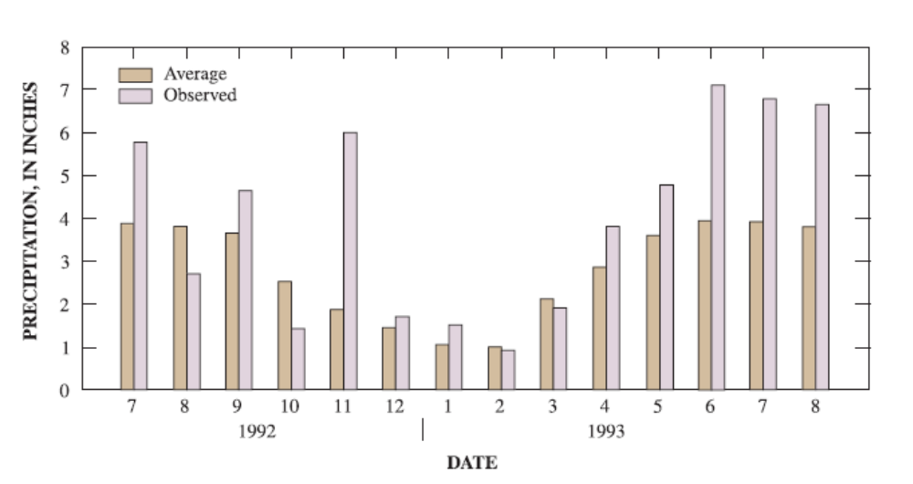
Source: Johnson, 2003.

Figure 5.1.2: The Upper Mississippi River Basin
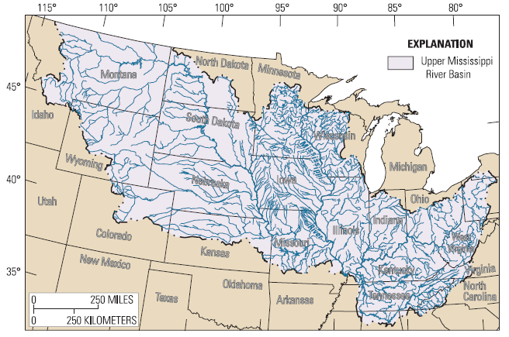
Source: Johnson, 2003.
Figure 5.1.3: Flood Stages Recorded in the 1993 Midwest Flood.
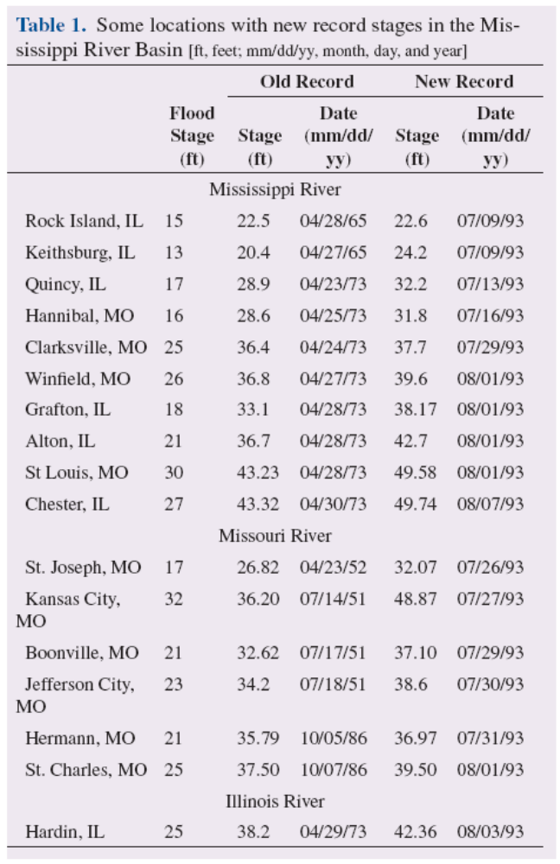
Source: Johnson, 2003.
Figure 5.1.4: Declared Counties for the 1993 Midwest Floods
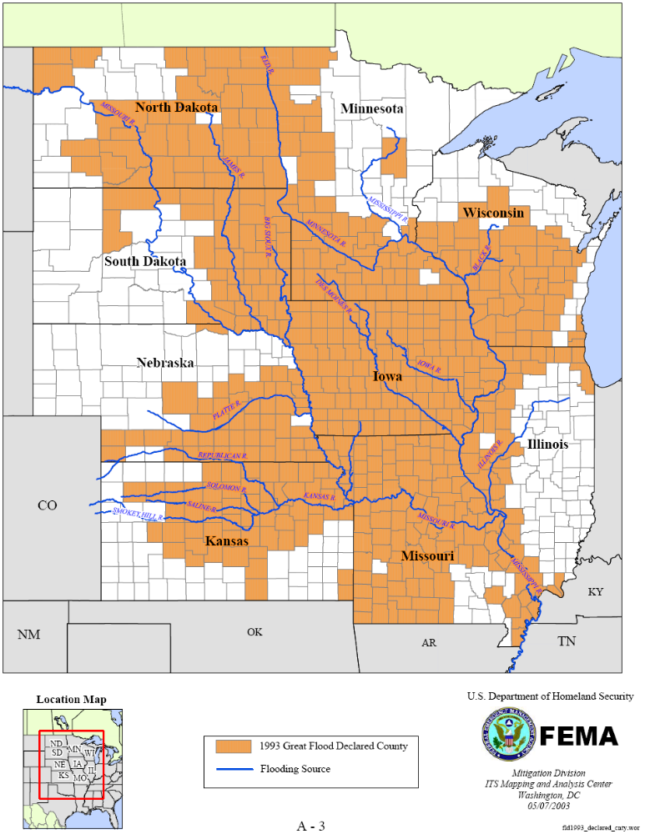
Source: FEMA.2003
Image 5.1.5: Total FEMA Expenditures per State
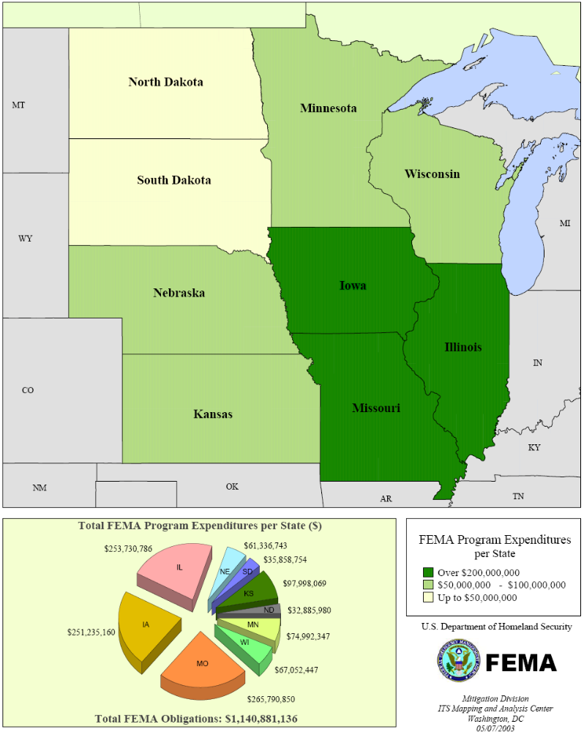
Source: FEMA, 2003.
Image 5.1.6: FEMA Program Expenditures per State in the 1993 Midwest Floods
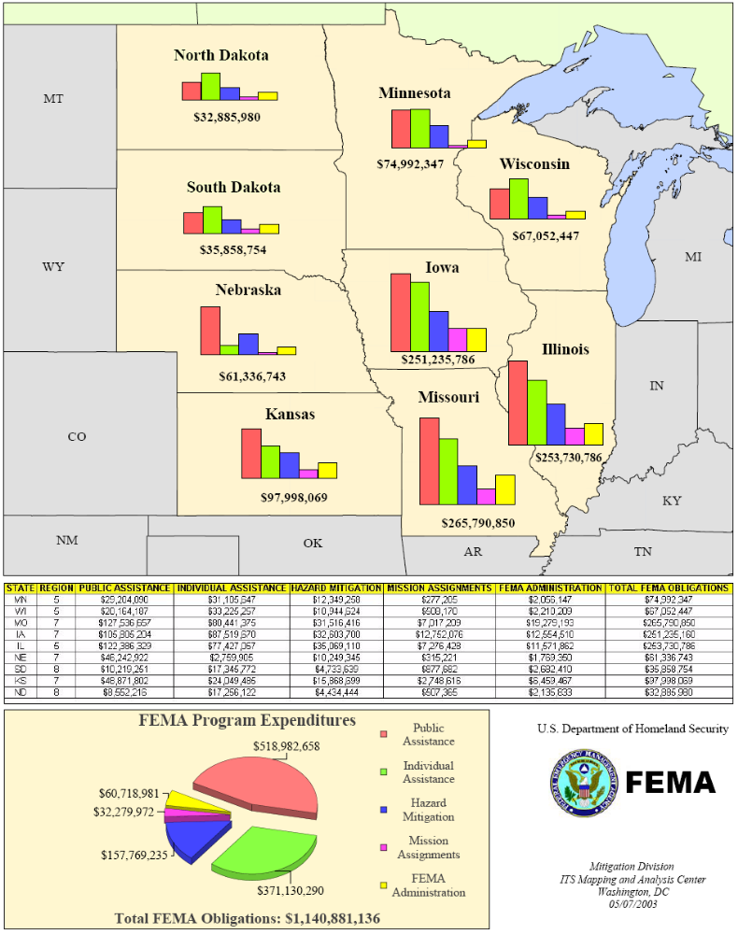
Source: FEMA, 2003.
Image 5.1.6: Hazard Mitigation Projects, June 1993-April 2003, per county
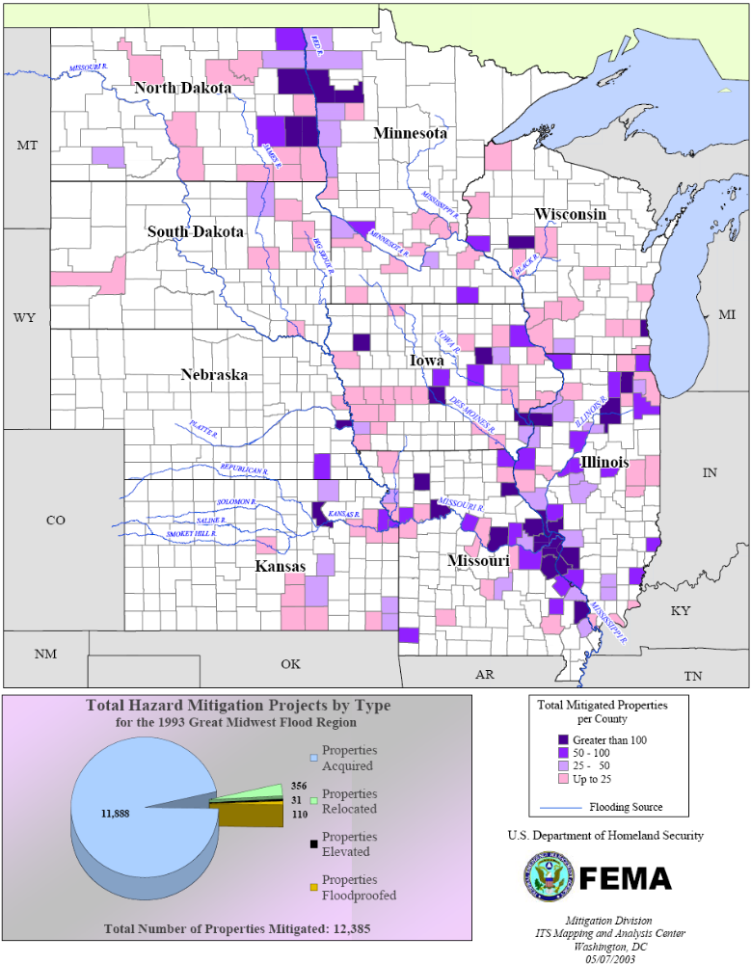
Source: FEMA, 2003
Sidebar 5.1.1: Chronology of Storms Contributing to the 1993 Midwest Floods
The following is a chronology of some of the more notable storms that occurred over the region from June to August. In June and July, rain fell somewhere in the region every day.
June 16-18--Two to seven inches of rain fell throughout southern Minnesota, northern Iowa, and southwestern Wisconsin, areas with already saturated soils. The heaviest rain fell directly over the Minnesota River. These storms caused the flooding on the Minnesota and Mississippi rivers in Minnesota and the Chippewa and Black rivers in Wisconsin that began the entire Mississippi River flood event. Further precipitation during the next few days caused flooding in and near Black River Falls, Wis., which led to a partial failure of the dam. It also caused flooding in other tributary basins in Wisconsin, namely, the Chippewa, Buffalo, Trempealeau, and Wisconsin River basins.
June 25--Additional localized rainfall in central Iowa contributed to the runoff at the three Iowa reservoirs--Saylorville, Coralville, and Red Rock.
June 27--Several areas recorded up to 4 inches of rainfall. The Iowa River basin below Coralville Lake was one of the areas that received heavy precipitation. Three to 5 inches fell over the Papillion Creek basin in Omaha, Neb.
June 28--Additional rainfall around Iowa City, Iowa, and the upper Mississippi River below Dubuque, Iowa, continued to aggravate the situation.
June 29--An additional 2 inches of rain fell on Iowa City and the upper Mississippi River during the night. Seven inches of rain occurred over the Lake Okoboji and Spirit Lake area in Iowa.
July 1--Near Quincy, Ill., an additional 2 to 5 inches of precipitation fell. Flood waters continued to rise along a 300-mile stretch of the Mississippi River on July 2. On July 6, the Mississippi River crested for the second time at Dubuque. The second crest continued downstream to the Quad-Cities, Keithsburg, Ill., and Hannibal, Mo., and new records were established.
July 2-5--Five to 7 inches of rain was reported in an area from Mitchell to Madison, S.D.
July 3-9--Six to ten inches of rain fell in various locations in Iowa, Kansas, and Missouri. Rain on July 3 caused the third episode of significant flooding in Marshall, Minn., in two months.
July 4-5--This storm was a significant event, producing a large amount of rainfall over southern Iowa. It produced a total of 4 to 8 inches of rain across a 250-mile long path from Taylor County in southwest Iowa, northeastward through Oskaloosa, Marengo, Cedar Rapids, and Dubuque.
July 7-8--Additional rainfall occurred on the Des Moines River basin. The rivers throughout central Iowa had not receded from the storm on July 4 and the three major reservoirs in the area were at capacity. Strong thunderstorms moved into central Iowa before sunrise on July 8 and rapidly traversed eastward across Iowa and into Illinois. A second set of thunderstorms developed over west-central Iowa later in the afternoon and slowly moved along the same path as the morning storms. By the time these storms weakened on July 9, 3 to 9 inches of rain fell in an uninterrupted 275-mile long band from the Nebraska border at Onawam eastward through Guttenburg, Iowa. Up to 8.5 inches of rain fell on the Des Moines River basin at Jefferson, Iowa. Marshalltown, Iowa, received up to 3 inches while 1 to 2 inches of rain fell over various parts of eastern Iowa and western Illinois. The Mississippi River crested for a third time at Camanche, Iowa, and the Quad-Cities also crested again. The runoff from the July 4 and July 8 storms caused record or near-record peak discharges on the Iowa, Skunk, Raccoon, and Des Moines River basins. The flood peaks from these tributaries entered the Mississippi River at about the same time the flood peak from the late June storm in the northern basins reached Keokuk, Iowa. The crest approached St. Louis from the north and joined high water coming in from the west down the Missouri River, an event that has never occurred since record keeping began.
July 11--Moderate to heavy rainfall fell in central Illinois.
July 13--Heavy rainfall occurred in the Des Moines area.
July 15-16--Up to 7 inches of rain fell in eastern North Dakota and western Minnesota. These storms caused flooding in the upper reaches of the Minnesota River basin in Minnesota and the James River basin in North Dakota.
July 17--Two to 5 inches of rain was reported in about a one-hour period over the Mill Creek basin near Cherokee, Iowa.
July 18--Light to heavy precipitation occurred across Iowa, Wisconsin, and Illinois. Portions of the Cedar River basin received up to an additional 5 inches of rainfall. Heavy rains caused flooding on the Baraboo River in Wisconsin.
July 22-25--Up to 13 inches of rain fell in parts of Nebraska, Kansas, North Dakota, Missouri, Iowa, and Illinois, resulting in peak stages along the Missouri River south of Omaha, Neb. On July 24, an additional 4 inches of rain fell on southern portions of Iowa and Illinois. The Mississippi River began to rise again and the Illinois Waterway also went above flood stage. There were unofficial reports of up to 16 inches of rainfall in southeast Nebraska.
July 31--Significant precipitation occurred in eastern Iowa. Iowa City and areas south reported 2 to 3 inches of additional rain.
Aug. 10--Up to 4 inches of rain fell near Iowa City.
Aug. 11--Additional precipitation occurred throughout the area with up to 5 inches falling in the Iowa River and Cedar River basins. Flash flooding occurred along the Iowa River near Marshalltown and Tama, Iowa, in the same area that experienced flooding previously.
Aug. 20 --Six inches of rain occurred in two hours over the southern Black Hills of South Dakota.
Aug. 21--Seven to 10 inches of rain fell near Wolf Point, Mont.
Source: USACE, N/D

Case Study 5.2: Housing Reconstruction after the 1994 Northridge Earthquake

Introduction

On the morning of January 17th, 1994 at 4:31AM, the residents of Los Angeles were awakened to the severe ground shaking of a magnitude 6.9 earthquake. The tremor’s epicenter was directly under the town of Northridge, a Los Angeles suburb located in the San Fernando Valley. Those fateful seconds would prove to be the beginning of the most expensive natural disaster in the history of the country, causing over $15 billion in property damage, as well as the deaths of 57 people and thousands of injuries. Fortunately, the area was well prepared for the event, as became evident one year later when the Kobe earthquake, with an identical magnitude, caused several thousands of fatalities and much more extensive property damage in comparison. None-the-less, thousands of homes were damaged or destroyed, and a monumental task of recovery to the housing infrastructure was required. This case will examine the earthquake, its consequences, and the federal government efforts to reconstruct the housing stock damaged as result.

The Event
The City of Northridge is located approximately 20 miles heading northwest from the City of Los Angeles. Northridge is located entirely within the San Fernando Valley – an area of urban sprawl characterized by residential neighborhoods, vast apartment complexes, industrial parks, low-rise office buildings, and several shopping malls. The well-known San Andreas Fault runs approximately 62 miles to the east and the north of the San Fernando Valley.
The oval-shaped San Fernando Valley runs approximately 18 miles wide from east to west, and 10 miles wide from north to south. The valley’s northern border is made up by the Verdugo Mountains, its western border by the San Gabriel Mountains, by the Simi Hills (made famous by the 2003 Firestorm) and the Santa Susana Mountains to the northwest, and to the south by the Santa Monica Mountains. The ground composition of the valley is dominated by thick alluvial fill. Under the alluvium lie miles of primarily marine-based sediment. Below the sediment lies granite and metamorphic rock layers.

Prior to January of 1994, there had been three major destructive earthquakes in California in modern times. In 1906, the San Francisco Earthquake struck, causing significant damage related to the fires that raged in the quake’s aftermath. In 1971, the magnitude 6.6 Sylmar Earthquake struck immediately east of where the 1994 quake struck in the San Fernando Valley, though the epicenter was away from urbanized zones. In 1989, San Francisco was affected by the magnitude 7.1 Loma Prieta Earthquake, which was epicentered to the south of the city. California’s diverse system of faults were well known, and intricately mapped. However, geologists were aware that many unknown faults could lie below the surface unbeknownst to urban and emergency planners.

On January 17th, 1994, at exactly 4:30am, a magnitude 6.7 (also reported as 6.8 and 6.9, depending upon the monitoring station) earthquake struck 18km below the surface under the heavily urbanized San Fernando Valley. At this time, most residents were asleep in their homes. The quake, which lasted about fifteen seconds, was the first to occur immediately below an area of such heavy human settlement in the United States. The cause of the earthquake was identified as movement which occurred along a blind (in that it did not break the ground surface) thrust fault. Because the fault had never broken the surface (nor did it in this event), and had not caused any significant seismic activity to date, it had not been identified by geologists.

Within the San Fernando Valley, as is common in most earthquakes, the severity of shaking varied by location. The strongest shaking occurred within an area that was about 30 miles in diameter, and which included southern Ventura and northern Los Angeles counties. Within this zone of great movement there existed a high number of buildings, both large and small in size, that were exposed to extreme lateral shaking.

Peak rates of ground acceleration for the quake, which, in contrast to the measurements provided by the Richter Scale, measure how hard the earth shakes, broke records for the region. Accelerations as great as 1.0g were recorded throughout a vast area within the Valley, rather than in individual, isolated areas as had been characteristically observed in previous events. The explanation for these measurements was the combination of the fact that it was a thrust-type earthquake and that its epicenter had occurred immediately below the urbanized area (Los Angeles FD, 1994).

Immediately following the earthquake, the aftershocks began. Of the thousands of registered aftershocks that occurred in the weeks that followed, 13 were of magnitude greater than or equal to 4.0 (between the dates of January 18th and January 28th, 1994.) These aftershocks were of particular importance because many of the buildings that were damaged but did not collapse were much more vulnerable to shaking than they had been before the January 17th event, and in many buildings where inspectors had not yet been able to inspect, such damage often went unnoticed.

The movement of the plates that caused the Northridge Earthquake, the parts of the San Fernando Valley rose vertically as much as 70 centimeters, and the entire valley shifted northward towards the city of Bakersfield, California, by a few centimeters (Los Angeles FD, 1994).

The Consequences

The Northridge Earthquake, when compared to other major seismic events that have occurred both within the country and throughout the world, could only be called moderate in magnitude. However, because of its epicentral location lying immediately beneath the heavily populated San Fernando Valley, it resulted in one of the most destructive disasters in modern US history.

The destruction was spread across all major sectors; housing, commercial, government, transportation, utilities, and more. Though the most dramatic pictures broadcast throughout the world by the media were of collapsed malls, highways, and parking garages, the housing sector suffered the greatest overall damage in terms of both the number of structures and financial loss.
The following list summarizes the major destruction that occurred:

- 57 people died, and as many as 9000 were injured
- 7 freeway bridges collapsed
- 170 bridges suffered damages
- Six major freeways sustained collapses along raised sections
- 450 public buildings, including schools, libraries, recreation centers, and offices, suffered significant damage.
- 6000 commercial buildings were damaged
- 9 large parking garages collapsed
- 9 hospitals were closed
- 1 dam suffered major structural damaged (but did not fail)
- 10,200 residential buildings (totaling 49,000 housing units) suffered serious structural damage, with an additional 85,000 structures (containing 388,000 housing units) suffered minor damage. (Comiero, 1996)

Building inspectors estimated that, of all the structures deemed unfit for habitation, 82% were residential in nature. Of this amount, 77% were apartment or condominiums, while the rest were single-family homes. Within a week of the event, over 14,500 housing units were deemed uninhabitable, and that number only climbed as more inspections were made. This damage was also recorded over a wide geographic base, with buildings receiving ‘red tags’ or ‘yellow tags’ as far away as the Santa Clarita Valley to the north, south-central Los Angeles to the south, Azusa to the east, and eastern Ventura County to the west.

Low-rise multistory wood-frame apartments that had a first floor ‘soft-storey’ garage suffered the greatest number of collapses and other structural damages. The soft-storey lacked the necessary lateral support to maintain their integrity during the intense side to side shaking that occurred during the quake. In many of these structures, the second floor collapsed completely onto the first, crushing cars and whatever else happened to be stored there. In addition to these structures, hundreds of apartment buildings with strong first floors were severely damaged. In the Sherman Oaks neighborhood, virtually all of the buildings were made uninhabitable by the quake (and had the quake been stronger, there surely would have been great loss of life through what would have been widespread collapse of these same structures).

Houses that were not on solid foundations (unbolted houses) and older houses with antiquated ‘cripple-stud foundations’ suffered heavily from the violent shaking. Even many of the ‘slab-on-grade’ foundations, which should have been protected from the shaking, suffered severe damages because they were not correctly anchored to those foundations. Chimneys of all types suffered cracking and collapse, and many masonry block (cinder block) walls collapsed or were damaged beyond repair. Wood homes, most significantly those that were two-storeys in height, became very elastic during the shaking, which resulted in heavy damages to both the structure and the contents of the home. Most of the homes that suffered the heaviest damages were not up to current building code standards of the time, which would have prevented such structural movement.

Mobile homes, which tend to perform terribly in many different kinds of natural disasters, fared no better in this earthquake. The most common source of damage was caused by these homes falling off of their temporary foundations. In Santa Clarita, which is about fifteen and a half miles from the earthquake’s epicenter, just under half of the 3,000 mobile homes within the county fell free of their foundations. Many (almost 150) of these homes were destroyed in fires when electrical and gas lines broke free during their fall from the foundation. It is well known that this risk to mobile homes associated with earthquakes could easily be mitigated through conversion of foundations to be permanent in nature, or installing bracing to the temporary foundations. (Los Angeles FD, 1994)

The Northridge Earthquake struck what was, at the time, a region of the country where some of the most comprehensive earthquake mitigation and preparedness measures had been taken. Like the 1993 World Trade Center bombing had taught planners there how to more adequately evacuate the buildings during a disaster – a lesson that saved many lives on September 11, 2001, the 1971 earthquake in San Fernando highlighted deficiencies in construction standards that were subsequently addressed. Therefore, in a high percentage of the structures affected by the 1971 event, earthquake resiliency was a prime consideration during construction (RMS, 2004). The 1994 earthquake also occurred early in the morning when the freeways were experiencing little traffic, and when public buildings were largely unoccupied. As a result of these two factors, the event was not nearly as damaging as it could have been. As a comparison, the Kobe, Japan earthquake, which struck exactly one year later with exactly the same magnitude, resulted in thousands of deaths as opposed to the dozens in California. California’s advancements in earthquake building code enforcement was credited heavily with the disparities in damages between the two events, and between Northridge and many other historical earthquakes of the same magnitude and shaken experienced elsewhere in the world.

Yet, despite the consolatory recognition of how much worse things could have been, the fact remained that tens of thousands of structures would need repair or replacement. Most notably, in the case of residential housing, this meant that thousands of families would be in dire and immediate need of a home.

Recovery Efforts of the Federal Government

Assistance to Californians for the housing infrastructure came through several government programs. The largest of these sources include:

- Small Business Administration (SBA) homeowner loans
- SBA personal property loans
- SBA business loans
- Federal Emergency Management Agency (FEMA) individual and family grants (IFGs)
- FEMA minimum home repair (MHR) grants; and
- HUD programs, including grants, loans, and Section 8 vouchers.

Research into the housing reconstruction following the disaster established that the total cost of rebuilding the affected housing sector amounted to between $12 and $13 billion. This figure, in addition to the Federal sources listed above, includes private insurance. It does not, however, include loans taken from private institutions (private bank loans) or reliance on personal savings, which, if known, would raise the final figure significantly (Comiero, 1996). As stated, the bulk of this total figure was covered by private insurance settlements – the exact amount lies somewhere between $8 and $10 billion (an amount that actually exceeded the premiums collected by the insurance companies for such an event in that area).

Despite the heavy payouts by private insurance companies, approximately 60% of the residential units that were damaged by the Northridge Earthquake were not adequately covered through the purchase of earthquake insurance. For these people, many of which did not have the personal finances to cover the damage to or loss of their homes, Federal assistance was their only hope.

The Small Business Administration (SBA) provided the greatest amount of assistance to these homeowners and renters (as well as businesses), primarily through the granting of three distinct financial aid programs. Together, the SBA programs represented approximately 64% of all federal assistance provided for housing reconstruction in the aftermath of the earthquake. There is no clear distinction between the homeowner loans and the business loans because of the fact that multifamily homes were considered businesses under the SBA program, thus validating the qualifications of such homeowners for the business loans. The loans were designed to provide up to a limited amount, according to the intended purpose of the loan, as illustrated below:

- SBA Business Loan – up to $1.5 million
- SBA Homeowner Loan – up to $200,000
- SBA Personal Property Loan – up to $40,000

The SBA received a total of 260,000 applications for these three loan types, of which they approved 121,000 and subsequently disbursed $3.3 billion. Of this amount, the following amounts were given to each of the three loan types:

- SBA Business Loan - $957 million (29%)
- SBA Homeowner Loan - $2.2 billion (66.6%)
- SBA Personal Property Loan - $145 million (4.4%)

The second largest source of relief and recovery funding for homeowners and renters came from the Federal Emergency Management Agency (FEMA). FEMA offered two separate programs, both of which were aimed at assisting in the short term, immediate rehabilitation. Their grants had relatively simple eligibility requirements, and therefore almost anyone with a legitimate claim was given funding. FEMA, in an effort to ensure a fair application process, went as far as to have their publications translated into several languages spoken by people in the affected areas, and did their best to ensure that translators would be available at the application interviews whenever possible.

The first of these FEMA programs, the Minimum Home Repair (MHR) Grant program, was created to cover the cost of repairing significant home repairs of relatively minor damages. The grants ranged in size from several hundred dollars up to a maximum of $10,000, but the average grant size was $2,900. Using a ‘fast-track assistance system’, FEMA was able to disburse checks of up to $2,350 without first having to perform detailed inspections as long as the applicant resided within identified zones of strong shaking or within a certain distance from the earthquake’s epicenter. Over 280,000 people applied for the MHR program, resulting in the granting by FEMA of over $787 million in funds.

The other grant program offered by FEMA was their Individual and Family Grant (IFG) program, which has since been restructured into the Individuals and Households (IHP) Program under the Department of Homeland Security (DHS). Under this program, applicants were eligible for up to $12,200 for the replacement and repair of real estate and personal property. In the Northridge Earthquake recovery period, over 660,000 people applied for the IFG program, resulting in FEMA’s granting of $256 million.

The Department of Housing and Urban Development (HUD) maintained several loan and grant programs that were made available to both homeowners and renters affected by the disaster. For those who were found ineligible for the SBA loans, the HUD programs were often a viable alternative. At first, HUD provided $200 million in emergency Section 8 Vouchers (see Sidebar 5.2.2) for renters in damaged low income properties who could not afford to cover their rent. Another $300 million was provided under the HUD Home Investment Partnership Program (HOME) and the Community Development Block Grant (CDBG) program, disbursed by local governments through their departments of housing at the discretion of the local jurisdiction. These funds were primarily used for rehabilitation of poor residential neighborhoods that suffered heavily from the earthquake. HUD grants and loans in the Los Angeles area averaged $51,000 in size, and were awarded primarily to low-income renters and to multifamily building owners.

Many renters and homeowners found relief, though not necessarily recovery, through the provision of FEMA funding by way of the Temporary Housing Assistance Program. Under this program, if an applicant’s insurance does not cover the cost of temporary housing, as renters they could be granted the cost of two months’ rent, and as homeowners the cost of three months’ rent. Through the program, FEMA approved over 119,000 applications for a total government expenditure of over $380 million. The rules of this program as they applied to the victims of the Northridge Earthquake were such that applicants were not able to apply them to home repairs or to repair or replace damaged personal property, and therefore the grant technically was not considered a traditional reconstruction program.

Of all the Federal reconstruction programs, the money disbursed was divided as follows:

- SBA Homeowner Loans – 43%
- SBA Personal Property Loans – 3%
- SBA Business Loans – 18%
- FEMA Individual and Family Grants (IFGs) – 4%
- FEMA Minimum Home Repair (MHR) Grants – 16%
- HUD programs, including grants, loans, and Section 8 vouchers – 16%

As would be expected considering the damage incurred upon the structures in the San Fernando Valley, the greatest amount of Federal recovery assistance, 59%, was given to single-family homeowners. Sixteen percent went to the tenants and owners of multifamily structures, though it has been shown that damages to these structures went largely unreported due to the inadequate experience of inspectors brought in from out of state, and because many owners or management companies did not adequately address the maintenance needs of the building (Loukaitou-Sideris, 2004).

Conclusion

Like all recovery operations, there were occasional hardships, setbacks, disagreements, and failures. But overall, the recovery of the housing market in the areas affected by the Northridge Earthquake was seen as a resounding success. Though a good portion of the recovery, which was followed by a reversal in a downward trend in the housing market, is credited with a national rise in the housing markets nationwide, the speed and scope of the recovery would surely have been much less impressive without the Federal aid provided. It is well recognized that the Federal programs do not aim to restore houses back to their pre-disaster condition, but nor do they claim to do so – the amounts of the grants and loans make this point clear. Homeowners and communities alike are expected to participate in multiple mechanisms and programs that increase disaster resilience, including observance of building codes, retrofitting of weak structures, insurance coverage, among others. These programs were designed to get victims back on their feet, and for many hundreds of thousands of applicants, that is exactly what they did.

References:

Comerio, Mary C., John D. Landis, and Catherine J. Firpo, with Juan Pablo Monzon. 1996. “Residential Earthquake Recovery: Improving California's Post-Disaster Rebuilding Policies and Programs.” California Policy Seminar Brief Series. September.

Corporation for Supportive Housing. N/D. “Department of Housing and Urban Development Housing Choice Voucher Program.” http://www.csh.org/index.cfm?fuseaction=Page.viewPage&pageID=3144

Los Angeles Fire Department. 1994. “The January 17, 1994 Northridge Earthquake.” EQE Summary Report. http://www.lafire.com/famous_fires/940117_NorthridgeEarthquake/quake/01_EQE_exsummary.htm

Los Angeles Fire Department 2. 1994. “Northridge Earthquake: January 17, 1994.” http://www.lafd.org/eq.htm

Loukaitou-Sideris, Anastasia and Nabil M. Kamel. 2004. Residential Recovery from the Northridge Earthquake: An Evaluation of Federal Assistance Programs. California Policy Research Center. University of California.

Risk Management Solutions (RMS). 2004. “Northridge Earthquake 10-Year Retrospective.” May 13. http://www.rms.com/publications/northridgeeq_retro.pdf

Science. 1994. “The Magnitude 6.7 Northridge, California, Earthquake of 17 January 1994.” Scientists of the U.S. Geological Survey and the Southern California Earthquake Center. Vol.266, No. 5184. October 21. Pp. 389-397.
Image 5.2.1: Intensity Distribution for the Northridge Earthquake
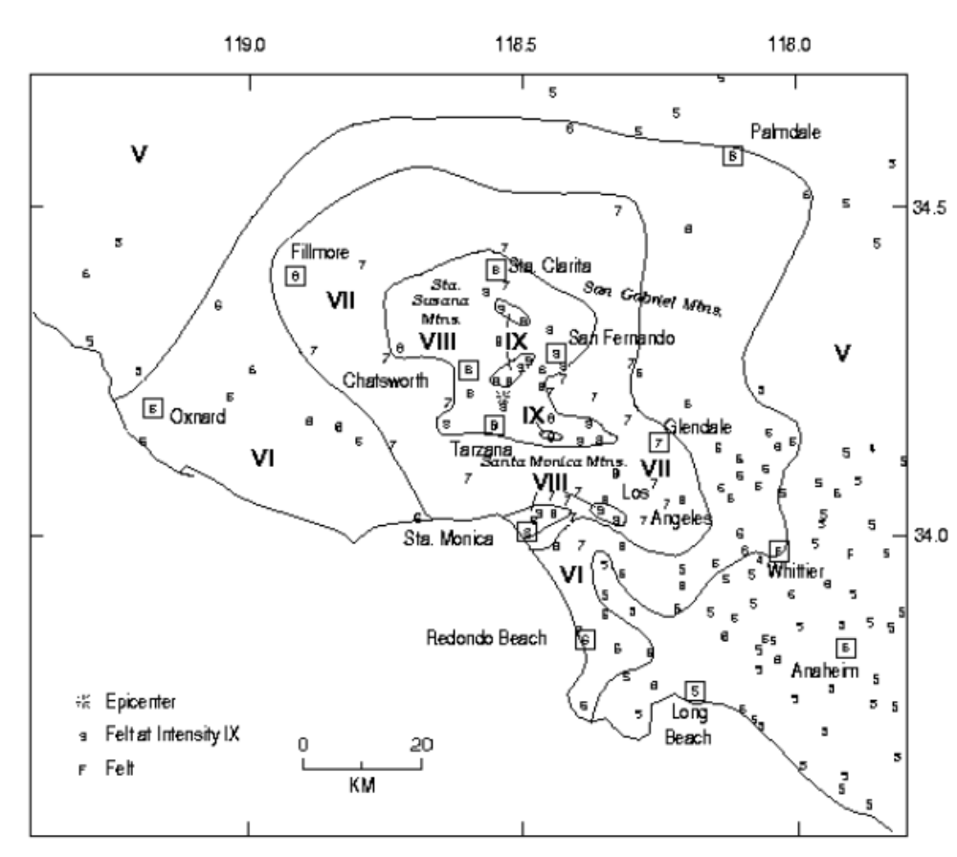
Source: US Geological Survey
Image 5.2.2: Distribution of Federal Assistance Funds and Appropriations in the Northridge Earthquake
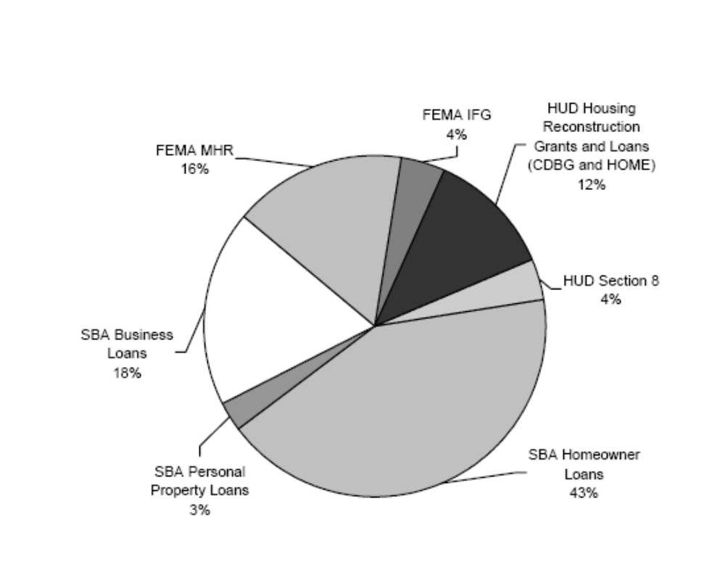
Source: Loukaitou-Sideris, 2004.
Sidebar 5.2.1: Los Angeles Fire Department Operations Following the Northridge Earthquake
On January 17, 1994, a magnitude 6.8 earthquake occurred at 0431 hours in Los Angeles. The earthquake's epicenter was in Northridge according to the Caltech Seismological Laboratory. Although the surface wave magnitude of this earthquake was initially estimated to be 6.6, it was later upgraded to 6.8 by the National Earthquake Information Center.
The following is a listing of significant events relative to this earthquake, and actions taken by the Los Angeles City Fire Department to mitigate its impact upon residents of the City of Los Angeles. Where possible, events are listed in chronological order.
Immediately following the earthquake, the L.A.F.D. initiated the Earthquake Emergency Operational Mode. The Los Angeles County Fire Department, Los Angeles Police Department, Area ~A~ Fire Departments (Beverly Hills, Culver City and Santa Monica), the Medical Alert Center and the California Highway Patrol were notified as to our operational status. Degraded dispatching was instituted citywide.
At 0435 hours, the Emergency Operations Center was activated.
As a result of the earthquake, one radio repeater site was rendered inoperative. This, however, did not adversely affect radio communications.
One of two 420 kilowatt back-up generators at the Information Services Division did not function properly when electricity was lost following the earthquake. Under an excessive load, the second of the two back-up generators overheated and then it too failed to operate.
The FCCS I computer system at O.C.D. relies on the system at I.S.D. to be operational. Therefore, when the computer system at I.S.D. lost power, the computer system at O.C.D. also went down and "manual mode" dispatching was instituted. This failure occurred at 0505 hours and manual mode dispatching continued until the Department of Water and Power restored the electricity approximately six hours later.
Fire department communications were not interrupted nor adversely impacted with the failure of the computer system.
Following the initial assessment by fire companies conducting their district drive-thru inspections, Division 3 was identified as the area most severely impacted by the earthquake. Fire companies reported numerous loom-ups, and severe structural damage to many buildings, both residential and commercial. At 0545 hours, Department Command was established at O.C.D. and Mayor Riordan declared a state of emergency.
By 0645 hours, as many as 50 structure fires were reported in addition to numerous ruptures in water and natural gas mains. Power outages were reported city wide.
The Santa Monica Fire Department requested mutual aid, however, this request could not be honored due to the critical state of events within the city of Los Angeles. Two of the six strike teams requested from Region I were subsequently directed to Santa Monica to provide necessary assistance.
Severe damage to several freeways was reported. Many freeways collapsed entirely or were damaged enough to require closure. Landslides hindered the movement of some fire companies in hilly areas as they performed their drive-thru inspections.
Sporadic looting was reported by fire companies. However, it did not appear to be a widespread problem during daylight hours.
By 0700 hours, there were over 100 active incidents being handled by field resources.
The following is a summary of Command Decisions that were made during the initial hours following the earthquake.
1. The entire off-going shift ("C" shift) was held over to provide additional staffing.
2. Disaster Preparedness Section Staff were recalled to staff the Urban Search and Rescue vehicle.
3. The Region I Coordinator (L.A. County Fire) was contacted and six strike teams and one USAR team were requested to respond to Valley Command, which was being established at fire station 88.
4. L.A.F.D. Command Staff was recalled to O.C.D.
5. Fire station 88 was established as the staging area for fire department resources.
6. L.A.F.D. inspectors were recalled to formulate damage assessment teams.
7. Dispatchers were sent to Coldwater to establish a back-up dispatch site.
8. Twenty-six fire companies were deployed into the valley to augment existing division 3 resources.
9. Two additional USAR teams were immediately dispatched to F.S. 88 at the request of Region I.
By 0945 hours, all fires in the valley were controlled and there were no active major structure fires in progress.
Due to severe damage following the earthquake, six valley hospitals closed. The hospitals that closed were as follows: Holy Cross, Oliveview, Northridge, Granada Hills, Kaiser Panorama City and West Hills.
Red Cross Shelters were established within the first twenty-four hours at the following locations: Sylmar High School, Reseda High School, San Fernando Recreation- Center, Canyon High School, Van Nuys Church of Christ, Glendale Armory, Hollywood High School, and Granada Hills High School.
Power began to be restored in several areas of the valley in the late evening and early morning. As power came back on, numerous reports of electrical shorts and live power lines were received.
By the end of the day, there were 18 confirmed deaths and 250 reported injuries, however, the exact number of casualties could not be ascertained.
There were a total of 466 fires reported on January 17. Routinely there are between 30 and 40 fires reported on a daily basis in the city of Los Angeles.
Within the first 24 hours of the earthquake the L.A.F.D. responded to more than 2,200 incidents, which nearly approximates 2 1/2 times the daily average.

Significant Incidents
One of the most significant incidents in terms of life loss occurred at a 3-story, 120 unit apartment complex located at 9565 Reseda Boulevard. Task Forces 70 and 73 were first to arrive on the scene and reported the collapse of a 3-story apartment building. The first floor was crushed in the collapse, reduced to a crawl space of two to three feet. Many of those that perished were buried under collapsed walls and the ceiling.
Ultimately involved in the rescue operation were seven L.A. City Fire companies, an L.A. City Fire USAR team, and USAR teams from L.A. County, Riverside County, Orange County and the State Office of Emergency Services.
Several residents self-evacuated prior to and shortly after the arrival of fire companies. Twenty-five to thirty residents were assisted out of the structure by firefighters. Eight were evacuated by firefighters and USAR teams and then were transported to area hospitals in conditions ranging from serious to critical.
To further assist with locating trapped victims, L.A.P.D. search dogs were brought in. Unfortunately, all that remained trapped had perished.
Sixteen fatalities in all resulted from the collapse of this building.
Another significant incident occurred at the Northridge Fashion Mall. A street sweeper that was working on the first floor of a 3-story parking structure was trapped in his pick-up truck when the entire parking structure collapsed.
An L.A. City Fire USAR team was at the scene but was redirected to the incident occurring on Reseda Boulevard due to the number of lives involved. Light Force 89, Engine 1, Heavy Utility 56 and a Gas Company Crew continued the rescue effort. As the incident progressed an L.A. County USAR team was directed to the location to assist.
Firefighters assisted by the Gas Company crew utilized the 'Jaws of Life', hydraulic jacks, sledge hammers, saws, and the Gas Company's jack hammer to reach the man who was pinned and in critical condition.
Aqueous Film Forming Foam had to be flowed down under the crushed pick-up truck, to prevent the ignition of leaking fuel.
It took firefighters six to seven hours to successfully extricate the man. He was transported to the U.C.L.A. Medical Center in critical condition by Air Ambulance. His condition has since been upgraded to serious.
A significant loss of property resulted from structure fires that occurred in three separate mobile home parks. These three fires simultaneously broke out immediately following the earthquake. The cause of these fires appears to have been the rupture of natural gas valves and/or mains.
Twenty to thirty mobile homes were lost at the mobile home park located at Cobalt and Rinaldi. Twenty-three mobile homes were lost at the park located near the intersection of Olden and Ralston. Sixty-seven mobile homes were lost at the park located at Glen Oaks and Foothill.
Arriving firefighters encountered fire hydrants with little or no pressure. To combat the fires, relay operations and water shuttles were implemented.
Firefighters evacuated all residents and no serious injuries were reported.
Also significant were the ruptures of a large natural gas main and a water main at the intersection of Balboa and Rinaldi. These ruptures occurred immediately following the earthquake.
Subsequent to the rupture, the natural gas main ignited, and five single family homes were consumed in the ensuing fire.
Area residents were evacuated by arriving firefighters and no serious injuries were reported.
At approximately 0520 hours, Engine 97 responded to an incident at 3999 Sunswept Drive in the Studio City area. Upon arriving on scene, Engine 97 reported the complete collapse of a three and four story single family dwelling which was located on a hillside.
Two of the four residents of the home had successfully extricated themselves from the structure prior to the arrival of firefighters. One resident was killed in the collapse and the fourth resident was trapped and in need of extrication. Due to the precarious position of the collapsed structure on the hillside and the continued after shocks, firefighters initially were unable to successfully rescue the still entrapped resident.
By 0900 hours, firefighters from Engines 78 and 97, along with several L.A.P.D. . Officers, had successfully effected the extraction of the trapped resident. The woman had only sustained minor injuries in the collapse of the home.

January 18, 1994
At 0815 hours, the Casualty Information Center reported 2,004 injuries treated and released at area hospitals, 506 hospitalized and 33 deaths.
At 1200 hours on January 18, the DWP estimated that approximately 95,000 people were still without power and between 50,000 and 100,000 were without water.
The National Guard arrived in Los Angeles and handled looter prevention and fixed post security missions in support of Police Department operations. By 0300 hours on the 18th, 480 Guardsmen and 120 Los Angeles County Sheriff's Deputies had deployed in Los Angeles.
Twenty-nine water tankers were strategically deployed throughout the valley for the purpose of supplying water to fire companies for potential fires. The combined water capacity of these tankers was 78,000 gallons.
Individual tankers were assigned to respond with specified department resources on all incidents. In addition, two Tanker Strike Teams consisting of one Battalion Chief, three tankers (water capacities per tanker range from 1,400 to S,000 gallons), and two engine companies were deployed to fire stations 106 and 90.
A Tanker Strike Team was dispatched to incidents any time there was an indication that there might be an actual fire. These tankers have multiple 2 1/2" outlets.
Five fire department pick-up trucks loaded with 2,000 feet of 3 1/2" hose were deployed to fire station 88 along with a cache of hose. They could be obtained through O.C.D. if a long distance relay became necessary.
The Community Service Unit of the L.A.F.D. prepared a Press Release detailing post earthquake safety tips. The Press Release detailed safety tips involving the use of unvented heating and cooking devices, natural gas leaks, usage of flashlights as opposed to candles, and chimney precautions.

January 19, 1994
At 0650 hours, the Casualty Information Center reported that as of 2400 hours,3,762 people had been treated and released at area hospitals, 526 people were admitted, and 40 people had been confirmed dead.
At 1530 hours, the Department of Water and Power reported that the water system in the valley had approximately 3,000 leaks as a result of the earthquake. It was further reported that it would take between two and three months to repair all of these leaks.
At 1700 hours, twelve L.A.F.D. ~200 series" engines were assigned to assist the DWP with water main pumping operations.
Damage Assessment Command organized thirty-six c assessment teams, each consisting of Fire Prevention Bureau Inspectors. The thirty-six teams corresponded with the thirty-six first-in districts in Division 3. Each team was assigned a respective first-in district.
The objective of these assessment teams was to determine the total number of buildings damaged, total number of dwelling units affected and to estimate the total number of residents displaced by the earthquake.
The initial assessments were completed on January 19, 1994. Following these initial assessments, teams will conduct a more thorough inspection throughout the city. These inspections are anticipated to take several weeks to complete.
The L.A.F.D. provided the Goodyear Center with ten post earthquake safety messages in English and Spanish. These messages were displayed on the Goodyear Blimp throughout the evenings of the l9th and the 20th.
Source: Los Angeles Fire Department 2, 1994.
Sidebar 5.2.2: Explanation of the Section 8 Voucher (HUD) Program
Established in 1974, the Section 8 Program is the single largest source of rental assistance in the country. The program is designed to bridge the gap between the cost of operating and maintaining housing units and what low-income individuals and families can afford to pay in rent. The Section 8 Program is administered at the local level by Local Housing Agencies (LHAs), also known as Housing Authorities, who receive Section 8 funding through an Annual Contributions Contract. Subsidies are available as Vouchers or Project-based, and you should be aware that PHAs are increasingly willing to convert tenant-based to project-based assistance (which is easier to underwrite for supportive housing). In 1998, a Federal law combined the Section 8 certificates and vouchers programs into one program, which is now called the “Section 8 Housing Choice Voucher Program.” In addition, HUD offers Welfare-to-Work rental vouchers. In order to qualify, the families must also meet special welfare-to-work criteria established in the law.

In 2001, the HUD/VA Appropriations Bill established new regulations governing the conversion of tenant-based vouchers into project-based Section 8 assistance. This new legislation gives Housing Authorities the authority to use up to 20% of their tenant-based vouchers for project-based assistance. However, the new regulations grant Housing Authorities greater flexibility in how the project-based assistance is used than in the previous project-basing regulations, and represent a promising potential source of funding for supportive housing.

Source: Corporation for Supportive Housing, N/D.

Case Study 5.3: September 11th Philanthropic Recovery Efforts

Introduction

On September 11, the United States suffered its greatest civilian mass casualty event since the Texas City Explosions/Fires of 1947 (581 deaths, 3,500 injuries). In addition to the fatalities and the physical property that was damaged or destroyed, millions of personal lives were deeply impacted. Hundreds of thousands of people suffered mental health problems that needed to be addressed. As many as 100,000 jobs were lost in New York City alone, and businesses suffered interruptions of weeks, months, and even years. Many victims’ families lost their primary source of income. It was painfully obvious from the moment the attacks began the recovery to this disaster would be extraordinary.

As expected, the Federal, State, local, and non-profit organizations performed their pre-determined roles in both the response and recovery to the disasters. For the vast majority of these players, their actions were commendable, and resulted in a much faster than expected recovery from the attacks. What was truly unexpected, however, was the outpouring of support from regular citizens of the United States and abroad who took a personal role in the recovery from the September 11th events.

In the weeks and months following the September 11th terrorist attacks in New York City, Arlington, VA, and Shanksville, PA, both the federal government and philanthropic entities (including corporations, foundations, and individuals) granted more financial assistance than has been provided in any previous disaster. Some Federal aid programs distributed more money in response to this disaster than they had given in all previous disasters combined (Seessel, 2003). Through the various charity outlets, American businesses, foundations, and private citizens gave over $2.8 billion to help the victims of the attacks to recover. This case will examine the ways in which charitable donations, through profiling both the September 11 Fund and the Liberty Fund, helped the nation to recover.

The Event

At 8:45 AM on Tuesday, September 11th 2001, American Airlines Flight 11, having been hijacked by a group of terrorists after taking off from Boston, crashed into the north tower of the World Trade Center (WTC) Complex in New York City (NYC). Initially, this event appeared to be isolated. Eighteen minutes later, as the media was televising video of the blazing tower around the world, a second commercial airliner came into view and disappeared with an enormous explosion into the South Tower of the WTC. This plane, United Airlines Flight 175 (also from Boston), confirmed that the U.S. was under attack by an unidentified terrorist group.

Immediately after the North Tower was hit, the NYC Fire and Police Departments dispatched personnel to secure the scene and begin rescue operations. Within five minutes of the second event, the Federal Aviation Administration (FAA) ordered all NYC airspace 'sterilized', (freed from air traffic). Seven minutes later, all NYC airports were closed, and nine minutes after that (9:26 AM), all U.S. civil flights were prevented from taking off. Over 4000 planes were aloft in U.S. airspace, with several hundred en route from overseas, and all were ordered grounded or re-routed to Canada. This action did not stop American Airlines flight 77, hijacked shortly after departing Washington Dulles Airport, from reaching its crash-destination of the Pentagon at 9:43 AM. A fourth commercial aircraft was known to be missing, and the White House was evacuated at 9:45 AM. At 10:10 AM, United Airlines Flight 93 from Newark, N.J. crashed in Somerset County, Pennsylvania, about 80 miles southeast of Pittsburgh. At approximately the same time, a structural collapse occurred at the Pentagon building in the area of airplane impact. Just after 10:00 AM, the South Tower of the WTC complex collapsed completely, raising the estimated dead and injured exponentially. In response to this tightly grouped series of events, Secret Service agents were positioned in Lafayette Park (across the street from the White House), the United Nations complex was evacuated in NYC, and many Federal departments and agencies were evacuated in Washington, DC. By 10:30 AM, the U.S. Office of Personnel Management (OPM) had begun the emergency evacuation of all DC federal buildings.

At 10:28 AM, the North Tower of the World Trade Center complex collapsed, adding to the scale of casualties. At this point, New York (NY) Governor Pataki closed all government offices in NY, and NYC mayor Giuliani ordered the evacuation of the area of Manhattan south of Canal Street. It was reported that several airports around the country were evacuating, and rumors of car bombs (at the U.S. State Department and other locations) and additional hijacked planes were making their way into the news.

At noon, it was still not clear that the attack was over. Washington, DC closed its city government buildings, and the General Services Administration (GSA) closed its buildings and courthouses throughout 5 states in the Capitol region. Washington D.C. Mayor Anthony Williams declared a state of emergency for the city of Washington at 1:22 PM. Soon after, the FAA announced that there would be no commercial air traffic until at least noon of September 12th.

By mid afternoon, rescue crews from around the country began arriving at the three sites to assist local police and fire departments and nearby mutual aid resources that had immediately responded. Mayor Giuliani announced in a press conference at 2:49 PM, that subway and bus services were restored in NYC. At this time, estimates of the number of injured or killed ranged from several hundred to tens of thousands, though no official was willing to give specific numbers. Collectively, the attacks resulted in the deaths of almost 3,000 people. At the WTC there were 2772 deaths, including the passengers and crew on the two airplanes (of this number, 50 were police officers and 319 were firefighters.) At the Pentagon, the terrorist attack claimed 184 victims. In Shanksville, PA, there were 45 deaths, all passengers or crew on United Airlines Flight 93.

As the evening approached (5:20 PM), Building #7 in the WTC complex, which had been burning for much of the day, also collapsed. It housed NY City’s multi-million dollar, recently completed, state-of-the-art Emergency Operations Center (EOC). In addition, other buildings in the area of the towers were on fire, and the collapsed debris continued to burn. Mayor Giuliani appeared at an evening press conference and urged New Yorkers to remain at home on September 12th if they could, though Defense Secretary Rumsfeld held a news conference with a different message: he stated that Pentagon employees should expect to report to work.

In the aftermath of the September 11th attacks, the U.S. experienced its first large-scale integration of emergency management, emergency medical response, law enforcement, and military resources using the Terrorism Annex to the FRP. In NYC, initial efforts on the part of locally based regional offices of Federal agencies to deal with emergency response were hampered by the destruction of the city’s EOC, and loss of use of federal facilities in lower Manhattan (including the planned Disaster Field Office). The city’s EOC capabilities had to be regenerated virtually from scratch. The Federal Center in NYC was not physically damaged, but telecommunications were knocked out, which meant that FEMA Region II, Environmental Protection Agency (EPA) II, and other Federal agencies had to use alternate operational locations. Additionally, the grounding of commercial aircraft restricted the deployment of emergency response personnel across the country.

At the time of the attacks, many senior Federal and State emergency managers were in Big Sky, Montana at a national emergency management conference, and some specialized response personnel were on deployment for potential hurricane response. To move the management and responder resources and supplies, traditional air transport had to be re-thought and new arrangements implemented. A rapid mobilization plan occurred for Federal resources despite these obstacles, and skilled upper and mid-level managers successfully executed the Federal mobilization. Mobilized Federal resources for the three 9-11 incident sites included search and rescue teams, Disaster Mortuary Teams, Disaster Medical Assistance Teams and other medical response teams, EPA HAZMAT teams, U.S. Army Corps of Engineers (USACE) debris removal teams, and American Red Cross mass care resources. The Catastrophic Disaster Response Group, the interagency group of senior managers established by the FRP to resolve major interagency conflicts during a federal disaster response, was never needed and did not convene. Thousands of federal employees were involved in the response to the attacks. Fire and EMS services, Urban Search and Rescue (US&R) teams, structural safety experts, and debris specialists were engaged in the largest search and rescue and debris removal missions in United States history.

Summary of Federal Government Response and Recovery Expenses

To place the charitable component of the response and recovery into the overall context of the disaster response, it is necessary to provide a brief overview of the Federal Government response and recovery expenses.

The cost to the Federal Government for the response and recovery of the World trade center was formally estimated to be $20 billion, though other informal measures are more difficult to assess and likely raise this figure significantly. FEMA provided 42% of the Federal share, with $8.8 billion in aid. HUD gave the second largest share, $2.48 billion, or 17% of the total share, while DOT ranked third at $2.37 billion (11.5%). All other Federal agencies contributed a total of $820 million, which amounted to 4% of the total Federal share. Also included in the Federal figures of aid are the tax benefits associated with the New York City Liberty Zone – an area of the city where new tax incentives have resulted in over $5 billion in indirect economic aid to the city and its residents. The exact amount of aid resulting from this program will never be known, and as such, the exact figure of Federal aid will remain an estimate. For a more detailed breakdown of costs and programs, see sidebar 5.3.1.

Since September 11th, the costs associated with securing the nation from future acts of terrorism have eclipsed this $20 billion figure, through the creation of the Department of Homeland Security, the costs of airport security, police and fire department overtime, special events security, equipment and training grants, technology grants, port security – the list is extensive. The cost of all of these measures combined, across the four years since the terrorist attacks, amounts to several hundred billion dollars, and will likely continue to rise for many years to come.

Philanthropy in the Aftermath of the September 11th Attacks

Charities have historically played a role in the nation’s response to disasters. Some charities, such as the American Red Cross or the Salvation Army, are equipped to arrive at a disaster scene and provide mass care, including food, shelter, and clothing, and in some circumstances, emergency financial assistance to affected persons. If the disaster is notably large, typically measured as a factor of the extent and nature of devastation to a community and charities’ typical services and capacities, some charities provide longer-term assistance (such as job training or mental health counseling). Finally, new charities may form after the disaster specifically to address the needs of survivors or specific population groups.

FEMA is the lead federal agency for responding to disasters and may link with charitable organizations to provide assistance. According to FEMA regulations, in the event of a presidentially declared disaster or emergency, such as September 11, FEMA is required to coordinate relief and assistance activities of federal, state, and local governments; the American Red Cross; the Salvation Army; and the Mennonite Disaster Service; as well as other voluntary relief organizations that agree to operate under FEMA’s direction. Although charities are expected to be among the first agencies to provide assistance to those affected, in the event of some natural disasters, FEMA may anticipate need and be the first to respond. FEMA can provide a range of assistance to individual disaster survivors. In natural disasters, such as hurricanes or floods, the bulk of FEMA’s individual assistance program money tends to be given to individuals whose residences have been damaged. However, following the September 11the events, FEMA was presented with different circumstances than what was normally encountered - few people had damage to their homes, but many needed unemployment assistance and help paying their mortgage or rent. (GAO 2, 2002)

In the wake of September 11th, foundations, corporations and relief funds financed a range of activities addressing direct and indirect consequences of the disaster. Many of these organizations defined “victims” more broadly than had typically done in the past, such that those who suffered economic and social dislocation as well as the families of those who died or were severely injured were included. The General Accounting Office (GAO), having carefully examined the role of charitable organizations contribution to the response and recovery from the disaster, concluded in their report “September 11: More Effective Collaboration Could Enhance Charitable Organizations” that “charitable aid made a major contribution in the nation’s response to the September 11 attacks, despite very difficult circumstances” (Seessel, 2003).
The Foundation Center, the self-described “nation’s leading authority on philanthropy,” has identified 1,339 foundations, corporations, and other institutional donors that made gifts in response to the September 11th terrorist attacks. These donors gave over $1.1 billion in more than 4,500 gifts for relief and recovery efforts and for issues related to the attacks (bioterrorism and civil rights, for example). Giving by institutional donors represented 39 percent of an estimated $2.8 billion in total private 9/11-related giving. 301 donors contributed in excess of $1 million each for relief and recovery. The average amount of giving per donor was $100,000, and foundations and corporations in the New York ‘tri-state’ area (New York, New Jersey, and Connecticut) provided 52 percent of all giving. Individual donors, on the other hand, provided 61 percent of all philanthropic giving, primarily through donations to either existing organizations or through funds that were created in response to the attacks. Private donations amounted to over $1.7 billion. To see a visual breakdown of the philanthropic giving after the September 11th attacks, see Figure 5.3.5.

Two Hundred and seventy-eight funds were created in the aftermath of the attacks to aid victims, their families, and communities affected by the disaster. These funds received support from institutional donors totaling $773 million. The September 11th Fund of the United Way of New York City/New York Community Trust received $163 million, surpassing all other organizations; the American Red Cross Liberty Disaster Relief Fund received $150 million. 1,538 direct-service providers, groups directly affected by the attacks, and organizations addressing September 11th-related issues received $235 million. Among direct-service organizations, arts and culture groups affected by the attacks received $56 million; local human service agencies providing aid to affected persons and communities garnered nearly $55 million. Recipient organizations and funds were located in 44 states and 12 countries (Foundation Center, 2004).

The American Red Cross Liberty Disaster Relief Fund, which raised funds for victims and their families and also provided direct services, ranked first in overall funds collected. It was also first in terms of the amount of funds collected from individual citizens, but second in terms of institutional donor contributions ($150.2 million provided by foundations and corporations, or 14 percent of all institutional giving, and $925 million from individuals.) The Liberty Fund captured roughly 36 percent of the estimated $2.8 billion in private funding following the September 11th attacks.

The September 11th Fund was the second largest 9/11 relief fund ranked by amount received ($162.5 million from institutional donors, or 15 percent of all institutional giving, and $383 million from individuals), but largest in terms of the funds collected from institutional charity. The Fund’s broad purposes include providing direct assistance to victims and their families and services to affected communities. Excluding donations raised for the Fund in a national telethon, foundations and corporations provided 41 percent of the Fund’s reported $410 million in private support. (Including the telethon pledges, the Fund received $534 million.)

Other top 9/11 relief fund recipients of institutional donors’ gifts included the Twin Towers Fund ($205 million), the International Association of Fire Fighters (IAFF) Fund ($161 million) and the New York Police and Fire Widows’ and Children’s Benefit Fund ($117 million), each established to aid the families of New York City police, firefighters, and rescue workers who were victims of the attacks; and the Citizens’ Scholarship Foundation ($113 million), a national-level fund that provides post-secondary educational assistance to dependents of those killed or injured in the attacks.

Relief funds created by more than 60 corporations to aid victims (especially employees) and their families and to support relief and recovery efforts together received $173.2 million. Eight corporate funds received at least $10 million in support. The largest relief fund recipient by far was the Citigroup Relief Fund, which received $15.1 million from the Citigroup Foundation to provide post-secondary scholarships to the children of victims (The Foundation Center, 2004.)

Though significant, the funds collected amounted to approximately 1 percent of the charitable contributions given by American citizens, foundations, and corporations. For a more detailed analysis of general philanthropic giving in the United States, see Sidebar 5.3.2.

The Red Cross “Liberty Fund”

In the days following the September 11, 2001 terrorist attacks, the Liberty Fund was created as a separate, segregated account (from other Red Cross funds) to provide assistance to individuals and families most affected by the disaster. Through the philanthropic donations of millions of individuals both within the United States and from around the world, as well as foundations and corporations, the Liberty Fund received $1.07 billion. By the end of 2005, the Liberty Fund succeeded in providing $858 million in financial, material, physical, and emotional relief to the victims of the attacks and their families, and has created detailed plans by which it will distribute the remainder of collected funds. Through the granting of these funds, thousands of families have received financial assistance that enabled them to pay rent, school expenses, and buy food and health care items. Thousands of others have received or will receive critical mental health and other health care services to facilitate their recovery from the September 11th events.

In August of 2002, the Red Cross began its transition to the second phase of a plan to distribute the Liberty Fund – titled the September 11th Recovery Program (SRP). At this time, though efforts to provide financial assistance to those directly affected by the September 11, 2001 terrorist attacks continued, the Fund’s focus shifted to ensure that those with longer-term needs, such as mental health and health care, were receiving the help they require. In developing the longer-term program, Red Cross officials consulted with victims directly affected by the tragedy, other service agencies, and Red Cross staff in Oklahoma City who continue to provide services to people impacted by the April 1995 Murrah Building bombing. The updated program consisted of core services (see below) delivery, including the distribution of remaining direct client financial assistance and longer-term services such as support for families, mental health and health, and grants for community-based agencies who provide services to those most directly affected by the disaster.

The following core services are part of Liberty Fund and its SRP’s mission to provide assistance to those most seriously affected by the September 11 tragedies.

Core Services of the Liberty Fund

- Emergency Financial Assistance; A core mission of the Red Cross is to provide rapid assistance to individuals and families affected by disasters in order to enable them to resume their daily activities. The Liberty Fund was designed to ensure timely distribution of funds to families of those who were killed in the September 11 attacks, those who were seriously injured, and others directly affected by the attacks. To distribute these funds, the Red Cross maintained their stated belief that “disaster victims are in the best position to evaluate their own immediate and longer-term needs and to choose from the resources provided to meet them.” Six hundred sixty-seven ($667) million had been distributed or committed to those directly affected by the attacks as of December 31, 2004. Emergency Financial Assistance falls under three general categories: Families of the Deceased or Missing, or Persons Seriously Injured in the Attacks; Displaced Residents, Economically Affected Individuals, and Disaster Responders; and Longer-Term Services – the September 11th Recovery Program (SRP).

  - Families of the Deceased or Missing, Persons Seriously Injured in the Attacks; As of December 31, 2004, the Liberty Fund distributed or committed a total of $385 million in direct financial assistance to the families of the deceased or missing and to persons seriously injured in the attacks through the following programs:

- Family Gift Program - The Family Gift Program was developed to provide families of the deceased and persons seriously injured in the attacks with basic living expenses not met by other sources. The vast majority of families and individuals in this category received a full year of assistance under the program. Overall, this program assisted 3,561 beneficiaries and disbursed over $209 million. Additionally, $4 million was spent providing travel and accommodations memorializing the first anniversary of the attacks in 2002.

- Supplemental Gift Program - The Supplemental Gift is a financial grant issued to the estates of decedents and to those individuals who were seriously injured on September 11th. The Plan anticipated that each estate or individual would receive $45,000. Due to additional Liberty Fund donations received since the program’s creation, the amount of the Supplemental Gift was increased to $55,000. As of December 31, 2004, $160 million had been disbursed or committed to this program. Thus far, Supplemental Gifts have been disbursed to 2,889 estates and seriously injured individuals; an additional 23 have been accrued for payment.

- Special Circumstances Gift - Initially under the Plan, $15 million in financial assistance was allocated for dependent extended or nontraditional families of the deceased who would not benefit from the Supplemental Gift Program. These individuals were not beneficiaries of the estate of someone who died in the attacks, or were seriously injured persons who received other Red Cross gifts but continue to have compelling longer-term financial needs. The provision of such financial assistance for these individuals and families was determined on a case-by-case basis, taking into account a variety of factors, such as the individual’s unmet financial needs, the level of dependence on the deceased, and the nature of the special circumstance. As of December 31, 2004, 1,052 applications were reviewed and 565 individuals, including 69 international clients, received a Special Circumstances Gift for a total of nearly $12 million.

  - Displaced Residents, Economically Affected Individuals, and Disaster Responders; As a result of the terrorist attacks of September 11th, roughly 50,000 households were displaced from their home or job for some time. To help meet the needs of such individuals and other financially impacted individuals, the Liberty Fund originally allocated $290 million in assistance to displaced residents and economically affected individuals. Most of this assistance was provided in 2002. To date, more than $282 million has been provided to those individuals and families who worked below Canal Street and lost their jobs due to the attacks, or who lived south of Canal Street in Manhattan on September 11th and were displaced, had their home damaged, or had access to their home disrupted as a result of the attacks. Funds allocated under this program helped cover costs associated with relocation, rent or mortgage payments, hotel stays, crisis counseling, cleaning, and storage. As the volume of requests from affected residents has dropped significantly for this specific form of assistance, this program was discontinued on June 30, 2004.

  - Longer-Term Services – September 11 Recovery Program (SRP); The Red Cross continues to offer economic assistance, counseling, health care services, and other assistance to clients. As outlined below, families of the deceased, seriously injured and their families, residents, and rescue workers and their families are eligible for a range of longer-term services. SRP works with a variety of organizations to assure that comprehensive information on Red Cross benefits and services is disseminated to targeted populations.

- Additional Assistance Program - In the Fall of 2002, concerns were raised about a number of individuals who did not fall within the original framework of the Liberty Fund, but who were nonetheless victims of the attacks and deserving of financial and other assistance (e.g., health and mental health services) through the SRP. The Additional Assistance Program was created to ensure that these needs could be met for clients in the following categories:

  - People with Disabling Health Injuries or Conditions. This category includes individuals such as rescue and recovery workers, who do not qualify for financial assistance under the Family Gift and Supplemental Gift Programs. Under these programs, individuals must have been hospitalized for 24 hours within the week following the September 11 attacks. An example of a person outside this program criterion would be an individual who was injured on September 11, 2001, treated at a hospital and released the same day, but subsequently disabled as a result of the September 11 disaster and unable to work for more than 90 consecutive days.

  - People with Disabling Mental Health Conditions. Similar to people with physical disabilities, this programmatic category allows the Red Cross to provide limited financial benefits on a case-by-case basis to individuals who, while they have been diagnosed as having a disabling mental-health condition stemming from the September 11 disaster, would not otherwise qualify for Liberty Fund financial assistance.

  - Surviving Family Members. This category allows for the provision of additional financial assistance to financially dependent family members of persons who died on September 11 and continue to have compelling financial needs.

  - Rescue and Recovery Workers. This category allows for the provision of limited financial benefits to people who were officially deployed to restricted work sites, including Ground Zero, Fresh Kills landfill, the Pentagon, and Shanksville, PA, and were physically injured or are suffering from a disabling mental health condition.

Under the Additional Assistance program, an individual is eligible to receive up to six months of financial assistance to meet demonstrated unmet, essential housing and living expenses. Assistance for other necessary expenses could also be provided based on a case-by- case assessment under this program. As of December 31, 2004, 493 individuals with “dire unmet essential living expenses” were awarded an average of $9,195 from the SRP, which in total has distributed more than $4.5 million in Additional Assistance to eligible individuals. One noteworthy component of this program regards the application of modern technology to ease disbursement. In October 2004, SRP began using “Client Assistance Cards”, which work exactly like debit cards, to distribute funds to victims.

Family Support Services. This component of the SRP involves non-monetary assistance to the victims of the attack. Family Support Specialists (the trained caseworkers assigned to each of the individuals and families receiving Liberty Funds) create individualized service plans in partnership with those affected to support each individual’s and family’s return to more normal living. They provide ongoing individual as well as group support and assistance, along with assessment, counseling, crisis intervention, advocacy, and information and referral services. As of December 31, 2004, Family Support Services had completed its work with 98 percent of 5,962 domestic individuals and families affected by the September 11 attacks, and continues to provide ongoing support to 112 individuals and families. A “Case Audit Unit” works with Family Support Services to ensure that clients have appropriately received Red Cross funds, and as of December 31, 2004, the Case Audit Unit and the Office of the General Counsel have resolved work with 1,225 or 82 percent of 1,492 cases under legal review and continue to work with the remaining 267 cases.
Delivery of this service to overseas victims was transitioned from the International Family Assistance Program (IFAP), which existed under the initial programmatic functions of the Liberty Fund, to the SRP. International victims receiving casework services include family members of the deceased, injured individuals, overseas dependents, and residents who have since relocated overseas. As of December 31, 2004, SRP was working with 31 national Red Cross and Red Crescent societies to meet the needs of 161 active clients.

- Mental Health Services. The Red Cross provides financial assistance for longer-term mental health treatment to people who were directly impacted by the September 11 attacks through the “9/11 Mental Health and Substance Abuse Program.” The programs goal is to make financially affordable any required treatment for conditions such as anxiety, depression, post-traumatic stress disorder, or substance abuse, to victims who could not otherwise afford them. Through the SRP, the Red Cross provides financial assistance for the following services:

  - individual, couple, group, and family counseling;
  - psychological testing or evaluations for children;
  - psychotropic medication;
  - psychiatric hospitalization; and
  - inpatient and outpatient substance abuse treatment.

To date, the program, which is accessible to people regardless of their address, immigration, or insurance status, has provided assistance with treatment costs to more than 5,387 people residing in 37 states, the District of Columbia, Puerto Rico, and nine foreign countries.
The 9/11 Mental Health and Substance Abuse Program was jointly created by the Red Cross (Liberty Fund) and the September 11th Fund soon after September 11th, 2001. In October 2004, the Red Cross and The September 11th Fund began public communication that the Red Cross will assume full sponsorship of the Program, which became effective January 1, 2005. Through this transfer, the Red Cross now supports the continued provision of financial assistance to individuals who previously received treatment-related assistance from The September 11th Fund.
- Health Care Services. The Red Cross provides clinical case management to individuals who were physically injured in the September 11th attacks or the ensuing recovery efforts, as well as financial assistance for health treatment costs not covered by insurance or other programs. The program has provided financial assistance with such expenses as home health care, surgical expenses, and durable medical equipment. The Red Cross also pays the out-of-pocket cost of 24 months of health insurance for surviving immediate family members and people who became physically disabled due to their September 11th injuries through the Health Insurance Subsidy Program (HISP). As of December 31, 2004, more than 1,220 individuals are receiving coverage of their health insurance costs to date. To date, more than 4,500 individuals have received assistance through Health Care Services; an estimated 150 injured clients are expected to continue to require and receive longer-term assistance.

- Client Assistance Center. The Client Assistance Center (CAC) is the main entry point or call center for SRP services, with a mission of connecting people affected by September 11 to the services most appropriate for their needs. Callers, or those contacting SRP via mail or email, are screened for eligibility for Red Cross services and benefits. Those who may be eligible for services then receive a thorough needs assessment. Those who are not eligible are given information on other available resources as appropriate. The CAC also addresses complaints and inquiries from clients and their advocates. The CAC phone number is 1-877-746-4987.

- September 11 Recovery Grants. The Recovery Grants Program is an ongoing grants program that addresses various issues related to September 11th victims. Each quarter, organizations are encouraged to submit applications or proposals on various topics for funding consideration. For illustrative purposes, the following application and proposal requests, issued during the final quarter of 2004, are provided below:

  - Youth Recovery & Resilience – A Request for Applications (RFA) was widely disseminated to umbrella organizations, non-profits, and government offices involved in services for children and youth throughout the United States. Over 100 organizations submitted applications, and 64 were invited to submit full proposals. The RFA encourages non-profit organizations to apply for grant funds to support programs and services that:

    - Reach children impacted by the September 11 terrorist attacks where they live, play, and learn.
    - Enhance children’s capacity to manage stress and to develop and/or maintain effective coping skills, self-reflection, or interpersonal skills.
    - Help caring adults better understand the needs of children exposed to trauma and better support their emotional health and growth.
    - Develop or maintain collaborations or partnerships among community organizations, mental health service providers, and specialized centers capable of providing professional support for the detection and treatment of young people affected by traumatic experiences.

  - Health Impacts – A Request for Proposals (RFP) was issued to seven health screening and monitoring programs to solicit their proposals for services addressing the needs of individuals intensively exposed to the World Trade Center building collapse and/or the recovery site and who are both experiencing health problems and are at significant risk for negative long-term health impacts. Funded services could include:

    - Patient advocacy services to address psychosocial and entitlement issues.
    - Medical care specifically targeted to the needs of people injured in occupational settings and/or whose injuries impede their ability to work who are otherwise unable to pay for treatment.
    - Diagnostic consultations needed to make accurate diagnoses.
    - The addition of screening slots in existing programs to monitor the health needs of people significantly exposed to the site.

In December of 2004, the Red Cross awarded approximately $20 million in Recovery Grant funding to 67 non-profit organizations providing mental health and wellness services, as well as community-based services to people impacted by the 9/11 attacks.

- Client Support Network. As of June 30, 2004, the Case Management Grant Program, which made funds available to other agencies providing case management to clients most severely impacted by September 11, officially ended. The Case Management Grant Program provided 13 awards, totaling approximately $2.9 million, to serve more than 1,400 clients. Building on the work done by the Case Management Grant Program, the Client Support Network began operation on July 1, 2004. The Client Support Network funds other agencies that provide case management to Red Cross-eligible individuals on a fee-for-service basis. By working with various agencies throughout the United States, the Client Support Network ensures that clients have access to services provided locally in their own communities, and also allows clients the freedom to choose their own service provider (as well as the freedom to switch providers if they wish). As of December 31, 2004, the program was serving 713 clients through 35 agencies.

- Client Activities. SRP hosts ongoing group activities for clients called “Family Days.” Family Days feature informational and wellness activities, combined with a support component led by trained facilitators. As of the end of 2004, approximately 2,150 clients had attended a total of 234 Family Day events. SRP also supports external agencies that provide activities offering clients opportunities to develop local supportive networks to aid in their recovery. These activities can range from mentoring events, to support groups, to family retreats. To date, SRP has approved 129 external client activities which have served more than 3,460 clients.

- External Partnerships. SRP works in collaboration with a wide array of external partners including government agencies, advocacy organizations, family support, and other constituency groups to meet the identified, ongoing, and emerging needs of clients. Examples are described below:

  - Recently, SRP established service and referral connections with two New Jersey-based programs. The first, a newly-funded program operated by the University of Medicine and Dentistry of New Jersey called “It’s-4-U-NJ,” provides free crisis counseling for all New Jersey residents affected by the September 11 attacks. SRP met with the management staff of It’s-4-U-NJ to secure a referral relationship between the new program and the 9/11 Mental Health and Substance Abuse Program. SRP reached out to the second program, the New Jersey Unmet Needs Roundtable, to ensure SRP participation in their meetings and facilitate cross-referral of individuals whose financial or service needs can be met by SRP.

  - SRP staff connected the Friendship Ambassador Foundation, which has the mission of promoting peace through cultural exchange, with organizations serving victims of the September 11 attacks in California and Massachusetts. This connection helped the Friendship Ambassador Foundation convene events for surviving family members in Boston and Los Angeles.

  - To inform SRP planning for Recovery Grants funding towards community recovery needs in Lower Manhattan, SRP worked with downtown Manhattan service providers addressing the needs of residents impacted by the September 11 attacks. SRP met with 12 organizations that continue to address the September 11th-related needs of downtown residents. During this meeting, participants discussed current needs, service trends, and the organizations’ assessment of existing community-based services. SRP has additionally met with organizations serving the downtown community at large, managers of buildings impacted in the attacks, and Community Board members.

- Outreach and Service Coordination. SRP continues to reach out to both affected individuals and external organizations to provide information on the services and benefits available to those directly impacted by the September 11 attacks. Examples of outreach efforts that occurred in late 2004 include:

  - An informational mailing to more than 850 individuals who were physically injured in the attacks to encourage enrollment in the 9/11 Mental Health and Substance Abuse Program and the Health Insurance Subsidy Program.

  - Community-based presentations on the Health Insurance Subsidy Program to ensure that eligible individuals applied for the program before the December 31, 2004 application deadline.

  - Stories about the 9/11 Mental Health and Substance Abuse Program in five newsletters sent to rescue-and-recovery-worker employers and/or unions, as well as multiple presentations at unions and non-profit organizations to promote the program to eligible individuals.

  - A presentation at the FBI field offices to describe the assistance available to September 11 terrorist attack responders. SRP provided multiple brochures and posters to the FBI offices that deployed agents and staff to the Pentagon, the World Trade Center, and Shanksville, PA.

  - Ongoing media advertisements promoting the 9/11 Mental Health and Substance Abuse Program. SRP ran advertisements in AM New York, a free newspaper with a daily circulation of 270,000 readers in the New York metropolitan area, as well as newspapers in the greater New York area, Maryland and Virginia. In addition, twenty-six external organizations provided a direct link on their Web sites to information about these services, substantially increasing public awareness of services available. (American Red Cross, 2004)

The September 11 Fund

The September 11th Fund (the Fund) was established the day of the terrorist attacks by The New York Community Trust and United Way of New York City to meet both the immediate and longer-term needs of victims, families and communities. A second, directly-associated fund was created September 21st from proceeds of a telethon, America: A Tribute to Heroes, which was broadcast on the major US television networks. Lorie Slutsky, president The New York Community Trust, and the United Way’s CEO, Ralph Dickerson, made contact soon after the events transpired to create the joint fund. They defined a deliberately broad mandate for The September 11th Fund: to help meet the immediate and longer-term needs of victims, families and communities affected by the attacks. In order to avoid the creation of an entirely new organization, the Trust and United Way Boards delegated authority over the Fund to an independent board and staff. With their combined experience in large-scale philanthropy, they had the ability to make educated and effective grant decisions quickly.

From September 2001 through December 1, 2004 the Fund received more than $534 million in contributions and interest income and awarded 559 grants totaling almost $528 million. Of the total amount granted, more than $260 million provided financial assistance and almost $191 million provided services to individuals and families, more than $66 million provided services to help businesses and communities rebuild and almost $10 million helped with rescue and recovery efforts. Remaining funds are earmarked for the completion of promised services, community revitalization and other projects.

Grants from the Fund enabled cash assistance, counseling and other services to the families of those who were killed, the injured and those displaced from their homes or jobs. The Fund also provided grants to affected small businesses and community organizations. It did this by making grants to nonprofit organizations and agencies with the expertise to meet a wide range of needs quickly. The Fund supported organizations and agencies that provide cash assistance, legal counseling, grief therapy, job training and placement, and other services for victims, families, and others directly affected. It also made grants to assist nonprofits and small businesses as they help communities rebuild.

The Fund made its first emergency grant within 13 days of the attacks. Cash assistance, grief therapy, legal counseling, job assistance, and other services were immediately made available. Rebuilding funds were granted to non-profits and small businesses in affected communities. The Fund made grants to cover the cost of food, equipment and supplies and reimbursed dozens of non-profits that incurred expenses in the rescue and recovery effort.

While these immediate needs were being met through the emergency response program, the Fund planned its Ongoing Recovery Program, which was a framework designed to meet the longer-term needs of the victims, families and communities directly affected by the attacks. Ongoing assistance was coordinated with government and other charities to obtain necessary resources and help those who might otherwise "fall through the cracks". The September 11th Fund, for example, chose to provide assistance to more than one family of a victim (from a first marriage, for example), and to elderly parents who were not technically dependents, but who were receiving help with rent or mortgage payments.

The Fund created two programs providing cash assistance to victims of the tragedy: the “emergency” program and the “cash assistance” program. Both provided immediate financial support to surviving family members and financial dependents of those killed, the severely injured, and dislocated workers and residents in lower Manhattan. The programs provided "bridge" support until other known, larger sources of financial assistance would become available. Up to $20,000 was available per family or for each direct financial dependent of someone who died; up to $20,000 per person for those injured; up to $10,000 per person for residents; and up to $4,000 per person for dislocated workers.

“Tribute to Heroes”
Only 10 days after the attacks, on September 21st, in collaboration with other non-profits and other organizations, “America: A Tribute to Heroes,” a national telethon, was broadcast simultaneously on ABC, CBS, FOX and NBC, 30 broadcast and cable networks, the internet and AOL, 8,000 radio stations, and the Armed Forces Radio and Television Networks. Many artists performed and more did their part by answering phones and taking pledges. Private citizens contributed a total of $129 million as result of this effort. This money was provided to the stewardship of the Fund to be included in addition to its regular donation structure. Ultimately, the telethon alone provided almost half of the money distributed by The September 11th Fund in direct cash assistance to victims.

In December of 2004, the September 11th Fund ended its operations (though ongoing programs remained in service.) The total funds received were $534,216,000. Of this amount, $399 million was collected under the regular operations of the fund, $129 million was collected as result of the telethon, and almost $6 million was received through investment income. The Fund awarded $527 million through the provision of 559 grants to nonprofits and other service organizations. A full breakdown of funds by program is provided as Figure 5.3.10.

September 11th Fund Programs

- Cash Assistance Program
Through the Fund's cash assistance programs, nearly 100,000 people received financial relief. A breakdown is provided below:

  - Most of the 3,800 families of the deceased and people who were seriously injured received about $20,000
  - Most of the 35,000 displaced workers received about $4,000
  - Most of the 6,000 displaced residents received about $4,000

Cash assistance programs were designed to take into account grants and other funding provided by government agencies and other charities, in some cases to provide help until other funds arrived and in other cases to help those who otherwise would not receive assistance. The Fund worked through Safe Horizon, a victim services organization, local United Ways, JPMorgan Chase and The New York Community Trust to deliver help. The Fund continues to provide cash assistance through its existing programs for those who are eligible and have not yet come forward for help.

- Emergency Cash Program - Eleven days after the terrorist attacks, Safe Horizon began writing checks on the spot at Pier 94, in anticipation of the Fund’s approved grant. Through this program, more than 45,000 individuals received checks supporting more than 100,000 people. In total, $261 million was provided by the Emergency Cash Program.

- Helping People Get Help - Though hundreds of funds were created and thousands of charities offered assistance, it wasn’t easy getting access to the billions of dollars in charitable and government aid that was available. In addition, coordination was essential to avoid duplication and ensure that victims received help as quickly as possible. In answer to these problems the Fund spent millions to coordinate assistance, and help people learn what was available to weave together a safety net for themselves and their families. To do this, a nationwide outreach effort was mounted that included a 24-hour toll free hotline, a web-based assistance guide, multiple websites, publicity, advertising and public service announcements. Daily information sessions were conducted in English, Spanish and Chinese throughout the five boroughs of New York City. Hundreds of personal service coordinators helped families, displaced workers and residents one-on-one. In addition, the Fund supported the 9/11 United Services Group (USG) an organization created to maintain a database of victims and coordinate the efforts of 40 charities. USG ensured that agencies talked to each other so people in need would not fall through the cracks. Through this program, more than 100,000 individuals were assisted. Grants totaling $37.5 million were provided for these purposes by the Fund. The following are notable facts about the program:

  - Hotline staff responded to more than 200,000 calls; during peak periods, volume reached 400 calls per day.
  - 19,966 people used caseworkers to access benefits and services.
  - 17,688 people attended 1,207 Information sessions.
  - Ads were placed in 70 papers in 17 languages. More than 1 million ethnic New Yorkers became aware of charitable programs in their native tongue including Spanish, Chinese, Greek, Korean, Russian, Bangla, Hindi, Urdu and Arabic—among other languages.
  - The Advertising Council distributed important emergency messages including 12 TV Public Service Announcements (PSAs), and one radio PSA worth $89.8 million in advertising time and space.

- Legal Advice - Many direct and indirect victims found themselves suddenly in need of legal assistance as result of the September 11th disaster. Whether settling an estate, procuring death certificates, getting access to public and private benefits, managing child custody issues, applying to the Federal Victim Compensation Fund, or avoiding eviction, legal expertise was essential. September 11th Fund grants provided free legal advice and assistance for victims of the attacks, at the Family Assistance Centers and at locations throughout New York and New Jersey. More than 20,000 victims received free legal support, and 1,745 cases were brought to the Federal Victim Compensation Fund thanks to September 11th Fund supported lawyers. Through this program, more than 20,780 individuals were assisted. Grants totaling $11.8 million were provided for these purposes by the Fund. The following are notable facts about the program:

  - Victims’ families received an estimated $2.1 billion from the Federal Victim Compensation Fund with help from Trial Lawyers Care (TLC), a national organization created after 9/11 and supported by the September 11th Fund. TLC helped more than 3,600 families from 35 states and 11 countries.
  - The September 11th Fund supported a special project of TLC to help 17 catastrophically injured clients get the special kinds of expert advice and assistance they needed to win appropriate awards.
  - The Association of the Bar of the City of New York counseled nearly 7,500 people.
  - New York Lawyers for the Public Interest gave pro bono legal support to two unions—SEIU Local 32BJ (24 members killed) and HERE Local 100 (44 members killed). Some of these families were undocumented and needed help in their applications to the Federal Victim Compensation Fund.
  - The NY Immigration Coalition provided more than 2,500 immigrant and refugee victims with free legal assistance.

- Anti-bias Efforts - After September 11th, many ethnic communities throughout the country found themselves at increased risk of hatred and bias. To counter this, The September 11th Fund supported Community Through Unity, a nationwide grant program of The National Conference for Community and Justice (NCCJ). Grants were awarded to 12 non-profit organizations to create or enhance efforts in their communities to address bias, prejudice and discrimination experienced by South Asian, Muslim and Arab communities due to the September 11th attacks. The Fund is also providing support to NCCJ to convene a conference of grantees to share best practices, learn from each other’s experiences and develop coordinated strategies for the future. Grantees are conducting programs that provide a variety of services and activities. Grants totaling $1.4 million were provided for these purposes by the Fund.

- Employment Assistance Program - The Fund responded to the issue of post-disaster unemployment by helping people find new jobs and improve their skills through a comprehensive employment program. More than 11,000 displaced workers enrolled in what became the largest program of its kind in the US. Individuals chose an employment and training provider based on their primary language, work experience, skills needed and convenience. A job search and training allowance helped those who met income requirements take advantage of the program when Federal unemployment and other forms of support ran out. Simultaneously, the City was experiencing a severe economic decline, which further impacted the availability of jobs. Ultimately, 2.2 million hours of occupational training and over one million hours of English-as-a-Second-Language classes were provided by 13 organizations funded throughout New York and New Jersey. In total, 11,394 people were assisted through the provision of $78 million in grants (of which $36 million was income support).

- Rebuilding Communities - The Fund provided loans, grants, technical and marketing assistance to small businesses and non-profits in lower Manhattan and at Ronald Reagan Airport in Washington, D.C. by making grants to established agencies with a track record of working with small businesses and overseeing loan portfolios. The objective was to help these businesses and organizations survive despite the serious economic harm suffered in their areas. For many, government resources were not enough, or their businesses did not qualify for government assistance for lack of documentation or size. Small businesses and non-profits eligible for Fund support included those physically damaged and/or subjected to prolonged loss of pedestrian and vehicular traffic due to government restrictions. Over 1000 nonprofits and businesses benefited from this program, which was made possible through $54 million in grants. Notable facts about the program include:

  - Civic Capital Corporation made loans to 88 small businesses and 34 individual seat holders of the New York Board of Trade
  - SEEDCO assisted 1,029 small businesses through the Lower Manhattan Small Business and Workforce Retention Project.
  - Renaissance Economic Development Corporation made loans to 73 small businesses in Chinatown ranging from garment factories and restaurants to nail salons and laundromats.
  - A grant to Millennium High School helped complete construction to become the first new public high school to be opened downtown since September 11, 2001 providing a missing element that will encourage families with teen-aged children to stay in the neighborhood.
  - A partnership with the Lower Manhattan Development Corporation launched a comprehensive tourism marketing and promotion campaign for Chinatown to bring more media attention, visitors and revenue to the area.

- 9/11 Mental Health and Substance Abuse Program – Recognizing that that emotional trauma would be widespread after 9/11, and that the need for professional support was a priority, the 9/11 Mental Health and Substance Abuse Program was designed. The Fund and the American Red Cross worked together to create a mental health program that would allow people to seek help whenever and wherever they felt most comfortable, and would then provide reimbursement for out-of-pocket costs. The program is administered by the Mental Health Association of New York City, and provides treatment by a licensed provider at minimal cost to the individual wherever he/she lives. It is the primary payment source for those who have no insurance or other resources, and covers related out-of-pocket expenses for those who have existing insurance. The program covers up to $3,000 per covered individual and is retroactive to September 11, 2001. Services include individual, group, couples and family counseling, psychotropic medications, alcohol or substance abuse detoxification, counseling, or outpatient rehabilitation, inpatient hospitalization and some inpatient substance abuse treatment. In total, almost 10,000 people took advantage of the program. The Fund contributed $12.1 million to this program.

Mental Health Training - Recognizing that the number of mental health practitioners in the New York, Long Island, and New Jersey regions would be unprepared for the influx of new clients, the Fund supported a training program that brought the most recent information about diagnosing and treating Post Traumatic Stress Disorder (PTSD) to thousands of professionals. The training initiative was designed to improve the knowledge and skill level of the metropolitan NYC area mental health and human services community with respect to trauma, related mental health conditions, and the most effective supports and treatments available, and consisted of a variety of courses addressing the needs of diverse audiences ranging from introductory material to advanced and specialized trauma treatment methods. Training and support was also provided for clergy to help them assess PTSD in themselves and others. Over 6,500 providers were given training at a cost of $4 million.

- Health Care Services - Many people either lost health care insurance due to recent unemployment resulting from the terrorist attacks. Many of these people were not eligible for government assistance and were left without adequate health care. To address this need, free health care for twelve to eighteen months was provided for people who lost their jobs or income and could not afford to buy private health insurance and were not eligible for public health insurance programs. The program offered choice about whether to receive benefits from a neighborhood clinic or through a network of doctors, and supplemented Consolidated Omnibus Budget Reconciliation Act (COBRA) insurance payments for those who were able to maintain this type of insurance when their job ended. It supplemented health insurance payments for those who reside in states where the Fund could not establish group rates. Through this program, 15,000 people were assisted through $32.2 million in funding.

- Health Care Screenings and Treatment - First responders, day laborers and volunteers who were part of the rescue or recovery effort in Lower Manhattan were exposed to potentially hazardous environmental conditions, as were residents and workers who fled the area. The Fund made grants to monitor conditions and support efforts to secure appropriate clean-up and other governmental supports. It also provided funds to assure that rescue and recovery workers had access to screening and treatment for resultant respiratory disorders. Through this program, over 7,000 people were assisted through $3.8 million in grants.

- Helping Children and Youth - An estimated 25,000 students, pre-school through high school, experienced the terrorist attacks firsthand or were traumatized by the subsequent evacuation or relocation from their schools. The Fund supported art therapy and child support groups as well as family retreats, after-school programs, professional development for teachers and other activities intended to relieve stress and improve academic performance. Thousands of students participated from 17 elementary/middle schools in lower Manhattan, seven high schools and three parochial schools. Grants supported case managers, training for counselors in trauma, crisis management and intervention, cultural training for counselors working in the Chinatown community, training for teachers in identifying mental health problems and extra help for students in need of remediation or preparing for college. This program served over 10,000 students, through $10.9 million in grants.

Conclusion

The philanthropic component of disaster management and recovery has long been established, but is in no way perfect. The most notable lesson learned about charitable giving in the aftermath of disasters to have emerged as result of the September 11th attacks is that greater coordination would have helped significantly to ease the efforts of the charitable organizations involved, and for the distribution of collected funds to victims of the disaster. The GAO found that, despite some early efforts, little coordination of charitable aid occurred early on, although a more integrated approach emerged as time progressed. Even with these efforts, they found that victims felt that locating and applying for grant funding was a confusing process, and they did not always know about funds for which they were eligible (GAO2, 2002).

Some months after the disaster, oversight agencies and large funders worked to establish a more coordinated approach. Efforts include:
- New York State Attorney General had encouraged charities to work together to ease access to aid, including use of a common application form and database.
- The 9/11 United Services Group (http://www.sept11help.org/), a consortium of 13 charities formed in December 2001 to foster a more coordinated approach to aid delivery, has in place a database that a few member charities are using. Both the 9/11 United Services Group and the Survivors’ Fund in Virginia have trained service coordinators to help survivors identify and access a broad range of services.
- FEMA has taken steps to expand its geographic service area for FEMA aid and has convened unmet needs committees in New Jersey and in New York City.
- United Way of the National Capital Area has held information-sharing meetings for Washington and Virginia service providers (GAO 2, 2002).

However, in both financial terms and in terms of the number of people served, it is undeniable that charitable organizations and individual donations played a significant role in the recovery from the September 11th attacks. It is clear that, due to the high-profile nature of these events, there was a greater amount given by all philanthropic sources, but the same could be said for Federal, State, and local resources dedicated. It is likely that these events will, and have already, significantly raised the profile of charitable organizations within the disaster management community, and it would only be of benefit for their role to be considered seriously by planners in the future.

References:

American Red Cross. 2004. “Liberty Disaster Relief Fund Quarterly Report, December 31, 2004.” Liberty Oversight Commission.
Foundation Center, The. 2004. “Giving in the Aftermath of September 11.” December. Excerpted from September 11: The Philanthropic Response, published by the Foundation Center. www.fdncenter.org/research/911/
General Accounting Office (GAO). 2002. “September 11: Interim Report on the Response of Charities.” September. GAO-02-1037.
General Accounting Office 2. 2002. “September 11: More Effective Collaboration Could Enhance Charitable Organizations’ Contributions in Disasters.” December. GAO-03-259.
General Accounting Office. 2003. “September 11: Overview of Federal Assistance to the New York City Area.” October. GAO-04-72.
Harrald, John R., Barbera, J., Renda-Tanali, I.R., Coppola, D, and Shaw, G.L. 2002. “Observing and Documenting the Interorganizational Response to the September 11 attack on the Pentagon.” Proceedings, 9th Annual Conference of TIEMS. Waterloo, Canada. Pp. 32-4, <http://www.seas.gwu.edu/~icdm/nsf_9_11.htm>
Kiplinger's Personal Finance. 2004. “Charities: How America Gives.” Vol. 58, No. 10. Pg. 32. October.
Seessel, Tom. 2003. “Responding to the 9/11 Terrorist Attacks: Lessons from Relief and Recovery in New York.” A Report Prepared for the Ford Foundation. The John S. Watson Institute for Public Policy. Trenton.
September 11th Fund. 2004. “The September 11th Fund: Final Report.” The United Way of New York City and the New York Community Trust. http://www.september11fund.org/index.php
WWW.Wikipedia.Com. N/D. Internet-based Encyclopedia.
Figure 5.3.1: Costliest Disasters for FEMA, HUD, and DOT
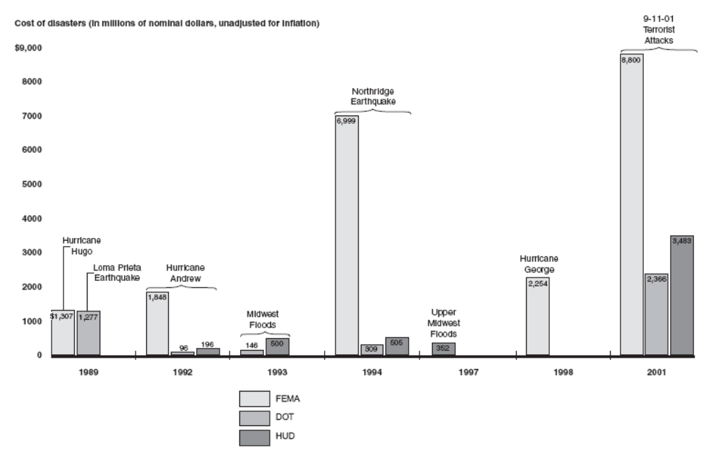
Source: GAO, 2003
Figure 5.3.2: Federal Compensation for Disaster Related Costs and Losses (as of 07/2003)
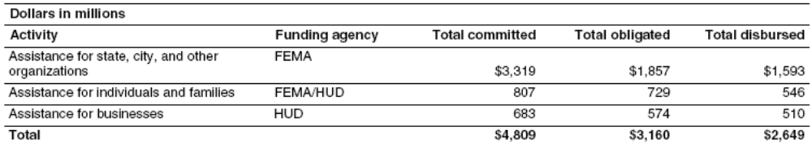
Source: GAO, 2003
Figure 5.3.3: Federal Infrastructure Restoration and Improvement (as of 07/2003)
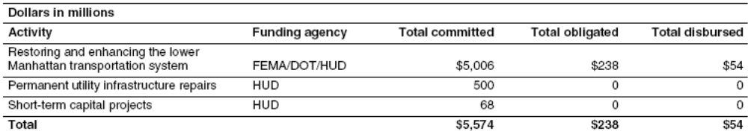
Source: GAO, 2003

Figure 5.3.4: Federal Economic Revitalization Efforts (as of 07/2003)
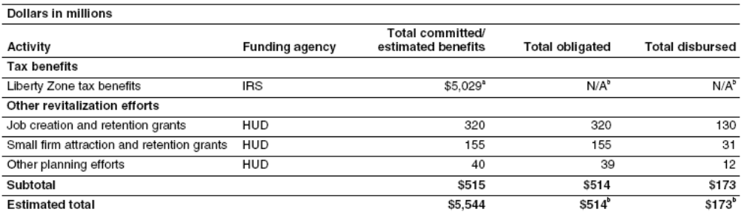
Source: GAO, 2003

Figure 5.3.5: Philanthropic Giving after the September 11th Attacks (as of 12/2004)
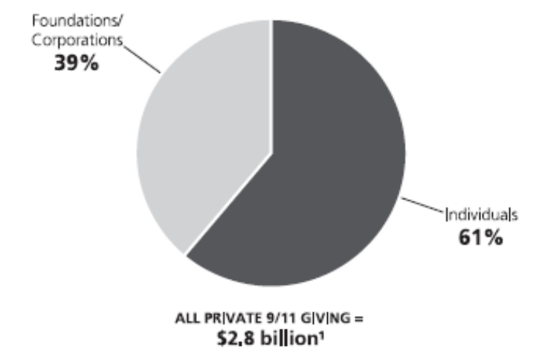
Source: The Foundation Center
Figure 5.3.6: September 11 Fund for 35 Charities
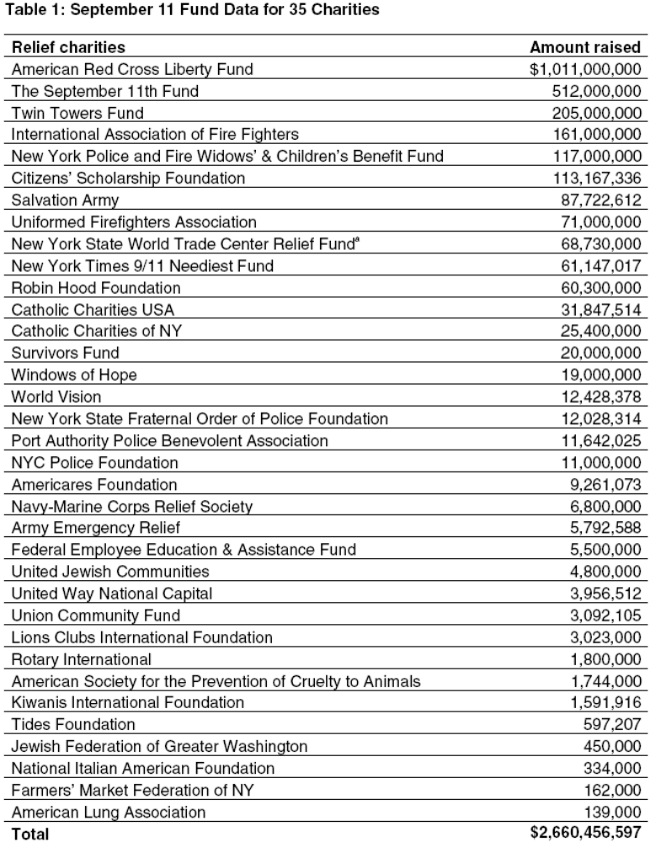
Source: GAO 2, 2002

Figure 5.3.7: American Red Cross Liberty Disaster Relief Fund Distribution Plan

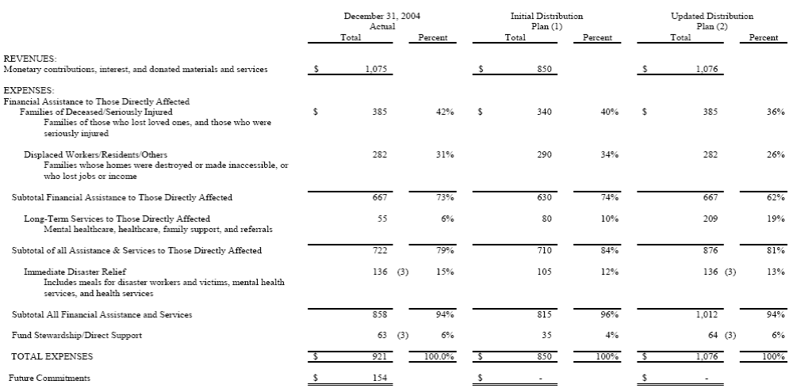
Source: American Red Cross, 2004.
Figure 5.3.8: Liberty Fund Expenditures
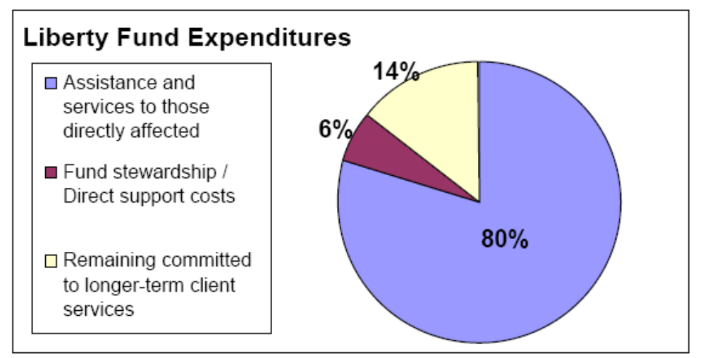
Source: American Red Cross, 2004.

Figure 5.3.9: September 11th Fund Expenditures
Grants by Category as of 12/1/04
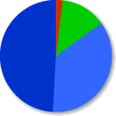 | Victims & Families - 85%
 |  | Cash Assistance - 49% ($261 million)
 |  | Other Services - 36% ($191 million)
 | Community Organizations - 13%
 |  | Grants/Loans ($66 million)
 | Rescue/Recovery - 2%
 |  | Cash Reimbursement ($10 million)
Total Spent to Date: $528 Million

Source: www.september11fund.org/aboutus.php

Figure 5.3.10: Expenditures of the September 11 Fund by Program
Cash and Services to Individuals & Families
Cash assistance . . . . . . . . . . . . . . . . . . . . . . . . $260,865,502 82
Employment assistance . . . . . . . . . . . . . . . . . . . $85,980,022 56
Helping people get help. . . . . . . . . . . . . . . . . . .$37,518,986 140
Health care. . . . . . . . . . . . . . . . . . . . . . . . . . . . .$36,072,109 31
Mental health & counseling . . . . . . . . . . . . . . .$19,454,571 53
Legal & financial advice. . . . . . . . . . . . . . . . . . .$11,801,405 37
Total . . . . . . . . . . . . . . . . . . . . . . . . . . . . . . . . $451,692,595 399

Helping Communities
Rebuilding. . . . . . . . . . . . . . . . . . . . . . . . . . . . . $54,064,968 75
Children & youth. . . . . . . . . . . . . . . . . . . . . . . ..$10,926,882 22
Anti-bias efforts. . . . . . . . . . . . . . . . . . . . . . . . . …$1,424,340 8
Total . . . . . . . . . . . . . . . . . . . . . . . . . . . . . . . . . $66,416,190 105

Rescue & Recovery
Rescue & recovery . . . . . . . . . . . . . . . . . . . . . . . . $9,810,711 55

Source: www.september11fund.org
Sidebar 5.3.1: Federal Disaster Assistance Committed to New York City Following the September 11th Terrorist Attacks

Initial Response to the Attacks - $2.55 Billion

- FEMA - $2.2 Billion
- DOT - $100 Million
- HUD - $250 Million

Numerous assistance programs are included in this grouping, such as search and rescue operations, debris removal operations, emergency transportation measures, and emergency utility service repair. FEMA provided the bulk of the federal funds for initial response efforts—$2.20 billion—While DOT and HUD provided the bulk of the remaining funds.

Highlights
- Search and Rescue - $22 Million (largest in U.S. History)
- Debris Removal - $1.7 Billion ($1 Billion of which will be used to establish an insurance company to cover the city and any contractors from potential claims that may arise)
- Emergency Transportation Measures - $299 Million
- Other Response Assistance (Health Monitoring, EPA Cleanup, Etc.) - $285 Million
- Emergency and Temporary Utility Service - $250 Million (to be disbursed)

Compensation for Losses - $4.81 Billion

- FEMA - $3.84 Billion
- HUD - $960 Million

This funding, provided by FEMA and HUD, compensated state and local organizations, individuals, and businesses for disaster-related costs, such as mortgage and rental assistance to individuals and grants to businesses to cover economic losses.

Highlights
- NYPD and NYFD benefits, wages, and other reimbursement - $643 Million
- Other public assistance to NYC, New York State, and other organizations - $847 Million
- Non-traditional Assistance - $1 Billion
- FEMA Hazard Mitigation Grant Program - $377 Million
- Mortgage and Rental Assistance Program - $200 Million
- Crisis Counseling - $99 Million
- Individual and Family Grant Program - $110 Million
- Other FEMA Assistance - $34 Million
- HUD Residential Grant Program - $106 Million
- HUD Business Assistance Program - $510 Million

Infrastructure Restoration - $5.57 Billion

- FEMA - $2.75 Billion
- DOT - $2.24 Billion
- HUD - $580 Million

The majority of this funding is a combination of FEMA and DOT funds to rebuild and enhance the lower Manhattan transportation system, including the construction or repair of roads, subways, ferries, and railroads. HUD is funding efforts to improve utility infrastructure.

Highlights
- Projects planned to restore and enhance the lower Manhattan transportation system - $4.55 Billion
- Permanent Utility Infrastructure Repairs and Improvements - $750 Million
- Short Term Capitol Projects - $68 Million

Economic Revitalization - $5.54 Billion

- HUD - $520 Million
- Liberty Zone - $5.03 Billion

Efforts to revitalize the economy in lower Manhattan include the Liberty Zone tax benefit plan (a Congressionally-created tax benefit plan in lower Manhattan) - an estimated benefit of $5.03 billion - and $515 million in HUD funding for business attraction and retention programs. Once the city, state, and HUD finalize plans for the remaining $1.16 billion, these funds will most likely be directed to infrastructure restoration and improvements and/or economic revitalization.
Highlights
- Liberty Zone Tax Benefits – Approximately $5 Billion, but expected to grow
- HUD Business Assistance Programs and Planning for Rebuilding and Permanent Memorial - $515 Million

Assistance by Agency to New York City:

- FEMA - $8.8 Billion – 42.9%
- Liberty Zone Tax Benefits - $5.03 Billion – 24.5%
- HUD - $3.48 Billion – 17%
- DOT - $2.37 Billion – 11.5%
- Other Agencies - $820 Million – 4%

Source: U.S. General Accounting Office Report GAO-03-1174T
Sidebar 5.3.2: Philanthropy in the United States.

$179.4 Billion Amount that individuals gave to churches and charities in 2003, up 0.2% from 2002 after inflation.
$831 Million Amount disbursed by the Liberty Fund, created by the Red Cross after 9/11, to victims and their families.
75% Percentage of total charitable contributions from individuals.
9 out of 10 Number of households that give to charity.
$1,620 Average annual amount that contributing households give to charities, which represents about 3% of their income.
$1,800 VS. $1,310 Amount contributed to charity by households that itemize deductions versus households that take the standard deduction.
Sources: American Red Cross, The Chronicle of Philanthropy, Giving USA, Independent Sector

Additional Sources of Information on the 1993 Midwest Floods

CDC Investigation of Diseases After the Flood - http://www.cdc.gov/mmwr/preview/mmwrhtml/00031822.htm
Effects of the Floods on Wetlands - http://water.usgs.gov/nwsum/WSP2425/flood.html
FEMA NFIP in the 1993 Floods - http://www.fema.gov/nfip/voices.shtm
NASA Flood Images - http://rsd.gsfc.nasa.gov/rsd/images/Flood_cp.html
NOAA Abatement and Control Document - www.nwrfc.noaa.gov/floods/papers/oh_2/great.htm
USGS “Stream Gauging and Storm Forecasting” - http://water.usgs.gov/wid/FS_209-95/mason-weiger.html
American Red Cross “Looking Back” - http://www.redcross.org/news/ds/floods/030806midwest93.html

Additional Sources of Information on the Northridge Earthquake
Berkeley Northridge Earthquake Resources - http://nisee.berkeley.edu/northridge/northridge.html
Images of the Quake - http://images.google.com/images?q=northridge+earthquake&hl=en&lr=&safe=off&sa=N&tab=ii&oi=imagest
FEMA for Kids: Northridge - http://www.fema.gov/kids/north5.htm
Southern California Earthquake Center Northridge Earthquake Page - http://www.data.scec.org/chrono_index/northreq.html
USGS Response to the Northridge Earthquake - http://pubs.usgs.gov/of/1996/ofr-96-0263/

Additional Sources of Information on September 11th Attacks
9/11 Commission Report - http://www.9-11commission.gov/
American Red Cross Recovery Grants - http://www.recoverygrants.org/
FEMA September 11th News Archives - http://www.fema.gov/news/newsrelease.fema?id=5152
September 11 Digital Archive - http://www.911digitalarchive.org/
September 11 Fund Homepage - http://www.september11fund.org/index.php

September 11 News Archive - http://www.september11news.com/

Glossary of Terms

Blind Thrust Fault - A thrust fault that does not rupture all the way up to the surface so there is no evidence of it on the ground. It is "buried" under the uppermost layers of rock in the crust.

Commodity Credit Corporation - A federally owned and operated corporation within the US Department of Agriculture created to stabilize, support and protect agricultural prices and farm income through loans, purchases, payments, and other operations.
Community Development Block Grant (CDBG) - A federal entitlement program administered by HUD's Community Planning and Development Office that seeks to improve communities by providing decent housing, a suitable living environment, and expanding economic opportunities - principally for persons with low and moderate incomes.
Cripple-Stud - a stud shorter than the full height of the wall it is anchoring.
Economic Development Administration (EDA) - an agency within the US Department of Commerce that provides grants to economically-distressed communities to generate new employment, help retain existing jobs and stimulate industrial and commercial growth.

Farm Service Agency - A division of the USDA that oversees the administration of all federal farm programs.
Ground acceleration - A measure of earthquake intensity. Unlike the Richter magnitude scale, it is not a measure of the total size of the earthquake, but rather how hard the earth shakes in a given location.
Ground Zero – the former World Trade Center site, so named because it was the direct target of two of the hijacked airlines on September 11th, and the site where a majority of the damages and fatalities sustained that day occurred.

HUD ‘HOME’ Investment Partnerships Program - Consists of a block-grant of federal housing funds that goes to States and local jurisdictions. This program is designed to expand the supply of safe, decent, sanitary, and affordable housing, with an emphasis on providing rental housing for very low-income and low-income Americans. Its second focus is to mobilize and strengthen state and local governments' abilities to design and implement strategies for achieving adequate supplies of affordable housing. Third, this program promotes the development of partnerships among state and local governments, the federal government, private industry, and non-profit organizations.
Job Training Partnership Act - enacted to establish programs to prepare youth and unskilled adults for entry into the labor force and to provide job training to economically disadvantaged and other individuals facing serious barriers to employment.
Levee - A man-made embankment that controls or confines water.

Psychotropic - Affects the mind, emotions, or behavior.
Slab-on-grade - A slab-on-grade home has no basement or basement floor slab; the slab in constructed directly on the ground

Acronyms
BIA – Bureau of Indian Affairs
CAC - Client Assistance Center (Liberty Fund)
CDBG – Community Development Block Grant
COBRA - Consolidated Omnibus Budget Reconciliation Act (Insurance)
DHS – Department of Homeland Security
DOI – Department of the Interior
DOT – Department of Agriculture
EDA – Economic Development Administration
EMS – Emergency Medical Services
EOC – Emergency Operations Center
EPA – Environmental Protection Agency
FAA – Federal Aviation Administration
FBI – Federal Bureau of Investigation
FEMA – Federal Emergency Management Agency
FRP – Federal Response Plan
GAO – General Accounting Office
GSA – General Services Administration
HAZMAT – Hazardous Materials
HHS – Department of Health and Human Services
HISP - Health Insurance Subsidy Program (Liberty Fund)
HMGP – Hazard Mitigation Grant Program
HUD – Department of Housing and Urban Development
IAFF – International Association of Fire Fighters
IFAP – International Family Assistance Program (Red Cross)
IFG – FEMA Individual and Family Grant Program
MHR – FEMA Minimum Home Repair Grant Program
NCCJ - National Conference for Community and Justice
NOAA – National Oceanographic and Atmospheric Administration
NPS – National Park Service
NYC – New York City
OPM – Office of Personnel Management
PSA – Public Service Announcement
PTSD - Post Traumatic Stress Disorder
RFA – Request for Applications
RFP – Request for Proposals
SBA – Small Business Administration
SEMA – (Missouri) State Emergency Management Agency
SRP – September 11th Recovery Program (of the Liberty Fund)
TLC – Trial Lawyers Care
US&R – Urban Search and Rescue
USACE – U.S. Army Corps of Engineers
USDA – United States Department of Agriculture
USG – United Services Group
USGS – United States Geological Survey
WTC – World Trade Center
Discussion Questions

General

- Compare the various Federal recovery programs. Are they effective? Should they be changed? If so, how would you change them, and how would the changes be funded?

- Is it realistic to expect State and local organizations to be able to contribute to the cost of recovery, or should the Federal Government assume 100% of the cost. Explain your answer.

- Why is coordination of recovery efforts so important? What kinds of things could go wrong in the absence of strong coordination mechanisms?

- What are the benefits to having a ‘customer service’ oriented approach to recovery from the standpoint of the Federal Government? What are the benefits of this approach from the standpoint of the victims?

- How is it beneficial to join mitigation and recovery in the post-disaster phase? Give some examples of situations where this has been effective, or examples that you propose for future disasters that could be effective in your opinion. Explain your answers.

1993 Midwest Floods

- Are levees an effective flood control measure? Why or why not?

- Should the Federal government be responsible for damages to structures that received funds in previous floods? Why or why not?

- If the Federal Government reimburses farmers for the losses of their crops in floods, should owners of businesses in other sectors expect the same recovery measures for their losses? Why or why not?

- Explain how the Federal Buyout programs help to alleviate long term flood losses. Are the benefits of these floods realized if a future flood does not affect the old property? Why or why not?

- What are some of the greatest challenges faced by communities in the recovery period of a flood disaster?

Northridge Earthquake

- Did the Federal government do enough to help Californian’s recover from the Northridge Earthquake? Why or why not?
- In what ways does earthquake recovery differ from the recovery from other disasters? Give examples from the cases provided or from personal experience or knowledge.

- Is it appropriate to give loans instead of grants to victims of earthquakes? Why or why not?

- How long is an appropriate time to expect victims of earthquakes to expect to wait before government funding is provided for the rebuilding of their home?

- How could mitigation measures be applied to federal funding for recovery after a disaster like the Northridge earthquake. Could the same be done after other types of natural or technological disasters? If not, what could be done?

September 11th Attacks

- Why was the concept of ‘victim’ expanded for the September 11th disaster? How was it different than other disasters? Is it possible to place a definitive limit on who is defined as a victim, and if so, what would that limit be?

- How was the recovery from the September 11th disaster different from most other natural and technological disasters? How did this change the way recovery was conducted?

- The primary difference between the two profiled funds was the way in which they conducted business; under the Liberty Fund, the American Red Cross performed most of the tasks internally, and under the September 11th Fund, the money was granted to third parties who performed the recovery actions themselves. What are the advantages and disadvantages to each?

- How will we know when the recovery from the September 11th attacks is complete?

- Should we expect that philanthropic participation in future disasters will be proportionally the same as after the September 11th attacks, or will it be less? More? Explain your answer.

Suggested Out Of Class Exercises

- Research on FEMA’s website any active disaster declarations. Find out what recovery measures are being provided to victims of the disaster.

- Contact your local office of emergency management, and research what kinds of recovery plans are in place in the event of a disaster. Report your findings to the class.

- Compare the premium costs of insuring a $200,000 home in your area from either earthquake, hurricane, or flood damage for a period of 20 years, and compare it to the costs associated with damages from the same disaster to the home, its contents, and any temporary relocation costs. Is such coverage worth the expense?

- Contact a local Red Cross chapter, and discuss with them the process by which you can become certified in one or more recovery skills (such as mental health counseling). Take the course, and volunteer your services with the chapter.

- If your community has experienced a large-scale disaster that required Federal assistance, interview a victim about the recovery process. Do they have any major complaints or praise? For what? Is there anything they would have liked to have had access to but which did not exist at the time of recovery? Was their life ever returned to normal? If so, how much of a part of the recovery did Federal government aid contribute?

