SCID Design

Consider three possible design approaches

- Use a scraper at minimum gap to fully mask 4K bore.

- Put 4K bore at minimum gap compatible with synchrotron power load associated with normal beam conditions.

- Put 20 - 50K bore at minimum gap compatible with synchrotron power load associated with normal beam conditions.

Difference between cold bore aperture and magnetic gap:
  - dg ~ 1 mm @ 4K.
  - dg ~ 3 mm @ 20 - 50K.

Synchrotron radiation sources:
Magnet | Distance to Straight Center [m]
Dipole | 5.13
Corrector 1 | 3.94
Corrector 2 | 2.84

Simplified Source Model:
- Source at center of magnet
- Hard edge field
  - For E_{e} = 1.9 GeV, I = 0.4 A:
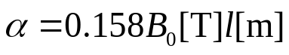
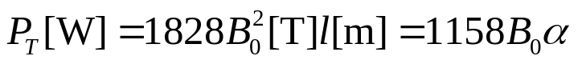
Fraction absorbed at aperture:
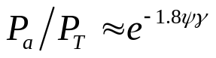
Case 1

Place scraper/mask at center of straight with 5mm gap. SCID is downstream. L = 2m. Base layout on masking corrector 2, the closest source.
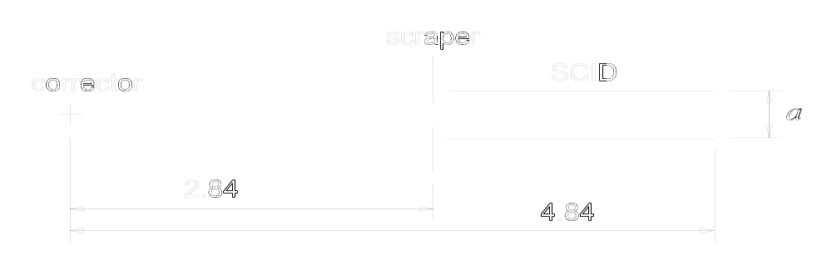
a = 8.5 mm
g = 9.5 mm
● = 23mm, B₀ = 1.5 T, E₁ = 240 eV

Note that this is the basis for the previous solution considered. However we were using 8mm as the minimum allowed gap.

Case 2

Place 4K bore at minimum gap. Base layout on dipole, farthest source. Place SCID at center of straight. Still use 5mm scraper to mask as much as possible.
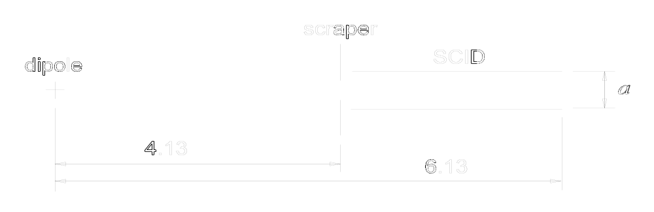
Upstream photon masks allow 0.024 rad of dipole radiation fan to enter the straight.
Total power, P_{T} = 37W.
Power absorbed by scraper, P_{s} = 0.64W.
Power absorbed at bore is a function of a.
a [mm] | P_{a} [W]
5 | 1.8
6 | 0.8
7 | 0.2

a = 7mm
g = 8mm
a)  = 20mm, B₀ = 1.5T, E₁ = 350 eV
Period doubling:  = 40mm, B₀ = 1.5T, E₁ = 50 eV
(B_{p} ~ 1.7T)
Unrestricted B_{p} ~ 2.9T, B₀ ~ 2.5T, E₁ ~ 20 eV

b)  = 22mm, B₀ = 1.6T, E₁ = 240 eV

c)  = 23mm, B₀ = 1.5T, E₁ = 240 eV - same as Case 1
Period Doubling:

Normal configuration:
Doubled configuration:

Wind as two coils. Reverse polarity of one coil to double period.
Case 3

Place 20 - 50K bore at a = 5mm. Same layout as Case 2. Achieve same result as Case 1, Case 2c.
a = 5.0 mm
g = 8.0 - 9.5 mm
● = 23mm, B₀ = 1.5 T, E₁ = 240 eV

Cryocooler for “warmer” bore has much higher capacity, ~20 – 50W.
  - 1.8W absorbed for nominal beam conditions is no problem.
  - Consider extreme mis-steer during accelerator physics. I = 0.04A. If all power entering straight (dipole and correctors) is deposited on bore, P_{a} < 5W. Still OK.
  - For extreme mis-steer at full current, P_{T} ~ 50W. This would like cause a quench. This is extremely unlikely, may not be possible.

