MCNPX, Version 26C

by

John S. Hendricks
Gregg W. McKinney
Joe W. Durkee
Joshua P. Finch
Michael L. Fensin
Michael R. James
Russell C. Johns
Denise B. Pelowitz
Laurie S. Waters
Los Alamos National Laboratory

Franz X. Gallmeier
Oak Ridge National Laboratory

December 7, 2006

CONTENTS

1.0. Introduction 1
1.1. Summary of New MCNPX Features 1
1.2. Availability 2
1.3. Documentation 2
1.4. Guarantee 3
2.0. Description of new MCNPX Features 4
2.1. Depletion/Burnup 4
2.1.1. Depletion Process 5
2.1.2. Collision Density Generation 5
2.1.3. The Predictor Corrector Methodology 6
2.1.4. BURN Card Setup 7
2.1.5. Burn Time, Total System Power, and Power Fraction 8
2.1.6. Flux Normalization Parameters 9
2.1.7. Burn Materials 10
2.1.8. Automatic Fission Yield Selection Process 12
2.1.9. Metric Tonnes of Uranium (MTU) 13
2.1.10. Isotope Reactivity Options 13
2.1.11. Models Option 13
2.1.12. Fission Product Tracking/Output Frequency 14
2.1.13. The Isotope Generator Algorithm 15
2.1.14. Proper Tracking of Entire Decay Chains 16
2.1.15. Example INPUT 16
2.2. CEM03 Upgrade 17
2.2.1. Intra Nuclear Cascade (INC) 18
2.2.2. Preequilibrium (PREC) 18
2.2.3. Evaporation and/or Fission 19
2.2.4. Coalescence 19
2.2.5. Fermi Breakup 19
2.2.6. Additional Notes 19
2.3. Long File Names 20
2.4. Terminate Tallies at Desired Precision 20
2.5. Spherical Mesh Weight Windows 21
2.5.1. User Interface 21
2.5.2. Plotting 22
2.6. Charged Ions from Neutron Capture in Table Range 25
2.6.1. User Interface 26
2.6.2. Diagnostics 26
2.6.3. Important Considerations 27
2.7. Delayed-Gamma Emission. 27
2.7.1. The Products of Fission: Residual Nuclides and Radiation 28
2.7.2. Decay Chains and Emission Sampling 29
2.7.3. Simple Multi-Particle Reactions 30
2.7.4. User Interface 31
2.7.5. Sampling and Execution 32
2.8. Criticality Source Convergence Acceleration 33
2.8.1 Example 33
2.8.2 User Interface 35
3.0. MCNPX 26C Feature EXTENSIONS and Enhancements 36
3.1. Proton Step-Size Control 36
3.2. New Photon Emission Data 37
3.3. New S(α,β) Scattering Law 37
3.4. Differential Data Tallies Extended to Table Physics 37
3.5. Separate Printout of Induced Fission Multiplicity 38
3.6. Weight Window MESH Angles in Radians and Degrees 38
3.8. Interrupts in Electron Tracking 38
3.9. Extended ZAID Identifiers 38
3.10. LINLIN Contour Plot Default 39
3.11. Weight Window Contour Plot Improvement 39
3.12. Allow Deleted Segmenting Surfaces 39
3.13. Improved Windows Installation 39
3.14. Spherical GRIDCONV 40
4.0. MCNPX 26C Corrections 41
4.1. Significant Problem Corrections 41
4.1.1. Auger Electrons below Energy Cutoff 41
4.1.2. Detectors in Lattice Geometries 42
4.1.3. KCODE/PRDMP 5th Entry 42
4.1.5. CEM03 Corrections 42
4.2. Minor Problem Corrections 42
4.2.1. Cylindrical Weight Window Mesh 42
4.2.2. I8 Mesh Tally Plots 42
4.2.3. Continue Cards for Input with FATAL Errors 42
4.2.4. Sometimes Can Plot Only First Mesh Tally 42
4.2.5. Incorrect KCODE/Message Passing Interface (MPI) Error Message 43
4.2.6. Incorrect LCS Error Message 43
4.2.7. Mesh Tally Writing to Backup runtpe 43
4.2.8. Pulse-Height-Tally Variance Reduction Techniques with MPI 43
4.2.9. PTRAC and Event Log Omission 43
4.2.10. FM Tally Multiplier in Model Physics Regime 43
4.2.11. Make Clean Enabled for PC Build 43
4.2.12. Zero Electron Mesh Tallies 43
4.2.13. Universe Map Crash 44
4.2.14. Insufficient Storage for Tallies 44
4.2.15. Lost Particles with Coincident REC Surfaces 44
4.2.16. GRIDCONV Compiler Bug 44
4.2.17. Geometry Plot Basis Vectors 44
4.2.18. WWN Label Error. 44
4.2.19. Crash for Some READ Card Placements 45
4.2.20. Internal Corrections 45
5.0. Future work 45

MCNPX, VERSION 26C

ABSTRACT

MCNPX is a Fortran90 Monte Carlo radiation transport computer code that transports nearly all particles at nearly all energies for nearly all applications. The new capabilities of the latest version, MCNPX 26C, are described.

Introduction
MCNPX (MCNP eXtended) is a Fortran90 (F90) Monte Carlo radiation transport computer code that transports nearly all particles at nearly all energies. It is a superset of MCNP4C3 and has many capabilities beyond MCNP4C3. MCNPX is a production computer code that models the interaction of radiation with matter, and its quality is guaranteed; it can be used with confidence. The MCNPX guarantee is described in Section 1.1.4.

1.1. Summary of New MCNPX Features
The new capabilities and enhancements of MCNPX 26C beyond MCNPX 2.5.0 and MCNPX26B are listed as follows (where applicable, the initials of the principal developers are shown in parentheses). Note that the first two capabilities are developmental. Although they are not fully guaranteed and must be used cautiously, they are considered of such significance that they are included. Note also that total nu (not prompt nu) is the default for fission neutrons. The new MCNPX26C capabilities are:
- delayed-gamma emission (JWD),
- criticality source convergence acceleration (JPF),
- spherical mesh weight windows (JSH),
- charged ions from neutron capture in table range (MRJ),
- depletion/burnup enhancements (MLF),
- corrections/enhancements/extensions
  - weight window MESH angles in radians and degrees (JSH),
  - weight window contour plot improvement (GWM),
  - improved windows installation (MRJ/GWM),
  - spherical GRIDCONV (MRJ), and
  - additional enhancements and corrections.

MCNPX 26C also includes the following MCNPX 26A and 26B capabilities beyond MCNPX_2.5.0:

- depletion/burnup,
- CEM03 physics,
- long file names (JSH),
- tallies terminated at desired precision: STOP card (JSH),
- corrections/enhancements/extensions
  - proton step size control: HSTEP on M card (GWM),
  - new photon emission data: PHTLIB (REP/GWM),
  - new S(α,β) scattering law (REM/GWM/JSH),
  - differential data tallies extended to table physics (GWM),
  - separate printout of induced fission multiplicity (JSH),
  - interrupts in electron tracking (GWM),
  - extend ZAID identifiers (GWM),
  - LINLIN contour plot defaults (GWM),
  - allow deleted segmenting surfaces (FXG),
  - additional enhancements and corrections.

1.2. Availability
The latest general-release version of MCNPX is MCNPX 2.5.0, which is available from the Radiation Safety Information and Computational Center (RSICC) and the Office of Economic Cooperation and Development/Nuclear Energy Agency (OECD/NEA) in Paris, France.

For approved users, beta test program versions, including MCNPX26C, may be downloaded from the MCNPX website. Approximately 1600 MCNPX beta test users are an essential part of the MCNPX software quality assurance program. To become a new beta test user usually requires being an MCNPX sponsor, collaborator, or participant in an MCNPX workshop training course. For more information, contact mcnpx@lanl.gov.

MCNPX is US export controlled. Generally, MCNPX is easy to obtain for legitimate purposes, but restrictions protect the code, data, and documentation once it is acquired.

1.3. Documentation
Restricted Documentation:

Complete MCNPX documentation is available in the “MCNPX User’s Manual,” which comes with MCNPX from RSICC and is available to MCNPX beta testers from the Worldwide Web (WWW).

Unrestricted Documentation:

Documentation of MCNPX features in MCNPX 2.5.0—that is, all MCNPX features beyond MCNPX2.3.0 and MCNP4C—is provided in “MCNPX Extensions, Version 2.5.0.”

MCNPX capabilities developed since the RSICC’s international release version, MCNPX 2.5.0 (namely, the capabilities of MCNPX 26a, 26b, and 26c), are documented herein.

All of the extended MCNPX capabilities are summarized in the one-page MCNPX features list.

1.4. Guarantee
MCNPX is guaranteed. We are so confident of the quality of MCNPX that we will pay $20 to the first person finding anything that does not meet or exceed the capabilities of MCNPX 2.3.0 and MCNP4C3. European users will be awarded €20. We also will pay a brand new $2 bill for any error in MCNPX that has been inherited from its constituent codes. A list of all winners since June 2001 can be found on the MCNPX WWW site.

Description of new MCNPX Features
Total nu (not prompt nu) is now the default for fission neutrons. To track previous problems with the prompt nu default, turn off total nu with the TOTNU NO card and command.

Note that the new delayed gamma emission and criticality source convergence acceleration capabilities are developmental. Although they are not fully guaranteed and must be used cautiously, they are considered of such significance that they are included.

The principal new capabilities of MCNPX beyond MCNPX 2.5.0 are

- Depletion/burnup,
- CEM03 physics,
- Long file names,
- Tallies terminated at desired precision: STOP card,
- Spherical mesh weight windows, and
- Charged ions from neutron capture in table range,
- Delayed-gamma emission,
- Criticality source convergence acceleration..

2.1. Depletion/Burnup
The depletion/burnup capability is based on CINDER 90, which was written by William B. Wilson, and MonteBurns, which was written by Holly R. Trellue. The initial patch to MCNPX was developed by Joe W. Durkee and Gregg W. McKinney. Most of the corrections and enhancements to MCNPX 26A, 26B and 26C were developed by Michael L. Fensin and integrated by John S. Hendricks.,, Currently, the depletion/burnup/transmutation capability is limited to criticality (KCODE) problems.

The new MCNPX 26C capabilities are
- Variable dimensioning
- Proper execution with cross section models
- Proper tracking of short half-life isotopes
- Continue Runs

Previous versions of MCNPX depletion confined the user to only 100 burn materials per depletion calculation. Now users can burn as many materials as user computer memory permits. Previous version of MCNPX depletion also did not properly track atom fractions for isotopes implementing model derived cross sections. MCNPX 26C now adequately tracks the buildup of isotopes implementing a cross section model.

A CINDER90 bug caused the calculation to kick out short-half life isomers, leading to an incorrect buildup of nuclides resulting from the decay of short lived isomers. MCNPX 26C tracks all isomers regardless of the length of half-life, thus properly accounting for nuclide buildup from the decay of short lived isomers.

MCNPX 26C now also works with continue runs.

2.1.1. Depletion Process
MCNPX depletion is a linked process involving steady-state flux calculations in MCNPX and nuclide depletion calculations in CINDER90. MCNPX runs a steady-state calculation to determine the system eigenvalue, 63-group fluxes, fission rates, absorption rates, fission multiplicity ν, and Q values. CINDER90 then takes those MCNPX-generated values and carries out the depletion calculation to generate new number densities at the following time step. MCNPX then takes those new number densities and generates another set of fluxes and reaction rates; the process repeats itself until after the final time step.

MCNPX calculates parameters only for those materials listed on the MCNPX material cards, produced by the isotope generator algorithm, or selected by the specified fission product tier. However, CINDER90 tracks the time-dependent reactions of 3456 isotopes using intrinsic cross-section and decay data inherent in the CINDER90 code when the information is not specified from MCNPX. Although MCNPX tracks only certain specified isotopes that contain transport information, CINDER90 continues to track the data of all 3456 isotopes using nuclide densities from the prior time step to do the burnup calculation for the following time step. Therefore, even though an isotope in a certain decay chain may not be listed in an MCNPX calculation, the full decay process still is tracked in the CINDER90 code exactly; therefore, the isotope concentrations reported are still true isotope concentrations.

For MCNPX to burn materials properly, the user must point to the CINDER.dat library file. This file contains decay, fission yield, and 63-group cross-section data not calculated by MCNPX. The CINDER.dat library file will be accessed properly by the code if the file is placed in the working directory in which the user is executing MCNPX or in a directory in which the command window PATH is set to the directory where cinder.dat resides. If the code cannot find the CINDER.dat, a fatal-error message will be printed and the case will cease calculation.

2.1.2. Collision Density Generation
MCNPX calculates continuous energy reaction rates for (n,gamma), (n,f), (n,2n), (n,3n), (n,alpha) and (n,proton). CINDER90 must use the MCNPX-calculated 63-group fluxes to determine the rest of the interaction rates that accumulate in the transmutation process.

For example, MCNPX currently does not calculate the continuous (n, beta) reaction rates. CINDER90 must take the 63-group flux calculated by MCNPX and multiply its inherent 63-group (n, beta) cross section to determine the amount of (n,beta) reactions in the system. The 63-group cross sections in CINDER90 were collapsed over a generic spectrum that may or may not be representative of the system to be analyzed and thus may lead to large discrepancies in the isotope inventory of daughter products from these reactions.

The energy integrated total collision rates calculated in MCNPX for use in the CINDER90 code for depletion are printed at the end of each kcode cycle. Reaction rates are printed only for those isotopes also used in the transport calculation.

2.1.3. The Predictor Corrector Methodology
The depletion equations use fluxes, nuclide number densities, and cross sections to determine the time-dependent nuclide inventory. The simplified one-group depletion equation is

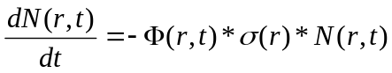 .

The corresponding solution for nuclide density is

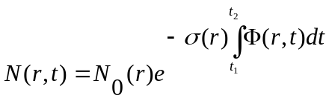 .

Therefore, the change in nuclide concentration is dependent on the time-integrated flux. Unfortunately, the time-dependent flux (integrated to get the time-integrated flux) also is dependent on the nuclide density, which makes the above equation nonlinear. To make the above equation linear, an assumption must be made about the time-dependent flux. MCNPX currently assumes that the flux is constant throughout the burn step:

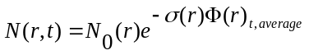 .

This approximation is true only if the average flux used in the calculation is the “true average” flux over the burn step.

MCNPX makes an approximation of the average flux behavior by using a predictor corrector technique. This technique involves the following multistep process:

- A burnup calculation is completed in CINDER90 to the half time step [t(i)→t(i+1/2)] (Predictor Step).

- Fluxes and collision densities are recalculated in a steady-state MCNPX calculation at the half-time step.

- The recalculated fluxes and collision densities then are used to burn over the full time step [t(i)→t(i+1)] (Corrector Step).

The fluxes and collision densities recalculated at the half time step are assumed to be the average fluxes and collision densities encountered during the entire time step. This approximation is true only if the flux shape change between the two time steps varies linearly; in most cases, this technique is usually an acceptable approximation. Implementing this technique allows the user to burn a system using fewer burn steps than if no approximation were made on the average flux behavior.

However, even with this approximation, burning with large time steps that encounter large flux-shape changes during the time step will lead to inaccurate calculations. Therefore, the user must use time steps that are small enough to capture the flux-shape change accurately over time.

2.1.4. BURN Card Setup
The following example explains the setup for a BURN card.

BURN TIME=T1,T2,T3,...
PFRAC=F1,F2,F3,...
POWER=P
MAT=M1,M2,M3,...
OMIT=J1,N1,I11,I12,...,J2,N2,I21,I22,...
AFMIN=A
BOPT=B1,B2,B3 ,

where

Ti = duration of burn step i (days). Default is one time step of one day.

Fi = power fraction of each time step (0–1). The default for this parameter is to assume Fi = 1.0 for each time step if a PFRAC flag is not specified at all.

P = power level (MW). Default is 1.0 MW.

Mi = list of material numbers to include in the burn. The default for this parameter is to burn all materials.

Ji = ith material for which to omit nuclides Ii1, Ii2, etc. Currently, there is no default for this parameter.

Ni = number of omitted nuclides listed for the ith material. Currently, there is no default for this parameter.

Ii1, Ii2, ... = 1st, 2nd, etc. omitted nuclides for the ith material. Currently, there is no default for this parameter.

A = atom fraction minimum below which the atom fraction is set to zero. Default is 1.0e-10.

B1 = Q value multiplier. Default is 1.0.

B2 = burn table output frequency, ordering, and content flag.
Input Value Output Inventory Ordering
1 (default) High to low, based on mass
2 High to low, based on activity
3 High to low, based on specific activity
4 Increasing zaid

Positive input values cause output to be printed only at the end of the entire job. Negative input values cause output to be printed at the end of each burn step. Three tiers of fission-product content are available. To specify the content, add zero (default), 10, or 20 to the magnitude of the B2 Input Value.

TIER Fission-product content.
1 (default) Zr-93,Mo-95,Tc-99m,Ru-101,Xe-131,Xe-134,
Cs-133,Cs-137,Ba-138,Pr-141,Nd-143,Nd-145.
2 All incident neutron cross sections contained in the Fp array included in
the current (v250) XSDIR.
3 All isotopes contained in the Fp array.

B3 = Models option
-1 Fatal error if models are used in the problem.
0 Zeros out the atom fraction of any data using a model. It is preferable to determine which isotopes are needed to be zeroed out and place them on the omit card for the burned material; however, this option exists as a simpler alternative to the omit card.
1 Runs with models.

A blank BURN card will run a case for 1 day, at 1 MW, with a corresponding PFRAC = 1.0, burning all materials, using the TIER 1 fission products, and listing the nuclide output in high-to-low mass (as long as the isotope generator algorithm does not generate a nuclide in which there exists no transport cross sections in the XSDIR, which ultimately would lead to a fatal error).

2.1.5. Burn Time, Total System Power, and Power Fraction
The TIME flag corresponds to the incremental time duration for each depletion step. Each “Ti” listed in this flag corresponds to a time duration (days) in which the system is burned.

For example:

TIME = 10, 100, 15 .

The system is first burned for 10 days, followed by a 100-day burn, followed by a 15-day burn, for a total burn of 125 days.

The POWER flag is the total system power level (in megawatts). Because this value corresponds to the total recoverable energy from the system, the value entered on this flag should correspond to the total recoverable thermal system power.

For example:

POWER = 100 .

In this case, the total recoverable thermal system power is assumed to be 100 MW.

The PFRAC flag corresponds to the fractional value of total system power (POWER) in which to burn the system for the equivalent time duration. This flag was implemented to account for power level changes occurring during system life as a result of the startup process or the need to down-power the system for system maintenance. For each Ti value listed on the TIME flag, a corresponding Fi value listed on the PFRAC flag must exist.

For example:

TIME = 11, 33, 22 ,
PFRAC = 1.0, 0.9, 1.2 , and
POWER = 10 .

For the first 11 days of system life, the system is burned at 1.0*10 MWth of the total system power at 10 MWth. For the next 33 days of system life, the system is burned at 0.9*10 MWth of the total system power at 9 MWth. For the final 22 days of system life, the system is burned at 1.2*10 MWth of total system power at 12 MWth.

2.1.6. Flux Normalization Parameters
MCNPX generates collision densities for the CINDER90 depletion calculation. These generated collision densities are normalized per source neutron. CINDER90 requires a total flux to deplete the system appropriately. The following flux multiplier is calculated to transform the MCNPX normalized flux into a total flux for the CINDER90 depletion calculation:

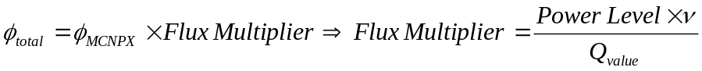 .

MCNPX calculates the system-averaged ν and Q value. The power level used for the flux multiplier calculation is the power entered on the POWER flag. The Q value used in the calculation is an estimate of the recoverable energy per fission event. Currently, MCNPX takes the prompt recoverable energy per fission (Q-prompt) and multiplies that value by the constant normalization factor 1.111. The constant normalization factor 1.111 is an estimate of the delayed fission energy contribution and capture gamma energy contribution. The capture gamma energy contribution is highly dependent upon system geometry and therefore the normalization constant may or may not estimate the actual Q value properly. Underestimating the Q value leads to an overestimation of the system fluxes and thus, an overestimation of the system collision densities. Because the equation for nuclide depletion is highly dependent on the collision densities:

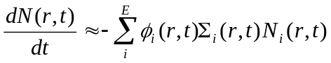 .

Increasing the collision density leads to an overestimation of the material burnup. In the current depletion capability, three methods are used to correct this overestimation:

1. adjusting the Q value multiplier (B1 value on the BOPT flag; default = 1.0),
2. modifying the total thermal system recoverable energy by adjusting the power level entered on the POWER flag, and
3. altering the system power on the PFRAC flag.

2.1.7. Burn Materials
The materials to be burned must be listed on the MAT flag. Each “Mi” entry corresponds to the material number listed in Data Cards section of the input deck.

For example:
…
BURN TIME=100,70
MAT=1,3,4
POWER=1.0
PFRAC=1.0,1.0
BOPT=1.0 -12 1.0
C Material Cards
m1
8016.60c 4.5854e-2
92235.60c 1.4456e-4
92238.60c 1.9939e-2
94238.60c 1.1467e-4
94239.60c 1.0285e-3
94240.60c 7.9657e-4
94241.60c 3.3997e-4
94242.60c 5.6388e-4
m2 2004 -1.0
m3 40000.60c -1.0
m4 1001.60c 4.7716e-2
8016.60c 2.3858e-2
5010.60c 3.6346e-6
5011.60c 1.6226e-5
mt4 lwtr.01t
…

In this example, materials m1, m3, and m4 will be burned.

Burnup is calculated for the entire system of materials listed on the MAT option, as well as for each individual material listed on the MAT option containing a fissile actinide. The total system burnup, as well as other important time-dependent parameters, is listed on the burn table.

For example:

neutronics and burnup data

step duration time power keff flux ave. nu ave. q burnup
(days) (days) (MW) (GWd/MTU)
0 0.000E+00 0.000E+00 1.000E+00 1.15793 4.428E+15 2.878 209.106 0.000E+00
1 1.000E+02 1.000E+02 1.000E+00 1.00865 5.157E+15 2.900 209.094 5.892E+01
2 7.000E+01 1.700E+02 1.000E+00 0.98152 5.465E+15 2.920 208.965 1.002E+02…

For each individual material, another burn table is created that lists the fraction of fission power created by that specific material, as well as the individual burnup of that material. The power fraction is calculated for an individual material using the following methodology:

- Determine if the material contains an actinide.
- If yes, sum up the continuous energy fission energy created to obtain an individual burn material fission energy.
- Sum up all of the total material fission energy contributions for each material that contains an actinide.
- Calculate the power fraction as

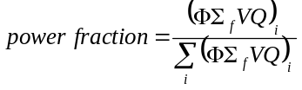 .

The burnup for each individual material then is calculated using

.

[MTU = MTHM (metric tonnes of heavy metal) and is explained further in Section 2.1.8.]

For example (corresponding to the BURN and Material Cards listed above):
…
Individual Material Burnup

Material #: 1

step duration time power fraction burnup
(days) (days) (GWd/MTU)
0 0.000E+00 0.000E+00 1.000E+00 0.000E+00
1 1.000E+02 1.000E+02 1.000E+00 5.892E+01
2 7.000E+01 1.700E+02 1.000E+00 1.002E+02

Material #: 3

step duration time power fraction burnup
(days) (days) (GWd/MTU)
0 0.000E+00 0.000E+00 0.000E+00 0.000E+00
1 1.000E+02 1.000E+02 0.000E+00 0.000E+00
2 7.000E+01 1.700E+02 0.000E+00 0.000E+00

Material #: 4

step duration time power fraction burnup
(days) (days) (GWd/MTU)
0 0.000E+00 0.000E+00 0.000E+00 0.000E+00
1 1.000E+02 1.000E+02 0.000E+00 0.000E+00
2 7.000E+01 1.700E+02 0.000E+00 0.000E+00
…

In this example, materials 1, 3, and 4 were burned, and only material 1 contained fissionable actinides. The stated power fraction for material 1 is 1.000E+00 because material 1 supplied all of the fission power to the system.

2.1.8. Automatic Fission Yield Selection Process
The CINDER90 code offers a thermal, fast, high-energy fission yield for each fissile isotope contained in the CINDER.dat library file. The proper fission yield to be used for a specified problem is dependent on the impinging neutron energy at the interaction site. Because CINDER90 is a deterministic code that uses one-group constants and does not account for multi-energy behavior, knowledge of the neutron spectrum must be imported from the steady-state continuous energy calculation.

MCNPX determines which fission yield to use for a specified problem by calculating the integral fission rate for the defined energy boundaries (thermal, fast, and high energy), determining which energy range contains the majority of fissions, and then selecting the appropriate fission yield corresponding to the energy range containing the majority of fissions at each time step.

This calculation is completed separately for each burn material. Therefore, if a specific calculation warrants a thermal fission yield for one burn material and a fast fission yield for another burn material, MCNPX will be able to implement a thermal fission yield for the burn material experiencing a thermal spectrum and a fast fission yield for the burn material experiencing a fast spectrum. The process is automatic; thus, users do not have to worry about selecting an appropriate fission yield that best represents their system because MCNPX will determine the correct fission yield automatically.

2.1.9. Metric Tonnes of Uranium (MTU)
MCNPX lists burnup in units of GWD/MTU. The MTU term calculated in MCNPX is actually the sum of the masses of isotopes containing >90 protons. Therefore, thorium and plutonium contribute to the MTU calculation. It is possible for elements containing >82 protons to fission; however, the probability of fission is very low. If a fuel (82 < Z < 90) is analyzed, the burnup must be adjusted to reflect appropriately the nature of how the burnup calculation is completed.

2.1.10. Isotope Reactivity Options
The OMIT flag allows the user to run a transport calculation without including the transport data from a specified isotope. This flag presents the user with the ability to investigate the reactivity effects that a certain isotope has on the analyzed system.

The OMIT flag has the following format: OMIT=J1,N1,I11,I12,...,J2,N2,I21,I22,...

Ji = ith material for which to omit nuclides Ii1, Ii2, etc.
If J1 = -1, then the omitted nuclide list is applied to all materials and J2, J3, etc., are not allowed. No default.

Ni = number of omitted nuclides listed for the ith material. No default.

Ii1, Ii2, … = 1st, 2nd, etc., omitted nuclide for the ith material. No default.

The AFMIN flag allows the user to determine below which mass fraction an isotope will be dropped from the transport calculation. The A value of AFMIN flag signifies the minimum atom fraction for all isotopes in which isotopes below that atom fraction will have their atom fraction set to zero. The default is 1.0E-10.

2.1.11. Models Option
The B3 section of the BOPT flag invokes the models option. Cross-section models are a heritage of the high-energy physics capabilities of MCNPX. The models are benchmarked for a variety of problems for neutron energies >150 MeV. The B3 section of the BOPT flag allows the user to disallow the use of models if the cross-section energy of interest is below the benchmarked value.

For the B3 section of the BOPT flag, the following options exist:

B3 = -1 Fatal error if models are used in the problem.

B3 = 0 Zeros out the atom fraction of any data using a model. It is preferable to determine which isotopes are needed to be zeroed out and to place them on the omit card for the burned material; however, this option exists as a simpler alternative to the omit card.

B3 = 1 Runs with models.

2.1.12. Fission Product Tracking/Output Frequency
The B2 value on the BOPT flag corresponds to the selected fission products used in the MCNPX transport process, as well as the format for the nuclide concentrations in the output file. MCNPX reports nuclide concentrations only for actinides listed on the material cards or generated by the isotope generator algorithm, as well as fission products listed on the material cards or generated by the isotope generator algorithm.

B2 = burn table output frequency, ordering, and content flag.
Input Value Output Inventory Ordering
1 (default) High to low, based on mass
2 High to low, based on activity
3 High to low, based on specific activity
4 Increasing zaid

Positive input values cause the output to be printed to the output file only at end of an entire job. Negative input values cause output at the end of each burn step.

Three tiers of fission-product content are available. Each tier corresponds only to those isotopes that are used for particle transport in MCNPX and the nuclide densities, which are reported in the output file. To select a specific tier, add zero (default), 10, or 20 to the magnitude of the B2 Input Value.

TIER Fission-Product Content
1 (default) Zr-93,Mo-95,Tc-99m,Ru-101,Xe-131,Xe-134,
Cs-133,Cs-137,Ba-138,Pr-141,Nd-143,Nd-145.
2 All Incident Neutron Cross Sections contained in Fp Array included in
current (v250) XSDIR
3 All isotopes contained in Fp Array
The fission product array:
01003,05010,05011,32072,32073,32074,32076,33075,34077,34079,34080,34082,35081,36082,36083,36084,36085,36086,37085,37086,37087,38086,38088,38089,38090,39089,39090,39091,40090,40091,40092,40093,40094,40095,40096,41095,41097,42095,42096,42097,42098,42099,42100,43099,44100,44101,44102,44103,44104,44105,44106,45103,45105,46104,46105,46106,46107,46108,46110,47109,47111,48110,48111,48112,48113,48114,48116,49115,50116,50117,50118,50119,50120,50122,50123,50124,50125,50126,51121,51123,51124,51125,51126,52122,52124,52125,52126,52128,52130,52132,53127,53129,53130,53131,53132,53133,53134,53135,54128,54129,54130,54131,54132,54133,54134,54135,54136,55133,55134,55135,55136,55137,56134,56136,56137,56138,56140,57139,57140,58140,58141,58142,58143,58144,59141,59142,59143,59145,60142,60143,60144,60145,60146,60147,60148,60150,61147,61148,61149,61151,62147,62148,62149,62150,62151,62152,62153,62154,63151,63152,63153,63154,63155,63156,63157,64152,64154,64155,64156,64157,64158,64160,65159,65160,66160,66161,66162

For example:

BOPT 1.0 -14 1.0 .

In this case, the fission product and actinide concentrations, as well as the burn tables, are listed at the end of each time step in increasing zaid order; the Tier-2 fission products are used in MCNPX transport and are listed in the output file as

- = list at the end of each time step,
- = list isotope concentrations in increasing zaid, and
4 + 10 = use Tier-2 fission products.

2.1.13. The Isotope Generator Algorithm
Capturing every decay chain product, from every initial parent isotope, for transport in MCNPX would be a very memory-intensive process. Also, although CINDER90 tracks decay and depletion cross-section data for 3456 isotopes, many of these isotopes do not contain useful transport information for MCNPX. To save computation time and reduce the influx of unimportant information, if an isotope is specified on an MCNPX material, only the immediate daughter products are tracked in MCNPX for particle transport. CINDER90 still tracks all of the daughter/granddaughter/great-granddaughter/etc., decay reactions for 3456 isotopes; therefore, the total isotopics listed in MCNPX are the true concentrations from the depletion process. However, the steady-state particle transport model includes only those isotopes listed on the material cards that are selected from the fission product array and produced by the isotope generator algorithm.

The following chart displays the isotopes generated for an isotope that has a Z > 4. The location of each generated isotope corresponds to the position of that isotope as it would appear in the Chart of the Nuclides:
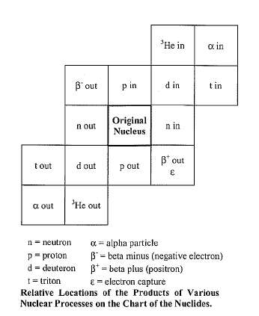

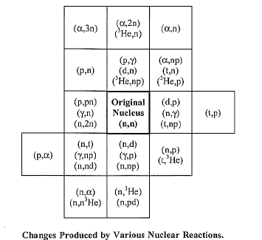

2.1.14. Proper Tracking of Entire Decay Chains
Because the isotope generator algorithm captures only the daughter reactions of the isotopes specified on the material card, the entire isotope decay chain will not be implemented into the MCNPX transport model and subsequently will not be tracked in the MCNPX output file. Understanding nuclide buildup and depletion is never a straightforward process; therefore, receiving nuclide concentrations of members of an isotopes decay chain may give insight into the variation in isotope buildup and depletion. Further, decay chain members may have significant cross sections that would lead to altered MCNPX flux and collision density calculations.

For MCNPX to track a decay chain member, that isotope must be listed on the material card at beginning of life (BOL). Because the decay chain members will not be present at BOL, the decay chain member’s zaid on the corresponding burn material card, with an atom density of 1E-36, can be input. Therefore, the buildup of that specific decay chain member will be tracked in the MCNPX transport calculation and the corresponding nuclide mass will be listed in the output file.

2.1.15. Example INPUT
The following example explains the input setup for the burn card:

BURN TIME=15.0,30.0,30.0 MAT=3,4 POWER=2.0
OMIT=3,3,8017,92234,92239,4,1,92234
BOPT=1.0 -11

This card specifies a power level of 2 MW, with time steps of 15 days, 30 days, and 30 days, for a total of 75 days. Materials 3 and 4 are included in the burn with isotopes 8017, 92234, and 92239 excluded from material 3 and isotope 92234 excluded from material 4. Output will be produced at the end of each burn step and ordered by decreasing mass, and Tier-2 fission products will be treated.

MCNPX requires that each cell to be burned contain a unique material number. By giving each burn cell a unique material number, the user may ensure that flux is normalized by the ratio of the fission rate in that cell versus all other burn cells. Currently, if the user does not select a unique material number for each individual burn cell, the flux will not be normalized properly leading to incorrect results.

Print Tables 40 and 50 are repeated in the output file for each time step, giving the updated atom fractions and densities. Print Table 55 provides the burnup results at the end of each time step.

2.2. CEM03 Upgrade
The CEM2K physics package has been replaced with the new CEM03 physics package which will soon also have the new LAQGSM physics package. The MCNPX user interface has not changed: if the 9th entry on the LCA card is 1, then CEM03 will be used.

CEM03.01 is the latest modification of the improved Cascade-Exciton model (CEM). It is a completely new, updated, and modified version, not just an incremental improvement, in comparison with its predecessors, CEM2k+GEM2,, CEM2k, CEM98, CEM97, and CEM95.

CEM03.01 describes reactions induced by nucleons, pions, and photons as a three-stage process: IntraNuclear Cascade (INC), followed by preequilibrium emission of particles during the deexcitation of the excited residual nuclei formed during the INC, followed by evaporation of particles from or fission of the compound nuclei. If the excited residual nucleus produced after the INC has a mass number A < 13, CEM03.01 uses a recently updated and improved version of the Fermi Breakup model to calculate its decay instead of considering a preequilibrium stage followed by evaporation from compound nuclei. CEM03.01 considers also coalescence of complex particles up to ⁴He from energetic nucleons emitted during the INC.

The main improvements of CEM03.01 in comparison with its predecessors are

2.2.1. Intra Nuclear Cascade (INC)
We developed new approximations to describe more accurately experimental elementary energy and angular distributions of secondary particles from hadron-hadron and photon-hadron interactions using available data and approximations published by other authors. We have normalized photonuclear reactions to detailed systematics developed by others. The condition for transition from the INC stage of a reaction to preequilibrium was changed; on the whole, the INC stage in CEM03.01 is longer, whereas the preequilibrium stage is shorter in comparison with previous versions. The algorithms of many INC routines were changed, and almost all INC routines were rewritten, which sped up the code significantly; some preexisting bugs in the INC were fixed.

2.2.2. Preequilibrium (PREC)
The condition for transition from the preequilibrium stage of a reaction to evaporation/fission was changed; on the whole, the preequilibrium stage in CEM03.01 is shorter, whereas the evaporation stage is longer in comparison with previous versions. The widths for complex-particle emission were changed by fitting the probability of several excitons to “coalesce” into a complex particle that may be emitted during the preequilibrium stage to available experimental data on reactions induced by protons and neutrons. Algorithms of many PREC routines were changed, and almost all PREC routines were rewritten, which sped up the code significantly; some bugs were discovered and fixed.

2.2.3. Evaporation and/or Fission
The evaporation and fission stages of reactions are calculated by CEM03.01, with an updated and improved version of the Generalized Evaporation model code GEM2 by Furihata, which considers evaporation of up to 66 types of different particles and light fragments (up to ²⁸Mg). In comparison with GEM2, the calculation of fission widths in CEM03.01 was changed by fitting the ratio of the level-density parameters at the saddle point to that in the evaporation channel to the systematics of proton-induced fission cross sections by Prokofiev., Several routines by Furihata from GEM2 were slightly modified in CEM03.01; some bugs found in GEM2 were fixed.

2.2.4. Coalescence
The coalescence model implemented in CEM is described is improved. In comparison with its initial version, we have changed the coalescence momentum radii p_0 for the various light composite particles up to ⁴He by fitting them to measured data on nucleon-induced reactions at energies up to 1 GeV.

2.2.5. Fermi Breakup
The Fermi Breakup model used in CEM is improved., In comparison with its initial version, we have modified the model to decay some unstable light fragments that could be produced by the original Fermi Breakup model. Several bugs observed in the original version [12] were fixed.

2.2.6. Additional Notes
Almost all routines of CEM03.01 were rewritten and many algorithms were changed so that the code is much faster now than all its predecessors. The output of CEM03.01 was significantly extended, which allows us to calculate with the standard CEM03.01 many more different characteristics of nuclear reactions, in comparison with its predecessors.

CEM03 is more accurate but somewhat slower than the CEM2K it replaces. CEM problems no longer track – that is, the results from CEM2K do not match the results of CEM03 for the same input decks. Problems using model physics and having photonuclear reactions also no longer track.

2.3. Long File Names
MCNPX file names may now be 40 characters long. The execute line message may now be 240 characters long. File names also may be paths.

For example:

MCNPX name = ..\..\destination_output_files. inp = ..\input_file .

In this example, the input file is named input_file and is located in the next directory up.

MDATA Files

Mesh tally MDATA files now use the name option. In the above example, the MDATA file would be named destination_output_files.d and would be put in the directory ..\..\ .

Implementation Details

The 40-character length is set by the parameter lfilen = 40 in module_global_parameters, GLOBAL1_zc.F . Thus, longer file names should be possible but have not been tested.

In some cases, warnings and fatal-error messages will give only the first eight characters of a file name because of format constraints. In most cases, the rewriting of all formats containing file names result in cleaner output. The full file name usually is allowed. Short file names no longer are followed by blanks to achieve the old eight-character file name length.

2.4. Terminate Tallies at Desired Precision
A new input card, “STOP”, has been added to enable stopping of calculations when a desired tally precision is reached:

STOP NPS n CTME m Fk e .

This card will cause MCNPX to stop after n histories, after m minutes, or when the tally fluctuation chart bin of tally k has a relative error less than e.

MCNPX will stop at the first met criteria.

For radiography problems, the second NPS card entry, n, may be provided to specify how many histories are used for direct radiography tally contributions:

STOP NPS n m .

For multitasking calculations, CTME will be checked only at rendezvous points, where all tasks rendezvous for tally fluctuations and other activities.

The tally precision stop will be checked only at rendezvous points for the tally bin of the tally fluctuation charts. Thus, the calculation usually will proceed for a short time after the desired error is achieved. Thus,

STOP F111 .05

will cause MCNPX to stop at the first rendezvous for which the relative error is less than 0.05. That is, MCNPX may stop at error = 0.048 or other value slightly less than 0.05.

2.5. Spherical Mesh Weight Windows
The mesh-based weight window and the weight window generator are now available in spherical geometry (X-3:JSH-2006-68). The spherical mesh geometry may be thought of as an orange where the theta (θ) azimuthal angles are the bounds between slices. Or the spherical mesh geometry may be thought of as a globe where the phi (φ) polar angles are latitude and the theta (θ) azimuthal angles are longitude. The north pole is at φ = 0 degrees; the south pole is at φ = 180 degrees; London is at θ = 0 degrees and all the way around the globe at θ = 360 degrees.

For problems that are best described in the R-φ-θ spherical geometry coordinate system, spherical mesh weight windows can offer variance reduction speedups of orders of magnitude compared to less suitable rectangular and cylindrical meshes. A speedup of six orders of magnitude over analog has been observed by using spherical mesh weight windows. [Note that rectangular mesh windows are about 30% slower than cell-based windows and cylindrical and spherical mesh windows run about 60% slower than cell-based windows. Problems with spherical geometry that may benefit from spherical mesh weight windows include spherical detectors, unknown materials hidden in spherical geometries, distant sources and detectors in air, spherical satellite geometries, modeling planets, and more.

2.5.1. User Interface

Mesh Specification

The weight window generator mesh is specified with the MESH card. The “GEOM” keyword now has the following possible entries:

XYZ or REC Cartesian coordinate rectangular mesh (unchanged)
RZT or CYL R-Z-θ cylindrical mesh (unchanged)
RPT or SPH R-φ-θ spherical mesh (new)

The RPT and SPH entries are new. The phi (φ) polar mesh bounds are specified with the JMESH keyword. As with the cylindrical mesh, the theta (θ) azimuthal mesh bounds are specified with the KMESH keyword. Also consistent with the cylindrical mesh, the lower radial and angular mesh bounds (R-φ-θ ) are all implicitly zero.

Example:

Mesh geom sph origin 7 -9 -12 ref -23 39 -10 axs .4 -.5 .2 vec .1 -.2 -.7
imesh 60. iints 3
jmesh .1 .35 .5 jints 1 1 1
kmesh .2 .85 1 kints 1 1 1

In this example a spherical mesh is located at origin = 7 -9 -12. The reference location in the XYZ coordinate system of the problem is at ref = -23 39 -10. The weight window generator lower weight window bound will be W for whatever mesh cell contains this location, where W is half the source weight by default or whatever is the 3rd entry on the WWG weight window generator card. The polar (φ) axis of the spherical mesh (as in latitude on the globe) is axs = .4 -.5 .2 which MCNPX will normalize to a unit vector. The azimuthal planes (as in longitude on a globe, or orange slices, or cylindrical mesh theta bins) are measured relative to the azimuthal vector, theta (θ), vec = .1 -.2 -.7. Vec will also be renormalized by MCNPX and must be orthogonal to φ. The radial mesh bins have 3 interpolates between 0 and 60 --- that is, the mesh bounds are at 0, 20, 30, and 60 cm. The polar angles (φ) are at .1, .35, and .5 revolutions from the axs vector. The azimuthal angles (θ) are at .2, .85. and 1 revolutions from the vec vector. Note that 0 ≤ φ ≤ .5 and 0 ≤ θ ≤ 1 are always required.

The polar and azimuthal angles may also be specified in radians or degrees. For example, the JMESH and KMESH entries for the above example in degrees would be:

jmesh 36 126 180 jints 1 1 1
kmesh 72 306 360 kints 1 1 1

2.5.2. Plotting

The interface for geometry plots of the spherical mesh window boundaries is the same as for cylindrical mesh boundaries. Geometry plots are colored by the input weight windows from the WWINP file by selecting WWN as the color option. The weight window and weight window generator mesh boundaries are plotted by clicking “CellLine” to get to the WWG or WW options. The command-prompt plot commands would be “LA 0 1 wwn COLOR on LA 0 0” to color by input windows. The commands “MESH 2” and “MESH 4” plot the generator mesh from the MESH card and weight window mesh from the WWINP file.

Figures 1-3 illustrate three views of a geometry divided into cells coincident with the spherical mesh, so that each color represents a specific geometry and mesh cell in each view. Figures 2 and 3, drawn through the mesh sphere origin and normal and orthogonal to the polar axis, give the intuitive polar (Figure 2) and azimuthal (Figure 3) views. However, skewed, off-center plots of spherical meshes with skew axes give very non-intuitive plots as illustrated in Figure 1.

The most challenging part of the spherical mesh weight window capability was the plotting because the spherical mesh may be in one skew coordinate system and the plot frame in another skew coordinate system which has an “s,t” auxiliary coordinate system. In the most complicated case, equations with hyperbolic sinh and cosh functions must be simultaneously solved with trigonometric equations with sin and cos functions. Iterative solutions were used in these special cases out of desperation. And even these iterative solutions fail to draw mesh boundaries correctly in some instances when both the plot extents are unequal and the geometries are skew creating hyperbolas and intersecting ellipses. Further, polar mesh boundaries looking down into the polar angle sometimes plot incorrect ellipses when the ellipse is partially (but not mostly) out of bounding radial sphere. Note that cylindrical geometries are considerably simpler to plot because they never have to plot hyperbolas and the ellipses, if any, do not intersect each other.

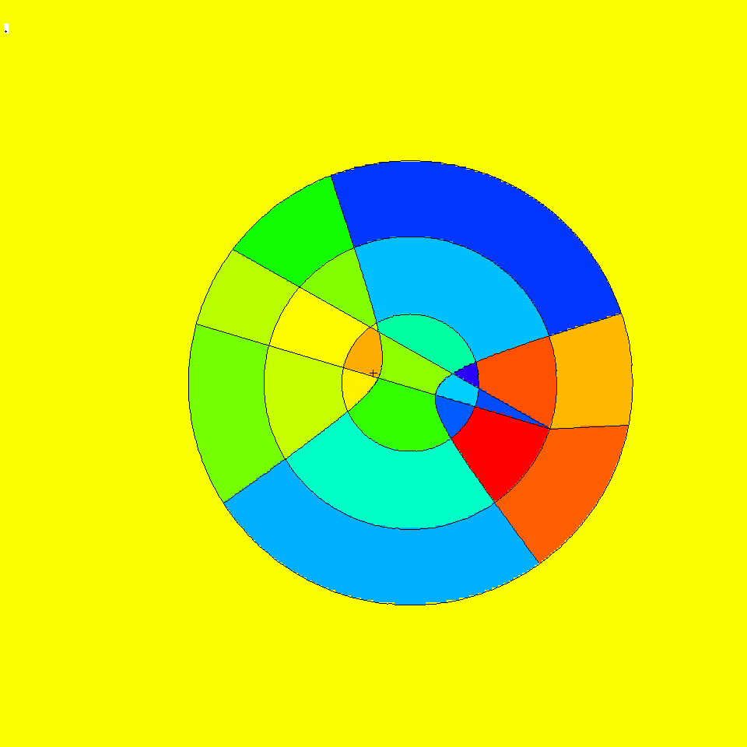

Figure 1. Plot view: basis .84514 -.0507093 .169031 .408248 .408248 -.816497, or = -3 -9 -20, ex 100. Spherical mesh orientation: origin 7 -9 -12, axs .4 -.5 .2, vec .1 -.2 -.7.

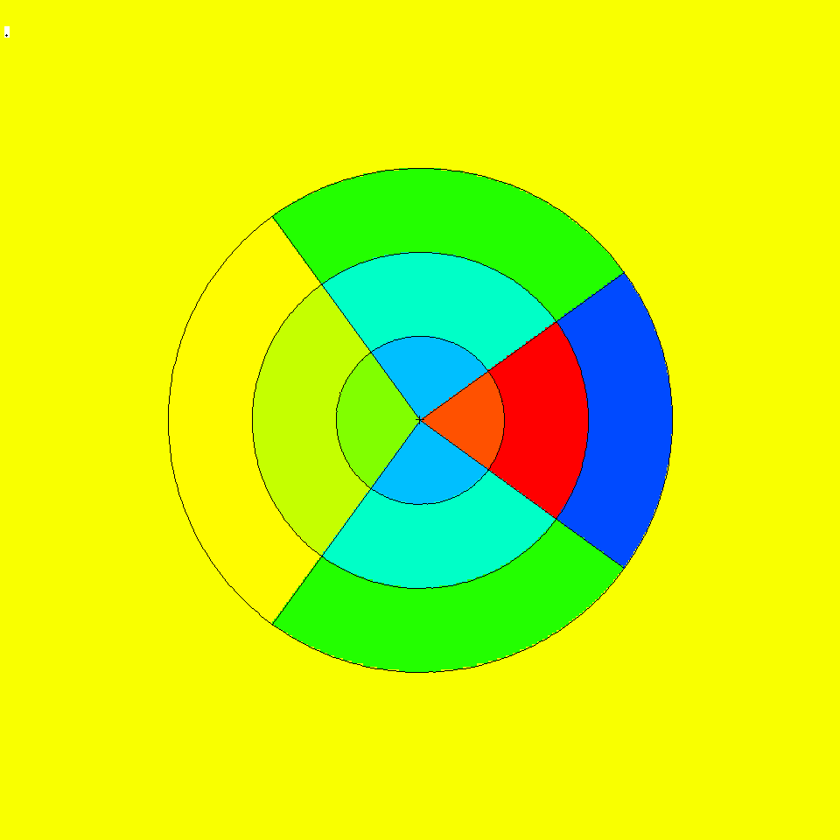

Figure 2. Plot view orthogonal to polar axis showing polar bins jmesh = 36 and 126
degrees. The polar axis (0 degrees) is to the right and is not plotted.

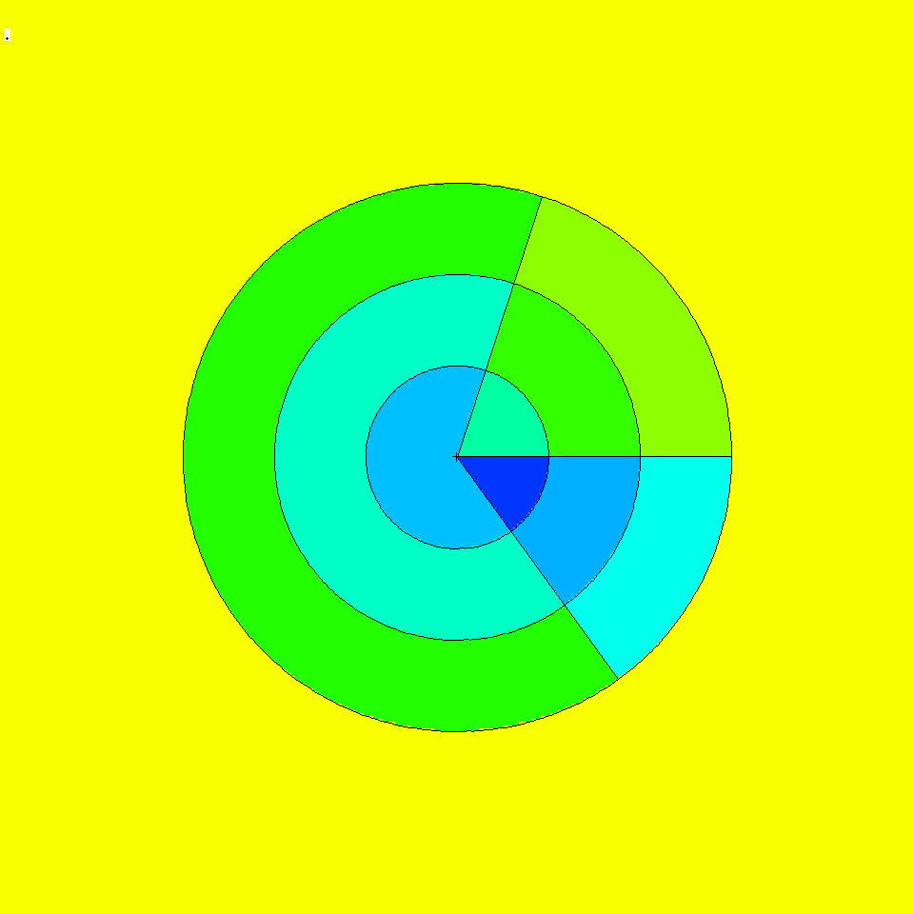

Figure 3. View normal to polar axis at origin showing azimuthal planes at kmesh = 72, 306, and 360 degrees. The azimuthal vector, vec, is to the right (360 degree plane).

2.6. Charged Ions from Neutron Capture in Table Range
MCNPX can now produce light ions from neutron capture reactions in certain isotopes in the table energy range when such data are not available in the libraries. The optional “neutron capture ion algorithm” (NCIA) is called for neutron capture in He-3, Li-6, and B-10 producing protons, tritons, deuterons, and alphas according to the following table:

Table 1. Available Reactions

Isotope | Reactions
He-3 (2003) | n(He-3,h)t  n(He-3,d)d
Li-6 (3006) | n(Li-6,t)a
B-10 (5010) | n(B-10,g)a

The optional NCIA would not be needed if the nuclear data libraries were complete and contained these data. If these data are in the data tables then the library physics produces the secondary ions instead of the NCIA.

2.6.1. User Interface

The NCIA capability is controlled by the PHYS:N card 7th entry which also controls light-ion recoil:

PHYS:N 6J L

where:
L = 3 NCIA on: create charged ions from neutron capture in the table energy range if the library does not have secondary particle production data for these ions. No light-ion recoil.
0 <L ≤1 Light ion recoil with biasing factor L (produced L elastic scatter recoil
ions per incident neutron.)
1 <L ≤2 Light ion recoil with biasing factor L-1 and NCIA on.

Light ion recoil will only occur for neutrons and protons colliding with H, D, T, He-3 and He-4. Neutron capture ions (NCIA) will only occur for neutrons colliding with He-3, Li-6, and B-10 and only if the ion production cross sections are unavailable in the data tables.

The 7th PHYS:N or PHYS:H entry is ignored for collisions in the physics model energy range because the models produce the required elastic and inelastic ions automatically.

The default is L = 0 : no light ion elastic recoil and no neutron capture ions.

2.6.2. Diagnostics

The diagnostic indicating the NCIA has been used is in Print Table 100 of the OUTP file.

For example, when using He-3 (2003) as a material and specifying h, d, and t on the mode card with NCIA turned on, Print Table 100 will show:

particle-production data for ipt= 34 being used from 2003.66c
no particle-production data for ipt= 9 from 2003.66c
using aceion for particle production for ipt= 9 in zaid 2003
no particle-production data for ipt= 31 from 2003.66c
using aceion for particle production for ipt= 31 in zaid 2003
no particle-production data for ipt= 32 from 2003.66c
using aceion for particle production for ipt= 32 in zaid 2003
2003.66c 5535 2-he-3 at 293.6K from endf-vi.1 njoy99.50

In this example, ipt=34 (alpha) production data is found. No data is found for ipts 9 (protons), 31 (deuterium) and 32 (tritium).

2.6.3. Important Considerations

Energy Cutoff: The energies of the light ions are often very low, especially for thermal neutron captures. To enable transport of these secondaries, use the CUT card to reduce the low energy cutoff.

Secondary Production Correlations: Unlike most secondary particle production in the Table region, NCIA particles are coupled. Capture in He-3 produces a triton and proton. If the data library already had proton production, the library would be used for the proton but the tritons would be produced by NCIA. The NCIA correlation between the triton and proton would be lost. Note that if the triton and proton are both produced by the library there is no correlation, either.

Heating Tallies: Because neutron energy deposition is physically mediated in most cases by the secondary particle emission, NCIA may be inconsistent for heating calculations. Neutron heating is done with kerma factors (heating numbers) whereas heating from the charged secondaries is done at collisions. For +f6 tallies and type 3 mesh tallies the charged ion heating is subtracted from the neutron heating and thus is counted only once but inconsistently. For F6:n and F6:h,d,t,a tallies the heating is counted once for each particle type. If heating tallies are done in cells where charged ions are produced, either turn off NCIA or remove the light ions from the mode card.

2.7. Delayed-Gamma Emission.
Warning! The new delayed gamma emission capability and delayed neutron capability is preliminary and not guaranteed. It has been included in MCNPX26C because of user and sponsor demand.

The radioactive decay of fission products, or residual nuclides excited by neutron or photonuclear interaction, frequently results in the emission of gamma/x-rays at times appreciably later than the initiating event. These photon emissions are referred to here as “delayed gammas.”
MCNPX already treats delayed neutrons from fission with both delayed neutron model physics and delayed neutron library physics from data tables.

MCNPX enables the automated calculation of delayed-gamma signatures emitted due to (1) the decay of radioactive fission products created by neutron fission or photofission, or (2) residual nuclides created by simple multi-particle interactions (SMRs). The delayed-gamma capability uses CINDER 90, which was written by William B. Wilson, modified by Holly R. Trellue to disable flux-induced transmutation. The initial multigroup patch for fission-induced delayed-gamma emission was developed by Gregg W. McKinney, Holly R. Trellue, and Laurie S. Waters. Joe W. Durkee developed the modifications to enable line emission for fission and SMRs.

The delayed-gamma capability has been developed for pulsed or low-flux modeling. Thus, CINDER90 nuclear transmutation is limited to decay chains only—neutron-induced transmutation is inactive. In contrast to the kcode isotopic burn capability, the delayed-gamma emission modeling does not include neutron- (or photon-) induced isotopic transmutation by CINDER90. However, SMR treatment for selected reactions of nuclides present on the MCNPX material cards is treated. Execution of the delayed-gamma capability is limited to fixed sources (SDEF).

The Products of Fission: Residual Nuclides and Radiation

The relative amounts of fission products vary with the fissioning isotope and the particle (i.e., neutron, photon, etc.) inducing the fission. To illustrate this behavior, Fig. 4 shows CINDER90 ²³⁵U fission-yield data for thermal and high-energy neutron-induced fission.

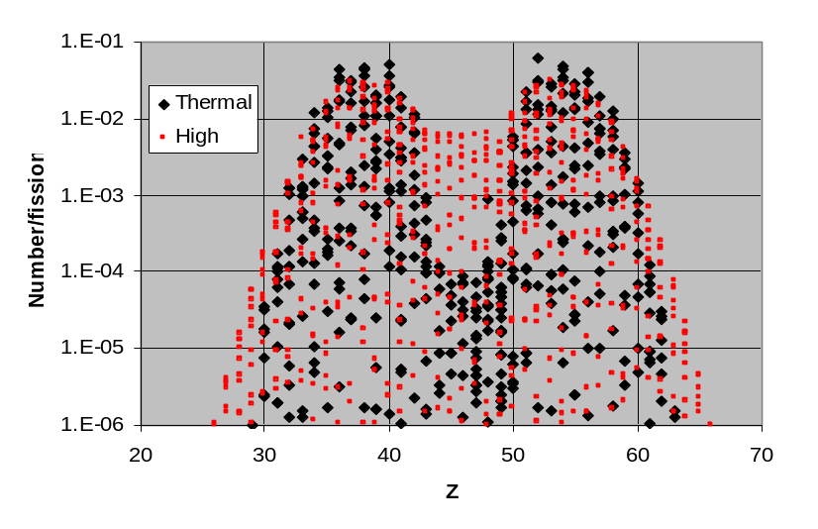

Figure 4. Thermal and fission-spectrum yield curves for ²³⁵U.

For sub-20-MeV neutrons, fission-product sampling is done for thermal, fission, and 14-MeV neutrons and isotopes of uranium, plutonium, thorium, americium, californium, curium, einsteinium, fermium, and neptunium. At high energies (En>20 MeV), LAHET is used to produce a list of residual nuclides.

Many fission products are unstable. As part of their decay process, photons are emitted.
The delayed-photon emissions occur with intensities and at energies that are unique to each radionuclide. As examples, Fig. 5 shows the 25-group and line emission spectra for ¹³⁹Xe and ⁹⁴Sr.

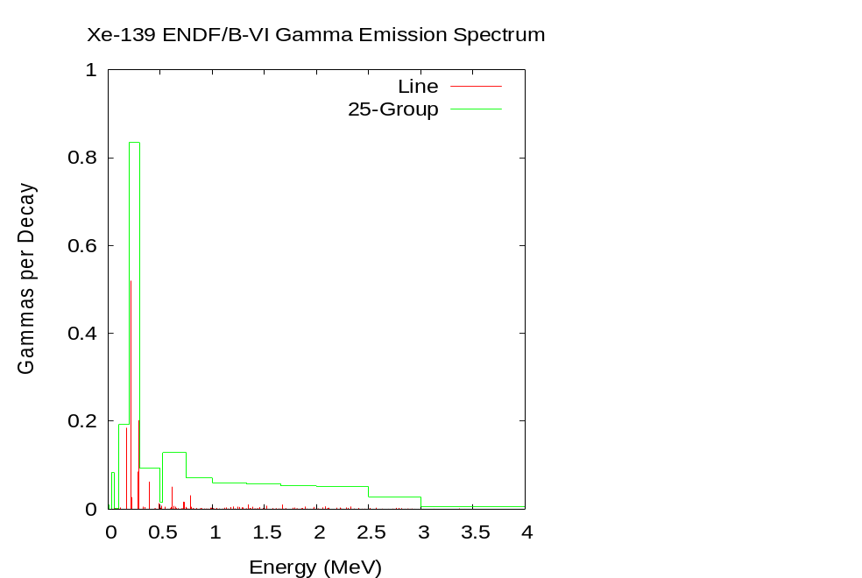
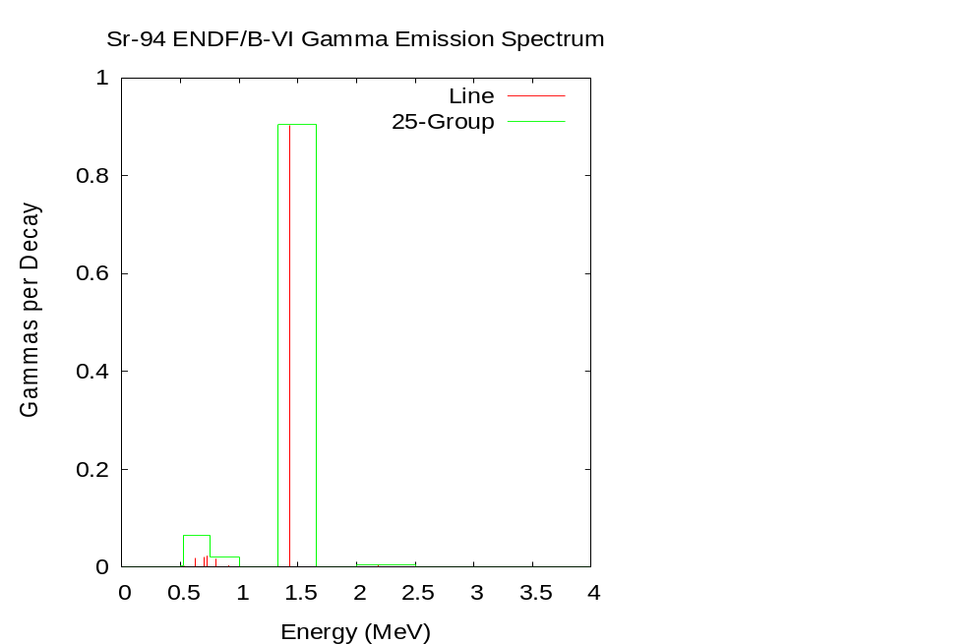

Figure 5. 25-group and line emission photon spectra for ¹³⁹Xe and ⁹⁴Sr.

Decay Chains and Emission Sampling

Not only are the fission-products and residual nuclides radioactive sources, but so too are their decay products. Each contributes to the delayed signature. Thus, a fission event may have hundreds or thousands of lines contributing to its signature.

CINDER90 has been integrated into MCNPX to calculate the radioactive decay-chain nuclide densities as a function of time. The nuclide densities, decay constants, and particle (neutron, photon) emission probabilities are used to calculate distributions that are sampled for particle emission energy and delay time (direction is sampled isotropically).

Photon-emission data are available for 979 nuclides. These data are comprised of (1) line (discrete) data, and (2) continuous data. The continuous component of the line data were developed using computational physics models to augment “missing” measured data so as to create an evaluated dataset whose calculated decay heats agreed with measured values. These data are stored in file cindergl.dat. The composition of the line data are listed in Table 2

Table 2. cindergl.dat delayed-gamma data composition.

Composition by Data Component
Data component | Quantity
Total | 282035
Discrete | 24199
Continuous | 257836
Ascii lines | 747730
Composition by Nuclide
 | Nuclides | Quantity
Discrete Only | 526 (54%) | 19821
Continuous Only | 292 (30%) | 214293
Discrete and Continuous Mix | 161 (16%) | 47921 total  4378D,67742C

All remaining nuclides, of the 3400 treated by CINDER90, require treatment using the cinder.dat 25-group data.

Simple Multi-Particle Reactions

The delayed-gamma simulation capability includes the treatment of simple multi-particle reactions (SMRs). These are reactions in which only two to four particles, a residual nucleus, and photons are present in the final state. The reactions are designated using the ENDF “MT” identifier. Presently, MCNPX treats eight such reactions, which are listed in Table 3. Not all SMR types are available for all nuclides in the MCNPX data library.

Table 3. Available Reactions

ENDF/B-VI MT | Reactions
16 | (n,2n)
17 | (n,3n)
37 | (n,4n)
103 | (n,p)
104 | (n,d)
105 | (n,t)
106 | (n,³He)
107 | (n,alpha)

For nuclides (present in MCNPX problem input files) experiencing SMRs, delayed-photon emission is treated in the same manner as fission products. However, there is presently no treatment of target-nuclide depletion (mass is not conserved).

Figure 6 illustrates the results of an SMR calculation involving the bombardment of a sphere of ¹⁶O by 15-MeV neutrons. The ¹⁶O (n,p) ¹⁶N (t_{1/2}=7.1 s) reaction produces a set of prominent photon lines due to the decay of ¹⁶N.

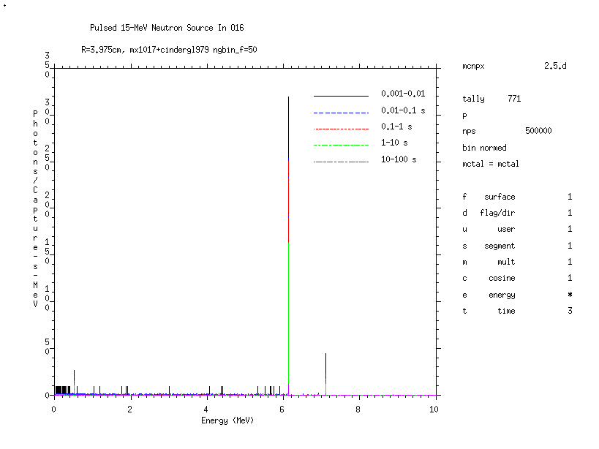

Figure 6. Delayed-gamma signature produced by ¹⁶N as a result of the (n,p) reaction for a pulsed 15-MeV neutron source (500000 source neutron histories) surrounding a 3.975-cm radius sphere of ¹⁶O. Shown is the MCNPX f1 tally on the surface of the ¹⁶O sphere using time bins of 0.001–0.01 s, 0.01–0.1 s, 0.1–1.0 s, 1–10 s, and 10–100 s with uncertainty suppressed (noerr mcplot option).

User Interface

Total nu is now the default for neutron fission. Thus the TOTNU card is no longer needed unless only prompt nu is desired. To have only prompt fission, use:

TOTNU NO

Delayed neutron physics is controlled with the 4th entry, DNB, on the PHYS:N card. DNB (delayed-neutron bias) has the following options, where negative entries do analog sampling (simulate nature), and positive entries bias delayed-neutron production:

-1001 Analog sampling, models when libraries missing
-101 Analog sampling, models only
-1 Analog sampling, libraries only (Default)
0 None -- do not create any delayed neutrons
N Create N delayed neutrons (1-15), libraries only
100+N Create N delayed neutrons (1-15), models only
1000+N Create N delayed neutrons (1-15), models when lib missing

Delayed gamma physics is controlled with the 6th entry, DGB, on the PHYS:P card. DGB (delayed-gamma bias), has the following options:

0 None -- do not create any delayed gammas (Default)
-101 Analog sampling, models only, multigroup-only emission
-102 Analog sampling, models only, multigroup + line emission
-103 Analog sampling, models only, line-only emission (fragile)

Line-only emission (DGB = -103) is “fragile” (untested capability). Multigroup + line emission (DGB = -102) is most useful because for many reactions line data do not exist and for low-probability events multigroup emission is statistically better. Multigroup-only emission (DGB = - 101) is good for many applications where individual line signatures are not required and runs about 5 times faster than the line emission options. In addition, the multigroup emission spectra converge much faster - sometimes orders of magnitudes faster - than the individual line spectra emission as discussed in the following section.

Sampling and Execution

Delayed-gamma simulation by MCNPX is memory and execution-time intensive. Both demands are stem from the calculation of the time-dependent atom densities, and the use of the photon line-emission data, to create energy and time cumulative distribution functions (cdfs). These cdfs are sampled for the energy and time of emission of each delayed gamma (directional emission is taken to be isotropic in the laboratory system).

Measures are taken in MCNPX to eliminate redundant calculations so as to reduce execution time. These measures include the one-time calculation of time-dependent atom densities by CINDER90, and the one-time calculation and array storage of some cdf values. This comes at the expense of memory. Modern desktop PCs and clusters having 1-2 Gbyte of memory lack the necessary memory to store all of the required cdf information.

Despite the use of execution-time reduction measures, time-consuming tasks remain. For instance, the emission energies of each radioactive decay-chain nuclide must be loaded (from the master array that into which all cindergl.dat line data is saved during initialization) and sorted (for line-emission purposes) for each fission event. This is necessary because mass conservation involving fission, inclusive of the number of prompt neutrons emitted, means that any fission product may have several other “siblings” for a series of fission events. There is insufficient storage on modern computers to store the line data for the assortment of combinations of fission-product pairs and their associated decay chains.

Another major time-intensive task involves the identification of the line at which a delayed gamma is emitted. Once the energy cdf is sampled for a proposed emission energy, that energy is forwarded to a routine along with an array containing all line-emission energies for the fission event. That array is searched for the nearest-neighbor emission energy corresponding to the proposed emission energy. This search task adds appreciable time to the calculation—this search is not done for multigroup delayed-gamma emission.

Because MCNPX is a Monte Carlo code, applications needing high-fidelity line signatures may require billions of source particles to achieve relatively stable signatures. Even then, lines may fluctuate appreciably when relatively rare emission paths are sampled. Tallies should be examined carefully to ensure that they are statistically robust.

2.8. Criticality Source Convergence Acceleration
Warning! The new criticality source convergence capability is preliminary and not guaranteed. It has been included in MCNPX26C because of its significance to criticality calculations.

In Monte Carlo criticality calculations the eigenvalue, keff, usually converges much faster than the eigenfunction which is the source distribution or neutron flux in the system. The problem is acute for loosely-coupled systems such as power reactors. MCNPX includes the “Vacation Matrix” capability to better converge source distributions in criticality calculations. The method has been developed by Joshua Finch (Purdue University / LANL) in collaboration with John Hendricks and Chan Choi (Purdue University.)

Example

Figures 7 – 9 show results for a 35 X 35 lattice of fuel pins : 330 cm long, 0.8cm radius UO2 enriched ~3% . Although a “standard” Monte Carlo calculation with many million histories gives a good answer (Figure 7) a shorter calculation (Figure 8) does not correctly model the fission distribution. The estimate with the Vacation Matrix method (Figure 9) is much better.

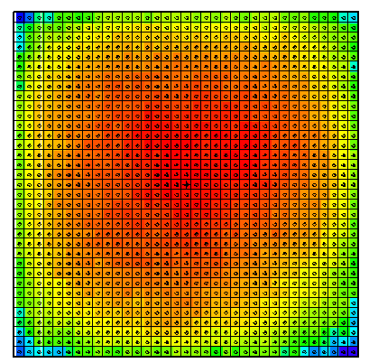

Figure 7: Standard Monte Carlo, “Converged” with 2 million histories

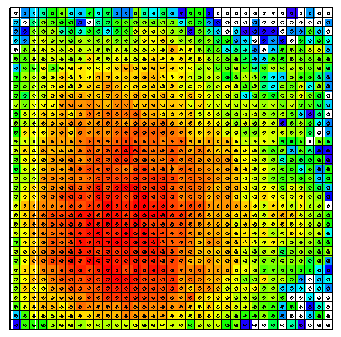

Figure 8: Standard Monte Carlo, 50K histories (poor convergence)

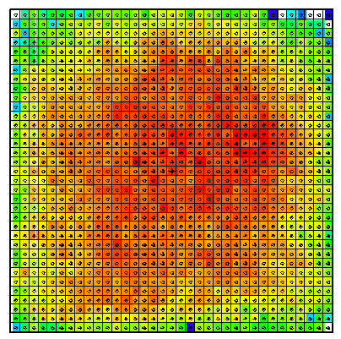

Figure 9: Vacation Matrix method, 50K histories (adequate convergence)

User Interface

The 24th entry of the DBCN card is used to toggle between different matrix implementations. The default value of DBCN(24) is zero, when no matrix method is used. The IDUM card is used in conjunction with the DBCN card to produce more options, as described.

DBCN(24) Table |  | Geometry Specification
 |  | cell | mesh
Fission Estimate | collision | 2 | 3
Fission Estimate | track-length  [IDUM(3)=0] | 5 | 4
Fission Estimate | combined [IDUM(3)≠0] | 5 | 4

(Special diagnostics to the screen terminal are also available. If DBCN(24) = -1, the cell based collisional vacation matrix will be written to the screen. If DBCN(24) = 1, the cell based collisional vacation matrix will be used and written to the screen.)

The optional IDUM card entries have the following functions:

IDUM(1) = 0 : bias B range of 0.7 < B < 2.3 (default)
≠ 0 : bias B range of 0.1·idum(1) < B < 3.0 – 0.1·idum(1)

IDUM(2) = 0 or 6 : average vacation matrix (default)
= 5 : raw (cycle) vacation matrix
= 4 : average fission matrix

IDUM(3) = 0 : no change to fission estimate (default)
≠ 0 : used with DBCN(24) = 4 or 5, combined fission estimate

If the cell based geometry is used, each fissionable cell defined in the problem occupies one dimension of the solution matrix. If the mesh based geometry is used, the MESH card must be used to define the superimposed mesh, and the WWG card must be used with an arbitrary tally (1st entry equal to tally number, 2nd entry zero). The mesh is defined exactly as for the weight-window generator, and it must overlay all fissionable material. When the mesh based geometry is used, the solution matrix is dynamically accumulated according to whether each mesh zone through which the tracked particles pass is fissionable.

3.0. MCNPX 26C Feature EXTENSIONS and Enhancements
Several MCNPX features have been extended and have included changes or additions to the user interface:

- proton step-size control: HSTEP on M card (GWM),
- new photon emission data: PHTLIB (REP/GWM)
- new S(α,β) scattering law (REM/GWM/JSH),
- differential data tallies extended to table physics (GWM),
- separate printout of induced fission multiplicity (JSH),
- weight window MESH angles in radians and degrees (JSH),
- interrupts in electron tracking (GWM)
- extension of ZAID identifiers (GWM),
- LINLIN contour plot defaults (GWM),
- weight window contour plot improvement (GWM),
- allow deleted segment surfaces (FXG),
- improved Windows installation (MRJ/GWM),
- spherical GRIDCONV (MRJ), and
- additional enhancements.

3.1. Proton Step-Size Control
The proton step size can be controlled by a new keyword, hstep, on the material Mn card:

Mn hstep = m .

For example,

M123 estep = 10 hstep = 15 .

The hstep keyword for protons works just like the estep keyword for electrons. The hstep keyword causes the number of proton substeps per energy step to be increased to m (15 in the above example) for the material (123 in the above example). If n is smaller than the built-in default found for this material, the entry is ignored. Both the default value and the estep value actually used are printed in Print Table 85 in the MCNPX output file.

The estep keyword is used only for electrons, and hstep is used for all other charged particles. If estep is specified and hstep is not, then the estep value is used for hstep to preserve backward compatibility.

3.2. New Photon Emission Data
The “new” Nov 2001 BCDLIB gamma emission data—which becomes PHTLIB in binary form—are now the default. The BCDLIB library contains a better description of the gamma decay process and produces a better gamma decay spectrum. Gamma emission from metastable states is blocked for half-lives >1 ms. Thus, MCNPX consistently provides the prompt emission spectra. The BCDLIB data contain the nuclear structure data needed to generate deexcitation photons.

The BCDLIB file is found in the MCNPX source directory under Data/LCS. When MCNPX is compiled, the PHTLIB (binary version) is created. The PHTLIB creation also has been corrected to eliminate several long-lived decay gammas that were >1 ms.

Users of executable MCNPX versions should use the latest PHTLIB file. After unzipping Win32.zip or Linux.tar.gz, etc., the files PHTLIB and BERTIN in the data directory should be used and put in with the other cross sections from ENDF, etc.

Users who compile MCNPX should get the latest PHTLIB from their build directory,
Build_directory/src/phtlib/phtlib .

3.3. New S(α,β) Scattering Law
A new S(α,β) tabular data-scattering law from NJOY (REM, T-16) was added for compatibility with forthcoming ENDF/B-VII data libraries.

3.4. Differential Data Tallies Extended to Table Physics
Differential cross-section data now may be calculated and tallied in the table physics region. When noact = -2 (8th entry on the LCA card), the sourced particle immediately collides in the source material. All subsequent daughter particles then are transported without further collision, as if in a vacuum. Differential cross sections (secondary energy and/or angle distributions, residual nuclei and light ions, and other information) then can be calculated and tallied with an F1 or F8 tally. The tallied data then can be plotted.

The noact = -2 option no longer automatically sets all physics to model physics. Now, table physics is used whenever possible to get the differential data actually used in a given problem. To get the differential data with models only, the use of table data can be turned off with the PHYS:pl card, 5th entry.
.

3.5. Separate Printout of Induced Fission Multiplicity
Induced fission multiplicity now is printed separately instead of being combined with spontaneous fission in Print Table 117.

.

3.6. Weight Window MESH Angles in Radians and Degrees
The mesh-based weight window generator required that azimuthal angles for cylindrical meshes be specified in revolutions. Now these angles and the polar and azimuthal angles of spherical meshes may be specified in revolutions, radians, or degrees. For example, consider the following spherical geometry MESH card on which the polar (JMESH) and azimuthal (KMESH) angles are specified in revolutions.

MESH geom SPH origin 7 -9 -12 ref -23 39 -10 axs .4 -.5 .2 vec .1 -.2 -.7 imesh 60. iints 3
JMESH .1 .35 .5 jints 1 1 1
KMESH .2 .85 1 kints 1 1 1

These angles may now be specified in degrees or radians as well as revolutions. Thus the jmesh and kmesh entries for the above mesh card specified in degrees would be:

jmesh 36 126 180 jints 1 1 1
kmesh 72 306 360 kints 1 1 1

The jmesh and kmesh entries for the above mesh card specified in radians would be:

jmesh .6283185 2.199114 3.141592 jints 1 1 1
kmesh 1.256637 5.340707 6.283185 kints 1 1 1

MCNPX recognizes the appropriate units by looking for .5, 3.14, or 180 for the last spherical geometry jmesh entry and for 1, 6.28, or 360 for the last spherical or cylindrical kmesh entry.

3.8. Interrupts in Electron Tracking
The <ctrl-c> interrupts now work during electron tracking. Normally, at the start of each <ctrl-c> particle track, or trajectory, MCNPX checks to see if the interrupt flag has been set. However, for electrons that may have many substeps, another tracking algorithm, DBMIN, has interrupts that previously were not checked. DBMIN finds the minimum distance to a boundary from a point, and then all tracking (substeps) within that distance of the point does not have to check bounding surfaces. By checking for <ctrl-c> interrupts in DBMIN, these interrupts now work better for electron problems (GWM, 4/19/06).

3.9. Extended ZAID Identifiers
The ZAID identifier may now be alphanumeric to allow more nuclides. Examples would be 1001.abc or 1001.xyc or 1001.a9c, all of which are continuous-energy neutron libraries.

3.10. LINLIN Contour Plot Default
The default interpolation scheme for tally contour plots (FREE SC) is now LINLIN to avoid carrying over a default of LINLOG, LOGLIN, or LOGLOG, which then truncates out all the values less than zero. This extension was suggested by Róbert Kákonyi at the University of Szeged, Hungary.

3.11. Weight Window Contour Plot Improvement
The weight window contour plots now plot white instead of blue for zero (no window game played) and negative (zero importance) windows instead of blue for zero windows (GWM 4/3/06).

3.12. Allow Deleted Segmenting Surfaces
The tally segmenting capability (FSn tally card) was extended to work for segmenting surfaces that are deleted duplicate surfaces. The undeleted duplicate surface then is used automatically. This enhancement was suggested by Jeff Bull. (Franz X. Gallmeier/GWM, 4/24/06).

3.13. Improved Windows Installation
The windows configuration and installation has been improved (MRJ, GWM 6/2/06.)

A new version of GNU Make is included in the MCNPX source files. The upgrade from 3.79 to 3.81 fixes the problem of having a PATH environmental variable that exceeds 255 characters. This eliminates the need for running "Makepath" before building the MCNPX executable on Windows; however, this assumes that the person who installed your MSVC and Intel compilers requested the installer to update your env. variables. If you use this new version of Make and get a compile/link error during the build (e.g., can't find some library), most likely your env. variables are not permanently set. You have 3 options:

1) Permanently update your env. variables using the My Computer (right click) => Properties => Advanced => Env. Variables. The important variables are: INTEL_COMPILER8.0 (or perhaps INTEL_FORTRAN80), INTEL_SHARED, INTEL_LICENSE_FILE, PATH, LIB, and INCLUDE. You should see these set in your MAKEPATH.BAT file as well. Simply create or edit these env. variables and set them to the values listed in your MAKEPATH.BAT file. The one I found missing from my LIB variable was the following (note you do not have to worry about the length of these paths anymore):

D:\Program Files\Microsoft Visual Studio .NET 2003\Vc7\PlatformSDK\Lib

2) Run the MSVC and Intel batch files to set your env. variables before building MCNPX (vcvars32.bat for MSVC and ifortvars.bat for Intel). Of course this is just as much of a hassle as running MAKEPATH.BAT each time.

3) Continue executing MAKEPATH.BAT before you compile.

Also, execution of the test problems in parallel has been improved by forcing problems 18 and 36 to run sequentially.

3.14. Spherical GRIDCONV
The GRIDCONV auxiliary code, which takes MCNPX mesh tallies from the MDATA files and processes them into a usable form for Tecplot and other graphics packages, has been extended to plot spherical mesh tallies. The GRIDCONV modification is to provide all 3 coordinates in spherical meshes to Tecplot.

To plot the spherical mesh in Tecplot do the following:

use the Data->Alter->Transform Coordinates menu option.
In the menu box, set Transformation to "Spherical to Rectangular"
Set the Theta variable to "A"
Set the Radius variable to "R"
Set the Psi variable to P
Leave the default to Create New Variables
Set Angles to "Degrees"
Hit "Compute" button.

Once the transformation is complete, hit "Close" and go to the upper left hand corner and change the pull down menu from 2-D Cartesian to 3-D Cartesian. From there, under Plot->Assign XYZ, set the X, Y and Z variables to the variables you just created and you should get a nice global style plot. Make sure when you specify a Contour plot that you’re plotting the "flux" variable (or whatever variable is of interest).

An example is illustrated below. (MRJ, 7/20/06)

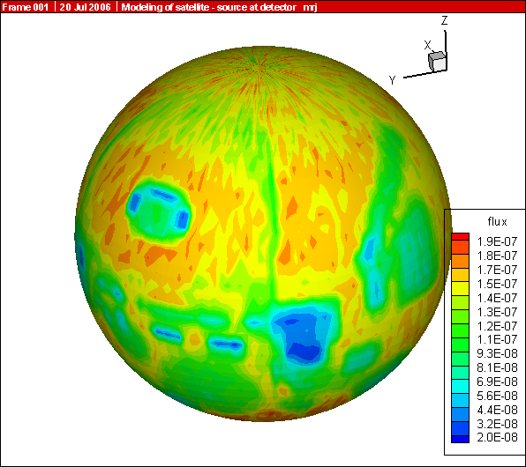
p_1MeV.png

4.0. MCNPX 26C Corrections

4.1. Significant Problem Corrections
The following problems could cause incorrect answers. Fortunately, they occur only in very special situations and affect only a few MCNPX users.

4.1.1. Auger Electrons below Energy Cutoff
Auger electrons were not made from photoelectric fluorescence, and tally heating from fluorescence was neglected when produced by photons below the photon energy cutoff. The effect is small and has been found in all previous MCNP and MCNPX versions. The affected tallies are the MCNPX +F6 and F6:e tallies. A $2 award was made to Greg Cunningham (ISR-1, LANL) (D-5:JSH-2006-18) (GWM).

4.1.2. Detectors in Lattice Geometries
Point detectors in lattice geometries could cause a crash. Possibly answers could be wrong without a crash. The error results because the levp variable could be changed erroneously in (and thus needed to be restored after) the do 695 loop in subroutine tallyd. The possible problem has occurred in all previous MCNP and MCNPX versions. A $2 award was made to Kin Yip (Brookhaven National Laboratory) (D-5:JSH-2006-111) (GWM, 3/7/06).

4.1.3. KCODE/PRDMP 5th Entry
If the PRDMP 5th entry is not one for KCODE problems, then RUNTPE files can crash and other problems can occur because an array overflows. The problem occurs only if the TFC update frequency, NPD, the 5th entry, is larger than the current KCODE cycle, KCY, when adding to the tally fluctuation charts. In most cases, this is not a problem because the default value for NPD with KCODE is “1”. A €20 award was made to Sergey Belousov (INRNE-BAS, Sophia, Bulgaria) (D-5:JSH-2006-112) (GWM 4/19/06).

4.1.5. CEM03 Corrections
(New 26C) A number of small corrections were made to CEM03 by Dick Prael and Gregg McKinney to correct for Z/A imbalances (REP/GWM 6/2/06).

4.2. Minor Problem Corrections
The following problems do not cause wrong answers, but they may cause crashes when encountered. In any case, they occur only in very special situations and affect only a few MCNPX users.

4.2.1. Cylindrical Weight Window Mesh
Neither the weight window nor the weight-window generator cylindrical meshes properly used the theta bin. The improper use affected using, generating, and plotting these weight-window meshes. Cylindrically symmetric meshes (no theta bins) were unaffected. Answers also were not affected because variance reduction affects only efficiency (GWM/JSH).

4.2.2. I8 Mesh Tally Plots
Improper initialization caused mesh tallies not to plot in MCNPX versions compiled with the I8 configuration option, namely, 64-bit integer code versions. A $20 award was made to Bill Schmitt (Draper Labs, Massachusetts) (D-5:JSH-2005-190) (GWM/JSH).

4.2.3. Continue Cards for Input with FATAL Errors
Continue cards failed for input with FATAL errors. A $2 award was made to Valery Taranenko (GSF, Germany) (D-5:JSH-2005-191).

Sometimes Can Plot Only First Mesh Tally
Geometry plots in the command mode (the mode with the PLOT> prompt) for mesh tallies failed in some cases:

PLOT> TALnn.m .

The above command would plot only the first mesh tally if there were non-mesh tallies in the same problem (JSH).

Incorrect KCODE/Message Passing Interface (MPI) Error Message
The warning error message, “KCODE with load balancing is very inefficient.”, had a bad format that caused a crash whenever criticality problems were run in parallel with load balancing. A €20 award was made to Steven van der Marck (NRG, Petten, Netherlands) (D-5:JSH-2005-239) (GWM).

Incorrect LCS Error Message
The LAHET (LCS) diagnostic message for “projectile negatives” and “target negatives” incorrectly listed the atomic number twice rather than the Z-number and then the atomic number. A $2 award was made to Igor Remec (ORNL) (D-5:JSH-2005-238) (GWM).

Mesh Tally Writing to Backup runtpe
The mesh tallies could cause a crash when writing to backup runtpe files. The backup runtpe files are those temporarily created for the PRDMP 3J N option, which allows overwriting the runtpe file with only the last N dumps to conserve space. A €20 award was made to Steven Van der Marck (NRG, Netherlands) (D-5:JSH-2006-005), who also provided the correction.

Pulse-Height-Tally Variance Reduction Techniques with MPI
Pulse-height tallies (F8) with variance reduction techniques crashed when run in parallel with MPI. A $20 award was made to Ronald McConn (PNL) (D-5:JSH-2006-019) (GWM).

PTRAC and Event Log Omission
Both PTRAC (PTRAC card) and Event Logs (DBCN card) write the individual events of a history. Neither wrote collisions using physics models (rather than data tables) in the mix-and-match energy range. (GWM, 4/12/06)

FM Tally Multiplier in Model Physics Regime
The FM (tally multiplier) multiplies tallies by cross sections and other quantities from the MCNPX data libraries. If the tally is at an energy above the highest energy in the data tables, that is, in the model physics energy region, then MCNPX (like MCNP) uses the cross section at the highest energy of the table. However, when a model is used instead of a data table, then no data table values are available at lower energies and MCNPX may crash or get erroneous answers. In some cases, this crash happens in the mix/match energy region between the lowest data table energy and the highest data table energy. The new approach (starting with MCNPX 26B) is to issue an error message at the first occurrence of an FM multiplier above the energy range of a data table and then to return a zero multiplier (MRJ, 4/18/06).

Make Clean Enabled for PC Build
The Make Clean command now works at all levels of the build system on PCs (GWM, 5/25/05).

Zero Electron Mesh Tallies
Electron mesh tallies gave all zeroes in void regions. Corrected by GWM, 2/23/06, and $2 awarded to Carlo Petrovich (ENEA, Bologna, Italy) (D-5:JSH-2006-101, 4/24/06).

Note that a low-density issue also exists in the workaround, namely adding materials of very low densities. For heavier-charged particles, a numerical problem occurs in the straggling routines with densities <~1e-9 g/cm³ and with densities <~1e-15 g/cm³ for electrons. For now, users should avoid such low densities.

Universe Map Crash
The universe map for lattice/repeated structures geometries, Print Table 128, could occasionally have an array overflow that caused a crash in rare cases, thus affecting all previous code versions. A $2 award was made to Benjamin Amiri, LANL, D-5 (D-5:JSH-2006-142) (GWM 5/26/06).

Insufficient Storage for Tallies
Some tallies with large numbers of cells and surfaces can cause a “bad trouble” exit in MCNP with the message, “ li>lit+1 the trouble is in the code, not in your problem.” The problem is that insufficient space is set aside for the TALLOC pointers to ITDS in OLDCD1 where there is a “T” (totals bin) on the F card. A $2 award was made to Benjamin Amiri, LANL, D-5 (X-3:JSH-2006-053) (GWM 7/13/06).

Lost Particles with Coincident REC Surfaces
If the REC (rectangular surface) macrobody has coincident surfaces particles could get lost. A $2 award was made to Richard Starr, NASA-Goddard (X-3:JSH-2006-XXX) (GWM 9/11/06)

GRIDCONV Compiler Bug
The auxiliary program GRIDCONV (for plotting mesh tallies) would crash for the Intel 9.1 complier because of the over-complexity of some write statements. These have now been simplified. (GWM 7/13/06)

Geometry Plot Basis Vectors
MCNPX now forces the geometry plot coordinate system always to be right-handed. Previously, it was possible to specify left-handed coordinate systems in some cases, which led to plotting errors or easily misinterpreted plots. (GWM/JSH 5/6/05)

The “Theta” command after the command prompt and the “Rotate” button in the interactive geometry plotter enable rotation of a geometry plot frame. The “PX”, PY”, and “PZ” commands after the command prompt and the “XY”, “YZ”, and “XZ” buttons in the interactive geometry plotter enable changing the view of a geometry plot frame. Because these commands only changed the first two basis vectors of the plot, and not necessarily the third, a left-handed geometry would sometimes result. This in turn sometimes caused improper drawing of cell or mesh boundaries. Now whenever the first two basis vectors are changed the third is always generated as the cross product ensuring a right-handed coordinate system only. (JSH 9/27/06)

WWN Label Error.
If “WWN” is selected as the label quantity in the interactive geometry plotter, the values displayed would not be the weight windows. (JSH 8/1/06)

Crash for Some READ Card Placements
If the READ card is part of a continued line in the cell cards an index was out of range which could cause a crash. (RCJ 10/5/06)

Internal Corrections

The 20th entry on the DBCN card now causes MCNPX26A to track MCNPX2.5.0 instead of MCNP4C3 and MCNPX2.4.0. (JSH 4/7/05)

The algorithm to change the size of singly-dimensioned integer arrays during the course of particle transport was corrected so that it no longer could cause array overflows. (RCJ 9/6/06)

Out-of-bounds conditionals which fail on some compilers but have been in MCNPX forever were corrected. For example,
if (k.gt.0.and.t(k).eq.zero) …
will work on older compilers, but on new compilers if k=0 then t(k) will fail because both conditions are treated together. (RCJ 10/16/06)

All references to the UNICOS operating system were deleted. (JSH 10/24/06)

HTAPE3x had the appropriate I4 formats changed to I6 so that HTAPE3X could accommodate 5-digit cell and surface numbers. (FXG 9/12/06)

Future work
The following projects are at least partially funded and are actively being developed. These capabilities should be available soon in a future MCNPX version:

  - Additional Cinder90 capabilities: fixed-source depletion.
- improved convergence of eigenfunctions in criticality problems
- improved physics with the LAQGSM/CEM03 model
- integration of HTAPE tallies directly into MCNPX, including continue runs
- heavy-ion tracking and interactions
- electric and magnetic field tracking

The following projects are on our wish list. Some have been partially developed but await further funding.

- detectors and DXTRAN for all neutral particles at all energy ranges with anisotropic scattering (currently approximated as isotropic for models),
- CAD link,
- secondary particle angle biasing for isotropic distributions,
- neutral particle perturbation techniques extended to physics model region,
- plotting of physics model total and absorption cross sections, and
- forced collisions for neutral particles extended to physics models.

John S. Hendricks (JSH, LANL, X-3-MCC); Gregg W. McKinney (GWM, LANL, X-3-MCC), Joseph Durkee (LANL, D-5), Michael Fensin (LANL, X-3-MCC), Joshua Finch (LANL, P-23), Michael R. James (LANL, D-5), Russell C. Johns (LANL, D-5), Robert E. MacFarlane (REM, LANL, T-16), Denise B. Pelowitz (LANL, D-5), Laurie S. Waters (LANL, D-5), Franz X. Gallmeier (ORNL).
The delayed-gamma capability utilizes CINDER 90, which was written by William B. Wilson (LANL, T-16), modified by Holly R. Trellue (HRT, LANL, X-1) and Joe W. Durkee (JWD, LANL, D-5). The multigroup patch to MCNPX was developed by LSW, HRT, and GWM; the line-emission upgrades were written primarily by JWD. .
The depletion/burnup capability is based on CINDER 90, which was written by William B. Wilson (LANL, T-16), and MonteBurns, which was written by Holly R. Trellue (LANL, X-1). The initial patch to MCNPX was developed by GWM and Joe W. Durkee (JWD, LANL, D-5). MCNPX26a, 26b, and 26c were written mainly by Michael L. Fensin (MLF, D-5).
CEM03 was developed mostly by Stepan G. Mashnik (LANL, X-3), with algorithms developed by Arnold J. Sierk (LANL, T-16). LAHET was written by Richard E. Prael (REP, LANL, X-3) and adapted into MCNPX 26B by GWM.
http://www-rsicc.ornl.gov/.
http://www.nea.fr/.
http://mcnpx.lanl.gov/beta/.
http://mcnpx.lanl.gov/docs/MCNPX_2.5.0_Manual.pdf/.
http://mcnpx.lanl.gov/.
http://mcnpx.lanl.gov/opendocs/reports/Interface.pdf/.
http://mcnpx.lanl.gov/opendocs/misc/FeaturesList.pdf/
Cash Award Fine Print: This offer is subject to cancellation or modification without notice. A bug is defined as an error we choose to correct in the source code. We make awards even for the most trivial or insignificant of problems, but not for proposed code enhancements or proposed extended capabilities. Awards are given only to the first MCNPX user reporting a problem. Reported problems must be reproducible, and awards are paid when the correction is integrated into a forthcoming MCNPX version. We endeavor to make MCNPX the most error-free and robust Monte Carlo radiation transport code possible, and we back this code with a cash guarantee.
http://mcnpx.lanl.gov/opendocs/misc/Cashbugs.pdf/.
Michael L. Fensin, John S. Hendricks, and Samim Anghaie, “Enhanced Monte Carlo Linked Depletion Capabilities in MCNPX” (Abstract: Los Alamos National Laboratory report LA-UR-05-9559) 2006 International Congress on Advances in Nuclear Power Plants Embedded International Topical Meeting at the 2006 ANS Annual Meeting, ICAPP '06, Reno, Nevada (June 4–8, 2006).
Michael L. Fensin, John S. Hendricks, Gregg W. McKinney, and Holly Trellue, “Advances in Monte Carlo Depletion Capabilities for MCNPX,” Los Alamos National Laboratory report; abstract: LA-UR-05-7895, full paper: LA-UR-06-0629. American Nuclear Society 14th Biennial Topical Meeting of the Radiation Protection and Shielding Division, Carlsbad, New Mexico (April 3–6, 2006).
Michael L. Fensin, John Hendricks, Holly Trellue, Gregg McKinney, “Advances in Monte Carlo Depletion Capabilities for MCNPX,” Los Alamos National Laboratory Report LA-UR-06-3920, Transactions of the American Nuclear Society, 95, 497, 2006 Winter Meeting, Albuquerque, New Mexico (November 12-16, 2006)
Michael L. Fensin, John Hendricks, Holly Trellue, Samim Anghaie, “Incorporation of a Predictor-Corrector Methodology and 1-GroupReaction Rate Reporting Scheme for the MCNPX Depletion Capability,” Los Alamos National Laboratory Report LA-UR-06-3925, Transactions of the American Nuclear Society, 95, 317, 2006 Winter Meeting, Albuquerque, New Mexico (November 12-16, 2006)
S. G. Mashnik, K. K. Gudima, M. I. Baznat, A. J. Sierk, R. E. Prael, and N. V. Mokhov, “CEM03.S1, CEM03.G1, LAQGSM03.S1, and LAQGSM03.G1 Versions of CEM03.01 and LAQGSM03.01 Event-Generators,” Los Alamos National Laboratory report LA-UR-06-1764 (March 6, 2006), also available at http://mcnpx.lanl.gov > documents.
Stepan G. Mashnik, Konstantin K. Gudima, Arnold J. Sierk, Mircea I. Baznat, and Nikolai V. Mokhov, “CEM03.01 User Manual,” Los Alamos National Laboratory report LA-UR-05-7321 (2005); RSICC Code Package PSR-532, http://www-rsicc.ornl.gov/codes/psr/psr5/psr-532.html/ (2006).
S. G. Mashnik, K. K. Gudima, and A. J. Sierk, “Merging the CEM2k and LAQGSM Codes with GEM2 to Describe Fission and Light-Fragment Production,” Los Alamos National Laboratory report LA-UR-03-2261 (2003); E-print: nucl-th/0304012; Proc. 6th Int. Workshop on Shielding Aspects of Accelerators, Targets and Irradiation Facilities (SATIF-6), April 10–12, 2002, Stanford Linear Accelerator Center, CA 94025, USA, NEA/OECD, Paris, France, 2004, pp. 337–366.
Stepan G. Mashnik, Arnold J. Sierk, and Konstantin K. Gudima, “Complex Particle and Light Fragment Emission in the Cascade-Exciton Model of Nuclear Reactions,” Los Alamos National Laboratory report LA-UR-02-5185 (2002); E-print nucl-th/0208048.
S. G. Mashnik and A. J. Sierk, “CEM2k—Recent Developments in CEM,” Los Alamos National Laboratory report LA-UR-00-5437 (2000); Proc. of the 2000 ANS/ENS Int. Meeting, Embedded Topical Meeting Nuclear Applications of Accelerator Technology (AccApp00), November 12–16, 2000, Washington, DC (USA), American Nuclear Society, La Grange Park, IL, 2001, pp. 328–341; E-print: nucl-th/0011064.
A. V. Prokofiev, S. G. Mashnik, and A.J. Sierk. “Cascade-Exciton Model Analysis of Nucleon-Induced Fission Cross Sections of Lead and Bismuth at Energies from 45 to 500 MeV,” Los Alamos National Laboratory report LA-UR-98-0418 (1998); E-print: nucl-th/9802027; Nucl. Sci. Eng. (1999), Vol. 131, No. 1, pp. 78–95.
S. G. Mashnik and A. J. Sierk, “Improved Cascade-Exciton Model of Nuclear Reactions,” Los Alamos National Laboratory report LA-UR-98-5999 (1998); E-print: nucl-th/9812069; Proc. Forth Int. Workshop on Simulating Accelerator Radiation Environments (SARE-4), Knoxville, TN, September 13–16, 1998, Oak Ridge National Laboratory, 1999, pp. 29–51.
S. G. Mashnik, “User Manual for the Code CEM95,” Bogoliubov Laboratory of Theoretical Physics, Joint Institute for Nuclear Research, Dubna, Russia (1995), CEM95 Code Package IAEA1247 distributed by the OECD Nuclear Energy Agency, Paris, France, 1995, http://www.nea.fr/abs/html/iaea1247.html.
S. G. Mashnik, K. K. Gudima, M. I. Baznat, A. J. Sierk, R. E. Prael, and N. V. Mokhov, “CEM03.01 and LAQGSM03.01 Versions of the Improved Cascade-Exciton Model (CEM) and Los Alamos Quark-Gluon String Model (LAQGSM) Codes,” Los Alamos National Laboratory Research Note X-5-RN (U) 05-11; Los Alamos National Laboratory report LA-UR-05-2686 (2005).
S. G. Mashnik, M. I. Baznat, K. K. Gudima, A. J. Sierk, and R. E. Prael, “CEM03 and LAQGSM03: Extension of the CEM2k+GEM2 and LAQGSM Codes to Describe Photo-Nuclear Reactions at Intermediate Energies (30 MeV to 1.5 GeV),” E-print: nucl-th/0503061, J. Nucl. and Radiochem. Sci., Vol. 6, No. 2, pp. A1–A19 (2005).
S. G. Mashnik, M. I. Baznat, K. K. Gudima, A. J. Sierk, ”CEM03.01 and LAQGSM03.01 Improvement for Gas-Production Cross Section Calculations,” Los Alamos National Laboratory report LA-UR-05-8447 (2005); Proc. 14th Biennial Meeting on the Radiation Protection and Shielding Division, Carlsbad, New Mexico, USA, April 3–6, 2006, CD with the RPSD2006 Procs., ANS, La Grange Park, IL, USA, 2006, ISBN: 0-89448-693-4, pp. 169–172.
S. Furihata, “Statistical Analysis of Light Fragment Production from Medium Energy Proton-Induced Reactions,'” Nucl. Instrum. Methods B 171 (2000) 252–258; PhD thesis, Tohoku University, March, 2003 (and references therein).
A. V. Prokofiev, “Compilation and Systematics of Proton-Induced Fission Cross-Section Data,” NIM, A463 (2001) 557–575.
A. V. Prokofiev, S. G. Mashnik, and W. B. Wilson, “Systematics of Proton-Induced Fission Cross Sections for Intermediate Energy Applications,” Los Alamos National Laboratory report LA-UR-02-5837 (2002), E-print: nucl-th/0210071.
V.D. Toneev, K.K. Gudima, “Particle Emission in Light and Heavy-Ion Reactions,” Nucl. Phys. A400 (1983) 173c–190c.
N. Amelin, “Physics and Algorithms of the Hadronic Monte-Carlo Event Generators. Notes for a Developer,” CERN/IT/ASD Report CERN/IT/99/6, Geneva, Switzerland (1999).
GEANT4, Users's Documents, Physics Reference Manual," December 8, 1998, http://wwwinfo.cern.ch/asd/geant4/G4Users Documents/UsersGuides/PhysicsReferenceManual/html/PhysicsReferenceManual.html.
Herman M., Editor (June, 2005), ENDF-6 Formats Manual, Document ENDF-102, Report BNL-NCS-44945-05-Rev.
England T.R. and Rider B.F. (October, 1994), “Evaluation and Compilation of Fission Product Yields,” Los Alamos National Laboratory report LA-UR-94-3106.
Wilson W.B., England T.R., Arthur E.D., Beard C.A., Bowman C.D., Engel L.N., Gavron A., George, D.C., Daemen L.L., Hughes, III H.G., Kinnison W.W., LaBauve R.J., Lee D.M., Lichtenstein H., Lisowski P.W., Muir, D.W., Palounek A.P., Perry R.T., Pitcher E.J., Prael R.E., Russell G.J., Sanders G., Waters L.S., Young, P.G, and Ziock H.J. (January 11–15, 1993), “Accelerator Transmutation Studies at Los Alamos with LAHET, MCNP, and CINDER90,” Proceedings of the Workshop on Simulating Accelerator Radiation Environments.
Katakura J. and England T.R., (1991), “Augmentation of ENDF/B Fission Product Gamma-Ray Spectra by Calculated Spectra,” Los Alamos National Laboratory report LA-12125-MS.
Herman M., Editor (June, 2005), ENDF-6 Formats Manual, Document ENDF-102, Report BNL-NCS-44945-05-Rev.
Joshua P. Finch, acation Matrix Method for Fission Source Convergence in Monte Carlo Criticality Calculations,”PhD Dissertation, Purdue University, West Lafayette, Indiana (December 2006)

