FermiLab
TD Note 99-065

Status of new superconductor development

Report of High Field Materials Low Temperature Superconductor Workshop

Seog-Whan Kim, Giorgio Ambrosio and Emanuela Barzi
Technical Devision, Development and Test Department

The Workshop

High Field Materials Low Temperature Superconductor Workshop
November 1-3, 1999 ~ Santa Rosa CA

Organized by: University of Wisconsin-Madison - Applied superconductivity Center

Lawrence Berkeley National Laboratory - Superconducting Magnet Group

Program Committee: David Larbalestier (UW-ASC) and Ron Scanlan (LBNL)

Program Coordinator: Mel Adams (UW-ASC)

Program Assistant: Denise Roberts (UW-ASC)
Monday morning
- Welcome --- D. Larbalestier (UW-ASC) and R. Scanlan (LBNL)
They gave welcome statements.
The charge of the workshop is: “It’s possible to do High Field Magnets, we need conductor”
This meeting is not a conference, but a meeting for discussion. The result of discussions will be asked to DOE.
Magnet Needs D. Larbalestier (UW-ASC)
- Low-Temperature Superconductor Development Requirements for the US Fusion Program --- J. Schultz (MIT)
After 95 budget cut of the US fusion program and cancellation of the superconducting Tokamak, the superconducting magnet and cable research met difficulties.
The main research for the moment is international collaboration : KSTAR (not in a collaboration yet), ITER-RC, etc.
He showed the specification (requirement) of the superconducting wires for fusion programs.
The goal is to achieve Jc =1000 A/mm² at 16T × 600 mJ/cc, and 2km of piece length.
We need to develop superconducting conductors to re-activate the fusion research.
- Common Coil Magnet: As a Facility to Conductor and Magnet development --- R. Gupta (LBNL)
The common coil arrangement has many advantages to make a better test facility. The merits of the common coil test facility are;
- It will be easier to make slit or hole for sample inserting,
- Stronger magnetic field is possible,
- Various conductor design (cross-sectional design),
- Various material (Cu, NbTi, Nb₃Sn, Nb₃Al, HTS, etc.) can be used together,
- Both Wind & React and React & Wind are possible.
He did not mention, but the longitudinal component of the magnetic field has to be compensated.
- Common Coil Magnet: Conductor Properties and Magnet Design --- S. Gourlay (LBNL)
Important conductor properties for common coil magnet : Jc, magnetization, degradation and strain sensitivity.
To reduce magnetization, we need to find a way to reduce Jc at low field with keeping high Jc at high field.
We are trying to obtain more Jc, which is the most important property. They require a d_{eff} of less than 70 micron since they plan to use correction methods to account for magnetization.
- High Field Magnets at BNL --- P. Wanderer (BNL)
He talked about the VLHC magnet development.
Because of the high magnetic field, we need a new superconductor. (In the case of common coil field is 7 T for Phase 1, and 12.5 T for Phase II. Available new conductors are;
- Low Tc : Nb₃Sn, Nb₃Al
- High Tc : BSCCO-2212, BSCCO-2223, YBCO
Several trials of building magnets of new material; Race track coils of HTS tape, Nb₃Sn tape, NbTi wire and SSC cable.
Much more research is necessary including studies on eddy current and magnetization.
- High Field Magnet Development at Fermilab --- G. Ambrosio (FNAL)
Jc=3000 A/mm² @ 12 T 4.2 K,
d_{eff} < 20-50 micron,
0.85 < Cu/non-Cu in wire < 1.2 (Can be different in cable adding Cu wires)
RRR > 75,
Short heat treatment,
Low cost.

- Conductor Optimization: Mixing Pure Cu & SC Strands in Rutherford Cables --- P. McIntyre (TAMU)
The main idea is separating superconducting strands and copper strands, and cabling with these two kinds of strands.
This method gives more opportunity to control characteristics of the cable.
We can obtain necessary magnet performance with less improvement of Jc.
We can use several materials in a cable or a magnet.
This gives an easier way to design multi layer magnets.
Block coil geometry → stress management → optimizing conductor → current programming → suppress persistent current multi-poles.
- Final Session Discussion
There were some different opinions about the required Jc value for 15T and 20T dipole magnet.
One of the most important issues of this discussion is making cables with superconducting strands and copper strands (P. McIntyre suggested that)
Even if we can increase the current capacity of the cable with the separated cable, we need to develop superconducting conductors with higher Jc.
Some people said “Don’t say impossible. Before SSC many people said impossible, but we achieved all we want.”
Nb3Sn Conductors J. Ekin (NIST)
A. Reports on Fabricating Conductor
- Critical Issues in Developing High J_{c} Nb₃Sn Conductors --- S. Hong (OST)
LBNL requirements : 0.8 mm 50% Cu, Jc > 1030 A/mm² at 15T (54 subelements)
63% Cu, Jc > 2890 A/mm² at 10T (42 subelements)
TAMU and Fermilab requirements: Jc > 2000 A/mm² at 12T.
Now developing Nb₃Sn wires with modified jelly-roll process (multi-barrier method, re-stack method, etc.)
For internal tin process we need more than 50 % of copper, but external tin requires only 30 % of copper.
The present Jc record is 2200 A/mm² at 12T.
If the reaction can be done without Cu in a jelly-roll process, the Jc can be more than 3000 A/mm²(in principle). We need to study the effective filament diameter.
A conductor with higher Sn ratio showed higher Jc. (also see the next talk)
To reduce magnetization, we need to decrease Jc at low field.
- Critical Issues in Developing High J_{c} Nb₃Sn Conductors --- E. Gregory (IGC)
IGC is involved in KSTAR and LDX projects.
The main process is internal tin method.
The required critical current is 1100 A/mm² at 12T.
For High Energy Physics we need to increase Jc, reduce losses reduce strain sensitivity and reduce the cost.
Barrier breaking may be solved by controlling the heat treatment carefully.
A conductor with higher Sn ratio showed higher Jc in filaments. (also see the previous talk)
Bigger Jc in non copper can be achieved by bigger Sn ratio in bronze.
Critical issues of the process
- Reproducibility of the property
- Maximize Jc
- Small d_{eff} and good stability
- Producing long pieces
- Purity and hardness of materials and grain size are important also.
To down cost, reducing Nb is necessary (Nb is an expensive material).
- Cabling and Conductor Issues from a User Perspective --- R. Scanlan (LBNL)
All the cables for national labs and universities are made at LBNL.
10 companies are developing Nb₃Sn and 3 national labs need cables.
Conductor development goals
- Jc: 3000 A/mm² @ 12T 4.2 K (Je = 1000 A/mm²),
- φ_{eff} < 80 μm (below flux jump stability limit),
- Jc permanent degradation @ ε < 0.5%
- Low Jc degradation @ σ < 100 MPa,
- Unit piece length > 10 Km,
- Billet > 100 Kg,
- Wire cost < 1.5 $ / KA m --- 200 $ / Kg (final version)
- Should be suitable for react & wind and wind & react.
- Short (fast) heat treatment (less than a week).
- Mechanical Effects on Pre-reacted Six-Around-One Nb₃Sn Cable and Other HEP Conductor Issues --- A. Ghosh (BNL)
They use 6 around 1 cable to reduce the effect of Lorentz force. They should be careful because of the increased inductance.
In the Nb₃Sn wire development, obviously increasing Jc is the most important thing, but also we have to control loss and d_{eff}.
To control the properties, we must understand what happens in the wires or cables. → R&D is essential (Even if it takes long time).
B. SBIR Reports
- Novel Nb3 Sn Development at Supercon – Work in Progress --- T. Wong (Supercon)
PIT has many advantages as follows;
- Good for micro-structure engineering,
- Short d_{eff} (20 μm),
- Jc improvement possible (1250 A/mm² at 13T ).
- Low degradation.
To reduce filament size, they are trying to make uniform and fine grains.
Also trying to adding Zr, Ga and Mg (I did not understand how these materials work).
They are studying tube making method; wrap sheet and hot extrusion.
- Superconducting Systems SBIR Results --- S. Pourrahimi (SSI)
Just opened company.
Main item is Nb₃Al conductor for 850MHz NMR. Also developing Nb₃Sn conductor.
They succeeded in making Nb₃Al joint.
They are trying to achieve;
- Nb₃Al conductor of Jc =100 A/mm² at 20T 4.2K.
- Flexible Nb₃Al wire.
- Nb₃Sn conductor of Jc = 2000 A/mm² at 12T 4.2K (not proved because untested yet)
- Possible Approaches for Manufacturing Nb₃Sn Wires and the Possible Effect on Cost/Performance --- M. Tomsic (EURUS)
He explained their continuous tube forming and filling method and the cassette drawing method.
Deformation and uniformity of a wire is affected much by drawing.
- Supergenics LLC SBIR Results --- B. Zeitlin (Supergenics LLC)
They use internal tin process.
This process was suggested by Hashimoto in 1974. In the US this process was used from 1983 (LBNL and BNL. Also used for ITER)
Now, this process is becoming more and more complicated.
To reduce the cost, we can consider
- Removing barrier
- Separating copper
More cost down can be obtained by mass-production. Probably $240/kg.
To improve Jc at high field
- Adding Ti in Sn
- Fine filament (1 – 2 μm).
- Fabrication of Rare Earth Doped Nb3 Sn Superconductors --- J. Miller (Alchemet)
He explained the process to make artificial pinning centers in Nb₃Sn
(Nb₆Sn₅ + 9Nb = 5Nb₃Sn)
The best result was obtained by Ce doping; 40A at 16 T (Jc=?)
Material uniformity is the most important factor.
C. Reports on Characterizing and Understanding Nb3Sn
- Some Things We Don’t Understand About Nb₃Sn and the Opportunities that this Presents --- D. Larbalestier (UW-ASC)
He listed several questions to be solved during the R&D.
- Nb₃Sn is inhomogeneous (NbTi is more homogeneous). This inhomogeneity may affect critical field and temperature. How affects?
- Why inhomogeneous?
- How can we control the grain size (grain size determines pinning center density)?
- Now we are running to increase Jc. But how much should be the Tc, B* and B_{c2}?
- Also we have many questions about fabrication process.
We don’t have sufficient data yet.
To answer the questions,
- we need to design new composites
- we need to characterize over wide range of B.
- we need to understand the relationship between microscopic characteristics and the property of the wire.
- Studies of Composition and T_{c} Profile in PIT Nb₃Sn --- C. Hawes (UW-ASC)
He showed measured resistivity and specific heat of reacted Nb₃Sn conductor.
The reaction times were 2, 4 16 and 47 hours.
16 hour reaction may be long enough.
- Study of Sn-Cu Interdiffusion in 2 TWC/OST Internal Sn Strands --- M. Naus (UW-ASC)
Internal tin wire showed better critical current at 12 T than bronze process.
He showed many phase diagrams and cross-section photographs.
He focused on how big is the β and ε phases.
- Nb3 Sn Microstructure Property Relationships --- P. Lee (UW-ASC)
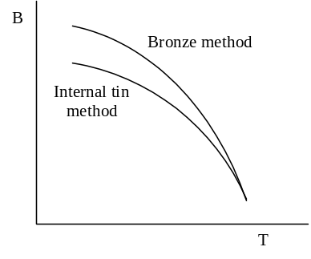He showed B-T curves of several conductors made with internal tin method and bronze method.
He measured samples from several manufactures.
The conductor of the best grain size (fine and uniform in longitudinal direction) was EM-LMI conductor, and Mitsubishi conductor gave the best performance (Highest Ic ?).
He said bronze method is better than internal tin method.

- Heat Treatment Study of Nb₃Sn Strands for the Fermilab’s High Field Dipole Model --- E. Barzi (FERMI)
Showed how short heat treatments do not compromise Sn diffusion, do not degrade I_{c} either, and preserve the RRR enough for magnet applications. Hence they should be favored for cost reduction.
- Behavior of Rutherford Cables of Nb₃Sn with Transverse Pressure --- D. Dietderich (LBNL)
All the measurements were done at NHMFL.
They measured critical currents of stacked Nb₃Sn Rutherford cables (Jc = 2000 A/mm²).
Measurements were done in both of the face-on and edge-on magnetic fields.
The critical current is lower under a bigger stress.
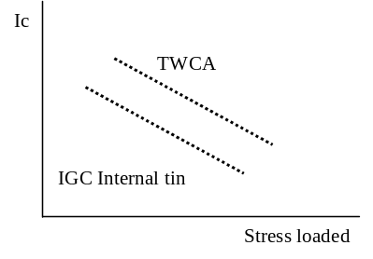TWCA and Oxford jelly-roll cable showed similar results, but IGC internal tin cable showed a little bit less Ic value.
Reasons of different Ic.
- Cu distribution,
- Sub-element size and distribution,
- Composition of sub-element.

- Open Issues in Nb3 Sn Processing --- M. Suenaga (BNL)
Nb filaments physically move at early stage of heat treatment.

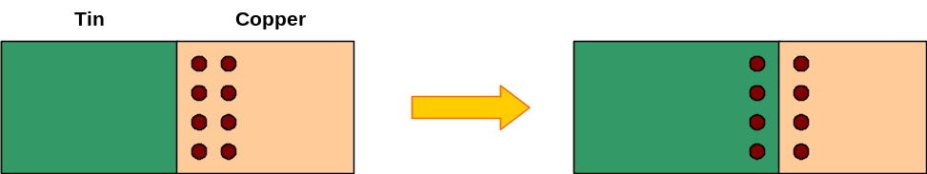
- Final Session Discussion
How important is the microscopic research? ( How much research fund do we have to pay? )
Different opinions about characterization of Nb₃Sn conductor;
- Some people said that we need to build a characterization method (mechanical, chemical, electrical )
- Somebody said we need more experience to build that.
- For the moment, the most important process of Nb₃Sn is internal tin (Oxford, IGC), but the uncertainty is too big to characterize.
Again, some people discussed the separation of superconducting cable and copper cable. The conclusion was “worth to try, but anyway we need to increase the Jc.”
Why AC characteristics are not included the cable specification.
Tuesday morning
- 20 T or Bust --- Dave Sutter (DOE-HEP)
He explained;
- What is HEP?
- Why we need to build accelerators with higher energy?
- We need to develop superconducting magnet.
Now we have two options; high field option and low field option.
Also we have many research groups. Each group is making progress.
The most important thing is cost down. But when we consider cost down;
- We have to consider the total cost of the machine,
- There should be an operation margin,
- We should care the radiation,
- Don’t try the cheapest. Try affordable.
- Computer design is not a real magnet. We must be more careful.
The conclusion : 20T or bust!
Nb₃Al Processing and Properties E.W. Collings (OSU)
- Introduction to NbAl Processing and Properties --- E.W.Collings (OSU)
Research collaboration with DoE/HEP and NRIN (Japan)
Several processes were developed; Rod-in-tube, Jelly-roll, Powder-in-tube.
Key issues are;
- Mechanical : bonding, drawing
- Chemical : Nb-Al ratio, laminate thickness.
Cassette die is a promising tool for drawing.
The most important thing is to make long cables.
- Progress in NbAl Processing at the Ohio State University and Review Of Present Status of US/Japan Progress in the Field --- M. Sumption (OSU)
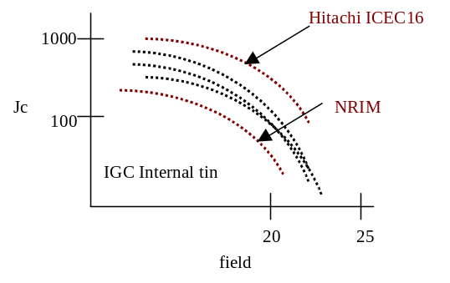Much research is undergoing with collaboration with Japanese industries.
He showed many plots measured by Japanese group and introduced OSU reel-to-reel machine. This machine is fully operational.
Hitachi ICEC16 conductor showed the best Ic result and NRIM 1.5μ RIT conductor showed lowest Ic result (see right figure).
Main research issue is to find factors that affect the Jc.

- Jelly Roll Nb₃Al Conductors by Hydrostatic Extrusion --- T. Wong(Supercon)
The speaker was Mark. K. Rudziak.
They used warm hydrostatic extrusion, and produced a conductor (Nb:Al volume ratio is 3.85:1).
There was a breakage at 37m in 0.69 mmφ.
Heat treatment was 10 hours at 800°C.
A wire of smaller diameter showed higher Jc value.
They seem to have many problems to produce long wires.
- NbAl Precursor Fabrication at IGC and Innovare --- E. Gregory (IGC)
He said Resistive heating Ga rapid quenching method is the best ( for what ?).
Best record is 450 A/mm² at 12 T (jelly-roll)
It is very difficult to make long wire of NbAl, because;
- It is impossible to increase temperature,
- The difference between melting point and stable oxides is big.
Trying to develop fabrication technique; jello-roll process, re-stack method.
Also developing drawing method;
- Grooved rolling followed by cassette die drawing,
- Alternate swaging and drawing
- Hydrostatic extrusion
- NbAl Precursor Fabrication at OST --- S. Hong (OST)
He made a very short talk
They tried extrusion and re-stacked billet.
Barrier breaking (by melting Al) was observed. Pre-heat treatment temperature was 400°C.
At high field, Nb₃Sn and Nb₃Al showed similar Jc values.
- A Method for Producing Nb₃Al Precursor Wire --- J. Hendricks (ACE)
They don’t have a funded program to develop this wire.
They are developing a new process, which is a mixture of MJR and PIT.
Make a sandwich with Nb and Al → compress → Jelly roll.
This method may relax problems caused by difference of material strength.
Somebody (I don’t remember who) comments that jelly rolling is less important than drawing.
The question is whether this method makes the drawing easier or not.
- Innovative Approaches to NbAl Precursor Fabrication and Attachment of Copper Stabilizer after Rapid Quenching --- M. Tomsic (EURUS)
Several issues and options concerning the fabrication process;
- compaction process,
- round powdered roll forming,
- hex groove rolling,
- swaging,
- there are many process options.
They add Cu after rapid quenching step. This gives a way to put the exact amount of copper.
Design and installation of the process is in the final step.
- Final Session Discussion
S. Pourrahimi said;
- Making thinner filaments is not the only way to increase Bc,
- Even if the filament size is big, a good heat treatment will give more Bc.
R. Scanlan asked companies about their facility;
- Companies said that their facilities have limits,
- Japanese companies have much better devices,
- Also they need much room for the drawing processes. Need to try hydro-static extrusion.
Laboratories have some flexible facilities. Useful?
HTS R. Scanlan (LBNL)
- Ic Testing Possibilities at NIST and International Standards --- L. Goodrich (NIST)
Japanese companies are playing important roles.
We can follow that, but in that case we have to fit to the Japanese standards.
- Transverse Stress Effect in Bi-2212, Bi-2223, and YBCO Coated Conductor --- J. Ekin (NIST)
Strain stress characteristic of an LTS is reversible, but that of a HTS is irreversible.
So far 2212 seemed to be inferior to 2223 or YBCO. The performance of 2212 is continuously improving, but we need to study why 2212 is inferior.
They measured degradation of a few cables after pressing (degradation test) from IGC, Oxford and Showa..
2212 samples showed about 10% of degradation after 100 MPa pressing.
2223 samples showed about 3 % of degradation.
However, the direct comparison between 2212 and 2223 is difficult, because the shapes of the two samples were different (2212 has square cross-section, but 2223 has round).
They did not make 10 cycle test. They thought that 1 cycle is enough because of the irreversibility.
Samples showed less degradation than expected.
- Behavior of Bi-2212 Rutherford Cables with Transverse Pressure --- D. Dietderich (LBNL)
They measured Ic variation with strain.
Cables with thick core and those with orange like cross-section were measured at NHMFL.
They used the same sample holder and split magnet shown at the previous presentation.
Results of the measurements;
- Edge loading and face loading did not show a big difference,
- Ic degradation is permanent,
- Cables show similar degradation to round wires,
Reason of the degradation;
- strand internal geometry,
- defect during the heat treatment.
The degradation is irreversible. Will pressing degraded cable make more degradation?
Also we need to characterize the degradation.
- High Field 4.2K Evaluation of ASC Production Wire --- A. Squitieri (UW-ASC)
He showed Jc measurement results of two wires (2223 Ag tapes)
- 2212 Processing Issues --- E. Hellstrom (UW-ASC)
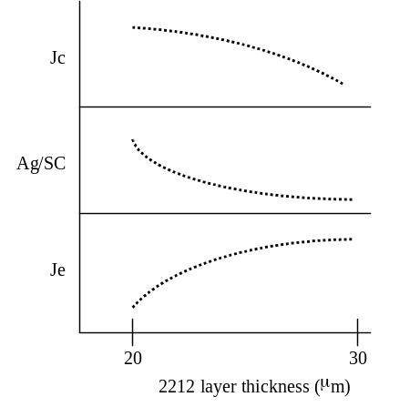He reported the status of HTS development by Japanese industry, which was presented at a Japanese workshop two weeks before. Hot issues presented at the Japanese workshop were as follows.
Showa : Pre-annealing intermediate rolling
- 4.2 K 0 T 800,000 A/cm²,
- 4.2 K 10 T 500,000 A/cm² (short sample)
- 4.2 K 10 T 400,000 A/cm² (long length)
- They have an important steps in their process; burning organic materials in 400 ~ 600°C and eliminating carbon in 835 ~ 860°C.
- The effect of 2122 layer thickness is as the figure.
Toshiba : 2212 on Ni/NiO
- He doubted usefulness of this conductor because Ni is a magnetic material.
Hitachi : rotation symmetric arranged tape-in-tube wire.
- This arrangement eliminates non-isotropic behavior of a wire.
- They said they could make more than 10 km of this wire.
One of the most important conclusions was that 2212 can become a useful material.
- Combustion Chemical Vapor Deposition of High Temperature Ceramic Insulator Coatings on Superconductor Wires --- S. Shoup (Microcoating Technologies)
It was their first time to attend this meeting.
The purpose of attending this time is to introduce their products.
She said that they can make very thin coating on superconducting wires with their “Combustion Chemical Vapor Deposition” technique.
This technique may help design superconducting magnet.
Also it is possible to make coating only on parts of the surface.
- Percolation Effects in Coated Conductors --- D. Larbalestier (UW-ASC)
He introduced a new observation technique; magneto-optical technique.
With this technique we can clearly observe cracks, seams or barriers.
He used this technique to observe the effect of nickel substrate grain structure on YBCO connectivity in coated conductor. He showed some photos of cross-sections.
- MIT Lead: An HTS Current Lead Incorporating Operation in the Current-Sharing Mode --- Y. Iwasa (MIT)
He described their current lead made of HTS and Ag-Au stabilizer.
They calculated the heat balance and optimized the lead. (He showed many equations.)
Also they calculated by a numerical way, and measurements were done.
Analytic calculation showed a very good agreement with the measured values. In the case of IGC lead, the values calculated from equations has less error than those from numerical calculation.
- Final Session Discussion
P. McIntyre gave a short talk about stress measurement of 2212 cables. He said the cable is an armored spring core cable. Unfortunately I don’t remember what was his conclusion. (Did he conclude anything?)
Some discussions on stress reversibility;
- It is not strange that a brittle material shows irreversibility,
- We don’t need to focus on the reversibility. What we need is wires with adequate performance and affordable price.
HTS is being developed fast. Probably we can buy satisfactory HTS wires with affordable prices 4 or 5 years later. It is important to develop a technique of making long length.
Also LTS market is growing. The more important issue for this community is LTS.
Laboratories and universities want to activate as much R&D as possible. But companies are careful since they have to survive.
Many other discussions about fabrication process and cost down were made;
- Improving YBCO conductor,
- Hybrid type conductor,
- Highly polished Ni plate
- Etc.

Open Discussion on R&D Issues E.W.Collings (OSU)
D. Larbalestier (UW-ASC)
R. Scanlan (LBNL)
B. Strauss (DOE-HEP)
Supercon said that they can reduce the fabrication cost by their new technique;
- Drawing superconducting wire without copper or with a very small amount of copper,
- Copper can be added in cabling,
- Also it is possible to increase the Jc.
- Mass production will give more cost down.
We need to understand the physics in the material. Without understanding the R&D will meet a limitation.
Some discussions about how we can exchange the information and results obtained by the research programs.
Money
- SBIRs (now: 7 phase I, 5 phase II),
- 500 K$ for this FY, lab procurements.
Deliverables (Phase I – process development):
- Row material specs,
- samples at key process steps to Univ. and labs.
- final report by manufacturers,
- material for coils to be tested.
Deliverables (Phase II – scale up: after 2-3 years when a good process has been developed):
- all previous items,
- wire for a 1m long magnet,
- production scale up cost analysis.
Program organization
- director: Ron Scanlan,
- Steering/advisor(??) committee: 3labs + Winsconsin Univ, OSU, TAMU.
- Contracts will go through Scanlan (after speaking with steering committee),
- money are for industries and common facility.
- Workshop report: will be prepared by Ron, checked by steering committee.
Big companies were very careful, but small companies were rather aggressive.

Transparencies used for report talk

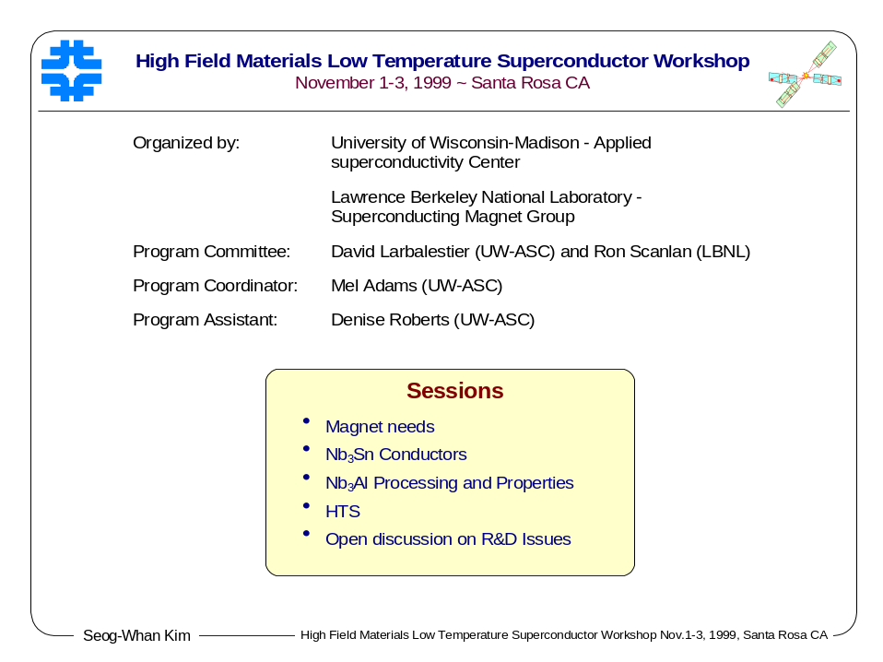

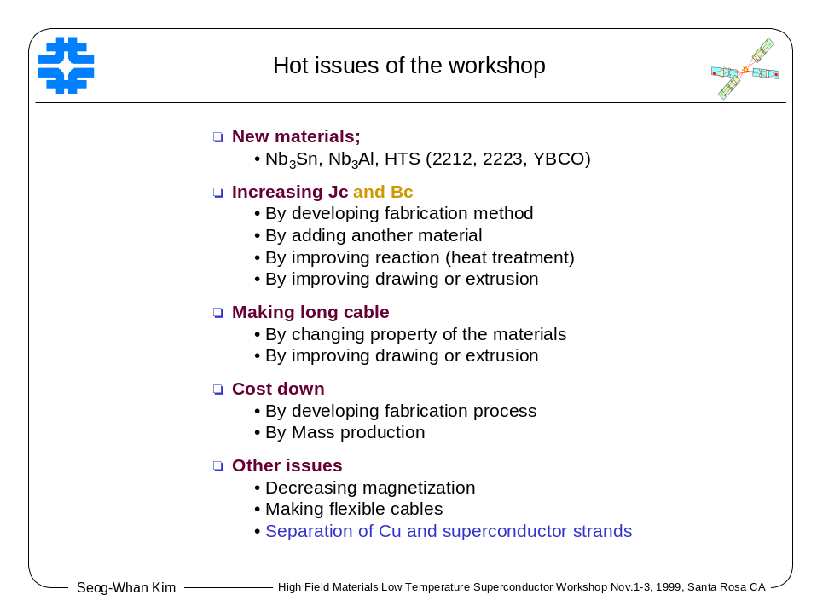

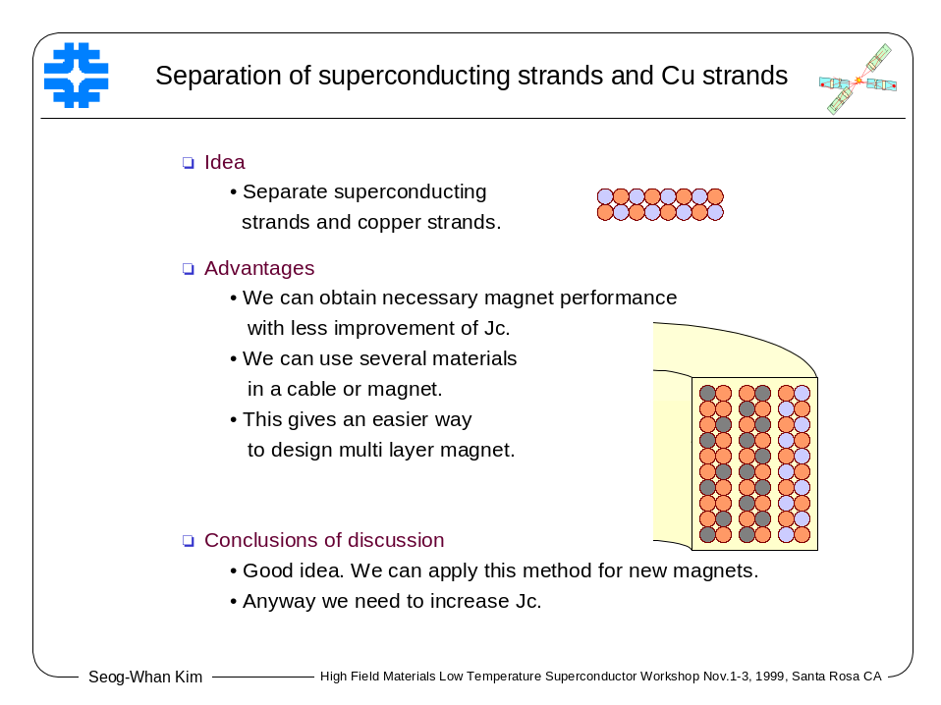

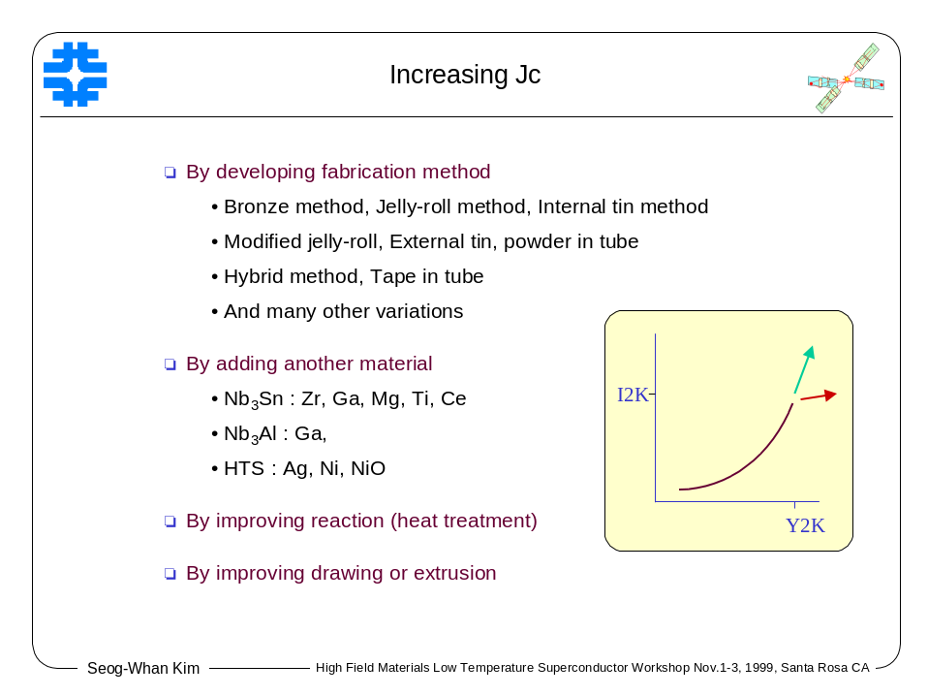
Attendee List

Mel Adams
University of Wisconsin-Madison
1500 Engineering Dr., 917 ERB
MADISON WI 53706-1687
PHONE: 608/263-5029
FAX: 608/263-1087
E-MAIL: madams@engr.wisc.edu

Giorgio Ambrosio
Fermi National Accelerator Laboratory
P.O. Box 500, MS 316
BATAVIA IL 60510
PHONE: 630/840-2297
FAX: 630/840-2383
E-MAIL: giorgioa@fnal.gov

Emanuela Barzi
Fermi National Accelerator Laboratory
P.O. Box 500, MS 316
BATAVIA IL 60510
PHONE: 630/840-3446
FAX: 630/840-2383
E-MAIL: barzi@fnal.gov

Florin Buta
Ohio State University
Materials Science & Engineering
477 Watts Hall
2041 College Rd.
COLUMBUS OH 43210
PHONE: 614/688-3684
FAX: 614/688-3677
E-MAIL: florin+@osu.edu

Ted Collings
Ohio State University
Materials Science & Engineering
477 Watts Hall
2041 College Rd.
COLUMBUS OH 43210-1179
PHONE: 614/688-3701
FAX: 614/688-3677
E-MAIL: ted+@osu.edu

Lance Cooley
University of Wisconsin-Madison
Applied Superconductivity Center
1500 Engineering Dr.,937 ERB
MADISON WI 53706
PHONE: 608/262-8291
FAX: 608/263-1087
E-MAIL: ldcooley@facstaff.wisc.edu

George Cui
MicroCoating Technologies
3839 Green Industrial Way
CHAMBLEE GA 30341
PHONE: 678/287-2448
FAX: 678/287-3201
E-MAIL: gcui@microcoating.com
Dan Dietderich
University of California-Berkeley
Lawrence Berkeley National Laboratory
1 Cyclotron Rd., MS 46-161
BERKELEY CA 94720
PHONE: 510/486-6087
FAX: 510/486-5310
E-MAIL: drdietderich@lbl.gov

Jack Ekin
National Institute of Standards and Technology
325 Broadway, Mail Stop 814.05
BOULDER CO 80303
PHONE: 303/497-5448
FAX: 303/497-5316
E-MAIL: ekin@boulder.nist.gov

Arup Ghosh
Brookhaven National Laboratory
P.O. Box 5000
17 Cornell Avenue,
Bldg. 902-A
UPTON NY 11973-5000
PHONE: 631/344-3974
FAX: 631/344-2190
E-MAIL: ghosh1@bnl.gov

Loren Goodrich
National Institute of Standards and Tech
325 Broadway,
Mailcode 814.05
BOULDER CO 80303-3328
PHONE: 303/497-3143
FAX: 303/497-5316
E-MAIL: goodrich@boulder.nist.gov

Steve Gourlay
University of California-Berkeley
Lawrence Berkeley National Laboratory
1 Cyclotron Road, MS 46-161
BERKELEY CA 94720
PHONE: 510/486-7156
FAX: 510/486-5310
E-MAIL: sagourlay@lbl.gov

Eric Gregory
IGC Advanced Superconductors Inc.
1875 Thomaston Ave.
WATERBURY CT 06704
PHONE: 203/753-5215 ext. 227
FAX: 203/753-2096
E-MAIL: gregory@mail1.nai.net

Ramesh Gupta
University of California-Berkeley
Lawrence Berkeley National Laboratory
1 Cyclotron Road, MS 46-161
BERKELEY CA 94720
PHONE: 510/495-2250
FAX: 510/486-5310
E-MAIL: rgupta@lbl.gov

Alex Gurevich
University of Wisconsin-Madison
Applied Superconductivity Center
1500 Engineering Drive, 605 ERB
MADISON WI 53706
PHONE: 608/263-2549
FAX: 608/263-1087
E-MAIL: agourevi@facstaff.wisc.edu

Bill Hassenzahl
Advanced Energy Analysis
3756 Grand Avenue, Suite 404
OAKLAND CA 94610
PHONE: 510/452-1010
FAX: 510/452-1033
E-MAIL: advenergy1@aol.com

Chris Hawes
University of Wisconsin-Madison
Applied Superconductivity Center
1500 Engineering Drive, 605 ERB
MADISON WI 53706
PHONE: 608/263-4462
FAX: 608/263-1087
E-MAIL: hawes@cae.wisc.edu

Eric Hellstrom
University of Wisconsin-Madison
Applied Superconductivity Center
1500 Engineering Drive, 911 ERB
MADISON WI 53706
PHONE: 608/263-9462
FAX: 608/263-1087
E-MAIL: hellstrom@engr.wisc.edu

John Hendricks
Alabama Cryogenic Engineering, Inc.
P.O. Box 2470
HUNTSVILLE AL 35804
PHONE: 256/536-8629
FAX: 256/536-8645
E-MAIL: aceinc@mindspring.com

Seung Hong
Oxford Superconducting Technology
600 Milik St.
CARTERET NJ 07008-0429
PHONE: 732/541-1300 ext. 215
FAX: 732/541-7769
E-MAIL: seutthong@aol.com

Yukikazu Iwasa
Massachusetts Institute of Technology
Francis Bitter Magnet Laboratory
185 Albany St., Room NW 14-3101
CAMBRIDGE MA 02139-4307
PHONE: 617/253-5548
FAX: 617/253-5405
E-MAIL: iwasa@jokaku.pfc.mit.edu

Alan Jackson
University of California-Berkeley
Lawrence Berkeley National Laboratory
1 Cyclotron Rd.
BERKELEY CA 94720
PHONE: 510/486-7384
FAX: 510/486-5310
E-MAIL: ajackson@lbl.gov

Juris Kaugerts
BWX Technologies, Inc.
P.O. Box 785, Mt. Athos Rd.
LYNCHBURG VA 24505-0785
PHONE: 804-522-6560
FAX: 804-522-6905
E-MAIL: juris.kaugerts@mcdermott.com

Seog-Whan Kim
Fermi National Accelerator Laboratory
P.O. Box 500, MS 316
BATAVIA IL 60510
PHONE: 630/840-2735
FAX: 630/840-2383
E-MAIL: swkim@fnal.gov

David Larbalestier
University of Wisconsin-Madison
Applied Superconductivity Center
1500 Engineering Dr., 915 ERB
MADISON WI 53706-1687
PHONE: 608/263-2194
FAX: 608/263-1087
E-MAIL: larbales@engr.wisc.edu

Peter Lee
University of Wisconsin-Madison
Applied Superconductivity Center
1500 Engineering Dr., 939 ERB
MADISON WI 53706-1687
PHONE: 608/263-1760
FAX: 608/263-1087
E-MAIL: peterlee@facstaff.wisc.edu

William K. McDonald
Alabama Cryogenic Engineering, Inc.
P.O. Box 2470
HUNTSVILLE AL 35804
PHONE: 256/536-8629
FAX: 256/536-8645
E-MAIL: aceinc@mindspring.com

Al McInturff
University of California-Berkeley
Lawrence Berkeley National Laboratory
1 Cyclotron Road, MS 46-161
BERKELEY CA 94720
PHONE: 510/486-7242
FAX: 510/486-5310
E-MAIL: mcinturff@seminole.lbl.gov

Peter McIntyre
Texas A & M University
Department of Physics
Spence Street, Room 237
COLLEGE STATION TX 77843
PHONE: 409/845-7727
FAX: 409/845-2590
E-MAIL: mcintyre@physics.tamu.edu

Jaydee Miller
Alchemet, Inc. (Pyromet)
5 Commerce Drive
ASTON PA 19014
PHONE: 610/497-2803
FAX: 610/566-7119
E-MAIL: alchemet@libertynet.org

Michael Naus
University of Wisconsin-Madison
Applied Superconductivity Center
1500 Engineering Dr., 602 ERB
MADISON WI 53706-1687
PHONE: 608/263-4462
FAX: 608/263-1087
E-MAIL: naus@cae.wisc.edu

Jeff Parrell
Oxford Superconducting Technology
600 Milik Street
CARTERET NJ 07008-0429
PHONE: 732/541-1300
FAX: 732/541-7769
E-MAIL: parrell@ndi.net

Shahin Pourrahimi
Superconducting Systems Inc.
90 Rumford Avenue
WALTHAM MA 02453
PHONE: 781/642-6702
FAX: 781/642-6705
E-MAIL: pourrahimi@superconductingsystems.com

Tae Young Pyon
IGC Advanced Superconductors, Inc.
1875 Thomaston Ave.
WATERBURY CT 06704
PHONE: 203/753-5215x226
FAX: 203/753-2096
E-MAIL: tpyon@as.igc.com

John Rice
Composite Technology Development, Inc.
1505 Coal Creek Dr.
LAFAYETTE CO 80026
PHONE: 303/664-0394
FAX: 303/664-0392
E-MAIL: john@ctd-materials.com

Denise Roberts
UW-ASC
1500 Engineering Dr., #905 ERB
MADISON WI 53706
PHONE: 608/263-5027
FAX: 608/263-1087
E-MAIL: deroberts@facstaff.wisc.edu
Mark Rudziak
Supercon, Inc.
830 Boston Turnpike
SHREWSBURY MA 01545
PHONE: 508/842-0174
FAX: 508/842-0847
E-MAIL: supercn@aol.com

William Sampson
Brookhaven National Laboratory
Superconducting Magnet Group
RHIC Project
P.O. Box 5000, Building 902
UPTON NY 11973-5000
PHONE: 631/344-2036
FAX: 631/282-2190
E-MAIL: ghosh1@bnl.gov

Ronald Scanlan
University of California-Berkeley
Lawrence Berkeley National Laboratory
1 Cyclotron Road, MS 46-161
BERKELEY CA 94720
PHONE: 510/486-7241
FAX: 510/486-5310
E-MAIL: rmscanlan@lbl.gov

Joel Schultz
Massachusetts Institute of Technology
Plasma Science & Fusion Center
185 Albany Street, NW22-213
CAMBRIDGE MA 02139
PHONE: 617/253-8151
FAX: 617/253-0807
E-MAIL: jhs@psfc.mit.edu

Shara Shoup
MicroCoating Technologies
3839 Green Industrial Way
CHAMBLEE GA 30341
PHONE: 678/287-2478
FAX: 678/287-3201
E-MAIL: sshoup@microcoating.com

Alex Squitieri
University of Wisconsin-Madison
Applied Superconductivity Center
1500 Engineering Drive, Room 620 ERB
MADISON WI 53706
PHONE: 608/263-1027
FAX: 608/263-1087
E-MAIL: squitieri@engr.wisc.edu

Bill Starch
University of Wisconsin-Madison
Applied Superconductivity Center
1500 Engineering Drive, Room 605 ERB
MADISON WI 53706
PHONE: 608/263-8923
FAX: 608/263-1087
E-MAIL: wlstarch@facstaff.wisc.edu
Bruce Strauss
US Department of Energy
High Energy Physics
19901 Germantown Road, SC-224
GERMANTOWN MD 20874-1290
PHONE: 301/903-3705
FAX: 301/903-2597
E-MAIL: bruce.strauss@science.doe.gov

Masaki Suenaga
Brookhaven National Laboratory
Department of Applied Science
P.O. Box 5000, Bldg. 480
UPTON NY 11973-5000
PHONE: 631/344-3518
FAX: 631/344-4071
E-MAIL: mas@sun2.bnl.gov

Mike Sumption
Ohio State University
Material and Science Engineering
477 Watts Hall, 2041 College Rd.
COLUMBUS OH 43210
PHONE: 614/688-3684
FAX: 614/688-3677
E-MAIL: mdsumption+@osu.edu

David Sutter
US Department of Energy
High Energy Physics
19901 Germantown Road, SC-224
GERMANTOWN MD 20874-1290
PHONE: 301/903-5228
FAX: 301/903-2597
E-MAIL: hep-tech@science.doe.gov

Richard Thome
Massachusetts Institute of Technology
Plasma Science & Fusion Center
185 Albany Street
NW22-229
CAMBRIDGE MA 02139
PHONE: 617/253-8155
FAX: 617/253-0807
E-MAIL: thome@psfc.mit.edu

Mike Tomsic
EURUS Technologies, Inc.
110 E. Canal St.
TROY OH 45373
PHONE: 937/332-0348
FAX: 937/332-0898
E-MAIL: mtomsic@teameurus.com

Barry Valder
Oremet Wah Chang
P.O. Box 460
ALBANY OR 97321
PHONE: 541/967-6908
FAX: 541/967-6994
E-MAIL: barry.valder@oremetwahchang.com

Peter Wanderer
Brookhaven National Laboratory
Superconducting Magnet Division
P.O. Box 5000, Building 902
UPTON NY 11973-5000
PHONE: 631/344-7687
FAX: 631/344-2190
E-MAIL: wanderer@bnl.gov

Terrence Wong
Supercon, Inc.
830 Boston Turnpike
SHREWSBURY MA 01545
PHONE: 508/842-0174
FAX: 508/842-0847
E-MAIL: wongterry@aol.com

Bruce Zeitlin
Supergenics LLC
1233 Tree Bay Lane
SARASOTA FL 34242
PHONE: 941/349-0930
FAX: 941/349-0933
E-MAIL: brucezeitlin@home.com

