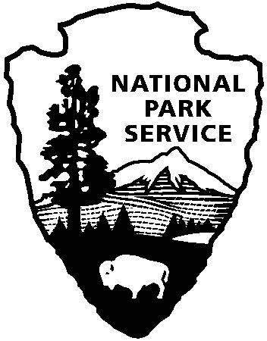
Release date:
Contact(s):
Phone number:
Date:
Release code:
History 3-D: Harpers Ferry in Depth
Harpers Ferry NHP News Release

Harpers Ferry National Historical Park
P.O. Box 65
Harpers Ferry, WV

304-535-6748 phone
304-535-6244 fax
When photography first appeared in the 1820s, the world’s ability to view itself was forever changed. People could record the world around them as it truly was. Using chemicals and metals, they recorded their likenesses for future generations. By the 1860s, new technologies were being brought to America which could allow anyone to experience, “an appearance of reality which cheats the senses with its seeming truth.” Oliver Wendell Holmes, a Massachusetts writer and doctor, introduced three-dimensional photography to the American public in 1859, allowing the middle class to travel around the country right in their own living room and see the monuments of the world in 3-D.

On Saturday, June 28th and Sunday, June 29th, Harpers Ferry National Historical Park will offer visitors the opportunity to experience history like never before: in 3-D. Participants in the day-long workshop will get the chance to build their own Holmes Stereoscope to take home, and then have the opportunity to use their new tool to see Harpers Ferry’s history come to life on a tour of town highlighting historic stereographs (3-D photos) of the parks most important sites. Cost of $35.00 per family covers photographs and one stereoscope kit. Children under 16 must be with a registered parent. Space is limited to 15 kits per day, one kit per family.

For more information, or to register, contact the living history offices at (304) 535-6063.

EXPERIENCE YOUR AMERICA
The National Park Service cares for special places saved by the American people so that all may experience our heritage.

National Park Service
U.S. Department of the Interior
Immediately
Marsha B. Wassel
304-535-6748
May 15, 2008
™

