Contract Report

CIGSS Thin Film Solar Cells

Year 4, Quarter 2 Report

Report no. FSEC-CR1513-05

April 18, 2005

Prepared for
National Renewable Energy Laboratory

1617 Cole Boulevard

Golden, CO 80401

Submitted by

Neelkanth G. Dhere
Florida Solar Energy Center®

1679 Clearlake Road

Cocoa, FL 32922-5703



CIGSS Thin Film Solar Cells

NREL contract no. NDJ-2-30630-03, UCF/FSEC Account no. 2012 6017
Year 4, Quarter 2 Report no. FSEC-CR-1513-05, April 18, 2005

Rapid Thermal Processing

A Rapid Thermal Processing (RTP) unit has been designed, constructed and installed for preparation of CIGSS thin films on 10 cm x 15 cm substrates by selenization/ sulfurization of elemental precursors using the vacuum deposited selenium layer and N₂:H₂S atmosphere. For RTP, selenium evaporation will be carried out by thermal evaporation in a separate setup. An optimized, minute amount of NaF will be added to improve the morphological and electrical properties of the absorber.
The configuration and schematic are shown in Fig. 1 and 2 respectively. A quartz tube (ID = 15 cm) is mounted with a stainless steel flange assembly. Feedthroughs are mounted on the end flange for connection to a thermocouple which would monitor temperature. Viton rubber ‘O’ ring in a groove is used to form an air-tight seal between the hard surfaces of the flange and glass tube. The flange has two openings – a gas inlet (for H₂S and Se vapors) and an exhaust. A pair of high density infrared heaters (Research Inc., Model 5090), each with a bank of 5 T3-style quartz infrared halogen lamps directs energy onto the reaction tube where the substrate is kept. Each lamp is rated at 1200 Watts. The power to the lamps is controlled by a pair of single-phase (120V AC, 55 A) standalone SCR power controls (Research Inc., Model 5620). Each T3-style quartz halogen lamp can provide an upward ramp of 100 ⁰C per 2 seconds. 90% of the radiant energy is radiated in less than 1 second.
The two heater arrays have to be controlled independently so that the thermal gradient across the thickness of the substrate remains symmetrical during all RTP processing phases. This would prevent the substrate from breaking and cracking. A supporting tray prevents the viscous substrate from sagging when the maximum process

lamp
reactor tube
substrate
substrate holder
reflector
Fig. 1: RTP System Configuration
.

Lid
Infrared Heater with electrical and water connections
Array of 5 Tungsten Halogen Lamps
Reaction Tube (Quartz)
Thermocouple
Substrate to be processed
Mobile mounting frame
Sliding wheel
Gas inlet
Exhaust
Valve
To mechanical pump
Flange assembly
Fig. 2: RTP Schematic
temperature crosses the transition point of soda lime glass substrate. Each heater consists of a specular aluminum reflector that directs the infrared energy supplied by the lamps on to the substrate. Connections to supply required cooling water to the heater have been provided. The heaters were mounted on a stand so as to face both the surfaces of the substrate. Two aluminum sheets with 95% reflectivity and measuring 1’x1’x0.02” each were formed into arcs and installed laterally on both sides of the quartz tube to reflect the heat back to the substrate during RTP. Circular reflective stainless steel sheets were placed within the quartz tube at both ends. A sliding mechanism has been provided to quickly move the heaters away from the reaction tube after the completion of the process for rapid cooling.
Experiments were carried out in order to determine the rate at which substrate temperatures would rise with the current setup. A mechanical pump was used to achieve a vacuum in the range of 10⁻³ Torr within the quartz tube. Cool water was circulated through each of the two infrared heaters at a rate of about 0.4 gallon per minute per heater. The two power controllers for the infrared lamp arrays were switched to ‘operate’ mode. The power was raised to 100%. The temperature of the substrate was measured by means of a K-type chromel-alumel thermocouple. An initial temperature ramp of >6 ºC per second and an average temperature ramp of 3.96 ºC per second were obtained so that the temperature increase from 25 ºC to 500 ºC could be attained in 120 seconds at 100% power (Figure 3). The control power was slowly reduced and the power supply was switched off after reaching the temperature of 500 °C.
The next set of experiments was carried out to determine the fixed power to the two heaters for reaching and maintaining temperature of 500 ºC. Initially, the power was kept at 30% of the maximum. The temperature rose to 430 ºC in 48 minutes and then remained stable. The power was then increased to 40%. Temperature rose to 500 ºC in 2 minutes with a tendency to rise further. At this stage the power was switched off (Figure 4). In the subsequent experiment, it was found that when total lamp power was fixed at 35%, the substrate temperature rose to 500 ºC in 52 minutes and remained stable (Figure 5).

The following graphs show ramp rates for various power settings:

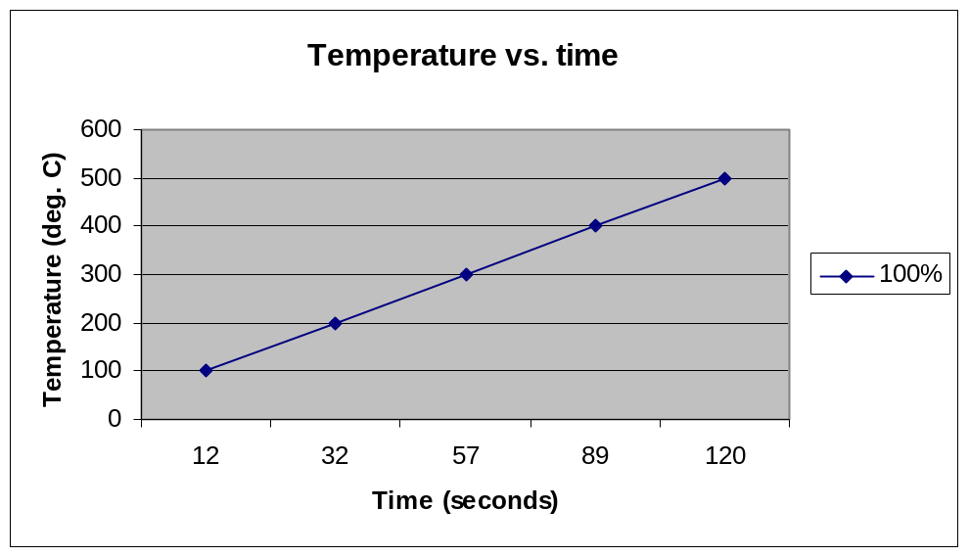

Fig. 3. Plot of Temperature vs. time at 100% power

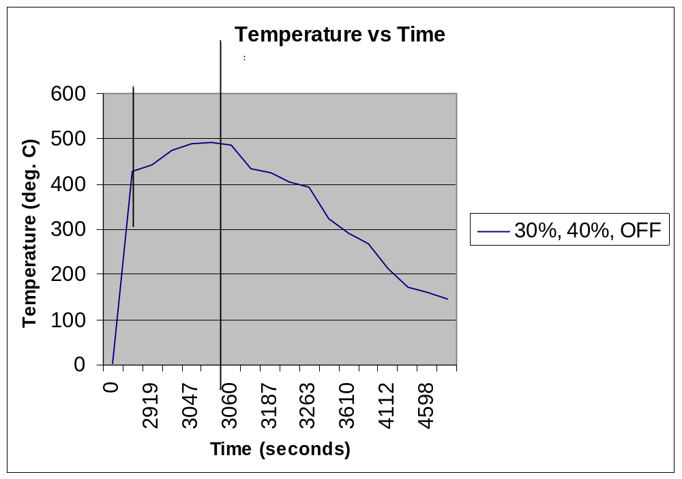

Fig. 4. Plot of temperature vs. time for 30%, 40% and 0% power

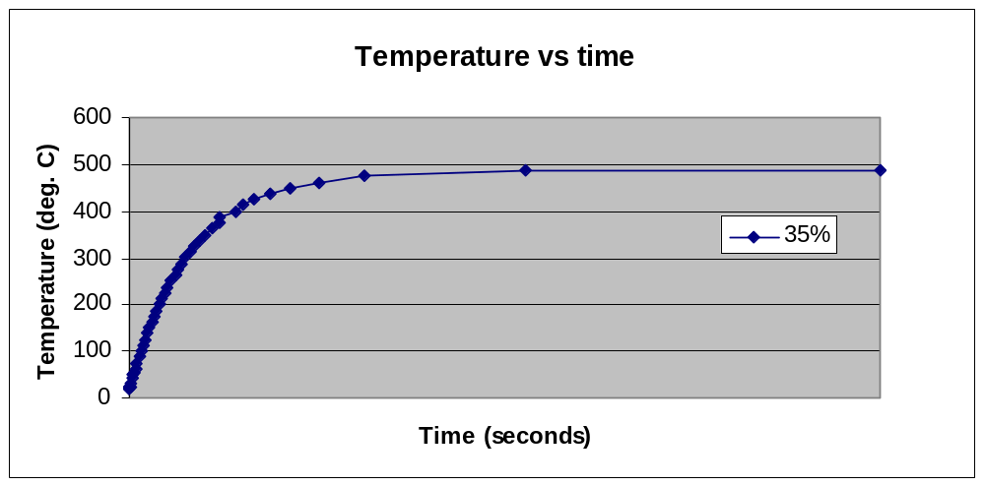
6000

Fig. 5. Plot of temperature vs. time for power fixed at 35% (constant)

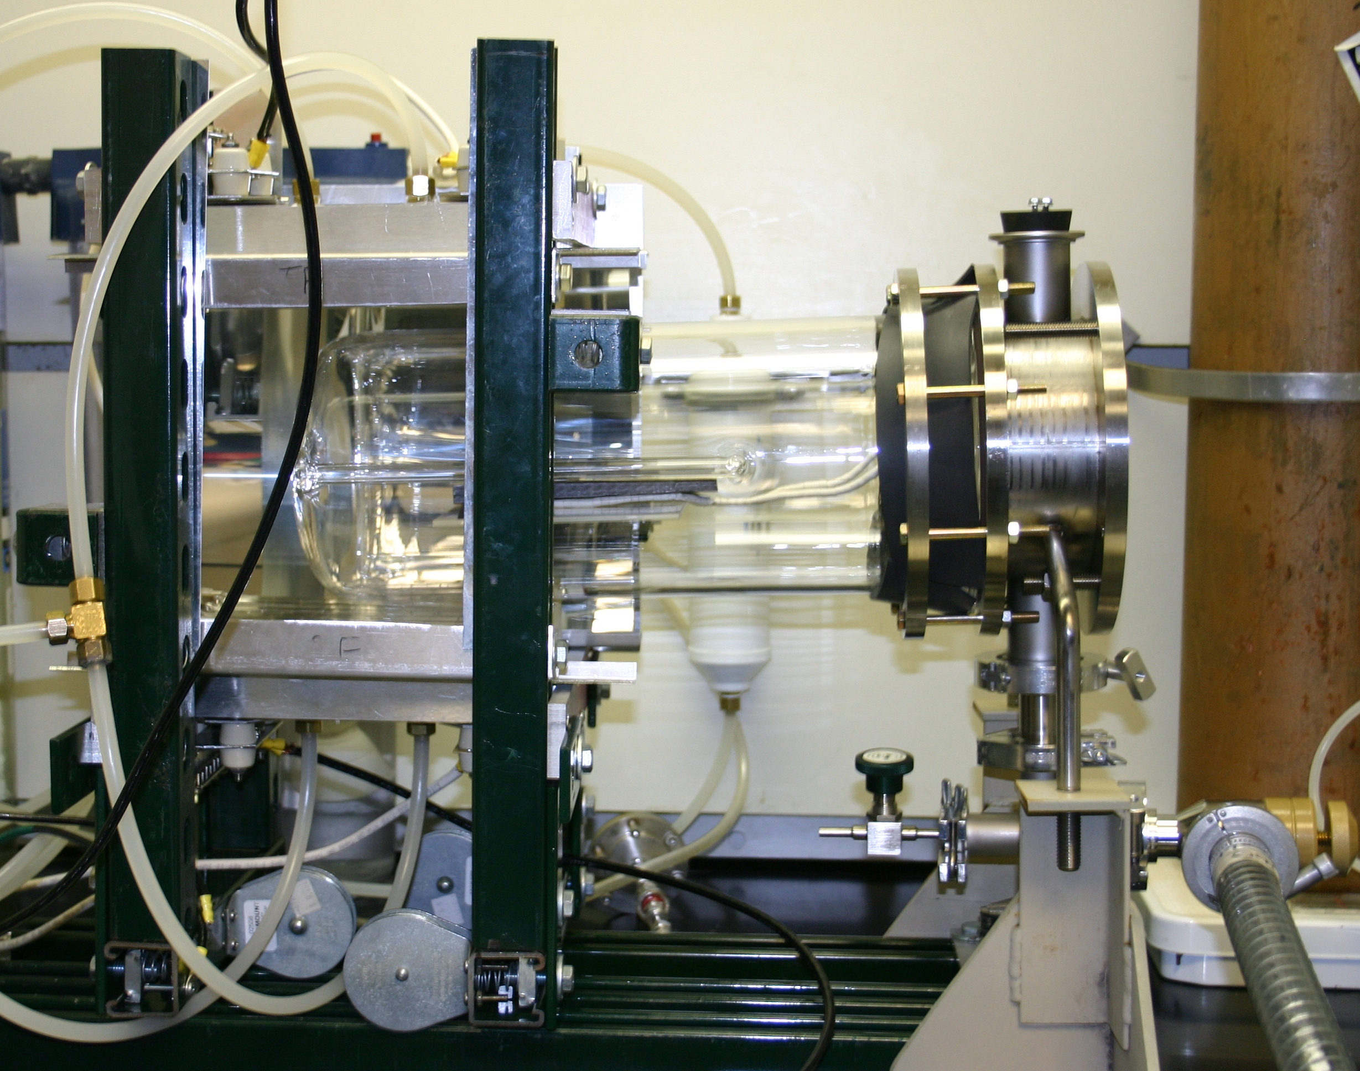

Fig. 6: RTP Setup at FSEC PV Materials Lab

Selenization/Sulfurization Furnace:

Three new temperature controllers from Eurotherm were procured. Necessary enclosure was procured and all three controllers along with a over temperature controller have been properly installed in the enclosure while the enclosure itself has been installed securely beneath the furnace. The controllers were connected to the selenization/sulfurization furnace and are being used to control the heat treatment process for the development of CIGSS thin films on glass and stainless steel substrates. The controllers were programmed with required parameters and initially tested for time/temperature readings. The time/temperature control ability and ramp has been improved using these controllers.

